Review Article
A review of Integrating Agronomic Practices and Food Processing for Enhancing Farmer Income

Abstract
The agricultural sector is moving away from its traditional focus on subsistence farming toward market-based systems that add value through their products which require new methods to boost farmer profits while maintaining sustainable farming practices. The combined use of better farming methods with food processing techniques provides a complete solution to this problem. The application of agronomic practices through Integrated Nutrient Management (INM) and conservation agriculture methods and integrated farming systems (IFS) together with crop diversification strategies results in better agricultural outcomes through effective resource usage and improved product outcomes. The implementation of these agricultural methods leads to higher production levels and better nutritional content and processing capabilities of agricultural products.
The process of food processing together with value addition techniques serves as an income booster through its ability to decrease post-harvest losses and increase product shelf life and product price stability and product availability in remote areas which contain valuable markets. Farmers can increase their earnings through a value chain approach which connects production activities with processing tasks and marketing operations. The process of effective integration faces obstacles because of insufficient infrastructure facilities and restricted access to funding and technological resources and disconnected market systems and divided land ownership.
Agro-processing clusters and Farmer Producer Organizations (FPOs) and cold chain development together with capacity-building and digital marketing platforms require policy support to remove barriers that create these challenges. The future development of precision agriculture and artificial intelligence technology and the rising demand for organic and functional food products create new ways to advance agronomy and food processing partnerships. The success of farmer development depends on using a comprehensive integrated system.
Keywords: Agronomic practices, Food processing, Value addition, and Farmer income
1. Introduction
Agriculture in the 21st century is changing significantly. It is moving from traditional subsistence farming to a more commercial, market-driven, and value-focused system (Hasenauer, R. P., & Yu Hasenauer, and Yu 2022). This change is mainly due to rising population pressures, shifts in dietary preferences, global agricultural market expansion, and the growing demand for high-quality, safe, and processed food products (Vos, and Bellù, 2019). However, farmers still face many challenges. These include rising input costs, shrinking landholdings, climate changes, pest and disease outbreaks, and price fluctuations in agricultural markets. These issues negatively impact farm profitability and sustainability, making it essential to focus on increasing farm income (Paudel, et al., 2023).
To improve farmer income, we need a comprehensive approach that goes beyond just increasing yields. It requires bringing together efficient farming practices, diversifying farming systems, and strengthening post-harvest management and value-added processes (Paramesh, et al., 2022). Farming practices, like using improved crop varieties, effective nutrient management, smart irrigation techniques, pest control, and conservation methods, are key in maximizing crop output and ensuring efficient resource use. These practices not only raise yields but also enhance produce quality such as size, color, texture, nutritional value, and shelf life which are vital for market acceptance and processing, (Kashyap, et al., 2022).
Diversifying farming systems contributes to income stability and reduces risks by combining crops with related activities like horticulture, livestock, fisheries, and agroforestry. These systems make better use of resources, generate multiple income sources, and increase resilience to climate and market changes (Sivaraman, et al., 2023). Additionally, focusing on high-value crops like fruits, vegetables, spices, and medicinal plants offers more chances for value addition and income growth (Das, and Darshan, 2024).
Post-harvest losses continue to be a major issue in agriculture, especially in developing countries like India, where a large portion of produce is lost due to poor storage, transportation, and processing methods (Negi, and Anand, 2017). Good post-harvest management, which includes grading, sorting, packing, storing, and developing cold chains, helps maintain quality and extends shelf life. More importantly, food processing and value addition such as drying, canning, pickling, juicing, and making ready-to-eat products turn raw agricultural products into higher-value goods. This not only reduces losses but also boosts the economic worth of produce, creates jobs, and strengthens connections between farmers and markets (Kumar, and Kalita, 2017).
Combining agronomic practices with food processing creates an effective way to increase farmer income. For example, choosing appropriate crop varieties with desirable processing traits, along with suitable farming practices, can greatly improve processing efficiency and product quality (Sattler, et al., 2010). Furthermore, contract farming, farmer producer organizations (FPOs), and agro-based industries can provide better market access, improve pricing, and enhance value chain integration, (Sharma, 2019).
Fig 1: Impact of Integrated Agronomic Practices on Income Enhancement
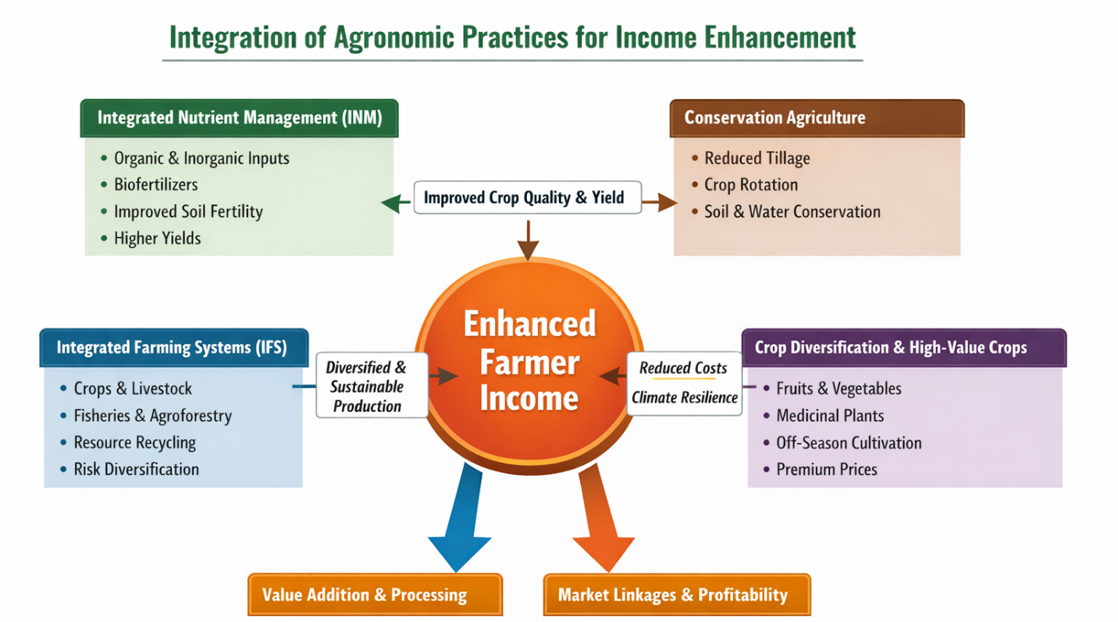
Recently, government efforts like “Doubling Farmers’ Income,” promoting agro-processing clusters, and supporting food processing startups have highlighted the need to connect production with processing and marketing. New technologies, such as precision agriculture, digital platforms, and supply chain improvements, are also crucial in linking farm production with what consumers want, (Abiri, et al., 2023)
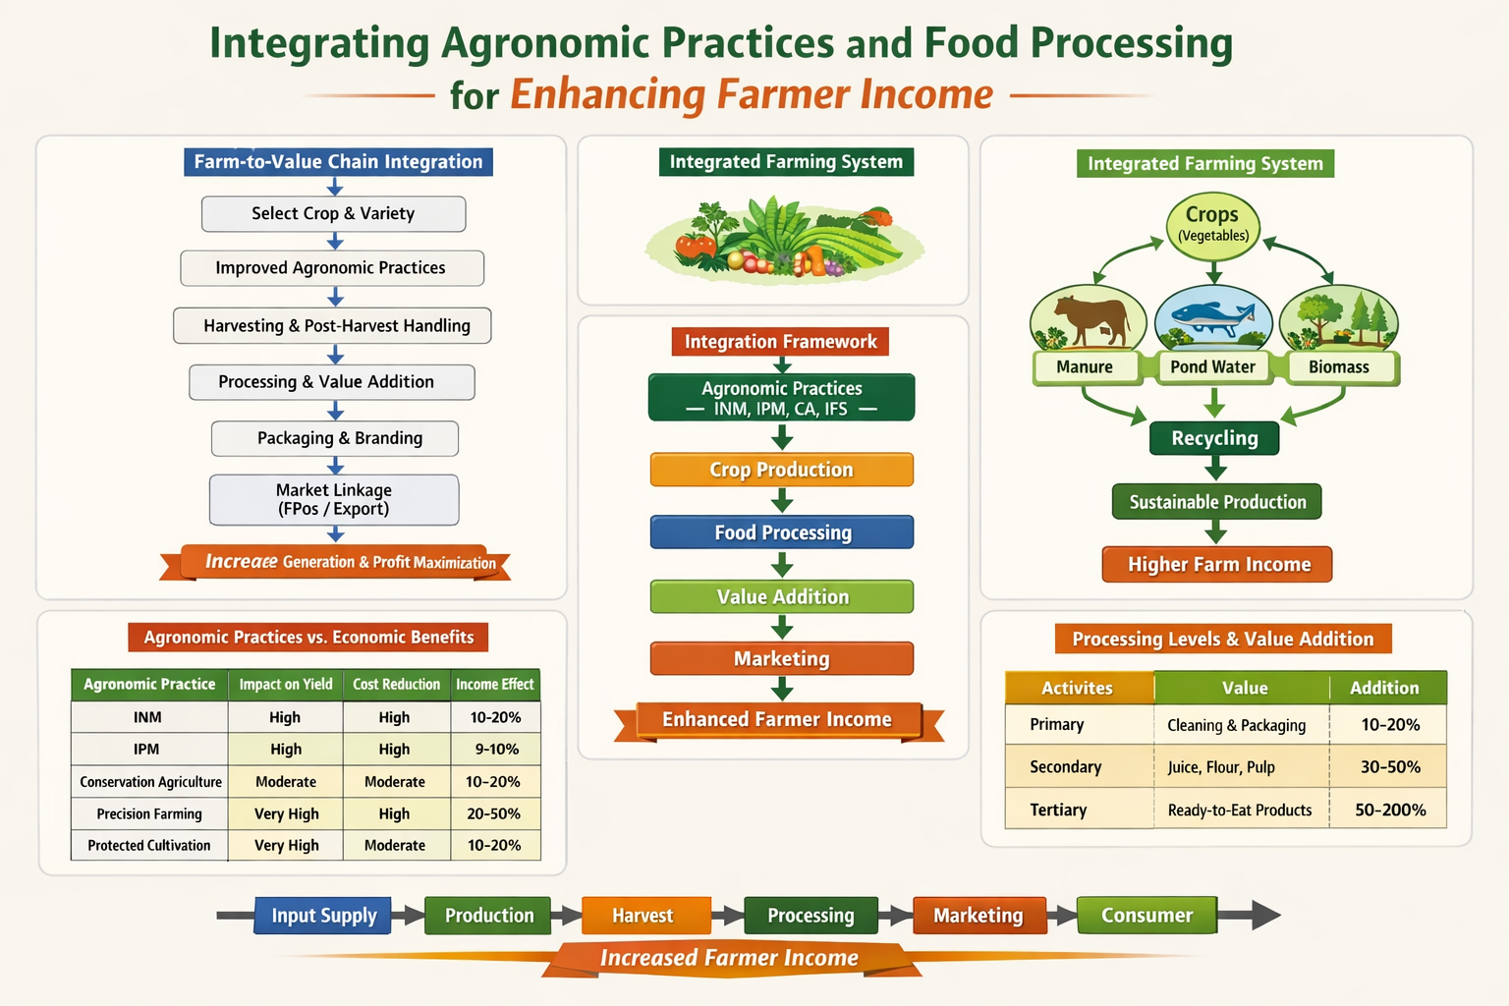
Thus, combining agronomic practices with post-harvest management and food processing is vital for creating a sustainable, profitable, and resilient agricultural system. This review aims to explore how these components connect and to highlight strategies for improving farmer income through a value chain-focused approach, (Nishad, et al., 2024)

Fig 2: Steps involved in developing Enhanced Farmer income from Integrated Farming Practice

2. Role of Improved Agronomic Practices
Improved agronomic practices are crucial for increasing agricultural productivity, profitability, and sustainability (Chauhan, et al., 2023). These practices focus on efficient resource use, managing soil health, and building climate resilience, all while ensuring the production of high-quality products suitable for both fresh markets and processing. Adopting scientific methods in crop production not only boosts yields but also lowers production risks and input costs, significantly improving farmer income (Nemade, et al., 2023).

Fig 3: Impact of Improved agronomic practices on sustainability
2.1 Integrated Nutrient Management (INM)
Integrated Nutrient Management (INM) takes a combined approach using a balanced mix of chemical fertilizers, organic materials like farmyard manure and compost, crop residues, and biofertilizers, (Wu, and Ma, 2015). The goal of INM is to optimize nutrient availability to align with crop needs while reducing nutrient loss to the environment. It improves nutrient-use efficiency by enhancing soil properties (Panta, and Parajulee 2021). Organic inputs improve soil structure, water retention, and microbial activity, while inorganic fertilizers provide readily available nutrients for crops. Biofertilizers, such as Rhizobium, Azotobacter, and phosphate-solubilizing bacteria, further boost nutrient availability. As a result, INM leads to higher crop yields and better produce quality in terms of size, color, and nutritional value. It also helps maintain soil fertility, reduces reliance on chemical fertilizers, lowers input costs, improves nutrient use, minimizes environmental pollution, and ensures greater profitability and long-term sustainability in farming, (Jat et al., 2015).
2.2 Conservation Agriculture
Conservation agriculture is an ecosystem-based approach that focuses on sustainable agricultural intensification. It relies on three main principles: minimal soil disturbance through no-till or reduced tillage, maintaining permanent soil cover with plant residues or cover crops, and rotating different crops (Palm, et al., 2014). By minimizing soil disturbance, conservation agriculture helps preserve soil structure and prevent erosion. Keeping crop residues enhances soil organic matter and conserves moisture, while crop rotations break pest and disease cycles and boost soil fertility (Bhan, and Behera, 2014). Overall, conservation agriculture improves soil structure, aggregation, and water infiltration and enhances soil moisture retention, which is especially beneficial in rainfed conditions. It also increases soil organic carbon and biodiversity while reducing soil erosion and land degradation. Moreover, this approach lowers fuel and labor costs due to less tillage and enhances resilience to climate variability and extreme weather, promoting sustainable productivity over time (Lal, 2015).
Table 1: Agronomic Practices vs Economic Benefits
Agronomic Practice | Impact on Yield | Impact on Quality | Cost Reduction | Income Effect
Integrated Nutrient Management (INM) | High | High | Moderate | High
Integrated Pest Management (IPM) | Moderate | High | High | High
Conservation Agriculture | Moderate | Moderate | High | Moderate
Precision Farming | High | High | Moderate | Very High
Protected Cultivation | Very High | Very High | Low | Very High

2.3 Integrated Farming Systems (IFS)
Integrated Farming Systems (IFS) combine various agricultural activities, such as crops, livestock, poultry, fisheries, beekeeping, and agroforestry, within one farm to optimize resource use and create multiple income streams throughout the year (Gupta, et al., 2020). This method recycles farm waste, using crop residues as livestock feed and returning animal manure to the soil. Such a circular system decreases dependence on outside inputs and boosts sustainability (Mishra, et al., 2023). IFS encourages efficient recycling of nutrients and resources, diversifies income sources, and reduces reliance on single enterprises. This approach also lessens risks from crop failures, market changes, and climate variability while providing more job opportunities and generating income year-round. Additionally, it improves soil health and maintains ecological balance (Kumar, et al., 2012) Combining various enterprises leads to higher overall productivity and profitability. Studies show that integrated farming systems yield better benefit-cost ratios, higher profits, and greater resilience than traditional monocropping systems, (Bhagat, et al., 2022).
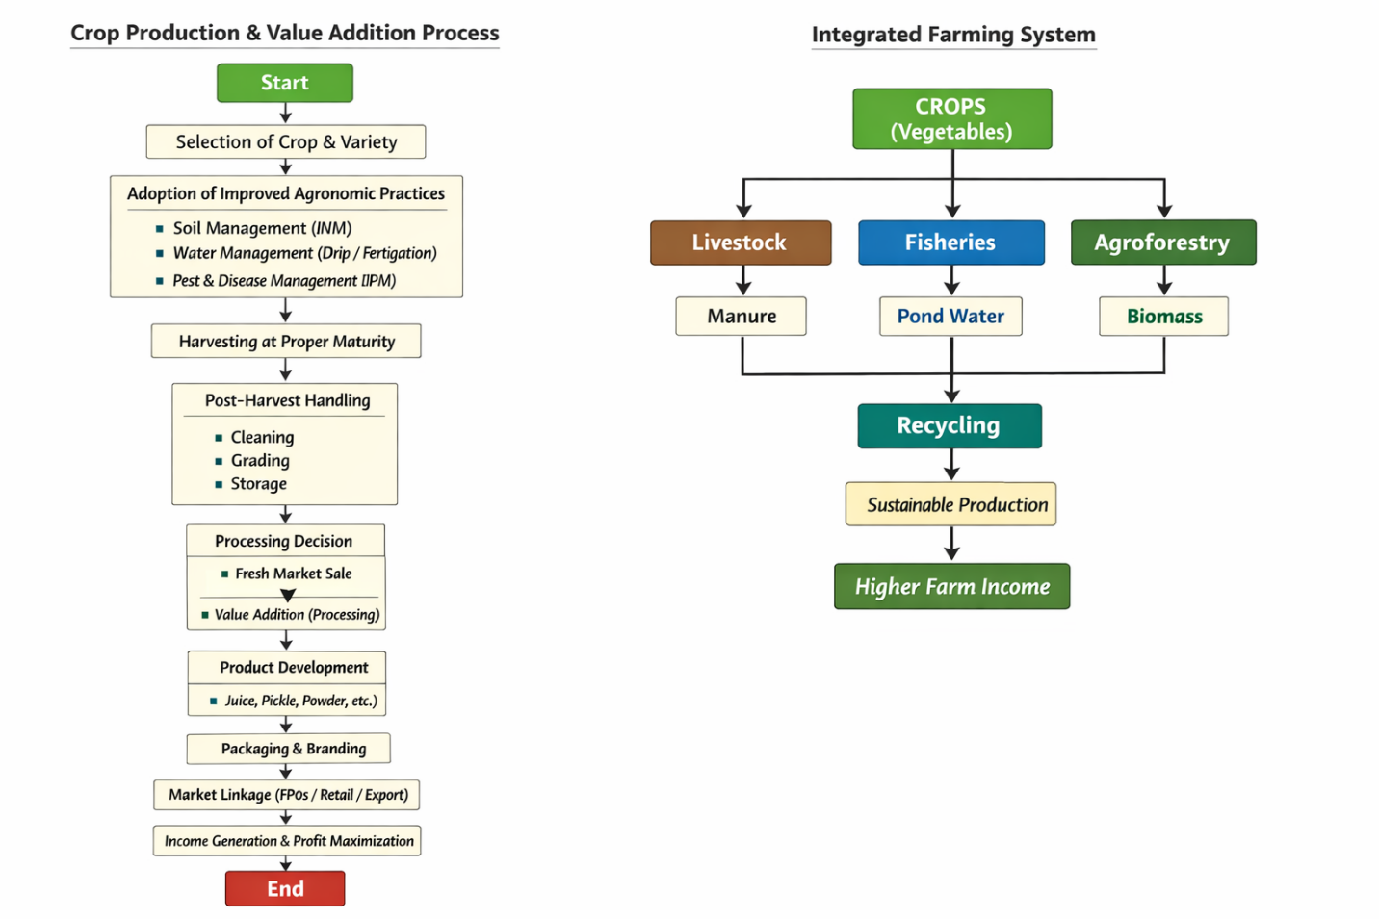

Fig 4: Impact of Integrated Farming System on Higher Farm Income
2.4 Crop Diversification and High-Value Crops
Crop diversification means including a variety of crops in a farming system to maximize resource use, lower risks, and increase income (Anuja, et al., 2020). Moving from low-value staple crops to high-value crops like fruits, vegetables, spices, flowers, and medicinal plants has become an effective way to boost farm profitability. These high-value crops usually have more market demand and can fetch better prices, especially when linked with processing industries. The use of protected cultivation technologies, like polyhouses and net houses, enables off-season production, allowing farmers to attain premium prices (Bhargavi, et al., 2019). Crop diversification increases income per unit area by incorporating horticultural and specialty crops, while multi-tier and intercropping systems optimize space use. Off-season vegetable production can lead to higher profitability, while producing quality raw materials supports agro-processing industries. Additionally, diversification enhances nutritional security and dietary variety. By spreading risks across various crops and enterprises, it strengthens resilience and secures more stable and sustainable farm income (Kumar, et al., 2012).

Fig 5: Process of Crop Production and Value Addition
3. Link Between Agronomy and Food Processing
Agronomic practices are key in determining the quality and suitability of agricultural products for food processing and value addition. How crops are grown, managed, and harvested directly affects important characteristics like raw material quality, nutritional composition, shelf life, and processing efficiency. These factors are crucial to ensure agricultural products meet the standards required by processing industries and consumers, (Augustin, et al., 2016).
The quality of raw materials is largely influenced by agronomic practices, including nutrient management, irrigation scheduling, pest control, and selecting the right varieties. Balanced and integrated nutrient management enhances the biochemical makeup of crops, leading to higher levels of vitamins, minerals, antioxidants, and other beneficial compounds (Siddique, et al., 2012). For example, using organic manures and biofertilizers can increase antioxidant levels and improve the nutritional quality of fruits and vegetables, making them more suitable for health-focused processing, (Lichtfouse, et al., 2009).
Additionally, irrigation management is vital in determining the physical and chemical traits of produce. Controlled irrigation methods, such as drip irrigation and regulated deficit irrigation, help maintain optimal moisture levels, improving fruit size, firmness, total soluble solids (TSS), and flavor, (Lipan, et al., 2021). These qualities are essential for processing industries, especially for products like juices, sauces, and dehydrated foods.
Advancements in cultivation techniques, such as soilless culture and protected cultivation, further enhance the uniformity, cleanliness, and quality of produce. Soilless systems, including hydroponics and cocopeat-based cultivation, allow precise control over nutrient supply and environmental conditions, resulting in consistent produce with uniform size, shape, and composition. This uniformity is highly desirable in processing industries, as it improves efficiency, reduces waste, and ensures standardization of final products, (Mohammed, et al., 2018).
Moreover, agronomic practices also influence the shelf life of produce by affecting factors such as moisture content, tissue strength, and susceptibility to post-harvest deterioration. Crops grown under optimal nutrient and water management conditions tend to have better storage quality and longer shelf life, which reduces post-harvest losses and facilitates transportation and processing, (Anusha, et al., 2024).
Processing efficiency is another critical aspect linked to agronomy. High-quality raw materials with desirable traits such as higher dry matter content, uniform ripening, and minimal defects lead to better recovery rates, lower processing losses, and superior end-product quality. For example, tomatoes with higher TSS are preferred for processing into paste and ketchup, while potatoes with high dry matter content are ideal for chips and fries, (Khatana, et al., 2026).
4. Role of Food Processing in Improving Farmer Income
Food processing is essential for increasing farmer income by turning perishable agricultural products into stable, high-value goods with a longer shelf life and better market appeal. In traditional farming systems, farmers usually sell raw products at low prices, especially during peak harvest times when supply is high (Sharma, et al., 2014). However, by processing food and adding value, the economic worth of agricultural products can rise significantly. This enables farmers to earn more and lessen post-harvest losses, (Augustin et al., 2016).
4.1 Value Addition
Value addition means transforming raw agricultural products into items with higher economic value through various processing, preservation, and packaging methods. This change not only increases the utility and shelf life of the products but also enhances their quality, convenience, and appeal to consumers, (Shukla, 2019).
Processing can occur at three levels: primary, secondary, and tertiary. Primary processing involves basic actions such as cleaning, grading, sorting, and packaging, which make fresh produce more marketable (Kumar, et al., 2016). Secondary processing turns raw materials into semi-processed or processed goods, such as milling grains, extracting oil, or making juice from fruits. Tertiary processing produces ready-to-eat or ready-to-cook products, like fruit juices, jams, pickles, dehydrated vegetables, frozen foods, and snacks, (Khetarpaul, 2005).
By changing raw products into processed goods, farmers can receive higher prices than if they sold unprocessed crops (Bhai, et al., 2026). For example, tomatoes made into ketchup or puree, fruits turned into jams and juices, and milk converted into cheese or yogurt can command much higher market prices. Additionally, value-added products typically last longer, allowing farmers and business owners to store and sell them when prices are better.
Value addition also lowers post-harvest losses, which can be quite high for perishable items like fruits and vegetables. By processing surplus products, farmers can avoid waste and make better use of their harvests. Moreover, it creates job opportunities, encourages rural businesses, and develops agro-based industries, (Dahal, et al., 2024).
Another important benefit of value addition is improved access to markets. Processed goods can be shipped long distances and sold in organized retail markets, export chains, and online platforms. This broadens farmers' market reach and boosts their income potential.
Table-2: Processing transforms raw produce into high-value products
Raw Product | Processed Product | Value Increase
Tomato | Sauce, ketchup | 2–5 times
Milk | Cheese, paneer | 3–6 times
Fruits | Jam, juice, dried products | 2–4 times

Fig 6: Process of Increased Generation and Profit Maximisation

Table 3: Processing Levels and Value Addition
Level of Processing | Activities | Examples | Value Addition (%)
Primary | Cleaning, grading, packaging | Fresh vegetables | 10–20%
Secondary | Basic processing | Flour, pulp, juice | 30–50%
Tertiary | Advanced processing | Ready-to-eat, frozen food | 50–200%

4.2 Reduction of Post-Harvest Losses
Post-harvest losses are a significant problem in agriculture, especially for perishable goods like fruits and vegetables. In developing countries, such as India, these losses can be between 20 and 30 percent due to insufficient storage, poor handling, inefficient transportation, and lack of processing facilities (Kiaya, 2014). These losses not only cut down the amount of marketable produce but also directly impact farmer income and food supply.
Food processing is crucial in reducing these losses by changing perishable products into more stable and durable items (Ogedengbe, et al., 2022). Methods like drying, dehydration, canning, freezing, and pickling significantly extend the shelf life of agricultural products. By processing extra produce during peak harvest times, farmers can prevent waste and make better use of their goods (Dos Santos, et al., 2020). Additionally, better post-harvest handling practices like grading, sorting, packaging, and cold storage help maintain quality and minimize both quantity and quality losses. Thus, food processing is an effective method for reducing post-harvest losses and increasing overall profits (Elik, et al., 2019).
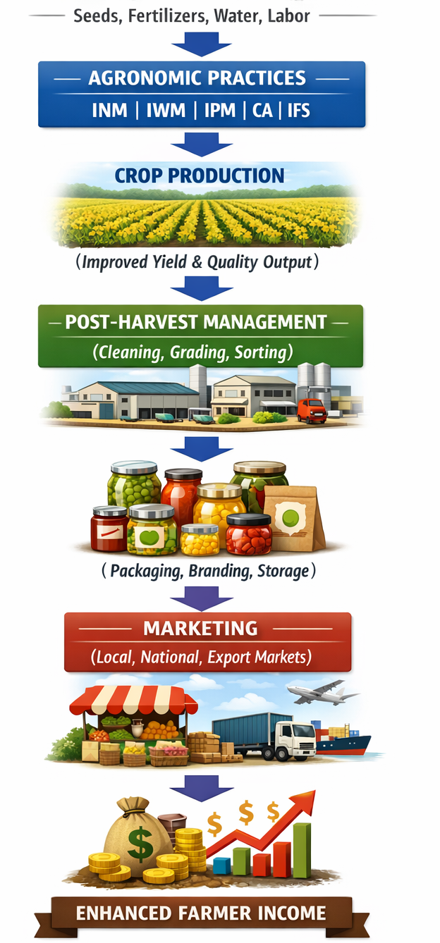

Fig 7: Influence of Crop Production on Enhanced Farmer Income
Table 4: Crop-wise Integration for Income Enhancement
Crop | Agronomic Practice | Processing Option | Market Product
Tomato | Drip + INM | Ketchup, puree | Packaged sauces
Mango | Pruning + fertigation | Pulp, pickle | Export products
Milk | Balanced feeding | Paneer, cheese | Dairy products
Wheat | Improved varieties | Flour, bakery items | Value-added grains
Chili | Integrated pest control | Powder, flakes | Spice market

4.3 Market Expansion
Food processing plays a significant role in expanding markets by allowing agricultural products to reach beyond local and regional areas. Fresh goods are often limited by their perishability and bulkiness, forcing farmers to sell nearby where prices can fluctuate due to oversupply, (Bharatkumar, et al., 2023) In contrast, processed items last longer, store better, and are easier to transport, enabling access to distant domestic and international markets, (Wilkinson, 2002).
Processed goods like packaged foods, juices, dried fruits, and ready-to-eat items can be sold through retail chains, supermarkets, and online platforms, increasing their reach and consumer base, (Baker, and Friel, 2016) This reduces farmers’ reliance on local markets and middlemen, leading to better price outcomes. Moreover, processing helps stabilize prices by absorbing excess production and reducing seasonal surpluses. As a result, farmers can achieve more steady and predictable income year-round, (Nordhagen, and Demmler, 2023).
4.4 Employment Generation
The growth of food processing industries positively impacts job creation, especially in rural communities. Agro-processing units offer a variety of job opportunities in areas such as handling, processing, packaging, storage, transportation, and marketing of agricultural products. This not only provides direct jobs but also leads to indirect employment in related fields like logistics, machinery, and retail.
Additionally, food processing encourages rural entrepreneurship by motivating farmers, self-help groups, and small business owners to start value addition ventures. It is particularly important for empowering women, as it creates opportunities for them to be involved in processing, packaging, and marketing food products. This contributes to income diversity, social inclusion, and overall rural development, (Paramesh, et al. 2022).
5. Integration of Agronomy and Processing
Bringing together agronomy and food processing through a value chain approach offers a solid framework for boosting farmer income and ensuring agricultural sustainability. A value chain includes all the steps involved in taking a product from input supply to final use, covering production, processing, packaging, and marketing. By effectively connecting these elements, farmers can go beyond simple production and engage in value addition, capturing a larger share of the final consumer price, (Attahiru, 2025).
5.1 Farm-to-Fork Model
The farm-to-fork model is a comprehensive strategy that connects all stages of the agricultural value chain, from farming to consumer consumption (Kiran, et al., 2023). This model focuses on the smooth flow of agricultural products through different phases, ensuring quality, efficiency, and value addition at each step, Antle, et al., 2017).

Integration within this model guarantees that high-quality production, based on improved farming practices, meets the needs of processing industries and market demand. Effective processing methods then boost the value and shelf life of the produce, while well-organized marketing systems support better price outcomes (Ould-Sidi, and Lescourret, 2011). Therefore, the chain of quality production, efficient processing, and better marketing creates a combined effect that maximizes returns for farmers and reduces losses in the supply chain, (Sharma, and Sharma, 2025).
5.2 Value Chain Components
The agricultural value chain consists of several connected parts that collectively impact the efficiency and profitability of the system, (Dong, 2021). It starts with input supply, which includes seeds, fertilizers, machinery, and other resources needed for crop production. Next is production, where scientific crop management practices ensure the best yield and quality, (Ma, and Sexton 2021).
The harvesting stage involves collecting produce in a timely and careful manner to minimize losses and maintain quality. After harvesting, products are processed, transforming them into value-added items with increased shelf life and market value. Packaging is important for protecting the product, maintaining quality, and making it more appealing. Finally, marketing ensures that the product reaches consumers through suitable channels, including local markets, retail chains, and export markets, (Vroegindewey, and Hodbod, 2018).
An integrated value chain approach allows farmers to take part in multiple stages beyond production, helping them capture a larger share of the generated value. This reduces the influence of middlemen, improves price realization, and enhances overall farm profitability, (Pal, and Sharma, 2018).
5.3 Case Evidence
Real-world examples from various farming systems show the benefits of combining agronomy with value chain approaches. Integrated crop-livestock systems improve profitability by lowering input costs through efficient use of resources like crop residues and animal manure. These systems also provide various income sources, contributing to economic stability, (Reddy, 2016).
Likewise, agroforestry and mixed farming systems enhance value capture by diversifying production and using resources more effectively. These approaches lessen reliance on external inputs, lower production costs, and bolster resilience to climate and market challenges, (Low, et al., 2023). Many farmers operating integrated systems have reported higher net returns, better benefit-cost ratios, and more sustainable livelihoods compared to those relying solely on monocropping.
Overall, merging agronomy and processing through a value chain approach allows farmers to progress from mere producers to active participants in the agricultural economy, leading to higher income, reduced risks, and long-term sustainability.
6. Challenges in Integration
Despite the clear potential for connecting agronomic practices with food processing to boost farmer income, several hurdles make its successful implementation difficult. These challenges occur at production, post-harvest, processing, and marketing stages, limiting farmers’ ability to fully benefit from value chain integration.
6.1 Lack of Processing Infrastructure
One of the primary challenges in linking agronomy and food processing is the lack of processing facilities, especially in rural areas. Many farmers do not have access to essential resources like grading units, cold storage, pack houses, and small processing plants. As a result, perishable items like fruits and vegetables are often sold right after harvest at lower prices, leading to distress sales. The lack of cold chain systems worsens post-harvest losses and limits potential for value addition. Additionally, high initial investment costs and weak public-private partnerships hinder the establishment of agro-processing industries in rural regions.
6.2 Limited Access to Credit and Technology
Many small and marginal farmers struggle to access timely and affordable credit. This issue prevents them from adopting better farming methods or investing in processing activities. Financial institutions often demand collateral, making it tough for resource-poor farmers to secure loans. Additionally, limited access to modern technology, like precision farming tools, improved irrigation systems, and better processing equipment, lowers productivity and quality. The digital divide and lack of knowledge about available government programs also stop farmers from using technological advancements effectively.
6.3 Poor Market Linkages
Weak market connections add another major challenge to the integration process. Farmers rely heavily on local markets and intermediaries, which often leads to low prices because of information gaps and limited bargaining power. Without organized marketing systems, efficient supply chains, and direct market access, farmers struggle to reach high-value markets, including export channels. Moreover, changes in market demand and prices create uncertainty, discouraging farmers from investing in value-added production and processing.
6.4 Inadequate Skill Development
Successful integration of agronomy and food processing calls for technical knowledge and business skills. However, many farmers lack proper training in modern farming methods, post-harvest management, and processing techniques. Limited extension services and a shortage of capacity-building programs widen this gap. Skills in quality control, packaging, branding, and marketing are also often missing, restricting farmers' ability to compete in producing and selling value-added products. Improving skill development through training, workshops, and institutional support is essential for empowering farmers to engage effectively in value chains.
6.5 Fragmented Landholdings
Fragmented and small landholdings are a structural barrier in Indian agriculture that limits the adoption of integrated farming and processing systems. Small-scale farmers often lack the size needed for efficient mechanization, bulk production, and investment in infrastructure. This fragmentation decreases economies of scale and makes it hard to standardize production for processing industries. Additionally, scattered land parcels complicate the implementation of integrated approaches like conservation agriculture, crop diversification, and integrated farming systems. Collectives such as Farmer Producer Organizations (FPOs) and cooperatives can help overcome this issue by gathering produce and resources.
6.6 Other Emerging Challenges
Beyond these issues, several new challenges further complicate the integration process. Climate change and weather variability affect crop yield and quality, which influences processing suitability. Regulatory hurdles, quality standards, and certification requirements for processed products can act as barriers, especially for small producers. Poor infrastructure for storage, transportation, and logistics raises transaction costs and lowers competitiveness. Also, the lack of coordination among stakeholders in the value chain reduces efficiency and value realization.
7. Policy and Institutional Support
Effective policy and institutional support are key to promoting the integration of farming practices and food processing and strengthening agricultural value chains. Governments and development agencies play a vital role in creating conditions that encourage investment, innovation, and market access.
Developing agro-processing clusters is an important strategy to enhance value addition at the regional level. These clusters provide shared facilities such as processing units, cold storage, packaging centers, and logistics support, lowering the investment burden on farmers and entrepreneurs. Cluster-based approaches improve efficiency, cut post-harvest losses, and support economies of scale.
Supporting Farmer Producer Organizations (FPOs) has emerged as a key method for uniting small and marginal farmers. FPOs enable group purchasing of inputs, adoption of better farming practices, and improved access to processing and marketing facilities. By strengthening their bargaining power and reducing intermediaries' roles, FPOs help farmers get better prices and engage more effectively in value chains.
Investing in cold storage and supply chain infrastructure is critical for maintaining the quality of perishable produce and ensuring its smooth movement from farm to market. Developing integrated cold chains, including pre-cooling units, refrigerated transport, and storage facilities, help reduce post-harvest losses and extend the shelf life of agricultural products, thus supporting processing and marketing activities.
Training and capacity-building initiatives are just as important for equipping farmers and rural entrepreneurs with the necessary skills. Extension services, vocational training programs, and skill development initiatives can enhance farmers’ capabilities in modern farming practices, post-harvest management, food processing, quality control, packaging, and marketing. This empowers them to take part actively in value addition and agribusiness.
The rise of digital marketing platforms and e-commerce has transformed agricultural marketing by providing direct connections between farmers and consumers. Digital tools improve price discovery, decrease dependency on intermediaries, and broaden market access to urban and international markets. Online marketplaces, mobile applications, and digital payment systems make transactions efficient and transparent.
Overall, strong policy support alongside effective institutional mechanisms is essential to bridge gaps in infrastructure, finance, technology, and market access, enabling successful integration of farming and food processing.
8. Future Prospects
The future of agriculture relies on adopting new technologies and innovative methods that combine production, processing, and marketing systems. Smart agriculture and precision farming technologies, including sensors, drones, IoT devices, and data analytics, allow efficient resource management and real-time decision-making. These technologies boost productivity, lower input costs, and enhance the quality of produce, making it better suited for processing.
Integrating artificial intelligence (AI) in supply chain management is expected to change the agricultural sector by improving demand forecasting, inventory management, logistics optimization, and quality monitoring. AI-driven systems can increase efficiency, cut waste, and ensure timely delivery of products to markets.
The growing demand for organic and functional foods presents major opportunities for value addition and income generation. Consumers are increasingly looking for safe, nutritious, and health-promoting food products, which creates a premium market for organic goods. Farmers who adopt organic and sustainable practices can enjoy higher prices and access niche markets.
The development of export-oriented processing industries offers further ways to boost farmer income. With proper quality standards, certification, and infrastructure, agricultural products can be processed and exported to international markets, leading to higher returns and foreign exchange earnings.
Moreover, promoting climate-resilient integrated systems, such as agroforestry and conservation agriculture, will be critical for ensuring sustainable agricultural development. These systems improve resilience to climate change, enhance resource-use efficiency, and support long-term productivity and profitability.
9. Conclusion
Integrating farming practices with food processing offers a transformative and sustainable way to boost farmer income and strengthen the agricultural sector. Improved farming methods lead to higher productivity, better resource use, and superior quality of produce, laying the groundwork for successful value addition. At the same time, food processing increases the economic value of agricultural products by extending shelf life, cutting post-harvest losses, enabling market expansion, and stabilizing prices.
A comprehensive approach that combines sustainable farming, varied production systems, and effective value chain management is vital for achieving long-term agricultural profitability and resilience. Strengthening policy support, developing infrastructure, improving institutional mechanisms, and adopting new technologies will further facilitate this integration. Ultimately, this integrated framework not only boosts farmer income but also supports rural development, job creation, and food and nutritional security.

Reference

Abiri, R., Rizan, N., Balasundram, S. K., Shahbazi, A. B., & Abdul-Hamid, H. (2023). Application of digital technologies for ensuring agricultural productivity. Heliyon, 9(12).
Antle, J. M., Basso, B., Conant, R. T., Godfray, H. C. J., Jones, J. W., Herrero, M., ... & Wheeler, T. R. (2017). Towards a new generation of agricultural system data, models and knowledge products: Design and improvement. Agricultural systems, 155, 255-268.
Anuja, A. R., Kumar, A., Saroj, S., & Singh, K. N. (2020). The impact of crop diversification towards high-value crops on economic welfare of agricultural households in eastern India. Current Science, 118(10), 1575-1582.
Anusha, M., Sri, K. R., Lokesh, M., Deepthi, N. M., & Malleswari, M. D. (2024). Postharvest management techniques for improved shelf life of horticultural crops: A review. Journal of Experimental Agriculture International, 46(11), 362-380.
ATTAHIRU, A. (2025). AGRO PROCESSING AND VALUE CHAIN DEVELOPMENT. RESHAPING DEVELOPMENT GOVERNANCE, AGRICULTURE AND DIGITAL FINANCE EDITOR AHMED ATTAHIRU, 1.
Augustin, M. A., Riley, M., Stockmann, R., Bennett, L., Kahl, A., Lockett, T., ... & Cobiac, L. (2016). Role of food processing in food and nutrition security. Trends in Food Science & Technology, 56, 115-125
Augustin, M. A., Riley, M., Stockmann, R., Bennett, L., Kahl, A., Lockett, T., ... & Cobiac, L. (2016). Role of food processing in food and nutrition security. Trends in Food Science & Technology, 56, 115-125.
Baker, P., & Friel, S. (2016). Food systems transformations, ultra-processed food markets and the nutrition transition in Asia. Globalization and health, 12(1), 80.
Bhagat, R., Walia, S. S., Sharma, K., Singh, R., Singh, G., & Hossain, A. (2024). The integrated farming system is an environmentally friendly and cost‐effective approach to the sustainability of agri‐food systems in the modern era of the changing climate: A comprehensive review. Food and Energy Security, 13(1), e534.
Bhai, S., Rathore, V., Kumari, A., Yadav, R. K., Chand, K., Kumar, A., ... & Pradhan, R. (2026). A Review of the Economic Impact of Value Addition and Food Processing on Farmers’ Income: An Extension Perspective. Journal of Experimental Agriculture International, 48(3), 1-13.
Bhan, S., & Behera, U. K. (2014). Conservation agriculture in India–Problems, prospects and policy issues. International Soil and Water Conservation Research, 2(4), 1-12.
Bharatkumar, D. P., Khatun, P., Kumar, C., & Yadav, A. K. (2023). Role of agriculture processing in export growth of agricultural products. Journal of Current Research in Food Science, 4(1), 49-56.
Bhargavi, B., Behera, U. K., Rana, K. S., Singh, R., Prasad, S., Pandey, R. N., & Singh, G. (2019). Crop diversification with high-value crops for higher productivity and profitability under irrigated ecosystem. Indian Journal of Agronomy, 64(4), 440-444.
Chauhan, A. P. S., Singh, D., Sharma, O. P., Kushwah, N., & Kumhare, A. (2023). Agronomic practices for enhancing resilience in crop plants. Plant Science Archives, 8(3), 1-3.
Dahal, B., Kimmerer, C., & Hailu, G. (2024). Value added to agricultural commodities. In Future food systems (pp. 89-107). Academic Press.
Das, S., & Darshan, N. (2024). Agricultural diversification and its impact on enhancing farm income. J Commun Mobiliz Sustain Dev., 19, 106-115.
Dong, L. (2021). Toward resilient agriculture value chains: challenges and opportunities. Production and Operations Management, 30(3), 666-675.
Dos Santos, S. F., Cardoso, R. D. C. V., Borges, Í. M. P., e Almeida, A. C., Andrade, E. S., Ferreira, I. O., & do Carmo Ramos, L. (2020). Post-harvest losses of fruits and vegetables in supply centers in Salvador, Brazil: Analysis of determinants, volumes and reduction strategies. Waste management, 101, 161-170.
Elik, A., Yanik, D. K., Istanbullu, Y., Guzelsoy, N. A., Yavuz, A., & Gogus, F. (2019). Strategies to reduce post-harvest losses for fruits and vegetables. Strategies, 5(3), 29-39.
Gupta, A. K., Yadav, D., Dungdung, B. G., Paudel, J., Chaudhary, A. K., & Arshad, R. (2020). Integrated farming systems (IFS)–a review paper. International Journal of Engineering Applied Sciences and Technology, 4(9), 134-137.
Hasenauer, R. P., & Yu, O. (2022, August). Innovation Marketing in the 21 st Century: A Total-System Approach to Meet Future Challenges. In 2022 Portland International Conference on Management of Engineering and Technology (PICMET) (pp. 1-11). IEEE.
Jat, L. K., Singh, Y. V., Meena, S. K., Meena, S. K., Parihar, M., Jatav, H. S., ... & Meena, V. S. (2015). Does integrated nutrient management enhance agricultural productivity. J Pure Appl Microbiol, 9(2), 1211-1221.
Kashyap, P., Prusty, A. K., Panwar, A. S., Paramesh, V., Natesan, R., Shamim, M., ... & Singh, M. P. (2022). Achieving food and livelihood security and enhancing profitability through an integrated farming system approach: a case study from western plains of Uttar Pradesh, India. Sustainability, 14(11), 6653.
Khatana, J. P., Wayal, Y. V., Keshavrao, C. B., Totawar, H. M., Nandu, P. K., Keerthana, M. V., ... & Muradi, K. B. (2026). A Review of Understanding and Mitigating Post-Harvest Losses in Horticulture: From Metabolic Pathways to Emerging Technologies. European Journal of Nutrition & Food Safety, 18(3), 253-268.
Khetarpaul, N. (2005). Food processing and preservation. Daya Books.
Kiaya, V. (2014). Post-harvest losses and strategies to reduce them. Technical Paper on Postharvest Losses, Action Contre la Faim (ACF), 25(3), 1-25
Kiran, B. R., Prasad, M. N. V., & Mohan, S. V. (2023). Farm to fork: Sustainable agrifood systems. In Sustainable and circular management of resources and waste towards a green deal (pp. 25-38). Elsevier
Kumar, A., Kumar, P., & Sharma, A. N. (2012). Crop diversification in Eastern India: Status and determinants. Indian Journal of Agricultural Economics, 67(4).
Kumar, D., & Kalita, P. (2017). Reducing postharvest losses during storage of grain crops to strengthen food security in developing countries. Foods, 6(1), 8.
Kumar, S., Kanwal, V., Rai, C. K., & Azad, A. K. (2016). Role of Value-Addition in Agrarian Farming System in Enhancing the Farmer’s Income. no. February.
Kumar, S., Subash, N., Shivani, S., Singh, S. S., & Dey, A. (2012). Evaluation of different components under integrated farming system (IFS) for small and marginal farmers under semi-humid climatic environment. Experimental agriculture, 48(3), 399-413.
Lal, R. (2015). A system approach to conservation agriculture. Journal of Soil and Water Conservation, 70(4), 82A-88A.
Lichtfouse, E., Navarrete, M., Debaeke, P., Souchère, V., Alberola, C., & Ménassieu, J. (2009). Agronomy for sustainable agriculture: a review. Sustainable agriculture, 1-7.
Lipan, L., Issa-Issa, H., Moriana, A., Zurita, N. M., Galindo, A., Martín-Palomo, M. J., ... & Corell, M. (2021). Scheduling regulated deficit irrigation with leaf water potential of cherry tomato in greenhouse and its effect on fruit quality. Agriculture, 11(7), 669.
Low, G., Dalhaus, T., & Meuwissen, M. P. (2023). Mixed farming and agroforestry systems: A systematic review on value chain implications. Agricultural Systems, 206, 103606.
Ma, M., & Sexton, R. J. (2021). Modern agricultural value chains and the future of smallholder farming systems. Agricultural Economics, 52(4), 591-606.
Mishra, A., Kumar, R., & Maryam, M. (2023). Climate-resilient agriculture system: An approach to integrated farming system (IFS). In Advances in water management under climate change (pp. 66-78). CRC Press.
Mohammed, H. N., Mahmud, T. M. M., & Puteri Edaroyati, M. W. (2018). Deficit Irrigation for Improving the Postharvest Quality of Lowland Tomato Fruits. Pertanika Journal of Tropical Agricultural Science, 41(2).
Negi, S., & Anand, N. (2017). Post-Harvest Losses and Wastage in Indian Fresh Agro Supply Chain Industry: A Challenge. IUP Journal of Supply Chain Management, 14(2).
Nemade, S., Ninama, J., Kumar, S., Pandarinathan, S., Azam, K., Singh, B., & Ratnam, K. M. (2023). Advancements in agronomic practices for sustainable crop production: A. Int. J. Plant Soil Sci, 35(22), 679-689.
Nishad, D. C., Mishra, H., Tiwari, A. K., & Mishra, D. (2024). Post-harvest management: Enhancing food security and sustainability. Advances in Agriculture Sciences Volume II, 24(4), 136.
Nordhagen, S., & Demmler, K. M. (2023). How do food companies try to reach lower-income consumers, and do they succeed? Insights from a systematic review. Global Food Security, 37, 100699.
Ogedengbe, T. C., Malomo, O. J., & Akanji, N. E. (2022). Post-harvest losses and reduction techniques in crop production: a review.
Ould-Sidi, M. M., & Lescourret, F. (2011). Model-based design of integrated production systems: a review. Agronomy for Sustainable Development, 31(3), 571-588.
Pal, D., & Sharma, L. (2018). Agricultural value chain: Concepts, definitions & analysis tool. Journal of Progressive Agriculture, 9(2), 53-60.
Palm, C., Blanco-Canqui, H., DeClerck, F., Gatere, L., & Grace, P. (2014). Conservation agriculture and ecosystem services: An overview. Agriculture, Ecosystems & Environment, 187, 87-105
Panta, S., & Parajulee, D. (2021). Integrated nutrient management (INM) in soil and sustainable agriculture. International Journal of Applied Sciences and Biotechnology, 9(3), 160-165.
Paramesh, V., Ravisankar, N., Behera, U., Arunachalam, V., Kumar, P., Solomon Rajkumar, R., ... & Rajkumar, S. (2022). Integrated farming system approaches to achieve food and nutritional security for enhancing profitability, employment, and climate resilience in India. Food and energy security, 11(2), e321.
Paudel, D., Neupane, R. C., Sigdel, S., Poudel, P., & Khanal, A. R. (2023). COVID-19 pandemic, climate change, and conflicts on agriculture: A trio of challenges to global food security. Sustainability, 15(10), 8280.
Reddy, P. P. (2016). Integrated crop–livestock farming systems. In Sustainable intensification of crop production (pp. 357-370). Singapore: Springer Singapore.
Sattler, C., Nagel, U. J., Werner, A., & Zander, P. (2010). Integrated assessment of agricultural production practices to enhance sustainable development in agricultural landscapes. Ecological Indicators, 10(1), 49-61.
Sharma, J., Upadhyay, S., Chaturvedi, V., & Bhardwaj, T. (2014). Enhancing farm profitability through food processing and value addition. Technologies for Sustainable Rural Development: Having Potential of Socio-Economic Upliftment (TSRD-2014), 1, 86.
Sharma, P. A. N. K. A. J. (2019). Socio economic impact of Farmer Producer Organization (FPOs) in district Solan of Himachal Pradesh. Department of Business Management, College of Horticulture, Dr. YSPUHF, Solan,(Nauni), Himachal Pradesh.
Sharma, R., & Sharma, S. K. (2025). Optimizing agricultural downstream supply chain: addressing information asymmetry and losses. Business Process Management Journal, 31(7), 2801-2824.
Shukla, P. (2019). Linkages between value addition, employment and farmers’ income. Indian Journal of Agricultural Economics, 74(3), 408-419.
Siddique, K. H., Johansen, C., Turner, N. C., Jeuffroy, M. H., Hashem, A., Sakar, D., ... & Alghamdi, S. S. (2012). Innovations in agronomy for food legumes. A review. Agronomy for sustainable development, 32(1), 45-64.
Sivaraman, K., Thankamani, C. K., & Srinivasan, V. (2023). Crop diversification: cropping/system approach for enhancing farmers’ income. In Handbook of spices in India: 75 years of research and development (pp. 3847-3926). Singapore: Springer Nature Singapore.
Venu, B. N., Reddy, V., Ashif, S., & Babu, S (2025). Start-ups’ in Indian Agriculture and Their participation in global value chains: Effects on income and employment: An economic analysis. International Journal of Research in Agronomy; 8(10): 53-58
Vos, R., & Bellù, L. G. (2019). Global trends and challenges to food and agriculture into the 21st century. Sustainable food and agriculture, 11-30.
Vroegindewey, R., & Hodbod, J. (2018). Resilience of agricultural value chains in developing country contexts: A framework and assessment approach. Sustainability, 10(4), 916.
Wilkinson, J. (2002). The final foods industry and the changing face of the global agro–food system. Sociologia ruralis, 42(4), 329-346.
Wu, W., & Ma, B. (2015). Integrated nutrient management (INM) for sustaining crop productivity and reducing environmental impact: A review. Science of the Total Environment, 512, 415-427.

