Submerged Fermentation-Based Purification and Characterization of Pectinase from Aspergillus niger using wheat bran as substrate

Abstract
This study isolated, screened, and identified a pectinase producing fungus from vegetable waste dumpyard soil and also cultured the isolated fungus under optimized conditions to obtain pectinase enzyme as well as purified and investigated the biochemical characteristics of the purified enzyme. The fungal strain was isolated on pectinase screening agar medium containing 1% pectin and obtained a clearance zone. It was identified as A.niger and cultivated for enzyme production using SmF. The purification of exopectinase was carried out by ammonium sulphate precipitation, dialysis and chromatographic techniques (gel filtration). Among the different concentrations (0-20%, 20-40%, 40-60%, 60-80% and 80-100%) of ammoniumsulphate precipitated samples, 70-80% sample showed highest activity on protein content, total exopectinase activity, specific activity and purification fold and recovery percent. The molecular weight of purified protein was determined by SDS-PAGE. The Sephadex G-100 purified samples revealed a distinct band with molecular weight of 60 kDa.
Studies on characterization of purified enzyme revealed that the A. niger showed good production of exopectinase. In the present investigation, exopectinase activity from A. niger was stable and found to be optimum at pH 6.0. Exopectinase activity from A. niger was found to be more active and exhibited its thermo stability at 40ºC for half an hour. Among the metal ions tested KCl enhanced the enzyme activity while FeCl₃ and CoCl₂ showed more inhibitory activity.

Introduction
Pectinases are heterogeneous groups of enzymes that can catalyze the breakdown of pectin. The most studied pectinases are polygalacturonase, pectate lyase, pectin lyase, and pectinesterase ( Mat Jalil et al 2023). The application of new enzymes with beneficial biochemical and physicochemical characteristics and low-cost production in commercial processes has always been considered as essential research (KC, S., Upadhyaya, J.,2020). Globally 2021 also witnessed a forecast of the global market growth of enzymes to about US $6.32 billion in terms of enzyme applications (GD Ametefe, AO Lemo 2022). It is worth noting that small-scale fruit companies could use locally produced pectin enzymes for extraction and clarifying fruit juices ( Sudeep KC et al 2020 and Zhang Z et al 2021) . The use of agricultural wastes for pectinase production is geared towards the creation of an environmentally or ecologically friendly way of producing valuable products ( Dutta K et al 2021 and Bano T et al 2017)
Plentiful amount of waste materials is produced by agricultural and fruit processing industries, which pose considerable disposal problems and ultimately leads to pollution. Consequently, in recent years considerable attention is being paid by the scientific community to exploit commercially useful products from some of these agricultural wastes. Various literature shows that enzymes such as pectinolytic enzymes which has wider industrial application can be easily obtained from vegetable wastes like carrot, pineapple, cabbage, tomatoes and beet, through simple extraction processes [Patilet al., 2012].
The use of enzyme technology to meet various human needs is becoming popular. Enzymes are used large-scale in industry to improve the production of fruit juices, fruits texture, and enzymatic peeling of fruits [Okonjiet al.,2019]. It has been used in the textile industry as well as coffee and tea fermentation. Pectinases are enzymes which are responsible for the biological degradation of pectin, a large molecular weight polysaccharide found in plants
Pectinases are also major industrial enzymes used in the production of fruit juices and wines Vegetable oil extraction can be augmented by applying enzymes such as pectinase. Pectinases are secreted by a wide range of microorganisms such as bacteria and fungi [Rasheedhaet al., 2010].The preference for a microbial source is generally due to the low cost of production, enzyme content is more predictable and controllable, availability of raw materials for production, and mass production without ethical clearance. The cost of production can be reduced by optimizing the enzyme production conditions [Hoondal et al., 2002]. The high cost of the production, as well as the stability of pectinases in an industrial process, is imaginable, the major constraint in the commercialization of the new sources of pectinase. Given the biotechnological potential of pectinolytic enzymes, microbial production of pectinases has been extensively studied in recent years [Kashyap et al., 2001].
Pectinase production by microorganisms is affected by different environmental parameters such as growth medium, pH, temperature, aeration, agitation, presence of metal ions and incubation time. Both solid state fermentation and submerged fermentation has been used for the production of polygalacturonases [Adalberto et al.,2016].
In the present study, pectinase produced by locally isolated A. niger in SmF has been purified using ammonium sulfate precipitation, dialysis and gel filtration chromatography. The purified enzyme has been characterized for its physico-chemical properties.
Material and Methods
Sample collection: Soil samples, collected from the site where the vegetable wastes were dumped which were obtained from different areas of in and around the Warangal city, Telangana state.
Isolation of fungi:
Potato dextrose agar (PDA) medium containing (gm/L): potato infusion, 200; dextrose, 20.0 and agar, 15.0 was chosen as growth medium for preliminary isolation of fungi.. The dilution-plate method (Johnson and curl, 1972) was employed for the isolation purpose. After serial dilutions inoculum were spread on potato dextrose agar medium. The plates were incubated in an inverted position at 28˚C for 7 days (Kaur and Kaur et al.,2014).
Primary screening of pectinolytic fungi: Selection and isolation of potential pectinolytic fungi were assessed by using 0.1 mL of inoculum from the enriched medium, they were plated on pectin agar media contains 0.2%, NaNO₃; 0.1%, K₂HPO₄; 0.05%, MgSO₄. 7H₂O; 0.05%, KCl; 10 mg, FeSO₄.7H₂O; 3%, Sucrose; 0.001%, ZnSO₄ and 0.001%, CuSO₄ supplemented with 1% pectin, incubated at 28±1ºC for 4-5 days. After 5 days of incubation, plates were flooded with iodine- potassium iodide solutionand observed for zone of hydrolysis around the wells (Reddy et al., 2012).
Pectinase production under submerged fermentation (SmF):Cultures grown in 250 ml Erlenmeyer flask containing 100 ml of pectin broth (pH 7.0), contains 0.2%, NaNO₃; 0.1%, K₂HPO₄; 0.05%, MgSO₄.7H₂O; 0.05%, KCl; 0.01%, FeSO₄.7H₂O; 3%, sucrose; 0.001%, ZnSO₄; 0.001%, CuSO₄ and 1% of pectin were used for assay of pectinase and exopolygalacturonase enzymes. After the sterilization of the Erlenmeyer flasks containing fermentation medium, young fungal mycelia of 3 day old cultures at the growing edges were used to inoculate aseptically. Inoculated flasks were incubated in the orbital shaker operating at 120-180 rpm at 28±1 ºC for 16 days. 10 ml of incubated broth from the culture flasks was withdrawn at different time intervals. The supernatants obtained from the centrifugations were used as enzyme sources for assay and quantification of protein content.
Enzyme recovery: After incubation, the culture medium was filtered to remove mycelium using Whatmann No.5 filter paper, the filtrate was centrifuged at 5000 rpm for 10 min. The clear supernatant was used as the extracellular enzyme source.
Quantitative assay for exopectinase activity: The exopectinase activity was assayed by DNS method (Miller, 1959) using 1% pectin as substrate. Reaction mixture containing equal amounts of 1% pectin (1.0 mL) prepared in citrate buffer (0.05 M; pH 5.0) and partially purified enzyme (1.0 mL) was incubated at 50ºC in water bath for 30 min. The reaction was terminated by addition of 3ml of 3,5-dinitrosalicilic acid (DNS) reagent and the contents were boiled for 15 min. After cooling the color developed was read at 540 nm. The amount of reducing sugar released was quantified using galactouronic acid as standard. The enzymatic activity of filtrate was expressed as Unit per ml (U/ml), which is defined as the amount of enzyme, which liberates 1 μmole of reducing sugar per mL per minute under assay conditions.

Purification of pectinase from A. niger:For purification studies filtrates of 16 days old SmF using wheat bran was taken. The enzyme assay was done as described in previous sections.
Ammonium sulphate fractionation: Extracellular pectinase was isolated and purified from the culture filtrates by ammonium sulphate precipitation followed by dialysis. The culture filtrates were centrifuged at 10,000 rpm for 20 min at 4˚C to remove suspended particles. The centrifuged culture fermentation broth was taken and saturated with different concentrations of ammonium sulphate under chilled conditions and kept for 2 hrs. Percentage sulphate of ammonium sulphate used was 10, 20, 30, 40, 50, 60, 70, 80, 90 and 100. Addition of ammonium sulphate was carried out with continuous stirring in an ice water bath and then it was kept at 4˚C for overnight. The precipitated protein was removed by centrifugation at 10,000 rpm for 20 min at 4˚C. Ammonium sulphate was again added to get the required saturation. The precipitated protein was again separated by centrifugation at 10,000 rpm for 30 min at 4˚C.
Dialysis: The pellet obtained was dissolved in 0.05 M sodium-citrate buffer pH 5.5. The ammonium sulphate fraction having maximum enzyme activity was dialyzed at 25˚C for 16 hrs against 400 ml of same buffer using a magnetic stirrer and changing the buffer solution twice during dialysis. Then the dialyzed protein was centrifuged and the clear supernatant was used for the estimation of pectinase activity and protein concentration as described earlier.

Purification by chromatographic technique
Gel filtration chromatography: The dialyzed enzyme fraction was further purified by gel filtration chromatography as per the standard method (Keller et al, 2006) with certain modifications. It was loaded on sephadex G-100 column (35×1.5 cm, bed volume 60 ml) and eluted with 0.01M Tris-HCl buffer (pH 6.0) with the flow rate of 20 ml/h. Total 40 fractions of 3 ml each were subsequently collected and its protein content was measured by taking A280 on spectrophotometer (UV-VIS 1601 Shimadzu, Japan). The fractions bearing high A280 were collected and evaluated for its pectinase activity. The fractions were analyzed for higher enzyme activity and were pooled together for further characterization.
SDS polyacrylamide gel electrophoresis: SDS-PAGE was carried out by the method Laemmli (1970). Different solutions required were prepared. Preparation of Sample - purified enzyme solution was mixed with equal volume of sample buffer (2X), boiled for 5 min and it was cooled prior to loading.
SDS-PAGE was performed by using 12% resolving and 2.5% stacking gel, the compositions. The sample containing 100-120 µg protein was loaded into wells. The standard SDS-PAGE molecular weight markers were co-electrophoresed.
Determination of molecular weight: The molecular weight of purified enzyme was determined by gel filtration through sephadex G-100 as well as SDS-PAGE using standard molecular weight marker protein (14.3 KDa α-lactalbumin, 20.1 kDa trypsin inhibitor, 29.0 kDa carbonic anhydrase, 44.3 kDa ovalbumin, 66.4 kDa bovine serum albumin and 97.2 kDa phosphorylase b)
Characterization of purified pectinase: The purified pectinase was analyzed to define its characterization by studying its pH, temperature and the influence of metal ions.
Effect of pH on enzyme activity: The partially purified pectinase was incubated at various pH ranges (2.0, 3.0, 4.0, 5.0, 6.0, 7.0, 8.0 and control) in sodium acetate buffer with 1 ml of 1% pectin as substrate at 40˚C for 30 minutes and assayed according to the method described by Miller (1959). The experimental set up was done in triplicates and the enzyme activity was estimated. The stability was determined after incubating the enzyme at pH 2.0 – 8.0 at room temperature and residual activity is determined.

Effect of temperature on enzyme activity: The optimum temperature needed for maximum activity of the purified enzyme was determined by varying the reaction temperature from 25˚C - 100˚C for 30 minutes and assayed according to the method described by Miller (1959). The thermal stability of pectinase was determined by measuring the residual activity after incubating the enzyme at temperature ranges from 25˚C - 100˚C for 30 min. All sets have been performed in triplicates and the enzyme activity was estimated.
Effect of metal ions on enzyme activity: The presence of metal ions in the culture media greatly affects the metabolic activity of the microbial cell and act as co-factors in various enzymatic reactions (Priyadarshini et al., 2014). The effect of various metal ions such as Ba⁺², Ca⁺², Co^{+2,} Fe⁺², K⁺, Mg⁺² and Na⁺ at 1 mM concentration was done. The residual activity was determined after incubating the purified pectinase in the respective metal ion solutions for 20min at room temperature.
The residual activity was calculated in percentage with reference to the activity of the enzyme without the metal ions (The activity in the absence of metal ions was calculated as 100%). (% residual activity is the remaining activity after 20 min incubation of enzyme with corresponding metal ions).
Statistical analysis: In order to evaluate and determine the significant of the findings and also to compare the differences among the findings, the statistical analysis was used. One way Analysis of Variance (ANOVA) and Duncan Multiple Range Test (DMRT) using SPSS Statistics, version 17.0 were used to analyze the significant different of the mean of experimental data.

Results and discussion
About 20 isolates with pectinase production were isolated and screened (Fig 1.0). Out of these, one isolate showing promising pectinolysis was chosen for further studies. Colonies exhibiting more than 2.0 mm pectinolytic zone was picked and further screened for pectinolyic activity on pectin screening agar medium. Efficient pectinase producing isolate was sequenced by Macrogen laboratories, South Korea (www.macrogen.com).The resultant fragment was searched against gene bank data base with nucleotide BLAST. The strain was identified as A. niger sequence deposited in NCBI gene bank with an accession number MN826319.
The above selected strain was screened further for pectinase production on different reported mediums, out of which potato dextrose agar media and pectin agar mediums were found to be supportive mediums for the maximum enzyme production by the strain. Pectinases production by A. niger was enhanced to some extent with all the agroindustrial byproducts. Maximum production was observed with 1% concentration of wheat bran and this isolate was used for production of exopectinase by submerged fermentation.

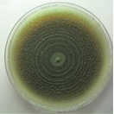
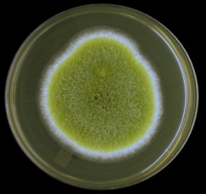
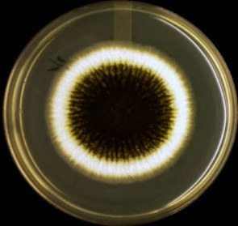
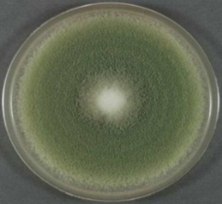

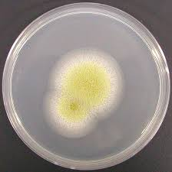
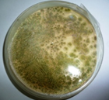
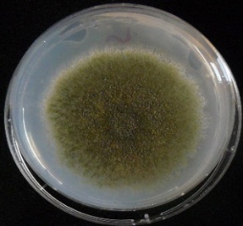
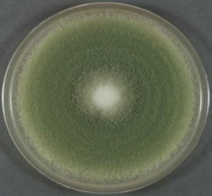
BUF AF RFB BUF1
Aspergillus niger Aspergillus flavus RV FV

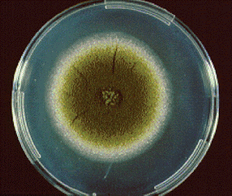
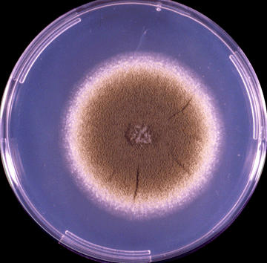

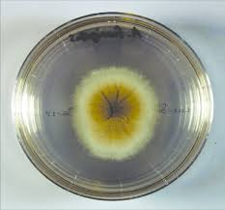
BV2 NV HF1 HF2

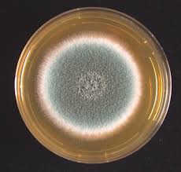
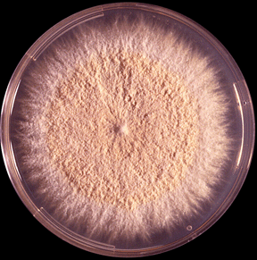
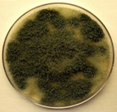
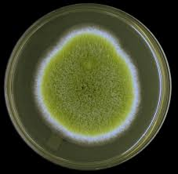
BF2 CV AF1 BF3

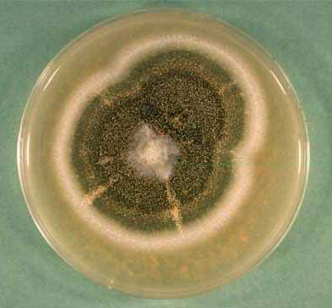
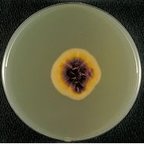
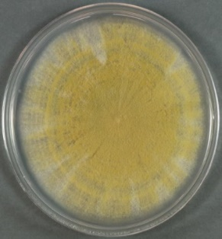
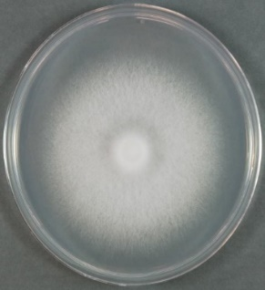
KAF WLRV WL HF

Fig 1.0 Isolated fungi on Petri dishes
Purification of enzyme
The results of purification of exopectinase from A. niger was given ( Table 1.0). Surprisingly, the exopectinase produced underSmF using wheat bran by A.niger was found that 70-80% ammonium sulphate saturation was optimum with totalprotein 19 mg, total exopectinase activity of 29.0 U and specific activity of 1.52 U/mg. The yield was145% with the purification fold 2.28. At 80-90% ammonium sulphate saturation total protein of 19.6 mg with total exopectinase activity and specific activity which were observed as 22.5 U and 1.14 U/mg respectively. At this saturation yield was 112 %with purification fold 2.10
Table 1.0 Partial purification of exopectinase enzyme produced by A.niger under SmF using wheat bran and its specific activity and yield
Ammonium sulphate saturation | Protein  (mg/ml) | Total protein  (mg) | Pectinase  (U/ml) | Total  pectinase  activity(U) | Specific  activity  (U/mg) | Purification  fold | Yield (%)
Crude | 1.50 | 30 | 1.000 | 20.0 | 0.666 | 1.00 | 100
0-10% | 0.30 | 6 | 0.620 | 12.4 | 2.06 | 3.09 | 62
10-20% | 0.41 | 8.2 | 0.780 | 15.6 | 1.9 | 2.85 | 78
20-30% | 0.58 | 11.16 | 0.810 | 16.2 | 1.5 | 2.25 | 81.00
30-40% | 0.72 | 14.4 | 0.950 | 19.0 | 1.34 | 2.01 | 95
40-50% | 0.80 | 16 | 1.200 | 24.0 | 1.5 | 2.25 | 120
50-60% | 0.85 | 17 | 1.220 | 24.4 | 1.43 | 2.14 | 122
60-70% | 0.91 | 18.2 | 1.355 | 27.1 | 1.48 | 2.22 | 135
70-80% | 0.95 | 19 | 1.450 | 29.0 | 1.52 | 2.28 | 145
80-90% | 0.98 | 19.6 | 1.125 | 22.5 | 1.14 | 2.10 | 112
90-100% | 0.50 | 10 | 0.900 | 13.0 | 1.8 | 1.77 | 65

Sephadex G-100 purified exopectinase obtained from A. niger: The dialyzed sample was further purified by Sephadex G-100 column chromatography and analyzed for its elution profile, purification profile, SDS-PAGE.
Elution profile of Sephadex G-100 purified exopectinase obtained from A. niger: The elution profile of dialyzed ammonium sulphate precipitated and dialyzed exopectinase samples on Sephadex G-100 column are presented in fig.2.
Fig 2 Elution profile of Sephadex G-100 purified exopectinase obtained from A. niger
A total of 26 fractions (5 ml each) were eluted. From the eluted fractions, the highest absorbance at 280 nm was recorded by fraction 5 followed by 4 and 6 (enzyme and protein). The fractions before 4 and after 10 recorded the lowest activities. Hence, the fractions 4, 5 and 6 which showed a single peak were pooled together and one part of this was taken for the purification profile study.
Patilet al. (2012) reported that the fractions from 10 to 22 expressed highest polygalacturonase activity by Penicillium sp. when subjected to gel filtration on Sephadex G-100 column chromatography. El-Batal et al. (2013) also expressed the enzyme activity between the fraction numbers 16 to 20 when subjected to gel filtration on Sephadex G-100 column chromatography.

Table 2 : Steps in the purification of exopectinase by A. niger
Samples | Total protein content (mg) | Total  exopectinase activity (U) | Specific activity  (U/mg) | Purification fold | Recovery  (%)
Crude extract | 30^{b}±0.1 | 20^{c}±0.1 | 0.666e±0.5 | 1.0^{d}±0.5 | 100ª±0.1
Ammonium sulphate precipitated sample | 19^{c}±0.1 | 29^{b}±0.1 | 1.52e±0.5 | 2.28^{d}±0.5 | 145ª±0.1
Dialyzed sample | 28^{b}±0.1 | 9.20^{c}±0.1 | 0.328e±0.005 | 0.84^{d}±0.005 | 41.8ª±0.1
Sephadex G-100 purified sample | 18^{b}±0.1 | 7.0^{c}±0.1 | 0.388e±0.005 | 1.33^{d}±0.005 | 21.87ª±0.1
Values are significant at P < 0.005
Protein content
It can be inferred from Table 2,decrease in the total protein content was observed in the Sephadex purified sample (18 mg) when compared to the dialysate sample (28 mg). Exopectinase activity and specific activity from the Table 2, it can be understood that, there was a decrease in the total exopectinase activity (7.0 U) of the Sephadex G-100 purified sample when compared to the dialyzed enzyme extracts (9.2 U). Though the exopectinase activity was decreased, the specific activity of the Sephadex G-100 purified sample (0.388 U//mg) was increased by 0.5 fold when compared to that of the dialyzed enzyme extract (0.328 U/mg). The increase in specific activity is thus, indicative of the progress in purification of the enzyme.
Udenwobele et al. (2014) who reported the reduction in total protein from crude (310, 345 and 300 mg) to dialyzed (10.58, 14.76 and 9.65 mg) of pectinase exhibited from A. niger, A. fumigates and A. flavus respectively.
Purification fold:
It can be observed from the table 2 that the purification fold and recovery percent of the Sephadex G-100 purified sample registered a value of 1.33 and 21.87%, which was higher than that of the dialyzed sample (0.84 and 41.8 %). Comparing the results, it is understood that as the exopectinase sample is being purified, the purification fold is increased in each successive step. On comparing table data can be concluded that the recovery percentage of the isolated enzyme decreased after each step of purification. It can also be observed that the recovery percentage of an enzyme is related to its total activity. Therefore from the tables, it is clear that the recovery percentage of exo-pectinase decreased with decrease in the total exopectinase activity.
Similar findings was observed by Siddique et al. (2012) who reported the final specific activity of the purified PGase from Rhizomucorpusillus as 61.35 U/mg, purification fold and yield as 12.34 and 27.06%, respectively. Yannam et al. (2014) who expressed that the total protein content of the purified polygalacturonase from Aspergillus foetidus decreased from 52.5 mg in the crude sample to 4.24 mg and the specific activity increased from 152.95 U/mg in the crude sample to 525.94 U/mg and achieved a yield of 27.7 % after chromatography. A. fumigatus pectinase was purified with a fold of 4.45, a yield of 26.14%, and specific activity of 38.88 U/mg of protein (Okonji, R. E., 2019).
It can be concluded from table 2 that the specific activity and purification fold were inversely proportional to the total exopectinase activity, total protein content and recovery% which means that as the total pectinase activity, total protein content and recovery% decrease, the specific activity and purification fold increase, whereas, in the case of recovery%, the value of specific activity and purification fold decreases with decrease in the total pectinase activity. Purification fold is directly proportional to the specific activity of an enzyme and therefore purification fold increases with an increase in specific activity. Hence, it can be confirmed from the above findings that, though the total exopectinase activity and total protein contents were decreased to many folds, there was an increase in the specific activity and purification fold ensuring the good progress in purification of the exopectinase obtained from A. niger. The purified exopectinase was lyophilized and preserved in deep freezer under -20ºC for the application in food industry.
Determination of molecular weight of pectinase purified from A. niger by SDS-PAGE: The purified exopectinase exhibited a single band on SDSPAGE. On comparing it with electrophoretic mobilities of standard molecular weight markers, it showed molecular weight of 60.0 kDa as shown in Fig 3.
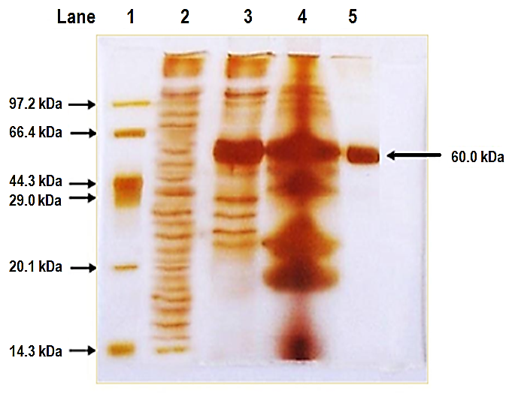
Lane 1 2 3 4 5

97.2 kDa
66.42 kDa 60kDa
44.3 kDa
29.0 kDa

20.1 kDa

14.3 kDa

Fig 3 SDS-PAGE of purified pectinase from A. niger
Lane 1- Protein Marker
2 – Crude exopectinase
3 – Ammonium sulphate precipitated sample
4 – Dialyzed sample
5 – Sephadex G-100 purified sample

According to Oyede (1998) the differences in molecular weights, nature and type of organisms used, substrates employed and analytical methods in addition to the monomeric units of the polypeptides could justify the differences. The present observation is coincides to those reported for some fungal extracellular pectinases, such as the 60 kDa enzyme from Cochlioboluscarbonum (Scott-Craig, 1998). The present findings are in accordance with the observations of Nayebyazdi and Ghanbary (2012) who reported that the purified pectinase from Aspergillus foetidus and A. aculeatus in SDS-PAGE revealed a molecular weight of 79 kDa and 63 kDa respectively.Kusuma and Bhargavi (2014) observed that polygalacturonase obtained from Bacillus subtilis exhibited molecular weight ranging between 43 kDa and 66 kDa.
Biochemical characterization of exopectinase enzyme:
Temperature optimum: The exopectinase enzyme produced by A. niger (fig. 4) under SmF using wheat bran expressed maximum activity at 40˚C which was 0.685 U/ml while, increase in enzyme activity the temperature was increased from 20˚C to 40˚C. The peak of enzyme activity (100%) was recorded at 40˚C. The enzyme showed 70% (0.480 U/ml) activity at 50˚C using wheat bran and activity declined sharply with further increase in temperature 80˚C. The enzyme was thermally inactivated and showed 0% activity at 90˚C.
Thermal stability: The thermal stability of the purified exopectinase activity produced by A. niger in wheat bran under SmF was found to be retained 74.5% (0.510U/ml) of original activity at 40˚C. At low temperature 20˚C and 30˚C retaining 58.5% (0.120 U/ml) and 64.5% (0.220 U/ml) of its original activity respectively. The enzyme activity retained 68.75% at 50ºC, 7.69% at 60ºC and 40% at 70ºC. Exopectinase enzyme activity exhibited its thermostability after half an hour. (Fig. 4)
Similar view was expressed by Juwonet al. (2012) who reported a decline in the enzyme activity with a temperature more than 40°C. Kaur and Kaur (2014) obtained that the pectinase obtained from Aspergillus sp. showed maximum activity of 186.32 U/ml at a temperature of 35°C.
The thermal stability of the pectinase showed that at 60°C, the enzyme retained 100% activity for 45 min and losing about 50% activity at the end of 120 min of incubation(Okonji, R. E., 2019).El-Batalet al. (2013) also observed 40°C as optimum temperature for enzyme activity and 30°C to 50°C for temperature stability when gamma irradiated Penicilliumcitrinum was used.
pH optimum: All the enzymes, proteins and pH will affect the ionization state of the amino acids which dictate the primary and secondary structure of the enzyme and hence, its overall activity. A change in pH will have a progressive effect on the structure of the protein and the enzyme activity. The pH dependence of the activity of exo-pectinase from A.nigerwas shown in figure 4.
The exopectinase activity was started at pH 2.0 (0.026 U/ml), reached optimum at pH 6.0 (0.133 U/ml) and declined subsequently. Slight difference in enzyme activity was recorded between pH 4.0 (0.110 U/ml) and 5.0 (0.120 U/ml). No detectable pectinase activity was observed at pH above 10.0. Exopectinase enzyme was more active at acidic pH (5.0 6.0) than alkaline pH (7.0 -8.0)
pH stability: Data from the figure 4 shows that purified exopectinase of A. niger retained 57.4% activity (0.076 U/ml) at pH 6.0, followed by 55% of activity (0.066 U/ml) at pH 5.0 under SmF (5.62). While, 76.9% of activity at pH 2.0 (0.02 U/ml), 68.9% of activity (0.04 U/ml) at pH 3.0, and 52.7% of activity at pH 4.0 (0.058 U/ml) have been retained respectively. It was found that enzyme activity was retained 67.5% (0.051 U/ml), 46.6% (0.021 U/ml) and 71.4% (0.015 U/ml) of its activity between pH 7 to pH 9.0 respectively.
This result is similar to the optimum pH of 5.0 and stability at 4 to 7 reported for Penicillium citrinum (El- Batal Al et al., 2013). A. fumigates pectinase has an optimum pH at 5.0 and decreases significantly below and above this value (Okonji, R. E., 2019).
. The present finding is similar with Mrudula and Anitharaj (2011) who also observed a maximal activity of pectinase at pH 5.0 from Aspergillus niger.
. The present result coincides with the findings of Irshad et al. (2014) and they reported highest activity of 244.0 U/ml at a pH of 5.5 from Aspergillus niger. Similar view was expressed by Laha et al. (2014) who demonstrated that the enzyme was stable at a pH 6-8 and showed highest activity at pH 5.0.

a. Temperature optimum b. Thermal stability

c. pH optimum d. pH stability

Fig.4 Characterization of pectinase enzyme produced by A. nigerunder SmF using wheat bran

Effect of metal ions: The influence of different metal ions on exopectinase activity by A. niger under SmF using wheat bran are summarized in table 3. A significant level of exopectinase activity was enhanced by KCl (0.768 U/ml) fallowed by control (0.650 U/ml) and NaCl (0.596 U/ml). Interestingly, CaCl₂ and MgCl₂ were recorded with similar activity (0.390 U/ml). BaCl₂ (0.270 U/ml) and FeCl₃ (0.150 U/ml) were shown slight inhibition in the enzyme activity, in contrast CoCl₂ showed complete inhibition of enzyme activity.
Among the metal ions tested, KCl enhanced the pectinase activity by 18.15 % whereas NaCl resulted in the reduction in the enzyme activity by 8.4 %. Metal such FeCl₃ exhibited a maximum inhibition of 76.93%, followed by , BaCl₂ 58.5%, CaCl₂ 40% and MgCl₂ 40% whereas, CoCl₂ showed complete inhibition of enzyme activity.
So, it was expressed that wheat bran might have supplied the required metal ions for enzyme activity. The metal ions, K⁺², Na⁺², Mg⁺², and Ca⁺² were showing slight to moderate increase in enzyme activity. Complete inhibition of enzyme activity was obtained by CO⁺².
In addition, result was observed by Joshi et al. (2015) who reported that Mn²⁺ and Fe²⁺ were found to be activators for marine pectinase, while pectinase activity was completely inhibited by Zn²⁺, Al^{3+,}, EDTA, and Cu²⁺ followed by Mn²⁺ (93%), Ba²⁺ (74%), and Ca²⁺ (61%).
A.fumigatus shows that the pectinase activity increased significantly by the monovalent ions but decreases by divalent ions and the trivalent ion (Okonji, R. E., 2019). Activation of the pectinolytic enzyme has been reported. El-Batal et al. (2013) expressed that the enzyme activity was enhanced in the presence of Mg⁺² and Zn⁺² to 12% and 5% respectively.

.

Table 3 Effect of metal ions on exopectinase activity by A. niger under SmF in wheat bran

Metals (1 mM) | Residual exopectinase activity (U/ml) and its percentage
Control | 0.650 | 100%
BaCl₂ | 0.270 | 41.5%
CaCl₂ | 0.390 | 60%
CoCl₂ | NA | NA
FeCl₃ | 0.150 | 23.07%
KCl | 0.768 | 118.15%
MgCl₂ | 0.390 | 60%
NaCl | 0.596 | 91.6%

.
Conclusions
To the best of our knowledge, this report provides the first description of the purification and characterisation of the pectinase produced A. niger from vegetable waste dumpyard soil. Pectinase is a thermostable protein that exhibits a broad pH activity profile and relatively high activity under acidic conditions. In addition, the enzyme exhibited high thermostability at 40ºC and also stable in the presence of metal ion KCl. These features, along with its abundant and cost-effective source, indicate that this enzyme can be considered a useful pectinase enzyme for various industrial and biotechnological applications.

References

- Adalberto PR, Golfeto CC, Moreira AC, Almeida FG, Ferreira D, Cass QB Souza DHF. Characterization of an exopolygalacturonase from Leucoagaricusgongylophorus, the symbiotic fungus of Atta sexdens. Advances in Enzyme Research. 2016;4:7-19.

- Bano T et al 2017. Sustainable industrial development through enzyme technology: an approach toward cleaner production- a literature review. IOSR-JBB 3(4) 1-7.
- Dutta K et al 2021 New trends in bioremediation technology toward environment-friendly society: a mini-review. Front Bioengin Biotech 9666858. DOI: 10.3389/fbioe.2021. 666858

- El-Batal. A. I., Osman, &Shaima, I. A. M. (2013). Optimization and characterization of polygalacturonase enzyme produced by gamma irradiated Penicilliumcitrinum. Journal of Chemical and Pharmaceutical Research, 5(1), 336-347.

- GD Ametefe, AO Lemo, FA Orji, AK Lawal, EEJ Iweala, SN Chinedu.Pectinase Activities of Selected Fungi Grown on Agrowastes via Solid-state Fermentation.IOP Conference Series: Earth and Environmental Science, 2022-IOP Conf. Ser.: Earth Environ. Sci. 1054 012003

- Gupta R, Beg QK, Khan S, Chauhan B. An overview on fermentation, downstream processing and properties of microbial alkaline proteases. ApplMicrobiolBiotechnol2002;60:381-95.
- Hoondal GS, Tiwari RP, Tewari R, Dahiya N, Beg QK. Microbial alkaline pectinases and their industrial applications: A review. ApplMicrobiolBiotechnol2002;59:409-18.
- Irshad, M., Anwar, Z., Mahmood, Z., Aqil, T., Mehmmod, S., & Nawaz, H. (2014). Bio-processing of agro-industrial waste orange peel for induced production of pectinase by Trichodermaviridi; its purification and characterization. Turkish Journal of Biochemistry/Turk BiyokimyaDergisi, 39(1).
- Johnson, L. F., & Curl, E. A. (1972). Methods for research on the ecology of soil-borne plant pathogens.Burgess Publishing Co., Minneapolis, MN
- Joshi, M., Nerurkar, M., &Adivarekar, R. (2015). Characterization, kinetic, and thermodynamic studies of marine pectinase from Bacillus subtilis. Preparative Biochemistry and Biotechnology, 45(3), 205-220.
- Juwon, A. D., Akinyosoye, F. A., &Kayode, O. A. (2012). Purification, characterization and application of polygalacturonase from Aspergillus niger CSTRF. Malaysian journal of microbiology, 8(3), 175-183.
- Kashyap DR, Vohra PK, Chopra S, Tewari R. Applications of pectinases in the commercial sector: A review. BioresourTechnol2001;77:215-27.
- Kaur, H. P., & Kaur, G. (2014). Optimization of cultural conditions for pectinase produced by fruit spoilage fungi. Int J of Advances in Pharmacy, Biology, 851-858
- KC, S., Upadhyaya, J., Joshi, D. R., Lekhak, B., Kumar Chaudhary, D., Raj Pant, B., ... &Raghavan, V. (2020). Production, Characterization, and Industrial Application of Pectinase Enzyme Isolated from Fungal Strains. Fermentation, 6(2), 59.
- Keller V., Jen J. J., and Brunner R. J., (2006). Purification of commercial pectinase by hydrophobic chromatography. J. Food. Sci. 47, 2076−2077.
- Kusuma, M. P., &Bhargavi, M. V. (2014). Studies on production, purification and molecular characterisation of polygalacturonase from Bacillus subtilis. European Journal of Biotechnology and Bioscience, 1(5), 1-6
- Laemmli, U. K. (1970). Cleavage of structural proteins during the assembly of the head of bacteriophage T4. Nature, 227(5259), 680-685.
- Laha, S., Sarkar, D., &Chaki, S. (2014). Optimization of production and molecular characterization of pectinase enzyme produced from penicilliumchrysogenum. Scholars Academic Journal of Biosciences, 2(5), 326-335.
- Miller, G. (1959). Determination of reducing sugar by DNS method. Anal. Chem, 31, 426-428.
- Mrudula, S., &Anitharaj, R. (2011). by Aspergillus niger Using Orange Peel as Substrate. Global Journal of Biotechnology & Biochemistry, 6(2), 64-71.

- MT Mat Jalil, NA Zakaria, NH Salikin, D Ibrahim. Assessment of cultivation parameters influencing pectinase production by Aspergillus niger LFP-1 in submerged fermentation Journal of Genetic Engineering and Biotechnology (2023) 21:45 jgeb.springeropen.com

- Nayebyazdi, N., &Ghanbary, M. A. T. (2012) Pectinase activity of some micromycetes isolated from agricultural soils. Journal of Sciences, Islamic Republic of Iran, 23(4), 305-311
- Okonji, R. E., Itakorode, B. O., Ovumedia, J. O., &Adeji, O. S. (2019). Purification and biochemical characterization of pectinase produced by Aspergillus fumigatus isolated from soil of decomposing plant materials. J App Biotech, 7(03), 1-8.
- Oyede, M. A., (1998). Studies on cell wall degrading enzymes associated with degradation of cassava (Manihotesculenta) tubers by some phytopathogenic fungi. Ph.D Thesis, Obafemi Awolowo University, Nigeria
- Pandey A, Soccol CR, Rodriguez-Leon JA, Nigam P. Solid-State Fermentation in Biotechnology. New Delhi: Asia Tech Publishers, Inc.; 2001. p. 200-21.
- Patil, R. C., Murugkar, T. P., & Shaikh, S. A. (2012). Extraction of pectinase from pectinolytic bacteria isolated from carrot waste. International Journal of Pharma and Bio Sciences, 3(1), 261-266.
- Priyadharshini, R. I., Prasannaraj, G., Geetha, N., &Venkatachalam, P. (2014). Microwave-mediated extracellular synthesis of metallic silver and zinc oxide nanoparticles using macro-algae (Gracilariaedulis) extracts and its anticancer activity against human PC3 cell lines. Applied biochemistry and biotechnology, 174(8), 2777-2790.
- Rasheedha AB, Kalpana MD, Gnanaprabhal GR, Pradeep BV, Palaniswamy M. Production and characterization of pectinase enzyme from Penicilliumchrysogenum. Indian J SciTechnol2010;3:377-81.
- Reddy, P. L., &Sreeramulu, A. (2012). Isolation, identification and screening of pectinolytic fungi from different soil samples of Chittoor district. International Journal of Life Sciences Biotechnology and Pharma Research, 1(3), 1-10
- Scott-Craig, J. S., Cheng, Y. Q., Cervone, F., De Lorenzo, G., Pitkin, J. W., & Walton, J. D. (1998). Targeted mutants of Cochlioboluscarbonum lacking the two major extracellular polygalacturonases. Appl. Environ. Microbiol., 64(4), 1497-1503.
- Siddiqui, M., Pande, V., &Arif, M. (2012). Production, purification, and characterization of polygalacturonase from Rhizomucorpusillus isolated from decomposting orange peels. Enzyme research, 1-8
- Sudeep KC et al 2020 Production, characterization and industrial application of pectinase enzyme isolated from fungal strains. Fermentation 6 59-69.
- Tochi BN, Wang Z, Xu SY, Zhang W. The influence of pectinase and pectinase/hemicellulases enzyme preparations on percentage pineapple juice recovery, particulates and sensory attributes. Pak J Nutr2009;8:1184-9.
- Udenwobele, D. I., Nsude, C. A., Ezugwu, A. L., Eze, S. O., Anyawu, C., Uzoegwu, P. Z., &Chilaka, F. C. (2014). Extraction, partial purification and characterization of pectinases isolated from Aspergillus species cultured on mango (mangiferaindica) peels. African Journal of Biotechnology, 13(24), 2445-2454
- Yannam, S. K., Shetty, P. R., &Obulum, V. S. R. (2014). Optimization, purification and characterization of polygalacturonase from mango peel waste produced by Aspergillus foetidus. Food Technol and Biotechnol, 52(3), 359-367.
- Zhang Z et al 2021 Isolation and screening of microorganisms for effective pretreatment of lignocellulosic agricultural wastes. BioMed Res Int 5514745. DOI:10.1155/2021/5514745.

