Ethnomedicinal Importance, Phytochemistry, and Biological Activities of
Alhagi camelorum DC. : A Comprehensive Review

Abstract: The hardy, prickly plant Alhagi camelorum, also referred to as "Kandero" or "Camel Thorn," has a long history in Ayurvedic and Greco-Arab traditional medicine. The current understanding of its taxonomy, phytochemical composition, and therapeutic potential is summarized in this article. The plant, which is found in arid parts of Eurasia and the Middle East, is distinguished by a wide range of bioactive secondary metabolites, such as phenolic acids, alkaloids and flavonoids. Its traditional use is validated by pharmacological studies, both in vitro and in vivo, which show strong anti-inflammatory, gastroprotective, nephroprotective, and antioxidant properties. Its effect as a calcium channel blocker and muscle relaxant supports its role in treating gastrointestinal problems including urolithiasis. Additionally, new studies demonstrate its use in veterinary medicine as well as its promise as a source of neuroprotective and anti-diabetic compounds. This article provides an in-depth review of Alhagi camelorum, addressing their taxonomic classification, botanical characteristics, and diverse pharmacological potential. Phytochemical investigations reveal a rich profile of bioactive compounds, including polyphenols, flavonoids, tannins, and novel triterpenes. Research demonstrates that these extracts possess significant antioxidant, nephroprotective, cardioprotective, and hepatoprotective properties. Furthermore, the plant shows clinical efficacy in treating gastrointestinal disorders, endocrine imbalances, and skin hyperpigmentation through enzyme inhibition (Tyrosinase and alpha-glucosidase). This review underscores the therapeutic versatility of Alhagi species and highlights their potential as a source for novel drug development in modern medicine.
KEYWORDS - Alhagi camelorum, Camel thorn, Phytochemistry, Traditional Medicine, Flavonoids, Ethno-veterinary.
- INTRODUCTION
Natural products have interesting and useful biological activities and they also perform various functions.[1] Researchers are increasingly turning their attention toward natural products in order to develop better drugs against cancer, as well as viral and microbial infections.[2] There are more than 35 000 plant species which are used in different human cultures around the world for medicinal purpose.[3] A broad range of biological activities such as antioxidant, cardiovascular, anti-ulcer, hepatoprotective, antispasmodic, antidiarrheal, antinociceptive, antipyretic, anti-inflammatory, anti-rheumatic, antibacterial and antifungal have been ascribed to different parts of Alhagi.[4] Alhagi species contains many active constituents such as flavonoids, fatty acids, coumarins, sterols, vitamins, and alkaloids.[5] Phenolic and flavonoids are the most common plant-based bioactive phytochemicals that is abundant in the kingdom Plantae. A multitude of bioactive phytochemicals has been explored as indispensable origin of novel antimicrobial, anti-tumor, cholesterol-lowering, immunomodulatory, anti-inflammatory, and antioxidant agents.[6] Alhagi camelorum belongs to the family of (Fabaceae) Leguminosae, which includes 550 genera and 13,000 species, many of which are used in traditional medicine and pharmaceutical purposes. [7,8] Plants belonging to the genus Alhagi are highly valued across the Middle East and Pakistan for their medicinal properties and use as animal fodder. While there has been historical confusion regarding their classification—with researchers often using names like Alhagi maurorum or Alhagi pseudoalhagi—the Flora of Pakistan clarifies that only one species exists within the country. Locally known as "Kandero" in Sindhi and "Oont Kataraa" in Urdu, leading botanists and experts have reached a consensus that the correct scientific name for this species is Alhagi camelorum.[9]
- TAXONOMY [10]
Kingdom - Plantae (Plants)
Division - Streptophyta
Class - Equisetopsida
Subclass - Mangoliidae
Order - Fabales
Family - Fabaceae
Genus - Alhagi
Species - Alhagi maurorum
Synonymous names: Alhagi mourorum, Alhagi pseudalhagi, Alhagi maurorum, Alhagi camelorum,
Althagi pseudalhagi, Alhagi pesudalghagi
Common/Vernacular Names: [11]
- English: Camel Thorn, Persian Manna Plant, Camel thorn, Persian Manna Plant, Caspian Manna, Hebrew Manna
- Hindi : Javasa , Bharbharra, Oont-jhari
- Sanskrit : Yavasa, Dhanvayasa, Duralabha, Yasa, Dusparsha, Kunashaka
- Gujarati : Javaso, Javasau
- Bengali : Javasha, Dulal labha
- Marathi : Dhamasa
- Tamil : Punaikanjuri, Kanchori, Turanchipin
- Telugu : Chinnadoolagondi, Dhanvayasamu, Tell-giniyachettu
- Malayalam : Kappa tumpa, Venkatithura, Valiya Kotithuva
- Kannada : Turuche, Turuchana gida, Neladangara, Ballidurabi

- GEOGRAPHICAL DISTRIBUTION
The plant is found in temperate and tropical Eurasia and the Middle East, Northern India, Afghanistan, Armenia, Azerbaijan, Northwest China, Cyprus, Iran, Iraq, Israel, Jordan, Kazakhstan, Kuwait, Lebanon, Mongolia, Pakistan, Syria, Tajikistan, Turkey, Turkmenistan, Uzbekistan and Russia. In China, the plant is mainly distributed in Xin Jiang Uighur Autonomous Region. In India, it is mostly found in arid and dry regions of Gujarat, Punjab, Uttar Pradesh and Rajasthan.[12]

- BOTANIC DISCRIPTION -
This plant is a rigid, thorny shrub characterized by small, simple leaves (10-25 mm long) with an alternate arrangement and smooth margins. Its pea-like flowers, ranging from pinkish-violet to maroon, bloom from April to September and emerge directly from spines along the branches. The most distinctive feature is the fruit, which consists of curved pods (19-34 mm long) that are constricted between the seeds and tipped with a small beak.[13,14]

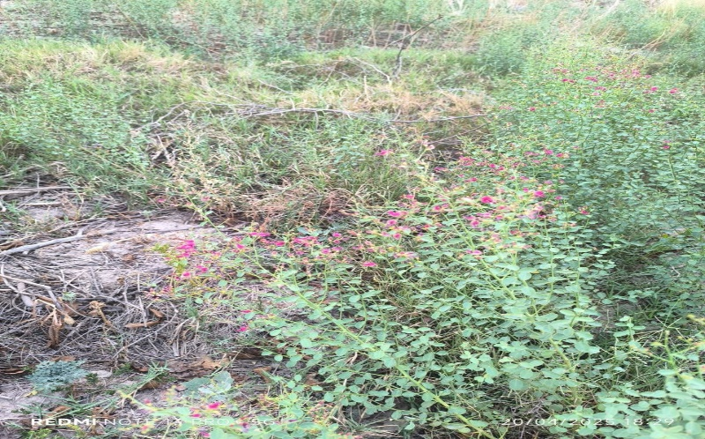
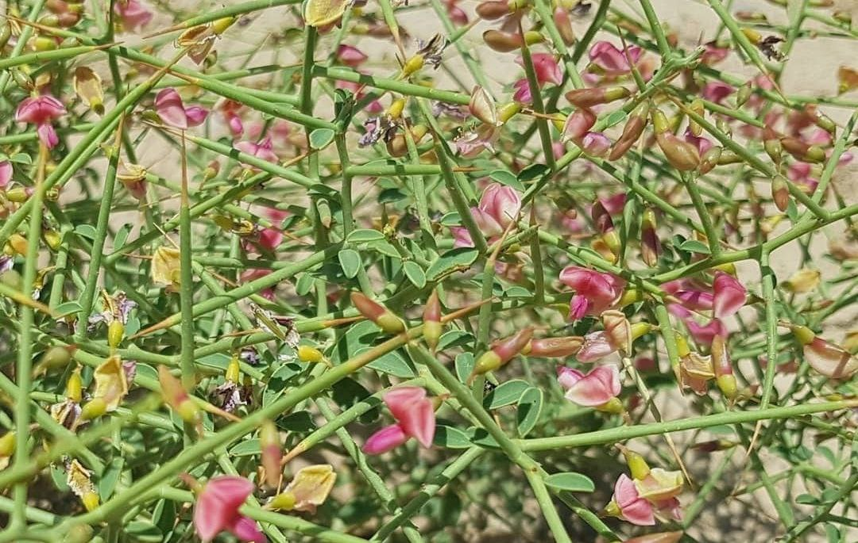

Picture – 1 Picture – 2

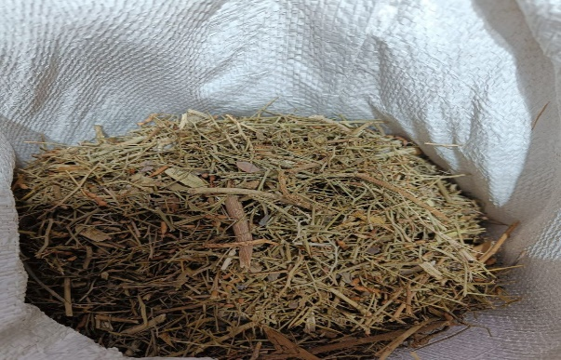

Picture – 3

Picture 1, 2 and 3: Alhagi camelorum

- PHYTOCHEMICALS[15] –
TABLE – 1 Phytoconstituents present in the Plant Parts
S. No. | PLANT PART | PHYTOCONTITUENTS
1. | Aerial part | (+)-Gallocatechin
1. | Aerial part | Leucodelphidin
2. | Leaf | Neophytadiene
2. | Leaf | 6,10,14-Trimethylpentadecan-2-one
2. | Leaf | Octadecane
2. | Leaf | Drimenol
3. | Root | 6,7-Dimethoxy-1-methyl-1,2,3,4tetrahydroisoquinoline
3. | Root | 1,2,3,4-Tetrahydroisoquinoline
3. | Root | Hordenine
4. | Stem | Phenethylamine
4. | Stem | beta-Ionone
4. | Stem | N-Methyltyramine
4. | Stem | Pentacosane
5. | Whole plant | (+)-Gallocatechin
5. | Whole plant | Leucodelphidin
5. | Whole plant | 24-Ethylcholesta-5,22-dien-3 beta-ol
5. | Whole plant | Melezitose

5.1 Phytochemical Screening Of Active Compounds From Different Parts Of A. maurorum
TABLE – 2 Compounds derived from different Plant Parts
PLANT PARTS | COMPOUND | REFERENCES
Leave extract | The presence of unsaturated sterols, triterpenes, tannins, flavonoids and carbohydrates and/or glycosides as major constituents | Atta & El-Sooud, 2004. [16]
Aqueous extract | flavonoids, fatty acids, coumarins, sterols, vitamins, and alkaloids. | Amani et al., 2006. [17]
Roots | New aliphatic ester and new thiophene. | Mudawi et al., 2007. [18]
Roots | 5,5″″-dipropyl-2,2′:5′,2″:5″,2‴:5‴,2″″-pentathienyl, octacosanoic acid, 28- hydroxy-2′, 3′-dihydroxy propylysate | Marashdah et al., 2008. [19]
Plant extract | A new flavonoid, isorhamnetin-3-O-[-alpha-lrhamnopyranosyl-(1 --> 3)]-beta-D-glucopyranoside (1), along with two known flavonoids 3'-O-methylorobol (2) and quercetin 3-O-beta-d-glucopyranoside (3). | Ahmad et al., 2010. [20]
Roots | Three new oleanane-type triterpene glycosides (1–3), along with four known compounds (4–7) glycosides, were isolated. Most of saponins isolated from A. maurorum show as sugar chain β-fabatriose | Hamed et al., 2012. [21]
Leaves/flowers | Contained some phenolic compounds. | Leghari et al., 2012 [22]
Plant material | Alhagi plants are also valued as a rich source of digestible protein and important minerals. | Muhammad et al., 2014. [4]
Aerial part extract | Presence of flavonoids and phenolic compounds. | Sheweita et al., 2016 [23]
Whole plant extract | The phytochemical profile of the extract showed the presence of carbohydrates, alkaloids, saponins, tannins, phenolics, flavonoids. | Khalifa et al., 2019. [24]
Plant extracts | Natural bioactive molecules, the plant essential oils treat the infectious disease and he antimicrobial activities of chloroformic and methanolic extracts of A. maurorum was evaluated against 8 bacteria (S. aureus, B. subtilis, R. toxicus, P. aeruginosa, E. coli, P. syringae, X. campestris, P. viridiflava) and 3 fungi (Pyricularia oryzae, Fusarium oxysporum and Botrytis cinerea). | Hadadi et al., 2020. [25]
Methanol and dichloromethane extracts of A. maurorum roots. | the antioxidant, enzyme inhibition, and phytochemical composition was found to contain higher total phenolic (105.91 mg GAE/g extract) and flavonoid (2.27 mg RE/g extract). A more correlation to its more substantial antioxidant potential as well as AChE, BChE, tyrosinase and α-glucosidase inhibition. A lead source of natural antioxidant and enzyme inhibitor compounds. | Saleem et al., 2020. [26]
The potential of A. maurorum aqueous extract | Gas Chromatography analysis revealed mainly the presence of the following phyto-compounds: Cyclopropenone, 2,3- diphenyl; 1-Nonadecanol; methyl-alpha-D-mannopyranoside; cis-9-Hexa dece nal. | Ammar et al., 2022. [27]
Crude extract fraction of A. maurorum aerial parts. | The major phenolic compound was isolated from the polyphenol-rich EFAM fraction and identified by conventional and spectroscopic methods of analysis as isorhamnetin-3-O-rutinoside. Furthermore, standardization of EAFM using UPLC-PDA-UV quantified isorhamnetin-3-Orutinoside as 262.91 0.57 g/mg of the fraction. | El-Zahar et al., 2022 [28]
A. maurorum extract | Proteus mirabilis is a frequent cause of catheter associated urinary tract infections. The most effective chemical compounds found in extract were tamarixetin, quercetin, and transanethole. | Mirzaei et al., 2022. [29]
Plant extract | Many bioactives like tannins, alkaloids, saponins, flavonoids are present and bioactivities include hepatoprotective, wound healing, antireheumatic, antiviral, antibacterial, antifungal, antidepressant and analgesic activities | Mulukuri &Kumar PP, 2023. [30]

5.2 Chemical Structures Of Phytochemicals [15] –

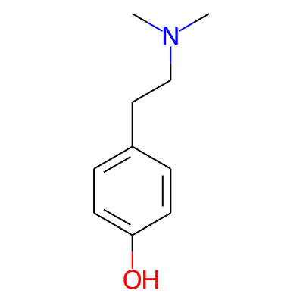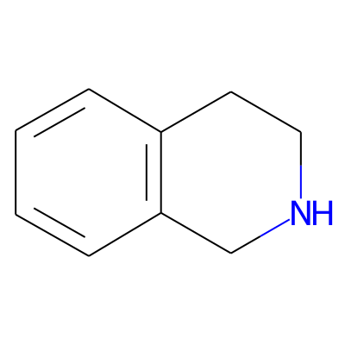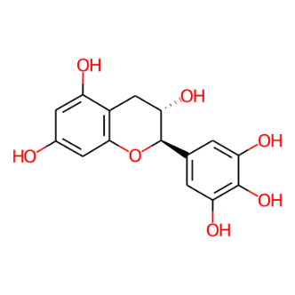
Hordenine 1,2,3,4-Tetrahydroisoquinoline (+)-Gallocatechin

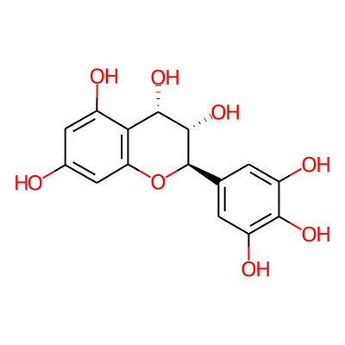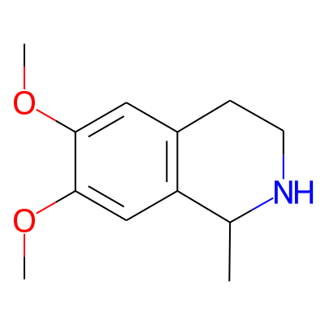
Leucodelphidin 6,7-Dimethoxy-1-methyl-1,2,3,4-tetrahydroisoquinoline

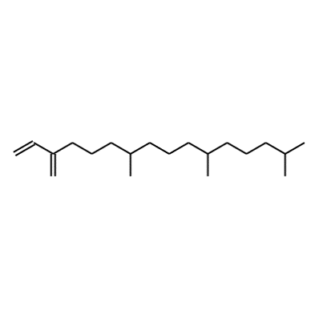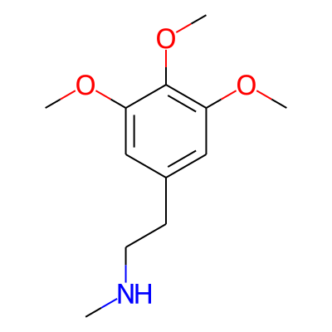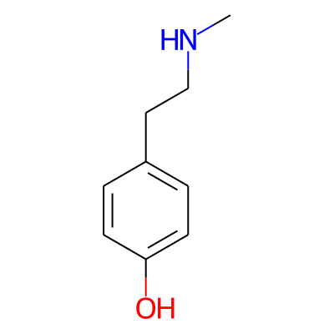

Neophytadiene N-Methylmescaline N-Methyltyramine

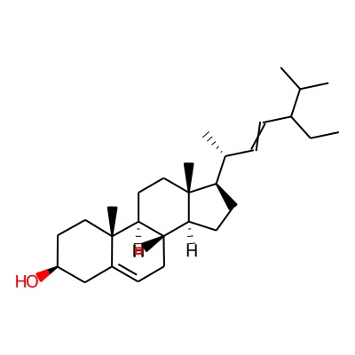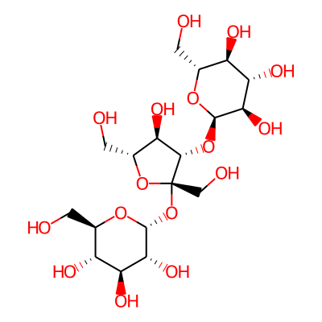

24-Ethylcholesta-5,22-dien-3beta-ol Melezitose

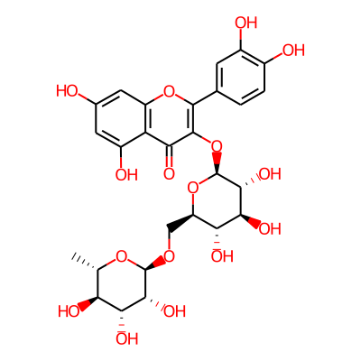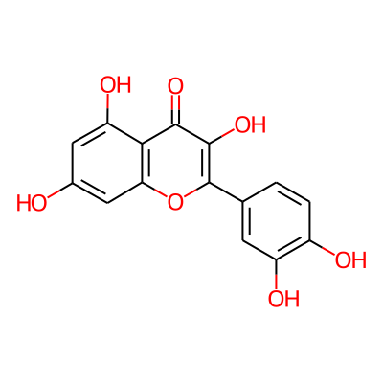
Rutin Quercetin

Figure – 1 Various Phytochemicals Present in different parts of A. camelorum

- IMPACT ON VETERINARY MEDICINE & ANIMAL NUTRITION
Alhagi maurorum is a key ethno-veterinary medicine used to treat gastrointestinal diseases in livestock like cattle and goats. Research shows that its distilled extract acts as a diuretic, specifically helping to regulate urine pH levels. For goats, a medicinal dose of 8.16 mL/kg is recommended to support these renal functions.[3] A. maurorum meal to broiler chicken was investigated and found that supplementation for 2% of total mixed diet didn’t have negative effect on immunological and biochemical measures of serum and also has significant positive effect on performance.[31]

- FOLKLORE CLAIMS –
In India, Alhagi is widely used as an expectorant, laxative, and diuretic. Regional folk remedies include smoking the leaves for asthma, applying leaf oil for rheumatism, and using crushed flowers to treat bleeding piles. Additionally, root extracts are used to help pass kidney stones, while various plant parts are utilized to alleviate fevers, headaches, and chest pain. Across Asia and the Middle East, Alhagi is a versatile traditional medicine. In China and the Uygur region, it is used to treat cancer, rheumatism, and neurogenic headaches. Throughout Palestine, Israel, Jordan, and Iran, root and flower decoctions are primary remedies for kidney stones, urinary issues, and heart problems. In Pakistan's Balochistan region, locals use powdered flowers to improve vision and treat stomachaches, while root extracts are specifically prepared to address liver issues.[13]

  - PHARMACOLOGICAL ACTIONS -
A broad range of biological activities such as antioxidant, cardiovascular, anti-ulcer, hepatoprotective, antispasmodic, antidiarrheal, antinociceptive, antipyretic, anti-inflammatory, anti-rheumatic, antibacterial and antifungal have been ascribed to different parts of Alhagi.[4] The ethanol root extract of Alhagi maurorum functions as a potent antipyretic and muscle relaxant by inhibiting acetylcholine. It exhibits bradycardiogenic effects (lowering heart rate) and acts as a spasmolytic agent, specifically relaxing the ureter to alleviate pain and facilitate the passage of kidney stones. However, research indicates that while it assists in stone expulsion, it does not directly dissolve oxalate stones.[32] Alhagi extracts provide a broad range of biological benefits, acting as a biofungicide for crops and an antibacterial agent against pathogens like E. coli. Medically, the plant offers anticancer and cardioprotective effects, improves metabolism during hypoxia, and functions as a powerful diuretic and muscle relaxant. Additionally, it supports neurological and urinary health by inhibiting key regulatory enzymes.[33]

TABLE – 3 PHARMACOLOGICAL ACTIVITIES -
Activity/effect | Plant Part / Extract Type | Method used / Model used | Specific Findings / Mechanism
Antioxidant | Aqueous Extract of Whole plant | Mice | Reduces malondialdehyde levels[34]
Antioxidant | Alcoholic Extract of Whole plant | Mice | Scavenging free radicals at concentrations up to 10 mg/ml.[34]
Antioxidant | Leaf Extract | Mice | Higher antioxidant potential than flower extract due to higher phenolic content.[34]
Antioxidant | Isolated Flavonoids | Mice | Three key antioxidant flavonoids isolated: Isorhamnetin derivative, 3'-O-methylorobol, and Quercetin-3-O-beta-D-glucopyranoside.[34]
Antioxidant | Automated (M-1) & Ultrasonic Extracts of leaves and flowers | DPPH, ABTS, FRAP beta – carotene assays | Leaves have higher potential in reducing oxidative stress. [35]
Nephroprotective | Hydroalcoholic Extract of Whole plant | Rats | Repairs kidney damage caused by Cisplatin-induced nephrotoxicity; histological anomalies were not discovered.[36]
Nephroprotective | Aqueous Extract of whole plant | Rats | Reduces calcium oxalate kidney stones. Used traditionally to alleviate kidney pain and spasms.[37]
Cardioprotective | Aqueous Extract of whole plant / Proanthocyanidins | Myocardial Infarction models | Acts as a myocardial depressant (in rats); reduced creatinine phosphate level and lipid peroxidation in animals with myocardial infarction.[4]
Intestinal immune promotion | Acid Polysaccharide (aAP, 22.734 kDa Mw) | Mice | Increases thymus and spleen indices; increases production of intestinal IgA antibody, serum IgG antibody, and intestinal cytokines.[38]
Antifungal | Methanol Extract (Roots) / Triterpene Compound and Phenolic extract | In-vitro laboratory study. | Novel ursene-type triterpene beta-30-norurs-11-en-3-ol extracted. Showed discernible antifungal activity against Saccharomyces cerevisiae and Aspergillus niger. Broad-spectrum inhibition against 5 fungal strains; MIC of 1.5 µg/ml against T. mentagrophytes; comparable to Nystatin and Clotrimazole.[39]
Anti-inflammatory | Ethanolic Extract of whole plant | Rats | Protects against Aspirin-induced inflammation; acid output diminished more than with ranitidine.[37]
Anti-inflammatory | Aqueous Extract of whole plant | Rats | Demonstrated anti-inflammatory effects in formalin-induced paw edema assay (mice); protective effects against free radical-mediated inflammatory diseases.[34]
Anti-nociceptive (pain) | Methanolic Extract of whole plant (200 & 400 mg/kg) | Mice | Showed anti-nociceptive (pain relief) effect in acetic acid-induced writhing and tail-flick tests in mice.[37]
Hepatoprotective | Hydroalcoholic Extract of whole plant | Rats | Protected against Valproic Acid (VPA)-induced hepatotoxicity; restored metabolic disturbances and suppressed lipid peroxidation.[40]
Anti-bph (benign prostatic hyperplasia) | Hydroethanolic Extract of whole plant | GC – MS Analysis  Rats Model | Comparable to Finasteride; reduced prostate weight and serum/prostatic testosterone levels; downregulated 5-alpha reductase and androgen receptor genes.[41]
Immunomodulatory activity | Polysaccharides (SS and AK regions) | Sheep lambs | Acts as a promising prebiotic; significantly enhances immune function and health in lambs.[42]
Antidiarrheal / antispasmodic | Methanolic Extract / Underground Parts | Castor oil induced Diarrhea in Rats. | Showed significant antidiarrheal effect (castor oil model); potential mechanism is blocking of calcium channels in intestinal tissue. [4]
Antidiarrheal / antispasmodic | Alcoholic Whole plants Extract | In vivo studies(oral administration) | Exhibited dose-dependent activity (200-400 mg/kg) by acting as a calcium channel blocker to reduce intestinal motility.[43]
Antidiarrheal / antispasmodic | Methanolic Extracts of whole plant | Rabbits | Significant anti-diarrheal effect at 200 mg/kg (IP); observed increased contractile force in duodenal smooth muscles.[44]
Anti-microbial Activity | Volatile Constituents (Flowers) / Flower extracts | In – vitro studies | Significant activity against a range of Gram-positive and Gram-negative bacteria (e.g., E. coli) and pathogenic fungi.[45]
Anti-diabetic / anti-hyperglycemic | Methanol Extract of whole plant | Alpha-glucosidase assay | Strong alpha-glucosidase inhibitory activity, slowing carbohydrate absorption.[46]
Anti-diabetic / anti-hyperglycemic | Hydroalcoholic Extract of whole plant | Wistar rats. | Exerted hepatoprotective effects in diabetic animal models, mitigating liver injuries.[47]
Anti-diabetic / anti-hyperglycemic | UHPLC-MS Profiled Root Extract | In-vitro Enzyme Assays & Molecular Docking | Inhibited AChE, BChE, alpha-glucosidase, and alpha-amylase; 18 metabolites identified.[48]
Neuroprotective | Methanol Extract (Roots) | In silico molecular docking | Inhibitory effects against Acetylcholinesterase (AChE) and Butyrylcholinesterase (BChE)[48]
Anti-ulcer / gastroprotective | Ethanolic Extract of whole plant | Clinical study | Significant protection against gastric ulcers (e.g., aspirin-induced); decreased acid output and protected oxidation status.[37]
Anti-ulcer / gastroprotective | Water Extract of whole plant | Clinical study | Used traditionally for enterocolitis, gastritis, peptic ulcers, and duodenal ulcers. Decreased acid production higher than ranitidine.[37]
Endocrine / gonadal activity | Hydroalcoholic Extract (Aerial Parts) | Hypercholesterolemic Rats | In hypercholesterolemic rats, significantly increased Testosterone, LH, and FSH levels while reducing Prolactin (PRL).[49]
Anti-hyperpigmentation | Methanolic Extract (Aerial Parts) | Tyrosinase inhibition assay | Used to treat hyperpigmentation disorders (e.g., melasma); effectively inhibited the activity of tyrosinase enzyme (63% inhibition.[4]

  - CONCLUSION AND FUTURE PROSPECTS -
Conclusions -
The genus Alhagi (A. camelorum and A. maurorum) acts as a link between contemporary clinical research and ancient herbal knowledge, including that of Ayurveda and Unani. Its potent antioxidant and immune-stimulating properties stem from a diverse phytochemical composition that includes flavonoids, phenolics, and special polysaccharides. These plants have demonstrated extraordinary efficacy in controlling complex disorders such as Benign Prostatic Hyperplasia (BPH) and preventing chemotherapy-induced kidney damage, in addition to addressing common problems like kidney stones and ulcers. Alhagi is a top contender for the creation of natural drugs because it is extremely safe and has proven to be as effective as or even better than common medications like ranitidine and finasteride.

Future Prospects:
- Clinical Trials: While animal models and in vitro studies have provided strong evidence, there is a need for more extensive human clinical trials to standardize dosages for conditions like diabetes and hormonal restoration.
- Drug Standardization: Future research should focus on isolating specific bioactive markers to ensure consistency in the commercial production of Alhagi-based supplements.
- Dermatological Applications: Given the 63% tyrosinase inhibition observed, Alhagi presents a significant opportunity for the natural cosmetic industry as a safe depigmenting agent.
- Ecological and Economic Growth: Encouraging the sustainable cultivation of Alhagi in arid regions could provide an economic boost to local communities while ensuring a steady supply for the global pharmaceutical market.

  - REFERENCES -

[1] Biswas A, Bari MA, Roy M, Bhadra SK. Inherited folk pharmaceutical knowledge of tribal people in the Chittagong Hill Tracts, Bangladesh. Indian J Tradit Knowl 2010; 9(1): 77-89.
[2] Revathi P, Parimelazhghan T. Traditional knowledge on medicinal plants used by Irula tribe of Hasanur hills, Erode District, Tamil Nadu, India. Ethnobot Leaflets 2010; 14: 136-60
[3] Ahmad N, Bibi Y, Raza I, Zahara K, Khalid N, Bashir T, Tabassum S. Traditional uses and pharmacological properties of Alhagi maurorum: A review. Asian Pacific Journal of Tropical Disease. 2015 Nov 1;5(11):856-61.
[4] Muhammad G, Hussain MA, Anwar F, Ashraf M, Gilani AH. Alhagi: a plant genus rich in bioactives for pharmaceuticals. Phytother Res. 2015 Jan;29(1):1–13.
[5] Khalil R, Yusuf M, Bassuony F, Gamal A and Madany M 2020 Phytotoxic effect of Alhagi maurorum on the growth and physiological activities of Pisum sativum L. South African J. Bot. 131 250–8
[6] Saleem H, Sarfraz M, Khan K M, Anwar M A, Zengin G, Ahmad I, Khan S U, Mahomoodally M F and Ahemad N 2020 UHPLC-MS phytochemical profiling, biological propensities and in-silico studies of Alhagi maurorum roots: a medicinal herb with multifunctional properties Drug Dev. Ind. Pharm. 46 861–8
[7] Abbas S R and Campus H 2020 The Holy Quran narrates about Alhagi Maurorum 24 23–4
[8] Duke J . . (2007). D hand book of medicinal plants of the B usa. crc. press. 2008 Handbook of medicinal plants of the Bible
[9] SOKMEN M. Antioxidant Activity of Alhagi camelorum Phenolics Extracted by Automated and Standard Extraction Techniques.
[10] POWO (2026). "Plants of the World Online, Available from Alhagi maumoraum,,Facilitated by the Royal Botanic Gardens, Kew.
[11] The Ayurvedic Pharmacopoeia of India. Part-I, Volume-I. New Delhi: Government of India, Ministry of Health and Family Welfare, Department of AYUSH; 1999. p. 127.

[12] Li N, Zhang G, Xiong Y, Makhabel B, Li X, Jia X. New isoflavonolignan Nabeela Ahmad et al./Asian Pac J Trop Dis 2015; 5(11): 856-861 861 with quinone reductase inducing activity from Alhagi pseudalhagi (M.B.). Fitoterapia 2010; 81(8): 1058-61.
[13] Gupta AK, Tandon N, Sharma M. Quality Standards of Indian Medicinal Plants. Indian Council of Medical Research, New Delhi 2008; 7:6-12
[14] Shafiq M, Iqbal MZ, Athar M. Medicinal Weed: The Ecological, Biological and Pharmaceutical Potential of Alhagi Maurorum Medikus-A Review.
[15] IMPPAT 2.0: An Enhanced and Expanded Phytochemical Atlas of Indian Medicinal Plants, R. P. Vivek-Ananth, Karthikeyan Mohanraj, Ajaya Kumar Sahoo and Areejit Samal*, ACS Omega 8:8827-8845 (2023).
[16] Atta AH, Mouneir SM. Antidiarrhoeal activity of some Egyptian medicinal plant extracts. J Ethnopharmacol. 2004 Jun;92(2-3):303-9.
[17] Amani A, Mehrabani M. Study of the effects of Alhagi maurorum Boiss on the heart of the rabbit. J Kerman Univ Med Sci. 2006;13(4):213-20.
[18] Mudawi MM, El-Bashir AA. Phytochemical and pharmacological studies of Alhagi maurorum. Sudan J Basic Sci. 2007;12:125-34.
[19] Marashdah MS, Al-Hazimi HM. Pharmacological screening of Alhagi maurorum as antidiabetic agent. Jordan J Pharm Sci. 2008;1(1):64-70.
[20] Ahmad S, Ali M, Alam P, Ahmed S. New ursane-type triterpene from the roots of Alhagi camelorum Fisch. J Asian Nat Prod Res. 2010;12(5):372-7.
[21] Hamed AI, Jofriet J, Konert M, Al-Yousef HM, Al-Said MS. Chemical constituents of Alhagi maurorum and their biological activities. Egypt J Chem. 2012;55(3):281-94.
[22] Laghari AH, Memon S, Nelofar A, Khan KM, Yasmin A. Determination of free phenolic acids and antioxidant activity of methanolic extracts of Alhagi maurorum by GC-MS and spectrophotometry. J Chem Soc Pak. 2012;34(5):1120-6.
[23] Sheweita SA, Khadrawy SM, Abd El-Hady AM. Alhagi maurorum extract attenuates lead acetate-induced hepatotoxicity in rats. Environ Sci Pollut Res Int. 2016;23(21):21532-41.
[24] Khalifa SI, Farag MA, El-Seedi HR. Phytochemical and pharmacological profile of Alhagi species. Phytochem Rev. 2019;18(5):1251-70.
[25] Hadadi S, Shiravi A, Zarei Mahmoudabadi A. Evaluation of anti-inflammatory and analgesic effects of hydroalcoholic extract of Alhagi maurorum in male rats. J Babol Univ Med Sci. 2020;22(1):304-12.
[26] Saleem H, Usman A, Ahmad I, Nazir M. UHPLC-MS/MS metabolic profiling and antioxidant, enzyme inhibitory and cytotoxic activities of Alhagi maurorum Boiss. Ind Crops Prod. 2020;154:112676.
[27] Ammar NM, Hassanien MA, Al-Okbi SY. Phytochemical and biological evaluation of Alhagi maurorum roots. J Pharm Res Int. 2022;34(12):45-58.
[28] El-Zahar AM, El-Sayed WA, Al-Yousef HM. Synthesis and antimicrobial activity of new compounds from Alhagi maurorum. Molecules. 2022;27(4):1124.
[29] Mirzaei A, Akbartabar Toori M, Mirzaei M. The effect of Alhagi maurorum hydroalcoholic extract on liver enzymes in rats. J Med Plants. 2022;21(82):45-53.
[30] Mulukuri D, Kumar PP. Alhagi maurorum: A comprehensive review of its traditional uses, phytochemistry, and pharmacology. Int J Green Pharm. 2023;17(2):88-95.
[31] Nobakht A, Shahryar HA. The effects mixture of Malva silvestris, Alhagi mauroum and Mentha spicata on performance, carcass traits and blood metabolites of broilers. J Anim Sci 2010; 3: 51-63.
[32] Marashdah MS, Al-Hazimi HM, Abdallah MA, Mudawi BM. Pharmacological activity of the new compound 5, 500 00-dipropyl-2, 20:50,200:500,200 0:500 0,200 00-pentathienyl and octocosanoic acid, 28-hydroxy-20, 30-dihydroxy propyleste isolated from Alhgi maurorum roots. Arabian J Chem 2008; 1(1): 61-6.
[33] Srivastava B, Sharma H, Dey YN, Wanjari MM, Jadhav AD. Alhagi pseudalhagi: a review of its phyto-chemistry, pharmacology, folklore claims and Ayurvedic studies. International journal of herbal medicine. 2014;2(2):47-51.
[34] Neamah NF. A pharmacological evaluation of aqueous extract of Alhagi maurorum. Global Journal of Pharmacology. 2012;6(1):41-6.
[35] Demir E, Laghari AH, Sökmen M, Memon S. Antioxidant Activity of Alhagi camelorum Phenolics Extracted by Automated and Standard Extraction Techniques. Separation Science and Technology. 2015 Mar 4;50(4):529-35.
[36] Iqbal MO, Ahmed MM, Arshad S, Javaid U, Khan IA, Manzoor M, Andleeb S, Riaz R, Munawar SH, Manzoor Z, Mumtaz A. Nephroprotective effects of Alhagi camelorum against cisplatin-induced nephrotoxicity in albino wistar rats. Molecules. 2022 Jan 29;27(3):941.
[37] Urabee MC, Abdulsattar JO, Nasif ZN, Al-Garawi ZS. Extraction methods of Alhagi Maurorum (camel thorn) and its therapeutic applications. InJournal of Physics: Conference Series 2021 Mar 1 (Vol. 1853, No. 1, p. 012053). IOP Publishing.
[38] Manafu Z, Du R, Kudereti T, Abulikemu G, Lakho SA, Xue L, Bierdelieke A, Khand FM, Leghari A, Xie Y, Abula S. Structure characterization and intestinal immune promotion effect of polysaccharide purified from Alhagi camelorum Fisch. International Journal of Biological Macromolecules. 2024 Jun 1;269:132077.
[39] Al-Snai A, Al-Kamel ML, Esmael ME. Antifungal effect of Alhagi maurorum phenolic extract. IOSR J Pharm. 2019;9(8):7-14.
[40] Iqbal MO, Manzoor M, Mumtaz A, Riaz R, Arshad S, Khan IA, Javaid U, Manzoor Z, Munawar SH, Andleeb S, Ahmed MM. Evaluation of the hepatoprotective activity of hydroalcoholic extract of Alhagi camelorum against valproic acid-induced hepatotoxicity in rats. Biomedicine & Pharmacotherapy. 2022 Jun 1;150:112953.
[41] Hoseinpour F, Hashemnia M, Cheraghi H, Salari Asl MM, Zare F, Zanjani IA. Protective effect of the hydroethanolic extract of camelthorn (Alhagi maurorum) on benign prostatic hyperplasia induced by testosterone in rats. BMC Complement Med Ther. 2025 Apr 12;25(1):136.
[42] Manafu Z, Zhang Z, Malajiang X, Abula S, Guo Q, Wu Y, Wusiman A, Bake B. Effects of Alhagi camelorum Fisch polysaccharide from different regions on growth performance and gastrointestinal microbiota of sheep lambs. Front Pharmacol. 22024 Apr 30;15:1379394.
[43] Awaad AS, El-Meligy RM, Qenawy SA, Atta AH, Soliman GA. Anti-inflammatory, antinociceptive and antipyretic effects of some desert plants. Journal of Saudi Chemical Society. 2011 Oct 1;15(4):367-73.
[44] Aziz M, Karim A, Tab N, Mekhfi H, Bnouham M, Ziyyat A, Legssyer A, Atmani F. Antidiarrhoeal activity of Cistus ladaniferus aqueous extract. Spatula DD. 2011;1(3):175-9.
[45] Laghari AH, Memon S, Nelofar A, Khan KM. Determination of volatile constituents and antimicrobial activity of camel thorn (Alhagi camelorum) flowers. Analytical Letters. 2014;47(3):413-21.
[46] Al-Fartuzy E. In vitro evaluation of selected medicinal plants as antidiabetic agents via inhibition of alpha-amylase, alpha-glucosidase, and pancreatic lipase. Saudi J Biomed Res. 2025;7(4):111-7.
[47] Saki G, Khodadadi A, Mirifar E, Mohammadi S. The effects of Alhagi maurorum on the liver properties and histological changes in diabetic rats. J Diabet Metabol Disord. 2018;17(3):288-97.
[48] Hassanien AA, Al-Huqail AA, EL-Gohary AE, El-Sayed AM. Chemical composition, antimicrobial and antioxidant activities of the essential oil of Alhagi maurorum Medic. South African Journal of Botany. 2020 Aug 1;132:325-30.
[49] Zarei A, Ashtiyani S C, Vaezi G H. A study on the effects of the hydroalcholic extract of the aerial parts of Alhagi camelorum on prolactin and pituitary-gonadal activity in rats with hypercholesterolemia. Arch Ital Urol Androl. 2014;86(3):188–92.

