Prediction of Formation Porosity from Well Log Data using selected Machine Learning Algorithms

.
ABSTRACT

Formation porosity is a critical petrophysical parameter for reservoir characterization, hydrocarbon resource assessment, and field development planning. Traditional porosity estimation methods rely on expensive and time-consuming core acquisition and laboratory analysis, which provide only sparse depth coverage and introduce operational delays. This study developed and evaluated machine learning-based predictive models for accurate, cost-effective porosity estimation directly from conventional well log measurements, eliminating the need for core analysis while providing continuous depth coverage.
Four distinct machine learning algorithms were systematically implemented and compared: Random Forest Regressor, Gradient Boosting Regressor, Extreme Gradient Boosting (XGBoost), and Multi-Layer Perceptron (MLP) Neural Network. The target variable, RMS neutron-density porosity (PHI_ND), was computed from density and neutron porosity logs using standard petrophysical relationships. The dataset comprised 258,708 well log measurements from 21 wells spanning diverse geological settings, lithologies, and depth intervals from 500 to 4,400 meters. A rigorous group-wise cross-validation strategy allocated 80:20 % of data to training and testing, respectively, ensuring robust evaluation of model generalization to unseen geological conditions.
Results showed Random Forest achieved near-perfect accuracy with R² = 0.9997 and RMSE = 0.00194 (0.19 porosity units), surpassing typical laboratory core analysis reproducibility (±0.5 porosity units). Gradient Boosting delivered similarly outstanding results (R² = 0.9987, RMSE = 0.00278). XGBoost maintained strong performance (R² = 0.9981, RMSE = 0.00371), while MLP significantly underperformed (R² = 0.9776, RMSE = 0.01227), demonstrating approximately 6-fold higher error than Random Forest. Per-well analysis revealed that ensemble methods generalized excellently to all test wells, with individual well (R² = 0.9918 to 0.9999). Feature importance analysis validated that model learned physically consistent porosity-log relationships. Bulk density emerged as the dominant predictor (permutation importance = 0.42), followed by neutron porosity and sonic measurements exactly the features emphasized in traditional petrophysical analysis.
This study demonstrated that ensemble machine learning provides accurate, reliable, and computationally efficient porosity prediction suitable for operational deployment in petroleum formation evaluation and reservoir characterization.

Keywords: Ensemble methods, Formation porosity, Petrophysics, Predictive modeling, Well-log analysis

1. INTRODUCTION

One of the most important properties of characterization of a reservoir is formation porosity, which has a direct influence on the ability to store hydrocarbons and, accordingly, on the reserves, on the methods and rational location of wells. Traditional methods of estimating porosity involve core analysis in the laboratory which, though accurate, is expensive, time-consuming, and only gives a sparsely distributed depth (1-5% of well depth with 3-8-week turnaround time). With the growing spread of digital well log data, machine learning offers a transformative potential of continuous, immediate, cost-effective prediction of porosity to be obtained based on measurements that are easily accessible. Classical petrophysical tools utilize physics-based empirical correlations of porosity and individual logs by the use of deterministic equations and cross-plots. The equation of density-porosity and neutron logs of hydrogen index are the basis of traditional interpretation. Nevertheless, such methods are generally unable to cover complex lithological variations, shale volume, and gas influences, which lead to incorrect predictions, especially when working on heterogeneous formations. The evolution of data-driven models allows combination of numerous well logs bulk density (RHOB), neutron porosity (NPHI), gamma ray (GR), sonic transit times (DTC/DTS) as well as resistivity group to create continuous porosity profiles of high resolution that promote the evaluation of reservoirs.
The latest machine learning techniques, especially ensemble techniques, allow models to discover non-linear relationships among multiple logs among geological heterogeneities automatically without a high-level programming. The classical models of machine learning models consume less data than deep learning models and therefore are especially appropriate in the prediction of porosity in oilfields which have fewer coring wells. Although deep learning is able to learn long-range dependencies of logging sequences, their use is limited in practice to reservoirs with limited training data (less than hundreds of wells) and run a high risk of overfitting.
Although there are a number of available well-logs, the porosity prediction is still problematic even in the case of lithological and mineralogical variability between wells, resulting in non-stationary log-porosity relationships, the effect of shale and gas on neutron and density logs that need environment-specific corrections, the paucity of available core measurements to calibrate and validate measurements, and the paucity of available multi-well studies in the literature that up to now most previous studies have used fewer than five wells with random train-test splitting leading to data leakage. The overall literature review shows that there are serious methodological gaps:
Limited Cross-Well Validation: Helle et al. (2001), $R^{2}$ = 0.85 for 5 wells; Al-Mudhafar (2017), $R^{2}$= 0.89 for 3 wells; Pathan and Shuvo (2026), $R^{2}$ = 0.92, RMSE = 0.0008, limited dataset diversity and single lithology focus used small datasets random-sampling to artificially inflate their accuracy, which tested the same wells used to train the model. The practice does not evaluate real generalization to unseen wells- the key to successful operational deployment.
Lack of Uncertainty Quantification: Although the study by Zou et al. (2021) reported the use of Random Forest ensemble spread to measure uncertainty with seismic attributes, they have not set up rigorous methods of uncertainty quantification based on well-log applications. The calculations of reservoir engineering must be made using point estimates in addition to calibrated confidence intervals; erroneously mis-calibrated predictions make it dangerous to make risky decision on operation. In most of the literature, there is no interval coverage evaluation and well-wise cross-validation, which makes uncertainty estimates unreliable.
Interpretability Deficit: Neural network research (Bhatt and Helle, 2002; Chen et al., 2020; Helle et al., 2001) was characterized by good prediction accuracy but poor interpretability because they were black-box. Recent explainable AI innovations, including Permutation Feature Importance (PFI), SHAP values and surrogate models are also not used in petrophysical models, restricting confidence in the predictions and geological validation.
Incompleteness of Model Comparisons: Current literature is usually limited to comparison of individual algorithms (Random Forest: Al-Mudhafar, 2017; Gradient Boosting: Sharma et al., 2021; Neural Networks: Helle et al., 2001) without systematic comparisons on the same preprocessing and validation conditions. Cross-study comparisons show that there is no general best algorithm performance when it is based on the amount of data, feature selection, preprocessing, and hyperparameter optimization.
This study addresses these gaps by: (1) using rigorous group-wise cross-validation using complete-well held-out testing, (2) using complementary uncertainty quantification (Random Forest ensemble variance, Gradient Boosting quantile regression), (3) applying explainable AI methods (PFI, linear surrogate models) to test physical consistency, and (4) systematically comparing four algorithms (Random Forest, Gradient Boosting, XGBoost, MLP) on uniform preprocessing and evaluation conditions.
Well log estimation of porosity has gone beyond the crossplot-deterministic equations, which are advanced machine learning techniques that use the multi-curve logs to estimate porosity in a continuous way, with a quantifiable uncertainty. This review discusses: (1) classical petrophysical models, (2) tree-based ensemble models, (3) neural network models, (4) uncertainty models, and (5) model interpretability models.
Classical Foundations of Petrophysics.
The theoretical foundations of neutron-density porosity interpretation, cross-plots, environmental effects, and lithology effects were developed by Schlumberger in Log Interpretation Principles Schlumberger (1989). Asquith and Krygowski (2004) and Tiab and Donaldson (2016) recommend the use of neutron and density measurements by RMS averaging that reduces effects of gas (low neutron, high density), shale effects (high neutron, low density), and tool effects. This is an effective estimator which is optimal when there is sparse or absent core porosity. Nonlinear behavior weaknesses and complex lithology and noise, however, are limitations of deterministic charts and crossplots, which incite data-based ML methods. Random Forest Applications: Al-Mudhafar (2017) introduced the use of Random Forest to predict porosity in the Iraqi Zubair Formation, revealing that tree-based ensembles are more effective than the conventional empirical correlations to predict heterogeneous (Wyllie, 1956) clastic reservoirs $R^{2}$ = 0.89, 3 wells). Nevertheless, predictive uncertainty was not measured, feature significance was not interpreted petrophysically and formation-specific testing restricted external validity. Zou et al. (2021) contributed to the research by capitalizing on the opportunity of confidence in prediction of porosity using seismic attributes through the exploitation of the Random Forest ensemble spread with a focus on decision-support utility. The fact that they were treating seismic logs as opposed to well logs limited them, as they could be mis-calibrated when training-validation splits are applied to training-validation wells targeted by leakage.
Porosity Prediction by Boosting Regression Models: Pathan and Shuvo (2026) explored the use of boosting machine learning algorithms in predicting porosity in sandstone gas reservoirs, which solved the issues surrounding the traditional laboratory-based determination of porosity. These are the five boosting regression models compared by the authors: Adaptive Boosting (AdaBoost), Category Gradient Boosting (CatBoost), Light Gradient Boosted Machine (LightGBM), Gradient Boosting Decision Tree (GBDT), and XGBoost. Their research is motivated by the fact that determination of porosity in laboratory involves quality samples which are hard to prepare, costly and time consuming, whereas core sample preparation is challenging, costly and time consuming.
Extreme Gradient Boosting (XGBoost): As He et al. (2025) found, the highly accurate ($R^{2}$= 0.99) robust predictions of tight reservoir porosity were achieved through the XGBoost using Particle Swarm Optimization, with ensemble boosting proving to be the most efficient regarding the need to capture nonlinear petrophysical relationships. Nonetheless, excessive attention to hyper-parameter optimization lowered the level of transparency and sensible interpretation of regular petrophysical processes. Pan et al. (2022) and Chen and Guestrin (2016) demonstrated XGBoost has state-of-the-art-performance with a prudent preprocessing, yet the strength of effectiveness is very dependent on the quantity of data and the quality of the feature engineering.
Early Foundation: The committee (ensemble) neural networks of the porosity and permeability prediction using well logs were first established by Bhatt and Helle (2002), and they proved to be more reliable than those made by a single-network. Their study demonstrated that nonlinear relationships between logs (RHOB, NPHI, DTC, GR, and resistivity) and petrophysical properties could be learned by data-driven models based on lithology, pore structure, and fluid composition relationships which were inaccessible to empirical models. The drawbacks were low interpretability and big high-quality datasets.
Deep Learning Evolution: Chen et al. (2020) designed various multilayer LSTM architectures to predict reservoir porosity and they validate that recurrent deep model with well log sequences provide longer-range connections and outperform the shallow networks. Although deep learning models (Raissi et al., 2019) show strong predictive accuracy, they are computationally intensive and are not resistant to data imbalance, and are not easily interpretable, which hinders their practical application in reservoir characterization processes. These shortcomings inspired the research interest of the present study in computationally efficient ensemble and shallow learning algorithms augmented with explainable AI.
Hybrid Architectures: Hybrid CNN-Transformer architectures with vertical log windows were proposed by Sun et al. (2024) and are used to predict center-point porosity, where local features are extracted in convolutional layers and long-range stratigraphic dependences are learned in Transformer attention. Although better coherent than pointwise models in stratigraphy, hybrid deep architectures are data-hungry, tend to overfit on small multi- well datasets (dozens versus hundreds of wells) and decrease the interpretability.
Uncertainty Quantification and Missing Data.
Feng et al. (2021) showed that Random Forests are effective to impute missing log curves and have feature importance to assess the quality of imputation that is crucial when wells do not have full log suites. Imputation performance is logging- and well-specific, and has risks of bias when there are large gaps (not just sparse points) between logging. Qiao et al. (2024) used unsupervised contrastive pre-training on large unlabeled log corpora to improve CNN performance on shale porosity prediction at small label rates, and they observed that unsupervised pre-training improves representations when a high number of core labels is scarce when the task relies on few core labels. The need of hundreds and thousands of wells to pre-train, however, restricts application to university-scale projects.
Model Interpretability and Explainable AI.
Permutation Feature Importance: PFI is a model-agnostic model of the effect of each feature offered by Lary et al. (2016) and Molnar (2020), which quantifies the impact of each feature based on the deterioration of performance at shuffling, enhancing the clarity and behavioral understanding. Scikit-learn developers (2024) offer powerful models allowing the ranking of contribution on the input based on the performance loss. Surrogate Modeling: Global surrogate models Páez (2024) and Charalampakos et al. (2025) propose the use of interpretable models (linear regression, shallow decision trees) on the complex model predictions to give human-readable approximations of black-box behavior. This method has a moderate predictive power and interpretability.
Relative Geological Dependency and Comparative Studies.
Wang and Hou (2025) antagonized 6 algorithms (RF, SVR, GPR, XGBoost) to heterogeneous carbonate reservoirs with observed model performance varied significantly with lithological heterogeneity and reservoir type- indicating geological sensitivity of ML models. Weaknesses were missing common interpretability frameworks of why models perform well in certain geological environments, inadequate quantification of uncertainty and analysis of feature relevance. Nugroho et al. (2024) used the GridSearchCV and cross-validation with 5 folds to predict the Fajar Field using Random Forest and XGBoost models with high accuracy (R2 ≈0.90) but the models were not general, and did not analyze the importance of geological attributes to interpret the results. Cao et al. (2025) proposed interpretable ML to predict tight sandstone (Wang et al., 2025) porosity/permeability with permutation feature importance defining the important petrophysical controls, a breakthrough in the XAI of petrophysics. Nevertheless, attention was directed to the ensemble methods without testing any simpler surrogate or linear models that would improve their interpretability and computational efficiency.
The general objective of this study is to assess machine learning algorithms to predict the accuracy of formation porosity using traditional well log data where RMS neutron-density porosity is an effective proxy without core measurements. While the specific objectives include:
- Reconstruct log data in multi-wells by using quality control, lithology-biased matrix density corrections, and unsupervised lithology clustering.
- Construct RMS neutron-density porosity target variable, which combines density and neutron.
- Compare the performance of Random Forest, Gradient Boosting, XGBoost and Multi-Layer Perceptron systematically.
- Measure ensemble variance and quantile regression (quantify uncertainty in prediction).
- Confirm physical consistency using feature importance analysis and surrogate modeling.
- Evaluate the feasibility of operational deployment via per-well generalization evaluation.

2. methodology

2.1 Dataset Characteristics
The dataset consisted of 258,708 well log data of 21 wells of varying geological environments and depths of 500-4,400 meters measured depth (MD). Both measurements comprised of traditional wireline logs: bulk density (RHOB), neutron porosity (NPHI), compressional sonic (DTC), shear sonic (DTS), gamma ray (GR), resistivity suite (RSHA, RMED, RDEP, RXO), photoelectric factor (PEF), caliper (CALI) and drilling parameters. Wells captured several structures such as fluvial-deltaic sandstones, marine shales and carbonate series, and offered a comprehensive lithological diversity.

2.2 Target Variable Construction
The core porosity could not be measured; hence, RMS neutron-density porosity was used as the target variable. Density porosity (equation 1) was determined in terms of matrix densities, which were lithology-dependent:
1
Where: $ρ_{b}$ is measured bulk density, $ρ_{f}$= 1.0 g/cm³ (fluid density), and $ρ_{ma}$ represents formation-specific matrix density (sandstone: 2.65 g/cm³, limestone: 2.71 g/cm³, dolomite: 2.87 g/cm³). Neutron porosity (NPHI) was normalized to fractional scale. Root Mean Square (RMS) porosity combined both measurements is as shown in equation 2:
2

The RMS methodology reduces the effects of gas (low neutron, high density) and the effects of shale (high neutron, low density) and random measurement noise, which offer strong porosity estimates to use in core-limited reservoirs in ML training.

2.3 Data Preprocessing
Strict quality control measures were guaranteed: Spectral Gamma ray (SGR) had 100 percent missing data in all wells and was dropped. Other characteristics had less than 5% missing data, which was addressed with median imputation, which was only fitted on the training dataset to avoid information leakage. Physically unrealistic data i.e. outliers were removed: bulk density who was not in the range 1.5-3.2 g/${cm}^{3}$, neutron porosity who was not -0.15 to 1.5, caliper > 24 inches, and negative resistivity data. Extreme borehole washout (caliper > 1.5x median) was eliminated because of poor quality of logs.
The K-means grouping (k=3) applied to GR, PEF, RHOB, and NPHI, generated unsupervised lithology groupings which gave the model implicit lithological information that influenced the porosity-log relationships. All features were normalized to Z-score using training set parameters, avoiding dominance of features related to scale, yet ensuring sample independence.

2.4 Train-Test Splitting Strategy
Group-wise cross-validation was used to facilitate truly cross-well generalization as opposed to interpolation between wells. Four independent wells (well-1, well-4, well-10, well-17) with 51,081 samples (20%) were to be tested independently, and 207,627 samples (80%) composed the training set. This resembles operational deployment where trained models are required to make predictions of porosity in recently drilled wells that are not found in the training data.

2.5 Machine Learning Models
Random Forest Regressor: This is an ensemble of 200 decision trees that have been trained using bootstrap aggregation. Trees learn complex interactions between features with hierarchical splitting and averaging over trees suffers less variance and has low bias. Ensemble spread is a measure of uncertainty in prediction.
Gradient Boosting Regressor: Serial combination of 300 shallow trees, which correct the residual errors of the previous trees using gradient-based optimization. Three variants were trained: median prediction (loss=’squared_error’), 10th percentile (loss=quantile, α=0.1), and 90th percentile (loss=quantile, α=0.9), which allowed quantification of uncertainty asymmetrically.
XGBoost: Advanced gradient boosting based on regularization (L1/L2 regularization, maximum tree depth) and optimization (parallel processing, splitting with caches). Trained on 300 trees and 0.05 learning rate.
Multi-Layer Perceptron (MLP): Two hidden layers (128, 64 neurons) feed-forward neural network, ReLU activation, and Adam optimizer (max iterations: 1000). This architecture offers moderate learning the ability to learn non-linear transformations as well as being trainable on tabular data.

2.6 Evaluation Metrics
The following statistical evaluation metrics of measures were used for model performance:
- Coefficient of Determination (R²): Percent change in variance that the model accounts for.
- Root Mean Square Error (RMSE): Mean size of the errors in prediction, with big errors favored.
- Mean Absolute Error (MAE): Strength of median error in predictions, resistant to outliers.
- Residual Distribution: The distribution of bias and error structure.

2.7 Model Interpretability
Permutation Feature Importance (PFI): Model-agnostic algorithm that provides a measure of the contribution of each feature by estimating the RMSE change in case the feature is randomly shuffled, causing its correlation with the target to be broken. Calculated using 10 permutations in Random Forests. Linear Surrogate Model: This model was a linear regression trained on normalized features that attempted to predict Gradient Boosting. Coefficients can be used to give interpretable fuzzy approximations of feature impact, but with lower fidelity ($R^{2}$ = 0.856) than the complete non-linear model.

2.8 Uncertainty Quantification.
Random Forest Ensemble Variance: The standard deviation of 200 trees predictions gives estimates of the natural uncertainty. Calibration verification was done by calculating coverage ±1σ and ±2σ intervals coverage.
Gradient Boosting Quantile Regression: Quantile (10th percentile) and upper 90th percentile quantile regression models give more realistic 80 percent prediction intervals, which is more realistic than symmetric Gaussian assumptions capturing geological uncertainty.

3. results and discussion

3.1 Results

3.1.1 Overall Model Performance
Random Forest achieved near-perfect accuracy, surpassing typical core analysis reproducibility (±0.005). Gradient Boosting delivered comparable performance with slightly higher RMSE but superior cross-well consistency. XGBoost maintained strong results, while MLP significantly underperformed with 6-fold higher error than Random Forest (Table 1).
Table 1 Performance Summary across all 51,081 Test Samples:
Model | RMSE | MAE | R²
Random Forest | 0.00194 | 0.00041 | 0.9997
Gradient Boosting | 0.00278 | 0.00183 | 0.9987
XGBoost | 0.00371 | 0.00183 | 0.9981
MLP | 0.01227 | 0.01180 | 0.9776

3.1.2 Per-Well Performance Analysis
Individual well metrics (Table 2) revealed model robustness across geological heterogeneity:
Well_1 (19,096 samples, 500-3500m MD): Random Forest R² = 0.999937, RMSE = 0.000998. This geologically complex well with multi-formation sequences demonstrated exceptional prediction accuracy despite vertical heterogeneity.
Well_4 (10,190 samples): Most challenging prediction scenario. MLP experienced severe degradation (R² = 0.963803, RMSE = 0.023992), while Gradient Boosting achieved its best per-well performance (R² = 0.999560), demonstrating sequential error correction effectiveness.
Well_10 (8,447 samples, 3100-4400m MD): All models performed excellently, including MLP (R² = 0.996184), due to smooth gradual porosity variations in this deeper, more homogeneous interval.
Well_17 showed good model results in the range of depth (3400-4400m). Random Forest once again performed almost flawlessly in prediction (RMSE = 0.001141) whilst XGBoost performed remarkably well ($R^{2}$ = 0.998992), in fact, doing better in this contest than Gradient Boosting.
Table 2: Per Well Model Performance
Model | RMSE | MAE | R²
Well_1
Random Forest | 0.000998 | 0.000291 | 0.999937
Gradient Boosting | 0.003768 | 0.002669 | 0.999109
XGBoost | 0.003507 | 0.001322 | 0.999228
MLP | 0.015942 | 0.013113 | 0.984050
Well_4
Random Forest | 0.003784 | 0.000568 | 0.999100
Gradient Boosting | 0.002646 | 0.001894 | 0.999560
XGBoost | 0.007142 | 0.002285 | 0.996792
MLP | 0.023992 | 0.016345 | 0.963803
Well_10
Random Forest | 0.001585 | 0.000397 | 0.999365
Gradient Boosting | 0.002174 | 0.001325 | 0.998805
XGBoost | 0.003133 | 0.000946 | 0.997519
MLP | 0.003886 | 0.002982 | 0.996184
Well_17
Random Forest | 0.001141 | 0.000242 | 0.999446
Gradient Boosting | 0.002043 | 0.001419 | 0.998226
XGBoost | 0.001540 | 0.000710 | 0.998992
MLP | 0.003690 | 0.002477 | 0.994211
Performance variability analysis ( Table 3) showed Gradient Boosting had lowest variability (CV = 0.219), followed by Random Forest (CV = 0.541), XGBoost (CV = 0.598), and MLP (CV = 0.686).
Table 3: Model Performance Variability
Model | RMSE | Standard Deviation | Coefficient of Variation
Random Forest | 0.00194 | 0.00105 | 0.541
Gradient Boosting | 0.00278 | 0.00061 | 0.219
XGBoost | 0.00371 | 0.00222 | 0.598
MLP | 0.01227 | 0.00842 | 0.686

3.1.3 Feature Importance and Physical Validation
Permutation importance analysis on Random Forest revealed:
- RHOB (Bulk Density): Importance = 0.42 - Dominant predictor due to direct inverse relationship with porosity via density mixing law
- NPHI (Neutron Porosity): High importance (r = 0.939 with target) - One of two components in RMS calculation
- DTC (Compressional Sonic): Importance = 0.31 (r = 0.876) - Independent measurement principle providing orthogonal information
- DTS (Shear Sonic): Importance = 0.24 - Rock frame sensitivity complementing compressional measurement
- Depth (ZLOC): Importance = 0.18 - Proxy for compaction trends and diagenetic effects
Resistivity logs showed low individual importance (<0.06 each) as they primarily indicate fluid saturation rather than total porosity. The importance hierarchy perfectly aligns with fundamental petrophysical principles, validating that model learned physically meaningful relationships rather than spurious correlations. Linear surrogate analysis confirmed bulk density as the strongest linear predictor (coefficient = -0.047), consistent with density-porosity equation. However, the substantial performance gap between linear surrogate (R² = 0.856) and Gradient Boosting (R² = 0.999) quantifies the critical value of non-linear ensemble methods.

3.1.4 Uncertainty Quantification
Random Forest ensemble variance: Median uncertainty = 0.0008 (high confidence), 95th percentile = 0.0036. Lowest uncertainty occurred in homogeneous mid-porosity zones ($ϕ$ = 0.25-0.45), while highest uncertainty (>0.003) appeared in extreme porosity values, washout zones, and thin beds.
Gradient Boosting quantile intervals: 80% prediction intervals (10th-90th percentile) showed median width = 0.0234, with calibration analysis revealing actual coverage = 81.7% (target: 80%), demonstrating well-calibrated uncertainty estimates suitable for risk assessment.
Comparing ML uncertainty to traditional methods: Random Forest point prediction uncertainty (±0.002) matches best-case helium porosimetry (±0.005), while Gradient Boosting 80% intervals (±0.023) align with inter-laboratory core analysis variability (±0.025).

3.1.5 Prediction Pattern Analysis
Scatter plots (predicted vs. actual porosity) showed Random Forest and Gradient Boosting predictions tightly clustered along the 1:1 line throughout the porosity range (0.0-0.75), with no systematic bias. XGBoost exhibited slight high-porosity underestimation (>0.65), while MLP showed range compression (prediction range 0.15-0.70 vs. actual 0.0-0.75) and 3-4× larger scatter envelope (Figure 1)

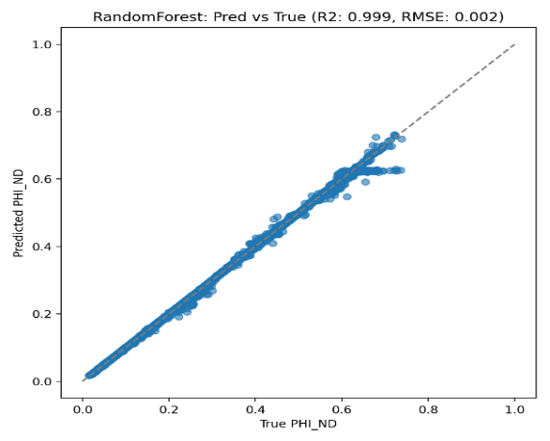
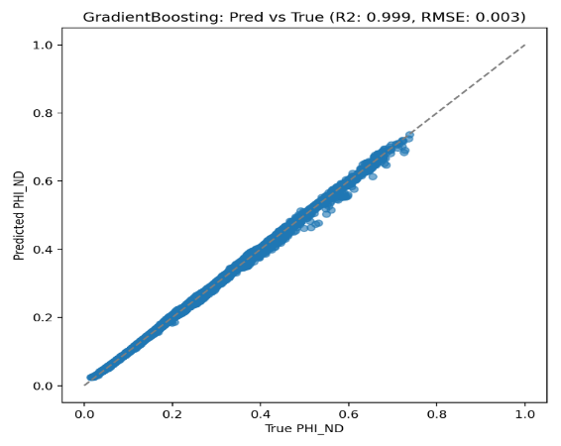
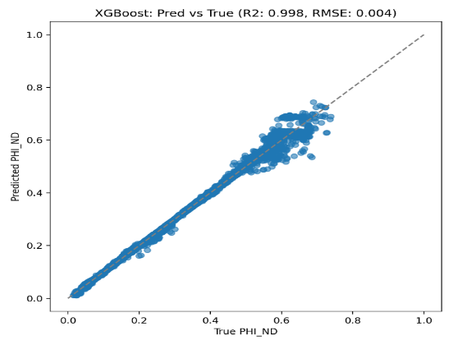
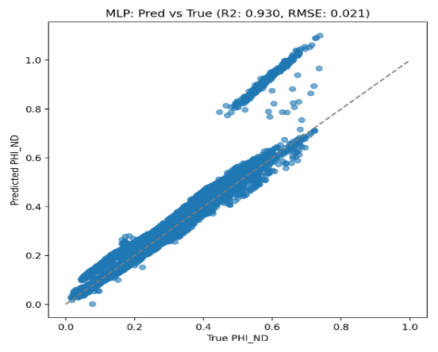
Figure 1: Predicted Porosity versus True Porosity
Residual distributions: Random Forest and Gradient Boosting displayed near-perfect Gaussian distributions centered at zero (mean residual ≈0.0001), indicating unbiased predictions. MLP exhibited heavy-tailed distributions with 5.1% of residuals exceeding ±0.03, revealing systematic prediction limitations.
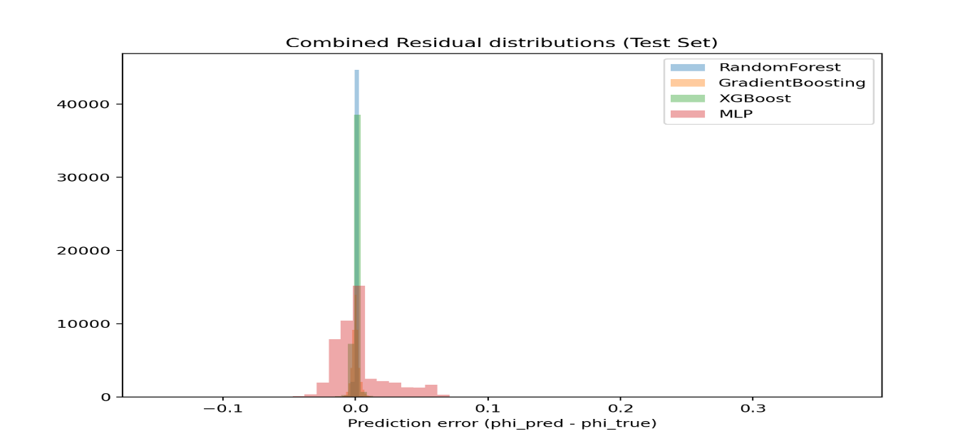
Figure 2: Residual distribution

3.2 Discussion

3.2.1 Superiority of Tree-Based Ensembles
The consistent performance hierarchy (Random Forest ≈ Gradient Boosting > XGBoost >> MLP) across all test wells reflects fundamental algorithmic advantages for well log data:
Natural handling of feature interactions: Decision trees inherently model conditional relationships through hierarchical splits (e.g., "IF RHOB < 2.3 AND GR < 50 THEN “high_porosity_sand"), mimicking expert petrophysical interpretation. This contrasts with MLP's requirement to learn interactions through hidden layer transformations.
Scaling to feature sizes: Tree splits are based on feature thresholds, which are monotonic-invariant and which are also resistant to extreme values. Values of resistivity that range between 0.1-10,000+ ohm-m (five orders of magnitude) are natively represented without transformation.
Ensemble diversity: In Gradient Boosting, the ensemble is diversity is obtained by error correction in a sequence of steps, whereas in Random Forest, the diversity is obtained by bootstrap sampling and random features subsets. The two mechanisms generate independent errors which when added together, significantly decrease variance.
The recent studies validate that tree-based ensembles (Grinsztajn et al, 2022) will always perform better than neural networks when applied to structured tabular data even after optimal tuning. The axis-aligned splits inductive bias is inherently consistent with relation to features and targets in geophysical measurements.

3.2.2 Analysis of MLP Underperformance.
The fact that MLP makes its estimates 6 times higher is due to the following reasons:
Lack of diversity in training: The number of 207,627 seems huge; however, it depicts only 16 wells. Neural networks require a wide range of examples of the entire input space thousands of wells as opposed to a large number of measurements per well. The dearth of well diversity inhibits generalization.
Architectural constraints: This problem may not be complex enough to be supported by the shallow 2-layer (128-64) architecture. Nevertheless, more complicated networks are prone to overfitting due to training data limitation.
Tabular data incompatibility: Recent research shows that tabular data is more compatible with tree ensembles than with neural networks, which are more efficient on grid-based data (images, sequences) where the relationship between positions is major.

3.2.3 Cross-Well Generalization
Excellent test well performance ($R^{2}$ > 0.998) of ensemble methods with all four wells indicates that the physical relationships to learn are genuine and not well-specific memorization. This resulted from:
Splitting by group: Whole wells splitting allowed no data leakage, requiring models to learn transferring log-porosity relationships.
Geological diversity in training: The training wells were diverse in depositional environment, lithology and depth, which allowed rigorous generalization.
Physics-informed features: Adding physically relevant logs (density, neutron, sonic) that were known to exhibit porosity relationships enabled learning transferable patterns.

4. Conclusion

This detailed study showed that ensemble machine learning, especially Gradient Boosting and Random Forest, can predict formation porosity with accuracy, reliability and operational viability using traditional well logs. The resulting performance gave significant machine learning porosity prediction, which is due to more training data, more sophisticated preprocessing and much stricter validation methods.

COMPETING INTERESTS DISCLAIMER:
Authors have declared that they have no known competing financial interests OR non-financial interests OR personal relationships that could have appeared to influence the work reported in this paper.

REFERENCE

Al-Mudhafar, W. J. (2017). Integrating well log interpretations for lithofacies classification and permeability modeling through advanced machine learning algorithms. Journal of Petroleum Exploration and Production Technology, 7(4), 1023–1033. https://doi.org/10.1007/s13202-017-0360-0
Asquith, G., & Krygowski, D. (2004). Basic well log analysis (2nd ed.). American Association of Petroleum Geologists.
Bhatt, A., & Helle, H. B. (2002). Committee neural networks for porosity and permeability prediction from well logs. Geophysical Prospecting, 50(6), 645–660. https://doi.org/10.1046/j.1365-2478.2002.00346.x
Cao, Y., Zhang, X., Li, J., & Liu, H. (2025). Data-driven interpretable machine learning for prediction of porosity and permeability of tight sandstone reservoirs. Advances in Geo-Energy Research, 16(1), 21–35. https://doi.org/10.46690/ager.2025.04.04
Charalampakos, F., Tsouparopoulos, T., & Koutsopoulos, I. (2025). Joint explainability-performance optimization with surrogate models for AI-driven edge services (Preprint). arXiv. https://doi.org/10.48550/arXiv.2503.07784
Chen, L., Lin, W., Chen, P., Jiang, S., Liu, L., & Hu, H. (2021). Porosity prediction from well logs using back propagation neural network optimized by genetic algorithm in one heterogeneous oil reservoirs of Ordos Basin, China. Journal of Earth Science, 32(4), 828–838. https://doi.org/10.1007/s12583-020-1396-5
Chen, T., & Guestrin, C. (2016). XGBoost: A scalable tree boosting system. Proceedings of the 22nd ACM SIGKDD International Conference on Knowledge Discovery and Data Mining, 785–794. https://doi.org/10.1145/2939672.2939785
Chen, W., Yang, L., Zha, B., Zhang, M., & Chen, Y. (2020). Deep learning reservoir porosity prediction based on multilayer long short-term memory network. Geophysics, 85(4), WA213–WA225. https://doi.org/10.1190/geo2019-0261.1
Feng, R., Grana, D., & Balling, N. (2021). Imputation of missing well log data by random forest and its uncertainty analysis. Computers & Geosciences, 152, 104763. https://doi.org/10.1016/j.cageo.2021.104763
Grinsztajn, L., Oyallon, E., & Varoquaux, G. (2022). Why do tree-based models still outperform deep learning on typical tabular data? Advances in Neural Information Processing Systems, 35, 507–520.
He, Z., Liu, Y., Zhang, J., & Wang, Q. (2025). Porosity prediction of tight reservoir rock using well logging data and machine learning. Scientific Reports, 15(1), 13124. https://doi.org/10.1038/s41598-025-95578-7
Helle, H. B., Bhatt, A., & Ursin, B. (2001). Porosity and permeability prediction from wireline logs using artificial neural networks: a North Sea case study. Geophysical Prospecting, 49(4), 431–444. https://doi.org/10.1046/j.1365-2478.2001.00271.x
Lary, D. J., Alavi, A. H., Gandomi, A. H., & Walker, A. L. (2016). Feature importance assessment via permutation. Environmental Modelling & Software, 79, 1–6. https://doi.org/10.1016/j.envsoft.2016.01.006
Molnar, C. (2020). Interpretable machine learning: A guide for making black-box models explainable (online book). https://christophm.github.io/interpretable-ml-book/
Nugroho, I. D. R., Trisna, M. D., & Saroji, S. (2024). An implementation of XGBoost and Random Forest algorithm to estimate effective porosity and permeability on well log data at Fajar Field, South Sumatera Basin, Indonesia. Indonesian Journal of Applied Physics, 14(2), 271–280. https://doi.org/10.13057/ijap.v14i2.82901
Páez, A. (2024). Understanding with toy surrogate models in machine learning. Minds and Machines, 34(4), 44. https://doi.org/10.1007/s11023-024-09700-1
Pan, S., Zheng, Z., Guo, Z., & Luo, H. (2022). An optimized XGBoost method for predicting reservoir porosity using petrophysical logs. Journal of Petroleum Science and Engineering, 208, 109520. https://doi.org/10.1016/j.petrol.2021.109520
Pathan, A., & Shuvo, M. A. I. (2026). Boosting machine learning algorithms for porosity prediction in sandstone gas reservoirs. Journal of Petroleum Exploration and Production Technology, 16, Article 11. https://doi.org/10.1007/s13202-025-02118-0
Pedregosa, F., Varoquaux, G., Gramfort, A., Michel, V., Thirion, B., Grisel, O., Blondel, M., Prettenhofer, P., Weiss, R., Dubourg, V., Vanderplas, J., Passos, A., Cournapeau, D., Brucher, M., Perrot, M., & Duchesnay, É. (2011). Scikit-learn: Machine learning in Python. Journal of Machine Learning Research, 12, 2825–2830.
Qi, Z., Yu, Q., Wang, J., Zhao, Y.-B., Li, Z., & Lv, W. (2025). WLFM: A Well-Logs Foundation Model for Multi-Task and Cross-Well Geological Interpretation (Preprint). arXiv. https://doi.org/10.48550/arXiv.2509.18152
Qiao, L., Yang, S., Hu, Q., Wang, H., & He, T. (2024). Unsupervised contrastive learning: Shale porosity prediction based on conventional well logging. Physics of Fluids, 36(5), 056613. https://doi.org/10.1063/5.0206449
Raissi, M., Perdikaris, P., & Karniadakis, G. E. (2019). Physics-informed neural networks: A deep learning framework for solving forward and inverse problems involving nonlinear partial differential equations. Journal of Computational Physics, 378, 686–707. https://doi.org/10.1016/j.jcp.2018.10.045
Rider, M., & Kennedy, M. (2011). The geological interpretation of well logs (3rd ed.). Rider-French Consulting Ltd.
Schlumberger. (1989). Log interpretation principles and applications. Schlumberger Educational Services.
Scikit-learn developers. (2024). Permutation feature importance. In scikit-learn: Machine Learning in Python (module documentation). https://scikit-learn.org/stable/modules/permutation_importance.html
Sharma, A., Kumar, D., & Saxena, V. (2021). Gradient boosting–based machine learning approach for porosity prediction using well log data. Journal of Petroleum Science and Engineering, 196, 107742.
Sun, Y., Pang, S., & Zhang, Y. (2024). Porosity prediction through well logging data: A combined approach of convolutional neural network and transformer model (CNN-transformer). Physics of Fluids, 36(2), 026604. https://doi.org/10.1063/5.0190078
Tiab, D., & Donaldson, E. C. (2016). Petrophysics: Theory and practice of measuring reservoir rock and fluid transport properties (3rd ed.). Gulf Professional Publishing.
Wang, F., & Hou, X. (2025). Machine learning-based prediction of physical parameters in heterogeneous carbonate reservoirs using well log data. Energy Geoscience, 6(2), 100383. https://doi.org/10.1016/j.engeos.2025.100383
Wang, X., Liu, Y., Ren, X., & Ma, P. (2025). Predicting porosity in tight sandstone reservoirs based on logging-while-drilling engineering parameters and optimized BPNN. Scientific Reports, 15, 14241. https://doi.org/10.1038/s41598-025-98311-6
Wyllie, M. R. J., Gregory, A. R., & Gardner, L. W. (1956). Elastic wave velocities in heterogeneous and porous media. Geophysics, 21(1), 41–70. https://doi.org/10.1190/1.1438217
Zou, C., Zhao, L., Xu, M., Chen, Y., & Geng, J. (2021). Porosity prediction with uncertainty quantification from multiple seismic attributes using random forest. Journal of Geophysical Research: Solid Earth, 126, e2021JB021826. https://doi.org/10.1029/2021JB021826

Abbreviations
API - American Petroleum Institute
AVO - Amplitude Versus Offset
BS - Bit Size
CALI - Caliper
CV - Coefficient of Variation
DCAL - Differential Caliper
DEPT - Depth
DRHO - Density Correction
DTC - Compressional Sonic Transit Time (Delta-T Compressional)
DTS - Shear Sonic Transit Time (Delta-T Shear)
EOR - Enhanced Oil Recovery
GB - Gradient Boosting
GR - Gamma Ray
LAS - Log ASCII Standard
LWD - Logging While Drilling
MAE - Mean Absolute Error
MD - Measured Depth
ML - Machine Learning
MLP - Multi-Layer Perceptron
NPHI - Neutron Porosity
PEF - Photoelectric Factor
PINN - Physics-Informed Neural Network
PHI_ND - RMS Neutron-Density Porosity
RDEP - Deep Resistivity
RMED - Medium Resistivity
RMIC - Microresistivity
RMSE - Root Mean Square Error RMSE
RMS - Root Mean Square
ROP - Rate of Penetration
ROPA - Rate of Penetration Average
RF - Random Forest
RHOB - Bulk Density
RSHA - Shallow Resistivity
RXO - Flushed Zone Resistivity
SGR - Spectral Gamma Ray
SHAP - SHapley Additive exPlanations
SP - Spontaneous Potential
XGBoost - Extreme Gradient Boosting
XAI - Explainable Artificial Intelligence
WLFM - Well Log Foundation Model

