Thermofluid-Inspired Nonlinear Entropy Modeling of Financial Markets under Time-Varying External Shocks

Abstract:
This study develops a thermofluid-inspired nonlinear entropy model to analyze uncertainty, instability, and risk propagation in financial markets subjected to time-varying external shocks. The framework is formulated as a reaction–diffusion equation with nonlinear growth and saturation effects, coupled with a space–time dependent source term representing decaying market disturbances. The governing dimensional model is rendered dimensionless, revealing key parameters controlling diffusion, amplification, and dissipation mechanisms. Numerical solutions are obtained via an explicit finite difference scheme, allowing systematic exploration of how diffusion, nonlinear reaction coefficients, and shock intensity shape the evolution of financial entropy. Results indicate that higher diffusion accelerates the spread of uncertainty, nonlinear saturation stabilizes entropy growth, and strong external shocks elevate entropy levels while their influence decays over time. The proposed model establishes a thermodynamically grounded framework for capturing interactions between information propagation, market volatility, and external disturbances, offering quantitative insights into financial instability and risk dynamics.
Keywords: Thermofluid Framework; Nonlinear Entropy Modeling; Financial Markets; Time-Varying External Shocks
- Introduction
Entropy, developed in thermodynamics, is a rigorous measure of irreversibility, disorder, and energy dissipation in physical systems, forming the basis of the Second Law of Thermodynamics (Bejan, 1996). Its development in statistical mechanics and information theory provided a probabilistic link between microscopic randomness and macroscopic variables, making it a powerful tool for analyzing complex systems with uncertainties. This dual thermodynamic–informational perspective has enabled entropy to extend beyond physical systems to diverse fields, including economics and finance. Bejan (2002) established the theoretical foundation for entropy generation minimization and exergy analysis, demonstrating the role of irreversibility in thermodynamic systems. Sciacovelli et al. (2015) further highlighted entropy generation as a key tool for design optimization in thermal systems. In fluid flow applications, Ullah et al. (2021) employed numerical analysis for non-Newtonian fluids, showing the influence of viscosity on entropy generation, while Fatunmbi and Salawu (2020) studied magneto-micropolar fluid flow in porous media, illustrating the effects of magnetic fields and microstructure on entropy production. Fatunmbi and Adeniyan (2020) examined the combined effects of nonlinear thermal radiation and variable properties on entropy generation in stretchable surface flows, demonstrating the significance of nonlinear processes in thermodynamic irreversibility.
Financial markets are complex adaptive systems characterized by nonlinear interactions, random fluctuations, and emergent patterns. Such features have inspired interdisciplinary research, particularly in econophysics, where concepts from statistical physics and information theory are applied to better understand financial dynamics (Mantegna & Stanley, 2000; Rosser, 2021). In this context, entropy naturally quantifies uncertainty, allowing for a deeper characterization of complex distributions. Measures such as Shannon entropy and relative entropy provide a more complete description of uncertainty than traditional variance-based metrics by considering the full probability distribution of returns (Zhou et al., 2013). The principle of maximum entropy has been widely applied for probability estimation and model calibration under incomplete information (Cover & Thomas, 2006). Entropy has also been applied to characterize market structure, where higher entropy values often indicate greater disorganization and lower predictability (Olbrys, 2022). Empirical studies show that entropy measures are sensitive to regime shifts and can detect transitions between stable and turbulent market conditions. For instance, entropy has been used to assess stock market efficiency during crises, capturing significant increases in uncertainty during systemic stress (Papla & Siedlecki, 2024), and complexity–entropy frameworks have been applied to cryptocurrency markets, revealing nonlinear transitions and emergent order during crash dynamics (Bui et al., 2025). Dionisio et al. (2007) quantified uncertainty and disorder in financial markets using entropy as an alternative to traditional risk measures, while Topal (2021) applied an entropy-based multi-criteria approach to evaluate electricity generation companies under uncertainty. Riabykh et al. (2025) introduced an entropy-based text feature engineering method for forecasting financial liquidity, demonstrating the value of information-theoretic measures in predictive financial analytics. Collectively, these studies highlight entropy’s ability to capture both randomness and structural evolution in financial systems.
Advances in financial thermodynamics and market microstructure analysis have provided physically motivated definitions of entropy. Recent studies show that models incorporating thermodynamic variables from limit order book dynamics can use entropy to measure market disorder, trading activity, and liquidity (Li et al., 2024). Stochastic thermodynamics further conceptualizes financial markets as non-equilibrium systems with entropy production and dissipation, analogous to physical systems governed by the Second Law of Thermodynamics. Touzo et al. (2021) applied information thermodynamics to the Glosten–Milgrom model, quantifying information flows in financial markets, while Ghosh (2025) reviewed statistical mechanics in financial thermodynamic systems, illustrating how entropy and energy analogies can model market dynamics and systemic risk.
Despite these developments, mainstream financial modeling remains dominated by econometric approaches, particularly ARCH and GARCH models, which effectively capture volatility clustering and conditional heteroskedasticity in time series (Engle, 1982; Bollerslev, 1986). However, these models assume linear or weakly nonlinear stochastic processes and lack a physical interpretation of irreversibility, dissipation, or information flow. Francq et al. (2011) examined variance-targeting techniques in GARCH models, highlighting their advantages and limitations, while Kim and Won (2018) proposed a hybrid approach combining LSTM neural networks with multiple GARCH models to improve volatility forecasting. Currently, there is limited research integrating information diffusion, nonlinear interactions, and time-dependent external disturbances into a unified framework, despite clear analogies between financial markets and physical transport systems where information diffuses, interacts nonlinearly, and is subject to external perturbations.
The present study develops a thermofluid-inspired nonlinear entropy model for financial markets, formulating financial entropy evolution as a nonlinear reaction–diffusion equation. This framework captures how information spreads, agents interact, and external shocks influence market dynamics. Drawing analogies from heat and mass transfer, the model incorporates nonlinear reaction terms to represent feedback, amplification, and saturation effects in market behavior, alongside a time-dependent source term for external disturbances. The originality of the study lies in combining thermodynamic principles, nonlinear dynamics, and financial modeling within a single partial differential equation framework. The model demonstrates how diffusion, nonlinearity, and external forces interact, offering deeper insights into market inefficiency, risk propagation, and systemic instability than existing entropy-based descriptive analyses. This work advances thermodynamic financial modeling and establishes a robust framework for studying complex financial systems under nonequilibrium conditions.
- Thermodynamic Foundation and Financial Systems Analogy
The current study is based on the principles of the Second Law of Thermodynamics, which deals with the evolution of entropy in non-reversible systems. The balance equation of entropy in continuum thermodynamics can be written as
$$\begin{aligned}\frac{∂s}{∂t}+∇⋅J_{s}={\overset{˙}{s}}_{gen},\#(1)\end{aligned}$$
where $s$ denotes entropy per unit volume, $J_{s}$ is the entropy flux, and ${\overset{˙}{s}}_{gen}$ represents the local entropy generation due to irreversible processes.
In classical heat transfer and fluid flow, entropy generation arises primarily from thermal gradients and viscous dissipation. The local volumetric entropy generation rate is typically given by
$$\begin{aligned}{\overset{˙}{s}}_{gen}=\frac{k}{T^{2}}{\left|∇T\right|}^{2}+\frac{μ}{T}Φ_{v},\#(2)\end{aligned}$$
where $k$ is the thermal conductivity, $T$ is the absolute temperature, $μ$ is the dynamic viscosity, and $Φ_{v}$ denotes the viscous dissipation function. In equation (2), the first term in descries entropy generation due to heat transfer across finite temperature gradients, and the second term accounts for irreversibility associated with viscous effects in fluid motion.
On the basis of these thermodynamic laws, the financial market is considered as an irreversible system where uncertainty develops through diffusion, nonlinear interactions, and external forcing. In this context, financial entropy $S(y,t)$ describes the level of disorder or uncertainty in the financial system.
The correspondence between thermodynamic and financial variables is established as follows:
Table 1: Relations between thermodynamic and financial variables
Thermodynamic System | Financial System
Temperature ($T$) | Financial entropy ($S$)
Thermal gradient ($∇T$) | Information gradient ($∇S$)
Heat flux | Information/market flow
Thermal diffusivity ($α$) | Financial diffusivity ($β$)
Viscous dissipation | Market friction and regulation ($P(t)$)
External heating | Market shocks ($Φ(y,t)$)

Under this analogy, entropy generation due to thermal gradients, represented by $(∇T)^{2}$, is extended to financial systems as a gradient-driven entropy production term $(∇S)^{2}$. This term captures the effect of spatial heterogeneity and information asymmetry within the market.
2.1. Entropy-Based Model Justification
By invoking a Fick-type constitutive relation for entropy flux,
$$\begin{aligned}J_{S}=-β∇S,\#(3)\end{aligned}$$
the divergence of the entropy flux yields a diffusion term:
$$\begin{aligned}∇⋅J_{S}=β∇^{2}S.\#(4)\end{aligned}$$
Furthermore, inspired by classical entropy generation formulations, the total entropy production in the financial system is modeled as a combination of gradient-driven and nonlinear contributions:
$$\begin{aligned}{\overset{˙}{S}}_{gen}=β|∇S|^{2}+aS-bS^{2}.\#(5)\end{aligned}$$
Consequently, the governing equation for financial entropy evolution is derived as
$$\begin{aligned}\frac{∂S}{∂t}=β∇^{2}S+β|∇S|^{2}+aS-bS^{2}+Φ(y,t)-P(t),\#(6)\end{aligned}$$
which is consistent with entropy transport equations in thermofluid systems, extended to incorporate financial dynamics. The resulting model captures key mechanisms analogous to thermodynamic systems:
Diffusion term $β∇^{2}S$ represents the spread of information across the market.
Gradient term $β|∇S|^{2}$ accounts for entropy generation due to market heterogeneity and information imbalance.
Nonlinear term $aS-bS^{2}$ models endogenous market interactions such as speculation and saturation.
Source term $Φ(y,t)$ represents external shocks such as economic news or policy changes.
Dissipation term $P(t)$ captures regulatory interventions and transaction costs that stabilize the system. Thus, this model establishes a thermodynamically consistent framework for financial modeling, in which market dynamics are interpreted as an irreversible entropy-driven process.
2.2 Model Assumptions
The formulation of the thermofluid-inspired financial entropy model is based on the following assumptions:
- The financial market is taken to be a one-dimensional space with the spatial coordinate y ∈ [0, L], which represents the market depth or levels of information dissemination.
- Financial entropy $S(y,t)$ is a continuous, bounded, and differentiable scalar field that represents the degree of uncertainty.
- The diffusion of information in the financial market is assumed to follow a diffusion process with constant financial diffusivity β.
- Entropy generation in the system is attributed to spatial inhomogeneities and internal market dynamics, which is modeled using the gradient-based and nonlinear reaction terms.
- The nonlinear reaction term is given by $(aS - bS^{2}),$ which is analogous to logistic growth. Here, $a$ represents the amplification of financial entropy due to speculative activities, whereas $b$ represents saturation due to constraints in the market.
- External disturbances in the system are modeled using a time-dependent and spatially varying source term $(Φ(y,t))$ representing heterogeneous financial shocks.
- The dissipation term $(P(t))$ represents regulatory mechanisms in the system.
- The system is assumed to be isothermal and closed, which means that stochastic effects and memory in the system are ignored.
- The boundary conditions of the system represent fixed levels of entropy or no-flux conditions depending on the degree of openness in the financial market

- Mathematical Model
Based on an entropy balance principle, the evolution of financial entropy is governed by
$$\begin{aligned}\frac{∂S}{∂t}=β\frac{∂^{2}S}{∂y^{2}}+β{\left(\frac{∂S}{∂y}\right)}^{2}+aS-bS^{2}+Φ(y,t)-P(t),\#(7)\end{aligned}$$
where:
$S(y,t)$: financial entropy (measure of market uncertainty),
$y$: spatial coordinate representing market depth,
$t$: time,
$β$: financial diffusivity (rate of information spread),
$β\frac{∂^{2}S}{∂y^{2}}$: entropy diffusion term,
$β{\left(\frac{∂S}{∂y}\right)}^{2}$: entropy generation due to spatial gradients (market heterogeneity),
$a$: linear entropy growth coefficient (speculative amplification),
$b$: nonlinear saturation coefficient (market stabilization),
$Φ(y,t)$: external entropy source (market shocks),
$P(t)$: entropy dissipation function (regulatory and frictional effects).
The external shock model for the present study is modeled as
$$\begin{aligned}Φ(y,t)=Ae^{-kt}\left(1+δy\right),\#(8)\end{aligned}$$
Where $A$: shock intensity, $k$ describes the temporal decay rate of shocks, and $δ$: is the spatial heterogeneity parameter across market depth.
To generalize the governing equation, the following dimensionless variables are introduced:
$$\begin{aligned}S^{*}=\frac{S}{S_{0}}, y^{*}=\frac{y}{L}, t^{*}=\frac{t}{t_{0}},\#(9)\end{aligned}$$
where: $S_{0}$ is the characteristic entropy scale, $L$ connotes characteristic market depth, and$t_{0}$ describes the characteristic time scale.
3.1 Dimensionless Governing Equation
We introduced dimensionless variables (9) into the governing equation to obtain:
$$\begin{aligned}\frac{∂S^{*}}{∂t^{*}}=Fo\frac{∂^{2}S^{*}}{∂y^{*2}}+Fo{\left(\frac{∂S^{*}}{∂y^{*}}\right)}^{2}+λS^{*}-γS^{*2}+Φ^{*}(y^{*},t^{*})-P^{*}(t^{*}),\#(10)\end{aligned}$$
where the dimensionless parameters are defined as
$$\begin{aligned}Fo=\frac{βt_{0}}{L^{2}}, λ=at_{0}, γ=bS_{0}t_{0}.\#(11)\end{aligned}$$
The dimensionless source and dissipation terms are given by
$$\begin{aligned}Φ^{*}(y^{*},t^{*})=\frac{t_{0}}{S_{0}}Φ(y,t), P^{*}(t^{*})=\frac{t_{0}}{S_{0}}P(t).\#(12)\end{aligned}$$
Accordingly, the dimensionless source term becomes
$$\begin{aligned}Φ^{*}(y^{*},t^{*})=Πe^{-Kt^{*}}\left(1+Δy^{*}\right),\#(13)\end{aligned}$$
where
$$\begin{aligned}Π=\frac{At_{0}}{S_{0}}, K=kt_{0}, Δ=δL.\#(14)\end{aligned}$$
The initial condition is prescribed as
$$\begin{aligned}S^{*}(y^{*},0)=S_{i}(y^{*}),\#(15)\end{aligned}$$
where $S_{i}(y^{*})$ represents a bounded initial entropy distribution. The boundary conditions are specified as
$$\begin{aligned}S^{*}(0,t^{*})=0, S^{*}(1,t^{*})=1,\#(16)\end{aligned}$$
representing fixed entropy states at the market boundaries. Alternatively, a no-flux boundary condition may be imposed:
$$\begin{aligned}{\left.\frac{∂S^{*}}{∂y^{*}}\right|}_{y^{*}=0,1}=0,\#(17)\end{aligned}$$
which corresponds to no information exchange across the market boundaries.
3.2 Numerical Simulation
The dimensionless governing equation is solved numerically using an explicit finite difference method. The spatial and temporal domains are discretized as:
$$\begin{aligned}y_{i}^{*}=iΔy, t_{n}^{*}=nΔt,\#(18)\end{aligned}$$
where $Δy$ and $Δt$ are the spatial and temporal step sizes, respectively. The derivatives are approximated as:
$\left\{\begin{aligned}\frac{∂S^{*}}{∂t^{*}}≈\frac{S_{i}^{n+1}-S_{i}^{n}}{Δt}, \\ \frac{∂^{2}S^{*}}{∂y^{*2}}≈\frac{S_{i+1}^{n}-2S_{i}^{n}+S_{i-1}^{n}}{(Δy)^{2}}, \\ \frac{∂^{2}S^{*}}{∂y^{*2}}≈\frac{S_{i+1}^{n}-2S_{i}^{n}+S_{i-1}^{n}}{(Δy)^{2}}, \\ {\left(\frac{∂S^{*}}{∂y^{*}}\right)}^{2}≈{\left(\frac{S_{i+1}^{n}-S_{i-1}^{n}}{2Δy}\right)}^{2}.\end{aligned}\right.$ (19)
The resulting finite difference scheme is given by
$$\begin{aligned}S_{i}^{n+1}=S_{i}^{n} +Fo\frac{Δt}{(Δy)^{2}}\left(S_{i+1}^{n}-2S_{i}^{n}+S_{i-1}^{n}\right)+FoΔt{\left(\frac{S_{i+1}^{n}-S_{i-1}^{n}}{2Δy}\right)}^{2}\#(20) \\ +FoΔt{\left(\frac{S_{i+1}^{n}-S_{i-1}^{n}}{2Δy}\right)}^{2}+Δt(λS_{i}^{n}-γ\left(S_{i}^{n})^{2}\right)+ +Δt Φ_{i}^{n}-Δt P^{n}.\# \\ \# \\ \#\end{aligned}$$where $\begin{aligned}Φ_{i}^{n}=Πe^{-Kt_{n}}(1+Δy_{i}), P^{n}=P(t_{n}).\#\end{aligned}$
For numerical stability, the following conditions must be satisfied:
$\left\{\begin{aligned}Fo\frac{Δt}{(Δy)^{2}}≤\frac{1}{2}, \\ Δt⋅max{\left|\frac{∂S^{*}}{∂y^{*}}\right|}^{2}≪1.\end{aligned}\right.$ (21)
The computational algorithm takes the following steps
- Initialize $S_{i}^{0}=S_{i}(y^{*})$ for all spatial grid points.
- Apply boundary conditions at each time step.
- Compute diffusion, entropy generation, reaction, source, and dissipation terms.
- Update the solution using the explicit scheme.
- Advance the time level: $n→n+1$.
- Repeat until the final simulation time is reached.
The present formulation extends conventional financial diffusion models by incorporating explicit entropy generation mechanisms, thereby providing a thermodynamically consistent framework for analyzing irreversible dynamics and shock propagation in financial markets.

Table 2: Dimensionless parameters and their interpretations.
Symbol | Description | Typical Values / Range | Dimensionless Form
$$S(y,t)$$ | Financial entropy | 0 – 1 | $$S^{*}=S/S_{0}$$
$$β$$ | Financial diffusivity | 0.01 – 0.5 | $$Fo=βt_{0}/L^{2}$$
$$a$$ | Linear growth coefficient | 0.5 – 2 | $$λ=at_{0}$$
$$b$$ | Nonlinear saturation | 0.1 – 1 | $$γ=bS_{0}t_{0}$$
$$A$$ | Shock intensity | 0.5 – 5 | $$Π=At_{0}/S_{0}$$
$$k$$ | Shock decay rate | 0.1 – 1 | $$K=kt_{0}$$
$$δ$$ | Spatial variation | 0 – 1 | $$Δ=δL$$
$$P(t)$$ | Dissipation / stabilization | 0.05 – 0.2 | $$P^{*}(t^{*})$$

4.0. Results and Discussion
To further understanding the behaviour of the embedded parameters on the financial entropy distribution, some graphs have been plotted in this section with appropriate discussion of the results.
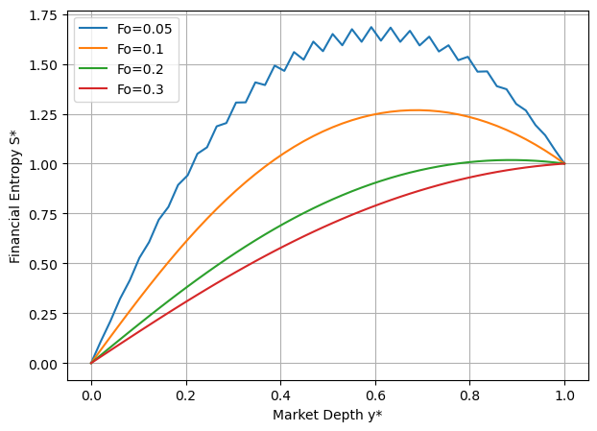
Figure 1: Financial entropy versus market depth for various values of diffusion parameter $F_{0}$
Figure 1 illustrates the variation of financial entropy with market depth for different values of the diffusion parameter $(Fo).$ The most notable feature is that the lowest diffusion rate ((Fo = 0.05)) produces the highest entropy peak, while increasing $(Fo)$ progressively reduces the magnitude of $(S^{*}).$ At low values of $(Fo),$ entropy increases rapidly from the boundary, reaching a pronounced peak (approximately 1.7) around region $(y^{*}≈ 0.5- 0.6).$This behaviour indicates a localized concentration of uncertainty within the market. As $Fo$ increases $(Fo = 0.2 - 0.3),$ the entropy profiles become smoother and more evenly distributed, and the peak value decreases significantly $(\sim 1.0).$ This suggests enhanced diffusion of information across the market, which prevents the accumulation of uncertainty in specific regions. Thus, diffusion acts as a stabilizing mechanism by redistributing financial entropy throughout the domain.
The results further indicate that the entropy distribution is governed by a diffusion–reaction balance, in which the diffusion parameter (Fo) controls the spatial spread of financial entropy, while nonlinear reaction terms regulate its growth and saturation. Analytical considerations show that lower diffusion rates lead to localized entropy buildup due to dominant generation mechanisms, whereas higher diffusion rates suppress peak formation and promote uniform distribution. The emergence of interior maxima is attributed to regions where entropy generation exceeds dissipation; however, these peaks remain bounded due to nonlinear saturation effects. This interplay establishes a stability structure within the financial system and highlights the critical role of diffusivity in mitigating localized market instabilities.
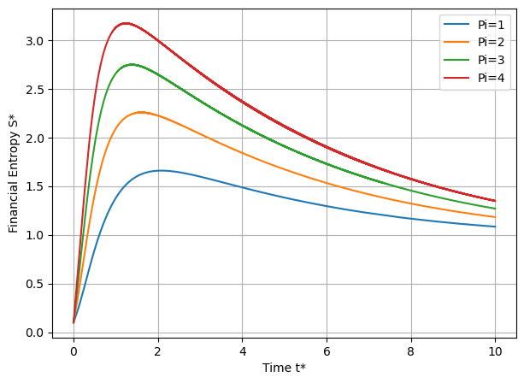
Figure 2: Effects of shock intensities $Π$ on financial entropy $S^{*}$
Figure 2 demonstrates the temporal evolution of financial entropy $(S^{*})$ at constant market depth for various values of shock intensity $(Π).$ The evolution of financial entropy reflects a balance among shocks, reactions, and dissipation. At short times, the growth rate is dominated by the external shock term, leading to a rapid increase in entropy proportional to the shock intensity. It is observed that all curves tend toward similar steady values; the long-time behavior is $Π$-independent, indicating that shocks are temporary and have no permanent effect. Peak financial entropy occurs when the decaying external shock term is balanced by nonlinear saturation and dissipation effects. At longer times, as the external shock decays exponentially, the system transitions to a reaction–dissipation regime in which financial entropy decreases gradually toward a steady state. Analytical results further show that peak financial entropy increases with shock intensity in a sublinear manner, while the long-time entropy is not affected by shock, reinforcing the transient nature of external shocks.

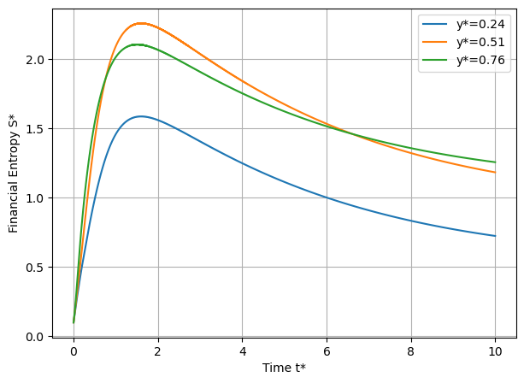
Figure 3: Distribution of temporary evolution of financial entropy $(S^{*})$ at different market depths $y^{*}$
Figure 3 presents the temporal evolution of financial entropy $(S^{*})$ at different market depths $(y^{*}= 0.24,; 0.51,; 0.76)$. The results reflect the combined influence of diffusion, nonlinear reaction, and time-decaying external shocks. This figure clearly demonstrates the interplay between space and time: The spatial effect $y^{*}$controls the magnitude of entropy generation via $(1+Δy_{i}^{ })$ while the temporal effect $(t^{*})$ controls decay of shocks. Combined effect shows that at early stage, the spatial differences amplified, whereas and at later stage, the temporal decay dominates, reducing differences
The time evolution of financial entropy demonstrates significant spatial dependence, especially during the shock-dominated regime. The analytical results indicate that the rate of entropy production increases with the level of market depth owing to the spatially varying source term, causing a faster rate and higher peaks in the entropy evolution for the interior regions. The maximum entropy is observed when the nonlinear saturation and dissipation are balanced by the level of external forcing, and the region that demonstrates the maximum peak is the mid-domain region. As the shock term decays exponentially, a reaction-dissipation regime is established, causing a decrease in entropy to a steady state.

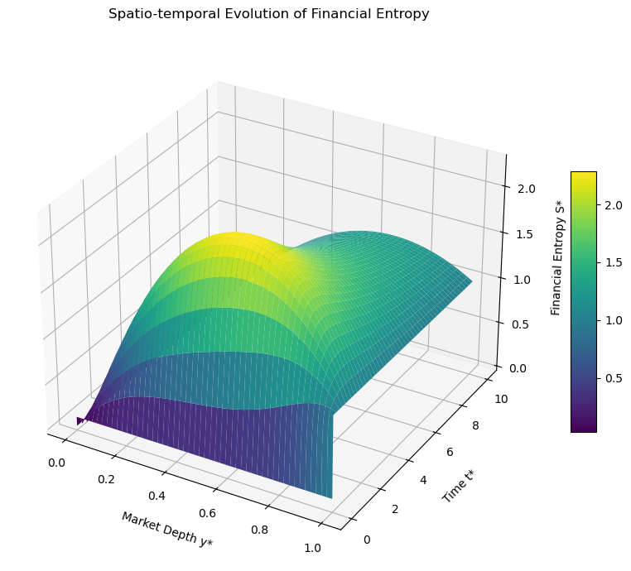
Figure 4: Spatio-Temporal Evolution of Financial Entropy
Figure 4 illustrates the joint variation of financial entropy (S^) with respect to market depth $(y^{*})$ and time $(t^{*})$, showing a nonlinear, non-monotonic dependence on depth and a progressive stabilization with time. The entropy is maximized at intermediate levels of liquidity, forming a distinct ridge, while its variation decreases with time, showing a smoothing effect.
The interplay between $(y^{*})$ and $(t^{*})$ is a nonlinear, inseparable relation. Initially, entropy is strongly dependent on changes in market depth, while this dependence decreases with time. This is a manifestation of path dependence, where the response to changes in liquidity depends on the evolution of the markets. The smooth evolution of the entropy ridge may indicate a self-organizing principle, driven by diffusion and nonlinear saturation, to a moderate level of entropy. From an economic perspective, these results are consistent with theoretical expectations. Intermediate levels of liquidity maximize informational friction and order flow complexity, hence maximizing entropy, while extremely low or high levels of liquidity minimize entropy. The decrease in entropy with time is consistent with adaptive behavior, such as learning and arbitrage, that converges to a state of equilibrium.
Overall, the findings highlight that financial entropy is jointly governed by liquidity structure and temporal dynamics, and that time-dependent entropy surfaces provide a richer framework for capturing market complexity than static measures.
5.0 Conclusion
This study proposes a thermofluid-based nonlinear entropy approach to study the behaviour of financial uncertainty under diffusion, nonlinear interactions, and external time-dependent shocks. The findings show that financial entropy evolves through a complex interplay of spatial diffusion, nonlinear saturation, and external temporal shocks. The main findings are listed below:
- The financial entropy is controlled by a diffusion-reaction-dissipation balance, and this determines its spatial and time evolution.
- The rate of diffusion is inversely proportional to entropy accumulation, and higher diffusion results in a stable distribution.
- The effect of shocks is significant for entropy levels, but this effect decreases over time because of exponential decay.
- The entropy levels are maximum for a particular range of the market, and this is the region of high uncertainty.
- The system is nonlinear and saturated, and this ensures that the entropy remains finite and never goes to infinity.
- The time evolution of entropy is such that there is a buildup, a maximum, and then a decay to equilibrium, and this is consistent with adaptive evolution.
- The entropy surface shows that the space and time are coupled and that this is a non-separable surface, and this is consistent with the behaviour of the markets.
Applications and Implications
- Provides a quantitative framework for measuring financial instability and systemic risk using entropy-based metrics.
- Useful for identifying critical liquidity regimes where uncertainty is maximized.
- Offers insights for regulators and policymakers to design interventions that enhance market stability through improved information diffusion.
- Applicable to risk management and portfolio analysis, where entropy can complement traditional volatility measures.
- Establishes a foundation for physics-informed financial modeling, linking thermodynamic principles with economic dynamics.
Limitations
The current model is based on a one-dimensional market depth, while markets are generally n-dimensional. The parameters are deterministic, while there are stochastic variations in the markets. More so, the external shock is assumed to be an exponentially decaying function, while this may not be the case in real markets. The empirical validation is also not included in this study.
Future Work
The present model can be extended to n-dimensional markets, including network effects and inter-market interactions with inclusion of Stochastic terms. Also, the model can be validated and calibrated using real financial datasets with shock function assumed to be a regime-switching or non-exponentially decaying function, and the model can also be extended to include machine learning concepts.

COMPETING INTERESTS DISCLAIMER:
Authors have declared that they have no known competing financial interests OR non-financial interests OR personal relationships that could have appeared to influence the work reported in this paper.

References
Bejan, A. (1996). Entropy generation minimization: The new thermodynamics of finite‐size devices and finite‐time processes. Journal of Applied Physics, 79(3), 1191-1218.
Bejan, A. (2002). Fundamentals of exergy analysis, entropy generation minimization, and the generation of flow architecture. International journal of energy research, 26(7).
Bollerslev, T. (1986). Generalized autoregressive conditional heteroskedasticity. Journal of Econometrics, 31(3), 307–327.
Bui, H. Q., Schinckus, C., & Lim, B. K. (2025). Spontaneous order in cryptocurrency markets: Crash dynamics and complexity–entropy causality plane. Physica A.
Cover, T. M., & Thomas, J. A. (2006). Elements of information theory (2nd ed.). Wiley.
Dionisio, A., Menezes, R., & Mendes, D. A. (2007). Entropy and uncertainty analysis in financial markets. arXiv preprint arXiv:0709.0668.
Engle, R. F. (1982). Autoregressive conditional heteroskedasticity with estimates of the variance of United Kingdom inflation. Econometrica, 50(4), 987–1007.
Fatunmbi, E. O., & Adeniyan, A. (2020). Nonlinear thermal radiation and entropy generation on steady flow of magneto-micropolar fluid passing a stretchable sheet with variable properties. Results in Engineering, 6, 100142.
Fatunmbi, E. O., & Salawu, S. O. (2020). Thermodynamic second law analysis of magneto-micropolar fluid flow past nonlinear porous media with non-uniform heat source. Propulsion and Power Research, 9(3), 281-288.
Francq, C., Horvath, L., & Zakoïan, J. M. (2011). Merits and drawbacks of variance targeting in GARCH models. Journal of Financial Econometrics, 9(4), 619-656.
Ghosh, P. K. (2025). A Comprehensive Study of Statistical Mechanics in Financial Thermodynamic Systems. J Invest Bank Finance, 3(2), 01-08.
Kim, H. Y., & Won, C. H. (2018). Forecasting the volatility of stock price index: A hybrid model integrating LSTM with multiple GARCH-type models. Expert Systems with Applications, 103, 25-37.
Li, H., Xiao, Y., Polukarov, M., & Ventre, C. (2024). Thermodynamic analysis of financial markets: Measuring order book dynamics with temperature and entropy. Entropy, 26(1), 24.
Mantegna, R. N., & Stanley, H. E. (2000). An introduction to econophysics: Correlations and complexity in finance. Cambridge University Press.
Olbrys, J. (2022). Entropy-based applications in economics, finance, and management. Entropy, 24(10), 1468.
Papla, D., & Siedlecki, R. (2024). Entropy as a tool for the analysis of stock market efficiency during periods of crisis. Entropy, 26(12), 1079.
Riabykh, A., Suleimanov, I., Nagovitcyn, I., Surzhko, D., Konovalikhin, M., & Koltsova, O. (2025). Entropy-based text feature engineering approach for forecasting financial liquidity changes. EPJ Data Science, 14(1), 17.
Rosser, J. B. (2021). Econophysics and the entropic foundations of economics. Entropy, 23(10), 1286.
Sciacovelli, A., Verda, V., & Sciubba, E. (2015). Entropy generation analysis as a design tool—A review. Renewable and Sustainable Energy Reviews, 43, 1167-1181.
Topal, A. (2021). Financial performance analysis of electricity generation companies with multi-criteria decision making: Entropy-based Cocoso method. Business & Management Studies: An International Journal, 9(2), 532.
Touzo, L., Marsili, M., & Zagier, D. (2021). Information thermodynamics of financial markets: the Glosten–Milgrom model. Journal of Statistical Mechanics: Theory and Experiment, 2021(3), 033407.
Ullah, H., Hayat, T., Ahmad, S., & Alhodaly, M. S. (2021). Entropy generation and heat transfer analysis in power-law fluid flow: Finite difference method. International Communications in Heat and Mass Transfer, 122, 105111.
Zhou, R., Cai, R., & Tong, G. (2013). Applications of entropy in finance: A review. Entropy, 15(11), 4909–4931.

