Original Research Article
Irrigation suitability and ionic toxicity of Houet River water used at the Dogona market garden site in Bobo-Dioulasso, Burkina Faso

ABSTRACT
Aims: To assess the suitability for irrigation and ionic toxicity of Houet River water used at the Dogona market gardening site in Bobo-Dioulasso.
Study design: This was a prospective longitudinal field study conducted along the Houet River, based on monthly sampling
Place and Duration of Study: The study was conducted from March 2023 to February 2024 along the Houet River, with four georeferenced sampling sites located upstream (P1–P2) and downstream (P3–P4) of the Dogona wastewater treatment plant discharge point, covering three hydrological seasons (dry season, rainy season, and cool season).
Methodology: Water was sampled monthly and analyzed for electrical conductivity (EC), total dissolved solids (TDS), and major ions (including Na⁺ and Cl⁻). Major-ion concentrations were converted to meq/L to compute irrigation-suitability indices (SAR, %Na, PI, MAR, and Kelly’s ratio). Irrigation water quality was then classified using the Wilcox (%Na versus EC) and USSL/Riverside (SAR versus EC) diagrams.
Results: The EC ranged from 398.60 ± 59.55 to 1441.75 ± 458.79 µS/cm and the STDs from 103.50 ± 19.53 to 392.50 ± 71.62 mg/L; the SAR from 1.20 to 6.18; %Na from 37.40 to 85.09; IP from 7.17 to 18.50; RAM from 5.88 to 26.01; and RK from 0.43 to 3.86. The differences were significant for most parameters (p < 0.05), except for Na⁺. The waters were classified as excellent to good according to Wilcox and C2S1 to C3S1 according to Riverside, with degradation immediately downstream of the discharge (P3), followed by partial dilution at P4.
Conclusion: Overall, the waters showed acceptable to moderate suitability for irrigation. However, their use requires precautions, including adequate drainage, leaching management, sodium control, and appropriate crop selection, especially in the immediate downstream area after mixing with the WWTP effluent.
Keywords: Irrigation suitability; Wilcox diagram; Riverside diagram (USSL); Houet River; Dogona.
1. INTRODUCTION
Water scarcity and increasing rainfall variability in Sudanian–Sahelian tropical zones are intensifying pressure on dry-season irrigation. As a result, market-gardening farms are increasingly turning to non-conventional water resources such as urban surface waters and diluted or partially treated wastewater to secure production and maintain market supply (UN-WATER, 2021). In sub-Saharan Africa, where urban growth often outpaces sanitation infrastructure, the agricultural reuse of waters influenced by urban discharges is an increasingly observed adaptation strategy, but one that needs to be supported by water-quality diagnostics and risk-management measures (Drechsel, 2022; FAO, 2023).
While these urban waters can support incomes and stabilise the supply of fresh vegetables, they may also pose agronomic risks that are sometimes underestimated, in particular increased salinity, sodicity, and reduced infiltration. These processes can degrade soil structure, increase clay dispersion, reduce permeability and complicate crop choice, especially in sensitive soils (Obijianya et al., 2025; Aldughaishi et al., 2024, Helmecke et al., 2020; Jones et al., 2021). Recent studies further indicate that indicators focused on structural stability can usefully complement conventional approaches based on SAR (Aldughaishi et al., 2024; Kramer & Mau, 2023).
The evaluation of a water source for irrigation suitability is classically based on salinity, infiltration performance, and the toxicity of specific ions. Water classification is commonly performed using combined reference frameworks, notably the USSL/Riverside and Wilcox diagrams. Assessment is also made by comparing measured values with international guidelines and standards in force for the agricultural reuse of wastewater, including those from the WHO, FAO, and the United States Environmental Protection Agency (US EPA) (Ayers & Westcot, 1985; Wilcox, 1955; Drechsel et al., 2023; Shokri et al., 2024).
However, two recurring limitations are found in studies on the agricultural use of urban waters in West Africa: first, a focus on contamination (microbiology, trace elements, nutrients) with an incomplete assessment of irrigation suitability using standardized indices and reference diagrams (Kpoda et al., 2015; Zongo et al., 2021); and second, an insufficient translation of water-quality classes into operational recommendations, even though these factors determine the long-term sustainability of irrigated soils (Drechsel et al., 2022; FAO, 2023; Obijianya et al., 2025; Purwar et al., 2020).
In Bobo-Dioulasso, Burkina Faso, the Dogona market-gardening site relies heavily on Houet River water in a context of urban discharges, including effluents from a wastewater treatment plant, with potentially stronger impacts during low-flow periods (Sauret et al., 2023; Dabré et al., 2025). Available assessments of the Houet River report a deterioration in water quality downstream of these inputs and highlight the need for targeted monitoring of the key parameters governing irrigation suitability-EC, sodium, major ions, and related indices, to better characterize agronomic constraints at the level of market-gardening schemes (Sauret et al., 2023).
Within this context, the present study aims to assess the irrigation suitability and ionic toxicity of Houet River water used at the Dogona market-gardening site in Bobo-Dioulasso, Burkina Faso.
2. METHODOLOGY
2.1 Study Area
The study was conducted in the Dogona market-gardening area in Bobo-Dioulasso, Burkina Faso, along the banks of the Houet River, whose waters are widely used for irrigation. The site is in the north-eastern part of the city (Sector 13), at 11°12′6″ N and 4°27′25″ W (Ouédraogo et al., 2020). To characterize the influence of the Dogona wastewater treatment plant (WWTP) discharge on the quality of irrigation water and the downstream dilution dynamics, four georeferenced sampling points were selected along the river: P1J1 (upstream, before the confluence), P2J1 (upstream, near the discharge point), P3J2 (immediately downstream, after mixing with the WWTP effluent), and P4J2 (further downstream).
The observation period covered March 2023 to February 2024 and included three seasons: dry (S1), rainy (S2), and cool (S3), to account for hydrological variability and seasonal fluctuations in pollutant loads. The location of the study area and the sampling points are present (Fig 1).
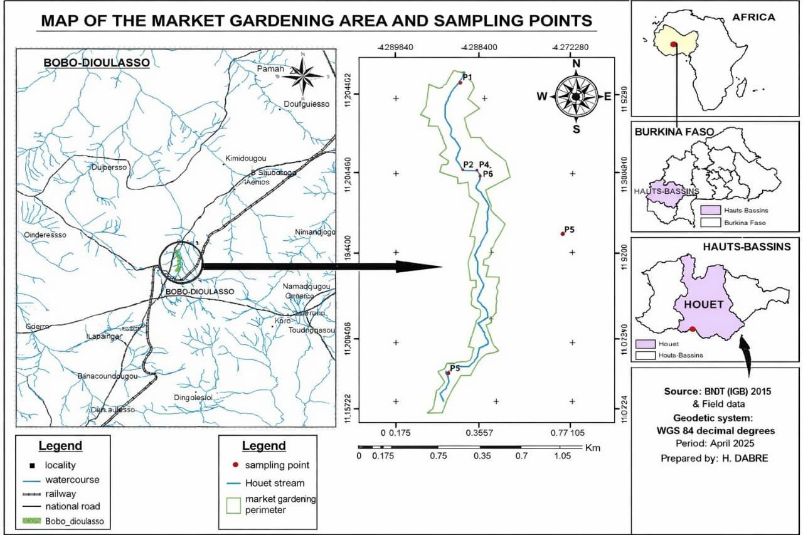
P1
P4
P3
Fig 1. Geographic location of the city of Bobo-Dioulasso and the Dogona market-gardening area (Dabré et al., 2025).
2.2 Water sampling and in situ measurements
Water samples were collected monthly from March 2023 to February 2024, covering the three seasons (S1, S2, S3), at four sites located upstream (J1) and downstream (J2) of the Dogona wastewater treatment plant (WWTP) discharge. Samples intended for physico-chemical analyses were collected in polyethylene bottles pre-rinsed with site water, then kept refrigerated (−4 °C) and transported to the laboratory as quickly as possible. In situ measurements included electrical conductivity (EC) and total dissolved solids (TDS), determined using a multiparameter probe previously calibrated in accordance with the laboratory’s internal procedures.
2.3 Laboratory measurement of parameters
Analyses were performed in the laboratory in accordance with traceable internal standard operating procedures, using standardized reagents (HACH/AFNOR), within a quality-control framework consistent with the requirements of ISO 17025. Na⁺ and K⁺ ions were determined by flame photometry after sample nebulization, based on the characteristic emission of excited atoms at specific wavelengths. Cl⁻, HCO₃⁻, Ca²⁺, and Mg²⁺ ions were quantified by titrimetry according to the laboratory’s reference procedures.
2.4 Assessment of irrigation suitability
Irrigation suitability was evaluated considering three complementary dimensions: (i) salinity hazard, (ii) specific ion toxicity, and (iii) the risk of infiltration/permeability deterioration related to sodicity. Salinity was assessed using electrical conductivity (EC) and total dissolved solids (TDS). Specific ionic toxicity was evaluated based on Na⁺ and Cl⁻ concentrations. Finally, infiltration/sodicity risk was assessed using the following indices: SAR, %Na, PI, MAR, and KR. These indices were calculated from major ions expressed in meq/L (after converting concentrations) and then used for water-quality classification. The calculations were performed using the following index equations (meq/L):
- SAR (sodium adsorption ratio) = Na⁺ / √[(Ca²⁺ + Mg²⁺)/2]
- %Na (soluble sodium percentage) = [(Na⁺ + K⁺) / (Ca²⁺ + Mg²⁺ + Na⁺ + K⁺)] × 100
- PI (permeability index) = [(Na⁺ + √HCO₃⁻) / (Ca²⁺ + Mg²⁺ + Na⁺)] × 100
- MAR (magnesium adsorption ratio) = [Mg²⁺ / (Ca²⁺ + Mg²⁺)] × 100
- KR (Kelly’s ratio) = Na⁺ / (Ca²⁺ + Mg²⁺)
Overall water classification was performed using the Wilcox diagram (%Na versus EC) to evaluate irrigation-water quality and the USSL/Riverside diagram (SAR versus EC) to characterize the combined salinity–sodicity hazard. The resulting values were interpreted by comparison with international guidelines and benchmarks (WHO, US EPA, FAO) related to water quality and agricultural reuse (WHO, 2012; Salauddin et al., 2018; Cadilhac et al., 2003). The water-classification scheme according to the U.S. Salinity Laboratory (USSL) (Bouselsal et al., 2014) is indicated (Fig 2).
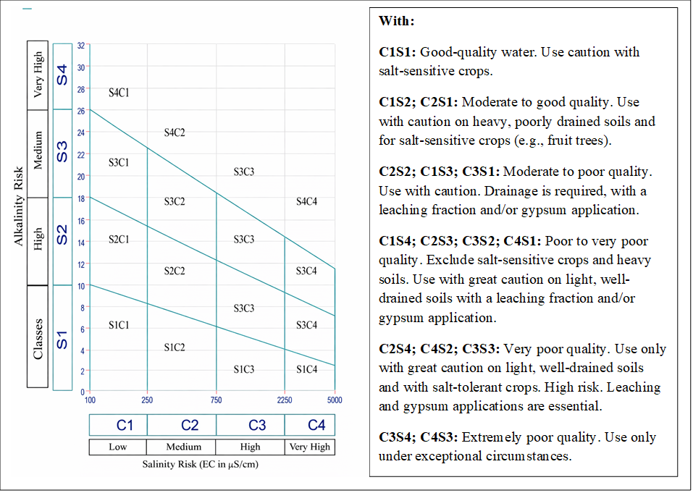
Fig 2. Classification of irrigation suitability in the USA
Salinity hazard CE (µS/cm
2.5 Data processing and analysis
Physico-chemical data were entered using Excel 2016 and summarized using descriptive statistics (mean ± standard deviation). Irrigation-suitability indices were computed from major ions after converting concentrations to meq/L based on chemical equivalents. Water classification was performed using the Riverside/USSL and Wilcox diagrams, produced with Diagramme software (v8.6, 2019). R software (version 4.5.2) was used for statistical analysis of the physico-chemical data. A one-way ANOVA, followed by a multiple mean-comparison test, at a significance level of α = 0.05 (95% confidence level), was performed to assess the significance of differences observed between sampling points.
3. RESULTS
3.1 Salinity and ionic toxicity
The results for salinity- and toxicity-related parameters and their variability are presented (Table 1). Electrical conductivity (EC) ranged from 398.60 ± 59.55 µS/cm (P2J1S3) to 1441.75 ± 458.79 µS/cm (P3J2S1), with a significant difference (Pr>(F) = 0.00004; p < 0.05). Total dissolved solids (TDS) ranged from 103.50 ± 19.53 mg/L (P1J1S3) to 392.50 ± 71.62 mg/L (P3J2S2), with a highly significant difference (Pr>(F) = 0.0000003).
Regarding specific ionic toxicity, chloride (Cl⁻) concentrations varied from 27.25 ± 5.85 mg/L (P1J1S3) to 62.00 ± 7.83 mg/L (P3J2S3), with a significant difference (Pr>(F) = 0.003; p < 0.05). In contrast, sodium (Na⁺) concentrations, ranging from 35.66 ± 3.73 mg/L (P1J1S3) to 120.36 ± 102.03 mg/L (P2J1S2), did not show a statistically significant difference (Pr>(F) = 0.118).
3.2 Infiltration rate
The ions K⁺, HCO₃⁻, Ca²⁺, and Mg²⁺, which are involved in assessing infiltration/permeability behavior and sodicity, showed significant spatial variability among sampling points (Table II). Potassium (K⁺) ranged from 9.44 ± 10.26 to 85.63 ± 40.49 mg/L and differed significantly (Pr>(F) = 0.000005). Bicarbonate (HCO₃⁻), calcium (Ca²⁺), and magnesium (Mg²⁺) concentrations also differed highly significantly among stations. HCO₃⁻ values ranged from 1.735 ± 0.06 to 15.175 ± 4.30 mg/L (Pr>(F) = 2.54 × 10⁻¹²), whereas Ca²⁺ ranged from 0.6050 ± 0.17 to 1.2800 ± 0.22 mg/L (Pr>(F) = 0.01) and Mg²⁺ from 0.3200 ± 0.32 to 0.9275 ± 0.26 mg/L (Pr>(F) = 0.007).
The agronomic indices used to assess infiltration risk and sodicity are presented (Table 3). Mean SAR values ranged from 1.20 to 6.18. %Na varied from 37.40% to 85.09%. The permeability index (PI) ranged from 7.17 to 18.50, while MAR ranged from 5.88 to 26.01 and Kelly’s ratio (KR) from 0.43 to 3.86.

Table 1. Values of salinity- and toxicity-related water parameters and their variability.
Sampling points | EC | DTS | Na+ | Cl⁻
P1J1S1 | 531± 31.50^{ab} | 156.25±81.23ª | 53.1225±7,13ª | 30.50±8.06^{ab}
P1J1S2 | 522.75±22.33^{b} | 147.75±28.66ª | 58.575±82,476ª | 29.00±4.96^{b}
P1J1S3 | 562.10±165.03^{ab} | 103.50±19.53ª | 35.6550±3,73ª | 27.25±5.85^{b}
P2J1S1 | 449.25±44.69^{b} | 144.50±52.77ª | 49.0950±7,19ª | 36.75±15.77^{ab}
P2J1S2 | 434.75±25.39^{b} | 128.00±52.16a | 120.3600±102,03ª | 31.50±6.81^{ab}
P2J1S3 | 398.60±59.55^{b} | 162.25±66.12ª | 53.0650±30,21ª | 33.75±11.73^{ab}
P3J2S1 | 1441.75±458.79^{c} | 351.25±46.42^{bc} | 38.2875±4,62ª | 51.50±21.99^{ab}
P3J2S2 | 788.25±159.96^{bc} | 392.50±71.62^{c} | 60.6700±21,68ª | 59.00±9.89^{ab}
P3J2S3 | 1117.25±687.71^{bc} | 336.00±68.87^{bc} | 43.6150±19,77ª | 62.00±7.83ª
P4J2S1 | 1289.50±502.21^{ac} | 202.50±82.21^{ab} | 84.8750±14,78ª | 42.50±11.59^{ab}
P4J2S2 | 701.50±244.031^{bc} | 162.75±98.59ª | 63.0575±32,0ª | 39.50±10.25^{ab}
P4J2S3 | 1053.25±304.00^{bc} | 249.75±82.17^{ac} | 46.4125±20,09ª | 50.50±25.94^{ab}
Pr>(F) | 0.00004 | 0.0000003 | 0.118 | 0.003
Significance | S | S | NS | S
Legend: P1: first sampling point; P2: second sampling point; P3: third sampling point; P4: fourth sampling point. J1: confluence point upstream of the WWTP treated wastewater discharge; J2: confluence point downstream of the WWTP treated wastewater discharge. S1: dry season; S2: cool season; S3: hot season. NS: not significant; S: significant.

Table 2. Values of the parameters used to calculate the infiltration-related indices of the water.
Sampling points | K+ | HCO₃⁻ | Ca²⁺ | Mg²⁺
P1J1S1 | 27.9900±11.63ª | 1.735±0.06ª | 0.6575±0.29ª | 0.5875 0.10^{ab}
P1J1S2 | 85.6325±40.49^{b} | 3.840±0.59^{ab} | 1.1850±0.27^{ab} | 0.3200 0.32ª
P1J1S3 | 26.2675±3.20ª | 3.825±0.77^{ab} | 1.2800±0.22^{b} | 0.5650 0.14^{ab}
P2J1S1 | 17.9925±11.65ª | 15.175±4.30^{c} | 1.0400±0.23^{ab} | 0.4175 0.22^{ab}
P2J1S2 | 9.4350±10.26ª | 3.665±0.23^{ab} | 0.7250±0.27^{ab} | 0.6700 0.38^{ab}
P2J1S3 | 24.2125±6.67ª | 2.910±0.35^{ad} | 0.8900±0.19^{ab} | 0.8550 0.31^{ab}
P3J2S1 | 24.7325±5.46ª | 5.805±1.07^{bd} | 0.9950±0.36^{ab} | 0.3800 0.09^{ab}
P3J2S2 | 29.3525±4.46ª | 6.625±0.99^{b} | 0.6050±0.17ª | 0.9275 0.26^{b}
P3J2S3 | 28.4100±9.20ª | 6.6551±0.28^{b} | 0.9250±0.22^{ab} | 0.7650 0.17^{ab}
P4J2S1 | 27.6650±8.96ª | 5.175±0.84^{ab} | 0.8900±0.17^{ab} | 0.4600 0.05^{ab}
P4J2S2 | 27.9250±4.28ª | 6.700±1.67^{b} | 0.7400±0.31^{ab} | 0.8500 0.27^{ab}
P4J2S3 | 26.4600±3.59ª | 4.680±0.53^{ab} | 1.0450±0.18^{ab} | 0.5750 0.24^{ab}
Pr>(F) | 0.000005 | 2.54E-12 | 0.01 | 0.007
Significance | S | S | S | S
Legend: P1: first sampling point; P2: second sampling point; P3: third sampling point; P4: fourth sampling point. J1: confluence point upstream of the WWTP treated wastewater discharge; J2: confluence point downstream of the WWTP treated wastewater discharge. S1: dry season; S2: cool season; S3: hot season. S: significant

Table 3. Mean values of infiltration-related indices and irrigation suitability indices of the water.
Sampling points | SAR | %Na | PI | MAR (%) | KR
P1J1S1 | 2,08 | 55,21 | 11,50 | 20,36 | 0,94
P1J1S2 | 1,95 | 51,93 | 11,17 | 11,97 | 0,89
P1J1S3 | 1,20 | 37,40 | 7,17 | 5,91 | 0,43
P2J1S1 | 2,85 | 56,77 | 12,26 | 7,46 | 1,10
P2J1S2 | 5,96 | 85,09 | 18,50 | 22,38 | 3,86
P2J1S3 | 6,18 | 81,92 | 18,25 | 10,45 | 3,65
P3J2S1 | 2,17 | 53,43 | 11,09 | 14,38 | 0,89
P3J2S2 | 2,10 | 50,42 | 10,47 | 5,88 | 0,81
P3J2S3 | 2,36 | 72,00 | 15,30 | 26,01 | 1,79
P4J2S1 | 2,76 | 67,73 | 14,70 | 25,09 | 1,65
P4J2S2 | 2,22 | 64,28 | 13,38 | 14,29 | 1,30
P4J2S3 | 1,92 | 55,07 | 11,33 | 21,59 | 0,92
Legend: P1: first sampling point; P2: second sampling point; P3: third sampling point; P4: fourth sampling point. J1: confluence point upstream of the WWTP treated wastewater discharge; J2: confluence point downstream of the WWTP treated wastewater discharge. S1: dry season; S2: cool season; S3: hot season; SAR: sodium adsorption ratio; PI: permeability index; MAR: magnesium adsorption ratio; KR: Kelly’s ratio
3.3 Water classification using the Wilcox and Riverside diagrams
The irrigation-water quality of the Houet River was summarized using the Wilcox and Riverside/USSL diagrams, which combine salinity (EC) with the sodium fraction (%Na) and sodicity (SAR), respectively. According to the Wilcox diagram (Fig 3), water from stations P1, P2, and P4 was classified as “excellent”, whereas station P3 (immediately downstream of the discharge) was classified as “good.” According to the Riverside/USSL diagram (Fig 4), the waters fell into two classes: C2S1, indicating medium salinity and low sodicity, corresponding to an EC between 250 and 750 µS/cm; and C3S1, indicating high salinity and low sodicity, corresponding to an EC between 750 and 2250 µS/cm. All sampling points remained within class S1 (low sodicity).

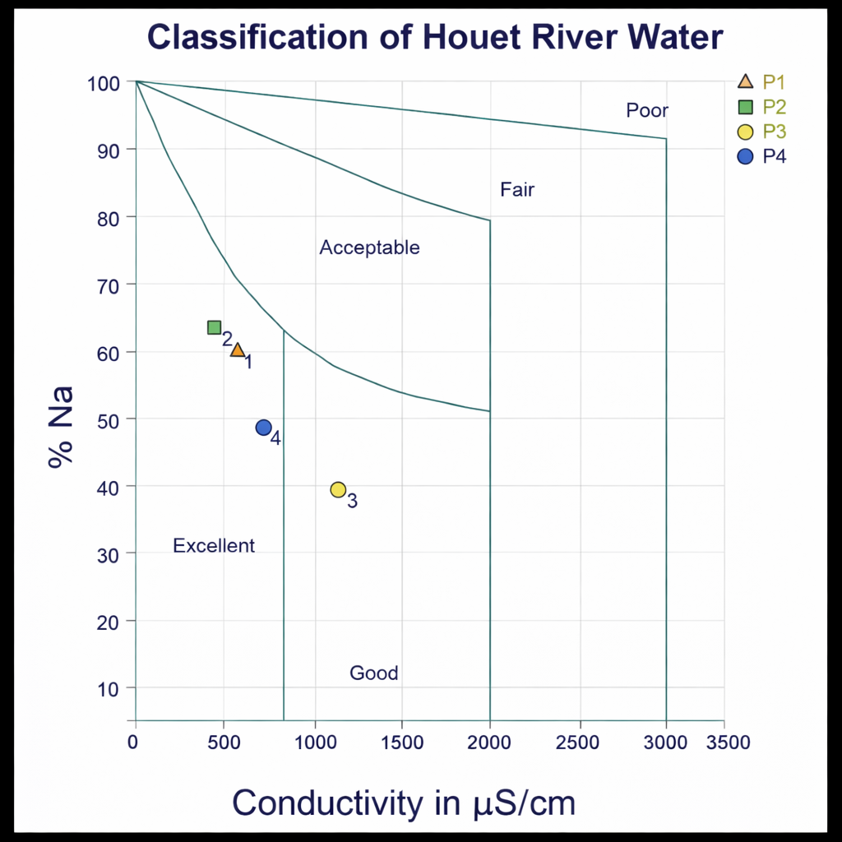
Fig 3. Classification of Houet River water according to the Wilcox diagram.
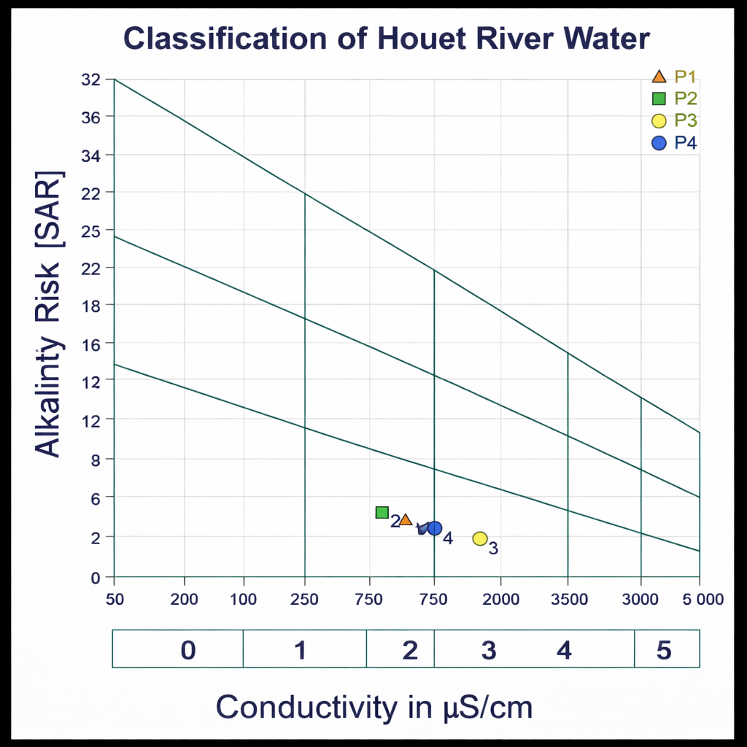
Fig 4. Classification of Houet River water according to the Riverside/USSL diagram.
4. DISCUSSION
The results show marked spatial and seasonal variability in the mineralization of Houet River water. Electrical conductivity (EC) ranged from 398.60 ± 59.55 µS/cm (P2, upstream of the confluence, cool season) to 1441.75 ± 458.79 µS/cm (P3, downstream of the confluence, dry season), and total dissolved solids (TDS) ranged from 103.50 ± 19.53 mg/L (P1) to 392.50 ± 71.62 mg/L (P3), with significant to highly significant differences. This pattern indicates overall low to moderate mineralization, with a clear increase at P3 immediately downstream of the wastewater treatment plant discharge, followed by a relative decrease at P4, consistent with a mixing–dilution effect. This dynamic confirms the influence of wastewater treatment plant discharges on the physico-chemical quality of the Houet River, as previously reported locally by Dende (2022), and consistent with the observations of Soumbougma et al. (2020) regarding variability in WWTP effluents. According to FAO guidelines, these EC/TDS levels correspond to moderately saline waters that are generally suitable for irrigation but require management precautions depending on crop sensitivity and soil characteristics (FAO, 2003; Ayers & Westcot, 1985). As highlighted by Kacmaz (2021) and Lingaswamy & Saxena (2015), even moderate salinity can become constraining when irrigation is repeated, particularly in poorly drained soils.
Regarding specific ionic toxicity, chloride (Cl⁻) concentrations showed a significant increase downstream of the discharge, whereas sodium (Na⁺) levels were less statistically consistent. This pattern suggests that the discharge footprint is expressed mainly through an increase in dissolved load and chlorides, with local sodium peaks, rather than through a uniform rise in Na⁺. Overall, the observed Cl⁻ concentrations remained within a no-to-low toxicity range, while sodium indicated moderate toxicity in some cases, in line with the interpretation of the U.S. Salinity Laboratory and the caution thresholds reported by FAO (2003). These findings are consistent with Dende (2022), who also concluded that Houet River water showed no major toxicity for these ions. From an agronomic perspective, this situation does not preclude the use of this water for irrigation, but it calls for increased vigilance for salt-sensitive vegetable crops (e.g., lettuce, mint), particularly when sprinkler irrigation is used, as it is more conducive to foliar toxicity than localized irrigation (Ayers & Westcot, 1985).
The analysis of infiltration risk and structural degradation confirms that interpretation cannot rely on a single indicator. SAR values (1.20–6.18) generally indicate low to moderate sodicity, consistent with the S1 classes of the USSL/Riverside diagram. However, the %Na (37.40–85.09) and KR (0.43–3.86) values, together with the deterioration observed for some indices (PI, MAR) after the confluence, show that at P3–P4 sodium becomes relatively more dominant compared with Ca²⁺ and Mg²⁺. This may affect soil structural stability over the medium term, especially under repeated irrigation on heavy, poorly drained soils. This finding is consistent with the principle established by the US Salinity Laboratory Staff (1954) and reiterated by Ayers and Westcot (1985): infiltration hazard depends on the EC–SAR combination, not on SAR alone. In other words, more saline water can temporarily maintain clay flocculation, whereas low-salinity but sodic water is more dispersive. The occurrence of KR > 1 in some station–season combinations reinforce this warning signal, in accordance with Kelly’s (1940) criterion.
This nuanced interpretation is supported by the Wilcox diagram, which classifies waters from P1, P2, and P4 as excellent and those from P3 as good. This indicates overall suitability for irrigation, with a more pronounced constraint in the immediate vicinity of the discharge. The shift back to a better class at P4 suggests a downstream dilution and relative self-purification effect. This observation is consistent with Dende (2022) but differs from the conclusions of Senou et al. (2023), who reported a more general unsuitability of Houet River water for irrigation at the same site. This discrepancy may be explained, at least in part, by differences in the sampling period: in the present study, the inclusion of the rainy season likely enhanced dilution, temporarily lowering salinity and some dissolved ions, whereas monitoring focused on the low-flow period would highlight salinity constraints more strongly. This hypothesis is consistent with the seasonal dynamics of tropical urban rivers receiving point-source discharges (Dende, 2022; Soumbougma et al., 2020).
The USSL/Riverside diagram further refines the diagnosis by distinguishing waters in classes C2S1 to C3S1: P1, P2, and P4 fall within a medium-quality category (moderate salinity), whereas P3 reaches a more restrictive quality class (higher salinity), requiring cautious management. In practical terms, these classes indicate that the water remains usable for irrigation, but under specific conditions, including functional drainage, appropriate leaching, and the selection of more salt-tolerant crops in the most exposed areas. This interpretation is consistent with the reference frameworks of FAO (2003), Wilcox (1955), and the US Salinity Laboratory Staff (1954), as well as with salinity-management recommendations reported by Kacmaz (2021) and Lingaswamy & Saxena (2015). It is also in line with recent studies on the agricultural reuse of treated wastewater, which emphasize that agronomic suitability can be maintained if salinity and sodicity parameters are closely monitored and practices are adapted accordingly (Ebissa et al., 2023; Darko et al., 2025).
5. CONCLUSION
The integrated assessment of irrigation suitability and ionic toxicity of reused waters at the Dogona market-gardening site indicates overall low to moderate salinity and ionic toxicity compatible with agricultural use but conditioned by sodicity and its potential effects on soil infiltrability. The observed SAR levels place the perimeter in a vigilance zone regarding permeability and structural stability, particularly immediately downstream of the discharge point (P3), where constraints were most pronounced. The Wilcox and USSL/Riverside diagrams confirm this diagnosis, showing excellent-quality water at points farther from the discharge and a local deterioration toward class C3S1 near the impact point (P3). Overall, Houet River water shows acceptable suitability for irrigation, but only under precautionary conditions. For operational implementation, it is necessary to maintain functional drainage, adjust the cropping pattern by selecting more salt-tolerant crops near P3, and prioritize surface (non-sprinkler) irrigation to limit foliar toxicity, while ensuring seasonal monitoring of key indicators to support the safe and sustainable reuse of river water.
DISCLAIMER (ARTIFICIAL INTELLIGENCE)
The authors hereby declare that NO generative AI technology such as large language models (ChatGPT, COPILOT, etc.) and text-to-image generators were used in the writing or editing of this manuscript.
COMPETING INTERESTS
The authors declare that they have no known competing financial interests or personal relationships that could have appeared to influence the work reported in this paper.

REFERENCES
Aldughaishi, U., Grattan, S. R., Nicolas, F., Peddinti, S. R., Bonfil, C., Ogunmokun, F., et al. (2024). Assessing the impact of recycled water reuse on infiltration and soil structure. Geoderma, 452, 117103. https://doi.org/10.1016/j.geoderma.2024.117103.
Ayers, R. S., & Westcot, D. W. (1985). Water quality for agriculture (FAO Irrigation and Drainage Paper No. 29, Rev. 1). Food and Agriculture Organization of the United Nations (FAO).
Bouselsal, B., Kherici, N., Ouargla, K. M., Annaba, B. M. (2014). Effets de la remontée des eaux de la nappe phréatique sur l’homme et l’environnement : cas de la région d’El-Oued (SE Algérie). Afrique Science 10(3) (2014) 161 - 170, ISSN 1813-548X,http://www.afriquescience.info.
Cadilhac, L., Albinet, M., Henry de Villeneuve, C., Oliveros-Toro, G., Fournier, I., Marchét, P., et al. (2003). Système d’évaluation de la qualité des eaux souterraines (SEQ – Eaux souterraines) : Rapport de présentation (Version 0.1, 75 p.). Agences de l’eau; Ministère de l’Écologie et du Développement durable (France).
Dabré, H., Gomgnimbou, A. P. K., Sanon, A. D., Sigué, H., & Gomgnimbou, M. K. (2025). Analyse des sources de risques environnementaux et sanitaires sur le périmètre maraîcher de Dogona dans la ville de Bobo-Dioulasso, à l’ouest du Burkina Faso. Asian Journal of Science and Technology, 16(1), 13335–13342
Darko, R. O., Odoi-Yorke, F., Abbey, A. A., Afutu, E., Owusu-Sekyere, J. D., Sam-Amoah, L. K., et al. (2025). A Review of Climate Change Impacts on Irrigation Water Demand and Supply - A Detailed Analysis of Trends, Evolution, and Future Research Directions. Water Resources Management, 39(1), 17–45. https://doi.org/10.1007/s11269-024-03964-z
Dende, Z. L. (2022). Évaluation de la qualité physico-chimique et microbiologique des eaux de la rivière Houet recevant les eaux de la STEP et leur aptitude d’usage à l’irrigation d’appoint en saison pluvieuse : Cas du site maraîcher de Dogona à Bobo-Dioulasso. Mémoire de fin d’études (texte imprimé), Institut International d’Ingénierie de l’Eau et de l’Environnement (2iE), Ouagadougou, Burkina Faso. 98 p.
Drechsel, P., Marjani Zadeh, S., & Salcedo, F. P. (2023). Water quality in agriculture: Risks and risk mitigation (192 pp.). Food and Agriculture Organization of the United Nations (FAO); International Water Management Institute (IWMI), 192 pp. https://doi.org/10.4060/cc7340en
Drechsel, P., Qadir, M., & Galibourg, D. (2022). The WHO guidelines for safe wastewater use in agriculture: A review of implementation challenges and possible solutions in the Global South. Water, 14(6), 864. https://doi.org/10.3390/w14060864
Ebissa, G., Yeshitela, K., Desta, H., & Fetene, A. (2023). Urban Agriculture And Environmental Sustainability. Environment, Development And Sustainability, 26(6), 14583‑14599. Https://Doi.Org/10.1007/S10668-023-03208-X
FAO. (2003). L’irrigation avec des eaux usées traitées : Manuel d’utilisation FAO, Bureau régional pour le Proche-Orient; FAO, Bureau sous-régional pour l’Afrique du Nord, 73 p.
FAO. (2023). Les eaux non conventionnelles pour le développement agricole dans les pays de l’Afrique du Nord : Vers le déblocage du potentiel des eaux usées traitées et des eaux de drainage agricole. Rapport technique. FAO. 183 p. https://doi.org/10.4060/cc7422fr
Helmecke, M., Fries, E., & Schulte, C. (2020). Regulating water reuse for agricultural irrigation: risks related to organic micro-contaminants. Environmental Sciences Europe, ISSN: 21904715, 32(1), 2–10. https://doi.org/10.1186/s12302-019-0283-0
Jones, E. R., Van Vliet, M. T. H., Qadir, M., & Bierkens, M. F. P. (2021). Country-level and gridded estimates of wastewater production, collection, treatment and reuse. Earth System Science Data, 13(2), 237–254. https://doi.org/10.5194/essd-13-237-2021
Kacmaz, H. (2021). A study on physicochemical characteristics of surface waters in the area of Dereli (Giresun, Turkey). Afyon Kocatepe Üniversitesi Fen ve Mühendislik Bilimleri Dergisi, 21, 1187–1194. https://doi.org/10.35414/akufemubid.977290.
Kelly, W.P. (1940) Permissible Composition and Concentration of Irrigated Waters. Proceedings of the ASCF, Vol.66,607. https://doi.org/10.1055/s-0028-1121592.
Kramer, I., & Mau, Y. (2023). Review: Modeling the effects of salinity and sodicity in agricultural systems. Water Resources Research, 59(6), e2023WR034750. https://doi.org/10.1029/2023WR034750
Lingaswamy, M., & Saxena, P. R. (2015). Water quality of Fox Sagar Lake, Hyderabad, Telangana State, India, its suitability for irrigation purpose. International Journal of Advanced Research in Science and Technology, 4(8), 490–494. https://doi.org/10.62226/ijarst20150874
Obijianya, C. C., Yakamercan, E., Karimi, M., Veluru, S., Simko, I., Eshkabilov, S., et al. (2025). Agricultural irrigation using treated wastewater: Challenges and opportunities. Water, 17(14), 2083. https://doi.org/10.3390/w17142083
WHO (2012): Mise en œuvre de la réforme de l’OMS, 2012. Conseil Exécutif Cent trente-deuxième session Point 5 de l’ordre du jour provisoire EB132/5 Add.8 8 janvier 2013 65(9), 1–16.
Ouédraogo, R. A., Rayangnéwendé, A., Pooda, L., Kambiré, F. C., & Koné, M. (2020). Risques de pollution environnementale par l’utilisation des pesticides en maraîchage : cas des exploitations de Sakaby et de Dogona à Bobo-Dioulasso. Sciences naturelles et appliquées, 39(2-1), 131–147.
Purwar, D., Sliuzas, R., & Flacke, J. (2020). Assessment of cascading effects of typhoons on water and sanitation services: A case study of informal settlements in Malabon, Philippines. International Journal of Disaster Risk Reduction, 51. https://doi.org/10.1016/j.ijdrr.2020.101755
Kpoda, N. W., Oueda, A., Somé, Y. S. C., Cissé, G., Maïga, A. H., & Kabré, G. B. (2015). Physicochemical and parasitological quality of vegetables irrigation water in Ouagadougou city, Burkina-Faso. African Journal of Microbiology Research, 9(5), 307–317. https://doi.org/10.5897/AJMR2014.7295
Salauddin, M., Hossain, K. T., Tanim, I. A., Kabir, M. A., & Saddam, M. H. (2018). Modeling Spatio-Temporal Shoreline Shifting of a Coastal Island in Bangladesh Using Geospatial Techniques and DSAS Extension. Annals of Valahia University of Targoviste, Geographical Series, 18(1), 1–13. https://doi.org/10.2478/avutgs-2018-0001
Sauret, E. G., Dende, L. Z., Compaoré, H. M., Augustin, M. A. K., Sadraki, Y., Koné, M., et al. (2023). Contribution of end-member mixing analysis model to characterize the sources responsible for urban river water quality: Case of Houet River in Burkina Faso. American Journal of Water Resources, 11(1), 1–10. https://doi.org/10.12691/ajwr-11-1-1
Senou, I., Nacanabo, B., & Nacro, H. B. (2023). Évaluation et risque sanitaire de la bioaccumulation de métaux lourds (cadmium, cuivre, plomb et le zinc) chez le chou (Brassica Oleracea L.) produit en agriculture urbaine : Cas du périmètre maraicher de Dogona (Bobo-Dioulasso). Journal of Applied Biosciences. ISSN: 1997-5902.188, 19783–19798. https://doi.org/10.35759/JABs.188.1.
Shokri, N., Hassani, A., & Sahimi, M. (2024). Multi-Scale Soil Salinization Dynamics From Global to Pore Scale: A Review. Reviews of Geophysics, 62(4), 1–80. https://doi.org/10.1029/2023RG000804
Soumbougma, A., Kadeba, A., Compaoré, N. F., & Boussim, J. I. (2020). Caractérisation des effluents industriels et effets de leur utilisation agricole sur la santé des populations : Cas de la commune de Bobo-Dioulasso. Revue Ivoirienne des Sciences et Technologie, 36, 52–68.
UN-WATER. (2021). Summary progress update 2021: SDG 6—Water and sanitation for all (Version July 2021). UN-Water.
US Salinity Laboratory Staff. (1954). The United States Weather Bureau. Science, 120(3124). ISSN 1095-9203. is published by the American Association for the Advancement of Science. 1200 New York Avenue NW, Washington, DC 20005. The title Science is a registered trademark of AAAS. https://doi.org/10.1126/science.120.3124.7a.
Wilcox, L. V. (1955). Classification and use of irrigation waters (U.S. Department of Agriculture Circular No. 969, 19 pp.). U.S. Department of Agriculture.
Zongo, N., Jean, D., Lompo, P., Dao, J., & Sedogo, M. P. (2021). L’amendement en gypse améliore les rendements du maïs su r un Lixisol affecté par la pollution saline-sodique Gypsum improves maize productivity of a saline-sodic affected Lixisol. Revue Science et Technique, Sciences Naturelles et Appliquées, 40(2), 39–53.

