MITIGATION OF EXPANSION IN CLAYS BY MIXING WITH TEZONTLE

ABSTRACT
The purpose of this study is to demonstrate that the expansion of clays or silts can be reduced by mixing them with porous materials such as tezontle (a type of volcanic rock). The tests presented in this article were conducted at the geotechnical laboratory of the Autonomous University of Querétaro. Expansive soils are a type of material that can undergo significant volume changes upon contact with water, generally when the soil is partially saturated and subsequently becomes saturated. Currently, several methods exist to stabilize these materials, such as the addition of hydrated lime or quicklime, cement, or fly ash. Methods can also be used to prevent water from coming into contact with the soil, such as drainage systems, waterproofing, and, in some cases, the construction of foundations that prevent contact with the clays (piles or waffle slabs with spacing between ribs). This research presents an alternative to reduce the percentage of expansion by mixing clay with tezontle, as this type of material is commonly found in some locations. For this purpose, percentages of 5, 10, and 15 were added, with grain sizes ranging from 19 to 4.75 mm. The expansion of the mixture was measured in a CBR mold under a load equal to that of the clay in its natural state. This allowed us to find that clay expansion can be mitigated by combining it with tezontle gravel. The results indicate that when a load is applied to the soil and it is subsequently saturated, a settlement of 0.24%, 0.3%, and 0.43% is experienced for each percentage of tezontle added, followed by swelling. In this case, there is a decrease in the percentage of expansion of 2.48% with the addition of 5% tezontle, 2.82% with the addition of 10% tezontle, and 3.21% with the addition of 15% tezontle, relative to the dry weight of the soil. This means that the percentage of expansion can be reduced by adding tezontle to the soil; however, a small collapse will occur first.

Keywords: expansive soils, CBR, stabilize.
- Introduction
Expansive clays are found in various parts of the world, such as the United States, Canada, Mexico, Australia, India, and others. Their colors vary depending on the minerals present in the material, but the problems they cause in construction remain the same. Various structures, such as roads, buildings, houses, and industrial warehouses, are built on this type of soil. Construction on expansive clays can pose a significant challenge for construction companies due to the soil's ability to swell and shrink with changes in humidity. Seasonal variations are one of the factors that most affect clays because during dry periods they contract, causing visible cracks on the surface, and during rainy periods they recover and increase the lost volume. However, human intervention also plays a significant role, such as the installation of pipes, drainage systems, or even excessive logging. The biggest problems arise when construction begins on "hard" soils during a dry season, which are actually highly plastic, dry clays. While the soil may initially appear to support the structure, when the rainy season arrives (or when another agent containing or transporting water is present), the soil will absorb the water and begin to expand, lifting any structure that exerts less pressure than the soil can bear.
To determine if a soil is likely to expand, one-dimensional expansion tests can be performed. These tests involve placing an undisturbed soil sample in a consolidation ring. Indicator gauges are used to measure the change in soil height when the soil becomes saturated. The result is expressed as a percentage of the initial height of the specimen placed in the consolidation ring. Another method involves correlation with consistency limits, for example, using the Reese and O’Neill (1988) criteria. If the soil has a liquid limit <50% and a plasticity index <25%, it has low expansion potential; if the soil has a liquid limit between 50 and 60% and a plasticity index between 25 and 35%, it has marginal expansion potential; and if the material has a liquid limit greater than 60% and a plasticity index greater than 35%, the soil has high expansion potential (see Table 1). Another method used is the activity method, which consists of dividing the plasticity index by the percentage of material finer than 2 microns. If the result is greater than 1.5, the clay will have a high expansion potential.
Table 1. Criteria for Defining Expansion Potential (Reese and O’Neill, 1988)
Limit Liquid (%) | Plastic Index (%) | Potential expansion (%) | Potential Expansion Classification
>60 | >35 | >1.5% | High
50 to 60 | 25 to 35 | 0.5 to 1.5 | Marginal
<50 | <25 | <0.5 | Low

The methods described above are considered indirect because they only confirm or deny whether the soil is expansive, but they don't specify how much pressure it can exert on overlying structures. For this, expansion pressure tests or triple odometer tests can be performed.
Knowing the type of mineral present in the clays can also be very helpful, since the mineral that causes the most expansion problems is sodium or calcium montmorillonite (this can be determined by performing an X-ray diffraction test).
If the soil has a marginal or high expansion potential, different methods can be used to reduce the risk or mitigate swelling, such as:
- Chemical stabilization. This consists of adding lime, cement, or fly ash to the clay structure. In addition to reducing or eliminating expansion, this can improve the physical and mechanical properties of the material. Adding approximately 5% of the dry unit weight can achieve this; however, it is always advisable to verify this with laboratory tests. - Installation of moisture barriers in conjunction with drainage systems. Geosynthetics can be placed to prevent water from penetrating the subsoil and, in case of infiltration, to channel it through vertical or French drains to safer areas.
- Modifying the expansive soil structure. This involves saturating the soil before construction. While very effective, it is essential to ensure that the saturated soil is not within the active zone. Gromko (1974) proposes placing a 10-15 cm layer of gravel on the surface before flooding the soil, which helps reduce evaporation.
- Replacement of expansive soil. If the thickness of the clay layer is not too great, it may be feasible to remove it completely and replace it with one with stable volumetric characteristics.
- Construction of foundations that prevent expansion. If the clay layer is 5 meters thick and a non-expansive soil with competent properties lies beneath it, foundation piles can be constructed extending down to the clay stratum, thus preventing volumetric changes in the foundations.
- Mixing with non-expansive soils. It has been found that mixing an expansive soil with a non-expansive soil significantly reduces the swelling percentage. The appropriate ratio must be analyzed beforehand.
As we have seen, there are several methods for dealing with soils that have swelling potential. The purpose of this article is to provide an additional alternative for reducing the expansion percentage.
- MATERIALS AND METHODS
To determine that the soil used in the tests possesses high expansive potential, it is first necessary to determine its physical properties. For this purpose, a particle size analysis was performed following the procedure of the ASTM D7928 standard, the consistency limits were determined according to ASTM D4318, the relative density of the soil solids was obtained using ASTM D854, and it was classified as explained in ASTM D2487. In addition, an expansion and expansion pressure test was carried out to confirm the degree of expansion of the material.
As mentioned in previous paragraphs, expansive material is sometimes removed and replaced with a more stable one, and in other situations, it is combined with other materials to obtain one with stable volumetric properties. In this investigation, a combination of both methods was used, mixing the clay with a material quite common in some places called tezontle.
In some parts of Mexico, tezontle can be found in material quarries that supply it to construction projects for use as fill, embankment, subgrade, or filter. This is a lightweight, porous, reddish (or black in some cases) material.
The state of the art indicates that if cavities are artificially created within clay strata, such as vertical boreholes for foundation piles, the lateral expansion of the clay will be directed towards these boreholes, significantly reducing the vertical thrust (Bimbela et al., 2014). Tezontle is used because its geological nature results in a percentage of pores in its structure, and the number of pores in the aggregates increases with grain size (Vargas Tapia et al., 2008).
The specific gravity, absorption, and pore volume of tezontle were determined following the procedure of ASTM C127, and the particle size analysis was performed according to ASTM C136. The tests to determine pressure expansion and one-dimensional expansion, as explained in ASTM D4546 Method C, are performed using consolidation rings approximately 20 mm high and 10 cm in diameter. This is not feasible for the purpose of this study because gravel is required. Another method that measures expansion, but is primarily developed for pavements, is the California Bearing Ratio (CBR) test. This test is performed using a mold 152.4 mm in diameter and 177.8 mm high. The standard procedure, according to ASTM D1883, for performing the CBR test involves compacting a soil sample on a 61.37 mm high disc placed inside the mold to achieve a specific density and moisture content. Once the sample is compacted, the disc is removed, a stem is inserted, and a 4.54 kg weight is applied. The mold is then placed in a water-filled tank. When placing the water tank, a dial micrometer is placed on the top of the stem to measure the volumetric change of the soil due to the water inflow. The final result of the procedure summary can be seen in Figure 1.
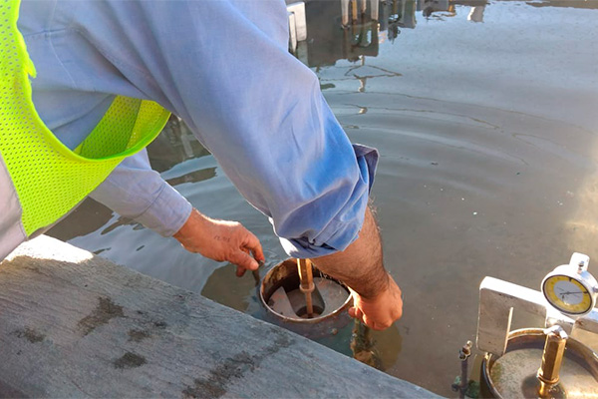
Figure 1. Example of CBR test placement to measure expansion.
The following limitations were encountered in conducting the study:
The stem in this test, being very small, cannot support a weight that closely replicates the specific gravity of the soil.
The test only allows particle sizes up to 19 mm in diameter.
To address these limitations, only gravels ranging from 4.75 mm to 19 mm were used, since, as mentioned previously, the larger the grain size, the greater the number and size of voids within the particles. Furthermore, to apply a surcharge to the soil equal to the specific gravity, a taller stem was fabricated to house the micrometer.
The procedure for measuring expansion using the modified CBR test is as follows:
Initially, the clay is brought to its natural moisture content found in situ.
The clay is mixed with the percentage of gravel for which the expansion is to be determined (for this experiment, 5%, 10%, and 15% of tezontle (a type of volcanic rock) were used relative to the specific gravity). The mixture is compacted to the natural specific gravity of the clay plus the density of the tezontle (volcanic rock) contributed by the included percentage, that is:
$$γ_{prom}=\frac{100}{\frac{P_{1}}{γ_{1}}+\frac{P_{2}}{γ_{2}}} \left(1\right)$$
$γ_{prom}$= Specific gravity of the clay-vesicular material mixture (g/cm3)
$P_{1}$= Percentage of vesicular material (5, 10, or 15%)
$P_{2}$= Percentage of clay (95, 90, or 85%)
$γ_{1}$= Density of vesicular material (g/cm3)
$γ_{2}$= Density of clay (g/cm3)
The compacted mixture is placed in the tank “without water” using the stem, and then a surcharge equal to that of the clay in situ is added.
Finally, the micrometer is placed on the stem, and the tank is filled with water to begin measuring the expansion. The final product of the procedure can be reviewed in Figure 2.
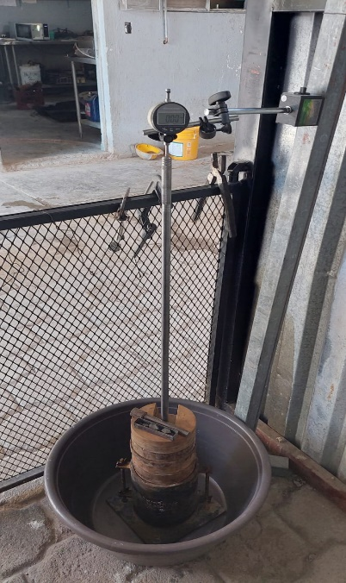
Figure 2. Result of the one-dimensional expansion test with CBR modification.
Results and Discussion
The clay used possesses all the characteristics that indicate it is an expansive soil (high liquid limit, high plasticity index, high clay content). These index properties can be observed in Table 1. The expansion test obtained in several tests carried out in accordance with the ASTM D4546 standard shows different values ​​in the percentage of expansion, between 9.13 and 12.02% (Figure 3) due to the variation in the water content in the undisturbed samples used; the expansion pressure itself varied between 4.87 and 7.79 t/m2. This, along with the Reese and O’Neill criteria in Table 1, classifies the soil as having high expansion.
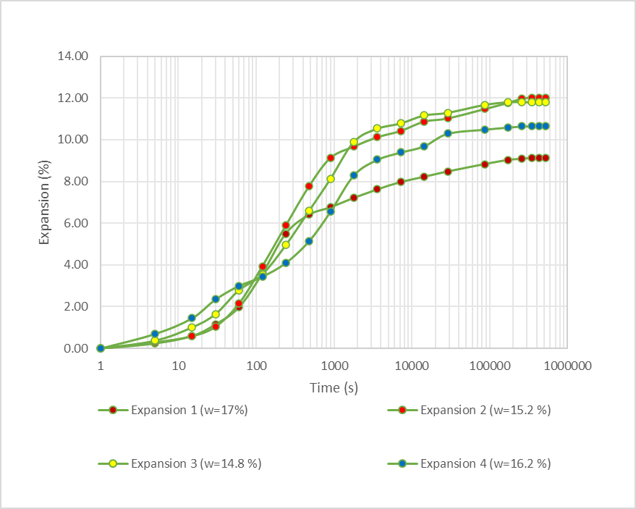
Figure 3. Results of the percentage of expansion in undisturbed soil samples.

Table 2. Index properties of the clay to be used in the experiment
Gravel | 0.00 | %
Sand | 16.30 | %
Slit | 49.39 | %
Clay | 34.31 | %
Limit liquid (LL) | 84.87 | %
Plastic limit (PL) | 33.33 | %
Plastic Index (PI) | 51.54 | %
Contraction limit (SL) | 14.72 | %
Lineal contraction (LS) | 21.63 | %
Liquidity ratio (LI) | 0.18
Specific gravity of soil solids ($G_{S}$) | 2.71
Soil classification | CH

According to the tests, the tezontle used has an open pore volume of 139.7 cm³ in a quantity of 1817 grams of material, a density of 1.7463, and an absorption of 8.3%.
Rodriguez P., Mesa G., and Bimbela C. demonstrate in their research that creating voids in expansive soils can help reduce their vertical expansion. In this case, the voids in the tezontle (volcanic rock) material, ranging from 4.75 cm to 19 mm, possess a number of pores that act as a volumetric buffer. That is, when the clay expands, it finds a space in the tezontle where it can swell freely, thus reducing the vertical thrust.
As mentioned previously, increasing the grain size of the tezontle aggregate also increases the amount of open porosity. Currently, there are no laboratory tests that allow for aggregate sizes larger than 3/4". Therefore, the aggregate size used for laboratory tests is between 4.75 and 19 mm.
The results of the clay expansion in the CBR mold (Figure 4) show an expansion percentage of 7.09% using a surcharge of 12.72 kPa while maintaining a moisture content of 14.8%.
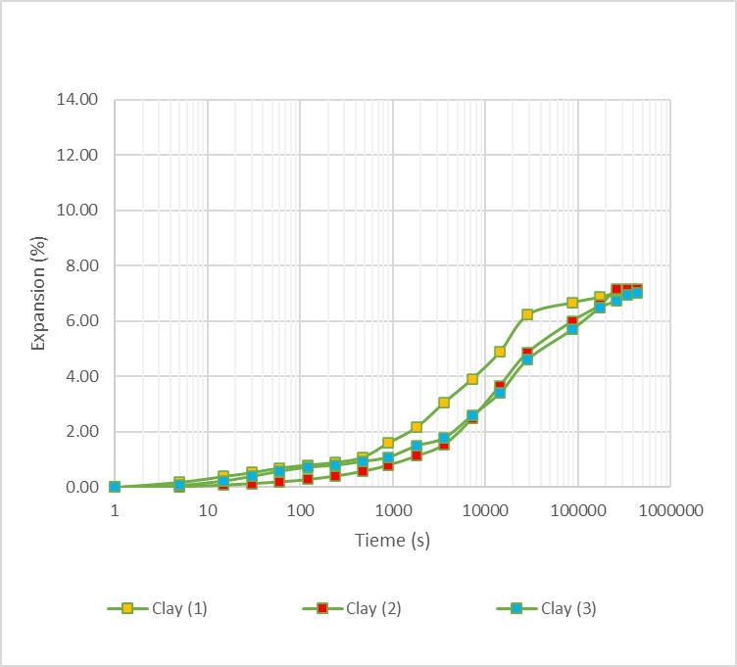
Figure 4. Percentage of clay expansion without tezontle.
For the clay mixture with 5% tezontle (volcanic rock), the expansion percentage was 4.61%. Adding 10% vesicular material resulted in an expansion percentage of 4.27%, and with 15% tezontle, the expansion percentage was 3.88%. These measurements were taken as a reference point, subtracting the height of the spacer disc from the height of the CBR mold, which is 116.4 mm. Furthermore, as shown in Figure 5, there was a slight settling in the mixture. This occurred because the natural voids in the tezontle initially filled before the expansion took place. The settling percentages were 0.24%, 0.3%, and 0.43%, respectively.
This suggests that although tezontle helps to mitigate expansion to some extent, it creates a small initial instability that increases as the soil becomes saturated. However, after one day of saturation, expansion begins to occur. In comparison, the deformation-time curve in Figure 4 (unstabilized clay) shows swelling at the moment the soil becomes saturated and does not exhibit any type of collapse or settlement. This type of soil would fall into a collapse-expansion category. Gonzalez E. mentions a category where the soil initially expands and subsequently collapses, but not a pattern of initial collapse followed by subsequent swelling.
The variation in the percentage of expansion between the CBR mold and the consolidation ring can be due to two important things. The first is that, since the soil in the CBR mold is below and some of the weights placed on the samples could exert lateral friction with the mold, the soil, when expanding, also has that additional friction with the mold, which is not generated in the expansion tests with the consolidation rings.
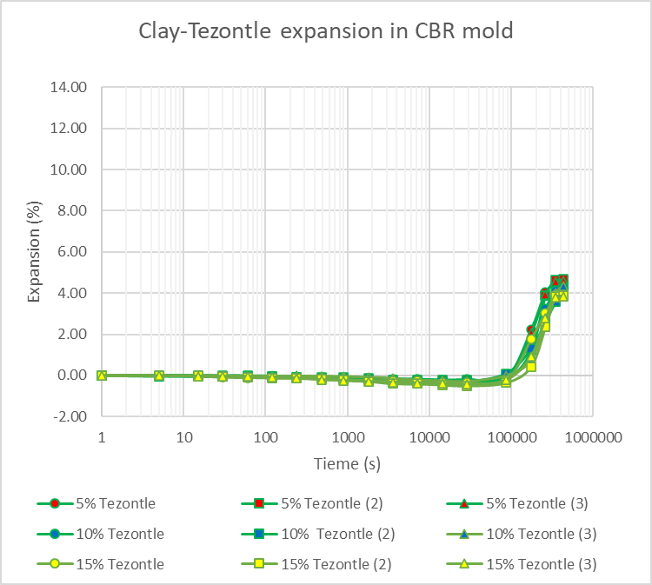
Figure 5. Percentage of expansion of the clay mixture with vesicular material.
Conclusions
The variation in the percentage of expansion between the oedometer tests and the CBR test may be due to the increased soil friction in the CBR mold compared to that of the consolidation rings.
However, it can serve as a preliminary result. The expansion of clays can be mitigated to some extent by combining them with tezontle (a type of volcanic rock). Initially, with 5% tezontle it decreases by 35%, with 10% it decreases by 39.8%, and with 15% it reduces it by 45.3%. While it doesn't eliminate the expansion completely, it can be used as an alternative to reduce it.
In this way, a quantity of tezontle can be added to the soil by combining it with another volume-reducing agent such as cement or lime. This is done to reduce construction costs.
In various parts of Mexico, such as El Salto, Jalisco; Acatlán, Jalisco; Valle de Santiago, Guanajuato; and Querétaro, Querétaro, among others, it is very common to find porous materials like tezontle, which can be used to stabilize silts or expansive clays instead of conventional chemical stabilizers such as lime or cement. Furthermore, the carbon footprint generated by the production of these materials is greater due to the high-temperature calcination processes compared to the extraction of vesicular material from quarries.
To apply this procedure in the field, a borrow material containing gravel between 4.75 and 75 mm can be selected (a larger size is acceptable if the necessary equipment is available to determine the degree of compaction and the layer thickness is at least twice the size of the largest aggregate). A minimum thickness of 0.20 m is scarified, and then mixed with tezontle gravel using a motor grader. The mixture is brought to its optimum moisture content or two percentage points higher, and then compacted to 95% of its maximum dry density obtained in the laboratory using a standard effort.
Table 3 shows a comparison of the findings obtained when using tezontle as a stabilization medium:
Table 3. Summary of results
Percentage of tezontle | Expansion reduction (%) | Initial Settlement (%) | Relative Efficiency
5% | 35.0% | 0.24% | High
10% | 39.8% | 0.30% | Medium-High
15% | 45.3% | 0.43% | Maximum Mitigation

COMPETING INTERESTS DISCLAIMER:
Authors have declared that they have no known competing financial interests OR non-financial interests OR personal relationships that could have appeared to influence the work reported in this paper.

References
- ASTM D854-14. Standard Test Methods for Specific Gravity of Soil Solids by Water Pycnometer.
- ASTM D1883-21. Standard Test Method for California Bearing Ratio (CBR) of Laboratory-Comapacted Soils.
- ASTM D2487-17e1 Standard Practice for Classification of Soils for Engineering Purposes (Unified Soil Classification System).
- ASTM D7928-21e1. Standard Test Method for Particle-Size Distribution (Gradation) of Fine-Grained Soils Using the Sedimentation (Hydrometer) Analysis.
- ASTM D4318-17e1. “Standard Test Methods for Liquid Limit, Plastic Limit, and Plasticity Index Soils”.
- ASTM D4546-21. “Standard Test Methods for One – Dimensional Swell or Settlement Potential of Cohesive Soils”.
7. Bimbela, C. A. (2014). Ecological and Sustainable Solution for Reducing Clay Expansion Through Drilling. [Master’s Thesis, Autonomous University of Querétaro]. DGBSDI-UAQ Institutional Repository. http://ri-ng.uaq.mx/handle/123456789/280
8. Gonzalez, Eduardo (2017). Deciphering the Enigma of Collapsible Expansive Soils. *Revista Geotecnia*.
9. Meza T., Guillermo (2016). Field Drilling: An Alternative for Reducing Soil Expansion. Thesis.
10. Rodriguez, Paulina. The Use of Porous Structures to Mitigate Clay Expansion. Thesis.
11. Geotechnical Studies for Overhead Transmission Line Structures, Specification CFE C0000-43. Federal Electricity Commission.
12. Gromko, G.J. (1974). Review of Expansive Soils. *International Journal of Rock Mechanics and Mining Sciences & Geomechanics Abstracts*, 11(10), 198 pp.

