Case report
From Isolated Dyspnea to Catastrophic Mechanical Complication:Posteromedial Papillary Muscle Rupture Following Subtle Inferior STEMI

Abstract
Background
Papillary muscle rupture (PMR) is a rare but rapidly fatal mechanical complication of acute myocardial infarction (MI) that may occur even after apparently limited ischemia. In the contemporary reperfusion era, its incidence is estimated between 0.05% and 0.26% of MIs, yet mortality remains extremely high.
Case Summary
A 67-year-old woman with diabetes presented with isolated acute dyspnea and subtle ST-segment elevation in inferior and posterior leads. Transthoracic echocardiography (TTE) revealed inferior wall akinesia and acute severe mitral regurgitation (MR) caused by flail mitral leaflet motion secondary to subtotal rupture of the posteromedial papillary muscle (PMPM). Within hours of admission, she developed sudden neurological deficits consistent with hyperacute ischemic stroke, followed by massive pulmonary edema and refractory cardiogenic shock (CS). Despite intensive supportive management and planned urgent surgical intervention, the patient died before surgery could be performed.
Discussion
PMR remains one of the most devastating mechanical complications of MI, with mortality reaching up to 80% without surgical treatment. This case highlights how a seemingly mild presentation of MI may rapidly evolve into catastrophic mechanical complications. Early echocardiographic evaluation and rapid multidisciplinary management are crucial, although prognosis remains extremely poor once CS develops.
Introduction
PMR is a rare but particularly devastating mechanical complication of acute MI. In the contemporary reperfusion era, its incidence is estimated to range between 0.05% and 0.26% of MIs [1]. Despite its rarity, PMR remains associated with extremely high mortality due to the abrupt onset of acute severe MR and rapid hemodynamic deterioration.
PMR typically occurs within the first hours to days following myocardial ischemia and results from necrosis of the papillary muscle caused by prolonged ischemic injury. Most cases occur between 24 hours and 7 days after ST-segment elevation myocardial infarction (STEMI), although earlier presentations have been reported, with a median time to diagnosis of approximately 13 hours in some series [2, 3].
Structural disruption of the papillary muscle leads to sudden loss of support of the mitral valve leaflets, resulting in acute severe MR. The abrupt regurgitant volume overload imposed on the left atrium and pulmonary circulation rapidly precipitates flash pulmonary edema, profound hemodynamic instability, and frequently CS.
We report an unusual and rapidly fatal clinical sequence in a diabetic woman presenting with isolated dyspnea that revealed a subtle inferior STEMI, which subsequently evolved to rupture of the posteromedial papillary muscle with acute severe MR, followed by ischemic stroke and refractory CS.
Case Presentation
A 67-year-old woman with significant cardiovascular risk factors, including long-standing diabetes mellitus, advanced age, and postmenopausal status, presented to the emergency department with acute worsening dyspnea. She experienced dyspnea corresponding to class III of the New York Heart Association (NYHA) classification for 8 hours before admission on a background of chronic exertional dyspnea (NYHA class II). She denied chest pain, palpitations, or other typical anginal symptoms.
On initial evaluation, the patient was conscious and hemodynamically stable. Cardiovascular examination revealed a new holosystolic murmur at the mitral area, while pulmonary auscultation detected bilateral basal crackles. Electrocardiography (ECG) showed subtle ST-segment elevation in the inferior and posterior leads with reciprocal ST-segment depression in the high lateral leads, consistent with an inferior STEMI (Figures 1 and 2).
Figure 1 : Subtle ST-segment elevation in inferior leads with reciprocal ST-segment depression in lateral leads.

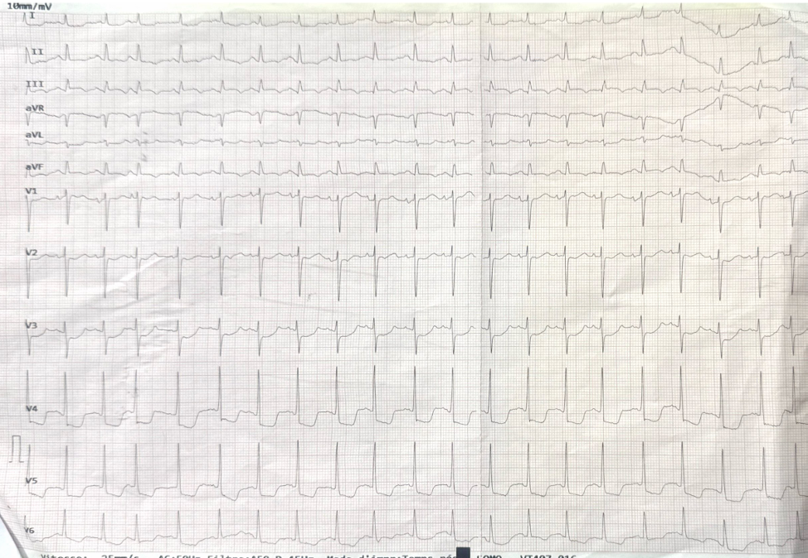
Figure 2 : Posterior and right precordial leads confirming inferoposterior STEMI pattern.

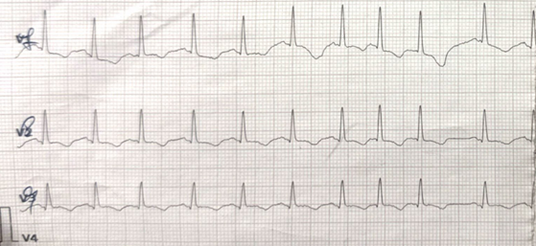
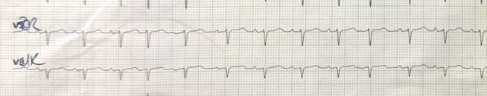
TTE demonstrated segmental left ventricular (LV) dysfunction with akinesia of the inferior wall. Acute severe MR was observed, with a regurgitant jet directed toward the lateral wall of the left atrium (Figure 3). The mechanism involved an everted flail A2 scallop attached to a highly mobile echogenic structure prolapsing from the LV into the left atrium during systole, consistent with subtotal rupture of the largest head of the PMPM (Figures 4 and 5). LV ejection fraction (LVEF) was preserved, right ventricular (RV) systolic function was normal, and the inferior vena cava (IVC) was not dilated, supporting the diagnosis of acute pulmonary edema. No pericardial effusion was observed.
Figure 3 : Severe eccentric regurgitant jet due to the prolapsing A2 segment of the anterior mitral valve leaflet.

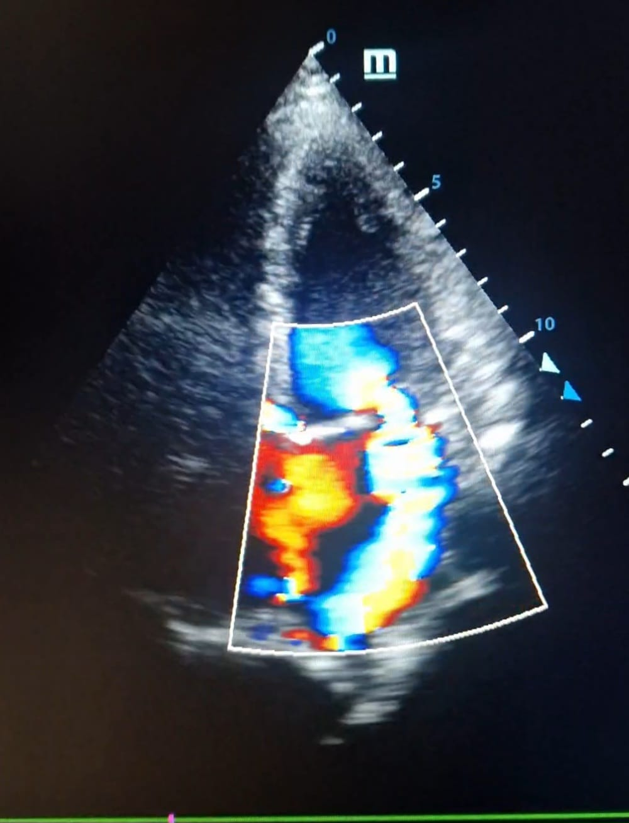
Within a few hours of admission, the patient developed sudden neurological deterioration characterized by left hemiplegia and dysarthria. Urgent non-contrast brain computed tomography (CT) performed one hour after symptom onset showed no acute abnormalities, findings compatible with hyperacute ischemic stroke not yet detectable on imaging.
Figure 4 : Four-chamber view showing the everted A2 segment of the anterior leaflet (blue arrow) attached to the ruptured body of the PMPM (echogenic mass, red arrow).

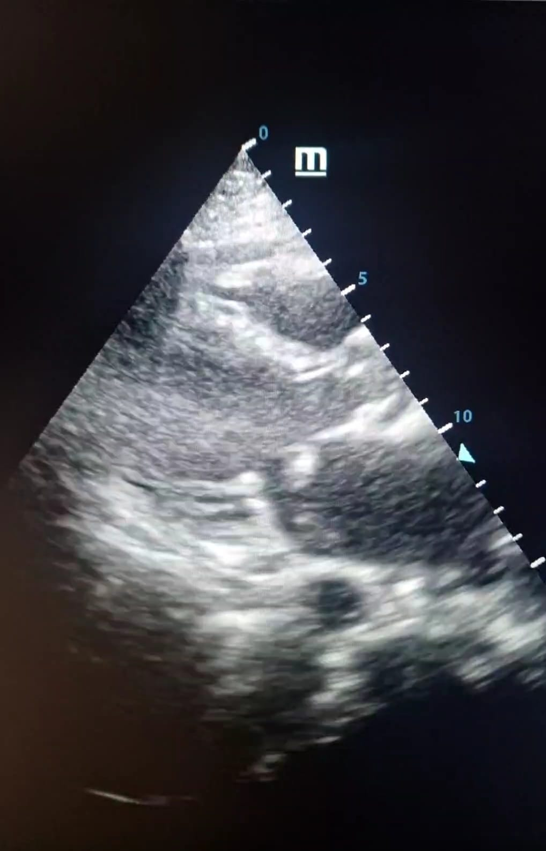
Figure 5 : Mid-parasternal short-axis view showing disappearance of the largest head of the ruptured posterior papillary muscle during systole as it protrudes into the left atrium.

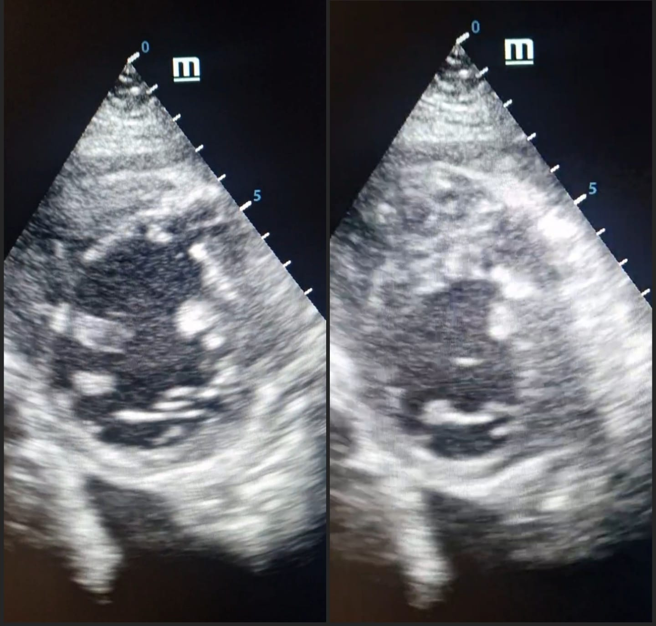
The patient subsequently experienced rapid clinical deterioration with the onset of massive pulmonary edema and CS, manifested by cold extremities, severe hypotension (71/30 mmHg), and extension of pulmonary crackles to the upper lung fields. She was transferred to the intensive care unit (ICU) for advanced hemodynamic management, including mechanical ventilation and vasoactive support. Coronary angiography and urgent surgical mitral valve repair with coronary revascularization were planned once hemodynamic stabilization could be achieved.
Despite maximal supportive therapy, the patient rapidly progressed to refractory CS and died approximately 10 hours after admission to the ICU before surgical intervention could be performed.
Discussion
The left ventricle contains two papillary muscles—the anterolateral and the posteromedial—which play a critical role in maintaining mitral valve competence during ventricular systole. Each papillary muscle gives rise to chordae tendineae that attach to both mitral valve leaflets, ensuring coordinated leaflet coaptation and preventing systolic prolapse into the left atrium.
However, the susceptibility of these muscles to ischemic injury differs because of their distinct coronary blood supply. The anterolateral papillary muscle benefits from a dual arterial supply from the left anterior descending (LAD) and the left circumflex (LCx) arteries, providing relative protection against ischemic injury. In contrast, the PMPM usually depends on a single arterial source—either the right coronary artery (RCA) or the LCx artery depending on coronary dominance [4]. This solitary vascular supply makes it particularly vulnerable to ischemic damage and subsequent rupture, especially in the setting of inferior MI.
Interestingly, most reported cases of PMR occur in relatively small infarctions involving less than 25% of the LV and in the absence of well-developed collateral circulation. In such situations, preserved global ventricular function may generate substantial mechanical stress and shear forces on the ischemic papillary muscle, ultimately leading to structural failure [5]. Moreover, PMR occurs more frequently in STEMI compared with non-STEMI.
Echocardiography plays a pivotal role in the diagnosis of PMR. TTE is generally the first-line imaging modality and may rapidly identify subtotal or complete rupture [6]. Typical echocardiographic findings include a highly mobile echogenic structure corresponding to the ruptured papillary muscle head prolapsing from the LV into the left atrium during systole [7], associated with a flail mitral leaflet and severe acute MR, as observed in our patient. Subtotal or complete rupture is usually the easiest form to recognize due to the characteristic oscillating motion of the papillary muscle head between the ventricle and the atrium.
However, the diagnostic sensitivity of TTE remains limited, ranging from approximately 65% to 85%, partly because the mitral valve apparatus is located posteriorly within the thorax. In cases of diagnostic uncertainty, transesophageal echocardiography (TEE) provides superior visualization, with reported diagnostic accuracy approaching 95–100% [8]. Real-time three-dimensional (3D) TEE may further refine anatomical assessment by precisely identifying the prolapsing mitral segment and demonstrating excellent correlation with surgical findings.
Once diagnosed, urgent surgical intervention remains the cornerstone of management and significantly improves survival compared with conservative medical therapy. Mortality rates for PMR may reach up to 75% within the first 24 hours when treated medically without surgical correction [5]. Data from the APEX-AMI trial demonstrated a 90-day survival of approximately 69% among surgically treated patients compared with only 33% among those managed medically.
The ACC/AHA guidelines (2013–2025) recommend mitral valve repair whenever feasible, particularly in cases of partial PMR where the tissue quality is suitable for repair. Mitral valve replacement (MVR), on the other hand, is more commonly performed and is considered the standard approach for complete or subtotal PMR, as in our case. MVR is also widely used due to greater surgeon experience and the established reliability and durability of the procedure, ideally in combination with concomitant coronary artery bypass grafting (CABG).
Nevertheless, surgery in the acute phase remains technically challenging because of the marked friability of infarcted myocardial tissue. Outcomes are therefore strongly influenced by the patient's preoperative clinical status. Several predictors of in-hospital mortality have been identified, including advanced age, chronic kidney disease, prior cardiac arrest, severe low cardiac output requiring extracorporeal membrane oxygenation (ECMO), CS, and a LVEF below 25% [9].
These observations highlight the critical importance of early recognition and prompt hemodynamic stabilization before definitive intervention.
The coexistence of acute ischemic stroke further complicates management. Severe acute MR secondary to PMR may promote thrombus formation within the left atrium due to acute dilation and blood stasis, creating a potential source of cerebral embolism. In addition, profound hemodynamic compromise and CS may lead to cerebral hypoperfusion and predispose to watershed ischemic infarction.
The occurrence of a recent ischemic stroke represents a major therapeutic dilemma, as cardiac surgery carries an increased risk of perioperative hemorrhagic transformation of the cerebral lesion. Management strategies therefore often require individualized decision-making within a multidisciplinary Heart Team. In selected patients, temporary mechanical circulatory support (MCS) may be used as a bridge to surgery. Devices such as intra-aortic balloon pump (IABP) or veno-arterial ECMO (VA-ECMO) can provide temporary hemodynamic stabilization [10], allowing time for partial recovery or neurological reassessment. Emerging transcatheter approaches, including edge-to-edge mitral valve repair, have also been described as potential rescue strategies in highly selected cases, although clinical experience remains limited [11, 6].
Importantly, the optimal timing of cardiac surgery following an acute ischemic stroke in the setting of PMR remains uncertain. Clinicians must therefore carefully balance the risk of neurological deterioration against the extremely high mortality associated with untreated acute severe MR.
Conclusion
This case illustrates the dramatic clinical course that may follow even subtle presentations of MI. PMR remains a rare but catastrophic complication that can rapidly lead to acute severe MR, pulmonary edema, and CS. Early recognition through prompt echocardiographic evaluation is essential to allow rapid hemodynamic stabilization and consideration of urgent surgical intervention. The coexistence of acute ischemic stroke further complicates therapeutic decision-making and highlights the need for rapid multidisciplinary management in these critically ill patients.
Key Points
- PMR is rare but rapidly fatal: Even small MIs can lead to rupture of the PMPM due to its single coronary blood supply.
- Atypical presentations can mask STEMI: Diabetic patients may present with isolated dyspnea without chest pain, delaying recognition of both the infarction and mechanical complications.
- Early echocardiography is essential: TTE can detect subtotal or complete rupture, while TEE and 3D TEE allow precise anatomical assessment and surgical planning.
- Acute ischemic stroke association is rare but clinically important: PMR can cause acute left atrial dilation and blood stasis, increasing the risk of thromboembolic cerebral events.
- Rapid multidisciplinary management is crucial: Survival depends on early recognition, hemodynamic support, and urgent surgical intervention, though prognosis remains poor once CS develops.
- Clinical lesson for practice: Any sudden respiratory deterioration after inferior MI should prompt immediate echocardiographic evaluation to exclude PMR. Close collaboration between cardiology, cardiac surgery, and neurology is essential to anticipate hemodynamic and neurological complications.
References
1. Damluji AA, van Diepen S, Katz JN, Menon V, Tamis-Holland JE, Bakitas M, Cohen MG, Balsam LB, Chikwe J; American Heart Association Council on Clinical Cardiology; Council on Arteriosclerosis, Thrombosis and Vascular Biology; Council on Cardiovascular Surgery and Anesthesia; and Council on Cardiovascular and Stroke Nursing. Mechanical Complications of Acute Myocardial Infarction: A Scientific Statement From the American Heart Association. Circulation. 2021 Jul 13;144(2):e16–e35. doi: 10.1161/CIR.0000000000000985.
2. Gong FF, Vaitenas I, Malaisrie SC, Maganti K. Mechanical Complications of Acute Myocardial Infarction: A Review. JAMA Cardiol. 2021;6(3):341–349. doi: 10.1001/jamacardio.2020.3690.
3. Estévez-Loureiro R, Lorusso R, Taramasso M, Torregrossa G, Kini A, Moreno PR. Management of Severe Mitral Regurgitation in Patients With Acute Myocardial Infarction: JACC Focus Seminar 2/5. J Am Coll Cardiol. 2024 May 7;83(18):1799–1817. doi: 10.1016/j.jacc.2023.09.840.
4. Estes EH Jr, Dalton FM, Entman ML, Dixon HB 2nd, Hackel DB. The anatomy and blood supply of the papillary muscles of the left ventricle. Am Heart J. 1966;71:356–362.
5. Sharma S, Burton LV, Beier K. Papillary Muscle Rupture. [Updated 2024 Nov 25]. In: StatPearls [Internet]. Treasure Island (FL): StatPearls Publishing; 2026. Available from: https://www.ncbi.nlm.nih.gov/books/NBK499976/
6. Pino PG, Parrini I, Moreo A, Terranova A, Nardi F. Echocardiographic Management of papillary muscle rupture during acute myocardial infarction. Explor Cardiol. 2025;3:101242.
7. Li S, Fang L, Wu W, Zhang Z, Ji L, Sun Z, He L, Wang Z, Fu W, Li F, Xie M, Yang Y. Echocardiographic diagnosis of rupture of mitral valve papillary muscle. Int J Cardiol. 2023 Nov 15;391:131273. doi: 10.1016/j.ijcard.2023.131273.
8. Sochowski RA, Chan KL, Ascah KJ, Bedard P. Comparison of accuracy of transesophageal versus transthoracic echocardiography for the detection of mitral valve prolapse with ruptured chordae tendineae (flail mitral leaflet). Am J Cardiol. 1991 Jun 01;67(15):1251–1255.
9. Kilic A, Sultan I, Chu D, Wang Y, Gleason TG. Mitral Valve Surgery for Papillary Muscle Rupture: Outcomes in 1342 Patients From The Society of Thoracic Surgeons Database. Ann Thorac Surg. 2020 Dec;110(6):1975–1981. doi: 10.1016/j.athoracsur.2020.03.097.
10. Matteucci M, Ronco D, Kowalewski M, Massimi G, De Bonis M, Formica F, et al. Long-term survival after surgical treatment for post-infarction mechanical complications: results from the Caution study. Eur Heart J Qual Care Clin Outcomes. 2024:qcae010.
11. Haberman D, Estévez-Loureiro R, Czarnecki A, Denti P, Villablanca P, Spargias K, et al. Transcatheter edge-to-edge repair in papillary muscle injury complicating acute myocardial infarction. ESC Heart Fail. 2024;11:1218–1227.

