Iron Deficiency in Older Adults Hospitalized for Acute Heart Failure: Prevalence, Clinical Correlates, and One-Year Outcomes in a Moroccan Prospective Study

Abstract
Background: Iron deficiency is a common comorbidity in patients with heart failure. This association is often underrecognized in clinical practice, despite its important implications for symptoms and prognosis. Iron deficiency has been associated with worse symptoms, impaired functional status, and poorer clinical outcomes. Data from North Africa remain scarce, particularly in older adults hospitalized for acute or decompensated heart failure

Methods: A single-center (Ibn Rochd University Hospital in Casablanca) prospective observational study was conducted in the Cardiology Division. The study included consecutive patients aged ≥65 years that were admitted for acute heart failure or decompensated chronic heart failure during a 12-month period. Iron deficiency was defined as a ferritin concentration <100 ng/mL, or 100-299 ng/mL with transferrin saturation <20%. Clinical, laboratory, and echocardiographic data were collected at admission. Patients were followed for one year for a composite outcome of heart failure rehospitalization or all-cause death.
Results: Fifty patients were included; the median age was 84 years (range, 65-104). Men and women were equally represented. Hypertension was present in 82%, diabetes in 32%, and active smoking in 18%. Functional limitation was substantial, with 50% of patients in NYHA class II, 40% in class III, and 10% in class IV. Anemia occurred in 52% of this cohort, and among those with Anemia, 82% of those were iron deficient. Among patients with iron deficiency, 63% were anemic and 37% were not. Echocardiographic findings displayed LVEF <45% for 38%; LV end-diastolic diameter >55 mm 24%; TAPSE <16 mm 24%; elevated pulmonary artery systolic pressure 40%; and a PASP/TAPSE ratio >3 mmHg/mm of 30%. At one year, event-free survival for the composite endpoint of heart failure rehospitalization or all-cause death was 94%. Given the very low number of events observed during follow-up, subgroup comparisons were descriptive and should be interpreted cautiously.
Conclusions: In this cohort of Moroccan patients hospitalized for acute heart failure, iron deficiency was highly prevalent and was frequently present in the absence of overt anemia. The data has highlighted the need for routine iron testing during the inpatient stay; as this will allow for the identification of patients who may later qualify for intravenous iron therapies after they have undergone a period of medical stabilization.
Keywords: heart failure; iron deficiency; anemia; acute heart failure; prognosis; Morocco.

Introduction

Heart failure contributes significantly to old age hospitalization, or death, and is a global problem; regions such as high-income countries have an even greater challenge dealing with heart failure than do low- or middle-income regions. Older adults suffer from heart failure and also frequently demonstrate comorbid conditions such as; frailty, renal failure, multiple co-existing diseases, repeat episodes of decompensation, and progressive autonomy loss. The deleterious cardiovascular effects of low cardiac output states and congestion are compounded by repeat visits to either the emergency department or hospitalizations (length of stay) for heart failure as well as by diminished quality of life and one of the strongest predictors of repeat hospitalizations following discharge from hospital. Ordinarily, many of these can be explained by the presence of heart disease only. However, they are largely due to the combination of heart disease and the many non-cardiac medical problems that the patient has and that lead to symptoms, tolerability of treatment, as well as the prognosis of the patient as a whole. Consequently, it is of great importance to assess the patients who come to the hospital with acute heart failure for possibly remediable comorbidities. To date, there has been little research performed on patients with heart failure in North Africa or other developing countries, thus, identifying research performed in the local area on this topic will help to clarify the characteristics and treatment of patients admitted to the hospital for heart failure based on observational data [1,2].

Iron deficiency has been recognized as a significant non-cardiac comorbid condition in patients with heart failure, and is now considered a systemic disease that is associated with metabolic, muscular, and functional deficits. Iron is vital for the transport of oxygen, mitochondrial respiration, cellular energy production, and the functional capacity of skeletal muscle; therefore, the presence of iron deficiencies in patients suffering from heart failure may lead to problems such as fatigue, decreased exercise tolerance and dyspnea, decreased ability to perform physical activities, and lower quality-of-life, independent of any associated hematological conditions (i.e., anemia) [3,4]. This is extremely important from a clinical standpoint because patients who have iron deficiency may not be symptomatic at the time of their presentation, do not typically meet the criteria for being classified as anemic, and may go unnoticed if clinicians only use laboratory methods such as complete blood counts to screen for iron deficiencies.

The development of iron deficiency due to heart failure is multifactorial and complex. Proposed etiologic mechanisms include low dietary intake/excessive malabsorption from bowel edema; chronic inflammatory disorders; renal dysfunction; repeated hospitalizations for decompensated heart failure; occult gastrointestinal bleeding; and altered iron metabolism due to Hepcidin. In acute decompensation these factors will be more pronounced, so that inflammation can complicate the interpretation of ferritin levels. Therefore, iron deficiency in heart failure could be described as absolute deficiency, functional deficiency or an overlapping of both types of deficiency. Determining the exact mechanism by which older adults develop iron deficiency is particularly important due to the high prevalence of chronic kidney disease, multiple medication usage, nutritional risk factors and presence of comorbidities [3,4].

Iron deficiency also plays an important role in chronic heart failure patients; studies show iron deficiency can affect 40%-60% of patients in chronic heart failure. Greater symptom burden, poor exercise capacity and worse clinical outcomes have been correlated with iron deficiency consistently across the literature for chronic heart failure patients [5]. The most commonly used biochemical definition of iron deficiency in clinical trials and practice guidelines is ferritin <100 ng/mL or ferritin between 100 to 299 ng/mL with transferrin saturation <20% present. Although this definition has been widely used in real world scenarios and is clinically relevant, controversy exists regarding its diagnostic accuracy for patients with chronic heart failure with comorbidities or acute illnesses [2, 6, 7]. Nevertheless, this definition serves as a currently accepted method to study iron deficiency within a chronic heart failure population in real world situations.

In the last ten years there has been major growth in the area of interest for this comorbidity. Randomized clinical trials have demonstrated that intravenous iron (particularly ferric carboxymaltose) may improve symptoms, functional status and, in many cases, the quality of life of select patients with heart failure that also exhibit iron deficiency (8–14). The results from the studies that examined safety and more definitive clinical outcomes showed more mixed results. Earlier studies demonstrated a decrease in the number of recurrent hospitalizations for heart-failure, but then large, more recent studies provided more ambiguous efficacy data. However, updated meta-analyses continue to demonstrate that there is a clinically relevant reduction in heart-failure events; however, they have yet to demonstrate a definitive mortality benefit (16–20). This evidence is a continuing justification for regularly assessing iron levels for patients with heart failure; and also shows the importance of further defining iron deficiency (and its assessment and treatment) within different/crosscutting clinical contexts — particularly in acute heart failure and among populations that are traditionally underrepresented.

Despite limited contemporary information regarding the prevalence and profile of iron deficiency in older adults with acute heart failure in Morocco, as well as North Africa in general, it is important to define this issue since older adult patients with acute heart failure may differ in patient characteristics, nutritional habits, comorbidity burden, and access to follow-up care, compared to older adult patients with acute heart failure in large cohort studies conducted in the western world. Therefore, the purpose of this study was to examine and describe the prevalence of iron deficiency in older adults admitted to a tertiary center in Morocco with acute heart failure, to examine the relationship between iron deficiency, anemia and selected echocardiographic features, and to assess the relationship of iron deficiency to clinical outcomes at short-term follow-up.

Materials and Methods
We performed a prospective observational study in the cardiology department of Ibn Rochd University Hospital, Casablanca, Morocco. The study period extended over one year. This tertiary-care center receives a substantial number of older adults with acute cardiovascular conditions and provides an appropriate setting in which to examine the burden of comorbidities in patients hospitalized for acute heart failure.
Eligible patients were 65 years of age or older and were hospitalized for acute heart failure or decompensated chronic heart failure according to clinical, laboratory, and echocardiographic criteria. Patients presented with acute infection and requiring immediate alternative management (severe inflammatory disease), patients with known hematologic malignancy or continuing iron supplementation were excluded from this study. At the same time, some patients included in the cohort could still present with intercurrent or concomitant infectious conditions noted during hospitalization, which reflects the complexity of older adults admitted with acute heart failure.
For the purpose of these analyses, data collected during the admission for all admission records included descriptive characteristics of patients (demographics, cardiovascular risk factors), previous medical history and chronic treatment and basic clinical findings (New York Heart Association (NYHA) Functional Classification). Laboratory testing included hemoglobin, ferritin, transferrin saturation, renal function, thyroid profile, lipid profile, natriuretic peptides, and other routinely available biomarkers.
Iron deficiency was defined according to contemporary guideline-based criteria as ferritin <100 ng/mL, or ferritin 100-299 ng/mL with transferrin saturation <20% [2,3,6,7]. Anemia was assessed using the admission hemoglobin value. Transthoracic echocardiography was performed within 48 hours of admission and included left ventricular ejection fraction, left ventricular end-diastolic diameter, TAPSE, pulmonary artery systolic pressure, and the PASP/TAPSE ratio. These parameters were chosen because they provide a practical overview of left ventricular systolic function, chamber remodeling, right ventricular systolic performance, and right ventricular-pulmonary arterial coupling, all of which are relevant in acute heart failure and may influence prognosis.
The primary study objective was to determine the prevalence of iron deficiency. Secondary objectives were to describe its relationship with anemia and selected clinical, biological, and echocardiographic features, and to examine its association with a composite outcome of heart failure rehospitalization or all-cause death at one year.
Continuous variables were summarized as mean ± standard deviation or median with range, depending on distribution . Categorical variables were expressed as counts and percentages. Group comparisons used Student's t test or the Mann-Whitney U test for continuous variables and the χ² test or Fisher's exact test for categorical variables, with p < 0.05 considered statistically significant. Given the modest sample size and limited number of events, outcome analyses should be interpreted as exploratory.

Results
A total of 50 patients were included. The median age was 84 years (range, 65–104), and men and women were equally represented. There were several significant cardiovascular predisposing factors in this population: 82% of patients were hypertensive, 32% diabetic, and 18% of participants smoked cigarettes (Table 1, Figure 1). Functional limitation at presentation was substantial, with half of the cohort in NYHA class II, 40% in NYHA class III, and 10% in NYHA class IV (Figure 2).

Table 1. Baseline clinical characteristics of the study population
Variable | Value
Sample size | 50
Age, median (range), years | 84 (65-104)
Male sex | 25 (50%)
Female sex | 25 (50%)
Hypertension | 41 (82%)
Diabetes mellitus | 16 (32%)
Active smoking | 9 (18%)
NYHA class II | 25 (50%)
NYHA class III | 20 (40%)
NYHA class IV | 5 (10%)
Anemia | 26 (52%)
Iron deficiency | 41 (82%)

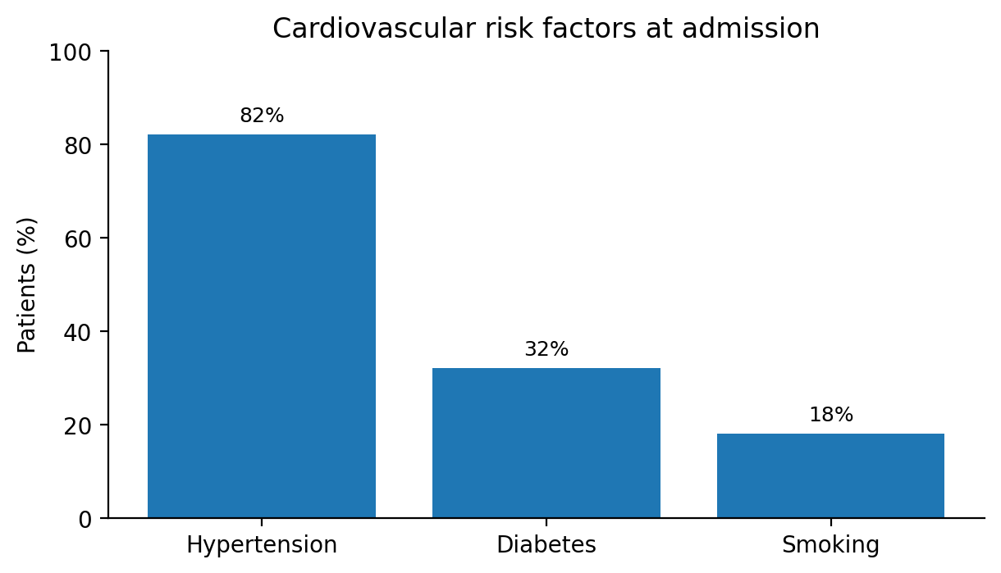
Figure 1. Prevalence of major cardiovascular risk factors at admission.

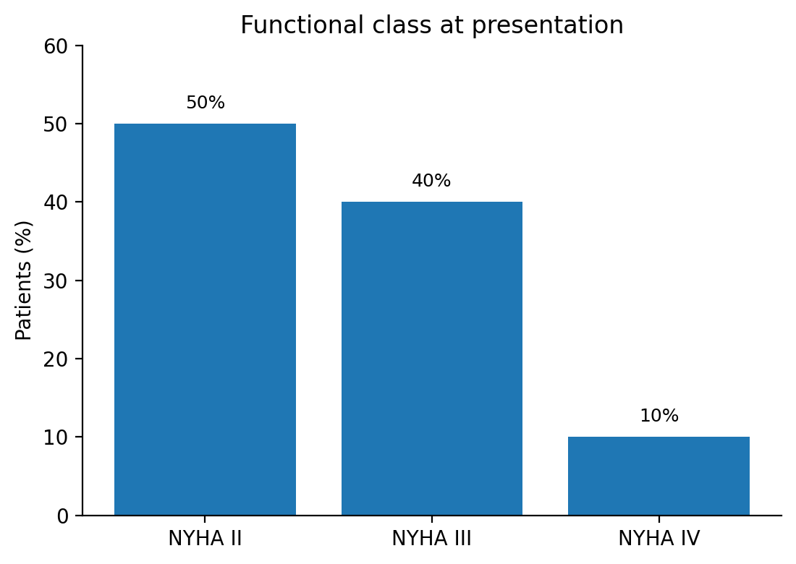
Figure 2. Functional class distribution according to NYHA category.
Fifty-two percent of patients were documented with anemia while 82% had documented iron deficiency. Iron deficiency was not confined to patients who were anemic as 65% of the individuals who were iron deficient were also anemic and 35% were not. Therefore, an appreciable proportion of patients would have been missed had hemoglobin been utilized as the sole test to screen for iron deficiency (Figure 3). A statistically significant relationship was found between iron deficiency and anemia (p < 0.001).

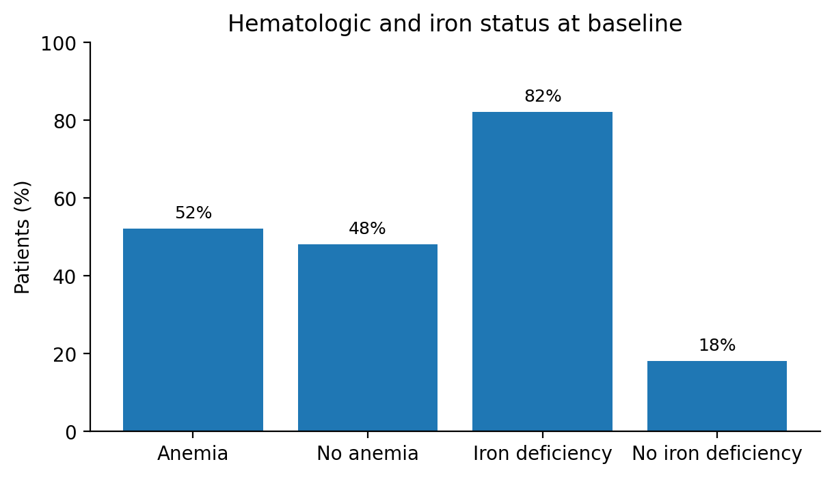
Figure 3. Baseline prevalence of anemia and iron deficiency.
Selected echocardiographic abnormalities were frequent. LVEF was below 45% in 38% of patients, LV end-diastolic diameter exceeded 55 mm in 24%, TAPSE was below 16 mm in 24%, pulmonary artery systolic pressure was elevated in 40%, and the PASP/TAPSE ratio exceeded 3 mmHg/mm in 30% (Table 2). Biologically, macrocytic anemia was rare (4%). Reduced creatinine clearance was documented in 76% of patients, BNP was elevated in 98%, thyroid disorders were present in 14%, and concomitant infection was noted in 78% of cases. The latter finding likely reflects the high degree of medical complexity in this population and may also have influenced the inflammatory milieu and iron biomarker profile.
Table 2. Selected echocardiographic and laboratory results.

Variable | Value
LVEF <45% | 19 (38%)
LV end-diastolic diameter >55 mm | 12 (24%)
TAPSE <16 mm | 12 (24%)
Elevated pulmonary artery systolic pressure | 20 (40%)
PASP/TAPSE ratio >3 mmHg/mm | 15 (30%)
Macrocytic anemia | 2 (4%)
Renal dysfunction based on creatinine clearance | 38 (76%)
Elevated total cholesterol | 38 (76%)
Elevated BNP | 49 (98%)
Thyroid disorder | 7 (14%)
Concomitant infection | 39 (78%)

In exploratory analysis, there was an increased occurrence of anemia among patients living outside of the Ibn Rochd catchment area (74%) and with atrial fibrillation (68%). These observations should be interpreted cautiously due to sample size and lack of adjustment.
One-year event-free survival for the composite endpoint of heart failure rehospitalization or all-cause death was 94% (Figure 4). At first sight, this outcome appears favorable for a cohort with a median age of 84 years hospitalized for acute heart failure.Exploratory analysis suggested a possible increase in risk among patients with iron-deficiency anemia, but this finding should be interpreted with great caution given the very small number of events, whereas non–iron-deficiency anemia did not appear to modify risk. However, these findings must be interpreted with great caution because the number of events was very small and the study was not powered for prognostic comparisons.

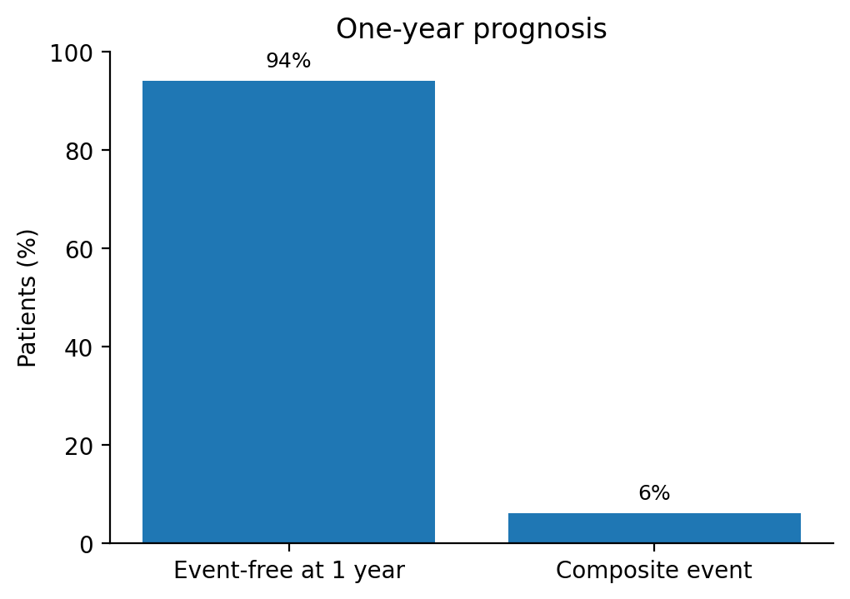
Figure 4. One-year event-free survival for the composite endpoint.

Discussion
The principal finding of this study is the very high prevalence of iron deficiency in older adults hospitalized for acute heart failure. More than four out of five patients met conventional biochemical criteria for iron deficiency, and more than one-third of iron-deficient patients were not anemic. This distinction matters clinically, because iron deficiency in heart failure has prognostic and functional implications that are only partially captured by hemoglobin concentration alone [3-5,7]. From a practical standpoint, this is one of the most relevant messages of the study: in older adults with acute heart failure, routine blood count is not an adequate surrogate for iron assessment.
The prevalence rate we determined was considerably higher than the reported 50% prevalence rate confirmed in multiple chronic heart failure cohorts [3,5]. Several factors may explain this difference. This discrepancy could largely be due to the older age demographic represented by our population, the acute nature of presentation in these patients, the high burden of comorbidity, and known dynamic fluctuation of iron markers seen throughout decompensations [15]. The high prevalence of renal dysfunction and the frequent presence of infection or inflammatory conditions in our cohort may also have contributed to functional iron deficiency.
The limited overlap of iron deficiency and anemia as identified in our data is worthy of attention. Although we have found that iron deficiency and anemia were significantly correlated, the correlation does not exist with perfect correlation. For example, more than one-third of iron-deficient subjects were not anemic. The findings of our study are also in agreement with other research findings related to heart failure and that iron deficiency is an important, independent clinical condition, not simply the cause of low hemoglobin. The role of iron in mitochondrial enzyme systems, oxidative metabolism and skeletal muscle energy is also important because the absence of iron will hinder physical performance and well-being where the oxygen carrying capacity has not yet been compromised. Consequently, this visualizes the reasons for excessive fatigue and limited effort tolerance in some patients despite having seemingly normal hemoglobin levels [3-5,7].

From a pathophysiological perspective, our findings are plausible. Heart failure may promote intestinal congestion and reduced nutrient absorption, whereas chronic inflammation and hepcidin-mediated sequestration can limit iron availability. Renal dysfunction may further exacerbate this imbalance through inflammation, reduced erythropoietin activity, and impaired metabolic reserve. In hospitalized older adults, poor oral intake, frailty, recurrent illness, and polypharmacy may also contribute. These mechanisms are likely to coexist in many patients. The high prevalence of iron deficiency observed in this study therefore probably reflects the combined influence of nutritional, inflammatory, renal, and cardiovascular factors rather than a single isolated pathway [4,21]. This is one reason why reliance on anemia alone leads to underdiagnosis.
The therapeutic implications are increasingly important. Notable studies such as FAIR-HF and CONFIRM-HF showed improvements in symptoms, exercise capacity, and quality of life with intravenous ferric carboxymaltose in symptomatic patients with iron deficiency [8-10]. AFFIRM-AHF extended this strategy to patients stabilized after acute heart failure and suggested a reduction in recurrent heart-failure hospitalizations, alongside a measurable benefit in health-related quality of life [13,14]. More recent studies have provided a less uniform signal. IRONMAN suggested a possible clinical benefit [16], whereas HEART-FID and FAIR-HF2 did not show a clear advantage across their primary efficacy outcomes [17,18]. Overall, the available evidence continues to support a beneficial effect of intravenous iron on heart-failure hospitalization, whereas its impact on cardiovascular and all-cause mortality remains less certain [19]. The contemporary guidelines recommend screening patients with heart failure for iron deficiency; intravenous iron therapy may be considered for appropriately selected symptomatic patients with either reduced or mildly reduced ejection fractions [2,3,6]. More recent trials and meta-analyses published after the 2023 ESC focused update have added important nuance to this field, but they should be interpreted as subsequent evidence rather than as part of the guideline basis itself.
The results of our investigation must be viewed cautiously. The 94% one-year event-free survival observed is commendable, especially when factoring in the median age of participants in our cohort. There are multiple potential explanations for this; one is the small sample size and the very low number of events which may contribute to a lack of precision in these estimates. Another possible explanation is the incomplete capture of out of institution events in older patients, who are likely to have had fragmented follow-up, from other institutions may further contribute to these limitations. Therefore, the exploratory observation that iron deficiency anemia is associated with a higher risk should not be considered definitive but rather a potential signal-generating observation that may warrant increased investigation in larger, multi-center cohorts.
Our findings support the implementation of routine iron studies during hospitalization for acute heart failure in our setting. In older adults, where dyspnea, fatigue, and reduced exercise tolerance can be multifactorial, identifying a potentially modifiable contributor such as iron deficiency is clinically attractive. The high rate of iron deficiency in our cohort suggests that systematic screening could have substantial practical yield.

There are a few limitations attached to this research. First of all, this study was conducted at one tertiary care center and included a small sample size. This limits the external validity and statistical accuracy of the findings. Second, while the participants were recruited from both prospective and consecutive groups of patients, the sample is still susceptible to selection bias due to the referral patterns and hospitalization thresholds as well as the characteristics of the center. Third, it is well-known that ferritin levels change due to inflammatory-related states. This may result in decreased ability to make an accurate determination of iron levels because of the presence of inflammatory states/infection in the patients in this study. Fourth, the number of clinical events would not allow for robust prognostic analysis or meaningful decline. Finally, some of the variables analyzed had missing data or only had aggregate data. This limited our ability to statistically evaluate subgroups in a meaningful way. Also, we had very limited data on treatment-related events and/or detailed adjudication of these events that occurred outside our institution. Due to the small size of the cohort, limited amount of outcomes and potential for incomplete outcome capture outside the institution; this time point should be interpreted with caution.

Conclusion

In this single-center prospective study of older adults hospitalized for acute heart failure in Casablanca, iron deficiency was highly prevalent and frequently present in the absence of overt anemia. Based on these results, routinely measuring iron levels in hospitalized patients is useful for identifying patients who may benefit from evidence-based intravenous iron therapies after being medically stabilized. To confirm the distribution of iron deficiency in a representative sample of Moroccan and North African patients and to clarify the prognostic and therapeutic significance of iron deficiency in everyday clinical practice, additional multicenter research will be necessary.

Declarations
Competing interests: The authors declare no competing interests.
Consent: Written informed consent has been obtained and documented in accordance with institutional policy.

References
1. Savarese G, Becher PM, Lund LH, Seferovic P, Rosano GMC, Coats AJS. Global burden of heart failure: a comprehensive and updated review of epidemiology. Cardiovasc Res. 2023 Jan 18;118(17):3272-3287. doi: 10.1093/cvr/cvac013.
2. McDonagh TA, Metra M, Adamo M, Gardner RS, Baumbach A, Böhm M, et al. 2021 ESC Guidelines for the diagnosis and treatment of acute and chronic heart failure. Eur Heart J. 2021 Sep 21;42(36):3599-3726. doi: 10.1093/eurheartj/ehab368.
3. Beavers CJ, Ambrosy AP, Butler J, Davidson BT, Gale SE, Piña IL, et al. Iron Deficiency in Heart Failure: A Scientific Statement from the Heart Failure Society of America. J Card Fail. 2023 Jul;29(7):1059-1077. doi: 10.1016/j.cardfail.2023.03.025.
4. Alnuwaysir RIS, Hoes MF, van Veldhuisen DJ, van der Meer P, Beverborg NG. Iron Deficiency in Heart Failure: Mechanisms and Pathophysiology. J Clin Med. 2021 Dec 27;11(1):125. doi: 10.3390/jcm11010125.
5. Klip IT, Comin-Colet J, Voors AA, Ponikowski P, Enjuanes C, Banasiak W, et al. Iron deficiency in chronic heart failure: an international pooled analysis. Am Heart J. 2013 Apr;165(4):575-582.e3. doi: 10.1016/j.ahj.2013.01.017.
6. McDonagh TA, Metra M, Adamo M, Gardner RS, Baumbach A, Böhm M, et al. 2023 Focused Update of the 2021 ESC Guidelines for the diagnosis and treatment of acute and chronic heart failure. Eur Heart J. 2023 Oct 1;44(37):3627-3639. doi: 10.1093/eurheartj/ehad195.
7. Masini G, Graham FJ, Pellicori P, Cleland JGF, Cuthbert JJ, Kazmi S, et al. Criteria for Iron Deficiency in Patients With Heart Failure. J Am Coll Cardiol. 2022 Feb 1;79(4):341-351. doi: 10.1016/j.jacc.2021.11.039.
8. Anker SD, Comin Colet J, Filippatos G, Willenheimer R, Dickstein K, Drexler H, et al. Ferric carboxymaltose in patients with heart failure and iron deficiency. N Engl J Med. 2009 Dec 17;361(25):2436-2448. doi: 10.1056/NEJMoa0908355.
9. Filippatos G, Farmakis D, Comin-Colet J, Dickstein K, Lüscher TF, Willenheimer R, et al. Intravenous ferric carboxymaltose in iron-deficient chronic heart failure patients with and without anaemia: a subanalysis of the FAIR-HF trial. Eur J Heart Fail. 2013 Nov;15(11):1267-1276. doi: 10.1093/eurjhf/hft099.
10. Ponikowski P, van Veldhuisen DJ, Comin-Colet J, Ertl G, Komajda M, Mareev V, et al. Beneficial effects of long-term intravenous iron therapy with ferric carboxymaltose in patients with symptomatic heart failure and iron deficiency. Eur Heart J. 2015 Mar 14;36(11):657-668. doi: 10.1093/eurheartj/ehu385.
11. Anker SD, Kirwan BA, van Veldhuisen DJ, Filippatos G, Comin-Colet J, Ruschitzka F, et al. Effects of ferric carboxymaltose on hospitalisations and mortality rates in iron-deficient heart failure patients: an individual patient data meta-analysis. Eur J Heart Fail. 2018 Jan;20(1):125-133. doi: 10.1002/ejhf.823.
12. Lewis GD, Malhotra R, Hernandez AF, McNulty SE, Smith A, Felker GM, et al. Effect of Oral Iron Repletion on Exercise Capacity in Patients With Heart Failure With Reduced Ejection Fraction and Iron Deficiency: The IRONOUT HF Randomized Clinical Trial. JAMA. 2017 May 16;317(19):1958-1966. doi: 10.1001/jama.2017.5427.
13. Ponikowski P, Kirwan BA, Anker SD, McDonagh T, Dorobantu M, Drozdz J, et al. Ferric carboxymaltose for iron deficiency at discharge after acute heart failure: a multicentre, double-blind, randomised, controlled trial. Lancet. 2020 Dec 12;396(10266):1895-1904. doi: 10.1016/S0140-6736(20)32339-4.
14. Jankowska EA, Kirwan BA, Kosiborod M, Butler J, Anker SD, McDonagh T, et al. The effect of intravenous ferric carboxymaltose on health-related quality of life in iron-deficient patients with acute heart failure: the results of the AFFIRM-AHF study. Eur Heart J. 2021 Aug 17;42(31):3011-3020. doi: 10.1093/eurheartj/ehab234.
15. Tkaczyszyn M, Skrzypczak T, Michałowicz J, Ponikowski P, Jankowska EA. Iron deficiency as an emerging therapeutic target in patients stabilized after an episode of acute heart failure. Cardiol J. 2021;28(6):962-969. doi: 10.5603/CJ.a2021.0165.
16. Kalra PR, Cleland JGF, Petrie MC, Thomson EA, Kalra PA, Squire IB, et al. Intravenous ferric derisomaltose in patients with heart failure and iron deficiency in the UK (IRONMAN): an investigator-initiated, prospective, randomised, open-label, blinded-endpoint trial. Lancet. 2022 Dec 17;400(10369):2199-2209. doi: 10.1016/S0140-6736(22)02083-9.
17. Mentz RJ, Garg J, Rockhold FW, Butler J, De Pasquale CG, Ezekowitz JA, et al. Ferric Carboxymaltose in Heart Failure with Iron Deficiency. N Engl J Med. 2023 Sep 14;389(11):975-986. doi: 10.1056/NEJMoa2304968.
18. Anker SD, Friede T, Butler J, Talha KM, Placzek M, Diek M, et al. Intravenous Ferric Carboxymaltose in Heart Failure With Iron Deficiency: The FAIR-HF2 DZHK05 Randomized Clinical Trial. JAMA. 2025 Jun 10;333(22):1965-1976. doi: 10.1001/jama.2025.3833.
19. Graham FJ, Pellicori P, Kalra PR, Ford I, Bruzzese D, Cleland JGF. Intravenous iron in patients with heart failure and iron deficiency: an updated meta-analysis. Eur J Heart Fail. 2023 Apr;25(4):528-537. doi: 10.1002/ejhf.2810.
20. Anker SD, Karakas M, Mentz RJ, Ponikowski P, Butler J, Khan MS, et al. Systematic review and meta-analysis of intravenous iron therapy for patients with heart failure and iron deficiency. Nat Med. 2025 Aug;31(8):2640-2646. doi: 10.1038/s41591-025-03671-1.
21. Anand IS, Gupta P. Anemia and Iron Deficiency in Heart Failure: Current Concepts and Emerging Therapies. Circulation. 2018 Jul 3;138(1):80-98. doi: 10.1161/CIRCULATIONAHA.118.030099.

