CLUSTERING OF CARDIOMETABOLIC ABNORMALITIES IN A HYPERTENSIVE COHORT: A RETROSPECTIVE HOSPITAL-BASED CROSS-SECTIONAL STUDY

ABSTRACT
Aims: To determine the prevalence of individual cardiometabolic risk factors and their clustering patterns, and to identify factors associated with high metabolic burden in a hypertensive cohort attending a tertiary centre in South-South Nigeria.
Study Design: Retrospective hospital-based cross-sectional study.
Place and Duration of Study: Medical Outpatient Clinic (MOPC), University of Benin Teaching Hospital (UBTH), Benin City, Edo State, Nigeria.
Methodology: Medical records of 826 adult hypertensive patients were reviewed. The primary outcome was high metabolic burden, defined as hypertension co-occurring with two or more additional cardiometabolic abnormalities (dysglycaemia, hypertriglyceridaemia, or low HDL-C). Chi-square tests assessed bivariate associations. Binary logistic regression identified independent predictors of high metabolic burden.
Results: The mean age was 54.93 ± 16.18 years; 56.9% were female and 74.2% were married. Any dyslipidaemia was present in 553 participants (66.9%). Metabolic burden distribution: 443 (53.6%) had hypertension only, 309 (37.4%) had one additional abnormality, and 74 (9.0%) had high metabolic burden. The most common comorbid phenotype was HTN with low HDL-C (19.9%), followed by HTN with dysglycaemia (14.3%). Sex (P = .007), marital status (P = .001), age group (P < .001), blood glucose category (P < .001), and proteinuria severity (P < .001) were significantly associated with high metabolic burden. On logistic regression, older age (AOR 1.046; 95% CI 1.020–1.072), male sex (AOR 0.132; 95% CI 0.064–0.273), higher eGFR (AOR 1.079; 95% CI 1.047–1.112), and elevated serum creatinine (AOR 175.6; 95% CI 17.86–1727.0) were independent predictors.
Conclusion: Cardiometabolic clustering affects a notable proportion of hypertensive patients at a Nigerian tertiary centre. Sex and renal parameters independently predict high metabolic burden, underscoring the need for integrated metabolic screening within hypertension management programmes in sub-Saharan Africa.
Keywords: cardiometabolic risk, hypertension, metabolic clustering, dyslipidaemia, Nigeria, tertiary hospital
INTRODUCTION
The global burden of hypertension continues to escalate, with prevalence estimated at 1.28 billion adults worldwide. (World Health Organization, 2025) Sub-Saharan Africa bears a disproportionate share of this burden, with Nigeria recording a hypertension prevalence of approximately 30–45% in adult community surveys. (Adeloye et al., 2021; Nwankwo et al., 2026; Olowoyo et al., 2025) The significance of hypertension, however, extends well beyond its independent contribution to cardiovascular risk. In clinical practice, hypertension rarely presents in isolation; it commonly clusters with other cardiometabolic risk factors, including dysglycaemia, low high-density lipoprotein cholesterol (HDL-C), and hypertriglyceridaemia. (Mossavarali et al., 2025; Onyegbutulem et al., 2021) This clustering pattern is central to the concept of the metabolic syndrome and confers a multiplicative rather than merely additive increase in cardiovascular morbidity and mortality.
The pathophysiology underlying cardiometabolic clustering is multifactorial, involving insulin resistance, adipose tissue inflammation, sympathetic overactivation, and renin-angiotensin-aldosterone system dysregulation.(Graur & Mihalache, 2025; Lonardo & Weiskirchen, 2025) These shared mechanisms explain why a diagnosis of hypertension should prompt systematic evaluation of the broader metabolic profile. Despite this, integrated cardiometabolic risk assessment remains inconsistently practiced in many resource-constrained settings, where hypertension care often focuses narrowly on blood pressure control.
In Nigeria and across sub-Saharan Africa, the rising prevalence of obesity, sedentary lifestyles, and dietary transition has accelerated the co-occurrence of multiple cardiometabolic risk factors in hypertensive populations.(Jobe et al., 2025; Olaomoju & Oniye, 2025) Published reports from Nigerian tertiary hospitals have described varying rates of dyslipidaemia and dysglycaemia among hypertensive patients. Still, studies characterizing the full pattern of metabolic clustering and its sociodemographic determinants within a large cohort are scarce. Understanding the prevalence and distribution of metabolic clustering in this population is essential for informing the design of comprehensive, risk-stratified hypertension management protocols.
This study was therefore designed to determine the prevalence of individual cardiometabolic risk factors and their clustering patterns among adult hypertensive patients attending the MOPC of UBTH, to characterize the metabolic phenotype distribution within the cohort, and to identify sociodemographic and clinical predictors of high metabolic burden, defined as the coexistence of hypertension with two or more additional cardiometabolic abnormalities.
METHODOLOGY
Study Area and Setting
The study was conducted at the Medical Outpatient Clinic (MOPC) of the University of Benin Teaching Hospital (UBTH), located in Benin City, Edo State, Nigeria. UBTH is a major tertiary referral centre serving a socioeconomically diverse patient population from Edo State and neighbouring states in the South-South geopolitical zone. The MOPC provides longitudinal ambulatory care for adult patients with chronic non-communicable diseases, including hypertension and its associated metabolic comorbidities, making it an appropriate setting for the study of cardiometabolic risk profiles in a hypertensive cohort.
Study Design
This was a retrospective, hospital-based cross-sectional study. Data were obtained through systematic abstraction of pre-existing clinical records of adult hypertensive patients attending the MOPC at UBTH. The retrospective cross-sectional design enabled efficient and comprehensive data collection from a large, established patient registry, while minimizing selection bias by including all eligible records that met predefined criteria.
Study Population and Sample Size
The source population comprised all adult patients with a confirmed diagnosis of hypertension receiving longitudinal care at the MOPC. A targeted sample size of 826 medical records was determined based on power calculation considerations for a cross-sectional study design, aiming to detect a medium effect size at 80% power and a 5% significance level, with reference to the expected prevalence of dyslipidaemia among hypertensive patients in the region. All 826 targeted records were successfully retrieved and included in the analysis.

Selection Criteria
Records were eligible for inclusion if they belonged to adult patients aged 18 years and above with a documented confirmed diagnosis of hypertension, with a minimum of three clinic visits over at least six months, and with a complete lipid profile (Total Cholesterol, LDL-C, HDL-C, and Triglycerides) documented within the preceding 12-month period. Records were excluded if the patient had a documented secondary cause of dyslipidaemia, including severe hypothyroidism, nephrotic syndrome, or obstructive liver disease, or if documentation for any required variable was incomplete.

Data Abstraction
Data were extracted from physical and electronic case files using a structured, pre-tested proforma. Variables collected included age, sex, marital status, level of education, weight (kg), systolic and diastolic blood pressure (averaged across the three most recent clinic visits), Random Blood Sugar (RBS), fasting lipid parameters (Total Cholesterol, LDL-C, HDL-C, Triglycerides), Serum Creatinine, estimated Glomerular Filtration Rate (eGFR), and urine dipstick results for proteinuria and haematuria.
Outcome Variable and Definitions
The primary outcome variable was high metabolic burden, defined as the concurrent presence of hypertension alongside two or more of the following additional cardiometabolic abnormalities: elevated blood glucose (Random Blood Sugar ≥140 mg/dL or documented diabetes mellitus); hypertriglyceridaemia (fasting serum Triglycerides ≥1.7 mmol/L or ≥150 mg/dL); and low HDL Cholesterol (HDL-C <1.0 mmol/L [<40 mg/dL] in males or <1.3 mmol/L [<50 mg/dL] in females). Each patient received a composite metabolic count of 0 to 3 additional abnormalities beyond hypertension, and a binary high metabolic burden variable (yes/no) was created for logistic regression analysis.
Data Analysis
Data were analyzed using IBM SPSS Statistics version 27.0 (IBM Corp., Armonk, NY, USA). Descriptive statistics summarized the patient cohort. Bivariate analysis using the Chi-square test (with Fisher-Freeman-Halton exact statistics where appropriate) examined associations between sociodemographic variables, clinical parameters, and high metabolic burden. Binary logistic regression using the Enter method was performed to identify independent predictors of high metabolic burden, with age (continuous), sex, weight (continuous), eGFR (continuous), and serum creatinine (continuous) as predictor variables. A two-sided P-value below .05 was used as the threshold for statistical significance throughout.
Ethical Considerations
Ethical approval was obtained from the Health Research Ethics Committee (HREC) of the University of Benin Teaching Hospital before data collection. The study was conducted in accordance with the principles of the Declaration of Helsinki. All records were fully anonymized before analysis, and no personal identifiers were retained in the dataset.

RESULTS AND DISCUSSION
Sociodemographic Characteristics of the Study Cohort (Table 1, Figure 1)
A total of 826 adult hypertensive patients were included in the study. The mean age of the cohort was 54.93 ± 16.18 years (median 56 years; range 18–96 years). The modal age group was 51–60 years, comprising approximately one in four participants (202; 24.5%), while 23.1% were aged 61–70 years. Together, the 51–70 year age range accounted for nearly half of the cohort. Approximately one in ten patients was aged 30 years or below (79; 9.6%), indicating a predominantly middle-aged to older adult hypertensive population, consistent with the typical clinical presentation of essential hypertension in this setting.
The majority of participants were female, at 470 (56.9%), with males comprising 356 (43.1%), and nearly three-quarters were married (613; 74.2%) , while 113 (13.7%) were widowed and 100 (12.1%) were single. Regarding educational attainment, about one in five patients had no formal education (157; 19.0%), approximately one quarter had attained primary education (193; 23.4%), the largest group had secondary education (265; 32.1%), and 211 (25.5%) had tertiary-level qualifications.

Prevalence of Individual Cardiometabolic Risk Factors (Table 2)
All 826 participants carried a confirmed diagnosis of hypertension, consistent with the eligibility criteria. Any dyslipidaemia (at least one abnormal lipid parameter) was present in 553 participants (66.9%), making it the most prevalent comorbid cardiometabolic abnormality in the cohort. The most common lipid abnormality was elevated total cholesterol above 200 mg/dL, identified in 317 patients (38.4%), followed by elevated LDL-C above 130 mg/dL in 277 patients (33.5%). Low HDL-C, using sex-specific cutoffs, was present in 232 patients (28.1%), while high triglycerides above 150 mg/dL were the least prevalent lipid abnormality at 51 patients (6.2%).
With respect to glycaemic status, 177 patients (21.4%) had an elevated random blood glucose of 140 mg/dL or above, of whom 56 (6.8%) were in the diabetes range (≥200 mg/dL) and 121 (14.7%) had impaired glucose (140–199 mg/dL). Nearly two in five patients had proteinuria of 1+ or higher on dipstick testing (320; 38.7%), and a notable proportion had a reduced eGFR below 60 mL/min/1.73m² (328; 39.7%). Haematuria was less prevalent, identified in 55 participants (6.7%).

Distribution of Metabolic Burden Categories (Table 3, Figure 2)
The distribution of metabolic burden categories revealed that the majority of participants (443; 53.6%) had hypertension as their sole identifiable cardiometabolic abnormality within the defined risk factor set. A substantial proportion (309; 37.4%) carried one additional metabolic abnormality alongside hypertension. Seventy-four patients (9.0%) had two or more additional metabolic abnormalities, meeting the study’s criterion for high metabolic burden. When disaggregated further, 71 (8.6%) had exactly two additional abnormalities and three (0.4%) had all three additional abnormalities present simultaneously. The mean metabolic burden score was 0.55 ± 0.65.
Metabolic Phenotype Patterns (Table 4)
Among patients with one additional metabolic abnormality (n = 309), the most prevalent comorbid combination was hypertension with low HDL cholesterol alone (164; 19.9% of the total cohort), followed by hypertension with dysglycaemia alone (118; 14.3%). Hypertension combined with hypertriglyceridaemia alone was the least common single-factor combination (27; 3.3%). Among the high metabolic burden group (n = 74), the dominant pattern was hypertension with concurrent dysglycaemia and low HDL-C (50; 6.1%), followed by hypertension with high TG and low HDL-C (15; 1.8%)
Association Between Sociodemographic Variables and Metabolic Burden (Figure 3)
Bivariate analysis demonstrated statistically significant associations between high metabolic burden and several sociodemographic variables. Age group was significantly associated with metabolic clustering (χ² = 22.48, df = 5, P < .001; Fisher-Freeman-Halton exact P < .001); notably, none of the 79 patients aged 30 years or below had high metabolic burden, while the 51–60 year age group recorded the highest count (28; 13.9%). Sex was also significantly associated (χ² = 7.18, df = 1, P = .007), with females exhibiting a markedly higher prevalence of high metabolic burden (53; 11.3%) compared to males (21; 5.9%). Marital status showed a significant association (χ² = 13.07, df = 2, P = .001), with widowed patients having the highest proportion of high metabolic burden (19; 16.8%), compared to married (52; 8.5%) and single patients (3; 3.0%). Educational attainment was not significantly associated with metabolic burden category (χ² = 3.41, df = 3, P = .332).

Association Between Clinical Parameters and Metabolic Burden (Table 5)
Among clinical and renal parameters, proteinuria severity (χ² = 25.84, df = 3, P < .001), haematuria (Fisher-Freeman-Halton exact P = .039), and blood glucose category (χ² = 194.02, df = 2, P < .001) were significantly associated with high metabolic burden. The prevalence of high metabolic burden increased markedly with proteinuria severity, from 5.7% among those with negative or trace proteinuria to 25.0% among those with 2+ proteinuria. Among patients with impaired glucose (140–199 mg/dL), a striking 41.3% had high metabolic burden, compared to only 2.3% of those with normal blood glucose. In contrast, reduced eGFR category was not significantly associated with high metabolic burden (χ² = 0.119, df = 1, P = .730).

Logistic Regression: Predictors of High Metabolic Burden (Table 6)
Binary logistic regression was performed with high metabolic burden (≥2 abnormalities) as the outcome. Seven predictor variables were entered simultaneously: sex, age, weight, serum creatinine, eGFR, and proteinuria.
Among the remaining predictors with interpretable estimates, older age was an independent predictor of high metabolic burden (AOR 1.050; 95% CI 1.024–1.078; P < .001), with each additional year of age increasing the odds by approximately 5.0%.
Male sex was a significant negative predictor (AOR 0.107; 95% CI 0.050–0.231; P < .001), indicating approximately 89% lower odds of high metabolic burden compared to females after adjustment.
Elevated serum creatinine (AOR 414.549; 95% CI 36.732–4678.536; P < .001) and higher eGFR (AOR 1.092; 95% CI 1.058–1.128; P < .001) were also independently associated with high metabolic burden.
Proteinuria was a significant negative predictor (AOR 0.316; 95% CI 0.189–0.528; P < .001). Weight was not a statistically significant independent predictor (AOR 1.011; 95% CI 0.984–1.039; P = .413).

Table 1. Sociodemographic Characteristics of the Study Cohort (n = 826)
Variable | Frequency (n) | Percentage (%)
Age Group (years)
≤30 | 79 | 9.6
31–40 | 85 | 10.3
41–50 | 135 | 16.3
51–60 (modal) | 202 | 24.5
61–70 | 191 | 23.1
>70 | 134 | 16.2
Mean age (SD) | 54.93 ± 16.18 years
Sex
Male | 356 | 43.1
Female | 470 | 56.9
Marital Status
Single | 100 | 12.1
Married | 613 | 74.2
Widowed | 113 | 13.7
Level of Education
None | 157 | 19.0
Primary | 193 | 23.4
Secondary | 265 | 32.1
Tertiary | 211 | 25.5

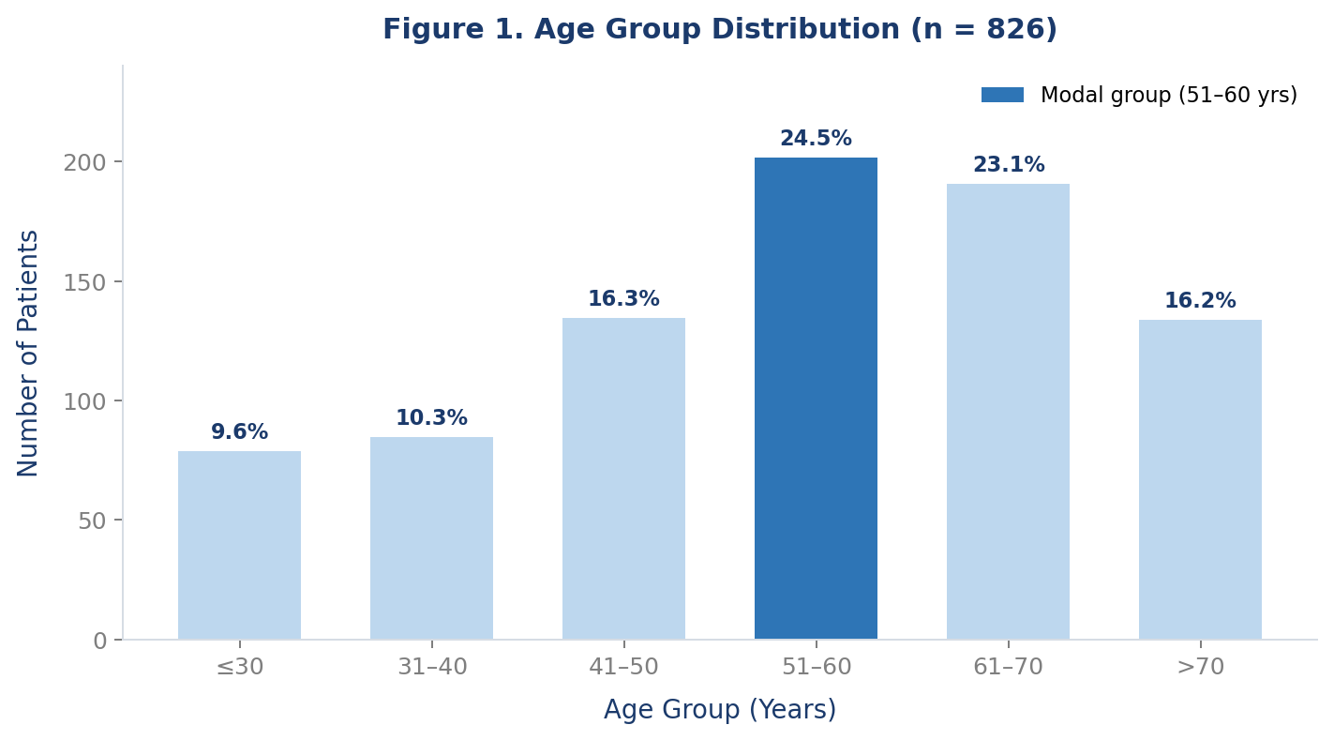
Figure 1. Age distribution of the study cohort
Table 2. Prevalence of Individual Cardiometabolic Risk Factors (n = 826)
Risk Factor | Frequency (n) | Percentage (%)
Hypertension (all patients, by definition) | 826 | 100.0
Any Dyslipidaemia (any abnormal lipid) | 553 | 66.9
High Total Cholesterol (>200 mg/dL) | 317 | 38.4
High LDL Cholesterol (>130 mg/dL) | 277 | 33.5
Low HDL Cholesterol (sex-specific cutoff) | 232 | 28.1
High Triglycerides (>150 mg/dL) | 51 | 6.2
Elevated blood glucose (RBG ≥140 mg/dL) | 177 | 21.4
Impaired glucose (140–199 mg/dL) | 121 | 14.7
Diabetes range (≥200 mg/dL) | 56 | 6.8
Proteinuria (any degree, ≥1+) | 320 | 38.7
Haematuria (any degree, ≥1+) | 55 | 6.7
Reduced eGFR (<60 mL/min/1.73m²) | 328 | 39.7

Table 3. Distribution of Metabolic Burden Categories (n = 826)
Metabolic Burden Category | Frequency (n) | Percentage (%)
HTN only (0 additional metabolic abnormalities) | 443 | 53.6
HTN + 1 metabolic abnormality | 309 | 37.4
HTN + ≥2 metabolic abnormalities (high metabolic burden) | 74 | 9.0
Detailed breakdown
0 additional abnormalities | 443 | 53.6
1 additional abnormality | 309 | 37.4
2 additional abnormalities | 71 | 8.6
3 additional abnormalities | 3 | 0.4
Total | 826 | 100.0

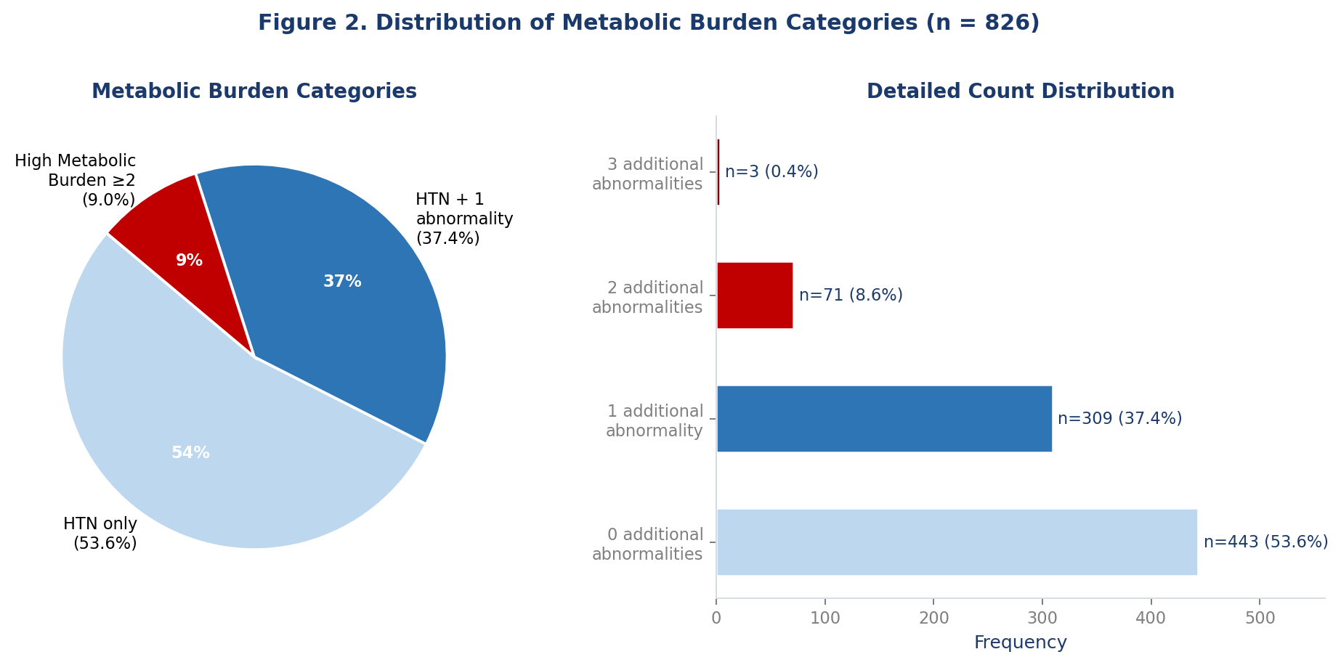
Figure 2. Distribution of metabolic burden categories: pie chart (left) and detailed count breakdown (right).
Table 4. Metabolic Phenotype Patterns in the Hypertensive Cohort (n = 826)
Metabolic Phenotype Pattern | Frequency (n) | Percentage (%)
HTN only | 443 | 53.6
HTN + Dysglycaemia | 118 | 14.3
HTN + Low HDL | 164 | 19.9
HTN + High TG | 27 | 3.3
HTN + Dysglycaemia + Low HDL | 50 | 6.1
HTN + High TG + Low HDL | 15 | 1.8
HTN + Dysglycaemia + High TG | 6 | 0.7
HTN + Dysglycaemia + High TG + Low HDL (full cluster) | 3 | 0.4
Total | 826 | 100.0

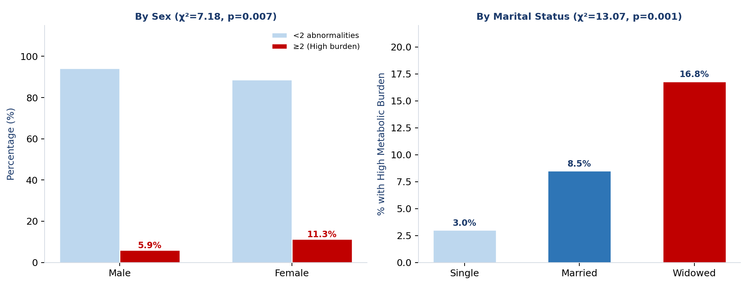
Figure 3. High metabolic burden prevalence by sex (left) and marital status (right).
Table 5. Association Between Clinical Parameters and High Metabolic Burden (n = 826)
Clinical Parameter | <2 Abnormalities  n=752 (%) | ≥2 Abnormalities  n=74 (%) | χ² (df) | p-value
Reduced eGFR (<60 mL/min/1.73m²)
eGFR reduced | 300 (91.5%) | 28 (8.5%) | 0.119 (1) | .730
eGFR normal | 452 (90.8%) | 46 (9.2%)
Proteinuria
Negative/trace | 477 (94.3%) | 29 (5.7%)
1+ | 227 (88.0%) | 31 (12.0%) | 25.84 (3) | <.001
2+ | 39 (75.0%) | 13 (25.0%)
3+ | 9 (90.0%) | 1 (10.0%)
Haematuria
Negative/trace | 697 (90.4%) | 74 (9.6%) | 7.05 (FFH) | .039†
1+ | 52 (100.0%) | 0 (0.0%)
2+ | 3 (100.0%) | 0 (0.0%)
† Fisher-Freeman-Halton exact test used for haematuria; FFH = Fisher-Freeman-Halton.

Table 6. Binary Logistic Regression: Independent Predictors of High Metabolic Burden (n = 826)
Variable | B | S.E. | Wald | df | p-value | AOR [Exp(B)] | 95% CI
Age (continuous, years) | 0.049 | 0.013 | 14.080 | 1 | <.001 | 1.050 | 1.024–1.078
Sex: Male vs Female | −2.230 | 0.389 | 32.802 | 1 | <.001 | 0.107 | 0.050–0.231
Weight (continuous, kg) | 0.011 | 0.014 | 0.669 | 1 | .413 | 1.011 | 0.984–1.039
eGFR (continuous) | 0.088 | 0.016 | 29.036 | 1 | <.001 | 1.092 | 1.058–1.128
Serum Creatinine (continuous) | 6.027 | 1.237 | 23.759 | 1 | <.001 | 414.549 | 36.732–4678.536
Proteinuria: Present vs Absent | −1.153 | 0.263 | 19.269 | 1 | <.001 | 0.316 | 0.189–0.528
Haematuria: Present vs Absent | 19.488 | 51,446.944 | 0.000 | 1 | .997 | — | —
AOR = Adjusted Odds Ratio; CI = Confidence Interval. Reference categories: Female (sex), Absent (proteinuria and haematuria). Model: omnibus χ² = 70.935, df = 7, P < .001; Nagelkerke R² = 0.182; Overall correct classification: 91.3%.

Discussion
This study examined the clustering of cardiometabolic risk factors among 826 adult hypertensive patients attending the MOPC at UBTH, a major tertiary centre in South-South Nigeria. The principal findings were that 9.0% of the hypertensive cohort harboured high metabolic burden (two or more additional cardiometabolic abnormalities beyond hypertension); that any dyslipidaemia was prevalent in two-thirds of patients (66.9%); that the dominant comorbid metabolic phenotype was hypertension with low HDL-C; and that female sex, older age, marital status, and proteinuria severity. On multivariable analysis, older age, female sex, higher eGFR, and elevated serum creatinine emerged as independent predictors of high metabolic burden.
The high overall prevalence of dyslipidaemia (66.9%) in this cohort is consistent with reports from comparable Nigerian tertiary populations, where abnormal lipid profiles are documented in 48–75% of hypertensive patients (Ojji et al., 2009; Okafor, 2012). The predominance of elevated total cholesterol (38.4%) and LDL-C (33.5%) as the most prevalent single lipid abnormalities, followed by low HDL-C (28.1%), reflects an atherogenic lipid phenotype that synergizes with elevated blood pressure to amplify cardiovascular risk. The relatively low prevalence of hypertriglyceridaemia (6.2%) in this cohort may reflect dietary patterns in this population or the use of non-fasting triglyceride values in some records.
The overall prevalence of high metabolic burden at 9.0% should be interpreted in light of the strict definition applied in this study, which required two or more abnormalities from a defined set of three (dysglycaemia, hypertriglyceridaemia, and low HDL-C), in addition to hypertension. Studies using broader metabolic syndrome criteria, such as the IDF or ATP-III definitions, have reported prevalences of metabolic syndrome among hypertensive Nigerians ranging from 40% to over 70%, reflecting the inclusion of abdominal obesity and different thresholds applied (Isezuo & Ezunu, 2005; Ojji et al., 2009). The more conservative estimate observed in this study likely reflects both the stricter criteria applied and the specific biochemical parameters available in the dataset.
The finding that nearly one in five patients (19.9%) had hypertension combined with low HDL-C as their sole additional risk factor is consistent with the established pattern of atherogenic dyslipidaemia in sub-Saharan African populations. Low HDL-C has been described as the most prevalent lipid abnormality among hypertensive Nigerians, attributable to genetic predisposition, dietary patterns, and physical inactivity.(Adediran et al., 2022) The co-occurrence of hypertension and low HDL-C represents a particularly high-risk phenotype, as both factors independently promote endothelial dysfunction and accelerate atherosclerosis. The second most common combination, hypertension with dysglycaemia (14.3%), highlights the ongoing epidemiological transition toward the dual burden of hypertension and diabetes in this population, consistent with data from the 2018 Nigeria Demographic and Health Survey and prior Edo State based studies. (Ibezim et al., 2025; Isara & Okundia, 2015; Nigeria Demographic and Health Survey 2018 Key Indicators Report The Federal Republic of Nigeria, 2019)
The significant association between female sex and high metabolic burden, corroborated by the logistic regression finding that females had approximately 87% higher odds than males, is a recurrent theme in the African literature on metabolic clustering. Proposed explanations include the greater prevalence of central adiposity among African women, hormonal influences on lipid metabolism, post-menopausal decline in oestrogen (which is protective of HDL-C levels), and the socioeconomic constraints limiting access to preventive healthcare among women in low-resource settings. (Aguilar et al., 2015; Peer et al., 2012)
The age-related gradient in metabolic burden observed in this study, with the 51–60 year age group carrying the highest absolute number of high-burden patients and age emerging as an independent predictor on regression (AOR 1.046 per year), is biologically plausible. Ageing is associated with progressive deterioration in insulin sensitivity, declining HDL-C, rising postprandial triglycerides, and impaired vascular compliance, all of which promote the accumulation of cardiometabolic risk factors over time.(Chia et al., 2018; Liu & Li, 2015) The absence of high metabolic burden among patients aged 30 years or below in this cohort may reflect the early clinical stage of hypertension in younger patients.
The significant association between widowed marital status and high metabolic burden (16.8% vs 8.5% among married patients, P = .001) warrants contextual interpretation. Widowhood may be associated with psychosocial stressors, diminished household income, and reduced access to consistent medical care, all of which are established risk factors for metabolic deterioration (Iregbu & Ozigbo, 2025; Mosha & Ngulube, 2024). This finding, however, requires careful interpretation given the confounding role of age.
The striking association between blood glucose category and high metabolic burden is mechanistically coherent. Patients with impaired glucose (41.3% high metabolic burden) and diabetes-range glucose (16.1% high metabolic burden) showed markedly higher rates of metabolic clustering compared to those with normal glucose (2.3%). This reflects the shared pathophysiological substrate of insulin resistance, which simultaneously promotes hyperglycaemia, suppresses HDL-C synthesis, and increases hepatic VLDL production, driving hypertriglyceridaemia.(Luciani et al., 2024) These findings reinforce the WHO recommendation that glycaemic assessment should be routine in all patients presenting with hypertension, particularly in settings where diabetes prevalence is rising.(Campbell et al., 2022)
The association between proteinuria severity and high metabolic burden is consistent with the established link between the cardiorenal metabolic syndrome and early kidney injury. The unexpected finding that higher continuous eGFR was independently associated with high metabolic burden in the logistic regression, alongside elevated serum creatinine, likely reflects the complex relationship between renal haemodynamics and metabolic burden in this cohort. The wide confidence interval for the serum creatinine odds ratio (AOR 175.6; 95% CI 17.86–1727.0), while statistically significant, indicates limited precision and should be interpreted with caution, pending larger confirmatory studies.
This study has several strengths. The large sample size of 826 patients, the use of a standardized data abstraction proforma, and the availability of complete biochemical data, including full lipid profiles and renal parameters, enhance the validity and applicability of the findings. The use of exact statistical tests (Fisher-Freeman-Halton) where cell frequencies were small strengthens the reliability of the inferential conclusions. Limitations include the retrospective cross-sectional design, which precludes causal inference. As a hospital-based study at a tertiary centre, the findings may not be generalizable to community-dwelling hypertensive populations. The absence of waist circumference measurements precluded application of formal metabolic syndrome criteria. Additionally, information on physical activity, dietary patterns, and the use of lipid-modifying medications was not captured and may represent residual confounders.
CONCLUSION
Cardiometabolic clustering affects a clinically significant proportion of adult hypertensive patients attending a tertiary facility in South-South Nigeria, with 66.9% demonstrating any dyslipidaemia and 9.0% carrying high metabolic burden defined as two or more additional cardiometabolic abnormalities beyond hypertension. Low HDL-C and dysglycaemia are the predominant comorbid metabolic phenotypes in this population. Female sex, older age, widowed marital status, worsening proteinuria, and impaired blood glucose are significantly associated with high metabolic burden. On multivariable analysis, older age, female sex, and renal parameters emerge as independent predictors.
These findings support the routine integration of comprehensive cardiometabolic risk assessment, including full lipid profiling and glycaemic evaluation, into standard hypertension care at Nigerian tertiary centres. Targeted screening programmes should prioritize older patients, females, and those with evidence of renal involvement. Longitudinal cohort studies with community-representative sampling are needed to further characterize the progression of cardiometabolic clustering and its outcomes in this population.
REFERENCES
Adediran, O., Okpara, I., Adeniyi, O., & Jimoh, A. (2022). Obesity prevalence and its associated factors in an urban and rural area of Abuja Nigeria. International Journal of Public Health and Epidemiology, 12(1), 1–5.
Adeloye, D., Owolabi, E. O., Ojji, D. B., Auta, A., Dewan, M. T., Olanrewaju, T. O., Ogah, O. S., Omoyele, C., Ezeigwe, N., Mpazanje, R. G., Gadanya, M. A., Agogo, E., Alemu, W., Adebiyi, A. O., & Harhay, M. O. (2021). Prevalence, awareness, treatment, and control of hypertension in Nigeria in 1995 and 2020: A systematic analysis of current evidence. The Journal of Clinical Hypertension, 23(5), 963. https://doi.org/10.1111/jch.14220
Aguilar, M., Bhuket, T., Torres, S., Liu, B., & Wong, R. J. (2015). Prevalence of the metabolic syndrome in the United States, 2003-2012. JAMA, 313(19), 1973–1974. https://doi.org/10.1001/jama.2015.4260
Campbell, N. R. C., Burnens, M. P., Whelton, P. K., Angell, S. Y., Jaffe, M. G., Cohn, J., Brito, A. E., Irazola, V., Brettler, J. W., Roccella, E. J., Figueredo, J. I. M., Rosende, A., & Ordunez, P. (2022). 2021 World Health Organization guideline on pharmacological treatment of hypertension: Policy implications for the region of the Americas. Lancet Regional Health - Americas, 9, 100219. https://doi.org/10.1016/j.lana.2022.100219
Chia, C. W., Egan, J. M., & Ferrucci, L. (2018). Age-related Changes in Glucose Metabolism, Hyperglycemia, and Cardiovascular Risk. Circulation Research, 123(7), 886. https://doi.org/10.1161/CIRCRESAHA.118.312806
Graur, L. I., & Mihalache, L. (2025). Pathophysiology and Mechanisms of Cardiovascular-Kidney-Metabolic Syndrome. Cardiovascular-Kidney-Metabolic Syndrome, 65–88. https://doi.org/10.1007/978-3-032-11445-7_5
Ibezim, H. U., Njoya, H. K., Esene, H., Azenabor, S. E., & Sule, S. (2025). Prevalence of Hypertension and Type 2 Diabetes Mellitus among Patients with Metabolic Syndrome in Rural Southern Nigeria: Gender and Age Disparities. Nigerian Medical Journal : Journal of the Nigeria Medical Association, 66(1), 279–289. https://doi.org/10.71480/nmj.v66i1.706
Iregbu, J. K., & Ozigbo, A. A. (2025). The Impact of Widowhood on Mental Health and Social Isolation among Elderly Women in Nigeria: A Narrative Review. Journal of International Research in Medical and Pharmaceutical Sciences, 20(2), 38–49. https://doi.org/10.56557/jirmeps/2025/v20i29565
Isara, A. R., & Okundia, P. O. (2015). The burden of hypertension and diabetes mellitus in rural communities in southern Nigeria. The Pan African Medical Journal, 20, 103. https://doi.org/10.11604/pamj.2015.20.103.5619
Isezuo, S. A., & Ezunu, E. (2005). Demographic and clinical correlates of metabolic syndrome in Native African type-2 diabetic patients. Journal of the National Medical Association, 97(4), 557–563.
Jobe, M., Beye, S. M., Gaye, N. D., Ka, M. M., Perel, P., Perkins, A. D., Kane, A., Prentice, A. M., Ojji, D. B., Jaiteh, L. E. S., Etyang, A. O., Shah, A. S. V., & Gaye, B. (2025). Hypertension in Sub-Saharan Africa: Burden, Barriers and Priorities for Improving Treatment Outcomes. Circulation Research, 137(1), 106. https://doi.org/10.1161/CIRCRESAHA.124.323889
Liu, H. H., & Li, J. J. (2015). Aging and dyslipidemia: A review of potential mechanisms. Ageing Research Reviews, 19, 43–52. https://doi.org/10.1016/j.arr.2014.12.001
Lonardo, A., & Weiskirchen, R. (2025). Insulin Resistance at the Crossroads of Metabolic Inflammation, Cardiovascular Disease, Organ Failure and Cancer. Biomolecules 2025, Vol. 15, 15(12). https://doi.org/10.3390/biom15121745
Luciani, L., Pedrelli, M., & Parini, P. (2024). Modification of lipoprotein metabolism and function driving atherogenesis in diabetes. Atherosclerosis, 394(5), 117545. https://doi.org/10.1016/j.atherosclerosis.2024.117545
Mosha, N. F. V., & Ngulube, P. (2024). Health Challenges Experienced by Widows in Low- and Middle-Income Countries: A Systematic Review. Indigenous, 9(3). https://doi.org/10.23917/indigenous.v9i3.5684
Mossavarali, S., Azizpour, Y., Golestani, A., Rezaei, N., Khosravi, S., Mirzad, M., Khashayar, P., & Tabatabaei-Malazy, O. (2025). Prevalence of dyslipidemia and its association with blood pressure control in Iranian hypertensive patients: insights from STEPS 2021. Lipids in Health and Disease, 24(1), 232. https://doi.org/10.1186/s12944-025-02660-0
Nigeria Demographic and Health Survey 2018 Key Indicators Report The Federal Republic of Nigeria. (2019). www.population.gov.ng
Nwankwo, M., Makena, W., Idris, A., Barnabas, D., Danborno, A. M., & Umoren, E. B. (2026). Prevalence of hypertension among adults in Nigeria: a systematic review and meta-analysis. BMC Cardiovascular Disorders 2026. https://doi.org/10.1186/s12872-026-05722-y
Ojji, D. B., Ajayi, S. O., Mamven, M. H., & Atherton, J. (2009). Prevalence of dyslipidemia in normoglycemic subjects with newly diagnosed high blood pressure in Abuja, Nigeria. Journal of Clinical Lipidology, 3(1), 51–56. https://doi.org/10.1016/j.jacl.2008.12.001
Okafor, C. I. (2012). The metabolic syndrome in Africa: Current trends. Indian Journal of Endocrinology and Metabolism, 16(1), 56. https://doi.org/10.4103/2230-8210.91191
Olaomoju, T., & Oniye, A. (2025). Prevalence and Predictors of Metabolic Syndrome Among Patients in a Secondary Healthcare Facility in Southwest Nigeria. Sahel Journal of Life Sciences FUDMA, 3(4), 123–130. https://doi.org/10.33003/sajols-2025-0304-15
Olowoyo, P., Okekunle, A. P., Asowata, O. J., Atolani, S., Morsy, M. I., Caiazzo, E., Gaye, B., Kadan, D. D., Bruzzese, D., Guzik, T. J., Maffia, P., & Owolabi, M. O. (2025). Prevalence of hypertension in Africa in the last two decades: systematic review and meta-analysis. Cardiovascular Research, 121(12), 1815–1829. https://doi.org/10.1093/cvr/cvaf125
Onyegbutulem, H. C., Dogo, D., Alu, F., Dankyau, M., Olorunfemi, D. S., Abdullahi, F. M., Akerele, I. O., Bala, N. J. afar, Ibeabuchi, U. N., & Mohammed, M. O. (2021). Patterns of dyslipidemia amongst hypertensive patients in abuja, north central Nigeria. Pan African Medical Journal, 39. https://doi.org/10.11604/pamj.2021.39.11.28807
Peer, N., Steyn, K., Lombard, C., Lambert, E. V., Vythilingum, B., & Levitt, N. S. (2012). Rising Diabetes Prevalence among Urban-Dwelling Black South Africans. PLOS ONE, 7(9), e43336. https://doi.org/10.1371/journal.pone.0043336
World Health Organization. (2025). Hypertension. https://www.who.int/news-room/fact-sheets/detail/hypertension

