Case report
Fulminant Acute Aortic Regurgitation Complicating Infective Endocarditis: Report of Two Fatal Cases

Abstract
Background:
Acute aortic regurgitation (AAR) is a rare but catastrophic complication of infective endocarditis (IE), often resulting from rapid valvular destruction or perivalvular extension of infection. The clinical course is frequently dramatic and requires urgent surgical intervention.
Case presentation:
We report two cases of acute severe aortic regurgitation complicating infective endocarditis. The first patient, a 58-year-old woman with Staphylococcus haemolyticus infective endocarditis, presented with extensive destruction of the aortic valve leading to massive regurgitation. The second patient, a 46-year-old woman, developed severe acute aortic regurgitation due to infective endocarditis complicated by a mitro-aortic trigone abscess and cusp prolapse. In both cases, transesophageal echocardiography revealed severe valvular damage requiring urgent surgical intervention. Despite appropriate antibiotic therapy and intensive medical management, both patients experienced rapid clinical deterioration and died before surgery could be performed.
Conclusion:
These cases illustrate the fulminant course and extremely poor prognosis of acute aortic regurgitation complicating infective endocarditis when immediate surgical treatment cannot be achieved.
Keywords:
Infective endocarditis; Acute aortic regurgitation; Aortic valve destruction; Mitro-aortic abscess; Echocardiography.

Introduction
Infective endocarditis remains a life-threatening condition associated with substantial morbidity and mortality despite advances in antimicrobial therapy and cardiac surgery. Acute aortic regurgitation (AAR) is among the most severe complications of infective endocarditis and usually results from rapid valvular destruction, cusp perforation, or perivalvular extension of infection.
Unlike chronic aortic regurgitation, the left ventricle in acute regurgitation has no time to adapt to the sudden increase in regurgitant volume. Consequently, abrupt elevation of left ventricular end-diastolic pressure leads rapidly to pulmonary congestion, hemodynamic instability, and cardiogenic shock. Early surgical intervention is therefore recommended in most patients presenting with severe acute aortic regurgitation related to infective endocarditis.
We report two cases of infective endocarditis complicated by fulminant acute aortic regurgitation leading to rapid clinical deterioration and death before surgical treatment could be performed.
Case Presentation 1
A 58-year-old woman with no prior history of cardiovascular disease was admitted for management of aortic infective endocarditis. The clinical history began 18 days prior to admission with epigastric pain, vomiting, and progressively worsening dyspnea. Initial transthoracic echocardiography performed at another institution revealed a vegetation on the ventricular side of the aortic valve, leading to hospitalization and initiation of antibiotic therapy.
On admission to our department, the patient was conscious and hemodynamically borderline stable. Blood pressure was 104/47 mmHg and heart rate was 95 bpm. Cardiac auscultation revealed a diastolic murmur over the aortic area. The patient was dyspneic on minimal exertion. Electrocardiography showed sinus rhythm at 90 bpm without conduction abnormalities.
Transthoracic echocardiography demonstrated a non-dilated left ventricle with preserved systolic function (LVEF 55%). Severe aortic regurgitation was observed, characterized by an effective regurgitant orifice area of 1.1 cm², a regurgitant volume of 65 mL, and a pressure half-time of 104 ms. Pulmonary artery systolic pressure was estimated at 56 mmHg.
Transesophageal echocardiography revealed a tricuspid aortic valve with extensive destruction of the right and posterior cusps, which appeared shredded and prolapsing into the left ventricular outflow tract, resulting in a large coaptation defect and massive regurgitation (Video 1). Short-axis transesophageal views confirmed severe cusp destruction with loss of normal leaflet coaptation (Videos 2A,B). No annular abscess was identified.
Blood cultures were positive for Staphylococcus haemolyticus. Intravenous antibiotic therapy was initiated and subsequently adapted to vancomycin according to antimicrobial susceptibility testing.
During hospitalization, the patient developed progressive renal failure (creatinine rising to 27 mg/L) and acute decompensated heart failure with bilateral pleural effusion. Despite intensive medical management, including diuretics and antibiotic adjustment, clinical deterioration continued. Given the severity of valvular destruction and hemodynamic compromise, urgent aortic valve replacement was indicated. However, the patient experienced rapid deterioration and died before surgical intervention could be performed.
Case presentation 2
A 46-year-old woman was admitted for the management of suspected infective endocarditis complicated by acute aortic regurgitation. The patient had a three-month history of progressively worsening dyspnea associated with palpitations and general fatigue. At admission, she presented with severe dyspnea corresponding to New York Heart Association (NYHA) functional class IV.
Clinical examination revealed tachycardia with a heart rate of 108 beats per minute and oxygen saturation of 95% on room air. Electrocardiography showed sinus rhythm with first-degree atrioventricular block and moderate left ventricular hypertrophy.
Transthoracic echocardiography demonstrated preserved left ventricular systolic function with an estimated ejection fraction of 70%. The left ventricle was not dilated. Severe aortic regurgitation was identified, characterized by an eccentric regurgitant jet and signs of elevated pulmonary pressures.
Transesophageal echocardiography revealed a tricuspid aortic valve with a vegetation located on the posterior cusp. A perivalvular abscess involving the mitro-aortic trigone was identified, associated with significant cusp prolapse and severe aortic regurgitation (Videos 3–4). Short-axis transesophageal views further confirmed extensive cusp destruction with loss of normal leaflet coaptation and severe regurgitation (Videos 5–6).
Laboratory investigations revealed a marked inflammatory syndrome with leukocytosis (19,000/mm³), elevated C-reactive protein (201 mg/L), and mild anemia with hemoglobin of 10.9 g/dL. Blood cultures were positive for Streptococcus mitis.
Computed tomography of the chest, abdomen, and pelvis demonstrated a moderate pericardial effusion. Cerebral computed tomography showed no evidence of embolic complications.
Empirical intravenous antibiotic therapy consisting of vancomycin, gentamicin, and ceftriaxone was initiated and subsequently adapted according to the microbiological results. Given the presence of severe aortic regurgitation associated with a perivalvular abscess, urgent surgical aortic valve replacement was indicated. However, the patient experienced rapid clinical deterioration with acute heart failure and died before surgical intervention could be performed.
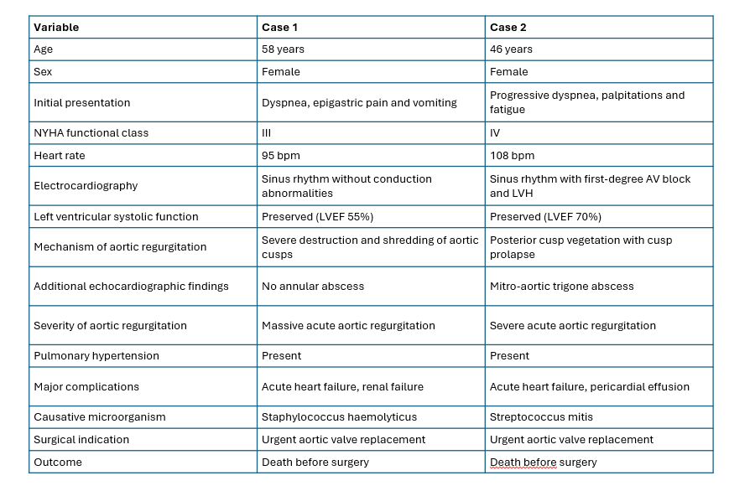
Table 1. Clinical, microbiological, and echocardiography comparison of the two reported cases
Discussion
Acute aortic regurgitation secondary to infective endocarditis represents a medical and surgical emergency associated with extremely high mortality. Rapid destruction of the aortic valve apparatus leads to sudden volume overload of the left ventricle, which is unable to adapt to the abrupt increase in regurgitant flow. This results in rapid elevation of left ventricular diastolic pressure and pulmonary congestion, often progressing to cardiogenic shock [1].
Both cases reported in the present study illustrate the dramatic evolution of infective endocarditis complicated by acute aortic regurgitation. In the first patient, extensive destruction of the aortic cusps resulted in massive regurgitation, while the second case demonstrated perivalvular extension of infection with development of a mitro-aortic trigone abscess.
Interestingly, the microbiological profile differed between the two cases. The first case was caused by Staphylococcus haemolyticus, a pathogen known for its aggressive tissue destruction and rapid valvular damage. In contrast, the second case was associated with Streptococcus mitis, a member of the viridans streptococci group commonly involved in infective endocarditis and frequently associated with perivalvular complications such as abscess formation [2,3].
Perivalvular complications such as abscess formation occur in approximately 10–30% of cases of infective endocarditis and are associated with worse prognosis and increased mortality [2]. These complications frequently require urgent surgical intervention.
Echocardiography plays a pivotal role in the diagnosis and management of infective endocarditis. While transthoracic echocardiography is usually the first imaging modality performed, transesophageal echocardiography provides superior visualization of valvular structures and perivalvular complications [5].
Current international guidelines recommend early surgical intervention in patients with infective endocarditis complicated by severe valvular dysfunction leading to heart failure or perivalvular extension of infection. Early surgery has been shown to significantly improve survival in patients with complicated infective endocarditis [4].
Unfortunately, despite appropriate antibiotic therapy and clear surgical indications, both patients in the present report experienced rapid clinical deterioration and died before surgical treatment could be performed. These observations highlight the fulminant nature of acute aortic regurgitation complicating infective endocarditis and the critical importance of early diagnosis and immediate surgical referral.
Conclusion
Acute aortic regurgitation is one of the most severe complications of infective endocarditis and is associated with extremely high mortality when surgical intervention cannot be performed rapidly. These two cases highlight the aggressive nature of infective endocarditis and the crucial role of early echocardiographic diagnosis and urgent surgical management.

References
- Cahill TJ, Prendergast BD. Infective endocarditis. Lancet. 2016.
- Habib G et al. ESC Guidelines for the management of infective endocarditis. Eur Heart J. 2023.
- Murdoch DR et al. Clinical presentation of infective endocarditis. Arch Intern Med. 2009.
- Kang DH et al. Early surgery versus conventional treatment for infective endocarditis. N Engl J Med. 2012.
- Evangelista A. Echocardiography in infective endocarditis. Heart. 2004.

Video 1.
Transesophageal echocardiography (mid-esophageal long-axis view at 122°) in Case 1 demonstrating extensive destruction of the aortic valve with eversion and flail motion of the cusps. The sequence shows both grayscale imaging and color Doppler revealing torrential acute aortic regurgitation.
Video 2.
Transesophageal echocardiography short-axis view of the aortic valve in Case 1.
(A) Color Doppler imaging demonstrating severe acute aortic regurgitation.
(B) Two-dimensional imaging without color Doppler showing loss of normal cusp coaptation and extensive valvular destruction.

Video 3.
Transesophageal echocardiography (mid-esophageal long-axis view at 128°) in Case 2 showing vegetation on the posterior aortic cusp with cusp prolapse.
Video 4.
Color Doppler imaging in the same view demonstrating severe eccentric acute aortic regurgitation in Case 2.
Video 5.
Short-axis transesophageal echocardiography view of the aortic valve in Case 2 showing extensive cusp destruction with loss of normal leaflet coaptation.
Video 6.
Short-axis transesophageal echocardiography with color Doppler demonstrating severe acute aortic regurgitation through the damaged aortic valve in Case 2.

