Bio-fabrication of a Flower Vase Through the Valorization of Sawdust by Fungal Species: Dual function for spent mushroom substrate

ABSTRACT
Spent mushroom substrates are produced in enormous quantities, reusing these materials as a vase can make them a substitute for plastics. In this study, sawdust was fermented by a fast-growing fungal species to produce a biobased flower vase. Sawdust and CaCO₃ (95:1) with 60% moisture were thoroughly mixed and sterilised. Thereafter, 10% spawn was aseptically inoculated into the sterilised substrate, followed by incubation at 25 ºC. The compressive strength, water absorption, and microstructural analysis of the biomaterial was performed. The biomaterial yielded a solid mass that can be used as a flower vase with a compressive strength of 5.0 kN, while that of flower vase was 3.3 kN. The water absorption capacity of the biomaterial is fair compared to that of a flower vase, but economical. The resulting biomaterial is lightweight and biodegradable, making it a cleaner alternative to traditional flower vases.
Keywords: Biomaterial; Spent mushroom substrate; Pleurotus sp; Flower vase; Compressive strength; Waste management; Mushroom; Fungi; Valorization; water absorption
Introduction
Conventionally, plastics, glass, metals, ceramics, and wood are some of the materials used for making flower vases (Sovjak and Fridrichova, 2018). Each of these materials have their shortcomings. Glass materials are fragile, metals are heavy and difficult to manipulate into desired shapes, ceramics are fragile and uncontrolled use of wood may lead to deforestation. Although plastics are cheap, lightweight, non-brittle, and attractive, they are recalcitrant and non-biodegradable (Asante-Kyei, 2018; Yanel, 2021). Therefore, they constitute a nuisance in the environment and may be a breeding ground for mosquitoes and other disease-causing organisms. Flowers are attractive, and many homes appreciate the aesthetics they offer; therefore, it is essential to establish an eco-friendly system for their usage. In a previous study, Asante-Kyei (2018) produced decorative flowerpots by using plastic waste. In the study, a beautiful flowerpot and an artificial flower were produced. However, both the pot and the artificial flower still remain non-biodegradable after long-term use, therefore, may constitute another waste. Cleaner technology is required to avoid this.
Also, mushroom-producing companies generate tonnes of waste after the production process of mushrooms. The spent mushroom substrate is usually discarded and left to rot without any form of use. Households that produce mushrooms for in-house use may also have spent mushroom waste to deal with. Sustainable development goals (SDGs) 6, 11 and 15, clean water and sanitation, sustainable cities and communities, life on land, aim towards ensuring good sanitation resulting in a community that is safe from disease-causing materials while halting loss of lives. Re-use of spent mushroom waste as a flower vase – a biomaterial will reduce the waste generated from plastic vase waste and spent mushroom waste. Also, since plastic waste can harbour disease causing organisms, likewise mushroom waste, reusing the latter will reduce the use of plastics for vases. Thus, biomaterials are cleaner alternatives for reducing pollution.
Biomaterials are materials made from organic substrates, and in this case it employs mycelium, the vegetative part of fungi, as a natural adhesive. Besides bio-composite production, fungal mycelium can be applied in certain environmental technologies (Alemu et al., 2022). In recent years, mycelium has found its place in biomaterial production, with a few companies including Evocative Design and Mycotech (Whabi et al., 2024), leading the way in designing and commercializing mycelium-based composites. Designers and architects have also incorporated mycelium-based products as alternatives to conventional materials, integrating them in various items such as packaging materials, synthetic leather, furniture, kitchen utensils, wall and ceiling panels, as well as blocks, biocement, and masonry units (Yang et al., 2020; Alemu et al., 2022; Gough et al., 2024).
Mycelium, characterized by a dense network of interconnected hyphae, possesses self-assembling properties that enable the formation of solid materials. As mycelium grows and colonizes organic substrates, it degrades compounds like cellulose and lignin through the secretion of enzymes such as Lactase, Lignin peroxidase (Lip), and Manganese peroxidase (MnP) (Zhang et al., 2022). The mycelium's ability to break down these organic materials allows it to bind them together, resulting in strong and three-dimensional structural materials (Elkhateeb and Daba, 2019).
Several factors impact on the quality of mycelium-based biomaterials, including the fungi strain used (Womer et al., 2023), the incubation duration, the conditions for mycelium growth, (Haneef et al., 2017), the substratum employed (Joshi et al., 2020), the additives used (Ghazvinian et al., 2019), the fabrication method (Appels et al., 2020), and the type of inoculums utilized (Girometta et al., 2019). Optimal mycelium growth on substrates contributes to higher compressive strength in mycelium-based biomaterials. Considerably longer incubation and pressing duration also influences the strength of the materials. The use of dry heat during the production process can increase the density and compressive strength of mycelium-based biomaterials more effectively than cold pressing. Moreover, the homogeneity of particle size and raw materials composition influence the quality of mycelium-based composites. The presence of mineral enzymes and vitamins in mycelium promotes its ramification on substrates, thereby influencing the strength of the composite materials (Solanilla‐Duque et al., 2022).
Fungal mycelium can form complex networks by means of their fine thread-like hyphae for decomposing lignocellulosic substrates. This leads to the formation of biomaterial with higher mechanical strength, hydrophobicity, and non-flammability, thus can replace conventional packaging materials. Use of this eco-friendly and biodegradable biomaterials as a substitute for glass or plastic will help make the cities safe and sustainable as highlighted in sustainable development goal 11 of the United Nations. This will further prevent the accumulation of non-biodegradable plastics once the bio-based materials are fully embraced, thus protecting the ecosystem. This study produced a bio-based flower vase as a replacement to the conventional non-biodegradable plastics and glass materials presently in use. A new value addition to spent mushroom substrate was identified in this study.
Materials and Methods

Sample Collection
Potato Dextrose Agar (PDA), and all chemicals were used in accordance with manufacturer’s description. Pleurotus sp was chosen because it is edible and can effectively produce enzyme for utilizing sawdust with a faster ramification rate (Alemu et al., 2022a, b; Bamigboye et al., 2019; 2021). Other bio-substrate materials, including sawdust, sorghum, and wheat bran, were purchased from a local market. Aluminium molds for molding were designed by the authors and constructed by a welder (28 cm by 15 cm). Distilled water was used for media preparation.
3.2 Preparation of Culture Media and Strain Cultivation
Tissue culture technique was used by picking a piece of pure mycelia from a healthy and clean P. ostreatus using a sterile forceps and placed in the centre of the PDA agar bottles (Bamigboye et al., 2019). The inoculated media bottles were then incubated at 28°C for 10 to 12 days.

3.3 Spawn Preparation
Red Sorghum grain was purchased from the local market, cleaned, and adjusted to a moisture content of approximately 50%. Wide-mouthed glass bottles were filled with 100 g (on a wet weight basis) of sorghum grain, autoclaved at 121°C for 30 minutes, and allowed to cool overnight in aseptic conditions. The sterilization process was repeated twice for. After cooling ten (10) plugs of mycelia, about 0.5 cm long from a 10-day old culture was inoculated into the sorghum grain-filled bottles, which were then incubated at 28°C (Adebayo et al., 2014).
3.4 Substrate Collection, Preparation, and Inoculation
Sawdust was locally sourced from sawmills in large quantity. Sawdust and wheat bran were chosen due to their abundance and local availability. Unwanted materials such as plastics, metals, and stones were removed from the substrate. A mixture of sawdust, wheat bran and lime was thoroughly mixed and combined in the ratio 98:1:1 (Alemu et al., 2022). Aluminium molds were designed, washed, cleaned, and sterilized.
3.5 Preparation of the Biomaterials (Flower Vase)
The sawdust and wheat bran mix was moistened to have 60 % moisture before filling into the aluminium moulds following Suganthi and Krishnakumari, (2018). The moisture content was confirmed by squeezing in between the palms to ensure there is no excess liquid oozing out. The substrates were manually compressed for firmness and autoclaved at 121°C for 20 minutes. The sterilized substrates in aluminium moulds (Plate 1) were inoculated with 10% of the earlier prepared spawn. The inoculated pans were incubated in the dark at 25±3°C for approximately 8 weeks until the mycelium completely colonized the substrates following Alemu et al. (2022). Subsequently, the moulds, containing the mycelium biomaterial was carefully removed and dried in a hot air oven at 90°C for 24hrs.
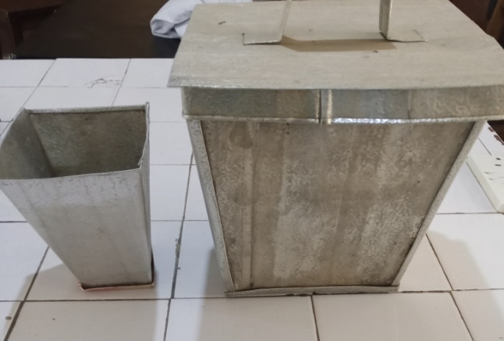
Plate 1: Aluminium mold designed for Bio-based flower vase
3.6 Physico-chemical and Mechanical Characterization of the biomaterial
3.6.1 Water Absorption and Hydrophobicity
Water absorption was determined following the method of Picco et al. (2024). A dish was placed in a thermostatically controlled air oven at 103°C, for about 30 minutes, it was cooled in the desiccator and weighed. About 5g of the sample was weighed into the dish and placed in the oven for one hour, returned to the oven and the process repeated until a constant weight was obtained. All experiment was done in duplicate using the formula:
Water absorption (%) = $\frac{W2-W3}{W2-W1} X 100$
Where W1 – Weight of plastic
W2 – Weight of plastic + sample weight (g)
W3 – Weight of plastic + sample weight after drying (g)

3.6.2 Compressive Strength Measurements
Compressive strength tests on the samples were conducted using an analogue Universal Testing Machine (UTM) as described by Lelivelt et al. (2015). The biosynthesized material was placed on the lower beam and compressed until they fractured completely as shown in plate 2. The compressive strength of the samples was calculated using the equation below:
Compressive strength =$\frac{Maximum load of failure (N)}{Area of Average Bed Face (mm)}$

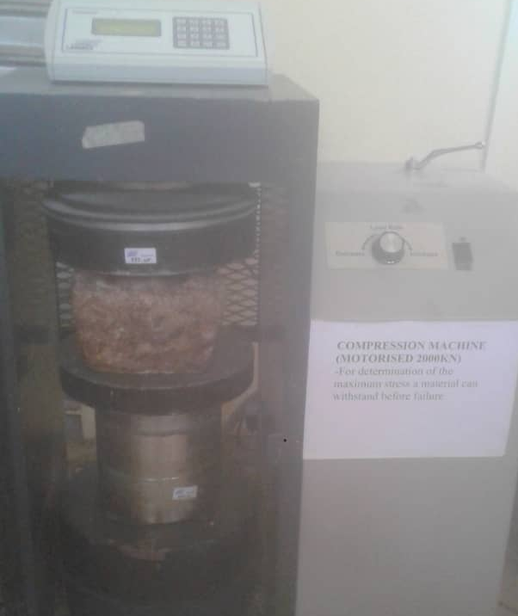

Plate 2: The Biomaterial being compressed in the machine

3.7 Scanning Electron Microscope (SEM)
The surface morphology of the biomaterial-based flower vase was analyzed using SEM (Bello et al., 2017). This involved capturing high-resolution images of the surface of the bio-based flower vase and plastic flower vase used as a control. The biomaterial samples were carefully cut to minimize distortion or damage. A thin layer of conductive material, such as gold or carbon, was applied to the samples to enhance image quality and reduce potential damage induced by the electron beam.

3.8 Energy Dispersive X-ray Spectroscopy (EDX)
EDX analysis was performed alongside SEM to determine the elemental composition of the natural and synthetic flower vase. The EDX system attached to the SEM allowed for the identification and quantification of elements present within the sample.
Results and Discussion

4.1. Strain cultivation and Spawn preparation
Mycelium growth was visually observed in slant bottles. The mycelia invasion rates were inspected every day, the glass bottles showed a gradually intensifying whitish growth of hyphae till its full ramification on the substrate after 15 days (Plate 3). Sorghum has been recorded as a good substrate for the growth of Pleurotus species. The spawn ramification days was similar to that reported by Alemu et al, (2022), while Adebayo et al. (2014) reported 18 days for Pleurotus pulmonarius.
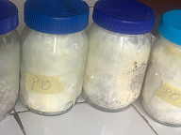

Plate 3: Fully ramified Mycelium on sorghum substrates in glass bottles

4.2 Mycelium Biomaterials
The mycelium biomaterials showed growth on the entire body as shown in plate 4. The whole flowchart of the Mycelium biomaterial is as shown in Figure 1. The ready-to-use oven-dried bio-based flower vase is as shown in plate 5. Mbabali et al. (2024) reported the production of a bio-composite using the same mushroom, probably due to the ease of cultivation. Also, Alemu et al., (2022) used the same fungus for producing a mycoblock. However, Ganoderma lucidum was used in an earlier study aimed at producing a biomaterial, and Fomes fomentarius was used elsewhere (Pohl et al., 2022; Mazian et al., 2023). This present study emphasized the use of the biomaterial first for mushroom cultivation, and later as a flower vase. This was not possible in the previous studies.
Both samples A and B were put on scale to weigh after complete dryness, sample A weighed 14 g, while sample B weighed 8 g. We concluded sample A to be harder and B softer, according to the test carried out on them.

4.5 Physico-Chemical and Mechanical Characterization Techniques

4.5.1 Water Absorption and Hydrophobicity of the Mycelium-Based Biomaterial.
Water absorption experiments evidenced that the water absorption capacity of the biomaterials for both samples A and sample B were 271.43 and 187.50, with a mean of 229. On the other hand, the water absorption for plastic used as control was 0 as shown in Table 1. Alemu et al, (2022) obtained water absorption capacity ranging from 59 to 68% for different substrate. The water absorption property of bio-based flower vases made from Pleurotus ostreatus mycelium is an important characteristic to consider, as it can affect the longevity and performance of the vases when used for floral arrangements. The ability of the vase material to absorb and retain water can impact the hydration levels and vase life of cut flowers (Aydin, 2023). Understanding the water absorption property is crucial in determining the suitability of bio-based vases for different floral applications. The composition of the substrate used in the production of bio-based flower vases can influence their water absorption property.
Different lignocellulosic materials, such as sawdust, straw, or agricultural waste, can have varying water absorption capacities. Vases produced from substrates with higher lignocellulosic content tend to have higher water absorption due to the porous nature of the mycelium structure. The water absorption property of bio-based flower vases can be further influenced by surface treatments and coatings. Applying water-resistant coatings or sealants to the vase surface can reduce water absorption and improve the durability of the material. Additionally, modifying the surface properties through treatments such as hydrophobic or hydrophilic coatings can regulate water absorption and enhance the performance of the vases (Shen et al., 2024).

4.5.2 Compressive Strength of Biomaterials
The mechanical strength of the biomaterial was evaluated by determining its compressive strength. The comprehensive strength of both samples A and sample B are 4.9KN and 5.1 KN respectively, with a mean of 5.0 KN as shown in Table 1. Based on this, the biomaterial demonstrated satisfactory compressive strength, indicating its ability to withstand external forces and maintain its structural integrity. This characteristic is crucial for practical applications such as supporting the weight of flowers as a biodegradable flower vase (ASTM International, 2019). The compressive strength of bio-based flower vase made from Pleurotus ostreatus mycelium is an important mechanical property to assess their structural integrity and durability.
Compressive strength refers to the maximum load the vase can withstand before it deforms or collapses under compression. Several factors can influence the compressive strength, including the density and composition of the substrate, the growth conditions of the mycelium, and the manufacturing process of the vases. The mycelium-based biomaterial demonstrated promising mechanical properties, with a high resistance to applied compressive forces. The specific values of compressive strength varied depending on factors such as the mycelium growth conditions, substrate composition, and processing parameters (Nashiruddin et al., 2022).
Also, the choice of substrate composition can significantly impact the compressive strength of bio-based flower vases. Studies have shown that using different lignocellulosic materials, such as sawdust, straw, or agricultural waste, as the substrate can result in variations in the density and mechanical properties of the final product. Vases produced from substrates with higher lignocellulosic content tend to have higher compressive strength due to the stronger bond formation within the mycelium network (Shen et al., 2024).
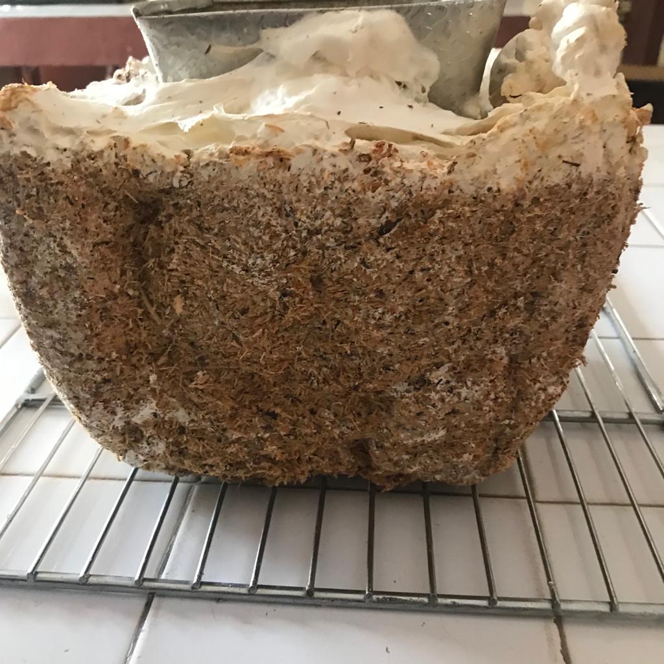

Plate 4: Fully ramified Mycelium growth (wet stage)

Figure 1: Flowchart showing production of Bio-based flower vase

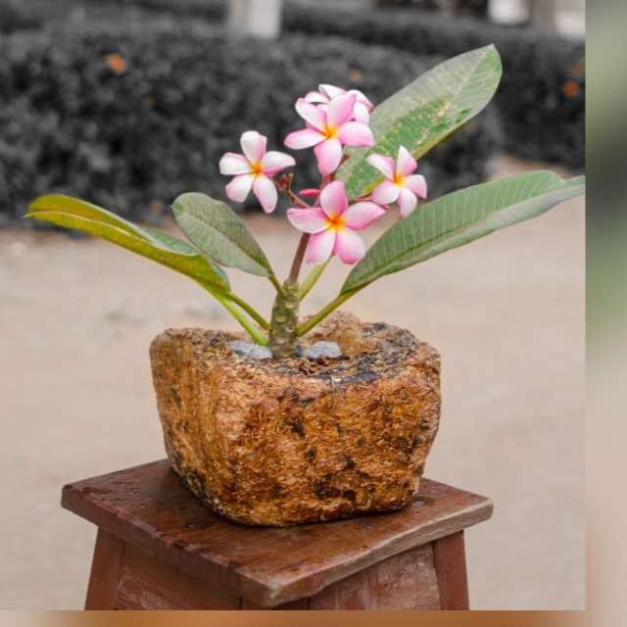

Plate 5: Developed Biomaterial (flower vase) with desired flower

Table 1: Properties of Plastic and Bio-based flower vase
Materials property | Control flower vase | Bio-based materials |  | Mean
Materials property | Plastic | Sample A (Harder) | Sample B (softer) | for bio-based materials
Compressive Strength (kN) | 3.0 | 4.9 | 5.1 | 5
Water Absorption | 0 | 271.24 | 187.5 | 229.37
Biodegradability | Non-degradable | Fully degradable | Fully degradable | Nil
Raw materials | Synthetic material | Mycelium and substrate | Mycelium and substrate | Nil
Manufacturing process | Melting and molding | Molding and growing | Molding and growing | Nil
Water content (g) | 0 | 38 | 15 | 26.5

4.6 Scanning Electron Microscopy (SEM)
In order to visualize the structural integrity of the material, SEM was used to check if the material is comparable to that of plastic. The test images revealed a porous and interconnected structure within the biomaterial matrix. The Mycelium based network formed during the growth of Pleurotus ostreatus showed a well-defined and organised arrangement of hyphae. The pores within the matrix were found to be relatively uniform in size and distribution which contributed to the overall porosity and water retention properties of the biomaterial. The results are shown in Figure 2.

4.7 Energy Dispersive X-ray Spectroscopy (EDX)
To further evaluate what was responsible for the high compressive strength and check for the safety of its elemental composition, EDX analysis was perfomed, The EDX test shows the absence of heavy metals or toxic elements, suggesting that the use of the biomaterial as a flower vase is environmentally safe and suitable for various applications. The presence of these elements can be attributed to the interaction between Pleurotus ostreatus and the sawdust substrate. The elemental composition of the Mycelium based flower vase and the plastic flower vase (control) are as shown in Table 2. Trace amounts of elements such as calcium (Ca), potassium (K), and phosphorus (P) were identified during the EDX analysis. These elements may contribute to the impressive compressive strength previously recorded. These elements may originate from minerals present in the sawdust and the fungi mycelia. Microscopic tests, such as SEM and EDX, are valuable techniques for evaluating the structural and elemental characteristics of bio-based flower vases made from Pleurotus ostreatus mycelium.
The plastic material (control) on the other hand showed a broader elemental composition including carbon, strontium, aluminium, boron, sodium, dysprosium, iron, magnesium, silicon, nitrogen and others. Any of these elements may get introduced into the environment after it has been discarded.
SEM allows for high-resolution imaging of the surface and internal structure of the vases, providing insights into the arrangement of mycelium fibers, porosity, and overall morphology. EDX, on the other hand, enables elemental analysis, allowing researchers to identify and quantify the presence of various elements within the vase material. SEM analysis of bio-based flower vases can reveal the surface morphology and porosity of the mycelium material. It allows for the visualization of the interconnected mycelial network, hyphal structure, and pore distribution within the vases. This information is crucial for understanding the material's permeability, water absorption characteristics, and potential for gas exchange, which can impact the performance and suitability of the vases for floral applications (Elkateeb and Daba, 2019). Also, EDX analysis helps in understanding the elemental makeup of the material, which can be correlated with its mechanical properties, such as strength, durability, and degradation characteristics. Combined, these microscopic tests provide valuable information for assessing the quality and performance of the bio-based flower vases (Gou et al., 2021).
Therefore, the micro-structural analysis of the biomaterial using scanning electron microscopy (SEM) carried out in this research provided valuable insights into its morphology.
The SEM images revealed a porous network structure composed of intertwined mycelial hyphae, which contributes to the overall strength and stability of the biomaterial. The interconnected hyphae create a three-dimensional network that enhances the biomaterial's mechanical properties. The study demonstrated the water absorption capacity and compressive strength of the biomaterial, making it suitable for applications like bio-based flower vases. The microstructural analysis revealed the intricate and porous network structure of the biomaterial. Overall, the study emphasizes the potential of Pleurotus ostreatus and sawdust as promising resources for the sustainable production of valuable biomaterials.

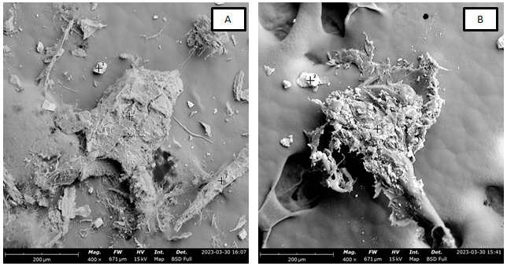

Figure 2: Scanning Electron Microscopy image of the biobased flower vase (A) and plastic flower vase (B)

Table 2: Elemental composition of bio-based flower vase and plastic flower vase.
Material | Element Number | Element symbol | Element Name | Atomic concentration (%) | Weight concentration (%)
Bio-based flower vase | 8 | O | Oxygen | 70.72 | 59.66
Bio-based flower vase | 16 | C | Carbon | 14.28 | 9.04
Bio-based flower vase | 19 | K | Potassium | 7.58 | 15.62
Bio-based flower vase | 20 | Ca | Calcium | 7.42 | 15.68
Plastic Flower vase | 8 | O | Oxygen | 66.39 | 49.71
Plastic Flower vase | 7 | N | Nitrogen | 10.13 | 6.64
Plastic Flower vase | 14 | Si | Silicon | 9.06 | 11.90
Plastic Flower vase | 35 | Br | Bromine | 4.96 | 18.50
Plastic Flower vase | 12 | Mg | Magnesium | 3.18 | 3.62
Plastic Flower vase | 6 | C | Carbon | 2.27 | 1.28
Plastic Flower vase | 11 | Na | Sodium | 1.97 | 2.12
Plastic Flower vase | 26 | Fe | Iron | 1.47 | 3.85
Plastic Flower vase | 38 | Sr | Strontium | 0.58 | 2.38
Plastic Flower vase | 66 | Dy | Dysprosium | 2.43 | 14.66
Plastic Flower vase | 13 | Al | Aluminium | 2.34 | 2.34

Conclusion
The biobased flower vase obtained in this study has higher compressive strength than the conventional plastic vase, but with high water absorption capacity. Other additional and desirable benefits of the biosynthesized flower vase is the green synthesis approach, ease of fabrication, non-toxicity, and biodegradability. This mycelium-based biomaterial can produce mushroom for harvesting prior its use as flower vase. After full harvest cycle, it can be used in place of plastic (a non-biodegradable material) as a flower vase. Plastics, have negative impact on the environment, thus producing this biodegradable biomaterial can offer dual use.
Conflict of interest
We declare that there is no conflict of interest as regards this publication.

References
Adebayo, E. A., Alao, M. B., Olatunbosun, O. O., Omoleye, E. O., & Omisakin, O. B. (2014). Yield evaluation of Pleurotus pulmonarius (oyster mushroom) on different agricultural wastes and various grains for spawn production. Ife Journal of Science, 16(3), 475-480.
Alemu, D., Tafesse, M., & Mondal, A. K. (2022). Mycelium‐based composite: The future sustainable biomaterial. International Journal of Biomaterials, 2022(1), 8401528.
Alemu, D., Tafesse, M., & Gudetta Deressa, Y. (2022). Production of mycoblock from the mycelium of the fungus Pleurotus ostreatus for use as sustainable construction materials. Advances in Materials Science and Engineering, 2022(1), 2876643.
Appels, F. V., van den Brandhof, J. G., Dijksterhuis, J., de Kort, G. W., & Wösten, H. A. (2020). Fungal mycelium classified in different material families based on glycerol treatment. Communications Biology, 3(1), 334.
Asante-Kyei, K. (2018). Design and production of decorative flower pot from plastic wastes. American Journal of Art and Design, 3(4), 33-41.
AYDIN, V. (2023). Factors affecting the post-harvest quality of cut flowers. Advances in Plant Research, 155-170.
Bamigboye C.O., Oloke J.K. and Dames J.F. (2019). Development of high yielding strain of Pleurotus tuber-regium: fructification, nutritional and phylogenetic studies. Journal of Food Science and Technology-Mysore, 56(8): 3597-3608. (IF: 2.6), INDIA.
Bamigboye, C.O., Okonji, R.E., Oluremi, I.O., James, V. (2022). Stain removing, juice-clarifying, and starch-liquefying potentials of amylase from Pleurotus tuberregium in submerged fermentation system. Journal of Genetic Engineering and Biotechnology.
Bello, M. A., Ruiz-León, Y., Sandoval-Sierra, J. V., Rezinciuc, S., & Diéguez-Uribeondo, J. (2017). Scanning Electron Microscopy (SEM) protocols for problematic plant, oomycete, and fungal samples. Journal of visualized experiments: JoVE, (120), 55031.
Elkhateeb, W. A., & Daba, G. M. (2019). The amazing potential of fungi in human life. ARC J. Pharma. Sci. AJPS, 5(3), 12-16.
Gou, L., Li, S., Yin, J., Li, T., & Liu, X. (2021). Morphological and physico-mechanical properties of mycelium biocomposites with natural reinforcement particles. Construction and Building Materials, 304, 124656.
Gough, P., Globa, A., & Reinhardt, D. I. E. (2024). Mycelium-based materials for the built environment: a case study on simulation, fabrication and repurposing myco-materials. In Sustainability and Toxicity of Building Materials (pp. 547-571). Woodhead Publishing.
Ghazvinian, A., Farrokhsiar, P., Vieira, F., Pecchia, J., & Gursoy, B. (2019). Mycelium-based bio-composites for architecture: Assessing the effects of cultivation factors on compressive strength. Mater. Res. Innov, 2, 505-514.
Girometta, C., Dondi, D., Baiguera, R. M., Bracco, F., Branciforti, D. S., Buratti, S., ... & Savino, E. (2020). Characterization of mycelia from wood-decay species by TGA and IR spectroscopy. Cellulose, 27, 6133-6148.
Haneef, M., Ceseracciu, L., Canale, C., Bayer, I. S., Heredia-Guerrero, J. A., & Athanassiou, A. (2017). Advanced materials from fungal mycelium: fabrication and tuning of physical properties. Scientific reports, 7(1), 41292.
Joshi, K., Meher, M. K., & Poluri, K. M. (2020). Fabrication and characterization of bioblocks from agricultural waste using fungal mycelium for renewable and sustainable applications. ACS Applied Bio Materials, 3(4), 1884-1892.
Lelivelt, R. J. J., Lindner, G., Teuffel, P., & Lamers, H. (2015). The production process and compressive strength of mycelium-based materials. In First International Conference on Bio-based Building Materials. 22-25 June 2015, Clermont-Ferrand, France (pp. 1-6).
Mazian, B., M’barek, H. N., Almeida, G., Augusto, P., & Perré, P. (2023). Water behavior, equilibrium, and migration of a biomaterial made of pure mycelium. Emergent Materials, 6(6), 1889-1902.
Nashiruddin, N. I., Chua, K. S., Mansor, A. F., A. Rahman, R., Lai, J. C., Wan Azelee, N. I., & El Enshasy, H. (2022). Effect of growth factors on the production of mycelium-based biofoam. Clean Technologies and Environmental Policy, 24(1), 351-361.
Picco, C. M., Suarez, N. E., & Regenhardt, S. A. (2024). Exploring the impact of substrate composition and process parameters on biomaterial derived from fungus mycelium (Pleurotus ostreatus) and agricultural wastes. MRS Advances, 9(2), 33-38.
Shen, S. C., Lee, N. A., Lockett, W. J., Acuil, A. D., Gazdus, H. B., Spitzer, B. N., & Buehler, M. J. (2024). Robust myco-composites: a biocomposite platform for versatile hybrid-living materials. Materials Horizons, 11(7), 1689-1703.
Solanilla‐Duque, J. F., Salazar‐Sánchez, M. D. R., & Rodríguez Herrera, R. (2022). Potential of lignocellulosic residues from coconut, fique, and sugar cane as substrates for Pleurotus and Ganoderma in the development of biomaterials. Environmental Quality Management, 32(1), 343-353.
Sovjak, B. R., & Fridrichova, E. (2018). Design study of indoor flower pots with an emphasis on their added value. In IN 5th International Multıdisciplanry scientific conference on Social Sciences and Arts Sgem August 26th–September 1st (pp. 163-170).
Suganthi, V., & Krishnakumari, S. (2018). Efficacy of different agricultural by product substrates and moisture content on mycelial growth of Pleurotus cornucopiae. J. Pharmacol. Phytochem, 7, 3407-3409.
Whabi, V., Yu, B., & Xu, J. (2024). From Nature to Design: Tailoring Pure Mycelial Materials for the Needs of Tomorrow. Journal of Fungi, 10(3), 183.
Womer, S., Huynh, T., & John, S. (2023). Hybridizations and reinforcements in mycelium composites: A review. Bioresource Technology Reports, 22, 101456.
Yanel, K. (2021). Modification of Hand Molding Flower Vase for Thermo Plastic Recycling. Jurnal Teknik Mesin, 11(1), 1-7.
Yang, L., Park, D., & Qin, Z. (2021). Material function of mycelium-based bio-composite: A review. Frontiers in Materials, 8, 737377.
Zhang, X., Hu, J., Fan, X., & Yu, X. (2022). Naturally grown mycelium-composite as sustainable building insulation materials. Journal of Cleaner Production, 342, 130784.

