Environmental Surveillance of Pseudomonas aeruginosa: Virulence Determinants and Antibiotic Resistance Patterns in Hospital Settings

Abstract

Pseudomonas aeruginosa is an opportunistic pathogen mainly responsible for many nosocomial infections. The pathogen has the ability to produce a diverse range of virulence factors to establish infection in host. Keeping these points in mind, the present study aims to isolate P. aeruginosa from hospital environment to characterize its virulence and determine its antibiotic susceptibility pattern. The study selectively isolated P. aeruginosa using cetrimide agar and conducted phenotypic, biochemical, and virulence characterization along with antibiotic susceptibility pattern testing. P. aeruginosa was found to be prevalent in hospital environment. Approximately 92% of the isolates recovered were mucoid, suggesting a pathogenic nature. The degree of siderophore production varied amongst the isolates, ranging from a 1.5-12 mm zone diameter. For phospholipase C production, 20% of isolates were strong producers, followed by 30% were moderate producer and 50% were weak producers. All isolates recovered from the air sample in the outer patient Department (OPD) and water sample from the hospital canteen tested positive for hemolysin production. In contrast isolates recovered from air samples at Hospital main gate and the Hospital Canteen did not produce hemolysin. All isolates exhibited cell surface hydrophobicity ranging from 20 to 80%. Additionally, 70% of the isolates were resistant to ampicillin. Norfloxacin, imipenem, and gentamicin were effective against all isolates. The isolates showed variable susceptibility to ciprofloxacin and chloramphenicol. The current study revealed P. aeruginosa to possess a diverse array of virulence factors enabling it to cause a wide range of infections even after exposure to multiple antimicrobial agents.
Keywords: Antibiotic susceptibility, Nosocomial infection, Occupational exposure, virulent factors
1. Introduction
Pseudomonas aeruginosa is a gram-negative, rod-shaped, heterotrophic, motile, opportunistic, facultative aerobic bacterium primarily associated with nosocomial infections ^{[1, 2]}. It most commonly causes infection in immunosuppressed individuals including burn patients, those undergoing wound care, cancer patients, individuals with HIV, neutropenic, and those suffering from cystic fibrosis ^{[3]}. It is frequently isolated from a variety of body fluids including nasal secretions, ear swab, sputum, wound exudates, ocular secretion, blood, urine, and samples from lower digestive tract ^{[4, 5].}
Though ubiquitously present in soil, air, and water and usually harmless in such environment. However, P. aerugionas potentially contaminates medical instruments and is frequently detected in hospital reservoirs such as wash basins, drinking water outlets, sinks, toilets, and bathrooms ^{[6]}. As an opportunistic pathogen, P. aeruginosa is implicated in broad spectrum of acute and chronic infections. It is a leading cause of pulmonary infection, bronchiectasis, and sepsis ^{[7, 8]}. In cystic fibrosis patients, it contributes to pulmonary damage and widespread diffuse panbronchiolitis ^{[9]} as well as progressive community-acquired pneumonia ^{[10]}.
P. aeruginosa is an extremely virulent pathogen, producing an arsenal of virulence factors including exotoxin enzymes ^{[11]} lipopolysaccharide (LPS), pilus and non-pilus adhesions, and flagellum, and secretory virulence factors such as siderophore, elastase, protease, rhamnolipids, hemolysin, and factor involved in biofilm formation, and hydrophobicity ^{[12-14]}. The production and expression of these virulence factors are mainly governed by quorum sensing and cell-to-cell signaling process ^{[5, 15]}.
The pathogenesis of P. aeruginosa is characterized by the synthesis of both extracellular and cell-associated virulence factors ^{[16]}. The formation of a slime layer on medical devices is a key element in the pathophysiology of P. aeruginosa ^{[17]}. The bacterium is considered as a classic opportunistic pathogen not only due to its virulence factors but also because of its remarkable resistance to multiple antibiotics and disinfectants ^{[18]}. Additionally, plasmid mediated resistance further enhance its ability to establish infection ^{[19]}.
The pathogen’s cell surface hydrophobicity is another important factor that influences adhesion and subsequent biofilm formation on medical equipment and surgical instruments ^{[15, 20]}. Biofilm development is a well-established mechanism of pathogenesis in hospital-acquired infection caused by P. aeruginosa ^{[21]}. P. aeruginosa cells growing in biofilm are highly resistant to the host immune system and antibacterial agents, allowing them to survive in hostile environment ^{[22]}.
Attachment to host cell and subsequent invasions are critical steps in the infection process ^{[23]}. The organism’s innate and acquired resistance to numerous structurally unrelated antibiotics can be attributable to several mechanisms including reduced cell wall permeability, enzyme expression, plasmid acquisition, active efflux systems, and biofilm formation ^{[24, 25]}. Infections caused by the multidrug-resistant P. aeruginosa are associated with increased mortality, morbidity, and health care cost represent a significant challenge in many health care setting ^{[26,27]}.
The present study aims to screen P. aeruginosa from various sources characterize their virulence attributes and evaluate their antibiotic sensitivity patterns.
2. Materials and Methods
All chemicals used in the experiments were analytical reagent (AR) grade. The microbiological media used in the study were procured from Hi –media (Mumbai, India) and utilized according to the manufacturer’s instructions. All glassware used was made of borosilicate glass.
2.1. Sample collection
A total of 45 distinct air samples were collected from various hospital environments including main gate, OPD, canteen. Additionally, 5 water samples were collected from hospital canteen located in Mohali district of Punjab, India.
For air sampling exposure plate technique was employed. Plates containing selective cetrimide media were exposed to the air for 15 minutes, allowing airborne microflora to settle on the surface. The plates were then transported to the laboratory for further analysis. Water samples were collected aseptically in sterile bottle and stored under appropriate condition until further processing. All the collected samples were inoculated on cetrimide agar within 4 hours of collection.
2.2. Isolation of P. aeruginosa
P. aeruginosa was selectively isolated using cetrimide agar ^{[28, 29]}. For air samples, the settling plate method was used. All water samples were directly streaked onto cetrimide agar plate incubated at 35±2ºC for 24 hours.
2.3. Purifying and maintaining the isolates
Isolated colonies were further purified by streaking onto nutrient agar plates. Pure cultures of isolates were maintained on nutrient agar slant at 4ºC and revived periodically. The pure culture were also preserved and maintained for long term in glycerol broth and stored at -70ºC in a deep freezer.
2.4. Characterization of the recovered isolates Morphological Characterization
Gram staining was performed to observe the cell morphology of the recovered bacterial isolates.
2.5. Cultural Characterization
Isolates were subsequently streaked in nutrient agar, cetrimide agar, and MacConkey agar, after incubation colonies were examined for cultural characteristics including margin, shape, size, elevation, opacity, and pigmentation.
2.6. Biochemical Characterization
A series of biochemical test were carried out to for the characterization and identification of the potential isolates. IMViC, oxidase, catalase, urease, carbohydrate fermentation, triple sugar iron, and motility tests, as well as other biochemical tests, were also performed on the isolates.
2.7. Virulence Characterization of the P. aeruginosa
2.7.1. Siderophore Production
The chromeazurol sulfonate (CAS) assay was performed due to its high sensitivity and reliability. Bacterial isolates were inoculated onto CAS agar plates and incubated at 35±2˚C for 24-48 hours. A color shift typically yellow-orange halos around the growth, indicate positive siderophore activity. Their diameter of the halo zone was measured ^{[29, 30]}. All experiments were performed in triplicate with appropriate positive and negative control.
2.7.2. Phospholipase C Production
The egg-yolk plate method was used for screening phospholipase C activity. Isolates were spot inoculated onto egg-yolk plates and incubated at 35±2˚C for 18-24 hours. A clear zone of hydrolysis indicate positive result. The diameter of the hydrolysis zone was measured ^{[29, 31]}. All experiments were performed in triplicate with appropriate positive and negative control
2.7.3. Hemolysin Activity
Hemolysin production was assayed by streaking isolates onto the blood agar plates. After 24 hours of incubation at 35±2˚C, the presence of a clear zone or translucent area around the growth indicate positive hemolysin production ^{[29, 32]}. All experiments were performed in triplicate with appropriate positive and negative control.
2.7.4. Hydrophobicity Test
Isolates were inoculated in a 10 mL nutrient broth (pH6.0) and incubated at 35±2˚C for 24 hours. Cells were then harvested by centrifugation at 2400 x g. The resulting cell plates were washed twice with Phosphate-buffered saline (PBS; 0.02M; pH 7.4). The washed cells were resuspended in 2 mL PBS, and transferred into test tubes. To each test tube 0.4 mL of xylene was added. The tubes were vigorously shaken for 2 min and allowed to stand undisturbed for 15 minutes. The optical density (OD) of the aqueous phase was measured, and the percentage of hydrophobicity for each isolates was calculated by using the formula given by Rosenberg et al. ^{[33]}. In the equation the variables involved (A=absorbance after xylene extraction and Ao=absorbance before xylene extraction).
Hydrophobicity (%H) = [(A-Aо)/Aо]*100 (1)
2.7.5. Biofilm Formation Assay
Biofilm formation was studied using a 96-well microtiter plate. Overnight grown culture of different isolates were inoculated into the wells and incubated. All experiments were conducted in triplicate (n=3) to ensure reproducibility and statistical validity. Appropriate positive and negative control also ran for each set of experiment. Then the growth was initially measured by taking OD at 600 nm using a photo spectrometer. The culture medium was then discarded and each well were washed thrice with sterile distilled water. The adherent cells (biofilm) were stained with crystal violet. After staining, 95% ethanol was added to solubilize the bound dye and absorbance was taken at 530 nm using ELISA reader. Biofilm formation efficiency was calculated based on the optical density. Background staining was accounted for by including non-inoculated control wells ^{[34]}.
2.8. Antibiotic Susceptibility Test
Antibiotic susceptibility of the isolates was determined using the Kirby-Bauer disc diffusion method on the Mueller-Hinton agar plates. A lawn culture was prepared by swabbing a small volume of each isolates uniformly across the agar surface. The plates were left to stand for 5 minutes to allow drying. Antibiotic discs were placed aseptically and equidistantly on the agar surface. The plates were then incubated at 35±2˚C for 24 hours. Zone of inhibition around each disc were measured and the diameter recorded ^{[29, 35]}. The susceptibility profile of each isolate was interpreted by comparing the inhibition zone diameter to the standard reference chart provided by that Hi-Media.Table 1 illustrate the lists of the t antibiotics used to assess susceptibility against P. aeruginosa.
Table 1: Antibiotics disc (potency) used for susceptibility testing against Pseudomonas aeruginosa.
Antibiotics | Disc potency (mcg)
Chloramphenicol | 30
Ampicillin | 25
Gentamicin | 10
Imipenem | 10
Norfloxacin | 10
Ciprofloxacin | 5

2.8.1. Statistical analysis
All experiments were conducted in triplicate (n=3) and data were expressed as mean ± standard deviation (SD). To find whether the biofilm formation and antibiotics susceptibility profiling were statistically significant, one way ANOVA was performed using SPSS software. For biofilm formation (OD₅₃₀) obtained from crystal violet assay were compared across isolates. Likewise, zones of inhibition for different antibiotics were compared to asses antibiotics susceptibility profiling. A p value of <0.05 was considered statistically significant.
3. Results
3.1. Selective Isolation of P. aeruginosa
A total of 10 different isolates of P. aeruginosa were selectively isolated from different environmental samples using cetrimide agar (Table 2). The colonies typically appeared large, greenish and exhibited a characteristics fried egg-like morphology. The isolates were further streaked on cetrimide and 2% Dettol agar for confirmation.
Table 2. Sources of samples and the prevalence of P. aeruginosa
S. No. | Sample sources | Designation of Isolates | Prevalence of the isolates (%)
1. | Air (Hospital Main Gate) | S1 | 10
2. | Air (OPD) | B2, B3, B4, B5, B6 | 50
3. | Water (Hospital Canteen) | W7, W8, W9 | 30
4. | Air (Hospital Canteen) | U10 | 10

3.2. Partial Characterization of the Isolates Based on the Morphological, Cultural, and Biochemical Characterizations
All isolates were further subjected to various morphological and culture characterizations. They were observed as Gram-negative and short rod with a green fried egg-like appearance on the cetrimide agar. On MacConkey agar the colonies appeared white, indicative of a non-lactose fermenter and emits a grape-like odor. For biochemical characterization the isolates were indole-negative, MR-negative, VP-negative, citrate-positive, oxidase-positive, and nitrate reduction-positive. The triple sugar iron (TSI) test showed an alkaline slant with no change in the butt (Alkaline/NC). Furthermore, all isolates tested negative for sugar fermentation and gas production (i.e., no color change was observed, which would have indicated acid and gas production).
3.3. Prevalence of P. aeruginosa in the Clinical Specimens
The prevalence of P. aeruginosa varied significantly among all environmental samples. It was most prevalent in air sample collected from OPD (50%), followed by the water sample collected from canteen (30%). Air samples from the hospital main gate and canteen showed a prevalence of 10% each (Table 2).
3.4. Virulence Characterization of Isolated P. aeruginosa
P. aeruginosa is an opportunistic pathogen and produces an arsenal of virulence factors to establish infection in a host. All the recovered isolates of P. aeruginosa were screened for the various virulence factors (i.e., siderophore, hemolysin, phospholipase, biofilm, and cell surface hydrophobicity). All isolates exhibited significant variability regarding their virulence factors.
3.4.1. Siderophore Production
The orange halo zone around the culture growth on CAS media indicates a positive results, and all isolates tested positive for the siderophore production assay (Figure 1A). The frequency of siderophore production among the isolates varied from 1.5 to12 mm. Isolate B2, recovered from the burn patients, showed the highest level of siderophore production at 12mm (diameter of orange halo zone), followed by B4 and W9 at 11mm each, while isolate S1 recovered from an air sample (hospital main gate) presented a halo zone size of 1.5mm, indicating it to be a weak siderophore producer (Figure 1B).

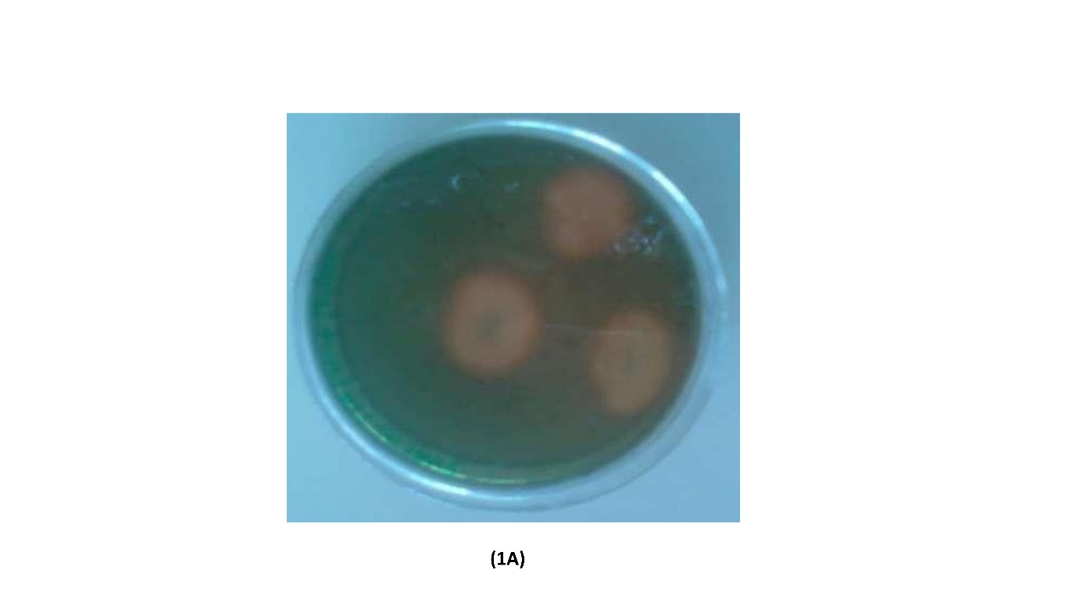
Figure 1A: Shows siderophore production (orange color halo zone positive test)
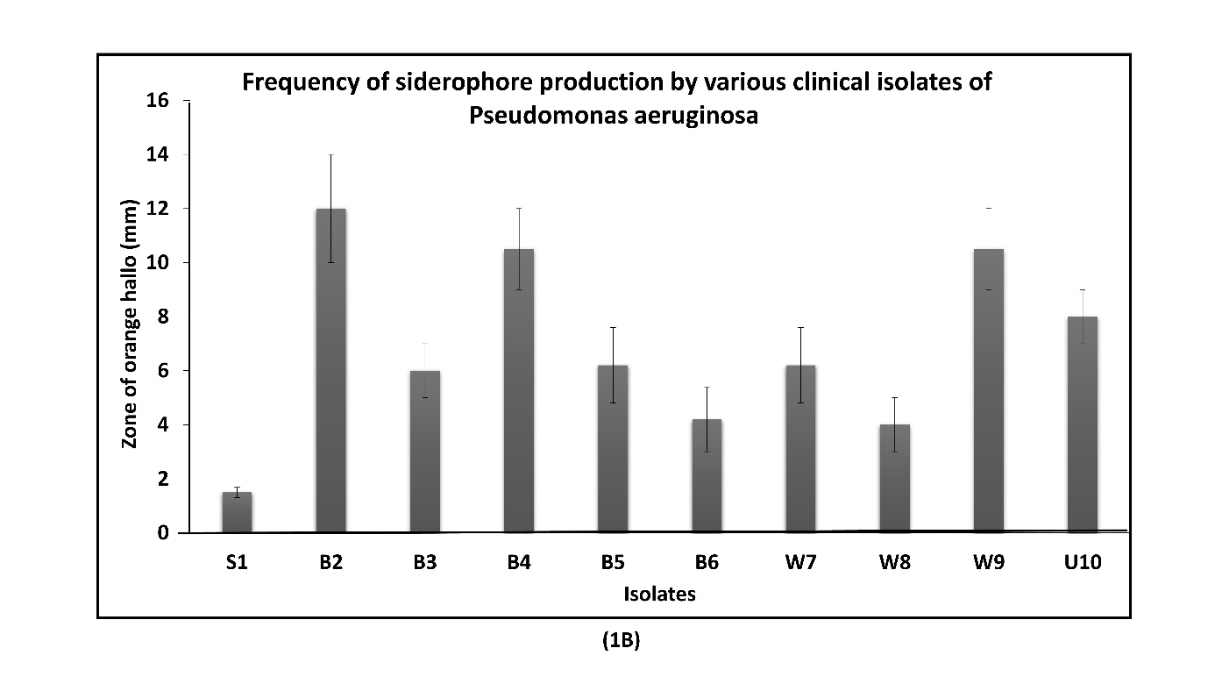
Figure 1B: Frequency of siderophore production by various isolates of Pseudomonas aeruginosa
3.4.2. Phospholipase C Production
The clear hydrolysis zone was considered positive for phospholipase C production (Figure 2A). The level of phospholipase C production varied significantly among the isolates, with zone diameters ranging from 2.7 to 12 mm (Figure 2B). Among all isolates, 20% were classified as strong producers (zone diameter 12 to10 mm), 30% as medium producer (zone diameter 9 to7 mm), and 50% as weak producers (zone diameter < 8 mm).
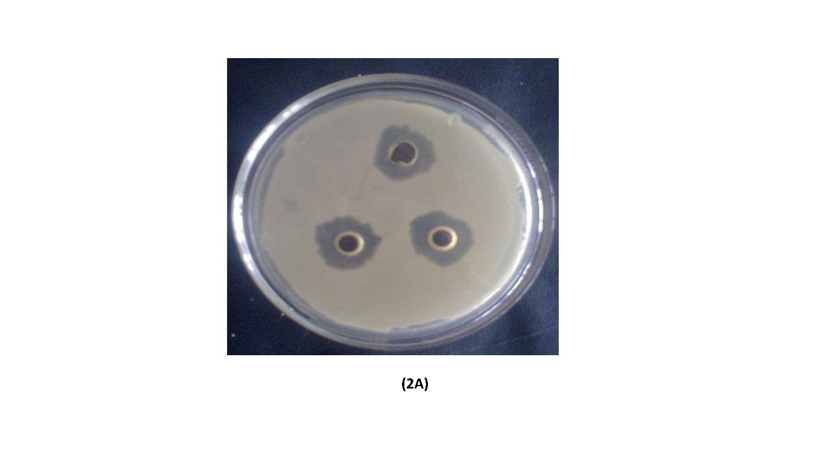

Figure 2A: Zone of inhibition shows phospholipase production by P. aeruginosa
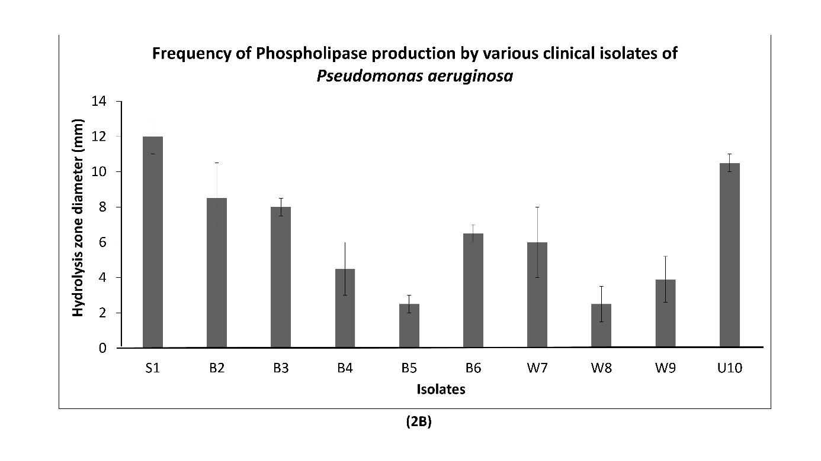
Figure 2B: Shows frequency of phospholipase production by different isolates
3.4.3. Hemolysin Production
In the current study a presence of a clear zone along the line of growth was recorded as positive for hemolysin production. Only eight isolates exhibited hemolysis on blood agar medium supplemented with 5% goat blood. The degree of hemolysis varied among the isolates. A, 100% hemolysis rate was observed for the isolates recovered from the burn and wound care patients. In contrast, isolates recovered from air samples at the hospital main gate and hospital canteen exhibited no hemolytic activity (Figure 2C).
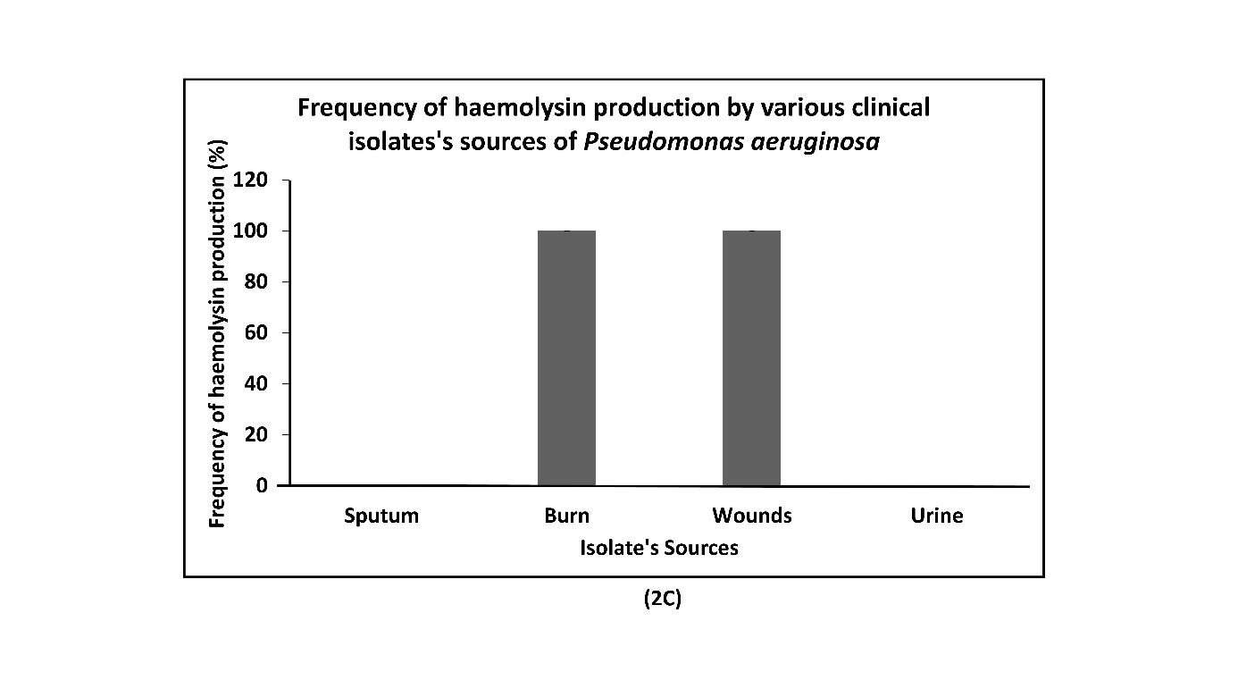
Figure 2C: Hemolysin production by various isolates of P. aeruginosa.
3.4.4. Cell Surface Hydrophobicity
Cell surface hydrophobicity of the isolates ranged from 20% to 80%. The present study found that isolate S1 and B5 had cell surface hydrophobicity value of 20% and 30%, respectively, which are less than 35% and therefore considered hydrophilic. In contrast the remaining isolates exhibited cell surface hydrophobicity values above 35%, indicating a hydrophobic nature. Isolate B4 showed the highest hydrophobicity value at 80 % (Figure 3A).
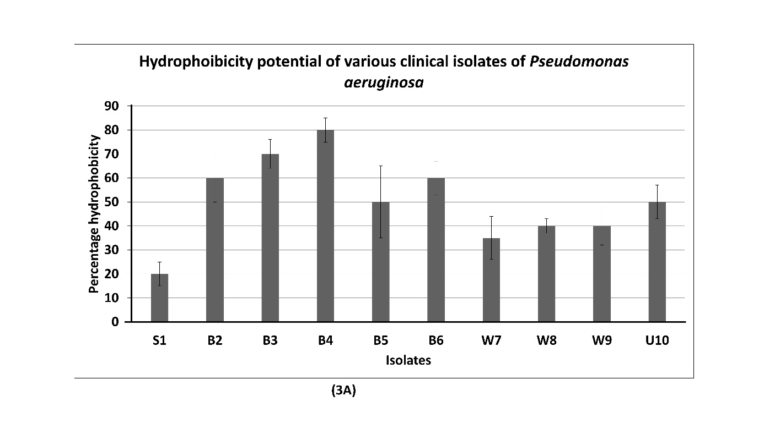
Figure 3A: Hydrophoibicity potential of various isolates of P. aeruginosa
3.4.5. Biofilm Formation
Different isolates of P. aeruginosa were screened for their biofilm formation ability using a microtiter plate assay. Based on the optical density (OD₅₃₀) measurments only two isolates (S1 and B3) were identified as non-biofilm former (OD < 0.2), while the remaining isolates exhibited OD >0.2 and were classified as biofilm former. Staistical analysis was performed using one way ANOVA followed by Tukey’s post hoc test to compare the biofilm forming ability amongst the isolates. The difference observed were statistically significant (p<0.05), confirming variation in biofilm formation amongst the test isolates (Figure 3B).
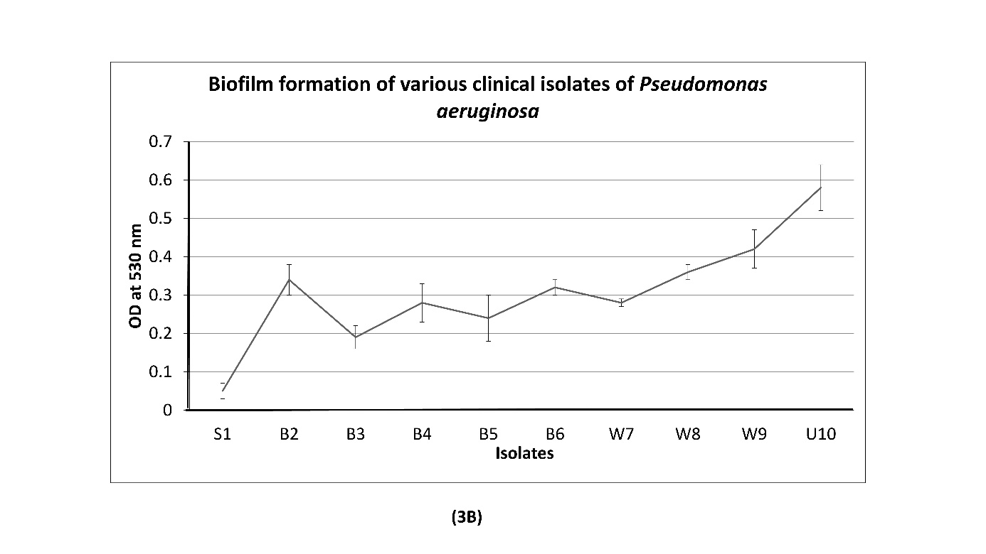
Figure 3B: Biofilm formation of various isolates of P. aeruginosa.
3.5. Antibiotic Sensitivity Tests
The antibiotic sensitivity profiles of all isolates were determined using the Kirby-Bauer disc-diffusion method. The antibiotic sensitivity (zone of inhibition) ranged from 14.5 mm to 30 mm across all isolates reflecting considerable variability in antibiotic efficacy. The data were statistically tested with one way ANOVA, for all six tested antibiotics. The analysis showed a statistically significant difference in mean inhibition zones (p<0.001), confirming that the antibiotics differ significantly in their effectiveness. Norfloxacin, was the most effective antibiotics against all isolates followed by imipenem and gentamicin. Most isolates showed moderate sensitivity to ciprofloxacin. In contrast, the majority of isolates were resistant to ampicillin, although a few isolates (B4, W8, and W9) exhibited intermediate sensitivity. For chloramphenicol, all isolates demonstrated a mix of resistant, intermediate, and sensitive responses.
These finding suggest that regular monitoring and susceptibility profiling required to inform empirical antibiotic therapy. Particularly in health care settings, where P. aeruginosa is prevalent. The statistically significant ANOVA result (p <0.001) supports the clinical relevance of tailoring antibiotic choice based on local resistance pattern.
The detailed results of the antibiotic sensitivity profiling of all the recovered isolates are shown in Table 3.
Table 3. Antibiotic susceptibility profiling of different clinical isolates
Isolates | Chloramphenicol |  | Ciprofloxacin |  | Ampicillin |  | Gentamicin |  | Imipenem |  | Norflo  xacin
 | Zone of Inhibition diameter (mm)
S1 | 25 | S | 19 | S | 18 | R | 15 | S | 18 | S | 21 | S
B2 | 12 | R | 19.5 | S | 18.5 | R | 15.5 | S | 16 | S | 23 | S
B3 | 19.5 | S | 15 | R | 17.5 | R | 16 | S | 18 | S | 21.5 | S
B4 | 15.5 | I | 14.5 | S | 19.5 | I | 13.5 | I | 20.5 | S | 30 | S
B5 | 12 | R | 21 | S | 18 | R | 16 | S | 18 | S | 23 | S
B6 | 12 | R | 17.5 | I | 18 | R | 14.4 | I | 18.5 | S | 25.5 | S
W7 | 11 | R | 21.5 | S | 17.5 | R | 15.5 | S | 21 | I | 26 | S
W8 | 15.5 | I | 21 | S | 20.5 | I | 15 | S | 19.5 | S | 21 | S
W9 | 21.6 | I | 20.5 | S | 19 | I | 15 | S | 16 | S | 21.5 | S
U10 | 12 | R | 19.5 | S | 18 | R | 15 | S | 16.5 | S | 28 | S

R: Resistant; I: Intermediate and S: Sensitive
4. Discussion
P. aeruginosa is a notorious pathogen and causes significant infection in immunocompromised, cystic fibrosis, cancer, and HIV patients. The pathogen is also reported to grow on minimal media, medical devices, surgical instruments, and even in some antimicrobial compounds including eye ointment. It also frequently grows in bed linens in hospital wards and commonly transmitted by health workers. Therefore, this pathogen can easily be recovered from patients and hospital environments.
The cetrimide agar is a selective media for isolating P. aeruginosa, because this medium contains cetrimide, a quaternary ammonium salt and a cationic detergent that complexes and denatures the bacterial cell membrane protein, thus inhibiting the growth of other bacteria on the cetrimide agar. This medium also enhances the production of pyocyanin and fluorescein blue-green and yellow florescent green pigments, which are responsible for the release of phosphorus and nitrogen from bacterial cells other than, P. aeruginosa, hence diminishing the growth and multiplication of other bacteria and supporting the growth of this pathogen ^{[36]}.
By comparing all the observational (i.e., morphological, cultural, and biochemical) data with Bergey’s Manual of Systematic Bacteriology ^{[37]} all isolates were identified as P. aeruginosa. Similar findings have been observed by Malini et al. ^{[38]} who recorded P. aeruginosa as the most common non-fermentative, Gram-negative bacteria associated with clinical infections at an occurrence rate of 53.8%. Similarly, Wei et al.^{[39]} isolated 132 isolates P. aeruginosa from various drinking water samples from 23 district of China, suggesting that P. aeruginosa is an opportunistic pathogens and a major threat to microbial safety of drinking water. Its presence in the drinking water also support that it can grow even in minimal media.
In another study different fungal genera including Aspergillus sp., Penicillium sp. and Trichophyton sp, and bacterial genera including Bacillus sp., Micrococccus sp., Staphylococcus sp., Streptococcus sp, recovered from Clifford University Medical Centre, Nigeria hospital environment through exposure plate methods ^{[40]}. The present study found the prevalence of P. aeruginosa to be 50% in OPD air samples, followed by 30% in water samples, collected from hospital canteen and 10% each in air sample collected from main gate of hospital and air sample collected from hospital canteen which closely resembles the above findings. Based on this information, P. aeruginosa has been strongly established as being an opportunistic pathogen that is frequently recovered from the clinical environment. This notorious pathogen is associated with the production of a diverse range of virulence factors, assisting the pathogens in establishing disease in the host.
Siderophore is a very important virulence factor produced by P. aeuroginosa. This finding found the degree of siderophore production to range between 1.5 to12 mm, which classify as strong, intermediate, and weak production values. All isolates were reported to produce siderophore at a prevalence of 100%. Similarly, 84.6% of clinical isolates of P. aeruginosa were reported to produce the siderophore pigment, which is very similar to the current study ^{[41-43]}. The Fe-CAS (Iron-chromeazurol S) is a blue-colored medium; when an inoculated organism produces siderophore, it sequesters iron from the medium, changing its color to an orange halo zone around the bacterial growth. The production of an orange halo zone and the respective diameter is directly proportional to the amount of siderophore production, with a larger-sized orange halo zone being indicative of a stronger producer, and vice-versa.
The principle of this assay is based on the color change from blue to orange, resulting in the removal of iron from the chromeazurol dye through the iron-chelating compound siderophore ^{[44}]. Siderophore production in the different P. aeruginosa isolates was confirmed by the appearance of the yellow/orange-colored zone, indicating siderophore production. The color changes from blue to orange as a result of the isolate’s siderophore production and sequestration of Fe from the dye ^{[45]}.
Another study also used quorum sensing modulation to reveal the pyocyanin and pyoverdine siderophore produced by P. aeruginosa PAO1 to enhance the capability of invasion, virulence, biofilm formation, and antibiotic resistance in the host ^{[46]}.
One phospholipase that plays a considerable role in bacterial pathogenesis is phospholipase C. Mittal et al. ^{[47]} found 12 isolates with high producibility and 6 isolates with weak producibility, with this study also similarly founding 20% of the isolates to be strong producers, 30% to be medium, and 50% to be weak producers of phospholipase C. Another study conducted in 2013 by Elleboudy et al. [48](2013) found 22.6% of phospholipase producing gram-negative rods were found to have phospholipase productivity ranging from high activity (Pz ≤0.69) to weak activity (0.99< Pz <0.90), compared to Gram-negative rods with only strong phospholipase activity.
Phospholipases have been confirmed in a variety of bacteria, including P. aeruginosa ^{[49]}. They are a heterogeneous group of enzymes that have the ability to hydrolyze one or more ester linkages in glycerophospholipids. Phospholipases hydrolyze the phosphodiester bond in the phospholipid backbone. Phospholipases also contribute to microbial virulence ^{[50]}. The phospholipase produced by P. aeruginosa iscapable of degrading the phospholipids present in the cell membrane of various body lines and of facilitating invasion of the pathogen.
Hemolysin is another key virulence factor responsible for pseudomonas infection. For this purpose, the study the blood agar medium, with hemolysis of erythrocyte indicating a positive result as revealed by the zone of hemolysis around the bacterial growth. In blood agar, P. aeruginosa produces hemolysin on hydrophilic media responsible for the lysis of erythrocyte ^{[51]}. The present study found that the frequency of hemolysis production to vary among the isolates. All isolates isolated from burn patients and wound care patients tested positive for hemolysis production, while the isolates recovered from urine and sputum tested negative.
Similarly, El-Mahdy and El-Kannishy, detected 85.6% isolates of P. aeruginosa to be able to produce hemolysin. Hemolysin also aids in the invasion of P. aeruginosa in eukaryotic cells through their cytotoxic effects and thus was found to be prominent in clinical isolates more than environmental isolates ^{[52]}.
Attachment and colonization with the host cell are the first steps in bacterial infection. Cell surface hydrophobicity is an important factor for adherence and colonization. It is a complex interaction between the cell surface of the bacteria and the surrounding environment ^{[53]}. The present study evaluated the colonization potential of the recovered isolates using the cell surface hydrophobicity test to evaluate the cells’ surface properties. A hydrophobicity value greater than 35% indicates the presence of hydrophobic molecules such as wall-intercalated proteins, cytoplasmic membrane proteins, surface array proteins, and lipids ^{[54]}. Values less than 35% indicate cells with a hydrophilic character ^{[55]}.
This study observed the cell surface hydrophobicity of the isolates to range from 20%-80%. Isolate B4 was more prominent and showed the highest hydrophobicity value of 80%. Meanwhile, the isolates S1 and B5 had respective hydrophobicity values of 20% and 30%, which is less than the criteria set for cell surface hydrophobicity (i.e., 35%) and hence are considered hydrophilic in nature. When evaluating surface properties such as hydrophobicity, having pathogenic organisms show adhesion ability of bacterial cells to host cells is significant.
Biofilm formation is another unique property of bacteria and plays a significant role in disease establishment. It is generally chronic in nature and assists bacteria in colonizing and establishing disease ^{[53]}. The present study found all isolates to be biofilm formers except the isolates S1 and B3. Significant OD difference among the isolates (p<0.05) strengthens and highlights the variability in biofilm formation ability among all isolates. Similarly, Hostacka et al. isolated P. aeruginosa from patients’lesions and reported an OD value greater than 0.2 to indicate a biofilm former, with values less than or equal to 0.19 indicating a non-biofilm former ^{[56]}. The ability to form biofilm allows P. aeruginosa to evade the host’s defensive mechanisms and also resist the antimicrobial action of antibiotics ^{[57, 58]}.
The extracellular virulence factors (i.e. siderophore, phospholipase, and hemolysin production; cell surface hydrophobicity, and biofilm production) play crucial roles in the colonization of P. aeruginosa, as these factors also help the organisms invade various tissues, produce toxins, enter blood vessels, and initiate systemic infections, tissue damage, and organ dysfunction, as well as resist host immunity.
Antibiotic susceptibility tests generally determine the effectiveness of antibiotics against any bacteria and are routinely performed in a laboratory to find the most suitable antibiotic for treating a particular bacterial infection. The present study found norfloxacin was the most effective antibiotic followed by imipenem and gentamicin against the P. aeruginosa isolates. Most of the isolates were also sensitive to ciprofloxacin. Meanwhile, the majority of isolates were found resistant to ampicillin, except isolates B4, W8, and W9 which showed intermediate values. Additionally, the one way ANOVA result confirm that the differences in the zone of inhibition of all six tested antibiotics statistically significant (p<0.001) demonstrating variable sensitivity of P. aeruginosa isolates to different antibiotics.
A similar result was also observed for chloramphenicol. Similarly, Raja and Singh found more than 90% of their isolates to be sensitive to the antibiotic chloramphenicol ^{[59]}. Imipenem belongs to the carbapenem group of antibiotics, which can bind with different penicillin-binding proteins. Imipenem was the most successful drug against P. aeruginosa. Mansoor et al. found 76% of their isolates to be sensitive to imipenem, 17% to have intermediate sensitivity, and 7% to be resistant. Prolonged administration of imipenem in P. aeruginosa-infected patients often causes the development of resistant mutations. P. aeruginosa as being notorious for this, as it is a dangerous and dreaded pathogen ^{[60]}. P. aeruginosa is regularly sensitive to only antibiotic agents such as cephalosporins, carbenicillin, colistin, gentamicin, quinolones, polymyxin, and streptomycin, with varying degrees of cross-resistance also being reported among these agents ^{[61]}.
Due to the presence of a porin channel in the cell wall and an efflux pump, P. aeruginosa is able to slow down or nullify the effects of antibiotics. Also, drug-resistant genes are present in both its bacterial DNA and plasmids, which is another reason for its resistance against antibiotics. Antimicrobial resistance is a serious problem for high-risk patient groups such as burn patients ^{[62, 63]}. P. aeruginosa is the most common bacterium associated with hospital-acquired infections and is easily isolated from hospitals and its environment. It possesses high intrinsic resistance to many diverse antibiotics during treatment plans.
It has another possible resistance to β-lactams antibiotics due to its high β-lactamase activity and lower outer-membrane permeability. Fluoroquinolones are also less effective due to the reduced binding efficiency for targeting quinolones, which in turn changes the DNA gyrase enzyme and/or the topoisomerase enzyme. The nucleotide and amino acid sequences of the gyrA, gyrB, parC and parE genes that are needed for the synthesis of DNA topoisomerase are very similar to that of DNA gyrase enzymes. Due to mutations occurring in the gyrB and parC genes, P. aeruginosa is usually observed to be resistant against all quinolones ^{[56]}. The majority of P. aeruginosa strains being resistant to antimicrobial agents is considered one of the key problems in many hospitals ^{[13, 26, 64, 65]}.
5. Conclusion
P. aeruginosa is an opportunistic bacterial pathogen generally linked with nosocomial infections and hospital-acquired infections worldwide. Due to its ability to produce a wide array of virulence factors, it can easily colonize any organ or external location and cause infection. It is commonly isolated from the body fluids, including wound secretions, sputum, urine, blood, eyes, and ears.
The current study has aimed to emphasize the morphological, biochemical, and qualitative virulence characterization of P. aeruginosa through antibiotic susceptibility profiling. P. aeruginosa was found to be most prevalent in burn samples (50%), followed by wound (pus) samples (30%), and sputum and urine samples (10%) each. The exo-product toxin levels varied substantially depending on the isolation site.
The level of siderophore production ranged from 1.5 to12 mm. The isolate B2, recovered from burns patients had the highest level of siderophore production and is considered a strong producer. The phospholipase production ranged from 2.7 to12 mm, with 20% of isolates bein gstrong producers, 30% medium producers, and 50% weak producers. The percentage of hemolysin producers differed among the isolates. The isolates from the burn and wound care patients showed 100% hemolysin production. Additionally, 80% of isolates tested positive for both cell surface hydrophobicity and biofilm formation.
The antibiotic susceptibility profile of P.aerugiosa isolates studied in the present study can help health care settings in selecting more effective antibiotic, tailoring antibiotics based on surveillance data. It reduce treatment failure and the spread of multidrug resistance strains. In the present study Norfloxacin, imipenem, and gentamicin were all effective against these isolates, while susceptibility to ciprofloxacin and chloramphenicol varied among them.. A majority of the isolates were ampicillin-resistant.
We also recommend routine monitoring of P. aeruginosa in hospital environment, wastewater treatment plants and nearby aquatic systems. This will track the dissemination of clinically relevant stains and guide public health interventions.
Therefore, the study is able to conclude P. aeruginosa to possess a diverse set of virulence factors that allow it to cause a wide range of infections and diseases. The relationship between virulence determinants and disease must be established so that the precise role of the determinants can be identified and potential markers for the disease designated.
6. Study limitations
The current study, providing an important insight into the virulence factors and antibiotic susceptibility of P. aeruginosa, has several limitations that should be acknowledged. Primarily, the isolates were recovered from single hospital (Mohali, Punjab) which restricts the geographical diversity of the isolates in other health care settings or region.
Secondly, the study was also conducted in very less number of isolates (n=10), which may not represent the significant information or result. Furthermore, study relied on phenotypic and morphological, biochemical methods without including genetic or molecular tools viz, PCR, genome sequencing which could provide deep insight into virulence gene architecture and antibiotic resistance mechanism.
Additionally, presence of in vivo validation further restricts the understanding of pathogenesis under actual biological system. Moreover, the study was also limited to a single period of time and did not consider seasonal variation in the prevalence of and virulence behavior of P. aeruginosa.

Ethical approval: No ethical and Patient consent approval required for this study.
Clinical trial number: not applicable.
Consent to Publish declaration: not applicable.
Consent to Participate declaration: not applicable.

COMPETING INTERESTS DISCLAIMER:
Authors have declared that they have no known competing financial interests OR non-financial interests OR personal relationships that could have appeared to influence the work reported in this paper.

References
- Diggle SP, Whiteley M. Microbe profile: Pseudomonas aeruginosa: Opportunistic pathogen and lab rat. Microbiology. 2020;166(1):30-3.
- Liao C, Huang X, Wang Q, Yao D, Lu W. Virulence factors of Pseudomonas aeruginosa and antivirulence strategies to combat its drug resistance. Front Cell Infect Microbiol. 2022;12:926758.
- Brown PD, Izundu A. Antibiotic resistance in clinical isolates of Pseudomonas aeruginosa in Jamaica. Rev Panam Salud Publica. 2004;16(2):125-30.
- Farida A, Asif M. Susceptibility pattern of Pseudomonas aeruginosa against various antibiotics. Afr J Microbiol Res. 2010;4:1005-12.
- Qin S, Xiao W, Zhou C, Pu Q, Deng X, Lan L, et al. Pseudomonas aeruginosa: Pathogenesis, virulence factors, antibiotic resistance, interaction with host, technology advances and emerging therapeutics. Signal Transduct Target Ther. 2022;7(1):199.
- Mena KD, Gerba CP. Risk assessment of Pseudomonas aeruginosa in water. Rev Environ Contam Toxicol. 2009;201:71-115.
- Kadota J, Mukae H, Ishii H. Long-term efficiency and safety of clarithromycin treatment in patients with diffuse panbronchiolitis. Respir Med. 2003;97:844-50.
- Tamaoki J. The effects of macrolides on inflammatory cells. Chest. 2004;125(2 Suppl):41S-51S.
- Moissenet D, Khedher M. Virulence factors in Pseudomonas aeruginosa: Mechanisms and modes of regulation. Ann Biol Clin (Paris). 2011;69(4):393-403.
- Hatchette TF, Gupta R, Marrie TJ. Pseudomonas aeruginosa community-acquired pneumonia in previously healthy adults: Case report and review of literature. Clin Infect Dis. 2000;31:1349-56.
- Sadikot RT, Blackwell TS, Christman JW, Prince AS. Pathogen-host interactions in Pseudomonas aeruginosa pneumonia. Am J Respir Crit Care Med. 2005;171:1209-23.
- Mittal R, Khandwaha RK, Gupta V, Mittal PK, Harjai K. Phenotypic characters of urinary isolates of Pseudomonas aeruginosa and their association with mouse renal colonization. Indian J Med Res. 2006a;123:67-72.
- Prasad B, Kaur HP, Kaur S. Potential biomedical and pharmaceutical applications of microbial surfactants. World J Pharm Pharm Sci. 2015;4(4):1557-75.
- Moradali MF, Ghods S, Rehm BH. Pseudomonas aeruginosa lifestyle: A paradigm for adaptation, survival, and persistence. Front Cell Infect Microbiol. 2017;7:39.
- Newman JW, Floyd RV, Fothergill JL. The contribution of Pseudomonas aeruginosa virulence factors and host factors in the establishment of urinary tract infections. FEMS Microbiol Lett. 2017;364(15):fnx124.
- Wagner VE, Iglewski BH. Pseudomonas aeruginosa biofilms in CF infection. Clin Rev Allergy Immunol. 2008;35:124-34.
- Farrag HA. Post irradiation effect of adherent growth slime formation and antibiotic resistance of Pseudomonas aeruginosa causing human infection. J Med Sci. 2001;1:244-50.
- Liao C, Huang X, Wang Q, Yao D, Lu W. Virulence factors of Pseudomonas aeruginosa and antivirulence strategies to combat its drug resistance. Frontiers in cellular and infection microbiology. 2022;12:926758.
- Olayinka AT, Olayinka BO, Onile BA. Antibiotic susceptibility and plasmid pattern of Pseudomonas aeruginosa from the surgical unit of a university teaching hospital in north central Nigeria. Int J Med Sci. 2009;1:79-83.
- Pompilio A, Piccolomini R, Picciani C, D’Antonio D, Savini V, Di Bonaventura G. Factors associated with adherence to and biofilm formation on polystyrene by Stenotrophomonas maltophilia: The role of cell surface hydrophobicity and motility. FEMS Microbiol Lett. 2008;287:41-7.
- Donlan RM, Costerton JW. Biofilms: Survival mechanisms of clinically relevant microorganisms. Clin Microbiol Rev. 2002;15:167-93.
- Leid JG, Willson CJ, Shirtliff ME, Hassett DJ, Parsek MR, Jeffers AK. The exopolysaccharide alginate protects Pseudomonas aeruginosa biofilm bacteria from IFN-γ-mediated macrophage killing. J Immunol. 2005;175:7512-8.
- Ofek I, Hasty DL, Sharon N. Anti-adhesion therapy of bacterial diseases: Prospects and problems. FEMS Immunol Med Microbiol. 2003;38:181-91.
- Deplano A, Denis O, Poirel L, Hocquet D, Nonhoff C, Byl B. Molecular characterization of an epidemic clone of panantibiotic resistant Pseudomonas aeruginosa. J Clin Microbiol. 2005;43:1198-204.
- Rocha AJ, Barsottini MR, Rocha RR, Laurindo MV, Moraes FL, Rocha SL. Pseudomonas aeruginosa: Virulence factors and antibiotic resistance genes. Braz Arch Biol Technol. 2019;62:e19180503.
- Yetkin G, Otlu B, Cicek A, Kuzucu C, Durmaz R. Clinical, microbiological and epidemiologic characteristics of Pseudomonas aeruginosa infections in a university hospital, Malatya, Turkey. Am J Infect Control. 2006;34(4):188-92.
- Swain J, Askenasy I, Rudland Nazeer R, Ho PM, Labrini E, Mancini L, Xu Q, Hollendung F, Sheldon I, Dickson C, Welch A. Pathogenicity and virulence of Pseudomonas aeruginosa: Recent advances and under-investigated topics. Virulence. 2025 ;16(1):2503430.
- Shenoy S, Baliga S, Saldanha DR, Prashanth HV. Antibiotic sensitivity patterns of Pseudomonas aeruginosa strains isolated from various clinical specimens. Indian J Med Sci. 2002;56:427-30.
- Rawat S, Prasad B. Prevalence and characterization of virulence properties of Pseudomonas aeruginosa from clinical samples and hospital environment in Dehradun. Int J Biol Pharm Res. 2015;6(6):491-9.
- Gokarn K, Pal RB. Preliminary evaluation of anti-tuberculosis potential of siderophores against drug-resistant Mycobacterium tuberculosis by mycobacteria growth indicator tube-drug susceptibility test. BMC Complement Altern Med. 2017;17:161.
- Aneja KR. Experiments in microbiology, plant pathology and biotechnology. New Delhi: New Age International Publishers; 2003. p. 274-5.
- Lal PB, Kumar N, Arif T, Mandal TK, Verma KA, Sharma GL, et al. In vitro anti-bacterial activity of a novel isoquinoline derivative and its post antibacterial effects on Pseudomonas aeruginosa. Afr J Biotechnol. 2008;2:126-30.
- Rosenberg M, Gutnick D, Rosenberg E. Adherence of bacteria to hydrocarbons, a simple method for measuring cell-surface hydrophobicity. FEMS Microbiol Lett. 1980;9:29-33.
- Kunwar A, Shrestha P, Shrestha S, Thapa S, Shrestha S, Amatya NM. Detection of biofilm formation among Pseudomonas aeruginosa isolated from burn patients. Burns Open. 2021 Jul 1;5(3):125-9.
- Hemalatha N, Dhasarathan P. Multi-drug resistant capability of Pseudomonas aeruginosa isolates from nosocomial and non-nosocomial sources. J Biomed Sci Res. 2010;2:236-9.
- Al-Bayati SS, Al-Ahmer SD, Shami AM, Al-Azawi AH. Isolation and identification of Pseudomonas aeruginosa from clinical samples. Biochem Cell Arch. 2021 Oct 1;21(2):3931-5.
- Bergey DH. Bergey’s manual of determinative bacteriology: A key for the identification of organisms of the class schizomycetes. Baltimore: Williams & Wilkins; 1923.
- Malini A, Deepa EK, Gokul BN, Prasad SR. Nonfermenting gram-negative bacilli infections in a tertiary care hospital in Kolar, Karnataka. J Lab Physicians. 2009;1(20):62-6.
- Wei L, Wu Q, Zhang J, Guo W, Gu Q, Wu H, et al. Prevalence, virulence, antimicrobial resistance, and molecular characterization of Pseudomonas aeruginosa isolates from drinking water in China. Front Microbiol. 2020;11:544653.
- Jesubunmi CO, Nwachukwu PA, Chigbu CC. Isolation and identification of air microflora in Clifford University Medical Center, Ihie Campus, Owerrinta, Abia State, Nigeria. Asian J Biotechnol Biorechnol. 2023;9(3):31-40.
- Alonso B, Fernández-Barat L, Di Domenico EG, Marín M, Cercenado E, Merino I, et al. Characterization of the virulence of Pseudomonas aeruginosa strains causing ventilator-associated pneumonia. BMC Infect Dis. 2020;20:1-8.
- Rodulfo H, Arcia A, Hernández A, Michelli E, Martinez DD, Guzman M, et al. Virulence factors and integrons are associated with MDR and XDR phenotypes in nosocomial strains of Pseudomonas aeruginosa in a Venezuelan university hospital. Rev Inst Med Trop Sao Paulo. 2019;61:e20.
- Khalil MA, Sonbol FI, Mohamed AB, Ali SS. Comparative study of virulence factors among ESβL-producing and non-producing Pseudomonas aeruginosa clinical isolates. Turk J Med Sci. 2015;45(1):60-9.
- Guan LL, Kanoh K, Kamino K. Effects of exogenous siderophores on iron uptake activity of marine bacteria under iron-limited conditions. Appl Environ Microbiol. 2001;67:1710-7.
- Syed SA, Vidhal NN. Evaluation of siderophores produced by different clinical isolates of Pseudomonas aeruginosa. Int J Microbiol Res. 2011;3:131-5.
- Díaz-Pérez SP, Solis CS, López-Bucio JS, Valdez Alarcón JJ, Villegas J, Reyes-De la Cruz H, et al. Pathogenesis in Pseudomonas aeruginosa PAO1 biofilm-associated is dependent on the pyoverdine and pyocyanin siderophores by quorum sensing modulation. Microb Ecol. 2023;86(1):727-41.
- Mittal R, Sharma S, Chhibber S, Harjai K. Contribution of quorum sensing systems to virulence of Pseudomonas aeruginosa in an experimental pyelonephritic model. J Microbiol Immunol Infect. 2006b;39:302-9.
- Elleboudy N, Aboulwafa M, Hassouna N. Phospholipases C from Pseudomonas aeruginosa and Bacillus cereus isolates, chromosome-mediated enzymes with roles in virulence. Turk J Biol. 2013;37:433-42.
- Barker AP, Vasil AI, Filloux A, Ball G, Wilderman PJ, Vasil ML. A novel extracellular phospholipase C of Pseudomonas aeruginosa is required for phospholipid chemotaxis. Mol Microbiol. 2004;53:1089-98.
- Vasil ML. Pseudomonas aeruginosa phospholipases and phospholipids. In: Ramos JL, Levesque RC, editors. Pseudomonas. Boston: Springer; 2006.
- Youssef NH, Duncan KE, Nagle DP, Savage KN, Knapp RM, McInerney MJ. Comparison of methods to detect biosurfactant production by diverse microorganisms. J Microbiol Methods. 2004;56:339-47.
- El-Mahdy R, El-Kannishy G. Virulence factors of carbapenem-resistant Pseudomonas aeruginosa in hospital-acquired infections in Mansoura, Egypt. Infect Drug Resist. 2019;12:3455-61.
- Costa GF, Tognim MC, Cardoso CL, Carrara-Marrone FE, Garcia LB. Preliminary evaluation of adherence on abiotic and cellular surfaces of Acinetobacter baumannii strains isolated from catheter tips. Braz J Infect Dis. 2006;10:346-51.
- Courtney HS, Ofek I. Relationship between expression of the family of M proteins and lipoteichoic acid to hydrophobicity and biofilm formation in Streptococcus pyogenes. PLoS One. 2009;4(1):e4166.
- Bibiloni R, Perez P, Garrote G, Disalvo E, De Antoni G. Surface characterization and adhesive properties of bifidobacteria. Methods Enzymol. 2001;336:411-27.
- Hostacka A, Cinzar I, Slobodnikova L, Kotulova D. Clinical Pseudomonas aeruginosa: Potential factors of pathogenicity and resistance to antimicrobials. Folia Microbiol. 2006;51:633-8.
- Prasad B, Sharma D, Kumar P, Dubey RC. Biocontrol potential of Bacillus spp. for resilient and sustainable agricultural systems. Physiol Mol Plant Pathol. 2023;102173.
- Livermore DM. Multiple mechanisms of antimicrobial resistance in Pseudomonas aeruginosa—Our worst nightmare. Clin Infect Dis. 2002;34:634-40.
- Raja NS, Singh NN. Antimicrobial susceptibility pattern of clinical isolates of Pseudomonas aeruginosa in a tertiary care hospital. J Microbiol Immunol Infect. 2007;40:45-9.
- Mansoor T, Musani MA, Khalid G, Kamal M. Pseudomonas aeruginosa in chronic suppurative otitis media: Sensitivity spectrum against various antibiotics in Karachi. J Ayub Med Coll Abbottabad. 2009;21:120-3.
- Toder DS, Gambello MJ, Iglewski BH. Pseudomonas aeruginosa LasA: A second elastase under the transcriptional control of lasR. Mol Microbiol. 1991;5:2003-10.
- Persat A, Inclan YF, Engel JN, Stone HA, Gitai Z. Type IV pili mechanochemically regulate virulence factors in Pseudomonas aeruginosa. Proc Natl Acad Sci U S A. 2015;112(24):7563-8.
- Steinstraesser L, Oezdogan Y, Wang SC, Steinau HU. Host defense peptides in burns. Burns. 2004;30:619-27.
- Prasad B, Arora P. Antibiotic susceptibility profiling of bacterial biodiversity associated with urinary tract infections. World Sci News. 2021;155:129-39.
- Prasad B. Antibiotic susceptibility profiling of bacteria recovered from cell phones. Int J Adv Res Med Pharm Sci. 2018;3:114-8.

