Original Research Article

Ag-Fe NANOPARTICLES PHYTOSYNTHESIZED BY MANGIFERA INDICA LEAF EXTRACT; CHARACTERIZATION AND BIOMEDICAL APPLICATIONS

Abstract
Silver nanoparticles have been reported to demonstrate enormous applications. However, the combination of silver with Iron metal and Mangifera indica leaf extract remain less explored. Therefore, this study is focused on the green synthesis, characterization, and biomedical applications (antibacterial and antioxidant activities) of silver–iron (Ag–Fe) bimetallic nanoparticles using Mangifera indica leaf extract. Ag–Fe nanoparticles were synthesized via phtyo-synthesis approach and characterized using UV–Vis spectroscopy, FTIR, SEM, and EDX analyses. The antibacterial activities were accessed using the agar well diffusion method and antioxidant activities by DPPH and ABTS assays. The UV–Vis spectra exhibited a distinct surface plasmon resonance peak at 445 nm, confirming the presence of Ag nanoparticles, along with minor peaks attributable to Fe interactions. FTIR analysis revealed functional groups such as hydroxyl, carboxylic, and carbonyl bands that acted as reducing and stabilizing agents. SEM images displayed irregular, non-spherical nanoparticles with moderate aggregation, while EDX confirmed the elemental composition of Ag and Fe. The antibacterial evaluation demonstrated that the Ag–Fe nanoparticles exhibited the highest inhibition against Pseudomonas aeruginosa (17.16 ± 0.76 mm), followed by Salmonella typhi, E. coli, and Klebsiella pneumoniae. Antioxidant assays showed that the Ag–Fe NPs exhibited dose-dependent radical scavenging activity. In the ABTS assay, it outperformed ascorbic acid at concentrations ≥40 µg/mL, with an IC₅₀ of 28.32 µg/mL. The DPPH IC₅₀ was 46.48 µg/mL, slightly lower than that of ascorbic acid. The synthesized Ag–Fe bimetallic nanoparticles demonstrated strong antibacterial and antioxidant potential, due to the synergistic effects of silver and iron, and the capping influence of phytochemicals in Mangifera indica leaf extract. These findings suggested that silver- iron bimetallic nanoparticles as candidate antimicrobial agents and benign antioxidants employed as therapeutic agents in biomedicals.
Key words: Phyto-synthesis, Ag-Fe, Mangifera indica, Antibacterial and Antioxidants

- Introduction
Nanomaterials are now being applied in diverse areas, including medicine, agriculture, environmental management, electronics, renewable energy, and food safety (Bayda et al., 2019). Among various nanomaterials, metal-based nanoparticles have captured more attention due to their exceptional electrical, optical, magnetic, and catalytic properties (Arsenov et al., 2023).
Silver (Ag) nanoparticles, instance, have been widely studied for their strong antimicrobial, antifungal, and antiviral activities, as well as their effectiveness in biosensors, food packaging, wound healing, and water purification systems (Shaikh et al., 2022). Iron (Fe) nanoparticles, on the other hand, offer magnetic behavior, redox potential, and catalytic efficiency, particularly useful in water treatment, magnetic resonance imaging (MRI), and environmental remediation (El-Saadony et al., 2023).
Bimetallic nanoparticles are composed of two metals that may exist as alloys, core–shell structures, or hetero-aggregates. These particles often exhibit superior physicochemical characteristics such as enhanced thermal stability, optical activity, and catalytic efficiency compared to their monometallic counterparts (Padilla-Cruz et al., 2021). Specifically, silver–iron (Ag–Fe) bimetallic nanoparticles combine the broad-spectrum bioactivity of silver with the magnetic and catalytic properties of iron, making them ideal for biomedical, environmental, and industrial applications (Thangapushpam et al., 2024).
Mango (Mangifera indica) leaves represent an underutilized agro-waste rich in bioactive compounds such as mangiferin, gallic acid, quercetin, and flavonoids. These phytochemicals have antioxidant, anti-inflammatory, and antimicrobial properties and have been shown to act as potent reducing agents in nanoparticle synthesis (Al-Karagoly et al., 2023). Extensive work on monometallic AgNPs or FeNPs, relatively few studies have examined the green synthesis of Ag–Fe bimetallic nanoparticles using plant extracts. Bimetallic systems synthesized via green methods have shown enhanced antimicrobial and antioxidant activities compared to single-metal nanoparticles due to synergistic effects between the constituent metals (Padilla-Cruz et al., 2021; Thangapushpam et al., 2024). Thus, this study explored the antibacterial and antioxidant effects of Ag-Mn nanoparticle synthesized by M. indica. Therefore, this study seeks to explore the green synthesis of Ag–Fe bimetallic nanoparticles using M. indica leaf extract, characterization and their antibacterial and antioxidant potentials.

Materials and Methodology

2.1 Plant Material
Fresh Mangifera indica leaves were collected from the environment of Mewar International University, Nigeria. The leaves were thoroughly washed with distilled water to remove all surface contaminants. After rinsing, the leaves were air-dried at room temperature and subsequently oven-dried at 60°C. The dried leaves were grounded into a fine powder using a mechanical grinder and stored in airtight containers.

2.2 Preparation of Leaf Extract
Crude extraction was prepared following the method described by Ibrahim (2015). Specifically, 10 grams of the powdered mango leaf was mixed with 90 milliliters of distilled water. The mixture was heated at 80°C for 60 minutes with continuous stirring. After cooling to room temperature, the extract was filtered using Whatman No. 1 filter paper, which was used as the reducing agent in nanoparticle synthesis.

2.3 Synthesis of Silver–Iron (Ag–Fe) Bimetallic Nanoparticles
The synthesis of silver–iron (Ag–Fe) bimetallic nanoparticles was carried out using the aqueous M. indica leaf extract (MLE) prepared. The green synthesis procedure was adapted from the method described by Amatya et al. (2021), with slight modifications. 10 mL of freshly prepared mango leaf extract was added to a mixture containing 10 mL of 1 mM silver nitrate (AgNO₃) solution and 10 mL of 0.1 M iron (II) sulphate (FeSO₄) solution. The mixture was combined in a 1:1:1 volume ratio (v/v/v) in a conical flask. The reaction mixture was continuously stirred on a magnetic stirrer at 60°C for 30 minutes to facilitate reduction and nanoparticle formation. The formation of Ag–Fe bimetallic nanoparticles was visually confirmed by a gradual color change in the solution, indicating the successful reduction of metal ions. The synthesized nanoparticles were subsequently harvested by centrifugation at 10,000 rpm for 15 minutes. The pellet was washed three times with distilled water to remove unreacted precursors and phytochemical residues. Finally, the nanoparticles were oven-dried at 60°C and stored in airtight containers for further characterization.

2.4 Characterization of Synthesized Nanoparticles
To confirm the successful synthesis and to evaluate the physical and chemical properties of the silver-iron (Ag-Fe) bimetallic nanoparticles, the sample was subjected to a set of characterization techniques. These include UV–Visible Spectroscopy (UV-Vis), Fourier Transform Infrared Spectroscopy (FTIR), Scanning Electron Microscopy - Energy Dispersive X-Ray (SEM – EDX) and Dynamic Light Scattering (DLS) for particle size determination (Malvern- size distribution equipment). UV–Visible Spectroscopy was used to investigate the optical properties and surface plasmon resonance (SPR) of the synthesized nanoparticles. The analysis was carried out using a double-beam UV–Vis spectrophotometer within a wavelength range of 200–800 nm. FTIR Spectroscopy was performed using a SHIMADZU FTIR-8400S spectrophotometer to identify the functional groups involved in the reduction of the bimetallic nanoparticles. The FTIR spectra, were recorded in the range of 4000–400 cm⁻¹, and analyzed to detect peaks that corresponds to hydroxyl, carbonyl, and other phytochemical-related functional groups (Darwich et al., 2024). Scanning Electron Microscopy (SEM) and Energy Dispersive X-Ray (EDX) was used to confirm the morphology and elemental composition of the synthesized nanoparticles (JEOL JCM-6000PLUS coupled with an EX-54450U1S61 detector, OH-USA) on various regions of the samples at 10 keV (Temesgen et al., 2024).
2.4 Antibacterial Activity
The method of Mezher et al. (2022) was adopted to assess the antibacterial activity of the synthesized Ag-Fe nanoparticles using the agar well diffusion method. Clinical isolates bacterial suspensions namely; Escherichia coli, Klebsiella pneumoniae, Salmonella typhi and Pseudomonas aeruginosa were standardized to 0.5 McFarland turbidity and swabbed uniformly on the surface of nutrient agar plates. A cork borer of 6mm diameter was used to make wells on the agar plates and 100 µL of Ag-Fe nanoparticle was added into separate wells. Gentamicin (10 µg/mL) was used as the positive control, while distilled water as the negative control. The plates were incubated at 37°C for 24 hours, after which the zones of inhibition were measured in millimeters. The tests were conducted in triplicate.
2.5 Minimum Inhibitory Concentration (MIC) and Minimum Bactericidal Concentration (MBC)
The Minimum Inhibitory Concentration (MIC) was determined using the microbroth dilution method in 96-well microtitre plates. Serial two-fold dilutions of the Ag-Fe nanoparticles was prepared in nutrient broth to obtain final concentrations of 6.25 µg/mL, 12.5 µg/mL, 25 µg/mL, 50 µg/mL, and 100 µg/mL. Each well was inoculated with 100µL of the standardized bacterial suspension. The microplates were incubated at 37°C for 24 hours, and bacteria growth was assessed visually. The MIC was recorded as the least concentration of Ag-Fe nanoparticles that inhibited visible microbial growth, indicating bacteriostatic activity (Temesgen et al., 2024). Escárcega-González et al. (2018) method was used to determine the Minimum Bactericidal Concentration (MBC), 10µL aliquots from wells showing no visible growth in the MIC assay was plated onto freshly prepared nutrient agar plates. These plates were incubated at 37°C for 24 hours.
2.6 1, 1- diphenyl-2-picryl hydrazyl (DPPH) Radical Scavenging Assay
The DPPH assay was carried out to evaluate the free radical scavenging activity of the synthesized Ag-Fe nanoparticles at different concentrations. 0.1 mM. DPPH solution was freshly prepared in methanol. In each reaction tube, 1 mL of DPPH solution was mixed with 1 mL of the nanoparticle sample at the designated concentration. The mixture was incubated in the dark at room temperature for 30 minutes. After incubation, the absorbance of the mixture was measured at 517 nm using a UV–Vis spectrophotometer. Ascorbic acid, at equivalent concentrations, was used as standard antioxidant (Donga and Chanda, 2021).
2.7 2,2′-azino-bis (3-ethylbenzothiazoline-6-sulfonic acid (ABTS) Radical Scavenging Assay
The ABTS radical scavenging activity of the Ag-Fe nanoparticles was assessed using already prepared ABTS radical cation solution. The ABTS⁺ solution was generated by mixing 7 mM ABTS stock with 2.45 mM potassium persulfate and the reaction mixture was allowed to stand in the dark at room temperature for 12–16 hours. Before use, the ABTS⁺ solution was diluted with methanol to an absorbance of 0.70 ± 0.02 at 734 nm. To test antioxidant activity, 1 mL of diluted ABTS⁺ solution was mixed with 1 mL of Ag-Fe nanoparticle samples at varying concentrations. The reaction mixtures were incubated in the dark for 10 minutes, and absorbance was measured at 734 nm. Ascorbic acid was used as a positive control. The percentage inhibition was calculated using the results from both assays were used to determine the concentration-dependent antioxidant potential of the Ag-Fe nanoparticles.
The percentage inhibition of DPPH or ABTS radicals was calculated using the formula:
$$Inhibition \left(\%\right)=\frac{A_{0}-A_{1}}{A_{0}}×100$$
where A₀​ is the absorbance of the control (DPPH or ABTS solution without sample), and A₁ is the absorbance of the test sample (Donga and Chanda, 2021).

2.8 Data Analysis
The Statistical Package for Social Sciences (SPSS) version 27 software was utilized to identify differences between the groups using one-way analysis of variance (ANOVA), Tukey's test, and unpaired T-tests (p<0.05).

3.0 Results and Discussion

3.1 UV–Vis Spectroscopy of Synthesized Bimetallic Ag–Fe Nanoparticles
The UV–Vis absorption spectra of the synthesized Ag–Fe nanoparticles using M. indica leaf extracts revealed characteristic surface plasmon resonance (SPR) peaks within the visible region. It showed prominent absorption bands between 410 nm - 475 nm, which confirms the successful formation of silver-based nanoparticles. The SPR peak is a sigmoid optical property of metallic nanoparticles and indicates the collective oscillation of conduction electrons upon interaction with light. Ag–Fe colloid showed a distinct SPR peak around 445 nm, which is indicative of Ag⁰ nanoparticles and corresponds to the brownish colloid color. This collaborates with the study of Kamli et al. (2021) that synthesized Fe and Ag from Beta vulgaris. They reported the usual Ag SPR at 450 nm, suggesting a strong interaction or possible core–shell structure.
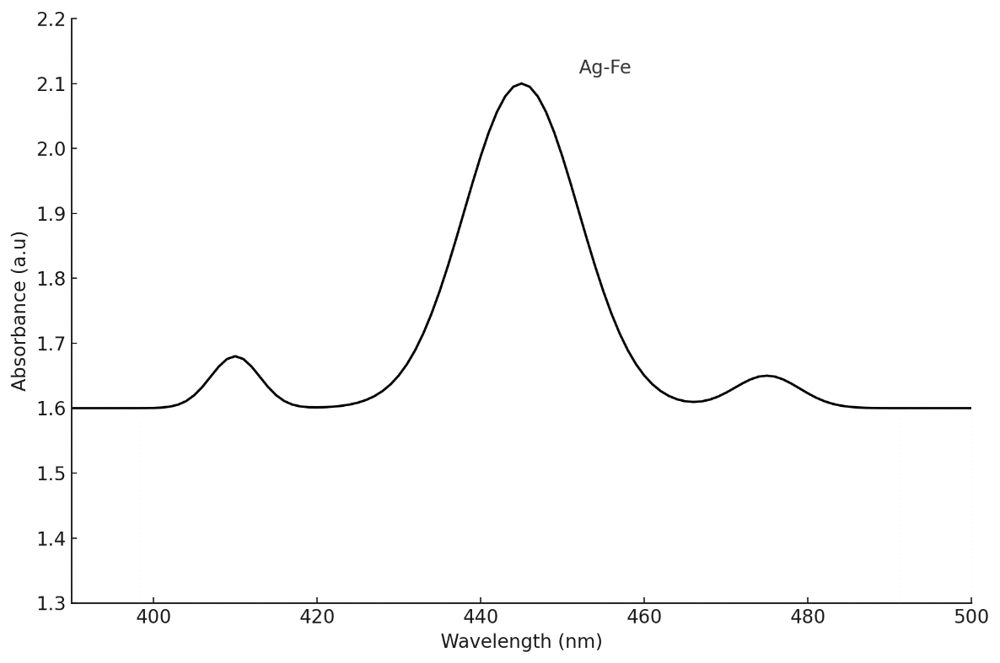
Figure 1. UV–Vis Spectroscopy of Synthesized Bimetallic Ag–Fe Nanoparticles
3.2 FTIR Spectroscopy of Ag-Fe Nps
Table 1 and Figure 2 depicted the FTIR spectrum of the synthesized Ag–Fe nanoparticles which showed several absorption bands that confirm the presence of bioactive phytochemicals from mango leaf extract acting as natural reducing and stabilizing agents. Peaks around 3279.5 cm⁻¹ and 1109.9 cm⁻¹ confirm the presence of hydroxyl and ether groups, likely from polyphenols and flavonoids. The band at 1650.9 cm⁻¹ suggests carbonyl or aromatic C=C stretching, common in plant secondary metabolites. The band at 2504.2 cm⁻¹ further supports the presence of carboxylic acids, which may coordinate with Ag⁺ and Fe²⁺ ions. These spectral features indicate that M. indica leaf extract facilitated the reduction of metal ions and also provided functional groups for stabilizing the synthesized Ag–Fe nanoparticles. Kolya and Kang (2022), observed similar peaks in their study with a C–O stretch around 1016 cm⁻¹ for green-synthesized Ag/Fe NPs, attributing it to C–O and O–H vibrations of residual phytochemicals. This suggest that these phytochemicals are strongly adsorbed on the Ag–Fe nanoparticle surface, acting as reducing agents during synthesis and as capping/stabilizing agents after formation.

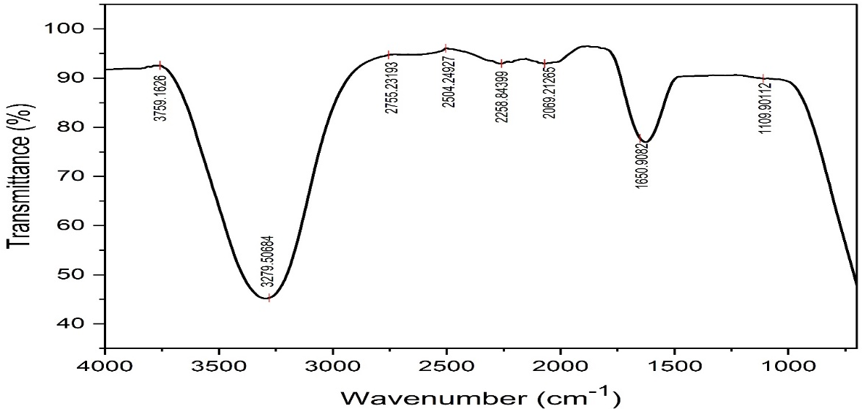

Figure 2. FTIR Spectroscopy of Ag-Fe Nps

Wave number (cm⁻¹) | Bond | Functional Group
3759.2 | O–H stretch (free) | Free hydroxyl groups (alcohols or phenols)
3279.5 | O–H stretch (H-bonded) | H-bonded alcohols or phenols
2755.2 | H–C=O stretch | Aldehydes
2504.2 | O–H stretch (carboxylic acid) | Carboxylic acids
2258.8 | C≡N or C≡C stretch | Nitriles or alkynes
2069.2 | Weak C≡C or CO stretching | Possibly alkynes or metal-carbonyl interactions
1650.9 | C=O stretch / N–H bend | Amides, carbonyls (ketones, esters), or aromatic C=C
1109.9 | C–O stretch | Alcohols, ethers, esters
Table 1. FTIR spectroscopy of Ag-Fe NPs M. indica leaf extract

3.3 Scanning Electron Microscopy – Energy Dispersive X-ray Spectroscopy

Figure 3 and Table 2 showed the SEM micrograph of Ag/Fe nanoparticles synthesized using M. indica leaf extract at a magnification of 1500×. The image reveals a dense distribution of star-like crystalline nanostructures, indicating uniform synthesis and dispersion across the substrate surface. These structures suggest well-formed nanoparticle agglomerates with distinct morphology, likely influenced by the phytochemical constituents of the M. indica leaf extract. The EDX Spectrum displayed a vast array of elemental composition of the synthesized Ag/Fe Nanoparticles. with an atomic concentration of Ag (0.05%), Fe (3.55%) and a weight concentration of Ag (0.09%) Fe (11.55%) respectively and average size of Z-Average: 55.92 nm. Zulfikar et al. (2021), reported similar spherical shape which was in the range of 200–400nm. Padilla-Cruz et al. (2021), also obtained ~13 nm core–shell Ag–Fe particles that also showed homogeneous spherical shapes clustering together.

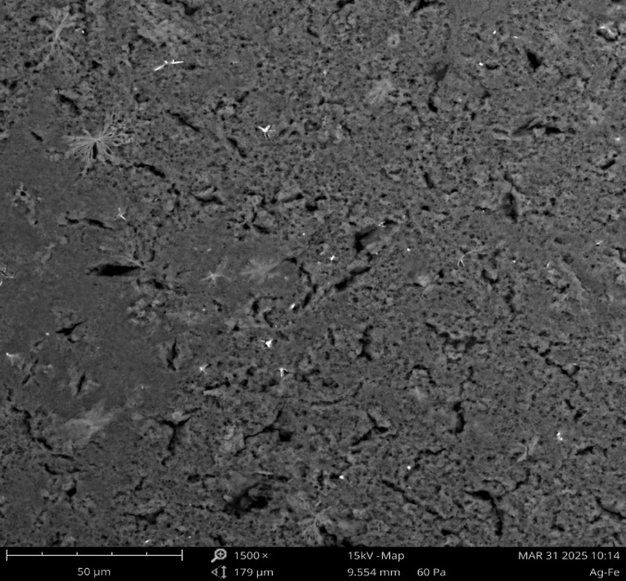
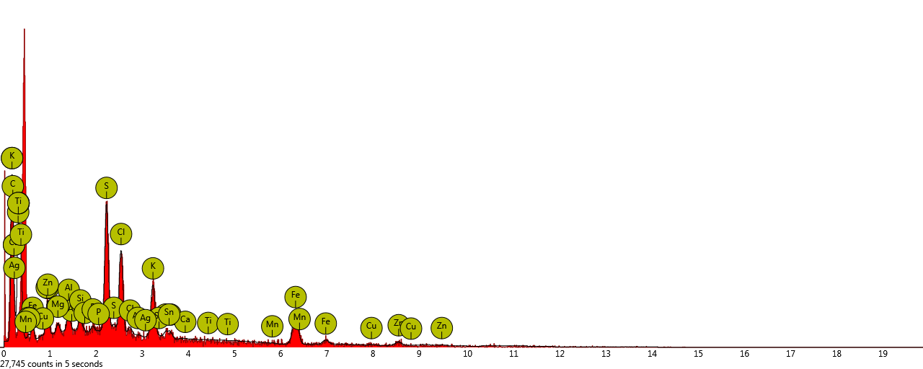
Figure 3. The EDX spectrum and SEM micrograph of Ag-Fe NPs (x 1500)
Table 2. Elemental composition of Ag-Fe Nanoparticles
Element  Number | Element  Symbol | Element  Name | Atomic  Conc. | Weight  Conc.
6 | C | Carbon | 66.96 | 46.91
7 | N | Nitrogen | 15.96 | 13.04
26 | Fe | Iron | 3.55 | 11.55
16 | S | Sulfur | 3.83 | 7.17
17 | Cl | Chlorine | 2.64 | 5.46
19 | K | Potassium | 2.00 | 4.57
30 | Zn | Zinc | 1.05 | 3.99
11 | Na | Sodium | 1.73 | 2.31
13 | Al | Aluminium | 0.78 | 1.23
50 | Sn | Tin | 0.14 | 0.97
29 | Cu | Copper | 0.18 | 0.66
14 | Si | Silicon | 0.37 | 0.61
20 | Ca | Calcium | 0.24 | 0.57
12 | Mg | Magnesium | 0.36 | 0.52
15 | P | Phosphorus | 0.16 | 0.28
25 | Mn | Manganese | 0.05 | 0.17
47 | Ag | Silver | 0.05 | 0.09
22 | Ti | Titanium | 0.00 | 0.00

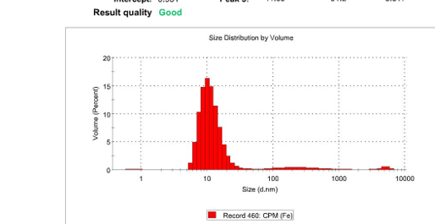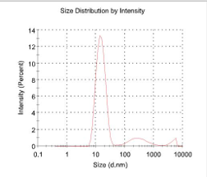

Figure 4. Ag/Fe NPs – Mangifera indica Dynamic light scattering (DLS)
3.4 Antibacterial activity of Ag-Fe NPs synthesized
The biosynthesized Ag–Fe nanoparticles were evaluated for their antibacterial efficacy against four pathogenic bacteria: Escherichia coli, Salmonella typhi, Pseudomonas aeruginosa, and Klebsiella pneumoniae. These organisms are all Gram-negative bacteria associated with serious infections (including diarrheal disease, typhoid fever, nosocomial pneumonia, etc.), and notably, many strains are multidrug-resistant. The Ag–Fe BNPs demonstrated significant antibacterial activity in disk diffusion assays, as evidenced by clear inhibition zones.
In this study, the Ag–Fe NPs produced measurable zones of inhibition against all tested bacteria, indicating a broad-spectrum antibacterial effect The result confirmed that the green-synthesized Ag–Fe NPs possess broad-spectrum antibacterial activity, with the strongest effect against P. aeruginosa as depicted in Table 3. Our findings align with zones of inhibition reported by Deljou and Goudarzi (2016), they observed biosynthesized AgNPs yielded a 22 mm zone against E. coli and 19 mm against S. typhi under similar concentrations. Lateef et al. (2016) observed complete growth inhibition of E. coli and K. pneumoniae when they used 40 µg/mL of AgNPs synthesized from cocoa pod extract, highlighting how effective biogenic Ag-containing NPs can be even against drug-resistant strains. Donga and Chanda (2021) also reported similar zones of inhibition against gram positive and negative clinical isolates. Notably, some studies report extremely large inhibition zones with biogenic AgNPs. Hamouda and Aljohani (2024) achieved zones up to 38 mm against E. coli, P. aeruginosa, and K. pneumoniae using seaweed-derived AgNPs at high concentration outperforming even standard antibiotics in that comparison. Ag–Fe NPs showed inhibition in this range, indicating a strong antibacterial activity.
Table 3 Zones of Inhibition of Ag–Fe NPs on Bacteria Isolates
Sample | E. coli | S. typhi | P. aeruginosa | K. pneumoniae
Ag–Fe NPs | 12.93 ± 0.40 | 14.90 ± 0.31 | 17.16 ± 0.76 | 12.27 ± 0.46
Positive Control (PC) (gentamycin) | 27.50 ± 0.50 | 27.17 ± 0.76 | 27.33 ± 0.58 | 29.30 ± 0.30
Negative Control (NC) | 0.00 ± 0.00 | 0.00 ± 0.00 | 0.00 ± 0.00 | 0.00 ± 0.00
Values are presented as Mean ± SD, n = 3

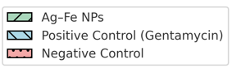
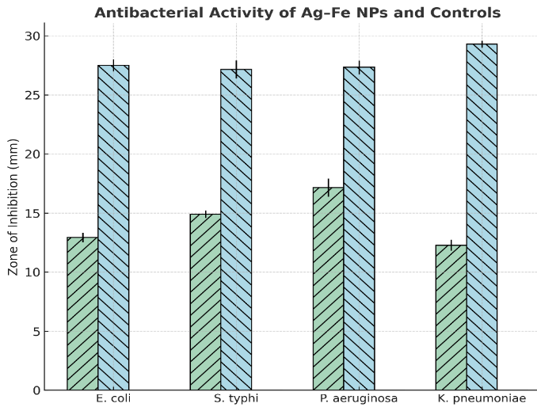
Figure 5 Antibacterial activity of Ag-Fe NPs
3.5 Antioxidant Activities of Ag–Fe bimetallic nanoparticles
The antioxidant potential of the Ag–Fe bimetallic nanoparticles was assessed using two complementary free radical scavenging assays: DPPH (1,1-diphenyl-2-picrylhydrazyl) and ABTS (2,2′-azino-bis(3-ethylbenzothiazoline-6-sulfonate)) radical scavenging. These assays measure the ability of the nanoparticles (and their capping phytochemicals) to quench stable free radicals by electron or hydrogen donation, thus indicating potential antioxidant activity. In our study, the Ag–Fe NPs demonstrated dose-dependent scavenging in both DPPH and ABTS assays, with a notable difference in efficacy between the two methods as shown in Table 4 and 5. The radical scavenging for DPPH increasing from 23.62% at 6.25 µg/mL to 69.17% at 100 µg/mL and ABTS radical scavenging activity reaching 82.29% inhibition at 100 µg/mL. The IC₅₀ (concentration required to scavenge 50% of the radicals) in the DPPH assay was lower (indicating higher activity) than the IC₅₀ in the ABTS assay. In DPPH assay, Ag–Fe NPs showed an IC₅₀ of 46.48 µg/mL, while ascorbic acid had a lower IC₅₀ of 34.38 µg/mL, this indicated higher potency. While, the ABTS assay revealed stronger activity for the nanoparticles, with an IC₅₀ of 28.32 µg/mL compared to 8.28 µg/mL for ascorbic acid as depicted in table 6.
Table 4. DPPH Radical Scavenging Activity of Ag–Fe Nanoparticles and Ascorbic Acid
Concentration (µg/mL) | % Inhibition  Ag-Fe NPs | % Inhibition  Ascorbic Acid
6.25 | 23.62 ± 1.12 | 15.58 ± 0.61
12.5 | 30.64 ± 0.13 | 39.83 ± 0.67
25 | 47.78 ± 0.09 | 59.06 ± 0.11
50 | 60.88 ± 0.05 | 69.26 ± 0.20
100 | 69.17 ± 0.17 | 78.34 ± 0.06
Values are presented as Mean ± SD, n = 3
Table 5. ABTS Radical Scavenging Activity of Ag–Fe Nanoparticles and Ascorbic Acid
Concentration (µg/ml) | % Inhibition  Ag-Fe NPs | % Inhibition  Ascorbic acid
20 | 37.63 ± 0.62 | 50.46 ± 0.72
40 | 60.06 ± 0.78 | 51.74 ± 0.96
60 | 76.26 ± 0.10 | 54.08 ± 0.87
80 | 81.47 ± 0.08 | 54.97 ± 0.57
100 | 82.29 ± 0.06 | 55.21 ± 0.25
Values are presented as Mean ± SD, n = 3
Table 6. IC₅₀ values of Ag–Fe Nanoparticles and Ascorbic Acid
Antioxidants | Samples | Linear IC₅₀ (µg/mL)
DPPH | Ag-Fe NPs | 46.48
DPPH | Ascorbic Acid | 34.38
ABTS | Ag-Fe NPs | 28.32
ABTS | Ascorbic Acid | 8.28

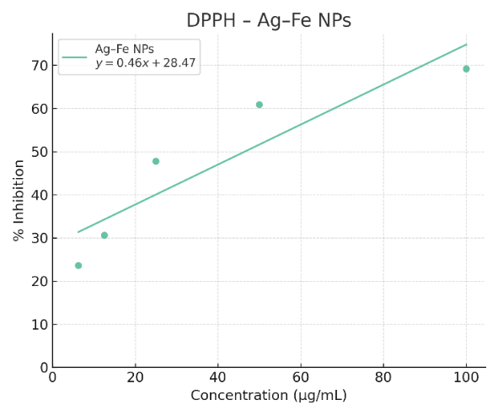  a) | 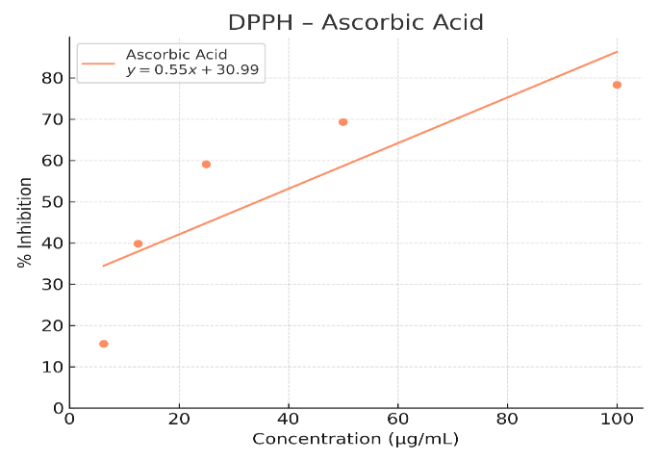  b)
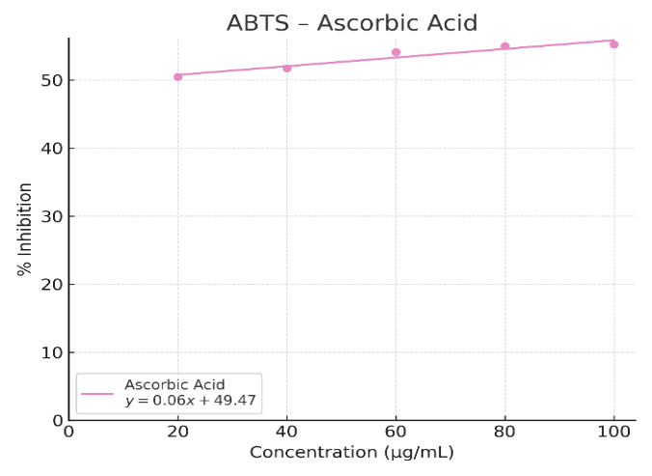  c) | 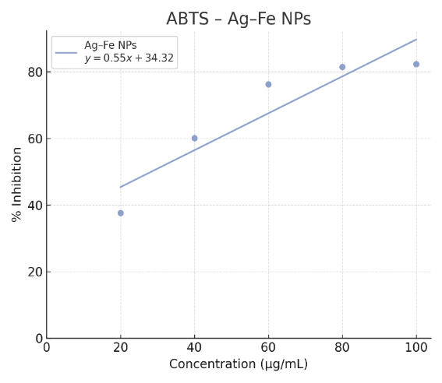  d)
Figure 6. Regression Coefficients of Antioxidants Concentrations of Ag-Fe NPs

This suggested that the nanoparticles were more efficient at quenching DPPH free radicals than ABTS⁺ radicals. Das et al. (2022) found that green-synthesized AgNPs using a Korean root extract had a DPPH IC₅₀ of 56.3 µg/mL, whereas their ABTS IC₅₀ was much higher (171.4 µg/mL). Bardania et al. (2020), reported similar trend of dose dependent antioxidant activity of biogenic Ag NPs. They attributed this almost three-fold difference to the nanoparticles being less effective in the ABTS assay, possibly due to steric or diffusional factors with the ABTS radical. In Ag–Fe system, a similar trend was observed indicating that while the NPs certainly have antioxidant capability, the extent is assay-dependent. The stronger performance in DPPH may suggest that the polyphenolic capping agents on the NP surface readily transfer hydrogen atoms to DPPH radicals (neutralizing them), but are slightly less aligned for scavenging the larger ABTS radical cation. Ag–Fe bimetallic nanoparticles exhibit clear antioxidant activity, with the DPPH scavenging efficacy being higher than ABTS scavenging in our measurements.
Donga and Chanda (2021), suggested green synthesized Ag NPs to serve as a good source of natural antioxidants which can be utilized to treat diseases and disorders especially those related with stress and caused by excessive production of ROS since they demonstrated it prominent antioxidant potential in various antioxidant assays.
- Conclusion
Silver–iron (Ag–Fe) bimetallic nanoparticles was successfully synthesized by leaf extracts of M. indica and characterized through UV–Vis spectroscopy which confirmed nanoparticle formation with a distinct SPR peak around 445 nm, while FTIR revealed the presence of bioactive phytochemicals that acted as reducing and stabilizing agents. SEM images showed aggregated, irregularly shaped nanoparticles with particle size of 55.92 nm, and EDX analysis confirmed the presence of Ag and Fe along with plant-derived elements. The synthesized nanoparticles exhibited significant antibacterial activity against E. coli, S. typhi, P. aeruginosa, and K. pneumoniae, and showed good antioxidant properties in both DPPH and ABTS assays. These findings confirm that M. indica leaf extract - mediated Ag–Fe nanoparticles are multifunctional, offering potential applications in biomedical. Hence, toxicity invivo model assessments could be conducted to evaluate safety and biocompatibility for biomedical applications.

CONFLICT OF INTEREST
The authors declare no conflict of interest

References
Al-Karagoly, H., Jaber, S., & Jawad, H. (2023). Silver nanoparticles synthesized from flaxseed extract: Antioxidant and antimicrobial evaluation. Applied Nanoscience, 13(1), 1–4.
Amatya S. P., Shrestha, S. & Aryal Y. (2021). Green Approach for Synthesis of Manganese Nanoparticle using Banana Peel (Musa paradiasca) and its Characterization. Amrit Research Journal, 2(01), 75-82.
Arsenov, D., Chaykina, D., Klimenko, S., & Savostyanov, V. (2023). Environmental impact of nanoparticle synthesis: A comparative review of chemical and green routes. Journal of Cleaner Production, 406, 137057.
Bardania H, Mahmoudi R, Bagheri H. (2020). Facile preparation of a novel biogenic silver-loaded nanofilm with intrinsic anti-bacterial and oxidant scavenging activities for wound healing. Sci Rep. 2020;10(1):1–4.
Bayda, S., Adeel, M., Tuccinardi, T., Cordani, M., & Rizzolio, F. (2019). The history of nanoscience and nanotechnology: From chemical–physical applications to nanomedicine. Molecules, 25(1), 112.
Deljou, A. & Goudarzi, S. (2016). Green Extra cellular synthesis of AgNPs using Thermophilic Bacillus sp. AZ1 and its Antimicrobial Activity Against Several Human Pathogen Bacteria, Iran Journal of Biotechnology, 14(2): 25-32 doi: 10.15171/ijb.1259
El-Saadony, M. T., Saad, A. M., Desoky, E. S. M., & Shafi, M. E. (2023). Eco-friendly synthesis of iron nanoparticles and their application in environmental and biomedical sectors. Environmental Science and Pollution Research, 30(5), 12345–12360.
Escárcega-González Carlos Enrique, JA Garza-Cervantes, A Vázquez-Rodríguez, Liliana Zulem Montelongo-Peralta, MT Treviño-González, E Díaz Barriga Castro, EM Saucedo Salazar, RM Chávez Morales, DI Regalado Soto, FM Treviño González, JL Carrazco Rosales, Rocío Villalobos Cruz & José Rubén Morones-Ramírez (2018). In vivo antimicrobial activity of silver nanoparticles produced via a green chemistry synthesis using Acacia rigidula as a reducing and capping agent, International Journal of Nanomedicine, 13 2349–2363. https://www.dovepress.com
Hamouda, R.A. & Aljohani, E.S. (2024). Assessment of Silver Nanoparticles Derived from Brown Algae Sargassum vulgare: Insight into Antioxidants, Anticancer, Antibacterial and Hepatoprotective Effect. Mar. Drugs 2024, 22, 154. https://doi.org/ 10.3390/md22040154
Ibrahim, H. M. M. (2015). Green synthesis and characterization of silver nanoparticles using banana peel extract and their antimicrobial activity against representative microorganisms. Journal of Radiation Research and Applied Sciences, 8(3), 265–275.

Kamli, M.R., Srivastava, V., Hajrah, N.H., Sabir, J.S.M., Ali, A., Malik, M.A. & Ahmad, A. (2021). Phytogenic Fabrication of Ag–Fe Bimetallic Nanoparticles for Cell Cycle Arrest and Apoptosis Signaling Pathways in Candida auris by Generating Oxidative Stress. Antioxidants 2021, 10, 182. https://doi.org/10.3390/ antiox10020182

Kolya, H. & Kang, C.W. (2022). Biogenic Synthesis of Silver-Iron Oxide Nanoparticles Using Kulekhara Leaves Extract for Removing Crystal Violet and Malachite Green Dyes from Water. Sustainability 2022, 14, 15800. https://doi.org/10.3390/ su142315800
Lateef Agbaje, Musibau A. Azeez, Tesleem B. Asafa, Taofeek A. Yekeen, Akeem Akinboro, Iyabo C. Oladipo, Luqmon Azeez, Sunday A. Ojo, Evariste B. Gueguim-Kana and Lorika S. Beukes (2016). Cocoa pod husk extract-mediated biosynthesis of silver nanoparticles: its antimicrobial, antioxidant and larvicidal activities, Journal Nanostructure Chemistry (2016) 6:159–169 DOI 10.1007/s40097-016-0191-4
Mezher, M., Hajj, R.E. & Khalil, M. (2022). Investigating the antimicrobial activity of essential oils against pathogens isolated from sewage sludge of southern Lebanese villages. GERMS, 12, 488–506.
Padilla-Cruz, A. L., Fuentes-Maldonado, L. E., & Martínez-Castañón, G. A. (2021). Green synthesis and antibacterial activity of Ag–Fe bimetallic nanoparticles using Gardenia jasminoides extract. Materials Science and Engineering: C, 123, 112005.
Ratan Das, Prahlad Deb, Himanshu Pande, Perugu Shyam & Devendra Singh (2022). Botanical synthesis of silver nanoparticles (AgNPs) and its antifungal effect against Alternaria porri causing purple blotch of onion: An in vitro and natural epiphytic study, Journal of Agriculture and Food Research, 10 (2022) 100390.
Savan Donga & Sumitra Chanda (2021). Facile green synthesis of silver nanoparticles using Mangifera indica seed aqueous extract and its antimicrobial, antioxidant and cytotoxic potential (3-in-1 system), Artificial Cells, Nanomedicine, and Biotechnology, 49:1, 292-302, DOI: 10.1080/21691401.2021.1899193
Shaikh, A. A., Bhosale, D. M., & Pawar, K. D. (2022). Synthesis of silver nanoparticles using mango (Mangifera indica) leaf extract and evaluation of their antimicrobial potential. Journal of Drug Delivery and Therapeutics, 12(5), 210–217.
Temesgen Achamo Orshiso, Enyew Amare Zereffa, Ananda Murthy H. C., Taye B. Demissie Suresh Ghotekar, Khanderao Pagar & Onkar Pardeshi (2024). One-Pot Biopreparation of Trimetallic ZnO–MgO–CuO Nanoparticles: Enhanced Cytotoxicity, Antibacterial Activities and Molecular Docking, Chemistry Africa, 7:1963–1980 https://doi.org/10.1007/s42250-023-00830-0
Thangapushpam, R., Krishnaveni, A., & Latha, S. (2024). Antioxidant potential of biosynthesized manganese dioxide nanoparticles using Azadirachta indica. Materials Letters, 354, 79–87.
Zulfikar Mona, Nadeem Raziya, Javed Tariq, Jilani Muhammad Idrees and Javed Iram (2021). Green synthesis of Fe nanoparticles by using Mangifera Indica extract and its application in photocatalytic degradation of dyes, Water Science and Technology, doi: 10.2166/wst.2021.074

