Effect of a biostimulant based on natural products on the growth of plantain banana plants in field and on the quality of harvested fruit

Abstract
Aims: Plantains are consumed all over the world and are mainly grown extensively due to the unavailability of seeds in sufficient quantity and quality, disease and the high cost of agricultural inputs. Recent studies have highlighted the positive effect of biostimulants on seedlings growth promotion and protection in the greenhouse and the nursery such as plantains, cocoa, vegetables etc. The aim of our study is to confirm this positive effect of biostimulants on the agronomic performance of plants in the field, as well as their effect on the quality of fruit.
Place and Duration of Study: Laboratory of Phytoprotection and Valorization of Genetic Resources of the Centre for Biotechnology, and the Laboratory of Biochemistry and Plant Physiology of Higher Teacher’s Training College, University of Yaounde 1, between November 2022 and January 2026.
Methodology: The plants were watered with the biostimulant (BS), the positive control (NPK) and water (W) as negative control throughout their growth in the field until the fruit was obtained. We evaluated the agro-morphological parameters of the plants and the fruit treated.
Results: The results obtained show that the biostimulant (BS) significantly improves the agronomic performance of plants and fruits compared to the positive control (NPK) and water (W). Indeed, it increases the diameter and the number of leaves of plants compared to the controls (NPK) and (W). The accumulation of total phenols and total proteins in the leaves of plantain banana was 2 times more important in the leaves treated with biostimulant compare to the one treated with water, while it was 2,5 times more important for total sugars. Similarly, it improved flowering time, ripening time, total plant growth time, bunch weight, total number of fingers on hand 1, hand 1 weight and hand 2 weight compared with the controls (NPK) and (W).
Conclusion: The biostimulant is thus an effective tool for promoting eco-responsible agriculture, a healthy, balanced organic plant feeding, good quality plantain fruit and the fight against poverty.
Keywords: Plantain banana (Musa spp.), biostimulant, growth promotion, growth biomarkers, fruit quality.

1. Introduction
The banana tree is a giant plant belonging to the Musaceae family. It is native to South East Asia and is a staple food for many populations in developing countries. Banana cultivation plays an important role in the lives of people in general and farmers in particular. Its importance is evident in terms of food, socio-economics, culture and the environment (Ndungo, 2008). Banana trees are cultivated in more than 120 countries on five continents. In tropical and subtropical regions, 85% of bananas are produced for local consumption. Banana is the most important fruit crop and the fourth most important food crop in the world in terms of tonnage, after rice, wheat and maize. Global annual banana production in 2018 was 100 million tonnes (FAO, 2019).
There are more than a thousand varieties of banana trees, the fruit of which can be eaten fresh or as a cooked vegetable, but can also be processed in many ways, such as chips, fries, fritters, jam, ketchup, alcohol, wine, beer, etc. Indeed, there are dessert bananas and cooking bananas, the ‘beer banana’ grown particularly in the Great Lakes region of Africa and characterized by its bitterness but is not exported, as well as plantains (true plantains, whose center of diversity is in West and Central Africa) which are very rich in starch and must be cooked before consumption (Jauzein, 2018).
Among bananas and in terms of global trade, plantains are a staple food for many populations in Central Africa in general and Cameroon in particular, and are increasingly being cultivated. In Cameroon, plantain production is estimated at nearly 30.5 million tonnes and has varied little over the past fifteen years, with little presence on international markets. The plantain produces a fruit that is eaten raw after ripening, known as sweet banana or table banana, generally eaten after cooking. Plantain plays an important role in the social structure of many rural communities, as in most cases they are the sole source of income (Tollens, 2004).
With a view to improving agronomic performance and food security issues in Africa, plantain cultivation is attracting growing interest from public authorities (Kwa & Temple, 2019). Farmers would benefit from moving away from synthetic agricultural inputs (SAIs), which are very costly and harmful to agriculture as well as the environment. They must turn to natural organic farming through the use of organic agricultural inputs (OAI) and products that stimulate plant as well as environmental health. In addition, they allow soils to retain their natural fertility in order to improve cultivation and combat crop diseases and pests (Aubert et al., 2018). The use of organic agricultural inputs and vitality stimulators on plants allows fruits to have a high nutritional value, which is necessary for the good health of consumers.
Biostimulants are natural substances and/or microorganisms that, when applied to plants or the rhizosphere, improve nutrient absorption and utilization, abiotic stress tolerance, crop quality and yield, regardless of the presence of nutrients (du Jardin, 2015). Recent studies have demonstrated the effectiveness of plant-based biostimulants on the growth and defense of Musa spp., of Xanthosoma sagittifolium, several vegetable and aromatic plants such as lettuce, mint, beans, basil, chilli peppers, tomatoes, etc. In addition, they appear to have effects on yield and soil quality (Ewané et al., 2020). They improve the performance of plantains in terms of growth but also in terms of reduced susceptibility to diseases, particularly black Sigatoka disease (Ewané et al., 2020), which results in a high accumulation of secondary metabolites and defense-related enzymes. In addition, a recent study has highlighted the high accumulation of microelements and antioxidants in plantain banana vivoplants treated with these biostimulants (Bindzi, 2022).
We hypothesized that this growth promotion and protection effect observed in the greenhouse and the nursery on plantain seedlings could be confirmed on plantain plant in the field. Therefore, the objective of this study was to evaluate the effect of the biostimulant on the agronomic performance of banana plants in the field, as well as its effect on the quality of plantain fruit.

2. Materials and methods
2.1. Materials
This research was conducted at the Nkolbisson Biotechnology Center of the University of Yaoundé 1, specifically at the Laboratory for Plant Protection and Genetic Resource (LPVRG) located in the 7th District of Yaoundé, in the region of Center Cameroon. The germination and propagation phase of varieties ‘Big Ebanga’ big finger, ‘Big Ebanga’ small finger, ‘Essong’ and French Clair varieties plantain seedlings were carried out in a greenhouse at a constant temperature of 28 to 32 °C and lasted four (04) weeks. The acclimatization of the plants produced was carried out under shade for a period of two months (8 weeks) and field growth for a period of twelve (12) months.
The suckers of the varieties of plantain banana, also known as ‘False horn’, are varieties belonging to sub-group family found in Central Africa, specifically in Cameroon. The plantain shoots used for this study were taken from an experimental plot at the Agricultural Research Institute for Development (IRAD) located in Nkolbisson in the 7th district of the city of Yaoundé (north-west), in the Center region of Cameroon. Its geographical coordinates are 3° 52’ North latitude and 11° 25’ East longitude. These varieties were chosen for their short production cycle (11 to 12 months) and their ability to produce a high number of shoots through the PIF technique.
The edaphic material was prepared. The white sawdust, used as a propagation substrate in the greenhouse germination trays, was obtained from a sawmill in the town of Yaoundé in Simbock. The black soil, used as a substrate for germination and plant growth, came from a plot of land in Santa Barbara in the Yaoundé 4th district. The substrate (black soil) was used for seedling growth under shade.
The biological material used was a plant-based biostimulant made from natural products (BS), a positive control (NPK) consisting of 20-10-10 NPK fertilizer, and a negative control (W) consisting solely of water.

2.2. Experimental disposal
The seedlings were germinated in a greenhouse, followed by acclimatization under shade and planting in the field, with the treatment being applied during watering in the different modalities. In the greenhouse, the seedlings were watered exclusively with 0.25 L per plant for each modality i.e., the biostimulant (BS), the positive control (NPK) and the water as negative control (W). The plantain banana plants resulting from PIF germination were weaned according to Meshuneke et al. (2020). After acclimatization, the seedlings were immediately planted in the field according to the different modalities. A plot of land next to a river was divided into three blocks for the three (03) modalities, namely biostimulant (BS), the positive control (NPK) and the negative control (W). The seedlings in the field were watered regularly twice a week with water and once a month with the three different treatments. In the greenhouse and under shade, the biostimulant was used diluted to a concentration of 25% while the NPK was used at a concentration of 0.25%.

3. Methods
3.1. Evaluation of the effect of treatment on the vegetative growth of plantain seedlings
The vegetative growth of plantain seedlings was evaluated in terms of plant height, diameter of the pseudo-stem and number of leaves following the protocol of Ewané et al., (2019). Vegetative growth was monitored in the field during approximately twelve months using a meter for measurements.

3.2. Evaluation of the effect of treatment on biomarkers accumulation in plantain leaves
A piece of 0.5 g leaf of banana plant collected and taken to the laboratory was used for biochemical analysis. Total soluble proteins were extracted using a modified protocol of Pirovani et al., (2008) and quantified using the Bradford method (1976). Total phenol extraction was done using the protocol of El Hadrami and Baaziz (1997) and quantified by the method of Marigo et al., (1973). Soluble sugars were extracted from the leaves of 6-month-old plants using a modified protocol of Babu et al., (2002) and quantified via absorbance at 620 nm (Dubois et al., 1956).

3.3. Evaluation of the effect of treatment on the maturation stage of plantain fruit
The flowering time, the ripening time and the total growth time were recorded for the plantain banana tree of the three modalities by monitoring the growth till maturation from the germination stage in the greenhouse and pre-emergence stage under shade to the vegetative stage and harvest time in the field.

3.4. Evaluation of the effect of treatment on plantain banana bunches
The plantain bunches were harvested in the field at optimal physiological maturity for all three (03) different modalities marked by the presence of a ripe fruit on the first or second hand of the bunch and were transported to the laboratory. Using a 50 kg scale, each bunch was weighed for the three different modalities and on the bunch, the different parameters assessed were the total number of fingers, hand 1 number of fingers, hand 1 weight, hand 2 number of fingers, hand 2 weight.

3.5. Histochemical and microscopic analysis of banana-plantain roots
Fresh roots of banana-plantain plants from different treatments were collected in the field and processed using the modified protocol of Sandoval et al., (2005). The roots were placed longitudinally in a microtome and thin sections of the roots were made. The sections were then, placed for 15 min in sodium hypochlorite (bleach) diluted 1/5, then they were rinsed thoroughly with water. The sections were placed in acetic acid for 7 min, then staining in iodine green-carmine was carried out for 5-7 min. the sections were then rinsed again with water in order to observe them under a light microscope between a slide and coverslip after placing a drop of water on the slide.

3.6. Statistical Analysis
Analysis of variance (ANOVA) was performed using Tukey's test at a 5% probability threshold using XLSTAT software 2025 (version 21.0 for Windows) to compare the different treatments and produce graphical representations. A three-factor ANOVA was performed for the agro-morphological parameters of the plants (diameter of the pseudo-stem, plant height and number of leaves) with Modality, Month and Repetition as factors. A two-factor ANOVA was performed for the agro-morphological parameters of the fruits (flowering time, ripening time, total growth time, bunch weight, total number of fingers, hand 1 number of fingers, hand 1 weight, hand 2 number of fingers, hand 2 weight) with Modality and Repetition as factors.

4. Results and Discussion
4.1. Results
4.2. Effect of treatment on the vegetative growth of plantain seedlings
Germination lasted 36 days, i.e. one (01) month and five (05) days in the greenhouse, while under shade cloth, acclimatization took place over eight (08) weeks, i.e. two (02) months. Similarly, the growth and development of the seedlings led to the production of mature plantain banana plants (Figures 1 and 2), followed by the production of plantain banana fruit from the 9th month to the 12th month in the field (Figure 3).

A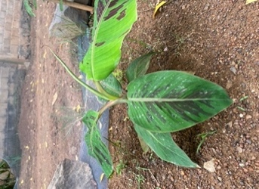 B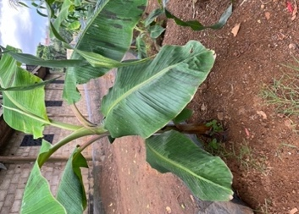 C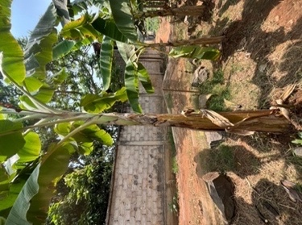 D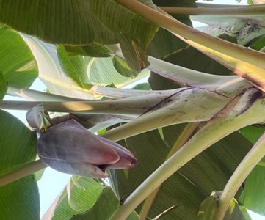
E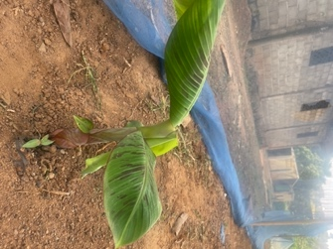 F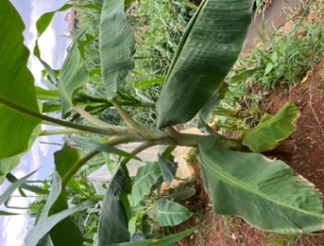 G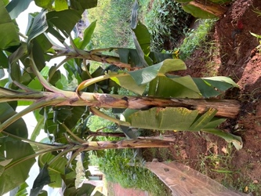 H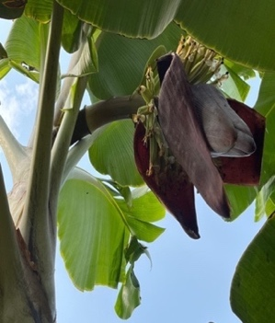
I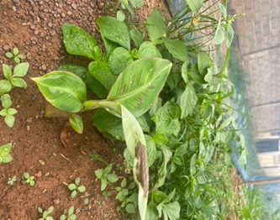 J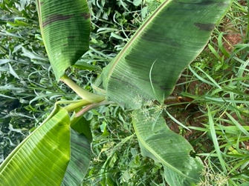 K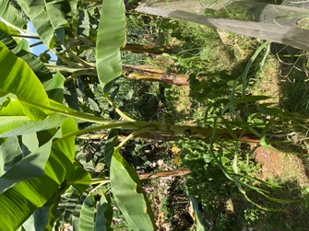 L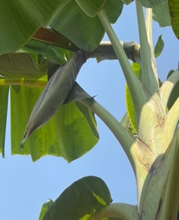
Figure 1: Growth of plantain banana plants in field at 1, 3, 9 months and flowering with flower shedding (seen at a distance of 1,7 m) for the modalities BS (A, B, C, D), NPK (E, F, G, H) and W (I, J, K, L).

A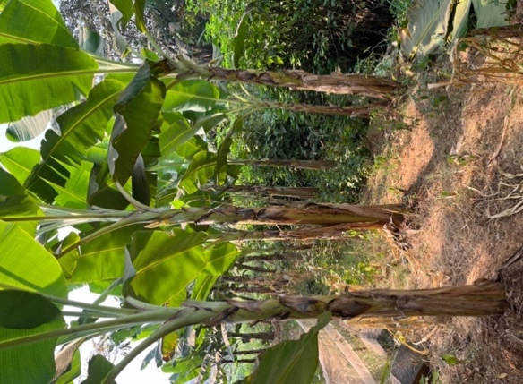B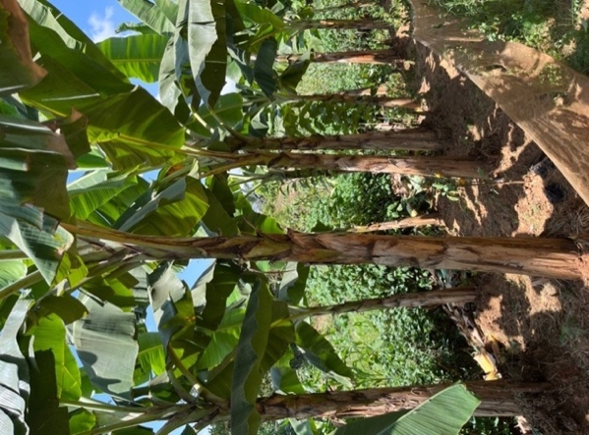C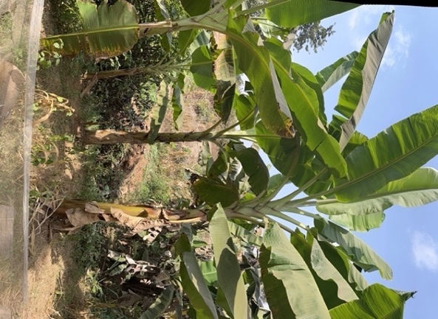
Figure 2: Big Ebanga plantain banana plants in the field (seen at a distance of 1,7 m) for different modalities: BS (A), NPK (B), W (C).

A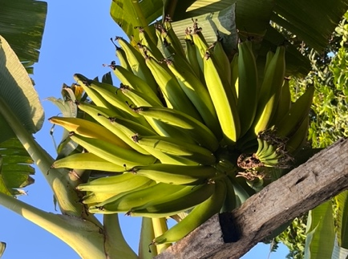 B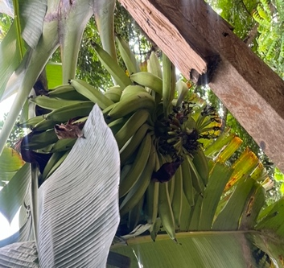 C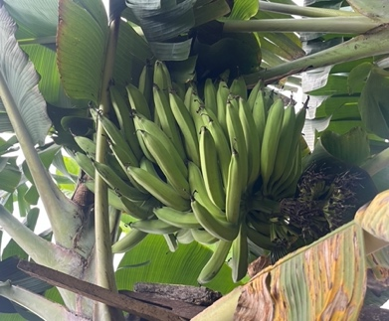 D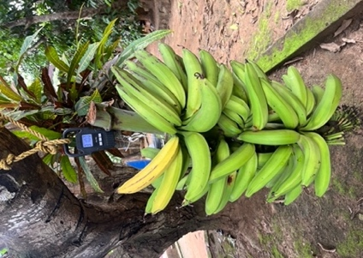
Figure 3: Bunch of ‘Big Ebanga’ small finger plantain banana on plant in the field seen at a distance of 1,7 m for different modalities: BS (A), NPK (B), W (C) and bunch weighing (D).
Analysis of variance (ANOVA) of the vegetative growth of plantain banana plants revealed that the variables treatment, month and repetition each had highly significant effects (P< 0.0001) on stem height, diameter of the pseudo-stem and number of leaves. However, the interaction between treatment*month had a highly significant difference (P< 0.0001) for the number of leaves (Table 1). The coefficient of determination R² of the different agro-morphological parameters is 89.8%, 83.7% and 83.7% respectively for stem height, diameter of the pseudo-stem and number of leaves, indicating that the model used is reliable and reproducible. The variables that most influence the vegetative growth of plantain banana plants are the modality and month for stem height, diameter of the pseudo-stem and number of leaves, repetition for stem height and diameter of the pseudo-stem, and the interaction between modality*month for the number of leaves.

Table 1: Analysis of variance (ANOVA) of the effect of treatments (BS, NPK and W) on the agromorphological parameters of plantain banana plants in the field (height, diameter and number of leaves).
 |  | Height (cm)  R²= 89.8% |  | Diameter (cm)  R²= 83.7% |  | Number of leaves  R²= 83.7%
Variable | df | F | P | F | P | F | P
Modality | 2 | 29.185 | 0.00 | 11.909 | 0.000 | 14.141 | 0.000
Month | 11 | 156.766 | 0.000 | 91.430 | 0.000 | 87.618 | 0.000
Repetition | 6 | 7.886 | <0.0001 | 4.816 | 0.000 | 0.762 | 0.600
Modality*Month | 22 | 1.172 | 0.276 | 1.020 | 0.440 | 3.619 | <0.0001
The values in bold correspond to tests where the null hypothesis is not accepted with a significance level of alpha = 0.05. F is the value of the F test and P is the probability.

Plants treated with the biostimulant (BS) had a highly significant (P<0.0001) effect on the vegetative growth of plantain banana plants, particularly the diameter of pseudo-stem and number of leaves, compared to the positive (NPK) and negative (W) controls. However, the positive control (NPK) had a significant effect (P< 0.0001) on stem height compared to the biostimulant (BS) and the negative control (W) (Figure 4). The biostimulant (BS) increased the diameter of pseudo-stem and number of leaves of plantain banana plants over time compared to the positive (NPK) and negative (W) controls (Figure 4). Two distinct statistical groups were obtained for the plant height, the diameter of pseudo-stem and the number of leaves (Figure 4). Overall, the biostimulant (BS) improved the vegetative growth of plantain banana plants the most over time compared to the positive (NPK) and negative (W) controls (Figure 4).
ABC
Figure 4: Effect of treatments (BS, NPK and W) on the agromorphological parameters of plantain banana plants in the field: height (A); diameter (B) and number of leaves (C).

4.3. Effect of treatment on biomarkers accumulation in plantain leaves
Analysis of variance (ANOVA) of biomarkers accumulation in the leaves of plantain banana plants revealed that the variable mobility had a highly significant effect (P< 0.0001) on the total phenols, total proteins and total sugars. The coefficient to determination R² of the different biomarker is 95.4%, 99.6% and 99.5% respectively for the total phenols, total proteins and total sugars indicating that the model use is reliable and reproducible. The variable that most influence the biomarkers accumulation in the leaves of plantain banana plants is modality (Table 2).

Table 2: Analysis of variance (ANOVA) of the effect of treatments (BS, NPK and W) on the accumulation of biomarkers (total phenols, total proteins and total sugars) in the leaves of plantain banana during the growth.
 |  | Total phenols  (mg EQ GA/g FW)  R²= 95.4% |  | Total proteins  (mg EQ BSA/g FW)  R²= 99.6% |  |  | Total sugars  (μg/g FW)  R²= 99.5%
Variable | df | F | P | F | P | F |  | P
Modality | 2 | 39,159 | 0,002 | 490,431 | <0,0001 | 423,279 |  | <0,0001
Repetition | 2 | 2,109 | 0,237 | 12,056 | 0,020 | 1,269 |  | 0,374
The values in bold correspond to tests where the null hypothesis is not accepted with a significance level of alpha = 0.05. F is the value of the F test and P is the probability.

Plants treated with the biostimulant (BS) had a highly significant (P< 0.0001) effect on the biomarkers accumulation in the leaves of plantain banana plants, particularly the total phenols, total proteins and total sugars compared to the positive (NPK) and negative (W) controls (Figure 5). The biostimulant (BS) increased the phenols, total proteins and total sugars in the leaves of plantain banana plants compared to the positive (NPK) and negative (W) controls (Figure 5). Overall, the biostimulant (BS) improved the accumulation of total phenols, total proteins and total sugars in the leaves of plantain banana plants compared to the positive (NPK) and the negative (W) control (Figure 5). Three distinct statical groups were obtained in the leaves of plantain banana plants in terms of total phenols, total proteins and total sugars for the biostimulant (BS), the positive control (NPK) and the negative control (W) (Figure 5).

ABC
Figure 5: Effect of treatments (BS, NPK and W) on the accumulation of biomarkers in the leaves of plantain banana during the growth: total phenols (A), total proteins (B) and total sugars (C).

4.3. Effect of treatment on the maturation stage of plantain fruit
The first flowers appeared from the 9th month (278th day) for plants treated with the biostimulant (BS), from the 10th month (305th day) for plants treated with the positive control (NPK) and from the 11th month (334th day) for plants treated only with the negative control, water (W). Similarly, depending of the modality, the plantain banana fruits (bunches) were harvested 03 to 05 months after flowering. The fruit ripened over a period of 278 to 318 days for plants treated with BS, 305 to 362 days for plants treated with NPK and 334 to 390 days for plants treated with water (W). The plantain banana plants matured to fruit after 469 days, including 386 days for the flowering period of the plants and 135 days for the ripening period of the plantain banana fruit (bunches).
Analysis of variance (ANOVA) of the ripening of plantain banana plants and fruits revealed that the variables modality and repetition each have highly significant effects (P< 0.0001) on flowering time, ripening time and total growth time (Table 3). The coefficient of determination R² for the different parameters was 99.1%, 87.6% and 96.2% respectively for flowering time, ripening time and total growth time, indicating that the model used is reliable and reproducible. The variable that has the greatest influence on the vegetative growth of plantain seedlings is repetition for diameter, treatment for height and week for leaf area. Plants treated with the biostimulant (BS) have a highly significant effect (P< 0.0001) on the maturation of plantain banana plants and fruits (bunches), particularly flowering time, fruit (bunch) ripening time and total growth time compared to positive (NPK) and negative (W) controls (Figure 6).

Table 3: Analysis of variance (ANOVA) of the effect of treatments (BS, NPK and W) on the flowering time, the maturation time and the total growth time of plantain banana plants in the field.
 |  | Flowering time (day)  R²= 99.1% |  | Maturation time (day)  R²= 87.6% |  | Total growth time (day)  R²= 96.2%
Variable | df | F | P | F | P | F | P
Modality | 2 | 461.608 | 0.000 | 34.269 | 0.000 | 137.693 | 0.000
Repetition | 6 | 78.806 | <0.0001 | 2.661 | 0.070 | 5.276 | 0.007

The values in bold correspond to tests where the null hypothesis is not accepted with a significance level of alpha = 0.05. F is the value of the F test and P is the probability.

The biostimulant (BS) significantly reduced (P< 0.0001) the flowering time, fruit ripening time (bunches) and total growth time of plantain banana plants over time compared to the positive (NPK) and negative (W) controls (Figure 6). Three distinct statistical groups were obtained for the flowering time and total growth time, while two distinct statistical groups were obtained for ripening time (Figure 6). Overall, the biostimulant (BS) showed the greatest improvement in flowering time, ripening time and total growth time of plantain banana plants in the field compared to the positive (NPK) and negative (W) controls (Figure 6).

ABC
Figure 6: Effect of treatments (BS, NPK and W) on the maturation stage of plantain banana plants in the field: flowering time (A), ripening time (B) and total growth time(C).

4.5. Effect of treatment on plantain banana bunches
For the three (03) modalities, thirty (30) bunches of plantains were obtained, i.e. ten (10) bunches for each modality. The plantain bunches were obtained at a mean of 127 days after the first flowers appeared (Figure 7) and the bigger weight were obtained with the bunches harvested from plantain banana plant of the modality treated with the (BS) biostimulant compared to the control’s ones (Table 4).
A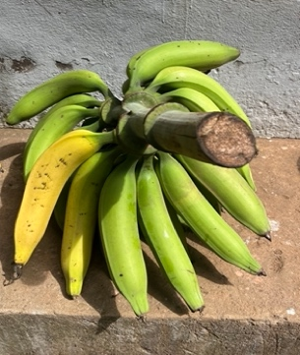 B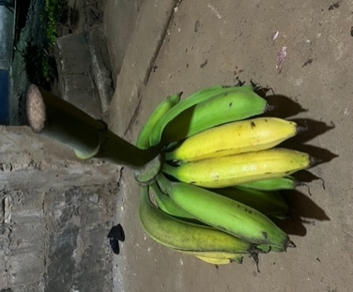 C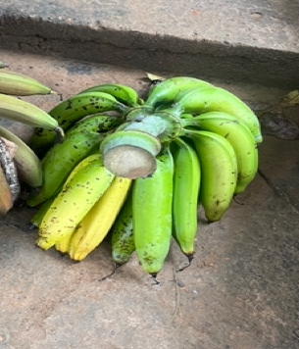
D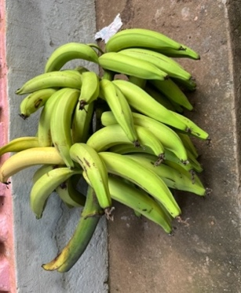 E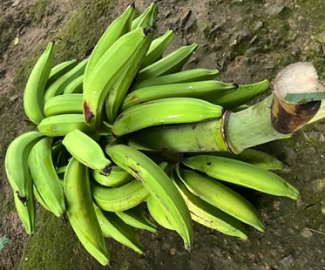 F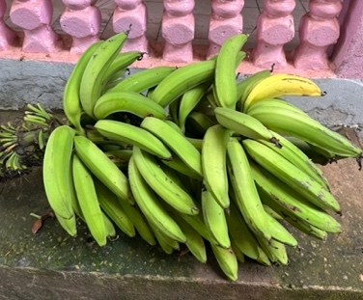
G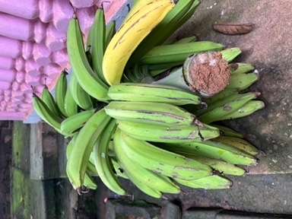 H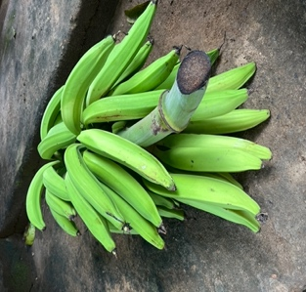 I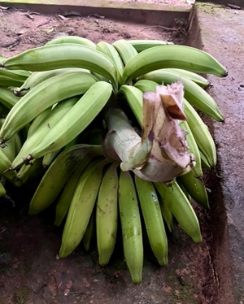
J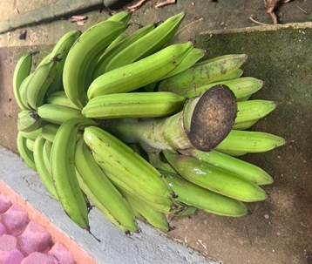 K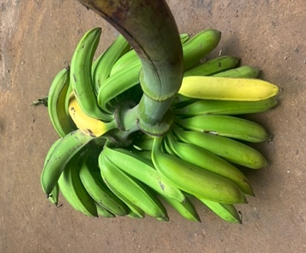 L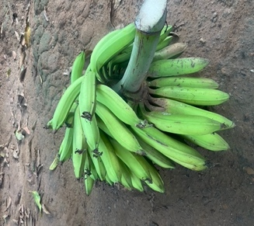
Figure 7: Bunches of plantain banana plants for the three modalities BS (A, D, G, J), NPK (B, E, H, K), W (C, F, I, L), after harvest seen at a distance of 1,3 m of varieties ‘Big Ebanga’ big finger (A, B, C), ‘Big Ebanga’ small finger (D, E, F), ‘Essong’ (G, H, I) and French Clair (J, K, L).

Table 4: Weight of plantain banana bunch treated with BS, NPK and W in the field during the growth, and harvested at maturity.
 | Bunch weight per modality (kg)
Plant variety | BS | NPK | W
‘Big Ebanga’ big finger | 17,50 | 14,31 | 9,30
‘Big Ebanga’ small finger | 27,00 | 25,00 | 23,00
‘Essong’ | 31,00 | 22,78 | 23,41
French Clair | 25,00 | 24,30 | 20,41

Analysis of variance (ANOVA) on plantain banana bunches revealed that the repetition variable has a slight effect on the number of fingers and the treatment variable has a slight effect on the hand 1 weight (Table 5). The coefficient of determination R² for the various agro-morphological parameters of the bunches is 53.8%, 56.6%, 43.4%, 48.4%, 43.1% and 50.7% respectively for bunch weight, total number of fingers, hand 1 number of fingers, hand 1 weight, hand 2 number of fingers and hand 2 weight, indicating that the model used is reliable and reproducible. The variables that influence the bunches of plantain banana plants are repetition for the total number of fingers and modality for hand 1 weight.

Table 5: Analysis of variance (ANOVA) of the effect of treatments (BS, NPK and W) on the plantain banana bunch (bunch weight, total number of fingers, number of fingers on hand 1, weight of hand 1, number of fingers on hand 2 and weight of hand 2).

 |  | Bunch weight  (kg)  R²= 53.8% |  | Total number of fingers  R²= 56.6% |  | Hand 1 number of fingers  R²= 43.4% |  | Hand 1 weight  (kg)  R²= 48.4% |  | Hand 2 number of fingers  R²= 43.1% |  |  | Hand 2 weight  (kg)  R²= 50.7%
Variable | df | F | P | F | P | F | P | F | P | F | P | F |  | P
Modality | 2 | 1.517 | 0.259 | 0.803 | 0.471 | 0.809 | 0.468 | 3.328 | 0.071 | 0.594 | 0.568 | 1.597 |  | 0.243
Repetition | 6 | 1.823 | 0.177 | 2.341 | 0.099 | 1.265 | 0.342 | 0.767 | 0.610 | 1.318 | 0.321 | 1.528 |  | 0.250
The values in bold correspond to tests where the null hypothesis is not accepted with a significance level of alpha = 0.05. F is the value of the F test and P is the probability.

Plants treated with the biostimulant (BS) influenced the agro-morphological parameters of plantain banana plant bunches, in particular bunch weight, hand 1number of fingers, hand 1 weight, and hand 2 weight, compared to the positive (NPK) and negative (W) controls. However, the positive control (NPK) slightly influenced but not significantly the total number of fingers and the hand 2 number of fingers compared to the biostimulant (BS) and the negative control (W) (Figure 8). The biostimulant (BS) increased the bunch weight, the hand 1number of fingers, the hand 1 weight and the hand 2 weight of the plantain banana bunches over time compared to the positive (NPK) and negative (W) controls, and the positive control (NPK) increased the total number of fingers and the hand 2 number of fingers compared to the biostimulant (BS) and the negative control (W) (Figure 8). One statistical group was obtained for all these parameters (bunch weight, total number of fingers, hand 1number of fingers, hand 1 weight, hand 2 weight and hand 2 number of fingers (Figure 8). Overall, the biostimulant (BS) showed the greatest improvement in crop weight, hand 1 number of fingers, hand 1 weight and hand 2 weight of plantain banana fruits compared to the positive (NPK) and negative (W) controls (Figure 8).

A B C
D E F
Figure 8: Effect of treatments (BS, NPK and W) on the agromorphological parameters of plantain banana bunches: bunch weight (A), total number of fingers (B); number of fingers on hand 1 (C); weight of hand 1 (D); number of fingers on hand 2 (E) and weight of hand 2 (F).

Analysis of histological cross-sections performed on matured plantain banana roots from the three (03) treatments i.e., biostimulant (BS), positive control (NPK) and negative control (W) has shown the presence of cellulose stained with pink colour on the roots treated with the biostimulant compared to the control roots. Indeed, the roots treated with the biostimulant are significantly more cellulose-rich compared to the control roots and independent of changes due to biotic and abiotic stresses experienced by the plant. Similarly, the roots treated with the biostimulant have more phenolic cells with white dots colour compared to the control roots, which contain fewer phenolic cells. In addition, the spatial organization of roots treated with the biostimulant (BS) and the positive control treated with NPK has shown the presence of metaxylems (mx), compared to the negative control which shows the presence of protoxylems (px) (Figure 9).

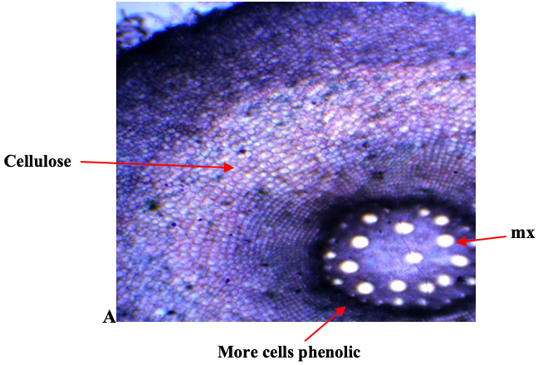
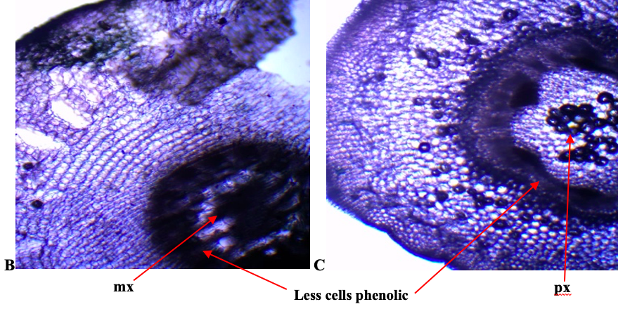
Figure 9: Cross-section of plantain banana roots from the three treatments BS (A), NPK (B) and W(C) showing metaxylem (mx), protoxylem (px) visualized and cells phenolic (white) under a fluorescence microscope with a 4X objective.

Analysis of histological cross-section performed on matured plantain banana roots from the three (03) treatments i.e., biostimulant (BS), positive control (NPK) and negative control (W), visualized under a photonic microscope with x40 objective has revealed the presence of cellulose on the different cell walls of the roots treated with the biostimulant compared to the control roots. Similarly, a significant lower quantity of suberin stained in red, lipids stained in yellow-brown, and lignin stained in green has been revealed in the roots of negative control (W) (Figure 10). However, the cross-section of the roots of the positive control (NPK) has shown a significant amount of lipids, lignin and suberin as well as in the roots treated with the biostimulant (BS). Indeed, the roots treated with biostimulant are significantly more cellulosic compared to the control roots (Figure 10).
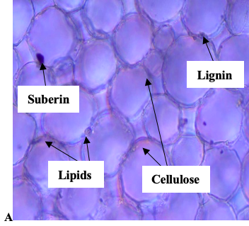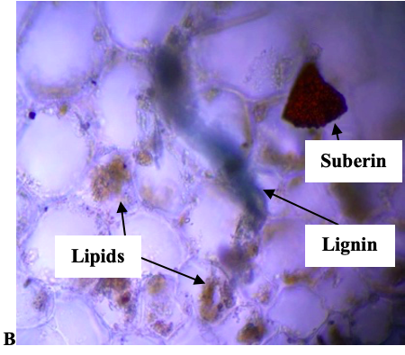
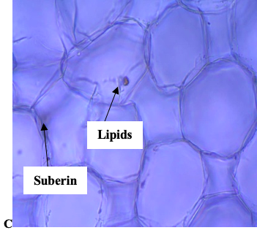
Figure 10: Cross-section of plantain banana roots from the three treatments BS (A), NPK (B) and W (C) showing the localization of cellulose, suberin, lignin and lipids, the section were stained with iodine carmine-green and immediately visualized under a fluorescence microscope with a 40X objective.

Analysis of histological cross-section performed on matured plantain banana roots from the three (03) treatments i.e., biostimulant (BS), positive control (NPK) and negative control (W) has revealed the reinforcement of the cell wall by the formation of cork layers in the walls of the roots (represented with red arrows) (Figure 11). The formation of these cork layers is highly intensified in the roots treated with the biostimulant (BS) compared to those of the control roots. The cell wall strengthening is due to the significant presence of these cork layers surrounding the cell walls of the treated roots, thus enhancing their resistance to pathogens and environmental attacks. Indeed, the cell walls of the control roots are larger, less tight and less reinforced, and the presence of cork layers was significantly lower compared to those of the treated roots (Figure 11).

A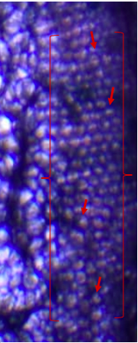B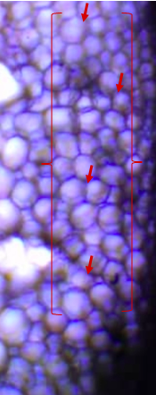C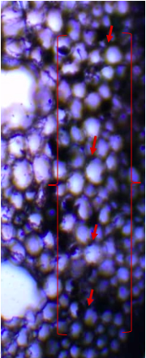
Figure 11: Cross-section of plantain banana roots showing cell wall reinforcement by cork layers (represented with red arrows) from the three treatments BS (A), NPK (B) and W (C) visualized under a fluorescence microscope with a 10X objective.

5. Discussion
The overall objective of our study was to evaluate the effect of the biostimulant on the agronomic performance of plants in the field, as well as its effect on the quality of plantain fruit. The agro-morphological parameters show that the biostimulant improves/increases the vegetative growth parameters of plantain banana plants, notably the diameter of the pseudo-stem and the number of leaves that were higher in plants treated with the biostimulant compared to the controls. This suggests that the biostimulant seems to contains mineral elements, primary and secondary metabolites that are easily assimilated by plants during watering. Previous studies have suggested that biostimulants contain high levels of nutrients essential for plant growth, such as nitrogen, phosphorus, potassium, calcium … and could therefore be considered as a biostimulant for seedlings (Mushunuke et al., 2020). Moreover, in course of time and regardless of weather conditions, the agro-morphological parameters of plants treated with the biostimulant are significantly improved compared to control plants. The biostimulant has positive effects on growth, plant height, increased leaf area (in particular, increased fruit productivity and harvest quality), and development of roots. It also, improves productivity and increases plant biomass (Benne, 2023). This show that regardless of the climate, the biostimulant has an effect on time and on promoting plant growth at different stages of germination in the greenhouse, the pre-emergence stage in the nursery and growth in the field (Tatsegouock et al., 2020). Similarly, the improvement in the agro-morphological parameters of plantain banana plants highlights the effectiveness of the biostimulant over time. This seems to be due to the action of the microbiome, which continues to metabolize the nutrients from the constituents contained in the biostimulant, particularly Tithonia diversifolia and clam shells (Kengoum, 2020). Indeed, the use of organic fertilizers has shown that the rate of decomposition of organic matter and the increase in yields were closely linked to the synchronization between the release of nutrients and their assimilation by the plant (Kaho et al., 2011). Tithonia leaves incorporated into the soil therefore appear to have a suitable decomposition rate, which has enabled the plant to assimilate a large proportion of the nutrients released during the decomposition of organic matter. Similarly, corn grain yields were higher on plots treated with Tithonia alone compared to plots treated with chemical fertilizers alone (Kaho et al., 2011). Biostimulants improved the responses of lettuce and mint compared to controls on lettuce and mint, in terms of spread, stem height, number of leaves, leaf length, leaf width and branch branching (Kengoum, 2020). These results appear to be due to the biostimulant action of biostimulants, which have the ability to improve nutritional efficiency, abiotic stress tolerance and/or crop quality characteristics, regardless of nutrient content (du Jardin, 2015). The nutrients contained in biostimulants, particularly nitrogen, phosphorus, potassium, calcium and magnesium, could be linked not only to the presence of Tithonia diversifolia, which is a plant very rich in biofertilizer elements, but also to the presence of clam shells, which are rich in calcium, magnesium and other minor constituents such as minerals (Ewané et al. 2020, Kengoum, 2020). This positive effect has recently been observed in plantain seedlings treated with fermented extracts of Tithonia diversifolia (Tatsegouock et al., 2020). A recent study has demonstrated the biostimulant effect of these clam shells on promoting the growth of PIF seedlings (Big Ebanga and Batard varieties) in terms of the diameter of pseudo-stems (83.7%), plant height (89.8%) and the number of leaves (83.7%) (Ewané et al., 2019). Proving thus that the use of biostimulants influences the growth of seedlings (diameter, height and number of leaves of plant). Similarly, biostimulants improve tolerance to abiotic and biotic stress, as well as the quality of live plants, regardless of their nutrient content, and improve root development in terms of weight, size and length (du Jardin, 2015).
Biomarkers accumulation was greater in the leaves of plantain banana plants treated with the biostimulant (BS) compared to controls. Indeed, the biostimulant appears to act as an elicitor inducing the accumulation of total phenols, total proteins and total sugars known as biomarkers of growth, but also of resistance/tolerance to biotic and abiotic stresses (Dhakshinamoorthy et al., 2014; Elock et al., 2026). Furthermore, these results also show that these biomarkers are involved at different levels in plant physiological and biochemical processes. Application of the biostimulant (BS) to plants during watering improved the plant responses and leads to an increase in the synthesis of biochemical markers of about 97.5% compared to the leaves of controls plants (NPK and W). This appear to be due to the continuous action of the microbiome through the metabolism of nutrients from the constituents contained in biostimulant (du Jardin, 2015). The use of foliar biostimulant on the root system allows plants to overcome stress, thus improving yield and the nutritional value of crops, in particular the nutrient content of phenols, flavonoids and their antioxidant activity in the leaves (Benne, 2023). Indeed, the use of organic fertilizers has shown that increased yields are closely linked to the synchronization between nutrient release and their assimilation by the plants (Kaho et al., 2011). Proteins play a structural role as they are involved in most physiological processes in the both humans and plants. Furthermore, proteins are synthesized from amino acids which also play a role in the growth and development processes of plants. Phenols are inhibitors of enzymes involved in photosynthesis and respiration, while sugar are involved in regulating the expression of several genes and are mostly used as an energy source for living plant cells (Boukhers, 2022).
Similarly, they allow the plant to assimilate a large proportion of the nutrients released during the decomposition of organic matter. Since banana fertilization is essentially mineral, the use of organic fertilizers helps maintain optimal soil fertility while providing essential elements to meet its nutritional needs (Dorey et al., 2024). The major nutrients contained in the biostimulant can be linked not only to the presence of the various plants that make up the biostimulant, which are very rich in biofertilizing, biopesticidal and biostimulant elements but also to the presence of clam shells, which are rich in calcium, magnesium and other minor constituents like boron, iron, … (Khoushab et al., 2010; Kengoum, 2020; Kom, 2020).
The improvement in flowering time, ripening time of plantain fruits, weight of plantain bunches and total growth time of plantain plants can be explained by the fact that the biostimulant has excellent physical and chemical properties. Indeed, the biostimulant has improved the ripening parameters of plantain fruit from 87.6% to 99.1%. In a previous work, the balanced cation fertilization (organic, mineral or organo-mineral) has significantly improved tomato plant varieties growth in terms of the number of clusters and fruits per plant, fruit yield and the phosphorus (P), potassium (K), calcium (Ca) and sodium (Na) content (Tonfack et al., 2009). Similarly, over the time and regardless of the climate, the biostimulant have influences fruit ripening parameters. The biostimulant have shown an effect on the grade, the diameter and weight of fruits, due to the presence of secondary metabolites they contained and which have exerted their biofertilizing and biostimulant proprieties. Furthermore, we have observed that the biostimulant has an effect on the fruit size and number in terms of number of fruits per hands, the grade, the diameter and weight of fruits. These results demonstrate the beneficial effects of applying the biostimulant during plant growth and the further performance of plantain banana plants and fruits harvested. The biostimulant promotes better fruiting, increased size, number of fruits and weight; and could probably improve taste and increased fruit content by reducing acidity, thereby accelerating fruit ripening. It also improves plant growth and tolerance to abiotic stress and helps the plant remain vigorous under growing conditions (Tahiri, 2023). The biostimulant has a significant effect on plants, inducing their biofertilizer, biostimulant, biofungicide and biopesticide properties, thereby accelerating germination and promoting growth in nurseries (Ewané et al., 2020). The use of organic fertilizer on okra have improved productivity in terms of quantity and fruit quality, since the organic fertilizer has not been leached out over time, which has contributed to the assimilation of nutrients by the plant (Banga & Ndona, 2022). The improvement in the total growth time of plantain banana plants can be explained by the excellent physicochemical properties of the biostimulant, which provides the minerals necessary and important for good plant growth, particularly macroelements, trace elements, microelements, but also primary and secondary metabolites and enzymes linked to defense, which are important in the defense and protection of the plant (Ewané et al., 2020; Kengoum, 2020; Kom 2020). This improvement can be explained by the fact that chitin exerts hormonal control over the emission and growth of plants. Indeed, under apical dominance of the mother plant, plantains should secrete more gibberellin than auxin in order to produce many suckers. Since gibberellin and auxin are plant hormones with opposing effects during their synthesis within a plant, banana trees generally secrete more gibberellin than auxin in order to produce many more shoots. In fact, auxin inhibits the development of lateral (axillary) buds in favor of apical dominance, while gibberellin reduces this apical dominance while promoting the development of dormant eyes and buds, suckers and shoots (Ndongo 2015). This increased synthesis of gibberellin stimulates the proliferation of suckers in plantains. The major nutrients contained in biostimulants can be linked not only to the presence of the various plants that make up the biostimulant, which are very rich in biofertilizers, biofungicides, biopesticides and biostimulants, but also to the presence of clam shells, which are rich in calcium, magnesium and other minor constituents like boron, iron, … (Khoushab et al., 2010; Kom 2020). This positive effect has recently been observed in vitro and in living banana plants treated with the many biostimulants (Tatsegouock et al., 2020; Kom 2020; Tahiri, 2023; Elock et al., 2026).
The histological analyses carried out on the cross-sections of matured plantain banana roots have shown that during the growth of plantain banana, the plants were exposed to biotic and abiotic stresses (parasites, nematodes, cold, drought etc..) which induced the resistance of treated roots to these stresses. Cross-sections of nodal roots showed the structure of vascular bundles and cortical parenchyma cells (Wuyts et al., 2007). The significant presence of phenolic cells in the treated roots compared to the non-treated roots explains the resistance of the treated plants to these biotic and abiotic stresses. Also, this resistance is due to the presence of primary and secondary metabolites contained in the biostimulant, thus allowing the plantain banana plants to resist biotic and abiotic stresses. The cell wall of treated roots is rich in cellulose and has extracellular matrix which permit plants to resist biotic attacks, particularly parasites. Similarly, the presence of cellulose, lignin, suberin and lipids allow different structures including the rhizodermis, parenchyma endodermis and xylem to strengthen roots cell wall (Nithya et al., 2009).
The high presence of phenols on the roots prevents the roots from being attacked by parasites and nematodes. Cellulose is the main structural component of cell wall in roots that provides rigidity to the roots and the mechanism necessary to facilitate penetration into the soil. It supports the cell structure and allows cell growth thereby promoting root extension and forms the xylem which enables transport of sap, thus facilitating water and minerals transport to the aerial part of the plant (Tribot, 2020). Other studies have shown the resistance of a set of Arabidopsis thaliana mutants defective in the cellulose synthetase subunits required for secondary cell wall formation towards a series of pathogens (Ramirez et al., 2011). Just like cellulose, lignin and suberin strengthen the cell wall, ensuring the rigidity and mechanical resistance essential for root penetration into the soil, they facilitate the transport of sap (water and minerals) and protection against pathogens. Indeed, the presence of lignin within the cell walls allows roots to grow and branch and acts as a physical barrier against attacks from soil fungi and bacteria lignin accumulates in the cell wall, thus increasing resistance to compression (Tribot, 2020). Cellulose synthesis is partially regulated by trafficking cellulose synthase complexes (CSCs) to and from the plasma membrane, where they are active in cellulose biosynthesis (Zhu and McFarlane, 2022).
Lignified cell walls are potential physical barriers to nematode migration and feeding as lignin would limit the access of nematode enzymes to cell wall polysaccharides (Wuyts et al., 2007). This lignification process may establish mechanical barriers to the pathogen particularly chemical modification of the cell wall-degrading enzymes, increased resistance of cell walls and of nutrients from the host to the pathogen; and entrapment (Nithya et al., 2009). Suberin prevents the unregulated passage of sap, forcing regulation at the cellular level. Moreover, suberin form a hydrophobic barrier allowing among other things, the control of water and solute flows to protect the plant from stress environmental factors such as drought or pathogens, this is due to the majority of fatty acids and alcohols present in the soluble fraction of roots (Delude, 2015). The best recognized lipid derived signals in plants are oxylipins, including jasmonic acid (JA) (Siebers et al., 2016). Lipids ensure the structural integrity of cells via membranes phospholipids, they serve as metabolic energy reserve and act as signaling molecules to to regulate cellular metabolism while forming a hydrophobic barrier essential for the protection and proper functioning of roots (Legrand, 2025). Lipids and the products of lipid metabolism play essential roles in the plants defense mechanism. Biotic stress alters the metabolism of lipids, which have both passive and active functions in plant immunity. Lipids are the main structural components of the cuticle and plasma membrane, constituting the first physical barriers that the pathogens encounter and also act as a source of signals perceived by both the invading pathogen and the plant, which regulate plant pathogen interactions (Siebers et al., 2016).

6. Conclusion
The aim of this study was to evaluate the effect of the biostimulant on the agronomic performance of plants in the field, as well as its effect on the quality of plantain fruit. The results show that the biostimulant promotes improvements in agromorphological parameters, ripening parameters, and parameters relating to plantain fruit and bunches compared to the control group. Thus, the constituent elements and contents of biostimulants based on natural products are a good alternative for the implementation of biological inputs that will be accessible to everyone, from farmers to the average citizen, unlike inorganic fertilizers, which are expensive and harmful to the environment and consumer health. However, from a social and environmental perspective, the promotion of this innovation should depend on the mastery of the manufacture of biostimulants or biological inputs and the effect (stimulant, biofortifier, biofertilizer, biofungicide, biopesticide, etc.) of the plants used.

References
Aubert G., Penato C., & Sarthou V. (2018). Biological Input: Definition. Dictionary of Agroecology. 45p.
Banga J. N., & Ndona K. R. (2022). Effects of different organic fertilizers and animal droppings on the growth and protection of Okra (Hibiscus esculentus) in an acidic soil of Bandundu. Congo Research Papers, 2021, 1 (5), pp.74-81. https://hal.science/ hal-03750933v1.
Benne H. F. Z. (2023). Verification of the effect of biostimulant products on the productivity of potato cultivation at the Hamadouche farm Tlemcen. Master II Academic Diploma, specializing in plant protection. Faculty of Natural and Life Sciences and Earth and Universe Sciences, University of Tlemcen. 88p.
Bindzi A. R. B. A. (2022). Effect the biostimulants products of the growth and the defense the vivoplants the banana plantain : analyse the microelements and the antioxydants in the leaves. Thesis for a Master's degree in Biochemistry. Faculty of Science, University of Yaoundé 1. 82p.
Boukhers I. (2022). Étude et valorisation du potentiel antioxydant de l’effet anti-inflammatoire et de l’index glycémique de farines issues de légumes amylacés : Manihot esculenta, Ipomoea batatas, Canna edulis et de leurs sous-produits. Médecine humaine et pathologie. Université de Montpellier, 2022. HAL Id : tel-04681323. https://theses.hal.science/tel-04681323v1. 22 : 106-197.
Delude C. (2015). La subérine chez Arabidopsis thaliana : mecanisme d’export et contribution des alcools gras. Laboratoire de biogenèse membranaire. HAL OPEN SCIENCE. 305p.
Desmier T. (2016). Antioxidants today: definition and applications. University of Limoges. 25p.
Dorey E., Meynard C., Lakhia S., Ruille M., & Dorel M. (2024). Evaluation of diffrent strategies of organic fertilization to restore soil fertility in Caribbean banana plantations. Acorbat international. Acorbat Revista de Tecnologia y Ciencia, 2024. 1(1) :9p. https://hal.science/hal- 05182226v1.
Du Jardin P. (2015). Plant biostimulants: Definition, concept, main categories and regulation. Scientia Horticulturae, biostimulants in Horticulture, vol. 196,‎ 30 novembre 2015, p. 3-14.196p.
Elock M.G., Meshuneke A., Wassom F.D., Dzelamonyuy A., Niemenak N. & Ewané C.A. (2026). Effect of a Bioproduct Based on Tithonia diversifolia and Emilia coccinea on the Growth and Protection of PIF Plantains in Nursery. Cameroun Journal of Biological and Biochemical Sciences, 34, 20-35. https://doi.org/10.63342/cjbbs2026.34.25028.en

Ewane C. A., Ndongo F., Ngoula K., Tene T. P. M., Opiyo S. O., & Boudjeko T. (2019). Potential biostimulant effect of clam shells on growth promotion of glantain PIF seedlings (var. Big Ebanga & Batard) and relation to black sigatoka disease susceptibility. American Journal of Plant Science, 10, 1763-1788. https://doi.org/10.4236/ajps.2019.1010125.
Ewane C. A., Meshuneke A., Tatsegouock R., & Boudjeko T. (2020). Field efficacy of a biopesticide based on Tithonia diversifolia against black sigatoka disease of plantain (Musa spp., AAB).
FAO. (2019). Statistical Compendium of Bananas. Food and Agriculture Organisation of the United Nations. 24p.
Jauzein F. (2018). Thousand and one bananas. Planet-Vie. By Creative Commons-Attribution. Wikimedia. Associate Professor of SVT.
Kaho F., Yemefack M., Feujio-Teguefouet P., & Tchantchaouang J. C. (2011). Combined effect of Tithonia diversifolia leaves and inorganic fertilizers on maize yields and the properties of ferralitic soil in Central Cameroon. Cameroon TROPICULTURA, 2011, 29, 1, 39-45.
Kengoum D. (2020). Partial characterization of biostimulant products based on Tithonia diversifolia and their effect on the growth of Lactuca sativa and Mentha peperita. Thesis for a Master's degree in Biochemistry. Faculty of Science, University of Yaoundé 1. 71p.
Khoushab F., & Yamabhai M. (2020). Influence of clam shells and Tithonia diversifolia powder on the growth of plantain PIF (var. French) seeding and their susceptibility to Mycosphaerella fijiensis. African Journal of Agricultural Research Revisited. Vol.15(3), pp.393-41, mars 2020. https://doi.org/10.5897/AJAR2019.14486.
Kom T. (2020). Effect of a biostimulant based on Urtica spp. on the growth of banana PIF plantains and their susceptibility to black Sigatoka. Thesis for a Master's degree in Biochemistry. Faculty of Science, University of Yaoundé 1. 75p.
Kwa M., & Temple L. (2019). Plantain: Socio-economic and technical issues, experiences in Intertropical Africa. Coordinators Editions Quæ, CTA, Presses agronomiques de Gembloux. CTA, Postbus 380, 6700 AJ Wageningen, Pays-Bas www.cta.int. Editions Quæ, RD 10, 78026 Versailles Cedex, France www.quae.com – www.quae-open.com. Passage des Déportés, 2, B-5030 Gembloux, Belgique. www.pressesagro.be. p 43.
Legrand P. (2025). Les lipides sont des nutriments importants et ne doivent plus être diabolisés, ni chez l’adulte, ni chez l’enfant. Académie d’Agriculture de France. https://hal.science/hal-05176100v1.
Meshuneke A., Ewane C. A., Tatsegouock R., & Boudjeko T. (2020). Tithonia diversifolia Mulch Stimulates the Growth of Plantain PIF Seedlings and Induces a Less Susceptibility to Mycosphaerella fijiensis in the Nursery. Laboratory of Phytoprotection and Plant Valorization, Biotechnology Centre, University of Yaoundé 1, Yaoundé, Cameroon. Department of Biochemistry, Faculty of Science, University of Yaoundé 1, Yaoundé, Cameroon. 683-688.
Nithya D. A., Ponnuswami V., Sundararaju P., Van den Bergh I., and Kavino M. (2009). Histopathological Changes in Banana Roots Caused by Pratylenchus coffeae, Meloidogyne incognita and Radopholus similis, and Identification of RAPD Markers Associated with P. coffeae Resistance. Department of Fruit Crops, Horticultural College and Research Institute, Tamil Nadu. Agricultural University, Coimbatore-641 003, Tamil Nadu, India. National Research Centre for Banana, Trichy, Tamil Nadu, India. Bioversity International, Commodities for Livelihoods, Boulevard de la Lironde, Parc Scientifique Agropolis II, 34397 Montpellier, France. Proc. IS on Banana Crop Prot., Sust. Prod. & Impr. Livelihoods. Eds.: D. Jones and I. Van den Bergh. Acta Hort. 828, ISHS 2009. 290p.
Ndongo E. F. (2015). Effect of clam shell (Crassostrea spp) on the growth and resistance plantain plants using the PIF method against Mycosphaerella fijiensis, the agent responsible for black Sigatoka. Agronomy thesis, Faculty of Agronomy and Agricultural Sciences (FASA), Cameroon. 96p.
Ndungo V. (2008). The situation of banana bacterial wilt in the Minova region; mapping, impact on food security, recommendations for sustainable control. Unpublished, Consultancy Report, AFC, 60P.
Pretorius C.J., Zeiss D.R., and Dubery I.A. (2021). The Presence of Oxygenated Lipids in Plant Defense in Response to Biotic Stress: A Metabolomics Appraisal. Plant Signal. Behav., 16, 1989215.
Ramirez V., Agorio A., Coego A., Garcia-Andrade J., Hernandez M.J., and Balaguer B. (2011). MYB46 modulates disease susceptibility to Botrytis cinerea in Arabidopsis. Plant Physiol. 155, 1920–1935.doi:10.1104/pp.110. 171843.

Sandoval., Estella., Bye., Robert A., Rios., Griselda., Aguilar., and Maria Isabel. (2005). Microscopic analysis and histochemical observations of the medicinal root of Iostephane heteropylla (Cav.) Benth. ex Hemsl (Asteraceae). Boletin de la Sociedad Botanica de Mexico. Num 77, 65-73.
Siebers M., Brands M., Wewer V., Duan Y., Holzl G., and Dormann P. (2016). Lipids in Plant– Microbe Interactions. Biochim. Biophys. Acta Mol. Cell Biol. 1861, 1379–1395.
Tahiri H., El yachiouil M., & Khadmaouil A. (2023). The influence of rooting biostimulant on the root growth of green beans. Faculty of science, Department of biology, 14000 Kenitra, Morocco. EDP Sciences. SHS Web of Conferences 175, 01012 (2023). ICISMAMH2S 2023. https://doi.org/10.1051/shsconf/202317501012. 7 : 7-9 p.
Tatsegouock R. N., Ewané C. A., Meshuneke A., & Boudjeko T. (2020). Plantain Bananas PIF seedlings Treatment with Liquid Extracts of Tithonia diversifolia Induces Resistance to Black Sigatoka Disease. American Journal of Plant Sciences. 11: 653–671.
Tollens E. (2004). Challenges: Food security and cash crops for export-main directions and comparative advantages of agriculture in the R.D.Congo. Working Paper, n86, Department of Agriculture and Environmental Economics, Catholic University of Leuven, 76p.
Tonfack B. L., Bernadac A., Youmbi E., Mbouapouognigni V-P., Ngueguim M., & Amougou A. (2009). Impact of organic and inorganic fertilizers on vigor, yield and the composition fruit yield of tomatoes grown on tropical andosols. https://doi.org/10.1051/fruits/2009012.
Tribot A. (2020). Valorisation de la partie lignine des effluents de prétraitement de biomasse forestière : élaboration et caractérisation d’agrocomposites. Université Clermont Auvergne.
Wuyts N., Lognay G., Verscheure M., Marlier M., De Waele D., and Swennen R. (2007). Potential physical and chemical barriers to infection by the burrowing nematode Radopholus similis in roots of susceptible and resistant banana (Musa spp.). Laboratory of Tropical Crop Improvement, Division of Crop Biotechnics, Catholic University of Leuven (K.U. Leuven), Kasteelpark Arenberg 13, 3001 Leuven. Unité de Chimie Analytique, Faculté Universitaire des Sciences Agronomiques de Gembloux, Passage des Déportés 2, 5030 Gembloux. Unité de Chimie Générale et Organique, Faculté Universitaire des Sciences Agronomiques de Gembloux, Passage des Déportés 2, 5030 Gembloux, Belgium. Plant Pathology (2007). Doi: 10.1111/j.1365-3059.2007.01607. 56, 878–890p.
Zhu Y., and McFarlane H.E. (2022). Regulation of cellulose synthesis via exocytosis and endocytosis. Curr Opin Plant Biol. 69:102273. https://doi.org/10.1016/j.pbi.2022.102273.

