Case report
Infertility in a Doberman Bitch Associated with Vaginal Hyperplasia and Hypothyroidism: A Clinical Case Report

ABSTRACT
A four-year-old Doberman bitch was presented with a history of repeated breeding failure despite mating with a proven fertile male, accompanied by difficulty in copulation and absence of copulatory tie. Clinical examination revealed lethargy, weight gain, cold intolerance, and bradycardia, suggestive of an underlying endocrine disorder. A protruding edematous vaginal mass consistent with vaginal hyperplasia was observed, while per vaginal examination indicated resistance to speculum passage and a septum-like structure suggestive of a congenital vaginal anomaly. Ultrasonography revealed normal uterine and ovarian morphology, excluding primary uterine pathology. Hematological evaluation showed mild anemia, and thyroid profiling confirmed Hypothyroidism. Vaginal exfoliative cytology demonstrated a predominance of superficial cornified cells, indicative of an estrogen-dominant environment. Therapeutic management included levothyroxine supplementation and supportive care, along with conservative management of vaginal hyperplasia. The findings suggest a multifactorial etiology of infertility involving endocrine dysfunction and possible anatomical obstruction, resulting in a guarded reproductive prognosis.
Keywords: Infertility; Vaginal hyperplasia; Hypothyroidism; Doberman bitch; Exfoliative cytology
INTRODUCTION
Infertility in bitches is a multifactorial condition involving complex interactions between anatomical, hormonal, and management-related factors (Noakes et al., 2018). Among the various reproductive disorders, vaginal hyperplasia is a relatively common estrogen-dependent condition characterized by edematous protrusion of vaginal mucosa through the vulva, typically observed during the proestrus and estrus phases. This condition is primarily associated with elevated estrogen levels and may interfere with normal mating and fertility (Bucci et al., 2022). Endocrine disorders such as Hypothyroidism have been increasingly recognized as significant contributors to reproductive dysfunction in canines. Hypothyroidism can disrupt the hypothalamic–pituitary–gonadal axis, leading to irregular estrous cycles, anovulation, and reduced conception rates (Feldman & Nelson, 2003). Additionally, metabolic disturbances associated with hypothyroidism may adversely affect general health, further compromising reproductive efficiency (Egger et al., 2024). Apart from endocrine influences, structural abnormalities of the reproductive tract, including congenital vaginal anomalies such as vaginal septum (double vagina), may also contribute to infertility by interfering with semen deposition and sperm transport (Johnston et al., 2001). Although such anomalies are relatively uncommon, their presence can significantly impair reproductive performance, particularly when combined with hormonal imbalances (Noakes et al., 2018).
The present case report describes infertility in a Doberman bitch with clinical evidence of vaginal hyperplasia, concurrent hypothyroidism, and suspected vaginal anatomical abnormality. The case highlights the importance of a comprehensive clinical and diagnostic approach in identifying multifactorial causes of infertility and emphasizes the need for integrated management strategies to improve reproductive outcomes.
CASE HISTORY AND CLINICALEXAMINATION
A four-year-old female Doberman bitch was presented to the Referral Veterinary Polyclinic of ICAR-Indian Veterinary Research Institute (IVRI), Izatnagar, with a history of repeated failure to conceive despite multiple matings with a proven fertile male (Figure 1). The owner reported difficulty during copulation, wherein the male exhibited normal libido and mounting behavior but failed to achieve a proper copulatory tie. Additionally, the bitch exhibited clinical signs including dullness, lethargy, reduced activity, constipation, weight gain, cold intolerance, and a tendency to seek warm places, along with poor and irregular estrous signs.

Figure 1: Doberman bitch at presentation with history of infertility and lethargy.
On general clinical examination, the animal appeared dull and lethargic. Vital parameters revealed a reduced heart rate (bradycardia), while other parameters were within physiological limits. Examination of the external genitalia showed a mildly constricted vulvar opening with protrusion of edematous vaginal tissue, consistent with vaginal hyperplasia (Figure 2).
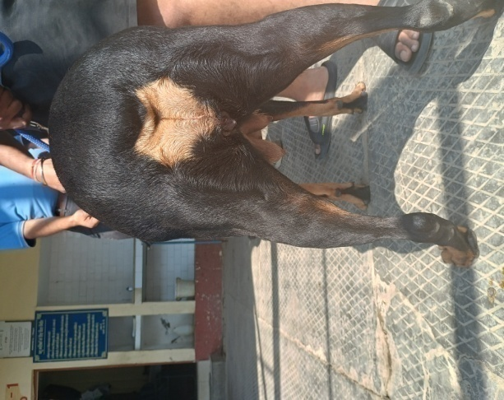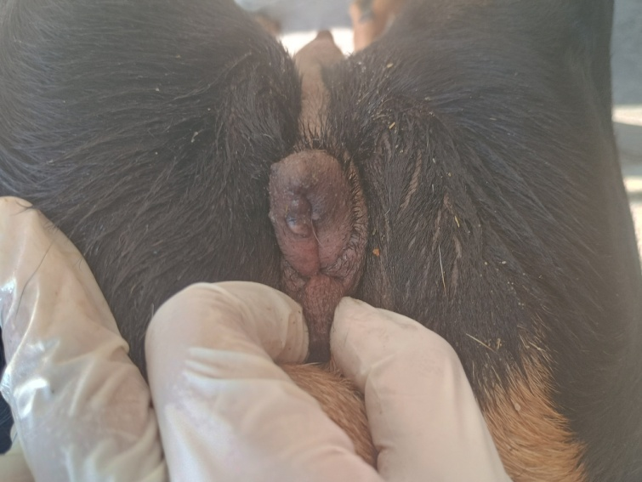
Figure 2: Constricted vulva with protrusion of edematous vaginal tissue suggestive of vaginal hyperplasia
Per vaginal examination was performed using a lubricated speculum; however, resistance was encountered during insertion. On further careful examination, a band-like structure suggestive of a vaginal septum was palpated, creating two distinct orifices, indicating a suspected congenital vaginal anomaly (double vagina) on digital palpation.
Ultrasonographic examination of the reproductive tract revealed a uterus of normal size and contour with no intrauterine contents, and both ovaries appeared normal without any cystic structures, indicating absence of pregnancy and no gross ovarian pathology (Figure 3).
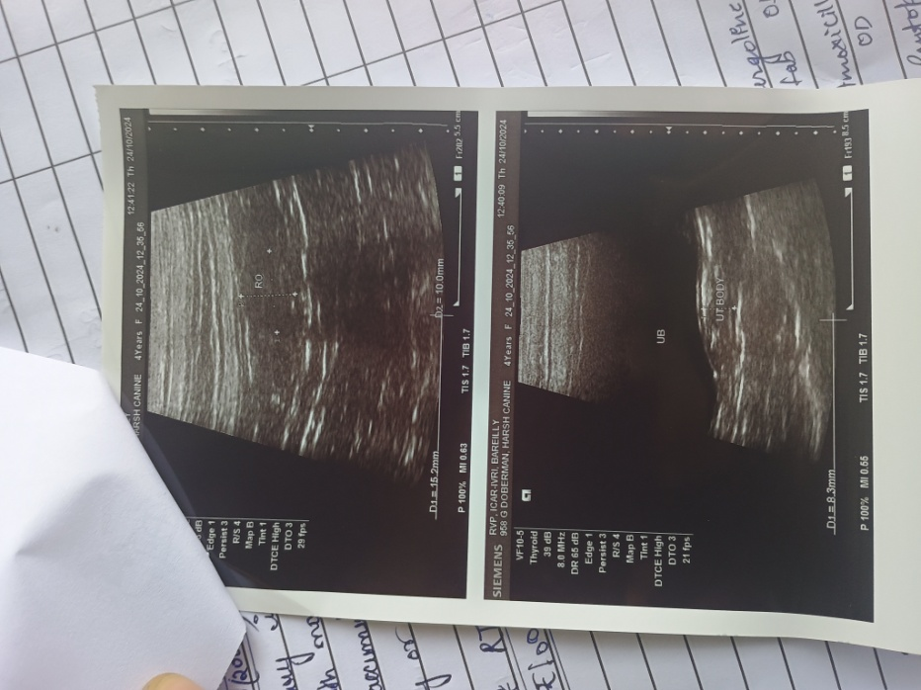
Figure 3: Ultrasonographic image showing a normal uterus and ovaries with no intrauterine contents.
Laboratory investigations were carried out using blood samples. Hematological analysis revealed mild anemia characterized by hemoglobin levels of 8–9 g/dL, packed cell volume (PCV) of 24–27%, and erythrocyte count of approximately 5.0 × 10⁶/µL, while Thyroid profiling revealed decreased T4, FT3 (1.57 pg/mL), and FT4 (0.49 ng/dL) levels along with low TSH, confirming Hypothyroidism.
Vaginal exfoliative cytology demonstrated a predominance of superficial cornified epithelial cells, indicative of an estrogen-dominant phase (Figure 4), which supports the presence of estrogen-mediated vaginal hyperplasia.

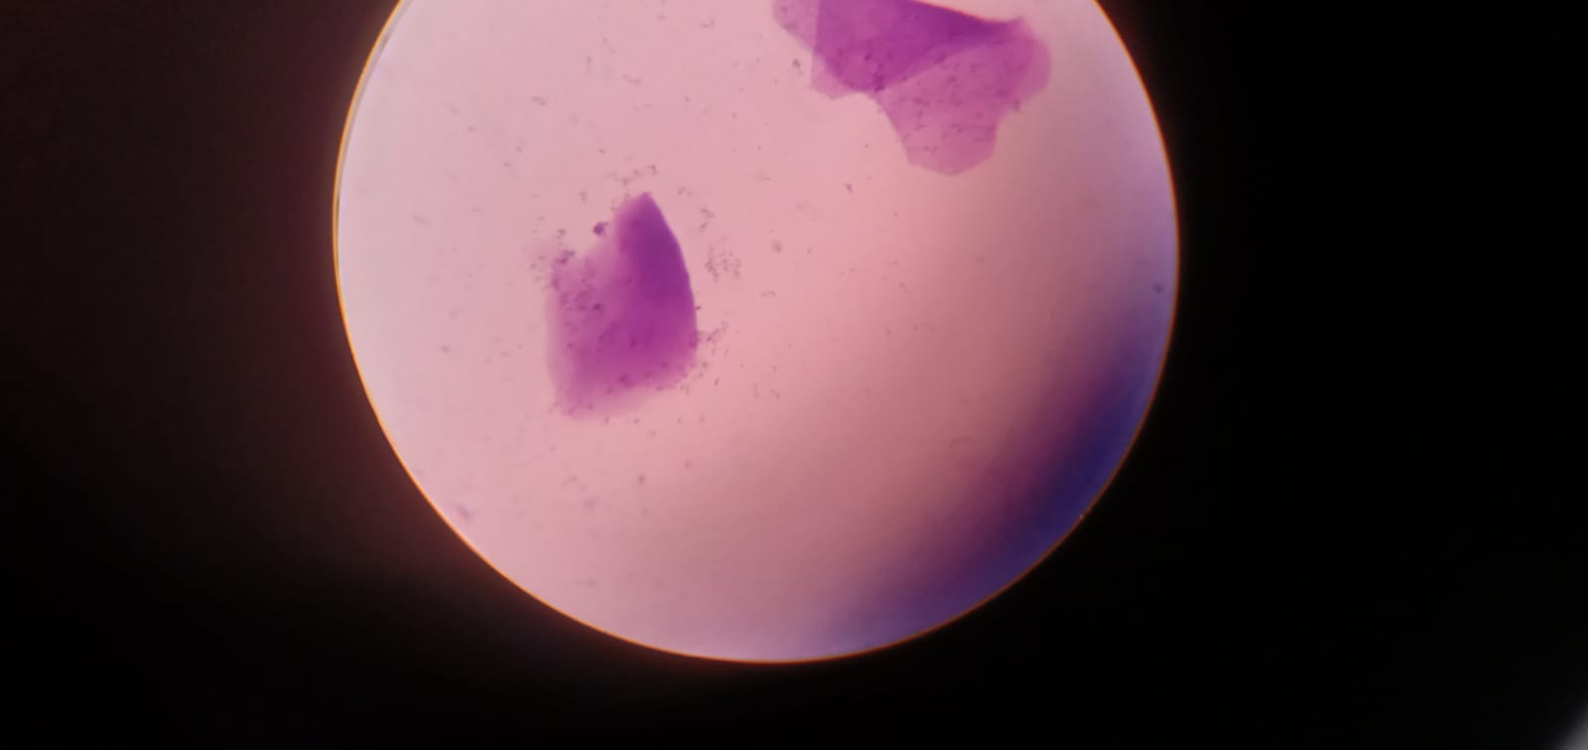

Figure 4: Vaginal cytology smear showing predominance of superficial cornified epithelial cells.
TREATMENT AND DISCUSSION
In the present case, therapeutic management was primarily directed towards correction of the underlying endocrine disorder, alleviation of clinical signs, and supportive management of vaginal hyperplasia to improve overall reproductive health and future breeding potential.
The bitch was diagnosed with Hypothyroidism based on clinical signs and thyroid profile (decreased T4 and elevated TSH). Accordingly, levothyroxine sodium was initiated as the treatment of choice at a recommended dose of 0.02 mg/kg body weight orally, twice daily, with advice for regular monitoring and dose adjustment based on clinical response and follow-up thyroid profiling. Correction of hypothyroidism is essential to restore metabolic balance, improve general health, and normalize reproductive hormonal function.
Supportive therapy was instituted to address the associated anemia and poor body condition, including hematinic supplementation (iron, folic acid, and vitamin B-complex) and dietary management aimed at improving nutritional status.
For the management of vaginal hyperplasia, conservative treatment was adopted as the condition was mild to moderate in severity. The protruded vaginal tissue was gently cleaned using sterile normal saline and protected with topical application of lubricating antiseptic gel to prevent desiccation and secondary infection. The owner was advised to maintain strict hygiene of the perineal region and to prevent self-trauma by the animal using an Elizabethan collar if required. As the condition is estrogen-dependent, no aggressive surgical intervention was attempted at this stage.
Considering the suspected congenital vaginal anomaly (vaginal septum/double vagina) and history of repeated breeding failure, the prognosis for natural conception was considered guarded to poor. The owner was advised regarding the possibility of persistent infertility due to anatomical obstruction and was counseled to avoid repeated breeding attempts until complete endocrine stabilization. Advanced diagnostic procedures such as vaginoscopy or surgical correction may be considered; however, in field conditions, conservative management and monitoring were preferred.
Overall, infertility in this case appears to be multifactorial, involving endocrine dysfunction due to Hypothyroidism, estrogen-mediated vaginal hyperplasia, and a suspected structural abnormality of the reproductive tract. Effective management of hypothyroidism is expected to improve general health and may partially restore reproductive function; however, anatomical factors may continue to limit fertility.
Further, the clinical presentation of dullness, lethargy, weight gain, cold intolerance, and bradycardia, along with laboratory findings of decreased T4 and elevated TSH, are consistent with Hypothyroidism. This endocrine disorder is known to disrupt the hypothalamic–pituitary–gonadal axis, leading to irregular estrous cycles, anovulation, and reduced fertility (Feldman & Nelson, 2003). Previous reports have indicated that hypothyroidism may impair reproductive performance by altering gonadotropin secretion and ovarian function, thereby contributing to infertility (Panciera et al., 2012). Vaginal hyperplasia observed in this case is an estrogen-dependent condition, typically associated with elevated circulating estrogen levels during proestrus or estrus (Noakes et al., 2018). The presence of a protruding, edematous vaginal mass and cytological findings showing predominance of superficial cornified epithelial cells indicate an estrogen-dominant environment. Although a direct causal relationship cannot be established, Hypothyroidism may have contributed indirectly to altered endocrine dynamics, potentially influencing the hormonal milieu and predisposing the animal to vaginal hyperplasia.
Furthermore, the difficulty during copulation and absence of successful mating tie suggest a possible anatomical impediment. Per vaginal examination revealed a band-like structure with two orifices, suggestive of a congenital vaginal septum (double vagina). Such structural abnormalities can interfere with proper semen deposition and sperm transport, thereby reducing the likelihood of fertilization (Johnston et al., 2001). However, in the absence of definitive confirmation through vaginoscopy or advanced imaging, the diagnosis remains presumptive. The ultrasonographic findings of a normal uterus and ovaries rule out major uterine or ovarian pathologies, thereby strengthening the likelihood of infertility being associated with endocrine and structural factors rather than primary uterine disease.
Taken together, the present case emphasizes the importance of integrating clinical findings, laboratory diagnostics, and reproductive examination for accurate diagnosis and management of infertility in bitches.

REFERENCES
- Bucci, R., Fusi, J., Robbe, D., Veronesi, M. C., & Carluccio, A. (2022). Management of Vaginal Hyperplasia in Bitches by Bühner Suture. Animals, 12(24), 3505. https://doi.org/10.3390/ani12243505
- Egger, R., Conze, T., & Wehrend, A. (2024). Einfluss der Hypothyreose auf die Fruchtbarkeit bei der Hündin und die neonatale Mortalität und Morbidität – eine Literaturübersicht. Tierärztliche Praxis Ausgabe K Kleintiere / Heimtiere, 52(04), 220–231. https://doi.org/10.1055/a-2364-2544
- Feldman, E. C., & Nelson, R. W. (2003). Canine and Feline Endocrinology and Reproduction - E-Book. Elsevier Health Sciences.
- Johnston, S. D., Kustritz, M. V. R., Olson, P. N. S., & Olson, P. S. (2001). Canine and feline theriogenology.
- Noakes, D. E., Parkinson, T. J., & England, G. C. W. (2018). Veterinary Reproduction and Obstetrics. Saunders.
- Panciera, D., Purswell, B., Kolster, K., Werre, S., & Trout, S. (2012). Reproductive effects of prolonged experimentally induced hypothyroidism in bitches. Journal of Veterinary Internal Medicine, 26(2), 326–333. https://doi.org/10.1111/j.1939-1676.2011.00872.x

