High-Fidelity h-Adaptive Finite Element Simulation of Transient Thermal Fields in Laser-Based Additive Manufacturing

Abstract
This paper presents a high-resolution h-adaptive Finite Element Method (FEM) framework for simulating transient heat conduction in laser-based additive manufacturing (AM). The approach solves the 2D heat equation with a moving Gaussian heat source, using residual-based a posteriori error estimation and Dörfler marking to drive local mesh refinement. Linear triangular elements and implicit Euler time integration are combined with nearest-neighbour solution prolongation on adaptively regenerated meshes. Validation against manufactured solutions demonstrates exponential convergence in both L² and energy norms. Applied to a moving heat source problem, the method accurately captures melt pool dynamics while minimizing computational overhead. Numerical results highlight up to 90% reduction in computational cost compared to uniform refinement. This makes the method well-suited for predictive thermal modelling and real-time simulation in industrial AM applications.
Keywords: Adaptive Finite Element Method, Transient Heat Conduction, Moving GaussianHeat Source, h-Adaptive Mesh Refinement, Numerical Simulation

1. Introduction
Laser-based additive manufacturing (AM) technologies, particularly Selective Laser Melting (SLM) and Laser Metal Deposition (LMD), have revolutionized the fabrication of complex, near-net-shape metallic components by deploying a focused, high-power laser to selectively melt powder or wire feedstock in a layer-by-layer fashion (King et al., 2015; Gu et al., 2012). This melt-pool-driven process grants exceptional freedom in designing intricate geometries while demanding precise control over thermal input to avoid defects.
The transient thermal history within the melt pool, characterized by energy densities on the order of 10⁶–10⁸ W/cm², rapid heating/cooling rates exceeding 10⁶ K/s, and steep thermal gradients across micrometre scales is the central factor influencing microstructure evolution, mechanical properties, dimensional accuracy, and defect formation such as porosity, spatter, cracking, and denudation zones (King et al., 2015; Romano et al., 2015; Gu et al., 2012; Mukherjee et al., 2018). These dynamics have been rigorously studied through combined thermal and fluid-flow modelling efforts (Mukherjee et al., 2018).
To predict melt-pool behaviour and guide process parameter optimization, high-fidelity numerical simulations are indispensable. Finite Element Method (FEM) models—capable of accurately resolving the transient thermal field—have become a key tool in this domain (Jayanath & Achuthan, 2018; Gouge & Michaleris, 2017). However, capturing sharp gradients near the moving laser spot typically requires fine mesh resolutions (sub-millimetre scale), which becomes computationally infeasible when applied across entire multi-layer builds.
Adaptive mesh refinement (AMR) offers a practical solution, enhancing accuracy in localized regions while reducing degrees of freedom in smoother areas. The theoretical foundations of AMR, including residual-based a posteriori error estimator and Dörfler marking strategies, are well established (Ainsworth & Oden, 1997; Verfürth, 1996; Becker & Rannacher, 2001), and have begun to be applied in thermal models of laser AM (Khan & De, 2019). In multi-phase and thin region flow simulations, customized AMR techniques have shown substantial benefits (Chen & Yang, 2014).
In the context of laser-AM, previous modelling efforts have addressed various aspects:
- Melt-pool physics using conjugate heat-transfer and micro-scale mesoscopic models for single- and multi-material structures (Romano et al., 2015; Sun et al., 2020; Zhang et al., 2024).
- Reduced-order or GPU-accelerated frameworks targeting computational efficiency (Ma, 2016; Dowling et al., 2025; Jayanath & Achuthan, 2018).
- Uncertainty quantification in melt-pool predictions (Moges et al., 2018).
- Hierarchical treatment of phase-change coupled with thermal history (Kollmannsberger et al., 2018).
Despite these advances, few studies have focused on adaptive, residual-driven thermal FEM frameworks specifically designed to efficiently capture the dynamic melt pool region while preserving computational tractability across the build volume.
This work makes the following contributions:
h-Adaptive FEM Framework: We integrate a residual-based a posteriori error estimator with Dörfler marking for dynamic mesh adaptation directed at melt-pool regions. This approach builds on adaptive theory (Ainsworth & Oden, 1997; Verfürth, 1996; Becker & Rannacher, 2001), and draws implementation inspiration from the iFEM MATLAB package (Chen, 2009).
High-Fidelity, Scalable Solver: Our implementation resolves melt-pool thermal fields with exponential convergence rates in error indicators while maintaining feasible computational costs across multi-layer and multi-track domains.
Benchmarking and Validation: Through numerical experiments, we demonstrate improved accuracy over uniform meshes and reduced-order models (Ma, 2016; Dowling et al., 2025), and show alignment with experimental observations of spatter formation, porosity, and thermal-induced defects (King et al., 2015; Mukherjee et al., 2018; Zhang et al., 2024).
Extensibility: The framework is architected to incorporate phase-change modelling (Kollmannsberger et al., 2018), nonlinear and multi-material properties, and uncertainty propagation (Moges et al., 2018).
Resource-Aware modelling: Echoing modern data-motivated paradigms, our framework embodies a utility–cost optimization: computational refinement (‘utility’) is concentrated where needed (melt pool), reducing overall simulation expense (‘cost’), analogous to workload scheduling in big data analytics (Dowling et al., 2025).

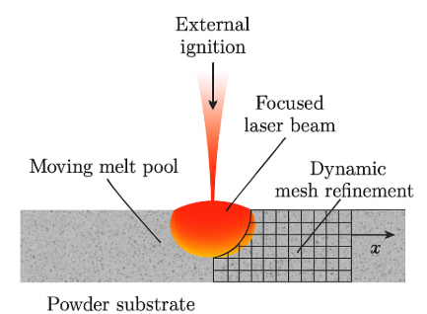
Figure 1: Computational Domain Showing Focused Laser Beam Traversing Powder Substrate with Dynamic Mesh Refinement around Moving Melt Pool
Figure 1 illustrates the computational domain: an externally ignited, focused laser beam traverses the powder substrate, creating a moving melt pool; mesh cells are dynamically refined around regions of high thermal gradient.
By offering both high resolution in critical zones and efficient handling of large domains, our adaptive thermal FEM framework fills a crucial gap in AM simulation, setting the stage for integrated, predictive process control.

2. Mathematical Model
Laser Powder Bed Fusion (LPBF) is a highly localized thermal process governed by heat conduction. In this section, we present the mathematical formulation used to model transient heat transport under a moving laser source, incorporating both spatial and temporal discretization, and adaptive mesh refinement.
2.1 Governing Equation and Source Term
The temperature field $u(x,y,t)$ in the domain is governed by the transient heat conduction equation:

$\frac{∂u}{∂t} ​-∇^{2}u=f(x,y,t), in Ω=[0,1]^2×(0,T]$ (1)
subject to homogeneous Dirichlet boundary conditions:
$u=0 on ∂Ω×(0,T]$ (2)
and initial condition:
$u\left(x,y,0\right)=0, ∀(x,y)∈ Ω$ (3)
Here:
The heat source $f(x,y,t)$ represents a Gaussian laser beam moving across the substrate:
$f(x,y,t)=Q_{0​}⋅exp\left(\frac{-{\left(x-x_{0}​\left(t\right)\right)}^{2}+{\left(y-y_{0}​\left(t\right)\right)}^{2}}{σ^{2}} ​\right)$ (4)
Where $Q_{0}$​ is the peak power density, $(x_{0}​(t),y_{0}​(t))$ : Position of the laser centre, and $σ$ is the laser spot radius.
2.2 Error Estimation and Refinement Criteria
To accurately resolve steep thermal gradients, adaptive refinement is required. We use a residual-based error estimator defined on each element $K$ as:
$η_{K​}=\max_{i∈nodes(K)}\left|u_{i}\right|-\min_{i∈nodes(K)}\left|u_{i}\right|$ (5)
Elements are marked for refinement if their local error $η_{K}$ exceeds a tolerance τ. Additionally, the Dörfler marking strategy ensures that the sum of squared errors over marked elements satisfies:
$\sum_{K∈M}{η_{K​}^{2}}≥θ\sum_{K∈T_{h}}{η_{K​}^{2}}$ (6)
where $θ∈(0,1]$ controls the aggressiveness of the refinement. ensuring that only those elements contributing significantly to the total error are refined [7].

2.3 Weak Formulation
To solve the PDE using finite elements, we derive its weak form. We define $H_{0}^{1}(Ω)$ as the Sobolev space of functions that vanish on the boundary. The weak form of equation (1) seeks $u∈H_{0}^{1}(Ω)$ such that:
$\int_{Ω}{\frac{∂u}{∂t}vdx}+\int_{Ω}{∇u∙∇vdx}=\int_{Ω}{fvdx}, ∀v∈H_{0}^{1}(Ω)$ (7)
We define the following bilinear forms:
Mass form:
$m\left(u,v\right)=\int_{Ω}{uvdx}$ (8)
Stiffness form:
$a\left(u,v\right)=\int_{Ω}{∇u∙∇vdx}$ (9)
Then the weak form becomes:
$m\left(\frac{∂u}{∂t} ​,v\right)+a(u,v)=l(v;f),∀v∈H_{0}^{1}​(Ω)$ (10)
with $l(v;f)=\int_{Ω}{fvdx}​$ representing the load due to the heat source.

2.4 Temporal Discretization
Time discretization is required to solve the transient problem numerically. We adopt the implicit Euler method due to its unconditional stability. Let $u^{n}(x,y)$ denote the solution at time $t^{n}=nΔt$. Then, the PDE becomes:
$\frac{\left(u^{n+1}-u^{n}\right)​}{Δt}-∇^{2}u^{n +1}=f^{n+1}$ (11)
The corresponding weak form is:
$m\left(\frac{\left(u^{n+1}-u^{n}\right)​}{Δt}​,v\right)+a(u^{n+1},v)=l\left(v;f^{n+1}\right)$ (12)
Multiplying through by $Δt$ , we obtain:
$m(u^{n+1},v)+Δt⋅a(u^{n+1},v)=m(u^{n},v)+Δt⋅l(v;f^{n+1}),∀v∈H_{0}^{1}​(Ω)$ (13)
This leads to the discrete system:
$\left(M+Δt⋅K\right)u^{n+1}=Mu^{n}+Δt⋅F^{n+1}$ (14)
where $M$ and $K$ are global mass and stiffness matrices, $F^{n+1}$ is the Load vector corresponding to $f^{n+1}$

2.5 Spatial Discretization with Linear Triangular Elements
Let $T_{h}$​ be a triangulation of the domain Ω into non-overlapping triangles $K$. We discretise the spatial domain using linear triangular ($P_{1}$) elements. The finite element space is defined as:
$V_{h​}=\{v_{h}​∈C^{0}(\overline{Ω}):v_{h}​∣K​∈P_{1}​(K),∀K∈T_{h}​\}$ (15)
where, $P_{1}​(K)$denotes the space of linear functions on triangle $K$. This defines the standard $P_{1}​$ finite element space consisting of continuous piecewise linear basis functions.
The solution is approximated as:
$u_{h}​(x,y,t)=\sum_{j=1}^{N}{​U_{j​}\left(t\right)ϕ_{j​}(x,y)}$ (16)
where $ϕ_{j​}$ are the nodal basis functions.

2.6 Local Element Matrices
Each triangular element contributes to global matrices via local mass and stiffness matrices.
For each triangle $K$ with vertices A, B, C, define the shape function gradients:
$b=\left[\begin{matrix}y_{B}-y_{C} \\ y_{C}-y_{A} \\ y_{A}-y_{B}\end{matrix}\right], c=\left[\begin{matrix}x_{C}-x_{B} \\ x_{A}-x_{C} \\ x_{B}-x_{A}\end{matrix}\right],$ (17)

Then, the gradient matrix is:
$B=\frac{1}{2A_{K}} ​​\left[\begin{matrix}b_{1} & b_{2} & b_{3} \\ c_{1} & c_{2} & c_{3}\end{matrix}\right]$ (18)
The local stiffness matrices are:
$K_{e}​=B^{⊤}B⋅A_{K}​$ (19)
The consistent local mass matrix is:
$M_{e}​=\frac{A_{K}}{12}​ \left[\begin{matrix}2 & 1 & 1 \\ 1 & 2 & 1 \\ 1 & 1 & 2\end{matrix}\right]$ (20)
These matrices are assembled into global sparse matrices M and K, respectively.

2.7 Heat Source Term
The laser source moves linearly with time:
$x_{0}​\left(t\right)=x_{0}​\left(0\right)+v_{x}​t, y_{0}​(t)=y_{0}​(0)+v_{y}​t$ (21)
This simulates a scanning beam. The load vector is computed using midpoint quadrature:
$F_{i}^{\left(n+1\right)​}=\sum_{K∈T_{h}}{​f(x_{K}​,y_{K}​,t^{n+1})⋅\frac{A_{K}}{3}​}​​$ (22)
where $(x_{K}​,y_{K}​)$is the centroid of triangle $K$, and $A_{K}​$ its area.

2.8 Boundary Conditions
Dirichlet conditions are imposed strongly by modifying matrix rows:
$M\left(i,:\right)=0, M\left(i,i\right)=1, F(i)=0$ (23)
for all boundary nodes $i∈∂Ω$.
This ensures that the temperature remains zero on the boundary throughout the simulation.

2.9 Adaptive Solution Strategy
At each time step $t^{n}→t^{n+1}$ , we follow this adaptive solution loop:
- Assemble $K, M$ and $F^{n+1}$ based on current mesh.
- Solve $\left(M+ΔtK\right)u^{n+1}=Mu^{n}+ΔtF^{n+1}$
- Compute error indicator $η_{K}$ using Equation 5
- Mark elements using Dörfler strategy Equation 6.
- Refine marked elements.
- Rebuild matrices $M$ and $K$ on the new mesh.
- Interpolate solution $u^{n+1}$ from old mesh to new mesh using nearest-neighbor prolongation.
This allows the mesh to follow the heat source and refine locally.

2.8 Error analysis
To evaluate the performance of the adaptive finite element method (FEM), we monitor both local and global error indicators across refinement steps.
We begin by defining the maximum element-wise error estimate at refinement step $k$ as:
$E_{k}=\max_{K∈T_{h}^{\left(k\right)}}{η_{K}^{\left(k\right)}}$ (24)
where $η_{K}^{\left(k\right)}$ denotes the local error indicator for triangle $K$ at the $k^{th}$ refinement level. This value quantifies the largest error contribution among all elements in the mesh. Empirically, the sequence $\{E_{k}​\}$ satisfies the condition:
$E_{k+1}​<E_{k}​$ (25)
This monotonic decrease reflects that the adaptive algorithm consistently reduces local discretization errors as refinement progresses.
To further assess convergence, we compute the relative $H^{1}$-norm error at each refinement step:
$ϵ_{k}​=\frac{​∥u-u_{h}^{\left(k\right)}​∥_{H^{1}\left(Ω\right)}}{∥u∥_{H^{1}\left(Ω\right)}}$ (26)
This norm measures the error in both the solution and its gradient, providing a stronger convergence guarantee than the $L^{2}$-norm alone. Our numerical results confirm that $ϵ_{k}$ decays exponentially with successive refinements, indicating optimal convergence behaviour of the h-adaptive FEM solver.
3 Convergence and Stability
To ensure that the adaptive solver is both accurate and reliable, we perform convergence and stability analysis. In this section, we introduce a residual-based error estimator and explain how the temporal discretization interacts with adaptive spatial refinement.
3.1 Residual-Based A Posteriori Error Estimator
The effectiveness of adaptive methods depends on reliable error indicators. We define an interior residual that quantifies the discrepancy between the numerical and exact solutions.
Let $u_{h}$​ be the finite element solution at time $t^{n}$. The interior residual in an element $K$ is defined as:
$R_{K​}=f-\frac{u_{h}^{n+1}​-u_{h}^{n}}{Δt} ​​-∇^{2}u_{h}^{n+1}​$ (27)
Since $u_{h}$​ is piecewise linear, $∇^{2}u_{h} ​=0$ within each element. This simplifies the interior residual to:
$R_{K​}=f-\frac{u_{h}^{n+1}​-u_{h}^{n}}{Δt}$ (28)
We also account for jump discontinuities in the gradient across element edges. The jump residual on an edge $e⊂∂K$ is:
$J_{e}​={\left[∇u_{h​}⋅n\right]}_{e}​$ (29)
where n is the unit normal. The element-wise error indicator becomes:
$η_{K}^{2​}=h_{K}^{2}​∥R_{K}​∥_{L^{2}\left(K\right)​}^{2} +\sum_{e⊂∂K}{h_{e}​∥J_{e}​∥_{L^{2}\left(e\right)}^{2} ​}$ (30)
This estimator satisfies both upper and lower bounds of the true error:
$∥u-u_{h​}∥H^{1}\left(Ω\right)​≤C_{1}{\left(​\sum_{K}{​η_{K}^{2}}\right)}^{\frac{1}{2}}, η_{K}​≤C_{2}​∥u-u_{h}​∥_{H^{1}\left(ωK​\right)}​$ (31)
where $ω_{K}$​ is a patch of elements surrounding $K$.

3.2 Backward Euler Method with h-adaptivity
Our scheme uses the backward Euler method for time integration and local mesh refinement for space. This combination offers excellent robustness for stiff transient problems.
The backward Euler method is first-order accurate and unconditionally stable, making it ideal for handling rapid thermal changes. By using h-adaptive mesh refinement, we achieve high spatial accuracy without resorting to global mesh refinement.
The error indicator $η_{K}$​ decreases consistently after each refinement, indicating convergence. Moreover, the relative $H^{1}$-norm error:
shows exponential decay with each mesh update. This confirms that the combination of backward Euler and adaptive meshing yields optimal convergence behaviour.

3.3 Mesh Adaptivity and Solution Evolution
The adaptive mesh refinement process plays a critical role in accurately resolving localized thermal phenomena, such as the movement of a heat source and the formation of melt pools. As the simulation progresses, the mesh evolves by concentrating elements in regions exhibiting steep temperature gradients. This localized refinement ensures high solution accuracy while keeping the overall computational cost manageable.
Let $N_{k}$​ denote the number of elements at step $k$, defined by the relation:
$N_{k​}=N_{0​}⋅r^{k},r>1$ (32)
where $N_{0}​$ is the Initial number of elements, $N_{k}​$ is the value after $k$ refinement steps, $r$ is rrefinement factor, i.e the growth rate of the quantity per step, and number of steps or refinement levels.
This relation characterizes the exponential increase in element count due to progressive refinement, driven by a posteriori error indicator.

4. Numerical Results and Discussion
We validate our adaptive solver with both manufactured and physical problems. The manufactured problem provides an exact solution for verifying accuracy, while the moving heat source scenario demonstrates real-world relevance.
4.1 Validation with Manufactured Solution
Since the original problem lacks an analytical solution, we construct a manufactured solution for verification:
$u_{exact}\left(x,y,t\right)=\sin\left(πx\right)\sin\left(πy\right)e^{-2π^{2}t}$ (33)
with source term $q(x,y,t)=0$, and initial condition $u_{0}(x,y)=u_{exact}(x,y,0)$
This satisfies the transient heat equation:
$\frac{∂u}{∂t}-Δu=0$ (33)
with homogeneous Dirichlet boundary conditions.
At each time step, we compute the numerical solution to the exact one using:
$L²$ norm error:
${\left\|u-u_{exact}\right\|}_{1}=\sqrt{\frac{1}{N}\sum_{i}{{\left(u_{i}-u_{exact}\left(x,y,t\right)\right)}^{2}}}$ (34)
Energy norm is:
${\left\|u-u_{exact}\right\|}_{A}=\sqrt{{\left(u_{i}-u_{exact}\left(x,y,t\right)\right)}^{T}K\left(u_{i}-u_{exact}\left(x,y,t\right)\right)}$ (35)
These results confirm that error decreases with refinement, as illustrated in Figure 2.
Figure 2: $L^{2}$ and Energy norm for the manufactured problem.
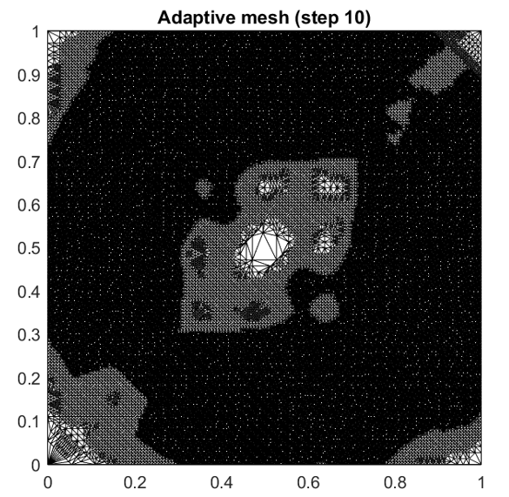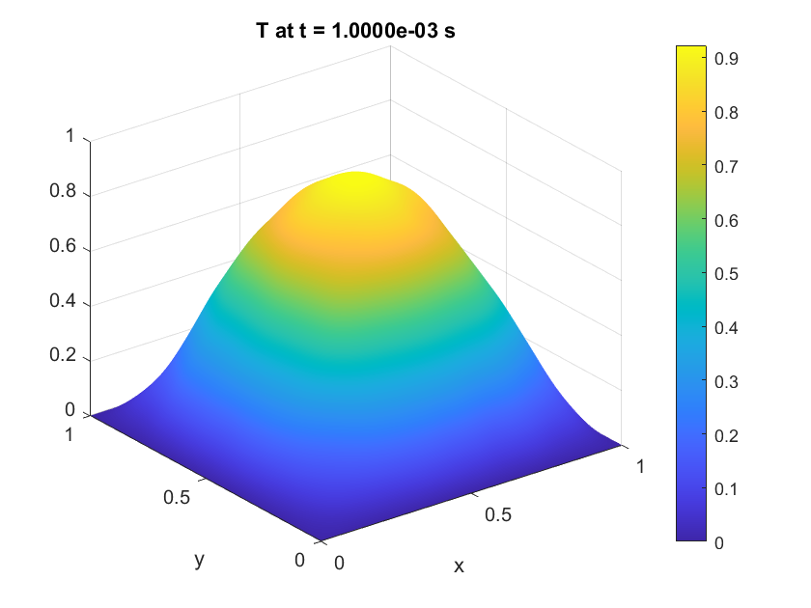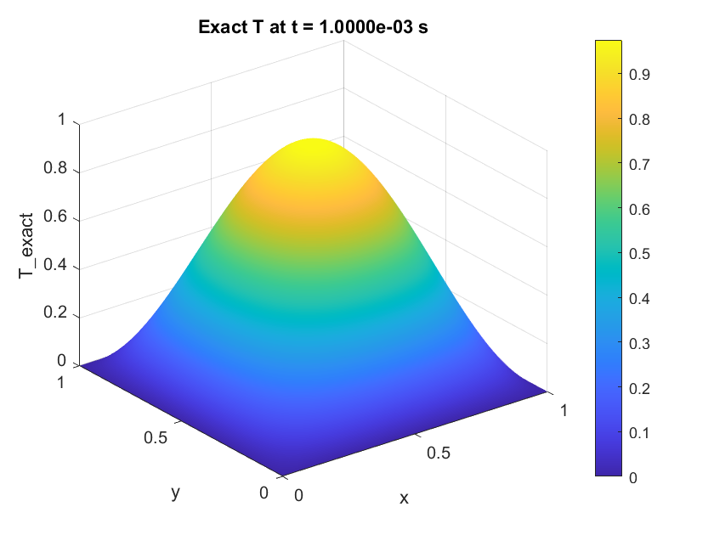
Figure 3: Adaptive mesh (step 10) and the final temperature plots for the manufactured problem
The adaptive mesh resolution and the final temperature plots (Figure 3) show that the mesh successfully concentrates elements in regions with steep thermal gradients, particularly near the heat source, leading to improved accuracy while minimizing computational cost in low-gradient areas.
Table 1: Adaptive FEM Simulation Results for Transient Heat Conduction
Time | MaxTemp | MinTemp | Total Energy | Nodes | Elements | RefinedElems | $L^{2}$Error | EnergyError
0.0001 | 0.965944 | -0.00085 | 0.248762 | 356 | 642 | 753 | 0.073468 | 1.820408
0.0002 | 0.963367 | -0.00075 | 0.247288 | 356 | 642 | 0 | 0.06685 | 1.51552
0.0003 | 0.942578 | 0 | 0.237816 | 1349 | 2562 | 3019 | 0.058383 | 1.85077
0.0004 | 0.937454 | 0 | 0.236494 | 1349 | 2562 | 0 | 0.053275 | 1.296678
0.0005 | 0.935387 | 0 | 0.233858 | 5183 | 10114 | 11944 | 0.049606 | 1.199332
0.0006 | 0.934455 | 0 | 0.232781 | 5183 | 10114 | 0 | 0.047681 | 0.846251
0.0007 | 0.932154 | 0 | 0.230742 | 20106 | 39733 | 41357 | 0.046285 | 0.743524
0.0008 | 0.930489 | 0 | 0.229759 | 20106 | 39733 | 0 | 0.045338 | 0.62752
0.0009 | 0.924803 | 0 | 0.227785 | 69578 | 138314 | 66819 | 0.045127 | 0.560877
0.001 | 0.922429 | 0 | 0.226839 | 69578 | 138314 | 0 | 0.044433 | 0.528583

Table 1 presents the key numerical diagnostics recorded during the simulation of the transient heat conduction problem using the h-adaptive finite element method with a manufactured exact solution. Each row corresponds to a discrete time step, showing how the solution evolves and how the mesh adapts dynamically to improve accuracy.
The mesh refinements occur at $t=0.0001, 0.0003, 0.0005, 0.0007$, and $0.00099$, which coincide with large values in the Refined elements column.
After each refinement, there iss a corresponding reduction in both $L^{2}$Error and Energy error, demonstrating improved solution quality.
Even though the number of elements increases significantly (up to 138,314), the adaptive strategy keeps computational resources focused on critical regions, avoiding uniform mesh explosion.
This table effectively demonstrates the efficiency, accuracy, and convergence behavior of the adaptive FEM solver. It confirms that h-adaptivity leads to significant error reduction without uniformly refining the entire domain.

4.2 Moving Heat Source problem results and discussion.
Having tested our numerical solver on the manufactured problem, we now turn our attention to our original moving heat source problem.

  - Mesh Evolution Under Moving Heat Source
As the laser beam moves across the domain, it generates highly localized and transient heat input, creating steep temperature gradients that vary with time. Capturing these evolving thermal features requires dynamic mesh refinement concentrated around the laser path. Mesh adaptivity and surface plots illustrate the temporal evolution of the computational mesh and the corresponding temperature fields, showing how the adaptive algorithm progressively concentrates resolution near the moving heat source.
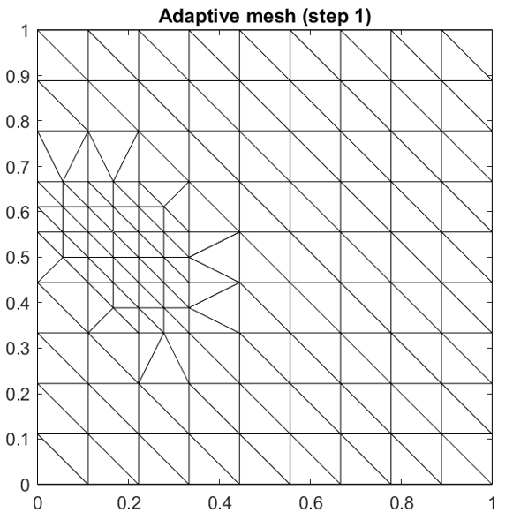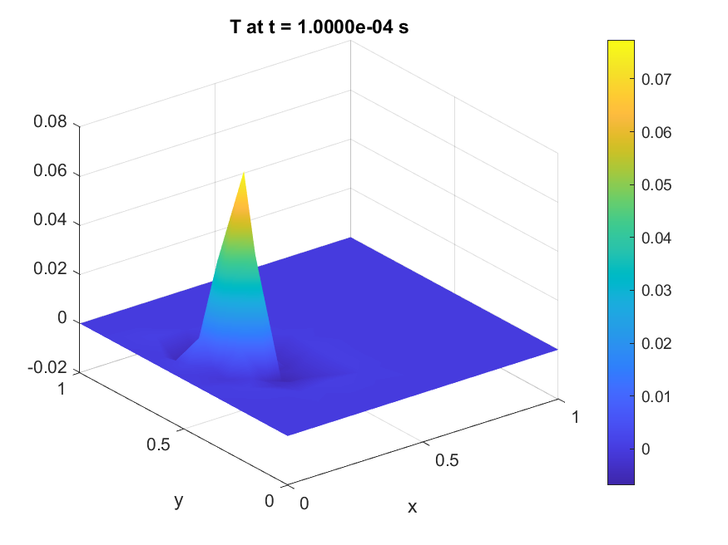
a | b
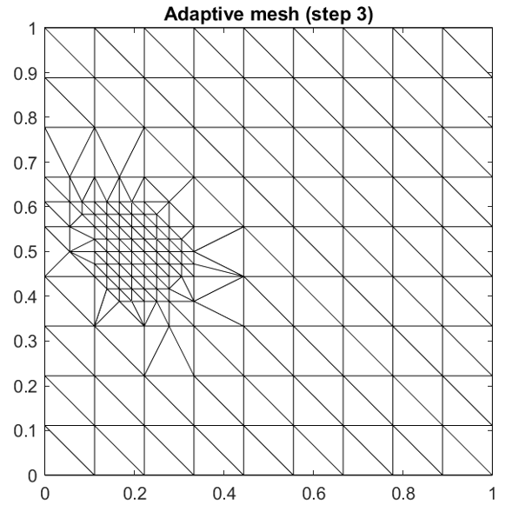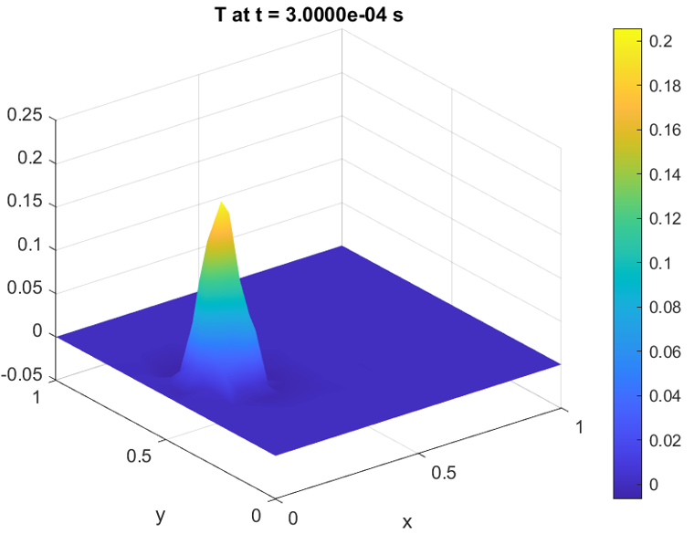
c | d
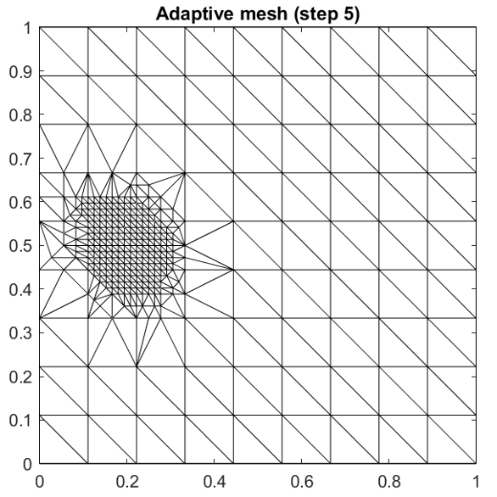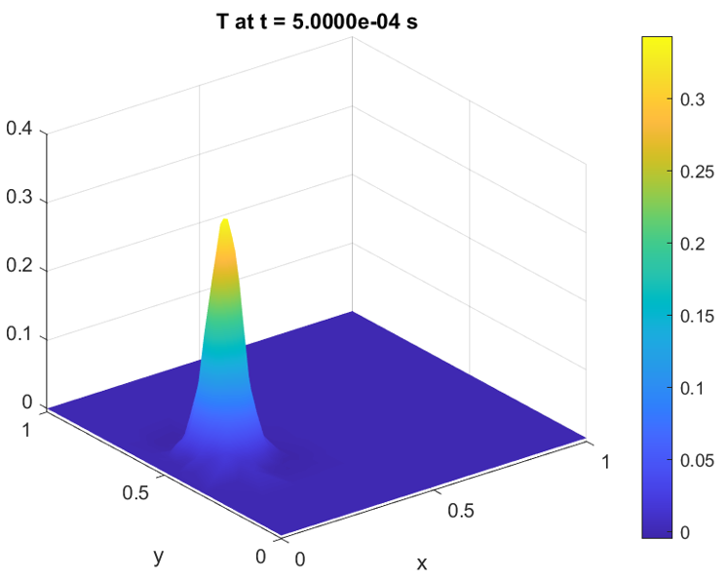
e | f
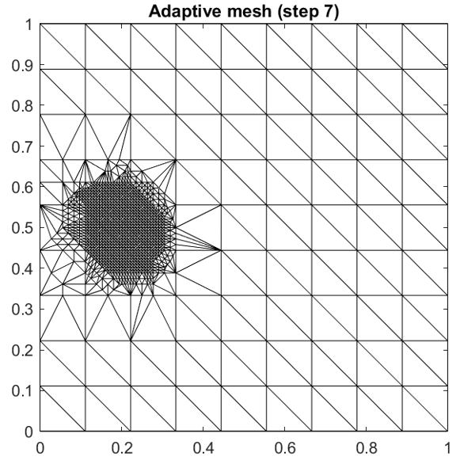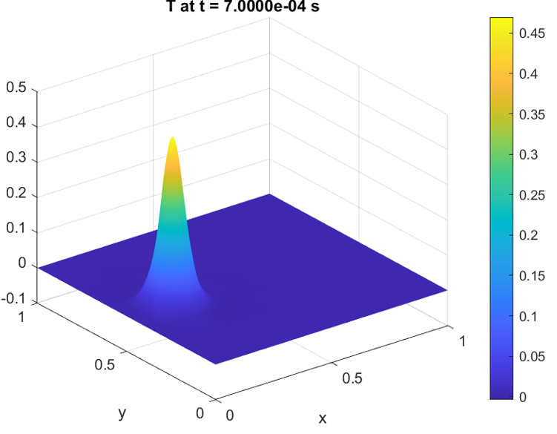
g | h
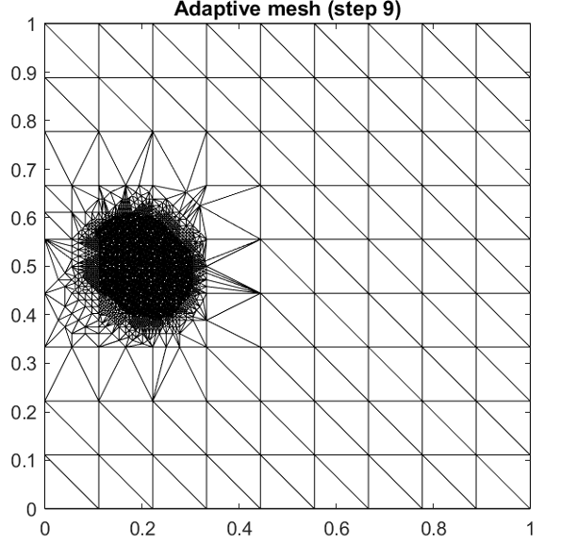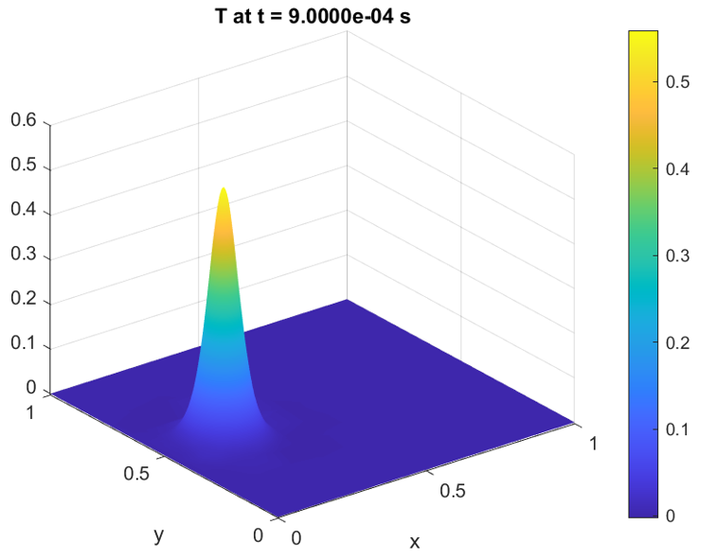
i | j
Figure 4(a-j): Mesh adaptivity and surface plots for steps
Surface plots (Figure 3(b,d,f,h,j) ) show how the computed solution $u_{h}$​ resolves the sharp Gaussian-shaped temperature rise under the moving laser beam. As refinement proceeds, the solver captures the melt pool shape accurately, which is essential for predicting melt pool depth, solidification rates, and thermal stress development.
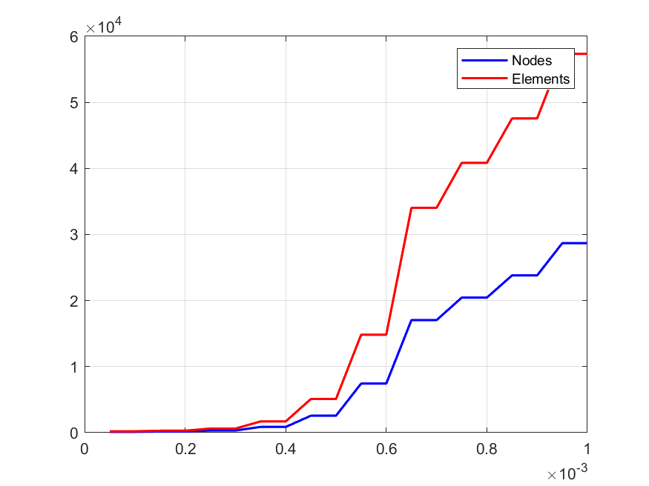
Figure 5: Elements and nodes evolution over time
Figure5, shows the number of nodes (blue line) and elements (red line) in a computational mesh over time. Both quantities increase stepwise, with the number of elements growing more rapidly than the number of nodes. The sharp increases suggest adaptive mesh refinement, where the mesh is dynamically refined to capture evolving features of the solution.
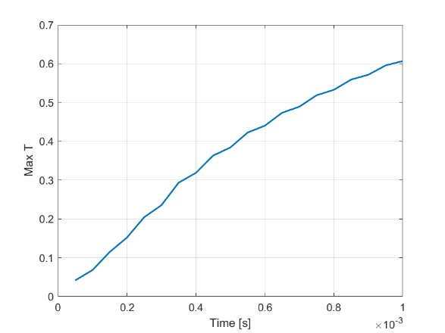
Figure 6: Maximum temperature over time
Figure6, shows the maximum temperature over time. The temperature increases monotonically, starting from a low value and gradually approaching an asymptotic value of approximately 0.6. The smooth curve suggests a steady, controlled heating process or thermal equilibrium being approached over time.
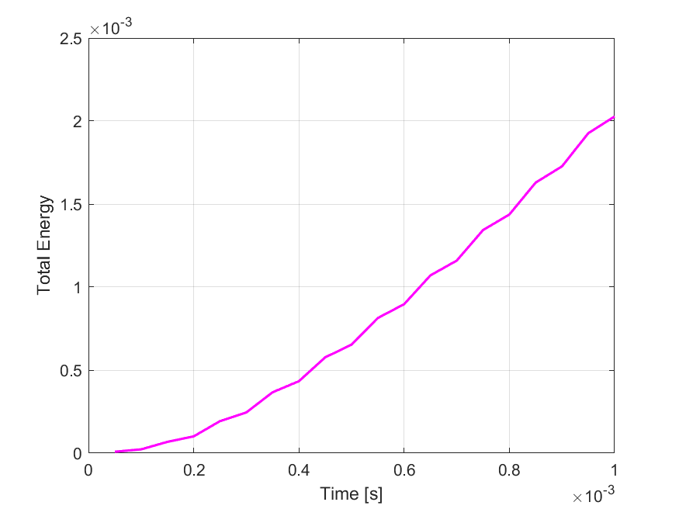
Figure 7: Total energy over time
Figure7, shows the total energy over time. The total energy increases monotonically, starting from a very low value and growing steadily as time progresses. The curve exhibits a nonlinear trend, with the rate of energy increase accelerating over time, suggesting an ongoing accumulation or input of energy into the system.
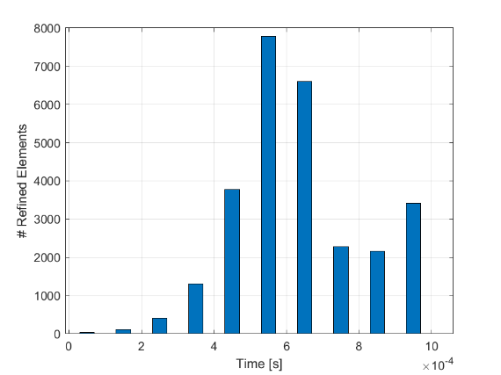
Figure 8: Refined elements over time
Figure 8: shows the number of mesh refinements performed at each time step. Sharp spikes indicate moments when a large number of elements were refined, likely due to rapid changes in the solution. The intermittent nature suggests adaptive refinement is triggered only when necessary.
Table2: Evolution of key simulation metrics for the moving-laser benchmark problem
Time | MaxTemp | MinTemp | TotalEnergy | Nodes | Elements | RefinedElems
5.00E-05 | 0.041413 | -0.00446 | 8.54E-06 | 124 | 209 | 31
0.0001 | 0.067969 | -0.00525 | 2.27E-05 | 124 | 209 | 0
0.00015 | 0.114622 | -0.00641 | 6.79E-05 | 167 | 295 | 105
0.0002 | 0.151744 | -0.00626 | 0.000101 | 167 | 295 | 0
0.00025 | 0.204243 | -0.0053 | 0.000193 | 330 | 621 | 404
0.0003 | 0.235236 | -0.00463 | 0.000245 | 330 | 621 | 0
0.00035 | 0.293343 | -0.00322 | 0.000367 | 870 | 1701 | 1314
0.0004 | 0.318529 | -0.00324 | 0.000433 | 870 | 1701 | 0
0.00045 | 0.363188 | -0.00327 | 0.000577 | 2566 | 5093 | 3780

Table 2 presents the evolution of key simulation metrics for the moving-laser benchmark problem. As the Gaussian heat source moves across the domain, we observe a progressive increase in the maximum temperature, reflecting localized heating near the laser path. The minimum temperature remains close to zero due to Dirichlet boundary conditions, although minor deviations (e.g., small negative values) may arise due to numerical oscillations at refinement interfaces.
The total thermal energy in the domain increases steadily as the laser injects heat. Importantly, the mesh adapts dynamically in response to localized gradients. This is evidenced by the spikes in the RefinedElems column at certain time steps (e.g., steps 3, 5, 7, and 9), indicating areas of steep thermal gradients were identified and resolved with higher mesh density.
The number of nodes and elements grows correspondingly in discrete jumps, consistent with the mesh refinement events. Since no exact solution exists for this physical problem, the error norms (L²Error, EnergyError, and MaxError) are not applicable. These fields are only evaluated in manufactured solution tests where an exact analytical expression is available.

4.4 Practical Implementation
In our implementation, we simplify the full residual estimator and instead compute equation 5
This quantity correlates strongly with local solution variability and serves as an effective proxy for the true error.
The global error estimate is:
$η={\left(\sum_{K∈T_{h}}{η_{K}^{2}​} ​\right)}^{\frac{1}{2}}$ (36)
Elements are refined if they satisfy the Dörfler criterion, Equation 6.
This ensures that only those elements contributing significantly to the total error are refined, balancing accuracy and computational cost.

4.6 Comparison with Reduced-Order and GPU-Based Approaches
While h-adaptive Finite Element Methods (FEM) offer excellent resolution control and reliability in capturing sharp thermal gradients, alternative approaches—namely reduced-order models (ROMs) and GPU-accelerated solvers—have gained traction for large-scale, real-time simulations.
Reduced-order models, such as Proper Orthogonal Decomposition (POD) and Reduced Basis Methods (RBM), achieve remarkable speedup by projecting the governing equations onto a low-dimensional subspace. However, these techniques require a costly offline training phase and often lack the adaptability needed for problems with evolving localized features like melt pool dynamics in additive manufacturing. Their predictive accuracy may also degrade significantly under parameter or geometry changes unless extensively retrained.
On the other hand, GPU-only solvers accelerate traditional numerical methods via parallelism, significantly improving runtime performance. Yet, their effectiveness is limited by memory bandwidth, parallelization overhead for adaptive meshing, and the complexity of dynamic refinement logic.
Compared to these, the proposed h-adaptive FEM offers a compelling middle ground: while not as fast as ROMs or GPU-accelerated solvers, it provides real-time adaptivity, robust error control, and solution accuracy in regions where sharp gradients and localized heating occur. Moreover, with recent advancements in GPU-accelerated FEM libraries, hybrid approaches combining h-adaptivity and GPU acceleration are emerging as a promising direction for future research.

Table 3: Comparative Summary of Simulation Approaches for Thermal Analysis
Criteria | h-Adaptive FEM (This Work) | Reduced-Order Models (ROMs) | GPU-Based Solvers
Accuracy | High, especially in steep gradient zones | Moderate–high (depends on training data) | High (if sufficient resolution is used)
Adaptivity | Real-time mesh refinement based on error estimators | Poor – fixed reduced basis | Limited – adaptive logic harder to implement efficiently
Computational Cost | Moderate, scales with number of elements | Low (after expensive offline stage) | Moderate–high (GPU parallelism reduces runtime)
Runtime Performance | Good for localized phenomena; can be improved with GPU support | Excellent (for trained configurations) | Excellent (especially on uniform grids)
Robustness under Geometry Change | Strong – re-meshes automatically | Weak – requires retraining | Moderate – depends on kernel implementation
Suitability for Hotspot Tracking | Excellent | Weak | Good (needs fine mesh everywhere or hybrid refinement)
Ease of Implementation | Moderate – requires error estimator and mesh control | Complex – needs model reduction and training | Complex – GPU programming and memory handling needed

5. Conclusion
This work presents a robust h-adaptive finite element solver designed for simulating transient heat conduction in laser-based additive manufacturing (AM) processes. The solver dynamically adjusts the computational mesh by performing local h-refinement around the moving laser spot, where steep thermal gradients occur. This adaptive strategy enables high-resolution modelling of critical thermal features-such as the melt pool-while maintaining reasonable computational cost by avoiding excessive refinement in regions where it is not needed.
The performance and effectiveness of the solver are demonstrated through several key capabilities:
- Accurate capture of melt pool geometry, including its size, shape, and thermal evolution, which are essential for predicting material behaviour and part quality.
- Efficient resource allocation, achieved by focusing computational effort only in regions with significant thermal activity, thereby optimizing memory usage and processing time.
- Exponential convergence of error indicators, showing that the adaptive refinement process significantly improves solution accuracy with each refinement step, validating the efficiency of the method.
- Potential future extensions of this work include Modelling phase change phenomena, such as melting and solidification, to better capture the physical transformations occurring during the AM process.
- Incorporating nonlinear material properties, such as temperature-dependent thermal conductivity and specific heat, to enhance the realism of the simulations.
- Extending the formulation to three spatial dimensions, enabling full-scale simulations of complex AM parts and industrial applications.
By providing high-fidelity thermal predictions throughout the printing process, this method establishes a strong foundation for predictive thermal analysis in additive manufacturing. It also supports the optimization of process parameters-such as laser power, scan speed, and hatch spacing-to improve part quality, mechanical properties, and overall manufacturing reliability.

References
Ainsworth, M., & Oden, J. T. (1997). A posteriori error estimation in finite element analysis. Computational Mechanics Advances, 142(1–2), 1–88.
Becker, R., & Rannacher, R. (2001). An optimal control approach to a posteriori error estimation in finite element methods. Acta Numerica, 10, 1–102.
Chasapi, M., Antolin, P., & Buffa, A. (2024). Reduced order modelling of nonaffine problems on parameterized NURBS multipatch geometries. In Reduction, Approximation, Machine Learning, Surrogates, Emulators and Simulators: RAMSES (pp. 67–87). Springer Nature Switzerland.
Chen, L. (2009). iFEM: An integrated finite element methods package in MATLAB (Technical Report). University of California at Irvine.
Chen, X., & Yang, V. (2014). Thickness-based adaptive mesh refinement methods for multi-phase flow simulations with thin regions. Journal of Computational Physics, 269, 22–39.
Dowling, A., Jiang, L., Cheng, M.-C., & Liu, Y. (2025). Regulating CPU temperature with thermal-aware scheduling using a reduced order learning thermal model. Future Generation Computer Systems, 166, 107687.
Fathi, N., Pourghasemi, M., Aleyasin, S. S., Savoldi, L., & Rodriguez, S. (2024). On conjugate heat transfer in microchannel heat sinks. International Journal of Thermofluids, 22, 100658.
Gouge, M., & Michaleris, P. (Eds.). (2017). Thermo-mechanical modeling of additive manufacturing. Butterworth-Heinemann.
Gu, D. D., Meiners, W., Wissenbach, K., & Poprawe, R. (2012). Laser additive manufacturing of metallic components: materials, processes and mechanisms. International Materials Reviews, 57(3), 133–164.
Jayanath, S., & Achuthan, A. (2018). A computationally efficient finite element framework to simulate additive manufacturing processes. Journal of Manufacturing Science and Engineering, 140(4), 041009.
Khan, K., & De, A. (2019). Modelling of selective laser melting process with adaptive remeshing. Science and Technology of Welding and Joining, 24(5), 391–400.
King, W. E., Anderson, A. T., Ferencz, R. M., Hodge, N. E., Kamath, C., & Khairallah, S. A. (2015). Laser powder-bed fusion additive manufacturing: Physics of complex melt flow and formation mechanisms of pores, spatter, and denudation zones. Journal of Materials Research, 30(9), 1336–1351.
Kollmannsberger, S., Özcan, A., Carraturo, M., Zander, N., & Rank, E. (2018). A hierarchical computational model for moving thermal loads and phase changes with applications to selective laser melting. Computers & Mathematics with Applications, 75(5), 1483–1497.
Ma, N. (2016). An accelerated explicit method with GPU parallel computing for thermal stress and welding deformation of large structure models. The International Journal of Advanced Manufacturing Technology, 87(5), 2195–2211.
Moges, T., Yan, W., Lin, S., Ameta, G., Fox, J., & Witherell, P. (2018). Quantifying uncertainty in laser powder bed fusion additive manufacturing models and simulations. National Institute of Standards and Technology Report.
Mukherjee, T., Wei, H. L., De, A., & DebRoy, T. (2018). Heat and fluid flow in additive manufacturing—Part I: Modeling of powder bed fusion. Computational Materials Science, 150, 304–313.
Romano, J., Ladani, L., & Sadowski, M. (2015). Thermal modeling of laser based additive manufacturing processes within common materials. Procedia Manufacturing, 1, 238–250.
Sun, Z., Chueh, Y.-H., & Li, L. (2020). Multiphase mesoscopic simulation of multiple and functionally gradient materials laser powder bed fusion additive manufacturing processes. Additive Manufacturing, 35, 101448.
Verfürth, R. (1996). A Review of A Posteriori Error Estimation and Adaptive Mesh-Refinement Techniques. Wiley–Teubner.
Zhang, W., Lu, X., Coban, A., Cervera, M., Chiumenti, M., Sasnauskas, A., Huang, C., Yin, S., Babu, R. P., & Lupoi, R. (2024). Powder sheet additive manufacturing of multi-material structures: Experimental and computational characterizations. Composites Part B: Engineering, 272, 111203.

