Comparative Phytochemical and Herbicidal Activity of Leaf and Flower Oleoresin from Adhatoda vasica L.

Abstract
The study presents a comparative phytochemical and herbicidal analysis of leaf (AVLO) and flower (AVFO) oleoresins from Adhatoda vasica L. (Acanthaceae), a widely utilized medicinal plant. Methanolic extracts were prepared via cold percolation and characterized using gas chromatography–mass spectrometry (GC–MS). A total of forty-nine phytoconstituents were identified, representing 80.43% of the total peak area in AVLO, and 82.22% in AVFO. Antipyrine (30.91%) was the prominent compound in AVLO, while 5-hydroxymethylfurfural (24.24%) was the major compound in AVFO. The herbicidal potential of both oleoresins was evaluated through seed germination bioassays against Raphanus raphanistrum subsp. sativus, revealing significant, dose-dependent inhibition. IC₅₀ values for seed germination, root length, and shoot length confirmed notable phytotoxic activity, with AVLO exhibiting marginally greater potency for seed germination inhibition, whereas AVFO showed greater potency for root and shoot length inhibition. These findings underscore the potential of A. vasica oleoresins as sustainable, natural bioherbicides and highlight their relevance for further exploration in agrochemical, pharmaceutical, and nutraceutical applications.
Keywords: Adhatoda vasica L., Oleoresin, Phytochemical analysis, Herbicidal activity, Antipyrine
INTRODUCTION
The Acanthaceae family, commonly known as the acanthus family, is one of the largest families among dicotyledonous angiosperms. It is renowned for the extensive variety of plants it contains with medicinal, aromatic, culinary, and ornamental properties. The family encompasses 250 genera and 2,500 species found across the globe, with a significant presence in Africa, Brazil, Indonesia, and Malaysia [1]. The genus Justicia is part of the Acanthaceae family and comprises over 600 species distributed in both hemispheres, ranging from tropical to temperate areas. Justicia species are frequently employed in the treatment of various ailments [2]. Adhatoda vasica L., belonging to the Acanthaceae family, is commonly known as Adosa, Vasaka, or Malabar Nut. This plant has a multitude of uses in traditional Ayurveda and is particularly renowned for its effectiveness in treating respiratory conditions, and is a shrub utilized by Asian and European medical practitioners [3,4]. The plant is utilized in numerous ancient medical systems, including Ayurveda, Siddha, and Unani, for treating respiratory ailments, cough, asthma, bronchitis, and as an expectorant. It has also been used to treat other diseases and conditions, including respiratory problems [5,6]. Adhatoda vasica L. contains a rich array of bioactive constituents such as alkaloids, flavonoids, phenolics, and essential oils, that contribute to its therapeutic properties [7-9]. The roots of Adhatoda vasica have yielded a novel alkaloid identified as 9-acetamido-3,4-dihydropyrido-(3,4-b)-indole, and a galactoside known as o-ethyl-α-D-galactoside. Furthermore, from the roots of this plant, sitosterol β-D-glucoside, D-galactose, and deoxyvasicinone have also been extracted [10,11]. Although the oleoresin derived from different parts of the plant has garnered attention for its potential therapeutic applications, a comprehensive comparative investigation of the phytochemical composition and herbicidal activity of the leaf and flower oleoresin from Adhatoda vasica L. is currently lacking. Therefore, the present study aims to fill this research gap by comparatively analyzing the chemical profiles and herbicidal potential of these oleoresins.
MATERIAL AND METHOD
Collection of plant material
The leaves and flowers of Adhatoda vasica L. were collected from Raja Road, Dehradun, (Latitude 30°22.8175' N and Longitude 77°53.5037' E). The collection site was situated at an altitude of 648 m above sea level in the Garhwal region of Uttarakhand.
Oleoresin preparation
Fresh leaves and flowers of Adhatoda vasica L. plant were collected, dried, and ground into a coarse powder. Extraction was performed using cold percolation method with methanol as a solvent, the powdered leaves and flowers were extracted. A rotary evaporator was used to filter and condense the resultant extract. The extracts were stored at 4°C for further chemical analysis and biological activity evaluation.
GC-MS analysis
The phytochemical analysis of AVLO and AVFO was analyzed using a GCMS-QP 2010 Plus system. The GC was equipped with a DB-5 capillary column (30 m × 0.25 mm, 0.25 µm film thickness). Helium was used as the carrier gas at a constant flow rate of 1.21 mL/min. The injection volume was 1 µL with a split ratio of 22:1. The oven temperature program was as follows: initial temperature 50°C (held for 2 min), increased to 210°C at a rate of 6°C/min, and held for 11 min. The injector and ion source temperatures were set at 60°C and 200°C, respectively. Mass spectra were recorded at 70 eV with a scan range of 40–600 m/z. Compounds were identified by comparing their mass spectra and retention indices with those in the NIST and Wiley libraries [12].
Herbicidal Bioassay
The herbicidal activity of AVLO and AVFO was assessed at various concentrations (250 to 1000 uL/mL) against hybrid radish (Raphanus raphanistrum sub sp. Sativus) seeds. The evaluation was conducted using a method developed by Sahu and Devkota (2013). The acetone oleoresin was diluted in a 1% Tween-20 aqueous solution to create different concentrations (ranging from 250 to 1000 uL/mL). To ensure the surface sterility, the radish seeds were treated with a 5% sodium hypochlorite solution for a duration of 15 minutes. Three replicates of seven sterilized radish seeds were placed in each petri dish lined with filter papers at the bottom to maintain adequate moisture for germination. Next, 4 mL of the respective concentrations of the acetone oleoresin were added to the petri dishes, and the seeds were allowed to germinate in an incubator at a temperature of 25±1°C for a period of 7 days. The experiment was concluded once all the seeds in the control group had germinated. The herbicidal activity of the acetone oleoresin was evaluated by comparing its effects to both the control group and the standard herbicide (Pendimethalin) using the formula.
% Inhibition =100 × (1- St/Sc)
Where,
St – no. of seeds germinates in treatment,
Sc – no. of seeds germinates in control

Statistical Analysis
All experiments were performed in triplicate, and results were expressed as mean± standard deviation. Data were analyzed using one-way analysis of variance (ANOVA) followed by Duncan's multiple range test (DMRT) at p < 0.05 significance level using SPSS software version 20.0 (IBM Corp., USA). IC₅₀ values were calculated using regression analysis in Microsoft Excel 2016.
RESULT AND DISCUSSION
Chemical composition variability of AVLO and AVFO
The phytoconstituents present in the AVLO and AVFO oleoresins were identified and are presented in Table 1 based on the sequence in which they eluted on the DB-5 column during GC-MS. Twenty-five and thirty components were identified in AVLO and AVFO, contributing to 80.43% and 82.22% of the total peak area of the oleoresins. Antipyrine (30.91%), Vitamin E (9.39%), Linolenic acid (5.36%), Phytol (4.38%), Silane (3.95%), Diethylbutoxypentyloxy (3.26%), n-Hexadecanoic acid (3.24%), 5-Hydroxymethylfurfural (2.61%), α-Amyrin (1.74%), 2-Hexadecen-1-ol (1.68%), Methyl ester (1.56%), Octadecanoic acid (1.45%), 5-Methylbenzimidazole (1.32%), Megastigmatrienone (1.18%), Phenol (1.07%) were identified as the major constituents of AVLO. It was observed that the main component of AVFO was 5-Hydroxymethylfurfural (24.24%), 1-(8-Methylimidazo[1,2-a]pyridin2-ylmethyl)-1,2,3,4tetrahydro-quinoline (6.53%), n-Hexadecanoic acid (4.93%), 1-Methyl-5fluorouracil (4.89%), 1,2-Bis(diethylamino)-1,2-bis(4cyanophenyl)ethane (4.58%), p-Butylphenol (3.94%), Phenol (3.63%), Hydroxy maltol (2.89%), Palmitin (2.42%), Malonylurea (1.97%), Oleic Acid (1.67%), α-Monostearin (1.67%), 2-Furancarboxaldehyde (1.42%), Octadecanoic acid (1.40%), 5-ethenyl-2-methoxy (1.29%), Benzene-ethano (1.28%), Quinazoline (1.26%), 2,4-Dihydroxy-2,5dimethyl-3(2H)-furan3-one (1.26%), Clindamycin (1.23%), methyl ester (1.20%) and stigmasterol (1.00%). In the studied oleoresins, compounds that constituted more than 3.00% were regarded as major constituents. The variation in chemical composition between leaf and flower oleoresins suggests organ- specific biosynthesis and accumulation of secondary metabolites in Adhatoda vasica L. Fig.1 displays the ion-chromatogram of AVLO and AVFO oleoresins.
Table 1: Comparative chemical composition of AVLO and AVFO
S. No | Compound identified | % Composition
S. No | Compound identified | AVLO | AVFO
 | α-Amyrin | 1.74 | _
 | β-Amyrin | 0.87 | _
 | Andrographolide | 0.66 | _
 | Antipyrine | 30.91 | _
 | Benzenemethanol | _ | 1.28
 | Benzenesulfonamide | 0.86 | _
 | Benzofuran | 0.65 | _
 | Benzoic acid | _ | 0.9
 | 1,2-Bis(diethylamino)- 1,2-bis(4-cyanophenyl) ethane | _ | 4.58
 | p-Butylphenol | _ | 3.94
 | Campesterol | 0.79 | _
 | Clindamycin | _ | 1.23
 | Dasycarpidan | _ | 0.82
 | Diethylbutoxypentyloxy | 3.26 | _
 | 2,4-Dihydroxy-2,5-dimethyl-3(2H)-furan-3-one | _ | 1.26
 | 2,6-Dimethoxy | _ | 0.76
 | 2,4-Di-tertbutylphenol | _ | 0.76
 | 5-Ethenyl-2-methoxy | _ | 1.29
 | 2-Furancarboxaldehyde | _ | 1.42
 | 2-Furancarboxylic acid | _ | 0.9
 | 2-Hexadecen-1-ol | 1.68 | _
 | n-Hexadecanoic acid | 3.24 | 4.93
 | Hydroxymaltol | _ | 2.89
 | 5-Hydroxymethylfurfural | 2.61 | 24.24
 | 5-Methylbenzimidazole | 1.32 | _
 | 5-Methyl-4-hexene-1yl acetate | _ | 0.86
 | 3-Hydroxy-4-decenoic acid, 9-  (tetrahydropyran-2yl) oxy-, 2-  (trimethylsilyl)ethyl | _ | 0.75
 | p-Isobutyl | 0.72 | _
 | Linolenic acid | 5.36 | _
 | Malonylurea | _ | 1.97
 | Megastigmatrienone | 1.18 | _
 | Megastigmatrienone | 0.64 | _
 | Methyl ester | 1.56 | 1.2
 | 1-Methyl-5-fluorouracil | _ | 4.89
 | 1-Methyl-transdecahydroquinol | _ | 0.86
 | 1-(8-Methylimidazo[1,2-a] pyridine-2-yl methyl)-1,2,3,4-tetrahydroquinoline | _ | 6.53
 | 3-(2-Methoxy-5-methylphenyl)acrylic acid | 0.67 | _
 | α-Monostearin | _ | 1.67
 | Octadecanoic acid | 1.45 | 1.4
 | Oleic Acid | _ | 1.67
 | Palmitin | _ | 2.42
 | Phenol | 1.07 | 3.63
 | Phytol | 4.38 | _
 | Pyrrolidine-5-one | _ | 0.91
 | Quinazoline | _ | 1.26
 | Silane | 3.95 | _
 | Stigmasterol | 0.85 | 1.00
 | Vasicione | 0.62 | _
 | Vitamin E | 9.39 | _
 | Total (%) | 80.43 | 82.22
AVLO= Adhatoda vasica L. Leaf oleoresin; AVFO= Adhatoda vasica L. Flower oleoresin; - = not determined [12].

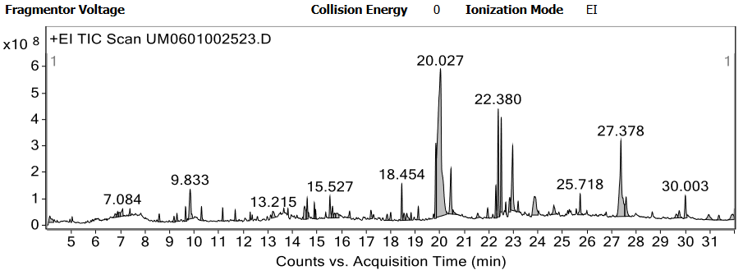
(a)

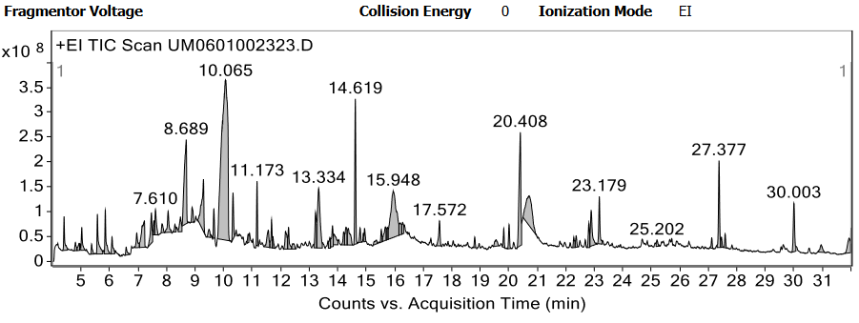
(b)
Figure 1: (a) Ion-chromatogram of AVLO; (b) Ion-chromatogram of AVFO.
Herbicidal activity
Seed germination inhibition
The mean percent seed germination inhibition of oleoresins from the leaf and flower parts of Adhatoda vasica at various doses (250-1000 μL/mL) is presented in Table 5. The oleoresins exhibit significant herbicidal properties in a dose- dependent manner. At the highest dose (1000 μL/mL), the herbicidal activity of the leaf part oleoresin (AVLO) was found to be 95.6%, followed by the flower part oleoresin (AVFO) at 95.00%. The IC₅₀ value, which represents the concentration required to inhibit seed germination by 50%, was attained in the control group, was computed in order to compare the relative herbicidal activity of all the samples. In Table 2 and Fig.2, the observed order of activity, in terms of IC₅₀, was AVLO (140.81±24.19 μL/mL) followed by AVFO (154.79±14.48 μL/mL), indicating that AVLO was more potent in inhibiting seed germination.
Table 2.: IC₅₀ value of inhibition of seed germination of AVLO and AVFO
S. No. | Sample name | IC₅₀ values (µL/mL) |  |  | Mean IC₅₀ values (µL/mL) ±SD
S. No. | Sample name | I | II | III | Mean IC₅₀ values (µL/mL) ±SD
1 | AVLO | 160.0 | 113.63 | 148.80 | 140.81±24.19
2 | AVFO | 144.6 | 148.4 | 171.37 | 154.79±14.48
AVLO= Adhatoda vasica L. Leaf oleoresin; AVFO= Adhatoda vasica L. Flower oleoresin; IC₅₀-half maximal inhibitory concentration.
Root length inhibition
The percent root length inhibition for AVLO was measured as 55.33%, 68.66%, 75.66% and 93.00% from lowest to highest concentrations (250-1000 μL/mL), while for AVFO it was 55.00%, 74.66%, 97.22%, and 96.22%, respectively (Table 5). IC₅₀ was calculated when 100% of the control seeds germinated, and was computed to assess the relative herbicidal activities of each sample with regard to the inhibition of root growth. The IC₅₀ value is inversely related to herbicidal activity; thus, a lower IC₅₀ indicates greater potency. The IC₅₀ for root length inhibition was observed in the following order: AVFO (96.47±15.15 μL/mL) > AVLO (140.97±25.26 μL/mL), indicating that AVFO exhibited greater potency of root growth inhibition (Table 3;Fig.2).
Table 3: IC₅₀ value of inhibition of root length of AVLO and AVFO
S. No. | Sample name | IC₅₀ values (µL/mL) |  |  | Mean IC₅₀ values (µL/mL) ±SD
S. No. | Sample name | I | II | III | Mean IC₅₀ values (µL/mL) ±SD
1 | AVLO | 145.83 | 113.63 | 163.46 | 140.97±25.26
2 | AVFO | 99.66 | 79.78 | 109.79 | 96.47±15.15
AVLO= Adhatoda vasica L. Leaf oleoresin; AVFO= Adhatoda vasica L. Flower oleoresin; IC₅₀- half maximal inhibitory concentration.
Shoot length inhibition
The percent shoot length inhibition for AVLO was measured as 57.66%, 64.00%, 80.66% and 91.66% from lowest to highest concentrations (250-1000μL/mL), while for AVFO it was 58.00%, 65.66%, 86.00%, and 95.00%, respectively (Table 5). IC₅₀ was calculated when 100% of the control seeds germinated, and was computed to assess the relative herbicidal activities of each sample with regard to the inhibition of shoot growth. The IC₅₀ for shoot length inhibition was observed in the following order: AVFO (125.89±30.67 μL/mL) > AVLO (129.83±25.64 μL/mL), indicating that AVFO exhibited marginally greater potency for shoot growth inhibition (Table 4; Fig. 2).
Table 4: IC₅₀ value of inhibition of shoot length of AVLO and AVFO
S. No. | Sample name | IC₅₀ values (µL/mL) in triplicates |  |  | Mean IC₅₀ values (µL/mL) ±SD
S. No. | Sample name | I | II | III | Mean IC₅₀ values (µL/mL) ±SD
1 | AVLO | 156.25 | 105.04 | 128.20 | 129.83±25.64
2 | AVFO | 139.92 | 90.72 | 147.05 | 125.89±30.67
AVLO= Adhatoda vasica L. Leaf oleoresin; AVFO= Adhatoda vasica L. Flower oleoresin; IC₅₀-half maximal inhibitory concentration.
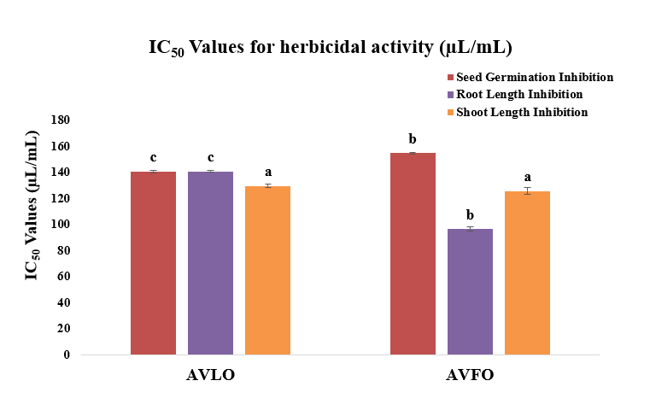
Figure 2: IC₅₀ values of seed germination, root length, shoot length of Adhatoda vasica L. oleoresins
Table 5: Percent inhibition of seed germination, root length, shoot length of Adhatoda vasica L.
S. No. | Sample | % Inhibition of seed germination |  |  |  | % Inhibition of root length |  |  |  | % Inhibition of shoot length
S. No. | Sample | 250 µL/mL | 500 µL/mL | 750 µL/mL | 1000 µL/mL | 250 µL/mL | 500 µL/mL | 750 µL/mL | 1000 µL/mL | 250 µL/mL | 500 µL/mL | 750 µL/mL | 1000 µL/mL
1 | AVLO | 56.66±1.15ª | 68.33±1.52^{b} | 75.33±1.52^{c} | 95.66±1.15^{d} | 55.33±1.15 ª | 68.66±1.52 ^{b} | 75.66±1.52 ^{c} | 93.00±2.00 ^{d} | 57.66±1.15 ª | 64.00±1.73 ^{b} | 80.66±1.15 ^{c} | 91.66±1.15 ^{d}
2 | AVFO | 55.66±1.15 ª | 67.00±1.00 ^{b} | 75.66±1.52 ^{c} | 95.00±1.73^{d} | 55.00±1.00 | 74.66±1.52 ^{b} | 77.22±2.30 ^{c} | 96.22±1.54 ^{d} | 58.00±1.00 ª | 65.66±1.15 ^{b} | 86.00±1.00 ^{c} | 95.00±1.00 ^{d}
3 | Pendimethalin* | 100 ± 0.0 | 100 ± 0.0 | 100 ± 0.0 | 100 ± 0.0 | 100 ± 0.0 | 100 ± 0.0 | 100 ± 0.0 | 100 ± 0.0 | 100 ± 0.0 | 100 ± 0.0 | 100 ± 0.0 | 100 ± 0.0
*Standard herbicide= Pendimethalin; AVLO= Adhatoda vasica L. Leaf oleoresin; AVFO= Adhatoda vasica L. Flower oleoresin. Values in the same row followed by different superscript letters are significantly different at p<0.05 according to Ducan’s multiple range test.
The greater herbicidal activity of AVFO for root and shoot growth inhibition compared to AVLO may be attributed to the higher content of 5-hydroxymethylfurfural (24.24%) and other phenolic compounds such as phenol (3.63%) and p-butylphenol (3.94%) in AVFO. Conversely, the superior seed germination inhibition by AVLO may be due to the presence of antipyrine (30.91%), linolenic acid (5.36%), and vitamin E (9.39%). Another possibility is that the synergistic effect of both minor and major compounds present in the oleoresins of Adhatoda vasica leaves and flower parts contributes to the enhanced herbicidal activity.
CONCLUSION
The comparative phytochemical analysis of leaf and flower part oleoresin from Adhatoda vasica L. revealed significant variations in their chemical composition. Both oleoresins exhibited significant herbicidal activities, indicating their potential plant protection applications. The herbicidal activity indicated promising allelopathic potential, suggesting further investigation into its efficacy against various noxious weeds. Future studies should focus on field trials to validate the efficacy under real-world conditions, formulation development to enhance stability and application, and isolation of individual bioactive compounds responsible for the observed herbicidal activity. Taxicological assessments will also be necessary to ensure environmental safety. The findings of this study provide a foundation for the development of novel, ecologically friendly, and biodegradable natural bioherbicides that could serve as sustainable alternatives to synthetic herbicides.
LIST OF ABBREVATIONS
AVLO | : Adhatoda vasica leaf oleoresin
AVFO | : Adhatoda vasica flower oleoresin
GC-MS | : Gas chromatography-mass spectrometry
IC₅₀ | : Half maximal inhibitory concentration
NIST | : National Institute of Standards and Technology
SD | : Standard deviation
REFERENCES
- Zhenghao Xu, Le Chang. "Acanthaceae." Identification and Control of Common Weeds: Singapore: Springer Singapore 2017;3: 329-338.
- Claeson UP, Malmfors T, Wikman G, Bruhn J.G. Adhatoda vasica: a critical review of ethnopharmacological and toxicological data. J Ethnopharm 2000; 72:1.
- Bhargava MK, Singh H, Kumar A. Evaluation of Adhatoda vasica as a wound healing agent in buffaloes. Clinical, mechanical and biochemical studies. Ind Veterin J 1988; 65(1):33.
- Kumar M, Dandapat S, Kumar A, Sinha MP, Anti-typhoid activity of Adhatoda vasica and Vitex negundo Persian Gulf Crop Protection 2013; 2(3): 64-75.
- Dhar KL, Jain MP, Koul SK, Atal CK. Vasicol, a new alkaloid from Adhatoda vasica. Phytochem 1981; 20(2): 319.
- Arya S, Kumar R, Prakash O, Kumar S, Mahawer SK, Chamoli S, de Oliveira MS. Chemical composition and biological activities of Hedychium coccineum Buch.-Ham. ex Sm. essential oils from Kumaun hills of Uttarakhand. Molecules 2022; 27(15): 4833.
- Rabia Khan, Yasmeen Shamsi. Medicinal benefits of Adhatoda vasica Nees.-In Unani and Contemporary Medicine 2020.
- Amin AH, Mehta DR. A bronchodilator alkaloid (vasicinone) from Adhatoda vasica Nees. Nature 1959; 184:1317.
- Arya S, Mahawer SK, Karakoti H, Kumar R, Prakash O, Kumar S, Rawat DS. Study of the Variability of the Chemical Profile, and Biological Activity Approaches of Hedychium coronarium J. Koenig Essential Oil from Different Habitats of Uttarakhand, India. J Food Quality 2023.
- Jain MP, Sharma VK, Phytochemical investigation of roots of Adhatoda vasica. Planta Medica 1982; 46: 250.
- Shinwari ZK, Shah M. The Ethnobotany of Kharan district, Balochistan, Pakistan. Proc Sym Med Pl 1995; 12: 35-38.
- Adams RP. Identification of essential oil components by gas chromatography/mass spectrometry. Carol stream, IL: Allured Publishing Corporation. 2007; 456.
- Sahu and Devkota. Allelopathic effects of Aqueous extract of leaves of mikania micrantha on seed germination and seedling growth of Oryza sativa L. and Raphanus sativus L. scientific world 2013;11.
- Ambreen Shoaib. A systematic ethnobotanical review of Adhatoda vasica (L.), Nees Cell Mol Biol (Noisy-le-grand) 2022; 2: 67(4): 248-263.

