Original Research Article
Development and Application of an Efficient Bacterial Liquid Inoculum for Composting of Organic Kitchen Waste

Abstract
The growing population along with urbanization have resulted in a rapid rise in the generation of organic waste. Neglecting the proper treatment of this waste would cause pollution and pose health risks. Households, restaurants, canteens and hotel waste constitute kitchen waste. Every day our growing cities generate more and more waste, which is overloading our municipal systems. Kitchen waste contains a high proportion of biodegradable organic material and therefore, microorganisms can play an important role in its degradation. So, a study was conducted to develop an efficient bacterial liquid inoculum for the composting of organic kitchen waste. The Liquid microbial inoculum is capable of coexisting and bringing out effective degradation of organic waste. The biological treatment of kitchen waste appears to be the most cost effective and carrier less negative environmental impact. Composting at home can be used as a sound method of kitchen waste management and the waste can be managed at the source itself and there by recycled. The microbial inoculum showed significant outcome for composting parameters such as Moisture content, Temperature, pH, Organic Carbon, Nitrogen, C:N ratio, Phosphate, Potash, Bulk density, Electric conductivity and Heavy metal analysis.
Key Words: Organic Waste management, Kitchen Waste, Microorganism, Liquid inoculum, Composting
1. Introduction
In developing nations, the most critical environmental and health issue facing many urban areas is the subpar management of solid waste. As cities expand and populations grow, the amount of waste generated in urban regions increases. Waste collection systems, which are often inefficient, typically serve only a portion of the urban area, resulting in garbage being discarded on streets and in unregulated dumping grounds. Organic materials constitute up to 70% of Municipal Solid Waste (MSW) in developing countries (Voegeli, Y., & Zurbrugg, C. 2008).
The Supreme Court in India has mandated the composting of biodegradable waste, following the recommendations of the Burman Committee report from 1999 and the subsequent MSW handling rules established in 2000 (CPCB, 2002). The breakdown efficiency of organic materials in a typical solid waste stream is largely influenced by microbial activity. Microorganisms facilitate the decomposition of organic substances by utilizing various substrate-specific hydrolytic enzymes. During the composting process, these enzymes, produced by the microorganisms, decompose numerous complex organic compounds, ultimately resulting in the formation of simple, water-soluble compounds (Benitez et al., 1999). This continuous process reduces organic materials into smaller volumes (Raut et al., 2008) and occurs under natural or controlled conditions, where microbial activity decomposes organic matter into compost (Giglotti et al., 2005).
Composting is an aerobic, biochemical, and microbial activity which is illustrated as the breakdown of organic material to a secure and sterilized residue referred to as humus (Wei et al., 2017). Microbes carry out the decomposition of kitchen waste in the process, taking carbon and nitrogen as energy sources, alongside oxygen and water, leading to the generation of water, carbon dioxide, heat, and nutrient-rich compost. A very high amount of biologically stable humic substances is present in the compost and they are an excellent soil amendment (Bialobrzewski et al., 2015). The rising temperature during composting acts as a natural barrier and thus eradicates the pathogens, thereby making the compost safer for application. It is a good practice to compost at home as it provides easy access to the waste and makes it possible to recycle it instantly thereby managing it at the source.
The purpose of this research was to determine the composition of compost and its quality, using a 1% liquid microbial inoculum in the kitchen waste composting process. The variables that were analyzed included temperature, moisture content, pH level, carbon and nitrogen levels, C:N ratio, and heavy metal content to find out the extent to which microbial inoculation can contribute to the composting process and quality of the final product.
2. Material and Methods
2.1 Sample collection of kitchen waste:
The systematic collection of kitchen waste from various residential areas in Surat, Gujarat, was carried out. Then the waste was crushed into small pieces to increase its surface area which made it the main raw material for composting. This optimization not only made the decomposition process more efficient but also led to the creation of organic compost enriched with nutrients. (M.K. Manu et al. 2019).
2.2 Analysis of kitchen waste:
The kitchen waste was analysed for various physicochemical parameter such as, moisture content, pH, bulk density, conductivity, carbon, nitrogen, organic matter, phosphate, potash, and particle size. The humic acid to fulvic acid ratio was examined using the method by Duchaufour and Jacquine (1966).

2.3 Inoculum preparation for the kitchen waste composting:
Consortia of kitchen waste-degrading isolates were utilized to prepare Liquid Microbial Inoculum, which was used to assist the composting of kitchen waste. Consortium was inoculated in modified Czapek mineral-salt broth (Patil et al., 2021).

2.4 Composting Process:
Pulverized kitchen waste samples were used as the substrate for the composting process. The waste was mixed with a liquid inoculum at a 1 McFarland standard density, with 1% of the inoculum introduced into 4 kg of kitchen waste samples. The samples were stirred every alternate day. A control experiment consisting of 4 kg of kitchen waste without adding any inoculum was conducted under the same experimental conditions and observed in three replicates over a period of seven consecutive days. Calcium oxide was put in to start the composting process and charcoal was applied to absorb the nasty Odors. The temperature reading was done every day. After seven days, compositing was complete, and coco peat was added to convert the material into a dry mixture. The mixture was then air-dried for 2 to 3 days before being packed and stored under suitable conditions. Further characterization of the compost was subsequently conducted (Haddad G. et al., 2015).
2.5 Evaluation of Compost:
The compost was analyzed for various parameters, including moisture content, pH, bulk density, conductivity, carbon, nitrogen, organic matter, phosphate, potash, and particle size, in accordance with the government guidelines of FCO (1985). The humic acid to fulvic acid ratio was examined using the method by Duchaufour and Jacquine (1966). Phytotoxicity assessments of the compost were conducted based on studies by Zucconi et al. (1981b), Tam and Tiquia (1994), and Tiquia et al. (1996).
Table 1 Summary of the methods for evaluation the compost
Parameters | Frequency | Methods and References
Temperature | Daily | Thermometer at room temperature & inner temperature of bin (Yee Van Fan et al.,2016)
Particle Size | Initial, Final | Minimum 90% material should pass through 4.0 mm SI sieve (FCO, 1985)
Ph | Initial, Final | Eutech instrument pH meter with extraction ratio of 1:5 (FCO, 1985)
Conductivity | Initial, Final | Equiptronics Model No. EQ664A with extraction ratio of 1:5 (FCO, 1985)
Total Organic Matter | Initial, Final | Sample ignite at 650ºC- 700ºC for 6-8 hrs (FCO, 1985)
Total Carbon | Initial, Final | 10g of sample dried at 105ºC for 6 hrs & ignite at 650ºC- 700ºC for 6-8 hrs (FCO, 1985)
Total Nitrogen | Initial, Final | Kjeldahl method (FCO, 1985)
C: N Ratio | Initial, Final | FCO, 1985
Moisture | Initial, Final | Dry oven method at 65ºC+ 1ºC (FCO, 1985)
Bulk density | Initial, Final | Measurement of compact volume (FCO, 1985)
Total Phosphate | Initial, Final | Gravimetric quimociac reagent method (FCO, 1985)
Total Potash | Initial, Final | Sample dry ashing at 650ºC-700ºC& dissolving in conc. HCl by flame photometer (FCO, 1985)
E4/E6 ratio | Initial, Final | Wavelength measured at 465 and 665 nm by spectrophotometer (Duchaufour & Jacqin,1966)
Heavy Metal Analysis | Final | Cadmium, Copper, Chromium, Lead, Nickel & Zinc – by Atomic Absorption Spectrophotometer, Mercury – by Flameless atomic absorption spectrophotometer, Arsenic- sample digest by aquaregia (HNO₃ + HCl in ratio of 1:3) (FCO, 1985)

3. Results AND Discussion:
3.1 Collection of kitchen waste:
A study was conducted to examine the composition of kitchen waste collected from residential houses in Surat, Gujarat. The variability in food patterns across households resulted in a heterogeneous mixture of waste.
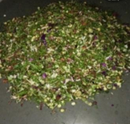
Figure 1 Collected Kitchen Waste

3.2 Kitchen Waste Analysis:
Collected kitchen waste was analysed for various physiochemical parameter like, moisture content, pH, bulk density, conductivity, carbon, nitrogen, organic matter, phosphate, potash, and particle size. The humic acid to fulvic acid ratio was examined using the method by Duchaufour and Jacquine (1966).
Table 2 Analysed parameter of kitchen waste
Analysed Perameter
Particle Size (mm) | 4
PH | 7.9
Conductivity (as dsm-¹) | 1.19
Total Organic matter % | 8.6
Total Organic matter % | 4.9
Total Carbon % | 1
Total Nitrogen % | 4.9
C: N Ratio | 4.9
Moisture % | 80
Bulk density (g/cm³) | 0.52
Phosphate (Quimociac reagent) % | 3.4
Total Potash % | 1.5
E4/E6 | 5.2

3.3 Development of Liquid Bacterial Inoculum:
Kitchen waste degrading bacteria were used for the development of liquid bacterial inoculum. These kitchen degrading bacteria was inoculated in modified mineral salt broth. (Patil et al. 2021)
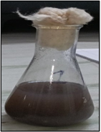
Figure. 2 Bacterial Liquid Inoculum
3.4 Composting of kitchen waste by microbial Inoculum:
The kitchen waste pulverized samples were used as substrate for studying the capability of the obtained microbial inoculum for degradation. Kitchen waste was mixed with liquid inoculum (LH 1) Mc Farland standard density 1. 1% of the inoculum was inoculated in 4 kg kitchen waste samples. The waste samples were stirred on an altered day regularly. A control set, kept under same experimental condition, was also observed for consecutive 7 days in triplicates. After decomposition of waste, compost was evaluated as per the Government guide-line of FCO,1985.
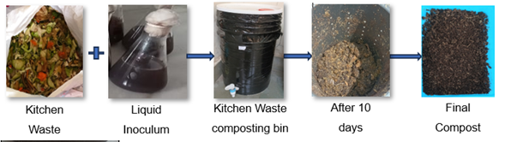
Figure 3 Composting process
3.5 Evaluation of Compost:
Daily observations of temperature changes during the composting process resulted in the presented in Figure 4. The final compost, with and without microbial inoculum (control), was subjected to quantitative analysis of parameters including moisture content, pH, bulk density, conductivity, carbon, nitrogen, organic matter, phosphate, potassium, particle size, E4/E6 ratio, and a phytotoxicity study. The outcomes of the compost heavy metal assessment are delineated in Table 3
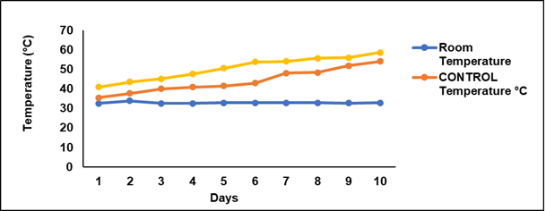
Figure: 4 Temperature profiling of composting process
The temperature is one of the key factors that influence the efficiency of the composting process significantly. The starting temperature for the inoculum-treated kitchen waste (LH 1) was 40.9°C, and for the untreated waste it was 32.6°C. As a result of being treated, the waste reached a temperature of over 50°C by the sixth day, the inoculated bin was observed to be rising in temperature. The control pile was the one with the slowest temperature increase, finally arriving at 54°C. The composting temperature increase was very quick, and its peak was at 10 days (Figure 4). The surrounding temperature was constant during the entire experiment, and it was considered as the reference for the corresponding changes in the composting bin. The kitchen waste consortium that had been inoculated underwent a notable decrease in its moisture content from 80% to 20%, whereas the control sample experienced a lesser drop to 23% (Figure 12). Both of them were in accordance with the FCO norms which permit a maximum moisture content of 25% in the final compost. The pH values of the inoculated samples and the control samples were the same at all times and were in the range of 6.5 - 7.5 recommended for most applications. Initially, the kitchen waste pH was 7.1 and the control pH was 7.9 at the end of composting (Figure 6). The results indicate that the moisture content and pH levels were indeed in compliance with the FCO quality compost standards. The pH levels recorded in the inoculum-treated and control samples, respectively, were not only within the range recommended by the FCO but also indicative of a successful composting process with the effective management of conditions conducive to decomposition. The pH stability suggests that the inoculum treatment did not adversely affect the compost's chemical properties, thereby potentially opening up a large-scale application of this method in composting operations.
In Figure 9, the carbon content of the kitchen waste was 4.9%. Meanwhile, the inoculum-treated LH1 had a 13.4% higher carbon content. The control sample showed a small reduction of 4.9% after the kitchen waste degradation process was completed. The FCO guidelines state that the final compost must have at least 12% carbon, and the results of this study show that the inoculated samples met that requirement, proving their high-carbon content. The nitrogen level of kitchen refuse was 1% while that of treated LH1 was 2.4%. The control resulted in a slight reduction of 1.09%. The FCO guideline already allows for the nitrogen in the final compost to be at least 0.8%. The ratio of kitchen waste C: N was 4.9, while that of inoculum-treated LH1 was 5.58. The control sample went up a bit to 10.82 as shown in figure 11. The FCO guidelines stipulate that the compost C:N ratio must be less than 20, and this research has all the samples exhibiting significant results (figure 11).
The electrical conductivity (EC) of kitchen waste was 1.19, whereas that of inoculum-treated LH1 was 0.94. The EC value of the control group was 1.27. FCO guidelines specify that the EC should not exceed 4, as shown in Figure 7. The organic matter content in kitchen waste was 8.6%, whereas that of inoculum-treated LH1 was 23.1% and the control showed 19.83%, respectively. The phosphate content in kitchen waste was 3.4%, whereas that in inoculum-treated LH1 was 5.34 A minor reduction of 4.27% was recorded for the control group. The FCO standards state that at least 0.4% phosphate should be in the final compost, and this research verified that phosphate is available in the final compost (Figure 15). The total potash content in kitchen waste was 1.5%, whereas that of LH1 was 7.5%, with the control showing a decrease of 3%. FCO guidelines recommend a minimum of 0.4% potash (Figure 14). Bulk density was 0.52 g/cm³ in kitchen waste, increasing to 0.95 g/cm³ in treated bin (LH 1). The control slightly increased to 1.4 g/cm³. The FCO guidelines specify a minimum bulk density of 0.4%, which is met (Figure 13).
The E4/E6 ratio in the kitchen waste was 5.2, whereas the inoculum-treated LH1 ratio was 0.31. The control showed a ratio of 0.82 in the compost (Figure 16). This spectroscopic observation E4/E6 of humic acids is relatively low (less than 5), indicating good conditions for humification of HA of high molecular weight with a predominance of aromatic molecules in their structure, so the presence of humic acids decomposed. (Freppaz et al., 2002).

Figure: 5 Particle size of compost Figure: 6 pH of compost

Figure: 7 Conductivity of compost Figure: 8 Organic matter of compost

Figure: 9 Total Carbon of compost Figure: 10Total Nitrogen of compost

Figure: 11 C:N ratio of compost Figure: 12 Moisture content of compost

Figure: 13 Bulk density of compost Figure: 14 Total potash of compost

Figure: 15 Total Phosphate of compost Figure: 16 E4/E6 ratio of compost

In this study, we examined the presence of heavy metals (Cu, Mn, Pb, Zn, and Hg) in the final compost. Significant levels of these metals were observed, except for Pb, which was absent in the inoculum-treated kitchen waste and found in minor amounts in the control sample. The assessment followed the government regulations that were laid down in FCO (1985). For the exam of heavy metals, the AAS was the method used, and the interpreting of results presented in Table 3 showed that the final compost had a lot of metal-like elements in it. This implies that the monitoring of heavy metals in compost to adhere to safety standards is a necessary practice.
Table: 3 Heavy metal analysis of Compost
Heavy metal  content, (as  mg/Kg), maximum | Control | LH1 | Reference value as per FCO
Arsenic | 0 | 0 | 10
Cadmium | 0 | 0 | 5
Manganese | 2.06 | 2.71 | 50
Copper | 1.46 | 0.63 | 300
Mercury | 0.0051 | 0.0048 | 0.15
Nickel | 0 | 0 | 50
Lead | 0.45 | 0.15 | 100
Zinc | 3.04 | 2.7 | 1000

The effects of compost water extract toxicity on the germination index of Vigna radiata, Cyamopsis tetragonoloba, Sorghum, and wheat were evaluated.

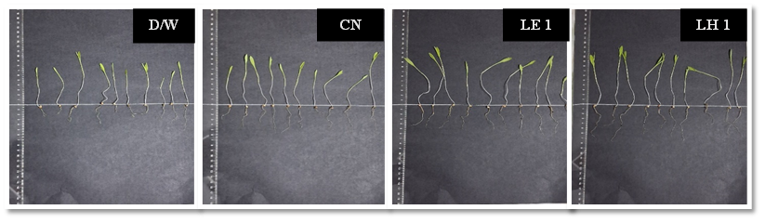

Figure 3.17 Seed Germination of Triticum aestivum (Wheat)

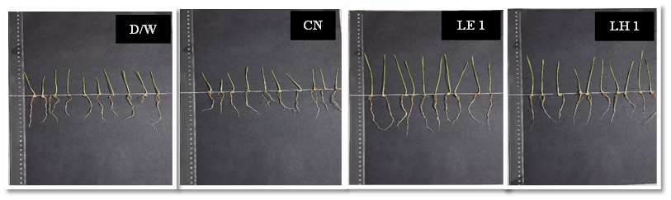

Figure 3.18 Seed Germination of Sorghum bicolor (Sorghum)
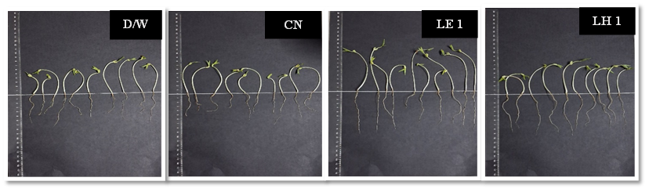

Figure 3.19 Seed Germination of Vigna radiata (Mungbean)

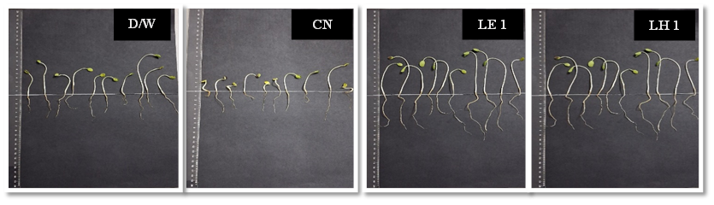

Figure 3.20 Seed Germination of Cyamopsis tetragonoloba (Guar)

Figure 3.21 Seed Germination
Figure 3.21 reveals that the application of treatments LH1 resulted in considerable enhancement of seed germination indices in all species that were tested. Among the different species, Vigna radiata was found to have the maximum germination percentage, while Cyamopsis tetragonoloba, Sorghum, and wheat came next in that order, showing a decreasing trend in their respective values. This suggests that the LH1 treatments not only counteracted but also gave rise to the best germination performance in these plants compared to others due to the lower toxicity of the compost extract in water.
The comparative analysis of composting processes and final compost quality in this study highlights the significant advantages of microbial inoculation in accelerating decomposition and producing superior compost. The heating of the inoculated bins (LH1) giving off a high temperature of up to 59.3°C is an indication of the presence of a lot of microbes and it also agrees with the findings of Raut et al. (2008) who said that there was a phase of heating more than 50°C in the thermophilic reactors. The fast rise in temperature in the inoculated bin is contrasted with the slow temperature rise in the control bin, which reached a maximum of 54°C, according to Dharani et al. (2021), and it is the inoculation that has provided the necessary conditions for efficient decomposition. The 80% to below 25% reduction in the moisture content of the inoculated samples correlated with the FCO standards and is in line with Bhave and Joshi (2017) findings that optimal microbial activity was reached. The pH of inoculated compost (7.0–7.1) is indicative of organic matter stability, as Dharani et al. (2021) confer, and it is slightly alkaline conditions that are the reason for Agapios et al. (2020) to talk about nutrient availability and microbial activity. Moreover, the inoculated compost had a carbon content that was over the FCO thresholds and was 2.4% and 2.1% nitrogen richer than the control, thus partnering with the results of Raut et al. (2008) and Manu et al. (2019). The C:N ratios of inoculated samples (5.58) point towards very well-matured compost which is in line with Sarkar et al. (2016) and indicates its suitability for agricultural use. Lower electrical conductivity (≤0.95) and higher organic matter content (23.1% and 22.41%) further validate superior compost quality. Minimal heavy metal content and a high germination index (e.g., for Vigna radiata) underscore safety and agricultural viability. These findings are consistent with previous studies by Zucconi al. et al. (1981), Tam and Tiquia (1994), Tiquia et al. (1996), and Khyalia, P. et al. (2022). This study demonstrates microbial inoculation as an effective and sustainable method for kitchen waste composting and enhancing and assessing compost quality.
Conclusion:
The work titled "Development and Application of an Effective Bacterial Liquid Inoculum for Composting Organic Kitchen Waste" was the center of the investigation at the time. The application of a bacterial liquid inoculum produced compost from kitchen waste. It was discovered through the outcomes that bacteria liquid inoculum in composting kitchen waste not only upgraded the quality of the compost but also the efficiency of degradation significantly when compared to an untreated control. The liquid inoculum of bacteria LH 1 played a great role in boosting compost parameters. The composting process witnessed optimal rises in temperatures with treated bin LH 1 inoculum reaching higher peaks (59.3 °C) than the control (54 °C), hence indicating that microbial activity was more effective. Besides that, in the inoculum-treated bin LH 1, the moisture content had significantly fallen (from 80% to 20%) at day 15, while the control was still quite high (23%). Compost made with inoculum showed superior values for key measurements such as pH, Carbon, N, organic matter, C:N ratio, BD, Ec, and P. These various evaluation compost perameter was evaluated by Government guideline of FCO-1985, it’s the standards for good quality of compost. What’s more, the lead (Pb) levels in the compost did not increase with inoculum presence beyond those in the control, which is, in turn, a vital factor for safety in agricultural applications. The final compost met heavy metal FCO-1985 standards. The study on the impact of the compost on plants revealed that the inoculum-treated compost significantly improved seed germination with Vigna radiata showing the highest germination rate, thus confirming the quality of the produced compost further. The research finally asserts that the addition of microbes to compost can not only hasten the composting process but also improve its quality. This discovery presents an advantageous method for the disposal of kitchen waste and the making of nutrient-packed compost by using the household bin.

Consent (where ever applicable)

Not applicable.

Ethical approval

Not applicable. This systematic review analyzed published literature and did not involve human participants.

References:
- Agapios, A., Andreas, V., Marinos, S., Katerina, M., & Antonis, Z. A. (2020). Waste aroma profile in the framework of food waste management through household composting. Journal of Cleaner Production, 257, 120340.
- Benitez, E., Nogales, R., Elvira, C., Masciandaro, G., Ceccanti, B., 1999. Enzyme activities as indicators of the stabilization of sewage sludges composting with Eisenia foetida. Bioresource Technol. 67, 297–303.

- Bhave, P. P., & Joshi, Y. S. (2017). Accelerated in-vessel composting for household waste. Journal of The Institution of Engineers (India): Series A, 98, 367-376.
- Bialobrzewski, I., Miks-Krajnik, M., Dach, J., Markowski, M., Czekała, W., & Głuchowska, K. (2015). Model of the sewage sludge-straw composting process integrating different heat generation capacities of mesophilic and thermophilic microorganisms. Waste Management, 43, 72-83.

- CPCB, 2002. Central Pollution Control Board, Management of Municipal Solid Wastes, New Delhi, India.

- Dharani, S., Saliha, B. B., Suresh, S., & Shenbagavalli, S. (2021). Evaluation and Acceleration of Municipal Biowaste Compost Production and its Effect on Growth and Yield of Amaranthus. International Journal of Plant & Soil Science, 33(21), 195-201.

- Duchaufour, Ph., and F. Jacquin, 1966. Nouvelles recherches sur l’extraction et le fractionnement des composés humiques. Bulletin ENSAN, VIII, 1, 3-24.

- Freppaz, M., Lunardi, S., Bonifacio, E., Scalenghe, R., & Zanini, E. (2002). Ski slopes and stability of soil aggregates.
- Gigliotti, G., Valentini, F., Erriquens, F. G., & Said-Pullicino, D. (2005). Evaluating the efficiency of the composting process: a comparison of different parameters. In Geophysical Research Abstracts (Vol. 7, p. 09606). Perugia, Italy: European Geosciences Union.

- Haddad, G., El-Ali, F., & Mouneimne, A. H. (2015). Humic matter of compost: determination of humic spectroscopic ratio (E4/E6). Curr Sci Int, 4, 56-72.

- Khyalia, P., Dangi, J., Barapatre, S., Dhania, G., Laura, J. S., & Nandal, M. (2022). Comparative analysis of compost quality produced from fungal consortia and rice straw by varying C/N ratio and its effect on germination of Vigna radiata. Nature Environment and Pollution Technology, 21(3), 1235-1242.
- Manu, M. K., Kumar, R., & Garg, A. (2019). Decentralized composting of household wet biodegradable waste in plastic drums: Effect of waste turning, microbial inoculum and bulking agent on product quality. Journal of Cleaner Production, 226, 233-241. https://doi.org/10.1016/j.jclepro.2019.03.350

- National Centre of Organic Farming. (2019). Biofertilizers and Organic Fertilizer- Fertilizer (Control) Order, 1985

- Patil, S. A., Navale, A. M., Deokar, C. D., & Patil, D. A. (2021). Development and assessment of microbial consortium for composting of organic waste. Journal of Pharmacognosy and Phytochemistry, 10(2), 241-245.
- Raut, M. P., William, S. P., Bhattacharyya, J. K., Chakrabarti, T., & Devotta, S. (2008). Microbial dynamics and enzyme activities during rapid composting of municipal solid waste–a compost maturity analysis perspective. Bioresource technology, 99(14), 6512-6519. https://doi.org/10.1016/j.biortech.2007.11.030

- Sarkar, S., Pal, S., & Chanda, S. (2016). Optimization of a vegetable waste composting process with a significant thermophilic phase. Procedia Environmental Sciences, 35, 435-440.

- Tam, N. F. Y., & Tiquia, S. (1994). Assessing toxicity of spent pig litter using a seed germination technique. Resources, Conservation and Recycling, 11(1-4), 261-274.

- Tiquia, S. M., Tam, N. F. Y., & Hodgkiss, I. J. (1996). Effects of composting on phytotoxicity of spent pig-manure sawdust litter. Environmental pollution, 93(3), 249-256.

- Van Fan, Y., Lee, C. T., Klemeš, J. J., Chua, L. S., Sarmidi, M. R., & Leow, C. W. (2018). Evaluation of effective microorganisms on home scale organic waste composting. Journal of Environmental Management, 216, 41 -48.
- Voegeli, Y., & Zurbrugg, C. (2008). Decentralised anaerobic digestion of kitchen and market waste in developing countries-‘state of the art’in south India. Proceedings Venice.

- Wei YunMei, W. Y., Li JingYuan, L. J., Shi DeZhi, S. D., Liu GuoTao, L. G., Zhao YouCai, Z. Y., & Shimaoka, T. (2017). Environmental challenges impeding the composting of biodegradable municipal solid waste: a critical review.

- Zucconi, F.; A. Pera; M. Forte and M. de Bertoldi(1981b). Evaluating toxicity of immure compost. Biocycle, 22 (4): 54-57.

