Review Article

Aesthetic Characteristics and Cultural Expression of Ceramic Calligraphy

__________________________________________________________________________________________

Abstract: With the development of ceramic techniques and artistic media, calligraphy has moved beyond paper and ink. So it has produced more kinds of expressive forms. Ceramic calligraphy is one of them. It combines calligraphy ceramic. It shows different aesthetic features and cultural meanings from traditional ink-on-paper calligraphy. This paper gives a systematic review of ceramic caligraphy. This paper reviews ceramic calligraphy from three areas: aesthetic characteristics, cultural expression, and contemporary applications. The paper takes scattered research into a concentrated form and provides a clear framework for analysis. Then, this paper reviews relevant literature, historical cases, and representative works, and analyses current research from four aspects: material, medium, craftsmanship and technique, writing style, and application context. This paper shows that the aesthetic value of ceramic calligraphy mainly comes from the interaction between material, technique, and writing style. This interaction moves calligraphy from a flat written form to a form with spatial and material qualities. Then, this paper shows that ceramic calligraphy has developed richer cultural meaning over time. From initial pottery inscriptions to Ming and Qing scholar inscriptions to contemporary research and applications in public art and cultural-continuous practices, this paper shows the evolution of ceramic calligraphy's cultural meaning. Additionally, in different periods, ceramic caligraphy serves as a form of cultural memory communication and identity expression, and this is true for different contexts. In the context of the contemporary era, ceramic calligraphy has shown a clear trend of cross- disciplinary integration and diverse development. In the context of contemporary art, design practice, and public space creation, ceramic calligraphy has entered contemporary culture. It is not a simple extension and development of ink-on-paper caligraphy. This paper shows that ceramic calligraphy is a more distinctive art form with its own unique characteristics, shaped by material, craftsmanship, and culture.
Keywords: Ceramic calligraphy; Aesthetic characteristics; Cultural expression; modern and contemporary applications; cross-media

___________________________________________________________________________
1. Introduction
The ceramic writing art form incorporates calligraphy and ceramic skills. This art form illustrates some obvious differences from traditional ink and paper calligraphy, such as using new materials and techniques and expressing its unique visual advantages. So it has its own artistic value and academic significance. However, ceramic writing is not just writing characters on a surface. It connects writing with the processes of shaping, glazing, firing, etc. So it creates an art formation that combines written expression and material form. Scholars have different views on what “ceramic calligraphy” refers to. Most studies agree that it includes inscriptions, dedicate and seals on the ceramic surface. And some researchers place it in the broad field of ceramic decorative art. In this context, it works with painting and sculpture as part of a larger visual system (Fang Yi, 2020; Fang Yi & Jiang Haochen, 2020). So these views show that ceramic calligraphy is not a simple transfer of ink-on-paper cursive. It comes from the interaction between materials, techniques, and writing language. In recent years, scholars have researched ceramic calligraphy from multiple angles. Some studies analyze the development of ceramic calligraphy historically, documenting its transformation from early symbolic marks(Shi, 2011) and pottery inscriptions to poetry and prose inscriptions and eventually more elaborate decorative forms(Wang J., 2024; Zhu, 2006). Some research is focused on the techniques of writing(Gao, 2013), carving(Wu Y., 2025), and painting(Jin, 2023). The studies discuss how the application of these techniques affects the form and visual effect of the lines. Other studies look at regional styles. This research compares differences in calligraphic choices and aesthetic preferences between kiln sites such as Jingdezhen(Zhang, 2025) and Changcha(Liu, 2025). And some studies explore the use of ceramic calligraphy in modern contexts. This research discusses its role in modern artists(Mao & Xiong, 2025), cultural and creative design(Wang Y., 2024), public space (Lin, 2006; Wang J. & Wang, 2012), and application path in educational practice(Li D. et al., 2025).

Given the important progress made by existing research, there are nonetheless some shortcomings if seen from the overall perspective. First, relevant studies are fairly scattered, and there is still insufficient systematic integration of the relationship between aesthetic characteristics, cultural expression, and practical applications of ceramic calligraphy. Second, the reference of some studies is still centered on ink-on-paper calligraphy, and there are still insufficient considerations for the role of materials and craftsmanship in the formation of aesthetic qualities; consequently, they fail to fully reveal the cross-media characteristics. Finally, research on ceramic calligraphy still lacks a comprehensive explanation for the formation of its Cultural expression and the transformation it undergoes in the contemporary context. This paper presents an overview of ceramic calligraphy from three dimensions: aesthetic characteristics, cultural expression, and modern and contemporary applications. It examines the formation of ceramic calligraphy's aesthetic features, cultural expression, and its applications in contemporary art, design, and public spaces.

2.Research Methodology
This paper uses a literature research method to organise and analyse the research on ceramic calligraphy. A literature review is more than a collection of existing studies. It also focuses on building a full understanding of the subject matter through induction and synthesis (Ibrahim & Mustafa Kamal, 2018). This paper finds related studies through Google Scholar and CNKI. The search words of this paper include “ceramin calligraphy", “aesthetic characteristics of ceramic calligraphy", cultural expression of ceramic calligraphy", and “modern. Contemporary applications of ceramic calligraphy". This paper also searches the literature studies by using other methods. Related words. There is no restriction on the starting year of publication; the search is limited to December 2025. The selection of literature is primarily based on its relevance to the research topic, the representativeness of its content, and its value as a reference for the analytical framework of this paper. During the process of literature screening and analysis, this paper focuses on the artistic characteristics of ceramic calligraphy in terms of materials, techniques, and styles, traces its historical transmission and cultural expression, and discusses its applications in contemporary art creation, cultural and creative design, and public art. Through the reading of abstracts or full texts of relevant literature, the main viewpoints, key points of discussion, and shortcomings of existing research are summarised. In the process of synthesising the literature, this paper employs a combination of comparative analysis and thematic summarisation to organise relevant perspectives from various studies. On this basis, an analytical framework comprising ‘aesthetic characteristics—cultural expression—modern and contemporary applications’ has been developed to present the main content of research on ceramic calligraphy and its internal connections.

3.Results
This section analyzes the aesthetic characteristics of ceramic calligraphy, the cultural meanings embedded in its visual forms, and its modern and contemporary applications. Through these three dimensions, it clarifies the distinctive artistic value of ceramic calligraphy and its evolving role in contemporary cultural practice.

3.1 Aesthetic Characteristics of Ceramic Calligraphy
Ceramic calligraphy utilises ceramic materials as its medium, integrating the art of calligraphy into the technical processes of shaping, decoration, and firing, thereby forming a unique aesthetic form distinct from calligraphy on paper and ink(Shi, 2011). Its aesthetic characteristics are primarily manifested in three aspects: the medium, technique, and style, and are epitomised by the organic unity of the beauty of the material, the beauty of craftsmanship, and the beauty of culture.

From the perspective of the aesthetic qualities of the medium, the physical properties of ceramic materials offer calligraphic art a different set of expressive possibilities compared to the traditional medium of ink on paper. Ceramic has a smooth and dense texture. It also has a stable surface. These features give ceramics a strong load-bearing capacity and good durability. They also help calligraphic lines keep a clear visual effect after high-temperature firing(Jin, 2023). Different types of porcelain clay also show different levels of ink absorption, response to wet and dry condition, and color change. This has a direct impact on the strokes and writing rhythm. The Cizhou ware clay is a typical example. It is dry and coarse and absorbs ink well. Thus, it easily creates the lively “flying white” effect. This effect works especially well to reflect the sharpness and strength of strokes in the running script and cursive script(Fu, 2012). We can see these characteristics in the brushstrokes of the calligraphically decorated Cizhou ware (see Figure 1).

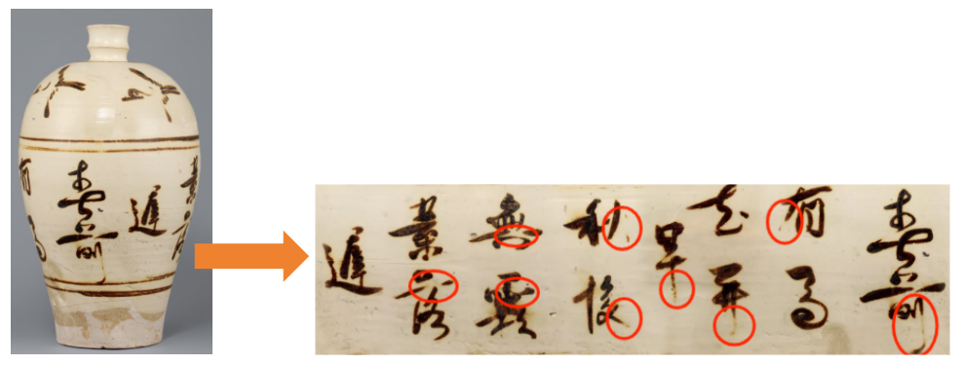
Figure 1: Detail of calligraphic decoration on a Cizhou ware piece (running-cursive script with a ‘flying white’ effect

In addition, as an integral part of a ceramic decoration, calligraphy also has the function to achieve balance of composition, evoke an artistic atmosphere, and balance solid and void elements. In this way, the ceramic work has richer cultural significance and beauty than its utility function (Li W. & Liu, 2011).

From an aesthetic perspective, ceramic calligraphy achieves a distinctive craftsmanship that sets it apart from two-dimensional calligraphy through the integrated use of various techniques, including brushwork, carving, and painting. In terms of writing techniques, whether employing high-temperature pigments such as blue-and-white or black under-glaze, or low-temperature pigments on the overglaze, artists can utilise variations in intensity, dryness, wetness, and the interplay between moist and arid textures to pursue the brushwork and ink aesthetics reminiscent of ink-wash painting on paper. Against the backdrop of the glaze colours, this creates visual effects that are either serene or vibrant(Gao, 2013). In terms of carving techniques, methods such as intaglio, relief and bas-relief give the calligraphic lines a three-dimensional form; the rhythm of the carving strokes interacts with the texture of the clay body, enhancing the work’s epigraphic quality and sense of spatial depth, and presenting the aesthetic characteristic of ‘using the chisel in place of the brush’ (Wu Y., 2025)(see Figure 2).

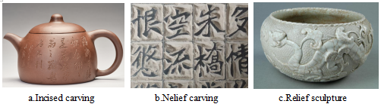
Figure 2: Three common carving techniques

In terms of painting techniques, the use of underglaze, overglaze, and high-temperature glazes has broken away from the traditional calligraphic style dominated by black and white, expanding the cultural expressiveness of ceramic calligraphy through the symbolic significance of colour (Jin, 2023)(see Figure 3).
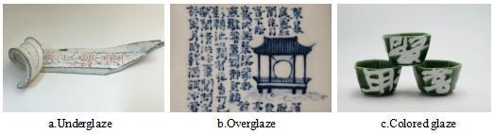
Figure 3: The three main painting techniques

From the aesthetic viewpoint of ceramic products, ceramic calligraphy is gradually establishing a rich and diverse but relatively stable aesthetic system during the evolution of its history and regional development. In the early engravings of ceramic relics and painted symbols, it set out the basic form of ceramic calligraphy. In the Tang Dynasty, it had a characteristic of maturity through underglaze colour poetry and prose writing at the Changsha Kiln. In the Song and Yuan Dynasties, it had a strong folk aesthetic form through black calligraphy on a white ground at the Cizhu Kilnm. In the Ming and Qing Dynasties, the literate groups participated in its development and caused the comprehensive application of poetry and calligraphy in blue-and-white ware, enamel-coloured ware and light-cinnabar-colour Ware. In this process, it also promoted the standardization of ceramic calligraphy. In the modern period, its individual expression and formal innovation tend to be stronger(Shi, 2011; Wu F. & Bi, 2025).

From a regional perspective, Jingdezhen ceramic calligraphy draws upon a mature imperial kiln system and exquisite body and glaze, employing mainly regular script. It emphasises rules and standards, and places great importance on the harmonious unity between calligraphy, painting, and vessel form, resulting in a style that is elegant, refined, and orderly(Zhang, 2025). In contrast, ceramic calligraphy from the Changsha Kiln is predominantly folk-inspired, employing mainly running and cursive scripts. It emphasises spontaneity and improvisation, with the arrangement of characters blending naturally with the vessel’s form, presenting an aesthetic orientation that is unadorned and free. The differences in their aesthetic character form a contrast between ‘refined elegance’ and ‘rustic sincerity’ within the stylistic framework of ceramic calligraphy (Liu, 2025). As shown in Table 1.

Table 1: A Comparison of Regional Styles in Ceramic Calligraphy from the Jingdezhen and Changsha Kilns
Comparative Aspect | Jingdezhen Ceramic Calligraphy | Changsha Kiln Ceramic Calligraphy
Creation | Official-style system; refined and elegant; highly standardised | Folk-oriented creation; highly free in craft; highly authentic in brushwork
Script Style | Mainly regular script | Mostly running the script
Form | Calligraphy and vessel form are coordinated as a whole | Text and vessel form are naturally integrated
Aesthetic Quality | Refined and elegant | Rustic and authentic

Overall, ceramic calligraphy, through the synergy of material medium, craftsmanship and stylistic forms, transforms the art of calligraphy from two-dimensional writing into three-dimensional presentation, and from ephemeral creation into a form of artefact that can be preserved over the long term. By unifying the ‘Dao’ and the ‘Qi’, it achieves a dual expression of aesthetic value and cultural spirit, constituting an important art form with comprehensive medium characteristics within the traditional Chinese art system(Shen, 2007) .

3.2 The Cultural Expression of Ceramic Calligraphy

As a unique art form resulting from the fusion of calligraphy and ceramic craftsmanship, ceramic calligraphy has continually evolved in its cultural expression throughout the history of Chinese ceramics, manifesting primarily in terms of historical heritage, spiritual significance, and cultural dissemination.

Historically speaking, the stylistic expression of ceramic calligraphy has evolved from a relatively monotonous form in its early stages to one of increasing diversity. From prehistoric times through to the Qin and Han dynasties, the engraved symbols, pictographic characters, and commemorative inscriptions found on pottery constituted the early forms of ceramic calligraphy. For instance, the pictographic inscriptions on the Neolithic Lingyang River pottery vessel exemplify the initial fusion of writing and pottery (Shi, 2011)(See Figure 4).
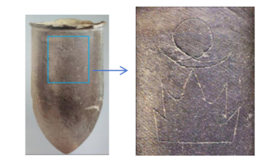
Figure 4: Pictographic inscriptions on a Neolithic ceramic vessel from Lingyang River

From the Tang and Song dynasties, calligraphic art developed, and the technique of producing pottery also improved. So, the ceramic calligram entered a new stage in its development. The Changsha Kiln decorated porcelain with Tang poetry, and it achieved large-scale production. The Cizhou Kiln continued the tradition of inscribing poetry and prose, and it formed an artistic style with bold brushwork and free execution. Some works also showed a “flying white” effect. So the lines became more rhythmic and more expressive (Li W. & Liu, 2011).During the Ming and Qing dynasties, driven by both imperial aesthetic standards and the active involvement of literati, ceramic calligraphy reached a stage of maturity. It gradually established a standardised system of inscriptions and a comprehensive style integrating ‘poetry, painting, calligraphy and seal carving’. An example of this is the Kangxi-period blue-and-white doucai ‘Twelve-Month Floral Cup’, on which each piece bears an inscribed poem. Enamelware from the Yongzheng and Qianlong periods achieved a high degree of integration between poetry, calligraphy, and seals, marking the full maturation of the artistic style of ceramic calligraphy (Wang J., 2024; Zhu, 2006). In the contemporary era, ceramic calligraphy has, whilst upholding traditional scripts and classical texts, actively explored new forms such as pure ceramic calligraphy, public ceramic murals, and underglaze blue-and-white, presenting a dynamic and multifaceted trajectory of development(Shi, 2011). Based on this historical evolution, ceramic calligraphy has developed distinct phased characteristics across different periods—from early expression, through mid-period presentation, to late-period development—with its evolutionary logic illustrated in Figure 5.
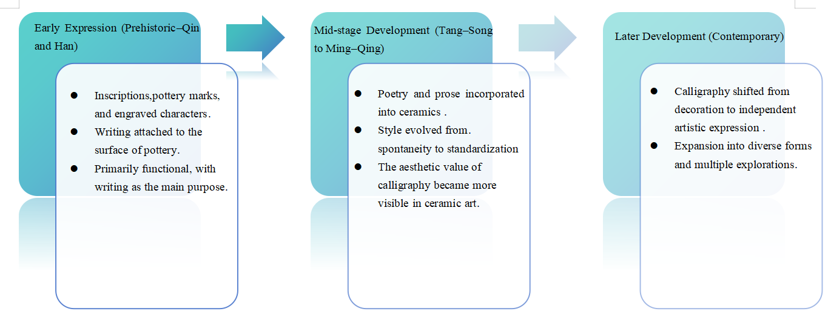
Figure 5: The phased characteristics of ceramic calligraphy across different periods

It embodies the spirit of traditional Chinese philosophy and the values of the nation’s culture, with its aesthetic orientation rooted in the philosophical systems of Confucian ‘beauty of moderation’, Daoist ‘harmony between heaven and humanity’, and Buddhist ‘ethereal tranquillity and distant serenity’. Through the harmonious integration of contrasting elements—such as overglaze and underglaze techniques, engraved characters and calligraphy, and dense ink against negative space—the artist creates an aesthetic framework where the tangible and the intangible give rise to one another, and the rigid and the supple complement each other, thereby embodying the holistic perspective and spirit of harmony characteristic of Eastern art (Tong et al., 2006). At the same time, the development of calligraphy on ceramics embodies a distinct national spirit; the continuous exploration by artisans across the ages in the selection of materials, the application of techniques, and the production processes has demonstrated a spirit of craftsmanship characterised by adherence to tradition whilst embracing innovation, and a relentless pursuit of perfection. A clear example is the strict rules on calligraphic decoration set by Nian Xiyao during his time as supervisor of the Imperial Kilns in the Qing Dynasty (Li W. & Liu, 2011). Based on this, the participation of literati further enriched the spiritual meaning of ceramic calligraphy. As an important way for the literati to engage with ceramic art, ceramic calligraphy used the inscription of classical poetry or original verse. So it expressed the aesthetic ideals, personal aims, and patriotic feelings of the literati class. For example, during the Republican era, the “Eight Friends of Zhushan” inscribed poems in running script and cursive script on their painted porcelain. So the worlds of calligraphy and painting influenced each other. This also continued and expanded the literati tradition of expressing feelings through objects and ideas through calligraphy (Fu, 2012).

In terms of cultural dissemination, ceramic calligraphy has long played an important role in the spread of culture. It relies on the practical nature and portability of ceramic objects. In traditional society, ceramic calligraphy spread across regions through trade and the movement of artefacts. For example, the Tang Dynasty Changsha Kiln ewer with poetry and the Song and Yuan Dynasty Cizhou Kiln ceramic pillows with calligraphy conveyed Confucian ethical ideas and literary meanings through daily use. So they formed a mode of dissemination based on the idea that “daily life embodies the Way” (Huang, 2020). See Figures 6 and 7.
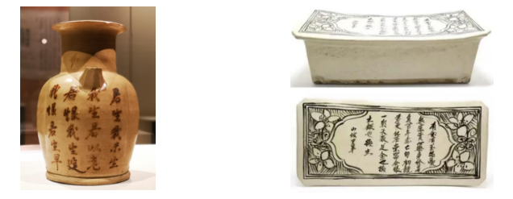
Figure 7: Yuan Dynasty Cizhou Kiln Calligraphic Ceramic Pillow

Figure 6: Tang Dynasty
Changsha Kiln Poetic
Inscribed Ewer

In the contemporary era, the channels for the spread of ceramic calligraphy have continued to grow. Public art, cultural and creative products, and digital media such as short videos and live streaming have become new display platforms. Through international exhibitions and digital sharing, ceramic calligraphy has reached a global audience(Jin, 2023; Xie, 2025). Ceramic calligraphy has kept a balance between the spirit of calligraphy and the ceramic medium during its historical development. It continues its spiritual values. It also expands its ways of spreading. So it forms a cultural expression with a relatively stable structure.

3.3 Modern and Contemporary Applications of Ceramic Calligraphy

As a unique art form, ceramic calligraphy is widely used in the modern and contemporary eras. It shows a trend toward more forms. It is not only a continuation of traditional decorative arts. It also has new life in modern artistic creation, cultural and creative design, public art, and education. The modern application of ceramic calligraphy preserves the artistic essence of traditional calligraphy whilst incorporating the diversity of contemporary artistic creation.

Firstly, the individuality and freedom of expression found in modern ceramic art have opened up new horizons for ceramic calligraphy. Modern ceramic art emphasises individuality, sensibility, and self-expression, pursuing unique, free, abstract, and unconventional forms of artistic expression; this has also spurred the innovative application of Chinese character elements in ceramics. Through the use of calligraphic styles such as seal script, clerical script, regular script, semi-cursive script and cursive script, the depiction of classical poetry—commonly found in modern Jingdezhen ceramics and similar works—not only enhances artistic expressiveness but also conveys innovative interpretations of the relationships between humanity and nature, and between people themselves, through the distinctive characteristics of Chinese characters(Kun, 2019).

Secondly, the application of ceramic calligraphy across multiple fields reflects its cross-disciplinary integration and broad expansion. In the realm of contemporary art, ceramic calligraphy combines with artistic forms such as ceramic painting, patterns and sculpture to pursue an aesthetic realm where ‘there is painting within poetry, and poetry within painting’. It has expanded into creative forms such as coloured-glaze ceramics and sculptural ceramics, demonstrating formal innovation in traditional calligraphy within a contemporary context(Mao & Xiong, 2025; Shi, 2011). In cultural and creative design and product development, ceramic calligraphy uses tea sets, daily ceramics, and decorative objects as carriers. It adds poetry, auspicious phrases, and elements of calligraphy, painting, and seal carving into product design. So it balances practical use and aesthetic value(Wang Y., 2024; Zou, 2010).In public art and cultural landscapes, ceramic calligraphy is widely used in ceramic murals and art installations in public spaces such as museums, airports, and stations. It helps strengthen cultural identity and gives people a sense of spiritual direction(Lin, 2006; Wang J. & Wang, 2012). See Figure 8.
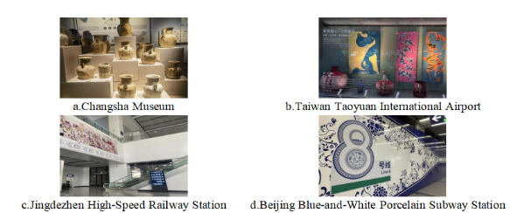
Figure 8: The use of ceramic calligraphy in public spaces

Lastly, the practice of ceramic calligraphy in modern education and experiential fields has added new ideas to its sustainable development. A combination of systematic teaching with hands-on experience has helped integrate ceramic calligraphy into school curricula and artistic activities, which has promoted the synergistic development of aesthetic education, cultural heritage, and value orientation(Li D. et al., 2025) (Figure 9).

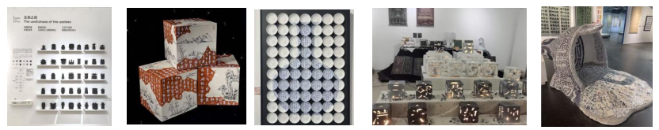

Figure 9: Graduation project exhibits from universities across China

Such practices, which unite "technique" and "way," can effectively avoid the trend of focusing solely and purely on skill training, thus providing a solid foundation for the inheritance and innovation of ceramic calligraphy (Zha & Yuan, 2025).

Overall, the multi-field applications of ceramic calligraphy in modern and contemporary times have not only expanded the boundaries of artistic expression but also sparked its new social functions. However, the diversification of ceramic calligraphy needs to maintain a careful and stable balance between innovative expression, cultural depth, and aesthetic quality.

4. Discussion
This paper provides an interdisciplinary analysis of ceramic calligraphy, including material aspects, craftsmanship skills, and the background of culture. Digital methods, interdisciplinary approaches, and cross-cultural perspectives are the direction of future study in the further promotion of the study of ceramic calligraphy.

From an aesthetic angle, ceramic calligraphy derives from the interaction of material characteristics, manufacturing processes, and writing styles. In existing research, Ceramic materials and the firing process directly impact the visual form and aesthetic qualities of calligraphic lines(Shen, 2007; Shi, 2011). In this process, calligraphic lines change from temporary traces into stable physical forms. So this change affects the way the work exists and how viewers experience it. Compared with ink-on-paper calligraphy, ceramic calligraphic lines must follow limits from the clay body, glaze color, firing conditions, etc. But these limits also create new aesthetic possibilities. These possibilities include changes in line shape and interaction between material texture by written effect. So, ceramic calligraphy forms the aesthetic features differing from ink-on-paper calligraphy.

In terms of cultural expression, existing studies focus on how calligraphy on ceramics carries culture across different periods. Early pottery symbols show the starting point. Tang and Song ceramic works combine calligraphy with decoration. Modern public art and cultural products also use text expression. So, ceramic calligraphy stays closely linked to historical context and cultural memory. Relevant studies show that ceramic materials act as physical carriers in calligraphic expression. They also help build and spread cultural meaning (Sun, 2019). So, ceramic calligraphy does not belong to a single calligraphic school or one fixed form. It develops its own way of expression in a wider cultural context.

In contemporary practice, ceramic calligraphy will extend into cultural design, public spaces, and education in creative industries. Ceramic calligraphy combines with modern design language in contemporary practice, which will help traditional culture to reach more people in the present world. Furthermore, Ceramic calligraphy works as a tool for hands-on learning in education. So it improves learners’ understanding of traditional culture. In addition to this, the results of studies indicate that ceramic work crosses the traditional boundaries through media change and the new design of the context (Luo, 2024). In this process, the writing of Chinese characters has been altered from a personal act into a public cultural practise.

Nevertheless, existing research still has some limits. Most existing studies are mainly qualitative. But the existing studies lack systematic data support. Also, they lack empirical research on public reception and cultural spreads. They also have a few studies that compare different cultural contextual aspects and historical periods. So these aspects limit a deeper understanding of the differences and similarities of ceramic calligraphy. In the future, research can be expanded in research methods and research perspectives. Researchers can use more quantitative methods and interdisciplinary research approaches. So this can improve the strength and reliability of research findings. Researchers can also carry out comparative studies between different cultures and time periods. This can support a deeper and more complete discussion on expression and communication in different social contexts.

This paper constructs a three-dimensional analytical system from three perspectives: aesthetic features of ceramic work, its expression of Chinese culture, and its modern usage to analyze the meaning of ceramic calligraphy as a cross-media art form and its artistic value. Compared to fragmented research methods in previous literature, the focus of this study is placed on the organic relationships among material media, artistic form, and cultural purpose in ceramic calligraphy. In this way, it can help to establish a more in-depth understanding of ceramic calligraphy as a cross-media art form and provide a reference for later empirical studies, comparative studies, and related artistic practices.

5. Conclusion
Ceramic calligraphy is a form of art that combines calligraphy and ceramics. Ceramics calligraphy has significant value in aesthetics, culture, and modern use. This paper mainly reviews related literature and case studies. The paper introduces the aesthetic characteristics, cultural expression, and modern and contemporary functions of ceramic calligraphy. The study demonstrates that ceramic calligraphy is not a simple extension of ink-on-paper calligraphy. It is a cross-media art form shaped by material properties and craftsmanship. Its aesthetic features arise from the interplay among materials, techniques, and writing styles. Its cultural expression develops over time and continues to change in the present. Its applications are also expanding into fields such as artistic creation or cultural and creative design, public art, and education, etc. This paper provides a multidimensional analysis of ceramic calligraphy, from material aspects, craftsmanship skills, and the background of culture. Digital methods, interdisciplinary approaches, and cross-cultural perspectives are the direction of future research to promote the study of ceramic calligraphy.

COMPETING INTERESTS DISCLAIMER:
Authors have declared that they have no known competing financial interests OR non-financial interests, or personal relationships that could have appeared to influence the work reported in this paper.
Disclaimer (Artificial intelligence)
The author hereby declares that generative artificial intelligence (AI) technologies, including ChatGPT (GPT-5, OpenAI, 2025)
Details of the AI usage are given below:
1. Purpose: To optimize logical structure and refine writing style.
2. Input: Only the author’s original text was provided for language editing; no confidential or unpublished data were used.
3. Responsibility: The author takes full responsibility for the content and conclusions of this manuscript.

COMPETING INTERESTS DISCLAIMER:
Authors have declared that they have no known competing financial interests OR non-financial interests OR personal relationships that could have appeared to influence the work reported in this paper.

References

Fang Yi. (2020). An exploration of ceramic calligraphy art from multiple perspectives. Jingdezhen Ceramics, (4), 57–58.

Fang Yi & Jiang Haochen. (2020). A brief discussion on the aesthetic beauty of ceramic calligraphy. Tian Gong Magazine, (3), 111–111.

Fu, W. (2012). The application of calligraphy in artistic ceramics. Jingdezhen Ceramics, 23(3), 13–14.

Gao F. (2013). On the Application Form of Calligraphy Elements in the Ceramic Art and Aesthetic Features. China Ceramics, 49(9), 87–89. https://doi.org/10.16521/j.cnki.issn.1001-9642.2013.09.021

Huang J. (2020). On the evolution and development of ceramic calligraphy art. Ceramic Studies, 35(6), 91–93. https://doi.org/10.16649/j.cnki.36-1136/tq.2020.06.030

Ibrahim, R., & Mustafa Kamal, R. (2018). Templates for Thinking. Unpublished Literary. Copyright MYIPO LY2018002437.

Jin K. (2023). Interpreting the Cultural Value and Aesthetic Features of Ceramic Calligraphy. Ceramics Science & Art, 57(5), 38–39. https://doi.org/10.13212/j.cnki.csa.2023.05.006

Kun, Z. (2019). Research on the presentation forms of Chinese character elements in modern ceramic art. 224–227. https://doi.org/10.2991/icassee-19.2019.45

Li D., Tian F., & Chen K. (2025). Application Methods and Roles of Ceramic Calligraphy in Patriotic Education. Ceramics Science & Art, 59(4), 118–119. https://doi.org/10.13212/j.cnki.csa.2025.04.084

Li W., & Liu Y. (2011). On the Aesthetics of Calligraphy in Ceramic Decoration. Arts Circle, (4), 83.

Lin X. (2006). Ceramic Calligraphy and Aesthetic Perceptions in Contemporary Society. Ceramic Studies, (4), 31–31. https://doi.org/10.16649/j.cnki.36-1136/tq.2006.04.014

Liu Z. (2025). The Decorative Art of Changsha Kiln Ceramic Calligraphy. Ceramics, (4), 103–106. https://doi.org/10.19397/j.cnki.ceramics.2025.04.041

Luo J. (2024). Integration and Development of Eastern and Western Aesthetics in Artistic Ceramic Painting. Ceramics, (5), 109–111. https://doi.org/10.19397/j.cnki.ceramics.2024.05.028

Mao L., & Xiong F. (2025). The Breakthrough Path of Ceramic Calligraphy in the Live Streaming Era: Inheritance, Challenges, and Innovation. Ceramics, (7), 71–73. https://doi.org/10.19397/j.cnki.ceramics.2025.07.050

Shen W. (2007). THE AESTHETIC FEATURE OF APPLYING CALLIGRAPHY ON CERAMIC DECORATION. China Ceramics, (4), 54, 58. https://doi.org/10.16521/j.cnki.issn.1001-9642.2007.04.017

Shi, G. (2011). The position of ceramic calligraphy aesthetics in the history of Chinese ceramics. Ceramic Studies, 28(3), 71–71. https://doi.org/10.16649/j.cnki.36-1136/tq.2011.03.035

Sun W. (2019). Discussion on the connotation and significance of calligraphy aesthetics in ceramic art education. Fine Art Version, 1(2), 27–31. https://doi.org/10.35534/fav.0102006c

Tong D., Zheng Y., Yu W., & Feng S. (2006). CERAMIC CALLIGRAPHY & TRADITIONAL CULTURE IDEOLOGY. China Ceramics, (9), 64–66. https://doi.org/10.16521/j.cnki.issn.1001-9642.2006.09.023

Wang J. (2024). Craftsmanship Integration and Artistic Heritage of Jingdezhen Ceramic Calligraphy in the Ming and Qing Dynasties. Chinese Calligraphy, (12), 194–196.

Wang J., & Wang X. (2012). Reason and Emotion Collide to Create Ethereality—A Brief Discussion of Personal Experiences in Learning Ceramic Calligraphy. Jingdezhen Ceramics, 23(5), 36.

Wang Y. (2024). Development and Exploration of Ceramic Calligraphy Cultural Creative Products under the Background of Contemporary Cultural Industry. Collections, (11), 165–167.

Wu F., & Bi B. (2025). Exploration of the formal rules and artistic characteristics of ceramic calligraphy. Jiangsu Ceramics, 58(3), 47–48. https://doi.org/10.16860/j.cnki.32-1251/tq.2025.03.007

Wu Y. (2025). Exploring the Artistic Characteristics and Cultural Heritage of Ceramic Calligraphy Engraving. Ceramics Science & Art, 59(3), 84–85. https://doi.org/10.13212/j.cnki.csa.2025.03.055

Xie Z. (2025). A Brief Discussion on Ceramic Calligraphy and Calligraphy. Ceramics, (4), 22–24. https://doi.org/10.19397/j.cnki.ceramics.2025.04.017

Zha Q., & Yuan Y. (2025). Ceramic Calligraphy is Integrated into the Traditional Calligraphy Teaching and Research. Ceramics, (1), 59–61. https://doi.org/10.19397/j.cnki.ceramics.2025.01.009

Zhang J. (2025). Comparison of Ceramic Calligraphy from Jingdezhen, Cizhou, and Changsha Kilns during the Tang, Song, and Yuan Dynasties. Jingdezhen Ceramics, 53(5), 137–139.

Zhu D. (2006). On the Artistry, Craftsmanship, and Decorativeness of Ceramic Calligraphy. Ceramic Studies, (4), 17–18. https://doi.org/10.16649/j.cnki.36-1136/tq.2006.04.008

Zou H. (2010). Ceramic Calligraphy on Tea Wares. JINGDEZHEN’S CERAMICS, 20(3), 39–40.

