Ecology and cutting propagation of Camellia mairei var. lapidea in Vietnam

Abstract
Camellia mairei var. lapidea belongs to family Theaceae, which has beautiful red flowers used as ornamental plant and seed oil is editable. In this study, C. mairei var. lapidea was first found to have natural distribution in Northwest Vietnam. It grows naturally in an evergreen broadleaved forest on the elevation of 2,100 m above sea level. There were only two adult individuals found, which bloomed and fruited numerously. Ripen fruits were much available on the forest floor, however seedlings or saplings were not available. C. mairei var. lapidea grows on Ferralsols soil with a soil depth of > 1.2 m, low rock content, low soil moisture, and well-drained soil. The maturity individuals may reach to 12 m tall and 18 cm in diameter at breast height. C. mairei var. lapidea flowers during December-February and ripen fruits appear during May-July. After ripening, whole fruits fall with fruit cover and seeds inside. It is potential for cutting propagation and IBA 0.5% by weight in powder type is best suitable for C. mairei var. lapidea. Even cuttings were taken from the natural forest it can achieve a rooting ratio of 40% in IBA 0.5%, higher than control of 33.3% at 4 months of growth. By treatment of IBA 0.5%, cuttings also have the highest shoot number (8 shoots), highest root number (6.7 roots), and longest root length (2 cm). It is recommended that further studies should be conducted for C. mairei var. lapidea to meet the demands of ornamentation and oil.

Keywords: Camellia, Cutting material, Ecology, Evergreen broadleaved forest, Natural condition.
1. Introduction
Camellia mairei var. lapidea (Y.C.Wu) Sealy Cohen-Stuart belongs to family Theaceae, genus Camellia. The species was recorded to have natural distributions in China South-Central and China Southeast [1]. It is an evergreen tree of up to 9 m at maturity. C. mairei var. lapidea distributes in natural forests on elevation zones of 1,000-2,800 m above sea level it can also grow in semi-shade or no-shade conditions [2]. The species flowers from April to June and seeds ripen in October. The species is hermaphrodite, pollinated by bees, and self-fertile. It grows well on light sandy to medium loamy soils and prefers well-drained soil with a pH of light acid to neutral [3]. Oil extracted from seeds of C. mairei var. lapidea is editable [4]. Because of its beautiful flowers, C. mairei var. lapidea has been used for ornamental purposes.
Seedling production was reported by sowing seed as soon as it ripens [5]. Seed germination takes 1-3 months at the temperature of 23ºC [6]. Seedlings must be tended in light shade condition for at least 6 months and seedlings of >15 cm could be planted. Seedlings from seeds have a high dead rate in the first winter and grow slowly. Cutting propagation may provide better quality materials for plantation.
Recently, C. mairei var. lapidea has been found to have distribution in the natural forest, North Vietnam. The species has beautiful red flowers in its distribution area. Recently, several new red-flowered Camellia species have been described from Vietnam [15], [16], [17]. Therefore, this study aims at describing the ecological characteristics of C. mairei var. lapidea in Vietnam and testing rooting capacity by cutting propagation.

2. Materials and method
2.1 Ecology characteristics

This was conducted at an evergreen broadleaved forest in Pa Vay Su commune, Phong Tho district, Lau Chau province, Northwest Vietnam (22°43'36.5"N, 103°23'14.9"E). Where C. mairei var. lapidea was found. Two plots of 100 m² each (10 × 10 m) were established for data collection including species composition, topography, vegetation, and edaphic condition. All individuals of the canopy layer were identified to species level and measured for diameter at breast height (DBH), total height, and crown diameter (D_{c}).

2.2 Cutting propagation
Branches for cuttings were collected from natural forests. They were then carefully protected and transferred to the nursery for the experiment. Exogenous hormone IBA (Indole-3-butyric acid) was used with two doses including 0.5% and 1.0% by weight in powder type, and a control (no exogenous hormone). River sand was used as a rooting medium. A randomized complete block design was set up.
Each cutting contained 2-3 leaves and only 1/3 area of each leaf has remained. The cutting base was cut between two leaves/internodes and perpendicularly. The cutting was set vertically to sand medium to a depth of 1.5-2.0 cm.
Transparent nylon was used to cover the cutting bed to avoid water evaporation. Also, a layer of nursery dark cloth with a shading level of 45-55% was used to cover the transparent nylon layer. The watering cutting bed was conducted manually twice a day in the morning and afternoon. The cutting bed was checked every day to remove rotted cuttings.
All cuttings were collected and counted for a number of rooted cuttings, a number of shoots per cutting, a number of roots on each cutting, and measured for length of each root in cutting at 4 months of growth.
Differences in rooting percentage, mean root number (MRN), mean root length (MRL), and shoot number were assessed by ANOVA analysis and post-hoc test at p =0.05. All analyses were conducted using SAS 9.2 (SAS Institute Inc., Cary, NC, USA).

3. Results
3.1 Ecology characteristics
C. mairei var. lapidea naturally distributes in an evergreen broadleaved forest on an elevation of 2,123 m above sea level with the slope of 25-45º facing southwest (Fig. 1a). The low vegetation layer mostly includes Indocalamus petelotii (A. Camus) Ohrnb with a height of 2-4 m. The humus layer on the forest floor was 15-25 cm. C. mairei var. lapidea grows on Ferralsols soil with a deep soil layer of > 1.2 m, low ratio of rock content, low soil moisture, and well-drained soil.
There were seven tree individuals found in plot 1 and six in plot 2 (Table 1). In each plot, only one individual of C. mairei var. lapidea was found (Fig. 1a). The individual was 13.7 cm in DBH and 9 m tall in plot 1, and 17.8 cm in DBH and 12 m tall in plot 2. The C. mairei var. lapidea trees distribute mixing with seven other evergreen trees (Table 1). Generally, C. mairei var. lapidea distributes in the lower canopy, while most other mixed species distribute in the upper canopy. This indicated the necessity of shading for the growth of C. mairei var. lapidea.

Table 1. Individual tree and their growths in two survey plots
Plot | No. | Scientific name | DBH (cm) | Height (m) | D_{c} (m)
1 | 1 | Castanopsis chinensis (Spreng.) Hance | 58.3 | 24 | 7
1 | 2 | Magnolia cathcartii (Hook. f. & Thomson) Noot. | 24.8 | 17 | 7
1 | 3 | Schefflera macrophylla (Dunn) R. Vig. | 11.8 | 8 | 3
1 | 4 | Schefflera macrophylla (Dunn) R. Vig. | 10.5 | 7 | 3
1 | 5 | Camellia mairei var. lapidea (Y.C.Wu) Sealy | 13.7 | 9 | 3
1 | 6 | Illicium tsaii A.C. Sm. | 18.5 | 14 | 6
1 | 7 | Rehderodendron macrocarpum H.H. Hu | 41.7 | 19 | 5
2 | 1 | Dendropanax chevalieri (R. Vig.) Merr | 39.2 | 16 | 8
2 | 2 | Camellia mairei var. lapidea (Y.C.Wu) Sealy | 17.8 | 12 | 5
2 | 3 | Daphniphyllum chartaceum Rosenth | 56.7 | 20 | 6
2 | 4 | Rhodoleia championii Hook. f. | 74.5 | 24 | 5
2 | 5 | Castanopsis chinensis (Spreng.) Hance | 46.2 | 20 | 7
2 | 6 | Magnolia cathcartii (Hook. f. & Thomson) Noot. | 22.0 | 16 | 5
DBH is diameter at breast height and D_{c} is a crown diameter

Flowers, fruits, and seeds (Fig. 1) were found numerous, however, seedlings were not found. There were only two individuals of C. mairei var. lapidea found as indicated in Table 1. In the site, C. mairei var. lapidea was found to have flower buds during October-January, flowers during December-February, and ripen fruits during May-July. After ripening, whole fruits fall with fruit cover and seeds inside.

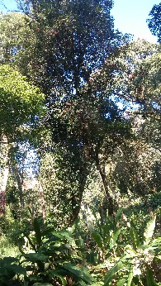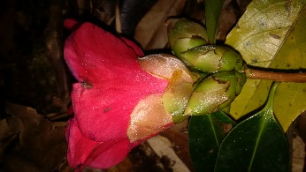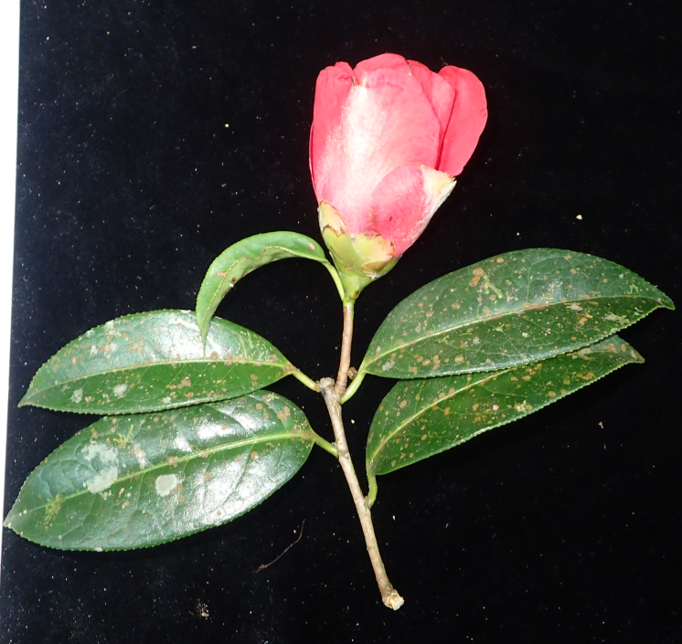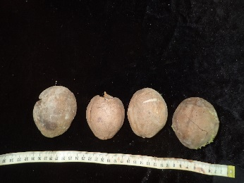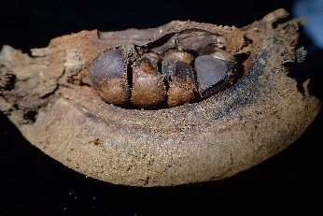
a
b
d
e
c
Figure 1. Evergreen broadleaved forest with an individual of Camellia mairei var. lapidea (Y.C.Wu) Sealy (a), flower buds (b), flower (c) fallen fruits (d), and fruit with seeds (e).

3.2 Cutting propagation

IBA doses significantly affected the rooting percentage and shoot number (Fig. 2). The highest rooting percentage (40%) was found in IBA 0.5%, reducing to 33.3% in control and 31.6% in IBA 1%. However, the difference between control and IBA 1% was not significant. A similar pattern was found in shoot number, indicating a significant difference among IBA doses and control. The highest shoot number (1.8 shoots) was found in IBA 0.5%, reducing to 1.6 shoots/cutting in control, and to 1.4 shoot/cutting is IBA 1%.

Figure 2. Effects of hormone doses on rooting and shoot numbers. Bars indicate +SE. Different letters ^{a, b} indicate significant difference of means at p = 0.05

IBA doses significantly affected the mean root number and mean root length (Fig. 3). The highest mean root number (6.7 roots) was found in IBA 0.5% and control, while it was 3.3 roots in IBA 1%. Mean root length (Fig. 4) was longest in IBA 0.5% (2.0 cm), reducing to IBA 1% (1.0 cm), and control (0.2 cm).

Figure 3. Effects of hormone doses on mean root number (MRN) and mean root length (MRL). Bars indicate +SE. Different letters ^{a, b, c} indicate significant difference of means at p = 0.05

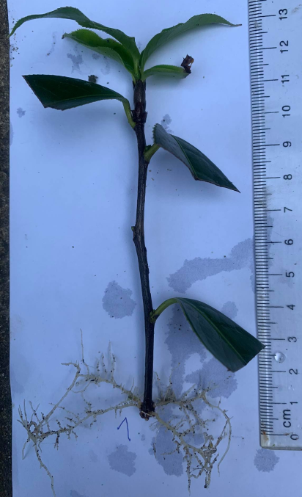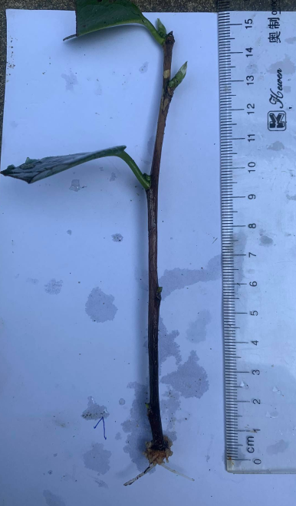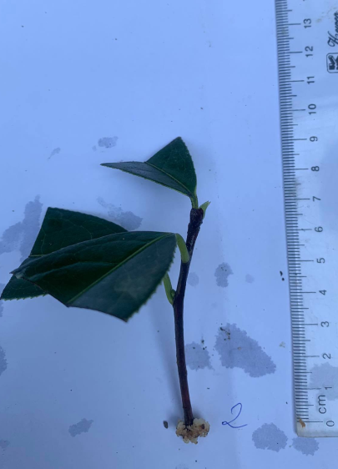
c
b
a
Figure 4. Rooted cuttings in different hormone doses (IBA 0.5% (a), IBA 1.0% (b)) and control (c)

4. Discussion
4.1. Ecology characteristics
Similar to C. mairei var. lapidea found in China [1], it was also found under the canopy of an evergreen broadleaved forest in Vietnam [24]. However, it is bigger and taller trees of up to 12 m tall and 18 cm DBH in Vietnam compared to that in China of up to 9 m tall. In China, it was found to distribute in wider elevation rages of 1,000-2,800 m above sea level [2], much wider than that in Vietnam, which is around 2,100 m.
Flower and fruit seasons of C. mairei var. lapidea in Vietnam are different from those in China. Flower season during April-June in China, but during December-February in Vietnam. While fruit season in Vietnam is from May-July, but around October in China. In addition, in both Vietnam and China C. mairei var. lapidea was found to distribute in well-drainage soil [3].
With the initial ecology characteristics of any plant, looking for potential distribution areas may become easy if the mapping technique is applied [7], [8], [18], [19]. Such a technique could be applied for C. mairei var. lapidea by using several digital maps of topography, climate, and edaphic conditions. Potential distribution areas may provide more information on ecology study, planting areas, and future development of C. mairei var. lapidea for oil production [4] in Vietnam.
No seedlings or saplings were found in the study plots, even ripen fruits were much available on the forest floor. This could be explained by a thick layer of low vegetation, which may hinder germination, survival, and growth of seedlings. The extremely small population size found (only two adult individuals) also raises concern for long-term conservation of this species [20], [21]. However, fruit and seed characteristics could be the main effect. Whole ripen fruits fall (Fig. 1) without breaking/cracking fruit cover for separating seeds. This affects water absorption and the germination of seeds. Furthermore, seed cover seems thick and the surrounding environment seems dry, which is not easy for seed germination. Also, seed germination of C. mairei var. lapidea takes a quite long time of up to 3 months in treated conditions [6], while germination of other camellias is much easier [9], [10]. This again indicates the difficulty for seed germination of C. mairei var. lapidea in natural conditions.

4.2 Cutting propagation
Effects of IBA hormone on rooting of camellia have been reported in many species [11], [12], [13], 14], [22], [23]. Which indicated that hormones promote rooting better than control and the best dose is 0.5% by weight in powder type, similar to result in the present study (Fig. 2). However, the rooting efficiency of C. mairei var. lapidea in the present study was much lower than that of other camellias as C. impressinervis and C. kirinoi [11], [12]. Such lower rooting efficiency may result from the fact that (1) cuttings of C. mairei var. lapidea were collected from natural forest and seemed old, (2) cut branches were not protected properly when transported from the field to nursery and it took several days. However, species difference may be the main reason as cuttings of C. kirinoi were also collected from the natural forest but resulted in >70% rooting [12].
It is indicated that older cutting materials must require a higher hormone dose, as higher hormone dose promotes old cells dividing better [12]. However, in the present study IBA 0.5% promoted rooting better than IBA 1%. In addition, the mean root length (Fig. 3) was also much longer in IBA 0.5% compared to IBA 1%. This could only be explained by internal factors of different species, which react differently to the surrounding environment including hormone. Therefore, IBA 0.5% is better than IBA 1%.
The rooting process seemed very low. Even at 4 months of growth, many cuttings were still in the stage of callouses, especially in control. The IBA 1% treatment also included many cuttings with callouses, different from IBA 0.5% without any callous cuttings. Higher IBA dose may inhibit the cell dividing process in C. mairei var. lapidea. Meanwhile, other camellias [11], [12] complete the rooting process in less than 4 months of growth. Cuttings of C. mairei var. lapidea may take 5, 6 months or longer to complete the rooting process.

5. ConclusionS
Camellia mairei var. lapidea (Y.C.Wu) Sealy was first found to have natural distribution in Northwest Vietnam in this study. C. mairei var. lapidea in Vietnam has some different ecology characteristics compared to its first found distribution areas in China. In Vietnam, adult individuals seem taller and bigger. In addition, flowering and fruiting seasons are also different from those in China. Natural regeneration of C. mairei var. lapidea seems to be difficult as no seedlings or saplings were found in the field, even ripen fruits with seeds were much available on the forest floor. Cutting propagation is a possible method to produce seedlings for C. mairei var. lapidea and IBA hormone is required with the best dose of 0.5% by weight in powder type. It is noted that the rooting process of C. mairei var. lapidea may take 6 months or longer. Therefore, special care must be carried out in cutting propagation.

7. References
[1] Wu, Z., Raven, P.H., & Hong, D. (2007). Flora of China. Science Press (Beijing) & Missouri Botanical Garden Press (St. Louis), 12, 1-534.
[2] Bean, W. (1981). Trees and Shrubs Hardy in Great Britain. Vol 1-4 and Supplement. Murray.
[3] Huxley, A. (1992). The New RHS Dictionary of Gardening. MacMillan Press.
[4] Kunkel, G. (1984). Plants for Human Consumption. Koeltz Scientific Books.
[5] Dirr, M.A., & Heuser, M.W. (1987). The Reference Manual of Woody Plant Propagation. Athens, Ga. Varsity Press.
[6] Bird, R. (1989). Growing from Seed 3. Thompson and Morgan.
[7] Vargas, J.H., Consiglio, T., Jorgensen, P.M., & Croat, T.B. (2004). Modelling distribution patterns in a species-rich plant genus, Anthurium (Araceae), in Ecuador. Diversity and Distributions, 10, 211-216.
[8] Nguyen, V.T., Phung, D.T., Tran, D.M., Nguyen, T.T., Dang, V.T., Dao, T.D., Mai, T.L., Nguyen, T.T.P., Ninh, V.K., Vu, T.L., Nguyen, H.T., Hoang, T.S., Trinh, N.B., Ho, T.L., Vu, V.T., & Tran, V.D. (2019). Possible planting areas for golden camellia - Camellia impressinervis in Vietnam. Asian Journal of Agriculture and Horticultural Research, 3, 1-7.
[9] Mai, T.L., Dao, T.D., Tran, D.M., Nguyen, T.T., Dang, V.T., Nguyen, T.T.P., & Tran, V.D. (2019). Can Camellia japonica grow in Vietnam? Seed germination and initial growth. Plant Cell Biotechnology and Molecular Biology, 20, 534-540.
[10] Nguyen, T.T., Mai, T.L., Tran, D.M., Dao, T.D., Nguyen, T.T.H., Nguyen, T.T.P., & Tran, V.D. (2020). Effects of storage and pre-sowing treatment on seed germination of Camellia impressinervis. Plant Cell Biotechnology and Molecular Biology, 21, 77-83.
[11] Dao, T.D., Mai, T.L., Tran, D.M., Dang, V.T., Ly, T.T.H., Nguyen, V.T., Phung, D.T., Nguyen, T.T.P., Ninh, V.K., Dang, H.H., Tran, C.N., Tran, H.Q., Pham, D.S., Vu, T.L., Nguyen, H.T., Hoang, T.S., Trinh, N.B., Ho, T.L., Tran, A.H., Duong, Q.T., Nguyen, Q.H., Tran, H.V., Nguyen, T.H.A., Dinh, H.D., Vu, V.T., & Tran, V.D. (2019). Cutting size and position affect rooting efficiency of Camellia impressinervis: A golden camellia. Plant Cell Biotechnology and Molecular Biology, 20, 179-187.
[12] Tran, D.M., Mai, T.L., Dao, T.D., Nguyen, T.T., Dang, V.T., Phung, D.T., Ninh, V.K., Nguyen, T.T.P., Ly, T.T.H., Nguyen, V.T., Dang, T.H.H., Tran, C.N., Tran, H.Q., Pham, D.S., Vu, T.L., Nguyen, H.T., Hoang, T.S., Trinh, N.B., Ho, T.L., Tran, A.H., Duong, Q.T., Nguyen, Q.H., Tran, H.V., Nguyen, T.H.A., Hoang, V.T., Dinh, H.D., Vu, V.T., Do, T.H.T., & Tran, V.D. (2019). Effects of cutting origin and exogenous hormone on rooting of Camellia kirinoi. Plant Cell Biotechnology and Molecular Biology, 20, 366-374.
[13] Rout, G.R. (2006). Effect of auxins on adventitious root development from single node cuttings of Camellia sinensis (L.) Kuntze and associated biochemical changes. Plant Growth Regulation, 48, 111-117.
[14] Yuexian, Y., Zhonglang, W., Anan, D., Li, D., & Yuanhua, G. (2012). The key technology of cutting propagation for Camellia reticulata. International Camellia Journal, 44, 114-116.
[15] Nguyen, T.T., Luong, V.D., Do, N.D., Kim, S.Y., & Curry, A.S. (2023). Camellia maianhii (Theaceae), a new species of red-flowered Camellia from the North Central Coast Region of Vietnam. Journal of Botany Research, 6(1), 176-183.
[16] Nguyen, T.L.T., Nguyen, V.C., Truong, Q.C., Nguyen, V.K., Luong, V.D., Truong, B.V., & Dang, V.S. (2023). Camellia hiepii (Theaceae), a new species from the Central Highlands of Vietnam. Kew Bulletin, 78, 359-366.
[17] Quach, V.H., Hoang, T.T., Truong, Q.C., Le, V.H., Luong, V.D., Vo, Q.T., Nong, V.D., & Curry, A.S. (2022). Camellia phuongchiana (Theaceae, section Piquetia), a new species from Lam Dong Province, southern Vietnam. Brittonia, 74, 339-345.
[18] Pham, T.M., Dang, G.T.H., Le, A.T.K., et al. (2023). Predicting the potential geographic distribution of Camellia sinensis var. shan under multiple climate change scenarios in Van Chan District, Vietnam. Modeling Earth Systems and Environment, 9, 1843-1857.
[19] Rong, S., Luo, P., Yi, H., Yang, X., Zhang, L., Zeng, D., & Wang, L. (2023). Predicting habitat suitability and adaptation strategies of an endangered endemic species, Camellia luteoflora Li ex Chang under future climate change. Forests, 14(11), 2177.
[20] Lin, C.H., Gu, H.Y., Ye, Q.L., Zhang, Z.J., Zhong, Z.M., & Yi, Q.F. (2023). Characteristics of population structure and dynamics in endangered Camellia granthamiana. Chinese Journal of Plant Ecology, 47(12), 1684-1692.
[21] Chen, S., Li, W., Li, W., Liu, Z., Shi, X., Zou, Y., Liao, W., & Fan, Q. (2023). Population genetics of Camellia granthamiana, an endangered plant species with extremely small populations in China. Frontiers in Genetics, 14, 1252148.
[22] Le, H.E., Truong, Q.C., Ngo, V.C., Nguyen, P.D., Nguyen, V.P., Do, V.D., Le, T.T.H., Ho, S.H., Nguyen, B.T., Ngo, G.P., & Ho, T.P. (2024). Conservation status and research on propagation of Camellia piquetiana in Lam Dong Province, Vietnam. Dalat University Journal of Science, 14(1), 56-71.
[23] Le Hong, E., Do Van, D., Nguyen Pham, D., Nguyen Van, P., Ngo Van, C., Le Thi Thuy, H., Ho Si, H., Nguyen Ba, T., Ngo Giang, P., Nguyen Nguyen, T., Truong Hoang, T., & Truong Quang, C. (2024). Conservation status and propagation of Camellia dalatensis and Camellia capitata by cuttings. BIOTROPIA, 31(3), 391-401.
[24] Ly, N.S., Luong, V.D., Le, T.H., Do, N.D., Tran, N., Nguyen, A.D., Nguyen, T.L., Uematsu, C., & Katayama, H. (2022). Camellia annamensis (Theaceae), a new species from central Vietnam. Taiwania, 67(2), 243-249.

