Original Research Article

Should Upper Gastrointestinal Endoscopy Be Routine Before Laparoscopic Cholecystectomy? A Prospective Study of Diagnostic Yield in Symptomatic Cholelithiasis

Abstract
Background: Symptomatic cholelithiasis is a common indication for elective laparoscopic cholecystectomy, yet the presence of gallstones does not invariably explain upper abdominal symptoms. Objective: To evaluate the diagnostic yield and clinical utility of preoperative upper gastrointestinal (UGI) endoscopy in patients with symptomatic cholelithiasis undergoing laparoscopic cholecystectomy. Methods: This prospective observational study was conducted at a tertiary care centre from October 2019 to October 2021. Seventy-one consecutive patients with clinically and ultrasonographically confirmed symptomatic cholelithiasis underwent preoperative UGI endoscopy. Demographic and clinical data were recorded. Endoscopic findings were analysed using descriptive statistics (SPSS v20). The primary outcome was detection of clinically significant UGI pathology.
Results: The cohort comprised 44 females (62.0%) and 27 males (38.0%), with 64.8% aged <40 years. Significant endoscopic abnormalities were identified in 36 patients (50.7%), while 35 (49.3%) had normal findings. Gastritis was the most common lesion (33.3%), followed by antral gastritis (22.2%) and reflux esophagitis (13.9%). Inflammatory and reflux-related lesions accounted for the majority of abnormalities. More than half (55.6%) of significant findings occurred in patients younger than 40 years. Lesion distribution was broadly similar between sexes. Conclusions: Preoperative UGI endoscopy demonstrated a high diagnostic yield in patients undergoing laparoscopic cholecystectomy for symptomatic cholelithiasis, identifying clinically relevant mucosal pathology in approximately half of cases. The substantial coexistence of upper GI disease highlights the potential value of a structured, symptom-oriented endoscopic strategy to optimise diagnostic precision and perioperative management. Further multicentre studies incorporating long-term symptom outcomes and cost-effectiveness analyses are warranted.

Keywords: Cholelithiasis, Gastrointestinal Endoscopy, Laparoscopic Cholecystectomy,

Introduction:
Symptomatic cholelithiasis is a common indication for elective laparoscopic cholecystectomy, yet the presence of gallstones does not invariably explain upper abdominal symptoms [1, 2]. Although laparoscopic cholecystectomy is safe and effective, persistent postoperative dyspepsia remains a recognised concern. Sakorafas et al. highlighted the risk of attributing nonspecific upper abdominal pain solely to gallstones, underscoring the importance of careful preoperative evaluation [3].
Distinguishing biliary colic from overlapping upper gastrointestinal (UGI) pathology remains challenging. Dyspeptic symptoms may arise from gastritis, reflux oesophagitis, peptic ulcer disease, or Helicobacter pylori infection. Testerman and Morris emphasised the clinical burden of H. pylori [4-10], while Hassan et al. suggested potential associations with chronic calculous cholecystitis [11]. Several studies, including those by Kolla et al. ^{(1),} Gupta et al. [8], Khedkar et al. [7], and Kunnuru et al. [2], have reported a substantial prevalence of endoscopic abnormalities in patients undergoing cholecystectomy. Rashid et al. [4] and Karmacharya et al. [9] further suggested that preoperative oesophagogastroduodenoscopy may identify treatable lesions that influence management.
Despite these findings, the role of routine preoperative endoscopy remains debated. While some advocate selective or universal screening (Mozafar et al.) [5], the meta-analysis by Lamberts et al. demonstrated inconsistent impact on outcomes and cost-effectiveness ^{(6).} Given this lack of consensus, the present study evaluates the diagnostic yield and clinical utility of preoperative UGI endoscopy in patients with symptomatic cholelithiasis undergoing laparoscopic cholecystectomy.
The Aim of the study to evaluate the effectiveness of upper endoscopy in patients with symptomatic cholelithiasis. The objectives of the study to evaluate the effectiveness of upper GI endoscopy in patients undergoing laparoscopic cholecystectomy. To evaluate the different types of Gastro Intestinal lesions on upper GI endoscopy in patients with symptomatic cholelithiasis

METHODS

Study design and setting
This prospective observational study was conducted in the Department of General Surgery, Jawaharlal Nehru Medical College and Hospital, Aligarh Muslim University, Aligarh, Uttar Pradesh, India, from October 2019 to October 2021. The study was approved by the Institutional Ethics Committee, and written informed consent was obtained from all participants or their guardians prior to enrolment.

Study population and sample size
Consecutive patients presenting with symptomatic cholelithiasis and planned for elective laparoscopic cholecystectomy were screened for eligibility. Symptomatic cholelithiasis was confirmed clinically and by abdominal ultrasonography. A total of 71 patients fulfilling the eligibility criteria were included in the final analysis.

Inclusion criteria
- Patients with clinical and ultrasonographic evidence of symptomatic cholelithiasis.
- Patients willing to undergo preoperative upper gastrointestinal (UGI) endoscopy.
- Patients providing written informed consent.
- All consecutive eligible patients admitted during the study period, irrespective of age or sex.

Exclusion criteria
- Patients refusing consent for UGI endoscopy.

Clinical assessment
Baseline demographic data, symptom profile, and relevant comorbidities were recorded using a structured proforma. Particular emphasis was placed on differentiating typical biliary colic from dyspeptic or reflux-related symptoms. All patients underwent ultrasonography to confirm gallstone disease prior to enrolment.

Endoscopic procedure
All patients underwent preoperative UGI endoscopy in the general surgery endoscopy suite. Patients were kept nil per oral for at least 6 hours prior to the procedure. Intravenous access was secured; no intravenous sedation or prophylactic antibiotics were administered. Topical 1% lignocaine was applied to reduce gag reflex.
A 120 cm forward-viewing flexible endoscope was used. The procedure was performed in the left lateral decubitus position under direct vision, advancing sequentially through the esophagus, stomach, and proximal duodenum. Careful mucosal inspection was carried out during insertion and withdrawal, and biopsies were taken when indicated. Endoscopic findings, including gastritis, antral or pyloric gastritis, reflux esophagitis, peptic ulcer disease, esophageal varices, and other abnormalities, were documented.

Outcome measures
The primary outcome was the diagnostic yield of UGI endoscopy in detecting clinically significant upper gastrointestinal pathology. Secondary outcomes included the frequency of abnormal endoscopic findings, correlation between presenting symptoms and endoscopic abnormalities, and any change in preoperative management based on endoscopic results.

Statistical analysis

Data were analysed using SPSS version 20.0 (IBM Corp., Armonk, NY, USA). Continuous variables were expressed as mean ± standard deviation and categorical variables as frequencies and percentages. Comparisons between categorical variables, including age group, gender, and presence of significant endoscopic pathology, were performed using the chi-square (χ²) test or Fisher’s exact test where appropriate. A two-tailed p-value <0.05 was considered statistically significant. Given the observational design and moderate sample size, analyses were exploratory in nature and primarily intended to assess associations rather than establish causality.

Results

Baseline Characteristics
Seventy-one patients with symptomatic cholelithiasis underwent preoperative upper gastrointestinal (UGI) endoscopy. Most patients were younger than 40 years (64.8%), while only 15.5% were older than 50 years, indicating a predominance of younger individuals in this cohort. Females constituted 62.0% of the study population, with a female-to-male ratio of 1.6:1, consistent with the known epidemiology of gallstone disease (Figure 1, Table 1).

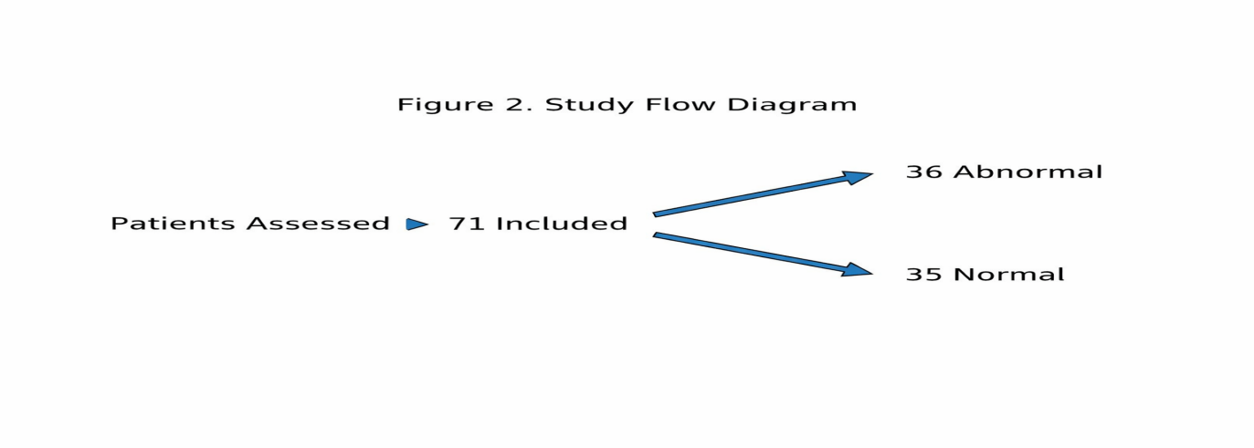
Figure 1: Study flow Diagram

Table 1: Baseline demographic characteristics (n=71)
Variable | n (%)
Age group (years)
<40 | 46 (64.8)
41–50 | 14 (19.7)
51–60 | 8 (11.3)
61–70 | 1 (1.4)
>70 | 2 (2.8)
Gender
Male | 27 (38.0)
Female | 44 (62.0)

Diagnostic Yield of Upper GI Endoscopy
Preoperative UGI endoscopy revealed clinically significant mucosal pathology in 36 of 71 patients, corresponding to a diagnostic yield of 50.7%. Nearly half of the patients (49.3%) had a normal endoscopic examination. The detection of upper gastrointestinal lesions in more than one-half of patients highlights the substantial burden of concomitant mucosal disease in individuals presenting with symptomatic cholelithiasis. This finding underscores the potential for symptom overlap between biliary and non-biliary gastrointestinal pathology and supports the rationale for comprehensive preoperative evaluation (Table 2).
Table 2: Overall endoscopic findings (n=71)
Finding | n (%)
Normal study | 35 (49.3)
Significant lesion | 36 (50.7)

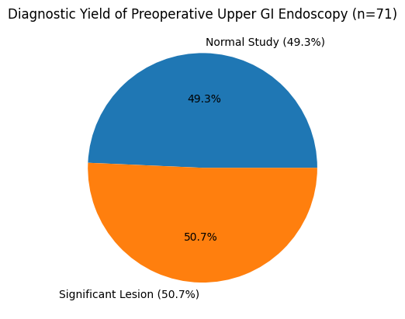

Figure 2: Diagnostic Yield of Preoperative Upper GI Endoscopy

Spectrum and Pattern of Endoscopic Lesions
Among the 36 patients with abnormal findings, inflammatory gastric pathology predominated. Gastritis was the most frequent lesion, observed in 33.3% of cases, followed by antral gastritis (22.2%). Reflux esophagitis accounted for 13.9% of significant lesions. When considered collectively, inflammatory and reflux-related conditions represented the majority of abnormalities detected. Less frequent findings included esophageal varices, pyloric gastritis, and combined mucosal lesions.
The predominance of gastritis and antral gastritis suggests that acid-peptic disease is a major contributor to upper abdominal symptomatology in this population. Importantly, several lesions identified on endoscopy have established medical therapies, which may influence symptom resolution independently of cholecystectomy.
Table 3: Distribution of significant endoscopic lesions (n=36)
Lesion | n (%)
Gastritis | 12 (33.3)
Antral gastritis | 8 (22.2)
Reflux esophagitis | 5 (13.9)
Esophageal varices | 2 (5.6)
Esophagitis | 2 (5.6)
Pyloric gastritis | 2 (5.6)
Other combined lesions | 5 (13.9)

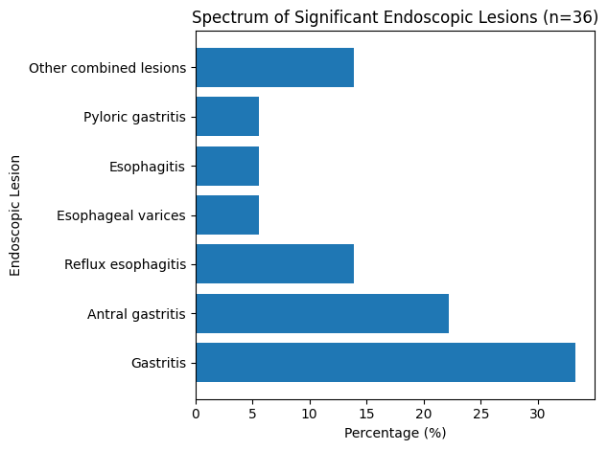
Figure 3: Distribution of Significant Endoscopic Lesions

Gender-Based Differences
Of the 36 patients with significant endoscopic findings, 22 were females and 14 were males. Although females had a higher absolute number of lesions, this corresponded to their greater representation in the study population. Gastritis and antral gastritis were the most common lesions in both sexes. Reflux esophagitis was proportionally more frequent in males (21.4%) compared to females (9.1%), whereas esophageal varices were observed only in female patients.
These findings suggest that while the overall burden of upper GI pathology parallels the gender distribution of gallstone disease, certain lesion patterns may vary between sexes.
Table 4: Gender-wise distribution of significant lesions
Lesion | Male (n=14) n (%) | Female (n=22) n (%)
Gastritis | 5 (35.7) | 7 (31.8)
Antral gastritis | 3 (21.4) | 5 (22.7)
Reflux esophagitis | 3 (21.4) | 2 (9.1)
Esophageal varices | 0 | 2 (9.1)
Other lesions | 3 (21.4) | 6 (27.3)

Age Distribution of Significant Lesions
More than half (55.6%) of all significant endoscopic abnormalities were identified in patients younger than 40 years. Patients aged 41–60 years accounted for 36.1% of lesions, while those older than 60 years represented a smaller proportion. The high prevalence of upper GI pathology among younger individuals is noteworthy, particularly given the assumption that acid-peptic disorders are more common in older age groups.
This age-related distribution reinforces the importance of not overlooking coexisting upper gastrointestinal disease in younger patients presenting with biliary symptoms.
Table 5: Age-wise distribution of significant lesions (n=36)
Age group (years) | n (%)
<40 | 20 (55.6)
41–50 | 6 (16.7)
51–60 | 7 (19.4)
≥61 | 3 (8.3)

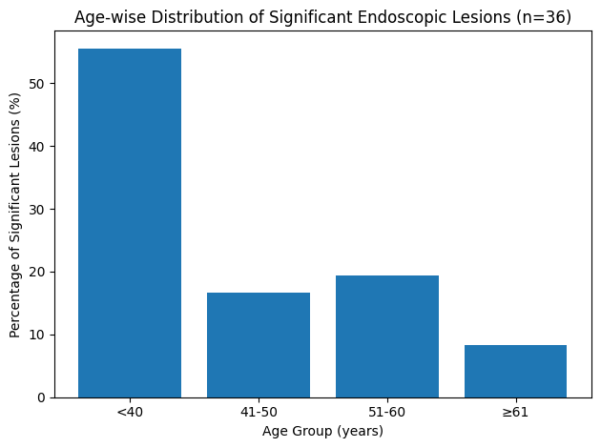

Figure 4: Age Distribution of Significant Endoscopic Findings

Overall Interpretation
In this prospective cohort, routine preoperative UGI endoscopy demonstrated a high diagnostic yield, identifying clinically relevant mucosal pathology in approximately one-half of patients undergoing laparoscopic cholecystectomy for symptomatic cholelithiasis. The predominance of inflammatory and reflux-related lesions suggests that a substantial proportion of symptoms attributed to gallstones may coexist with or be compounded by upper gastrointestinal disease. These findings have important implications for preoperative evaluation, patient counselling, and optimization of postoperative symptom outcomes.

Cost and Safety Considerations
Although provided free of cost to patients, preoperative UGI endoscopy required institutional resources, including equipment and personnel time. Formal cost-effectiveness analysis was beyond the scope of this study; however, clinically significant pathology was identified in 50.7% of patients. No procedure-related complications were observed, indicating a favourable safety profile. Broader health-system economic evaluation is warranted to determine whether selective use of endoscopy optimises resource utilisation while improving perioperative management (Table 1-5, Figure 1-5).

Discussion
In this prospective cohort of patients undergoing laparoscopic cholecystectomy for symptomatic cholelithiasis, preoperative upper gastrointestinal (UGI) endoscopy demonstrated a clinically meaningful diagnostic yield of 50.7%. Significant mucosal pathology was identified in more than half of the patients, with inflammatory and reflux-related lesions constituting the majority of abnormalities. These findings reinforce the concept that symptom overlap between biliary colic and acid-peptic disease is substantial and clinically relevant [1, 2, 7, 8]. In routine surgical practice, upper abdominal pain, dyspepsia, bloating, and heartburn are frequently attributed solely to gallstones once ultrasonographic confirmation is obtained. However, earlier critical appraisals have cautioned against oversimplification of symptom attribution in gallstone disease [3]. Our data suggest that such attribution may be incomplete in a considerable proportion of patients.
The predominance of gastritis and antral gastritis highlights the burden of acid-related mucosal disease in this population. Importantly, these conditions are amenable to structured medical therapy, including proton pump inhibitors and Helicobacter pylori eradication strategies where indicated [10]. Associations between H. pylori infection and chronic calculous cholecystitis have also been described [11], further supporting comprehensive evaluation. Early identification provides an opportunity for therapeutic optimisation before surgery and may contribute to improved postoperative symptom control. The detection of reflux oesophagitis and combined lesions further underscores the multifactorial nature of upper abdominal symptomatology in patients with gallstones. From a clinical standpoint, distinguishing biliary from non-biliary pain is critical to minimising the risk of persistent symptoms following technically successful cholecystectomy [4, 9].
A notable observation in our study was the high proportion of significant lesions among patients younger than 40 years. This challenges the assumption that clinically relevant UGI pathology is largely confined to older individuals and suggests that age alone may not be an adequate criterion for selective endoscopic screening. Moreover, although females constituted the majority of the cohort—reflecting the epidemiology of gallstone disease—the pattern of lesions was broadly similar between sexes. This observation aligns with previously reported data indicating substantial endoscopic findings across demographic subgroups [1, 2, 8].
Collectively, our findings emphasise the potential value of structured preoperative evaluation in patients with symptomatic cholelithiasis. While some authors advocate routine or universal screening [5], and systematic review evidence has questioned uniform benefit and cost-effectiveness [6], the high diagnostic yield observed in this prospective study supports a selective or protocol-driven approach. In an era increasingly focused on quality metrics and patient-reported outcomes, persistent postoperative dyspeptic symptoms remain a challenge. By identifying coexisting upper GI pathology preoperatively, surgeons may better counsel patients, tailor adjunctive medical therapy, and refine operative indications. These results contribute meaningful evidence to an ongoing clinical debate and have direct implications for perioperative optimisation strategies in general surgical practice.

Clinical Implications
The substantial prevalence of significant upper gastrointestinal pathology in this cohort underscores the value of structured preoperative assessment in symptomatic cholelithiasis. While universal screening remains debatable, our findings support a selective, symptom-driven approach. Patients with dyspepsia, reflux, atypical epigastric pain, or persistent upper abdominal discomfort may benefit most from endoscopic evaluation. Identification of treatable acid-peptic or inflammatory lesions enables targeted medical optimisation prior to surgery and may reduce persistent postoperative symptoms. Integrating defined clinical criteria into preoperative pathways may enhance diagnostic precision while avoiding unnecessary routine endoscopy.

Conclusion
Preoperative upper gastrointestinal endoscopy identified clinically significant mucosal pathology in approximately half of patients undergoing laparoscopic cholecystectomy for symptomatic cholelithiasis. Inflammatory and reflux-related lesions predominated and were frequently observed even in younger individuals. These findings underscore the substantial coexistence of upper GI disease in patients presenting with biliary symptoms and highlight the potential role of endoscopy in enhancing diagnostic precision and perioperative optimisation.
A structured, symptom-oriented endoscopic strategy may improve patient selection, facilitate targeted medical therapy, and potentially reduce the burden of persistent postoperative symptoms. Further multicentre, outcome-driven studies incorporating long-term symptom assessment and cost-effectiveness analysis are warranted to define the optimal integration of UGI endoscopy into preoperative pathways for gallstone disease.

Strengths
- Prospective observational design
- Inclusion of consecutive patients, reducing selection bias
- Structured and standardised endoscopic assessment
- Systematic documentation of lesion patterns and demographics
- Clinically relevant research question addressing an ongoing surgical debate
- Contextual evidence from a tertiary care centre

Limitations
- Single-centre design: The study was conducted at a single tertiary care institution, which may limit the generalisability of the findings to other populations and healthcare settings.
- Moderate sample size: Although prospectively conducted, the relatively small cohort (n=71) may limit the statistical power to detect subgroup differences and rare endoscopic pathologies.
- Lack of long-term follow-up: Postoperative symptom resolution and quality-of-life outcomes were not systematically evaluated, precluding definitive conclusions regarding the direct clinical impact of preoperative endoscopy on long-term outcomes.
- No cost-effectiveness analysis: The study did not assess the economic implications of routine versus selective upper GI endoscopy, which is an important consideration in resource-constrained settings.
- Absence of comparative arm: There was no control group of patients undergoing cholecystectomy without preoperative endoscopy, limiting the ability to directly compare outcomes between endoscopy-guided and standard pathways.
Despite these limitations, the prospective design, inclusion of consecutive patients, and structured evaluation of endoscopic findings enhance the methodological robustness and clinical relevance of the study.

Ethics Approval and Consent to Participate
The study was approved by the Institutional Ethics Committee of Jawaharlal Nehru Medical College and Hospital, Aligarh Muslim University . Written informed consent was obtained from all participants prior to enrolment.

COMPETING INTERESTS DISCLAIMER:
Authors have declared that they have no known competing financial interests OR non-financial interests OR personal relationships that could have appeared to influence the work reported in this paper.

REFERENCES
- Kolla V, Charles N, Datey S, Mahor D, Gupta A, Malhotra S. Upper gastrointestinal endoscopy prior to laparoscopic cholecystectomy: a clinical study at a tertiary care centre in central India. International Surgery Journal. 2016 Dec 8;3(2):637-42.
- Kunnuru SK, Kanmaniyan B, Thiyagarajan M, Singh BK, Navrathan N. A Study on Efficacy of UGI Scopy in Cholelithiasis Patients before Laparoscopic Cholecystectomy. Minimally Invasive Surgery. 2021 Jan 13;2021.
- Sakorafas GH, Milingos D, Peros G. Asymptomatic cholelithiasis: is cholecystectomy really needed? A critical reappraisal 15 years after the introduction of laparoscopic cholecystectomy. Digestive diseases and sciences. 2007 May;52(5):1313-25.
- Rashid F, Rashid N, Waraich N, Ahmed J, Iftikhar SY. Role of routine oesophago-gastroduodenoscopy before cholecystectomy. International Journal of Surgery. 2010 Jan 1;8(3):236-8.
- Mozafar M, reza Sobhiyeh M, Heibatollahi M. Is esophagogastroduodenoscopy essential prior to the elective surgical therapy of symptomatic cholelithaisis?. Gastroenterology and Hepatology From Bed to Bench. 2010 Mar 15;3(2).
- Lamberts MP, Kievit W, Özdemir C, Westert GP, van Laarhoven CJ, Drenth JP. Value of EGD in patients referred for cholecystectomy: a systematic review and meta-analysis. Gastrointestinal endoscopy. 2015 Jul 1;82(1):24-31.
- Khedkar I, Prasad D, Datta A. Diagnostic value of upper gastrointestinal endoscopy prior to elective laparoscopic cholecystectomy for symptomatic cholelithiasis. International Surgery Journal. 2017 Dec 26;5(1):105-9.
- Gupta P, Gupta V, Singh SP, Singh SP, Mishra SP, Singh P, Kumar A, Prakash M, Gupta M, Singh M, Havele S. Role of routine upper gastro intestinal endoscopy in patients of cholelithiasis presenting with dyspepsia in rural set-up. International Surgery Journal. 2016 Dec 8;3(2):509-15.
- Karmacharya A, Malla BR, Joshi HN, Gurung RB, Rajbhandari M. The predictive value of pre-operative symptoms including upper gastrointestinal endoscopy before laparoscopic cholecystectomy for elective symptomatic cholecystolithiasis. Kathmandu University Medical Journal. 2013;11(4):300-4.
- Testerman TL, Morris J. Beyond the stomach: an updated view of Helicobacter pylori pathogenesis, diagnosis, and treatment. World journal of gastroenterology: WJG. 2014 Sep 28;20(36):12781.
- Hassan EH, Gerges SS, Ahmed R, Mostafa ZM, Hassan A, ABD AL-HAMID HA, ABD EL-GALIL HE, Thabet S. Detection of Helicobacter antigen in stool samples and its relation to H. pylori positive cholecystitis in Egyptian patients with chronic calcular cholecystitis. Journal of the Egyptian Society of Parasitology. 2015 Dec 1;45(3):579-86.

