Review Article
Thoracolumbar Spine Trauma: A Literature Review

.
ABSTRACT
Aims:
To provide a comprehensive review of thoracolumbar trauma, including its epidemiology, biomechanical mechanisms, classification systems, clinical presentation, diagnostic evaluation, management strategies, complications, and prognosis.
Study Design:
Narrative literature review.
Methodology:
This paper reviews published literature relevant to thoracolumbar trauma and summarizes key aspects of injury patterns, risk factors, anatomical and biomechanical considerations, clinical manifestations, neurological assessment, imaging modalities, and current treatment approaches. Particular attention is given to commonly used classification systems, including the AO Spine Classification System and the Thoracolumbar Injury Classification and Severity Score (TLICS), as well as the role of conservative and operative management.
Results:
Thoracolumbar trauma represents a major form of spinal injury, particularly because the thoracolumbar junction is a biomechanically vulnerable transition zone between the rigid thoracic spine and the more mobile lumbar spine. Common causes include traffic accidents, falls, sports injuries, and occupational trauma. Injury patterns range from stable compression fractures to unstable burst fractures, distraction injuries, and fracture-dislocations, with varying risks of neurological impairment. Accurate evaluation requires careful history taking, physical and neurological examination, and appropriate imaging, including X-ray, computed tomography, and magnetic resonance imaging. Classification systems such as AO Spine and TLICS are essential for assessing fracture morphology, spinal stability, and neurological status, thereby guiding treatment decisions. Stable injuries without neurological deficit are often managed conservatively with bracing, analgesia, and rehabilitation, whereas unstable injuries or those associated with neural compression frequently require surgical decompression and spinal stabilization. Early recognition and timely intervention are important to reduce long-term disability and improve functional outcomes.
Conclusion:
Thoracolumbar trauma is a clinically significant condition with potentially severe neurological and functional consequences. A thorough understanding of its mechanisms, classification, diagnosis, and treatment options is essential for appropriate management. Early diagnosis, proper injury stratification, and timely individualized treatment can improve prognosis, minimize complications, and enhance patient recovery.
Keywords: Thoracolumbar trauma, spinal fractures, thoracolumbar junction, spinal injury classification, AO Spine classification, TLICS, spinal stability, spinal trauma management
1. INTRODUCTION
Thoracolumbar trauma represents one of the most frequently encountered forms of spinal injury in clinical practice and constitutes a significant cause of morbidity and long-term disability worldwide. The thoracolumbar region, generally defined as the segment between the tenth thoracic vertebra (T10) and the second lumbar vertebra (L2), plays a crucial role in maintaining spinal stability and facilitating body movement. This region is considered biomechanically vulnerable because it represents the transition zone between the relatively rigid thoracic spine and the more mobile lumbar spine. The thoracic spine is stabilized by the rib cage and has limited mobility, while the lumbar spine allows greater flexibility and movement. As a result, the thoracolumbar junction is particularly susceptible to traumatic forces and mechanical stress during high-energy injuries.
Thoracolumbar injuries can occur due to a variety of traumatic mechanisms. The most common causes include motor vehicle accidents, falls from height, sports-related trauma, and occupational injuries. In developing countries, road traffic accidents and occupational hazards remain the leading contributors to spinal trauma. These mechanisms often involve high-energy forces such as axial compression, flexion, extension, rotation, or combinations of these movements. Such forces can disrupt the normal anatomical structure of the vertebrae, intervertebral discs, ligaments, and surrounding soft tissues, potentially resulting in spinal instability and neurological compromise.
The clinical spectrum of thoracolumbar trauma is broad and ranges from relatively stable compression fractures to highly unstable injuries such as burst fractures, flexion-distraction injuries, and fracture-dislocations. Stable fractures may present with localized pain and limited mobility without neurological impairment, whereas unstable injuries can lead to spinal canal compromise and damage to the spinal cord or nerve roots. Neurological deficits associated with thoracolumbar trauma may manifest as motor weakness, sensory disturbances, bowel or bladder dysfunction, or complete paralysis depending on the severity and level of injury. Such complications can significantly affect patients’ quality of life and may result in permanent disability.
Early and accurate diagnosis is essential for the appropriate management of thoracolumbar injuries. Clinical evaluation begins with a detailed history and thorough physical examination, including neurological assessment to determine the extent of spinal cord or nerve root involvement. Imaging studies play a crucial role in confirming the diagnosis and evaluating the severity of the injury. Conventional radiography is often used as an initial screening tool to identify vertebral fractures or alignment abnormalities. However, computed tomography (CT) has become the gold standard for evaluating bony structures and fracture morphology, while magnetic resonance imaging (MRI) provides valuable information regarding soft tissue injuries, ligamentous disruption, intervertebral disc damage, and spinal cord compression.
To facilitate standardized evaluation and guide treatment decisions, several classification systems have been developed for thoracolumbar spinal injuries. Among the most widely used are the AO Spine Classification System and the Thoracolumbar Injury Classification and Severity Score (TLICS). The AO Spine Classification System categorizes injuries based on fracture morphology, neurological status, and the presence of specific modifiers, allowing clinicians to assess injury severity and determine appropriate management strategies. Meanwhile, the TLICS system evaluates three major parameters: injury morphology, integrity of the posterior ligamentous complex, and neurological status. These classification systems provide structured approaches that assist clinicians in determining whether conservative management or surgical intervention is indicated.
The management of thoracolumbar trauma depends on multiple factors, including fracture stability, degree of spinal canal compromise, neurological status, and overall patient condition. Conservative treatment is generally indicated for stable fractures without neurological deficits and typically involves pain control, spinal immobilization with braces or orthoses, early mobilization, and physical rehabilitation. On the other hand, unstable fractures or injuries associated with neurological impairment often require surgical intervention. Surgical treatment aims to decompress neural elements, restore spinal alignment, and achieve adequate spinal stabilization through various techniques such as posterior instrumentation, anterior stabilization, or combined approaches.
Despite advances in diagnostic imaging, surgical techniques, and rehabilitation strategies, thoracolumbar trauma continues to pose significant clinical challenges. Complications such as chronic pain, spinal deformity, neurological deficits, and reduced functional capacity remain common among affected individuals. Therefore, a comprehensive understanding of the epidemiology, pathophysiology, classification, diagnostic evaluation, and treatment strategies of thoracolumbar trauma is essential for optimizing patient outcomes and reducing long-term complications.
This review aims to provide a comprehensive overview of thoracolumbar trauma, including its epidemiology, mechanisms of injury, anatomical and biomechanical considerations, classification systems, diagnostic approaches, treatment options, complications, and prognosis. By summarizing the current literature on this topic, this paper seeks to enhance understanding of thoracolumbar injuries and support evidence-based clinical decision-making in the management of spinal trauma.

2. material and methods
This study was conducted as a narrative literature review focusing on thoracolumbar trauma and its clinical management. The objective of this review was to summarize current knowledge regarding the epidemiology, mechanisms of injury, classification systems, diagnostic evaluation, and management strategies for thoracolumbar spine injuries. Thoracolumbar trauma represents one of the most common types of spinal injury due to the biomechanical vulnerability of the thoracolumbar junction, which acts as a transition zone between the relatively rigid thoracic spine and the more mobile lumbar spine.
A comprehensive search of scientific literature was performed using electronic databases including PubMed, Google Scholar, and other accessible academic resources. The literature search was conducted using several keywords and combinations of terms such as thoracolumbar trauma, thoracolumbar spine injury, spinal fractures, thoracolumbar junction, AO Spine classification, thoracolumbar injury classification and severity score (TLICS), spinal cord injury, diagnosis of spinal trauma, and management of thoracolumbar fractures. These keywords were selected to ensure that relevant studies related to the pathophysiology, classification, diagnosis, and treatment of thoracolumbar trauma were identified.
Articles published in English that discussed thoracolumbar spine injuries in humans were considered for inclusion in this review. Priority was given to peer-reviewed journal articles, review papers, clinical studies, and guideline publications related to spinal trauma. Both classical references and recent publications were reviewed in order to provide a comprehensive understanding of the topic and to include updated concepts in spinal trauma management.
The selection of literature was based on relevance to the subject of thoracolumbar trauma. Studies that addressed key aspects of thoracolumbar injury, including mechanisms of injury, anatomical and biomechanical considerations, clinical manifestations, neurological assessment, imaging modalities, and treatment approaches, were included. Particular attention was given to literature describing commonly used classification systems such as the AO Spine Thoracolumbar Injury Classification System and the Thoracolumbar Injury Classification and Severity Score (TLICS), which are widely used in clinical decision-making.
After identifying relevant sources, the selected articles were carefully reviewed and analyzed. Important findings from these studies were extracted and organized into thematic categories to facilitate a structured discussion. These thematic sections included epidemiology, biomechanical mechanisms of injury, injury patterns, classification systems, clinical assessment, diagnostic imaging, and management strategies for thoracolumbar trauma.
The collected information was then synthesized to provide a comprehensive overview of the current understanding of thoracolumbar spine injuries. Emphasis was placed on identifying clinically relevant findings that may assist healthcare professionals in improving diagnosis, treatment planning, and patient outcomes. By integrating information from multiple scientific sources, this review aims to present an updated and comprehensive summary of thoracolumbar trauma and its management.

3. results
The present literature review demonstrates that thoracolumbar trauma remains one of the most clinically important forms of spinal injury because it occurs in a region characterized by a unique biomechanical transition between the relatively rigid thoracic spine and the more mobile lumbar spine. The reviewed sources consistently identify the thoracolumbar junction, especially T11–L2 and most notably T12–L1, as the most vulnerable area for traumatic injury due to its role as a stress concentration zone during axial loading, flexion, extension, distraction, and rotational movements.^{1,2,3} This structural transition explains why thoracolumbar trauma appears with high frequency in both high-energy and low-energy mechanisms and why injury patterns in this region are highly variable, ranging from stable compression fractures to severe fracture-dislocations with neurologic compromise.^{4,5}
The literature reviewed in this paper also shows that thoracolumbar trauma contributes substantially to the burden of spinal injury worldwide. The incidence of thoracolumbar trauma is reported to comprise a large proportion of all spinal injuries, with road traffic accidents and falls repeatedly cited as the leading etiologies.^{6,7,8} The epidemiologic profile described in the review shows a clear demographic pattern. In high-energy trauma, the most commonly affected patients are young adult males in the productive age group, often between 20 and 45 years, reflecting greater exposure to vehicle accidents, occupational trauma, sports-related injuries, and work at heights. In contrast, low-energy thoracolumbar fractures are more commonly seen in older patients, especially postmenopausal women with osteoporosis or patients with poor bone quality. These findings indicate that thoracolumbar trauma must be understood not as a single disease entity but as a broad clinical spectrum shaped by age, trauma mechanism, bone integrity, occupational exposure, and access to acute care.^{9,10}
Another major result of this review is the central role of anatomy and biomechanics in explaining both the frequency and severity of thoracolumbar injury. The thoracic spine benefits from rib cage support and has relatively limited mobility, whereas the lumbar spine is more mobile and designed to bear greater axial load.^{11,12} At the thoracolumbar junction, the abrupt transition between rigidity and mobility generates a vulnerable mechanical environment. The literature repeatedly describes this region as a “stress riser,” meaning that biomechanical forces become concentrated there during trauma. During vertical loading, the anterior and middle spinal columns may fail under compressive stress. During flexion-distraction, the posterior tension band may rupture. During translational or rotational trauma, multiple columns can fail simultaneously, producing the most unstable injuries. Thus, the reviewed literature confirms that the lesion pattern is inseparable from the direction, magnitude, and speed of the force acting on the spine.^{13,14,15}
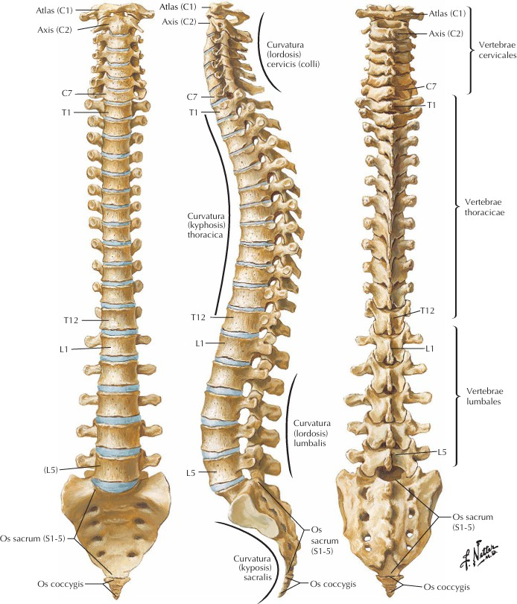

Figure 1. General Anatomy of the Spine (Netter, 2016)

The review further reveals that different mechanisms of trauma produce different morphological patterns of vertebral injury. Low-energy trauma in osteoporotic bone most commonly produces compression fractures confined mainly to the anterior column, usually with relatively preserved posterior stability. High-energy axial loading, especially when combined with flexion, more commonly results in burst fractures, where the vertebral body fails more extensively and osseous fragments may be retropulsed into the spinal canal. Flexion-distraction injury occurs when the spine undergoes excessive forward bending with posterior tensile failure, often associated with seat-belt type mechanisms. Translational and rotational injuries constitute the most severe category because they involve marked displacement, multi-column failure, and a high risk of complete neurologic injury. This pattern-based distribution supports the importance of mechanism-based diagnostic reasoning in acute thoracolumbar trauma.^{16,17,18}
A particularly important finding in the reviewed literature is that the vertebral level L1 is reported as the most frequently involved segment in thoracolumbar trauma, followed by T12 and L2. This observation is highly consistent with the biomechanical concept of the thoracolumbar junction as a vulnerable transition zone. The review also indicates that burst fracture is among the most frequent morphologic patterns in this region and contributes substantially to neurologic morbidity because posterior vertebral body fragments can narrow the spinal canal and compress the conus medullaris or cauda equina. In the sources reviewed, burst fractures were strongly associated with high-energy trauma, including falls from height and motor vehicle collisions, and were repeatedly linked with severe neurologic deficits.^{19,20,21}
The neurologic consequences of thoracolumbar trauma emerged as one of the most clinically decisive findings of this review.²¹ Unlike injuries in more uniform spinal regions, thoracolumbar trauma may involve the distal spinal cord, conus medullaris, or cauda equina, thereby producing a wide range of neurologic syndromes. The reviewed literature shows that lesions at higher thoracolumbar levels may produce upper motor neuron features such as spasticity and hyperreflexia, whereas injuries involving the cauda equina may produce lower motor neuron findings such as flaccid weakness, hyporeflexia, sensory loss, and sphincter dysfunction.^{22,23} Conus medullaris involvement may generate a mixed syndrome with bilateral weakness, saddle sensory disturbance, urinary retention or incontinence, bowel dysfunction, and sexual dysfunction. These findings underscore that the neurologic presentation of thoracolumbar trauma can be anatomically complex and that careful neurologic examination remains essential in every case.^{24,25}
The review also demonstrates that the severity of neurologic injury correlates not only with the fracture type but also with the degree of canal compromise, the presence of posterior ligamentous injury, and the timing of treatment. Stable compression fractures generally carry a low risk of major neurologic deficit, whereas unstable burst, distraction, and translational injuries are more often associated with serious neurologic compromise. The literature cited in the review notes that a significant proportion of thoracolumbar trauma cases present with neurologic lesions and that more severe injuries are frequently classified as complete or near-complete neurologic deficits. Delayed diagnosis, delayed referral, and delayed decompression are repeatedly associated with worse functional outcomes. This reinforces the importance of early recognition of red flags and urgent intervention when progressive neurologic signs are present.^{26,27}
Radiologic evaluation was also identified as a major pillar in the assessment of thoracolumbar trauma. Plain radiography remains useful as an initial imaging modality because it can identify vertebral collapse, malalignment, or gross fracture. However, the review clearly emphasizes the superior role of CT in the detection of complex fracture morphology, vertebral comminution, retropulsed fragments, and occult osseous injury. CT is especially useful in burst fractures, where canal compromise and posterior vertebral wall involvement must be carefully assessed.^{28,29,30} MRI, in turn, is highlighted as the best modality for evaluating the spinal cord, conus medullaris, cauda equina, intervertebral discs, epidural hematoma, and posterior ligamentous complex. Thus, the results of this review strongly support a multimodal imaging strategy in which CT defines the bony injury and MRI clarifies the soft tissue and neurologic injury.^{31,32}

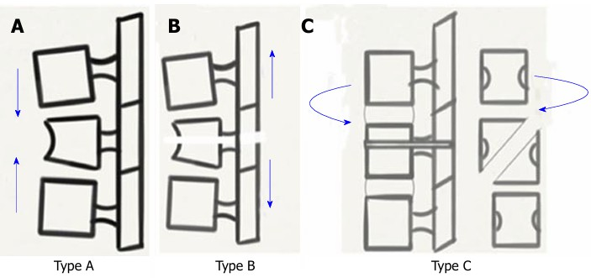

Figure 2. Biomechanical Mechanisms of Spinal Injury: Type A (Compression), Type B (Distraction), and Type C (Rotation) (Gamanagatti et al., 2015)

The reviewed literature further confirms the value of classification systems in organizing thoracolumbar trauma into clinically meaningful patterns. The Denis three-column model remains important because it provides a structural basis for differentiating stable from unstable injuries. According to this model, isolated injury to one column is usually stable, whereas disruption of two or more columns suggests instability and greater neurologic risk. This conceptual framework is especially useful in understanding burst fractures, where middle-column injury and canal encroachment are common. Although the Denis model has limitations, especially in purely ligamentous injury and osteoporotic trauma, it continues to provide a useful explanatory foundation for modern clinical reasoning.^{33,34}
The AO Spine classification system was also shown to be highly relevant in the reviewed literature because it links fracture morphology to injury severity. AO Type A injuries represent compression patterns, usually involving vertebral body collapse of varying severity. ^{35,36} AO Type B injuries involve distraction mechanisms and posterior tension band failure, often with significant instability even if the vertebral body injury appears limited. AO Type C injuries are characterized by translational or rotational displacement and represent the most unstable end of the spectrum. The literature reviewed in this paper consistently portrays Type C injuries as having the highest potential for major neurologic injury because of the severe mechanical disruption across the spinal columns.^{37,38}

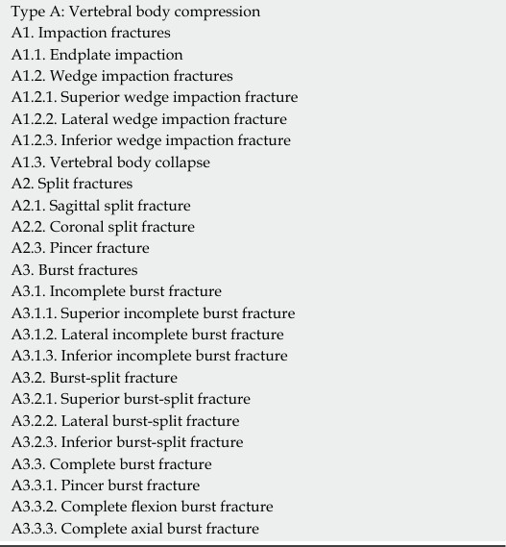

Figure 3. AO Type A Subcategories (Gamanagatti et al., 2015)

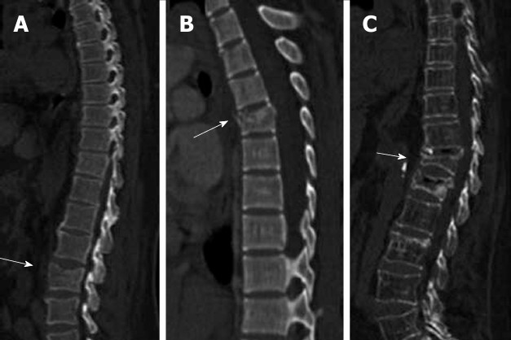

Figure 4. Type A1 Compression Injuries (Gamanagatti et al., 2015)

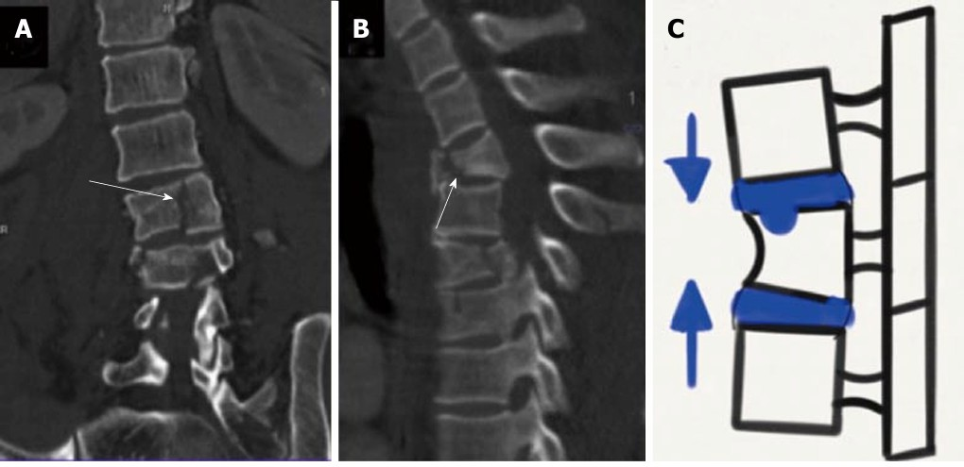

Figure 5. AO Type A2 Compression Injuries (Gamanagatti et al., 2015)

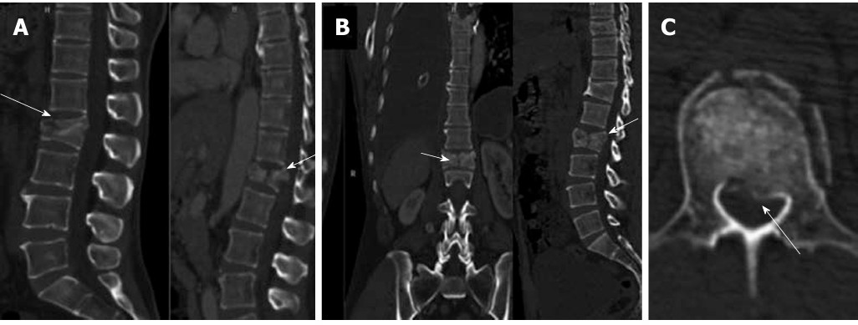

Figure 6. AO Type A3 Compression Injuries: Burst Fractures (Gamanagatti et al., 2015)
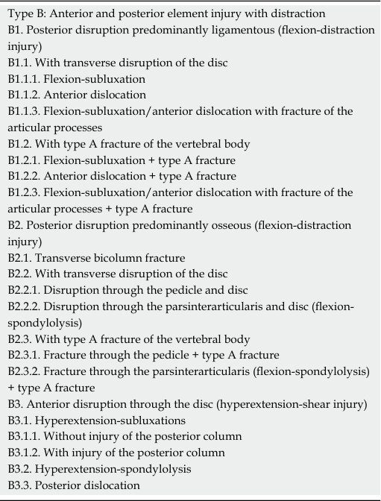

Figure 7. AO Type B Subcategories (Gamanagatti et al., 2015)

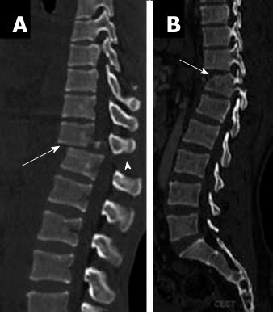

Figure 8. AO Type B1 Flexion-Distraction Injury (Gamanagatti et al., 2015)

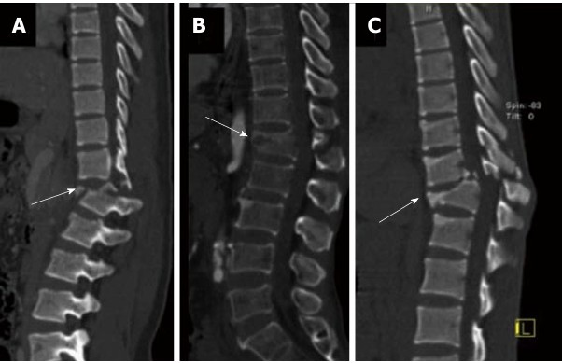

Figure 9. AO Type B2 Flexion-Distraction Injury (Gamanagatti et al., 2015)

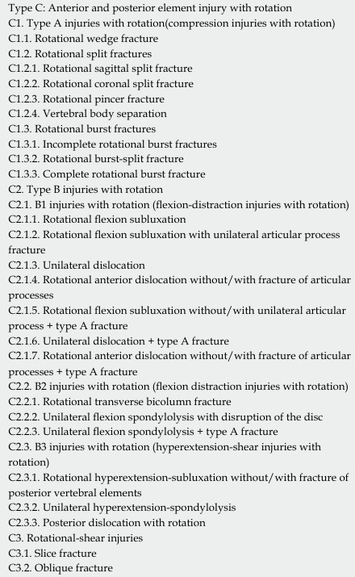

Figure 10. AO Type C Subcategories (Gamanagatti et al., 2015)

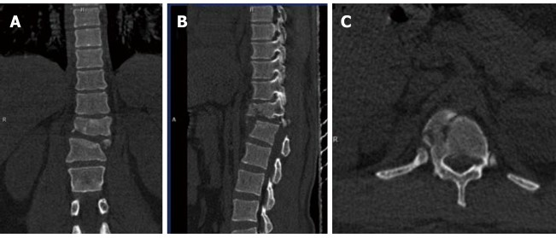

Figure 11. AO Type C1 Rotational Injuries (Gamanagatti et al., 2015)

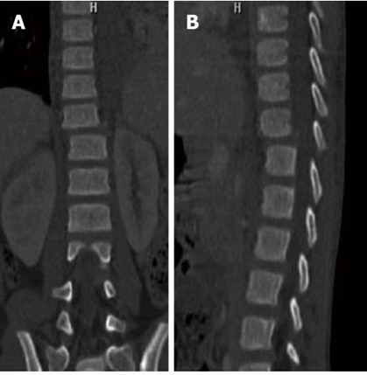

Figure 12. AO Type C2 Rotational Injuries (Gamanagatti et al., 2015)

The TLICS framework, as summarized in the review, adds further clinical value by incorporating three major components: fracture morphology, integrity of the posterior ligamentous complex, and neurologic status. This makes TLICS particularly useful for treatment selection because it does not rely solely on radiographic appearance.^{39.40} A patient with a modest-appearing fracture on CT may still require surgery if neurologic deficit is present or if MRI shows major ligamentous disruption. Conversely, an apparently dramatic vertebral body compression may be treated conservatively if the injury is mechanically stable and neurologically intact. Therefore, this review shows that TLICS enhances decision-making by integrating structure, stability, and neurologic severity into a single practical scoring approach.^{41,42}
Management findings in the reviewed literature show a clear distinction between stable and unstable injury patterns. Stable compression injuries without neurologic deficit are commonly managed conservatively with bracing, analgesia, early mobilization, activity modification, and rehabilitation. In contrast, unstable injuries, especially those involving multiple columns, posterior ligamentous failure, canal compromise, or neurologic deficit, are often treated surgically.^{43,44} Surgical goals include decompression of neural structures, restoration of alignment, stabilization of the spinal segment, and facilitation of early mobilization. The literature reviewed repeatedly supports early stabilization and decompression, especially in neurologically impaired patients, because delayed management is associated with worse neurologic and functional outcomes.^{45,46}
The results of this review also show that rehabilitation plays a major role in outcome after thoracolumbar trauma. Recovery does not depend only on fracture healing or instrumentation success but also on restoration of function, pain control, prevention of secondary complications, and adaptation to neurologic limitations.^{47,48} Functional outcomes are affected by muscle strength, residual neurologic status, pain severity, spinal balance, early mobilization, and access to structured physiotherapy. In patients with severe neurologic injury, long-term rehabilitation is essential for maintaining independence, training mobility, and managing bladder, bowel, and skin complications. In patients with apparently “minor” fractures, rehabilitation still remains important because prolonged immobilization, pain-related fear, and progressive kyphotic posture may all reduce long-term function.^{49,50}
Finally, the literature reviewed indicates that prognosis after thoracolumbar trauma is determined by multiple interacting factors. The degree of initial neurologic injury is consistently described as the strongest predictor of long-term outcome. Other important prognostic variables include fracture morphology, spinal stability, timing of intervention, patient age, bone quality, systemic comorbidities, and the presence of multiple trauma. Patients with stable compression fractures and no neurologic deficit generally have favorable recovery. In contrast, patients with severe burst fracture, conus medullaris injury, cauda equina syndrome, or translational instability often experience persistent deficits affecting gait, continence, sexual function, pain, and quality of life. Thus, the results of this review confirm that thoracolumbar trauma is both an acute mechanical injury and a potential lifelong disability condition.

4. discussion
The findings of this literature review strongly support the view that thoracolumbar trauma should be understood as a biomechanically determined, clinically heterogeneous, and functionally significant condition. One of the clearest themes across the reviewed sources is that the vulnerability of the thoracolumbar junction is not accidental. It is a direct consequence of structural transition. The thoracic spine is reinforced by the rib cage and exhibits more restricted movement, whereas the lumbar spine is larger, more mobile, and responsible for transmitting much of the upper body load. The abrupt shift between these two functional environments creates a weak point where traumatic forces are concentrated. This explains why T12–L1 repeatedly appears as the most commonly injured site and why even similar external trauma may produce more severe consequences here than in other spinal regions.
The review also highlights the importance of trauma mechanism in predicting fracture behavior. This is clinically important because thoracolumbar trauma cannot be properly interpreted by looking at radiographs alone without considering how the injury occurred. A fall from height with axial loading is far more likely to produce burst fracture and canal compromise than a simple low-energy fall. Likewise, a restraint-related flexion-distraction mechanism may produce major posterior ligamentous injury even when the vertebral body deformity appears less dramatic. Rotational and translational forces create the most destructive patterns because they disrupt alignment in multiple planes. Therefore, one major implication of this literature is that mechanism-based reasoning remains essential in the emergency evaluation of thoracolumbar trauma. Imaging findings become much more meaningful when interpreted within the biomechanical context of injury.
Another important point in the discussion is the contrast between high-energy and low-energy trauma. High-energy trauma tends to affect younger individuals and is associated with more unstable fractures, polytrauma, and higher neurologic risk. Low-energy trauma, by contrast, often affects older or osteoporotic patients and more commonly produces compression-type injuries. However, the literature reviewed makes it clear that low-energy trauma should not be underestimated. In elderly patients with poor bone quality, apparently modest trauma may still result in significant pain, progressive kyphosis, reduced mobility, and even delayed neurologic decline if the spinal canal is already compromised by degenerative narrowing or if occult instability is missed. This means that the clinical seriousness of thoracolumbar trauma is not determined by trauma energy alone but by the interaction between force and patient vulnerability.
The review further demonstrates that neurologic injury remains the most decisive factor in determining urgency, treatment strategy, and long-term prognosis. What makes thoracolumbar trauma especially challenging is the overlap between spinal cord injury and nerve root injury in this region. Lesions at the thoracolumbar junction may affect the distal cord, conus medullaris, or cauda equina, producing a spectrum that ranges from spastic paraparesis to flaccid paralysis with sphincter dysfunction. This mixed neurologic territory complicates both diagnosis and prediction of recovery. It also explains why careful neurologic examination and repeated reassessment are indispensable. A patient who initially appears neurologically intact may deteriorate if edema, hematoma, or progressive instability develops. The literature therefore supports aggressive evaluation of red flags, especially urinary dysfunction, saddle anesthesia, progressive weakness, marked canal compromise, and evidence of PLC disruption.
Imaging strategy is another major discussion point arising from this review. Conventional X-ray remains useful as a first-line tool, but it is insufficient for definitive evaluation of many thoracolumbar injuries. CT provides the best characterization of vertebral body collapse, comminution, pedicle involvement, and canal encroachment, making it indispensable in the acute setting. However, the review makes equally clear that CT alone does not fully define injury severity because ligamentous injury and spinal cord compression may remain underestimated. MRI becomes crucial when neurologic symptoms are present or when posterior ligamentous complex injury is suspected. In practice, this means that the most accurate understanding of thoracolumbar trauma is not derived from a single modality but from the combination of CT, MRI, and neurologic assessment.
The relevance of classification systems is strongly reinforced by the literature reviewed. The Denis model remains highly valuable because it offers an intuitive explanation of structural stability. The AO Spine system adds morphological precision by distinguishing compression, distraction, and translation/rotation injuries. TLICS contributes direct therapeutic relevance by translating imaging and neurologic findings into management thresholds. Taken together, these systems show that modern thoracolumbar trauma care depends on more than fracture description. It depends on identifying which injuries are stable, which are unstable, which threaten neural structures, and which require urgent surgical stabilization. In this sense, classification systems serve not just as academic frameworks but as practical instruments that link anatomy, biomechanics, radiology, and treatment planning.
A further important discussion concerns the timing of intervention. The literature summarized in this review repeatedly supports the principle that early stabilization and decompression improve outcomes in properly selected patients. This does not imply that every thoracolumbar fracture should undergo surgery. Stable compression fractures without neurologic deficit may do well with conservative management. However, once instability, deformity progression, posterior ligamentous failure, or neurologic deterioration is present, delayed treatment may allow worsening compression, persistent pain, progressive kyphosis, prolonged immobilization, and secondary systemic complications. Thus, the question is not whether surgery is universally better, but which patient subgroup clearly benefits from urgent operative treatment. The reviewed literature strongly suggests that unstable injuries and neurologically compromised patients form that subgroup.
The demographic and health-system findings in the review also deserve discussion because they broaden the significance of thoracolumbar trauma beyond pure anatomy. The injury disproportionately affects young adults in their productive years, especially men exposed to traffic trauma, construction work, and physical labor. In this population, thoracolumbar trauma may lead to loss of mobility, loss of employment, financial strain, and family dependency. At the same time, the burden is increasing in elderly patients with osteoporosis and fragility fractures. This dual pattern creates a complex public health challenge: prevention of high-energy trauma in younger adults and prevention of fragility fractures in older adults. The reviewed literature also suggests that delayed referral, limited access to specialist spinal services, and inadequate rehabilitation resources worsen outcomes, particularly in developing settings. Therefore, thoracolumbar trauma must also be viewed through the lens of health system capacity and social support.
The review further shows that long-term outcome after thoracolumbar trauma cannot be judged solely by radiographic union or hardware placement. Functional independence, pain control, bladder and bowel function, gait recovery, sexual function, and psychosocial adjustment are equally important. Many patients with severe neurologic injury continue to experience permanent limitations even after technically successful stabilization. Even patients without major neurologic deficit may develop chronic pain, post-traumatic kyphosis, reduced endurance, and fear of movement. These observations support a broader interpretation of successful treatment. In thoracolumbar trauma, success should include not only structural healing but also restoration of meaningful daily function and quality of life.
Another issue worth discussing is the relationship between mechanical instability and chronic degeneration. The literature suggests that untreated or inadequately treated instability can lead to progressive deformity, altered load distribution, chronic back pain, and accelerated degeneration of adjacent segments. Conversely, excessively rigid fixation may also create abnormal stress on neighboring spinal levels. This means that treatment should aim for biomechanical restoration rather than mere immobilization. The thoracolumbar junction is a transitional zone, and treatment strategies must respect that fact. Both conservative and operative management must therefore balance stability, alignment, motion preservation when feasible, and long-term function.
In academic terms, this review offers a coherent synthesis: thoracolumbar trauma is a condition in which anatomy, biomechanics, morphology, neurology, imaging, classification, treatment, and rehabilitation are tightly interdependent. The thoracolumbar junction is vulnerable because of its transitional mechanical design. The morphology of injury reflects the direction and energy of trauma. Neurologic outcome depends on canal compromise, lesion level, and timing of treatment. Imaging refines the diagnosis, while classification systems translate complexity into decision-making. Management then extends beyond the acute phase into rehabilitation and long-term quality-of-life restoration. This integrated understanding is the main contribution of the present literature review.
In summary, the discussion confirms that thoracolumbar trauma should be approached as a time-sensitive and multidisciplinary clinical problem. Early recognition of unstable patterns, accurate CT and MRI evaluation, appropriate use of AO and TLICS frameworks, and individualized treatment planning are essential. At the same time, prevention, rehabilitation, and long-term follow-up deserve equal emphasis because the burden of thoracolumbar trauma extends well beyond the acute fracture event. It persists into the domains of disability, psychosocial health, social reintegration, and quality of life.

5. Conclusion
Thoracolumbar spine trauma is a clinically significant injury that may result in severe neurological impairment and reduced mobility. It commonly arises from road traffic accidents, falls, and other high-energy trauma, leading to fractures, dislocations, or spinal cord injury. The AO Spine classification categorizes these injuries into Type A (compression fractures), Type B (distraction injuries with middle column disruption), and Type C (severe fracture-dislocations involving all three columns), while the TLICS system further assists in assessing injury severity based on fracture morphology, injury mechanism, and neurological status. Diagnostic evaluation with plain radiography, CT, and MRI is essential for comprehensive assessment, with each modality contributing important information on bony and soft tissue injury. Management may be conservative or surgical depending on injury severity, instability, and neurological involvement. Mild injuries are often treated with bracing and rehabilitation, whereas more complex injuries, particularly AO Type B and C lesions, frequently require surgical decompression and stabilization. Overall, early and appropriate management is crucial to reduce the risk of permanent neurological deficits and to improve functional outcomes. A better understanding of injury mechanisms and classification systems may support more accurate treatment decisions and enhanced recovery in patients with thoracolumbar spine trauma.

for his academic support. No specific funding was received for this work.

Competing interests
The author declares that there are no competing interests.

Consent (where ever applicable)
Not applicable. This manuscript is a literature review and does not involve individual patient data or case details for publication.

Ethical approval (where ever applicable)
Ethical approval was not required for this study because it is a literature review based on previously published sources and does not involve human participants, patient identifiers, or animal experimentation.

References
- Apriawan, T., Wicaksono, P., Meizikri, R., & Subagio, E. (2021). Emergency surgery for traumatic spinal cord injury in a secondary hospital: A case report. Surgical Neurology International, 12(375). https://doi.org/10.25259/SNI_333_2021
- Azarhomayun, A., Aghasi, M., Mousavi, N., Shokraneh, F., Vaccaro, A. R., Haj Mirzaian, A., et al. (2018). Mortality rate and predicting factors of traumatic thoracolumbar spinal cord injury: A systematic review and meta-analysis. Bulletin of Emergency and Trauma, 6(3), 181–194. https://doi.org/10.29252/beat-060301
- Azimi, P., Mohammadi, H., Azhari, S., Alizadeh, P., & Montazeri, A. (2015). The AOSpine thoracolumbar spine injury classification system: A reliability and agreement study. Asian Journal of Neurosurgery, 10(4), 282–285. https://doi.org/10.4103/1793-5482.162703
- Baroudi, M., Rezk, A., Daher, M., Balmaceno-Criss, M., Gregoryczyk, J. G., Sharma, Y., et al. (2024). Management of traumatic spinal cord injury: A current concepts review of contemporary and future treatment. Injury, 55(6), 111472. https://doi.org/10.1016/j.injury.2024.111472
- Bloemers, F., Jug, M., Nau, C., Komadina, R., Pape, H. C., & Wendt, K. (2024). Thoracolumbar injuries: Operative treatment: indications, techniques, timing and implant removal. Current practice. European Journal of Trauma and Emergency Surgery, 1959–1968. https://doi.org/10.1007/s00068-024-02602-y
- Bogduk, N. (2016). Functional anatomy of the spine. In Handbook of Clinical Neurology (Vol. 136). Elsevier B.V. https://doi.org/10.1016/B978-0-444-53486-6.00032-6
- Charles, Y. P., & Steib, J. P. (2015). Management of thoracolumbar spine fractures with neurologic disorder. Orthopaedics and Traumatology: Surgery and Research, 101(1), S31–S40. https://doi.org/10.1016/j.otsr.2014.06.024
- Dailey, A. T., Arnold, P. M., Anderson, P. A., Chi, J. H., Dhall, S. S., Eichholz, K. M., et al. (2018). Systematic review and evidence-based guidelines on the evaluation and treatment of patients with thoracolumbar spine trauma: Classification of injury. Congress of Neurological Surgeons (CNS) and Section on Disorders of the Spine and Peripheral Nerves.
- Denis, F. (1983). The three column spine and its significance in the classification of acute thoracolumbar spinal injuries. Spine, 8, 817–831.
- Elguettabi, K., Ouufaa, P. J., Faham, I., El Khamouye, A., Dait, N., Bouhou, O., et al. (2024). Post-operative complications of traumatic thoracolumbar spine surgery: Experience of the P11 Neurosurgical Emergency Department—CHU Ibnou Rochd Casablanca (2018–2022). European Journal of Medical and Health Sciences, 6(4), 61–66. https://doi.org/10.24018/ejmed.2024.6.4.2132
- Fernández-de Thomas, R., & De Jesus, O. (2023). Thoracolumbar spine fracture. StatPearls [Internet]. https://www.ncbi.nlm.nih.gov/books/NBK562204/
- Frost, B. A., Camarero-Espinosa, S., & Foster, E. J. (2019). Materials for the spine: Anatomy, problems, and solutions. Materials, 12(2), 1–41. https://doi.org/10.3390/ma12020253
- Gamanagatti, S., Rathinam, D., Rangarajan, K., Kumar, A., Farooque, K., & Sharma, V. (2015). Imaging evaluation of traumatic thoracolumbar spine injuries: Radiological review. World Journal of Radiology, 7(9), 253. https://doi.org/10.4329/wjr.v7.i9.253
- Ghobrial, G. M., & Jallo, J. (2013). Thoracolumbar spine trauma: Review of the evidence. Journal of Neurosurgical Sciences, 57(2), 115–122.
- Gomez, G. I., Li, G. Q., Valido, A. A., Stoner, A. J., Bromley-Dulfano, R. A., Sheira, D., et al. (2024). Thoracic and lumbar spine injury: Evidence-based diagnosis, management, and outcomes. The American Surgeon, 90(4), 902–910. https://doi.org/10.1177/00031348231216479
- Hsiao, C. K., Tsai, Y. J., Yen, C. Y., Li, Y. C., Hsiao, H. Y., & Tu, Y. K. (2023). Biomechanical effect of hybrid dynamic stabilization implant on the segmental motion and intradiscal pressure in human lumbar spine. Bioengineering, 10(1). https://doi.org/10.3390/bioengineering10010031
- Irianto, K. A., & Putra, D. B. (2018). Intermediate screw pada unstable thoracolumbar fracture: Case series dan review article. Jurnal Kesehatan Andalas, 7(3), 387. https://doi.org/10.25077/jka.v7i3.891
- Jakobsson, L., Björklund, M., & Westerlund, A. (2016). Thoracolumbar spine injuries in car crashes, 101–112.
- Jindal, R., Bansal, P., Gupta, S., & Garg, S. K. (2023). Quality of life after traumatic thoracolumbar spinal cord injury: A North Indian perspective. Spinal Cord, 61(7), 374–382. https://doi.org/10.1038/s41393-023-00900-7
- Joaquim, A. F. (2020). Operative versus non-operative management of traumatic thoracolumbar injuries according to the AO Spine Thoracolumbar Spine Injury Classification System. Arquivos Brasileiros de Neurocirurgia: Brazilian Neurosurgery, 39(3), 181–188. https://doi.org/10.1055/s-0039-1700578
- Joaquim, A. F., Ghizoni, E., Tedeschi, H., Batista, U. C., & Patel, A. A. (2014). Clinical results of patients with thoracolumbar spine trauma treated according to the Thoracolumbar Injury Classification and Severity Score. Journal of Neurosurgery: Spine, 20(5), 562–567. https://doi.org/10.3171/2014.2.SPINE121114
- Joaquim, A. F., Patel, A. A., Schroeder, G. D., & Vaccaro, A. R. (2019). A simplified treatment algorithm for treating thoracic and lumbar spine trauma. Journal of Spinal Cord Medicine, 42(4), 416–422. https://doi.org/10.1080/10790268.2018.1433267
- Katsuura, Y., Osborn, J. M., & Cason, G. W. (2016). The epidemiology of thoracolumbar trauma: A meta-analysis. Journal of Orthopaedics, 13(4), 383–388. https://doi.org/10.1016/j.jor.2016.06.019
- Kepler, C. K., Vroome, C., Goldfarb, M., Nyirjesy, S., Millhouse, P., Lonjon, G., et al. (2015). Variation in the management of thoracolumbar trauma and postoperative infection. Journal of Spinal Disorders & Techniques, 28(4), E212–E218. https://doi.org/10.1097/BSD.0000000000000224
- Komadina, R., Bloemers, F. W., Jug, M., Wendt, K. W., Nau, C., & Pape, H. C. (2024). Fractures of the thoracolumbar spine in osteoporosis. European Journal of Trauma and Emergency Surgery, 50(5), 1977–1984. https://doi.org/10.1007/s00068-024-02625-5
- Koosha, M., Nayeb Aghaei, H., Khayat Kashani, H. R., & Paybast, S. (2020). Functional outcome of surgical versus conservative therapy in patients with traumatic thoracolumbar fractures and Thoracolumbar Injury Classification and Severity Score of 4: A non-randomized clinical trial. Bulletin of Emergency and Trauma, 8(2), 89–97. https://doi.org/10.30476/BEAT.2020.46448
- Kumar, S. S. (2020). A study of fracture patterns and preventive strategies of thoracolumbar spine injuries. International Journal of Contemporary Medical Research, 7(2), 1–5. https://doi.org/10.21276/ijcmr.2020.7.2.12
- Lu, Y., Shang, Z., Zhang, W., Pang, M., Hu, X., Dai, Y., et al. (2024). Global incidence and characteristics of spinal cord injury since 2000–2021: A systematic review and meta-analysis. BMC Medicine, 22(1), 1–13. https://doi.org/10.1186/s12916-024-03514-9
- Maselli, F., Palladino, M., Barbari, V., Storari, L., Rossettini, G., & Testa, M. (2022). The diagnostic value of red flags in thoracolumbar pain: A systematic review. Disability and Rehabilitation, 44(8), 1190–1206. https://doi.org/10.1080/09638288.2020.1804626
- Morrissey, P. B., Shafi, K. A., Wagner, S. C., Butler, J. S., Kaye, I. D., Sebastian, A. S., et al. (2021). Surgical management of thoracolumbar burst fractures: Surgical decision-making using the AOSpine Thoracolumbar Injury Classification Score and Thoracolumbar Injury Classification and Severity Score. Clinical Spine Surgery, 34(1), 4–13. https://doi.org/10.1097/BSD.0000000000001038
- Moutinho, R., Tyrrell, P., & Cassar-Pullicino, V. N. (2017). Emergency and trauma imaging of the thoracolumbar spine. Seminars in Musculoskeletal Radiology, 21(3), 199–209. https://doi.org/10.1055/s-0037-1602406
- Nau, C., Christoph, H., Marko, P., Klaus, J., Radko, W., & Frank, K. (2024). Thoracolumbar injuries: Non operative treatment: Indications, management. 1951–1957.
- Netter, F. H. (2016). Atlas anatomi manusia.
- Neuhoff, J., Vaccaro, A., Oner, C., Schnake, K., & Kandziora, F. (2025). Advancements and emerging insights in thoracolumbar spine trauma. Brain and Spine, 5, 104150. https://doi.org/10.1016/j.bas.2024.104150
- Rajasekaran, S., Kanna, R. M., & Shetty, A. P. (2015). Management of thoracolumbar spine trauma: An overview. Indian Journal of Orthopaedics, 49(1), 72–82. https://doi.org/10.4103/0019-5413.143914
- Resnick, D. K., Weller, S. J., & Benzel, E. C. (1997). Biomechanics of the thoracolumbar spine. Neurosurgery Clinics of North America, 8(4), 455–469. https://doi.org/10.1016/S1042-3680(18)30293-6
- Ricciardi, G. A., Garfinkel, I. G., Carrioli, G. G., Svarzchtein, S., Cid Casteulani, A., & Ricciardi, D. O. (2022). Early postoperative complications of thoracolumbar fractures in patients with multiple trauma according to the surgical timing. Revista Espanola de Cirugia Ortopedica y Traumatologia, 66(5), 371–379. https://doi.org/10.1016/j.recot.2021.04.001
- Roberts, T. T., Leonard, G. R., & Cepela, D. J. (2017). Classifications in brief: American Spinal Injury Association (ASIA) Impairment Scale. Clinical Orthopaedics and Related Research, 475(5), 1499–1504. https://doi.org/10.1007/s11999-016-5133-4
- Rofi’i, A. Y. A. B., Maria, R., & Masfuri. (2019). Quality of life after spinal cord injury: An overview. Enfermeria Clinica, 29, 1–4. https://doi.org/10.1016/j.enfcli.2019.05.001
- Safdarian, M., Trinka, E., Rahimi-Movaghar, V., Thomschewski, A., Aali, A., Abady, G. G., et al. (2023). Global, regional, and national burden of spinal cord injury, 1990–2019: A systematic analysis for the Global Burden of Disease Study 2019. The Lancet Neurology, 22(11), 1026–1047. https://doi.org/10.1016/S1474-4422(23)00287-9
- Sangondimath, G., Das, K., & Varma, K. (2018). Thoracolumbar fractures: Nonsurgical versus surgical treatment. Indian Spine Journal, 1(2), 79–85. https://doi.org/10.4103/isj.isj_22_18
- Schouten, R., Lewkonia, P., Noonan, V. K., Dvorak, M. F., & Fisher, C. G. (2015). Expectations of recovery and functional outcomes following thoracolumbar trauma: An evidence-based medicine process to determine what surgeons should be telling their patients. Journal of Neurosurgery: Spine, 22(1), 101–111. https://doi.org/10.3171/2014.9.SPINE13849
- Schroeder, G. D., Harrop, J. S., & Vaccaro, A. R. (2017). Thoracolumbar trauma classification. Neurosurgery Clinics of North America, 28(1), 23–29. https://doi.org/10.1016/j.nec.2016.07.007
- Shahrami, A., Shojaee, M., Tabatabaee, S. M., & Mianehsaz, E. (2016). Diagnostic value of clinical findings in evaluation of thoracolumbar blunt traumas. Emergency (Tehran, Iran), 4(3), 127–131.
- Sun, P.-D., Zhang, X.-X., Zhang, Y.-W., Wang, Z., Wu, X.-Y., Wu, Y.-C., et al. (2021). Stress analysis of the thoracolumbar junction in the process of backward fall: An experimental study and finite element analysis. Experimental and Therapeutic Medicine, 22(4), 1–7. https://doi.org/10.3892/etm.2021.10551
- Tiwari, V., & Sadique, S. I. (2024). Demographic profile of traumatic spine injuries at a Level 1 trauma center of Eastern India: A retrospective study. Indian Journal of Neurotrauma. https://doi.org/10.1055/s-0044-1801382
- VandenBerg, J., Cullison, K., Fowler, S. A., Parsons, M. S., McAndrew, C. M., & Carpenter, C. R. (2019). Blunt thoracolumbar-spine trauma evaluation in the emergency department: A meta-analysis of diagnostic accuracy for history, physical examination, and imaging. Journal of Emergency Medicine, 56(2), 153–165. https://doi.org/10.1016/j.jemermed.2018.10.032
- Whang, P. G., Vaccaro, A. R., Poelstra, K. A., Patel, A. A., Anderson, D. G., Albert, T. J., et al. (2007). The influence of fracture mechanism and morphology on the reliability and validity of two novel thoracolumbar injury classification systems. Spine, 32(7), 791–795. https://doi.org/10.1097/01.BRS.0000258882.96011.47
- Yoganandan, N., Arun, M. W. J., Stemper, B. D., Pintar, F. A., & Maiman, D. J. (2013). Biomechanics of human thoracolumbar spinal column trauma from vertical impact loading. Annals of Advances in Automotive Medicine, 57, 155–166.
- Zileli, M., Sharif, S., & Fornari, M. (2021). Incidence and epidemiology of thoracolumbar spine fractures: WFNS Spine Committee recommendations. Neurospine, 18(4), 704–712. https://doi.org/10.14245/ns.2142418.209

