Case report
Testicular Teratoma with Metastatic Somatic Malignant Transformation: A Rare Case Report

Abstract
Background: Somatic malignant transformation (SMT) in testicular teratomas is a rare phenomenon and is associated with relative resistance to chemotherapy, making therapeutic management particularly challenging.
Case report: A 69-year-old man presented with a large left testicular mass associated with para-aortic lymphadenopathy. Radical orchiectomy revealed a teratoma with somatic malignant transformation, including adenocarcinomatous, sarcomatous, and neuroectodermal components.
Following BEP chemotherapy (bleomycin, etoposide, and cisplatin), the persistence of a residual lymph node mass led to a retroperitoneal lymph node dissection (RPLND). Histopathological examination revealed a pure residual teratoma.
Conclusion: This case highlights the prognostic value of histological analysis of residual masses and emphasizes the central role of surgery in metastatic forms with somatic malignant transformation.

Keywords
Testicular Neoplasms; Teratoma; Somatic Malignant Transformation; Germ Cell Tumor; Retroperitoneal Lymph Node Dissection; Neoplasm Metastasis

Introduction
Testicular germ cell tumors represent the majority of testicular cancers, accounting for approximately 95% of all testicular malignancies [7], among which teratomas constitute nearly 11% [3]. Somatic malignant transformation (SMT) is observed in 3–6% of testicular germ cell tumors (TGCTs) [4].
Among these tumors, teratoma is characterized by its capacity for pluritissue differentiation. Somatic malignant transformation is defined by the development of a non-germ cell malignant component within a teratoma and occurs in a small proportion of cases.
This entity is important to recognize because it significantly influences prognosis, response to systemic therapies, and surgical management. We report a case of metastatic lymph node SMT and discuss the key aspects of its management in light of the current literature.
Case Presentation
A 69-year-old patient presented with a painless left testicular mass that had been evolving for approximately one year. Clinical examination revealed a firm mass measuring about 15 cm.
Tumor markers showed elevated AFP levels (6181 IU/L), moderately increased LDH, and normal β-HCG levels.
Scrotal ultrasound and thoraco-abdominopelvic CT scan demonstrated a heterogeneous testicular mass associated with a 5 cm left para-aortic lymphadenopathy.
A left radical inguinal orchiectomy was performed. Histopathological examination revealed a teratoma with somatic malignant transformation, including adenocarcinomatous, sarcomatous, and neuroectodermal components, with epididymal invasion and extension beyond the tunica albuginea (pT2 according to UICC 2017).
Figure 1: Axial and coronal CT images showing the left testicular mass.
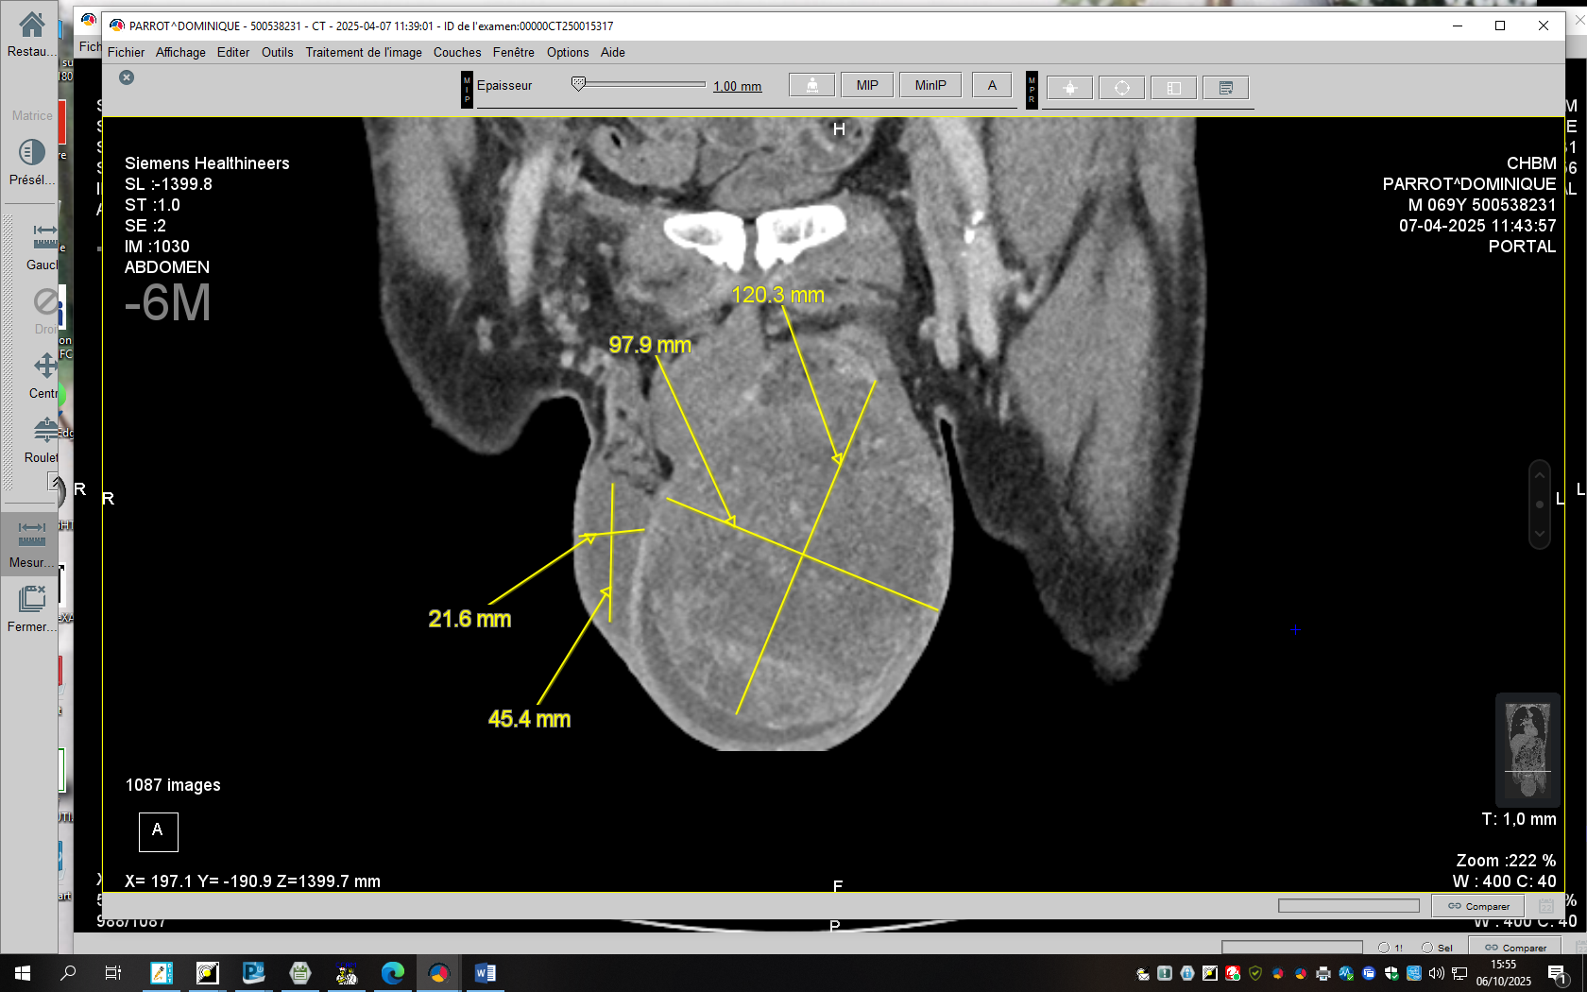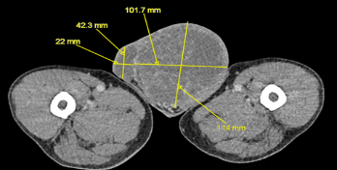
Figure 2: Axial and coronal sections of the latero-aortic metastasis.
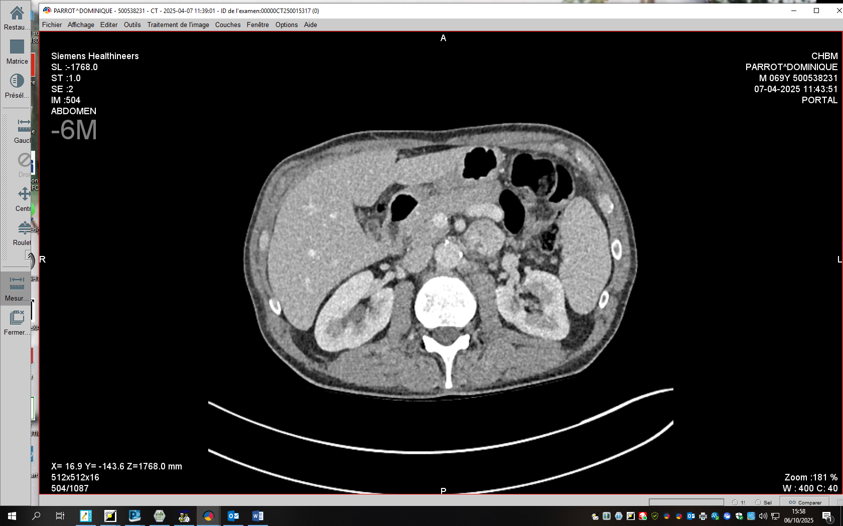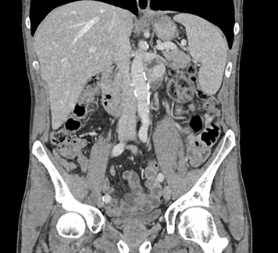
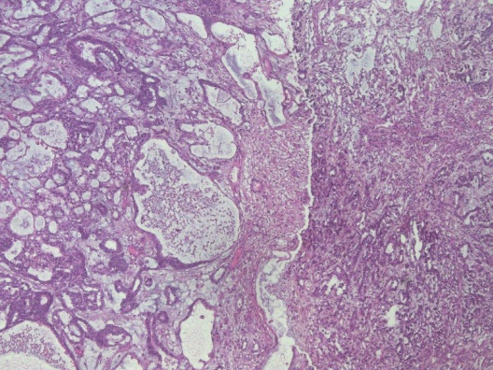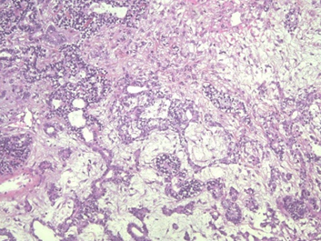
B
A
Figure 3: (A) Complex glandular structures consistent with an infiltrating adenocarcinomatous transformation; (B) Sarcomatous proliferation of atypical spindle cells arranged in fascicles.
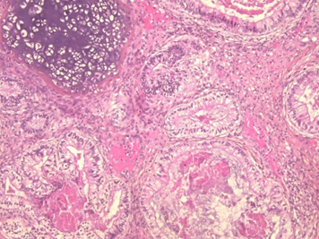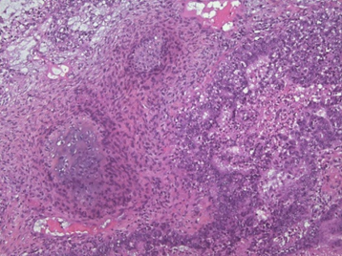
D
C
Figure 4:
(C) Focus of neuroendocrine differentiation composed of small round cells arranged in clusters;
(D) Intermingling of the different components, illustrating the pluripotential nature of teratoma and its potential for transformation into multiple cellular lineages

Postoperative Course
Postoperatively, AFP levels remained elevated (4500 IU/L). A PET-CT scan demonstrated hypermetabolic nodal progression, consistent with an increase in the size of the lymph node mass to 70 × 50 mm with intense radiotracer uptake.
After multidisciplinary discussion, the patient received BEP chemotherapy (four cycles), which resulted in a partial response with near normalization of AFP levels (28 IU/L). However, the findings did not allow exclusion of a germ cell component. The tumor was therefore classified as pT2N3M0S2, corresponding to an intermediate prognosis, stage IIC.
The persistence of a residual mass led to the performance of a retroperitoneal para-aortic lymph node dissection (RPLND). Histological analysis revealed a pure teratoma without viable malignant components.
The clinical course was favorable, with normalization of tumor markers and no evidence of recurrence at the first follow-up evaluation. A standardized clinical, biological, and radiological surveillance program was subsequently initiated.

Discussion
Somatic malignant transformation (SMT) within a testicular teratoma represents a rare but clinically significant entity, observed in approximately 3–6% of testicular germ cell tumors [1]. It corresponds to the development of a non-germ cell malignant component arising from the pluripotent differentiation of the teratoma, leading to significant changes in tumor biological behavior and prognosis [2].
From a histopathological perspective, several cellular lineages may be identified, most commonly including sarcomas, adenocarcinomas, and primitive neuroectodermal tumors [3,4]. This heterogeneity explains the clinical and therapeutic variability reported in the literature. In our case, the coexistence of adenocarcinomatous, sarcomatous, and neuroectodermal components illustrates the pluripotent potential of teratoma and confirms the diagnostic complexity of these mixed forms
The exact pathophysiological mechanism of somatic malignant transformation (SMT) remains debated. Two main hypotheses have been proposed: secondary malignant differentiation of totipotent embryonic cells or acquired neoplastic transformation of mature teratomatous tissues [5]. Some authors have also suggested a potential role of selective pressure induced by chemotherapy, which may promote the emergence of chemoresistant somatic components [6].
From a therapeutic perspective, SMT clearly differs from classical germ cell tumors because of its reduced sensitivity to cisplatin-based chemotherapy regimens [6,7]. Nevertheless, chemotherapy may still be indicated when an active germ cell component is suspected, particularly in the presence of elevated tumor markers. In our case, the persistent elevation of AFP after orchiectomy justified the administration of BEP chemotherapy, which resulted in a partial response, although a residual lymph node mass remained.
The management of residual masses represents a major clinical challenge. Several studies have shown that these masses contain viable teratoma in approximately 45% of cases and active malignant tissue in about 10% of cases [8]. Because their histological nature cannot be reliably predicted based solely on radiological findings, surgical resection remains the standard strategy [9]. Moreover, complete resection helps prevent the development of growing teratoma syndrome, characterized by tumor enlargement despite normalization of tumor markers, as well as the possibility of secondary malignant transformation [10].
In our case, the persistence of a lymph node mass after chemotherapy led to a retroperitoneal lymph node dissection, and histological analysis revealed a pure teratoma. This finding is consistent with data reported in the literature and highlights the predominantly therapeutic—not merely diagnostic—role of surgery for residual masses [9,11].
Long-term follow-up is based on combined surveillance using thoraco-abdominopelvic imaging and serum tumor markers. It has been demonstrated that biological marker elevation may precede radiological recurrence in a significant proportion of cases, supporting the need for structured and prolonged follow-up [12].
Thus, SMT represents a rare entity requiring a personalized multimodal strategy. Multidisciplinary coordination among urologists, medical oncologists, pathologists, and radiologists is essential to optimize oncological outcomes.

Conclusion
Somatic malignant transformation within a testicular teratoma is a rare and complex entity. Its management primarily relies on a surgical approach, as standard germ cell tumor chemotherapy is often ineffective. A multidisciplinary strategy is essential to optimize the diagnosis, treatment, and prognosis of these patients.
COMPETING INTERESTS DISCLAIMER:
Authors have declared that they have no known competing financial interests OR non-financial interests OR personal relationships that could have appeared to influence the work reported in this paper.

Références
1. Liu Y, Wang H, Li J, Zhang L. Metastatic primary testicular neuroendocrine carcinoma associated with somatic malignant transformation of teratoma: a rare case report. World J Surg Oncol. 2020;18:231.
2. Kikkawa F, Nawa A, Tamakoshi K, Ishikawa H, Suganuma N, Tomoda Y. Malignant transformation of mature cystic teratoma of the ovary including three cases occurring during follow-up. Gynecol Oncol. 1997;67(2):203–207.
3. Alderdice JM, Merrett JD. Factors influencing the survival of patients with testicular teratoma. J Clin Pathol. 1985;38(7):791–796.
4. Logothetis CJ, Samuels ML, Trindade A, Johnson DE. The growing teratoma syndrome. Cancer. 1982;50(8):1629–1635.
5. Ibrahim DY, Sun H. Somatic malignant transformation of a testicular teratoma: a case report. Case Rep Pathol. 2019;2019:Article ID 5273601.
6.International Germ Cell Cancer Collaborative Group. International germ cell consensus classification: a prognostic factor-based staging system for metastatic germ cell cancers. J Clin Oncol. 1997;15(2):594–603.
7.Albers P, Albrecht W, Algaba F, Bokemeyer C, Cohn-Cedermark G, Fizazi K, et al. EAU guidelines on testicular cancer. Eur Urol. 2015;68(6):1054–1068.
8. Carver BS, Shayegan B, Serio AM, Motzer RJ, Bosl GJ, Sheinfeld J. Long-term clinical outcome after postchemotherapy retroperitoneal lymph node dissection in men with residual teratoma. J Clin Oncol. 2007;25(9):1033–1037.
9. Heidenreich A, Pfister D, Witthuhn R, Thüer D, Albers P. Postchemotherapy retroperitoneal lymph node dissection in advanced testicular cancer: radical or modified template resection. Eur Urol. 2009;55(1):217–224.
10. Spiess PE, Kassouf W, Brown GA, Liu P, Gomez JA, Pisters LL. Growing teratoma syndrome: a review of the literature. J Urol. 2007;177(3):905–909.
11.Beck SDW, Foster RS, Bihrle R, Einhorn LH, Donohue JP. Reduced-template retroperitoneal lymph node dissection after chemotherapy. J Urol. 2003;169(1):93–96.
12. Donohue JP, Thornhill JA, Foster RS, Rowland RG, Bihrle R. Retroperitoneal lymph node dissection for clinical stage B testis cancer. J Urol. 1987;137(3):494–499.

