Beyond the Pelvis: Atypical Presentations of Prostate Cancer Mimicking Neurological and Head–Neck Pathologies— Largest Case Series from India

Abstract
Background:
Prostate carcinoma typically metastasizes to bone and regional lymph nodes. Cranial or extrathoracic metastases as initial presentations are exceedingly rare and can mimic neurological or head-and-neck pathologies, leading to diagnostic delay. Such cases are sparsely reported, and to our knowledge, no dedicated case series from India exists.
Methods:
We retrospectively analysed five patients who presented with atypical cranial or extra- thoracic manifestations and were subsequently diagnosed with metastatic prostate adenocarcinoma between 2020 and 2025 at our centre. Clinical, radiological, and histopathological data were reviewed.
Results:
Presentations included sudden-onset bilateral blindness due to optic canal metastasis (n=1), unilateral facial nerve palsy with skull base involvement (n=1), petrous bone lesion with facial nerve palsy (n=1), Sudden onset memory loss (n=1) and supraclavicular lymphadenopathy (n=1). Serum PSA ranged from 185–420 ng/mL. Imaging (MRI and PET-CT) demonstrated corresponding metastatic lesions. Biopsy or FNAC confirmed metastatic adenocarcinoma with PSA immunopositivity in all cases. All patients received androgen deprivation therapy, with selected cases receiving palliative radiotherapy. Partial neurological recovery was observed in two patients.
Conclusion:
Cranial and extrathoracic metastases may rarely represent the initial manifestation of prostate carcinoma. Awareness of such presentations is crucial, as early PSA testing and immunohistochemistry can facilitate prompt diagnosis and management. This represents the largest reported Indian case series describing these unusual initial manifestations of prostate cancer.
Keywords:
Prostate carcinoma, cranial metastasis, facial nerve palsy, optic canal, supraclavicular lymphadenopathy, atypical presentation, India

Introduction
Prostate cancer is one of the most common malignancies among elderly men worldwide. Metastatic spread typically involves the axial skeleton, pelvic lymph nodes, and lungs. Cranial metastases, skull-base involvement, and extrathoracic lymphadenopathy as initial manifestations are distinctly uncommon and are often misdiagnosed as primary neurological or head-and-neck pathologies [1,2].Such atypical presentations pose significant diagnostic challenges, particularly in the absence of urinary symptoms. Literature on these presentations is largely limited to isolated case reports, with no comprehensive Indian case series to date. We present five cases highlighting diverse cranial and extra-thoracic manifestations of prostate adenocarcinoma at initial diagnosis.

Presentation of cases
Case 1
A 65-year-old Indian male presented to the medical outpatient department with headache and sudden-onset bilateral loss of vision. Neurological examination was unremarkable except for visual impairment. Contrast-enhanced CT brain revealed a frontotemporal space-occupying lesion with midline shift and perilesional oedema. On detailed review, the patient reported increased urinary frequency and nocturia for six months, with recent 4.5 kg weight loss. Digital rectal examination revealed a hard, irregular prostate.
Laboratory findings included PSA > 100 ng/mL, alkaline phosphatase 1317 IU/L, hemoglobin 6.7 g/dL, and creatinine 1.23 mg/dL. Transrectal ultrasound guided biopsy confirmed high-grade adenocarcinoma (Gleason 10; 5 + 5) with diffuse bilateral involvement. The diagnosis of metastatic prostate carcinoma with intracranial metastasis was established, after PSMA PET CT whole body (fig 1,2) and the patient was commenced on androgen deprivation therapy (ADT) and supportive care.
Case 2
A 63-year-old man presented with right-sided lower motor neuron facial palsy, headache, tinnitus, loss of taste, and decreased lacrimation for one month. MRI brain revealed a 24 × 18 mm lesion along the greater superficial petrosal nerve abutting the cochlea, suggestive of a schwannoma. The patient underwent right temporal craniotomy via an extradural approach.
Histopathology with immunohistochemistry showed metastatic adenocarcinoma positive for PSA, consistent with prostatic origin. Serum PSA was 2300 ng/mL. PSMA PET- CT revealed intense tracer uptake in a right prostatic lesion (primary) with loss of periprostatic fat planes, tracer-avid left internal iliac node, and widespread skeletal metastases including skull, clavicles, ribs, vertebrae, and pelvis. Diagnosis: metastatic prostate carcinoma with skull-base involvement producing facial nerve palsy. The patient received ADT and palliative skull-base radiotherapy.
Case 3
A 72-year-old man presented with headache, right-sided hearing loss, and imbalance for three months, followed by dysphagia, dysphonia, and facial weakness. Examination revealed right facial and hypoglossal paresis with ipsilateral trigeminal hypoesthesia. MRI and CT temporal bone (fig 4) demonstrated an infiltrative lesion of the right petrous apex and clivus involving the internal auditory canal.

Further history revealed prior radical prostatectomy and radiotherapy for prostate adenocarcinoma five years earlier, with loss to follow-up for three years. Serum PSA was 223.2 ng/mL. Recurrent metastatic prostate carcinoma involving the petrous apex and clivus was diagnosed. The patient was restarted on ADT with local cranial radiotherapy, achieving partial symptomatic improvement.

Case 4
A 68-year-old man, referred from the Head-and-Neck department, presented with a painless left supraclavicular swelling (3 × 3 cm). There were no urinary or skeletal symptoms. Past history included left orchidectomy in childhood. FNAC of the supraclavicular node (Fig 5) showed metastatic poorly differentiated carcinoma of indeterminate origin. Whole-body PET-CT demonstrated an FDG-avid prostatic lesion with disseminated skeletal and cerebral metastases. Immunohistochemistry confirmed metastatic carcinoma positive for PSA and AMACR and negative for TTF-1, consistent with prostatic primary. The patient was commenced on ADT and supportive care.
Case 5
A 74 year old male presented with sudden onset memory loss. On evaluation , neuroimaging revealed calvarial and vertebral metastasis along with a pituitary macroadenoma .Considering the metastatic pattern , a serum PSA level was obtained , which was markedly elevated at 243 ng/dl.A PSMA PET-CT scan demonstrated increased tracer uptake in the prostate consistent with a primary malignancy along with multiple skeletal metastases involving the vertebrae, sternum, humerus and calvarium(Fig 6)
Subsequent transrectal ultrasound guided(TRUS) prostate biopsy confirmed the diagnosis of acinar adenocarcinoma of the prostate with a Gleason score of 4+4=8 showing a cribriform pattern. Patient was started on ADT and supportive care.

DISCUSSION
Prostate adenocarcinoma exhibits a well-characterized metastatic tropism, predominantly involving the axial skeleton and regional lymphatic drainage. Cranial and extra-thoracic metastases as initial clinical manifestations are exceptionally uncommon and usually indicate biologically aggressive disease. Their rarity, combined with non-urological symptomatology, frequently leads to misdiagnosis and delayed initiation of systemic therapy [1,2].
Pathophysiology of Cranial and Skull-Base Metastases
Cranial metastases from prostate cancer occur primarily via hematogenous dissemination through the valveless vertebral venous plexus (Batson’s plexus), allowing retrograde tumour spread to the skull base and intracranial structures without pulmonary filtration [3]. Skull-base involvement results in focal cranial neuropathies depending on the site of infiltration—optic canal lesions causing visual loss, petrous apex involvement leading to facial nerve palsy, and clival metastases producing lower cranial nerve deficits [4].
In our series, three patients presented with skull-base disease manifesting as optic neuropathy, facial nerve palsy, or mixed cranial nerve involvement, emphasizing the predilection of prostate cancer for osseous cranial structures rather than parenchymal brain metastases, which remain rare [5].

Diagnostic Pitfalls and Delayed Recognition
A major diagnostic challenge lies in the clinical and radiological mimicry of benign or primary neurological conditions. Schwannomas, meningiomas, pituitary adenomas, and primary skull-base tumours are frequently considered initial diagnoses, as demonstrated in two of our cases where neurosurgical intervention preceded oncologic diagnosis. Absence of lower urinary tract symptoms, seen in four of our five patients, further compounds this challenge [6].
This highlights the critical role of early PSA testing in elderly males presenting with unexplained cranial neuropathies, visual loss, or atypical lymphadenopathy. In our cohort, PSA levels were markedly elevated in all cases, and immunohistochemistry (PSA and AMACR positivity) proved decisive in establishing the prostatic origin [7].

Extra thoracic and Supraclavicular Metastases
Supraclavicular lymph node metastasis from prostate cancer is rare and reflects advanced disease with aberrant lymphatic drainage or hematogenous spread [8]. Such presentations are often initially evaluated under head-and-neck oncology services, as observed in our series. Recognition of this metastatic pattern is essential to avoid unnecessary diagnostic delays.

Therapeutic Implications and Outcomes
Androgen deprivation therapy remains the cornerstone of treatment for metastatic prostate cancer, even in patients presenting with atypical metastases. Palliative radiotherapy plays a crucial adjunctive role in symptom control for skull-base lesions, with partial neurological recovery observed in selected patients in our series, consistent with published literature [9].
While these atypical presentations generally indicate advanced disease with guarded prognosis, early recognition and initiation of systemic therapy can provide meaningful symptom relief and improve quality of life.

Novelty and Indian Context
Literature on cranial and extra-thoracic metastases from prostate cancer is largely confined to isolated case reports and small Western series. To our knowledge, this represents the largest Indian case series focusing specifically on atypical cranial and extra-thoracic initial manifestations of prostate carcinoma, underscoring the need for heightened awareness among neurologists, neurosurgeons, and head-and-neck specialists in the Indian setting.

Conclusion
Prostate cancer should be considered in elderly males presenting with unexplained cranial neuropathies, intracranial lesions, or supraclavicular lymphadenopathy, even in the absence of urinary symptoms. Early PSA estimation and appropriate immunohistochemical evaluation are essential for prompt diagnosis and management.

Declaration
During the preparation of this work the author(s) used Perplexcity tool in order to get reference detail and if similar case persist. After using this tool/service, the author(s) reviewed and edited the content as needed and take(s) full responsibility for the content of the published article.

COMPETING INTERESTS DISCLAIMER:
Authors have declared that they have no known competing financial interests OR non-financial interests OR personal relationships that could have appeared to influence the work reported in this paper.

References
1. Bubendorf L, Schöpfer A, Wagner U, et al.Metastatic patterns of prostate cancer: An autopsy study of 1,589 patients.Human Pathology. 2000;31(5):578–583.
2. Hess KR, Varadhachary GR, Taylor SH, et al.Metastatic patterns in adenocarcinoma. Cancer. 2006;106(7):1624–1633.
3. Laigle-Donadey F, Taillibert S, Mokhtari K, et al.Skull-base metastases.Journal of Neuro-Oncology. 2005;75(1):63–69.
4. Greenberg HS, Deck MD, Vikram B, et al.Metastasis to the base of the skull: Clinical findings in 43 patients.Neurology. 1981;31(5):530–537.
5. Hatzoglou V, Patel GV, Morris MJ, et al.Brain metastases from prostate cancer: An analysis of 11 cases.American Journal of Neuroradiology. 2014;35(3):466–471.
6. Saitoh H, Hida M, Shimbo T, et al.Metastatic patterns of prostate cancer.Cancer. 1984;54(12):3078–3084.
7. Epstein JI, Netto GJ.Biopsy Interpretation of the Prostate. 5th ed. Philadelphia: Wolters Kluwer; 2020.
8. Hollenbeck BK, Dunn RL, Ye Z, et al.Delayed diagnosis and treatment of prostate cancer.Cancer. 2004;100(5):1043–1050.

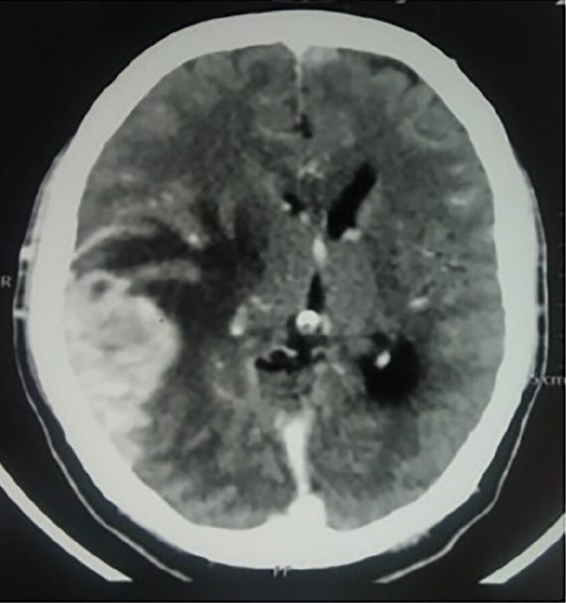
Fig1: shows peripheral enhancing cystic lesion in the right occipitoparietal region with perilesional oedema with mild effacement of third ventricle

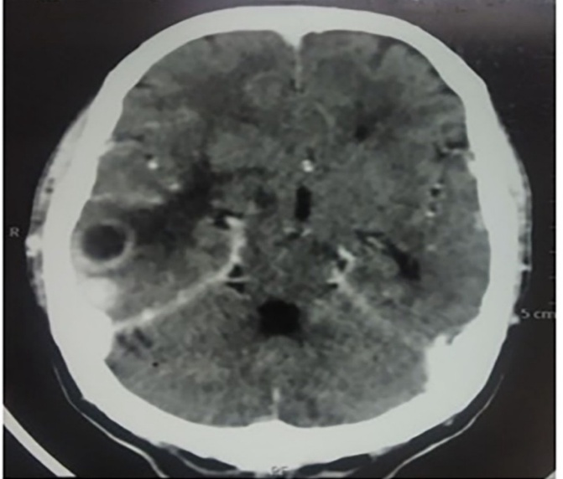
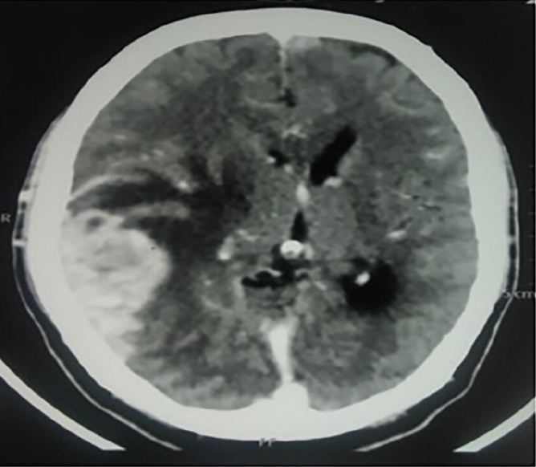
Fig: 2 shows metastatic lesion in temporal region with mass effect on third ventricle
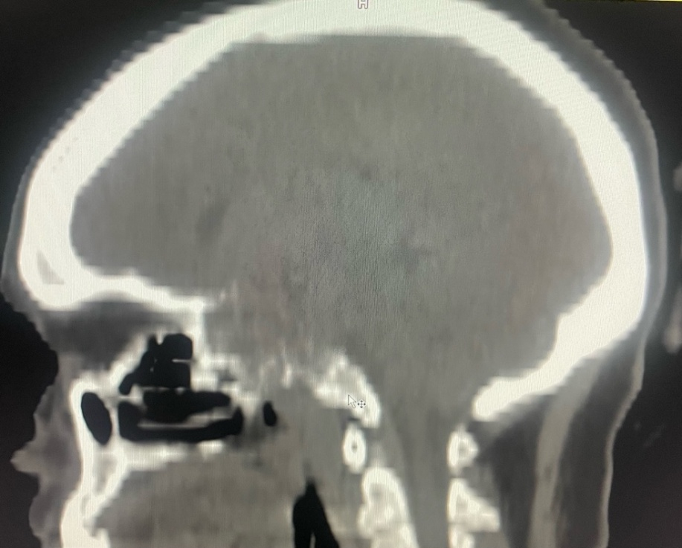
Fig: 3-CT Temporal bone shows infiltrative lesion of the clivus

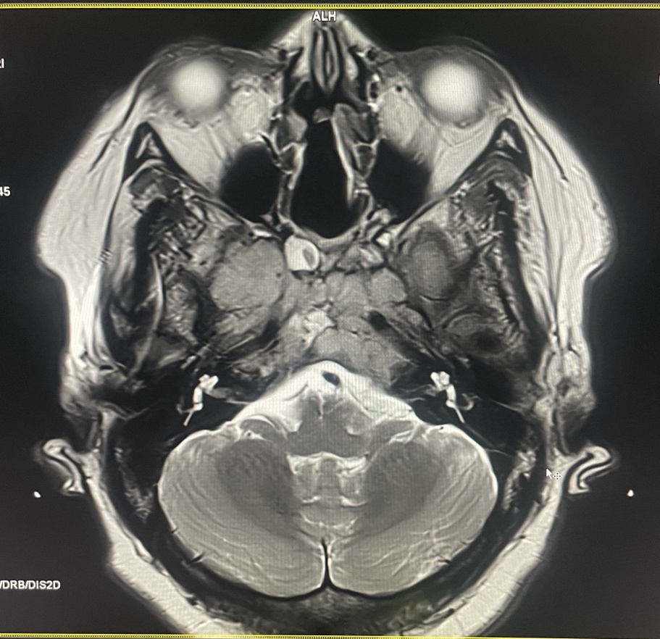
Fig : 4 -MRI shows bilateral temporal cave encasement with compression of temporal nerve on right side
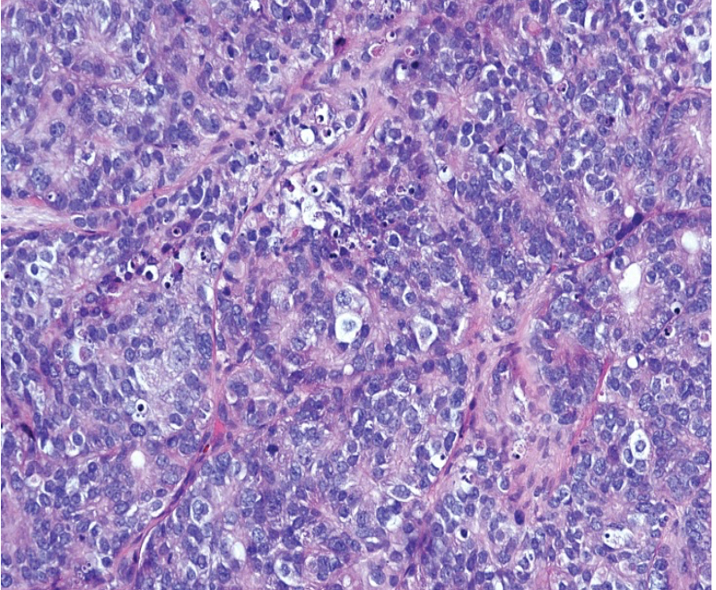
Fig: 5-Fine needle biopsy of left neck mass showing adenocarcinoma of undetermined origin, comprised of malignant cells

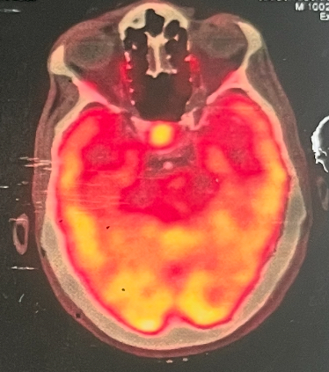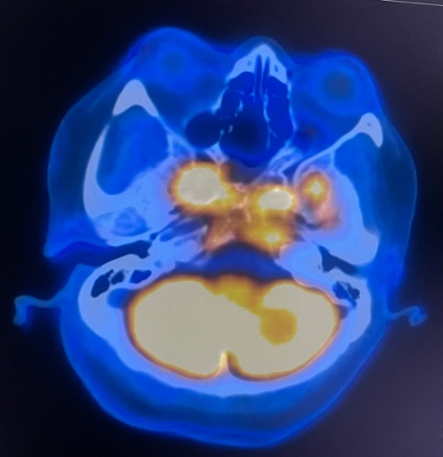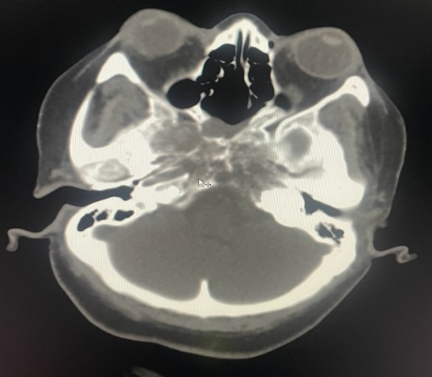
Fig : 6 -PSMA PET CT show avid lesion in calvarium with lytic lesion with some sclerotic component

