Case report

Bilateral Orbital Cellulitis: A Case Report and Review of the Literature

ABSTRACT
Orbital cellulitis (OC) is a potentially fatal emergency and develops rapidly, leading to severe visual loss and life-threatening complications. We present a 7-year-old boy who had catarrh, fever, headache, and right eye swelling, which later progressed to involve the left eye. An Orbital MRI was done, which showed bilateral orbital cellulitis with right intraocular collection extending into the right maxillary and ethmoidal sinuses. Management was both medical and surgical, using a multidisciplinary approach.
KEY WORDS: Cellulitis, antibiotics, sinuses, multidisciplinary.

INTRODUCTION
Orbital cellulitis can be defined as an acute, suppurative, inflammatory swelling of the orbital and periorbital tissues of infectious origin. Orbital cellulitis is a common complication of ethmoidal sinusitis with a higher incidence in the pediatric population.^{1,2} The route for infection could be ophthalmologic, dental, cutaneous, or through the respiratory system, where the normal commensal organisms from these sites can be translocated or, through a hematogenous spread, infect the orbit. The absence of a link between the venous and lymphatic systems separates the orbital tissue from the peri-orbital compartment, as well as the orbital septum and bone.^{3,4} The classification of orbital cellulitis depends on its relation to the orbital septum- preseptal or retroseptal cellulitis.⁵ Early diagnosis, high index of suspicion, effective and prompt treatment are essential to prevent rapid disease progression, morbidity, and impaired quality of life, including carvenous sinus thrombosis, meningitis, frontal abscess, osteomyelitis, loss of vision, and intracranial involvement with neurological sequelae.^{6,7}
We describe the case of a 7-year-old boy with bilateral orbital cellulitis and an intraocular extension collection.

CASE SUMMARY
A 7-year-old boy presented with a 4-day history of catarrh, fever, headache, and right eyelid swelling. The catarrh was associated with non-foul-smelling yellow discharge. Fever, which was described as high-grade, continuous, and temporarily relieved by oral acetaminophen. The headache was described as pounding in nature and localized to the right temporal area. Swelling of the right eyelid was insidious and progressively increasing in size, with associated eye pain that rendered the patient unable to open the right eye; no eye discharge. There was associated vomiting, non-bilious, non-projectile, non-bloody, containing recently ingested food, with approximately three episodes over the two days preceding presentation. There was no history of sore throat or cough, convulsions, neck stiffness, or photophobia. There was no swelling in other parts of the body, no history of trauma to the eye or head, or insect bite. No known allergy and no previous history of similar occurrence. At the onset of the symptoms, he was placed on oral antibiotics, 2 days later, he presented again on account of worsening of symptoms (progressive right eyelid swelling with visual impairment).
On Physical Examination: He was acutely ill looking with ptosis and swollen right eye, afebrile, not pale, anicteric, acyanosed, not dehydrated.
On Eye Examination: Left Eye: Both eyelids are normal, extraocular muscles are intact, with eye movement appreciated. Right Eye: Marked swelling of the right eyelid, edematous and erythematous (Figure 1), scanty clear eye discharge, tender to touch, reduced eye movement, and unable to open the eye. Other systemic examinations were normal.
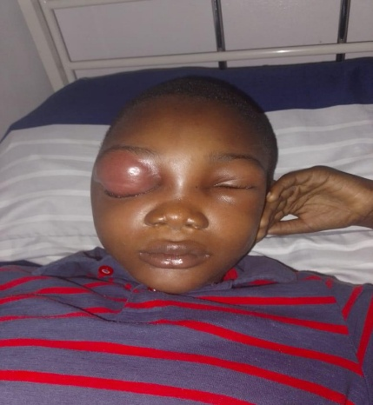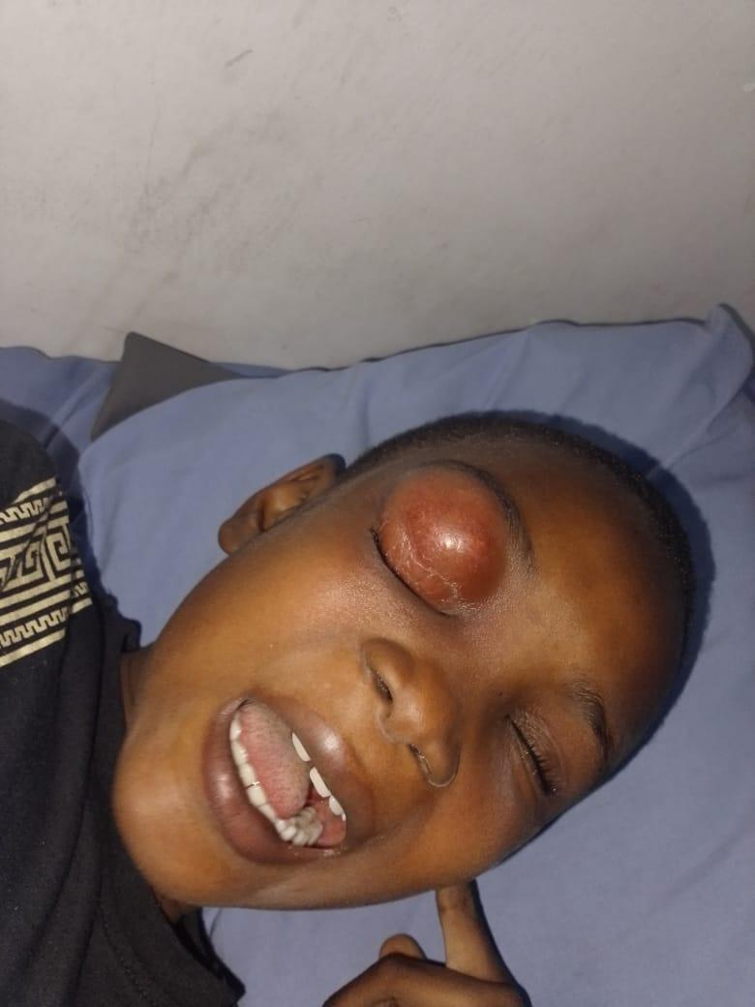
FIGURE 1: Right eye erythema and edema, with mild periorbital edema of the left eye

An assessment of pre-septal cellulitis, with suspected orbital cellulitis, was made.
Full blood count showed: total white blood cell count 12600/mm3, PCV 33%, neutrophils 74%, lymphocytes 13%. Markedly raised C-Reactive protein -118.68mg/L (1-10mg/L) and Erythrocyte sedimentation rate - 125mm/hr (3-5mm/hr). Viral markers were all negative, and electrolytes were normal, and an eye swab was taken for MCS (Which showed no growth after 72hours)
He was admitted and commenced on intravenous Vancomycin, metronidazole, and analgesics. On the third day of admission, the left eye was noticed to have started swelling, while the right eye showed no improvement. An Orbital MRI reported bilateral orbital cellulitis with right intraocular collection extending into the right maxillary and ethmoidal sinuses (FIGURE 2). On the 4th day of admission, Periorbital swelling of both eyes was noticed to be increasing in size. The eye examination was done and showed
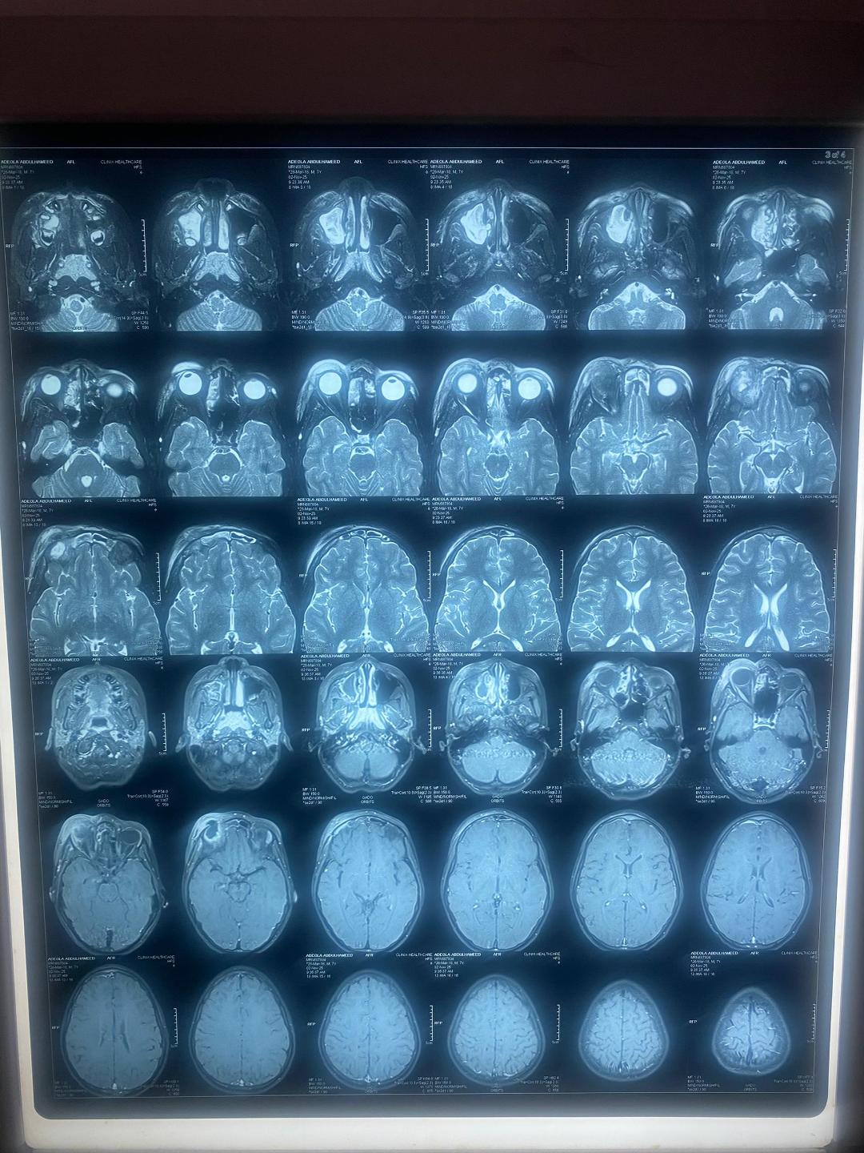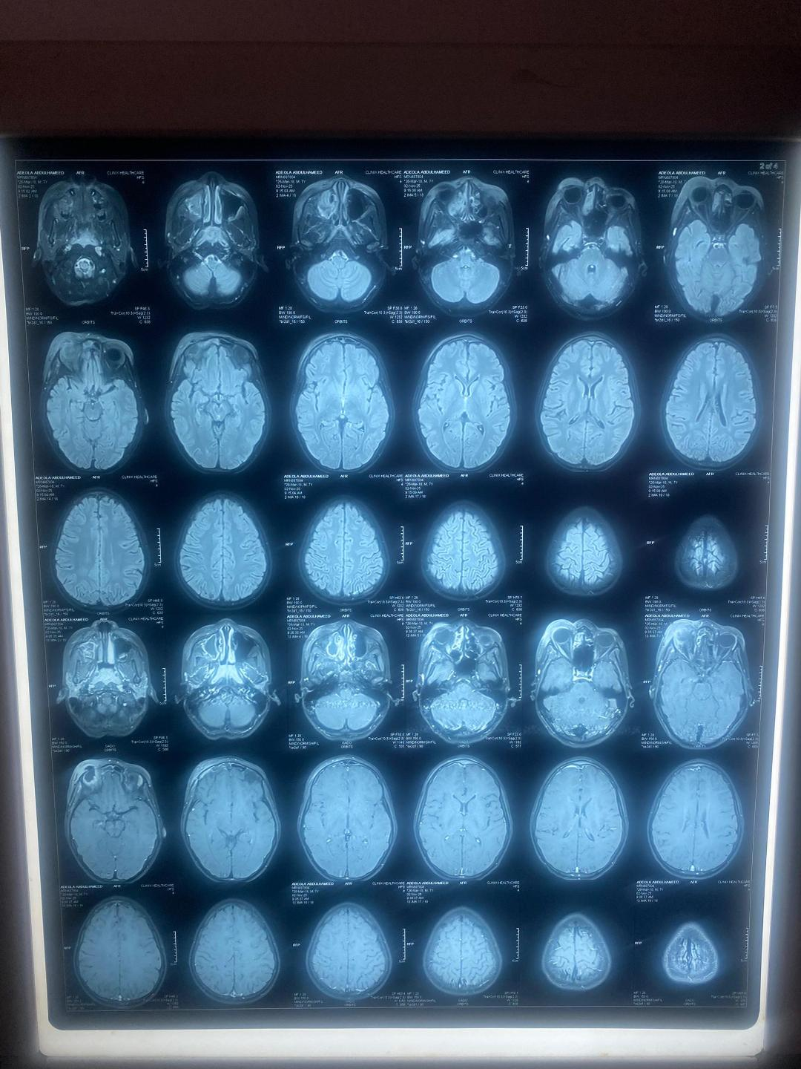
FIGURE 2: ORBITAL MRI- showing right eye proptosis and abscess
On Eye Examination, Right- marked swelling of the eyelid, edematous and erythematous with clear eye discharge, tender to touch, and the patient was unable to open and turn the eyes. Left eye- Mild swelling of the eyelid, edematous with minimal clear discharge, tender, but the patient was able to open and move the eye. (Figures 1 and 3)

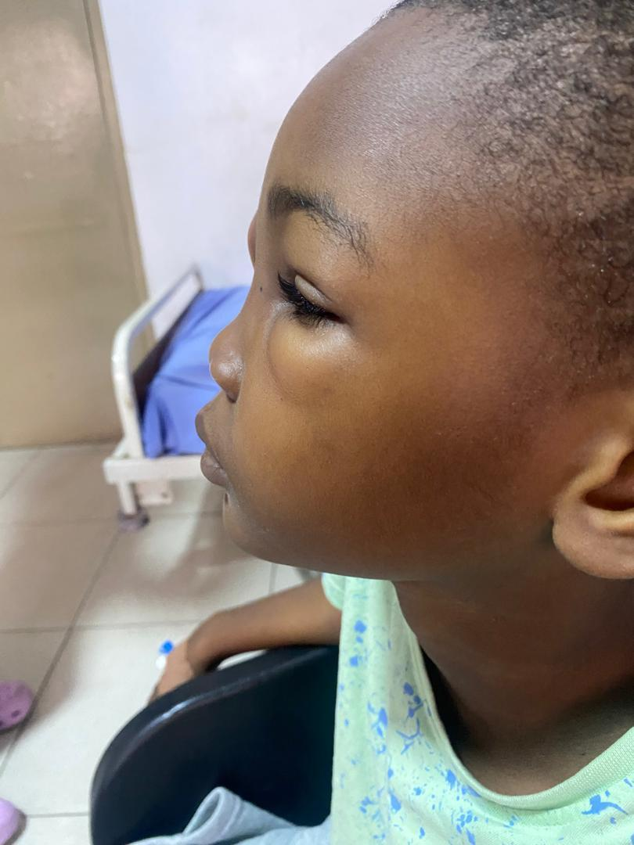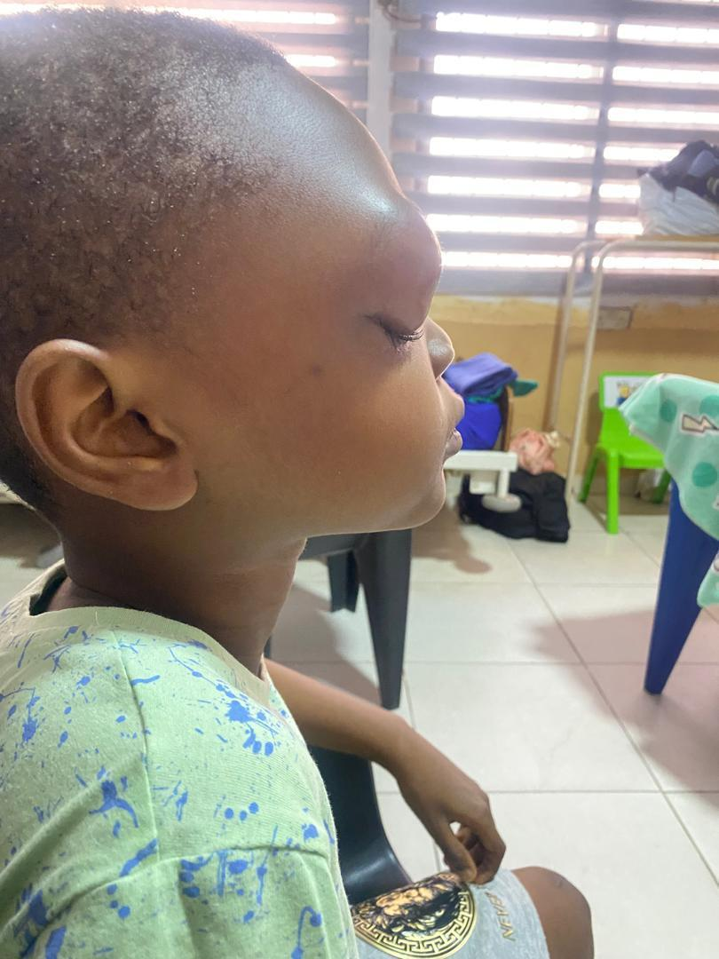

FIGURE 3: lateral view, showing bilateral periorbital edema
A multidisciplinary meeting was held involving the pediatrician, ophthalmologist, and ENT surgeon, and the patient was booked for an ethmoidectomy. He was commenced on analgesics and acetazolamide by the ophthalmologist following a review. The antibiotics were changed from Vancomycin and Ceftriaxone to Intravenous Amikacin and Meropenem. He also received intravenous steroids (Dexamethasone), Xylometazoline (Otrivin), and Betamethasone nasal drops. He had a surgery (Ethmoidectomy and right antrostomy) done, and 13mls of pus was aspirated from the periorbital and right maxillary sinus. The upper eyelid was incised, and gauze packing was done with wound dressing. The right anterior nasal packing was also done. The eye aspirate sample was taken for MCS.
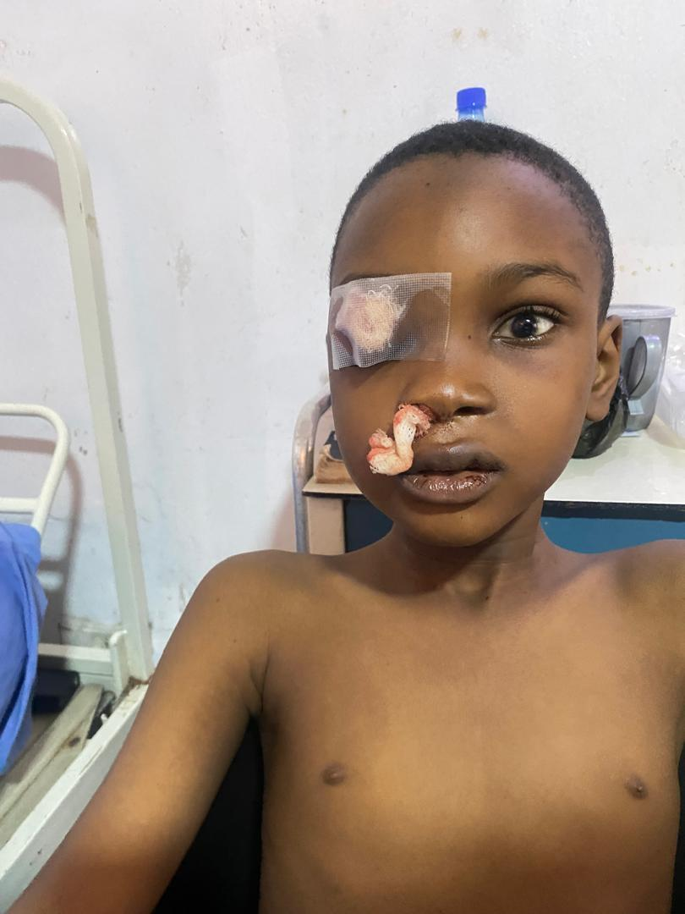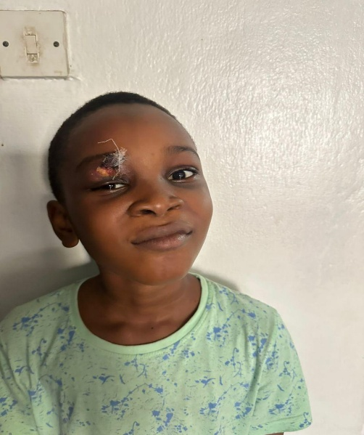
FIGURE 4: Post-surgical drainage of abscess
Post surgery, the patient's vital signs remained stable, and the nasal pack was to be removed the next day. On the 4th postop day, the right eye swelling remained the same size, with some difficulty opening the eye completely and reduced vision, but the eye discharge had resolved completely. The left eye was completely normal. The ENT surgeon and ophthalmologist did a further review, and a diagnosis of right upper eyelid abscess was made. The patient had incision and drainage of the right upper eyelid abscess (peri-orbital pus was drained). Patient continued with the intravenous antibiotics and other medications.
Thereafter, the patient's clinical condition remained stable, eye swelling completely resolved (figure 4), a repeat blood count was normal, and IV antibiotics were changed to oral antibiotics. He was discharged home after 15days on admission (7th day post-surgery). He is being followed up in the clinic and is doing well (figure 5).

FIGURE 5: on follow-up visit

DISCUSSION
Orbital cellulitis is a common life-threatening infection of the post-septal tissues of the orbit and one of the most common causes of orbital inflammation. It is an emergency condition, and it is important to make an early diagnosis with effective treatment. It often requires multidisciplinary management involving radiologists, ophthalmologists, maxillofacial surgeons, ENT surgeons, and, often, neurosurgeons.⁸ Orbital cellulitis has a peak occurrence in children between 6 and 15 years of age, with a male predominance, and this is in keeping with the index child, who is a 7-year-old male child.^{9,10} It is usually unilateral and only involves the second eye when the cavernous sinus is involved, and this may explain why the swelling, which was initially on the right eye, spread to involve the left eye.¹¹ Furthermore, these infections may spread through the dehiscence of the orbital bony wall or via the venous drainage of the orbit. These veins, which characteristically have no valves, drain into the pterygoid plexus or the cavernous sinus. The bilateral involvement of the cavernous sinus most frequently results in a contiguous spread to the contralateral orbit. This is the postulated pathway for the development of bilateral orbital cellulitis, and it may be associated with altered consciousness if an intracranial abscess develops. ¹² It is thought to occur as a result of an acute spread of infection from the blood, adjacent sinuses, and facial skin. Periorbital trauma and dental infection are other sources of spread to the orbit. ¹³ This is in agreement with this child, whose infection involved both the maxillary and ethmoidal sinuses, and this is because the ethmoidal sinus is the most common source of infection in children, as the frontal and sphenoidal sinuses do not develop until age. Several microbial agents have been implicated. In children, Haemophilus influenzae, Staphylococcus aureus, Streptococcus species, and anaerobic organisms were implicated as the commonest causes of orbital cellulitis in descending order of frequency of bacterial organisms. ^{5,14} For the index child, the culture yielded no growth, which can be accounted for by prior antibiotic use before sample collection. Additionally, it has been reported that blood and skin microscopy, culture, and sensitivity, though important, usually yield no growth; rather, the swabs taken endoscopically from the paranasal sinus yield better results. Infection could spread via direct contact/invasion and hematogenous spread. In children, the thinned inner orbital wall, which is further compressed by inflammatory edema, gives rise to palpebral edema and may explain the orbital edema in our patient. ¹⁴ Clinical features of orbital cellulitis include pain, proptosis, globe displacement, double vision and/or vision loss, chemosis, and extraocular motility deficit (ophthalmoplegia). Similarly, our patient presented with proptosis, loss of vision, and ophthalmoplegia. Antecedent and significant past medical history may include a history of headache, rhinitis, sinusitis, nasal discharge, and recent upper respiratory tract infection, and some features, like nasal discharge and headache, were present in the index case.^{15,16} Decreased visual acuity, pupillary signs, and vision loss may occur rapidly. The diagnosis was made by the clinical features at presentation and radiologic investigations. Radiological investigations, such as a CT scan and MRI, are key to the diagnosis of orbital disorders and would have shown clearly the changes occurring within the orbit.¹⁷ The orbital MRI aided diagnosis in our index case, as the child did not improve with the use of antibiotics, until the abscess was identified and drained after this imaging was done. With the diagnosis, a multidisciplinary approach is applied in care, including antibiotics and surgical drainage of the abscess. The early presentation of the patient with the timely institution of empirical treatment may have limited disease progression and complications. The index child made a remarkable improvement, which re-emphasizes the need for prompt diagnosis and treatment.

CONCLUSION
Orbital cellulitis is a common life-threatening infection of the post-septal tissues of the orbit and one of the common causes of orbital inflammation. It is an ophthalmologic emergency with life-threatening complications. Early diagnosis and prompt treatment (medical/surgical) with a multidisciplinary approach is key to good outcomes.

COMPETING INTERESTS DISCLAIMER:
Authors have declared that they have no known competing financial interests OR non-financial interests OR personal relationships that could have appeared to influence the work reported in this paper.

REFERENCES
1. Burek AG, Melamed S, Liljestrom T, Qi J, Kelly TG, Suelzer E, Mitchell M, Harris GJ, Havens PL. Evaluation and medical management of the pediatric patient with orbital Cellulitis/Abscess: A Systematic Review. J Hosp Med. 2021;16(11):680-687.
2. Wong SJ, Levi J. Management of pediatric orbital cellulitis: A systematic review. Int J Pediatr Otorhinolaryngol. 2018;110(April):123-129.
3. Atfeh MS, Khalil HS. Orbital infections: Five-year case series, literature review, and guideline development. J Laryngol Otol. 2015;129(7):670-676.
4. Lee S, Yen MT. Management of preseptal and orbital cellulitis. Saudi J Ophthalmol. 2011;25(1):21-29.
5. Saadouli D, Yahyaoui S, Mansour KB, Masmoudi M, El Afrit MA, Sammoud. Les cellulites orbitaires chez l’enfant : À propos de 60 cas. Journal Français d'Ophtalmologie. 2019;42(10):1056-1061.
6. Meara DJ. Sinonasal disease and orbital cellulitis in children. Oral Maxillofac Surg Clin North Am. 2012;24(3):487-496.
7. Tsirouki T, Dastiridou AI, Ibánez Flores N, Cerpa JC, Moschos MM, Brazitikos P, et al. Orbital cellulitis. Surv Ophthalmol. 2018;63(4):534-553.
8. Chaudhry IA, Al-Rashed W, Arat YO. The hot orbit: Orbital cellulitis. Middle East Afr J Ophthalmol. 2012;19:34-42.
9.Ailal F, Bousfiha A, Jouhadi Z, Bennani M, Abid A. Cellulites orbitaires chez l’enfant: À propos d’une étude rétrospective de 33 cas. Medicine Tropicale. 2004;64(4):359-362.
10. Sobol ES, Marchand J, Tewfik LT, Manoukian JJ, Schoss DM. Orbital complications of sinusitis in children. The journal of otolaryngology. 2002;31(3):131-136.
11. Singh SK, James E, Sabarigirish K, Swami H, Sood T. Bilateral orbital complications of paediatric rhinosinusitis. Med J Armed Forces India 2014; 70: 68 - 72
12. Harrington JN. Orbital Cellulitis. Available from: http: //emedicine. medscape. com/article/1217858.
13. Kanski JJ. Orbit in Clinical Ophthalmology. 5th ed. gh, New York: Butterworth Heinemann. p.568 - 9.
14. Coulibaly S. Aspects épidémiologiques et cliniques des cellulites orbitaires au CHU-IOTA à propos de 30 cas; 2023.
15. Schramm VL Jr, Curtin HD, Kennerdell JS. Evaluation of orbital cellulitis and results of treatment. Laryngoscope 1982; 92: 732.
16. Bergin DJ, Wright JE. Orbital cellulitis. Br J Ophthalmol 1986; 70: 174.
17. Eustis HS, Mafee MF, Walton C, Mondonca J. MR imaging and CT of orbital infections and complications in acute rhinosinusitis. Radiol Clin North Am 1998; 36: 1165 - 83.

