Case report
Late-Onset Ocular Hypotony Revealing Post-Traumatic Cyclodialysis: A Case Report

ABSTRACT
Post-traumatic cyclodialysis is a rare entity resulting from a detachment of the ciliary body from the scleral spur, most often secondary to blunt trauma. This condition creates a shunt space between the anterior chamber and the suprachoroidal space, leading to variable ocular hypotony. Its significance lies in the potential consequences for the optic nerve and macula. We report a case of delayed hypotony in a 13-year-old child, having intraocular pressure dropping from 12 to 6 mmHg on day 15 with a decrease in visual acuity from 10/10 to 4/10, diagnosed by gonioscopy and anterior segment OCT(AS-OCT), which evolved favorably under conservative medical management, by the prescription of cycloplegia based on atropine 1% for 1 month. This case highlights the need for close monitoring and early diagnosis.
Keywords: cyclodialysis, ocular hypotony, ocular trauma.
INTRODUCTION
Post-traumatic cyclodialysis constitutes a rare entity in ocular-palpebral traumatology, particularly in children (1), which should always be considered in cases of post-traumatic ocular hypotonia, particularly when it occurs late in a patient with closed-globe ocular trauma (2). The difficulty of this pathology lies in both the diagnostic and therapeutic approach, as well as in its complications, which can affect the functional and even anatomical prognosis of the eye (3,4). It refers to a rupture of the attachment system between the ciliary body and the scleral spur, creating an abnormal passage through which the aqueous humor flows into the suprachoroidal space. This leakage results in a decrease in intraocular pressure (IOP), which can lead to severe hypotony. Clinical manifestations include a flattened anterior chamber, decreased visual acuity, macular folds, and sometimes papilledema. Ultrasound biomicroscopy (UBM) is the reference examination for visualizing cyclodialysis, but anterior segment OCT is a useful non-invasive alternative, particularly in children (5,6). Treatment is based on atropine, photocoagulation, or surgery in cases of failure. We report this case due to the limited number of reported cases of cyclodialysis, to further expand the current knowledge.

CASE REPORT
This concerns a 13-year-old patient with no prior medical history, who presented it to the ophthalmic emergency department following direct ocular trauma caused by a ball. The initial examination revealed preserved visual acuity of 10/10.Slit-lamp examination revealed a mild (+1) anterior chamber reaction with the presence of red blood cells. The intraocular pressure (IOP) was 12 mmHg. The fundus appeared normal. Topical dexamethasone was administered with progressive tapering, combined with a mydriatic agent to control inflammation, prevent synechiae and for analgesic purposes. On day 15, visual acuity decreased to 4/10. Examination revealed a very shallow anterior chamber and a dropped IOP to 6 mmHg (figure 1A). Fundus examination showed stage I papilledema and macular folds (figure 2A). Gonioscopy revealed an exposed scleral band consistent with cyclodialysis cleft extending from 9 to 3 o’clock, involving approximately 6 clock hours (180°). Anterior segment OCT confirmed detachment of the ciliary bodies (figures 3A and 3B). Treatment with 1% atropine was initiated. After one month, the patient’s visual acuity had fully recovered, reaching 10/10; the intraocular pressure was normalized; the anterior chamber reformed and the papilledema was resolved. OCT confirmed complete reattachment of the ciliary bodies.
DISCUSSION
Cyclodialysis represents a specific cause of hypotony, often underdiagnosed in the acute phase, particularly when the IOP initially remains normal. Complications of prolonged hypotony include retinal abnormalities or papilledema (7,3). Pediatric post-traumatic cyclodialysis is characterized by subtle clinical signs due to the elasticity of the sclera and ciliary body, atypical symptom presentation, and a higher risk of delayed diagnosis, making careful gonioscopy and OCT assessment essential. Early recognition and management are crucial to ensure favorable anatomical and functional outcomes in this population (8). In the literature, pediatric cases of post-traumatic cyclodialysis remain rare, with very few cases described to date. A recent case published by Alhijji et al. (9) reports a 360° cyclodialysis in a child successfully treated medically, where UBM confirmed the reattachment of the ciliary body without invasive surgery. In our case, the cyclodialysis was limited to only 180°, and anterior segment OCT allowed the diagnosis of this condition. Conversely, most series that report adult patients involve ocular trauma with either open or closed globe injuries, which in most cases require surgical treatment (direct cyclopexy, cryotherapy, sutures) in order to restore intraocular pressure and achieve the best functional recovery (10,11).Current diagnostic tools emphasize UBM, although anterior segment OCT has established itself as the non-invasive examination of choice (12). Many recent cases highlight the use of advanced imaging to precisely visualize the extent of cyclodialysis, particularly when gonioscopy is challenging. The difference between these two paraclinical examinations is that OCT remains a non-invasive, non-contact method, easy to perform in children, can provide indirect information about anterior chamber depth and corneal changes related to hypotony, UBM offers direct visualization of the cyclodialysis cleft, its extent in clock hours, and the condition of the ciliary body and angle, making it indispensable for diagnosis and management(13,14).Anyway, both explorations help guide therapeutic management as well as facilitate follow-up, whether in the short term or long term. For the treatment, it depends on the extent of cyclodialysis. Atropine, by inducing cycloplegia, promotes the reattachment of the ciliary bodies. In cases of failure, laser photocoagulation may be used. Surgical cyclopexy remain reserved for extensive or complicated cases (15). We opted for medical management in our pediatric series due to the limited extent of the clefts, the potential for spontaneous closure in children, and the desire to minimize surgical and anesthetic risks. This strategy allowed close monitoring of cleft resolution and anterior chamber status using OCT and slit-lamp examination. The prognosis of this pathology is generally favorable when the diagnosis is made early. That’s why this case is particularly noteworthy, because pediatric post-traumatic cyclodialysis is rarely reported in literature and we should always think about this diagnosis in late onset post traumatic ocular hypotony to have the best anatomical and functional recovery without intervention.
CONCLUSION
Post-traumatic cyclodialysis must be systematically investigated in any case of contusive trauma accompanied by hypotony. The use of OCT, UBM and gonioscopy enables rapid diagnosis. Anterior segment OCT in children presents a key non-invasive tool and contributes to the diagnosis of this rather rare pathology. Conservative treatment may be adequate for localized forms. Early intervention helps prevent irreversible consequences associated with prolonged hypotony. This case demonstrates that, in similar pediatric presentations with moderate cyclodialysis clefts, non-surgical management can be both safe and effective, emphasizing the value of early detection and OCT-guided follow-up.
CONSENT
As per international standards, patient written consent has been collected and preserved by the author(s).
ETHICAL APPROVAL
As per international standards or university standards written ethical approval has been collected and preserved by the author(s).
DISCLAIMER (Artificial Intelligence)
Author(s) hereby declares that NO generative AI technologies such as Large Language Models (ChatGPT, COPILOT, etc.) and text-to-image generators have been used during writing or editing of this manuscript.
COMPETING INTERESTS
Authors have declared that no competing interests exist.
REFERENCES
1.MESSAFI, Imad and CHARIBA, Siham and MABROUKI, Fatima Zahra and MAADANE, Asmae and SEKHSOUKH, Rachid, Epidemiological, Clinical and Therapeutic Features of Severe Paediatric Ocular Traumas in Eastern Morocco. Available at SSRN: https://ssrn.com/abstract=4828160 or http://dx.doi.org/10.2139/ssrn.4828160
2. AAO - American Academy of Ophthalmology. Cyclodialysis Clefts. 2021Accessed Jan 15, 2021, San Francisco, USA AAO Available at https://eyewiki.aao.org/Cyclodialysis_Clefts
3.C. Marks, C. Vieville, E. Dumortier, E. Koch, J.F. Rouland, P. Labalette,430 La cyclodialyse : un diagnostic à évoquer devant une hypotonie post-traumatique,Journal Français d'Ophtalmologie,Volume 30, Supplement 2,2007, Page 2S276, ISSN 0181-5512, https://doi.org/10.1016/S0181-5512(07)80243-9.
4.Braudo, Sharon MD; Neuman, Gil MD; Shitrit, Noa MD; Goldberg, Mordechai MD. Challenging diagnosis and repair of an extensive cyclodialysis cleft. JCRS Online Case Reports 12(3): p e00125, July 2024. | DOI: 10.1097/j.jcro.0000000000000125
5.Teoh, Chin Sheng; Aquino, Maria Cecilia; Lim, Dawn K.; Chew, Paul; Koh, Victor, *. Use of anterior segment imaging and direct cyclopexy repair of cyclodialysis cleft. Taiwan Journal of Ophthalmology 12(2): p 213-218, Apr–Jun 2022. | DOI: 10.4103/tjo.tjo_24_21
6.Thomas Andrew Berk, Daniel Peretz, Alaa Mofti, Béatrice Des Marchais, Hady Saheb, Non-invasive monitoring of cyclodialysis cleft using anterior segment optical coherence tomography and its role in informing clinical treatment decisions, American Journal of Ophthalmology Case Reports, Volume 26,2022,101410, ISSN 2451-9936 https://doi.org/10.1016/j.ajoc.2022.101410.
7. Küchle M, Naumann GOH. Traumatic cyclodialysis and hypotony: clinical features and management. Ophthalmology. 1995;102(6):926–932.
8.Ganone, T., Harba, T. T., Djimta, M., Zenaba, M., Adyl, E., & Choua, O. (2025). Aspects Épidémiologiques, Cliniques et Thérapeutiques des Traumatismes Oculaires chez les Enfants de 0 à 15 ans à Ndjamena : Epidemiological, Clinical, and Therapeutic Aspects of Ocular Trauma in Children Aged 0 to 15 in Ndjamena. HEALTH RESEARCH IN AFRICA, 3(10).
9. Alhijji L, Alhaimi F, Alsuwailem G (2024) Case Report: Successful Medical Management of a Traumatic 360-Degree Cyclodialysis Cleft in a Pediatric Patient. Ann Case Report. 9: 2106. https://doi.org/10.29011/2574-7754.102106
10.Kato T, Hayasaka S, Nagaki Y, Matsumoto M. Management of traumatic cyclodialysis cleft associated with ocular hypotony. Ophthalmic Surg Lasers. 1999 Jun;30(6):469-72. PMID: 10392735.
11.Agrawal P, Shah P. Long-term outcomes following the surgical repair of traumatic cyclodialysis clefts. Eye (Lond). 2013 Dec;27(12):1347-52. doi: 10.1038/eye.2013.183. Epub 2013 Aug 30. PMID: 23989121; PMCID: PMC3869508.
12. Choudhury F, et al. Imaging of cyclodialysis cleft with anterior segment optical coherence tomography. Clin Ophthalmol. 2013; 7:587–590.
13.A. Morin, M. Delbarre, C. Friang, M. Marechal, F. Froussart-Maille,Cyclodialyse : un challenge thérapeutique, revue de la littérature sur les pratiques actuelles,Journal Français d'Ophtalmologie,Volume 42, Issue 8,2019, Pages 852-863, ISSN 0181-5512, https://doi.org/10.1016/j.jfo.2019.03.021.(https://www.sciencedirect.com/science/article/pii/S0181551219302645)
14.Selvan H, Yadav S, Gupta V, Gupta S. Case Report: Cyclodialysis Cleft in a Case of Open-globe Injury and Role of Swept-source Anterior Segment Optical Coherence Tomography in Diagnosis. Optom Vis Sci. 2020 Jun;97(6):395-399. doi: 10.1097/OPX.0000000000001518. PMID: 32511160.
15.B. Kudsieh, R. Vega-Gonzalez, J.I. Fernández-Vigo, J. Ruiz-Medrano, M. Samaan, J.M. Ruiz-Moreno,Surgical repair of traumatic cyclodialysis cleft guided by anterior segment ocular coherence tomography and intraoperative gonioscopy in a young patient: Case report,Journal Français d'Ophtalmologie,Volume 47, Issue 7,2024,104161, ISSN 0181-5512, https://doi.org/10.1016/j.jfo.2024.104161.(https://www.sciencedirect.com/science/article/pii/S0181551224001062)

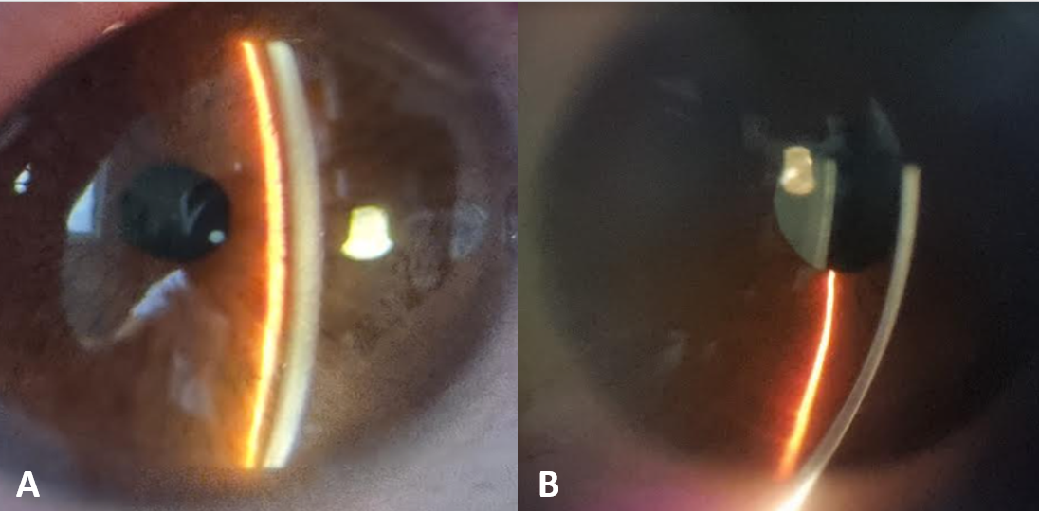
Figure 1: Slit-lamp photograph showing the depth of the anterior chamber. A: Image at admission with a reduced anterior chamber. B: Image day 30 of treatment with good anterior chamber depth.

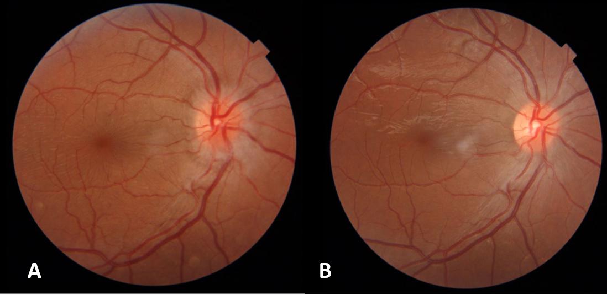
Figure 2: Fundus photograph of the right eye. A: Image at admission showing stage one of papilledema. B: Image at day 30 showing the disappearance of the papilledema.

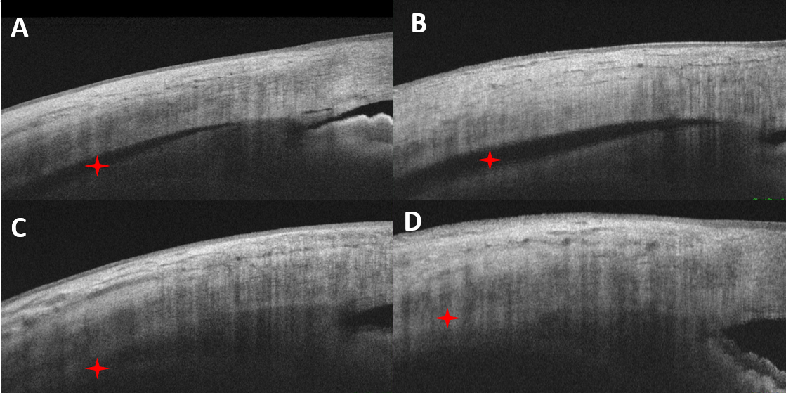
Figure 3: OCT image of the anterior segment. A and B Admission images showing a cyclodialysis (red star). C and D Images at day 30 showing the disappearance of the cyclodialysis (red star).

