Case report
Management of Neurotrophic Corneal Ulcer Using the
“Tuck-in Tenon Patch Graft” technique: A Case Report

ABSTRACT
Neurotrophic keratitis is a rare but serious corneal disorder characterized by impaired corneal sensory innervation, resulting in defective epithelial healing. Neurotrophic corneal ulcers may progress to deep stromal thinning or even perforation, thereby threatening visual prognosis. The literature describes a wide range of therapeutic approaches, from tear substitutes to biological agents and surgical techniques. In this article, we present an illustrative case managed with an autologous Tenon’s capsule graft using the “Tuck-in Tenon Patch Graft” technique, which led to a favorable anatomical and functional outcome over a follow-up period of 60 days. The patient had a history of diabetes under poorly controlled treatment with a history of use of non-steroidal anti-inflammatory drugs (NSAIDs). The preoperative visual acuity was 1/10, which improved to 2/10, resulting in a gain of 3 lines with a clinically significant improvement; the minimal stromal thickness increased from 210 µm to 410 µm at day 30.The patient's follow-up was carried out using anterior segment OCT (AS-OCT), which allowed for precise and progressive monitoring of graft integration as well as its stability, thus providing a non-invasive and relevant paraclinical follow-up method in this type of pathology. Tuck-in Tenon Patch Graft is a particularly relevant technique in settings where access to amniotic membranes or corneal grafts is limited.
Keywords: Neurotrophic keratitis – Corneal ulcer – Corneal perforation – Tenon graft
INTRODUCTION
Neurotrophic keratitis results from damage to the trigeminal nerve or its corneal branches. This sensory impairment leads to a decrease in reflex tear secretion, dysfunction of epithelial cells, and a loss of trophicity of the ocular surface. The causes are varied: herpetic viral infections, diabetic neuropathies, eye surgeries, trauma, or prolonged use of toxic eye drops. The Mackie classification distinguishes three progressive stages ranging from persistent erosion to full-thickness perforation. The advanced stage, characterized by severe corneal thinning, often necessitates surgical intervention. Therapeutic management has evolved considerably over recent years. Among modern approaches are matrix regenerators (RGTA), eye drops enriched with neurotrophic factors, autologous serum, and therapeutic contact lenses. However, these options are not always available, particularly in facilities with limited resources. In this context, autologous Tenon's capsule grafting constitutes a reliable, economical, and immediately applicable alternative. In literature, grafting with Tenon's capsule has been described by some authors as an effective means in the therapeutic management of corneal ulcers as well as corneal perforations (1,2,3). Several techniques have been described for the arrangement of this graft, either by the application of cyanoacrylate biological glue for the fixation of Tenon, or by suturing Tenon with 10/0 monofilament opposite the corneal defect, or the tuck-in Tenon patch graft technique which involves fixing the graft in a corneal pocket (4). In our case, we opted for the tuck-in tenon patch graft technique because it is one of the three techniques that allows for better graft stability with fewer sutures and better integration, which makes it possible to achieve good anatomical and functional results (5,6).In this case we illustrate the effectiveness of the Tuck-in Tenon Patch Graft technique as an alternative surgical approach in advanced neurotrophic keratitis in resource-limited settings. Data on the management of neurotrophic ulcers remain scarce in literature; therefore, we report this case to contribute to the existing evidence.
CASE REPORT
The patient presented in this case is a 63-year-old woman, being followed for poorly controlled diabetes with a history of chronic use of topical non-steroidal anti-inflammatory drugs. She consults for a red, painful eye, associated with a progressive decrease in visual acuity. Examination reveals a visual acuity of 1/10. Examination of the anterior segment shows a round, clean, non-infiltrated ulcer located in the inferotemporal area, measuring 1×1,5 mm, with a markedly decreased corneal sensitivity in the four quadrants that qualitatively assessed with a cotton wisp applied to the four corneal quadrants (figure 1). According to the Mackie classification, the patient was initially classified as stage 2 neurotrophic keratopathy, defined by persistent epithelial defect with no stromal melting. Initial AS-OCT shows a corneal thickness of 493 μm (figure 2A).An intensive medical treatment was initiated, including artificial tears every 2 hours to maintain corneal hydration and reduce mechanical stress; a topical aminoglycoside antibiotics, such as tobramycin, was used four times daily to prevent secondary bacterial infection; topical autologous serum 20% drops were instilled six times daily to provide growth factors and enhance epithelial regeneration and an eye patch was used as part of the conservative management. Despite this, the condition progressed, increasing in size 2×2,5 mm. The patient presented stage 3 neurotrophic keratopathy with stromal melting and impending perforation. Anterior segment OCT revealed corneal measuring 210 μm at the affected area (figure 2B). It was then decided to perform a Tenon’s capsule graft using the "Tuck-in Tenon patch graft" technique. This involves harvesting a fragment of Tenon’s capsule under sterile conditions following local anesthesia. After conjunctival peritomy at the superior temporal quadrant, tenon’s capsule was carefully exposed. A graft measuring 3×3 mm was dissected from underlying Tenon’s tissue, then sliding it into a stromal pocket created before at the periphery of the ulcer before securing it with a 10/0 monofilament suture without tension. The goal is to restore corneal tectonics by providing structural support and stimulating local healing. The postoperative course is characterized by progressive healing, a restoration of corneal thickness to 410 μm after 30 days, and a notable functional gain of 3 lines (figures 3 and 4). At the final follow-up, visual acuity was 2/10 at day 60. This result aligns with several literature data emphasizing the relevance of this type of graft as first-line treatment in certain contexts.
DISCUSSION
Neurotrophic ulcers represent a therapeutic and diagnostic challenge due to the absence of pain, delayed epithelial healing, and the high risk of perforation (7). It results from impaired corneal innervation, leading to decreased trophic support and subsequent epithelial breakdown. Chronic conditions such diabetes contribute significantly to the development of neurotrophic keratopathy (NK) by including peripheral neuropathy, which reduces corneal sensibility and impairs epithelial healing. Similarly, prolonged use of topical non-steroidal anti-inflammatory drugs (NSAIDs) may exacerbate epithelial damage by inhibiting prostaglandin-mediated healing responses; these two factors are recognized such a high risk to develop neurotrophic ulcer and need a careful monitoring in these populations to prevent this pathology that can affect both the anatomical structure and the functional outcome (8,9).Recent approaches have shown the interest of neurotrophic factors such as NGF (nerve growth factor) (10, 11 and 12), but their cost and availability remain limited. Amniotic membrane grafting, for its part, constitutes a gold standard but may be lacking in certain facilities (12,13). Tenon’s capsule grafting provides a simple, biological, autologous, and effective solution. From a physiological standpoint, Tenon's capsule constitutes connective tissue rich in fibroblasts, capable of promoting progressive stromal integration. The "Tuck-in Tenon patch graft" technique offers the additional advantage of creating a stable mechanical reinforcement. Published results show good epithelial healing, a reduction in the risk of perforation, and an almost negligible cost (14,15 and 16).In the series reported by Chaudhary and al.(3), the Tenon’s graft achieved corneal tectonic stability and allowing subsequent surgical interventions with good anatomical outcomes in patients presented a corneal perforation secondary to neurotrophic keratitis .In our case , follow up was performed using anterior segment OCT to assesses graft integration and corneal healing and demonstrating the progressive integration of the graft and the maintenance of globe integrity and this was used also by Chaudhary and al.(3),which allows for a better and more objective means of monitoring in the management of this type of graft.
CONCLUSION
The "Tuck-in Tenon Patch Graft" technique represents a valuable surgical alternative for the management of advanced neurotrophic corneal ulcers, particularly in resource-limited settings. It provides a reliable, effective, and accessible solution, helping to prevent perforation and preserve visual prognosis. Early diagnosis and management remain essential to optimize functional outcomes. The application of AS-OCT provides novel methodological approach, allowing detailed and progressive assessment of the Tenon’s graft and corneal recovery.
CONSENT
As per international standards, patient written consent has been collected and preserved by the author(s).
ETHICAL APPROVAL
As per international standards or university standards written ethical approval has been collected and preserved by the author(s).
DISCLAIMER (Artificial Intelligence)
Author(s) hereby declares that NO generative AI technologies such as Large Language Models (ChatGPT, COPILOT, etc.) and text-to-image generators have been used during writing or editing of this manuscript.
COMPETING INTERESTS
Authors have declared that no competing interests exist.
REFERENCES
1. Jhanji V, Young AL, Mehta JS, et al. Management of corneal perforation. Surv Ophthalmol. 2011;56(6):522–538.doi: 10.1016/j.survophthal.2011.06.003.
2.Deshmukh R, Stevenson LJ, Vajpayee R. Management of corneal perforations: an update. Indian J Ophthalmol. 2020;68(1):7–14. doi: 10.4103/ijo.IJO_1151_19.
3.Chaudhary S, Basu S, Donthineni PR. Long term outcome of Tenon’s patch graft in corneal perforation secondary to neurotrophic keratitis: a case report on a 4-year anatomical functional outcome. Int J Surg Case Rep. 2021; 83:106046. doi: 10.1016/j.ijscr.2021.106046.
4.Kate, A., Vyas, S., Bafna, R. K., Sharma, N., & Basu, S. (2022). Tenon’s Patch Graft: A Review of Indications, Surgical Technique, Outcomes and Complications. Seminars in Ophthalmology, 37(4), 462–470. https://doi.org/10.1080/08820538.2021.2017470
5.Sharma, Namrata MD*; Singhal, Deepali MD*; Maharana, Prafulla Kumar MD*; Vajpayee, Rasik B. FRCS (Edin), FRANZCO†. Tuck-In Tenon Patch Graft in Corneal Perforation. Cornea 38(8): p 951-954, August 2019. | DOI: 10.1097/ICO.0000000000001955
6.Bafna RK, Kalra N, Rathod A, et al. Hitch suture assisted tuck in Tenon’s Patch Graft for management of Corneal Perforations. European Journal of Ophthalmology. 2022 ;32(6) :3372-3382. doi:10.1177/11206721221078682
7.Versura, P., Giannaccare, G., Pellegrini, M., Sebastiani, S., & Campos, E. C. (2018). Neurotrophic keratitis: current challenges and future prospects. Eye and Brain, 10, 37–45. https://doi.org/10.2147/EB.S117261
8.Meneux, L., & Michon, F. (2024). Formation, maintenance et régénération de l'innervation cornéenne en contextes physiopathologiques (Doctoral dissertation, Université Montpellier).
9. Kaur, M., Rao, S., Balaji, A., Titiyal, J.S. (2025). Neurotrophic Keratitis. In: Sharma, B., Tandon, R., Titiyal, J.S. (eds) Viral Keratitis. Springer, Singapore. https://doi.org/10.1007/978-981-95-3148-6_13
10. Yanai R, Nishida T, Chikama T-I, Morishige N, Yamada N, Sonoda K-H. Potential new modes of treatment of neurotrophic keratopathy. Cornea. 2015;34: S121–7.
11. Versura P, Giannaccare G, Pellegrini M, Sebastiani S, Campos EC. Neurotrophic keratitis: current challenges and future prospects. Eye Brain. 2018; 10:37–45.
12. Faulkner WJ, Varley GA. Corneal diagnostic techniques. In: Krachmer JH, Mannis MJ, Holland EJ (eds). Cornea. Elsevier/Mosby, Philadelphia 2005:229–235.
13. Khodadoust AA, Silverstein AM, Kenyon KR, Dowling JE. Adhesion of regenerating corneal epithelium. The role of basement membrane. Am J Ophthalmol. 1968; 65:339–48.
14. Bae JH, Seon HK, Kim HK, et al. Use of autologous Tenon’s capsule graft for repair of traumatic scleral perforation. J Korean Ophthalmol Soc. 2008; 49:1706–1710.
15. Natarajan R, Nagpal N. Tectonic Tenon transplants for different corneal melts. Indian J Ophthalmol Case Rep. 2022; 2:59–60.
16.Rani, Nisha; Sahu, Srikant K; Sahoo, Sonali. Autologous Tenon’s patch graft: Techniques, clinical outcome, and complications in cases of immune corneal melt. Indian Journal of Ophthalmology 73(4): p 563-566, April 2025. | DOI : 10.4103/IJO.IJO_1890_24

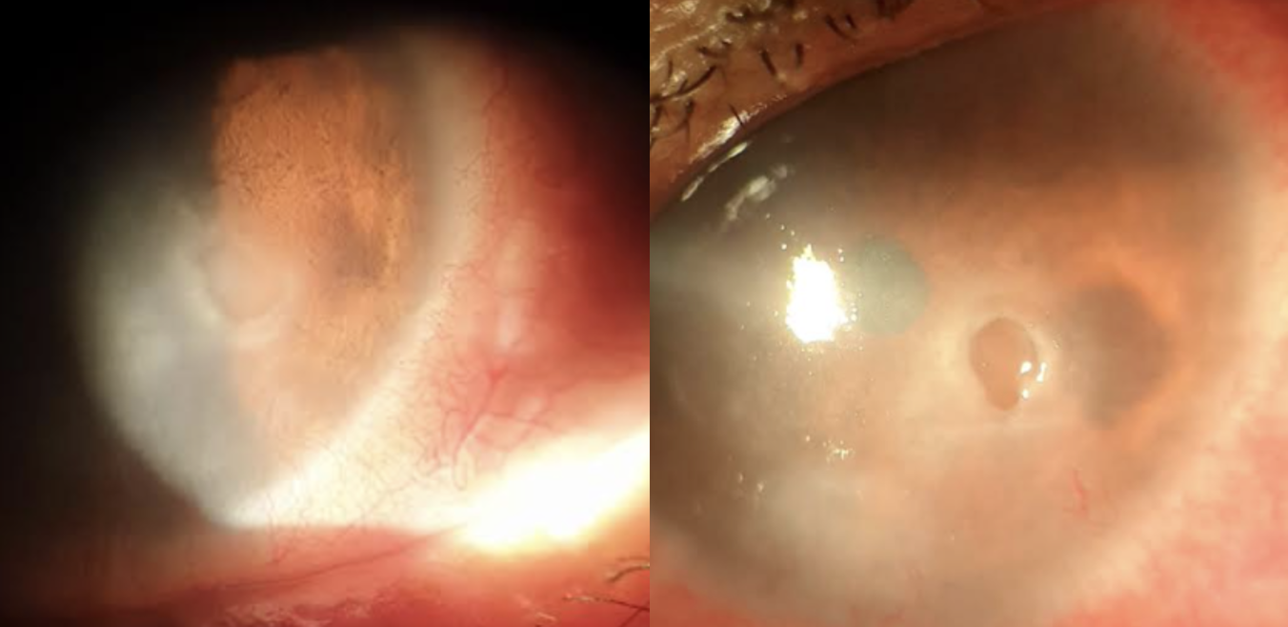
B
A
Figure 1: slit-lamp photographs of the anterior segment showing the appearance of the neurotrophic ulcer. A: Image at admission. B: Image after 15 days of medical treatment.

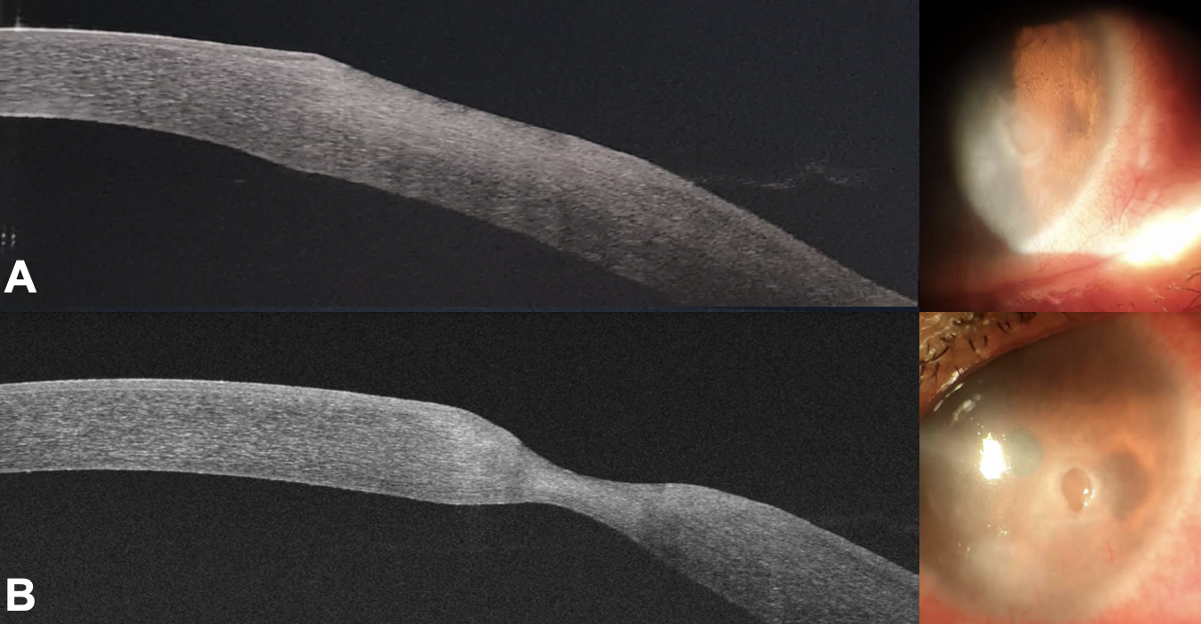
Figure 2: OCT image of the anterior segment showing corneal thinning of the neurotrophic ulcer. A: corneal thickness at 493 μm. B: corneal thickness at 210 μm.

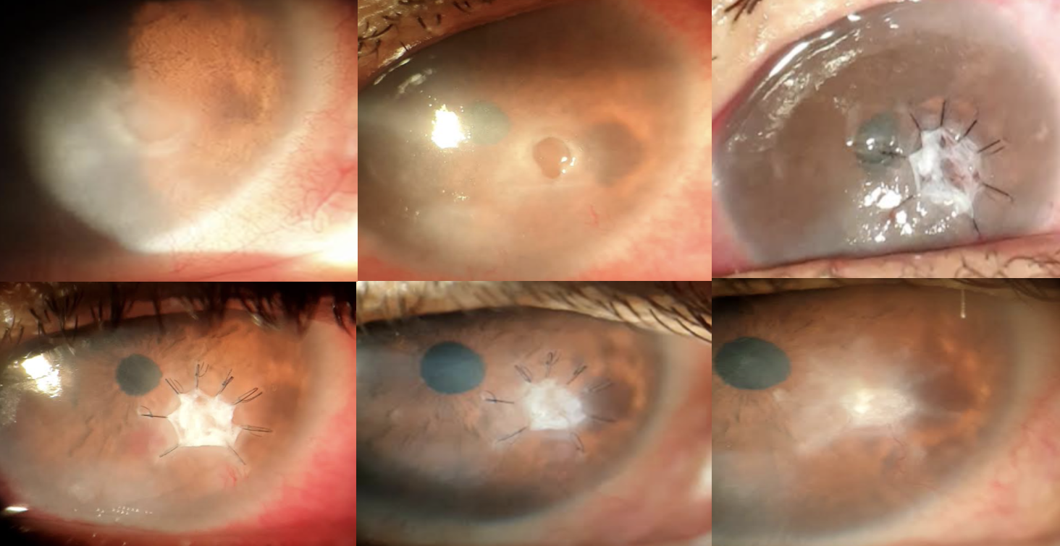
Figure 3: Slit-lamp photographs of the anterior segment showing the clinical evolution of the management of pre-perforation stage neurotrophic keratitis using the technique: Tuck-in Tenon patch graft.

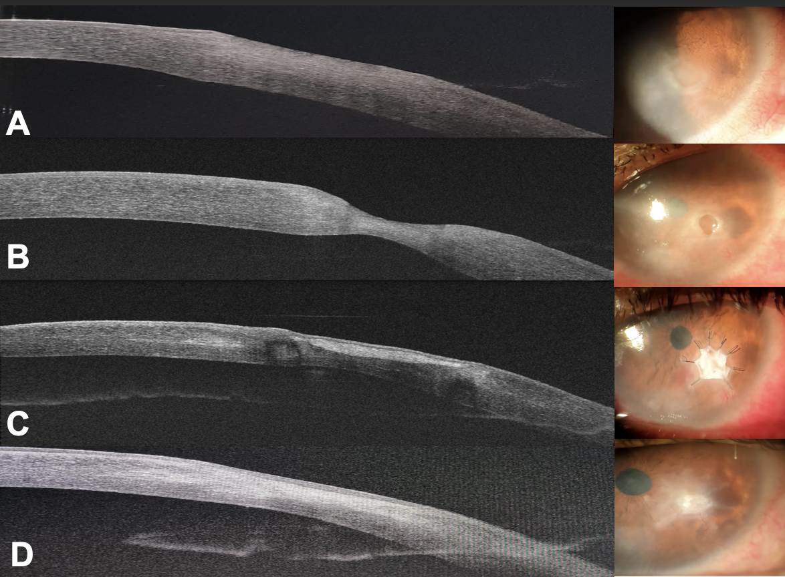
Figure 4: Anterior segment OCT image showing the evolution of corneal thickness as well as the integration of the Tenon's capsule over the ulcer to restore the corneal layers through a tectonic effect.
A: OCT image at admission with a thickness of 493 μm
B: OCT image at 15 days of medical treatment with a thickness of 210 μm
C: OCT image at 15 days after Tenon's capsule graft with a thickness of 365 μm
D: Final OCT image at 60 days with a thickness of 410 μm

