Case Report

An Atypical Case of Prolonged Cholestatic Hepatitis Following Acute Hepatitis A Infection and the Role of Corticosteroids: A Case Report

Abstract
Hepatitis A virus (HAV) infection is a common cause of acute viral hepatitis in children and usually follows a benign, self-limited course.¹⁻³ However, atypical manifestations are increasingly recognized, and prolonged cholestatic hepatitis is an uncommon but clinically important variant that may result in persistent jaundice, severe pruritus, and prolonged morbidity despite preserved liver synthetic function.¹,⁴⁻⁶ This report describes a 6-year-old boy with serologically confirmed acute hepatitis A who developed sustained conjugated hyperbilirubinemia, pruritus, and intermittent low-grade fever beyond three weeks of supportive care. Evaluation excluded autoimmune hepatitis, Wilson disease, biliary obstruction, chronic liver disease, and other common infectious etiologies. Because of persistent symptoms and delayed biochemical recovery, oral prednisolone was started at 2 mg/kg/day, following which the child showed rapid clinical improvement and progressive normalization of liver function tests. This case highlights the importance of recognizing prolonged cholestatic hepatitis as a distinct clinical pattern of HAV infection and suggests that short-course corticosteroid therapy may be considered in carefully selected refractory pediatric cases.⁴,⁶,⁷
Keywords: hepatitis A, prolonged cholestasis, pediatric hepatitis, corticosteroids, case report
Introduction
Hepatitis A virus is a non-enveloped, positive-sense RNA virus of the Hepatovirus genus and remains an important cause of acute viral hepatitis worldwide, especially in low- and middle-income settings.² In children, the infection is often asymptomatic or mild, and complete recovery typically occurs within a few weeks with supportive care alone.¹,³ However, the clinical spectrum extends beyond uncomplicated acute hepatitis and includes relapsing hepatitis, fulminant hepatic failure, prolonged cholestasis, autoimmune-like hepatitis, and extrahepatic manifestations.¹,⁵
Among these atypical patterns, prolonged cholestatic hepatitis is uncommon but significant because the child may remain deeply jaundiced and intensely symptomatic long after the initial hepatitic phase begins to resolve.⁴⁻⁶ It is characterized by persistent jaundice, pruritus, dark urine, and predominantly direct hyperbilirubinemia, often with preserved coagulation profile and serum albumin.⁴,⁶ This prolonged course frequently prompts repeated investigations and raises concern regarding biliary obstruction or chronic liver disease.
The pathogenesis of prolonged cholestasis after HAV infection is not fully understood. Proposed mechanisms include immune-mediated hepatocellular injury, cytokine-driven impairment of bile secretion, and transient dysfunction of hepatocellular transport systems.⁵,⁸ Because most patients eventually improve spontaneously, treatment remains largely supportive. Nevertheless, recent reports continue to suggest that corticosteroids may accelerate symptomatic and biochemical recovery in selected severe or refractory cases after exclusion of alternative diagnoses.⁶,⁷,⁹ The present case is reported to emphasize this unusual clinical variant and the possible role of steroids in management.
Case Presentation
A 6-year-old male child presented with fever for seven days followed by yellow discoloration of the eyes and dark urine for four days. There was no history of vomiting, bleeding manifestations, altered sensorium, long-term medication use, herbal remedies, blood transfusion, or exposure to hepatotoxins. Past medical history was unremarkable, and there was no family history of chronic liver disease, Wilson disease, or autoimmune illness.
On examination, the child was conscious, interactive, and hemodynamically stable. He had obvious icterus but no pallor, edema, rash, lymphadenopathy, or stigmata of chronic liver disease. Abdominal examination revealed hepatomegaly, with the liver palpable 5 cm below the right costal margin. There was no splenomegaly, ascites, or clinical evidence of hepatic encephalopathy.
Initial laboratory investigations revealed total bilirubin 16 mg/dL, direct bilirubin 14 mg/dL, alanine aminotransferase (ALT/SGPT) 3400 U/L, aspartate aminotransferase (AST/SGOT) 2948 U/L, serum albumin 3.5 g/dL, prothrombin time 13.9 seconds, and INR 1.2. Anti-HAV IgM was positive, whereas hepatitis B, hepatitis C, and hepatitis E serologies were negative. Ultrasonography of the abdomen showed hepatomegaly with normal echotexture and no evidence of gallstones, biliary dilatation, or extrahepatic biliary obstruction.
The child was initially managed conservatively with hydration, nutritional advice, rest, and symptomatic care. However, beyond three weeks of illness, he continued to have persistent jaundice, dark urine, low-grade fever, and significant pruritus. Despite the symptomatic cholestasis, liver synthetic function remained preserved. This mismatch between persistent clinical cholestasis and stable coagulation profile suggested the cholestatic variant of HAV infection described in the literature.⁴,⁶,⁷
Further investigations were undertaken to exclude other causes of prolonged conjugated hyperbilirubinemia. Antinuclear antibody and anti-smooth muscle antibody were negative. Serum ceruloplasmin was within the normal range. There was no radiological evidence of chronic liver disease, portal hypertension, or biliary obstruction. The child had no drug exposure history to suggest drug-induced liver injury. Taken together, these findings supported a diagnosis of prolonged cholestatic hepatitis secondary to acute hepatitis A.
Because symptoms remained troubling and biochemical recovery was delayed, oral prednisolone was started at 2 mg/kg/day. The response was marked. Within 48 hours, the child became afebrile. Pruritus improved substantially over the next week, and serial bilirubin values showed a progressive downward trend. Prednisolone was tapered gradually over two weeks. At follow-up four weeks after discontinuation of steroids, the child was asymptomatic with normalization of liver function tests. The overall course was strongly suggestive of prolonged cholestatic hepatitis associated with HAV infection with prompt improvement after short-course corticosteroid therapy.
Table 1-Serial laboratory profile
Parameter | At admission | After >3 weeks of persistent cholestasis | 1 week after prednisolone* | 4-week follow-up after stopping steroids*
Total bilirubin (mg/dL) | 16.0 | Persistently elevated | Downward trend noted | Normal
Direct bilirubin (mg/dL) | 14.0 | Persistently elevated | Downward trend noted | Normal
ALT/SGPT (U/L) | 3400 | Improving but abnormal | Further decline | Normal
AST/SGOT (U/L) | 2948 | Improving but abnormal | Further decline | Normal
Serum albumin (g/dL) | 3.5 | Preserved | Preserved | Normal
Prothrombin time (seconds) | 13.9 | Preserved | Preserved | Normal
INR | 1.2 | Stable | Stable | Normal

Discussion
Prolonged cholestatic hepatitis is an uncommon but well-recognized atypical manifestation of acute HAV infection. Reported frequency varies across studies, but published series suggest that it occurs in a small minority of patients, often ranging from less than 1% to around 7%.⁴⁻⁶ Children typically present with persistent jaundice, troublesome pruritus, dark urine, and direct hyperbilirubinemia lasting for weeks to months.⁴,⁶,⁷ In many cases, aminotransferases begin to decline while bilirubin remains elevated, resulting in a biochemical pattern that differs from uncomplicated acute hepatitis.
The differential diagnosis in such children is broad and must be approached systematically. Autoimmune hepatitis, Wilson disease, biliary obstruction, drug-induced liver injury, and other infectious or metabolic liver disorders need to be excluded before attributing persistent cholestasis solely to HAV.⁴⁻⁶ In the present child, negative autoimmune markers, normal ceruloplasmin, preserved synthetic function, and normal hepatobiliary imaging helped narrow the diagnosis. This step is particularly important because corticosteroid therapy should not be started empirically without reasonable exclusion of alternate etiologies.
The mechanisms responsible for prolonged cholestasis remain incompletely defined. Immune-mediated injury is thought to play an important role, and several authors have suggested that inflammatory cytokines may interfere with hepatocellular bile transport, thereby prolonging cholestasis even as the acute necroinflammatory phase begins to resolve.⁵,⁸ This may explain why some patients experience persistent itching and jaundice despite clinical stabilization and gradual reduction in aminotransferase levels.
Supportive care remains the mainstay of treatment, as spontaneous resolution is common.⁴,⁶ However, prolonged illness can substantially impair comfort, appetite, sleep, and family quality of life. In refractory cases, therapeutic options described in the literature include ursodeoxycholic acid, cholestyramine, antihistamines, and corticosteroids, although the evidence base remains limited.⁶,⁷,⁹ Among these, steroids have attracted attention because several case reports have documented relatively rapid relief of pruritus and decline in bilirubin following treatment.
The present case mirrors that pattern. After more than three weeks of ongoing cholestatic symptoms, oral prednisolone led to early defervescence, marked improvement in pruritus, and progressive biochemical recovery. Similar outcomes have been reported in recent pediatric literature. A 2023 BMJ Case Report described successful use of oral steroids in a child with prolonged cholestasis following HAV infection.⁷ A 2020 BMJ Case Report also documented recovery after oral steroid therapy in prolonged cholestasis after acute viral hepatitis.⁹ Although such reports cannot establish causality or define an optimal regimen, they strengthen the practical argument for considering short-course corticosteroids in selected patients with severe or persistent symptoms.
At the same time, caution is warranted. Most patients will recover without steroids, and unnecessary immunosuppression should be avoided. Therefore, the decision to use corticosteroids should be individualized and based on symptom burden, duration of cholestasis, laboratory trajectory, preserved liver synthetic function, and careful exclusion of other hepatobiliary disorders.⁴,⁶,⁷ In the present child, the dramatic temporal relationship between steroid initiation and improvement supports their likely benefit, even though spontaneous improvement cannot be fully excluded in a single case report.
Figure 1. Clinical timeline showing onset of fever, appearance of jaundice, persistence of cholestatic symptoms beyond three weeks, initiation of oral prednisolone, steroid taper, and complete clinical recovery.
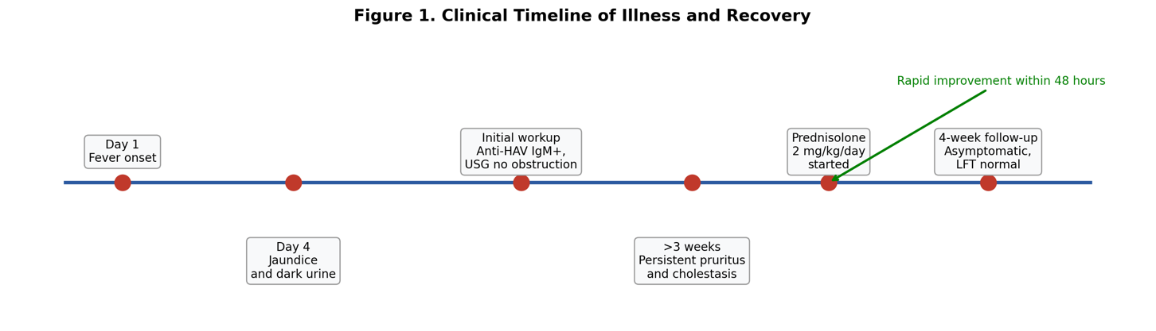
Figure 1 explanatory text: A horizontal clinical timeline can summarize symptom onset, day of jaundice appearance, confirmation of HAV infection, persistence of cholestasis beyond three weeks, initiation of prednisolone, early symptomatic response within 48 hours, tapering schedule, and complete recovery at follow-up. This figure helps readers quickly appreciate the delayed cholestatic phase and the temporal relation between corticosteroid therapy and improvement.

Figure 2. Serial biochemical profile showing initial marked transaminitis with conjugated hyperbilirubinemia and subsequent improvement after corticosteroid therapy.

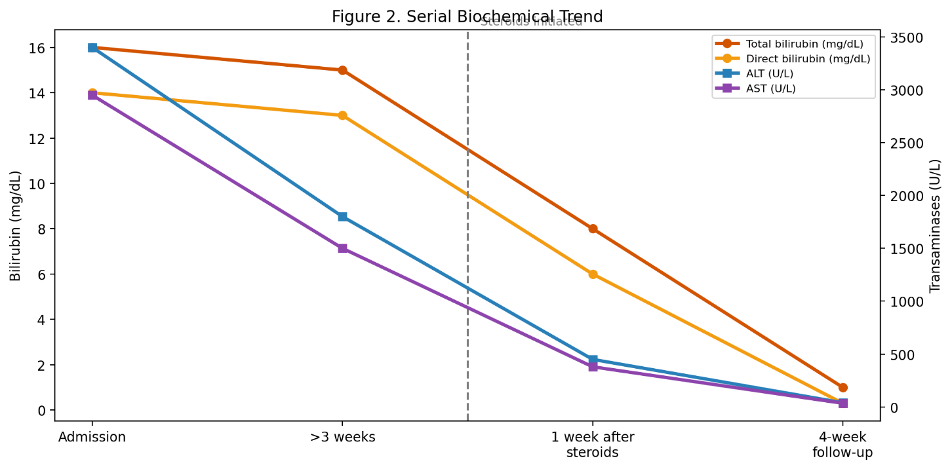
Figure 2 explanatory text: A line graph or table-based visual can depict the evolution of total bilirubin, direct bilirubin, ALT, and AST from presentation through follow-up. Even when exact intermediate values are unavailable, the conceptual trend demonstrates the marked initial hepatitic phase, prolonged cholestatic course, and subsequent improvement after steroid therapy.
Figure 3. Suggested diagnostic and therapeutic approach to prolonged cholestatic hepatitis after acute hepatitis A infection in children.⁴⁻⁷
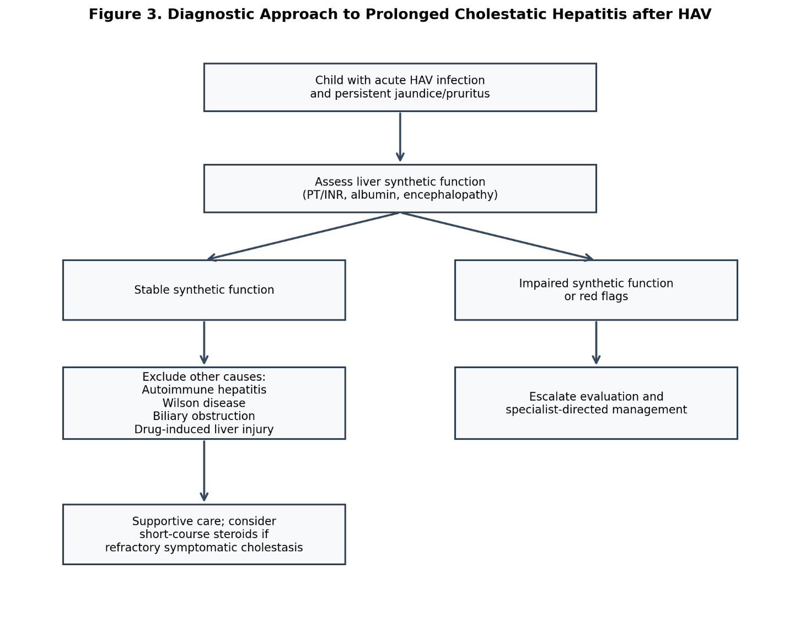
Figure 3 explanatory text: A simple clinical algorithm can illustrate the practical approach to a child with persistent jaundice after acute HAV infection: confirm serology, assess synthetic liver function, exclude biliary obstruction, autoimmune hepatitis, Wilson disease, and drug-induced injury, continue supportive care, and consider corticosteroids only in refractory symptomatic cases.⁴⁻⁷

Conclusion
Prolonged cholestatic hepatitis is an uncommon but important atypical manifestation of acute hepatitis A in children.⁴⁻⁶ It should be suspected in a child with persistent jaundice, direct hyperbilirubinemia, and severe pruritus despite stable hepatic synthetic function. Exclusion of autoimmune, metabolic, obstructive, and drug-related causes is essential before attributing the illness to cholestatic HAV alone. In carefully selected refractory cases, short-course corticosteroid therapy may provide rapid symptomatic relief and hasten biochemical recovery.⁶,⁷,⁹

COMPETING INTERESTS DISCLAIMER:
Authors have declared that they have no known competing financial interests OR non-financial interests OR personal relationships that could have appeared to influence the work reported in this paper.

References
- Schiff ER. Atypical clinical manifestations of hepatitis A. Vaccine. 1992;10 Suppl 1:S18-S20.
- Wang X, Ren J, Gao Q, Hu Z, Sun Y, Li X, et al. Hepatitis A virus and the origins of picornaviruses. Nature. 2015;517:85-88.
- Tong MJ, el-Farra NS, Grew MI. Clinical manifestations of hepatitis A. J Infect Dis. 1995;171 Suppl 1:S15-S18.
- Gordon SC, Reddy KR, Schiff L, Schiff ER. Prolonged intrahepatic cholestasis secondary to acute hepatitis A. Ann Intern Med. 1984;101:635-637.
- Singh SK, Borkar V, Srivastava A, Mathias A, Yachha SK, Poddar U. Atypical manifestations of childhood acute viral hepatitis. Eur J Pediatr. 2019;178:61-67.
- Yang W, Zhang S, Wu J. Prolonged cholestatic hepatitis A in children. J Pediatr Gastroenterol Nutr. 2011;52:734-738.
- Chirag R, Arun Babu T. Successful treatment of prolonged cholestasis following hepatitis A infection in a child with oral steroid therapy. BMJ Case Rep. 2023;16(12):e257477.
- Molecular Pathogenesis of Intrahepatic Cholestasis. Int J Mol Sci. 2021; relevant review article on bile acid transport and cholestatic mechanisms.
- Jayappa M, Kumar P, Goyal JP. Prolonged cholestasis after acute viral hepatitis: successfully treated with oral steroid. BMJ Case Rep. 2020;13(5):e234430.

