Original Research Article

Clinicians’ Perspectives on Fixed-Dose Combinations and Triple Therapy in Type 2 Diabetes Mellitus in Indian Settings

.
ABSTRACT

Objective: To assess clinicians’ perspectives on the use of fixed-dose combinations (FDCs) and triple therapy in diabetes mellitus (DM) in Indian settings, with a specific focus on preferred therapeutic choices, including dipeptidyl peptidase 4 inhibitors (DPP4i), sodium glucose co-transporter 2 inhibitors (SGLT2i), and their combinations.
Methods: The cross-sectional study was conducted using a 22-item questionnaire to collect insights from clinicians across India. The survey explored key aspects such as treatment practices, physician preferences, and observations related to the use of FDCs and triple therapy in the management of DM. Special emphasis was placed on preferred therapeutic options, including DPP4i, SGLT2i, and their combinations. The responses were analyzed using descriptive statistical methods.
Results: Out of 1,817 survey participants, the majority (62.19%) of clinicians indicated that FDCs play an important role in achieving good glycemic control. Furthermore, 77.6% agreed that combination therapies enhance treatment affordability, improve patient compliance, and lead to better glycemic outcomes. Approximately 84% of respondents identified SGLT2i as the preferred add-on therapy when used alongside a DPP4i and metformin FDC. About 69% of the clinicians reported that the most frequently used triple therapy was reported to be metformin + DPP4i + SGLT2i. A significant proportion (72.32%) of participants favored linagliptin as the DPP4i of choice in routine clinical practice. Additionally, 76.66% of participants noted that the dapagliflozin + linagliptin combination offers advantages over the dapagliflozin + vildagliptin combination, particularly in terms of better glycemic control, renal protection, cardiovascular benefits, and a reduced risk of urinary tract infections (UTIs).
Conclusion: The study highlights a strong clinical preference for FDCs, particularly metformin with DPP-4i and SGLT2i for enhancing glycemic control, affordability, and adherence in diabetes care. Linagliptin and dapagliflozin are widely favored for their glycemic, renal, and cardiovascular benefits, reinforcing their role in effective, organ-protective diabetes management strategies.

Keywords: Fixed-dose combinations, Glycemic control, SGLT2i, DPP4i, Linagliptin, Dapagliflozin

1. INTRODUCTION

Diabetes mellitus is a chronic metabolic condition that continues to rise globally. As of 2022, 14% of adults aged 18 years and older were living with diabetes, which was only 7% in 1990 [1]. India ranks second worldwide in diabetes prevalence, with an estimated 74.9 million individuals aged 20–79 affected in 2021, a figure projected to reach 124.9 million by 2045 [2].
In the management of type 2 diabetes mellitus (T2DM), fixed-dose combinations (FDCs) have become increasingly popular, offering multiple advantages, including reduced pill burden, lower risk of side effects, improved patient adherence, cost-effectiveness, and enhanced therapeutic efficacy. However, concerns persist over the irrational use of certain combinations [3,4]. Among oral antidiabetic therapies, the combination of metformin and DPP4i has shown both efficacy and a favorable safety profile compared to traditional options. Furthermore, triple therapy involving metformin, a dipeptidyl peptidase 4 inhibitor (DPP4i), and a sodium glucose co-transporter 2 inhibitor (SGLT2i) is widely regarded as a preferred strategy in routine clinical practice for its complementary mechanisms and enhanced glycemic outcomes [5].
Metformin, a biguanide antihyperglycemic agent, is considered the cornerstone of T2DM therapy. It exerts its effects primarily by reducing hepatic glucose production, decreasing intestinal glucose absorption, and enhancing insulin sensitivity through increased peripheral glucose uptake [6]. Linagliptin, a DPP4i, works by selectively and reversibly inhibiting the DPP-4 enzyme, thereby increasing levels of incretin hormones like GLP-1 (glucagon-like peptide-1) and GIP (glucose-dependent insulinotropic polypeptide). This results in glucose-dependent enhancement of insulin secretion and suppression of glucagon release, ultimately leading to reduced hepatic glucose output [7]. Dapagliflozin, an SGLT2i, lowers blood glucose by inhibiting glucose reabsorption in the renal proximal tubules. This action increases urinary glucose excretion and reduces plasma glucose levels, independent of pancreatic beta-cell function or insulin sensitivity [8]. The FDC of these drugs provides a synergistic approach that targets multiple pathophysiological defects in T2DM, resulting in improved glycemic control along with additional cardiovascular and renal benefits.
The study aimed to assess clinicians' perspectives on glycemic control, treatment affordability, patient adherence, and organ protection in the context of FDCs and triple therapy for T2DM in Indian settings. It specifically focused on preferred therapeutic options, including DPP4i, SGLT2i, and their various combinations.
2. materialS and methods

A cross-sectional study was conducted among experts in managing T2DM in Indian settings from June 2024 to December 2024. The study was performed after obtaining approval from Bangalore Ethics, an Independent Ethics Committee, which was recognized by the Indian Regulatory Authority, the Drug Controller General of India.

A convenient sampling technique was used, and an invitation was sent to clinical professionals across India based on their expertise and experience in treating T2DM in the month of March 2024 for participation in this Indian survey. About 1,817 clinicians from major cities of all Indian states, representing the geographical distribution, shared their willingness to participate and provide necessary data. Clinicians had the discretion to skip questions they did not wish to answer. Written informed consent was obtained from all participants, who were required to independently complete the questionnaire without consulting peers. Unanswered questions were treated as non-attempts.

The questionnaire booklet titled ZUCALINA was sent to the doctors who were interested in participating in this study. The ZUCALINA study questionnaire comprised 22-questions to gather current clinical practices, treatment patterns, and preferences related to the use of FDCs and triple therapy in T2DM, with a special focus on DPP4i, SGLT2i, and their combinations in routine clinical care.

Descriptive statistics were used to analyze the data, with categorical variables presented as frequencies and corresponding percentages. Visualizations, such as graphs and pie charts, were created using Microsoft Excel 2013 (version 16.0.13901.20400) to illustrate the findings.

3. results

Out of 1,817 survey participants, more than half (62.19%) of the clinicians reported that FDCs are important for achieving optimal glycemic control. Approximately 42% of respondents stated that 26–50% of their patients are currently on dual FDC therapies, while another 42% reported that 11–25% of patients are on triple drug FDC regimens. A significant majority (77.6%) believed that combination therapies improve treatment affordability, patient compliance, and result in better glycemic outcomes (Table 1).

Table 1: Distribution of responses on the perceived major advantages of using combination therapy

Major advantages of combination therapy | Response rate (n = 1817)
Affordability | 5.94%
Improved patient compliance | 10.79%
Better glycemic control | 5.67%
All the above | 77.6%

Regarding dual therapy, around 40% of participants indicated that metformin combined with a DPP-4i is the most frequently recommended regimen. When considering a third add-on agent, approximately 84% of participants preferred adding an SGLT2i to the FDC of metformin and a DPP-4i (Figure 1). Additionally, 69% reported that metformin + DPP-4i + SGLT2i is the most commonly used triple therapy in clinical practice (Figure 2). Among the DPP-4i, 72% of respondents identified linagliptin as their preferred choice (Figure 3). Around 32.47% reported having used linagliptin in clinical practice for 1–2 years. About 67% of participants agreed that linagliptin contributes to a definite improvement in estimated glomerular filtration rate (eGFR) (Figure 4).

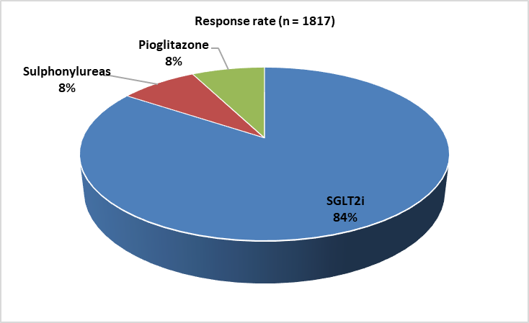

Figure 1: Distribution of responses on the preferred add-on medication to a DPP4i + metformin FDCs

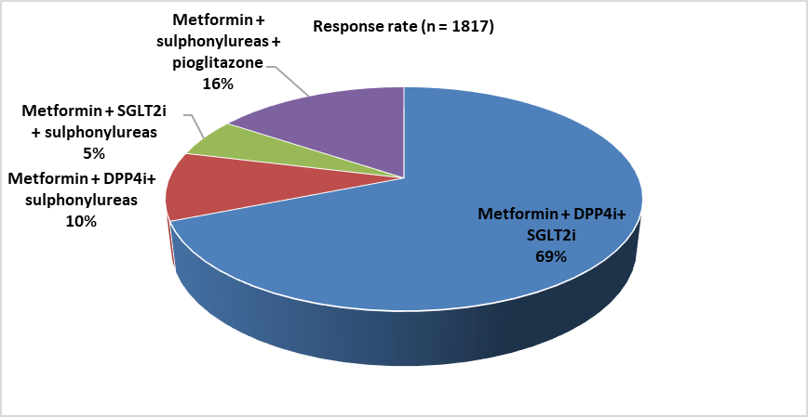

Figure 2: Distribution of responses to the most commonly used triple therapy in clinical practice

Figure 3: Distribution of responses on preferred choice among DPP4i in clinical practice

Figure 4: Distribution of responses on average HbA1c reduction found with linagliptin + dapagliflozin combination after 3 months of treatment in clinical practice

Nearly half (48.76%) of the experts observed an average HbA1c reduction of 0.5–1% after three months of treatment with the linagliptin + dapagliflozin combination. Around 52% reported using DPP4i + SGLT2i combinations in clinical practice for 1–3 years. Ease of achieving glycemic targets was cited by 52.94% as the most common reason for initiating linagliptin + dapagliflozin combination therapy. A large proportion (78.7%) favored the dapagliflozin + linagliptin FDC in patients with uncontrolled diabetes, cardiac comorbidities, and renal complications. About 60% of participants preferred the linagliptin + dapagliflozin + metformin combination in patients with HbA1c levels ranging from 8% to 11%, reflecting its suitability across varying degrees of poor glycemic control. A significant portion (76.66%) of respondents identified multiple advantages of the dapagliflozin + linagliptin combination over dapagliflozin + vildagliptin, including improved glycemic profile, renal and cardiovascular protection, and a reduced risk of UTIs (Table 2).

Table 2: Distribution of responses on the advantage of using the dapagliflozin + linagliptin combination over the dapagliflozin + vildagliptin combination

Advantages | Response rate (n = 1817)
Better glycemic profile | 4.07%
Better renal protection | 15.8%
Better cardioprotection | 3.03%
Better reduction of UTIs | 0.44%
All of the above | 76.66%

Approximately 85% of respondents agreed that appropriate pharmacotherapy plays a vital role in protecting organs in patients with diabetes and hypertension. About 41% highlighted that the FDC of dapagliflozin and linagliptin offers synergistic benefits, including better glycemic control, targeting multiple pathophysiological defects of diabetes, cardio-renal protection, reduced incidence of UTIs, and improved patient compliance. Most of the clinicians (90.09%) indicated that dapagliflozin is the preferred SGLT2i for achieving organ protection in addition to glycemic control (Table 3).

Table 3: Distribution of responses on preferred SGLT2i for organ protection with glycemic control

Preference | Response rate (n = 1817)
Dapagliflozin | 90.09%
Empagliflozin | 8.48%
Canagliflozin | 0.88%
Remogliflozin | 0.44%
All of the above | 0.11%

Around 82% of participants preferred the linagliptin + dapagliflozin combination for glycemic control with cardiovascular protection, while 95% selected the same combination for glycemic control with renal protection. Nearly 55% of clinicians identified social media as the preferred platform for patient education.

4. discussion

The findings of this study highlight a strong consensus among clinicians regarding the role of FDCs in optimizing glycemic control and improving treatment adherence in T2DM. More than 60% of survey respondents recognized the importance of FDCs, with around 78% emphasizing their potential to enhance affordability, compliance, and overall glycemic outcomes. These perceptions are consistent with previous evidence showing that FDCs reduce pill burden, simplify treatment regimens, and may contribute to better long-term control in T2DM. A previous study reported that FDCs improve patient adherence and enhance glycemic outcomes in individuals with T2DM [9].
The majority of participants indicated that combination therapies enhance affordability, improve patient compliance, and provide better glycemic control. In line with these findings, Bohm et al. reported that FDCs help lower treatment costs by reducing pill burden and combining multiple medications into a single tablet, making therapy more cost-effective. By simplifying treatment regimens, FDCs significantly improve adherence and compliance compared to separate drug dosing. This improved adherence contributes to more consistent use of antidiabetic medications and, consequently, better glycemic outcomes [10]. Supporting this, Phung et al. found that FDCs are often more cost-effective than individual drugs taken separately without compromising efficacy [11].
This study indicated a strong preference for SGLT2i as the third agent when used alongside a DPP4i + metformin FDC, reflecting a treatment approach that aligns well with current clinical recommendations. Baar et al. reported that the combination of metformin, DPP4i, and SGLT2i is widely used due to its additive glucose-lowering effects and additional metabolic advantages [12]. Similarly, Tsushima et al. highlighted that while treatment should be individualized, current guidelines often favor SGLT2i as the additional agent in triple therapy because of its superior glycaemic control and added cardiovascular and renal benefits [13].
In this study, most of the clinicians reported that the combination of metformin, DPP4i, and SGLT2i was the most commonly used triple therapy. Li et al. found that adding an SGLT2i to a dual regimen of metformin and a DPP4i leads to significant improvements in glycemic control, weight reduction, and blood pressure compared to dual therapy alone [14]. Similarly, Barnett et al. recommended that triple oral therapy, including a DPPi, metformin, and either a TZD or SGLT2i, should be considered, especially when minimizing the risk of hypoglycemia is a key treatment objective [15].
The survey findings also support the benefits of linagliptin, highlighting its preference as a DPP4i in clinical practice and its potential to improve eGFR. Gallwitz et al. highlighted that, unlike most other DPP4i, linagliptin is primarily eliminated via a non-renal (biliary/hepatic) pathway. This unique pharmacokinetic profile allows its use without dose adjustment in patients with renal impairment, a common concern in T2DM [16]. Similarly, Saini et al. reported that linagliptin’s long half-life and strong, selective binding to DPP4 help maintain effective glycemic control even with occasional missed doses, thereby enhancing patient convenience and adherence [17]. In another study involving 164 patients, Yagoglu et al. observed a significant improvement in eGFR in the linagliptin group compared with controls, suggesting a potential role in kidney function preservation [18]. Yamamoto et al. further reported that long-term linagliptin therapy provided sustained glycaemic control with no new safety concerns, regardless of baseline renal function [19].
The majority of clinicians highlighted dapagliflozin as the preferred SGLT2i for achieving both organ protection and glycemic control. In a multicenter randomized trial, Tavares et al. reported that dapagliflozin demonstrated promising trends in kidney protection among patients with acute organ dysfunction, further supporting its role beyond glycemic management [20]. Most of the clinicians also indicated that the combination of dapagliflozin and linagliptin offers superior benefits, such as improved glycemic control, enhanced renal and cardiovascular protection, and a lower incidence of UTIs compared to the dapagliflozin and vildagliptin combination. Supporting this, Dharmalingam M et al. found that the FDCs of dapagliflozin and linagliptin led to significantly greater improvements in glycemic control than the dapagliflozin and vildagliptin regimen. Due to its effectiveness, safety, and tolerability, this combination was considered a better therapeutic option for patients with T2DM who had previously been treated with metformin monotherapy [21].
These findings align with current guideline recommendations advocating these FDCs in routine practice. The American Diabetes Association – European Association for the Study of Diabetes (ADA–EASD) Consensus recognizes metformin as the first-line therapy for T2DM and strongly recommends the addition of SGLT-2i in patients with atherosclerotic cardiovascular disease, heart failure, or chronic kidney disease to reduce cardio-renal risk. While the guidelines do not explicitly outline triple oral therapy, they support the combination of metformin and SGLT-2i for relevant comorbidities, thereby providing an evidence-based framework that aligns with the use of FDCs containing metformin and an SGLT-2 inhibitor in appropriate clinical scenarios [22].
The major strength of the study is its large and diverse sample size of 1,817 participants, which enhances the generalizability of the findings across a wide range of clinical settings. The study effectively captures clinicians’ perspectives on drug efficacy, patient compliance, affordability, and organ protection, elements that are critical in optimizing diabetes care. However, its self-reported design introduces potential response and recall bias, while the cross-sectional nature precludes causal inference or long-term outcome assessment. Real-world outcome data and cost-effectiveness analyses are warranted to validate and optimize the clinical use of these FDCs in routine practice.
4. Conclusion

The study highlights a strong clinical preference for FDCs in T2DM, with over 60% recognizing their role in optimal glycemic control. The metformin + DPP4i + SGLT2i regimen, particularly linagliptin and dapagliflozin, is most favored for efficacy and organ protection. Linagliptin is valued for improving eGFR, while dapagliflozin is recognized for cardiovascular and renal benefits. Appropriate use of these combinations improves adherence, addresses glycemic gaps, and reduces cardio-renal risks in Indian patients.

COMPETING INTERESTS DISCLAIMER:
Authors have declared that they have no known competing financial interests OR non-financial interests OR personal relationships that could have appeared to influence the work reported in this paper.

References

- World Health Organization. Diabetes [Internet]. Geneva: WHO; [cited 2025 Aug 9]. Available from: https://www.who.int/news-room/fact-sheets/detail/diabetes
- Magliano DJ, Boyko EJ; IDF Diabetes Atlas 10th edition scientific committee. IDF Diabetes Atlas [Internet]. 10th ed. Brussels: International Diabetes Federation; 2021 [cited 2025 Aug 9]. Available from: http://www.ncbi.nlm.nih.gov/books/NBK581934/
- Kalra S, Das AK, Priya G, Ghosh S, Mehrotra RN, Das S, et al. Fixed-dose combination in management of type 2 diabetes mellitus: Expert opinion from an international panel. J Family Med Prim Care. 2020;9(11):5450-5457.
- Chen R, Li J, Chen D, Wen W, Zhang S, Li J, et al. Efficacy and safety of DPP-4 inhibitors and metformin combinations in type 2 diabetes: A systematic literature review and network meta-analysis. Diabetes Metab Syndr Obes. 2024;17:2471-2493.
- Ovalle F, Bell DSH. Triple oral antidiabetic therapy in type 2 diabetes mellitus. Endocr Pract. 1998;4(3):146-147.
- Dutta S, Shah RB, Singhal S, Dutta SB, Bansal S, Sinha S, et al. Metformin: A review of potential mechanism and therapeutic utility beyond diabetes. Drug Des Devel Ther. 2023;17:1907-1932.
- Freeman MK. Efficacy and safety of linagliptin in adults with type 2 diabetes mellitus. P T. 2011;36(12):807-842.
- Albarrán OG, Ampudia-Blasco FJ. Dapagliflozin, the first SGLT-2 inhibitor in the treatment of type 2 diabetes. Med Clin (Barc). 2013;141 Suppl 2:36-43.
- Moses RG, Kalra S, Brook D, Sockler J, Monyak J, Visvanathan J, et al. A randomized controlled trial of saxagliptin as add-on therapy in patients with type 2 diabetes and inadequate glycaemic control on metformin plus a sulphonylurea. Diabetes Obes Metab. 2014;16(5):443-450.
- Böhm AK, Schneider U, Stargardt T. Economic effects of fixed-dose versus loose-dose combination therapy for type 2 diabetes patients. Appl Health Econ Health Policy. 2023;21(1):109-118.
- Phung TL, Ong DT, Ngo NTN, Pham TT, Nguyen HT, Duong KNC, et al. Economic evaluation of fixed-dose drug combinations: A systematic review. J Appl Pharm Sci. 2024;14(12):1-26.
- van Baar MJB, van Ruiten CC, Muskiet MHA, van Bloemendaal L, IJzerman RG, van Raalte DH. SGLT2 inhibitors in combination therapy: From mechanisms to clinical considerations in type 2 diabetes management. Diabetes Care. 2018;41(8):1543-1556.
- Tsushima Y, Lansang MC, Makin V. The role of SGLT-2 inhibitors in managing type 2 diabetes. Cleve Clin J Med. 2021;88(1):47-58.
- Li M, Wang S, Wang X. Efficacy and safety of triple therapy with SGLT-2 inhibitor, DPP-4 inhibitor, and metformin in type 2 diabetes: A meta-analysis. Altern Ther Health Med. 2023;29(5):320-326.
- Barnett AH, Charbonnel B, Moses RG, Kalra S. Dipeptidyl peptidase-4 inhibitors in triple oral therapy regimens in patients with type 2 diabetes mellitus. Curr Med Res Opin. 2015;31(10):1919-1931.
- Gallwitz B. Emerging DPP-4 inhibitors: Focus on linagliptin for type 2 diabetes. Diabetes Metab Syndr Obes. 2013;6:1-9.
- Saini K, Sharma S, Khan Y. DPP-4 inhibitors for treating T2DM - hype or hope? An analysis based on the current literature. Front Mol Biosci. 2023;10:1130625.
- Yagoglu AI, Dizdar OS, Erdem S, Akcakaya B, Gunal AI. The effect of linagliptin on renal progression in type 2 diabetes mellitus patients with chronic kidney disease: A prospective randomized controlled study. Nefrologia. 2020;40(6):664-671.
- Yamamoto F, Ikeda R, Ochiai K, Hirase T, Hayashi N, Okamura T. Long-term safety and effectiveness of linagliptin in Japanese patients with type 2 diabetes and renal dysfunction: A post-marketing surveillance study. Diabetes Ther. 2020;11:523-533.
- Tavares CAM, Azevedo LCP, Rea-Neto Á, Campos NS, Amendola CP, Kozesinski-Nakatani AC, et al.; DEFENDER Investigators. Dapagliflozin for critically ill patients with acute organ dysfunction: The DEFENDER randomized clinical trial. JAMA. 2024;332(5):401-411.
- Dharmalingam M, Sharma SK, Prakash V, Maiti A, Kumar R, Murthy LSS, et al. Evaluating the efficacy, safety, and tolerability of combination therapy of dapagliflozin and linagliptin over dapagliflozin and vildagliptin in patients with type 2 diabetes mellitus inadequately controlled with metformin. Cureus. 2024;16(4):e58115.
- Davies MJ, D'Alessio DA, Fradkin J, Kernan WN, Mathieu C, Mingrone G, et al. Management of hyperglycemia in type 2 diabetes, 2018: A consensus report by the ADA and the EASD. Diabetes Care. 2018;41(12):2669-2701.

