Original Research Article
Effect of Crude Musa acuminata Sap On Doxorubicin Hydrochloride Induced Nephrotoxicity In Wistar Rat

Abstract
Background: Nephrotoxicity remains a major clinical challenge, particularly in patients undergoing chemotherapy with agents such as doxorubicin (DOX). Doxorubicin-induced renal damage is largely mediated through oxidative stress, inflammation, and tubular epithelial cell injury, leading to impaired renal function. Aim: This study evaluates the effect of crude Musa acuminata sap against doxorubicin-induced nephrotoxicity in Wistar rat. Methods: Thirty (30) adult male Wistar rats of body weight 150-250g were assigned into six (6) groups (A - F) of 5 rats each. Group A rats served as normal control and received feed and distilled water ad libitum. Group B rats served as positive control induced with DOX only at single dose of 10mg/kg i.p per day and remained untreated and received feed and distilled water ad libitum. Group C, D, E and F were nephrotoxicity induced with DOX and treated with 50, 100, 200 and 400 mg/kg mg/kg b.w of DOX for 7 days. Serum urea and creatinine and body weights were assayed. Results: The results show that DOX administration significantly (P<0.05) elevated serum urea and creatinine levels, confirming renal impairment. There was also a significant (P<0.05) increase in body weight among the untreated nephrotoxic group. However, treatment with crude Musa acuminata sap significantly reduced serum urea and creatinine levels compared to the untreated group, suggesting improved renal function. The treated groups also demonstrated better weight stability most especially in groups F. Conclusion: The findings indicate that crude MAS possesses nephroprotective properties, likely due to its antioxidant and anti-inflammatory phytochemicals property. The study supports the potential therapeutic role of plant-derived interventions in mitigating chemotherapy-induced renal toxicity. Further investigations involving histopathological and molecular analyses are recommended to elucidate the precise mechanisms of action.
Key words: Doxorubicin, Musa acuminate sap, nephrotoxicity, urea, creatinine

- Introduction

Medicine is an essential element to human survival cause if one is sick, death may occur but in today’s world where a lot of complicated diseases is rampant humans are finding it difficult to afford orthodox medicine which curbs most of this diseases. Low and middle income earners find it difficult to afford this medicine as rise in inflation and high cost of researching and manufacturing this drugs skyrockets the prices. Millions of people in this low and middle earner country are already struggling to feed even accessibility to this medicines is low, due to low resources. This research aims to help find cheaper and more accessible methods to treat disease and improve general healthcare and lives of people using traditional medicines.
Musa accuminata commonly known as wild banana generally believed to be native to Southeast Asia but spread to Africa and America via trade and colonization (Ani et al., 2024). This plant has been used wildly in traditional medicines for many health beneficial purposes which include calcium, nitrogen, phosphorous retention, this serves as its nutritional value. It is also used in treating various illness and disease traditionally .This have been scientifically investigated and believed to be true due to phenolic chemicals present in many parts of this plant which includes the fruit, leaf and pseudo stem this is said to be its pharmacological properties. The plants are perennial and produce a small number of stems (1-2) or a large number of stems (4-6). The leaf sheaths and petioles are glaucous or pruinose in appearance. Leaf-blades are rectangular, 2.0-2.5 m long × 0.4-0.6 m broad, truncated at the apex, and typically rounded at the base; however, leaf blades that are rounded on one side and acute on the other have been recorded. Fruits have a pedicel of approximately 1 cm at the base and a conspicuous acumen of 0.6-1.5 cm length at the apex. At full maturity, the pericarp is approximately 2 mm thick and brilliant yellow in color, while the pulp is white to cream-yellow to yellow in hue (Anupama,2021)
Doxorubicin hydrochloride is a anti cancer drug produced as far back as 1969. it is a topoisomerase II inhibitors which are under anthracyclines (idarubicin, daunorubicin, and doxorubicin (DOX).They induce DNA strand breaks and hinder the action of topoisomerases that are involved in the DNA replication and process of transcription. DOX has been demonstrated to have significant therapeutic potential and is recognized as one of the most efficient chemotherapy medications that have been approved by the Food and Drug Administration (FDA) for the treatment of various cancers such as breast cancer, carcinomas, sarcomas, and hematological malignancies Safhi,2018 Despite the extensive application of anthracyclines, the toxic effects of these drugs are multifaceted, with cardiotoxicity being the most well-known and most comprehensively studied adverse effect. Moreover, damage to other organs including the brain, liver and kidneys can also occur. It is already known that the anticancer activity of DOX can be attributed to the capability of the drug to intercalate into DNA, inhibit topoisomerase II, disrupt mitochondria function, and potentiate free-radical generation and oxidative damage. However, the precise mechanisms of action of DOX are complex and still relatively unknown. There have been many initiatives attempted to lessen the adverse effects of DOX, including the use of substances that possess antioxidant and/or antiapoptotic activity, the creation of efficient delivery systems, prodrugs, and the development of DOX analogues , as recently reviewed by Sonajou,2018. On the other hand, some of these techniques were not successful in reducing the toxic effects of anthracycline when tested in animal models or in human clinical trials. It is important to make an effort to find more efficient methods of combating DOX toxicity while maintaining or strengthening its therapeutic effects. Despite the side effects induced by DOX it is still widely used in cancer therapy . In addition to their cytotoxic effect therefore this research aims to use pharmacological properties of Musa acuminata to ameliorate this effects especially on kidney as related to this research. Cancer has been on the increase amongst the global population with 20 million new cases in 2022 only and 9.7 million death from cancer also recorded in 2022, this is why drugs like DOX is still being used to treat cancer despite its side effects, as research for a more better drug is still ongoing. Despite this people from low and middle income countries can barely afford this treatment talk more of affording medicines to help remove its adverse side effect. Cardiotoxicity has been the well known and comprehensively studied adverse effect of DOX (Wenningmann et al, 2019) while it is also known that other vital organs are also affected by the toxicity of DOX but has not been fully looked into. Also traditional medicines which have been used over the years in time past have been neglected but has strong potential to help advance powerful and more potent medicine. Hence, the reason for embarking on this research

2.0 Materials and Methods

The materials that were used in this study includes:
A total of thirty (30) male Wistar rats weighing 150 - 200g aged up to 3 months ,Standard laboratory equipment including animal cages, digital weighing balance, hypodermic syringes, oral cannula, Mindray BS-240 Fully Clinical Chemistry Analyzer was used to analyse the renal parameters, Microtone (Leedo HS 3345 fully automated, Leedo ES 300 tissue embedding system, Amscope B120C light microscope) from the Department of Anatomy, University of Nigeria Enugu campus were used for tissue assessment. Doxorubicin hydrochloride (zuvidox- 50 injection ip 50 mg Ol230070A) was purchased in Inels Pharmacy NO. 15 Lagos street, Independence Layout, Enugu -North Local Government Area of Enugu State

2.1 Procurement of Musa acuminata sap

Musa acuminata pseudo stem which was sourced from Ngoli 8 Integrated Farms Enugu state Nigeria, It was washed thoroughly and the outermost layer was removed and vascular bundles of the pseudo stem were used. The sap of Musa acuminata was obtained by slantingly cutting the internodes of the plant and allowing the sap to flow freely into a clean sterilized conical flask. The sap was stored in a cool environment under a temperature of 22.0±0.2ºC.

2.2 Procurement and Housing of Animal

Thirty (30) healthy Wistar rats were obtained from the Animal House Unit of the Department of Human Anatomy University of Nigeria Enugu campus .The animal were housed in standard wire mesh cages under controlled laboratory conditions (22±2°C, 12h light/dark cycle).The rats were provided with standard rodent chow (Mazuri rat and mouse diet) and water ad libitum and were allowed to acclimatize to the environment for seven days prior to experimentation.

2.3 Acute Toxicity Level
An acute toxicity test is carried out as an evaluation of the effects of a single dose of a test substance (doxorubicin) administered to animals, typically within 24 hours, to determine the substance toxicity and potential lethal dosage, often focusing on clinical signs and survival outcome .A single intravenous bolus was introduced via lateral tail vein under brief isoflurane anesthesia.
At a dose of 8 mg/kg doxorubicin IV which was selected based on established nephrotoxic models in rats (Qin et al., 2019; El-Kashef et al., 2017). This dose induces significant but non-lethal renal injury within 72 h.).

Chart 1. Treatment administered for two groups

Group | No of Animals | Treatments administered | Dose (mg/kg) | Volume (mL/kg)
Control | 3 | Sterile saline(0.9%NaCl) | — | 5
Doxorubicin (DOX) | 3 | Doxorubicin HCl | 8 mg/kg | 5

2.4 Experimental Design
A total of thirty (30) adult male Wistar rats aged more than 12 weeks and weighing between 150-250g were assigned into six (6) groups (A - F) of 5 rats per group.
Group A rats served as normal control and received feed and distilled water ad libitum.
B: administered (i.p) 10mg/kg body weight of DOX without treatment
C: administered 10mg/kg of DOX (I.P) + 50 mg/kg MAS
D: administered 10mg/kg of DOX (I.P) + 100 mg/kg MAS
E: administered 10mg/kg of DOX (I.P) + 200 mg/kg MAS
F: administered 10mg/kg of DOX (I.P) + 400 mg/kg MAS

2.5 ASSESSMENT OF BODY WEIGHT
After the stipulated 14 days the rats were all weighed and recorded using a digital electronic weighing scale (ANTOM Electronic compact scale) to determine the weight of the animal. A weighing container was placed on the balance and tarred (zero) to exclude the weight of the container, then the rat was gently placed on the weighing container and waited for the scale to stabilize before taking the reading for the groups and reading according to the method of Ani et al., 2017

2.6 Collection of Blood Samples And Tissue Extraction
At the end of 2 weeks, the animals were fasted overnight and subsequently anesthetized using formaldehyde topical anesthesia. Blood samples was collected by orbital puncture using heparinized capillary tube inserted into the medial canthus of the eye (30 degrees to the nose) and put into a container tubes coated with Ethylene diamine tetra acetic acid (EDTA) for hematological and renal markers analysis. Plasma was separated by centrifugation at 10,000 rpm for 5 min and stored at -80ºC until assayed for urea, creatinine, blood urea nitrogen levels etc. Moreover, the animals were dissected about 8cm proximal to anus and the kidney were harvested washed with distilled water, Mishra et al., 2016 and stored in plain tube containing (10%) diluted formalin for the histology.

2.7 Analysis of Biomarkers
Urea: Urea often reported as (BUN) was analyzed using Mindray BS-240 according to the adopted by the machine as follows:
Uses an enzymatic method (urease + GLDH).
Urea is broken down → produces ammonia → causes a drop in NADH.
The analyzer measures this drop at 340 nm—the bigger the drop, the higher the urea level.

Step-by-Step Procedure
The chemistry analyzer was turned on & the BS-240 solution was prepared and warmed-up and the probes were also washed .The reagents (R1 AND R2) were loaded into the analyzer . The analyzer was calibrated using the calibrator done every 1–4 weeks or with new reagents.
The QC samples were ran to ensure the system is working correctly and the animal samples were loaded into the racks

The analyzer was started and the test ran analyzer automatically: The samples + reagents were added and incubated at 37°C. The absorbance of the samples were read and the BUN concentrations were calculated and recorded in mg/dl.

The normal BUN range in rats is about 10–20 mg/dL and the time per test is approximately 10 minutes (including incubation).Accuracy is about CV < 3% (high). Mindray BS 240 directly measures urea in mg/dl so to report it is to convert to BUN by diving the urea report by 2.14

2.8 Assay of Creatinine concentration
This was also analyzed using the Mindray BS 240 chemistry analyzer where two reagent methods were available to test for creatinine according to Jaffe method.
Jaffe method: Creatinine reacts with picric acid in alkali to form a colored complex (read at 505 nm).
Enzymatic method: Enzymes convert creatinine to a dye product (read near 550 nm). And the Color intensity = creatinine concentration

Step to step procedures
The machine was started up and cleaned and the reagents (R1 AND R2) were loaded and lot information were entered. And calibrated with 2 levels of standards. The QC was ran and accepted because the results were within range and the creatinine test was selected. The Analyzer measured color changes and calculates concentration. The creatinine level was recorded in mg/dl. Higher levels indicate reduced kidney function / potential kidney damage.

2.9 Ethical Clearance
Ethical clearance for the study was sought and obtained from the Research and Bioethics Committee of the College of Medicine University of Nigeria, Enugu Campus. All the experimental procedures involving animals adhered to the Institutional guidelines of the National Institutes of Health (NIH) guide for the care and Use of Laboratory Animals.

2.9.1 Statistical Analysis
Statistical analysis was carried out using Statistical Package for Social Sciences software, version 26. All values that were generated out of this study were expressed as Mean ± Standard Deviation. Statistical difference in mean between groups was analyzed using one-way ANOVA (Analysis of variance).followed by Tukeys Post-hoc test for multiple comparisons. P–value ≤ 0.05 was considered as statistically significant.

3.0 RESULTS
Table 1: Effect of crude Musa acuminata on urea concentration (mg/dl)

Group | Day 1 | Day 21
A | 0.60±0.15 | 0.65±1.10
B | 20.10±0.25* | 23.50±1.25*
C | 22.10±0.15* | 26.10±0.45*
D | 19.40±0.00* | 21.50±0.10*
E | 18.15±0.10* | 23.20±1.57*
F | 21.10±1.22* | 10.20±1.28^{*β}
The results were presented as mean ± standard deviation. (n=5), the superscripts (^{*β}) P<0.05 shows a statistically significant difference (P<0.05) compared with the normal control and the positive control respectively.
The table shows the effect of Musa acuminata crude sap on nephrotoxicity as Group A has low urea concentration both on onset of nephrotoxicity (Day 1) and post treatment by Musa acuminata sap (Day 21) showing low signs of nephrotoxicity while Group B shows high urea concentration due to no treatment, and there were statistically significant (P<0.05) differences between the groups compared with the normal control and the positive control groups.

Table 2: Effect of crude Musa acuminata on creatinine concentration (mg/dl)

Group | Day 1 | Day 21
A | 1.00±0.01 | 0.90±0.20
B | 1.50±0.04 | 1.80±0.15
C | 1.30±0.00 | 1.40±0.06
D | 1.20±0.03 | 1.25±0.03
E | 1.50±0.00 | 1.53±0.01
F | 1.30±0.08 | 0.60±0.02
The results were presented as mean ± standard deviation. (n=5), the superscripts (^{*β}) P<0.05 shows a statistically significant difference(P<0.05) compared with the normal control and the positive control respectively.
The table shows the effect of Musa acuminata crude sap on nephrotoxicity as Group A has low creatinine concentration both on onset of nephrotoxicity(Day 1) and post treatment by Musa acuminata sap (Day 21) showing low signs of nephrotoxicity while Group B shows high creatinine concentration due to no treatment, Group C still has high concentration due to low dose treatment as well as Group D due to intermediate dose Group E shows high concentration due to chronic nephrotoxicity notwithstanding the high dose while Group F shows decline in creatinine concentration. There was no statistically (P<0.05) significant difference between the test groups compared with the normal control.
Table 3: Effects of crude Musa acuminata sap on the body weight (grams) of doxorubicin induced nephrotoxicity in Wistar rats.
Groups | Day 1 | Day 14 | Day 21
A | 200.10±0.15 | 210.10±0.18 | 230.50±0.50
B | 215.50±1.56 | 220.10±0.05 | 228.10±1.85
C | 180.60±1.19 | 185.30±1.20 | 183.40±0.20
D | 186.20±0.84 | 188.70±1.86 | 200.50±2.50
E | 190.10±1.50 | 193.30±0.28 | 196.20±1.30
F | 160.20±0.18 | 153.10±1.08^{αβ} | 150.40±0.86
Results were represented as mean + standard deviation (n=5), the superscripts (^{*β}) shows a statistically (P<0.05) significant difference between group A (normal control) and group B (positive control).

Group A shows relatively positive and increasing weight on Day 1 (onset of nephritis) and Day 14 (mid week of test) and on Day 21 (post treatment) due to normal control. Group B show no signs of weight loss probably due to water and fluid retention despite induction of nephritis with doxorubicin same with group C, D and E despite Musa acuminata treatment in low intermediate and high doses respectively. Group F shows decreased weight during day 14 and day 21 (post treatment) probably because of very high doses of Musa acuminata and there was a statistically (P<0.05) difference between group F compared with the normal and the positive control groups respectively.
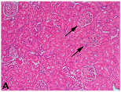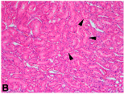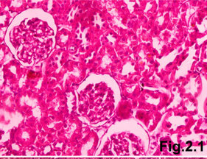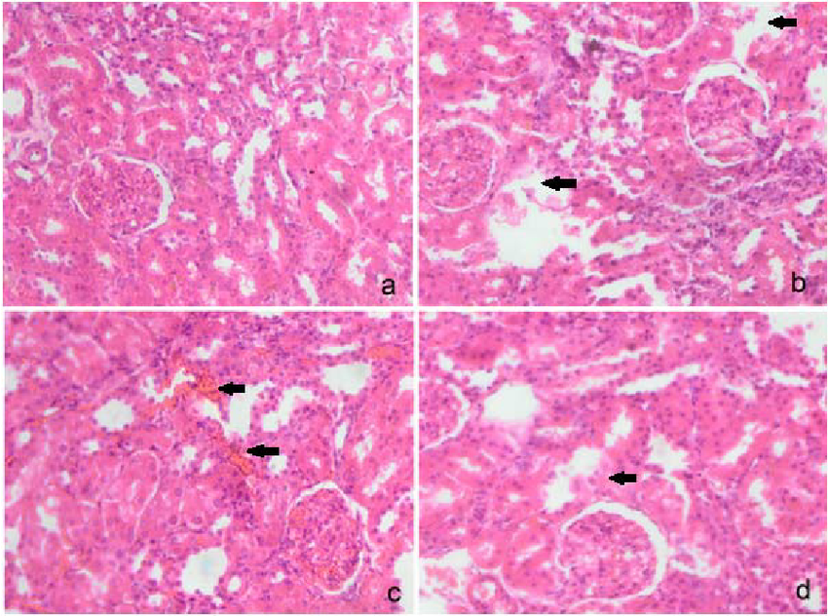
D
C
B
A
Figure 1. Histopathological examination of Wistar rat kidney. Fig. A and B (100x) Fig C and D (400x) showing normal histology of untreated rat kidney .Normal glomeruli (arrows) and tubules from the renal cortex are shown in panel (A) while panel (B) shows normal tubules (arrowheads) from the outer stripe of the outer medulla Specimens stained with hematoxylin and eosin

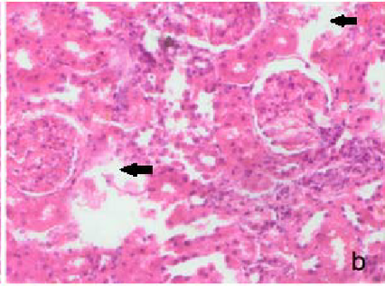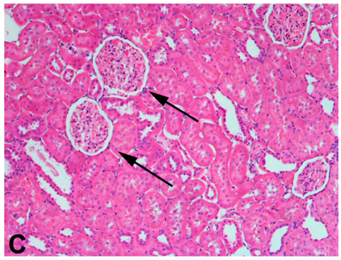
B
A

Figure 2. Histopathological examination of Wistar rat kidney (Positive control). Glomeruli (arrows (A)) from a doxorubicin induced nephritis rat appear to be hypertrophied as a compensatory response to a reduction in renal mass. Similarly, the tubules in the outer stripe of the outer medulla (B) of the rat also appear to be hypertrophied (arrowheads). Magnification, (400× Fig A) (Fig B,100x).Specimens stained with hematoxylin and eosin.

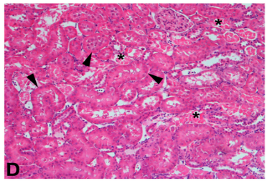
Figure 3. Histopathological examination of Wistar rat kidney with doxorubicin induced nephritis with intermediate treatment with Musa acuminata sap(100mg/kg), magnification(400×) showing areas of inflammatory cell invasion (thick arrows), , glomerular and tubular congestion (*),Specimens stained with hematoxylin and eosin.magnification.

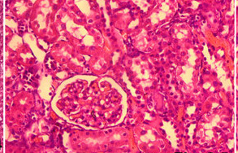

Figure 4. Histopathological examination of Wistar rat kidney with doxorubicin induced nephritis (chronic) treated with high dose of Musa acuminata sap 200 (mg/kg)showing almost normal histology with mild glomerular and tubular congestion, Specimens stained with hematoxylin and eosin.magnification (400 x)

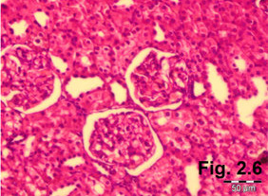
A

Figure 5. Histopathological examination of Wistar rat kidney with doxorubicin induced nephritis (chronic) treated with high dose of Musa acuminata sap (400mg/kg)and showing normal kidney histology similar to normal kidney histologymagnification (400×)with little to zero inflammations and congestions. Specimens stained with hematoxylin and eosin.

4.0 DISCUSSION
This study evaluated the effect of crude Musa acuminata sap on doxorubicin-induced nephritis in Wistar rats using serum urea, creatinine, and body weight as markers of renal function and systemic health. Doxorubicin is a well-established nephrotoxic agent whose renal toxicity is mediated through oxidative stress, inflammation, and tubular epithelial cell injury, resulting in impaired glomerular filtration and accumulation of nitrogenous waste products ((Safhi, 2018). Serum urea is a reliable indicator of renal dysfunction, as impaired renal excretion leads to its accumulation in the bloodstream. In this study, the significantly elevated urea concentration observed in the positive control group (Group B) confirms successful induction of nephritis by doxorubicin. This finding is consistent with previous reports demonstrating increased urea levels following doxorubicin-induced renal damage due to reduced glomerular filtration rate and tubular dysfunction (Koeppen & Stanton, 2018; The normal control group (Group A) maintained low urea concentrations throughout the study, indicating preserved renal function. Groups C and D, which received low and intermediate doses of crude Musa acuminata sap, did not show marked reductions in urea levels, suggesting that these doses were insufficient to ameliorate doxorubicin-induced nephrotoxicity. Similarly, Group E, despite receiving a high dose, continued to show elevated urea concentrations, which may reflect persistent chronic renal injury or inadequate bioavailability of active phytochemicals at that dose level. In contrast, Group F demonstrated a significant reduction in urea concentration by Day 21, indicating improved renal function. This finding suggests that very high doses of crude Musa acuminata sap possess nephroprotective and restorative properties. The observed reduction in urea may be attributed to the antioxidant and anti-inflammatory phytochemicals present in Musa acuminata, such as flavonoids, phenolics, and tannins, which are known to counteract oxidative stress and promote renal tissue repair (Koeppen & Stanton, 2018.
Creatinine is a more specific marker of glomerular filtration and renal function than urea. Elevated creatinine levels in the positive control group further confirm renal impairment induced by doxorubicin. The persistently high creatinine concentrations observed in Groups C, D, and E indicate that low to high doses of Musa acuminata sap were insufficient to fully restore renal function. Although statistical analysis showed no significant difference across groups, the biologically relevant reduction in creatinine concentration observed in Group F suggests improved renal clearance and partial recovery of glomerular function. The lack of statistical significance may be attributed to the small sample size (n = 5), which limits the power of the study. Nevertheless, the observed trend supports the nephroprotective potential of Musa acuminata sap at very high doses. These findings are in agreement with studies reporting that plant-derived antioxidants mitigate doxorubicin-induced nephrotoxicity by scavenging reactive oxygen species, reducing lipid peroxidation, and suppressing inflammatory mediators involved in renal injury, although exact mechanism are yet to be known (Al-Naimi,2019).
Body weight changes are indicative of general health status, metabolic balance, and disease progression. Group A exhibited progressive weight gain, reflecting normal physiological growth. Group B showed no significant weight loss despite nephritis induction, which may be attributed to fluid retention commonly associated with renal dysfunction (Radi, 2019). Similarly, Groups C, D, and E showed minimal weight changes, suggesting that low to high doses of Musa acuminata sap did not significantly affect systemic metabolism or fluid balance. However, Group F showed a significant reduction in body weight during the treatment period. This weight loss may reflect increased diuresis, reduced fluid retention, and normalization of renal function following recovery from nephritis (Radi, 2019) reported that improvement in renal function often leads to loss of retained fluid, which may manifest as a reduction in body weight. The findings of this study indicate that crude Musa acuminata sap exhibits dose-dependent nephroprotective effects in doxorubicin-induced nephritis. While low to high doses were insufficient to reverse renal damage, very high doses significantly improved biochemical indices of renal function. These results support the traditional use of Musa acuminata in managing kidney-related disorders and suggest its potential as a natural nephroprotective agent. However, further studies involving larger sample sizes, histopathological assessment of renal tissues, and isolation of active compounds are recommended to validate these findings and establish safe therapeutic dose ranges.
4.2 Conclusion
This study shows that crude Musa acuminata has therapeutic effect on nephrotoxicity induced by doxorubicin in Wistar rats as evident in (Group F) where urea and creatinine level showed improvement from nephritis (Group B) this shows that crude Musa acuminata could serve as a viable ,natural and easily accessible substitute to treat nephritis if its potential is fully harnessed .This research reinforces the traditional use of remedies but also showcases Musa acuminata sap potential in nephritis treatment. Crude Musa accuminata sap rich in antioxidant and anti-inflammatory phytochemicals, such as flavonoid, phenolics, and tannins and many more are properties which are help reduce oxidation and facilitate healing of nephrotoxicity. The implication of this research is particularly note worthy within the framework of global health as nephrotoxicity has been a significant public concern particularly in low- and middle-income countries as treatment for kidney related disease tends to be financially draining as standard nephrotoxicity drugs are costly and not accessible to all. Utilizing natural remedies help to address this issues of cost and availability. This treatment resonates with increasing interest in integrating traditional medicine which stresses the importance of natural substances with demonstrated therapeutics advantages.

COMPETING INTERESTS DISCLAIMER:
Authors have declared that they have no known competing financial interests OR non-financial interests OR personal relationships that could have appeared to influence the work reported in this paper.

REFERENCES
Al-Naimi, MS, Rasheed, HA & Hussien, NR. (2019). Renal biomarkers in nephrotoxicity. Clinical Nephrology. 91(3):145–153.
Ani CO, Polycarp A, Oti CU,Ejim NF, Nweke ML, Ugwuagbo V, Onah ES, Okeke PA, Etim BN, Agbor JI (2024). Impact of Musa accuminata sap on leptin and adiponectin concentration in high fat diet induced obesity on the offsprings of Wistar rat. International Journal of Clinical and Experimental Physiology. 2(7):1-7
Anupama, Y (2021). Morphological and pharmacological characteristics of Musa acuminata. International Journal of Botany Studies. 6(2):45–52.
Koeppen BM & Stanton BA (2018). Renal physiology. 6th edn. Philadelphia: Elsevier.
Mishra J, Dent, C & Devarajan, P (2016). Biomarkers of acute kidney injury. American Journal of Physiology – Renal Physiology. 311(4):F654– F662.
Safhi MM (2018).Cyclooxygenase-2 expression in doxorubicin-induced nephrotoxicity. Saudi Journal of Biological Sciences. 25(6):1180–1185.
Sanajou D, Ghorbani-Haghjo A & Argani H (2019). Doxorubicin-induced nephrotoxicity and oxidative stress. Journal of Renal Injury Prevention. 8(1):1–7.
Wenningmann N, Knapp M, Ande A, Vaidya TR & Ait-Oudhia S (2019). Insights into doxorubicin-inducedcardiotoxicity. Frontiers in Pharmacology. 10:153.
.

