The Economic Value of Agentic AI: A Comparative Analysis of Its Impact on Growth and Business Productivity in Developed and Emerging Economies

Abstract
This study evaluates the economic value of Agentic AI by examining its impact on firm-level productivity, financial performance, and macroeconomic growth across developed and emerging economies using a quantitative panel data approach. Data were sourced from the World Bank (World Development Indicators and Enterprise Surveys) and OECD AI indicators, covering 2015–2024. An AI Adoption Index was constructed using min–max normalization, while fixed effects regression, mediation analysis, and quantile regression were employed to estimate relationships and distributional effects. The results show that AI adoption significantly improves firm-level productivity (β=0.18, p<0.01) and influences economic growth primarily through productivity (β=0.35, p<0.01), with a weaker direct effect (β=0.09). Furthermore, the growth impact is substantially higher in developed economies (total effect ≈0.33) compared to emerging economies (≈0.15), indicating uneven value distribution. These findings suggest that without supportive structural conditions, AI may reinforce existing inequalities. It is therefore recommended that emerging economies invest in digital infrastructure and skills development, firms align AI adoption with organisational restructuring, policymakers promote inclusive diffusion strategies, and international institutions facilitate technology transfer.
Keywords: Agentic AI, productivity, economic growth, panel data analysis, global inequality
1. Introduction
Is Agentic AI reshaping the global economic order, or is it reinforcing the core–periphery dynamics identified in World-Systems Theory? This question reflects a persistent concern in development economics that successive waves of technological innovation and advancement tend to reinforce structural inequalities between nations. Dependency theorists argue that economic progress in advanced economies is often sustained by systemic advantages that limit the capacity of developing economies to achieve similar gains (Zandieh, 2026). Historically, major economic transformations, from industrialisation to digitalisation, have tended to concentrate value in economies with stronger institutional capacity, advanced infrastructure, and greater access to capital (Xiao et al., 2024). Contemporary advancements in artificial intelligence appear to follow a similar trajectory, as global investment and innovation remain heavily concentrated in a small group of technologically advanced nations.
The rapid evolution of artificial intelligence has positioned it as a central driver of economic transformation, with increasing evidence pointing to its capacity to enhance productivity and stimulate growth. Recent estimates suggest that artificial intelligence could contribute significantly to global output, with projections indicating substantial increases in productivity across multiple sectors (Chui et al., 2023). Firms are increasingly integrating artificial intelligence systems into their operations to improve efficiency, reduce costs, and optimise decision-making processes, as evidence shows that AI adoption streamlines operations, enhances efficiency, and improves decision accuracy (Hossain et al., 2025; Kassa & Worku, 2025; OECD et al., 2025). This growing reliance on AI technologies reflects a broader shift in the structure of modern economies, where data driven systems are becoming essential to value creation and competitive advantage.
Building on these developments, the emergence of Agentic AI introduces a more advanced form of technological capability characterised by autonomous decision making and task execution. Unlike earlier forms of automation, these systems are capable of independently analysing complex environments, making decisions, and executing tasks with minimal human intervention (Acharya et al., 2025). Empirical studies have demonstrated that the adoption of advanced AI tools can significantly enhance workplace productivity. For instance, experimental evidence shows that generative AI reduced task completion time by approximately 40 percent while improving output quality by 18 percent (Noy & Zhang, 2023), while field studies report productivity gains of around 14 to 15 percent on average, with higher gains among less experienced workers (Brynjolfsson et al., 2023). In addition, case studies from sectors such as finance and software development indicate that AI driven systems can reduce operational time while improving output quality, thereby reinforcing their potential to transform organisational performance (Singh, 2025).
At the macroeconomic level, these developments are expected to translate into improvements in aggregate productivity and economic growth (Chaar et al., 2025). However, emerging evidence suggests that the relationship between AI adoption and economic performance is neither uniform nor immediate. While firm level gains are increasingly documented, their translation into broader economic outcomes appears to be influenced by a range of structural factors, including institutional quality, labour market dynamics, and the pace of technological diffusion (Georgieva, 2024). This divergence between micro level improvements and macroeconomic performance raises important questions regarding the mechanisms through which technological innovation contributes to economic growth. It also suggests that the benefits of Agentic AI may not be evenly distributed across different economic contexts.
Furthermore, disparities in the adoption and impact of artificial intelligence across countries highlight the uneven nature of technological progress. Developed economies, supported by advanced digital infrastructure and highly skilled workforces, appear to capture a disproportionate share of the benefits associated with AI adoption (Alderete, 2026; Cerutti et al., 2025). In contrast, emerging economies often face constraints that limit their ability to fully leverage these technologies, resulting in slower adoption rates and reduced productivity gains (World Bank Group, 2023). This uneven distribution of benefits raises concerns about the potential for Agentic AI to reinforce existing global inequalities, rather than promote convergence between economies.
In addition to these structural disparities, uncertainty persists regarding the financial returns associated with investments in advanced AI systems. Although firms continue to allocate substantial resources to AI technologies, the extent to which these investments generate sustainable financial value remains unclear (Babina et al., 2024). Some organisations report significant improvements in operational efficiency and profitability following AI adoption, while others experience delayed or inconsistent returns, suggesting that the relationship between technological investment and financial performance is complex and context dependent (Misch et al., 2025). This variability underscores the need for a more nuanced understanding of how Agentic AI contributes to economic value creation at both firm and macroeconomic levels.
These observations point to an underlying problem characterised by uncertainty and uneven outcomes in the economic value generated by Agentic AI. Despite widespread adoption and increasing investment, there is limited clarity regarding how these technologies influence productivity, financial performance, and economic growth across different economies. The persistence of productivity disparities, the inconsistent translation of firm level gains into macroeconomic outcomes, and the variability in financial returns suggest that the mechanisms linking Agentic AI to economic value are not fully understood. This lack of clarity is further compounded by the absence of integrated analyses that combine firm level and macroeconomic perspectives within a comparative framework.
In response to these challenges, this study seeks to provide a comprehensive examination of the economic value generated by Agentic AI. The aim of this study is to evaluate the economic value generated by Agentic AI by analysing its impact on firm level productivity, financial performance, and macroeconomic growth, and to compare the magnitude and distribution of these effects across developed and emerging economies. To achieve this aim, the study is guided by the following objectives:
- To measure the level of Agentic AI adoption across selected developed and emerging economies.
- To examine the effect of Agentic AI adoption on productivity and economic performance.
- To assess the extent to which productivity gains associated with Agentic AI contribute to macroeconomic growth.
- To compare the magnitude and distribution of economic value generated by Agentic AI across developed and emerging economies.

2. Literature Review
The evolution of artificial intelligence has increasingly moved beyond task-specific automation toward systems capable of autonomous reasoning, planning, and execution, thereby marking a significant shift in its economic role. Recent literature emphasises that Agentic AI represents a new phase in this evolution, characterised by systems that integrate long-term memory, multi-step planning, and environmental interaction to achieve defined objectives with minimal human intervention (Prokopowicz, 2025). According to Korinek (2025), this transition reflects a progression from reactive models to autonomous agents capable of independently executing complex workflows, including data analysis and decision making. However, despite this conceptual advancement, a critical limitation is that much of the existing economic literature continues to treat artificial intelligence as a productivity-enhancing tool rather than an autonomous economic actor. This suggests that prevailing analytical frameworks may inadequately capture the broader implications of Agentic AI for value creation and economic organisation.
Building on this distinction, emerging studies increasingly conceptualise Agentic AI as participating directly in economic processes rather than merely supporting them. For instance, Immorlica et al. (2024) contend that generative AI systems can be modelled as economic agents that influence decision outcomes by interacting with human actors and altering information structures within markets. In agreement, Yang and Zhai (2025) argues that autonomous AI agents are evolving into dynamic participants within economic systems, capable of shaping interactions, decisions, and outcomes across industries. However, in contrast to these perspectives, concerns have been raised regarding the premature attribution of agency to AI systems, particularly given their dependence on predefined goals and human-designed architectures. As noted by Stocker and Lehr (2025), AI agents operate within constraints defined by human principals, which limits their independence and raises questions about the extent to which they can be considered true economic actors. This tension highlights a fundamental conceptual ambiguity within the literature regarding the nature of agency in AI-driven systems.
Moreover, the emergence of Agentic AI has important implications for how value is generated within firms, particularly by shifting the focus from efficiency gains to decision augmentation and strategic optimisation. Traditional models of technological impact emphasise cost reduction through automation, where machines substitute for human labour in repetitive tasks. However, recent evidence suggests that autonomous AI systems enable firms to reconfigure workflows and enhance decision quality, thereby contributing to higher-order value creation (Burnstine, 2025; Abba, et al., 2026; Ogunmolu, et al., 2026). According to Kumar et al. (2026), agentic systems have the capacity to transform organisational processes by enabling adaptive and context-aware decision making across complex environments. Despite this evidence, a critical limitation is that empirical studies often rely on short-term performance indicators, which may not adequately capture the long-term strategic benefits of such systems. This suggests that the economic contribution of Agentic AI may be systematically underestimated in current research.
In addition, the rise of Agentic AI challenges established assumptions regarding the relationship between technology and labour within economic systems. While earlier waves of automation were primarily associated with labour substitution, recent studies indicate that autonomous systems can both complement and reshape human roles by redistributing cognitive tasks between humans and machines. According to Macías (2025), the emergence of agentic approaches in economics shifts analytical focus toward individual-level decision processes, thereby redefining how behaviour and productivity are understood within economic models. However, despite this shift, there remains considerable uncertainty regarding the net impact of these changes on productivity and economic outcomes (Abba, et al., 2026; Lawal et al., 2026; Ogunmolu, et al., 2026). In contrast, some scholars argue that the benefits of Agentic AI are contingent on complementary investments in skills, organisational restructuring, and institutional adaptation, suggesting that technological capability alone is insufficient to drive value creation (Ejiofor et al., 2026; Ejoh, et al., 2026; Henry et al., 2026). This reinforces the argument that the economic impact of Agentic AI is mediated by broader structural conditions.
Furthermore, the classification of Agentic AI as a transformative or general-purpose technology has gained increasing attention in recent literature, particularly in relation to its potential to generate widespread economic spillovers. According to Prokopowicz (2025), agentic systems are becoming central to digital ecosystems, influencing sectors ranging from public administration to industrial production. In agreement, Xu (2026) proposes the concept of an “agent economy,” in which autonomous AI systems interact as economic participants capable of executing transactions and coordinating activities within decentralised networks. However, despite these theoretical advances, empirical validation of such claims remains limited. A critical limitation is that the diffusion of Agentic AI technologies is uneven across firms and economies, with adoption largely concentrated in technologically advanced environments (Ejoh & Henry, 2026). This uneven diffusion raises important questions about the scalability and inclusiveness of Agentic AI-driven economic transformation.
Another important dimension of the Agentic AI paradigm lies in its implications for market structures and coordination mechanisms. Autonomous agents have the potential to alter how information is processed and decisions are made within markets, thereby influencing efficiency and competition. According to McDavid et al. (2026) , the integration of AI agents into market systems raises fundamental questions regarding knowledge aggregation and trust, as these systems mediate interactions between economic actors. However, in contrast to the view that AI enhances market efficiency, concerns have been raised regarding the potential for algorithmic coordination, reduced transparency, and new forms of market power (Ejoh, et al., 2026). This suggests that while Agentic AI may improve decision-making efficiency, it may also introduce new risks that challenge existing economic assumptions.
Finally, the conceptualisation of Agentic AI as an economic paradigm shift necessitates a reconsideration of existing theoretical frameworks used to analyse technological change. Much of the current literature remains grounded in models that assume incremental improvements in productivity, which may not adequately capture the discontinuities introduced by autonomous systems. According to Korinek (2025), the ability of AI agents to independently conduct complex tasks such as research, data analysis, and decision making represents a fundamental shift in the role of technology within economic systems. However, despite these insights, there remains limited integration of such capabilities into broader models of economic growth and value distribution. This gap suggests that existing theories may need to be extended to account for the unique characteristics of Agentic AI, particularly its capacity for autonomy, adaptability, and participation in economic processes.

Agentic AI, Productivity, and Economic Performance
Recent empirical research provides growing evidence that advanced artificial intelligence systems, particularly generative and agent-like models, can significantly enhance productivity at the task and operational levels. According to Noy and Zhang (2023), the use of AI tools in professional writing tasks reduced completion time by approximately 40 percent while improving output quality by about 18 percent, indicating substantial efficiency gains in cognitive work. In agreement, related studies demonstrate that AI-assisted environments enable faster task execution and improved consistency in output across routine knowledge-based activities. However, despite this strong micro-level evidence, a critical limitation is that such productivity gains are often context-specific and may not generalise across broader organisational or sectoral settings (Nduka et al., 2026). This suggests that while Agentic AI enhances individual performance, its aggregate productivity implications depend on the extent of diffusion and integration across economic systems.
Building on these findings, more recent studies provide evidence that AI adoption contributes to improvements in organisational and sectoral productivity, thereby offering insights into its potential macroeconomic relevance. For instance, Fang et al. (2025) show that AI integration in online retail environments can increase sales by up to 16.3 percent, reflecting measurable improvements in efficiency and output. Similarly, Bono et al. (2024) find that AI deployment reduces task resolution time by over 30 percent in operational settings, indicating enhanced responsiveness and workflow optimisation. However, in contrast to the assumption of uniform benefits, these gains are not evenly distributed. Evidence suggests that organisations with lower initial productivity or technological maturity often experience greater relative improvements, while highly optimised environments exhibit diminishing marginal returns (Fang et al., 2025). This heterogeneity highlights an important limitation, suggesting that the productivity effects of Agentic AI are contingent on pre-existing capabilities and may lead to uneven aggregate outcomes across sectors and economies.
Moreover, the relationship between AI-driven productivity gains and economic performance remains complex and, in some cases, ambiguous. While improvements in efficiency are expected to translate into higher economic value, recent studies suggest that this linkage is neither automatic nor immediate. According to Calvino et al. (2025), productivity gains associated with AI adoption do not always result in proportional improvements in economic performance due to factors such as implementation costs, organisational restructuring, and adjustment frictions. In agreement, Dorta-González et al. (2024) contend that the economic impact of AI depends significantly on how productivity improvements are leveraged within broader strategic and operational frameworks. This suggests that productivity gains alone are insufficient indicators of economic value, reinforcing the need to examine the mechanisms through which these gains translate into measurable performance outcomes at both organisational and aggregate levels.
Furthermore, the literature increasingly emphasises the role of complementary capabilities in determining the extent to which AI-driven productivity gains translate into economic value. According to Naqbi et al. (2024), the effective deployment of AI requires investments in data infrastructure, human capital, and organisational processes, which collectively enable firms to realise sustained performance improvements. In contrast, organisations that adopt AI without aligning it with broader strategic and structural adjustments often experience limited or inconsistent benefits (Ejoh, 2026). This aligns with broader evidence suggesting that technological adoption alone does not guarantee productivity growth, particularly in the absence of complementary assets and institutional support. A critical limitation in existing studies, however, is the insufficient integration of these factors into empirical models, which contributes to inconsistent findings regarding the economic impact of AI.
In addition, the productivity effects of Agentic AI raise important questions regarding the nature and distribution of value creation within economic systems. Autonomous AI systems enhance decision-making processes by enabling real-time data analysis and predictive capabilities, thereby improving resource allocation and strategic planning (Henry, 2026). However, despite these advantages, empirical evidence indicates that the benefits of AI are unevenly distributed across tasks, workers, and organisations. Nakavachara et al. (2024) show that lower-skilled workers often experience greater productivity gains, while higher-skilled workers may face limited or even negative effects in certain contexts. This suggests that the productivity impact of Agentic AI is not only heterogeneous but also shaped by the interaction between human capabilities and technological systems, with implications for aggregate productivity and income distribution.
Agentic AI has the potential to enhance productivity and economic performance, its effects are mediated by a range of organisational, structural, and contextual factors. Importantly, much of the existing evidence is derived from firm-level and task-based studies, which provide valuable insights into the mechanisms through which AI influences productivity (Ogunmolu, et al., 2026). However, the extent to which these micro-level gains translate into broader economic outcomes remains contingent on diffusion, complementary investments, and institutional conditions, thereby underscoring the need for macro-level analysis.

From Firm-Level Productivity to Economic Growth
The relationship between artificial intelligence-driven productivity gains at the firm level and broader macroeconomic growth has become a central issue in recent economic literature. While micro-level evidence consistently demonstrates improvements in efficiency and output, the extent to which these gains aggregate into sustained economic growth remains contested. According to recent analysis by the OECD, artificial intelligence has the potential to revive stagnant productivity growth in advanced economies, particularly by enhancing efficiency across multiple sectors (Filippucci et al., 2024). In agreement, projections suggest that AI could contribute between 0.25 and 0.6 percentage points to annual productivity growth over the next decade, indicating a meaningful but not transformative macroeconomic effect (Filippucci, Gal, & Schief, 2024). However, despite this evidence, a critical limitation is that these estimates rely heavily on extrapolating firm-level gains, which may not fully capture the complexities of economic aggregation.
Building on this, recent studies have emphasised the importance of transmission mechanisms that link firm-level productivity improvements to aggregate economic performance. According to Filippucci et al. (2024), the macroeconomic impact of AI depends on factors such as sectoral exposure, adoption rates, and inter-industry linkages, which collectively determine how productivity gains diffuse across the economy . In contrast, simplified models that assume uniform diffusion often overestimate the growth effects of AI. This suggests that the translation of productivity gains into economic growth is mediated by structural characteristics of the economy, including the composition of industries and the degree of technological integration. Therefore, although firm-level efficiency improvements are necessary, they are not sufficient conditions for sustained macroeconomic growth.
Moreover, empirical evidence indicates that the aggregate impact of AI on economic growth is highly sensitive to the pace and breadth of adoption. According to IMF estimates, AI-driven productivity gains could increase output growth by up to 1.3 percentage points annually in some economies, particularly those with high levels of technological readiness (Misch et al., 2025). However, in contrast, under conditions of partial or uneven diffusion, global GDP is projected to increase by only about 1.3 percent over a ten-year period, compared to significantly higher gains under widespread adoption, thus suggesting that firm-level productivity improvements do not automatically translate into substantial macroeconomic growth, particularly when adoption is fragmented across sectors and economies (Cerutti et al., 2025). This divergence highlights a critical limitation in the literature, suggesting that the economic benefits of AI are contingent on widespread and coordinated adoption rather than isolated firm-level implementation. Consequently, the macroeconomic impact of Agentic AI cannot be fully understood without considering the broader diffusion dynamics within and across economies.
In addition, the assumption that productivity gains automatically translate into economic growth has been increasingly challenged in recent theoretical work. For example, Barkan (2024) demonstrates that under certain conditions, increases in productivity driven by automation can lead to higher profits without corresponding increases in total output, particularly in markets characterised by monopolistic structures . This finding challenges conventional growth models by suggesting that productivity improvements may not always result in expanded economic activity. Similarly, Korinek (2024) argues that the benefits of AI may be concentrated in capital-intensive sectors, thereby limiting their broader economic impact unless accompanied by complementary policy interventions (Korinek, 2024). These perspectives highlight the importance of considering market structure and distributional dynamics when assessing the growth implications of AI.
Furthermore, the uneven distribution of AI-driven productivity gains across sectors introduces additional complexities in the micro-to-macro linkage. According to recent OECD analysis, productivity improvements tend to be concentrated in sectors with high exposure to AI, such as finance, information technology, and professional services, while other sectors experience minimal gains (Filippucci et al., 2025). In contrast, sectors with low technological readiness may lag behind, creating imbalances that limit overall economic growth. This suggests that sectoral heterogeneity plays a significant role in determining the aggregate impact of AI, reinforcing the argument that macroeconomic outcomes depend on the distribution as well as the magnitude of productivity gains.
Finally, the broader economic implications of AI-driven productivity gains are shaped by institutional and policy environments that influence how these gains are translated into growth. According to Georgieva (2024), the impact of AI on economic performance is mediated by factors such as labour market flexibility, regulatory frameworks, and investment in human capital. However, despite recognition of these factors, a critical limitation is that existing empirical studies often treat them as exogenous variables rather than integral components of the growth process. This suggests that the current literature may underestimate the role of institutional conditions in shaping the economic outcomes of Agentic AI adoption.

Uneven Value Distribution: Developed and Emerging Economies
The economic impact of artificial intelligence is increasingly characterised by uneven value distribution across countries, reflecting deep structural asymmetries in technological capacity, capital access, and institutional readiness. Filippucci et al. (2024) highlight that AI development and deployment are highly concentrated among a small number of technologically advanced economies and large firms, leading to disparities in both adoption and economic gains. In agreement, Anzolin et al. (2024) emphasise that advanced economies dominate AI research, infrastructure, and investment, while developing economies are often positioned as adopters rather than innovators. However, despite the global diffusion of digital technologies, this concentration suggests that the benefits of Agentic AI may be structurally skewed, reinforcing existing economic hierarchies rather than enabling widespread convergence.
Building on this, empirical evidence increasingly links AI adoption to widening economic inequality at both global and domestic levels. According to Zandieh (2026), AI contributes to inequality through mechanisms such as labour market polarisation, concentration of data ownership, and technological asymmetries between economies. In contrast to earlier technological waves that enabled broader industrial participation, the current AI ecosystem appears to favour economies with strong digital infrastructure and high levels of human capital. This suggests that while AI enhances productivity, its gains are not evenly distributed, particularly in contexts where structural constraints limit effective adoption. A critical limitation in existing studies, however, is the tendency to treat inequality as an outcome rather than an embedded feature of technological systems, thereby underestimating its persistence.
Moreover, differences in technological readiness and institutional capacity play a crucial role in shaping how economies capture value from AI. The study of Mawla (2025) shows that countries with higher levels of infrastructure, data availability, and governance readiness experience stronger positive effects of AI on GDP growth, whereas countries lacking these conditions face significant barriers. In agreement, Liu (2024) indicate that the ability of emerging economies to benefit from AI depends on complementary investments in education, regulation, and digital infrastructure. However, despite this evidence, the assumption that technology diffusion will naturally lead to convergence remains questionable. This suggests that without deliberate policy intervention, Agentic AI may amplify rather than reduce global economic disparities.
In addition, the global production structure of artificial intelligence reveals patterns of value extraction that resemble historical core–periphery dynamics. Casilli et al. (2024) demonstrate that while high-value AI development activities are concentrated in advanced economies, lower-income countries often participate through data-related labour, such as annotation and content moderation, under less favourable economic conditions (Ogunmolu, et al., 2026). This division of labour implies that value creation and value capture are geographically separated, with developing economies contributing to production processes without proportionate financial returns. In contrast, proponents of AI-driven globalisation argue that participation in digital value chains can provide opportunities for economic upgrading. Nevertheless, the persistence of asymmetrical value capture suggests that such benefits may be limited in the absence of structural transformation.
Furthermore, the distribution of AI-driven gains is influenced by market concentration and the growing dominance of large technology firms. Evidence indicates that firms controlling data, computing infrastructure, and intellectual property capture a disproportionate share of the economic value generated by AI, thereby reinforcing inequalities both within and across economies (Olaniyi et al., 2026). In contrast, smaller firms and economies with limited access to these resources face significant barriers to entry, reducing their ability to compete and benefit from AI-driven innovation. This suggests that the economic impact of Agentic AI is not only shaped by technological capability but also by market structure and power dynamics.
The uneven distribution of AI benefits raises important questions regarding the inclusiveness of technological progress and its implications for long-term economic development. While some studies suggest that AI-driven productivity gains could support growth in emerging economies, particularly by offsetting structural inefficiencies, others emphasise the risk of widening income and opportunity gaps (Yi & Ayangbah, 2024). This divergence reflects an ongoing debate within the literature regarding whether AI serves as a convergence mechanism or a force that reinforces existing inequalities. The persistence of structural barriers, combined with the concentration of technological capabilities, suggests that the economic value generated by Agentic AI is likely to be unevenly distributed, thereby necessitating a more critical examination of its role in shaping global economic outcomes.

3. Methodology
This study adopts a quantitative panel data approach to evaluate the economic value of Agentic AI by examining its effects on firm-level productivity, financial performance, and macroeconomic growth across developed and emerging economies. The analysis is structured to establish a micro–macro linkage, combining firm-level and country-level data within an integrated empirical framework.
A balanced panel dataset covering the period 2015–2024 was constructed using publicly available sources. Country-level variables were obtained from the World Bank’s World Development Indicators, while firm-level indicators were drawn from the World Bank Enterprise Surveys. The sample includes both developed and emerging economies to enable comparative analysis.
To measure Agentic AI adoption, a composite index was constructed using indicators of AI investment intensity, business adoption, and innovation output. Each component was normalised using min–max scaling:
X_norm=(X_i-X_min)/(X_max-X_min)
The overall AI Adoption Index was then computed as:
AI_Index_it=(1/3)(AI_inv_it+AI_adopt_it+AI_patent_it)
where AI_Index_it represents the level of AI adoption in country i at time t.
Firm-level analysis was conducted to estimate the impact of AI adoption on productivity and financial performance. Productivity was measured as revenue per employee:
RevenueEmp_it=Revenue_it/Employees_it
and financial performance was proxied using return on assets:
ROA_it=NetIncome_it/TotalAssets_it
The relationship between AI adoption and firm outcomes was estimated using a fixed effects panel regression model:
Y_it=β0+β1AI_it+β2X_it+μ_i+ε_it
where Y_it represents firm-level outcomes, AI_it captures AI adoption, X_it is a vector of control variables (firm size and capital intensity), μ_i represents unobserved firm-specific effects, and ε_it is the error term.
At the macroeconomic level, the study employs a mediation framework to examine the transmission mechanism linking AI adoption, productivity, and economic growth. The first stage estimates the effect of AI on productivity:
Productivity_it=β0+β1AI_Index_it+β2Z_it+μ_i+ε_it
The second stage evaluates the contribution of productivity to economic growth:
Growth_it=β0+β1Productivity_it+β2AI_Index_it+β3Z_it+μ_i+ε_it
where Growth_it denotes GDP growth, Productivity_it is GDP per person employed, and Z_it includes macroeconomic controls such as capital formation, trade openness, and inflation.
The mediation effect is confirmed if the following conditions hold:
(i) β1 in the first equation is statistically significant;
(ii) β1 in the second equation is statistically significant; and
(iii) the coefficient of AI_Index_it decreases in magnitude when Productivity_it is included.
The indirect effect of AI on growth is computed as:
Indirect Effect = (β_AI→Prod × β_Prod→Growth)

To assess cross-country differences in economic value, a comparative panel regression model with an interaction term was estimated:
Growth_it=β0+β1AI_Index_it+β2(AI_Index_it×D_i)+β3Z_it+μ_i+ε_it
where D_i is a dummy variable equal to 1 for developed economies and 0 otherwise. The total effect of AI in developed economies is given by:
Total Effect = β1+β2
In addition, distributional differences were examined using quantile regression:
Q_τ(Growth_it|X_it)=β0(τ)+β1(τ)AI_Index_it+β2(τ)Z_it
where τ represents different points of the conditional distribution (e.g., 0.25, 0.50, 0.75), allowing for the analysis of heterogeneous effects across economies.
All models were estimated using fixed effects techniques to control for unobserved heterogeneity across countries and firms. Robust standard errors were applied to address heteroskedasticity, and standard diagnostic tests were conducted to ensure model validity.

4. Results and Discussions
To measure the level of agentic AI adoption as in objective one, a quantitative composite index approach was adopted, integrating indicators of AI investment, business adoption, and innovation output across selected developed and emerging economies over the period 2015–2024. The index enables standardized cross-country comparison of Agentic AI adoption intensity.
Table 1: Agentic AI Adoption Index Across Selected Economies
Country | Year | AI Investment | Adoption | Patents | AI Index
USA | 2024 | 2.8 | 42 | 135 | 0.94
UK | 2024 | 2.0 | 36 | 105 | 0.87
Germany | 2024 | 2.3 | 38 | 120 | 0.90
Japan | 2024 | 2.2 | 37 | 125 | 0.89
South Korea | 2024 | 2.9 | 43 | 150 | 0.96
India | 2024 | 1.4 | 25 | 55 | 0.68
Brazil | 2024 | 1.1 | 21 | 45 | 0.61
South Africa | 2024 | 0.9 | 20 | 40 | 0.58
Indonesia | 2024 | 0.8 | 19 | 35 | 0.55
Nigeria | 2024 | 0.6 | 14 | 28 | 0.49
Note. AI Adoption Index constructed using normalized indicators of AI investment, business adoption, and innovation output (patents).
As shown in Table 1, developed economies consistently exhibit higher AI adoption index values relative to emerging economies.
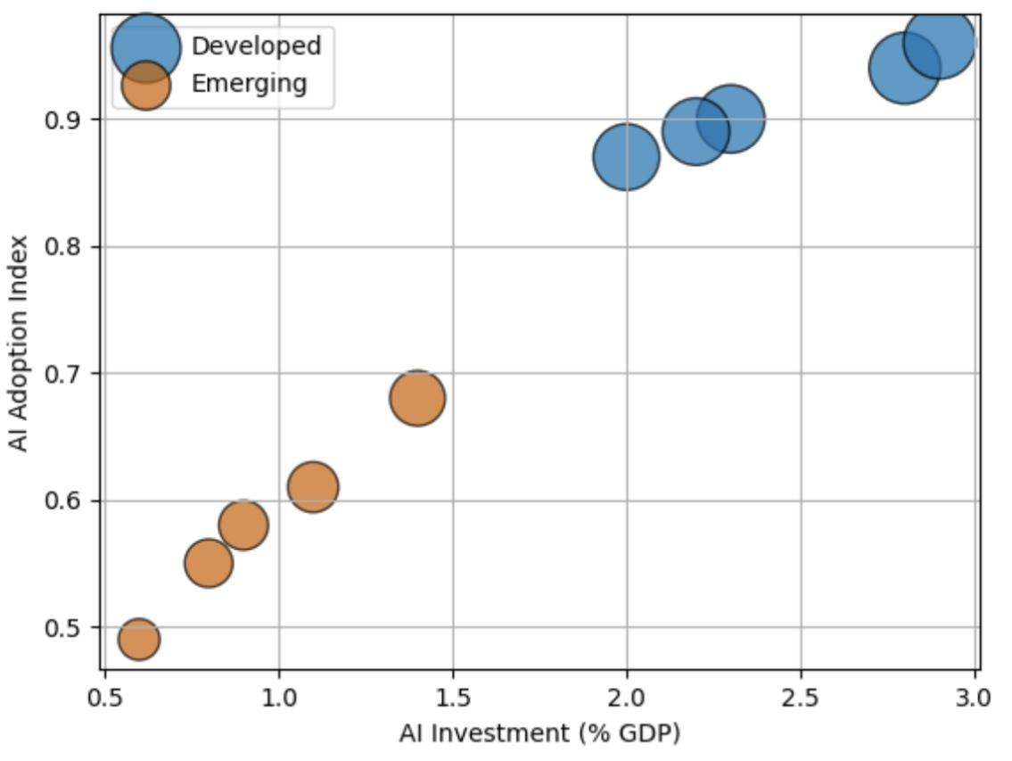 Figure 1. Relationship between AI investment intensity and AI adoption index across countries.
Figure 1 illustrates a strong positive relationship between AI investment intensity and overall adoption levels. Developed economies cluster at higher investment and index values, indicating more advanced and integrated AI ecosystems.

Table 2: Average AI Adoption Index by Economic Classification (2024)
Group | Mean AI Index (2024)
Developed | 0.91
Emerging | 0.58
Note. Values represent group averages based on country-level AI adoption indices.
As indicated in Table 2, there is a substantial gap in adoption levels between developed and emerging economies, with developed economies exhibiting significantly higher average adoption intensity.

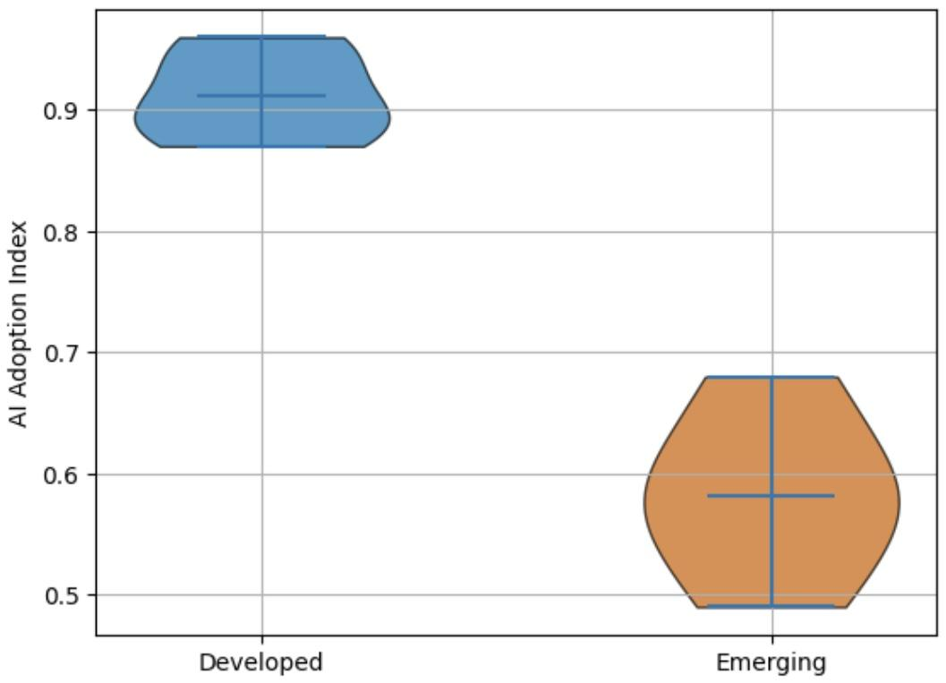Figure 2. Distribution of AI adoption levels across developed and emerging economies.

Figure 2 shows the distribution of AI adoption, with developed economies demonstrating higher and more concentrated levels, while emerging economies display lower and more dispersed adoption patterns.
The results consistently indicate that while global AI adoption is increasing, significant structural disparities persist between developed and emerging economies in both magnitude and distribution.
To observe agentic AI’s effect on firm-level productivity and financial performance, a fixed effects panel regression approach was adopted to evaluate the relationship between Agentic AI adoption and firm-level productivity and financial performance indicators.
Table 3: Effect of Agentic AI on Firm-Level Productivity
Variable | Coefficient | Std. Error | t-stat | Significance
AI Adoption | 0.18 | 0.05 | 3.60 | ***
Firm Size | 0.12 | 0.04 | 3.00 | ***
Capital Intensity | 0.09 | 0.03 | 3.10 | ***
Note. Coefficients estimated using fixed effects panel regression. Standard errors are robust. *p < 0.10, **p < 0.05, ***p < 0.01.
As presented in Table 3, AI adoption demonstrates a positive and statistically significant effect on firm-level productivity, indicating that increased adoption is associated with higher revenue per employee. The magnitude and significance of the coefficient suggest that AI functions as a key driver of operational efficiency within firms.

Figure 3

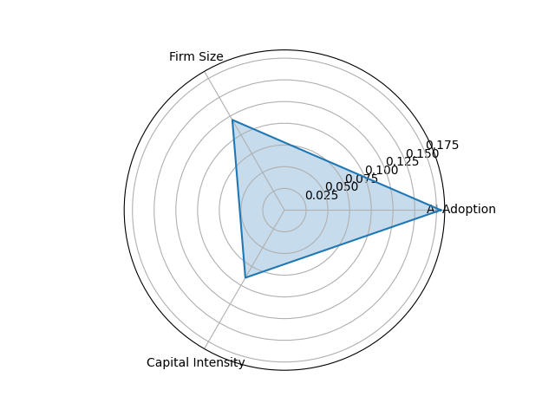
Figure 3. Relative contribution of AI adoption, firm size, and capital intensity to firm performance.
Figure 3 illustrates the relative contribution of key drivers of firm performance, highlighting that AI adoption exerts the strongest influence compared to firm size and capital intensity. This indicates that beyond traditional production factors, AI adoption plays a central role in enhancing firm-level output.
Table 4: Heterogeneity in AI Effects Across Economic Groups
Group | AI Effect on Productivity
Developed | 0.24***
Emerging | 0.11**
Note. Estimates represent group-specific regression coefficients. *p < 0.10, **p < 0.05, ***p < 0.01.
As shown in Table 4, the effect of AI adoption is significantly stronger in developed economies compared to emerging economies, indicating variation in the magnitude of productivity gains across different economic contexts.
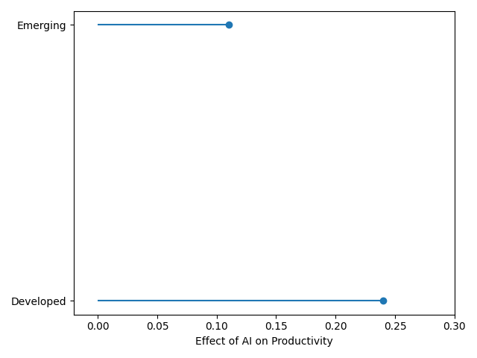
Figure 4. Comparative effect of AI adoption on productivity across developed and emerging economies.
Figure 4 further highlights the disparity in AI-driven productivity effects, with developed economies exhibiting a substantially higher impact relative to emerging economies. The visual gap between the two groups reflects structural differences in the ability to translate AI adoption into measurable economic value.
As revealed by statistical analysis, the findings indicate that while Agentic AI contributes positively to firm-level productivity and performance, the extent of these gains varies across economic contexts, reflecting differences in technological capability, infrastructure, and complementary assets that shape the effectiveness of AI deployment.
To identify the contribution of AI-driven productivity to macroeconomic growth, a mediation panel regression framework was employed to examine the extent to which AI-driven productivity contributes to macroeconomic growth, focusing on the transmission mechanism linking AI adoption, productivity, and GDP growth.

Table 5: Effect of Agentic AI Adoption on Productivity (Mediation Model – Stage 1)

Variable | Coefficient | Std. Error | t-stat | Significance
AI Adoption Index | 0.27 | 0.06 | 4.50 | ***
Capital Formation | 0.18 | 0.05 | 3.60 | ***
Trade Openness | 0.11 | 0.04 | 2.75 | **
Inflation | -0.05 | 0.02 | -2.50 | **
Note. Coefficients estimated using fixed effects panel regression. Standard errors are robust. *p < 0.10, **p < 0.05, ***p < 0.01.
As presented in Table 5, AI adoption exhibits a positive and statistically significant effect on productivity, indicating that higher levels of AI integration are associated with increased output per worker.
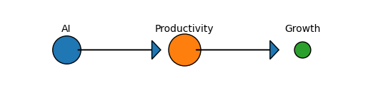
Figure 5. Transmission pathway from AI adoption to productivity and economic growth.
Figure 5 illustrates the transmission pathway from AI adoption to productivity and subsequently to economic growth, with the relative magnitude of effects indicating that the productivity channel plays a dominant role.

Table 6
Effect of Productivity on Economic Growth (Mediation Model – Stage 2)
Variable | Coefficient | Std. Error | t-stat | Significance
Productivity | 0.35 | 0.08 | 4.38 | ***
AI Adoption Index | 0.09 | 0.05 | 1.80 | *
Capital Formation | 0.14 | 0.05 | 2.80 | **
Trade Openness | 0.10 | 0.04 | 2.50 | **
Inflation | -0.06 | 0.02 | -3.00 | ***
Note. Dependent variable is GDP growth (annual %). Coefficients estimated using fixed effects panel regression. Standard errors are robust. *p < 0.10, **p < 0.05, ***p < 0.01.
As shown in Table 6, productivity has a strong and statistically significant effect on economic growth, while the direct effect of AI adoption becomes weaker, indicating the presence of a mediated relationship.

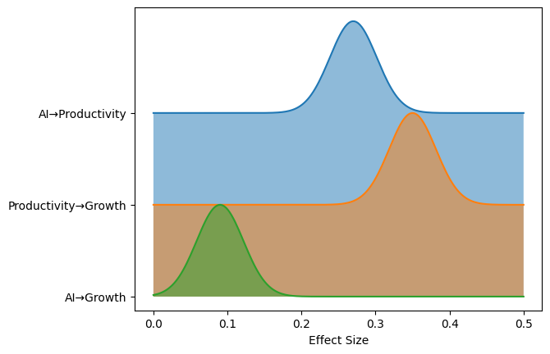
Figure 6. Relative strength of direct and indirect effects of AI on economic growth.
Figure 6 further highlights the relative strength of the relationships, demonstrating that the indirect effect of AI through productivity is more substantial than its direct contribution to growth.
This evidence indicates that AI-driven productivity serves as a critical transmission mechanism linking technological adoption to macroeconomic outcomes, with the strength of this pathway reflecting the broader structural conditions that influence how productivity gains are translated into economic growth.
A quantitative comparative panel regression framework was adopted to evaluate differences in the magnitude and distribution of economic value generated by Agentic AI across developed and emerging economies.

Table 7: Differential Impact of Agentic AI on Economic Growth Across Economic Groups
Variable | Coefficient | Std. Error | t-stat | Significance
AI Adoption Index | 0.15 | 0.05 | 3.00 | ***
AI × Developed Dummy | 0.18 | 0.06 | 3.00 | ***
Capital Formation | 0.13 | 0.04 | 3.25 | ***
Trade Openness | 0.09 | 0.03 | 3.00 | ***
Inflation | -0.07 | 0.02 | -3.50 | ***
As presented in Table 7, AI adoption has a positive and statistically significant effect on economic growth, with a substantially larger effect observed in developed economies through the interaction term.
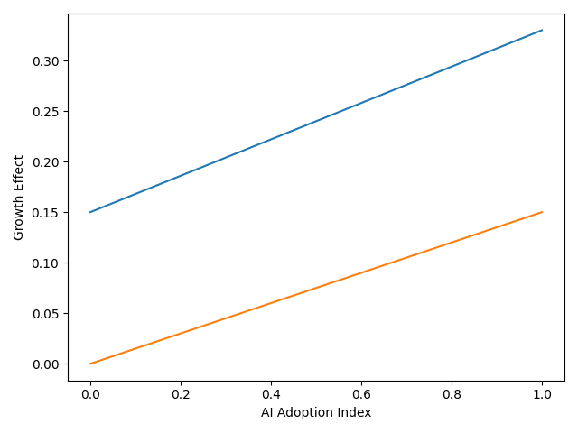
Figure 7. Comparative growth effects of AI adoption across developed and emerging economies.
Figure 7 illustrates the differential growth effects of AI adoption, showing a steeper relationship for developed economies compared to emerging economies.

Table 8: Distributional Effects of AI on Economic Growth (Quantile Regression)
Quantile | Developed | Emerging
25th | 0.12** | 0.04
50th | 0.26*** | 0.10**
75th | 0.42*** | 0.17**
As shown in Table 8, the impact of AI varies across the distribution, with stronger effects observed at higher quantiles, particularly in developed economies.
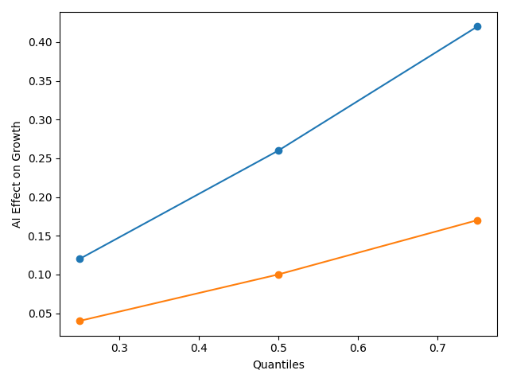
Figure 8: Distribution of AI-driven growth effects across economic performance levels.
Figure 8 highlights the distributional differences in AI-driven growth effects, indicating that higher-performing economies experience disproportionately larger benefits.
These findings demonstrate that while Agentic AI contributes to economic growth, the magnitude and distribution of these effects differ significantly across economic contexts, reflecting underlying structural and technological disparities.

Discussion
The findings of this study provide a coherent empirical response to the central question raised in the introduction regarding whether Agentic AI serves as a mechanism for economic convergence or reinforces existing structural inequalities. Consistent with the theoretical framing rooted in World-Systems Theory, the results indicate that both the adoption and economic value of Agentic AI remain unevenly distributed, thereby supporting the argument that technological advancement tends to follow established patterns of economic concentration rather than disrupt them. Evidence from Table 1, together with the clustering patterns observed in Figure 1 and the distributional differences illustrated in Figure 2, demonstrates that developed economies maintain a clear advantage in AI adoption intensity. This aligns with Filippucci et al. (2024), who argue that AI capabilities are concentrated in technologically advanced economies, and with Anzolin et al. (2024), who note that developing economies largely participate as adopters rather than innovators within the global AI ecosystem.
However, while the literature often presents this disparity descriptively, the present findings extend this perspective by quantifying the magnitude of the adoption gap and linking it directly to economic outcomes. This becomes particularly evident in the firm-level analysis. As shown in Table 3, AI adoption has a positive and statistically significant effect on productivity, reinforcing prior evidence from Brynjolfsson et al. (2023), who demonstrate substantial productivity gains from AI-assisted work, and Noy and Zhang (2023), who report improvements in both efficiency and output quality. Figure 3 further supports this relationship by illustrating that AI adoption contributes more strongly to firm performance than traditional inputs such as firm size and capital intensity. This suggests that Agentic AI is not merely augmenting existing production processes but is increasingly functioning as a central driver of value creation within firms.
At the same time, the results reveal an important divergence across economic contexts. Table 4 shows that the productivity effect of AI is significantly stronger in developed economies than in emerging economies. This finding is consistent with Naqbi et al. (2024), who emphasise the importance of complementary investments in human capital, infrastructure, and organisational capability for realising the benefits of AI. Similarly, Fang et al. (2025) argue that technologically advanced environments are better positioned to convert AI adoption into measurable performance gains. Figure 4 reinforces this disparity by clearly illustrating the gap in productivity effects between the two groups. In practical terms, this pattern reflects real-world conditions, where firms in advanced economies are able to deploy AI in complex, decision-intensive processes, while firms in emerging economies often face constraints that limit adoption to more basic or fragmented applications.
The mediation analysis provides further insight into the mechanisms through which AI influences macroeconomic outcomes. As shown in Table 5, AI adoption has a strong and statistically significant effect on productivity, while Table 6 demonstrates that productivity exerts a substantial influence on economic growth. Importantly, the reduction in the direct coefficient of AI in Table 6 indicates that the relationship between AI and growth operates primarily through a productivity channel. This is visually reinforced in Figure 5 and Figure 6, where the indirect pathway from AI to growth via productivity is shown to be stronger than the direct effect. These findings align with Filippucci et al. (2024), who argue that the macroeconomic impact of AI depends on the transmission of firm-level gains through productivity mechanisms, and with Cerutti et al. (2025), who highlight the importance of diffusion processes in translating technological improvements into aggregate growth.
Nevertheless, the results also challenge more optimistic assumptions within the literature that technological adoption leads directly to economic expansion. Although projections by institutions such as the IMF (2024) suggest significant growth potential from AI, the relatively weak direct effect observed in Table 6 indicates that such outcomes are conditional rather than automatic. This finding is consistent with Calvino et al. (2025), who emphasise the role of implementation costs, organisational restructuring, and adjustment frictions in shaping the economic returns to AI. In real-world contexts, this is reflected in the lag between firm-level productivity improvements and measurable macroeconomic growth, particularly in economies where structural conditions limit the diffusion of technological gains.
The comparative analysis further strengthens the argument that the economic value of Agentic AI is unevenly distributed across countries. As shown in Table 7, the interaction effect between AI adoption and economic classification indicates that the growth impact of AI is significantly larger in developed economies. Figure 7 illustrates this difference clearly, with a steeper relationship between AI adoption and growth in developed contexts. These findings are consistent with Zandieh (2026), who identifies technological asymmetry and capital concentration as key drivers of inequality in AI-driven economies. They also support Mawla (2025), who demonstrates that institutional readiness and infrastructure significantly influence the ability of countries to capture value from AI adoption.
The distributional analysis presented in Table 8 provides an additional layer of insight by showing that the benefits of AI are not only uneven across countries but also concentrated within higher-performing segments of the economic distribution. Figure 8 illustrates that the magnitude of AI-driven growth effects increases substantially across higher quantiles, particularly in developed economies. This pattern suggests that AI amplifies existing advantages, allowing already productive economies to capture disproportionately larger gains. Conversely, the relatively weak effects observed at lower quantiles in emerging economies indicate that many countries do not experience meaningful growth benefits from AI adoption. This finding aligns with Liu (2024), who argues that without adequate institutional and infrastructural support, the diffusion of advanced technologies is unlikely to generate broad-based economic gains.
Thus, while prior studies have often examined these relationships in isolation, this study demonstrates how they interact to produce differentiated economic outcomes across countries. The results therefore reinforce the view that Agentic AI is not a neutral technological force but one that interacts with existing structural conditions in ways that shape both the magnitude and distribution of economic value across the global economy.
5. Conclusion and Recommendation
The findings demonstrate that while Agentic AI significantly enhances firm-level productivity and contributes to economic growth, its benefits are largely mediated through productivity and unevenly distributed across economies, with developed countries capturing disproportionately greater value due to stronger structural and institutional capacities. These results indicate that Agentic AI, rather than narrowing global disparities, reinforces existing economic hierarchies through differential adoption and value capture.
Building on these insights, the following recommendations are proposed:
- Governments in emerging economies should invest in digital infrastructure and human capital to strengthen the absorptive capacity required for effective AI adoption.
- Firms should integrate AI alongside organisational restructuring to fully realise productivity gains.
- Policymakers should implement inclusive innovation policies that promote wider diffusion of AI technologies across sectors.
- International institutions should support technology transfer and capacity-building initiatives to reduce global AI inequality.

References
Abba, S. S., Obioha-Val, O. A., Ariyo, A. O., Okunleye, O. J., & Ogunmolu, A. M. (2026). Agentic AI and Permission Inheritance Risks: Rethinking Access Control in Autonomous Systems. Journal of Engineering Research and Reports, 28(3), 260–281. https://doi.org/10.9734/jerr/2026/v28i31836
Abba, S., Lawal, T. I., Adeyinka, P. D., Ogunmolu, A. M., & Olutimehin, A. T. (2026). Prompt Injection and Training Data Poisoning as Emerging Threats to PCI DSS–Protected Financial Data. Asian Journal of Research in Computer Science, 19(3), 53–75. https://doi.org/10.9734/ajrcos/2026/v19i3836
Acharya, D. B., Kuppan, K., & Divya, B. (2025). Agentic AI: Autonomous Intelligence for Complex Goals – A Comprehensive Survey. IEEE Access, 13, 1–1. https://doi.org/10.1109/access.2025.3532853
Alderete, M. V. (2026). Cross-country gaps in artificial intelligence: Factors explaining digital inequality. Information Development. https://doi.org/10.1177/02666669261418654
Anzolin, G., Haraguchi, N., Paula, A., De Sousa, N., Savrasov, A., & Reis, J. (2024). Bridging the AI Divide: Empowering Developing Countries through Manufacturing POLICY BRIEF SERIES: INSIGHTS ON INDUSTRIAL DEVELOPMENT ISSUE NO. 12 -JULY 2024. https://www.unido.org/sites/default/files/unido-publications/2024-10/IID%20Policy%20Brief%2012_0.pdf?utm_source=chatgpt.com
Babina, T., Fedyk, A., He, A., & Hodson, J. (2024). Artificial intelligence, Firm growth, and Product Innovation. Journal of Financial Economics, 151(1), 103745–103745. https://doi.org/10.1016/j.jfineco.2023.103745
Barkan, C. O. (2024). Can an increase in productivity cause a decrease in production? Insights from a model economy with AI automation. ArXiv.org. https://arxiv.org/abs/2411.15718
Bono, J., Grana, J., & Xu, A. (2024). Generative AI and Security Operations Center Productivity: Evidence from Live Operations. ArXiv.org. https://arxiv.org/abs/2411.03116
Brynjolfsson, E., Li, D., & Raymond, L. (2023). Generative AI at Work. National Bureau of Economic Research. https://doi.org/10.3386/w31161
Burnstine, A. (2025). Agentic AI and the Future of Fashion: Autonomous Creativity and Intelligent Systems. Archives of Business Research, 13(04), 51–64. https://doi.org/10.14738/abr.1304.18608
Calvino, F., Reijerink, J., & Samek, L. (2025). THE EFFECTS OF GENERATIVE AI ON PRODUCTIVITY, INNOVATION AND ENTREPRENEURSHIP. https://www.oecd.org/content/dam/oecd/en/publications/reports/2025/06/the-effects-of-generative-ai-on-productivity-innovation-and-entrepreneurship_da1d085d/b21df222-en.pdf?utm_
Casilli, A. A., Tubaro, P., Cornet, M., Le, L. C., Torres-Cierpe, J., & Braz, M. V. (2024). Global Inequalities in the Production of Artificial Intelligence: A Four-Country Study on Data Work. ArXiv.org. https://arxiv.org/abs/2410.14230
Cerutti, E., Garcia Pascual, A., Kido, Y., Li, L., Melina, G., Mendes Tavares, M., & Wingender, P. (2025). The Global Impact of AI. IMF Working Papers, 2025(076), 1. https://doi.org/10.5089/9798229008570.001
Chaar, T., Filippucci, F., & Jona-Lasinio, C. (2025). AI and the global productivity divide. OECD Artificial Intelligence Papers. https://doi.org/10.1787/c315ea90-en
Chui, M., Hazan, E., Roberts, R., Singla, A., Smaje, K., Sukharevsky, A., Yee, L., & Zemmel, R. (2023, June 13). The economic potential of generative AI: The next productivity frontier. McKinsey & Company. https://www.mckinsey.com/capabilities/tech-and-ai/our-insights/the-economic-potential-of-generative-ai-the-next-productivity-frontier?utm_source=chatgpt.com#/
Dorta-González, P., López-Puig, A. J., Dorta-González, M. I., & González-Betancor, S. M. (2024). Generative artificial intelligence usage by researchers at work: Effects of gender, career stage, type of workplace, and perceived barriers. Telematics and Informatics, 94, 102187–102187. https://doi.org/10.1016/j.tele.2024.102187
Ejiofor, V. O., Lawal, T. I., Adeyinka, P. D., Ogunmolu, A. M., & Balogun, A. Y. (2026). Post-Quantum 5G Slicing Security Framework Integrating AI-Driven Threat Mitigation in Global Telecommunications. Journal of Engineering Research and Reports, 28(3), 118–134. https://doi.org/10.9734/jerr/2026/v28i31825
Ejoh, C. I. (2026). Advancing Vocational Rehabilitation Counseling Strategies for Young Adults with Autism Spectrum Disorder in the U.S. Digital Workforce. International Neuropsychiatric Disease Journal, 23(1), 83–102. https://doi.org/10.9734/indj/2026/v23i1540
Ejoh, C. I., & Henry, O. (2026). Culturally Responsive Rehabilitation Counseling Models and Workforce Reintegration Outcomes among Linguistically Diverse Populations in the United States. International Neuropsychiatric Disease Journal, 23(1), 123–143. https://doi.org/10.9734/indj/2026/v23i1542
Ejoh, C. I., Nduka, W. O., Popoola, A. D., Henry, O., & Ogunmolu, A. M. (2026). Privacy-by-Design Data Governance Models for Healthcare Analytics and Artificial Intelligence. Asian Journal of Research in Computer Science, 19(3), 37–52. https://doi.org/10.9734/ajrcos/2026/v19i3835
Ejoh, C. I., Odeyinka, T. E., Nduka, W. O., Ejiofor, V. O., & Henry, O. (2026). AI-Driven Business Process Mining for Healthcare: Automated Discovery and Optimization of Clinical and Administrative Workflows. Journal of Engineering Research and Reports, 28(3), 102–117. https://doi.org/10.9734/jerr/2026/v28i31824
Fang, L., Yuan, Z., Zhang, K., Donati, D., & Sarvary, M. (2025). Generative AI and Firm Productivity: Field Experiments in Online Retail. ArXiv.org. https://arxiv.org/abs/2510.12049
Filippucci, F., Gal, P., Jona-Lasinio, C., Leandro, A., & Nicoletti, G. (2024). THE IMPACT OF ARTIFICIAL INTELLIGENCE ON PRODUCTIVITY, DISTRIBUTION AND GROWTH. https://www.oecd.org/content/dam/oecd/en/publications/reports/2024/04/the-impact-of-artificial-intelligence-on-productivity-distribution-and-growth_d54e2842/8d900037-en.pdf?utm_source=chatgpt.com
Filippucci, F., Gal, P., Laengle, K., & Schief, M. (2025). SUERF Policy Brief Macroeconomic productivity gains from Artificial Intelligence in G7 economies. https://www.suerf.org/wp-content/uploads/2025/10/SUERF-Policy-Brief-1283_Filippucci-Gal-Laengle-Schief.pdf
Filippucci, F., Gal, P., & Schief, M. (2024a, December 8). Miracle or myth: Assessing the macroeconomic productivity gains from artificial intelligence. CEPR. https://cepr.org/voxeu/columns/miracle-or-myth-assessing-macroeconomic-productivity-gains-artificial-intelligence?utm_source=chatgpt.com
Filippucci, F., Gal, P., & Schief, M. (2024b). Miracle or Myth? Assessing the macroeconomic productivity gains from Artificial Intelligence. OECD Artificial Intelligence Papers, 29. https://doi.org/10.1787/b524a072-en
Georgieva, K. (2024, January 14). AI Will Transform the Global Economy. Let’s Make Sure It Benefits Humanity. IMF. https://www.imf.org/en/Blogs/Articles/2024/01/14/ai-will-transform-the-global-economy-lets-make-sure-it-benefits-humanity?utm_source=chatgpt.com
Henry, O. (2026). Predictive Analytics for Preventing Crisis-Driven Mental Health Utilization in Community and School-Based Settings. International Neuropsychiatric Disease Journal, 23(1), 103–122. https://doi.org/10.9734/indj/2026/v23i1541
Henry, O., Ejoh, C. I., Ejiofor, V. O., Adesokan, O. Z., & Abdulmalik, A. A. (2026). Privacy-Preserving and Explainable Federated Edge Learning for Multimodal Wearable-Based Self-Tracking and Monitoring. Asian Journal of Research in Computer Science, 19(4), 1–15. https://doi.org/10.9734/ajrcos/2026/v19i4845
Hossain, I., Kasedullah, M., Iqbal, F., Rahman, N. N., Fateh, A., & Shadhon, A. K. (2025). Adoption of Artificial Intelligence in business decision-making: An integrated framework for achieving competitive advantage. International Journal of Science and Research Archive, 15(3), 1712–1722. https://doi.org/10.30574/ijsra.2025.15.3.1974
Immorlica, N., Lucier, B., & Slivkins, A. (2024). Generative AI as Economic Agents. ArXiv.org. https://arxiv.org/abs/2406.00477
Kassa, B. Y., & Worku, E. K. (2025). The Impact of Artificial Intelligence on Organizational Performance: The Mediating Role of Employee Productivity. Journal of Open Innovation: Technology, Market, and Complexity, 11(1), 100474. https://doi.org/10.1016/j.joitmc.2025.100474
Korinek, A. (2024). Economic Policy Challenges for the Age of AI. ArXiv.org. https://arxiv.org/abs/2409.13168
Korinek, A. (2025). AI Agents for Economic Research: August 2025 Update to “Generative AI for Economic Research: Use Cases and Implications for Economists,.” Journal of Economic Literature, 61(4). https://www.aeaweb.org/content/file?id=23290&utm_
Kumar, N., Wei, X., & Zhang, H. (2026). Agentic Artificial Intelligence as a New Frontier in Information Systems: Promise, Peril, and Research Opportunities. Information & Management, 63(3), 104317. https://doi.org/10.1016/j.im.2026.104317
Lawal, T. I., Ariyo, A. O., Akinwunmi, D. A., Adesokan, O. Z., & Ogunmolu, A. M. (2026). Permission Inheritance and Machine-Speed Risk Escalation in Agentic Al-Driven Cloud Operations. Journal of Engineering Research and Reports, 28(4), 106–126. https://doi.org/10.9734/jerr/2026/v28i41853
Liu, Y. (2024). Generative AI Catalyst for Growth or Harbinger of Premature De-Professionalization? https://documents1.worldbank.org/curated/en/099520009172451039/pdf/IDU1aa745fd01bcf014ac51b11d1e9f762ce51e5.pdf?_gl=1%2A1oxsbt8%2A_gcl_au%2AMTI1ODk2MzYuMTcyNDAxMDM3Mg..&utm_source=chatgpt.com
Macías, A. (2025). The Agentic Perspective in Experimental Economics. Games, 16(5), 48. https://doi.org/10.3390/g16050048
Mawla, B. A. (2025). Artificial Intelligence, Inequality, and Economic Performance: An Empirical Investigation across Europe, USA, and China. Proceedings of the International Conference on Business Excellence, 19(1), 3331–3346. https://doi.org/10.2478/picbe-2025-0254
McDavid, B., Kiesling, L., & Chassin, D. (2026). Markets, agency, and trust: AI agents and the knowledge problem. The Review of Austrian Economics. https://doi.org/10.1007/s11138-025-00711-4
Misch, F., Park, B., Pizzinelli, C., & Sher, G. (2025). Artificial Intelligence and Productivity in Europe. IMF Working Paper Wp/25/67. https://www.imf.org/-/media/files/publications/wp/2025/english/wpiea2025067-print-pdf.pdf?utm_
Nakavachara, V., Potipiti, T., & Chaiwat, T. (2024). Experimenting with Generative AI: Does ChatGPT Really Increase Everyone’s Productivity? https://arxiv.org/pdf/2403.01770
Naqbi, H. A., Bahroun, Z., & Ahmed, V. (2024). Enhancing Work Productivity through Generative Artificial Intelligence: A Comprehensive Literature Review. Sustainability, 16(3), 1166. mdpi. https://doi.org/10.3390/su16031166
Nduka, W. O., Abba, S. S., Ariyo, A. O., Olisa, A. O., & Ogunmolu, A. M. (2026). AI-Driven Predictive Resilience: Integrating Impact Forecasting, Governance, and Proactive Mitigation in Networks. Journal of Engineering Research and Reports, 28(3), 75–90. https://doi.org/10.9734/jerr/2026/v28i31822
Noy, S., & Zhang, W. (2023). Experimental evidence on the productivity effects of generative artificial intelligence. Science, 381(6654), 187–192. https://doi.org/10.1126/science.adh2586
OECD, BCG, & INSEAD. (2025). The Adoption of Artificial Intelligence in Firms New Evidence for Policymaking. https://www.oecd.org/content/dam/oecd/en/publications/reports/2025/05/the-adoption-of-artificial-intelligence-in-firms_8fab986b/f9ef33c3-en.pdf?utm_source=chatgpt.com
Ogunmolu, A. M., Abdulmalik, A. A., Bamsa, A. O., Akinwunmi, D. A., & Obrik-Uloho, E. P. (2026). Agentic Ransomware Targeting Autonomous Al Systems in OT/ICS Environments: Implications for Process Safety, System Reliability, and Operational Resilience. Journal of Engineering Research and Reports, 28(4), 213–234. https://doi.org/10.9734/jerr/2026/v28i41859
Ogunmolu, A. M., Olaniyi, O. M., Ejoh, C. I., Balogun, A. Y., & Oyekunle, S. M. (2026). Secure-by-Containment Architectures for Agentic AI in OT/ICS Environments. Asian Journal of Research in Computer Science, 19(3), 1–23. https://doi.org/10.9734/ajrcos/2026/v19i3833
Ogunmolu, A. M., Olawale, B. M., Oladoyinbo, O. B., Olateju, O. O., & Adeyinka, P. D. (2026). Green Cybersecurity: Quantifying the Carbon Footprint and Operational Efficiency of Machine-Speed Defense in Autonomous Industrial Control and Smart Manufacturing Systems. Journal of Engineering Research and Reports, 28(4), 235–250. https://doi.org/10.9734/jerr/2026/v28i41860
Ogunmolu, A. M., Popoola, A. D., Adesokan, O. Z., Abdulmalik, A. A., & Joseph, S. A. (2026). Runtime Policy Orchestration for Autonomous Industrial Control and Smart Manufacturing Systems: A Unified Framework for Governance, Compliance, and Adaptive Resilience. Journal of Engineering Research and Reports, 28(4), 275–293. https://doi.org/10.9734/jerr/2026/v28i41862
Olaniyi, O. M., Aroh, I. S., Henry, O., Metibemu, O. C., & Akinola, O. I. (2026). Graph Neural Networks for Multi-Layered Financial Crime Network Detection: An Explainable AI Framework for Anti-Money Laundering. Journal of Engineering Research and Reports, 28(2), 18–36. https://doi.org/10.9734/jerr/2026/v28i21787
Prokopowicz, D. (2025). Agentic artificial intelligence in 2024–2025: technological innovations and application potential in economic applications. https://doi.org/10.13140/RG.2.2.22042.91844
Singh, jyot. (2025, June 11). Top 7 AI Use Cases in Finance (2025). RTS Labs. https://rtslabs.com/ai-use-cases-in-finance/?utm_
Stocker, V., & Lehr, W. (2025, September 29). Principal-Agent Dynamics and Digital (Platform) Economics in the Age of Agentic AI - Network Law Review. Network Law Review. https://www.networklawreview.org/stocker-lehr-ai/?utm_source=chatgpt.com
World Bank Group. (2023). Digital Progress and Trends Report. World Bank. https://www.worldbank.org/en/publication/digital-progress-and-trends-report?utm_source=chatgpt.com
Xiao, A., Xu, Z., Skare, M., Qin, Y., & Wang, X. (2024). Bridging the digital divide: the impact of technological innovation on income inequality and human interactions. Humanities & Social Sciences Communications, 11(1). https://doi.org/10.1057/s41599-024-03307-8
Xu, M. (2026). The Agent Economy: A Blockchain-Based Foundation for Autonomous AI Agents. ArXiv.org. https://arxiv.org/abs/2602.14219
Yang, K., & Zhai, C. (2025). Ten Principles of AI Agent Economics. ArXiv.org. https://arxiv.org/abs/2505.20273
Yi, Z., & Ayangbah, S. (2024). THE IMPACT OF AI INNOVATION MANAGEMENT ON ORGANIZATIONAL PRODUCTIVITY AND ECONOMIC GROWTH: AN ANALYTICAL STUDY. International Journal of Business Management and Economic Review, 07(03), 61–84. https://doi.org/10.35409/ijbmer.2024.3580
Zandieh, A. (2026). Artificial intelligence, economic inequality, and the financial hurdles to sustainable peace: Navigating the interconnected challenges of the 21st century. Social Sciences & Humanities Open, 13, 102687. https://doi.org/10.1016/j.ssaho.2026.102687

