Predicting Video Game Sales Success Using Machine Learning Techniques

.
ABSTRACT

Aims:
To develop a machine learning-based model for predicting video game sales success and to evaluate its effectiveness in classifying games into high and low sales categories.
Study Design:
An experimental study based on supervised machine learning classification techniques.
Methodology:
A publicly available dataset containing video game attributes such as genre, platform, publisher, and global sales was utilized. Data preprocessing included data cleaning, removal of irrelevant features, categorical encoding, and normalization. Class imbalance was addressed using oversampling techniques. Feature selection was performed using the chi-square test to identify the most relevant predictors. The problem was formulated as a binary classification task by defining a target variable representing high and low sales categories. The proposed model was evaluated and compared with baseline classifiers under the same experimental conditions.
Results:
The proposed machine learning model achieved an accuracy of 78%, with balanced precision and recall values. Comparative evaluation showed that the proposed approach outperformed baseline models, including Support Vector Machine and Logistic Regression, across all performance metrics. The model demonstrated strong capability in identifying high-sales games with improved classification reliability.
Conclusion:
Machine learning techniques provide an effective approach for predicting video game sales success and can support data-driven decision-making in the gaming industry. The proposed framework improves classification performance through structured preprocessing and feature selection; however, further studies incorporating additional external factors may enhance prediction accuracy.

Keywords: Video Game Analytics, Random Forest, Sales Predication, Virtual Reality, Machine learning, Sales Satisfaction, Data preprocessing, Oversampling, Entertainment Industry.

1. INTRODUCTION

Video game industry has become one of the fastest-growing sectors within the global entertainment market. Advances in hardware technology, online connectivity, and digital distribution platforms have contributed to a significant increase in both game production and consumer demand. In recent years, the industry has experienced remarkable revenue growth, particularly in PC and mobile gaming markets. This growth was further accelerated during the COVID-19 pandemic, as entertainment consumption patterns shifted toward digital and interactive media [1]. As a result, video games have become a highly competitive commercial product, where understanding sales performance is crucial for developers, publishers, and investors.
Accurately predicting video game sales remains a challenging task due to the complex interaction of multiple factors, including game genre, platform, publisher reputation, release timing, and market competition. Traditional forecasting approaches often rely on historical averages or manual analysis, which may fail to capture nonlinear relationships within large and heterogeneous datasets. Consequently, there has been growing interest in applying machine learning techniques to analyze sales data and improve prediction accuracy across various commercial domains [2].
Machine learning models have been successfully applied to video game analytics, particularly for sales prediction and performance evaluation. Previous studies have explored the use of regression models, decision trees, support vector machines, and ensemble-based algorithms to estimate global sales or classify games based on their expected success [3-7]. Among these methods, ensemble learning techniques such as Random Forest have demonstrated strong performance due to their ability to handle high-dimensional data, reduce overfitting, and model complex patterns effectively [8].
Random Forest combines multiple decision trees through bootstrap sampling and random feature selection, resulting in a robust and flexible predictive model. Its effectiveness has been reported in several studies related to sales forecasting and feature selection, especially when dealing with noisy or imbalanced datasets [5] [9]. However, many existing studies focus on predicting exact sales values or rely heavily on post-release variables such as user reviews and critic scores, which limits their applicability for early-stage decision-making.
In this study, a Random Forest classification model is proposed to predict video game sales satisfaction by categorizing games into high and low sales groups based on global sales performance. A comprehensive preprocessing pipeline is employed, including data cleaning, categorical feature encoding, class balancing using oversampling techniques, and feature selection based on the chi-square test [10] [11]. This approach aims to improve classification reliability while maintaining model interpretability.
The main contributions of this work can be summarized as follows:
- The development of a structured and reproducible preprocessing and modeling framework for video game sales satisfaction prediction;
- The evaluation of Random Forest performance in comparison with Support Vector Machine and Logistic Regression models; and
- The provision of practical insights that may support data-driven decision-making in the video game industry.
The remainder of this paper is organized as follows. Section II reviews related work on video game sales prediction. Section III describes the dataset and preprocessing methods. Section IV presents the model design and experimental setup. Section V discusses the experimental results and analysis. Finally, Section VI concludes the paper and outlines directions for future research.

2. RELATED WORK
Studies on video game sales prediction have attention due to the rapid growth of the gaming industry and the availability of large public datasets. Early studies primarily relied on traditional statistical and regression-based approaches to estimate sales performance. While these methods provided initial insights, their ability to model complex relationships among multiple game attributes was limited.
Multiple studies have applied machine learning techniques to improve sales prediction accuracy. Keerthana [12] investigated the use of Random Forest, Linear Regression, and ID3 decision tree models for predicting video game sales. Although the results were promising, the study was constrained by a relatively small dataset, which reduced the generalizability of the findings. Similarly in [9], proposed a regression-based model for predicting on global video game sales using a limited set of influential features. Their approach depended on user and critic reviews, making it unsuitable for predicting sales performance before a game’s release.
More recent studies have explored ensemble and hybrid modeling techniques. Vishwakarma and Kumar [10] evaluated several regression algorithms, including Ridge, Lasso, and Multi-Layer Perceptron, and reported that traditional machine learning models can outperform more complex approaches when applied to structured, and tabular datasets. Blomgren [4] compared Random Forest, Bagging, and Decision Tree models using Mean Absolute Percentage Error (MAPE) and found that ensemble-based methods achieved more stable performance, particularly when pre-release indicators were included.
Hybrid feature selection strategies have also been introduced to enhance prediction quality as combined Random Forest feature importance with correlation-based methods to identify the most relevant predictors for video game sales [3]. Although their model achieved moderate accuracy, the study demonstrated the importance of effective feature selection in reducing noise and improving model interpretability. In a related context [13], applying Random Forest for cost-sensitive feature selection and it showed that ensemble methods can successfully identify informative feature subsets while reducing redundancy.
Beyond direct sales prediction, some studies have focused on player behavior and retention analysis and they employed survival analysis and ensemble learning techniques to predict player churn in mobile games, highlighting the strong relationship between user engagement and commercial success [11]. These findings suggest that sales performance is influenced not only by game attributes but also by post-release user behavior.
Despite the progress made in this area, several challenges remain. Many existing studies rely on post-release variables, such as user ratings and reviews, which limits their usefulness for early sales forecasting. In addition, class imbalance and inconsistent preprocessing practices which often affect model performance and reliability. This study addresses these limitations by applying a structured preprocessing pipeline, balancing the dataset through oversampling, and evaluating a Random Forest classifier against baseline models using consistent experimental settings.

3. MATERIALS AND METHODS

The workflow of this study includes dataset description, data preprocessing, target variable construction, handling class imbalance, feature selection, and data normalization. Each step was carefully designed to ensure data quality, model reliability, and experimental reproducibility.

  - Dataset Description
The dataset used in this study was obtained from a publicly available source commonly employed in machine learning research on video game analytics [9], [11]. It contains information on video game titles released across multiple platforms and includes attributes such as genre, platform, publisher, year of release, global sales, regional sales, and additional descriptive features. This dataset has been widely used in previous studies due to its relevance to sales prediction and entertainment analytics [4], [14]. The raw dataset includes both categorical and numerical attributes and was collected from multiple reporting sources. As a result, the data contains missing values, inconsistent platform naming, and duplicate records, which required careful preprocessing before model development.

  - Data Cleaning and Preprocessing
To prepare the dataset for machine learning analysis, a systematic preprocessing pipeline was applied. First, records containing missing or incomplete values in critical fields were removed to preserve data integrity. Columns that were not relevant to the prediction task, such as game titles, regional sales details, and rating descriptors, were excluded. Duplicate records and empty rows were also removed. Next, platform names were standardized to ensure consistency across the dataset. For example, the platform label “2600” was replaced with “Atari 2600” to eliminate ambiguity and improve categorical coherence. Such standardization steps are essential for reducing noise and improving model performance [14]. Categorical variables, including Platform, Genre, and Publisher, were transformed into numerical representations using label encoding. This method assigns a unique integer value to each category and is suitable for tree-based models such as Random Forest [4].

  - Target Variable Construction
To evaluate sales satisfaction, a binary target variable named Is_Good_Sales was constructed. Global sales values were used as the reference measure. Games with global sales above the mean value of the dataset were labeled as 1 (High Sales Satisfaction), while games with sales below the mean were labeled as 0 (Low Sales Satisfaction). This threshold-based labeling approach has been adopted in several prior studies on video game sales prediction [1]. By applying this transformation, the prediction task was formulated as a binary classification problem, which is well suited for ensemble learning algorithms.

  - Handling Class Imbalance
An initial analysis of the target variable revealed a significant class imbalance, with low-sales games representing the majority of the dataset. Such imbalance can bias machine learning models toward the dominant class and reduce their ability to correctly identify minority-class instances. To address this issue, the Random_Over_Sampler technique was applied to the training data. This method increases the number of samples in the minority class by replicating existing instances, resulting in a balanced class distribution without altering the original feature space. Oversampling techniques have been shown to improve classification performance in imbalanced datasets [7], [15]. The effect of this balancing process is illustrated in Figure 1, which shows the class distribution before and after oversampling.
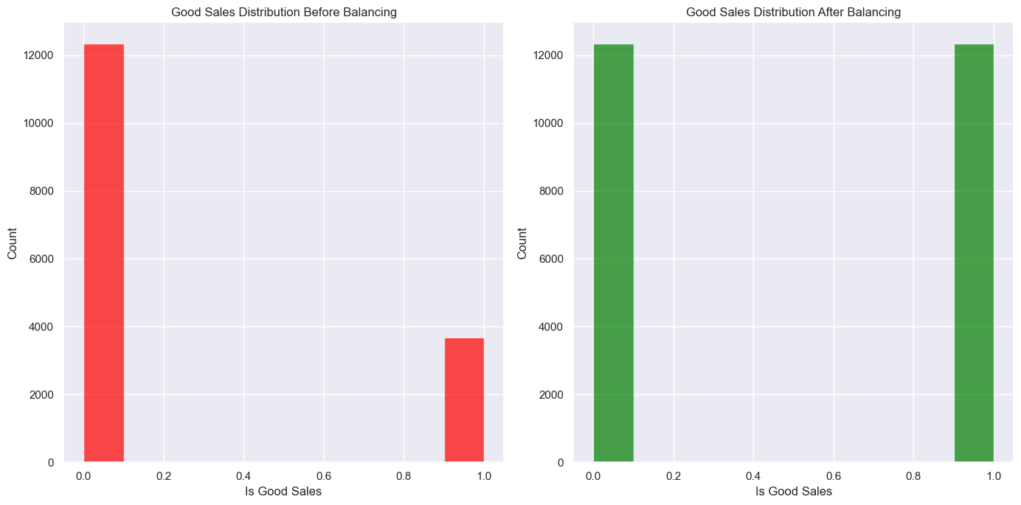
Fig. 1. Compression of good sales distribution before and after balancing

  - Feature Selection
Feature relevance was assessed using the chi-square statistical test implemented through the SelectKBest method. The chi-square test measures the strength of association between each input feature and the target variable, allowing the identification of the most informative predictors [11]. Based on the chi-square scores, the top three features were selected for model training. This step reduced dimensionality, improved computational efficiency, and enhanced the interpretability of the resulting model.

  - Normalization
To ensure that all numerical features contributed proportionally during model training, data normalization was applied. Normalization rescales feature values to a common range and helps stabilize the training process. Although Random Forest is relatively insensitive to feature scaling, normalization was particularly beneficial for comparative experiments involving Support Vector Machine and Logistic Regression models.

4. MODEL DESIGN AND EXPERIMENTAL SETUP
The experimental setup includes model architecture, hyperparameter configuration, data splitting strategy, baseline model selection, evaluation metrics, and implementation details. All experiments were conducted using the preprocessed dataset described in Section 3.

  - Model Architecture
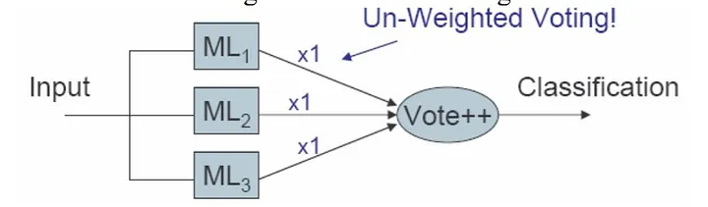
Random Forest is an ensemble learning algorithm that constructs multiple decision trees and combines their predictions to generate a final classification result. In classification tasks, each individual tree outputs a class label, and the final prediction is determined by majority voting across all trees. This ensemble strategy reduces variance and improves generalization compared to single decision-tree models [8]. Each tree in the Random Forest is trained using a bootstrap sample drawn from the training dataset. In addition, at each split within a tree, only a random subset of features is considered. This randomness introduces diversity among the trees and helps prevent overfitting, particularly when dealing with high-dimensional or noisy data. The overall workflow of the Random Forest model, including bootstrap sampling, tree construction, and voting-based classification, is illustrated in Figure 2.
Fig. 2. Visualization for the un-weighted random forest algorithm
  - Hyperparameter Configuration
The performance of Random Forest depends on several hyperparameters that control the structure and behavior of the ensemble. In this study, the following hyperparameters were considered:
- Number of trees (n_estimators): controls the size of the ensemble
- Maximum tree depth (max_depth): limits the depth of each decision tree
- Minimum samples required for node splitting: prevents overly complex trees
- Number of features considered at each split: controls feature randomness
To determine suitable values for these parameters, a cross-validation-based tuning process was applied using the training dataset. This approach balances bias and variance, leading to more stable and reliable predictions [16].
  - Experimental Data Splitting
After completing data preprocessing, the dataset was divided into two disjoint subsets:
- 70% training data
- 30% testing data
This split allows the model to learn from a sufficiently large training set while preserving an independent test set for unbiased evaluation. The data split was performed before applying oversampling to avoid information leakage. Oversampling and feature selection were applied only to the training data. The distribution of samples across the training and testing sets is shown in Figure 3.
  - Baseline Models for Comparison
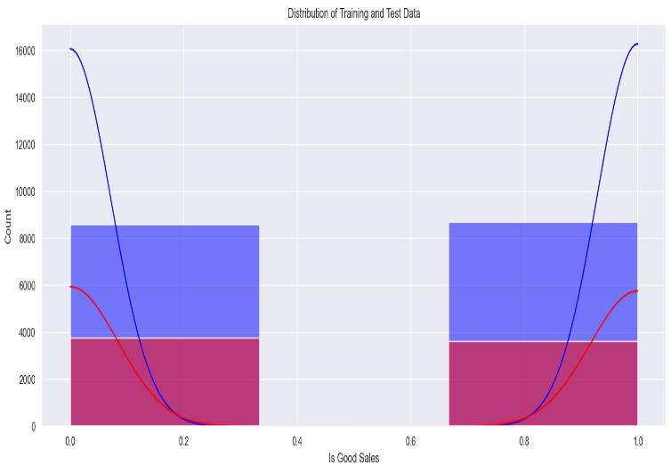
Fig. 3. Distribution of training and test data splitting

To assess the effectiveness of the proposed Random Forest model, two additional classification algorithms were implemented as baseline models:
- Support Vector Machine (SVM): selected for its effectiveness in handling high-dimensional feature spaces
- Logistic Regression: chosen as a classical baseline method for binary classification
All baseline models were trained using the same preprocessed features, balanced training data, and experimental conditions to ensure a fair comparison.

  - Evaluation Metrics
Model performance was evaluated using several standard metrics, including accuracy, precision, recall, and F1-score. Accuracy measures the proportion of correctly classified samples, while precision reflects the model’s ability to correctly identify high-sales games. Recall indicates the ability to capture all relevant instances, and the F1-score provides a balanced measure between precision and recall.These metrics provide a comprehensive evaluation of model performance, particularly in the presence of class imbalance.

  - Training Procedure
The experimental workflow followed these steps:
- Split the dataset into training and testing subsets
- Apply oversampling to balance classes in the training data
- Perform feature selection using the chi-square test
- Train the Random Forest model using optimized hyperparameters
- Train SVM and Logistic Regression models using the same data
- Evaluate all models on the untouched testing dataset
- Compare results using the selected evaluation metrics
Oversampling was strictly limited to the training set to preserve the validity of the evaluation process.

  - Implementation Details
All experiments were implemented using a Python-based machine learning environment. Standard libraries such as scikit-learn, pandas, and NumPy were used for data processing, model training, and evaluation. To ensure reproducibility, random seeds were fixed during model training and evaluation.

5. TESTING, RESULTS, AND DISCUSSION
The evaluation includes exploratory data analysis, quantitative performance assessment, and interpretation of the results. All reported results were generated using the testing dataset, which remained independent from the training and oversampling procedures.

  - Exploratory Data Analysis
Exploratory data analysis was conducted to gain an initial understanding of the dataset and to identify general trends related to video game sales performance.

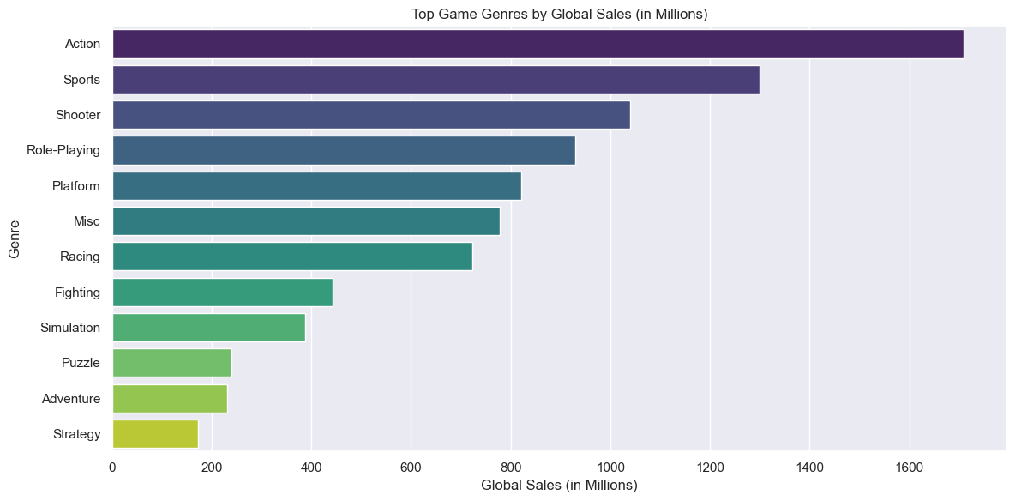
1. Genre Distribution
Fig. 4. Top game genres by global sales (in millions)
As shown in Figure 4, Action, Sports, and Shooter genres appear frequently in the dataset. Despite their popularity, these genres do not always achieve the highest average global sales. This observation may be explained by market saturation and strong competition among similar titles, which can reduce the sales impact of individual games.
2. Platform Distribution

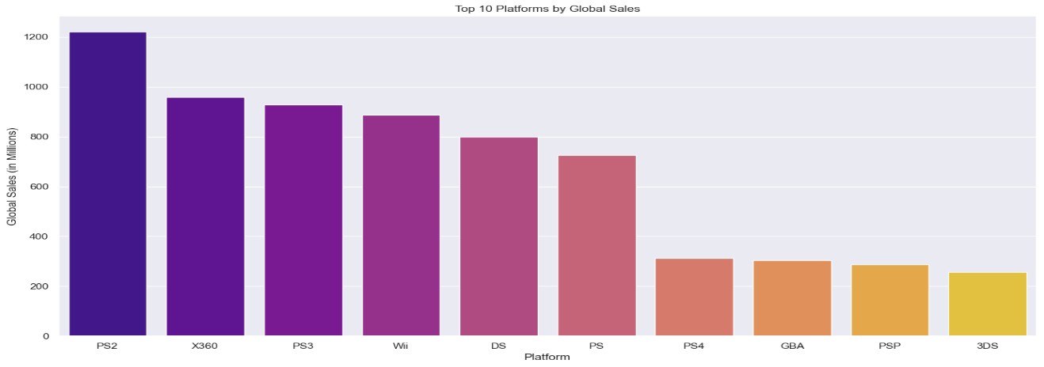
The results indicate that PlayStation and Xbox platforms dominate global sales. This dominance can be attributed to strong brand recognition, a large user base, and the availability of exclusive high-profile titles. Figure 5 illustrates the distribution of global sales across gaming platforms.
Fig. 5. Top 10 platforms by global sales

  - Random Forest Performance Evaluation
The Random Forest classifier was evaluated using the 30% test set. The confusion matrix is reported in Table 1.
Table 1. Confusion Matrix for Random Forest
Actual \ Predicted | Low Sales (0) | High Sales (1)
Low Sales (0) | 112 | 29
High Sales (1) | 21 | 138
The Random Forest model achieved an overall accuracy of 78%, indicating a strong ability to correctly classify video games into high and low sales categories. The model demonstrated balanced performance across both classes, with a precision of 84% for low-sales games and 75% for high-sales games. Furthermore, the recall values reveal that the model successfully identified 87% of high-sales games, which is particularly important in real-world applications where detecting successful products is critical. The F1-scores for both classes (80% for high sales and 76% for low sales) confirm the consistency and reliability of the model.
These results demonstrate that the model is capable of reliably distinguishing between high- and low-sales games. The high recall for class 1 (87%) indicates that the model effectively identifies most high-performing games, which is valuable in applications where missing a successful title may lead to lost commercial opportunities. The performance metrics are visually summarized in Figure 6.

  - Comparative Model Performance
To contextualize the effectiveness of Random Forest, its performance was compared with two baseline models: Support Vector Machine (SVM) and Logistic Regression. The comparative results are provided in Table 2.
Table 2. Performance Comparison of Machine Learning Models
Model | Accuracy | Precision | Recall | F1-Score
Random Forest | 78% | 79.5% | 78.5% | 77.8%
Support Vector Machine | 74% | 75.1% | 72.3% | 73.5%
Logistic Regression | 69% | 70.0% | 67.8% | 68.9%

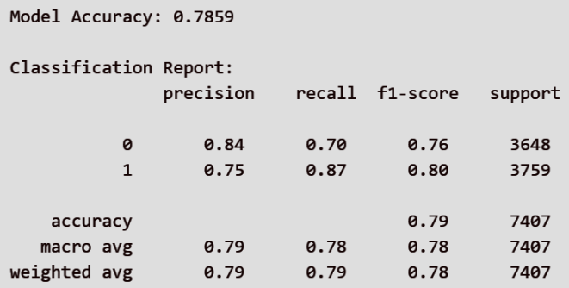

Fig. 6. Evaluation of the model

The comparative analysis shows that the Random Forest model outperformed both Support Vector Machine and Logistic Regression across all evaluation metrics. This superior performance can be attributed to the ensemble nature of Random Forest, which enables it to capture complex and nonlinear relationships within the dataset. In contrast, the Support Vector Machine achieved moderate results, particularly in precision, but showed lower recall, indicating limitations in detecting all relevant instances. Logistic Regression produced the weakest performance among the models, likely due to its assumption of linear relationships, which does not align well with the complexity of video game sales data. These outcomes validate the suitability of ensemble learning methods for structured datasets that contain complex interactions among features.

  - Discussion of Findings
The experimental results highlight several important findings. First, data preprocessing played a critical role in improving model performance. Class balancing through oversampling significantly reduced bias toward the majority class and improved classification fairness. Feature selection using the chi-square test helped reduce dimensionality and focus the model on the most informative attributes. Second, the Random Forest model demonstrated strong robustness and stability. Its ensemble structure enabled it to capture complex relationships between game attributes and sales outcomes, which explains its superior performance compared to single-model classifiers. Finally, some limitations should be acknowledged. The dataset does not include external factors such as marketing expenditure, pre-release hype, or social media engagement, which are known to influence sales performance. Incorporating such features may further improve prediction accuracy in future studies.
These findings are consistent with previous studies that highlight the effectiveness of ensemble learning techniques in predictive analytics. The strong performance of Random Forest suggests that combining multiple decision trees enhances generalization and reduces overfitting. Moreover, the importance of data preprocessing, including oversampling and feature selection, is clearly reflected in the improved classification results. Without these steps, the model would likely suffer from bias toward the majority class and reduced predictive accuracy.

6. CONCLUSION
This study presented a machine learning approach for predicting video game sales satisfaction using a Random Forest classification model. A structured and reproducible methodology was applied, including data cleaning, categorical feature encoding, class balancing through oversampling, and feature selection using the chi-square test. Based on the experimental evaluation, the proposed model achieved an accuracy of 78% and demonstrated balanced performance across precision, recall, and F1-score metrics. Comparative experiments confirmed that Random Forest outperformed Support Vector Machine and Logistic Regression models, highlighting its effectiveness in handling complex and structured sales data. The results emphasize the importance of data preprocessing in improving classification performance. Addressing class imbalance and selecting relevant features contributed significantly to model stability and fairness. In addition, the high recall achieved for high-sales games indicates that the proposed approach is particularly useful for identifying commercially successful titles, which can support decision-making processes for developers and publishers in the video game industry. Despite the promising results, this study has certain limitations. The dataset used is limited to historical sales and basic game attributes and does not include external factors such as marketing investment, pre-release promotion, user sentiment, or social media engagement. Moreover, the model does not consider temporal effects or seasonal trends that may influence sales behavior over time. It also need to have new algorithm such as what is used in[17-19] and studying behavior such as in [20]. These limitations may affect the generalizability of the findings to real-world market scenarios.

7.FUTURE WORK
Future research can extend this work in several directions. First, incorporating additional data sources such as online reviews, social media sentiment, search trends, and marketing indicators may enhance prediction accuracy and provide deeper insights into consumer behavior. Second, temporal modeling techniques, including time-series analysis or recurrent neural networks, could be explored to capture dynamic changes in sales performance. Third, deploying the model within distributed computing frameworks such as Apache Spark or Hadoop may improve scalability and enable real-time prediction for large-scale datasets. Finally, model interpretability techniques such as SHAP or LIME could be applied to better understand feature contributions and support transparent, data-driven decision-making.

REFERENCES

[1] C. Blomgren, "Forecasting initial sales of video games using Youtube trends," 2022.
[2] G. T, R. Choudhary, and A. Prasad, "Prediction of Sales Value in online shopping using Linear Regression," IEEE., 2018.
[3] I. Stellios, P. Kotzanikolaou, and C. Grigoriadis, "Assessing IoT enabled cyber-physical attack paths against critical systems," Computers & Security, vol. 107, p. 102316, 2021.
[4] A. Prasad, "Estimating Video Game Success using Machine Learning," 2019.
[5] A. Yufa, H. Chan, P. Berger, and j. Yu, "Predicting Global Video-Game Sales," Quest Journals, vol. 7, no. 3, pp. 60-64, 2019.
[6] G. e. Biau and E. Scornet, "A Random Forest Guided Tour," p. 42, 18 Nov 2015.
[7] H. He and E. Garcia, "Learning from Imbalanced Data," IEEE, vol. 21, p. 22, SEPTEMBER 2009.
[8] S. Kotsiantis, D. Kanellopoulos, and P. Pintelas, "Data Preprocessing for Supervised Leaning," INTERNATIONAL JOURNAL OF COMPUTER SCIENCE, vol. 1, p. 7, 2006.
[9] b. Keerthana, "sales prediction on video games using machine learning," Journal of Emerging Technologies and Innovative Research, pp. 326-331, June 2019.
[10] S. Vishwakarma and S. Kuma, "Video game sales prediction model using regression model."
[11] P. Bertens, A. Guitart, and A. Peri´a˜nez, "Games and Big Data: A Scalable Multi-Dimensional Churn Prediction Model," IEEE, 2017.
[12] Q. Zhoua, H. Zhoua, and T. Li, "Cost-sensitive feature selection using random forest: Selecting low-cost subsets of informative features," Elsevier, 2015.
[13] Á. López-Cabarcos, D. Ribeiro-Soriano, and J. Pi ˜neiro-Chousa "All that glitters is not gold. The rise of gaming in the COVID-19 pandemic," Journal of Innovation & Knowledge, p. 269, 2020.
[14] a. E. A. G. Haibo He, "Learning from Imbalanced Data," IEEE, SEPTEMBER 2009.
[15] F. Livingston, "Implementation of Breiman’s Random Forest Machine Learning Algorithm " p. 8, 2005.
[16] L. Breiman, "CONSISTENCY FOR A SIMPLE MODEL OF RANDOM FORESTS," p. 7, September 9, 2004 2004.
[17] M. A. Al-Hadi, G. H. Al-Gaphari, I. A. Al-Baltah, F. B. Julian, and A. A. Al-Hadi, "IoT-Based Healthcare Monitoring System," in 2024 1st International Conference on Emerging Technologies for Dependable Internet of Things (ICETI), 2024: IEEE, pp. 1-7.
[18] M. Al-Hadi and G. H. Al-Gaphari, "Intelligent Systems and Applications in Engineering," stress, vol. 15, p. 17, 2024.
[19] A. A. Alsabri and M. A. Al-Hadi, "A Hybrid CNN-BLSTM Model for Phishing Attack Detection Using Deep Learning to Strengthen Internet Security," Sana'a University Journal of Applied Sciences and Technology, vol. 3, no. 4, pp. 964-972, 2025.
[20] A. Alsabri and M. Al-Hadi, "The Role of Cybersecurity Awareness in Reducing the Complexity Impact of Authentication Methods on End-Users’ Behavior," Global Social Science and Humanities Journal, vol. 3, no. 4, pp. 55-65, 2025.

