Translating Braille Patterns into Arabic Text Using a Convolutional Neural Network

.
ABSTRACT

Considering optical Braille patterns has been investigated in several studies. There is a huge number of studies which analyzed Braille patterns in different natural languages. However, the Arabic patterns have not been examined as same as the other languages. This is due to the lack of the datasets of the Arabic patterns and the shortage of researches in this area. This study utilizes YOLOv11 model as a detection tool because of its relative effectiveness and the level of accuracy as well as the staged training approach with the AdamW optimizer and Automatic Mixed Precision. For the translation of the Arabic patterns into text, post-processing steps are performed including: detecting cells vertically clustered, horizontally sorted within a line, adaptively defined word boundaries, and corrected reading order of right-to-left. In the analysis of experiments, the best findings achieved is 0.99 of all the precision, recall, and F1 scores. Moreover, the inference time is 12.3 ms per image. The proposed framework has been examined with a primary dataset of 5924 pages of images of Braille patterns of 45 classes of Arabic letters and diacritics. The yielded results show that the proposed framework is a robust approach toward effective, scalable, responsive Arabic Braille recognition (OBR) for assistive technologies to be mobile and wearable. By building the first dedicated corpus in Arabic Braille and providing an end-to-end recognition suite, this study laid the groundwork for future research and applications in the field. This research helps in bridging a significant void in accessibility and sets the groundwork for the development of the first multilingual Braille recognition system.

Keywords Arabic Braille, Optical Braille Recognition (OBR), YOLOv11m, deep learning, assistive technology, computer vision.

1. INTRODUCTION

  - Background about Braille

Writing constitutes one of the most significant intellectual achievements of humanity, serving as both a repository and a transmitter of knowledge across generations. From the earliest inscriptions on stone tablets in ancient Mesopotamia to today’s complex and digitized texts, writing has enabled humans to record historical events, communicate intricate beliefs, and preserve cultural, scientific, and philosophical knowledge. By externalizing thoughts and ideas into tangible symbols, societies have been able to transcend both temporal and spatial boundaries, facilitating cultural, technological, and scientific advancement in ways that oral communication alone could not achieve. The accumulation and transmission of written knowledge provided a stable framework for education and the development of social institutions, including legal systems, religious traditions, and scientific inquiry. Civilizations such as the Ancient Egyptians, Greeks, and Islamic Arabs effectively harnessed the power of writing not only to preserve their cultural heritage but also to disseminate knowledge across wider populations. Religious texts, legal codes, and educational treatises were meticulously documented, thereby forming the basis of structured learning systems. Literacy, therefore, should not be viewed merely as the ability to read and write; it is a foundational instrument of civilization, enabling the formation of structured educational systems, the codification of knowledge, and the promotion of social cohesion.
Despite the crucial role of writing in advancing civilization, access to written knowledge has historically been unequal. Blind and visually impaired individuals have, for centuries, been excluded from direct engagement with written materials. Before the nineteenth century, access to knowledge for the blind relied on oral transmission or intermediaries who would read and interpret texts. This reliance on others created systemic educational and social barriers, preventing visually impaired individuals from fully participating in cultural, academic, and professional activities. This exclusion persisted until the early nineteenth century, when Louis Braille, a Frenchman who had been blind since the age of three, developed a tactile system of reading and writing in 1824. Braille’s system, consisting of coded, touchable dots arranged in small cells, allowed blind individuals to perceive written language through tactile interaction, granting them independence in reading, writing, and communication. The introduction of Braille was revolutionary: it transformed the educational landscape for blind individuals, enabling their active participation in academic, cultural, and professional life and marking a significant milestone in the global pursuit of inclusive education.
Each basic Braille cell is composed of six raised dots arranged in a 3×2 matrix, with each possible configuration representing a distinct letter, number, or punctuation mark. Over time, the system was expanded to include eight-dot Braille cells, allowing for the representation of advanced mathematical symbols, scientific notation, and computer commands. This evolution has transformed Braille from a tool for basic literacy into a medium capable of supporting advanced scientific, technological, and digital communication. Braille literacy has consequently become a critical benchmark for assessing the academic, social, and professional participation of blind individuals. The ability to read and write in Braille is strongly correlated with higher educational attainment, improved career opportunities, and enhanced social inclusion.
According to reports by the World Health Organization (WHO) in 2019 and 2023, approximately 1.3 billion people worldwide live with some form of visual impairment, with 39 million classified as completely blind. Despite technological advancements in digital accessibility, the production of Braille materials remains limited, time-consuming, and costly. For instance, converting a single volume of scientific or educational literature into Braille may exceed $15000 and take several weeks to prepare (Raj, 2022). Such figures emphasize the persistence of the accessibility gap, even in an era marked by widespread digital technologies.
Although assistive technologies such as audiobooks and screen readers provide partial solutions, they cannot fully replicate the cognitive, linguistic, and analytical benefits conferred by Braille literacy. Research demonstrates that individuals who read Braille achieve higher levels of spelling accuracy, grammatical awareness, and reading comprehension compared to those who rely solely on auditory access to written materials (AlSalman et al., 2021). These findings underline the importance of Braille as an educational resource and a crucial tool for inclusive learning, enabling blind students to engage meaningfully with academic content and develop skills comparable to sighted peers.
In the Arab world, significant efforts have been made to unify and standardize Arabic Braille, culminating in initiatives such as the Unified Arabic Braille Portal (Othman & El Ghoul, 2021). Despite these advancements, Arabic Braille faces unique challenges. The Arabic script is inherently written from right to left, whereas Arabic Braille is aligned with the left-to-right orientation of global Braille standards. This discrepancy introduces technical complexities in computational representation, automated translation, and digital integration. Moreover, Arabic script relies heavily on context-dependent diacritical marks, known as tashkeel, which require additional linguistic processing to accurately render and interpret text. Such linguistic and technical intricacies make the development of efficient Arabic Braille recognition systems particularly challenging.
Accessibility issues are further compounded in the context of mathematical and scientific notation. Whereas sighted readers interpret mathematical expressions in a two-dimensional layout, Braille notation presents mathematical content linearly. This difference introduces additional cognitive and technical challenges for blind learners and highlights the urgent need for automated recognition and translation systems capable of accurately converting tactile Braille patterns into digital text while preserving their semantic and structural integrity (Bitter, 2013).

  - Critical Discussion about the Gap in Studies

Despite the significant advancements in the field of Optical Braille Recognition (OBR), progress has been notably slower than the rapid developments seen in artificial intelligence, computer vision, and pattern recognition technologies over the past two decades. This is particularly evident with respect to Arabic Braille, which has received considerably less attention than English or East Asian Braille systems. Early Arabic Braille recognition systems were primarily limited to document scanning and basic image processing. These systems often struggled with real-world conditions, showing high brittleness and low robustness when exposed to environmental variability, such as inconsistent lighting, shadows, page curvature, and double-sided embossing (Li et al., 2019; Antonacopoulos & Bridson, 2004). Such limitations significantly reduced the applicability of early OBR technologies beyond controlled laboratory settings.
In real-world applications, additional challenges emerge from variations in capture conditions. For example, mobile devices are frequently used in unsupervised scenarios such as classrooms, libraries, or public spaces, where environmental lighting, surface reflections, and user handling introduce further inconsistencies. Traditional OBR algorithms often fail to generalize to these situations, as most were developed and validated under ideal, controlled conditions. According to Lu et al. (2022), the translation of lab-based OBR systems to naturally captured images frequently results in significant drops in accuracy and reliability.
Another critical challenge lies in the scarcity of publicly available Arabic Braille datasets. While English Braille research benefits from several large-scale datasets, Arabic datasets are limited, poorly curated, or nonexistent. For instance, the DSBI dataset (2019) contains only 114 images, whereas the NSBD dataset (2022) has fewer than 300. The absence of a comprehensive, high-quality Arabic Braille dataset severely hampers the development and evaluation of new recognition systems. This lack of resources limits the ability to train machine learning models effectively and undermines efforts to develop robust and generalizable recognition algorithms.
Arabic Braille research is also underrepresented in the global OBR community. Arabic is rarely chosen as the target language for OBR systems, resulting in a relative neglect of this important linguistic population (Shao et al., 2022; AlSalman et al., 2021). This neglect has far-reaching implications: Arabic-speaking blind individuals have fewer educational materials in accessible formats, further widening the educational gap between sighted and visually impaired learners. In addition, the asymmetry in communication between sighted educators and blind learners (where teachers cannot readily interpret students’ Braille outputs) exacerbates the challenges of inclusive education (Hsu, 2020). This phenomenon, often termed “asymmetric communication,” represents a significant social and educational barrier, highlighting the need for OBR systems that can accurately translate Braille into readable Arabic text for educators and peers.
Moreover, the linguistic complexities of Arabic introduce additional challenges for automated recognition systems. Arabic script is highly context-dependent, with letters changing shape depending on their position within a word, and diacritical marks, known as tashkeel, influencing pronunciation, meaning, and grammatical structure. Unlike Latin scripts, Arabic is written from right to left, which contrasts with the left-to-right orientation used in standardized Arabic Braille. As a result, reconstructing Arabic text from Braille requires not only precise dot detection but also advanced post-processing algorithms capable of handling bidirectional scripts, contextual letter shaping, and the correct placement of diacritical marks. This complexity sets Arabic OBR apart from other languages and necessitates specialized solutions that integrate visual recognition with linguistic processing.
Mathematical and scientific notation further compound the challenges of Arabic OBR. Whereas sighted readers interpret formulas in two-dimensional layouts, Braille notation linearizes these structures, requiring recognition systems to accurately capture sequential patterns and relationships between symbols (Bitter, 2013). Inadequate handling of mathematical Braille can lead to misinterpretation of educational content, limiting blind students’ ability to learn STEM subjects effectively. Despite the importance of this issue, few studies have explored the integration of Arabic mathematical Braille into automated recognition frameworks.
Technological gaps also persist in relation to current machine learning approaches. While convolutional neural networks (CNNs) and modern object detection frameworks have shown promising results in detecting small and dense visual patterns, most existing OBR models have focused on English Braille. Directly transferring these models to Arabic Braille is nontrivial due to differences in script orientation, dot density, and linguistic context. Furthermore, the detection of double-sided Braille, where dots from the reverse side of a page may interfere with detection, remains a largely unsolved problem. These limitations demonstrate that, despite advances in AI and computer vision, there is still no fully robust, scalable system for Arabic Braille recognition.
Building on the previously discussed background and identified gaps, the educational and social implications of the current limitations in Arabic OBR cannot be overstated. Restricted access to educational materials in Braille limits opportunities for Arabic-speaking blind students, reducing their engagement with mainstream educational programs and professional development pathways. In addition, the absence of automated Arabic OBR tools perpetuates reliance on human intermediaries, which is both time-consuming and costly. Developing a robust Arabic OBR framework that effectively addresses linguistic, computational, and practical challenges is therefore not only a technical necessity but also a critical step toward promoting educational equity and social inclusion.
In conclusion, the existing gaps in Arabic OBR are multifaceted, encompassing technical limitations, the scarcity of curated datasets, linguistic and directional complexities, insufficient handling of mathematical notation, and persistent educational inequities. Addressing these challenges requires a holistic approach that integrates advanced machine learning techniques, linguistic processing, comprehensive dataset development, and validation under real-world conditions. A well-designed framework would substantially enhance access to educational and scientific materials for Arabic-speaking blind individuals, thereby contributing to both knowledge dissemination and social inclusion. This rationale directly informs the present study, which aims to design, implement, and evaluate a CNN-based Arabic Braille recognition system capable of detecting and reconstructing Arabic Braille text in natural images, while preserving grammatical, linguistic, and directional accuracy. Building on this foundation, the next section outlines the methodology employed to achieve these objectives.

2. Method and Dataset

This section presents the methodology adopted in this study and describes the dataset used for training and evaluation. The methodological design focuses on developing a robust and scalable framework for Arabic Braille recognition using supervised deep learning. The section is structured to explain the proposed framework, the data collection and preparation process, and the evaluation strategy, ensuring clarity, reproducibility, and scientific rigor.

2.1 The Proposed Framework

The proposed Arabic Braille recognition framework is designed as an integrated, end-to-end pipeline that transforms raw Braille images into readable Arabic text. The framework is grounded in supervised object detection and post-processing techniques and is structured to address the unique spatial, linguistic, and directional challenges associated with Arabic Braille.
The overall workflow of the system is illustrated in figure 1, which summarizes the main processing stages, starting from image acquisition and ending with reconstructed Arabic text.

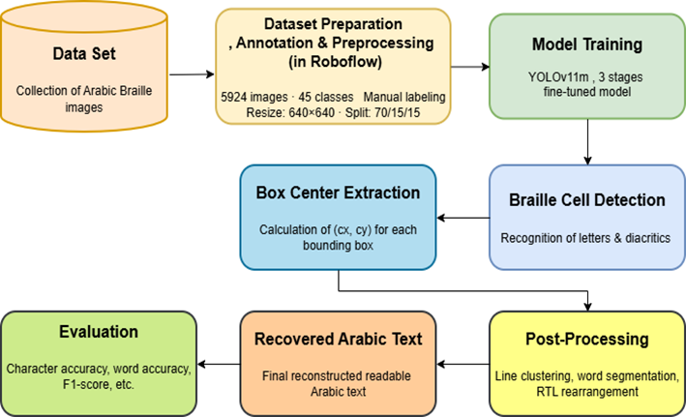

Fig. 1. Workflow for Arabic Braille detection and reconstruction using YOLOv11m

The first stage of the framework involves collecting Arabic Braille images under varied real-world conditions. These images are then prepared through resizing, annotation, and normalization to ensure compatibility with the detection model. Following dataset preparation, the YOLOv11m object detection model is configured and trained to identify individual Braille cells corresponding to Arabic letters and diacritical marks.
YOLOv11m was selected as the base detection model due to its proven ability to handle dense, overlapping, and small-scale visual patterns. Compared to lighter variants, it offers superior detection accuracy in complex scenes, while avoiding the computational overhead associated with heavier architectures. This balance makes it particularly suitable for deployment in assistive technologies, including mobile and embedded systems.
Once trained, the model detects Braille cells and outputs bounding boxes along with class predictions. The spatial centers of these bounding boxes are then extracted to preserve the geometric relationships between detected cells. These spatial relationships form the basis for subsequent text reconstruction.
A dedicated post-processing stage follows detection. In this stage, detected Braille cells are grouped into textual lines based on vertical alignment, after which horizontal ordering is applied. Word boundaries are identified through gap analysis between adjacent bounding boxes, and characters are reordered to match the natural right-to-left reading direction of Arabic. This stage is essential for reconstructing linguistically coherent Arabic text from isolated visual detections.
Finally, the framework outputs both annotated detection images and the reconstructed Arabic text. The entire pipeline is designed to operate automatically, enabling efficient processing of single images or complete datasets.

2.1 Dataset

The dataset used in this study was specifically constructed to support Arabic Braille recognition under realistic conditions. A total of 5924 images were collected, representing 45 distinct classes, including 37 Arabic letters and 8 Arabic diacritical marks.
Data collection was conducted in collaboration with associations for the blind in Derna and Tripoli, Libya. In the initial phase, Arabic Braille sheets were produced using a mechanical Braille typewriter. These sheets contained isolated letters, diacritical marks, and medium-length sentences, arranged at varying spatial densities to capture diverse layout configurations. Characters were deliberately positioned across different regions of the page, including centered, edge-aligned, and randomly distributed layouts.
Images were captured using a smartphone camera under a wide range of conditions. Variations were introduced in lighting (natural and artificial), camera angles, distances, and page orientations to enhance dataset diversity and improve robustness under real-world imaging scenarios. Representative examples of the collected Arabic Braille images, illustrating these variations, are presented in Figure 2.

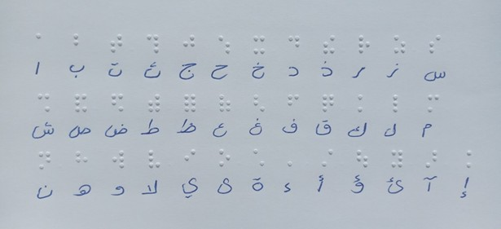

Fig. 2. Arabic Braille page with the full alphabet captured under non-uniform lighting

To further expand the dataset and increase realism, an additional data collection phase was carried out using printed Arabic Braille textbooks obtained from an association for the blind in Tripoli. These materials introduced authentic educational content and printing characteristics, thereby strengthening the dataset’s applicability to real-world educational scenarios.
All images were resized to 640×640 pixels to ensure uniformity during training. Manual annotation was performed using the Roboflow platform, where each Braille cell was labeled according to its corresponding Arabic letter or diacritical mark. Figure 3 illustrates an example of the annotation process, showing bounding boxes and class labels assigned to individual Braille cells. Since Arabic characters are not natively supported by the platform, numeric labels were initially assigned and later mapped to Arabic symbols during model configuration.

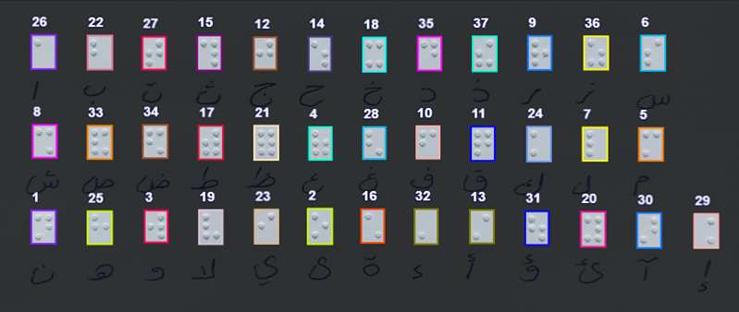

Fig. 3. Example of annotated Arabic Braille cells with bounding boxes and labels

The dataset was divided into three subsets following a standard split of 70% for training, 15% for validation, and 15% for testing. Specifically, the training subset consisted of 4142 images and was used to optimize the parameters of the detection model. The validation subset included 900 images and served to monitor model performance during training and to prevent overfitting. Finally, the testing subset comprised 882 images and was reserved for the final evaluation of the framework, providing an unbiased assessment of detection accuracy and generalization capability.
To preserve the structural integrity of Braille patterns, aggressive synthetic augmentations such as large-angle rotations and horizontal flipping were avoided. Instead, realism and variability were achieved primarily through natural variations introduced during data acquisition. All pixel values were normalized to the range [0, 1] prior to training.

2.3 Evaluation Overview

Evaluation is conducted at the conclusion of the framework pipeline to assess both detection accuracy and overall system performance. Standard metrics, including Precision, Recall, F1-score, and mean Average Precision (mAP), are computed to evaluate Braille cell detection. In addition, inference time per image is measured to assess computational efficiency. The accuracy of the reconstructed Arabic text is also examined as an indicator of end-to-end framework effectiveness.

3. results and discussion

This section presents a comprehensive analysis of the experimental results obtained from evaluating the proposed Arabic Braille recognition framework. The discussion integrates quantitative performance metrics with qualitative observations to assess the effectiveness of the staged training strategy, the robustness of Braille cell detection, the reliability of post-processing for Arabic text reconstruction, and the practical feasibility of the proposed system under real-world imaging conditions.

3.1 Training Behavior and Model Convergence

The proposed YOLOv11m-based framework was trained using a multi-stage learning strategy designed to balance convergence speed, detection accuracy, and generalization capability under GPU memory constraints. Three distinct training stages were employed, each serving a specific role in the learning process.
During the initial training stage, the model was trained from scratch for 50 epochs using the default learning rate. This phase established a strong foundation for feature learning, enabling the model to capture fundamental Braille dot patterns across the full set of Arabic letters and diacritical marks. Both training and validation losses exhibited a steady downward trend, indicating stable convergence and effective learning behavior. The high precision, recall, and mAP values achieved at this stage confirm that the model successfully learned general Braille structures.
The second training stage involved an additional 30 epochs with the same learning rate to further refine detection performance. While precision and recall increased to very high levels, a slight decline in mAP@0.5:0.95 was observed. This behavior suggests that overly aggressive optimization may lead to noisy detections and reduced localization robustness, particularly for small or overlapping Braille cells. The observed fluctuations in loss values during this stage are indicative of mild overfitting.
In the final training stage, fine-tuning was performed for 25 epochs using a reduced learning rate. This adjustment resulted in more stable convergence and improved generalization. Precision and recall values stabilized, while the highest mAP@0.5:0.95 score was achieved, demonstrating enhanced robustness across diverse Braille symbols. Consequently, the fine-tuned model obtained in this stage was selected as the final deployment model.
Figure 4 illustrates the training and validation loss curves for the final model, highlighting smooth convergence and the absence of severe overfitting.
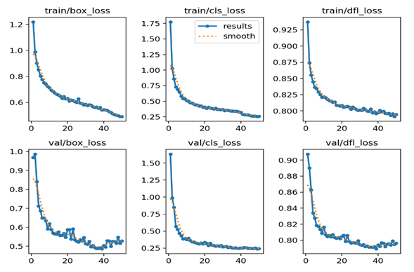

Fig. 4. Training and validation loss curves of YOLOv11m – Stage 3 (25 epochs), showing stable convergence

3.2 Overall Detection Performance

The final YOLOv11-M model was evaluated on an independent test set of 882 unseen images to assess detection accuracy and generalization. Standard object detection metrics, including Precision, Recall, F1-score, and mean Average Precision (mAP), were used.
The results indicate that the proposed framework achieves high accuracy across Arabic Braille letters and diacritics. Precision and Recall values of 0.994 demonstrate both correct identification of Braille cells and comprehensive detection coverage. The F1-score of 0.994 confirms balanced overall performance.
The model achieved a mean Average Precision of 0.994 at IoU 0.5 (mAP@0.5), reflecting excellent localization under standard overlap thresholds. A lower mAP of 0.888 at IoU 0.5:0.95 highlights the challenge of precise localization for small or closely spaced Braille dots, which is expected in strict evaluation scenarios.
Inference speed was measured at approximately 12.3 ms per image, demonstrating that the system can support real-time or near real-time applications.

Table 1. Overall detection performance of the proposed Arabic Braille recognition framework, including Precision, Recall, F1-score, mAP metrics, and inference speed

Metric |  | Value
Precision |  | 0.994
Recall |  | 0.994
F1-score |  | 0.994
mAP@0.5 |  | 0.994
mAP@0.5:0.95 |  | 0.888
Inference Speed |  | ~12.3 ms/image

3.3 Class-wise Performance Analysis

A detailed class-wise evaluation reveals variations in detection performance among Arabic letters and diacritical marks. Characters with distinctive and spatially complex Braille patterns achieved higher mAP@0.5:0.95 scores, while simpler characters and certain diacritics exhibited slightly lower performance.
These variations are consistent with the intrinsic structure of Arabic Braille, where minimal positional differences between dots can significantly affect visual separability. Despite these challenges, the model demonstrates strong generalization across all 45 classes, confirming its ability to learn subtle spatial relationships and handle linguistic diversity.
The consistently high precision and recall values across most classes further indicate that the annotation strategy and dataset diversity contributed positively to model robustness.

3.4 Class-wise Performance Analysis

While accurate Braille cell detection is essential, meaningful system performance ultimately depends on the ability to reconstruct coherent Arabic text. To address this requirement, a dedicated post-processing pipeline was implemented to transform raw detection outputs into readable Arabic text.
The pipeline organizes detected Braille cells into textual lines based on vertical alignment, identifies word boundaries using adaptive gap analysis, and reorders characters according to the right-to-left reading direction of Arabic. This process effectively resolves ambiguities that cannot be addressed by visual detection alone.
The results demonstrate that the post-processing stage significantly enhances end-to-end system performance, achieving 98% accuracy in line reconstruction and 96% accuracy in word segmentation. Mis-segmentation errors were limited to less than 2% of cases, primarily occurring in densely packed or poorly illuminated regions.
Figure 5 presents detection results with bounding boxes, while Figure 6 illustrates the corresponding reconstructed Arabic text.

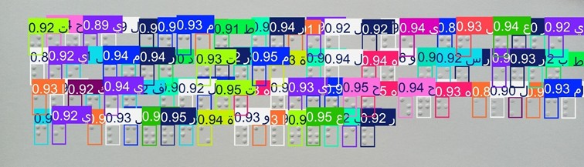

Fig. 5. Detection results showing localized Arabic Braille cells with bounding boxes

Fig. 6. Example of reconstructed Arabic text generated from detected Braille cells

3.5 Error Analysis and System Limitations

Despite the strong overall performance, several limitations were identified. Detection errors were more likely under non-uniform lighting conditions, extreme camera angles, and overlapping Braille dots. In some cases, these factors led to incorrect character ordering or partial misclassification, particularly for diacritical marks.
Resolution and capture method were also found to influence performance. Full-page captures occasionally introduced distortions, whereas half-page images and optimized aspect ratios produced more reliable results. These findings emphasize the importance of controlled image acquisition for optimal system performance.

3.6 Comparison with Existing Studies

To position the proposed framework within the existing body of Optical Braille Recognition research, a comparative analysis with selected recent studies was conducted. This comparison focuses on key aspects, including dataset characteristics, adopted methodologies, and reported performance metrics. Particular attention is given to differences in linguistic coverage, dataset scale, and applicability to real-world imaging conditions.
As summarized in Table 2, most previous studies rely on relatively small or language-specific datasets and are often evaluated under controlled acquisition environments. In contrast, the proposed framework is developed using a large-scale Arabic Braille dataset captured under natural imaging conditions and employs an end-to-end detection and reconstruction pipeline based on YOLOv11m combined with customized post-processing. This comparison highlights the relative contribution of the present study in advancing Arabic Braille recognition toward more practical and scalable solutions.

Table 2. Comparative Evaluation of Recent Optical Braille Recognition Studies

Ref | Dataset | Model / Approach | Metric | Value
Lu et al. (2022) | NSBD + DSBI | Anchor-free ResNet-50 | Hmean = 0.689 | First Braille detection in natural scenes
Nascimento et al. (2023) | Kaggle Braille (1,560 images) | YOLOv5 | F1 ≈ 0.990, mAP@0.5 ≈ 0.995 | YOLO-based Braille recognition for education
Al-Salman & AlSalman (2024) | Two custom datasets | Fly-LeNet (CNN + optimization) | Accuracy = 99.8%, F1 ≈ 0.997 | Multilingual Braille recognition pipeline
This Study | Arabic Braille (5,924 images, 45 classes) | YOLOv11-M + custom post-processing | F1 = 0.994, mAP@0.5 = 0.994 | First end-to-end Arabic Braille recognition framework

The comparative results presented in Table 2 indicate that the proposed framework achieves performance levels that are comparable to, and in several aspects competitive with, existing Optical Braille Recognition approaches. Although some previous studies report very high accuracy or F1-scores, these results are frequently obtained under constrained experimental setups or with limited linguistic scope.
The results in Table 2 further demonstrate that the proposed YOLOv11-M-based framework maintains strong detection performance despite increased task complexity, including a larger number of classes and end-to-end text reconstruction. This highlights the robustness of the detection pipeline and its ability to generalize beyond controlled settings.
In addition, the use of a real-time object detection architecture enables efficient inference and full-text reconstruction, distinguishing the proposed method from segmentation-based or symbol-level approaches. These characteristics emphasize the practical applicability of the framework and its suitability for real-world Arabic Braille recognition scenarios.

3.7 Practical Implications

The experimental results confirm the feasibility of deploying the proposed Arabic Braille recognition framework in assistive and educational contexts. The system enables automatic conversion of Arabic Braille images into readable text with high accuracy and near real-time performance.
Such capabilities have the potential to reduce communication barriers between blind learners and sighted educators, facilitate inclusive education, and support broader access to Arabic educational materials.

4. Conclusion and Future Work

This study introduced a novel deep learning framework for Arabic Optical Braille Recognition (OBR), based on the YOLOv11-M architecture combined with a custom post-processing pipeline. A new Arabic Braille dataset comprising 5924 images across 45 classes (letters and diacritics) was also developed, enabling comprehensive evaluation under natural imaging conditions.

Key findings include:
- High Detection Accuracy:
The YOLOv11-M model achieved a precision of 0.994, recall of 0.994, F1-score of 0.994, and mAP@0.5 of 0.994 on 882 unseen test images. These results demonstrate the model’s strong capability to accurately distinguish between 45 Arabic Braille classes with minimal false detections.
- Robust Generalization:
The model maintained high performance despite variations in illumination, orientation, and scale, indicating robustness and suitability for real-world applications.

- Effective Text Reconstruction:
The custom post-processing algorithm achieved 98% accuracy at the line level and 96% at the word level, successfully preserving the right-to-left linguistic structure and spatial integrity of Arabic text.
- Efficient Real-Time Operation:
Average inference time was 12.3 ms per image, confirming that the framework is capable of real-time detection and reconstruction, making it suitable for mobile or embedded assistive applications.

Contributions of the Study:
- Scientific: Positioned Arabic Braille recognition at the intersection of object detection and computer vision research, providing a state-of-the-art reference for future studies.
- Technical: Developed a complete end-to-end framework including data collection, model training, and post-processing for text reconstruction.
- Dataset: Provided a large-scale Arabic Braille dataset with diverse real-world conditions, addressing gaps in previous research.
Practical & Humanitarian: Enabled Arabic text reconstruction for visually impaired students, supporting educators and parents in reading Braille content, thus enhancing accessibility.

Limitations and Future Work:
- Dataset expansion to include more handwritten, multi-page, and tactile-scanned Braille samples is planned to improve generalization.
- Post-processing can be enhanced using sequence-aware or transformer-based methods to handle multi-column or complex layouts.
- Optimization for mobile and embedded platforms will enable low-resource real-time applications.
Impact:
The framework offers significant potential to improve Arabic Braille accessibility and supports inclusive educational practices. By integrating YOLOv11-M with linguistically-aware post-processing, this work lays a foundation for scalable, practical, and real-world Arabic Braille recognition systems.

References

Al Salman, A., & Alsalman, A. (2024). Fly LeNet: A deep learning–based framework for converting multilingual braille images. Heliyon, 10(4), e26155. https://doi.org/10.1016/j.heliyon.2024.e26155
Alsalman, A., Gumaei, A., Alsalman, A., & Al Hadhrami, S. (2021). A deep learning–based recognition approach for the conversion of multilingual braille images. Computers, Materials & Continua, 67(3), 3847–3864. https://doi.org/10.32604/CMC.2021.015614
Antonacopoulos, A., & Bridson, D. (2004). A robust braille recognition system. In Marinai, S., & Dengel, A. (Eds.), Proceedings of the International Workshop on Document Analysis Systems (DAS 2004) (Lecture Notes in Computer Science, Vol. 3163, pp. 533–545). Springer. https://doi.org/10.1007/978-3-540-28640-0_41
Bitter, M. (2013). Braille in mathematics education (Master’s thesis). Radboud University Nijmegen, Netherlands.
Hsu, B. M. (2020). Braille recognition for reducing asymmetric communication between the blind and non-blind. Symmetry, 12(7), 1069. https://doi.org/10.3390/sym12071069
Li, R., Liu, H., Wang, X., & Qian, Y. (2019). Effective optical braille recognition based on two-stage learning for double-sided braille image. In Kim, J., Chung, K. Y., & Pyun, K. (Eds.), Pacific Rim International Conference on Artificial Intelligence (PRICAI 2019) (Lecture Notes in Computer Science, Vol. 11643, pp. 150–163). Springer. https://doi.org/10.1007/978-3-030-29894-4_12
Lu, L., Wu, D., Xiong, J., Liang, Z., & Huang, F. (2022). Anchor-free braille character detection based on edge feature in natural scene images. Computational Intelligence and Neuroscience, 2022, 7201775. https://doi.org/10.1155/2022/7201775
Nascimento, R. P., Reis, J. R., Aragão, L. A. F., Araújo, A. S., Heidrich, R., & Barone, D. A. C. (2023). Reconhecimento automático de caracteres braille utilizando rede neural convolucional YOLO. Revista Novas Tecnologias na Educação, 21(2), 131–140. https://doi.org/10.22456/1679-1916.137647
Othman, A., & El Ghoul, O. (2021). Unified Arabic braille portal by Mada: Innovative digital resource to reduce braille illiteracy in the Arab region. Nafath, 6(19), 35–40. https://mip.qa/nafath/
Raj, S. S. (2022). Braille convertor (Master’s thesis). Concordia University of Edmonton, Canada.
Shao, Z., Yu, Z., Gu, Y., & Wang, W. (2022). Braille to Chinese translation system based on optical braille recognition. In Proceedings of the 2022 2nd Asia Pacific Conference on Communications Technology and Computer Science (ACCTCS) (pp. 22–26). IEEE. https://doi.org/10.1109/ACCTCS53867.2022.00013

