Original Research Article
Performance Evaluation of YOLOv12 Models for Malaria Parasite and White Blood Cell Detection

.
ABSTRACT

Manual microscopic examination of thick blood smears remains the gold standard for malaria diagnosis in resource-limited settings, yet it is labor-intensive, slow, and significantly prone to human error. This study addresses these diagnostic bottlenecks by leveraging the recently released YOLOv12 object detection framework to automate the simultaneous detection of Plasmodium parasites and White Blood Cells (WBCs). Utilizing the challenging, smartphone-captured Nakasi dataset, the research focuses on bridging the gap between high-performance deep learning and the practical constraints of field-based microscopy.
The study design follows a robust methodology centered on stratified 5-fold cross-validation for architecture selection, ensuring that the model generalizes well across diverse samples. To handle the significant morphological variability inherent in field-captured images, targeted offline data augmentation techniques were applied. Contrary to the prevailing trend of deploying increasingly massive neural networks, a comprehensive computational analysis revealed that the ultra-lightweight YOLOv12-Nano variant delivers accuracy comparable to its larger counterparts. Most notably, this variant reduces floating-point operations (FLOPs) by over 90%, making it uniquely suited for deployment on low-cost mobile devices.
On a strictly isolated 100-image hold-out test set, the optimized pipeline established a new state-of-the-art benchmark, achieving an overall mAP@50 of 0.795 and an mAP@50–95 of 0.463. Error analysis indicates robust class separation between parasites and leukocytes, although persistent challenges remain in distinguishing faint ring-stage parasites from common staining artifacts. Ultimately, this work demonstrates that modern, highly efficient single-stage detectors offer a viable, scalable pathway for deploying real-time, AI-assisted diagnostics on edge hardware. By providing high-fidelity detection with minimal computational requirements, this approach facilitates more accessible and reliable malaria screening in endemic regions.

Keywords: Malaria diagnosis, deep learning, object detection, YOLOv12, thick blood smear
1. INTRODUCTION

Malaria remains one of the most devastating global health challenges, particularly in tropical and subtropical regions. According to the World Health Organization’s (WHO) World Malaria Report 2024, the global burden of the disease has intensified, with approximately 263 million cases reported in 2023, an alarming increase of 11 million cases compared to the previous year (Tola et al., 2025) . The disease’s impact is disproportionately concentrated; out of 83 endemic countries, only 29 accounted for nearly 95% of cases and 96% of deaths. Mortality statistics are equally stark, with four nations bearing the brunt of over half the global malaria deaths: Nigeria (30.9%), the Democratic Republic of the Congo (11.3%), Niger (5.9%), and the United Republic of Tanzania (4.3%) (World Malaria Day 2024, 2024) . Among vulnerable demographics, children under five remain the most severely affected, with Nigeria alone accounting for 39.3% of global malaria fatalities in this age group (World Malaria Report 2023, 2023).
Malaria being a common and life-threatening disease in both tropical and subtropical regions is caused by a parasite known as Plasmodium. Transmitted by female Anopheles mosquitoes, it affects both humans and animals. However, there are four (4) different species of plasmodia that mostly occur in humans and through human-mosquitoes-human can be transmitted. They are P.falciparum, P.vivax, P.ovale and P.malaria (LOISE GATHIGIA NDUNG’U, 2017). Among these four (4), the deadliest is P.falciparum which is very common, followed by P.vivax (Fact Sheet about Malaria, 2024). Despite being a life-threatening disease, malaria is treatable and curable if diagnosed early and accurately.

To diagnose malaria, direct microscopic examination of blood smears remains the gold standard for detecting malaria parasites (Grignaffini et al., 2024). Before examination, the specimen is usually stained with Giemsa or Leishman stain, which gives the parasites a distinct appearance. Giemsa staining is a fast and simple technique for visualizing the active form of parasites in the blood. The World Health Organization (WHO) endorses the use of the malaria microscopy standard operating procedure for this diagnostic process (Maturana et al., 2022). This stained drop of blood is used to create both thick and thin blood smears. The thick blood smear is used to detect the presence of malaria parasite whereas the thin blood smear is used to detect the parasite species (Yang et al., 2020) (Nugroho et al., 2022) .This precise parasite counting is essential not only for diagnosing malaria but also for evaluating drug resistance, measuring drug effectiveness, and determining the severity of the infection. In low-resource settings, however, microscopists often work independently, without a standardized system to help maintain their skills and ensure consistent diagnostic quality (Thakkar et al., 2020).
To address these bottlenecks, automated diagnostic tools powered by Artificial Intelligence (AI) have emerged as a critical area of research. The proliferation of mobile devices with significant processing power has enabled the deployment of Deep Learning (DL) algorithms at the edge, making automated diagnosis accessible even in remote areas. While earlier iterations of object detection models have shown promise, the detection of minute parasites in complex blood smear images remains a challenge (Rosado et al., 2016). This study focuses on the performance evaluation of YOLOv12, the latest evolution in the "You Only Look Once" series released in early 2025. Unlike its predecessors, YOLOv12 introduces an attention-centric architecture, making it a potentially transformative tool for detecting small, dense objects like malaria parasites.
s
Many research has been done by using classical image processing, machine learning and deep learning algorithms to detect malaria parasites and white blood cells in both thick and thin blood smear images. With the advent of Convolutional Neural Networks (CNNs), the focus shifted toward robust feature extraction. Several studies such as (Ambarka et al., 2023; Hoyos & Hoyos, 2024; Koirala et al., 2022; Krishnadas et al., 2022; Mura et al., 2025; Sazak & Kotan, 2025; Zedda et al., 2024) that have explored deep learning for detecting Plasmodium falciparum trophozoites and white blood cells (WBCs) in thick blood smear images. One study (Nakasi et al., 2021) developed an end-to-end pipeline using Faster R-CNN with ResNet-101 and SSD MobileNet V2 models. Both single-class (WBC or parasite only) and multi-class detectors were evaluated, showing that Faster R-CNN outperformed SSD. Similarly, (Yang et al., 2020) introduced a smartphone-based application that utilized intensity-based Iterative Global Minimum Screening (IGMS) and a custom CNN (Yang et al., 2020) for parasite detection. WBCs were segmented using Otsu thresholding followed by noise filtering.

To improve detection of smaller malaria parasites, (Abdurahman et al., 2021) employed modified versions of YOLOv3 and YOLOv4. The enhancements aimed at improving performance on thick blood smear images captured via smartphone cameras. (Koirala et al., 2022; Mura et al., 2025; Sukumarran et al., 2024), ,(Koirala et al., 2022; Zhang & Chen, 2023) also focused on using a modified version of yolo to improve performance. In (Rosado et al., 2016), a more lightweight, mobile-centric approach was proposed which leveraged classical image processing and hand-crafted features to detect both WBCs and parasites. These features were classified using a Support Vector Machine (SVM) which was trained on a small dataset of only 194 images.
Most works used older versions YOLOV4 not the current version which has been optimized for speed and detecting small objects. The authors in (Sazak & Kotan, 2025) though they made use of YOLOV11, focused of Blood Cell Detection and not malaria parasites. Most recently, attention mechanisms have been identified as the key to solving small object detection challenges. While some works attempted to hybridize YOLO with attention modules such as YOLO-PAM (Parasite-Attention-Based Model)(Zedda et al., 2023), these were often custom modifications rather than native architectural features.
This sets the stage for YOLOv12, a significant departure from its CNN-dominated predecessors, YOLOv12 is an attention-centric object detector. It integrates Area Attention mechanisms and Residual Efficient Layer Aggregation Networks (R-ELAN) specifically designed to maximize feature retention and capture global context without sacrificing real-time speed. Despite these theoretical advantages, literature specifically evaluating YOLOv12 on malaria datasets is scarce. Existing benchmarks focus on general datasets like COCO or specific domains like fruitlet counting, leaving a gap in understanding how this new architecture performs on histopathological data. This paper addresses that gap by rigorously evaluating YOLOv12 against previous state-of-the-art models for malaria parasite detection.

2. methodology

The Nakasi dataset (Nakasi et al., 2021) consisting of 930 thick blood smear images collected from Mulago National Referral Hospital, Uganda, under approved ethical guidelines. Images were acquired using a Samsung J6 Android smartphone (5 MP resolution, 3264 x 2448 pixels) mounted on an Olympus microscope with a (1000x) objective magnification. To capture variability in parasite and cell presentation, multiple viewpoints were recorded per slide.The original annotations, provided in Pascal VOC format, include bounding boxes for two classes: Malaria Parasite (mp) and White Blood Cell (wbc). We utilized the Roboflow platform for data management, where annotations were converted to the YOLO format compatible with the YOLOv12 training pipeline.
To ensure robust performance estimation and mitigate sampling bias, we employed a stratified 5-fold cross-validation scheme. The initial dataset of 830 images was partitioned such that each fold contained 80% (664 images) for training and 20% (166 images) for validation. An independent hold-out test set of 100 images was strictly excluded from all training and cross-validation procedures to serve as the final benchmark for generalization. Following architecture selection via cross-validation, the training set was expanded using offline augmentation within Roboflow. Pre-processing included automatic contrast stretching to enhance parasite visibility against the blood background. To improve model robustness against variations in orientation, focus, and illumination were employed which yielded a total of 2,490 images.

2.1 Model Architecture
We employed the YOLOv12 object detection framework (Tian et al., 2025). Released in February 2025, YOLOv12 integrates a CSPNet-PP backbone with GELAN computation blocks and a Path Aggregation Feature Pyramid Network (PA-FPN) for enhanced feature extraction. We evaluated four model scales, Nano (n), Small (s), Medium (m), and Large (l), to identify the optimal trade-off between accuracy and computational efficiency. All variants were initialized with official pre-trained weights.

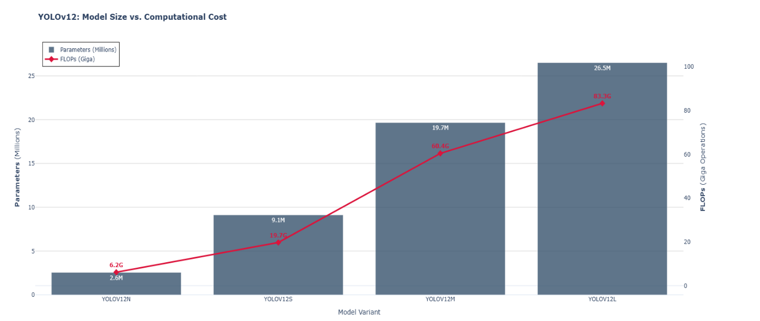Figure 1: Yolov12 Model Size vs Computational Cost

We observe a non-linear escalation in resource requirements across the model family. The YOLOv12-Large variant demands 26.5 million parameters and 83.3 GFLOPs per inference pass. In stark contrast, the selected YOLOv12-Nano variant operates with merely 2.6 million parameters and 6.2 GFLOPs, representing a 90% reduction in model size and a 92% reduction in computational cost. When synthesized with the detection performance reported in Table 1, these data indicate that the Nakasi malaria dataset does not benefit from the immense capacity of larger models. Consequently, the Nano variant offers the optimal Pareto frontier between diagnostic accuracy and the latency constraints required for mobile deployment in resource-limited settings.

2.2 Training

All experiments were conducted on Google Colab utilizing a single NVIDIA A100-SXM4 (40 GB) GPU.

Phase I: Architecture Selection (Cross-Validation)
To isolate architectural differences, each YOLOv12 variant was trained for 20 epochs on the original 830-image dataset with augmentations disabled. Hyperparameters were fixed as follows:
- Epochs: 20
- Batch Size: 16
- Image Size: 768 x 768
- Optimizer: AdamW
- Learning Rate: 1.667 x 10 ⁻³
- Online Augmentation: Disabled (Scale, Mosaic, MixUp, and Copy-Paste set to 0.0).

Phase II – Final training YOLOv12n achieved the highest mAP@50 in Phase I and was therefore selected for final training. The model was trained for 30 epochs on the augmented 2,490-image dataset using identical hyperparameters
Evaluation Metrics
The performance of the malaria parasite and white blood cell detection system was assessed using COCO-style metrics provided in the YOLOv12 evaluation framework. These metrics quantify both localization accuracy and classification reliability.
- Precision (P): Measures the proportion of predicted positives that are correct, indicating how well the model avoids false alarms.
$$P=\frac{TP}{TP+FP}$$

- Recall (R): Captures the ability of the model to identify actual positive instances, reflecting how many true objects are successfully detected.
$$R=\frac{TP}{TP+FN}$$

- mAP@50: Mean Average Precision computed at a default Intersection over Union (IoU) threshold of 0.50, summarizing detection quality at a moderate overlap requirement.

- mAP@50–95: Mean Average Precision averaged across IoU thresholds ranging from 0.50 to 0.95 in increments of 0.05, offering a more comprehensive measure of localization robustness.

3. results and discussion

The experimental results provide strong evidence supporting the viability of ultra-lightweight deep learning architectures for clinical diagnostic tasks, particularly in environments where computational resources are constrained. In many malaria-endemic regions, diagnostic systems must operate on low-cost hardware with limited processing capability, making model efficiency as important as predictive accuracy. The findings of this study demonstrate that smaller object detection architectures can maintain competitive detection performance while significantly reducing computational requirements.

3.1 Cross-Validation Performance
Five-fold cross-validation was conducted on the original Nakasi dataset consisting of 830 annotated microscopy images. During this stage, online data augmentation was intentionally disabled in order to evaluate the intrinsic learning capacity of each model architecture without artificially increasing data diversity. Table 1 summarizes the mean performance metrics obtained across the five folds for the four YOLOv12 variants evaluated.

Table 1: Mean cross-validation results across five folds (no external augmentation)
Model | mAP@50 | mAP@50–95 | Precision | Recall
YOLOv12l | 0.775 | 0.458 | 0.712 | 0.801
YOLOv12m | 0.780 | 0.463 | 0.724 | 0.793
YOLOv12s | 0.787 | 0.466 | 0.717 | 0.809
YOLOv12n | 0.789 | 0.461 | 0.709 | 0.827
The results reveal a relatively small performance gap across the four architectures, indicating that the malaria detection task may not require extremely deep networks to achieve competitive performance. Interestingly, the YOLOv12n (Nano) variant achieved the highest mAP@50 (0.789) and the highest recall (0.827) among all evaluated models. In contrast, the YOLOv12s variant recorded the best mAP@50–95 (0.466), suggesting slightly stronger localization accuracy across multiple IoU thresholds.

The strong performance of the YOLOv12n model is somewhat counterintuitive, as larger models such as YOLOv12l typically outperform smaller architectures due to their higher parameter capacity and deeper feature representations. However, the relatively small size of the Nakasi dataset likely limits the advantages of large architectures. With limited training samples, large models may become prone to overfitting or fail to fully utilize their representational capacity. In contrast, smaller architectures often generalize better under such conditions because their reduced parameter space imposes an implicit regularization effect.

Given its superior balance between detection performance and computational efficiency, the nano model was selected for final training. This decision aligns with the primary objective of this study which involves developing a clinically deployable detector that can operate efficiently on low-cost hardware platforms commonly available in resource-limited laboratories.

3.2 Final Model Performance on Hold-Out Test Set

Following model selection, the YOLOv12n architecture was retrained for 30 epochs using the augmented training dataset consisting of 2,490 images. Data augmentation was applied at this stage to improve model generalization and expose the network to a wider range of visual variations, including rotation, scaling, and contrast shifts that commonly occur in microscopy imaging.
The final model was evaluated on an independent hold-out test set of 100 images, containing 1,312 annotated instances, including 1,035 malaria parasites (mp) and 277 white blood cells (wbc). Table 2 below shows the results for the final model.

Table 2 Final performance on the hold-out test set (100 images, 1,312 instances)
Class | Images | Instances | Precision | Recall | mAP@50 | mAP@50–95
all | 100 | 1,312 | 0.714 | 0.827 | 0.795 | 0.463
mp | 97 | 1,035 | 0.640 | 0.727 | 0.714 | 0.299
wbc | 83 | 277 | 0.787 | 0.928 | 0.876 | 0.627

Figure 2 presents the training behavior of the YOLOv12n model over 30 epochs, showing both detection performance and learning convergence. The figure consists of two plots: (A) detection performance measured using mean Average Precision (mAP) and (B) learning convergence illustrated by training and validation box loss.
In Figure 2A, the mAP@50 steadily improves from approximately 0.68 in the early epochs to about 0.79 by epoch 30, indicating that the model progressively learns to detect and localize objects more accurately. The mAP@50–95 metric follows a similar trend, increasing gradually from roughly 0.38 to around 0.46. As expected, this metric remains lower because it evaluates detection accuracy under stricter localization thresholds. Both curves begin to plateau after about 20 epochs, suggesting that the model has reached stable performance and further training would likely yield only marginal gains.
Figure 2B illustrates the box loss convergence during training. The training box loss decreases consistently from approximately 1.80 to 1.51, demonstrating continuous improvement in bounding box localization. The validation box loss shows minor fluctuations but generally follows the same downward trend, stabilizing near 1.58–1.60 toward the final epochs. The relatively small gap between the training and validation losses indicates good generalization with limited overfitting.
Overall, the plots confirm that the YOLOv12n model exhibits stable learning dynamics and effective convergence, achieving strong detection performance while maintaining good generalization on unseen data

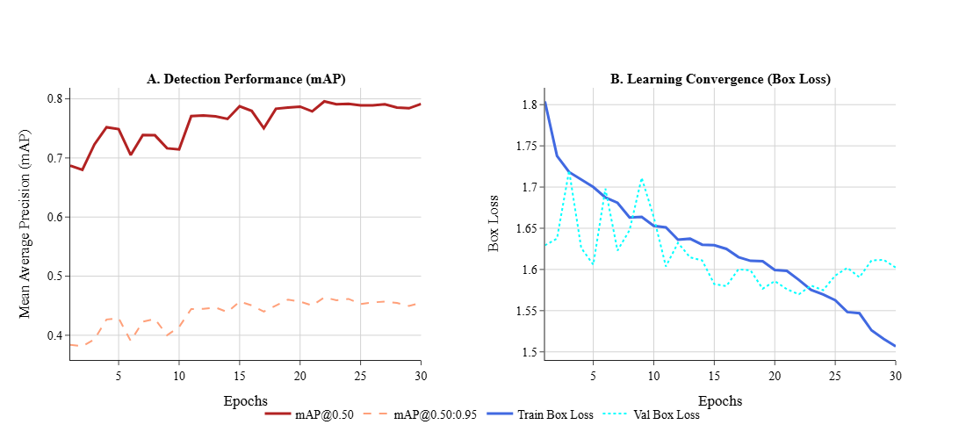
Figure 2: Detection Performance and Learning Loss

Overall, the final detector achieved mAP@50 of 0.795 and mAP@50–95 of 0.463, closely aligning with the cross-validation performance and confirming that the model generalizes well to unseen data.
A clear performance difference can be observed between the two target classes. White blood cells were detected with significantly higher accuracy, achieving mAP@50 of 0.876 and recall of 0.928, compared to malaria parasites, which achieved mAP@50 of 0.714 and recall of 0.727. This disparity can be attributed to several biological and imaging factors.
First, white blood cells exhibit consistent morphological characteristics, including larger size, distinct nuclei, and relatively stable staining patterns. These properties create visually salient features that are easier for convolutional networks to identify. In contrast, Plasmodium parasites exhibit substantial intra-class variability across different developmental stages, including ring, trophozoite, and schizont forms. These stages vary in size, shape, and staining intensity, making the detection task inherently more challenging.
Second, parasites are often significantly smaller than white blood cells and may appear as faint chromatin dots within red blood cells. This small object detection challenge is further exacerbated by slide artifacts such as staining debris, dust particles, and uneven illumination, which can visually resemble parasite structures.

The confusion matrix presented in Figure 3 provides further insight into the model’s classification behavior and error distribution.
The detector demonstrated excellent inter-class discrimination, with only six instances of parasites misclassified as white blood cells, representing approximately 0.6% of parasite predictions. Notably, there were no cases in which white blood cells were misclassified as parasites, indicating that the model has learned highly reliable class boundaries between these two object categories.
Despite this strong class discrimination capability, the primary challenge lies in distinguishing parasites from the background. The model produced 333 false negatives for the parasite class, indicating that a substantial number of parasite instances were missed entirely. Many of these missed detections likely correspond to extremely faint or early-stage ring parasites, which can be visually indistinguishable from background noise or poorly stained erythrocytes.
Additionally, the model generated 320 false positive detections, where background regions were incorrectly classified as parasites. Once again, these errors are likely caused by staining artifacts, debris, or dust particles that resemble the small chromatin dots characteristic of parasite nuclei. Such artifacts are common in microscopy slides and represent a known challenge for automated detection systems.

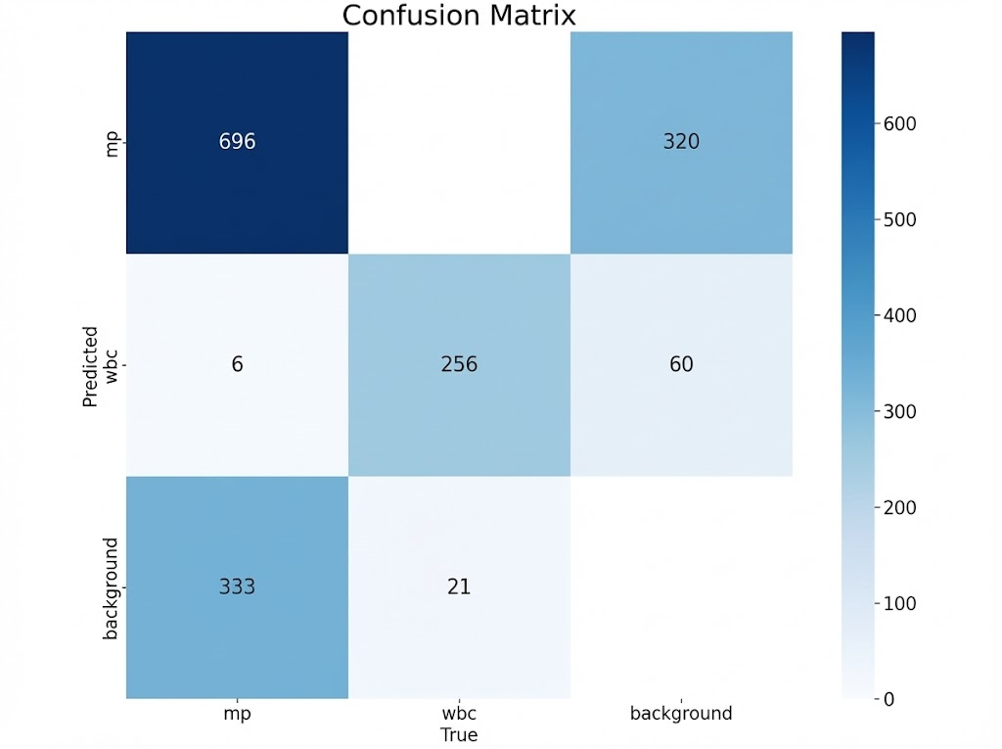
Figure 3: Final Model Performance

In contrast, white blood cell detection proved highly robust, with 256 correctly identified instances and only 21 false negatives. This high level of performance further supports the observation that larger and morphologically consistent cellular structures are easier for deep learning models to detect reliably.

4. Conclusion
This study establishes a new benchmark for automated malaria screening on the Nakasi dataset using the YOLOv12. We made use of stratified cross-validation and targeted offline augmentation for all the YOLOv12 variants. The YOLOv12-Nano model resulted in an mAP@50 of 0.795 and also a mAP@50–95 of 0.463 on a fully isolated test set, outperforming other models and demonstrating the strength of single-stage detectors in medical microscopy.

Despite its compact size, YOLOv12-Nano delivers accuracy comparable to larger models while drastically reducing the computational overhead and size of the model, making it ideal for deployment on edge devices like smartphones for resource-limited settings such as remote area in regions like Nigeria. The model effectively distinguishes malaria parasites from white blood cells, though detecting faint, ring-stage parasites remains challenging. Strong white blood cell detection ensures reliable parasitemia estimation relative to leukocyte counts.

Future improvements will focus on reducing false positives from staining artifacts and expanding the dataset to enhance generalization across multiple laboratory settings. Overall, this work provides a fast, accurate, and reproducible framework for AI-assisted malaria diagnostics in resource-limited environments.

References

Abdurahman, F., Fante, K. A., & Aliy, M. (2021). Malaria parasite detection in thick blood smear microscopic images using modified YOLOV3 and YOLOV4 models. BMC Bioinformatics, 22(1). https://doi.org/10.1186/s12859-021-04036-4
Ambarka, A., Djara, T., Sobabe, A.-A., & Fayomi, H. (2023). Prediction of Malaria Plasmodium Stage and Type Through Object Detection. BioSMART 2023 - Proceedings: 5th International Conference on Bio-Engineering for Smart Technologies. https://doi.org/10.1109/BioSMART58455.2023.10162108
Fact sheet about malaria. (2024, December 11). Https://Www.Who.Int/News-Room/Fact-Sheets/Detail/Malaria.
Grignaffini, F., Simeoni, P., Alisi, A., & Frezza, F. (2024). Computer-Aided Diagnosis Systems for Automatic Malaria Parasite Detection and Classification: A Systematic Review. In Electronics (Switzerland) (Vol. 13, Number 16). Multidisciplinary Digital Publishing Institute (MDPI). https://doi.org/10.3390/electronics13163174
Hoyos, K., & Hoyos, W. (2024). Supporting Malaria Diagnosis Using Deep Learning and Data Augmentation. Diagnostics, 14(7). https://doi.org/10.3390/diagnostics14070690
Koirala, A., Jha, M., Bodapati, S., Mishra, A., Chetty, G., Sahu, P. K., Mohanty, S., Padhan, T. K., Mattoo, J., & Hukkoo, A. (2022). Deep Learning for Real-Time Malaria Parasite Detection and Counting Using YOLO-mp. IEEE Access, 10, 102157–102172. https://doi.org/10.1109/ACCESS.2022.3208270
Krishnadas, P., Chadaga, K., Sampathila, N., Rao, S., Swathi, K. S., & Prabhu, S. (2022). Classification of Malaria Using Object Detection Models. Informatics, 9(4). https://doi.org/10.3390/informatics9040076
LOISE GATHIGIA NDUNG’U. (2017). MOLECULAR MARKERS ASSOCIATED WITH AMODIAQUINE RESISTANCE IN RODENT MALARIA PARASITE Plasmodium berghei ANKA LOISE GATHIGIA NDUNG’U.
Maturana, C. R., de Oliveira, A. D., Nadal, S., Bilalli, B., Serrat, F. Z., Soley, M. E., Igual, E. S., Bosch, M., Lluch, A. V., Abelló, A., López-Codina, D., Suñé, T. P., Clols, E. S., & Joseph-Munné, J. (2022). Advances and challenges in automated malaria diagnosis using digital microscopy imaging with artificial intelligence tools: A review. In Frontiers in Microbiology (Vol. 13). Frontiers Media S.A. https://doi.org/10.3389/fmicb.2022.1006659
Mura, D. A., Zedda, L., Loddo, A., & Di Ruberto, C. (2025). YOLO-Tryppa: A Novel YOLO-Based Approach for Rapid and Accurate Detection of Small Trypanosoma Parasites. https://doi.org/10.20944/preprints202503.1489.v1
Nakasi, R., Mwebaze, E., & Zawedde, A. (2021). Mobile-aware deep learning algorithms for malaria parasites and white blood cells localization in thick blood smears. Algorithms, 14(1). https://doi.org/10.3390/a14010017
Nugroho, H. A., Nurfauzi, R., Murhandarwati, E. E. H., & Purwono, P. (2022). PlasmoID: A dataset for Indonesian malaria parasite detection and segmentation in thin blood smear. https://doi.org/10.48550/arXiv.2211.15105
Rosado, L., Da Costa, J. M. C., Elias, D., & Cardoso, J. S. (2016). Automated Detection of Malaria Parasites on Thick Blood Smears via Mobile Devices. Procedia Computer Science, 90, 138–144. https://doi.org/10.1016/j.procs.2016.07.024
Sazak, H., & Kotan, M. (2025). Automated Blood Cell Detection and Classification in Microscopic Images Using YOLOv11 and Optimized Weights. Diagnostics, 15(1). https://doi.org/10.3390/diagnostics15010022
Sukumarran, D., Hasikin, K., Khairuddin, A. S. M., Ngui, R., Sulaiman, W. Y. W., Vythilingam, I., & Divis, P. C. S. (2024). An optimised YOLOv4 deep learning model for efficient malarial cell detection in thin blood smear images. Parasites and Vectors, 17(1). https://doi.org/10.1186/s13071-024-06215-7
Thakkar, H., Pede, P., Thakker, P., & Shah, N. (2020). Detection of Malaria using Machine Learning. https://ssrn.com/abstract=3606136
Tian, Y., Ye, Q., & Doermann, D. (2025). YOLOv12: Attention-Centric Real-Time Object Detectors. http://arxiv.org/abs/2502.12524
Tola, D. E., Tesfaye, A. H., Solbana, L. K., Nagari, S. L., Bayissa, Z. B., & Chaka, E. E. (2025). Attack rate and determinants of malaria outbreak in Ethiopia: A systematic review and meta-analysis. In Clinical Epidemiology and Global Health (Vol. 33). Elsevier B.V. https://doi.org/10.1016/j.cegh.2025.102045
World Malaria Day 2024. (2024, May 16). Https://Www.Cdc.Gov/Malaria/Features/World-Malaria-Day/Index.Html.
World Malaria Report 2023. (2023). World Health Organization.
Yang, F., Poostchi, M., Yu, H., Zhou, Z., Silamut, K., Yu, J., Maude, R. J., Jaeger, S., & Antani, S. (2020). Deep Learning for Smartphone-Based Malaria Parasite Detection in Thick Blood Smears. IEEE Journal of Biomedical and Health Informatics, 24(5), 1427–1438. https://doi.org/10.1109/JBHI.2019.2939121
Zedda, L., Loddo, A., & Di Ruberto, C. (2023). YOLO-PAM: Parasite-Attention-Based Model for Efficient Malaria Detection. Journal of Imaging, 9(12). https://doi.org/10.3390/jimaging9120266
Zedda, L., Loddo, A., & Di Ruberto, C. (2024). A deep architecture based on attention mechanisms for effective end-to-end detection of early and mature malaria parasites. Biomedical Signal Processing and Control, 94. https://doi.org/10.1016/j.bspc.2024.106289
Zhang, X., & Chen, B. (2023). Research on Malaria Parasite Detection in Thick Blood Smears Based on YOLO-VF. 2023 5th International Academic Exchange Conference on Science and Technology Innovation, IAECST 2023, 1486–1490. https://doi.org/10.1109/IAECST60924.2023.10502526

