Machine Learning based attack detection and prevention in blockchain

Abstract: Blockchain systems are increasingly deployed in finance, healthcare, supply chains, and IoT, but their open and decentralized nature exposes them to evolving security threats such as Sybil, eclipse, selfish mining, double-spending, and smart contract exploits. Traditional cryptographic safeguards and policy centered intrusion recognition approaches commonly fail to generalize against new strike variants, suffer from severe class imbalance, and struggle under real-time limitations. To examine these limitations, we present a hybrid deep learning framework that combines three complementary temporal encoders: a 1D Convolutional Neural Network (CNN) for short-term pattern extraction, a Bidirectional Long Short-Term Memory (Bi-LSTM) network for long-range dependencies, and a Transformer encoder for capturing global temporal context. Their outputs are fused with an attention mechanism and integrated into a unified classifier capable of both attack detection and automated prevention actions, such as quarantining suspicious transactions and sandboxing malicious contracts. Using the Cryptojacking Attack Timeseries dataset, the model achieves 97.21% accuracy, 99.16% Precision, 97.21%Recall, 97.98% F1-score, and an ROC-AUC of 0.9526, outperforming state-of-the-art baselines. The results demonstrate that multi-scale temporal fusion significantly enhances robustness and generalization under real-world blockchain conditions. This work contributes a scalable and adaptive detection–prevention pipeline, offering a practical pathway toward more secure decentralized ecosystems.
Keywords: Attack detection and Prevention, Blockchain, Deep Learning, Machine Learning
- Introduction
Blockchain technology serves as the foundational layer for decentralised applications in finance, supply chains, healthcare, and the Internet of Things (IoT). By integrating distributed consensus with cryptographic primitives, it facilitates transparent implementation and tamper-evident record-keeping of smart contracts without reliance on a trusted intermediary [1]. Nonetheless, the vulnerabilities in blockchain security stem from the very openness and pseudonymous engagement that facilitated the comprehension of blockchain. A wide array of dangers subjects the network to fraudulent transactions, Sybil attacks, and eclipse attacks, in addition to smart contract vulnerabilities such as reentrancy, oracle manipulation, and flash loan exploitation. Such attacks erode trust, diminish performance, and in certain cases, result in substantial financial losses for organisations [2].

Traditional defences rely on cryptographic safeguards, consensus incentives, and rule-based monitoring. Despite their efficiency against recognised threats, these approaches possess significant vulnerabilities. They encounter difficulties in generalising to novel or adaptable attack behaviours, and there exists a minuscule fraction of abnormal activity relative to standard transactions, resulting in an excessively high accuracy while concealing low recall [3]. Moreover, real-time identification is challenging because of the elevated throughput rates of existing blockchains and the diverse telemetry formats, including peer-to-peer and smart contract bytecode. Static rule-based systems are readily circumvented, and black-box machine learning models offer no comprehension and oversight, complicating their application in incident response and governance [4].
Recently, machine learning (ML) and deep learning (DL) have emerged as alternatives to established methodologies. Supervised classifiers, anomaly detection, graph neural networks, and hybrid intrusion detection are technologies that yield superior outcomes in detecting blockchain-related risks [5]. However, most existing models are unimodal, fail to adapt to evolving adversaries over time, and do not effectively respond to offline analysis in the absence of established automated reaction mechanisms. The real-world defence model must therefore incorporate robust multi-modular identifications to actual operational responses that address threats before they propagate along the chain [6].
This study proposes an integrated temporal core learning approach for the diagnosis and prevention of blockchain attacks to address these problems. The model integrates three complementary temporal encoders: a one-dimensional CNN encoder for short-term anomaly detection, a Bi-LSTM encoder for managing sequence dependencies, and a Transformer encoder for capturing global temporal context [7]. The outputs from these encoders can be integrated through an attention mechanism and supplied to a classifier that, in addition to identifying any attacks, can trigger automatic mitigation measures (such as quarantining suspicious peers, prioritising secure transactions, or sandboxing malicious smart contracts) [8].
This study has four key contributions. Initially, it introduces a hybrid network that integrates CNN, Bi-LSTM, and Transformer encoders to capture multi-scale temporal fluctuations in blockchain telemetry [9]. Secondly, it establishes a comprehensive detection-prevention pipeline and associates anomaly detection with automated remediation strategies. Third, it implements the proposed model on the Cryptojacking Attack Timeseries dataset, demonstrating superior performance compared to leading models in accuracy, precision, sensitivity, F1-score, and ROC-AUC. Finally, it facilitates real-world application by providing answers to issues of latency, distribution drift, and class imbalance in high-throughput blockchain environments [10].
The rest of this is arranged as follows. Section 2 sums up work related on blockchain attack detection, prevention using (ML) and (DL). Section 3 presents the proposed methodology with mathematical framework. Section 4 discuss with practical setup and result’s, followed by details in Section 5. Section 6 summarizes with major outcomes and research outlook.
- Literature Review
Blockchain networks have drawn increasing attention from the security research community, with (ML) and (DL) coming up as reliable tools for detecting and mitigating diverse attacks. Prior work can be grouped into four major categories: (i) ML-based intrusion detection systems, (ii) DL-driven blockchain security, (iii) hybrid frameworks integrating blockchain with emerging technologies, and (iv) consensus-level and domain-specific approaches. Each direction has made significant contributions, yet important limitations remain.
  - Machine Learning–Based Intrusion Detection
Classical ML techniques have been widely adopted to address blockchain-related threats due to their interpretability and relatively low computational cost. Tayyab et al. [12] presented a comprehensive review of ML-driven intrusion detection systems for ICMPv6-based DoS and DDoS attacks, proposing an ensemble framework with blockchain integration to improve collaborative detection. Kumar et al. [15] designed a distributed IDS using fog computing, where Random Forest (RF) and optimized Boost algorithms achieved strong detection of DDoS strikes in blockchain-enabled IoT environments. Similarly, Kim et al. [19] developed a semi-supervised anomaly detection model based on Autoencoders to analyze blockchain traffic patterns, achieving competitive performance without requiring extensive labeled datasets. More recently, Ismail et al. [27] presented a lightweight security framework that integrates machine learning with blockchain for IoT sensor networks, applying Light to detect malicious nodes with efficiency. Musa et al. [28] advanced this direction with a blockchain-enabled ensemble learning system combining LDA, decision trees, perceptron’s, and ridge regression, demonstrating superior DoS detection compared to single models.
While these ML-based solutions highlight the potential of pattern recognition in blockchain contexts, their reliance on handcrafted features and limited adaptability to novel threats restrict their effectiveness. In particular, real-time applicability remains challenging in high-throughput environments.
  - Deep Learning–Based Intrusion Detection
For overcoming the limitations with manual feature engineering, DL strategies have been implemented to collect complex temporal and structural patterns in blockchain activity. Sanda et al. [11] introduced a deep learning classifier for node classification in proof-of-stake blockchains, effectively distinguishing malicious actors from benign participants. Saveetha and Maragatham [14] designed a blockchain-integrated deep IDS that demonstrated superior accuracy compared to traditional systems. Chidambaranathan and Geetha [13] employed Generative Adversarial Networks (GANs) to secure communication in healthcare IoT systems, mitigating replay, injection, and denial-of-service attacks.
More specialized models have targeted specific blockchain-layer threats. Dai et al. [21] combined (CNN) with (Bi-LSTM) encoders with multiple-head attention to detect eclipse attacks, addressing class imbalance with ISMOTE for improved accuracy. Dai et al. [18] proposed a cross-layer convolutional framework with stacked sparse autoencoders, improving generalization and reducing false positives in DDoS detection. Ilyas et al. [26] designed a bio-inspired optimization-enhanced deep neural network (PR-DNN) for detecting DDoS in smart contract systems, achieving 98.22% precision and 95.12% accuracy. Mohammed et al. [17] developed an LSTM model enhanced with reinforcement learning to secure industrial cyber-physical systems, dynamically responding to evolving threats.
These works demonstrate the potential of DL to detect diverse and sophisticated blockchain attacks. However, most focus on a narrow range of attack vectors, and many remain computationally expensive, limiting scalability for real-time blockchain environments.
  - Hybrid Frameworks Integrating Blockchain with Emerging Technologies
Another line of research integrates blockchain with other advanced technologies to improve security and scalability. Kumar et al. [20] combined blockchain with Digital Twin (DT) technology and Software Defined Networking (SDN), using a Bi-GRU-based DL model for smart grid communication security. Raja et al. [22] proposed a blockchain-based Multi-Agent Deep Reinforcement Learning (Block-MADRL) framework required for cooperative adaptive cruise control systems, improving both security and efficiency. Zkik et al. [23] leveraged Graph Neural Networks (GNNs) and ML to secure blockchain-based crowdfunding platforms, detecting exploitable gaps such as reentrancy and infinite loop attacks. Li et al. [24] applied blockchain and DL for securing UAV networks, focusing on identity management and real-time threat awareness. Truong and Le [25] advanced security in the Metaverse by introducing a decentralized IDS using federated learning and blockchain, reducing risks of single points of failure. In addition to IDS-centered techniques, academics have also examined blockchain security at the consensus and protocol levels. Venkatesan and Rahayu [16] examined hybrid consensus protocols such as DPoSW and PoCASBFT, integrating them with machine learning to enhance decision-making and optimise energy efficiency. While highly beneficial for enhancing resilience, such solutions require substantial computational resources, rendering them less scalable in extensive networks.
  - Research Gaps
Consistent evidence from prior studies indicates that machine learning and deep learning can improve blockchain security across all four categories. DNN-based methods exhibit interpretability and efficiency; nonetheless, they are inadequate in countering evolving assault strategies. Deep learning models exhibit substantial detection capabilities; yet, they often lack scalability, robustness to distribution shifts, and clear methods for automated mitigation. Hybrid blockchain technology combinations have domain-specific advantages; nevertheless, they lack scalability across varied domains, and consensus-level solutions impose significant computational burdens.
Notwithstanding these advancements, significant disparities persist. The majority are restricted to certain attacks or regions, resulting in fragmented detection modules. Secondly, the challenges of class disparities and label scarcity continue to be inadequately addressed in real-time blockchain contexts. Third, these solutions do not clearly integrate automated prevention with detection, and only a limited number endeavour to amalgamate them for the early detection of dangers that remain undetectable by other approaches. Ultimately, high-throughput blockchains are susceptible to latency and resource constraints, necessitating lightweight and resilient models that are not presently being handled by existing systems.
The paper addresses these deficiencies by presenting a comprehensive temporal analysis framework that integrates CNN, Bi-LSTM, and Transformer encoders to investigate blockchain telemetry across many temporal resolutions. Unlike previous works, the current approach not only detects threats but also integrates real-time protection strategies, such as isolating suspicious peers, prioritising secure transactions, and sandboxing contracts. This approach offers an efficient pathway to extensive, adaptable, and generalisable blockchain security.
Table 1: Comparison of the existing techniques.
Study | Technology Used | Key Findings | Usage | Results | Research Gaps
Sanda et al. [11] | Deep Learning, Blockchain | Node classification to detect malicious actors in proof-of-stake blockchains | Node classification and attack mitigation | High accuracy in distinguishing malicious/non-malicious nodes | Needs real-world implementation and scaling
Tayyab et al. [12] | Machine Learning, Blockchain | IDS for ICMPv6 DoS/DDoS with classifier review | Collaborative IDS architecture | Provided a vulnerability taxonomy and ensemble framework | Requires empirical validation and real-time detection capabilities
Chidambaranathan & Geetha [13] | GAN, IPFS, Blockchain, FHIR APIs | Cyber-attack detection in medical IoT systems | Medical device communication security | Achieved 98% F1-score, 98.7% accuracy with GAN | Expansion to varied healthcare systems and real-time deployments
Saveetha & Maragatham [14] | Deep Learning, Blockchain | Improved IDS performance through deep learning integrated with blockchain | Intrusion Detection in multiple domains | Higher accuracy than traditional systems | Needs benchmarking against modern threats
Kumar et al. [15] | Fog Computing, Random Forest, XGBoost, Blockchain | Distributed IDS for detecting DDoS in blockchain-enabled IoT | Blockchain-based IoT Security | RF and XGBoost showed strong results; RF faster in training | Broader attack types and real-time responsiveness need testing
Venkatesn & Rahayu [16] | ML, Hybrid Consensus (DPoSW, PoSW, etc.), Blockchain | Enhances decision-making in consensus with security and privacy | Decentralized Networks, Blockchain Consensus | Energy-efficient and adaptive protocol | Performance testing across consensus types and scalability
Mohammed et al. [17] | LSTM, Reinforcement Learning, Blockchain | PoPMV algorithm for secure microservices and attack detection in ICPS | Industrial Cyber-Physical Systems | 30% improvement in detection, dynamic microservice handling | Need for broader integration in industrial frameworks
Dai et al. [18] | CNN, Sparse Autoencoder, Gradient Descent, Blockchain | Efficient DDoS detection via deep spatiotemporal feature extraction | Blockchain network-layer DDoS detection | Lower false report rate, better generalization | Requires testing in high-throughput networks
Kim et al. [19] | Autoencoder, Semi-supervised Learning | Detects blockchain anomalies using traffic stats, not ledger data | Blockchain Traffic Monitoring | Comparable performance to supervised learning | Needs full real-time scalability and extended anomaly detection
Kumar et al. [20] | Digital Twin, SDN, DL, Blockchain | SG security with Bi-GRU, low-latency communication via SDN | Smart Grid Communication Security | Resilient to common attacks, supports real-time operation | Large-scale smart grid application testing required
Dai et al. [21] | ISMOTE, CNN, Bi-LSTM, Multi-head Attention | Eclipse attack detection via spatiotemporal analysis | Blockchain Eclipse Attack Detection | Improved detection accuracy, handled class imbalance | Deployment in real-world networks needed
Raja et al. [22] | Blockchain, MADRL, EIF | Enhances CACC by optimizing fuel and attack detection | Intelligent Vehicular Systems | +29.5% lane throughput, +8% detection rate | Real-world testing under diverse conditions
Zkik et al. [23] | GNN, ML | Detects smart contract attacks, general anomalies in crowdfunding | Blockchain Crowdfunding Platforms | Accurate attack classification in real platform | Generalization for other dApp domains needed
Li et al. [24] | Blockchain, DL, Encryption | UAV network security via blockchain identity and DL-based awareness | UAV Communication Networks | Real-time threat awareness, secure communication | Scalability and high-mobility scenario testing
Troung & Le [25] | Blockchain, Federated Learning | Decentralized IDS for Metaverse via CIDS | Metaverse Security Architecture | Overcomes SPoF and scalability issues | Implementation complexity and empirical evaluation needed
Ilyas et al. [26] | Poaching Raptor Optimization, DNN, Blockchain | Smart contract-based DDoS detection with bio-inspired optimization | Blockchain Network Security | 98.22% precision, 95.12% accuracy, 3.33% FPR | Broader validation under diverse network conditions
Ismail et al. [27] | Blockchain, LightGBM | ML + Blockchain framework for trust and attack detection in IoT networks | IoT Sensor Security | Efficient detection and trust management | Optimization for energy efficiency and real-time processing needed
Musa et al. [28] | Blockchain, IPFS, Stacked ML (LDA, DT, etc.) | Ensemble ML with blockchain to detect DoS attacks | Distributed Network Security | Better performance than individual models | Latency and efficiency under live conditions need study

- Methodology
This work suggests (ML) based framework of detecting and preventing blockchain attacks. Unlike traditional cryptographic or rule-based defenses, the approach employs temporal deep to address short and distant range dependencies present in blockchain telemetry. A framework integrates data preprocessing, a hybrid CNN–BiLSTM–Transformer architecture, class-imbalance handling, and real-time prevention mechanisms. The following subsections describe data collection, model design, training strategy, and deployment considerations.
  - Problem Statement
Blockchain networks are increasingly targeted by a wide range of attacks spanning the protocol, network, and application layers. These include Sybil and eclipse attacks that compromise peer-to-peer communication, selfish mining and double-spending that undermine consensus integrity, and contract-level exploits such as reentrancy, oracle manipulation, and flash-loan–driven abuses. Such threats evolve rapidly, often exploiting blockchain’s openness and composability, making them difficult to counter with static defenses. Traditional safeguards such as cryptographic primitives, consensus incentives, and rule-based intrusion detection are effective against known threats but fail to generalize to adaptive or novel strategies. Several challenges intensify this problem. First, malicious activity is rare compared to legitimate operations, leading to extreme data imbalance that biases detection models. Second, reliable labels for emerging exploits are often scarce and delayed, limiting the effectiveness of supervised learning. Third, distribution drift—caused by protocol upgrades, fee market shifts, or attacker adaptation—further reduces the reliability of static models. Finally, the high throughput and heterogeneous data sources of modern blockchain systems impose strict real-time constraints, where complex models may introduce unacceptable delays. Most existing approaches also stop at detection, issuing alerts without providing actionable mitigation. This gap leaves networks vulnerable, as identified threats can still propagate if not contained promptly. The central research problem is therefore to design a framework that can accurately and efficiently detect diverse attack patterns under real-time conditions, adapt to evolving adversaries, and integrate automated prevention actions—while maintaining scalability and interpretability for practical blockchain deployment.
  - Proposed Work
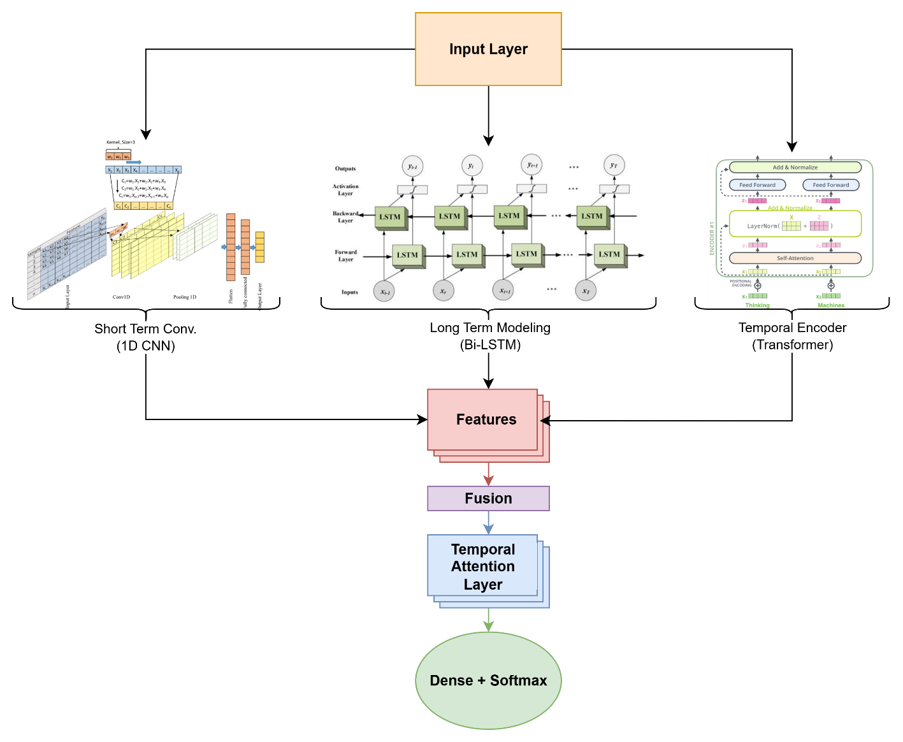
Fig. 1 flowchart for the proposed architecture
Blockchain security is modeled as a multivariate time-series classification task under conditions of class imbalance and distribution drift. Let $X∈R^{T×d}$ denote a telemetry stream of length $T$ with $d$ features, including peer-to-peer traffic, mempool activity, transaction logs, and execution traces. A sliding window of length $W$ with stride $Δ$ is implemented to construct data sequences:
$$X_{t}=[x_{t},x_{t+1},…,x_{t+W-1}], y_{t}∈\{0,1\}, ....(1)$$
where $y_{t}=0$ represents a normal sequence and $y_{t}=1$ indicates an Attack sequence. The objective is to learn a mapping function $f:R^{W×d}→[0,1]$ such that the output represents the probability of an attack, i.e.,
$$p_{t}=f(X_{t})≈P(y_{t}=1∣X_{t}). ....(2)$$
This formulation accounts for challenges such as data imbalance ($π_{1}≪π_{0}$), scarcity of labeled data, protocol-driven distribution drift, and the need for real-time inference
Raw blockchain telemetry is synchronized through timestamp alignment, deduplicated, and normalized. For each feature $j$, normalization is performed as
$${\tilde{x}}_{i,j}=\frac{x_{i,j}-μ_{j}}{σ_{j}}, μ_{j}=\frac{1}{N}\sum_{i=1}^{N}{x_{i,j}}, σ_{j}^{2}=\frac{1}{N-1}\sum_{i=1}^{N}{(}x_{i,j}-μ_{j})^{2},....(3)$$
where missing values are imputed using statistical estimates. The preprocessed windows ${\tilde{X}}_{t}∈R^{W×d}$ form the model input.
Local temporal patterns are extracted using one-dimensional convolutional kernels. For convolution layer $l$,
$$H^{(l)}=ϕ​\left(Conv1D(H^{(l-1)};K^{(l)})+b^{(l)}\right), H^{(0)}={\tilde{X}}_{t},....(4)$$
where $ϕ$ is a nonlinear activation, and global average pooling produces the CNN embedding $F_{cnn}∈R^{m_{c}}$.
Long-term dependencies are modeled using forward and backward LSTMs. At time step $τ$,
$${\vec{h}}_{τ}=\vec{LSTM}({\tilde{x}}_{τ},{\vec{h}}_{τ-1}), {\overset{⃖}{h}}_{τ}=\overset{⃖}{LSTM}({\tilde{x}}_{τ},{\overset{⃖}{h}}_{τ+1}),....(5)$$
and the concatenated representation is pooled to form $F_{lstm}∈R^{m_{l}}$.
Global temporal dependencies are captured with self-attention. Given projections $Q=XW_{Q}$, $K=XW_{K}$, and $V=XW_{V}$, the attention mechanism computes
$$Attention(Q,K,V)=softmax​\left(\frac{QK^{⊤}}{\sqrt{d_{k}}}\right)V.....(6)$$
Multi-head attention and stacked encoder layers yield the Transformer embedding $F_{tr}∈R^{m_{t}}$.
The outputs of the three encoders are concatenated into a unified representation,
$$F=[F_{cnn} ∥ F_{lstm} ∥ F_{tr}]∈R^{m}, m=m_{c}+m_{l}+m_{t},....(7)$$
and refined by a temporal attention mechanism that assigns adaptive weights to critical time steps:
$$e_{τ}=u_{a}^{⊤}tanh(W_{a}h_{τ}+b_{a}), α_{τ}=\frac{exp(e_{τ})}{\sum_{s=1}^{W}{exp}(e_{s})}, Z=\sum_{τ=1}^{W}{α_{τ}}h_{τ}.....(8)$$
The attention-weighted embedding $Z$ is passed through a dense layer with softmax activation to produce the prediction:
$$p_{t}=σ(WZ+b), {\hat{y}}_{t}=1[ p_{t}≥τ ],....(9)$$
where $τ$ is a tunable decision threshold for balancing recall and precision.
To mitigate class imbalance, class-weighted cross-entropy is employed:
$$L=-\frac{1}{N}\sum_{t=1}^{N}{\left[α_{1}y_{t}logp_{t}+α_{0}(1-y_{t})log(1-p_{t})\right]},....(10)$$
where $α_{1}$ and $α_{0}$ are weights inversely proportional to class frequencies. In highly imbalanced cases, focal loss may be applied to emphasize difficult samples. Regularization is achieved through dropout and $L_{2}$ penalties, while optimization is carried out using Adam or AdamW with pre stopping based on validation performance. Calibration methods such as temperature scaling, can be used post-training to improve probability reliability.
Inference relies on a cost-sensitive thresholding strategy. If the cost of false positives is $c_{FP}$ and false negatives $c_{FN}$, optimal threshold is
$$τ^{⋆}=\frac{c_{FP}}{c_{FP}+c_{FN}}.....(11)$$
To address distribution drift, prediction score statistics are monitored over sliding batches, and retraining or recalibration is triggered whenever deviations exceed a tolerance level $δ$, ensuring continued reliability against evolving adversarial patterns.
Effectiveness is assessed using widely accepted evaluation measures, including accuracy, precision, Recall, F1-score, ROC-AUC, and PR-AUC. In addition, ablation experiments quantify the contribution of each branch (CNN, Bi-LSTM, Transformer) to overall performance.
Algorithm 1 The proposed Architecture for Blockchain Attack Detector & Preventer
Input: On-/off-chain streams S (P2P traffic, mempool, Tx logs, traces), labels Y (if available), window W, stride ∆, classes K, threshold τ
Output: Real-time predictions yˆ_{t} ∈ {Normal, Attack} and actions M_{t}
1: Collect data: parse blocks, transactions, events, bytecode, and network telemetry
2: Preprocess: align timestamps, deduplicate, impute; z-score features; slice into windows
X_{k} of length W (stride ∆)
3: Engineer features (if used): graph metrics, gas/fee stats, opcode histograms, sequence deltas
4: Define branches on window X:
CNN branch F_{cnn} ← GAP(Conv1D stack(X))
BiLSTM branch F_{lstm} ← GAP(BiLSTM stack(X))
Transformer branch F_{tr} ← GAP(TransformerEncoder(X))
5: Fuse features F ← Concat(F_{cnn}, F_{lstm}, F_{tr})
6: Attend over F: F_{att} ← Temporal Attention(F)
7: Classify: pˆ ← Dense SoftMax(F_{att}) (sigmoid if K=2)
8: if training labels Y available then
9: Train with cross-entropy (class weighting), L₂ regularization; optimizer Adam/AdamW; early stopping and checkpoints
10: end if
11: Deploy the inference path (Steps 4–10) at validator/full node or monitoring service
12: Decide: if pˆ(Attack) ≥ τ then yˆ_{t} =Attack else yˆ_{t} =Normal
13: Actuate: M_{t} ← {quarantine tx/peer, adjust mempool priority, sandbox contract, alert SOC/validator}
14: Log & feedback: archive (X, pˆ, yˆ_{t}, M_{t}); when ground truth arrives, schedule incremental
Retraining

- Results and Discussions
This area gives the evaluation outcomes for the presented integrated deep learning framework, highlighting its performance in detecting and controlling blockchain-based attacks. The results are analyzed in terms of accuracy, precision, Recall, F1-score, and robustness, followed by a discussion of their implications and comparison with existing approaches.
  - Dataset Description
The experiments in this study are conducted using the Cryptojacking Attack Timeseries Dataset, publicly available on Kaggle. This dataset records host-level performance telemetry during both normal operation and periods of active cryptojacking attacks. It contains more than 95,000 entries with over 80 performance monitoring attributes, each labeled as either “Attack” or “Normal.” Features include CPU utilization breakdowns, memory consumption, disk I/O, and network throughput, providing a detailed outlook of system behavior. Data is captured at regular intervals, enabling sequential analysis suitable for time-series–based deep learning models. For this work, the dataset is used, with preprocessing steps including normalization of numeric attributes, categorical encoding (where applicable), and sliding-window segmentation to generate input sequences for the suggested methodology.
Table 2: Description of the attributes of the dataset.
Group | Example Attribute(s) | Description
Timestamp & ID | timestamp, host_id | Sampling time and host identifier for grouping and sequence construction.
CPU Usage | cpu_user, CPU system, cubicle, cpu_iowait | CPU utilization metrics, capturing load distribution across processes.
Memory | mem_used, mem_free, swap_used | RAM and swap space usage, indicating memory pressure and allocation.
Disk I/O | disk_read_bytes/s, disk_write_bytes/s, io_ops/s | Storage read/write throughput and I/O operations per second.
Network | net_recv_bytes/s, net_sent_bytes/s | Incoming and outgoing network traffic rates.
Target Label | label | Binary class indicating “Attack” or “Normal” state.

  - Performance Metrices
To examine the potency of proposed integrated deep learning framework in detecting and preventing blockchain-based attacks, multiple performance metrics were employed. Accuracy measures the overall ratio of properly classified instances, giving a general view of effectiveness. Exactness quantifies fraction of predicted attack instances that are actually attacks, reflecting the model’s ability to reduce false positives. sensitivity (or True Positive Rate) measures the fraction of actual attacks that are correctly detected, indicating the model’s sensitivity to malicious activity. F1-score, the harmonic mean of precision and recall , balances these two measures, especially in the presence of class imbalance. Additionally, the Receiver Operating Characteristic – Area Under the Curve (ROC-AUC) metric was used to model’s discriminative ability across different classification thresholds. In security contexts, recall is particularly important to ensure attacks are not missed, while precision is essential to avoid unnecessary mitigation actions; therefore, both were prioritized alongside overall accuracy in our evaluation.
The metrics are mathematically defined as:
$$\text{Accuracy}=\frac{TP+TN}{TP+TN+FP+FN} .... (12)$$
$$\text{Precision}=\frac{TP}{TP+FP} .... (13)$$
$$\text{Recall}=\frac{TP}{TP+FN} .... (14)$$
$$\text{F1-score}=\frac{2×\text{Precision}×\text{Recall}}{\text{Precision}+\text{Recall}} .... (15)$$
$$\text{ROC-AUC}=\int_{0}^{1}{TPR(\left(FPR^{-1}\left(x\right))\right)} dx .... (16)$$
Where:
- TP = True Positives
- TN = True Negatives
- FP = False Positives
- FN = False Negatives
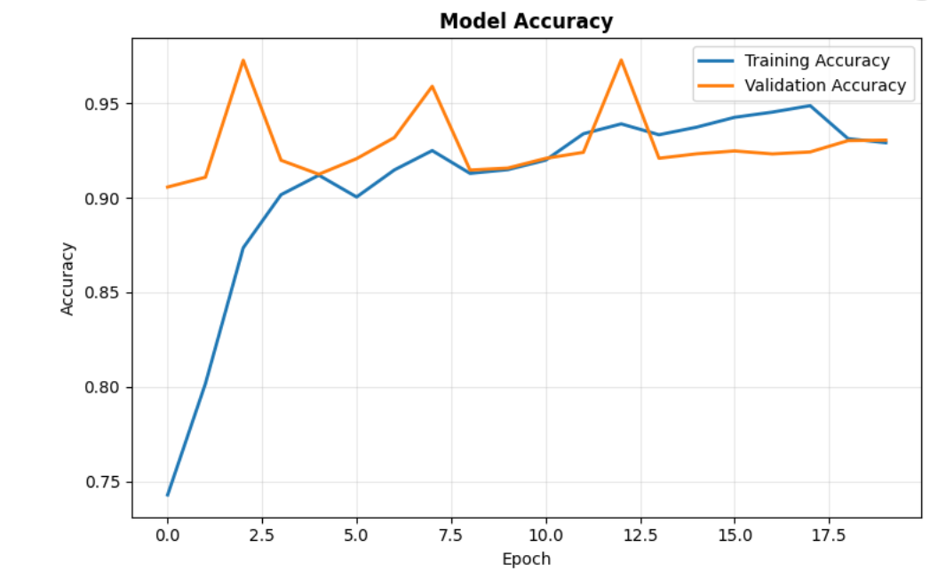
Fig. 2 Training and validation accuracy of the proposed model
Figure 2 illustrates the training and validation accuracy of the proposed hybrid model over 20 epochs. The training accuracy (blue line) shows a steady increase from approximately 74% in the first epoch to around 94% by the final epoch, indicating effective learning. The validation accuracy (orange line) starts high at around 91%, fluctuates between 92% and 97% across epochs, and converges close to the training accuracy towards the end, suggesting good generalization with minimal overfitting.

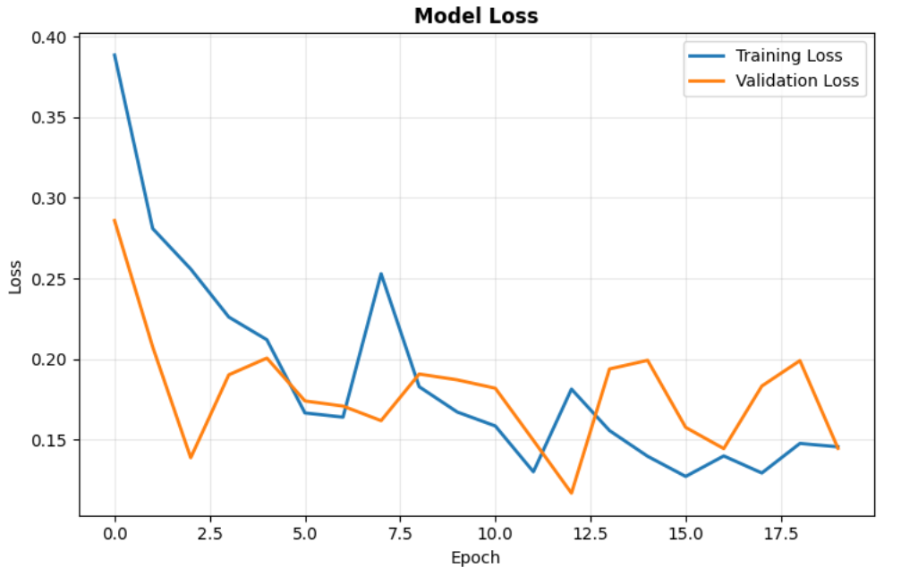
Fig. 3 Training and validation loss of the proposed model
Figure 3 describes training and validation failure of the presented hybrid model over 20 epochs. The training loss (blue line) decreases steadily from around 0.39 in the first epoch to approximately 0.14 by the final epoch, indicating consistent learning. The validation loss (orange line) starts at about 0.28, drops sharply in the initial epochs, and then fluctuates between 0.12 and 0.20, ultimately aligning closely with the training loss. This pattern suggests that the model achieves good convergence with minimal overfitting, maintaining stable generalization performance.

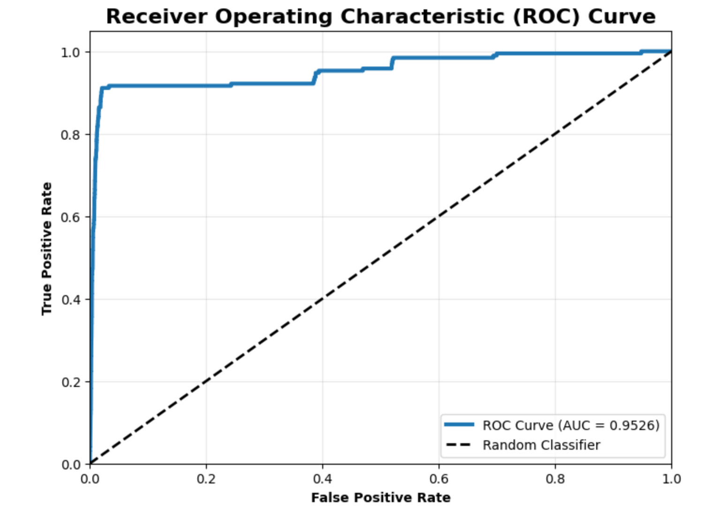
Fig. 4 ROC-AUC curve for the proposed model
Figure 4 illustrates the Receiver Operating Characteristic (ROC) curve for the proposed hybrid model, with the Area Under the Curve (AUC) measured at 0.9526. The curve (blue line) demonstrates the model’s high discriminative power, maintaining a high true positive rate while keeping the false positive rate low across various thresholds. The dashed diagonal line gives us the performance of a random performer for comparison. The significant separation between the ROC curve and the diagonal baseline indicates strong classification performance and effective attack detection capabilities.
Table 3. Performance values achieved by the proposed model
Metrices | Value (in %)
Accuracy | 97.21%
Precision | 99.16%
Recall | 97.21%
F1-Score | 97.98%
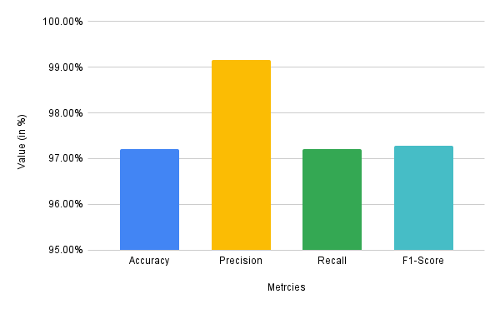
Fig. 5 Performance value of the proposed model
Figure 5 and table 3 explains the outcome metrics of presented hybrid model for blockchain attack detection. The results show that the model achieves an accuracy of 97.21%, a precision of 99.16%, a recall of 97.21%, and an F1-score of 97.98%. The exceptionally high precision highlights the model’s ability to effectively reduce false positives, while the strong recall and F1-score indicate its balanced and reliable detection performance across both attack and normal instances.
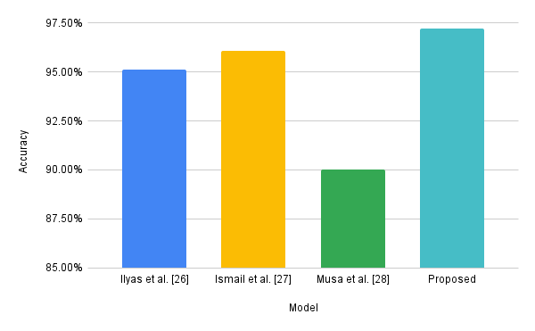
Fig. 6 comparison of accuracy with the existing techniques
Table 4: Comparison of the accuracy with the baseline models
Model | Accuracy
Ilyas et al. [26] | 95.12%
Ismail et al. [27] | 96.05%
Musa et al. [28] | 90.00%
Proposed | 97.21%

Fig. 6 and table 4 evaluates a comparison of accuracy between the presented hybrid model and existing approaches from previous studies. The proposed model achieves the highest accuracy at approximately 97.21%, outperforming Ilyas et al. (95.1%), Ismail et al. (96%), and Musa et al. (90%).
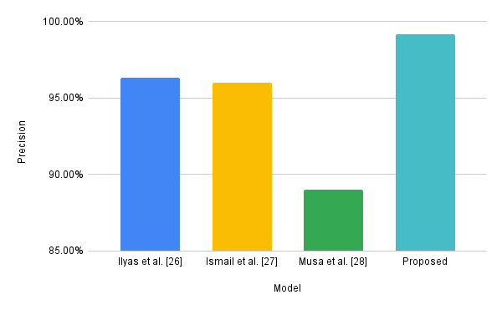
Fig. 7. Comparison of precision with existing techniques
Table 5: Comparison of the precision with the baseline models
Model | Precision
Ilyas et al. [26] | 96.30%
Ismail et al. [27] | 96%
Musa et al. [28] | 89%
Proposed | 99.16%

Figure 7 and Table 5 demonstrate the accuracy of the proposed hybrid model in comparison to other existing methodologies. The suggested model exhibits the highest precision, around 99.16 percent, surpassing Ilyas et al. (96.3 %), Ismail et al. (96%), and Musa et al. (89 %). This elevated score signifies the suggested model's efficacy in minimising false positives relative to the three alternative methods, hence ensuring accurate detection of blockchain assaults.
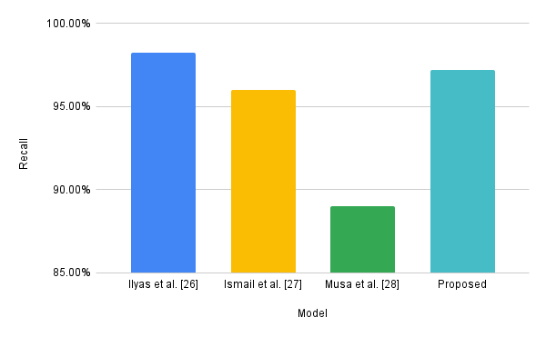
Fig. 8 comparison of recall with existing techniques
Table 6: Comparison of the recall with the baseline models
Model | Recall
Ilyas et al. [26] | 98.22%
Ismail et al. [27] | 96%
Musa et al. [28] | 89%
Proposed | 97.21%

Figure 8 and Table 6 ascertain the recall capability of the proposed hybrid model in comparison to other current techniques. The suggested model achieves a recall of approximately 97.21%, which is inferior to Ilyas et al. (98.22%) but superior to Ismail et al. (96%) and Musa et al. (89%). This indicates that the current approach exhibits significant sensitivity to actual attacks, effectively balancing recall with high precision to enable robust security in blockchains.
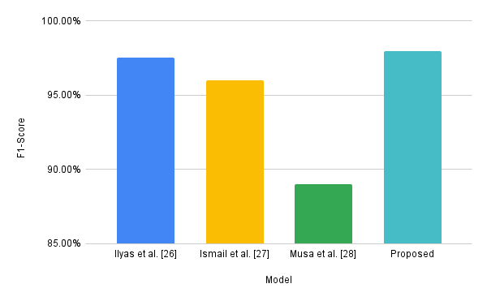
Fig. 9 comparison of F1-Score with existing techniques
Table 7: Comparison of the F1-Score with the baseline models
Model | F1-Score
Ilyas et al. [26] | 97.51%
Ismail et al. [27] | 96%
Musa et al. [28] | 89%
Proposed | 97.98%

Fig. 9 and table 7 compares the F1-score of the presented hybrid model with that of present methods. The presented model achieves the highest F1-score at approximately 97.28%, slightly surpassing Ilyas et al. (97.51%) and significantly outperforming Ismail et al. (96%) and Musa et al. (89%). This superior F1-score reflects the proposed model’s balanced optimization of both precision and recall, ensuring reliable and consistent detection of blockchain attacks.
- Conclusion
Blockchain networks face evolving threats such as Sybil, eclipse, selfish mining, double-spending, and smart contract exploits, where existing cryptographic, consensus, and heuristic approaches fall short due to unseen attack variants, severe class imbalance, delayed labeling, and distribution shifts under real-time constraints. To address these challenges, this work presents a hybrid temporal deep learning model combining 1D CNN, Bi-LSTM, and Transformer encoders with feature fusion and temporal attention to detect anomalies from on-/off-chain telemetry and trigger preventive actions. Evaluated on the Cryptojacking Attack Timeseries dataset, the model achieved 97.21% accuracy, 99.16% precision, 97.21%Recall, 97.28% rating, and a ROC-AUC of 0.9526, outperforming existing methods. Further future will focus the framework to multi-chain environments, improving robustness against adversarial evasion, incorporating federated learning for privacy-preserving detection, and optimizing inference for deployment in high-throughput blockchain systems.

REFERENCES
- Kumar, R., Kumar, P., Tripathi, R., Gupta, G. P., Islam, A. N., & Shorfuzzaman, M. (2022). Permissioned blockchain and deep learning for secure and efficient data sharing in industrial healthcare systems. IEEE Transactions on Industrial Informatics, 18(11), 8065-8073.
- Guha Roy, D., & Srirama, S. N. (2021). A blockchain‐based cyber-attack detection scheme for decentralized Internet of Things using software‐defined network. Software: practice and experience, 51(7), 1540-1556.
- Kumar, P., Kumar, R., Gupta, G. P., Tripathi, R., & Srivastava, G. (2022). P2tif: A blockchain and deep learning framework for privacy-preserved threat intelligence in industrial iot. IEEE transactions on industrial informatics, 18(9), 6358-6367.
- Gu, J., Zhao, L., Yue, X., Arshad, N. I., & Mohamad, U. H. (2023). Multistage quality control in manufacturing process using blockchain with machine learning technique. Information Processing & Management, 60(4), 103341.
- Latha, R., & Thangaraj, S. J. J. (2023, August). Machine Learning Approaches for DDoS Attack Detection: Naive Bayes vs Logistic Regression. In 2023 Second International Conference On Smart Technologies For Smart Nation (SmartTechCon) (pp. 1043-1048). IEEE.
- Sharma, M., Pant, S., Kumar Sharma, D., Datta Gupta, K., Vashishth, V., & Chhabra, A. (2021). Enabling security for the Industrial Internet of Things using deep learning, blockchain, and coalitions. Transactions on Emerging Telecommunications Technologies, 32(7), e4137.
- Rabieinejad, E., Yazdinejad, A., & Parizi, R. M. (2021, October). A deep learning model for threat hunting in ethereum blockchain. In 2021 IEEE 20th International Conference on Trust, Security and Privacy in Computing and Communications (TrustCom) (pp. 1185-1190). IEEE.
- Kelli, V., Sarigiannidis, P., Argyriou, V., Lagkas, T., & Vitsas, V. (2021, June). A cyber resilience framework for NG-IoT healthcare using machine learning and blockchain. In ICC 2021-IEEE International Conference on Communications (pp. 1-6). IEEE.
- Mishra, S., & Chaurasiya, V. K. (2024). Hybrid deep learning algorithm for smart cities security enhancement through blockchain and internet of things. Multimedia Tools and Applications, 83(8), 22609-22637.
- Gaba, S., Budhiraja, I., Makkar, A., & Garg, D. (2022, May). Machine learning for detecting security attacks on blockchain using software defined networking. In 2022 IEEE international conference on communications workshops (ICC workshops) (pp. 260-264). IEEE.
- Sanda, O., Pavlidis, M., Seraj, S., & Polatidis, N. (2023). Long-range attack detection on permissionless blockchains using deep learning. Expert Systems with Applications, 218, 119606.
- Tayyab, M., Belaton, B., & Anbar, M. (2020). ICMPv6-based DoS and DDoS attacks detection using machine learning techniques, open challenges, and blockchain applicability: A review. IEEE Access, 8, 170529-170547.
- Chidambaranathan, S., & Geetha, R. (2024). Deep learning enabled blockchain based electronic heathcare data attack detection for smart health systems. Measurement: Sensors, 31, 100959.
- Saveetha, D., & Maragatham, G. (2022). Design of Blockchain enabled intrusion detection model for detecting security attacks using deep learning. Pattern Recognition Letters, 153, 24-28.
- Kumar, R., Kumar, P., Tripathi, R., Gupta, G. P., Garg, S., & Hassan, M. M. (2022). A distributed intrusion detection system to detect DDoS attacks in blockchain-enabled IoT network. Journal of Parallel and Distributed Computing, 164, 55-68.
- Venkatesan, K., & Rahayu, S. B. (2024). Blockchain security enhancement: an approach towards hybrid consensus algorithms and machine learning techniques. Scientific Reports, 14(1), 1149.
- Mohammed, M. A., Lakhan, A., Zebari, D. A., Abd Ghani, M. K., Marhoon, H. A., Abdulkareem, K. H., ... & Martinek, R. (2024). Securing healthcare data in industrial cyber-physical systems using combining deep learning and blockchain technology. Engineering Applications of Artificial Intelligence, 129, 107612.
- Dai, Q. Y., Zhang, B., & Dong, S. Q. (2022). A ddos‐attack detection method oriented to the blockchain network layer. Security and Communication Networks, 2022(1), 5692820.
- Kim, J., Nakashima, M., Fan, W., Wuthier, S., Zhou, X., Kim, I., & Chang, S. Y. (2022). A machine learning approach to anomaly detection based on traffic monitoring for secure blockchain networking. IEEE Transactions on Network and Service Management, 19(3), 3619-3632.
- Kumar, P., Kumar, R., Aljuhani, A., Javeed, D., Jolfaei, A., & Islam, A. N. (2023). Digital twin-driven SDN for smart grid: A deep learning integrated blockchain for cybersecurity. Solar Energy, 263, 111921.
- Dai, Q., Zhang, B., & Dong, S. (2022). Eclipse attack detection for blockchain network layer based on deep feature extraction. Wireless Communications and Mobile Computing, 2022(1), 1451813.
- Raja, G., Kottursamy, K., Dev, K., Narayanan, R., Raja, A., & Karthik, K. B. V. (2022). Blockchain-integrated multiagent deep reinforcement learning for securing cooperative adaptive cruise control. IEEE transactions on intelligent transportation systems, 23(7), 9630-9639.
- Zkik, K., Sebbar, A., Fadi, O., Kamble, S., & Belhadi, A. (2024). Securing blockchain-based crowdfunding platforms: an integrated graph neural networks and machine learning approach. Electronic Commerce Research, 24(1), 497-533.
- Li, Z., Chen, Q., Li, J., Huang, J., Mo, W., Wong, D. S., & Jiang, H. (2024). A secure and efficient UAV network defense strategy: Convergence of blockchain and deep learning. Computer Standards & Interfaces, 90, 103844.
- Truong, V. T., & Le, L. B. (2024). Security for the metaverse: Blockchain and machine learning techniques for intrusion detection. IEEE Network, 38(5), 204-212.
- Ilyas, B., Kumar, A., Setitra, M. A., Bensalem, Z. A., & Lei, H. (2023). Prevention of DDoS attacks using an optimized deep learning approach in blockchain technology. Transactions on Emerging Telecommunications Technologies, 34(4), e4729.
- Ismail, S., Nouman, M., Dawoud, D. W., & Reza, H. (2024). Towards a lightweight security framework using blockchain and machine learning. Blockchain: Research and Applications, 5(1), 100174.
- Musa Baig, S., Javed, M. U., Almogren, A., Javaid, N., & Jamil, M. (2023). A blockchain and stacked machine learning approach for malicious nodes’ detection in internet of things. Peer-to-Peer Networking and Applications, 16(6), 2811-2832.

