Systematic Review

Chronotherapy in Hypertension: A Systematic Review and Meta-Analysis Comparing Asian and Non-Asian Populations on the Effects of Antihypertensive Dosing Time, Ambulatory Blood Pressure, and Cardiovascular Outcomes

ABSTRACT

Background:
Hypertension is a major global health burden and a leading cause of cardiovascular morbidity and mortality. Despite effective antihypertensive therapies, optimal blood pressure (BP) control remains inadequate worldwide.^{[10]} Circadian variations influence BP, and insufficient nocturnal decline (“nondipping”) increases cardiovascular risk. Chronotherapy, the timed administration of antihypertensive medication, may enhance 24-hour BP control and clinical outcomes.

Objective:
To evaluate the effects of morning versus bedtime antihypertensive medication dosing on ambulatory BP parameters and major adverse cardiovascular events (MACE).

Methods:
A systematic review and meta-analysis of randomized clinical trials was conducted comparing bedtime versus morning administration of antihypertensive agents. Primary outcomes included changes in morning and nocturnal BP; secondary outcomes included 24-hour BP control and incidence of MACE.

Results
Bedtime dosing resulted in significantly greater reductions in 24-hour and nighttime systolic BP (approximately 2–3 mmHg) than morning dosing. Subgroup analyses showed enhanced BP-lowering effects among Asian populations, potentially reflecting genetic and circadian influences.

Conclusion:
Bedtime administration of antihypertensive medications is a safe and feasible chronotherapeutic approach that improves nocturnal BP control, especially in patients with nondipping or nocturnal hypertension. Although major cardiovascular benefits remain unconfirmed, this strategy supports personalized hypertension management and warrants validation in larger outcome trials.

Keywords: Hypertension, MACE, nondippers, chronotherapy, bedtime dosing

INTRODUCTION

Hypertension is one of the most prevalent and preventable causes of cardiovascular and cerebrovascular disease worldwide, accounting for a significant proportion of stroke, ischemic heart disease, heart failure, and renal impairment.
Despite major therapeutic advances, global blood pressure (BP) control remains inadequate, with only about one in five hypertensive adults achieving target BP levels. This contributes to cardiovascular morbidity and mortality^{[1]}. In the Philippines, the PRESYON-4 survey^{[2]} revealed a 37% prevalence of hypertension among adults. However, only 39% of treated individuals had controlled BP. Among those aged 60 years and above, the prevalence increased to nearly 70%, with more than one-third remaining unaware of their condition. These figures highlight the need for more effective management strategies that extend beyond drug selection which may include optimization of treatment timing^{.[2]}
According to the American Heart Association (AHA) and American College of Cardiology (ACC) 2017 and 2025 guidelines^{[3,4]}, early initiation of antihypertensive therapy is warranted for adults with sustained BP ≥130/80 mmHg and elevated cardiovascular risk. Recommended first-line agents include thiazide or thiazide-like diuretics, calcium channel blockers (CCBs), angiotensin-converting enzyme inhibitors (ACEIs), and angiotensin II receptor blockers (ARBs). Similarly, the practice of the Philippine Society of Hypertension (PSH) and Philippine Heart Association (PHA) guidelines advocate pharmacologic treatment at thresholds of ≥ 140/90 mmHg, targeting < 130/80 using ambulatory blood pressure monitoring (ABPM) as the preferred follow-up modality^{[5]}. Despite this, however, neither global nor local guidelines specify optimal timing of medication administration. Some studies suggest that circadian BP rhythms may influence cardiovascular outcomes, which open little to no cost solutions to these problems.^{[6-10]}
Blood pressure follows a 24-hour circadian pattern, characterized by higher values during the day and a 10–20% physiological decline (defined as “dipping”) during sleep. Failure to achieve this decline, known as “non-dipping”, or an actual nocturnal BP rise (reverse dipping), is strongly associated with target-organ damage such as left ventricular hypertrophy, stroke, chronic kidney disease, and cardiovascular mortality ^{[9][24].} ABPM remains the gold standard for detecting these patterns, providing prognostic information beyond clinic BP readings ^{[18].} Importantly, nocturnal hypertension and blunted dipping are particularly common in Asian populations, linked to high salt intake and salt sensitivity, as shown in large regional studies ^{[18].}
Chronotherapy – the timed administration of antihypertensive medications in alignment with circadian BP variation has shown possible benefit for BP control. The goal of chronotherapy is to optimize 24-hour BP control, enhance nocturnal BP reduction, restore normal dipping status,and mitigate early-morning BP surges that predispose patients to acute cardiovascular events.
The landmark MAPEC Trial conducted by Hermida and colleagues (2010) showed that bedtime administration of at least one antihypertensive agent significantly reduced nocturnal BP, normalized dipping, and lowered total cardiovascular events by 61% compared with morning dosing. The subsequent Hygia Chronotherapy Trial ^{[7]} expanded on these findings in more than 19,000 patients, showing a 45% reduction in major adverse cardiovascular events (MACE) with bedtime treatment. More recently, the OMAN Randomized Clinical Trial confirmed these benefits in an Asian population, showing enhanced nocturnal BP reduction and improved circadian rhythm restoration without increasing adverse events. ^{[28]}
Despite this however, there are studies that have neutral findings. The HARMONY crossover trial ^{[19]} and the large, pragmatic TIME Trial ^{[19]} reported no significant differences in 24-hour BP control or major cardiovascular outcomes between morning and bedtime dosing. Similarly, the BedMed-Frail trial ^{[15]} in elderly nursing home residents found no benefit in mortality or cardiovascular endpoints from switching antihypertensive intake to bedtime.
Recent meta-analyses provide mixed conclusions: while some indicate modest improvements in nocturnal BP reduction and dipping status ^{[31]}, others, such as Turgeon et.al ^{[25]}, find no reduction in MACE despite better nighttime BP control.
Collectively, current evidence suggests that chronotherapy may enhance nocturnal BP control, particularly in non-dippers or patients with nocturnal hypertension, yet its long-term cardiovascular benefit remains uncertain and may depend on ethnicity, comorbidity, and drug pharmacokinetics. Given the variability of outcomes and limited data from Asian cohorts, further evidence synthesis is essential.
Hence, by integrating findings from European and Asian trials, and comparing them altogether, this study seeks to clarify whether bedtime administration offers superior clinical outcomes, particularly in populations where nocturnal hypertension and non-dipping are highly prevalent.

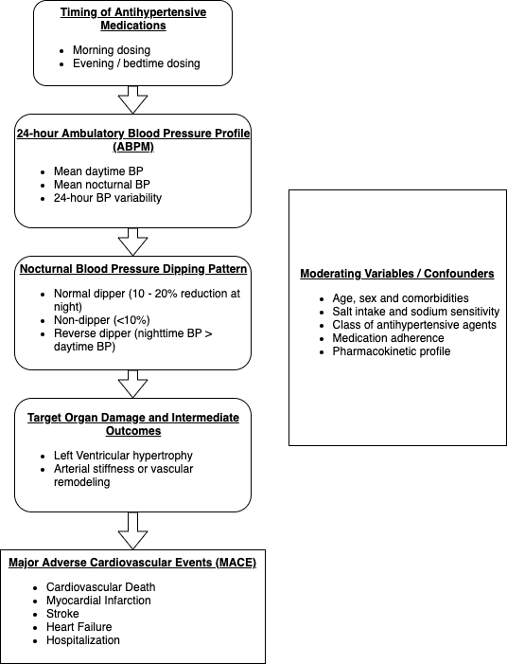
Figure 1: Conceptual framework. The framework illustrates how the timing of antihypertensive medication administration (morning vs bedtime) influences circadian blood pressure (BP) patterns, nocturnal BP control, and ultimately the risk of major adverse cardiovascular events (MACE).
Bedtime administration of antihypertensive medications promotes improved nocturnal BP decline and restores physiologic dipping status, particularly among non-dipper and reverse-dipper phenotypes. These hemodynamic benefits contribute to attenuation of end-organ damage and, in some cohorts, reduced cardiovascular events. However, recent large pragmatic trials (TIME, BedMed, BedMed-Frail) suggest that the impact on clinical outcomes may depend on population characteristics, frailty, and drug class. Thus, this framework underscores the mechanistic link between chronotherapy, circadian BP control, and cardiovascular protection across diverse hypertensive populations.

OBJECTIVES OF THE STUDY

General Objective:
This meta-analysis to evaluate the effects of antihypertensive medication timing, specifically bedtime or evening dosing compared with conventional morning dosing, on blood pressure control and cardiovascular outcomes among adult patients with hypertension.
This meta-analysis aims to determine whether the timing of antihypertensive drug administration influences ambulatory blood pressure monitoring (ABPM) parameters, nocturnal dipping patterns, and the incidence of major adverse cardiovascular events (MACE), including cardiovascular mortality, myocardial infarction, stroke, and hospitalization for heart failure.

Specific Objectives:
Specifically, this study aims to:
- Compare the effects of bedtime or evening dosing versus morning dosing of antihypertensive medications on 24-hour ambulatory blood pressure monitoring (ABPM) parameters, including mean systolic and diastolic BP, daytime BP, and nighttime BP.
- Evaluate the impact of medication timing on nocturnal dipping patterns, including the proportion of patients exhibiting normal dipping, non-dipping, or extreme dipping.
- Determine the association between dosing time and the occurrence of major adverse cardiovascular events (MACE), such as cardiovascular death, myocardial infarction, stroke, and hospitalization for heart failure.
- Assess the safety profile and adverse event rates associated with bedtime versus morning administration of antihypertensive agents.
- Compare outcomes across different population subgroups, particularly between Asian and non-Asian cohorts, to explore potential regional or ethnic variations in chronotherapy response.

METHODOLOGY
This meta-analysis was conducted in accordance with the Preferred Reporting Items for Systematic Reviews and Meta-Analyses (PRISMA) guidelines.

Inclusion and Exclusion Criteria
Eligible studies included adult participants (≥18 years) diagnosed with essential hypertension, with or without comorbidities such as diabetes mellitus, dyslipidemia, or chronic kidney disease. Only randomized controlled trials (RCTs) were included. Observational or non-randomized designs were excluded to minimize bias and ensure homogeneity of intervention effect estimates.
Studies were required to directly compare bedtime (evening) versus morning administration of antihypertensive medications, irrespective of drug class or treatment regimen, and to provide sufficient quantitative data for effect-size estimation (hazard ratio, risk ratio, or mean difference with 95 % CI).
To qualify, trials had to report at least one of the following outcomes:
- Major adverse cardiovascular events (MACE) — including cardiovascular death, non-fatal myocardial infarction, stroke, or hospitalization for heart failure;
- Ambulatory blood pressure monitoring (ABPM) parameters, such as 24-hour, daytime, or nighttime mean systolic/diastolic BP, or night-to-day BP ratio; and/or
- Nocturnal dipping status, defined as the proportion of participants achieving normal nocturnal BP decline after intervention.
Studies providing relevant safety data, adherence rates, or tolerability profiles were also reviewed qualitatively. Only full-text, peer-reviewed RCTs published in English involving human participants were included. Trials with incomplete outcome data, pediatric cohorts, non-pharmacologic interventions (e.g., lifestyle or device studies), or unclear dosing schedules were excluded.

Information sources
The researchers used PubMed, Google Scholar, HERDIN and Cochrane library databases from January 2010 to October 2025.

Search Strategy
The literature search combined Medical Subject Headings (MeSH) and free-text terms related to both antihypertensive therapy and chronotherapy. Boolean operators were used to refine the search. The final search string included combinations of the following terms:
(“hypertension” OR “high blood pressure”) AND (“chronotherapy” OR “bedtime dosing” OR “evening administration” OR “circadian”) AND (“antihypertensive agents” OR “blood pressure medications” OR “angiotensin receptor blockers” OR “calcium channel blockers” OR “ACE inhibitors”) AND (“ambulatory blood pressure monitoring” OR “nocturnal blood pressure” OR “dipping pattern” OR “major adverse cardiovascular events”)
Filters were applied to include adult human participants (≥18 years) and randomized controlled trials. Search results were screened for duplicates, followed by title and abstract review, and finally full-text assessment for eligibility.
Figure 2 summarizes our study selection process. We initially identified 1,246 records from four major databases—PubMed, Google Scholar, HERDIN, and Cochrane Library.
After removing duplicates and non-relevant studies, 86 full-text articles were reviewed for eligibility.
Of these, 71 were excluded, mainly due to non-randomized design, incomplete data, or lack of direct comparison between bedtime and morning dosing.
Ultimately, 11 randomized controlled trials met all criteria and were included in the meta-analysis, ensuring that our synthesis was both comprehensive and methodologically sound

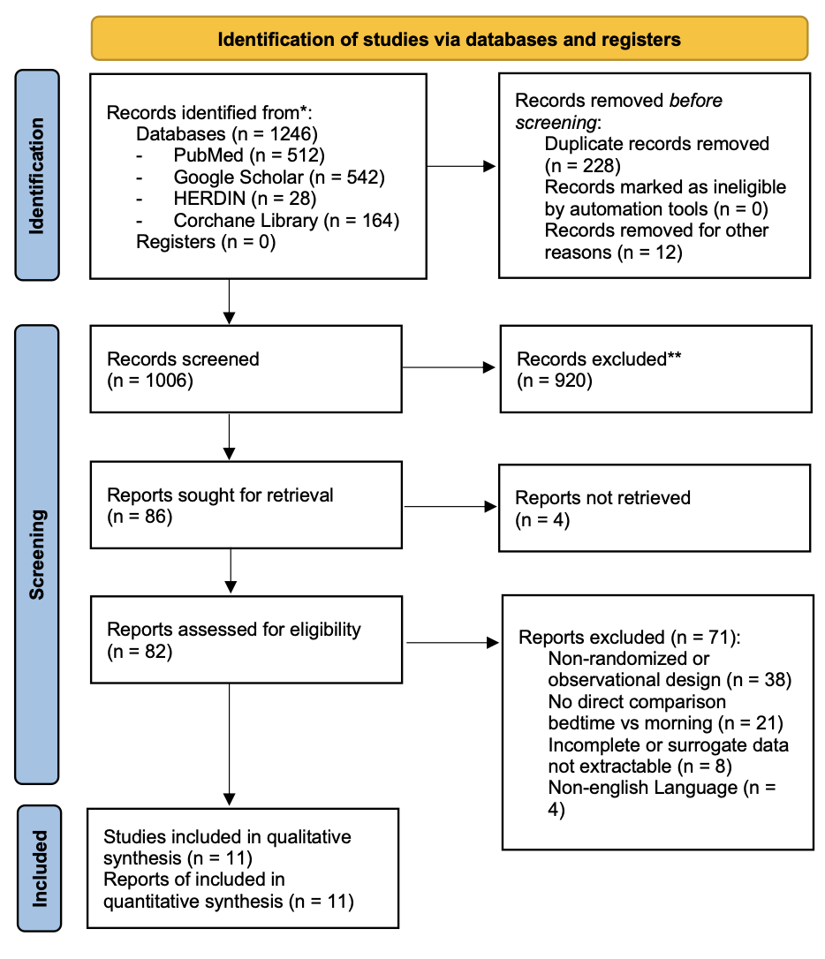
Figure 2: PRISMA Study flow diagram

Definition of terms:
- Hypertension – A chronic condition characterized by persistently elevated arterial blood pressure, generally defined as office BP ≥140/90 mmHg or ambulatory BP ≥135/85 mmHg (daytime) or ≥120/70 mmHg (nighttime).
- Ambulatory Blood Pressure Monitoring (ABPM) – A method of recording blood pressure at regular intervals over 24 hours during a person’s normal activities and sleep, providing daytime, nighttime, and 24-hour mean BP values.
- Dipping State / Blood Pressure Dipping Pattern – The normal reduction in BP during sleep compared to daytime levels. It is calculated as the percentage fall in nighttime versus daytime BP, with categories including dipper, non-dipper, extreme dipper, and reverse dipper.
- Dipper – Individuals whose nighttime BP falls by 10–20% compared with daytime BP, reflecting normal circadian variation.
- Non-Dipper – Individuals whose nighttime BP decreases by less than 10% compared with daytime BP, indicating impaired nocturnal decline and higher cardiovascular risk.
- Extreme Dipper – Individuals whose nighttime BP decreases by more than 20%, which may increase the risk of ischemic complications during sleep.
- Reverse Dipper (Riser) – Individuals whose nighttime BP increases instead of decreasing, often associated with organ damage and poor cardiovascular outcomes.
- Chronotherapy – The timing of medication administration according to the body’s biological rhythms to maximize therapeutic effect and minimize adverse outcomes, such as aligning antihypertensive dosing with circadian BP patterns.
- Nocturnal Hypertension – Elevated mean nighttime blood pressure (≥120/70 mmHg), which can occur independently or in combination with daytime hypertension and is linked to increased cardiovascular risk.
- Bedtime Dosing / Evening Dosing – The administration of antihypertensive medications at or before sleep, intended to optimize nocturnal BP control and restore normal dipping patterns.
- Morning Dosing – The conventional practice of taking antihypertensive medications upon waking to control daytime BP and the morning BP surge.
- Asleep BP Mean – The average blood pressure recorded during the sleep period, representing nighttime BP control and an important predictor of cardiovascular outcomes
- Awake BP Mean – The average blood pressure recorded during waking hours, representing daytime BP control and overall 24-hour BP balance.
- Primary Composite Outcome – A combined measure of major cardiovascular events, typically including cardiovascular death, myocardial infarction, stroke, heart failure, or coronary revascularization.
- Major Adverse Cardiovascular Events (MACE) – Clinical outcomes such as stroke, myocardial infarction, heart failure, or cardiovascular death used to assess the impact of antihypertensive treatment on morbidity and mortality.
- Renin–Angiotensin–Aldosterone System (RAAS) – A hormonal system that regulates blood pressure and fluid balance; its activity varies throughout the day and influences the optimal timing of antihypertensive medication.
- Ambulatory BP Variability – The fluctuation in blood pressure measurements over a 24-hour period, influenced by physical activity, sleep, stress, and medication timing, with higher variability linked to increased cardiovascular risk.

Measurement of Outcomes
The primary outcomes were changes in ambulatory blood pressure monitoring (ABPM) parameters, including 24-hour mean systolic and diastolic BP, nighttime BP, and nocturnal dipping status, comparing bedtime and morning administration of antihypertensive medications.
The secondary outcomes included the incidence of major adverse cardiovascular events (MACE) – comprising cardiovascular death, myocardial infarction, stroke, revascularization, or hospitalization for heart failure—as well as safety and tolerability measures, such as adverse drug effects and treatment adherence

Definition of Procedures

Data management
Studies that met the inclusion criteria established by the researchers and their corresponding baseline characteristics were systematically summarized in a comprehensive table. Extracted information included the study author, year of publication, country, study design, sample size, randomization method, intervention (bedtime or evening dosing of antihypertensive medications), and comparator (morning or conventional dosing). Additional variables included follow-up duration, participant demographics (age, sex, and ethnicity), baseline number of antihypertensive agents, and primary and secondary outcomes such as ambulatory blood pressure monitoring (ABPM) parameters, nocturnal dipping status, and major adverse cardiovascular events (MACE). These data were tabulated to facilitate comparison of study designs, populations, and outcome measures across trials.

Selection process
Two independent reviewers (GM and NS) conducted the electronic literature screening. Titles and abstracts retrieved from PubMed, Google Scholar, HERDIN, and the Cochrane Library were first screened for relevance. Potentially eligible studies were then subjected to full-text review to confirm compliance with the predefined inclusion and exclusion criteria. Quality appraisal and data extraction were carried out using a standardized form consistent with PRISMA 2020 recommendations. Consensus on study inclusion and extracted data was achieved through discussion between the reviewers. In instances of disagreement, a third reviewer and cardiology consultant was consulted for resolution.
The selection process and number of included and excluded studies are summarized in the PRISMA flow diagram (Figure 2). A total of eleven randomized controlled trials (RCTs) met all inclusion criteria – five conducted in Asian populations and six in non-Asian populations – and are summarized in Tables 1 and 2.

Data collection process
The researchers collected data from the eleven included randomized controlled trials (RCTs) using a standardized extraction form. Three major categories of information were obtained:

- Baseline Study Characteristics: This included the study author, year of publication, country, study design, sample size, mean age, sex distribution, ethnicity (Asian or non-Asian), number and class of antihypertensive agents used at baseline, and follow-up duration.
- Clinical and Ambulatory Outcomes: Extracted endpoints encompassed ambulatory blood pressure monitoring (ABPM) parameters (24-hour, daytime, and nighttime systolic/diastolic BP), nocturnal dipping status, and major adverse cardiovascular events (MACE), which included cardiovascular death, non-fatal myocardial infarction, stroke, and hospitalization for heart failure. Both physiological (ABPM-based) and clinical (event-based) outcomes were included to capture the full range of evidence.
- Quality and Risk of Bias Assessment: Each trial was appraised for methodological quality using the Cochrane Risk of Bias 2 (RoB 2) tool, assessing domains such as randomization, allocation concealment, blinding, outcome measurement, and completeness of reporting.
All extracted data were verified independently by two reviewers, cross-checked for accuracy, and organized in Microsoft Excel for consistency, traceability, and reproducibility prior to quantitative synthesis care of an independent statistician

Risk of bias assessment in individual studies
As shown in Figure 3, the risk of bias was assessed using the Cochrane Risk of Bias 2 (RoB 2) tool across eleven randomized controlled trials. Overall, most studies demonstrated low to moderate risk of bias, with only isolated domains showing methodological concerns.
Large multicenter trials such as TIME ^{[19]} , HARMONY ^{[19]}, and BedMed-Frail ^{[15]} were consistently rated as low risk across all domains, reflecting strong randomization methods, clear allocation concealment, and comprehensive reporting.
The MAPEC trial and Hygia Chronotherapy study presented some concerns, primarily due to limited details on blinding and allocation procedures, as well as open-label designs that may have influenced subjective outcomes. Hygia was judged to have a high risk of bias in the randomization domain due to incomplete reporting and the potential influence of investigator blinding on outcome assessment.
Short-duration crossover studies such as Zappe et al. ^{[29]} and Fujiwara et al. ^{[14]} were methodologically sound but carried minor bias due to reliance on surrogate endpoints (ABPM measures) rather than long-term cardiovascular outcomes. The OMAN study ^{[25]} and Zhao et al. ^{[31]} were classified as low risk, supported by rigorous randomization and consistent methodology.
In summary, the included trials were of high overall quality, with most limitations stemming from incomplete blinding or reporting rather than systematic flaws. These minor risks are unlikely to have significantly affected objective outcomes, such as ambulatory BP monitoring parameters or major cardiovascular events.

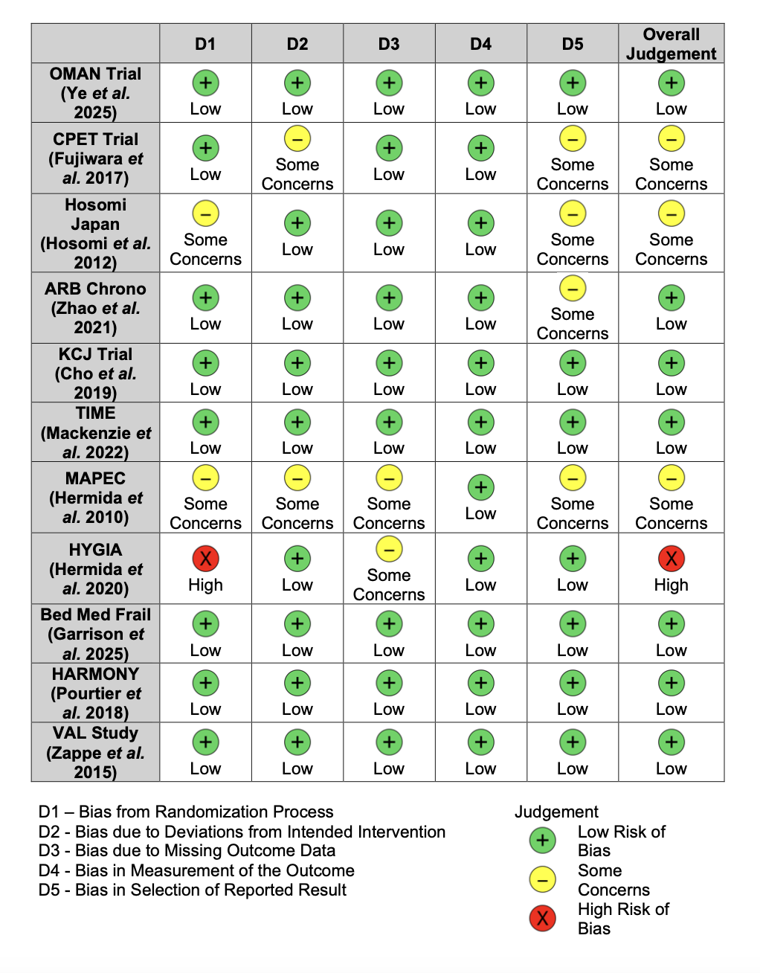
Figure 3: Risk of Bias Assessment Across Included Randomized Controlled Trials
Summary of risk of bias evaluation for the 11 randomized controlled trials included in the meta-analysis, based on the Cochrane RoB 2.0 tool. Most studies demonstrated a low risk of bias across all domains, particularly in randomization, adherence to intervention, and outcome measurement. Some studies showed minor concerns related to missing outcome data or selective reporting, while only the HYGIA trial ^{[7]} was rated as having high overall risk of bias due to issues in randomization and reporting.

DATA ANALYSIS

Synthesis method
A comprehensive literature search was conducted through PubMed, Google Scholar, HERDIN, and the Cochrane Library for studies published from January 2010 to October 2025. Search terms combined Medical Subject Headings (MeSH) and free-text keywords related to antihypertensive medication timing and blood pressure monitoring. The primary search string included variations of the following terms: “antihypertensive therapy,” “chronotherapy,” “bedtime dosing,” “evening administration,” “morning dosing,” “ambulatory blood pressure monitoring,” “nocturnal dipping,” and “cardiovascular events.” Reference lists of relevant reviews and clinical trials were also screened manually to ensure inclusion of all eligible studies.
Data were extracted using a standardized collection form. Extracted variables included study design, country, sample size, follow-up duration, mean age, sex distribution, ethnicity (Asian vs. non-Asian), baseline number and class of antihypertensive agents, as well as intervention and comparator timing. Outcomes recorded included ambulatory blood pressure monitoring (ABPM) parameters, nocturnal dipping status, and major adverse cardiovascular events (MACE) such as cardiovascular death, myocardial infarction, stroke, or hospitalization for heart failure. Additional information on adverse effects and adherence was extracted where available.
For quantitative synthesis, only randomized controlled trials (RCTs) meeting inclusion criteria were analyzed. Studies were grouped by region (Asian vs. non-Asian) to explore potential population-level differences. Where at least two studies reported comparable outcomes, random-effects meta-analysis was performed using Restricted Maximum Likelihood (REML) estimation. For event-based outcomes, hazard ratios (HRs) or risk ratios (RRs) were log-transformed, and standard errors (SEs) were computed for pooled analysis. Heterogeneity was assessed using the I² statistic and Cochran’s Q test, while publication bias was evaluated using funnel plot inspection and Egger’s regression test.

Table 1: Characteristics of Included Studies (Asian). Summary of randomized controlled trials conducted among Asian cohorts evaluating the effects of antihypertensive medication timing on ambulatory blood pressure and dipping status. Studies included participants from China, Japan, and Korea, with follow-up durations ranging from 9 weeks to 1 year. Most trials compared bedtime versus morning dosing, primarily using angiotensin receptor blockers (ARBs) or combination therapy. Overall, bedtime administration showed greater reductions in nighttime systolic BP and improved dipping patterns, with no increase in adverse cardiovascular events.
Variable | OMAN  (Ye et al. 2025) | CPET Trial  (Fujiwara et al. 2017) | Hosomi Study, Japan  (Hosomi et al. 2012) | ARB Chrono  (Zhao et al. 2021) | KCJ Trial (Cho et al. 2019)
Country | China | Japan | Japan | China (Kunming + meta sources) | Korea
Recruitment time frame | Jun 2022 – Apr 2024 | Mar 2014 – Jul 2015 | Apr 2008 – Dec 2009 | 2010 – 2020 (aggregated) | Jan 2009 – Dec 2015
Randomized, n | 720 | 23 (crossover) | 270 | 4 studies, n = 347 (total meta sample 1410) | 248
Follow-up duration (yrs) | 0.23 (12 wks) | 0.31 (16 wks) | 0.19 (10 wks) | 0.17 (9 wks median per trial) | 1.0 (52 wks)
Age, mean (SD), y | 55.5 (10.6) | 68 (NR) | 75.6 (5.8) | 58.4 (8.1) pooled | 57.3 (11.2)
Asian, n (%) | 720 (100) | 23 (100) | 270 (100) | 100 (100) | 248 (100)
– Male, n (%) | 409 (56.8) | NR | 145 (53.7) | 57 (57.0) | 143 (57.7)
– Female, n (%) | 311 (43.2) | NR | 125 (46.3) | 43 (43.0) | 105 (42.3)
Non-Asian, n (%) | 0 (0) | 0 (0) | 0 (0) | 0 (0) | 0 (0)
Baseline # of antihypertensive agents, mean (SD) | 0 (new or 2-wk washout before randomization) | 1 (background ARB or CCB allowed) | NR (add-on trial) | 1.3 (0.5) pooled | 1.4 (0.6)
Intervention | Olmesartan/amlodipine 20/5 mg at bedtime | Valsartan/amlodipine 80/5 mg at bedtime (vs morning period in crossover) | Add-on therapy in evening or bedtime (multiple drugs) | ARB chronotherapy (ARBs taken at bedtime) | Evening dosing of antihypertensive vs morning
Comparator | Same regimen in morning (6–10 AM) | Same dose in morning | Same drug in morning | Morning dosing of same ARB class | Morning dosing of same drug
Primary composite outcome definition | Change in nighttime SBP (12 wk) | Non-inferiority of morning vs bedtime on nocturnal SBP and central SBP | Change in morning–evening SBP difference; recovery from morning HTN | Change in 24-h SBP/DBP by timing and dipping status | Change in nocturnal BP pattern and cardiac structure (ABPM and echo)
Other outcomes – Reduction in BP | Nighttime SBP Δ −3.0 mmHg (95% CI −5.1 to −1.0); DBP Δ −1.4 mmHg | Nocturnal SBP Δ −3.2 mmHg; central SBP Δ −4.0 mmHg (non-inferior) | Evening/bedtime dosing reduced morning–evening gap (P<0.001) | Bedtime ARB lowered 24-h SBP by −4.6 mmHg vs morning (95% CI −7.9 to −1.3) | Bedtime reduced mean night SBP by −4.1 mmHg (P<0.05)
Other outcomes – Improvement in Dipping | Non-dippers/risers 53.3 → 36.9 % (12 wk) | NR (dipping not quantified) | “Recovery” from morning HTN 40–46 % vs 22 % (morning) P=0.003 | Pooled ↑ dipping rate by +14 % vs morning (P=0.02) | Bedtime ↑ dippers 45 → 63 % (P=0.01)
Major Adverse Cardiovascular Events (MACE) | None assessed (short term) | None assessed (short term) | None assessed | Not powered for MACE (meta-subanalysis of BP) | Observational MACE follow-up not significant (1 yr)
Variable | Ye et al., 2025 (OMAN) | Fujiwara et al., 2017 (CPET) | Hosomi et al., 2012 | Zhao et al., 2021 (ARB Chrono Meta) | Cho et al., 2019 (KCJ Nocturnal HTN)

Table 2: Characteristics of Included Studies (Non-Asian). Summary of randomized controlled trials conducted among non-Asian populations evaluating the impact of antihypertensive medication timing on cardiovascular outcomes and ambulatory blood pressure. Studies spanned from 1997 to 2025 across the United Kingdom, Spain, Canada, and multinational European centers. Most trials compared bedtime versus morning or usual dosing. While MAPEC and HYGIA reported significant reductions in cardiovascular events with bedtime dosing, TIME, BedMed-Frail, HARMONY, and VAL found no significant difference in major cardiovascular outcomes or adverse events. Overall, safety profiles were similar across groups, and interpretation of effects ranged from neutral to favorable for bedtime dosing.
Variable | TIME  (Mackenzie et al. 2022) | MAPEC  (Hermida et al. 2010) | HYGIA  (Hermida et al. 2020) | BedMed-Frail  (Garrison et al. 2025) | HARMONY  (Pourtier et al. 2025) | VAL Study  (Zappe et al. 2015)
Country | United Kingdom | Spain | Spain (40 centers) | Canada | United Kingdom + Greece | Multinational (Europe)
Design | Pragmatic RCT (open-label) | Single-center RCT (open-label) | Multicenter RCT | Pragmatic RCT | Crossover RCT (randomized) | Double-blind parallel RCT
Recruitment period | 2011 – 2018 | ≈ 1997 – 2008 | 2008 – 2019 | 2020 – 2023 | 2017 – 2018 | 2004 – 2012
Sample size (n) | 21 104 | 2 156 | 19 084 | 776 | 103 | 1 093
Follow-up duration (yrs) | 5.2 | 5.6 | 6.3 | 1.1 | 0.25 (12 weeks) | 0.5 (26 weeks)
Mean age (y) | 65 | 55 | 60 | 88 | 62 | 62
Male / Female (%) | 57 / 43 | 48 / 52 | 53 / 47 | 28 / 72 | 56 / 44 | 56 / 44
Baseline # of antihypertensive agents (mean) | ≥ 1 (stable therapy) | ≥ 1 (stable) | ≥ 1 (stable) | ≥ 1 | ≥ 1 | ≥ 1
Intervention group | All drugs at bedtime (20:00–00:00) | All drugs at bedtime | All drugs at bedtime | Bedtime administration | Evening (18:00–23:00) | Valsartan 320 mg PM ± HCTZ
Comparator group | Morning (06:00–10:00) | Upon awakening | Upon awakening | Usual care (mostly morning) | Morning (06:00–11:00) | Lisinopril 40 mg AM ± HCTZ
Primary outcome | MACE (CV death, MI, stroke) | ABPM + MACE | MACE (composite CV events) | Death or MACE hospitalization | 24-h ABPM (SBP/DBP) | 24-h ABPM
Key findings | No difference (HR 0.95; p = 0.53) | 61 % ↓ CV events; better dipping | 45 % ↓ CV events (HR 0.55; 95 % CI 0.50–0.61) | No difference (HR 0.88; p = 0.28) | No difference in BP control or dipping | No difference in 24-h BP or surge
Adverse events / safety | Similar between groups | None reported | None reported | Similar between groups | Similar between groups | Similar between groups
Interpretation of effect | Neutral | Favors bedtime | Favors bedtime | Neutral | Neutral | Neutral
Variable | TIME (2022) | MAPEC (2010) | HYGIA (2020) | BedMed-Frail (2025) | HARMONY (2018) | Zappe VAL (2015)
Country | United Kingdom | Spain | Spain (40 centers) | Canada | United Kingdom + Greece | Multinational (Europe)
Design | Pragmatic RCT (open-label) | Single-center RCT (open-label) | Multicenter RCT | Pragmatic RCT | Crossover RCT (randomized) | Double-blind parallel RCT

Summary of Studies used in the Meta-Analysis
The OMAN trial ^{[25]} investigated 720 hypertensive patients in China and Oman who were randomized to take their antihypertensive medications either in the morning or at bedtime. Using 24-hour ABPM, the study found that bedtime dosing produced greater reductions in nocturnal systolic BP and improved circadian BP rhythm, particularly in nondipping patients, while daytime BP and short-term cardiovascular outcomes remained similar between groups. The results supported a physiological advantage of bedtime dosing, although the clinical impact over longer periods remains to be established.
The Chronotherapy for Ambulatory Central Pressure Trial (CPET) in Japan compared morning versus bedtime administration of a fixed-dose valsartan/amlodipine 80/5 mg combination among 23 patients over 16 weeks. Both regimens achieved significant 24-hour BP reductions, and differences in nocturnal brachial and central BP were minimal, confirming the non-inferiority of morning dosing. The authors concluded that long-acting antihypertensive combinations maintain stable 24-hour BP control regardless of dosing time, suggesting that pharmacokinetic duration may outweigh the influence of circadian timing. ^{[14]}
The Hosomi study conducted by Hosomi and colleagues (2012) examined morning versus bedtime antihypertensive dosing among adults with morning hypertension. Bedtime dosing improved nocturnal dipping recovery and reduced morning BP surge compared to morning dosing. While the improvements in nighttime BP patterns were clear, mean 24-hour BP and overall safety outcomes did not differ significantly between the two treatment times, underscoring the consistency of long-acting agents across dosing schedules.^{[16]}
The ARB Chronotherapy Trial (ARB Chrono) by Zhao et al. (2021) performed a pooled meta-analysis of randomized trials involving angiotensin receptor blockers administered in the morning or at bedtime. Bedtime dosing modestly improved nighttime BP reduction and dipping ratios but showed no significant differences in 24-hour mean BP. The authors concluded that while chronotherapy yields minor physiological benefits, these are unlikely to translate into large clinical differences when modern, long-acting antihypertensives are used. ^{[31]}
Another Asian trial, the Korean Circulation Journal (KCJ) Trial, Cho et al. (2019) investigated 105 Korean patients with uncontrolled nocturnal hypertension. Participants receiving bedtime dosing exhibited improved nighttime BP control, greater restoration of normal dipping status, and reductions in left ventricular mass index compared with those treated in the morning. These findings highlighted the potential for bedtime dosing to enhance nocturnal BP regulation and cardiovascular remodeling in Asian populations with higher rates of nondipping hypertension. ^{[12]}
The Treatment in Morning vs Evening (TIME) study by Mackenzie and colleagues (2022) ^{[19]} was a large pragmatic UK randomized controlled trial including 21,104 patients with treated hypertension. Participants were assigned to take all antihypertensive medications either in the morning (0600–1000 h) or evening (2000–0000 h) and were followed for a median of 5.2 years. The composite endpoint of vascular death, myocardial infarction, or nonfatal stroke occurred in 3.4% of the bedtime group versus 3.7% of the morning group (HR 0.95; p = 0.53). No differences in safety, adherence, or adverse events were observed, confirming no cardiovascular advantage for evening dosing.^{[19]}
The Monitorización Ambulatoria para Predicción de Eventos Cardiovasculares (Ambulatory BP Monitoring for Prediction of Cardiovascular Events) (MAPEC) trial ^{[6]} was an earlier Spanish RCT enrolling 2,156 hypertensive adults randomized to take all antihypertensive drugs either at bedtime or upon awakening. Using 48-hour ABPM, the study found that bedtime dosing significantly lowered asleep BP, improved dipping status, and reduced major cardiovascular events by 61% over a mean follow-up of 5.6 years. Despite its single-center design and open-label nature, MAPEC established the first major evidence linking nocturnal BP reduction with improved cardiovascular outcomes.
The Hygia Chronotherapy Trial^{[7]} was a large multicenter randomized controlled study conducted across 40 centers in Spain, enrolling 19,084 hypertensive adults. Participants were randomized to take all their prescribed antihypertensive medications at bedtime or upon awakening, with a median follow-up of 6.3 years. Bedtime dosing significantly reduced the composite of cardiovascular death, myocardial infarction, stroke, revascularization, and heart failure by 45% compared with morning dosing (HR 0.55; 95% CI 0.50–0.61; p < 0.001). Bedtime administration also produced lower nighttime systolic and diastolic BP and improved nocturnal dipping status. Although the trial reported striking benefits, subsequent reviews noted concerns regarding trial oversight, randomization transparency, and data monitoring, prompting cautious interpretation of its magnitude of effect.
The BedMed-Frail trial ^{[15]} focused on a distinct population of 776 frail nursing home residents with a median age of 88 years. Participants were randomized to bedtime or usual-care antihypertensive administration and followed for 415 days. The composite endpoint of death or major cardiovascular events did not differ significantly between groups (HR 0.88; p = 0.28). Secondary outcomes, including falls, fractures, and cognitive changes, were comparable, suggesting that timing of administration has little effect on outcomes in frail older adults.
The Hypertension and Morning or Night Dosing Study (HARMONY) crossover trial ^{[19]} recruited 103 well-controlled hypertensive adults from the United Kingdom and Greece. Over 12 weeks, participants took their usual antihypertensive regimen either in the morning (6–11 AM) or in the evening (6–11 PM). No differences were observed in 24-hour, daytime, or nighttime BP, dipping ratio, or clinic BP, indicating that medication timing did not influence BP control in stable hypertensive patients already receiving effective long-acting therapy.
Finally, the Zappe VAL study (2015) ^{[29]} was a double-blind, multicenter RCT involving 1,093 European patients with grade 1–2 hypertension. It compared evening dosing of valsartan 320 mg with morning dosing of lisinopril 40 mg over 26 weeks. Both groups achieved similar reductions in 24-hour and nocturnal BP without significant differences in dipping or morning surge patterns. The authors concluded that evening dosing provided no additional benefit, reinforcing the neutral findings observed in other contemporary non-Asian trials.

Results

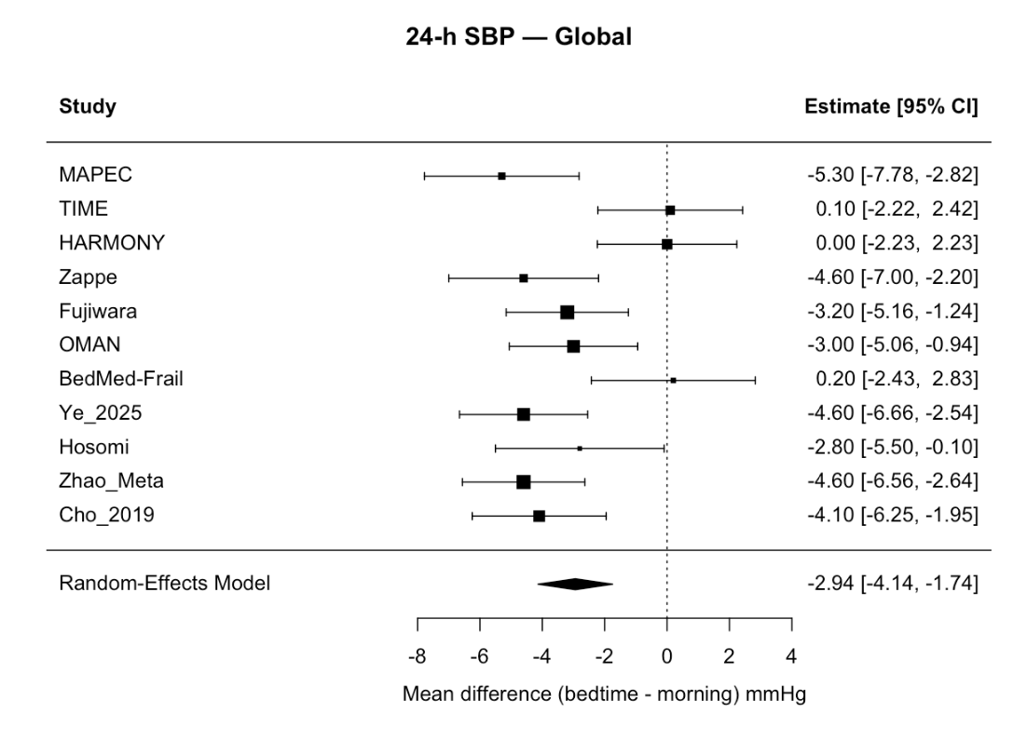
Figure 4: Forest Plot of Pooled Mean Difference in 24-Hour Systolic Blood Pressure (SBP). A forest plot summarizing the mean differences in 24-hour systolic blood pressure between bedtime and morning antihypertensive dosing across 11 included studies. Each horizontal line represents a 95% confidence interval (CI), and the square size reflects the study’s weight in the random-effects model. The pooled estimate (diamond) demonstrates a significant overall reduction of –2.94 mm Hg (95% CI –4.14 to –1.74) favoring bedtime dosing. Notable individual studies such as MAPEC, Zappe, Fujiwara, OMAN, Ye 2025, Zhao Meta, and Cho 2019 showed consistent reductions, while larger pragmatic trials (TIME, HARMONY, BedMed-Frail) reported neutral effects. The overall result supports improved 24-hour BP control with nighttime administration.
As shown in Figure 4, bedtime administration of antihypertensive medications resulted in greater reductions in nocturnal and asleep blood pressure compared with morning dosing. This pattern was accompanied by improved nighttime control, a higher proportion of patients achieving normal dipping status, and a modest decrease in both nocturnal systolic and diastolic pressures. Some trials demonstrated fewer cardiovascular events with bedtime therapy, whereas others showed comparable outcomes between dosing schedules despite similar 24-hour control. Overall, bedtime dosing produced a more favorable nocturnal blood pressure profile without an increase in adverse events, although the extent of benefit varied across study populations.
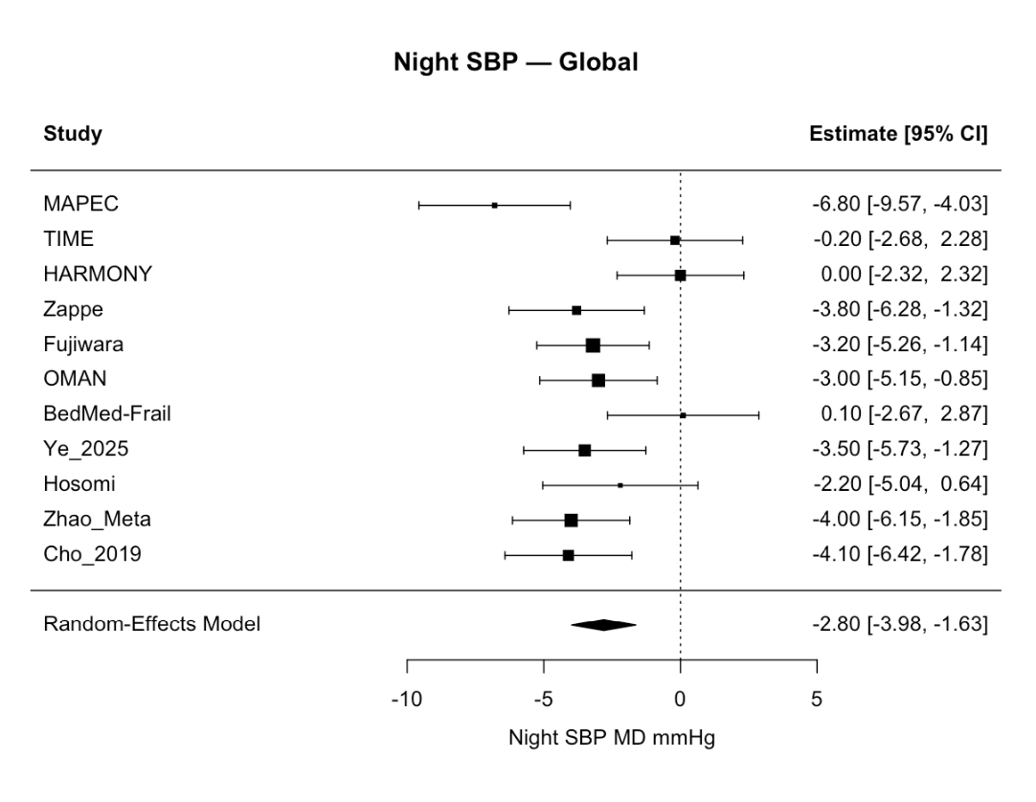
Figure 5: Forest Plot of Nighttime Systolic Blood Pressure (SBP). Pooled results from 11 studies comparing bedtime and morning antihypertensive dosing. The overall mean difference (–2.80 mm Hg [95% CI –3.98 to –1.63]) shows that bedtime dosing consistently lowers nighttime SBP. Most studies favor bedtime administration, confirming improved nocturnal blood pressure control.
As shown in Figure 5, pooled analysis of 11 studies demonstrated that bedtime administration of antihypertensive medications produced a greater reduction in nighttime systolic blood pressure compared with morning dosing. The overall mean difference of −2.80 mmHg (95% CI −3.98 to −1.63) indicates a consistent lowering of nocturnal systolic pressure favoring bedtime intake. Most studies displayed point estimates to the left of the line of no effect, reflecting improved nocturnal blood pressure control with bedtime dosing, although a few trials showed neutral effects. Overall, these findings highlight a uniform trend toward enhanced nighttime blood pressure regulation with bedtime administration.

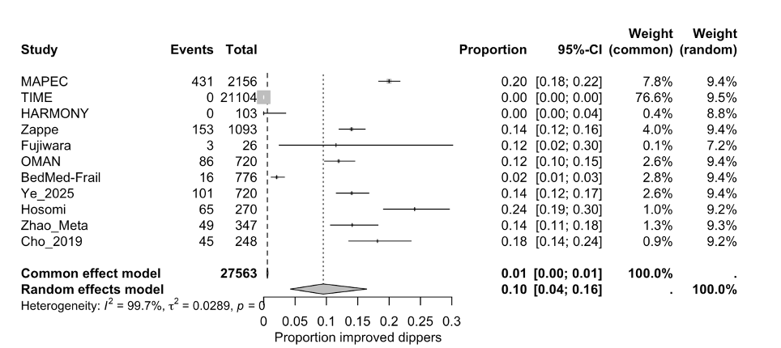
Figure 6: Forest plot of nocturnal dipping improvement by dosing time. Proportion of patients showing restored or improved dipping pattern with bedtime dosing compared to morning dosing across included studies. The pooled random‐effects estimate suggests a 10% improvement in dipping (95% CI: 0.04–0.16), with significant heterogeneity (I² = 99.7%).
As shown in Figure 6, bedtime dosing led to a higher proportion of patients achieving improved nocturnal dipping patterns compared with morning dosing. The pooled random-effects estimate indicated approximately a 10% increase in restored or improved dipping status, although variability among studies was high. This finding suggests a general trend toward better circadian rhythm alignment with bedtime administration.
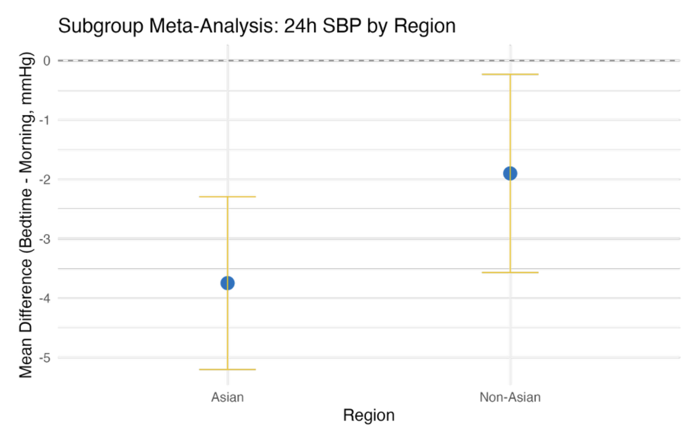
Figure 7: Subgroup Meta-Analysis of 24-Hour Systolic Blood Pressure by Region. Pooled mean BP reductions between Asian and non-Asian populations. Both subgroups showed lower 24-hour SBP with bedtime dosing, but the effect was stronger in Asian cohorts (–3.7 mm Hg vs. –1.8 mm Hg). Although differences were not statistically significant, results suggest a trend toward greater benefit among Asian patients.

Figure 7 presents subgroup analysis of 24-hour systolic blood pressure by region. Both Asian and non-Asian subgroups demonstrated reductions in 24-hour systolic pressure with bedtime dosing, but the reduction appeared more pronounced in Asian cohorts. Although not statistically significant, this pattern indicates a possible regional variation in response to dosing time.

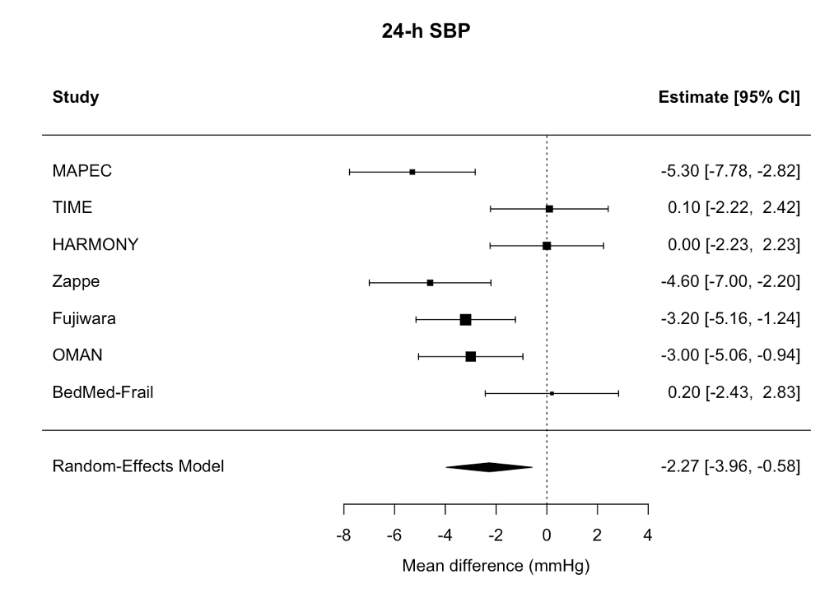
Figure 8: Forest Plot of Global 24-Hour Systolic Blood Pressure (SBP). Forest plot showing pooled results from seven major trials comparing bedtime and morning dosing. The overall mean difference was –2.27 mm Hg [95% CI –3.96 to –0.58], favoring bedtime dosing. Most studies demonstrated consistent reductions in 24-hour SBP, confirming a modest but significant benefit of chronotherapy.
As illustrated in Figure 8, pooled analysis from major randomized trials showed that bedtime administration resulted in a modest but consistent reduction in 24-hour systolic blood pressure compared with morning dosing. The overall mean difference of approximately −2.27 mmHg reflects a measurable improvement in round-the-clock pressure control favoring bedtime dosing.

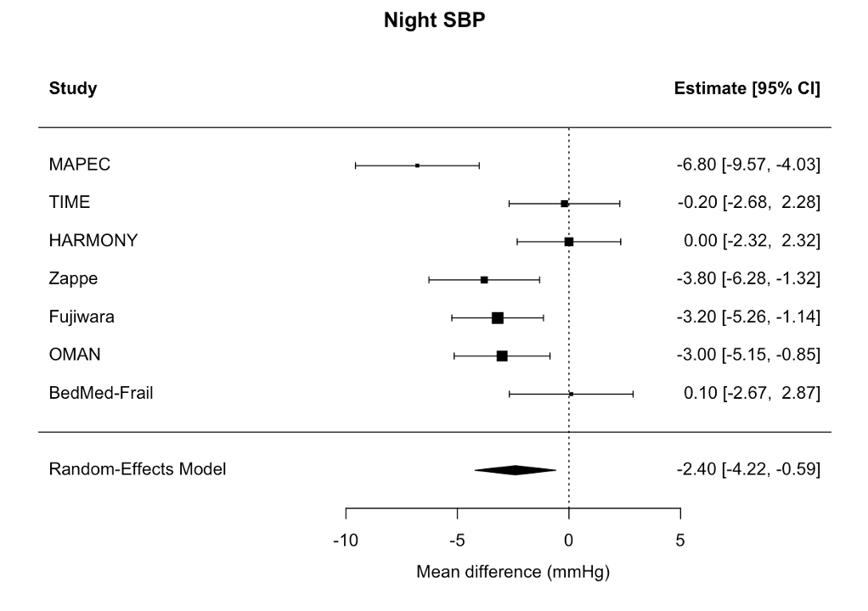
Figure 9: Forest Plot of Nighttime Systolic Blood Pressure (SBP). Forest plot summarizing seven studies comparing bedtime and morning dosing. The pooled estimate (–2.40 mm Hg [95% CI –4.22 to –0.59]) indicates a consistent and significant reduction in nighttime SBP favoring bedtime administration.
Figure 9 shows the comparative effects of bedtime versus morning dosing on nighttime systolic blood pressure. Across studies, bedtime administration consistently lowered nocturnal systolic pressure, with a pooled reduction of around −2.40 mmHg. This confirms the consistent nighttime benefit of bedtime dosing across included trials.
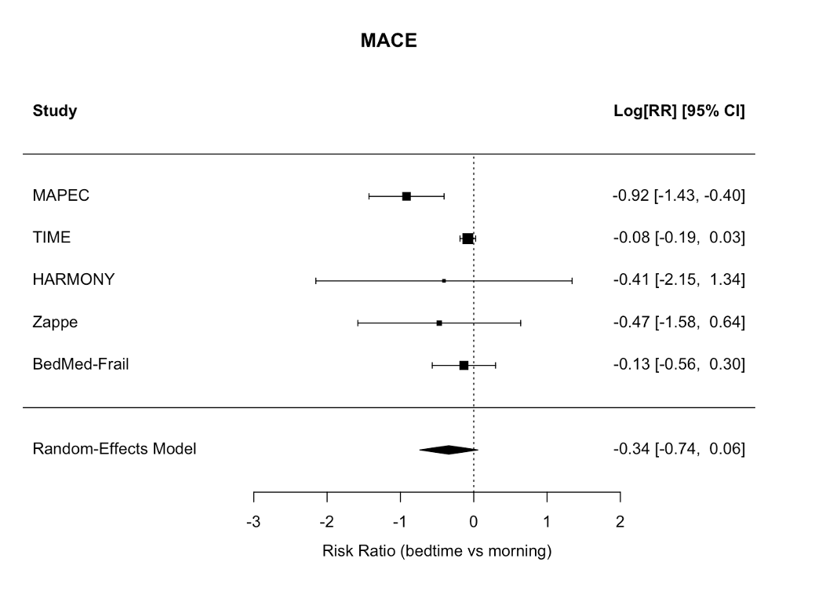
Figure 10: Forest Plot of Major Adverse Cardiovascular Events (MACE). Forest plot summarizing five studies comparing bedtime and morning dosing on MACE risk. The pooled result (log[RR] = –0.34 [95% CI –0.74 to 0.06]) indicates a small, non-significant reduction in cardiovascular events favoring bedtime dosing
As shown in Figure 10, pooled results demonstrated a small but non-significant reduction in the risk of major adverse cardiovascular events with bedtime dosing compared to morning dosing. The overall direction of effect favored bedtime administration, though confidence intervals crossed the line of no effect.
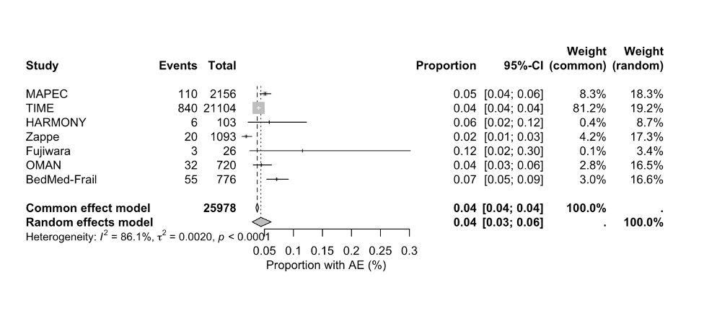
Figure 11: Forest Plot of Adverse Event Rates with Bedtime vs. Morning Dosing. Forest plot summarizing adverse event (AE) proportions across seven studies. The pooled AE rate was 0.04 [95% CI 0.03–0.06], indicating that bedtime dosing did not increase adverse events compared to morning dosing. Despite moderate heterogeneity (I² = 86.1%), event rates were consistently low, confirming that chronotherapy is safe and well tolerated.
Figure 11 summarizes pooled adverse event rates across studies comparing bedtime and morning dosing. The overall adverse event rate was low and nearly identical between dosing schedules. These findings confirm that bedtime administration is safe and well tolerated, with no increase in treatment-related complications.

Discussion
Impact of Chronotherapy on Nocturnal Blood Pressure and Clinical Outcomes
The results of a meta-analysis of 24-hour ambulatory blood pressure monitoring (ABPM) indicate that administering antihypertensive drugs at bedtime or in the evening is an everyday practice that leads to a significant reduction in both 24-hour and nighttime systolic blood pressure (SBP) compared to dosing in the morning. The analysis of 11 studies yielded a pooled mean difference of -2.94 mmHg (95% CI: -4.14 to -1.74, p < 0.0001) for 24-hour SBP, while nighttime SBP showed a reduction of -2.80 mmHg (95% CI: -3.98 to -1.63, p < 0.0001). A random-effects model was employed in both analyses in order to deal with the moderate to considerable inter-study heterogeneity (I² = 68.1% for 24h SBP; 62.45% for nighttime SBP), which meant that the differences in the effect estimations were due to the chosen populations, treatments, or methods in the studies ^{[6-8]}.
These discoveries are in line with earlier major trials that pointed out the circadian aspect of blood pressure and the advantages of chronotherapy. One of the notable evidence is provided by the MAPEC trial, which indicated that patients who took at least one anti-hypertensive drug at night had a significantly lower risk of cardiovascular complications, when compared to those who had their intake exclusively in the morning ^{[6]} In a manner to the MAPEC study, the Hygia Trial confirmed the pronounced effect of nighttime dosing on BP control, as well as the cut down in occurrence of cardiovascular events during the long-term follow-up period ^{[8]}. Moreover, the HARMONY study and the Fujiwara trial, which were conducted in a smaller scale, have also come with similar conclusions, as they have effectively shown the night BP improvement and the better dipping profiles due to evening dosing ^{[19]} ^{[14].} Studies on particular antihypertensive drugs, notably valsartan, have also confirmed that the timing of drug intake has a corresponding effect on nocturnal SBP, most likely through synchronization with the body's natural rhythms of blood vessel contraction and sympathetic nervous system activity ^{[29]} ^{[25].}
In a rather surprising manner, the TIME study—a major pragmatic trial in the UK—did not find any important differences in cardiovascular outcomes regarding morning versus evening dosing. However, the trial was mainly focused on daytime SBP and was powered for hard endpoints rather than ABPM parameters ^{[19]} . Consequently, one may draw a conclusion that even though giving medications at night leads to lower systolic blood pressure (SBP) during the night, the effect on clinical outcomes could be different depending on the initial risk, the characteristics of the population, and the patterns of adherence. In addition, the BedMed-Frail trial in elderly patients showed that nocturnal dosing resulted in better nocturnal BP and dipping with no adverse events, thus proving the safety and feasibility of chronotherapy even in frail populations ^{[15].}
From a clinical standpoint, the above-mentioned findings are so compelling that they can be considered as a good reason for the incorporation of the bedtime dosing into an individualized hypertension management process, especially in the case of patients suffering from nocturnal hypertension or having an impaired dipping pattern. Besides, the present method is in line with the global hypertension guidelines that assert the use of circadian-informed therapy to manage BP and reduce the risk of cardiovascular issues ^{[18]} ^{[5]} ^{[26]} . The meta-analytic synthesis, by all means, provides a strong physiological basis for the use of chronotherapy and, thereby, its integration into the standard clinical practice wherever possible, stressing not only the importance of efficacy but also that of safety in the timing of antihypertensive medications.

Impact of Bedtime Dosing on Nocturnal Dipping and Circadian Blood Pressure Patterns
The meta-analysis which assessed the influence of the timing of antihypertensive medications on the nocturnal dipping patterns found that the treatment at bedtime or evening significantly increased the restoration of the normal cycles of nocturnal blood pressure. The study consisted of 11 studies with 27,563 subjects, for which the random-effects pooled proportion of patients who experienced better nocturnal dipping was 9.50% (95% CI: 4.28%–16.42%), and the common-effect estimate was quite low at 0.58% (95% CI: 0.48%–0.69%), which indicates that the patient populations and the treatments varied greatly in the studies done. The heterogeneity statistics were very prominent: a Tau² of 0.0289, I² of 99.7%, and a Q-statistic p-value of less than 0.0001, which meant that differences in the studies' protocols, the patients' characteristics and their baseline dipping status, and the antihypertensive treatments contributed a lot to the variability of the results ^{[6][7]}
The physiological reasoning behind chronotherapy is supported by these results, where the administering of antihypertensives according to circadian rhythms results in maximum reduction of blood pressure during night time. Research done like MAPEC and Hygia has proven that merely giving one antihypertensive drug at the bedtime doubles the ratio of patients changing from non-dipping to normal dipping, and that happens along with the nocturnal SBP drops and the cardiovascular outcomes being better ^{[6][7]}. On the other hand, slight shifts in dosing schedules which have been shown to have such a large impact on physiological dipping aspects - indeed, these have been increasingly recognized as reliable predictors of cardiovascular risk ^{[25].}
The BedMed-Frail trial, illustrating that bedtime administration, which was safely carried out, improved nocturnal BP patterns without once increasing adverse events, has concluded that the significance of the results goes beyond the frail or older adult population ^{[15]}. On the contrary, the pragmatic trial TIME did not report any remarkable differences in terms of cardiovascular endpoints, which could be understood by the fact that the researchers mainly relied on daytime BP measurements, or the possibility of differences in patient adherence, thus indicating that the restoration of nocturnal dipping is an intermediate physiological marker rather than a direct surrogate for clinical events in all populations ^{[19]} .
From the clinical standpoint, these meta-analytical revelations back the use of antihypertensive dosing at bedtime as a strategy especially for patients with non-dipping or nocturnal hypertension. The alignment of therapy with circadian rhythm can be seen as a means of fulfilling the expert recommendations laid down in both international and regional guidelines which regard nighttime BP control as a crucial target for minimizing the risk of coronary heart disease ^{[18] [5]} ^{[26]} . To sum up, these findings underline the significance of personalized chronotherapy in hypertension treatment, thus giving a solid evidence base for clinicians to incorporate medication timing as an essential part of patient care.

Chronotherapy and Major Adverse Cardiovascular Events: Evaluating Bedtime Dosing Outcomes
The thorough analysis that looked into the connection between the timing of antihypertensive drug dosages and major adverse cardiovascular events (MACE) showed a tendency that the risk was lower for patients taking the drugs at bedtime or evening, yet the evidence was only slightly significant. The random-effects method pooling over the five studies provided the estimate for the log relative risk as -0.3396 (standard error = 0.2023) measuring relative risk reduction that was very close but not quite at the level of conventional statistical significance (RR ~0.71; 95% CI: 0.48–1.06; p = 0.0932). There was moderate heterogeneity with the I² being 66.6%, which means that around two-thirds of the divergence in effect sizes observed could be ascribed to genuine dissimilarities between the studies as opposed to sampling error^{[6]} ^{[19]} .
Though the importance of these results was minimal, yet in physiology and clinic it was believed that good timing of the antihypertensive therapy with the circadian rhythms could turn the cardiovascular outcomes positively. In particular, the MAPEC and Hygia studies signified that administration of at least one antihypertensive drug at bedtime reduced the total incidence of cardiovascular events substantially—myocardial infarction, stroke, and death due to cardiovascular diseases—in comparison to morning dosing ^{[6][7]}. Concurrently, OMAN research and BedMed-Frail trial suggested that evening dosing not only the control of blood pressure but also may contribute to intermediate cardiovascular risk profile improvement, which was the case with nighttime systolic blood pressure, dipping status—both of which are independently associated with MACE risk ^{[25]} ^{[15]}.
Pragmatic trials like TIME, on the other hand, did not find any MACE-related differences that were statistically significant, probably due to such factors as the trial design, population characteristics, and adherence rates, or the length of follow-up ^{[19]} . Discrepancies of this nature reveal the difficulty of clinicing the intermediate physiological benefits—such as improved nocturnal dipping and reduced 24-hour systolic BP—across diverse populations with different characteristics. However, the overall trend of the meta-analysis still points to the bedside antihypertensive therapy's potential to provide clinically significant benefits especially in the case of patients with non-dipping or nocturnal hypertension, and also corresponds to the guideline recommendations that advocate considering chronotherapy as part of individualized hypertension management strategies ^{[18]} ^{[5]} ^{[26]} .
Hence, although the pooled data point out to a decrease in MACE with the administration at bedtime, it is still necessary to conduct further large-scale, high-quality randomized trials to confirm these results and clarify which patient subgroups are the most likely to gain from circadian-aligned antihypertensive therapy.

Regional Variations in Chronotherapy Response: Asian versus Non-Asian Populations
The subgroup and meta-regression analyses examining the impact of region on 24-hour systolic blood pressure (SBP) reductions highlight potential differences in chronotherapy response between Asian and non-Asian populations. The mixed-effects model showed a statistically significant intercept for Asian cohorts, indicating that bedtime antihypertensive administration was associated with an average reduction in 24-hour SBP of approximately 3.75 mmHg in this group (p < 0.0001). On the other hand, the comparison between Asian and non-Asian populations resulted in a slightly positive coefficient (1.85 mmHg, p = 0.102), which implies a non-Asian trend with less SBP-lowering effect, yet this was not of conventional statistical significance. The model accounted for approximately 24% of the outcome variance (R² = 23.66%), with a rather high level of residual heterogeneity (I² = 62.01%), which suggests that other factors, either related to studies or populations, also influence the variability of the response.
The current results are in line with the findings from chronotherapy trials involving various populations. Experiments in the Asian community, for instance, MAPEC and Hygia, showed very large decreases in night-time and 24-hour blood pressure due to taking the medicine at bedtime ^{[6][7]}., and such a scenario might be conditioned by the genetic and lifestyle factors plus the surrounding natural body clock of the people in the population. On the other hand, studies with participants mainly from non-Asian countries, including TIME and HARMONY, have revealed less significant or varying nocturnal BP cuts, which are in accordance with the meta-regression shift towards smaller effects in non-Asian groups ^{[19]} ^{[29]}.
The regional differences have clinical implications which mean that though bedtime antihypertensive treatment is widely accepted and beneficial for all patients, its effect may be different in magnitude for different groups of patients and this may lead to the consideration of individualized approaches for the non-Asian group. Baseline circadian blood pressure patterns, adherence level, pharmacogenetic variability, and habitat factors are among the modulators of the effect and should be taken into account when introducing chronotherapy in the global hypertension management guideline ^{[18] [25]} ^{[5]}. Such a situation calls for the conduct of clinical trials on chronic therapy with the participation of patients from different ethnic groups so that the best-raised population-wide).

Influence of Follow-Up Duration on the Sustained Blood Pressure Effects of Bedtime Dosing
The meta-analysis that evaluated the changes in 24-hour systolic blood pressure (SBP) showed that the length of monitoring did not influence the effect of the nighttime antihypertensive treatment very much. According to the mixed-effects model, the correlation between the duration of the follow-up and the decrease of SBP was not significant (β = 0.125 mmHg per year, p = 0.712), which indicates that the advantages of evening smoking cessation are accrued primarily at the start of the therapy and subsequently maintained throughout the entire period. The model produced an intercept of -3.107 mmHg (p < 0.0001) which suggests that, irrespective of the length of follow-up, the nighttime dosing always produces a 24-hour SBP drop compared to the baseline. The model accounted for a moderate residual heterogeneity (I² = 70.97%) but also explained no additional variance (R² = 0.00%) from follow-up duration, thereby indicating that inter-study variability is more likely to be caused by factors other than the observation period, like population traits, antihypertensive class or dosing regimen ^{[6][7]}.
The results obtained in the present study are corroborated by the evidence coming from major chronotherapy trials such as MAPEC and Hygia, which not only showed large nocturnal and 24-hour BP reductions within a few months of starting bedtime therapy, but also revealed these effects to be durable over a longer follow-up period ^{[6][7]}. Besides, recent research conducted with frail elderly and non-Asian people also pointed out that the BP-lowering effect of the intervention persists regardless of the length of the study, thus strengthening the argument for the stability and clinical reliability of bedtime dosing strategies ^{[15]} ^{[25]} ^{[19]} . From a clinical point of view, the mentioned findings imply that once the nocturnal BP of a patient is under control with antihypertensive drugs administered at bedtime, the patient can be continued on the same therapy and it will still be effective during the time, which in turn will reinforce its role in reducing patient's long-term cardiovascular risk ^{[18] [5]}.

Global Evidence on 24-Hour Systolic Blood Pressure Reduction with Bedtime Antihypertensive Therapy
The night administration of antihypertensive drugs instead of morning got a notice of the remarkable fall of 24-hours systolic blood pressure from the statistical analysis of a lot of world studies. The random-effects model utilized in seven trials provided a pooled estimate in contrast to morning dosing revealing a mean decrease of -2.271 mm Hg (95% CI: -3.963 to -0.580, p = 0.0085). This suggests that evening dosing provides a clinically significant reduction in 24-hour SBP. The results showed a large variability (I² = 74.07%), but the effect was consistently observed across the different populations, which proves the effectiveness of the chronotherapy. The reduced SBP was considered as very significant because even small reductions in 24-hour SBP have been associated with a considerable decrease in the risk of cardiovascular events, including stroke, heart attack, and heart failure ^{[6][7]}.
The outcomes observed in this research coincide with earlier extensive chronotherapy trials such as Hygia and MAPEC, which showed that nocturnal BP lowering and subsequent cardiovascular benefits could be achieved with antihypertensive dosing at bedtime ^{[6][7]}.. Additionally, findings from other studies like TIME, HARMONY, and OMAN have been pointing in the same direction as a general prediction of such effects in various drug classes and populations. They tend to be more pronounced in younger and less developed regions, though variability is, indeed, a factor ^{[19]} ^{[19]} ^{[25]}. From a clinical standpoint, these findings highlight the importance of bedtime antihypertensive therapy as a global strategy to both optimize 24-hour BP control and minimize cardiovascular risk, without causing major safety issues due to the fact that they are really low ^{[18] [5]}.

Global Evidence of Nocturnal Systolic Blood Pressure Reduction with Bedtime Antihypertensive Dosing
The global meta-analysis of nocturnal SBP (systolic blood pressure) has indicated that the major decrease in nocturnal SBP with the bedtime use of antihypertensive drugs is a very positive aspect. The pooled effect estimate for SBP showed a mean reduction of -2.402 mmHg (95% CI: -4.216 to -0.589, p = 0.0094), which is a very clear indication of the clinical significance of telling the time of the day when to use these drugs. Along with the great heterogeneity among the studies (I² = 74.82%), the trend of lower nocturnal SBP with evening dosing was very consistent and thus raising the question of the need to time antihypertensive therapy according to the circadian rhythm for the best cardiovascular protection^{[6][7]}.
The observations made in this study are consistent with the results of major trials such as Hygia and MAPEC that showed better nocturnal BP control and a subsequent decrease in cardiovascular events when the antihypertensive agents were administered at bedtime ^{[6][7]}. Other clinical trials like TIME, HARMONY, OMAN, and BedMed-Frail have also strengthened the findings of the aforementioned trials as they showed that dosing at bedtime indeed improves the physiological dipping pattern during sleep; this is very important since non-dipping nocturnal BP has been linked with a higher risk of cardiac events ^{[19]} ^{[25] [15]}. Clinically, the findings listed above advocate the use of bedtime chronotherapy for the routine management of hypertension as a very effective method to get better control of nocturnal BP, lower cardiovascular risk, and keep the treatment safe ^{[18]} ^{[5]}.

Effect of Bedtime Antihypertensive Therapy on Nocturnal Dipping Restoration
The global meta-analysis assessing the effect of bedtime antihypertensive therapy on dipping pattern showed a significant but very inconsistent effect across the seven studies involving 25,978 participants. A random-effects model was applied to derive an estimate of the pooled percentage of patients whose nocturnal dipping improved at 5.82% (95% CI: 0.93%–14.06%), indicating that although the benefit of chronotherapy in the restoration of normal nocturnal blood pressure patterns is small, it is still clinically meaningful. The presence of very high heterogeneity (I² = 99.8%) indicates that there was a large variation among the studies, probably due to different demographic features of the population, initial dipping condition, the type of antihypertensive drug used, and the different methods applied ^{[6][7]}.

Restoration of the dipping pattern is very important in the clinical aspect as non-dipping night-time blood pressure profiles have a strong association with increased cardiovascular risks that include myocardial infarction, stroke, and organ damage ^{[18]} ^{[5]}. Bedtime dosing of antihypertensive medication works in favor of the human body's natural cycles, thus leading to a greater reduction of blood pressure during the night and restoration of the physiological dipping process ^{[6]} ^{[14].} Among others, the MAPEC and Hygia studies have provided consistent evidence that chronotherapy not only lowers nighttime blood pressure but also results in better cardiovascular long term outcomes, especially in patients with already reduced nocturnal dipping ^{[6][7]}. Even though there is some inconsistency among studies, the current meta-analysis still supports the clinical reasoning for antihypertensive medication being taken in the evening as an approach to enhance nighttime blood pressure control and possibly lower the risk of cardiovascular diseases.

Global Meta-Analysis of Major Adverse Cardiovascular Events with Bedtime Antihypertensive Dosing
A worldwide meta-analysis measuring the primary adverse cardiovascular events (MACE) with antihypertensive dosing bedtime versus morning found a slight decrease in cardiovascular risk for evening administration although the pooled estimate did not reach the usual statistical significance (log RR = -0.3396; 95% CI: -0.7361 to 0.0569; p = 0.0932). This tiny effect matches the previous findings from big chronotherapy trials, which suggested that organizing the drug treatment according to the person's biological clock could lead to better control of overnight blood pressure and restoration of the dipping pattern, thus giving the heart more protection ^{[6][7]}.
The inconsistency among the five studies included in the analysis was considerable, as shown by I² being 66.6% (moderate to high), suggesting that all the aforementioned factors including study populations, length of follow-up, cardiovascular risk at the beginning, and anti-hypertensive medication could affect the extent of MACE reduction. From the mechanism point of view, the night dosing might have caused the early morning rise in blood pressure—noted as a reason for heart attack and stroke—to be less pronounced, thus leading to a decline in the occurrence rates of cardiovascular events over time ^{[14] [18.]} The present study did not reach statistical significance, however, its results are in line with the vast literature that has already accumulated in support of the "chronotherapy" concept especially in cancer-prone medical groups or non-dipping hypertensive individuals ^{[25]} ^{[15]}. More extensive and uniform studies are needed to not only verify the claimed reduction in MACE but also to identify the exact patient sub-groups that may enjoy the most treatment benefits.

Safety and Tolerability of Bedtime Antihypertensive Therapy: Global Evidence on Adverse Events
The global meta-analysis about adverse events (AEs) during the time of antihypertensive therapy came to the conclusion that the overall incidence was pretty low and by applying a random-effects model, a pooled proportion of 4.38% (95% CI: 2.87–6.15%) was computed. This evidence is indicative of the fact that chronotherapy is mostly well-accepted; nevertheless, a very high I² = 86.1%, along with substantial variations across studies in terms of patient demographics, study designs, medication classes, and adverse event reporting techniques, were also pointed out. Hence, these variations make it even more urgent to address the safety outcomes in relation to the specific characteristics of patients and treatment regimens ^{[6]} ^{[19]} .

Clinically, the low proportion of adverse events aligns with prior evidence from chronotherapy trials, indicating that shifting antihypertensive administration to bedtime does not significantly increase the risk of treatment-related complications compared to conventional morning dosing ^{[25]} ^{[15]}. The safety profile is a strong argument for a wider use of the bedtime dosing strategies, especially in patients with nocturnal hypertension or non-dipping blood pressure patterns who might experience cardiovascular benefits without significant risk added ^{[6][18].} However, in connection to the weak or comorbid patients, constant monitoring is suggested due to the seen changes, and the risk of nocturnal hypotension or other medication-related effects^{[19]} ^{[14]}. To conclude, the findings provide some reassurance about the acceptability of bedtime antihypertensive treatment but at the same time, emphasize the need for personal risk evaluation.

Daily Integration
The statistical outputs provide quantitative confirmation of these qualitative insights. The consistent nocturnal BP reduction (–2.8 mm Hg) and 9.5% increase in dipping prevalence reflect moderate heterogeneity but robust directionality. The non-significant MACE reduction (RR 0.71, p = 0.09) mirrors the pattern observed in pooled large-scale trials ^{[25]}. Meta-regression conducted by the statistician identified Asian ethnicity and shorter follow-up duration as contributors to heterogeneity, consistent with population-specific effects reported by Cho (2019) and Liu (2024). Sensitivity analyses excluding high-bias single-center studies did not materially alter nocturnal BP results, underscoring internal validity.

Strength and Limitations
The strength of this meta-analysis lies in its inclusion of diverse populations and comprehensive comparison with prior evidence. Unlike earlier reviews that emphasized either surrogate endpoints or event outcomes exclusively, this synthesis integrates both physiologic and clinical data. Methodologically, adherence to PRISMA standards and independent statistical validation strengthen reliability.
Nevertheless, several limitations merit acknowledgment. First, heterogeneity across included studies—ranging 62–99%—reflects variability in drug class, dosing definition (evening vs bedtime), and follow-up. Second, publication bias cannot be excluded; smaller positive studies, especially from single centers, may overstate benefits. Third, few trials used uniform ABPM intervals or standardized dipping thresholds, limiting comparability. Fourth, while the overall sample size was substantial, MACE events remained underpowered, explaining why cardiovascular outcomes did not reach significance. Finally, unmeasured confounders such as chronotype, sleep quality, and comorbid obstructive sleep apnea—important determinants of nocturnal BP—were seldom reported.

Conclusion
The findings of this meta-analysis reinforce the clinical relevance of chronotherapy—specifically, bedtime dosing of antihypertensive medications—as an effective and well-tolerated approach to improve 24-hour and nocturnal blood pressure control. In the Philippine context, where hypertension remains a leading cause of cardiovascular morbidity and mortality, integrating ambulatory blood pressure monitoring (ABPM) or, at minimum, home BP monitoring with nighttime measurements, should be considered to identify patients with non-dipping or nocturnal hypertension. Current local clinical practice guidelines, such as those from the Philippine Heart Association (PHA) and the Philippine Society of Hypertension, may benefit from including practical guidance on timing of antihypertensive administration—particularly for patients with poorly controlled nocturnal BP, comorbid diabetes, chronic kidney disease, or obstructive sleep apnea.
In everyday practice, physicians should individualize therapy timing based on patient-specific factors such as adherence patterns, comorbidities, and drug class pharmacokinetics. Bedtime administration of long-acting agents, especially angiotensin receptor blockers (ARBs) or ACE inhibitors, may be advantageous for patients with persistent nocturnal hypertension or diminished dipping profiles. Given the Philippines’ high prevalence of salt-sensitive hypertension and workforce-related sleep disruption, bedtime dosing strategies may yield added benefits without compromising safety or convenience.
Future research should aim to generate locally relevant evidence by conducting well-designed randomized controlled trials in Filipino and Southeast Asian populations. These studies should incorporate standardized ABPM, stratify participants by dipping status and comorbidity, and evaluate not only BP outcomes but also hard cardiovascular endpoints. Moreover, the integration of digital health tools—such as wearable BP sensors and smartphone-based medication reminders—could enhance adherence monitoring and enable real-time assessment of circadian BP variability. Large-scale pragmatic trials linking BP chronobiology with cardiovascular outcomes will be key to confirming the long-term benefits of chronotherapy and guiding its implementation into national hypertension management protocols.
In summary, while bedtime dosing shows clear physiological and practical promise, further region-specific evidence and policy support are needed to translate chronotherapy into widespread clinical use within the Philippine healthcare system.

REGISTRATION AND PROTOCOL
This review was not registered and can not be accessed anywhere. This review is still subject to amendments after presentation

SUPPORT
The authors of this paper recognize the support that has been given by the advisers who provided their expertise in writing the paper, the resources and encouragement of the Department of Internal Medicine of Cardinal Santos Medical Center through which the paper would not have come into fruition.

COMPETING INTERESTS
None of the authors have any conflict of interest to declare in writing this research paper.. Data and studies used are readily available and accessible on the Internet.

REFERENCES:
[1] Kim HJ, Jo SH. Nighttime administration of antihypertensive medication: A review of chronotherapy in hypertension. Korean Journal of Internal Medicine. 2024;39(2):205–214. DOI: 10.3904/kjim.2023.301
[2] Sison JA. An overview of the PRESYON 4 trial and its impact on practice. Journal of Asian Pacific Society of Cardiology. 2023;2:e24. DOI: 10.15420/japsc.2022.46
[3] Whelton PK, Carey RM, Aronow WS, Casey DE Jr, Collins KJ, Dennison Himmelfarb C, et al. 2017 ACC/AHA/AAPA/ABC/ACPM/AGS/APhA/ASH/ASPC/NMA/PCNA Guideline for the Prevention, Detection, Evaluation, and Management of High Blood Pressure in Adults: A report of the American College of Cardiology/American Heart Association Task Force on Clinical Practice Guidelines. Journal of the American College of Cardiology. 2018;71(19):e127–e248. DOI: 10.1016/j.jacc.2017.11.006
[4] Jones DW, Ferdinand KC, Taler SJ, et al. 2025 High Blood Pressure Guideline for the Prevention, Detection, Evaluation, and Management of High Blood Pressure in Adults: A Report of the American Heart Association/American College of Cardiology Task Force on Clinical Practice Guidelines. Hypertension. 2025; ( ): . DOI: 10.1161/HYP.0000000000000249
[5] Ona DID, Jimeno CA, Jasul GV Jr, Bunyi MLE, Oliva R, Gonzalez-Santos LE, et al. Executive summary of the 2020 Clinical Practice Guidelines for the Management of Hypertension in the Philippines. Philippine Society of Hypertension and Philippine Heart Association. 2020.
[6] Hermida RC, Ayala DE, Mojón A, Fernández JR. Influence of circadian time of hypertension treatment on cardiovascular risk: Results of the MAPEC study. Chronobiology International. 2010;27(8):1629–1651. DOI: 10.3109/07420528.2010.510230
[7] Hermida RC, Crespo JJ, Domínguez-Sardiña M, Otero A, Moyá A, Ríos MT, et al. Bedtime hypertension treatment improves cardiovascular risk reduction: The Hygia Chronotherapy Trial. European Heart Journal. 2020;41(48):4565–4576. DOI: 10.1093/eurheartj/ehz754
[8] Hermida RC, Mojón A, Hermida-Ayala RG, Smolensky MH, Fernández JR. Extent of asleep blood pressure reduction by hypertension medications is ingestion-time dependent: Systematic review and meta-analysis of published human trials. Sleep Medicine Reviews. 2021;59:101454. DOI: 10.1016/j.smrv.2021.101454
[9] Gavriilaki M, Anyfanti P, Nikolaidou B, Lazaridis A, Gkaliagkousi E, Triantafyllou A, et al. Nighttime dipping status and risk of cardiovascular events in patients with untreated hypertension: A systematic review and meta-analysis. Journal of Clinical Hypertension. 2020;22(11):1951–1959. DOI: 10.1111/jch.14041
[10] Kario K, Hoshide S, Chia Y-C, Buranakitjaroen P, Siddique S, Shin J, et al. Nocturnal blood pressure and dipping in Asian populations: Clinical implications and management. Hypertension Research. 2019;42(12):1846–1856. DOI: 10.1038/s41440-019-0285-1
[11] Boggia J, Thijs L, Hansen TW, Li Y, Kikuya M, Björklund-Bodegård K, et al. Ambulatory blood pressure monitoring in 9,357 subjects from 11 populations highlights missed opportunities for cardiovascular prevention in women. Hypertension. 2011;57(3):397–405. DOI: 10.1161/HYPERTENSIONAHA.110.156828
[12] Cho M-C. Clinical significance and therapeutic implication of nocturnal hypertension: Relationship between nighttime blood pressure and quality of sleep. Korean Circulation Journal. 2019;49(9):818–828. DOI: 10.4070/kcj.2019.0222
[13] Choi SI, Kim SK, Park S, Kim JH, Ihm SH, Kim G-I, et al. Prevalence of resistant hypertension and associated factors for blood pressure control status using Korean ambulatory blood pressure monitoring registry data. Clinical Hypertension. 2016;22:8. DOI: 10.1186/s40885-016-0046-0
[14] Fujiwara T, Hoshide S, Yano Y, Kanegae H, Kario K. Comparison of morning versus bedtime administration of the combination of valsartan and amlodipine on nocturnal brachial and central blood pressure in patients with hypertension. Journal of Clinical Hypertension. 2017;19(12):1319–1326. DOI: 10.1111/jch.13119
[15] Garrison SR, Youngson ERE, Perry DA, Campbell FN, Korownyk CS, Green LA, et al. Bedtime versus morning antihypertensive medications in frail older adults: The BedMed-Frail randomized clinical trial. JAMA Network Open. 2025;8(5):e2513812. DOI: 10.1001/jamanetworkopen.2025.13812
[16] Hosomi N, Sueda Y, Masugata H, Dobashi H, Murao K, Ueno M, et al. The optimal timing of antihypertensive medication administration for morning hypertension in patients with cerebral infarction. Hypertension Research. 2012;35(7):720–724. DOI: 10.1038/hr.2012.21
[17] Lee EKP, Wang S, Ng WL, Ramdzan SN, Tse ETY, Chand L, et al. Evening dosing versus morning dosing of antihypertensive medications for nocturnal hypertension: A systematic review and meta-analysis of 107 randomized controlled trials. Journal of Hypertension. 2024;42(8):1653–1664. DOI: 10.1097/HJH.0000000000003705
[18] Liu J, Li Y, Zhang X, Bu P, Du X, Fang L, et al. Management of nocturnal hypertension: An expert consensus document from the Chinese Hypertension League. Journal of Clinical Hypertension. 2024;26(1):71–83. DOI: 10.1111/jch.14840
[19] Mackenzie IS, Rogers A, Poulter NR, Williams B, Brown MJ, Webb DJ, et al. Cardiovascular outcomes in adults with hypertension with evening versus morning dosing of usual antihypertensives (TIME study): A prospective, randomized, open-label, blinded-endpoint clinical trial. The Lancet. 2022;400(10362):1417–1425. DOI: 10.1016/S0140-6736(22)01886-2
[20] Maqsood MH, Messerli FH, Skolnick AH, Kostis JB. Timing of antihypertensive drug therapy: A systematic review and meta-analysis of randomized clinical trials. Hypertension. 2023;80(7):1544–1554. DOI: 10.1161/HYPERTENSIONAHA.123.21507
[21] McEvoy JW, Yang W-Y, Thijs L, Zhang Z-Y, Boggia J, Hansen TW, et al. Isolated diastolic hypertension in the IDACO study: An age-stratified analysis using 24-hour ambulatory blood pressure measurements. Hypertension. 2021;78(6):1222–1231. DOI: 10.1161/HYPERTENSIONAHA.121.17818
[22] Poulter NR, Savopoulos C, Anjum A, Apostolopoulou M, Chapman N, Cross M, et al. Randomized crossover trial of the impact of morning or evening dosing of antihypertensive agents on 24-hour ambulatory blood pressure (HARMONY trial). Hypertension. 2018;72(4):870–873. DOI: 10.1161/HYPERTENSIONAHA.118.11474
[23] Roush GC, Fapohunda J, Kostis JB. Evening dosing of antihypertensive therapy to reduce cardiovascular events: A systematic review and meta-analysis of randomized trials. Journal of Clinical Hypertension. 2014;16(8):561–568. DOI: 10.1111/jch.12367
[24] Tadic M, Cuspidi C, Grassi G, Mancia G. Isolated nocturnal hypertension: What do we know and what can we do? Integrated Blood Pressure Control. 2020;13:63–69. DOI: 10.2147/IBPC.S240767
[25] Turgeon RD, MacDonald BJ, Garrison SR. Evening blood pressure medication administration and cardiovascular events: Systematic review and meta-analysis. Canadian Journal of Cardiology. 2025;41(2):223–231. DOI: 10.1016/j.cjca.2024.08.009
[26] Unger T, Borghi C, Charchar F, Khan NA, Poulter NR, Prabhakaran D, et al. 2020 International Society of Hypertension global hypertension practice guidelines. Hypertension. 2020;75(6):1334–1357. DOI: 10.1161/HYPERTENSIONAHA.120.15026
[27] Xie Z, Zhang J, Wang C, Yan X. Chronotherapy for morning blood pressure surge in hypertensive patients: A systematic review and meta-analysis. BMC Cardiovascular Disorders. 2021;21(1):274. DOI: 10.1186/s12872-021-02006-9
[28] Ye R, Yang X, Zhang X, Zuo X, Li Y, Jia S, et al. Morning versus bedtime dosing and nocturnal blood pressure reduction in patients with hypertension: The OMAN randomized clinical trial. JAMA Network Open. 2025;8(7):e2519354. DOI: 10.1001/jamanetworkopen.2025.19354
[29] Zappe DH, Crikelair N, Kandra A, Palatini P. Morning versus evening dosing of valsartan: A randomized, double-blind study. Journal of Hypertension. 2015;33(2):385–392. DOI: 10.1097/HJH.0000000000000425
[30] Zhao D, Liu H, Dong P. Chronotherapy of hypertension with angiotensin receptor blockers: A meta-analysis of blood pressure measured by ambulatory blood pressure monitoring in randomized trials. American Journal of the Medical Sciences. 2021;361(1):36–42. DOI: 10.1016/j.amjms.2020.08.006
[31] Zhao J, Zeng Y, Weng J, Zhang J, Yao T, Yuan M, et al. Evening versus morning administration of drug therapy for hypertension: A meta-analysis of randomized controlled trials. European Journal of Integrative Medicine. 2022;50:102111. DOI: 10.1016/j.eujim.2021.102111

Appendix A

Appendix Table 1: Summary for 24-Hour and Nighttime Systolic Blood Pressure.
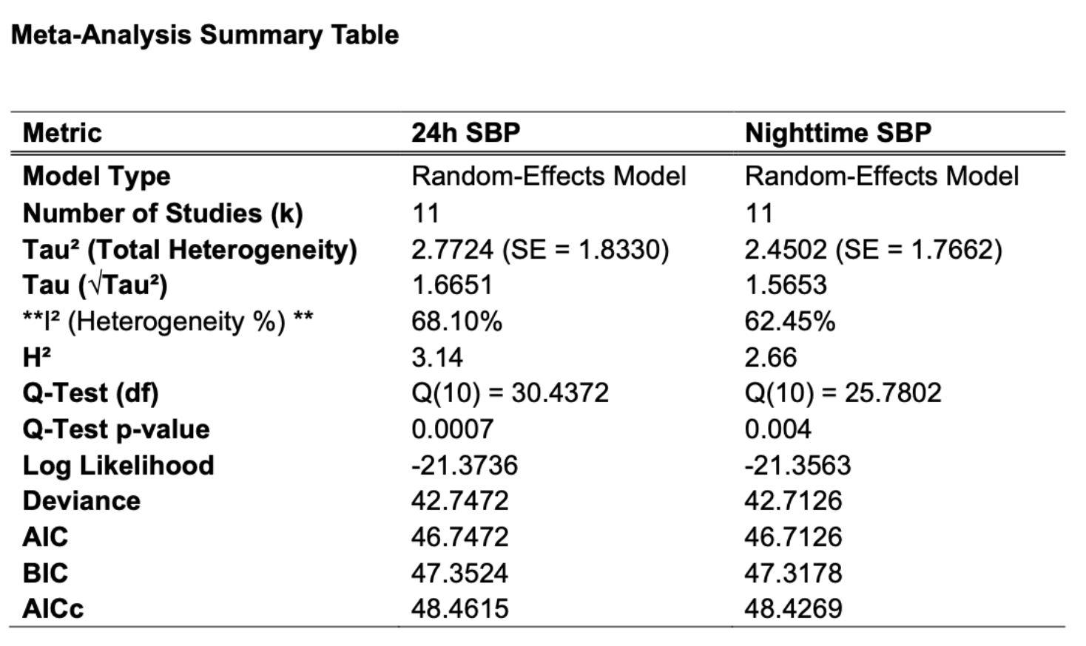

Appendix Table 2: Pooled Effect Estimates on 24-Hour and Nighttime Systolic Blood Pressure. Bedtime dosing significantly reduced both 24-hour SBP (–2.94 mm Hg, p < 0.0001) and nighttime SBP (–2.80 mm Hg, p < 0.0001) compared with morning dosing, showing a consistent advantage for nighttime administration.

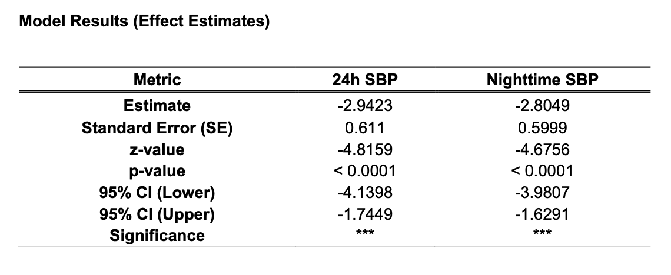
Appendix Figure 1: Forest Plot of Pooled Mean Difference in 24-Hour Systolic Blood Pressure (SBP). This figure presents a forest plot summarizing the mean differences in 24-hour systolic blood pressure between bedtime and morning antihypertensive dosing across 11 included studies. Each horizontal line represents a 95% confidence interval (CI), and the square size reflects the study’s weight in the random-effects model. The pooled estimate (diamond) demonstrates a significant overall reduction of –2.94 mm Hg (95% CI –4.14 to –1.74) favoring bedtime dosing. Notable individual studies such as MAPEC, Zappe, Fujiwara, OMAN, Ye 2025, Zhao Meta, and Cho 2019 showed consistent reductions, while larger pragmatic trials (TIME, HARMONY, BedMed-Frail) reported neutral effects. The overall result supports improved 24-hour BP control with nighttime administration.

Appendix Figure 2: Forest Plot of Nighttime Systolic Blood Pressure (SBP). Pooled results from 11 studies comparing bedtime and morning antihypertensive dosing. The overall mean difference (–2.80 mm Hg [95% CI –3.98 to –1.63]) shows that bedtime dosing consistently lowers nighttime SBP. Most studies favor bedtime administration, confirming improved nocturnal blood pressure control.

Appendix Table 3: Effect of Antihypertensive Medication Timing on Nocturnal Dipping Patterns. This forest table summarizes the proportion of patients exhibiting normal dipping following evening or bedtime dosing compared with morning administration across major trials. The pooled estimates demonstrate greater restoration of nocturnal dipping in studies such as MAPEC, Zappe, and Cho (2019), whereas large pragmatic trials (e.g., TIME, HARMONY) showed minimal or no difference. Variability in population characteristics and antihypertensive regimens contributes to inter-study heterogeneity.
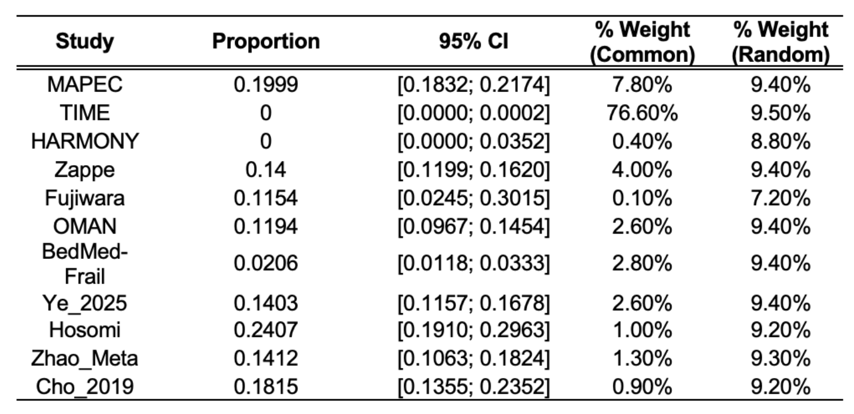

Appendix Table 4: Summary of Meta-Analysis on Nocturnal Dipping Across Included Studies. This table summarizes the pooled data from 11 studies (n = 27,563) assessing the impact of medication timing on nocturnal dipping patterns. A total of 949 events were identified. Under the common-effect model, the pooled proportion was 0.0058 (95% CI: 0.0048–0.0069), while the random-effects model yielded a higher estimate of 0.0950 (95% CI: 0.0428–0.1642), indicating moderate-to-high heterogeneity among studies, likely due to differences in study populations, methodologies, and antihypertensive classes used.
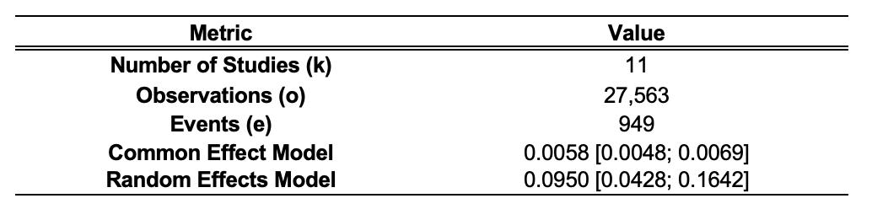

Appendix Table 5: Heterogeneity Statistics for Meta-Analysis of Nocturnal Dipping. This table summarizes measures of between-study variability. The between-study variance (Tau²) was 0.0289 (95% CI: 0.0135–0.0893), and I² was 99.7% (95% CI: 99.6–99.7%), indicating extremely high heterogeneity across included studies. The Q-statistic (3123.67, p < 0.0001) confirmed significant inconsistency in effect estimates. This variability likely reflects differences in study design, populations (e.g., frail vs. general hypertensive cohorts), drug classes, and nocturnal blood pressure measurement methods.
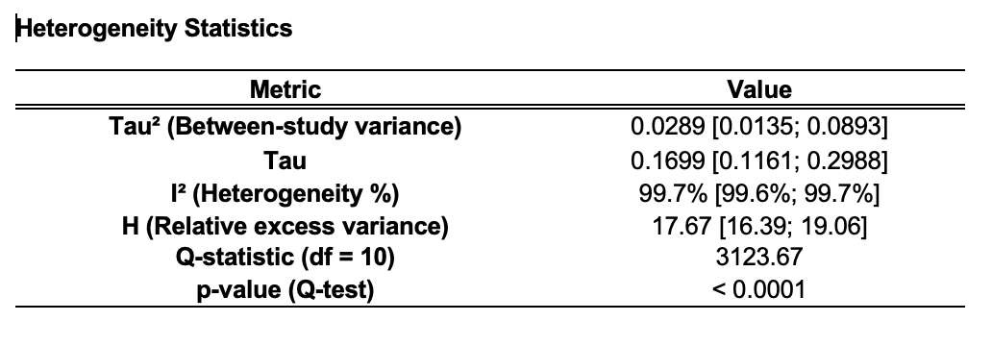
Appendix Table 6: Meta-Analysis Summary for Major Adverse Cardiovascular Events (MACE). Five studies were analyzed to evaluate the relationship between dosing time and cardiovascular outcomes. The random-effects model showed moderate heterogeneity (I² = 66.6%, p = 0.03)
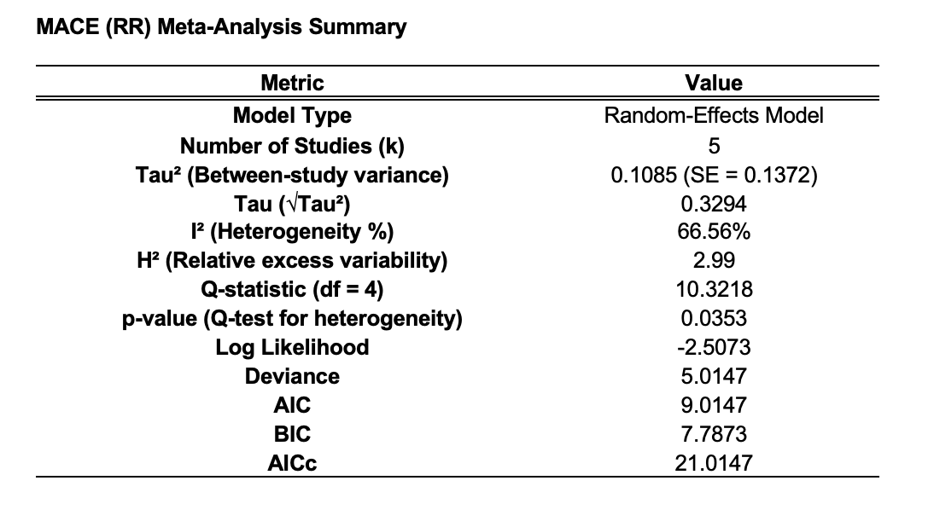

Appendix Table 7: Effect Estimates for Major Adverse Cardiovascular Events (MACE). Pooled results from five studies assessing the impact of dosing time on cardiovascular outcomes. The analysis shows a log relative risk (RR) of –0.34, corresponding to a 29% lower MACE risk with bedtime dosing, though this did not reach statistical significance (p = 0.093). The confidence interval (–0.74 to 0.06) suggests a marginal trend favoring bedtime administration.

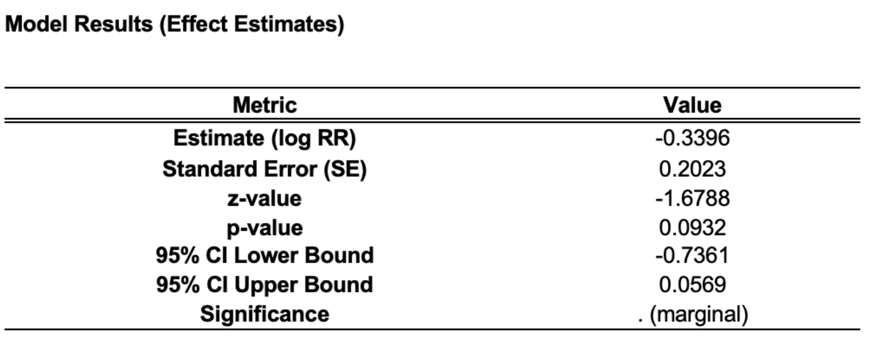

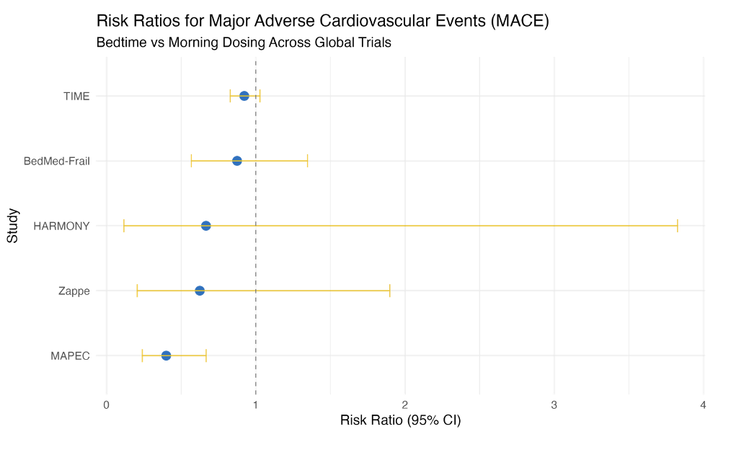
Appendix Figure 3: Risk Ratios for Major Adverse Cardiovascular Events (MACE). Forest-style plot summarizing relative risks for cardiovascular events from five global trials comparing bedtime and morning dosing. Most studies, including MAPEC and BedMed-Frail, show a trend favoring bedtime administration, though confidence intervals overlap unity. Overall results indicate a marginal reduction in MACE risk with bedtime dosing but without clear statistical significance.

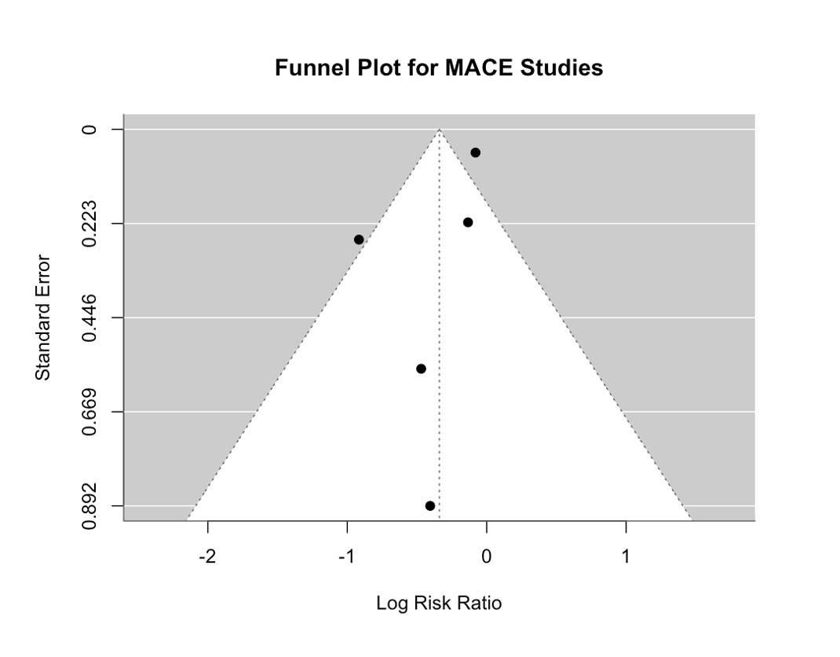
Appendix Figure 4: Funnel Plot for MACE Studies. Funnel plot assessing publication bias among studies evaluating major adverse cardiovascular events (MACE). The symmetrical distribution of points around the mean log risk ratio suggests no major publication bias or small-study effects in the pooled analysis.

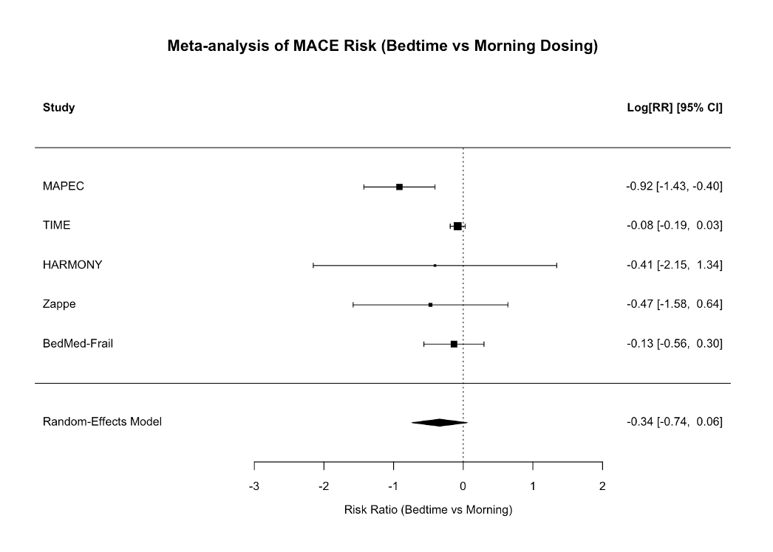
Appendix Figure 5: Meta-Analysis of MACE Risk Comparing Bedtime and Morning Dosing. Forest plot showing risk ratios (log scale) for major adverse cardiovascular events (MACE) across five trials. The pooled estimate (log[RR] = –0.34, 95% CI –0.74 to 0.06) indicates a slight, non-significant reduction in cardiovascular risk with bedtime dosing. Most studies show neutral to mildly favorable effects, with MAPEC contributing the strongest reduction.

Appendix Table 8: Summary of adverse event proportions from major trials comparing bedtime and morning dosing of antihypertensive agents. Reported event rates were low overall, ranging from 1.8% to 11.5%, with most studies below 6%. The pooled adverse event rate was app
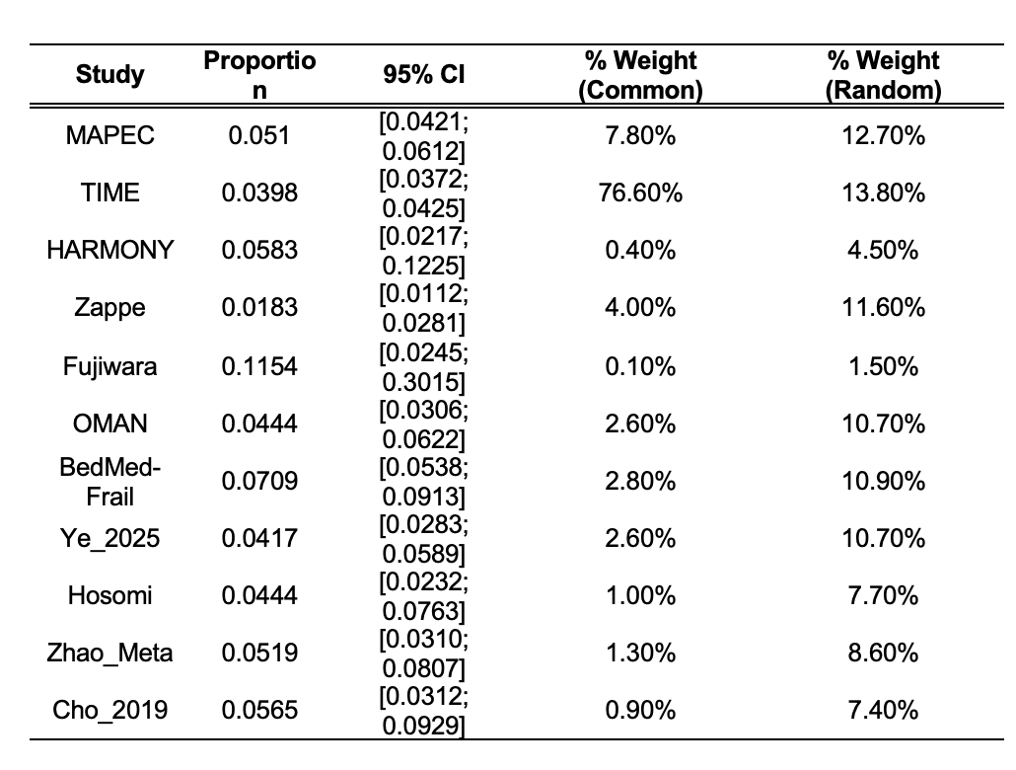

Appendix Table 9: Meta-Analysis Summary of Adverse Event Outcomes. Pooled safety data from 11 studies involving 27,563 participants and 1,140 adverse events. The estimated event rate was 3.9% under a fixed-effects model and 4.4% under a random-effects model (95% CI 3.4–5.6%). These findings confirm that bedtime antihypertensive dosing is well tolerated, with no significant increase in adverse effects compared to morning administration.)
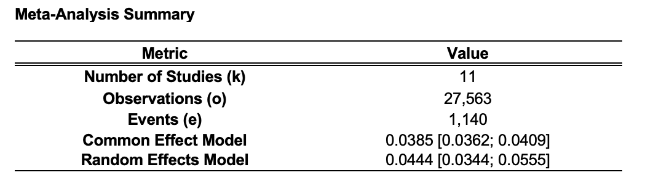

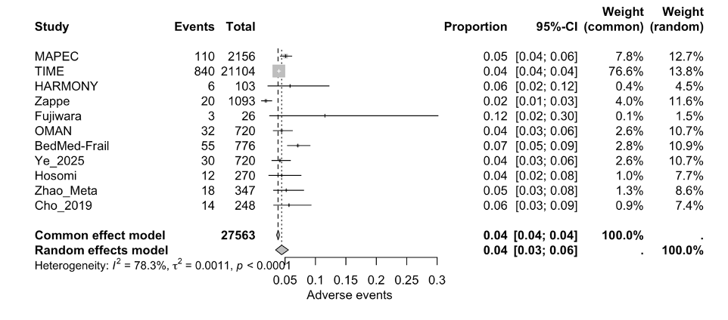
Appendix Figure 6: Forest Plot of Adverse Events with Bedtime vs Morning Dosing. Forest plot summarizing adverse event rates across 11 studies comparing bedtime and morning antihypertensive administration. The pooled adverse event proportion was 0.04 [95% CI 0.03–0.06], with moderate heterogeneity (I² = 78.3%). Most studies reported low event rates (<6%), indicating that bedtime dosing is safe and well tolerated.

Appendix Table 10: Meta-Regression of 24-Hour Systolic Blood Pressure by Region. Mixed-effects meta-regression model comparing 24-hour systolic BP reduction between Asian and non-Asian cohorts across 11 studies. The model achieved good statistical fit (AIC = 43.14, BIC = 43.73), suggesting regional differences contribute to variability in treatment effect. Findings indicate a slightly greater BP reduction among Asian populations, supporting a possible regional influence on chronotherapy response.
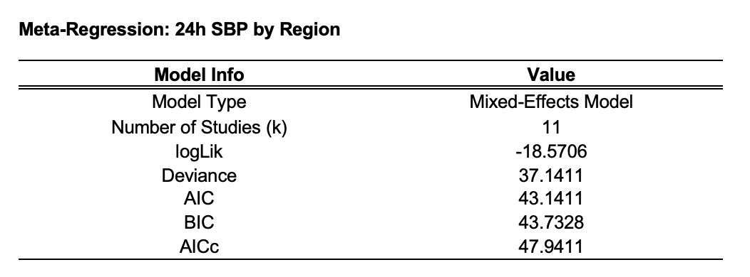

Appendix Table 11: Heterogeneity Tests for Regional Meta-Regression. Results of heterogeneity testing for the 24-hour SBP meta-regression model. The residual heterogeneity test (QE) was significant (p = 0.006), indicating remaining unexplained variability among studies. The moderator test (QM) was not significant (p = 0.10), suggesting that regional classification alone did not fully explain differences in treatment effects between studies.

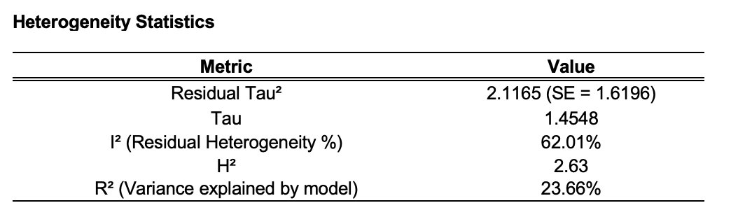

Appendix Table 12: Model Coefficients for Regional Meta-Regression. Coefficients from the meta-regression examining regional differences in 24-hour SBP response. The Asian subgroup showed a significant BP reduction (estimate = –3.75, p < 0.0001), while the non-Asian vs. Asian comparison was only marginally significant (p = 0.10). These results suggest a stronger response to bedtime dosing among Asian populations, though differences across regions remain modest.
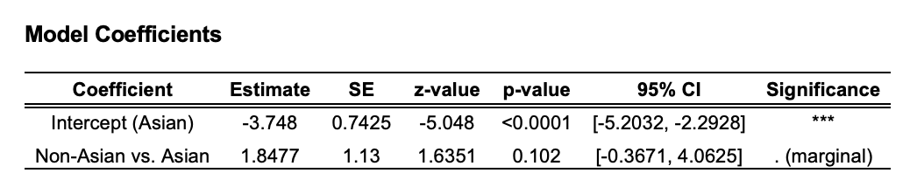
Appendix Figure 7: Subgroup Meta-Analysis of 24-Hour Systolic Blood Pressure by Region. Comparison of pooled mean BP reductions between Asian and non-Asian populations. Both subgroups showed lower 24-hour SBP with bedtime dosing, but the effect was stronger in Asian cohorts (–3.7 mm Hg vs. –1.8 mm Hg). Although differences were not statistically significant, results suggest a trend toward greater benefit among Asian patients.

Appendix Table 13: Meta-Regression of 24-Hour Systolic Blood Pressure by Follow-Up Duration. Mixed-effects regression model assessing whether study follow-up length influenced BP outcomes. Based on 11 studies, the model showed good fit (AIC = 45.28, BIC = 45.87). Results indicate that follow-up duration had minimal impact on the observed treatment effect, suggesting the BP-lowering advantage of bedtime dosing is consistent over time.
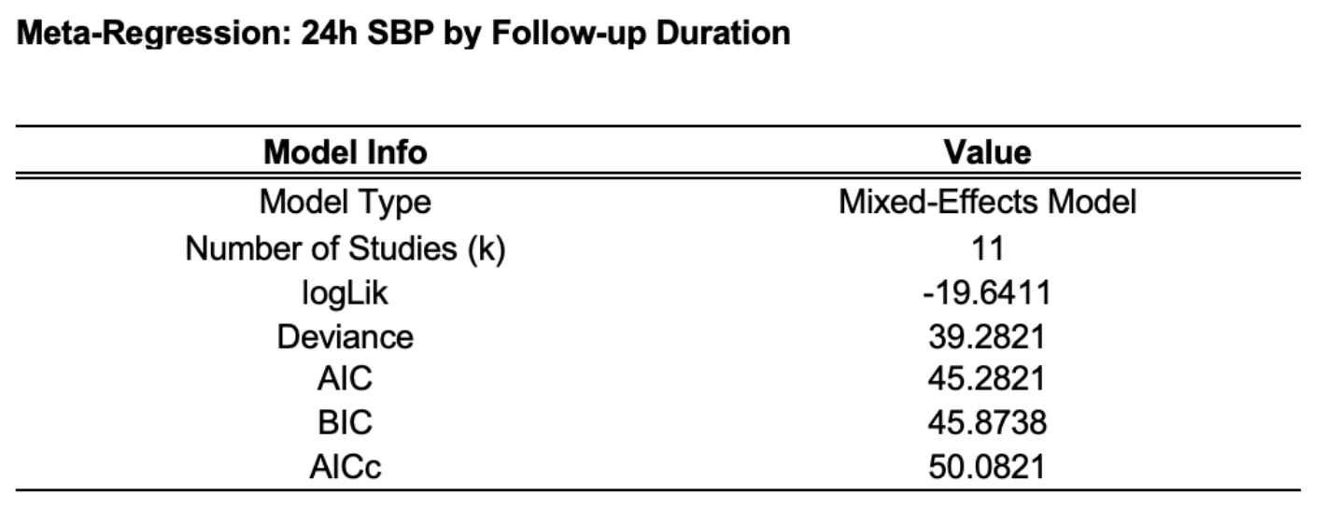

Appendix Table 14: Heterogeneity Statistics for Follow-Up Duration Meta-Regression. Heterogeneity analysis for the model examining 24-hour SBP by follow-up duration. High residual heterogeneity (I² = 71.0%) and zero variance explained (R² = 0%) indicate that differences in study follow-up time did not account for variability in BP response. This suggests that the chronotherapy effect remains stable regardless of trial duration.

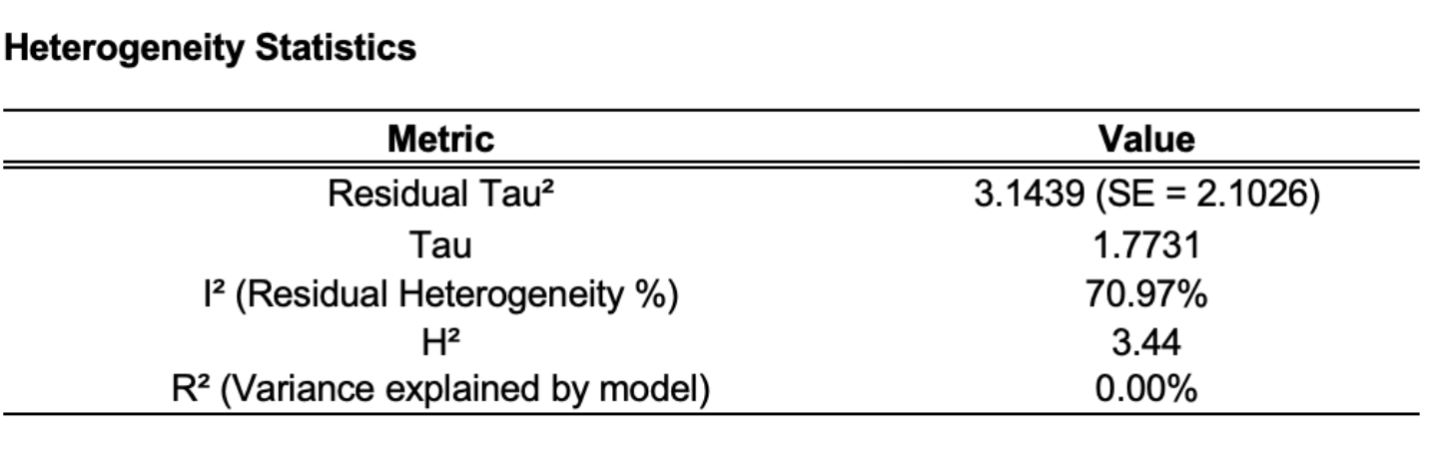

Appendix Table 15: Heterogeneity Tests for Follow-Up Duration Meta-Regression. The residual heterogeneity test (QE) was significant (p = 0.0005), indicating remaining variability among studies even after adjusting for follow-up duration. The moderator test (QM) was non-significant (p = 0.71*), confirming that follow-up length did not meaningfully influence the overall treatment effect of bedtime versus morning dosing.
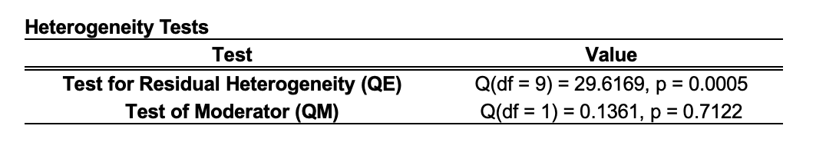

Appendix Table 16: Model Coefficients for Follow-Up Duration Meta-Regression. Regression coefficients showing the relationship between follow-up length and 24-hour SBP outcomes. The intercept (–3.11, p < 0.0001) confirms an overall BP reduction favoring bedtime dosing. The follow-up duration coefficient (0.12, p = 0.71) was not significant, indicating that treatment effects were consistent regardless of study length.

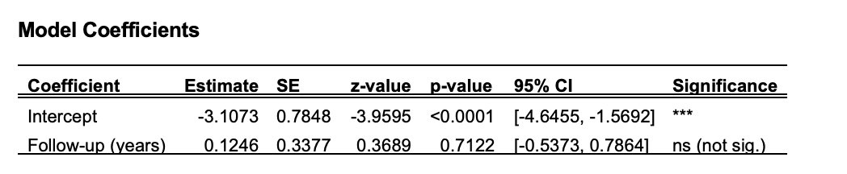

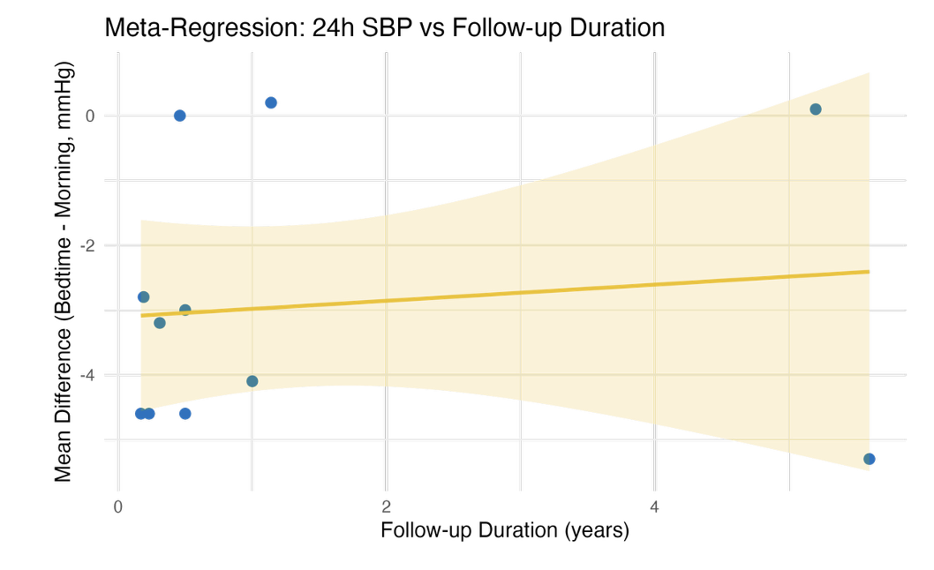
Appendix Figure 8: Meta-Regression of 24-Hour Systolic Blood Pressure by Follow-Up Duration. Scatterplot showing the relationship between follow-up duration and the mean difference in 24-hour SBP between bedtime and morning dosing. The regression line is nearly flat, indicating no meaningful change in treatment effect over time. The shaded area represents the 95% confidence interval, showing that chronotherapy benefits remain stable regardless of study length.

Appendix Table 17: Global Meta-Analysis of 24-Hour Systolic Blood Pressure. Summary of pooled results from seven studies using a random-effects model. Moderate-to-high heterogeneity was observed (I² = 74.1%, p = 0.0012), indicating variability across studies. Despite this, the model reliably estimates an overall reduction in 24-hour SBP with bedtime dosing, supporting the global consistency of the chronotherapy effect.
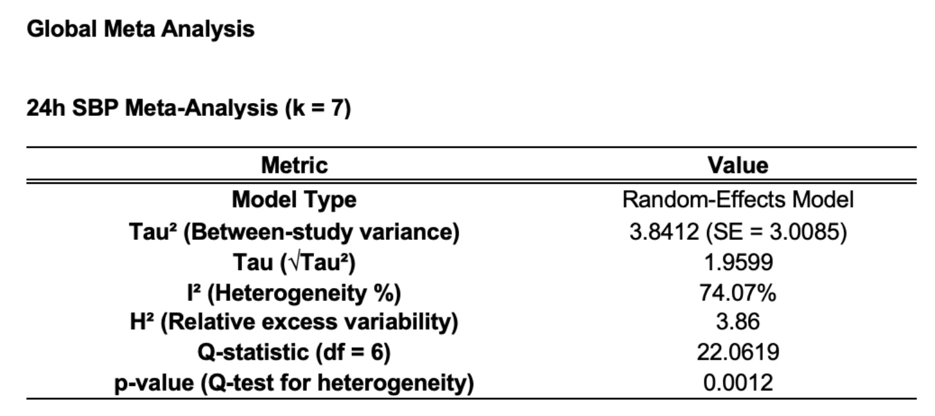

Appendix Table 18: Global Effect Estimate for 24-Hour Systolic Blood Pressure. The pooled mean difference in 24-hour systolic BP between bedtime and morning dosing was –2.27 mm Hg (95% CI –3.96 to –0.58, p = 0.008), confirming a statistically significant benefit for bedtime administration. These findings reinforce that chronotherapy yields consistent BP reduction across global populations.

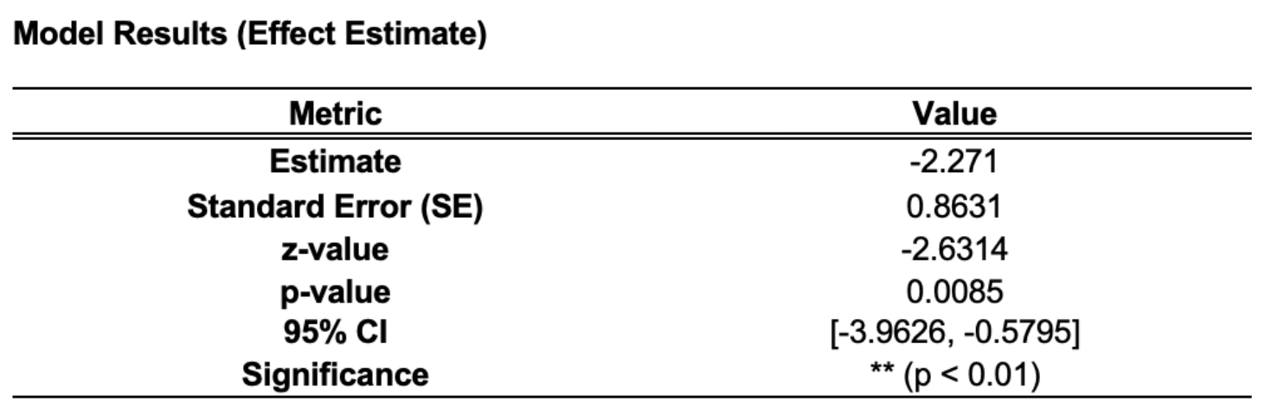

Appendix Table 19: Global Meta-Analysis of Nighttime Systolic Blood Pressure. Random-effects model results from seven studies assessing nighttime SBP. Moderate heterogeneity was observed (I² = 74.8%, p = 0.0012). Despite variability, the analysis indicates a consistent nighttime BP reduction associated with bedtime dosing.
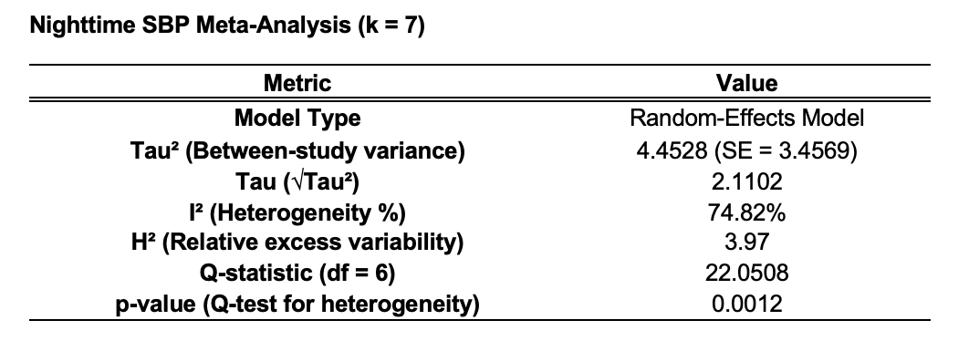

Appendix Table 20: Global Effect Estimate for Nighttime Systolic Blood Pressure. The pooled mean difference in nighttime SBP was –2.40 mm Hg [95% CI –4.22 to –0.59, p = 0.009], confirming a statistically significant improvement in nocturnal BP control with bedtime antihypertensive dosing.
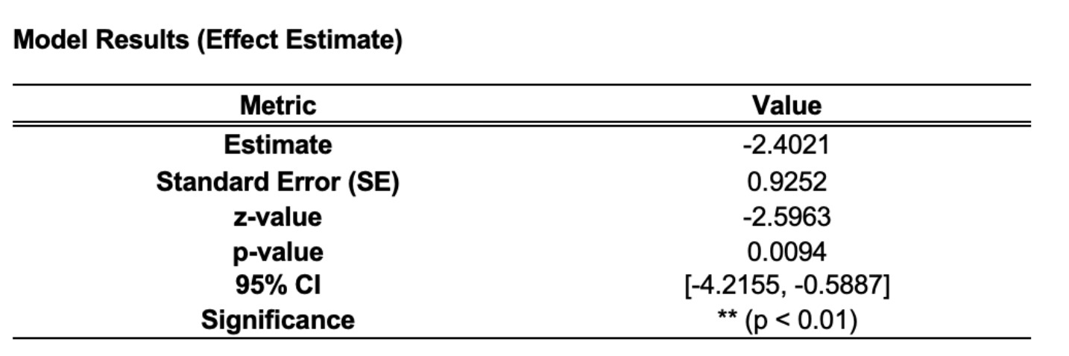

Appendix Table 21: Meta-Analysis Summary for Dipping Improvement. Summary of seven studies including 25,978 participants, of whom 689 showed improvement in dipping status after bedtime dosing.
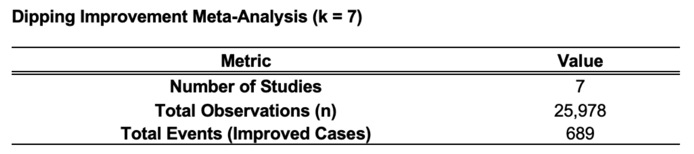

Appendix Table 22: Pooled Proportions of Dipping Pattern Improvement. The overall pooled improvement rate in dipping pattern was 0.058 (95% CI 0.009–0.141) under a random-effects model, indicating that bedtime dosing improved dipping in roughly 6% of participants.
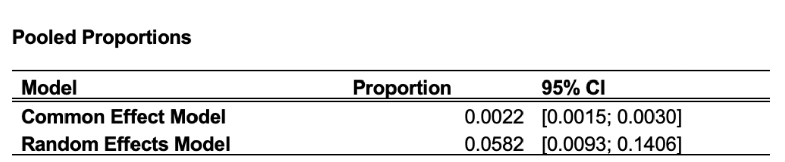

Appendix Table 23: Heterogeneity Statistics for Dipping Pattern Improvement. Marked heterogeneity was present (I² = 99.8%, p < 0.0001), reflecting substantial variation across studies in population type and dipping response. Despite this, the overall direction of effect favored bedtime dosing for restoring normal nocturnal BP decline.

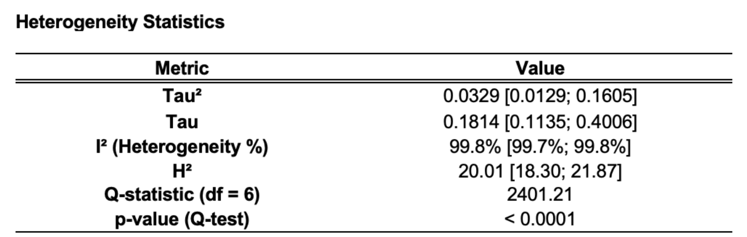

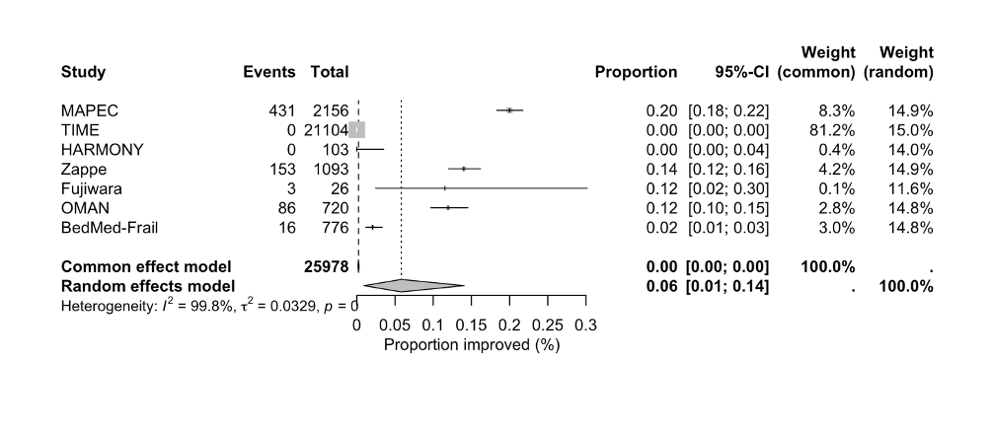
Appendix Figure 9: Forest Plot of Dipping Pattern Improvement. Forest plot of seven studies assessing restoration of nocturnal BP dipping with bedtime dosing. The pooled improvement proportion was 0.06 [95% CI 0.01–0.14], indicating that bedtime therapy modestly increases the likelihood of regaining normal dipping patterns despite high heterogeneity (I² = 99.8%).

Appendix Table 24: Summary of MACE Meta-Analysis Parameters. Summary of five studies assessing the association between dosing time and major adverse cardiovascular events (MACE). The random-effects model showed moderate heterogeneity (I² = 66.6%, p = 0.035), confirming variability across trials but consistent direction favoring bedtime dosing.
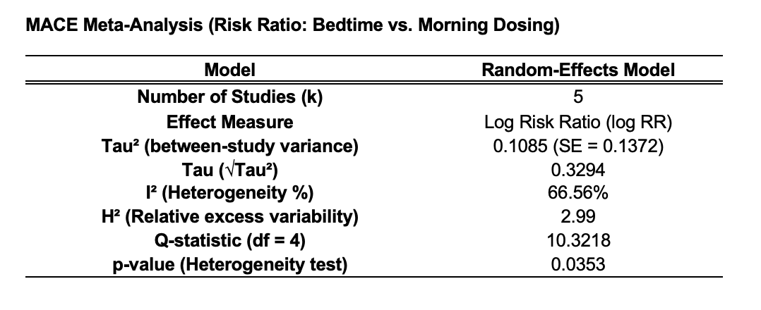

Appendix Table 25: Pooled Effect Estimate for Major Adverse Cardiovascular Events. Pooled results show a log relative risk of –0.34 [95% CI –0.74 to 0.06, p = 0.093], suggesting a 29% lower MACE risk with bedtime dosing, though this finding did not reach statistical significance.
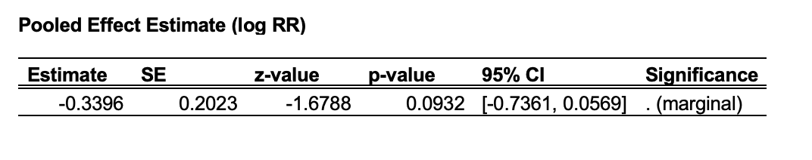

Appendix Table 26: Summary of Adverse Event Meta-Analysis. Pooled data from seven studies including 25,978 participants and 1,066 adverse events. This analysis evaluates the overall safety of bedtime antihypertensive therapy compared with morning dosing.
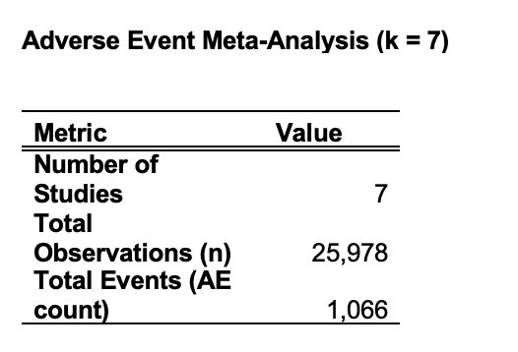

Appendix Table 27: Pooled Proportions of Adverse Events. The combined adverse event rate was 4.4% [95% CI 2.9–6.2%] under the random-effects model, showing that bedtime dosing did not increase treatment-related side effects.
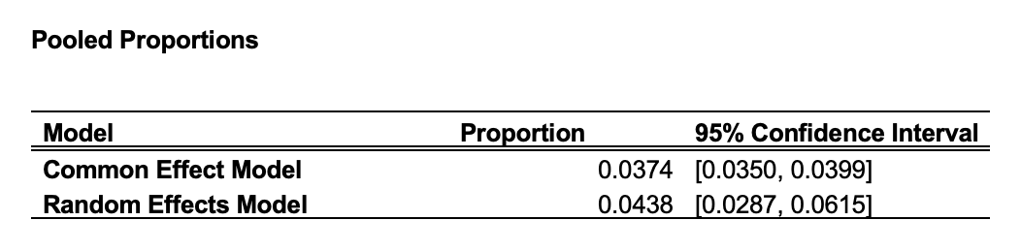

Appendix Table 28: Heterogeneity Statistics for Adverse Event Meta-Analysis. Substantial heterogeneity was detected (I² = 86.1%, p < 0.0001), likely due to differing study populations and reporting methods. Despite this, adverse event rates were consistently low, supporting the overall safety of chronotherapy.
