Original Research Article
Development, Optimization and Biochemical Characterization of Bioplastic Films from Cassava Peels and False yam Tubers Starch.

.
ABSTRACT
The leaching of harmful chemicals from conventional plastics food packaging, into foods and their gradual accumulation in the living systems, has intensified concerns the use of plastics and its waste management control protocol. Their environmental persistence poses serious ricks to human health, environmental safety and aquatic. Therefore, study was set out to explored the development and analysis of starch extracted from cassava Manihot esculenta peels and false yam Icacina trichantha tubers to synthesize bioplastic films (C₀, F₀ and CF₀) and reinforced with 2.5% bleached fibre from bamboo stem (C_{2.5}, F_{2.5} and CF_{2.5}).The films were formed using glycerol as a plasticizer through solution casting technique. The developed films were analyzed for water barrier properties, mechanical, thermal, biochemical, and soil degradability. The incorporation of fibre into the starch matrices for bioplastic formulation significantly reduced the percentage of water absorption at 30, 40, 50 and 60ºC, while percentage water absorption increased as temperature increased. Ultimate tensile strength (UTS) and percentage elongation decreased on the addition of fibre reinforcement, with C₀ had the highest ultimate tensile strength (4.85 ± 0.12 MPa) while CF_{2.5} had the lowest (2.13 ± 0.28 MPa), CF₀ had the highest percentage elongation (22.22 ± 0.20%) while (CF_{2.5}) had the lowest (11.19 ± 0.32%). Film opacity increased with the addition of fibre reinforcement. Fourier Transform Infrared Spectroscopy (FTIR) analysis revealed that intermolecular hydrogen bonding occurred between glycerol and the two samples of starch extract and plasticizer. The synthesized bioplastic films showed similar thermal behaviour. The cross-sectional micrographs revealed that the films containing cassava peel starch showed higher homogeneity than films with false yam. The Gas chromatography mass spectrometer GC-MS analysis revealed high content of oleic acid which impacted on the structural integrity of synthesized bioplastic films. The degradation by films decreased with the addition of fibre reinforcement, C₀ had the highest degradation (43.52 ± 0.01%) at the 60 days. The findings of this research provide insights into the development of biodegradable medical products and food packaging bioplastic films.

Keywords: Bioplastic films, reinforcement, degradability, starch, fibre, characterization, agro-waste

1. INTRODUCTION

In modern society, plastic-based materials have become ubiquitous due to their favorable combination of physicochemical properties like moisture and gas barrier performance, transparency, mechanical strength, chemical resistance, and low production cost (Emadian et al., 2017). Conventional plastics such as polyethylene (PE), polypropylene (PP), and polyethylene terephthalate (PET) are widely utilized across multiple sectors, including food packaging, medical device manufacturing, construction, and consumer goods. Their versatility arises from their modifiable molecular structures and thermal stability, allowing them to be molded into diverse forms such as films, containers, and medical tubing (Henning et al., 2022).
However, despite their functional benefits, synthetic petroleum-based plastics pose major environmental and biomedical challenges. They are non-biodegradable, accumulating in ecosystem (Thomas, 2020). Improper disposal of plastics packaging materials and medical plastics consumables such as gloves, syringes, and surgical wraps contributes to infectious waste buildup and micro-plastic pollution. Environmental pollution by synthetic plastic wastes is now recognized widely to be a major environmental burden especially in the aquatic environment where there is extremely prolonged biophysical breakdown of plastics, increased flooding of urban communities due to blocked drainages, limited plastic removal option, and detrimental negative effects on wildlife and human health (Bhuyan, 2022; Alobi et al., 2017).
Globally, plastic waste constitutes more than 60% of the total global municipal solid waste of which 22% were recovered and 78% disposed of in the ocean or dumped to the landfills (Olanrewaju & Oyebade, 2019). In 2010, Nigeria with a population of about 200 million people, stood among the top ten largest contributors to plastic waste, contributing 830,000 metric tons of mismanaged plastic waste to the oceans (Onaji-benson & Ali, 2023). According to Dania (2022), Lagos State, the commercial centre of Nigeria, with approximately 22 million inhabitants generated an average of 870,000 tonnes of plastic waste yearly which are mainly disposed in the ocean. Moreover, some of the other existing disposal methods, such as incineration and landfilling, are not environmentally sustainable (Prasteen et al., 2018)
Furthermore, plastics have several toxic constituents which are chemically harmful, either directly toxic themselves or because they absorb and carry other pollutants. These monomers and other substances in plastics can mimic the effects of oestrogen, interfere with testosterone and thyroid hormones, inducing ovarian disorder, sperm motility leading to neurological, and reproductive damages in living organisms. Pesticides and organic toxins are found on plastic particles at harmful concentrations. Seafood, alcohol and plastic-bottled water are the greatest sources of micro-plastic ingestion in humans (Okunola et al., 2019).
Consequently, there is an increased interest to explore alternative sources that are renewable and biodegradable such as the utilization of biomass like starch and fibre obtained from agricultural waste, for an eco-friendly and sustainable society. Bioplastic films derived from renewable biomass is gaining recognition as an excellent alternative to the conventional plastics which are petroleum based. The ability to handle important factors in the deterioration of food, such as oxygen, water and carbon dioxide, while incorporating the possibility of combining antimicrobial and functional biomolecules, has produced a wide range of possibilities in relation to film technology solutions for the food industry (Haghighi et al., 2020).
Bioplastic films are polymers made from plant sources that are bio-assimilated or mineralized in the environment through a process in which the polymer chains are broken down into smaller fragments of monomers or dimers, which leads to decomposition (Henning et al., 2022) by the action of living organisms such as microbes and fungi. Bioplastic films have been categorized under three main types namely, biotechnologically synthesized, microorganism derived and biomass derived biopolymers (Asgher et al., 2020).
Asgher et al. (2020) reported that, the utilization of biopolymers originating from of microorganism derived such as Polyhydroxyalkanoates (PHAs), Polyhydroxy butyrate (PHBs), and Poly (3hydroxybutyrate-co-3-hydroxyvalerate) (PHBV) as biomedical materials is limited due to several practical reasons. A primary obstacle is the substantial production cost associated with these materials. This high cost presents a major challenge to scaling up manufacturing to satisfy the extensive and growing demand from the biomedical and food packaging industry. Furthermore, other biotechnological synthesized polymers, including polylactic acid (PLA), also face considerable implementation hurdles. Their production requires the use of advanced biotechnical processes, which in turn require specialized expertise and a high-technology infrastructure to operate effectively.
Lately, the utilization of biomass derived biopolymers (i.e., starch, cellulose, proteins) into biodegradable bioplastic films used as biomedical materials is gaining the attention of researchers due to their comparatively high abundance at low cost along with their ability to make colourless, odourless, and non-toxic films (Amin et al., 2019). Starch is composed of amylose and amylopectin with relative amounts of each component varying according to its plant source. Film-forming, barrier and mechanical properties, as well as processing conditions, are dependent on amylose to amylopectin ratio (Henning et al., 2022).
However, majority of starch is sourced from conventional starch which are edible sources such as cassava (Manihot esculenta) with 16–19% amylose content, corn (Zea mays) with 28–33% amylose content, yam (Discorea rutundata) (1.4-50%), wheat (Triticum aestivum) 30–32% amylose content, and potato (Solanum tuberosum) 30–32% amylose content. Starch-based films, however, are brittle and hydrophilic, therefore limiting their processing and application. In order to overcome these drawbacks, starch can be mixed with various synthetic and/or natural polymers which in some studies are plant fibres (Mendes et al., 2016).
However, in recent years there have been a few studies on the development of films using non-conventional starch sources which are agro-industrial waste materials, less-edible and non-edible plants rich in starch and fibre, with huge potential to serve as alternative sources of starch for developing bioplastic films. Non-conventional starch sources display a wide range of amylose content such as amadumbe (7%), mango kernel (15%), water chestnut and sweet potato (22%), loquat seed (26%), arrowroot and mung bean (30%), ulluco (35%) and kithul (39%) (Henning et al., 2022).
There are limited studies on the use of cassava peels starch for the development of bioplastic films, and the utilization of false yam tuber starch for the synthesis of bioplastic films have been rarely exploited.Therefore, this research is aimed at synthesizing bioplastic films from starch extract of cassava peels and false yam tubers, reinforced with bamboo fibre powder. Furthermore, the biochemical characterization of synthesized bioplastic films based on their mechanical properties and chemical interactions was determined.
2. material and methods

2.1 Methods
2.1.1 Production of Bioplastic
The bioplastic films were produced by solution casting method as described by Prasteen et al. (2018) with slight modifications. The raw materials for bioplastic production included starch extracts of cassava peels and false yam tuber, bamboo fibre, glycerol, vinegar and distilled water as displayed in list 1. Glycerol was used as a plasticizer, vinegar was used as a preservative and in addition to the dissolving effect of water. The effect of fibre as a reinforcement was determined.
List 1: Composition of prepared samples of bio-plastic films.
Sample | Cassava Peel Starch (g) | False Yam Starch (g) | Bamboo Fibre (g) | Distilled Water (mL) | Vinegar (mL) | Glycerol (mL)
Sample 1 (C₀) | 10 | 0 | 0 | 30 | 5 | 5
Sample 2 (C_{2.5}) | 7.5 | 0 | 2.5 | 30 | 5 | 5
Sample 3 (C₅) | 5 | 0 | 5 | 30 | 5 | 5
Sample 4 (F₀) | 0 | 10 | 0 | 30 | 5 | 5
Sample 5 (F_{2.5}) | 0 | 7.5 | 2.5 | 30 | 5 | 5
Sample 6 (F₅) | 0 | 5 | 5 | 30 | 5 | 5
Sample 7 (CF₀) | 5 | 5 | 0 | 30 | 5 | 5
Sample8 (CF_{2.5}) | 3.75 | 3.75 | 2.5 | 30 | 5 | 5
Sample 9 (CF₅) | 2.5 | 2.5 | 5 | 30 | 5 | 5

2.1.2 Bioplastic Characterization
2.1.2.1 Test for Mechanical Properties of Bioplastic
The hardness, tensile yield strength, ultimate tensile strength and elongation-at-break of the bioplastic samples were evaluated according to established protocols utilizing the ASTM D882-02 (2002) standard. In the analysis of the mechanical properties of film samples, an Instron 3365 universal testing machine with a loading cell of 30 kg. The film samples were cut into rectangular pieces with a scale of (70×10 mm) and the gauge length of samples were set at (30 mm). The specimens were held with 2 mm/min crosshead speed was applied to pull out the specimens. Deformation (mm) and force (N) of the specimen were then recorded. The evaluation of the mechanical properties was carried out using the average value of the measurements.

2.1.2.2 Film Transparency and Chemical Resistance Tests
The Transparency value (opacity) of the biofilms were evaluated as described by Lescano et al. (2021). The samples were cut into 10 × 80 mm strips, placed in quartz cuvettes, and the transparency at 600 nm was measured in a spectrophotometer (Genesys 10S UV-VIS, ThermoFisher Scientific). Empty cuvettes were used as blanks. The Opacity was calculated using Equation (1), where A is the absorbance at 600 nm. The results were reported in A600nm/mm.

$$Opacity= \frac{A_{600}}{Thickness (mm)} Equation 1$$

2.1.2.3 Water Absorption Test
Immersion method of Judawisastra et al. (2017) was adopted. Bioplastic sheets of known weights were immersed in distilled water at varying temperatures of 30, 40 and 50ºC for 60 min. The samples were taken out periodically at intervals of 0, 5, 10, 15, 20, 25, 30, 45 and 60 min, and weights were taken immediately after wiping out adsorbed water on the surface. The % water absorption by the bioplastic films were calculated using equation (2) shown below.
$\% Water absorption= \frac{W_{S}-W_{d}}{W_{S}} x 100 Equation 2$
Where $W_{S}$ is the weight after submersion and $W_{d}$ is the initial weight before submersion (dry weight).
2.1.2.4 Fourier Transform Infrared Spectroscopic (FTIR) Analysis
The functional group of the bioplastic films were assessed using using a FTIR model Vertex 70 Bruker spectrophotometer (Bruker, Germany). Spectra were recorded at a spectral range between of 4000 and 400 cm-1 and at a resolution of 4 cm-1 (Tarique et al., 2021; Weligama Thuppahige et al., 2023). The FTIR spectrum was employed in the transmittance mode. FTIR analyses were performed to ascertain the possible chemical interactions composite films.
2.1.2.5 Determination of Bioactive Compound in Bioplastic films
The assessment of bioactive compound of the synthesized bioplastic films was determined using a performed using an Agilent-6890 N gas chromatographer with an HP 5973 mass spectrometer detector. The identification of compounds in the bioplastic films was made by correlating mass spectra and retention times with that of pure compounds (Chandrasekar et al., 2023). Furthermore, the NIST (National Institute of Standards and Technologies, USA), mass spectra library, was also used for this analysis.
2.1.2.6 Scanning Electron Microscopic (SEM) Analysis of Bioplastic films
The surface morphology of the bioplastic films were studied using the method described by Tarique et al. (2021) using the Phenom XL G2 Desktop Scanning Electron Microscope (ThermoScientific). The fresh samples were fixed in 2.5% glutaraldehyde followed by dehydration using an ethanol series (range from 10% to 100%) and acetone (100%). The chemically treated samples were later dried using critical point drier. Then the samples were mounted on aluminium stubs using double-sided tapes and coated with a platinum layer (4 nm) to prevent charging. Samples were observed under the SEM at accelerating voltage of 15 kV, and the analysis was conducted under high vacuum mode. The SEM micrographs of 150µm magnification level was used to understand the morphological characterization.
2.1.2.7 Thermogravimetric analysis
Thermogravimetric analysis (TGA) were conducted according to Tarique et al. (2021) to ascertain the thermal stability and thermal decomposition of the bioplastic films using TGA Instruments (Mettler-Toledo AG, Schwerzenbach, Switzerland). The test parameters were taken as the temperature was varied from 25 to 600°C under a constant heating range of 10℃/min in a nitrogen gas medium. A 10 mg of the film sample was put and heated in the aluminium tray. The weight reduction versus temperature is illustrated in TGA analysis.
2.1.2.8 Soil Biodegradability Test
Biodegradability of synthesized bioplastic films were evaluated for 60 days through soil burial test method as described by Jangong et al. (2019). The bioplastic samples were oven dried at 70oC to remove any moisture until a steady weight was obtained and recorded as an initial weight of samples. This test was carried out by burying the samples 30cm below the ground of a plantain plantation farm at Ikeduru Local Government Area of Imo State. An interval of 5 days was used after which the samples were taken out wiped with a clean soft brush to remove surface sand and debris that may add to the weight of the sample. The sample were then weighed and recorded as the final weight. The percentage degradability is calculated using the equation 3 below.
$$Degradability \%=\frac{W_{i}-W_{F}}{W_{i}} x 100 Equation 3$$
Where $W_{i}$ and $W_{f}$ denote weight before placement in soil and weight after the sample is taken out and cleaned respectively.
2.1.2.9 Data Management and Analysis
Data generated were subjected to student’s-test and one-analysis of variance (ANOVA) and Tukey postHoc tests with the aid of Graph Pad. Statistical significance was taken at p≤0.05. The results were presented in simple percentages and mean ± standard deviations.

3. results and discussion

The experimental results are presented in Figure 1 -4 and Table 1-4

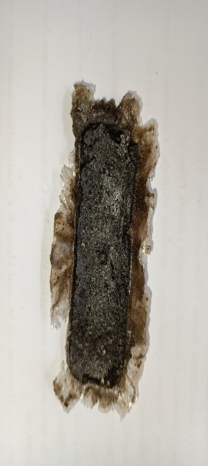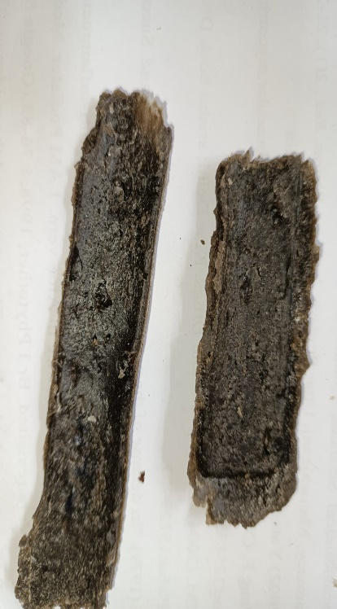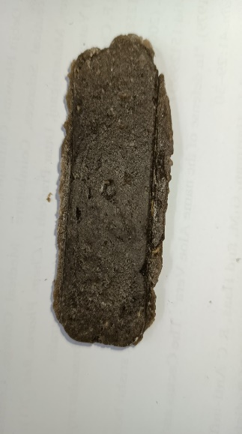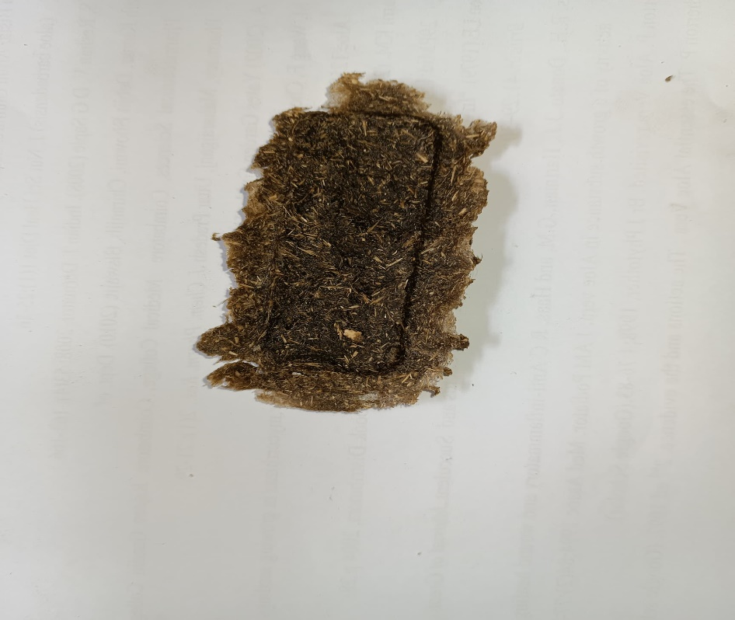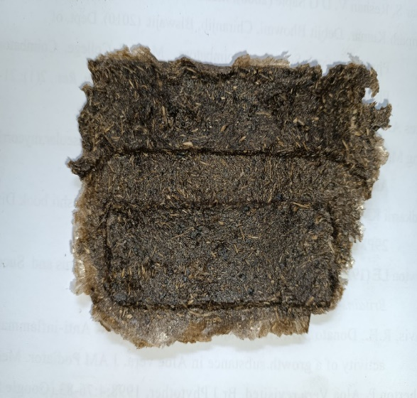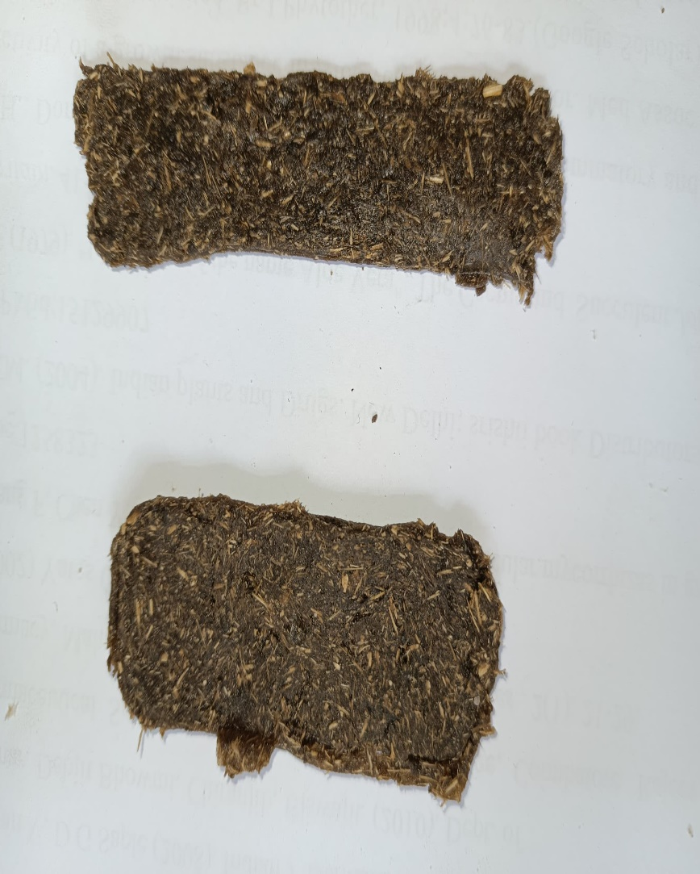
A
F
E
C
B
D

Figure 1: Synthesized bioplastic films.
Where A=bio-plastic formulated from cassava peels starch, B = bioplastic formulated from false yam tubers starch, C=bioplastic formulated from an equal combination of false yam tubers starch and cassava peels starch, D= 75% cassava peel starch and 25% fibre, E= bioplastic formulated from a combination of false yam tubers starch and 25% fibre reinforcement, F=75% equal volume of cassava peel starch and false yam tubers and 25% fibre reinforcement.
Table 1: Showing the thickness, absorbance and opacity of various formulated Bio-plastic films.
 | Thickness (mm) | Absorbance | Opacity
Samples
C₀ | 1.81 ± 0.09ª | 2.85 ± 0.07ª | 1.57 ± 0.02ª
F₀ | 1.77 ± 0.04ª | 2.82 ± 0.09ª | 1.59 ± 0.05ª
CF₀ | 1.88 ± 0.05ª | 2.99 ± 0.06ª | 1.59 ± 0.03ª
C_{2.5} | 1.90 ± 0.05ª | 3.97 ± 0.05^{b} | 2.09 ± 0.05^{b}
F_{2.5} | 1.80 ± 0.02ª | 3.91 ± 0.09^{b} | 2.17 ± 0.07^{b}
CF_{2.5} | 1.80 ± 0.03ª | 3.94 ± 0.08^{b} | 2.19 ± 0.06^{b}
Values bearing different alphabet letters per column are statistically significant (p<0.05) of bio-plastic films made from cassava peels and false yam tubers and reinforced with bamboo fibre. Where C0=bio-plastic formulated from cassava peels starch, F0 = bio-plastic formulated from false yam tubers starch, CF0=bio-plastic formulated from an equal combination of false yam tubers starch and cassava peels starch, F2.5= a combination of false yam tubers starch and 25% fibre reinforcement. C2.5 = 75% cassava peel starch and 25% fibre, CF2.5=75% equal volume of cassava peel starch and false yam tubers and 25% fibre reinforcement.

Table 2. Mechanical properties of synthesized bioplastic films.
Test | UTS*, (N/mm²) | Yield strength  (x 10⁻¹ N/mm²) | Young's Modulus | % Elongation
C₀ | 4.85 ± 0.12ª | 0.35 ± 0.03ª | 5.56 ± 0.11ª | 20.34 ± 0.67ª
F₀ | 2.59 ± 0.17^{b} | 0.20 ± 0.01^{bc} | 3.24 ± 0.16^{bd} | 19.53 ± 0.22ª
CF₀ | 3.91 ± 0.11^{c} | 0.20 ± 0.01^{bc} | 14.33 ± 0.29^{c} | 22.22 ± 0.20^{b}
C_{2.5} | 3.22 ± 0.15^{d} | 0.17 ± 0.04^{bc} | 3.19 ± 0.88^{bd} | 15.68 ± 0.76^{c}
F_{2.5} | 2.86 ± 0.10^{bd} | 0.26 ± 0.02^{ac} | 14.25 ± 0.50^{c} | 13.89 ± 0.42^{d}
CF_{2.5} | 2.13 ± 0.28e | 0.61 ± 0.05^{b} | 4.13 ± 0.25^{b} | 11.19 ± 0.32^{ef}

Values are mean ± standard deviation of triplicate determinations. Values bearing different alphabet letters per column are statistically significant (p<0.05). UTS* (N/mm²) of bio-plastic films made from cassava peels and false yam tubers. Where C₀=bio-plastic formulated from cassava peels starch, F₀ = bio-plastic formulated from false yam tubers starch, CF₀=bio-plastic formulated from an equal combination of false yam tubers starch and cassava peels starch, F_{2.5}= a combination of false yam tubers starch and 25% fibre reinforcement. C_{2.5} = 75% cassava peel starch and 25% fibre, CF_{2.5}=75% equal volume of cassava peel starch and false yam tubers and 25% fibre reinforcement.

Figure 2: Showing the Ultimate Tensile strength of synthesized bioplastic films
UTS* is Ultimate tensile strength (N/mm²) of bioplastic films made from cassava peels and false yam tubers starch, reinforced with bamboo fibre. Bars are mean ± standard deviation of triplicate determinations. Bars bearing different alphabet letters per column are statistically significant (p<0.05). Where C₀=bioplastic formulated from cassava peels starch, F₀ =bioplastic formulated from false yam tubers starch, CF₀=bioplastic formulated from an equal combination of false yam tubers starch and cassava peels starch, F_{2.5}= a combination of false yam tubers starch and 25% fibre reinforcement. C_{2.5} = 75% cassava peel starch and 25% fibre, CF_{2.5}=75% equal volume of cassava peel starch and false yam tubers and 25% fibre reinforcement.C₀ presented a significantly higher ultimate tensile strength compared to other synthesized bioplastic film, CF_{2.5} had the lowest ultimate tensile strength.
Figure 3: Young’s Modulus of bioplastic films made from cassava peels and false yam tubers and reinforced with bamboo fibre.
Bars are mean ± standard deviation of triplicate determinations. Bars bearing different alphabet letters per column are statistically significant (p<0.05). Where C₀=bio-plastic formulated from cassava peels starch, F₀ = bio-plastic formulated from false yam tubers starch, CF₀=bio-plastic formulated from an equal combination of false yam tubers starch and cassava peels starch, F_{2.5}= a combination of false yam tubers starch and 25% fibre reinforcement. C_{2.5} = 75% cassava peel starch and 25% fibre, CF_{2.5}=75% equal volume of cassava peel starch and false yam tubers and 25% fibre reinforcement.

Figure 4: Percentage elongation of synthesized bioplastic films.
Bars are mean ± standard deviation of triplicate determinations. Bars bearing different alphabet letters per column are statistically significant (p<0.05). Where C₀=bio-plastic formulated from cassava peels starch, F₀ = bio-plastic formulated from false yam tubers starch, CF₀=bio-plastic formulated from an equal combination of false yam tubers starch and cassava peels starch, F_{2.5}= a combination of false yam tubers starch and 25% fibre reinforcement. C_{2.5} = 75% cassava peel starch and 25% fibre, CF_{2.5}=75% equal volume of cassava peel starch and false yam tubers and 25% fibre reinforcement.

Figure 5: Thickness of synthesized bioplastic films
Bars are mean ± standard deviation of triplicate determinations. Bars bearing different alphabet letters per column are statistically significant (p<0.05). Where C₀=bioplastic formulated from cassava peels starch, F₀ = bioplastic formulated from false yam tubers starch, CF₀=bioplastic formulated from an equal combination of false yam tubers starch and cassava peels starch, F_{2.5}= a combination of false yam tubers starch and 25% fibre reinforcement. C_{2.5} = 75% cassava peel starch and 25% fibre, CF_{2.5}=75% equal volume of cassava peel starch and false yam tubers and 25% fibre reinforcement.
The thickness of the synthesized bioplastic films ranged from 1.5-2mm without any significant difference among them which indicated that the bioplastic films were consistently molded.

Figure 6: Absorbance of synthesized bioplastic films
Bars are mean ± standard deviation of triplicate determinations. Bars bearing different alphabet letters per column are statistically significant (p<0.05). Where C₀=bio-plastic formulated from cassava peels starch, F₀ = bio-plastic formulated from false yam tubers starch, CF₀=bio-plastic formulated from an equal combination of false yam tubers starch and cassava peels starch, F_{2.5}= a combination of false yam tubers starch and 25% fibre reinforcement. C_{2.5} = 75% cassava peel starch and 25% fibre, CF_{2.5}=75% equal volume of cassava peel starch and false yam tubers and 25% fibre reinforcement.

The absorbance varies significantly among the samples with lower absorbance reported among samples without the banboo fibre reinforcement (C₀), (F₀) and (CF₀) with values ranging between 2.82 to 2.99. Higher absorbance was reported among sample with bamboo fibre reinforcement (C_{2.5}), (F_{2.5}), (CF_{2.5}) with values ranging between 3.91-3.97. This suggests that the samples with reinforcement are more effective in absorbing light compared to samples without reinforcement.

Figure 7: Opacity of synthesized bioplastic films
Bars are mean ± standard deviation of triplicate determinations. Bars bearing different alphabet letters per column are statistically significant (p<0.05). Where C₀=bio-plastic formulated from cassava peels starch, F₀ = bio-plastic formulated from false yam tubers starch, CF₀=bio-plastic formulated from an equal combination of false yam tubers starch and cassava peels starch, F_{2.5}= a combination of false yam tubers starch and 25% fibre reinforcement. C_{2.5} = 75% cassava peel starch and 25% fibre, CF_{2.5}=75% equal volume of cassava peel starch and false yam tubers and 25% fibre reinforcement.

Opacity follows a similar trend to absorbance :Lower Opacity: ( C0 ), ( F0 ), ( C F0 ) with values around 1.57 to 1.59.Higher Opacity: ( C2.5 ), ( F2.5 ), ( CF2.5 ) with values around 2.09 to 2.19.Higher opacity values indicate that samples ( C2.5 ), ( F2.5 ), and ( CF2.5) are less transparent.

Figure 8. Percentage water absorption capacity of bioplastic films at 30°C for 60minutes.
Where C₀=bio-plastic formulated from cassava peels starch, F₀ = bio-plastic formulated from false yam tubers starch, CF₀=bio-plastic formulated from an equal combination of false yam tubers starch and cassava peels starch, F_{2.5}= a combination of false yam tubers starch and 25% fibre reinforcement. C_{2.5} = 75% cassava peel starch and 25% fibre, CF_{2.5}=75% equal volume of cassava peel starch and false yam tubers and 25% fibre reinforcement.

At 30°C, C0 showed a gradual increase in water absorption, peaking at 45 minutes (2.7922%) and then decreasing. F0 showed similar behavior with a peak at 45 minutes (1.7500%). CF0 peaked at 60 minutes (1.8581%), indicating a delayed maximum absorption. C2.5 and F2.5 showed consistent increases, with C2.5 peaking at 55 minutes (1.7986%) and F2.5 at 45 minutes (2.0182%). CF2.5 peaked earlier at 30 minutes (1.6984%). Which was considered unusual.

Figure 9: Percentage water absorption capacity of bioplastic films at 40°C for 60minutes.
Where C₀=bio-plastic formulated from cassava peels starch, F₀ = bio-plastic formulated from false yam tubers starch, CF₀=bio-plastic formulated from an equal combination of false yam tubers starch and cassava peels starch, F_{2.5}= a combination of false yam tubers starch and 25% fibre reinforcement. C_{2.5} = 75% cassava peel starch and 25% fibre, CF_{2.5}=75% equal volume of cassava peel starch and false yam tubers and 25% fibre reinforcement.

At 40°C, C0 showed a peak at 35 minutes (2.7314%). F0 peaked at 55 minutes (2.0143%). CF0 peaked at 35 minutes (2.1585%). C2.5 showed a steady increase, peaking at 60 minutes (2.2525%). F2.5 showed two peaks, at 45 minutes (1.8625%) and 55 minutes (2.0143%). CF _{2.5} peaked at 60 minutes (1.8222%).

Figure 10. Percentage water absorption capacity of bioplastic films at 50°c for 60minutes.
Where C₀=bioplastic formulated from cassava peels starch, F₀ = bioplastic formulated from false yam tubers starch, CF₀=bioplastic formulated from an equal combination of false yam tubers starch and cassava peels starch, F_{2.5}= a combination of false yam tubers starch and 25% fibre reinforcement. C_{2.5} = 75% cassava peel starch and 25% fibre, CF_{2.5}=75% equal volume of cassava peel starch and false yam tubers and 25% fibre reinforcement.
At 50°C, C0 showed a peak at 35 minutes (3.5367%). F0 peaked at 50 minutes (2.9443%). CF0 showed a steady increase, peaking at 45 minutes (2.9039%). C_{2.5} had a steady increase, peaking at 55 minutes (2.2570%). F_{2.5} showed multiple peaks, with the highest at 35 minutes (2.3592%). CF_{2.5} peaked at 40 minutes (3.1846%).

Figure 11. Percentage water absorption capacity of bioplastic films at 60°C for 60minutes.
Where C₀=bioplastic formulated from cassava peels starch, F₀ = bioplastic formulated from false yam tubers starch, CF₀=bioplastic formulated from an equal combination of false yam tubers starch and cassava peels starch, F_{2.5}= a combination of false yam tubers starch and 25% fibre reinforcement. C_{2.5} = 75% cassava peel starch and 25% fibre, CF_{2.5}=75% equal volume of cassava peel starch and false yam tubers and 25% fibre reinforcement.
At 60°C, C0 peaked at 30 minutes (3.9250%) and then dropped to 0%. F0 showed an initial peak at 20 minutes (2.8639%) and then decreased to 0%. CF peaked at 40 minutes (2.0311%) and then decreased. C_{2.5} showed a peak at 35 minutes (3.8511%) and then dropped. F_{2.5} showed a peak at 35 minutes (2.8996%) and then decreased. CF_{2.5} peaked at 35 minutes (3.5206%).
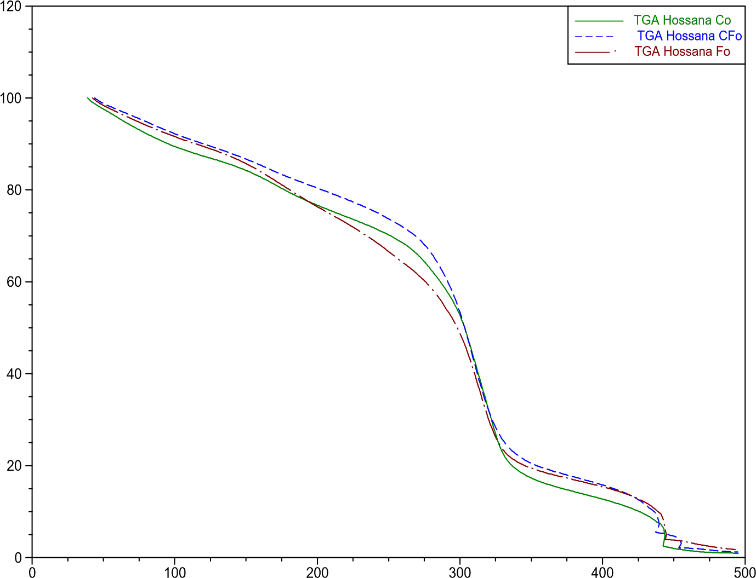
% Weight
Temperature (°C)
Figure 12. Thermogrametric analysis curves of synthesized bioplastic films.
Where C₀= Bioplastic film synthesized from cassava peels starch, F₀= Bioplastic film formulated from false yam starch and Cf₀= Bioplastic film formulated from equal combination of false yam starch and cassava peel starch. The three samples of bioplastic films all followed the same pattern of decomposition with sample CF₀ having a relatively higher percentage weight loss the samples behaved exactly the same way from 300ºC to 350ºC.

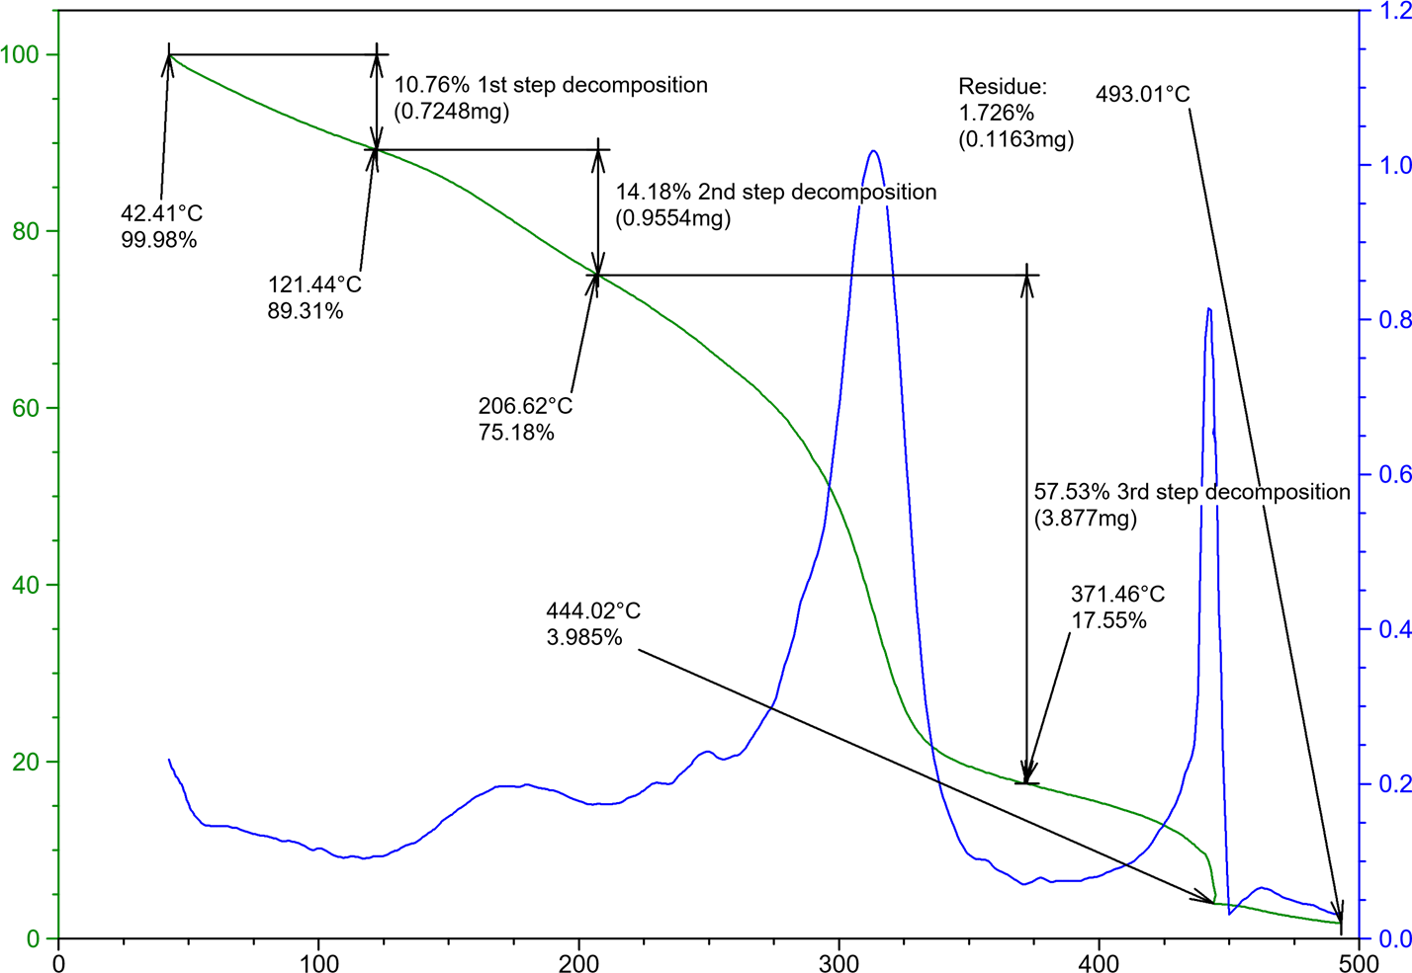
% Weight Loss
Derivative weight (%/min)
Temperature (°c)
FIGURE 13. Thermogravimetric analysis curve and the derivative weight loss of synthesized bioplastic films.
The graph showed three decomposition stages which is typical to bioplastic films. Decomposition at stage one began at 42.41ºC, with a 99.98% mass remaining, a 10.76% mass loss occurred at 121.44ºC. The second decomposition stage involved a 14.18% mass loss at 206.62ºC, while at stage three there was a corresponding weight loss of 57.53% at 371.46ºC

Table 3. Bioactive compounds present in synthesized bioplastic films from cassava peel starch (C₀).
S/N | Retention Time | Bioactive Components | % Report
1 | 5.533 | 4-Mercaptophenol | 0.14
2 | 6.375 | 2(3H)-Furanone | 0.29
3 | 6.788 | Cyclobut-1-enylmethanol | 0.02
4 | 7.061 | 3(2H)-Pyridazinone, 6-methyl- | 0.28
5 | 7.240 | 7-Oxabicyclo[4.1.0]heptan-2-one, 6-methyl- | 0.20
6 | 8.238 | D-Fructose, 1-O-methyl- | 5.50
7 | 8.361 | (R*,R*)-5-Hydroxy-4-methyl-3-heptanone | 7.38
8 | 9.066 | n-Nonadecanol-1 | 0.78
9 | 9.455 | Cyclohexanecarboxylic acid, 4-methyl-, methyl ester | 0.75
10 | 9.717 | Carbonic acid, but-2-yn-1-yl pentadecyl ester | 0.57
11 | 10.065 | 2-Hexyn-1-ol | 0.37
12 | 10.194 | 2-Hexyn-1-ol | 0.39
13 | 10.588 | Dodecane, 1-fluoro- | 4.83
14 | 10.949 | 3-Deoxy-d-mannoic lactone | 1.43
15 | 11.451 | Oxazole, 5-hexyl-2,4-dimethyl- | 1.63
16 | 11.802 | (1R,2R,8aS)-2,4,4,7a-Tetramethyl-1-(3-oxobutyl)-trans-hydrindan-2-carboxylic acid | 0.66
17 | 12.077 | 3-Methyl-4-(phenylthio)-2-prop-2-enyl-2,5-dihydrothiophene 1,1-dioxide | 0.27
18 | 12.160 | 1-Dodecanol, 2-hexyl- | 0.48
19 | 12.369 | Styracitol | 0.30
20 | 12.615 | Undecanoic acid | 0.50
21 | 12.771 | Lactose | 0.23
22 | 12.888 | Oleic acid | 0.20
23 | 13.151 | Hexadecanoic acid, methyl ester | 1.16
24 | 13.287 | 2-Methyl-Z,Z-3,13-octadecadienol | 0.30
25 | 13.763 | 1,2-Benzenedicarboxylic acid, butyl 2-methylpropyl ester | 0.63
26 | 13.931 | n-Hexadecanoic acid | 4.34
27 | 14.475 | n-Hexadecanoic acid | 0.18
28 | 14.685 | 7,11-Hexadecadienal | 0.50
29 | 15.085 | Cyclopropaneoctanal, 2-octyl- | 0.06
30 | 15.359 | Trifluoroacetoxy hexadecane | 0.24
31 | 15.530 | trans-13-Octadecenoic acid, methyl ester | 1.45
32 | 15.891 | N-Furfuryl-N'-(benzyl)oxamide | 2.47
33 | 16.413 | Oleic acid | 4.34
34 | 16.686 | Octadecanoic acid | 1.87
35 | 17.008 | cis-7,cis-11-Hexadecadien-1-yl acetate | 0.34
36 | 17.681 | 9,12-Octadecadienoic acid (Z,Z)- | 0.07
37 | 18.197 | Hexadecenoic acid, Z-11- | 0.06
38 | 18.396 | 6-Octadecenoic acid, (Z)- | 0.10
39 | 18.684 | 9,12-Octadecadienoic acid (Z,Z)- | 0.14
40 | 18.807 | Oleic acid | 0.16
41 | 19.367 | 9,12-Octadecadienoic acid (Z,Z)- | 0.12
42 | 19.864 | Oleic acid | 0.31
43 | 20.088 | cis-7,cis-11-Hexadecadien-1-yl acetate | 0.00
44 | 20.384 | 6-Octadecenoic acid | 0.16
45 | 20.450 | Cis-13-6-Octadecenoic acid | 0.06
46 | 20.571 | Oleic acid | 0.03
47 | 20.771 | 9-Octadecenoic acid | 0.16
48 | 21.060 | 9,17-Octadecadienal, (Z)- | 0.18
49 | 21.168 | Oleic acid | 0.08
50 | 21.391 | Oleic acid | 0.21
51 | 21.491 | Oleic acid | 0.04
52 | 21.582 | Oleic acid | 0.04
53 | 21.897 | 9-Octadecenal, (Z)- | 1.12
54 | 22.162 | 6-Octadecenoic acid, (Z)- | 0.63
55 | 22.488 | Oleic acid | 0.21
56 | 22.598 | Oleic acid | 0.02
57 | 22.846 | Oleic acid | 0.42
58 | 23.106 | 6-Octadecenoic acid, (Z)- | 0.27
59 | 23.430 | Oleic acid | 0.21
60 | 23.500 | Oleic acid | 0.09
61 | 23.615 | 1,2-Benzisothiazole, 3-(hexahydro- 1H-azepin-1-yl)-, 1,1-dioxide | 0.03
62 | 23.712 | Oleic acid | 0.18
63 | 23.876 | Hexadecenoic acid, Z-11- | 0.17
64 | 24.012 | Oleic acid | 0.18
65 | 24.314 | 6-Octadecenoic acid, (Z)- | 0.61
66 | 24.570 | 2,3-Dihydroxypropyl elaidate | 0.45
67 | 24.636 | Oleic acid | 0.27
68 | 24.705 | Cyclopropaneoctanal, 2-octyl- | 0.16
69 | 24.834 | Oleic acid | 0.68
70 | 25.386 | n-Propyl 11-octadecenoate | 1.30
71 | 25.518 | Oleic acid | 0.22
72 | 25.607 | Succinic acid, di(2-methoxyphenyl) ester | 0.24
73 | 26.171 | Oleic acid | 2.55
74 | 26.296 | Oleic acid | 0.26
75 | 26.686 | Nickel, (.eta.-4-diallyl ether)-(2,4-dimethyl-3-pentylisonitrile) | 2.12
76 | 27.405 | Oleic acid | 7.02
77 | 27.622 | Propanamide, N-(3-methoxyphenyl)-2,2-dimethyl- | 1.40
78 | 27.771 | Propanamide, N-(3-methoxyphenyl)-2,2-dimethyl- | 0.45
79 | 27.821 | 4-Quinolinecarboxylic acid, 2-chloro- | 0.30
80 | 27.868 | Propanamide, N-(3-methoxyphenyl)-2,2-dimethyl- | 1.35
81 | 28.034 | 1H-Indole-2-carboxylic acid, 6-(4-ethoxyphenyl)-3-methyl-4-oxo-4,5,6,7-tetrahydro-, isopropyl ester | 1.22
82 | 28.240 | Benzo[h]quinoline, 2,4-dimethyl- | 0.84
83 | 28.323 | Thymol, TBDMS derivative | 1.53
84 | 28.759 | Pyridine-3-carboxamide, oxime, N-(2-trifluoromethylphenyl)- | 1.74
85 | 28.834 | 1H-Indole-2-carboxylic acid, 6-(4-ethoxyphenyl)-3-methyl-4-oxo-4,5,6,7-tetrahydro-, isopropyl ester | 0.86
86 | 29.263 | Ethyl 2-acetamido-3,3,3-trifluoro-2-(4-fluoroanilino)propionate | 3.36
87 | 29.574 | Thymol, TBDMS derivative | 0.41
88 | 29.858 | Thymol, TBDMS derivative | 0.56
89 | 30.246 | Acetamide, 2-chloro-N-(3-cyano-4,6-dihydro-4,4,6,6-tetramethylthieno[2,3-c]furan-2-yl)- | 1.98
90 | 30.344 | Heptasiloxane, 1,1,3,3,5,5,7,7,9,9,11,11,13,13-tetradecamethyl- | 1.54
91 | 30.685 | Thymol, TBDMS derivative | 2.52
92 | 31.015 | Propanamide, N-(4-methoxyphenyl)-2,2-dimethyl- | 0.59
93 | 31.134 | 2-Ethylacridine | 0.53
94 | 31.200 | Thymol, TBDMS derivative | 1.36
95 | 31.651 | Propanamide, N-(3-methoxyphenyl)-2,2-dimethyl- | 1.04
96 | 31.989 | Ethyl 2-acetamido-3,3,3-trifluoro-2-(2-fluoroanilino)propionate | 0.24
97 | 32.586 | Propanamide, N-(3-methoxyphenyl)-2,2-dimethyl- | 0.26
98 | 32.744 | Thymol, TBDMS derivative | 0.18
99 | 32.796 | Thymol, TBDMS derivative | 0.14
100 | 32.863 | 1-methyl-4-phenyl-5-thioxo-1,2,4-triazolidin-3-one | 0.23
101 | 33.065 | 3-Quinolinecarboxylic acid, 6,8-difluoro-4-hydroxy-, ethyl ester | 0.26
102 | 33.214 | Nickel, (.eta.-4-diallyl ether)-(2,4-dimethyl-3-pentylisonitrile) | 0.22
103 | 33.366 | Bisnorandrostane, 3,12-diacetoxy-17-(1-methyl-4-oxo-5-phenylpentyl)- | 0.21
104 | 33.780 | Pyridine-3-carboxamide, oxime, N-(2-trifluoromethylphenyl)- | 1.23
105 | 33.847 | Ethyl 2-(2-chloroacetamido)-3,3,3-trifluoro-2-(3-fluoroanilino)propionate | 0.85
106 | 34.149 | Propanamide, N-(4-methoxyphenyl)-2,2-dimethyl- | 0.21
107 | 34.566 | Stigmasterol | 5.32
108 | 35.522 | Propanamide, N-(3-methoxyphenyl)-2,2-dimethyl- | 0.06
109 | 35.594 | 2,6-Lutidine, 3,5-dichloro-4-cyclohexylthio- | 0.09
110

Bioplastic films synthesized from cassava peel starch (C₀) bioplastic films presented 110 bioactive compounds. (R*,R*)-5-Hydroxy-4-methyl-3-heptanone and Oleic acid had the highest percentage report of 7.38% and 7.02% with retention time of 8.238 minutes and 27.405 minutes respectively. Propanamide, N-(3-methoxyphenyl)-2,2-dimethyl- had the lowest percentage report of 0.01% with a retention time of 35.770 minutes.
Table 4: Bioactive compounds present in bioplastic film synthesized from false yam tuber starch (F₀).
S/N | Retention Time | Bioactive Components | % Report
1 | 6.755 | 2-Fluorobenzyl alcohol | 0.13
2 | 7.115 | (1S,2R,4R,7R)-4-Isopropyl-7-methyl -3,8-dioxatricyclo [5.1.0.02,4]octane | 0.26
3 | 7.942 | 1-Nitro-2-acetamido-1,2-dideoxy-d-mannitol | 0.90
4 | 8.586 | Butanoic acid, 3-hydroxy-, ethyl ester | 0.39
5 | 8.675 | 2H-Azepin-2-one, hexahydro-1-(hydroxymethyl)- | 0.34
6 | 9.908 | 6-Acetyl-.beta.-d-mannose | 0.15
7 | 10.206 | Undec-10-ynoic acid, undecyl ester | 0.25
8 | 10.466 | Cyclononene | 0.29
9 | 10.705 | Dodecyl propyl ether | 0.28
10 | 10.819 | Decanoic acid, 2,3-dihydroxypropyl ester | 0.13
11 | 11.068 | Undecylenic acid | 0.36
12 | 11.377 | n-Hexadecanoic acid | 0.16
13 | 11.460 | d-Lyxose | 0.22
14 | 12.076 | Undec-10-ynoic acid, tetradecyl ester | 0.14
15 | 12.381 | Cyclopentadecanone, 2-hydroxy- | 0.14
16 | 12.550 | Undec-10-ynoic acid, undecyl ester | 0.10
17 | 13.156 | Hexadecanoic acid, methyl ester | 0.36
18 | 13.893 | n-Hexadecanoic acid | 1.97
19 | 14.292 | Z,Z-4,16-Octadecadien-1-ol acetate | 0.45
20 | 14.477 | 3-Dodecen-1-ol | 0.22
21 | 14.829 | (S,Z)-Heptadeca-1,9-dien-4,6-diyn-3-ol | 1.42
22 | 15.184 | 9-Octadecenal | 0.01
23 | 15.246 | Cyclopropaneoctanal, 2-octyl- | 0.01
24 | 15.528 | 11-Octadecenoic acid, methyl ester | 1.11
25 | 15.886 | Methyl stearate | 0.31
26 | 16.113 | cis-9,10-Epoxyoctadecan-1-ol | 0.12
27 | 16.406 | cis-13-Octadecenoic acid | 2.37
28 | 16.676 | Octadecanoic acid | 0.90
29 | 16.955 | Cyclopropaneoctanal, 2-octyl- | 0.37
30 | 17.714 | 11-Dodecen-1-ol trifluoroacetate | 0.16
31 | 17.768 | Cyclopropaneoctanal, 2-octyl- | 0.03
32 | 17.910 | 1,3,12-Nonadecatriene | 0.22
33 | 18.012 | Oleic acid | 0.08
34 | 18.431 | E-11-Hexadecenal | 0.16
35 | 18.610 | 9,17-Octadecadienal, (Z)- | 0.22
36 | 18.856 | Cyclopropaneoctanal, 2-octyl- | 0.09
37 | 18.902 | Oleic acid | 0.04
38 | 18.997 | (Z)-Tetradec-11-en-1-yl 2,2,2-trifluoroacetate | 0.02
39 | 19.124 | Oleic acid | 0.23
40 | 19.363 | Oleic acid | 0.06
41 | 19.447 | Oleic acid | 0.05
42 | 19.840 | 9-Octadecenoic acid, (E)- | 0.11
43 | 20.178 | Oleic acid | 0.16
44 | 20.502 | Oleic acid | 0.09
45 | 20.780 | Oleic acid | 0.07
46 | 20.871 | 6-Octadecenoic acid, (Z)- | 0.01
47 | 21.134 | 1-Cyclohexylnonene | 0.15
48 | 21.211 | Oleic acid | 0.03
49 | 21.517 | 6-Octadecenoic acid, (Z)- | 0.06
50 | 21.575 | 6-Octadecenoic acid, (Z)- | 0.22
51 | 21.960 | Oleic acid | 0.06
52 | 22.238 | 6-Octadecenoic acid, (Z)- | 0.33
53 | 22.536 | Propyleneglycol monoleate | 0.36
54 | 22.821 | 9-Octadecenoic acid (Z)-, 2-hydroxy-1-(hydroxymethyl)ethyl ester | 0.13
55 | 22.924 | Oleic acid | 0.14
56 | 23.210 | 9-Octadecenoic acid (Z)-, 2-hydroxy-1-(hydroxymethyl)ethyl ester | 0.21
57 | 24.000 | Acetamide, 2-chloro-N-(3-cyano-4,6 -dihydro-4,4,6,6-tetramethylthieno[2,3-c]furan-2-yl)- | 0.82
58 | 25.610 | Anthracene, 9-(2-propenyl)- | 6.79
59 | 25.777 | 1H-Indene, 2-butyl-5-hexyloctahydro- | 1.13
60 | 25.970 | Pyridine-3-carboxamide, oxime, N-(2-trifluoromethylphenyl)- | 0.77
61 | 26.143 | 2,6-Lutidine, 3,5-dichloro-4-cyclohexylthio- | 1.35
62 | 27.467 | 1H-Indene, 2-butyl-5-hexyloctahydro- | 25.02
63 | 28.294 | 2-Ethylacridine | 3.28
64 | 28.780 | Thymol, TBDMS derivative | 5.02
65 | 29.170 | Thymol, TBDMS derivative | 2.28
66 | 29.470 | Acetamide, 2-chloro-N-(3-cyano-4,6-dihydro-4,4,6,6-tetramethylthieno[2,3-c]furan-2-yl)- | 5.67
67 | 29.843 | Thymol, TBDMS derivative | 1.72
68 | 30.337 | Acetamide, 2-chloro-N-(3-cyano-4,6-dihydro-4,4,6,6-tetramethylthieno[2,3-c]furan-2-yl)- | 5.19
69 | 30.597 | Demecolcine | 1.41
70 | 30.796 | Benzo[h]quinoline, 2,4-dimethyl- | 2.95
71 | 31.356 | 6-Chloro-1-ethyl-4-oxo-N-(pyridin-4-ylmethyl)quinoline-3-carboxamide | 2.86
72 | 31.915 | Benzo[h]quinoline, 2,4-dimethyl- | 9.82
73 | 32.992 | Cyclopenteno[4.3-b]tetrahydrofuran, 3-[(4-methyl-5-oxo-3-phenylthio)tetrahydrofuran-2-yloxymethylene]- | 2.11
74 | 33.695 | Propanamide, N-(3-methoxyphenyl)-2,2-dimethyl- | 2.59
75 | 34.510 | 1,2-Benzenediol, 3,5-bis(1,1-dimethylethyl)- | 2.63
76 | 35.168 | Cyclopenteno[4.3-b]tetrahydrofuran, 3-[(4-methyl-5-oxo-3-phenylthio)tetrahydrofuran-2-yloxymethylene]- | 0.19
77 | 35.312 | 1H-Indole-2-carboxylic acid, 6-(4-ethoxyphenyl)-3-methyl-4-oxo-4,5,6,7-tetrahydro-, isopropyl ester | 0.17
78 | 35.425 | Thymol, TBDMS derivative | 0.28

The Table 4. presented 78 bioactive compounds for bioplastic film synthesized from false yam tuber starch (F0). 1H-Indene, 2-butyl-5-hexyloctahydro-and Benzo[h]quinoline, 2,4-dimethyl-had significantly high % reports of 25.02% and 9.82% respectively.

Table 5: Bioactive compounds present in bioplastic film synthesized from starch extract of cassava peels and false yam tuber (CF₀).
S/N | Retention Time | Bioactive Components | % Report
1 | 8.120 | Hexadecane | 0.39
2 | 8.926 | Methyl tetradecanoate | 0.29
3 | 10.821 | Tetradecanal | 0.60
4 | 12.280 | 2-Heptadecanone | 1.30
5 | 12.676 | Hexadecanoic acid, methyl ester | 0.79
6 | 13.818 | n-Hexadecanoic acid | 15.90
7 | 15.142 | 9,12-Octadecadienoic acid (Z,Z)- | 1.72
8 | 15.425 | 9-Octadecenoic acid, methyl ester, (E)- | 2.70
9 | 15.755 | Methyl stearate | 0.40
10 | 16.614 | trans-13-Octadecenoic acid | 63.90
11 | 17.682 | 9,17-Octadecadienal, (Z)- | 3.12
12 | 19.692 | Oleic acid | 0.89
13 | 20.378 | 9-Octadecenal, (Z)- | 0.40
14 | 21.127 | 2-Methyl-Z,Z-3,13-octadecadienol | 1.27
15 | 24.150 | Oleic acid | 0.40
16 | 27.057 | Erucic acid | 2.59
17 | 30.006 | Z-2-Octadecen-1-ol | 0.93
18 | 30.256 | Oleic acid | 1.17
19 | 33.585 | Oleic acid | 0.85
20 | 34.956 | Oleic acid | 0.38

The result presented 20 bioactive compounds for bioplastic film synthesized from starch extract of cassava peels and false yam tuber (CF0). A remarkably high % report was observed for trans-13-Octadecenoic acid (63.90%) and n-Hexadecanoic acid (15.90%) with retention time of 16.614min. and 13.818min. respectively

Table 6: FTIR identified functional groups of synthesized bioplastic film (F₀).
Wavelength (cm⁻¹) | Peak Area | Functional Group | Intensity | Interpretation
745 | 16 | C-H bending | Weak | Indicates the presence of alkane or aromatic structures, possibly C-H bending vibrations.
844 | 63 | C-H bending (out-of-plane) | Medium | Suggests the presence of aromatic compounds, especially mono-substituted benzene rings due to out-of-plane C-H bending.
1302 | 75 | C-N stretching | Medium | Indicates the presence of primary or secondary amines, likely due to C-N stretching vibrations.
1432 | 75 | CH₂ bending | Medium | Suggests alkane structures due to CH₂ bending vibrations.
1820 | 186 | C=C stretching | Strong | Indicates the presence of alkenes or aromatic compounds due to C=C stretching vibrations.
1991 | 166 | C≡C stretching | Strong | Indicates strongly the presence of alkynes due to C≡C.
2208 | 141 | C≡N stretching | Strong | Suggests the presence of nitriles due to C≡N stretching vibrations.
2509 | 91 | S-H stretching | Medium | Indicates the presence of thiols due to S-H stretching vibrations.
2741 | 184 | C-H stretching | Strong | Strong peak suggests the presence of aldehydes due to C-H stretching vibrations.
2919 | 177 | C-H stretching | Strong | Indicates the presence of alkanes due to C-H stretching vibrations.
3341 | 138 | N-H stretching  Possible | Strong | Suggests the presence of amines due to N-H stretching vibrations.
3438 | 19 | O-H stretching (broad) | Weak | Broad peak indicates the presence of alcohols or phenols due to O-H stretching vibrations.
3551 | 13 | O-H stretching | Weak | Indicates the presence of alcohols due to O-H stretching vibrations.
3815 | 10 | O-H stretching | Weak | Suggests the presence of free O-H groups in alcohols due to O-H stretching.
3884 | 11 | O-H stretching | Weak | Indicates the presence of alcohols due to O-H stretching vibrations.

Table7: FTIR identified functional groups of synthesized bioplastic film (C₀).
Wavelength (cm⁻¹) | Peak Area | Functional Group | Intensity | Interpretation
762 | 55 | C-H bending | Medium | Indicates the presence of alkane or aromatic structures, possibly C-H bending vibrations.
1228 | 125 | C-O stretching | Strong | Suggests the presence of alcohols, ethers, or esters due to C-O stretching vibrations.
1435 | 22 | CH₂ bending | Weak | Suggests alkane structures due to CH₂ bending vibrations.
1622 | 40 | C=C stretching | Medium | Indicates the presence of alkenes or aromatic compounds due to C=C stretching vibrations.
1841 | 207 | C=O stretching | Strong | Strongly indicates the presence of anhydrides or ketones due to C=O stretching vibrations.
1933 | 455 | C=O stretching | Very Strong | Very strong peak indicating the presence of anhydrides or other carbonyl-containing compounds due to C=O stretching vibrations.
2455 | 106 | S-H stretching | Strong | Indicates the presence of thiols due to S-H stretching vibrations.
2695 | 158 | C-H stretching | Strong | Suggests the presence of aldehydes due to C-H stretching vibrations.
2810 | 124 | C-H stretching | Strong | Indicates the presence of aldehydes or other hydrocarbons due to C-H stretching vibrations.
2997 | 144 | C-H stretching | Strong | Suggests the presence of alkanes due to C-H stretching vibrations.
3395 | 66 | O-H stretching | Medium | Indicates the presence of alcohols or phenols due to O-H stretching vibrations
3512 | 67 | O-H stretching | Medium | Suggests the presence of alcohols or phenols due to O-H stretching vibrations.

Table 8: FTIR identified functional groups of synthesized bioplastic film (CF₀).
Wavelength (cm⁻¹) | Peak Area | Functional Group | Intensity | Interpretation
809.66 | 66 | C-H (aromatic) Out-of-plane bending | Weak | Indicates the presence of aromatic compounds due to the low peak area.
1270 | 24 | C-O stretching | Very Weak | Stretching in alcohols, ethers, indicates a very weak presence of alcohols or ethers.
1385 | 71 | C-H (alkane) | Weak | Bending vibrations, indicates the presence of alkanes
1444 | 61 | C=C (aromatic) | Weak | Stretching in aromatics, indicates the presence of aromatic rings
1868 | 152 | C=O (anhydrides) | Strong | Indicates a strong presence of anhydrides
1968 | 215 | C=O (ketones) | Strong | Indicates a strong presence of ketones.
2079 | 20 | C≡C (alkyne) | Very Weak | Indicates a very weak presence of alkynes.
2160 | 83 | C≡N (nitriles) | Weak | Indicates the presence of nitriles with weak intensity.
2465 | 18 | C-H (alkyne) | Very Weak | Stretching vibrations, indicates a very weak presence of alkynes.
2589 | 137 | S-H (thiol) | Medium | Stretching vibrations, indicates a medium presence of thiols.
2790 | 94 | C-H (aldehyde) | Weak | Indicates the presence of aldehydes.
2914 | 83 | C-H (alkane)  Stretching | Weak | Indicates the presence of alkanes.
3034 | 65 | O-H (alcohol | Weak | Indicates the presence of alcohols
3236 | 83 | N-H (amine) | Weak | Indicates the presence of amines
3351 | 92 | O-H stretching | Weak | Indicates the presence of carboxylic acids.

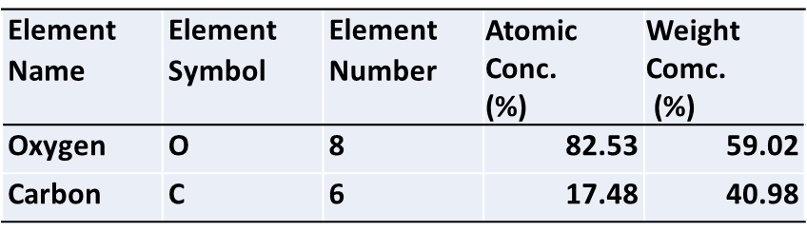
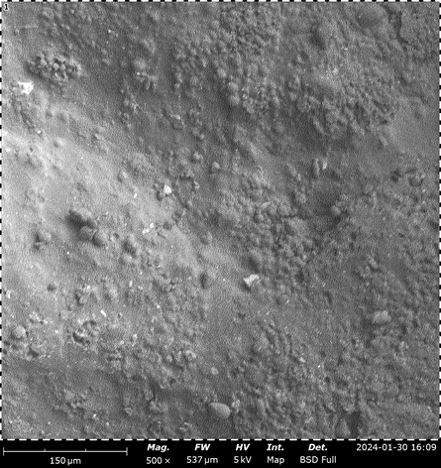
Figure 14: Scanning electron microscopy of synthesized bioplastic films from Cassava peel starch C₀ at 500x
The bioplastic film showed a cross-sectional areas of homogeneity and an area with slightly rough and porous texture having the individual granules clustered together, as seen in the outlined red circles on the micrograph. The table next to the image highlights the elemental composition of the bioplastic film, showing that it consists mainly of oxygen (82.53% atomic concentration) and carbon (17.48%) with a corresponding weight concentrations of 59.02% and 40.98% respectively

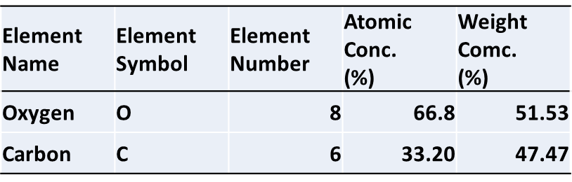
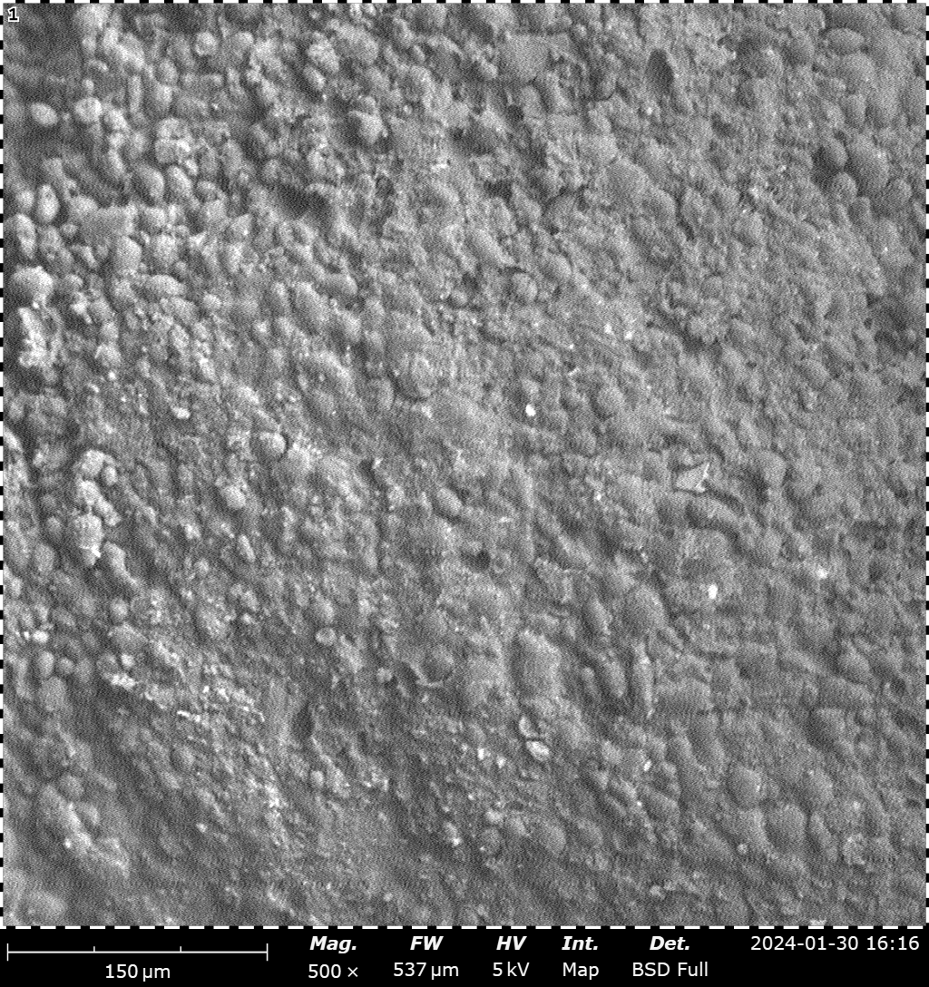
Figure 15: Scanning electron microscopy of synthesized bioplastic films from false yam starch F₀ at 500x.
The bioplastic film showed a cross-sectional areas of homogeneity and an area with slightly rough and porous texture having the individual granules clustered together, as seen in the outlined red circle on the top-left section of the image. The table next to the image highlights the elemental composition of the bioplastic film, showing that it consists mainly of oxygen (66.8% atomic concentration) and carbon (33.20%) with a corresponding weight concentrations of 55.53% and 47.47% respectively.

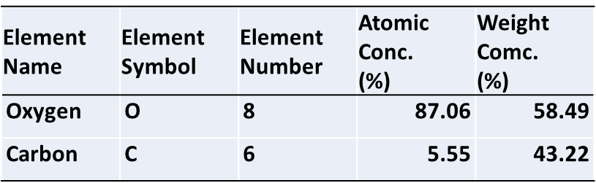
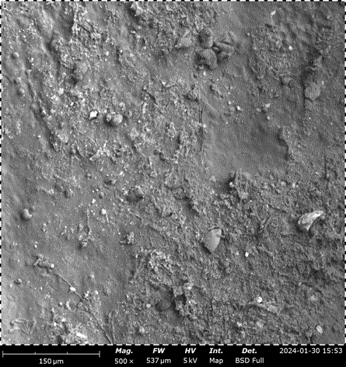
Figure 16: Scanning electron microscopy of synthesized bioplastic film from a combination of an equal amount of cassava peel starch and false yam starch (CF₀) at 500x

Figure 17: Percentage degradation of synthesized bioplastic, by soil burial method for 60 days.
C₀=bio-plastic formulated from cassava peels starch, F₀ = bio-plastic formulated from false yam tubers starch, CF₀=bio-plastic formulated from an equal combination of false yam tubers starch and cassava peels starch, F_{2.5}= a combination of false yam tubers starch and 25% fibre reinforcement. C_{2.5} = 75% cassava peel starch and 25% fibre, CF_{2.5}=75% equal volume of cassava peel starch and false yam tubers and 25% fibre reinforcement.

The graph summarized the percentage degradation of various bioplastic film formulations over a 60-day period. Seven samples were studied: conventional plastic, (C₀), (F₀), (CF₀), (C_{2.5}), (F_{2.5}), and (CF_{2.5}). Conventional Plastic showed negligible degradation throughout the 60-day period, with values staying as low as 0.44 ± 0.01%. This confirms the non-biodegradable nature of conventional plastic.

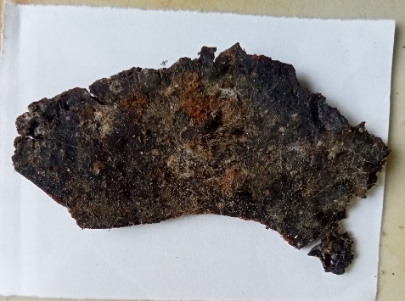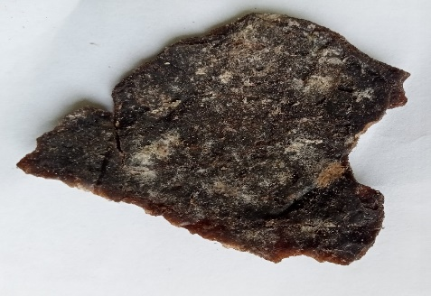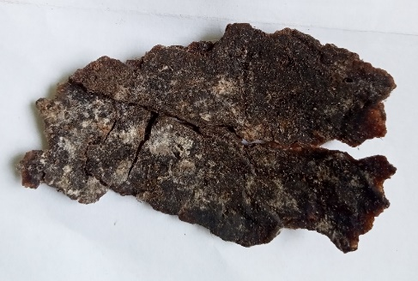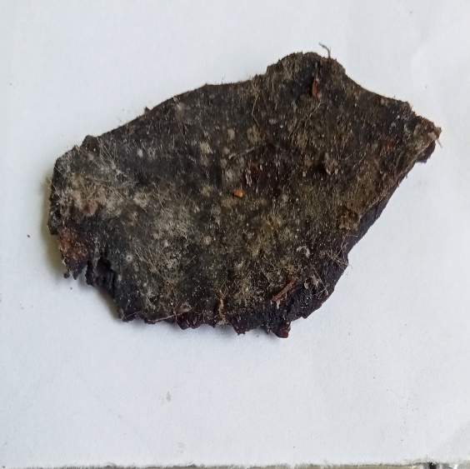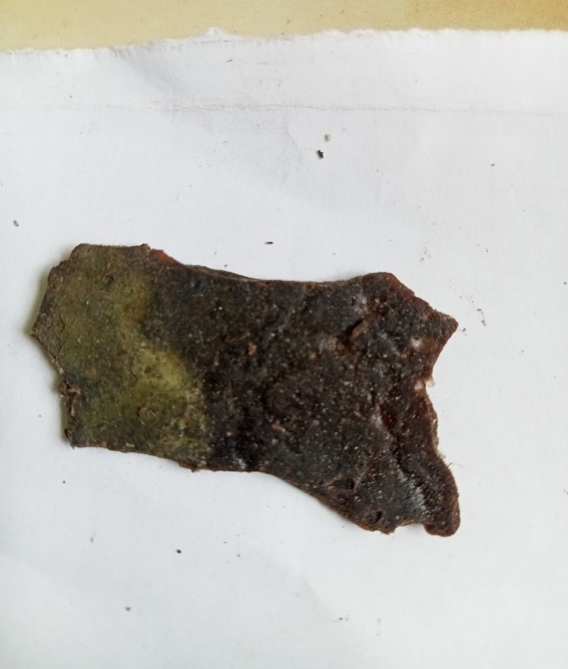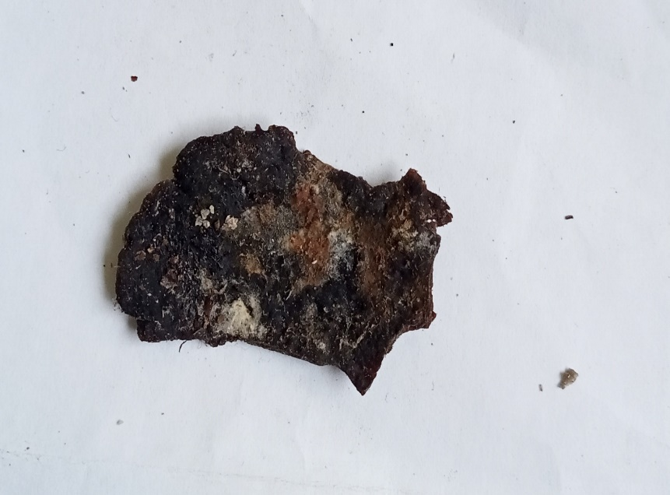
A
F
E
C
B
D
Figure 18: Degradation of bioplastic films after 60 days of soil burial
Where A=bioplastic formulated from cassava peels starch, B = bioplastic formulated from false yam tubers starch, C=bioplastic formulated from an equal combination of false yam tubers starch and cassava peels starch, D=a combination of false yam tubers starch and 25% fibre reinforcement. E = 75% cassava peel starch and 25% fibre, F=75% equal volume of cassava peel starch and false yam tubers and 25% fibre reinforcement.

3.2 Discussion of Result
3.2.1 Thickness, Absorbance and Opacity
Table 1 presented results for the thickness, absorbance and opacity of the formulated Bioplastic films. There was no significant differences in the thickness of the bioplastic films, this suggested that the sample preparation was quite consistent in terms of thickness.
The absorbance varied significantly among the samples with lower absorbance reported among samples without the fibre reinforcement (C₀), (F₀) and (CF₀) with values ranging between 2.82 to 2.99. Higher absorbance was reported among sample with bamboo fibre reinforcement (C_{2.5}), (F_{2.5}) and (CF_{2.5}) with values ranging between 3.91 and 3.97Au. This suggests that the samples with reinforcement have components that could absorb more light compared to samples without reinforcement.
Color and opacity of the biodegradable film are important measures for acceptability as packaging materials. Normally, for good visual presentation of products, films intended for packaging should have high gloss and low opacity. The values for opacity follows a similar trend to absorbance with lower opacity seen in (C₀), (F₀) and (CF₀) with values ranging from 1.57 to 1.59 while higher opacity was seen in (C_{2.5}), (F_{2.5}) and (CF_{2.5}) with values ranging from 2.09 to 2.19. The opacity values indicate that samples (C_{2.5}), (F_{2.5}), and (CF_{2.5}) are less transparent, which could explain their higher absorbance values.
Samples (C_{2.5}), (F_{2.5}), and (CF_{2.5}) have higher absorbance and opacity, indicating that they are less transparent and absorb more light compared to samples (C₀), (F₀), and (CF₀). Thicknesses are relatively consistent across all samples, suggesting that differences in absorbance and opacity are due to other factors, like the composition or treatment of the samples.
The results from Table 1 showed that the reduction of opacity was attributed to cross-linking of the starch molecules and the increased concentration of fibre reinforcement, which can decrease the crystallinity of starch with an eventual decrease in opacity. This is in agreement with the report of Bidari et al. (2023) on the effect of starch and glycerol concentration on film opacity.
3.2.2 Ultimate Tensile Strength (UTS)
The ultimate tensile strength measures the maximum stress that a material can withstand while being stretched before breaking. As presented in
Table 2. The highest UTS was observed in sample C₀, with a value of (4.85±0.12 N/mm2) within the range of what Karnwal et al., (2025) reported for potato starch films indicating exceptional uniformity and consistency in the sample C0 matrix. Conversely, sample CF_{2.5} exhibited the lowest UTS at (2.13 ± 0.28 N/mm²), suggesting a failure in the load transfer, likely cause by poor interfacial compatibility of the fibre and the starch. The UTS values for F₀, CF₀, C_{2.5}, and F_{2.5}, are 2.59 ± 0.17, 3.91 ± 0.11, 3.22 ± 0.15, and 2.86 ± 0.10 respectively. The values for C_{0,} F₀, CF₀, C_{2.5}, F_{2.5} and CF_{2.5} are higher than that report by Loo and Sarbon (2020) on gelatin-based films cross-linked with tapioca starch. A general trend observed was the decrease in UTS as the concentration of added fibre increased from 0 to 2.5g in the Cassava peel starch formulated bioplastic films, suggesting that higher concentrations may lead to weaker tensile properties. This this poor tensile strength may be attributed to discontinuities in the polymer matrix caused by the increased concentration of added fibre for reinforcement.
3.2.3 Yield Strength
Yield strength.is the stress at which a material begins to deform plastically. Sample CF₀ demonstrated the highest yield strength of (0.61 ± 0.05 N/mm²) as presented in Table 2. Suggests excellent resistance to plastic deformation. In contrast, sample CF₂.₅ had the lowest yield strength at (0.17 ± 0.04 N/mm²), reflecting poor deformation resistance. Sample F₀, and F_{2.5} showed an increase in yield strength with increase in the concentration fibre added, while the C₀ and CF₀ series displayed more variability, with CF_{2.5} having a notable increase in yield strength compared to its counterparts. This increase in yield strength in the F series can be attributed to the enhanced interaction between the polymer chains and the reinforcing fibre at higher concentrations, which restricts plastic deformation
3.2.4 Young’s Modulus
Young’s modulus measures the stiffness of a material. Sample CF₀ exhibited the highest Young’s modulus of (14.33±0.29 N/mm²) as presented in Table 2. Is similar to the values reported Karnwal et al., (2025) for potato and maize starch films, indicating significant rigidity. On the other hand, sample C_{2.5} had the lowest Young’s modulus at (3.19 ± 0.88 N/mm²), suggesting it is the most flexible among the samples. In the bioplastic films formulated with the combination of cassava peels starch and the false yam tuber starch, at zero concentration of added fibre (CF₀) was notably stiffer than the other samples, with stiffness generally decreasing with higher concentrations, especially in the false yam tuber starch formulated bioplastic films. The high stiffness of CF₀ could be attributed to the strong bonding and uniform distribution of the reinforcing fibre within the polymer matrix, which enhances the overall rigidity. In contrast, the decrease in stiffness at higher concentrations might be due to agglomeration of the reinforcing fibre, leading to less efficient stress transfer between the polymer matrix and the fibre.
3.2.5 Percentage Elongation at Break (EB)
Elongation at break assesses the flexibility and stretch ability of films; it represents the film elongation from the initial length to the breaking point. It is an important property because it evaluates the ability of a film to stretch and resist breakage during mechanical manipulation in industrial process. Figure 6 presented the percentage elongation at break result of synthesized bioplastic. The percentage elongation of samples C₀, F₀, CF₀, C_{2.5}, F_{2.5}, and CF_{2.5} are 20.34 ± 0.67%, 19.53 ± 0.22%, 22.22 ± 0.20%, 15.68 ± 0.76%, 13.89 ± 0.42%, 11.19 ± 0.32%, and 10.05 ± 0.49%, respectively. These values are less than the approximately 50 to 90 percent elongation at break for gelatin films cross-linked with tapioca starch reported by Loo and Sarbon (2020), but are similar to the approximately 10.21-22.71% reported by Cao and Song (2019) for non-conventional starch from loquat seed starch, gum karaya, oregano essential oil and tween 80.
3.2.6 Water Absorption
Water absorption is a critical parameter in evaluating the durability and stability of composite materials, especially in biocompatible applications where materials are exposed to aqueous environments such as in food packaging and drugs production. This study investigated the water absorption behavior of six composite materials (C₀, F₀, CF₀, C_{2.5}, _{F2.5}, and CF_{2.5}) at different temperatures (30°C, 40°C, 50°C, 60°C) over a period of 60 minutes, the percentage of water absorbed by each sample was recorded at 5-minute intervals.
At 30°C, C0 showed a gradual increase in water absorption, peaking at 45 minutes (2.7922%) and then decreasing. F₀ showed similar behavior with a peak at 45 minutes (1.7500%). CF₀ peaked at 60 minutes (1.8581%), indicating a delayed maximum absorption. C_{2.5} and F_{2.5} showed consistent increases, with C_{2.5} peaking at 55 minutes (1.7986%) and F_{2.5} at 45 minutes (2.0182%). CF2.5 peaked earlier at 30 minutes (1.6984%). Which was considered unusual. At 40°C, C0 showed a peak at 35 minutes (2.7314%). F₀ peaked at 55 minutes (2.0143%). CF₀ peaked at 35 minutes (2.1585%). C_{2.5} showed a steady increase, peaking at 60 minutes (2.2525%). F_{2.5} showed two peaks, at 45 minutes (1.8625%) and 55 minutes (2.0143%). CF_{2.5} peaked at 60 minutes (1.8222%). At 50°C, C0 showed a peak at 35 minutes (3.5367%). F0 peaked at 50 minutes (2.9443%). CF₀ showed a steady increase, peaking at 45 minutes (2.9039%). C_{2.5} had a steady increase, peaking at 55 minutes (2.2570%). F_{2.5} showed multiple peaks, with the highest at 35 minutes (2.3592%). CF_{2.5} peaked at 40 minutes (3.1846%). At 60°C, C₀ peaked at 30 minutes (3.9250%) and then dropped to 0%. F₀ showed an initial peak at 20 minutes (2.8639%) and then decreased to 0%. CF₀ peaked at 40 minutes (2.0311%) and then decreased. C_{2.5} showed a peak at 35 minutes (3.8511%) and then dropped. F_{2.5} showed a peak at 35 minutes (2.8996%) and then decreased. CF_{2.5} peaked at 35 minutes (3.5206%).
The report showed that, higher temperatures generally increase the water absorption rate initially. At 60°C, all samples showed a significant absorption drop after peaking, suggesting temperature-induced structural changes. All the bioplastic samples exhibited an initial increase in absorption, followed by a peak and then a decline. The time to peak absorption varied between samples and temperatures, with higher temperatures causing earlier peaks.
The water absorption behavior of composite materials is significantly influenced by both temperature and material composition. Higher temperatures accelerate the absorption process but can lead to structural changes that reduce long-term absorption capacity. The incorporation of fibre insignificantly decreases water absorption capacity of the film with fibre. These findings provide valuable insights for selecting appropriate composite materials for applications requiring exposure to aqueous environments.
3.2.7 Thermogravimetric Analysis (TGA)
TGA was done to investigate the thermal degradation and stability of synthesized bioplastic films. The decomposition of films (mg) as a function of temperature (℃) as displayed in Figure 12 and Figure 13. There were three steps in the thermal degradation of the films, as shown in TGA and DTG curves Figure.15. These three steps of thermal decomposition phenomena for most starch-based films were reported by
The first step of thermal decomposition of films happened below 42.41°C -121.44 ℃, which was approximately 0.7248mg mass loss, this was due to loss of moisture content from the films. Simultaneously, this step was also related to loss of mass that can also be attributed to the loss of the weak bond of water molecules as well as low molecular weight compounds in films. All films, including C₀, F₀ and CF₀, experienced the same situation.
The second step of thermal decomposition of synthesized bioplastic films happened in the range of 121.44°C- 206.62°C, with approximately 0.9554mg mass loss, which is related to the loss of glycerol compounds, including water molecules.
With further increase in the temperature, the DTG of the synthesized bioplastic films displayed two sharp peak at temperature range of 300-325°C, and 425- 450ºC leading to a weight loss of approximately 17.55% and 3.985% respectively, At a temperature of approximately 444.42ºC, there was a 3.985% mass loss of the bioplastic films, which displayed higher mass decomposition in the third step.
These results of thermal decomposition were in good agreement with the results of studies of Sanyang et al (2015),and Ilyas et al., 92018) who reported on G-plasticized sugar palm starch.
3.2.8 Film morphology (SEM)
The Figure 14. Scanning electron microscopic images of the cross-section of cassava peel starch bioplastic films (C₀) at 500× magnification. The image showed the formation of bioplastic films and the undissolved starch granules on the surface of the bioplastic. This suggests that the bioplastic films are rough and brittle. Although cross-sectional micrograph showed homogeneity on a large portion of the surface and below the surface of the film, the rough cross-sectioned structures might be attributed to low interfacial adhesion between cassava peel starch and glycerol plasticizer. A similar finding was observed by Abera et al., 2020 who reported that the biopolymers having 30% plasticizer were less homogeneous than 40% plasticized films. According to the result by the SEM-EDX of the film, carbon and oxygen were reported to be available in the cassava peel starch with a high atomic concentration of oxygen (82.53%) and a considerable amount of carbon (17.48%).
The Figure 15 presented the Scanning electron microscopic image of the cross-section of bioplastic films formulated with false yam tuber starch (F0) at 500× magnification, containing atomic concentration of oxygen and carbon of 66.8% and 33.2% respectively. The image showed the formation of bioplastic films and the on the surface of the bioplastic film revealing a rough and brittle film surface. Although Cross-section micrograph showed incomplete gelatinization at the regions marked with a circle but the homogeneity is consistent in a large portion of the surface area. In Figure 1. The rough cross-section structures might be attributed to low interfacial adhesion between false yam tuber starch, the cassava peel starch and glycerol plasticizer. According to the result of the SEM-EDX of the film, the atomic concentration are 87.06% and 5.55% for oxygen and carbon SEM-EDX micrograph reported to be presence of oxygen and carbon alone all films analyzed.
3.2.9 Soil burial degradation
Figure 17 and Figure 18 showed the percentage degradation of the various bioplastic film formulations over a 60-day period. Seven samples were studied: conventional plastic, (C₀), (F₀), (CF₀), (C_{2.5}), (F_{2.5}), and (CF_{2.5}). Conventional plastic showed negligible degradation throughout the 60-day period, with values staying as low as 0.44 ± 0.01%. This confirms the non-biodegradable nature of conventional plastic.
Bioplastic film samples without bamboo fibre (C₀), (F₀), (CF₀) exhibited significant degradation compared to conventional plastic. Cassava peel starch without fibers (C₀): started at 1.33 ± 0.01% degradation at day 5 and increased progressively to 43.52 ± 0.01% by day 60. False yam starch without fibers (F₀): started at 1.11 ± 0.02% degradation at day 5 and increased to 38.38 ± 0.04% by day 60. The combination of cassava and false yam starch without fibers (CF₀): showed higher initial degradation (1.78 ± 0.03% at day 5) compared to (C₀) and (F₀), reaching 42.44 ± 0.02% by day 60.
Bioplastic samples with 2.5% bamboo fiber (C_{2.5}), (F_{2.5}), (CF_{2.5}) had improved biodegradability of the bioplastic films. Cassava peel starch with 2.5% bamboo fiber (C_{2.5}) showed degradation from 1.11 ± 0.02% at day 5 to 36.64 ± 0.02% by day 60. False yam starch with 2.5% bamboo fiber (F_{2.5}), started at 0.89 ± 0.01% degradation and increased to 32.63 ± 0.04% by day 60. The combination of cassava peels and false yam tuber starch with 2.5% bamboo fiber (CF_{2.5}, exhibited the highest overall degradation, from 1.11 ± 0.02% at day 5 to 34.66 ± 0.01% by day 60.
In the initial degradation days (Day 5 to Day 10), All bioplastic formulations exhibited low initial degradation rates compared to subsequent days, indicating a period of adaptation or conditioning for microbial activity. In the mid-term degradation (Day 15 to Day 30, there was a noticeable increase in degradation rates. This period marked the most rapid increase in biodegradation for most samples, especially those containing bamboo fibers. In the long-term degradation duration (Day 35 to Day 60), degradation rates continued to increase but at a slower rate compared to the mid-term period. By day 60, all bioplastic formulations exhibited significantly higher degradation compared to conventional plastic.
The percentage degradability of synthesized bioplastic films, (C₀), (F₀), (CF₀), (C_{2.5}), (F_{2.5}), and (CF_{2.5}), are higher than the 14.2% of 110 days duration reported by Gómez and Michel (2013) for starch-based bioplastic films and but lower than the 96% degradation reported by Jangong, et al. (2019) for starch and chitosan blend.
4. CONCLUSION
In this study, the effects of bamboo fibre reinforcement on bioplastic films synthesized from cassava peels starch and false yam tubers starch, were investigated. Different formulated bioplastic films were studied based on their water barrier, mechanical, structural, thermal, and environmental properties.
Samples; bioplastic film synthesized from cassava peel starch with 25% bamboo fibre (C_{2.5}), bioplastic film synthesized from false yam tuber starch with 25% bamboo fibre (F_{2.5}), and the combination of an equal amount of cassava peel starch and false yam starch with 25% bamboo fibre (CF_{2.5}), have higher absorbance and opacity, indicating they are less transparent and absorbed more light compared to samples; cassava peel starch bioplastic film (C₀), false yam tuber starch bioplastic film (F₀), and the combination of an equal amount of cassava peel and false yam tuber starch (CF₀). Thicknesses are relatively consistent across all samples, suggesting that differences in absorbance and opacity are due to other factors, likely the composition or treatment of the samples.
The water absorption behavior of composite materials was significantly influenced by both temperature and material composition. Higher temperatures accelerate the absorption process but can lead to structural changes that reduce long-term absorption capacity. The bamboo fibre significantly reduce the water absorption capacity, with CF_{2.5} and F_{2.5} showing the highest reduced rate at elevated temperatures. These findings provide valuable insights for selecting appropriate composite materials for applications requiring exposure to aqueous environments.
Conventional plastic remains non-degradable, showing the necessity for biodegradable alternatives. Bioplastic films made from cassava and false yam starch, especially when reinforced with bamboo fibre, exhibited substantial biodegradation within 60 days. The addition of bamboo fiber enhanced the degradation rate, making these bioplastics more suitable for applications where environmental biodegradability is essential. This comprehensive analysis highlights the potential of bioplastics, particularly those reinforced with natural fibers, as viable eco-friendly alternatives to conventional plastics.
Therefore, non-conventional starch, and natural fibre from agro waste materials can serve as an alternative to conventional plastics, used as food packaging material.

.

COMPETING INTERESTS DISCLAIMER:
Authors have declared that they have no known competing financial interests OR non-financial interests OR personal relationships that could have appeared to influence the work reported in this paper.

References

“Authors have declared that no competing interests exist.”
Abel, O. M., Chinelo, S., & Chidioka, R. (2021). Enhancing Cassava Peels Starch as Feedstock for Biodegradable Plastic. Journal of Materials and Environmental Science, 12(02), 169–182.https://jmaterenvironsci.com/Document/vol12/vol12_N2/JMES-2021-12016-Abel.pdf
Alobi, N. O., Sunday, E. A., Magu, T. O., Oloko, G. O. & Nyong, B. K. (2017). Analysis of starch from non-edible root and tubers as sources of raw materials for the synthesis of biodegradable starch plastics. Journal of Basic Applied Research 3(1): 27 – 32.
Asgher, M., A., S., Bilal, M., & Iqbal, M. N. (2020). Bio-based active food packaging materials : Sustainable alternative to conventional petrochemical-based packaging materials. Food Research International, 137(August). https://doi.org/10.1016/j.foodres.2020.109625
Asgher, M., A., S., Bilal, M., & Iqbal, M. N. (2020). Bio-based active food packaging materials : Sustainable alternative to conventional petrochemical-based packaging materials. Food Research International, 137(August). https://doi.org/10.1016/j.foodres.2020.109625
Bidari, R., Abdillah, A. A., Ponce, R. A. B. & Charles, A. L. (2023). Characterization of Biodegradable Films Made from Taro Peel (Colocasia esculenta) Starch. Polymers, 15, 338. https://doi.org/10.3390/ polym15020338.
Cao, T. L., & Song, K. B. (2019). Effects of gum karaya addition on the characteristics of loquat seed starch films containing oregano essential oil. Food Hydrocolloids, 97. https://doi.org/10.1016/j.foodhyd.2019.105198.
Chandrasekar, C. M., Krishnamachari, H., Farris, S., & Romano, D. (2023). Development and characterization of starch-based bioactive thermoplastic packaging films derived from banana peels. Carbohydrate Polymer Technologies and Applications, 5(May), 100328. https://doi.org/10.1016/j.carpta.2023.100328
Emadian M.S., Onay T.T, & Demirel B. (2017). Biodegradation of Bioplastics in Natural Environments. Waste Management Review. 59, 526-536.
Henning, F. G., Ito, V. C., Demiate, I. M., & Lacerda, L. G. (2022). Non-conventional starches for biodegradable films: A review focusing on characterization and recent applications in food packaging. Carbohydrate Polymer Technologies and Applications, 100157. https://doi.org/10.1016/j.carpta.2021.100157
Jangong, O. S., Gareso, P. L., Mutmainna, I., & Tahir, D. (2019). Fabrication and characterization starch/chitosan reinforced polypropylene as biodegradable. Journal of Physics: Conference Series, 1341(8). https://doi.org/10.1088/1742-6596/1341/8/082022
Judawisastra H., Sitohang R. D. R., Marta L, & Mardiyati M. (2017) Water Absorption and its Effect on the Tensile Properties of Tapioca Starch/Polyvinyl Alcohol Bioplastics. Iop. Conference. Series Making Science Engineering 223:1-9.
Karnwal, A., Abdur R., Amar, Y. J., Abdel, R. M. S. A-T., Manickam, S., Piyush, K., Deepak, K. Tabarak, M. (2025). Advanced starch-based films for food packaging: Innovations in sustainability and functional properties. Food Chemistry, 102662 https://doi.org/10.1016/j.fochx.2025.102662
Lescano, M., Vásquez, N., Tarrillo, S., Yoplac, I., & Velásquez-Barreto, F. F. (2021). Development and Optimization of Biofilms Made from Potato or Arracacha Starch. Starch/Staerke, 73(9–10), 1–8. https://doi.org/10.1002/star.202100075
Loo, C.P., Sarbon N.M. (2020) Chicken skin gelatin films with tapioca starch. Food Bioscience, 35:100589. https://doi.org/10.1016/j.fbio.2020.100589
Mendes, J. F., Paschoalin, R. T., Carmona, V. B., Sena Neto, A. R., Marques, A. C. P., Marconcini, J. M., Mattoso, L. H. C., Medeiros, E. S., & Oliveira, J. E. (2016). Biodegradable polymer blends based on corn starch and thermoplastic chitosan processed by extrusion. Carbohydrate Polymers, 137, 452–458. https://doi.org/10.1016/j.carbpol.2015.10.093
Okunola A, A., Kehinde I, O., Oluwaseun, A., & Olufiropo E, A. (2019). Public and Environmental Health Effects of Plastic Wastes Disposal: A Review. Journal of Toxicology and Risk Assessment, 5(2). https://doi.org/10.23937/2572-4061.1510021
Olanrewaju, O. O., & Oyebade, D. (2019). Environmental Menace of Plastic Waste in Nigeria: Challenges, Policies and Technological Efforts Plastic Recycling and Reusability View project Wastewater Treatment View project. June. https://www.researchgate.net/publication/335989265
Onaji-benson, T., & Ali, P. A. (2023). Addressing the Plastic Waste Problem in Nigeria. Nigerian Economic Summit Group, November, 1–18.
Prasteen, P., Thushyanthy, H. Y., Mikunthan, T., & Prabhaharan, M. (2018). Bio-Plastics - An Alternative to Petroleum Based Plastics. International Journal of Research Studies in Agricultural Sciences, 4(1), 1–7. https://doi.org/10.20431/2454-6224.0401001
Tarique, J., Sapuan, S. M., & Khalina, A. (2021). Effect of glycerol plasticizer loading on the physical, mechanical, thermal, and barrier properties of arrowroot (Maranta arundinacea) starch biopolymers. Scientific Reports, 11(1), 1–17. https://doi.org/10.1038/s41598-021-93094-y
Weligama Thuppahige, V. T., Moghaddam, L., Welsh, Z. G., Wang, T., & Karim, A. (2023). Investigation of critical properties of Cassava (Manihot esculenta) peel and bagasse as starch-rich fibrous agro-industrial wastes for biodegradable food packaging. Food Chemistry, 422(January), 136200.

APPENDIX

APPENDIX 1: Statistical analysis results
Table Analyzed | UTS
One-way analysis of variance
P value | < 0.0001
P value summary | ***
Are means signif. different? (P < 0.05) | Yes
Number of groups | 9
F | 176.0
R square | 0.9874
ANOVA Table | SS | df | MS
Treatment (between columns) | 33.94 | 8 | 4.243
Residual (within columns) | 0.4338 | 18 | 0.0241
Total | 34.38 | 26
Tukey's Multiple Comparison Test | Mean Diff. | q | Significant? P < 0.05? | Summary | 95% CI of diff
C₀ vs F₀ | 2.260 | 25.22 | Yes | *** | 1.816 to 2.704
C₀ vs CF₀ | 0.9400 | 10.49 | Yes | *** | 0.4958 to 1.384
C₀ vs C_{2.5} | 1.630 | 18.19 | Yes | *** | 1.186 to 2.074
C₀ vs F_{2.5} | 1.990 | 22.20 | Yes | *** | 1.546 to 2.434
C₀ vs CF_{2.5} | 2.720 | 30.35 | Yes | *** | 2.276 to 3.164
C₀ vs C₅ | 3.630 | 40.50 | Yes | *** | 3.186 to 4.074
C₀ vs F₅ | 3.430 | 38.27 | Yes | *** | 2.986 to 3.874
C₀ vs C_{F5} | 3.030 | 33.81 | Yes | *** | 2.586 to 3.474
F₀ vs CF₀ | -1.320 | 14.73 | Yes | *** | -1.764 to -0.8758
F₀ vs C_{2.5} | -0.6300 | 7.029 | Yes | ** | -1.074 to -0.1858
F₀ vs F_{2.5} | -0.2700 | 3.012 | No | ns | -0.7142 to 0.1742
F₀ vs CF_{2.5} | 0.4600 | 5.132 | Yes | * | 0.01580 to 0.9042
F₀ vs C₅ | 1.370 | 15.29 | Yes | *** | 0.9258 to 1.814
F₀ vs F₅ | 1.170 | 13.05 | Yes | *** | 0.7258 to 1.614
F₀ vs C_{F5} | 0.7700 | 8.591 | Yes | *** | 0.3258 to 1.214
CF₀ vs C_{2.5} | 0.6900 | 7.698 | Yes | *** | 0.2458 to 1.134
CF₀ vs F_{2.5} | 1.050 | 11.71 | Yes | *** | 0.6058 to 1.494
CF₀ vs CF_{2.5} | 1.780 | 19.86 | Yes | *** | 1.336 to 2.224
CF₀ vs C₅ | 2.690 | 30.01 | Yes | *** | 2.246 to 3.134
CF₀ vs F₅ | 2.490 | 27.78 | Yes | *** | 2.046 to 2.934
CF₀ vs C_{F5} | 2.090 | 23.32 | Yes | *** | 1.646 to 2.534
C_{2.5} vs F_{2.5} | 0.3600 | 4.017 | No | ns | -0.08420 to 0.8042
C_{2.5} vs CF_{2.5} | 1.090 | 12.16 | Yes | *** | 0.6458 to 1.534
C_{2.5} vs C₅ | 2.000 | 22.31 | Yes | *** | 1.556 to 2.444
C_{2.5} vs F₅ | 1.800 | 20.08 | Yes | *** | 1.356 to 2.244
C_{2.5} vs C_{F5} | 1.400 | 15.62 | Yes | *** | 0.9558 to 1.844
F_{2.5} vs CF_{2.5} | 0.7300 | 8.145 | Yes | *** | 0.2858 to 1.174
F_{2.5} vs C₅ | 1.640 | 18.30 | Yes | *** | 1.196 to 2.084
F_{2.5} vs F₅ | 1.440 | 16.07 | Yes | *** | 0.9958 to 1.884
F_{2.5} vs C_{F5} | 1.040 | 11.60 | Yes | *** | 0.5958 to 1.484
CF_{2.5} vs C₅ | 0.9100 | 10.15 | Yes | *** | 0.4658 to 1.354
CF_{2.5} vs F₅ | 0.7100 | 7.922 | Yes | *** | 0.2658 to 1.154
CF_{2.5} vs C_{F5} | 0.3100 | 3.459 | No | ns | -0.1342 to 0.7542
C₅ vs F₅ | -0.2000 | 2.231 | No | ns | -0.6442 to 0.2442
C₅ vs C_{F5} | -0.6000 | 6.694 | Yes | ** | -1.044 to -0.1558
F₅ vs C_{F5} | -0.4000 | 4.463 | No | ns | -0.8442 to 0.04420

Table Analyzed | Yield strenght
One-way analysis of variance
P value | < 0.0001
P value summary | ***
Are means signif. different? (P < 0.05) | Yes
Number of groups | 9
F | 158.1
R square | 0.9860
ANOVA Table | SS | df | MS
Treatment (between columns) | 1.546 | 8 | 0.1932
Residual (within columns) | 0.0220 | 18 | 0.001222
Total | 1.568 | 26
Tukey's Multiple Comparison Test | Mean Diff. | q | Significant? P < 0.05? | Summary | 95% CI of diff
C₀ vs F₀ | 0.1500 | 7.432 | Yes | ** | 0.04997 to 0.2500
C₀ vs CF₀ | 0.1500 | 7.432 | Yes | ** | 0.04997 to 0.2500
C₀ vs C_{2.5} | 0.1800 | 8.918 | Yes | *** | 0.07997 to 0.2800
C₀ vs F_{2.5} | 0.0900 | 4.459 | No | ns | -0.01003 to 0.1900
C₀ vs CF_{2.5} | -0.2600 | 12.88 | Yes | *** | -0.3600 to -0.1600
C₀ vs C₅ | -0.5300 | 26.26 | Yes | *** | -0.6300 to -0.4300
C₀ vs F₅ | 0.2300 | 11.39 | Yes | *** | 0.1300 to 0.3300
C₀ vs C_{F5} | 0.1800 | 8.918 | Yes | *** | 0.07997 to 0.2800
F₀ vs CF₀ | 0.0 | 0.0 | No | ns | -0.1000 to 0.1000
F₀ vs C_{2.5} | 0.0300 | 1.486 | No | ns | -0.07003 to 0.1300
F₀ vs F_{2.5} | -0.06000 | 2.973 | No | ns | -0.1600 to 0.04003
F₀ vs CF_{2.5} | -0.4100 | 20.31 | Yes | *** | -0.5100 to -0.3100
F₀ vs C₅ | -0.6800 | 33.69 | Yes | *** | -0.7800 to -0.5800
F₀ vs F₅ | 0.08000 | 3.963 | No | ns | -0.02003 to 0.1800
F₀ vs C_{F5} | 0.0300 | 1.486 | No | ns | -0.07003 to 0.1300
CF₀ vs C_{2.5} | 0.0300 | 1.486 | No | ns | -0.07003 to 0.1300
CF₀ vs F_{2.5} | -0.06000 | 2.973 | No | ns | -0.1600 to 0.04003
CF₀ vs CF_{2.5} | -0.4100 | 20.31 | Yes | *** | -0.5100 to -0.3100
CF₀ vs C₅ | -0.6800 | 33.69 | Yes | *** | -0.7800 to -0.5800
CF₀ vs F₅ | 0.08000 | 3.963 | No | ns | -0.02003 to 0.1800
CF₀ vs C_{F5} | 0.0300 | 1.486 | No | ns | -0.07003 to 0.1300
C_{2.5} vs F_{2.5} | -0.09000 | 4.459 | No | ns | -0.1900 to 0.01003
C_{2.5} vs CF_{2.5} | -0.4400 | 21.80 | Yes | *** | -0.5400 to -0.3400
C_{2.5} vs C₅ | -0.7100 | 35.18 | Yes | *** | -0.8100 to -0.6100
C_{2.5} vs F₅ | 0.0500 | 2.477 | No | ns | -0.05003 to 0.1500
C_{2.5} vs C_{F5} | 0.0 | 0.0 | No | ns | -0.1000 to 0.1000
F_{2.5} vs CF_{2.5} | -0.3500 | 17.34 | Yes | *** | -0.4500 to -0.2500
F_{2.5} vs C₅ | -0.6200 | 30.72 | Yes | *** | -0.7200 to -0.5200
F_{2.5} vs F₅ | 0.1400 | 6.936 | Yes | ** | 0.03997 to 0.2400
F_{2.5} vs C_{F5} | 0.09000 | 4.459 | No | ns | -0.01003 to 0.1900
CF_{2.5} vs C₅ | -0.2700 | 13.38 | Yes | *** | -0.3700 to -0.1700
CF_{2.5} vs F₅ | 0.4900 | 24.28 | Yes | *** | 0.3900 to 0.5900
CF_{2.5} vs C_{F5} | 0.4400 | 21.80 | Yes | *** | 0.3400 to 0.5400
C₅ vs F₅ | 0.7600 | 37.65 | Yes | *** | 0.6600 to 0.8600
C₅ vs C_{F5} | 0.7100 | 35.18 | Yes | *** | 0.6100 to 0.8100
F₅ vs C_{F5} | -0.0500 | 2.477 | No | ns | -0.1500 to 0.05003

Table Analyzed | Young
One-way analysis of variance
P value | < 0.0001
P value summary | ***
Are means signif. different? (P < 0.05) | Yes
Number of groups | 9
F | 499.3
R square | 0.9955
ANOVA Table | SS | df | MS
Treatment (between columns) | 589.5 | 8 | 73.69
Residual (within columns) | 2.656 | 18 | 0.1476
Total | 592.1 | 26
Tukey's Multiple Comparison Test | Mean Diff. | q | Significant? P < 0.05? | Summary | 95% CI of diff
C₀ vs F₀ | 2.320 | 10.46 | Yes | *** | 1.221 to 3.419
C₀ vs CF₀ | -8.770 | 39.54 | Yes | *** | -9.869 to -7.671
C₀ vs C_{2.5} | 2.370 | 10.69 | Yes | *** | 1.271 to 3.469
C₀ vs F_{2.5} | -8.690 | 39.18 | Yes | *** | -9.789 to -7.591
C₀ vs CF_{2.5} | 1.430 | 6.448 | Yes | ** | 0.3308 to 2.529
C₀ vs C₅ | 2.340 | 10.55 | Yes | *** | 1.241 to 3.439
C₀ vs F₅ | 4.040 | 18.22 | Yes | *** | 2.941 to 5.139
C₀ vs C_{F5} | 3.100 | 13.98 | Yes | *** | 2.001 to 4.199
F₀ vs CF₀ | -11.09 | 50.00 | Yes | *** | -12.19 to -9.991
F₀ vs C_{2.5} | 0.05000 | 0.2254 | No | ns | -1.049 to 1.149
F₀ vs F_{2.5} | -11.01 | 49.64 | Yes | *** | -12.11 to -9.911
F₀ vs CF_{2.5} | -0.8900 | 4.013 | No | ns | -1.989 to 0.2092
F₀ vs C₅ | 0.02000 | 0.09018 | No | ns | -1.079 to 1.119
F₀ vs F₅ | 1.720 | 7.755 | Yes | *** | 0.6208 to 2.819
F₀ vs C_{F5} | 0.7800 | 3.517 | No | ns | -0.3192 to 1.879
CF₀ vs C_{2.5} | 11.14 | 50.23 | Yes | *** | 10.04 to 12.24
CF₀ vs F_{2.5} | 0.08000 | 0.3607 | No | ns | -1.019 to 1.179
CF₀ vs CF_{2.5} | 10.20 | 45.99 | Yes | *** | 9.101 to 11.30
CF₀ vs C₅ | 11.11 | 50.09 | Yes | *** | 10.01 to 12.21
CF₀ vs F₅ | 12.81 | 57.76 | Yes | *** | 11.71 to 13.91
CF₀ vs C_{F5} | 11.87 | 53.52 | Yes | *** | 10.77 to 12.97
C_{2.5} vs F_{2.5} | -11.06 | 49.87 | Yes | *** | -12.16 to -9.961
C_{2.5} vs CF_{2.5} | -0.9400 | 4.238 | No | ns | -2.039 to 0.1592
C_{2.5} vs C₅ | -0.03000 | 0.1353 | No | ns | -1.129 to 1.069
C_{2.5} vs F₅ | 1.670 | 7.530 | Yes | ** | 0.5708 to 2.769
C_{2.5} vs C_{F5} | 0.7300 | 3.291 | No | ns | -0.3692 to 1.829
F_{2.5} vs CF_{2.5} | 10.12 | 45.63 | Yes | *** | 9.021 to 11.22
F_{2.5} vs C₅ | 11.03 | 49.73 | Yes | *** | 9.931 to 12.13
F_{2.5} vs F₅ | 12.73 | 57.40 | Yes | *** | 11.63 to 13.83
F_{2.5} vs C_{F5} | 11.79 | 53.16 | Yes | *** | 10.69 to 12.89
CF_{2.5} vs C₅ | 0.9100 | 4.103 | No | ns | -0.1892 to 2.009
CF_{2.5} vs F₅ | 2.610 | 11.77 | Yes | *** | 1.511 to 3.709
CF_{2.5} vs C_{F5} | 1.670 | 7.530 | Yes | ** | 0.5708 to 2.769
C₅ vs F₅ | 1.700 | 7.665 | Yes | *** | 0.6008 to 2.799
C₅ vs C_{F5} | 0.7600 | 3.427 | No | ns | -0.3392 to 1.859
F₅ vs C_{F5} | -0.9400 | 4.238 | No | ns | -2.039 to 0.1592

Table Analyzed | % Elongation
One-way analysis of variance
P value | < 0.0001
P value summary | ***
Are means signif. different? (P < 0.05) | Yes
Number of groups | 9
F | 324.8
R square | 0.9931
ANOVA Table | SS | df | MS
Treatment (between columns) | 535.1 | 8 | 66.88
Residual (within columns) | 3.707 | 18 | 0.2059
Total | 538.8 | 26
Tukey's Multiple Comparison Test | Mean Diff. | q | Significant? P < 0.05? | Summary | 95% CI of diff
C₀ vs F₀ | 0.8100 | 3.092 | No | ns | -0.4885 to 2.109
C₀ vs CF₀ | -1.880 | 7.175 | Yes | ** | -3.179 to -0.5815
C₀ vs C_{2.5} | 4.660 | 17.79 | Yes | *** | 3.361 to 5.959
C₀ vs F_{2.5} | 6.450 | 24.62 | Yes | *** | 5.151 to 7.749
C₀ vs CF_{2.5} | 9.150 | 34.92 | Yes | *** | 7.851 to 10.45
C₀ vs C₅ | 8.200 | 31.30 | Yes | *** | 6.901 to 9.499
C₀ vs F₅ | 10.29 | 39.27 | Yes | *** | 8.991 to 11.59
C₀ vs CF₅ | 10.66 | 40.69 | Yes | *** | 9.361 to 11.96
F₀ vs CF₀ | -2.690 | 10.27 | Yes | *** | -3.989 to -1.391
F₀ vs C_{2.5} | 3.850 | 14.69 | Yes | *** | 2.551 to 5.149
F₀ vs F_{2.5} | 5.640 | 21.53 | Yes | *** | 4.341 to 6.939
F₀ vs CF_{2.5} | 8.340 | 31.83 | Yes | *** | 7.041 to 9.639
F₀ vs C₅ | 7.390 | 28.21 | Yes | *** | 6.091 to 8.689
F₀ vs F₅ | 9.480 | 36.18 | Yes | *** | 8.181 to 10.78
F₀ vs CF₅ | 9.850 | 37.59 | Yes | *** | 8.551 to 11.15
CF₀ vs C_{2.5} | 6.540 | 24.96 | Yes | *** | 5.241 to 7.839
CF₀ vs F_{2.5} | 8.330 | 31.79 | Yes | *** | 7.031 to 9.629
CF₀ vs CF_{2.5} | 11.03 | 42.10 | Yes | *** | 9.731 to 12.33
CF₀ vs C₅ | 10.08 | 38.47 | Yes | *** | 8.781 to 11.38
CF₀ vs F₅ | 12.17 | 46.45 | Yes | *** | 10.87 to 13.47
CF₀ vs CF₅ | 12.54 | 47.86 | Yes | *** | 11.24 to 13.84
C_{2.5} vs F_{2.5} | 1.790 | 6.832 | Yes | ** | 0.4915 to 3.089
C_{2.5} vs CF_{2.5} | 4.490 | 17.14 | Yes | *** | 3.191 to 5.789
C_{2.5} vs C₅ | 3.540 | 13.51 | Yes | *** | 2.241 to 4.839
C_{2.5} vs F₅ | 5.630 | 21.49 | Yes | *** | 4.331 to 6.929
C_{2.5} vs CF₅ | 6.000 | 22.90 | Yes | *** | 4.701 to 7.299
F_{2.5} vs CF_{2.5} | 2.700 | 10.31 | Yes | *** | 1.401 to 3.999
F_{2.5} vs C₅ | 1.750 | 6.679 | Yes | ** | 0.4515 to 3.049
F_{2.5} vs F₅ | 3.840 | 14.66 | Yes | *** | 2.541 to 5.139
F_{2.5} vs CF₅ | 4.210 | 16.07 | Yes | *** | 2.911 to 5.509
CF_{2.5} vs C₅ | -0.9500 | 3.626 | No | ns | -2.249 to 0.3485
CF_{2.5} vs F₅ | 1.140 | 4.351 | No | ns | -0.1585 to 2.439
CF_{2.5} vs CF₅ | 1.510 | 5.763 | Yes | * | 0.2115 to 2.809
C₅ vs F₅ | 2.090 | 7.977 | Yes | *** | 0.7915 to 3.389
C₅ vs CF₅ | 2.460 | 9.389 | Yes | *** | 1.161 to 3.759
F₅ vs CF₅ | 0.3700 | 1.412 | No | ns | -0.9285 to 1.669

Table Analyzed | Thickness
One-way analysis of variance
P value | 0.0576
P value summary | ns
Are means signif. different? (P < 0.05) | No
Number of groups | 6
F | 2.955
R square | 0.5518
ANOVA Table | SS | df | MS
Treatment (between columns) | 0.03940 | 5 | 0.007880
Residual (within columns) | 0.0320 | 12 | 0.002667
Total | 0.07140 | 17
Tukey's Multiple Comparison Test | Mean Diff. | q | Significant? P < 0.05? | Summary | 95% CI of diff
C₀ vs F₀ | 0.04000 | 1.342 | No | ns | -0.1016 to 0.1816
C₀ vs CF₀ | -0.07000 | 2.348 | No | ns | -0.2116 to 0.07165
C₀ vs C_{2.5} | -0.09000 | 3.019 | No | ns | -0.2316 to 0.05165
C₀ vs F_{2.5} | 0.01000 | 0.3354 | No | ns | -0.1316 to 0.1516
C₀ vs CF_{2.5} | 0.01000 | 0.3354 | No | ns | -0.1316 to 0.1516
F₀ vs CF₀ | -0.1100 | 3.690 | No | ns | -0.2516 to 0.03165
F₀ vs C_{2.5} | -0.1300 | 4.360 | No | ns | -0.2716 to 0.01165
F₀ vs F_{2.5} | -0.03000 | 1.006 | No | ns | -0.1716 to 0.1116
F₀ vs CF_{2.5} | -0.03000 | 1.006 | No | ns | -0.1716 to 0.1116
CF₀ vs C_{2.5} | -0.02000 | 0.6708 | No | ns | -0.1616 to 0.1216
CF₀ vs F_{2.5} | 0.08000 | 2.683 | No | ns | -0.06165 to 0.2216
CF₀ vs CF_{2.5} | 0.08000 | 2.683 | No | ns | -0.06165 to 0.2216
C_{2.5} vs F_{2.5} | 0.1000 | 3.354 | No | ns | -0.04165 to 0.2416
C_{2.5} vs CF_{2.5} | 0.1000 | 3.354 | No | ns | -0.04165 to 0.2416
F_{2.5} vs CF_{2.5} | 0.0 | 0.0 | No | ns | -0.1416 to 0.1416

Table Analyzed | Absorbance
One-way analysis of variance
P value | < 0.0001
P value summary | ***
Are means signif. different? (P < 0.05) | Yes
Number of groups | 6
F | 180.3
R square | 0.9869
ANOVA Table | SS | df | MS
Treatment (between columns) | 5.048 | 5 | 1.010
Residual (within columns) | 0.06720 | 12 | 0.0056
Total | 5.115 | 17
Tukey's Multiple Comparison Test | Mean Diff. | q | Significant? P < 0.05? | Summary | 95% CI of diff
C₀ vs F₀ | 0.03000 | 0.6944 | No | ns | -0.1753 to 0.2353
C₀ vs CF₀ | -0.1400 | 3.240 | No | ns | -0.3453 to 0.06527
C₀ vs C_{2.5} | -1.120 | 25.92 | Yes | *** | -1.325 to -0.9147
C₀ vs F_{2.5} | -1.060 | 24.53 | Yes | *** | -1.265 to -0.8547
C₀ vs CF_{2.5} | -1.090 | 25.23 | Yes | *** | -1.295 to -0.8847
F₀ vs CF₀ | -0.1700 | 3.935 | No | ns | -0.3753 to 0.03527
F₀ vs C_{2.5} | -1.150 | 26.62 | Yes | *** | -1.355 to -0.9447
F₀ vs F_{2.5} | -1.090 | 25.23 | Yes | *** | -1.295 to -0.8847
F₀ vs CF_{2.5} | -1.120 | 25.92 | Yes | *** | -1.325 to -0.9147
CF₀ vs C_{2.5} | -0.9800 | 22.68 | Yes | *** | -1.185 to -0.7747
CF₀ vs F_{2.5} | -0.9200 | 21.29 | Yes | *** | -1.125 to -0.7147
CF₀ vs CF_{2.5} | -0.9500 | 21.99 | Yes | *** | -1.155 to -0.7447
C_{2.5} vs F_{2.5} | 0.06000 | 1.389 | No | ns | -0.1453 to 0.2653
C_{2.5} vs CF_{2.5} | 0.03000 | 0.6944 | No | ns | -0.1753 to 0.2353
F_{2.5} vs CF_{2.5} | -0.03000 | 0.6944 | No | ns | -0.2353 to 0.1753

Table Analyzed | Opacity
One-way analysis of variance
P value | < 0.0001
P value summary | ***
Are means signif. different? (P < 0.05) | Yes
Number of groups | 6
F | 118.6
R square | 0.9802
ANOVA Table | SS | df | MS
Treatment (between columns) | 1.463 | 5 | 0.2925
Residual (within columns) | 0.0296 | 12 | 0.002467
Total | 1.492 | 17
Tukey's Multiple Comparison Test | Mean Diff. | q | Significant? P < 0.05? | Summary | 95% CI of diff
C₀ vs F₀ | -0.02000 | 0.6975 | No | ns | -0.1562 to 0.1162
C₀ vs CF₀ | -0.02000 | 0.6975 | No | ns | -0.1562 to 0.1162
C₀ vs C_{2.5} | -0.5200 | 18.13 | Yes | *** | -0.6562 to -0.3838
C₀ vs F_{2.5} | -0.6000 | 20.92 | Yes | *** | -0.7362 to -0.4638
C₀ vs CF_{2.5} | -0.6200 | 21.62 | Yes | *** | -0.7562 to -0.4838
F₀ vs CF₀ | 0.0 | 0.0 | No | ns | -0.1362 to 0.1362
F₀ vs C_{2.5} | -0.5000 | 17.44 | Yes | *** | -0.6362 to -0.3638
F₀ vs F_{2.5} | -0.5800 | 20.23 | Yes | *** | -0.7162 to -0.4438
F₀ vs CF_{2.5} | -0.6000 | 20.92 | Yes | *** | -0.7362 to -0.4638
CF₀ vs C_{2.5} | -0.5000 | 17.44 | Yes | *** | -0.6362 to -0.3638
CF₀ vs F_{2.5} | -0.5800 | 20.23 | Yes | *** | -0.7162 to -0.4438
CF₀ vs CF_{2.5} | -0.6000 | 20.92 | Yes | *** | -0.7362 to -0.4638
C_{2.5} vs F_{2.5} | -0.08000 | 2.790 | No | ns | -0.2162 to 0.05623
C_{2.5} vs CF_{2.5} | -0.1000 | 3.487 | No | ns | -0.2362 to 0.03623
F_{2.5} vs CF_{2.5} | -0.02000 | 0.6975 | No | ns | -0.1562 to 0.1162

APPENDIX II
Table 4.9: % Degradation of formulated bioplastic films after 60 days.
DAYS | % DEGRADATION
DAYS | Con. Plastic | C₀ | F₀ | CF₀ | C_{2.5} | F_{2.5} | CF_{2.5}
5 | 0.00 | 1.33 ± 0.01 | 1.11 ± 0.02 | 1.78 ± 0.03 | 1.11 ± 0.02 | 0.89 ± 0.01 | 1.11 ± 0.02
10 | 0.00 | 2.44 ± 0.01 | 1.89 ± 0.02 | 2.33 ± 0.02 | 3.89 ± 0.02 | 2.22 ± 0.02 | 1.56 ± 0.01
15 | 0.00 | 4.00 ± 0.01 | 3.89 ± 0.01 | 4.00 ± 0.01 | 7.67 ± 0.02 | 4.78 ± 0.03 | 2.44 ± 0.01
20 | 0.00 | 10.22 ± 0.07 | 8.67 ± 0.03 | 8.44 ± 0.02 | 12.56 ± 0.01 | 7.44 ± 0.01 | 4.11 ± 0.01
25 | 0.00 | 14.00 ± 0.03 | 11.67 ± 0.03 | 13.67 ± 0.12 | 14.67 ± 0.01 | 11.00 ± 0.01 | 5.78 ± 0.02
30 | 0.11 ± 0.01 | 20.89 ± 0.02 | 15.56 ± 0.03 | 15.67 ± 0.11 | 15.56 ± 0.02 | 14.33 ± 0.02 | 8.33 ± 0.02
35 | 0.11 ± 0.01 | 23.44 ± 0.02 | 17.67 ± 0.03 | 18.22 ± 0.07 | 17.89 ± 0.01 | 15.33 ± 0.03 | 10.89 ± 0.05
40 | 0.33 ± 0.00 | 28.78 ± 0.03 | 20.89 ± 0.02 | 22.11 ± 0.03 | 19.56 ± 0.01 | 16.67 ± 0.03 | 16.89 ± 0.02
45 | 0.44 ± 0.01 | 38.89 ± 0.01 | 31.11 ± 0.03 | 33.22 ± 0.02 | 24.44 ± 0.02 | 21.00 ± 0.02 | 22.00 ± 0.02
50 | 0.44 ± 0.01 | 37.56 ± 0.02 | 29.44 ± 0.06 | 29.78 ± 0.05 | 22.22 ± 0.03 | 20.44 ± 0.01 | 21.44 ± 0.01
55 | 0.44 ± 0.01 | 38.89 ± 0.02 | 31.11 ± 0.02 | 33.22 ± 0.01 | 24.44 ± 0.01 | 24.00 ± 0.01 | 26.00 ± 0.01
60 | 0.44 ± 0.01 | 43.52 ± 0.01 | 38.38 ± 0.04 | 39.21 ±0.02 | 36.64 ± 0.02 | 32.63 ± 0.01 | 34.66 ± 0.01
Values bearing different alphabet letters per column are statistically significant (p<0.05) of bio-plastic films made from cassava peels and false yam tubers and reinforced with bamboo fibre. Where C₀=bioplastic formulated from cassava peels starch, F₀ = bioplastic formulated from false yam tubers starch, CF₀=bio-plastic formulated from an equal combination of false yam tubers starch and cassava peels starch, F_{2.5}= bioplastic synthesized from a combination of false yam tubers starch and 25% fibre reinforcement. C_{2.5} = 75% cassava peel starch and 25% fibre, CF_{2.5}=75% equal volume of cassava peel starch and false yam tubers and 25% fibre reinforcement.

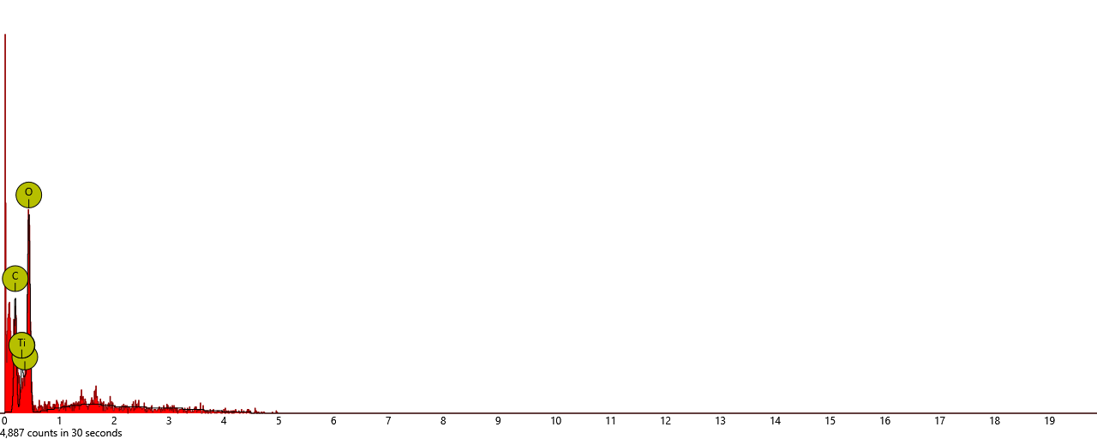
APPENDIX III
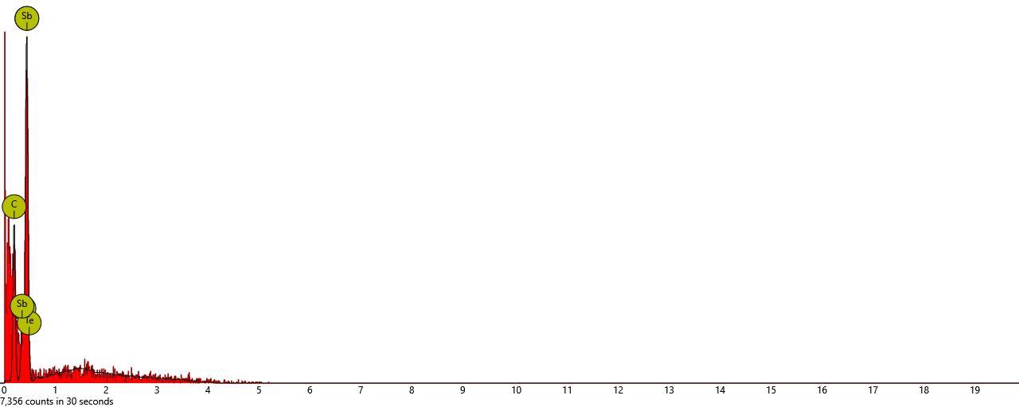
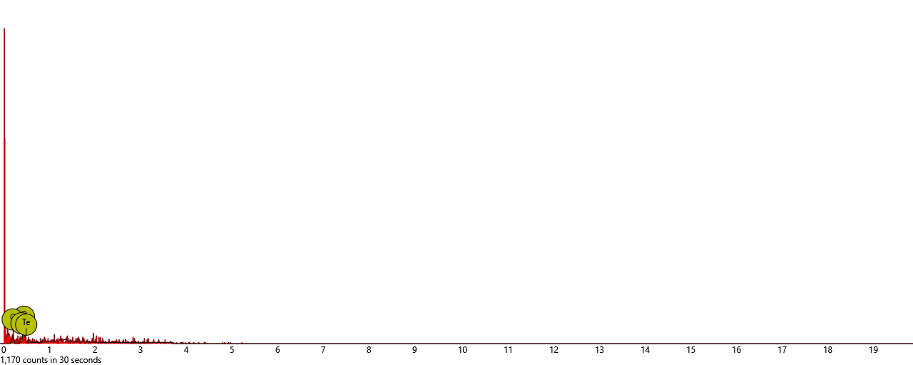

SEM-EDX Graph showing the peaks that identified the elements present.

APPENDIX IV
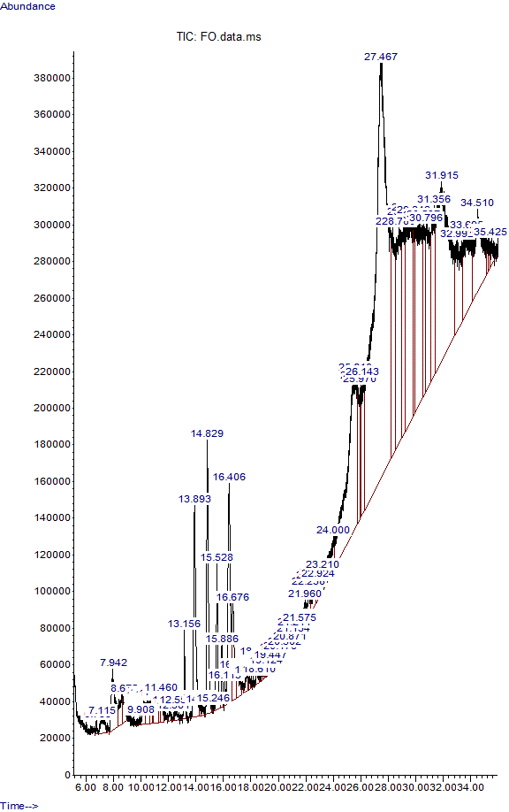
GC-MS analysis of bio-plastic film formulated with false yam tuber starch (F₀)
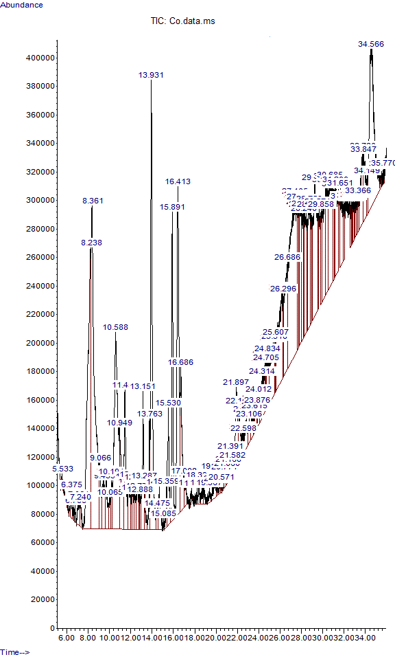
GC-MS analysis of Cassava peels starch formulated bioplastic (C₀)

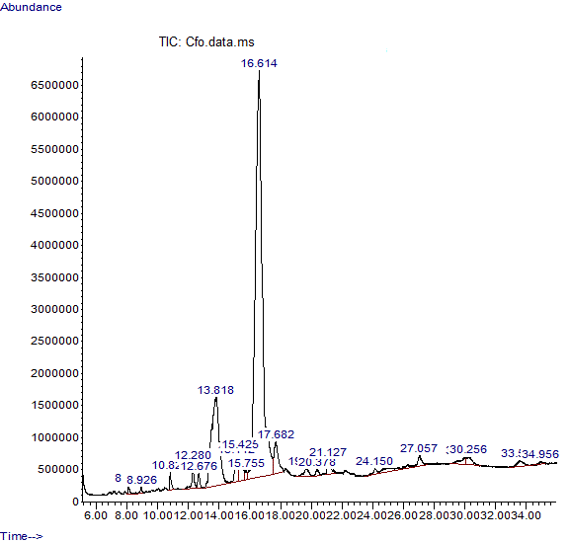
GC-MS analysis of bioplastic film formulated from an equal combination of false yam starch and cassava peel starch (CF₀).
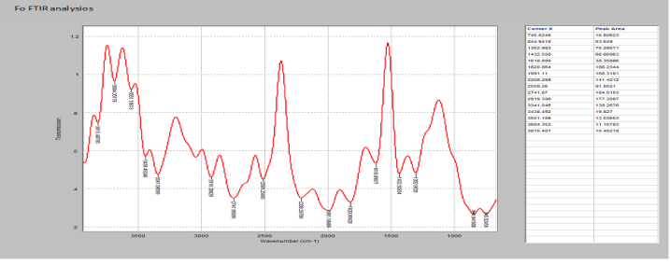
APPENDIX V
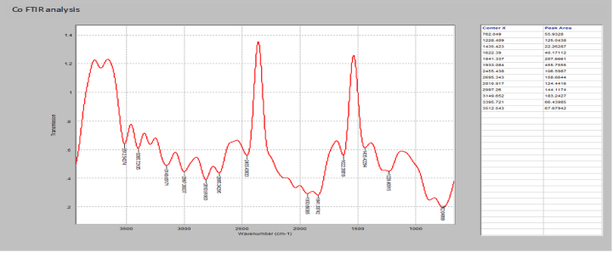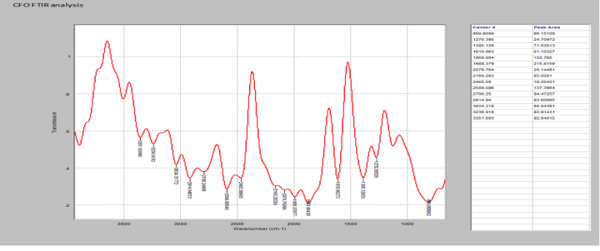

FTIR Spectra of bioplastic films from cassava starch (a), false yam tuber starch (b) combination of cassava and false yam Starch.

