Original Research Article

Biochemical Characterization of Starch Extract of Manihot esculenta Peels and Icacina trichantha Tubers for Bioplastic Film Production

.
ABSTRACT
The utilization of conventional edible starch sources as raw materials for biodegradable film matrices has generated food insecurity concerns and conflicts between food supply and industrial sector. Therefore, this research work attempted to harness the potential of agro-industrial waste as raw materials for medical and industrial applications, in pursuit of food sustainability and green synthesis. The aim of this research was to, biochemically characterize starch extracted from cassava (Manihot esculenta) peels, and false yam (Icacina trichantha) tuber for the synthesis of bioplastic films as a promising alternative to conventional plastics. This study demonstrated the biochemical characterization of these starches by evaluating their physicochemical properties (swelling power, solubility, amylose and amylopectin composition, absorbance, moisture content, ash content and pH), functional group using Fourier Transformed Infrared Spectroscopy (FT-IR), the presence of bioactive compounds using Gas Chromatography- Mass Spectrometer (GC-MS) and the morphological structure with the aid of Scanning electron Microscopy. The physicochemical analysis revealed that starch from cassava peels have significantly (p<0.005) higher values of solubility (3.97± 0.002%) swelling power (6.38±0.07g/g), amylose (22.90±0.16%) and moisture (6.59±0.18%) than false yam which on the other hand had higher content of amylopectin (82.98±0.68), ash (0.32±0.02%) and pH (8.3 ± 0.13). The FT-IR spectra of both starch sources demonstrated that carboxyl and hydroxyl groups were present in abundance and further revealed the unique presence of medium stretching vibrations of thiol and amine function group in cassava peel starch. Oleic acid was the most abundant bioactive compound among found in cassava peels (22.25%) while cis-13-Octadecenoic acid (28.47%) was the most abundant in false yam tuber starch. The scanning electron micrograph confirmed the shape and sizes of the crystalline structure of both starches. Although the starch extraction method was able to successfully retrieve the starch from these lignocellulosic substances, a comparatively less starch yield was observed in false yam tuber. However, both cassava peel starch and false yam starch were found to exhibit similar beneficial characterizations, their potential utilization as alternative starch-based matrices was demonstrated through this study

Keywords: Plant starch, cassava peels, false yam tuber, agro-waste

1. INTRODUCTION

Starch, a naturally occurring polysaccharide of immense industrial relevance is one of the most abundant renewable biomaterials on Earth (Kadiyala & Rehm, 2018). It is widely distributed in plants and serves as a cheap and critical source of carbohydrate for human consumption, particularly in tropical African countries such as Nigeria (Omoregie Egharevba, 2020; Henning et al., 2022). Beyond its nutritional significance, starch exhibits remarkable physicochemical and functional properties that makes it a versatile raw material for numerous applications. These include textiles (as fabric stiffeners), food (as preservatives, additives, and thickeners), biofuel production, medicine (as scaffolding biomaterials and drug carriers), cosmetics, paper production, and more recently, bioplastic manufacturing. (Bello et al., 2020; Acharjee et al., 2019).
Structurally, starch functions as a primary energy reserve in plants, synthesized in the amyloplasts of storage tissues such as tubers, roots, seeds, and leaves. In cereals, it is predominantly located in the endosperm, while in tuberous plants it accumulates in the parenchymal cells of roots and rhizomes (Roy et al., 2020). At the molecular level, this biocompatible polymer comprises two main polysaccharides: amylose, a linear chain molecule representing approximately 22–26% of total starch, and amylopectin, a highly branched molecule constituting about 74–78%. Amylose molecules are connected by α-D-(1, 4) glycosidic linkages, while the branching points in amylopectin occur through α-D-(1, 6) bonds. Variations in the amylose-to-amylopectin ratio, granule morphology, and molecular chain length significantly influence the physicochemical behavior of starch which includes gelatinization temperature, swelling, solubility, pasting quality, and crystallinity (Henning et al., 2022). Although, these inherent differences can restrict industrial performance, necessitating various modification techniques such as physical, chemical, and enzymatic treatments to improve its processability and functionality (Roy et al., 2020; Šárka et al., 2023), Such diversity offers a broad platform for designing high quality starch films with excellent degradation time, tensile behavior, and moisture retention ability required in numerous industrial and biomedical applications.
While starch can be derived from conventional agricultural sources such as corn, cassava, wheat, potato, yam, and rice, dependence on these edible crops for industrial starch extraction has raised serious concerns about food security and sustainable agricultural resource allocation (Carvalho et al., 2024). The growing global population, coupled with limited arable land and climate-induced crop stress, calls for the diversification of starch sources to prevent competition between industrial use and food supply. Consequently, non-conventional starch sources-derived from less-edible tubers, fruits, grasses, seeds, and agro-waste are being explored as sustainable alternatives (Henning et al., 2022; Šárka et al., 2023). These sources mitigate food-versus-industry conflicts and also align with circular bio-economical goals through waste valorization and reduced environmental footprint (Carvalho et al., 2024).
Non-conventional starch sources are usually native crops or vegetables that are commonly produced for purposes other than starch; they have much smaller global production than conventional sources. Technological interest in novel starch properties, as well as environmental concerns and a move towards agricultural diversification, have led to studies that have characterized starch from non-conventional sources, in addition to the development of biodegradable films that are mainly used for food and biomedical applications. Furthermore, Starches from these non-conventional sources exhibit smaller granule sizes (5–20 μm) and unique crystalline patterns that favor homogeneous film formation (Henning et al., 2022).
Among these non-conventional sources, cassava (Manihot esculenta) peels has gained attention as a rich and abundant agro-waste material with significant starch content (Henning et al., 2022). Global cassava peel waste production is estimated at approximately 82 million tons annually, with Nigeria contributing about 18% (~15 million tons). This underutilized biomass has found diverse industrial applications, such as animal feed, bioenergy feedstock, and in materials for water purification and energy storage, demonstrating its potential as a renewable raw material for bioplastic film production (Carvalho et al., 2024). Similarly, false yam (Icacina trichantha Oliv.), a drought-resistant shrub native to West and Central Africa, produces large yam-like tubers only consumed during food long drought season and intense famine. Although known for its medicinal uses (e.g., treating malaria, rheumatism, and poisoning), I. trichantha remains underutilized industrially due to the presence of anti-nutritional compounds such as hydrogen cyanide, oxalates, tannins, and phytates. Nevertheless, its high starch yield and low competition with food crops make it an excellent candidate for sustainable starch extraction and bioplastic synthesis (Omoregie Egharevba, 2020).
Therefore, this study aims to characterize the biochemical properties of starch extracted from Manihot esculenta peels and Icacina trichantha tubers, evaluating their suitability for bioplastic film production. The research investigates their physicochemical, structural, functional, and thermal properties to assess their potential as renewable biomaterials. By emphasizing the valorization of underutilized and less-edible starch sources. This work contributes to advancing sustainable bioplastic development, reducing agricultural waste, supporting food security, and promoting biomedical innovation through eco-friendly material design.

2. material and methods

2.1 Chemicals and Equipment
All chemicals used in this research are analytical grade chemicals. All the equipments and apparatus used in this study were of good quality and in good working condition. They include; centrifuge (MedGroup MSLZL09), waterbath (Hilmedics H-420), spectrophotometer (turner® 390), test tubes (Pyrex) and test tube racks, electronic weighing balance (Sunrise SUN-224CL-220Gm), micropipettes (West tune), and Digital weighing Balance and electronic micrometer screw gauge, foil papers.
2.2 Plant Sample Collection and Identification
Cassava peels and false yam tubers were obtained from local farmers in Ikeduru local government area of Imo state, Nigeria (Figure 1). The plant samples were identified by Dr. C. M. Duru, a taxonomist in the Department of Biology, Federal University of Technology, Owerri, Imo state, with voucher; FHI 67875532 (Manihot esculenta) peels, and FHI 67875533 false yam (Icacina trichantha) tubers. They were washed under running water to remove soil debris and other impurities, dried and kept at room temperature for use.

2.3 Methods
2.3.1 Plant Extraction
2.3.1.1 Starch Extraction from Cassava Peels
Starch extraction from cassava peels were carried out according to Abel et al. (2021) with little modification. The Cassava peel was washed properly with distilled water to remove residues and impurities. The outer dark brown skin was carefully removed, then washed and pulverized to produce pulp. The pulp solution was filtered with a clean muslin cloth. The collected filtrate was allowed to stand for 6 hours then decanted of the supernatant. The white precipitate (starch) was obtained and oven dried for 48 hours at 90ºC. The dried starch was allowed to cool and then stored in an air tight container for further analysis.
2.3.1.2 Starch Extraction from False Yam Tubers
The outer brown skin of the false yam were peeled with kitchen knife and washed. The clean tubers were cut into smaller pieces and pulverized to produce pulp. Starch was extracted from the samples following the procedure described by Alobi et al., (2018) with slight modification. The pulp solution produced was strained through a piece of cotton fabric to extract the starch. The filtrates were allowed to settle for six hours. On complete sedimentation, the supernatant was decanted and the starch slurry was preserved for further analysis.
2.3.2 Starch Characterization
2.3.2.1 Swelling Power and Solubility of Starch Extract
The solubility and swelling power of cassava peels and false yam tuber starch were determined using the method described by Lescano et al. (2021). Suspensions of starch (0.4 g) in water (40 mL) were heated in 40 mL conical centrifuge tubes at temperatures between 70°C for 30 min with constant stirring. The solutions were then centrifuged at 5000 rpm for 5 min before the obtained pellet was weighed and the supernatant was dried in Petri dishes at 110°C for 6 h. The solubility (%) and swelling power (g water/g starch) were calculated from Equations (1) and (2), respectively, where P is the initial weight, P1 is the weight of the dry supernatant, and P2 is the weight of the sediment after centrifugation.
$Solubility (\%) =\frac{weight of soluble starch \left(g\right)}{weight of starch \left(g\right)}x 100 Equation 1$
$Swelling Power \left(\frac{g}{g}\right) \frac{weight of sediment paste (g)}{weight of starch \left(g\right)-weight of soluble starch (g)} x 100 Equaton 2$

2.3.2.2 Determination of Amylose and Amylopectin Compositions of Starch
The amylose content of cassava peels starch and false yam tuber starch were determined according to the colorimetric iodine assay index method described by Ferreira et al., (2019). 100 mg of starch powder was put into a 100ml volumetric flask, and 1ml of 95% ethanol and 9 ml of 1M sodium hydroxide are added. The contents were heated in a boiling water bath to gelatinize the starch. After cooling for 1 h, distilled water was added and the contents were mixed properly. Five ml of the starch Solution was then put in a 100 ml volumetric flask with a pipette. One ml of 1 M acetic acid and 2 ml of iodine solution (0.2 g iodine and 2.0 g potassium iodide in 100 ml aqueous solution) are added and the volume was made up with distilled water. The contents were shaken well and left to stand for 20 min. Absorbance (A) of the solution was measured at 620 mm with COLEMAN Model 35-D Spectrophotometer. Amylopectin content was determined by a difference of 100.
$$\% Amylopectin=100-\%amylose Equation 3$$
2.3.2.3 Moisture Content
The moisture content of cassava peels starch and false yam tuber starch were determined using the method described by Nwachoko et al. (2015), Clean flat dishes were dried for 15 minutes at 105OC were allowed to cool in the desiccator for 15 minutes and weighed (W1). Then 2 g of each starch samples was transferred to the dish (W2). The dish was cleaned and placed in the oven at 105OC for 4 hours. Later, the dishes were removed, covered and placed in the desiccator and allowed to cool for 15 minutes and weighed as quickly as possible (W3). The percentage moisture content was calculated using the equation (4) below.
$Moisture comtent \left(\%\right)=\frac{[final weight \left(W2\right)-Initial weight \left(W1\right)](g)}{\left[Initial weight \left(W3\right)\right](g)} Equation 4$
2.3.2.4 Ash Content
Crucibles were placed in a muffle furnace for 20 minutes. Then, they were removed and placed in a desiccator for 30 min to cool off and weighed. Then 2 g of each sample was weighed into different dishes (crucibles). The dishes were placed on a hot plate under a fume chamber and slowly the temperature was increased until smoking ceases and the sample becomes thoroughly charred. Then, the dishes were placed at the centre of the muffle furnace ashed. After which the dishes with the ash were placed in the desiccator and allowed to cool and weighed. The percentage ash content was calculated using the equation (5).
$\% Ash content =\frac{W1(g)}{W2\left(g\right)} x 100 Equation 5$
W1= the initial weight of the sample, W2= the weight of the ash.
2.3.2.5 Starch Functional Group Analysis
Evaluation of functional groups present in the starch was done using Fourier Transform Infrared Spectroscopy (FTIR) according to the method described by Hoyos-Leyva et al. (2017) with slight modification. Before the analysis commenced, the starches were conditioned at 23 ± 2 °C and 0% relative humidity for five days in a desiccator. A Vertex 70 FT-IR spectrometer, which was equipped with a cadmium mercury telluride detector and KBr beam splitter using an ATR accessory with a diamond crystal at an angle of incidence of 45° was used. The spectra were collected from fifty scans at a resolution of 4 cm−1 over the 4000–400 cm−1 wavenumber region. For each sample, three spectra were taken and averaged, and finally, processing was performed using the OPUS software (version 7.0).
2.3.2.6 Morphology and Size Distribution of Starch Granules
The surface morphology of the cassava peels and false yam tuber starch samples were assessed using a scanning electron microscopy (E-SEM, EVO LS10, Carl Zeiss Microscopy GmbH, Jena, Germany) according to the method described by (Martínez et al., 2019). The starch samples were fixed to a conductive carbon tape of double glue and placed in the microscope cells. The analysis was performed at 20 kV electron acceleration voltage to obtain images with a backscattering electron signal at 500× and 1000× magnification. The images obtained were processed using Carl Zeiss Microscopy software.
2.3.2.7 Quantitative Phytochemical Analysis of Starches
Detailed determination of bioactive compounds in the cassava peels starch and false yam starch samples were done according to the method described by Chandrasekar et al. (2023) with a gas chromatographic-mass spectroscope (GC-MS). Gas chromatography and mass spectroscopic analysis the samples was performed using an Agilent-6890 N gas chromatographer with an HP 5973 mass spectrometer detector. The identification of compounds in the starch samples was made by correlating mass spectra and retention times with that of pure compounds. Furthermore, the NIST (National Institute of Standards and Technologies, USA), mass spectra library, was also used for this analysis.

3. results and discussion

The experimental results are presented in Figure 1 -2 and Table 1-4

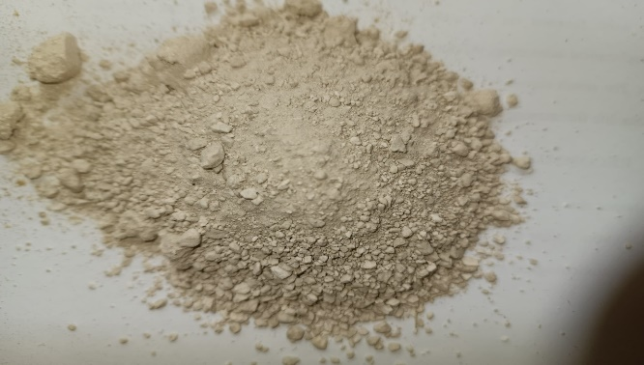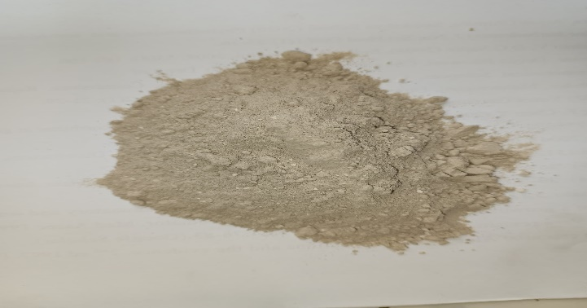
A
B
Fig. 1. Plant sample extracts. (A) Cassava (Manihot esculenta) peel starch powder starch. (B) False yam (Icacina trichantha), tuber starch powder. Cassava peel starch powder (a) and false yam tuber starch powder (b), presented a light brown colour, with a smooth texture for false yam while cassava peel starch is crystalline.

Table 1: Physicochemical analysis of cassava peels and false yam starch (CF₀).
Test | Cassava peels (C_{s}) | False yam (F_{s})
Solubility (%) | 3.97 ± 0.002 | 2.71 ± 0.002^{b}
Swelling power (g/g) | 6.38 ± 0.07ª | 2.74 ± 0.17^{b}
Absorbance | 0.67 ± 0.13ª | 0.50 ± 0.02^{b}
Amylose content  (%) | 22.90 ± 0.16ª | 17.02 ± 0.32^{b}
Amylopectin (%) | 77.10 ± 0.54ª | 82.98 ± 0.68^{b}
Moisture content (%) | 6.59 ± 0.18ª | 4.33 ± 0.25^{b}
pH value | 7.9 ± 0.17ª | 8.3 ± 0.13^{b}
Ash content (%) | 0.28 ± 0.01ª | 0.32 ± 0.02^{b}
Table 1 shows that starch from cassava peels have significantly (p<0.005) higher values of solubility (3.97± 0.002%) swelling power (6.38±0.07g/g), amylose (22.90±0.16%) and moisture (6.59±0.18%) than false yam which on the other hand had higher content of amylopectin (82.98±0.68) and ash (0.32±0.02%).
Table 2: FTIR identified functional groups of false yam tuber starch (Fs).
Wavelength (cm⁻¹) Fs | Peak Area | Functional Group |  | Intensity | Interpretation
1383 | 122 | C-H bending |  | Strong | Indicates the presence of alkane structures with strong C-H bending vibrations.
1619 | 46 | C=C stretching |  | Medium | Suggests the presence of alkenes or aromatic compounds with medium C=C stretching vibrations.
2465 | 288 | C-H stretching |  | Very Strong | Strongly indicates the presence of alkanes with very strong C-H stretching vibrations.
2578 | 75 | C-H stretching |  | Medium | Suggests the presence of alkanes or aldehydes with medium C-H stretching vibrations.
2688 | 60 | C-H stretching |  | Medium | Indicates the presence of alkanes or aldehydes with medium C-H stretching.
2797 | 66 | C-H stretching |  | Medium | Interpretation: Suggests the presence of alkanes or aldehydes with medium C-H stretching vibrations.
2902 | 139 | C-H stretching |  | Strong | Strongly indicates the presence of alkanes with strong C-H stretching vibrations.
3103 | 95 | C-O stretching |  | Strong | Suggests the presence of alcohols, ethers, or esters with strong C-O stretching vibrations
3259 | 88 | O-H stretching |  | Strong | Indicates the presence of alcohols or phenols with strong O-H stretching vibrations.
3344 | 119 | O-H stretching |  | Strong | Strongly suggests the presence of alcohols or phenols with strong O-H stretching vibrations.
3688 | 20 |  | O-H stretching | Weak | Indicates the presence of alcohols with weak O-H stretching vibrations.
3812 | 40 |  | O-H stretching | Medium | Suggests the presence of alcohols with medium O-H stretching vibrations.

Table 3: FTIR identified functional groups of cassava peel starch (Cs).
Wavelength (cm⁻¹) | Peak Area | Functional Group | Intensity | Interpretation
786 | 43 | C-H bending | Weak | Indicates the presence of alkanes or aromatic structures with weak C-H bending vibrations.
1051 | 15 | C-O stretching | Weak | Suggests the presence of alcohols, ethers, or esters with weak C-O stretching vibrations.
1320 | 34 | C-N stretching | Weak | Indicates the presence of amines with weak C-N stretching vibrations.
1444 | 27 | CH₂ bending | Weak | Suggests the presence of alkanes with weak CH₂ bending vibrations
1606 | 32 | C=C stretching | Weak | Indicates the presence of alkenes or aromatic compounds with weak C=C stretching vibrations.
1855 | 97 | C=O stretching | Medium | Suggests the presence of anhydrides or ketones with medium C=O stretching vibrations.
1993 | 150 | C=O stretching | Strong | Indicates the presence of anhydrides or other carbonyl-containing compounds with strong C=O stretching vibrations.
2218 | 162 | C≡C stretching | Strong | Indicates the presence of alkynes with strong C≡C stretching vibrations
2453 | 66 | S-H stretching | Medium | Suggests the presence of thiols with medium S-H stretching vibrations.
2551 | 96 | C-H stretching | Medium | Indicates the presence of aldehydes or hydrocarbons with medium C-H stretching vibrations.
2748 | 433 | C-H stretching | Very Strong | Strongly indicates the presence of aldehydes or other hydrocarbons with very strong C-H stretching vibrations.
3152 | 92 | N-H stretching | Medium | Suggests the presence of amines with medium N-H stretching vibrations.
3261 | 108 | O-H stretching | Strong | Indicates the presence of alcohols or phenols with strong O-H stretching vibrations.
3423 | 190 | O-H stretching | Strong | Strongly indicates the presence of alcohols or phenols with very strong O-H stretching vibrations.
3717 | 72 | O-H stretching | Medium | Suggests the presence of alcohols with medium O-H stretching vibrations.

Table 4: Bioactive compounds present in cassava peels starch extract (Cs)
S/N | Retention Time (mins) | Bioactive Components | % Report
1 | 7.070 | 3-Methyl-6-hepten-1-yn-3-ol | 0.89
2 | 7.722 | Citral | 1.18
3 | 16.990 | Hexadecanoic acid, methyl ester | 3.78
4 | 17.638 | n-Hexadecanoic acid | 6.92
5 | 17.866 | Cyclopentaneundecanoic acid | 0.31
6 | 18.804 | trans-13-Octadecenoic acid, methyl ester | 8.69
7 | 19.051 | Methyl stearate | 4.29
8 | 19.217 | 11,13-Dimethyl-12-tetradecen-1-ol | 0.88
9 | 19.434 | Oleic acid | 12.54
10 | 19.601 | 6-Octadecenoic acid, (Z)- | 7.17
11 | 19.795 | p-Menth-8(10)-en-9-ol, cis- | 0.92
12 | 19.830 | Octadec-9-enoic acid | 1.08
13 | 19.981 | 9-Octadecenoic acid, (E)- | 4.54
14 | 20.228 | Oleic acid | 8.63
15 | 20.328 | 9-Octadecenoic acid, (E)- | 1.98
16 | 20.601 | 1,3-Dioxolane, 4-ethyl-5-octyl-2,2 -bis(trifluoromethyl)-, cis- | 9.31
17 | 20.712 | Cyclopropane carboxamide, 2-cyclop ropyl-2-methyl-N-(1-cyclopropylethyl)- | 3.42
18 | 20.807 | Octadec-9-enoic acid | 1.19
19 | 20.934 | 9,17-Octadecadienal, (Z)- | 2.13
20 | 21.044 | 3,7,11-Tridecatrienoic acid, 4,8,12-trimethyl-, methyl ester, (Z,E)- | 2.35
21 | 21.646 | Trimethylsilyl-di(timethylsiloxy)-silane | 2.79
22 | 21.777 | Glyceric acid (ISP-TFA) | 2.22
23 | 23.479 | 2,5-Furandione, 3-dodecyl- | 0.68
24 | 23.550 | Oleic acid | 1.08
25 | 23.601 | (1R,4R)-1-methyl-4-(6-Methylhept-5 -en-2-yl)cyclohex-2-enol | 0.57
26 | 24.481 | 1H-Indene, 2-butyl-5-hexyloctahydro- | 0.82
27 | 26.076 | 1,2-hydrazinedicarbothioamide, N1, N2-dibutyl- | 0.90
28 | 26.640 | 9-Octadecenoic acid, (E)- | 0.23
29 | 28.039 | 3,7,11-Tridecatrienoic acid, 4,8,1 2-trimethyl-, methyl ester, (Z,E)- | 0.96
30 | 28.113 | benzoic acid, 4-[(2-methyl-1-oxo-2 -propen-1-yl)oxy]-, oxiranylmethyl ester | 1.09
31 | 28.926 | 3,7,11-Tridecatrienoic acid, 4,8,12-trimethyl-, methyl ester, (Z,E)- | 1.71
32 | 29.751 | 6-Octadecenoic acid | 2.60
33 | 30.011 | Bicyclo[4.2.0]oct-2-ene, 3,7-dimethyl-7-(4-methyl-3-pentenyl)-8-(2,6  ,10-trimethyl-1,5,9-undecatrienyl)-, [1.alpha.,6.alpha.,7.beta.,8.al  pha.(1E,5E)]- | 2.31
The result from the GC-MS analysis of cassava peels starch extract (Cs) showed the presence of thirty three (33) bioactive compounds, with Oleic acid having the highest percentage report of 22.25% and Cyclopentaneundecanoic acid having the lowest percentage report of 0.31% with retention time of 23.550 and 17.866min respectively.
Table 5: Bioactive compounds present in false yam starch extract (Fs
S/N | Retention Time  (mins) | Bioactive Components | % Report
1 | 7.081 | 10-Undecen-4-one, 2,2,6,6-tetramethyl- | 2.69
2 | 7.691 | 2,6-Octadienal, 3,7-dimethyl-, (E) | 4.37
3 | 16.993 | Hexadecanoic acid, methyl ester | 16.41
4 | 17.641 | n-Hexadecanoic acid | 15.54
5 | 18.808 | cis-13-Octadecenoic acid, methyl ester | 28.47
6 | 18.974 | Fumaric acid, pent-4-en-2-yl tridecyl ester | 0.86
7 | 19.050 | Heptadecanoic acid, 16-methyl-, methyl ester | 6.06
8 | 19.440 | cis-Vaccenic acid | 17.14
9 | 19.647 | Oleic acid | 6.12
10 | 19.699 | 12-Methyl-E,E-2,13-octadecadien-1-ol | 2.10
11 | 19.799 | 1H-Indene, 2-butyl-5-hexyloctahydro- | 0.49
The result from the GC-MS analysis of false yam starch extract (Fs) showed the presence of eleven (11) bioactive compounds with cis-13-Octadecenoic acid, methyl ester, cis-Vaccenic acid, Hexadecanoic acid, methyl ester, and n-Hexadecanoic acid having highest percentage report of 28.47%, 17.14%, 16.41% and 15.54% respectively. 1H-Indene, 2-butyl-5-hexyloctahydro- and Fumaric acid, pent-4-en-2-yl tridecyl ester having the lowest percentage report of 0.49% and 0.86%
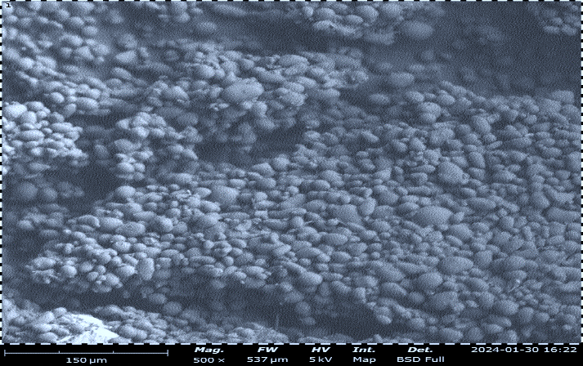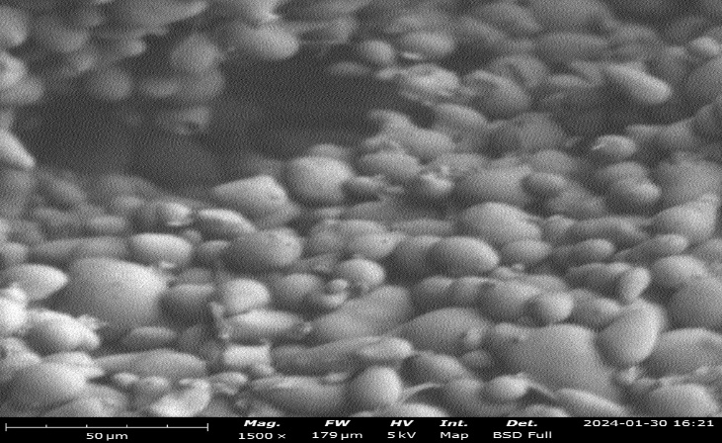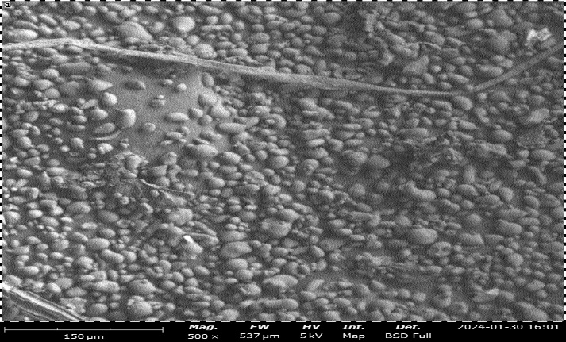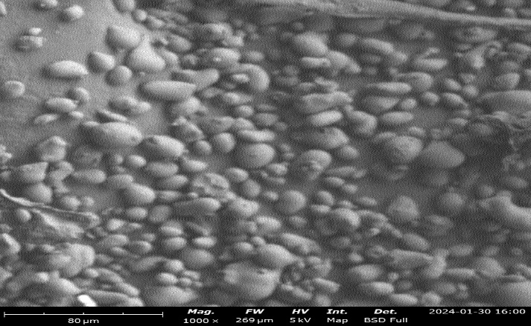
A
B
C
D
Figure 2. Scanning electron microscopy of extracted starch
(A) Cassava peel starch at 150 µm (B) cassava peels starch at 80 µm (C) False yam starch at 150 µm (B) False yam starch at 1500 µm. (D) False yam starch at 1500 µm. The scanning electron microscopy showed the crystalline structure of the starch granules which is the general spherical shape with different sizes. The arrow in (B) and (D) points to starch granules of both cassava peels and false yam tuber starch.

3.2.1 Physicochemical Properties of Starch Samples
3.2.1.1 Amylose and Amylopectin Content
Amylose and amylopectin contents of cassava peels and false yam tuber starch are presented in Table 1. The amylose content of the cassava peel starch (22.90%) is higher than that of false yam tuber starch (17.02%) while cassava peel starch has lower amylopectin content (77.1%) than false yam tuber starch (82.98%). These values of amylose and amylopectin contents of false yam tuber starch are similar to the result reported by Alobi et al. (2017). Both starch samples had lower amylose content than 34.21% for cassava starch as reported by Oladayo et al. (2016) and the arracacha and potato starches at 31.28% and 29.56%, respectively (Lescano et al., 2021). High amylose content of the starch samples indicated decrease in crystallinity and gel thickness; increased amorphous regions, gel hardness, higher pasting temperature and amylose aggregation/spoilage tendencies. High amylose starches have increased tendency for water absorption (Alobi et al., 2017). The amount of amylose and amylopectin present in starch influences the mechanical property of the starch polymer. High amylose in starch presents higher stiffness and hardness than in high amylopectin starch due to the comparatively less branching structures. Therefore, this research showed that false yam tuber starch has a low amylose content compared to cassava peels starch starches, and the starch samples are expected to produce bioplastic films with good food packaging quality.
3.2.1.2 Moisture Content of Starch Samples
Moisture content of starch is the total quantity of vapour present in it. Cassava peel starch presented a higher moisture content (6.59%) than that of false yam tuber starch (4.33%). These values are far less than the maximum limit for moisture in starch which is 14% (Oladayo, Umunna, Joseph & Oluwaseguun, 2016) and 12% according to African Organization for Standardization of cassava starch. Higher values of moisture in starch causes caking of the starch, affects its texture and encourages the growth of microorganisms which cause odours and off flavour. In biomedical film production, maintaining starch moisture below 10% is often recommended to prevent premature microbial growth and ensure consistent polymer processing during extrusion or casting (Henning et al., 2022). Starch with lower moisture content exhibits reduced agglomeration, facilitating uniform dispersion of plasticizers and additives during formulation (Siqueira et al., 2021). Excessive moisture in starch promotes caking, lump formation, and microbial proliferation, leading to undesirable odor, color changes, and biochemical degradation. Such effects are detrimental to biomedical-grade starch films where contamination or instability could compromise biocompatibility and sterility (Bhat & Khan, 2022).
3.2.1.3 Ash Content of Starch Samples
False yam starch has higher ash content (0.32 ± 0.02%) and pH (8.3 ± 0.13) compared to the starch extracted from cassava peels having ash content of (0.28 ± 0.01%) and pH of (7.9 ± 0.17) and the result reported by Martínez et al. (2019) for the three native potatoes of the Andean region. Ash content generally gives an idea the viscosity of starch especially when used for bioplastic production for food packaging. High ash content like as seen in false yam starch often due to the presence of minerals, causing inconsistent starch gelatinization properties thereby affecting the structure and texture of the film.
3.2.1.4 Solubility and Swelling Power
The solubility and swelling power of the cassava peels starch (3.97 % and 6.38g/g) and false yam tuber starch (2.71% and 2.74g/g) respectively at 70OC are presented in Table 1. The solubility of the cassava peels starch was higher than that of the false yam tuber starch indicating that the solubility of starch polymers such as amylose was higher in the cassava peels starch. These value are lower than the report of Lescano et al., (2021) for potato starch (9.67%, 15.48g/g) and arracacha starch (4.17 %, 13.19 g/g) respectively. Starch solubility and swelling power, are influenced by the chemical composition, structure, and molecular properties of the starch, which further impacts on the integrity of the bioplastic film. Higher solubility can cause better interaction with plasticizer resulting in better film formation while low solubility of starch impacts poor mechanical properties due to incomplete gelatinization of starch. Swelling power of starch impacts the water vapor and gas permeability of the film. Higher swelling of starch can lead to increased permeability and poor barrier properties.
3.2.1.5 Presence of Functional Groups
The presence of functional groups revealed by the FT-IR spectra of starches extracted from Manihot esculenta peels and Icacina trichantha tubers displayed distinct absorption bands characteristic of polysaccharides, confirming the presence of typical starch functional groups. The broad and intense band observed between 3200 and 3400 cm⁻¹ was attributed to the O-H stretching vibrations, which correspond to intramolecular and intermolecular hydrogen bonding between hydroxyl groups within glucose residues (Henning et al., 2022; Kumar, Ghoshal, & Goyal, 2021). This band is a key feature of native starch, reflecting its hydrophilic nature and ability to form complex hydrogen-bonded networks. The relative broadness and intensity variation observed between M. esculenta and I. trichantha starches suggest differences in their hydrogen bonding density, which may influence their water affinity, solubility, and gelatinization behavior, all of which are critical parameters for their application in the synthesis of bioplastic films used for food packaging and biomedical devices.
Another characteristic peak observed in the region of 2800-2950 cm⁻¹ corresponds to C-H stretching vibrations of aliphatic groups within the starch molecular backbone, specifically from the -CH₂ and -CH₃ functional groups of glucose rings (Oliveira et al., 2020). The band observed around 1645-1650 cm⁻¹ was assigned to the O-H bending vibrations of bound water molecules absorbed within the starch granules (Nawab et al., 2017). This is consistent with the hygroscopic nature of starches and indicates the presence of structural water within the granule matrix a feature that affects gelatinization and storage stability, particularly relevant to biopolymer formulations for packaging biomedical hydrogel systems.
The spectral region between 1200 and 900 cm⁻¹ showed multiple strong bands, typically associated with C-O-C stretching vibrations of glycosidic linkages, C-O stretching, and C-C skeletal vibrations within the anhydroglucose unit (Henning et al., 2022). Notably, absorption near 1047 cm⁻¹ is characteristic of the crystalline regions of amylopectin, whereas peaks near 1022 cm⁻¹ are attributed to amorphous regions dominated by amylose (Kumar et al., 2021). The intensity ratio of these peaks provides a qualitative measure of relative crystallinity. The higher intensity at 1047 cm⁻¹ observed in I. trichantha starch indicates a slightly higher crystalline ordering than in M. esculenta starch, suggesting enhanced structural rigidity and lower water permeability. These properties are desirable for applications in food packaging films that require moisture barriers.
In contrast, M. esculenta peel starch exhibited a slightly broader band around 1022 cm⁻¹, indicating a more amorphous molecular organization. Such amorphous structures are typically associated with higher solubility and faster biodegradation rates, making this starch suitable for applications where rapid disintegration or dissolution is required, such as edible films, controlled-release drug carriers, and bioresorbable wound dressing materials.
Therefore, the FT-IR profiles confirm that both starch sources possess the key functional groups (O-H, C-H, and C-O-C) associated with typical starch molecular architecture, with no trace of chemical impurities or structural degradation. This validates the efficiency of the extraction process and the purity of the starch obtained. The spectral data therefore affirm that M. esculenta peel and I. trichantha starches maintain the native polysaccharide configuration necessary for their adaptation into bioplastic films.
3.2.1.6 Presence of Bioactive Compound
The GC–MS analysis of the starch extracts identified a variety of low- and medium-molecular-weight compounds, including fatty acids, esters, alcohols, alkanes, and aromatic compounds. These compounds are characteristic of native starches and their naturally associated biomolecules. In both Manihot esculenta and Icacina trichantha starch extracts, major constituents such as hexadecanoic acid (palmitic acid), octadecanoic acid (stearic acid), and their corresponding esters were detected which are known to enhance hydrophobic interactions within biopolymer matrices, thereby improving moisture resistance and mechanical integrity (Thakur et al., 2019; Liu et al., 2021).
The presence of bioactive compounds such as phenolic acids, phytosterols, and certain long-chain hydrocarbons was also observed, indicating that these starches contain naturally occurring antioxidant and antimicrobial components. Such constituents are highly desirable for biomedical applications, particularly in wound healing films and antimicrobial coatings, where bioactive properties can inhibit microbial colonization and promote tissue regeneration (Bello et al., 2020; Zhou et al., 2021)
The abundance of oxygenated hydrocarbons (alcohols, esters, and acids) indicates the presence of functional moieties capable of forming hydrogen bonds with the starch backbone. This feature enhances the compatibility of the material with biological environments, as such interactions promote hydrolytic degradation into non-toxic by-products (Acharjee et al., 2019; Thomas, 2020). Furthermore, the predominance of saturated fatty acids implies that the films would exhibit moderate water barrier properties, a critical feature for wound dressing materials that must balance breathability with protection from external moisture and pathogens (Henning et al., 2022).
In comparison between the two starch sources, I. trichantha starch showed a slightly higher diversity of lipid-based compounds, possibly due to residual natural lipids in the tuber matrix. This may confer improved hydrophobicity, suggesting films produced from it might demonstrate better moisture resistance and film durability than those derived from cassava peels. On the other hand, M. esculenta peel starch showed stronger signals for carbohydrate derivatives, indicating higher purity and potentially faster biodegradability. Such complementary features suggest that blending these two non-conventional starches could yield composite films with optimized hydrophilic–hydrophobic balance suitable for biomedical and hospital consumables (Carvalho et al., 2024).
3.2.1.6 Starch Morphology
The morphology of cassava peels starch and that of false yam tuber starch is similar to the granules reported by Weligama et al. (2023) on cassava peel and bagasse and that of the native cassava starch reported by Sriroth et al. (1999). Therefore, it can be claimed that the morphological characteristics of the native cassava starch and the residual starch available in both of cassava peel and false yam tuber are approximately similar. A significantly high amount of residual starch granules was also observed within the cassava peel and false yam tuber. Furthermore, the SEM images revealed the shapes and sizes of starch from both cassava and false yam. This demonstrated that the studied agro wastes samples are rich sources of residual starch. Therefore, both the cassava peel and false yam tuber can be used as alternative matrices to the edible starches that are being commonly used for developing biodegradable food packaging. The possible replacement of common edible starches with these alternative starchy matrices would not only address any future food insecurity related issues, but also will ensure the environmental sustainability by reducing adverse environmental impacts due to the direct disposal of starch and moisture rich waste.

4. Conclusion

The present study demonstrates that starch extracted from Manihot esculenta peels and Icacina trichantha tubers represents a sustainable, renewable, and ecologically friendly alternative to conventional petroleum-based polymers. The physicochemical and structural characterization confirmed that both starch sources possess distinct compositional attributes suitable for bioplastic film production. The use of such non-conventional starch sources promotes waste valorization and strengthens circular bio-economy by converting agricultural residues into high-value industrial and biomedical products. This findings highlights the industrial adaptability and biomedical relevance of these non-conventional starch sources as a raw material for bioplastic films. Their biodegradability, biocompatibility, and non-toxic degradation profile position them as promising raw materials for numerous industrial applications. The molecular structure of starch, particularly its structural morphology, modifiable amylose-to-amylopectin ratio and functional group chemistry, validates mechanical, thermal, and degradation behavior to be engineered for specific biomedical functions like in drug delivery, tissue scaffolds and wound healing. Furthermore, utilizing underexploited starch resources such as cassava peels and I. trichantha tubers aligns with global priorities for food security and sustainable industrial practices. By reducing reliance on edible crops for starch extraction, these non-conventional sources mitigate the competition between food and industrial starch applications. Their incorporation into value-added material development not only enhances economic diversification in agrarian economies like Nigeria but also supports responsible production and consumption patterns as advocated in the United Nations Sustainable Development Goals.

COMPETING INTERESTS DISCLAIMER:
Authors have declared that they have no known competing financial interests OR non-financial interests OR personal relationships that could have appeared to influence the work reported in this paper.

References
Alobi, N. O., Sunday, E. A., Magu, T. O., Oloko, G. O. & Nyong, B. K. (2017). Analysis of starch from non-edible root and tubers as sources of raw materials for the synthesis of biodegradable starch plastics. Journal of Basic Applied Research 3(1): 27 – 32.
Ballesteros-Martinez, ´ L., P´erez-Cervera, C., & Andrade-Pizarro, R. (2020). Effect of glycerol and sorbitol concentrations on mechanical, optical, and barrier properties of sweet potato starch film. NFS Journal, 20, 1–9. https://doi.org/10.1016/j. nfs.2020.06.002.
Bidari, R., Abdillah, A. A., Ponce, R. A. B. & Charles, A. L. (2023). Characterization of Biodegradable Films Made from Taro Peel (Colocasia esculenta) Starch. Polymers, 15, 338. https://doi.org/10.3390/ polym15020338.
Cao, T. L., & Song, K. B. (2019). Effects of gum karaya addition on the characteristics of loquat seed starch films containing oregano essential oil. Food Hydrocolloids, 97. https://doi.org/10.1016/j.foodhyd.2019.105198.
Garcia, M. C., Elias, T. M., Ribeiro, K. d. O., Soares JÚNior, M. S. & Caliari, M. (2019). Microbiological and physicochemical profiles of the sour cassava starch and bagasse obtained from cassava agroindustry. Food Science and Technology, 39(4), 803-809. https://doi.org/10.1590/fst.32117.
Judawisastra H., Sitohang R. D. R., Marta L, & Mardiyati M. (2017) Water Absorption and its Effect on the Tensile Properties of Tapioca Starch/Polyvinyl Alcohol Bioplastics. Iop. Conference. Series Making Science Engineering 223:1-9.
Nawab, A., Alam, F., & Hasnain, A. (2017). Mango kernel starch as a novel edible coating for enhancing shelf- life of tomato (Solanum lycopersicum) fruit. International Journal of Biological Macromolecules, 103, 581–586. https://doi.org/10.1016/j. ijbiomac.2017.05.057
Nawab, A., Alam, F., Haq, M. A., Lutfi, Z., & Hasnain, A. (2017). Mango kernel starchgum composite films: Physical, mechanical and barrier properties. International Journal of Biological Macromolecules, 98, 869–876. https://doi.org/10.1016/j. ijbiomac.2017.02.054.
Oliveira Filho, J. G., Bezerra, C. C. O. N., Albiero, B. G., Oldoni, F. C. A., Miranda, M. &. (2020). New approach in the development of edible films: The use of carnauba wax micro- or nanoemulsions in arrowroot starch-based films. Food Packaging and Shelf Life, 26, Article 100589. https://doi.org/10.1016/j.fpsl.2020.100589
Rodrigues, S. C. S., Da Silva, A. S., De Carvalho, L. H., Alves, T. S., & Barbosa, R. (2020). Morphological, structural, thermal properties of a native starch obtained from babassu mesocarp for food packaging application. Journal of Materials Research and Technology, 9(6), 15670–15678. https://doi.org/10.1016/j.jmrt.2020.11.030.
Rojas-Bringas, P. M., De-la-Torre, G. E., & Torres, F. G. (2021). Influence of the source of starch and plasticizers on the environmental burden of starch-Brazil nut fiber biocomposite production: A life cycle assessment approach. Science of the Total Environment, 769, Article 144869. https://doi.org/10.1016/j.scitotenv.2020.144869
Roy, K., Thory, R., Sinhmar, A., Pathera, A. K., & Nain, V. (2020). Development and characterization of nano starch-based composite films from mung bean (Vigna radiata). International Journal of Biological Macromolecules, 144, 242–251. https://doi.org/10.1016/j.ijbiomac.2019.12.113
Saberi, B., Golding, J. B., Marques, J. R., Pristijono, P., Chockchaisawasdee, S., Scarlett, C. J., et al. (2018). Application of biocomposite edible coatings based on pea starch and guar gum on quality, storability and shelf life of ‘Valencia’ oranges. Postharvest Biology and Technology, 137, 9–20. https://doi.org/10.1016/j. postharvbio.2017.11.003
Satoto, R., Karina, M., Abdullah, A. H. D. & Nugroho, P. (2019). Mechanical and degradability properties of polyethylene/ PBL composites in a wet-dry controlled environment. Journal of Materials and Environmental Sciences, 10(8), 706-718. http://www.jmaterenvironsci.com
Sekiguchi, T., Saika, A., Nomura, K., Watanabe, T., Watanabe, T., Fujimoto, Y., Enoki, M., Sato, T., Kato, C., Kanehiro, H., 2011. Biodegradation of aliphatic polyesters soaked in deep seawaters and isolation of poly(e-caprolactone)-degrading bacteria. Polymer Degradation and Stability. 96, 1397–1403.
Setti, L., Francia, E., Pulvirenti, A., De Leo, R., Martinelli, S., Maistrello, L., Macavei, L.I., Montorsi, M., Barbi, S. and Ronga, D. (2020). Bioplastic film from black soldier fly prepupae proteins used as mulch: Preliminary results. Agronomy, 10. 933.
Sharma, V., Kaur, M., Sandhu, K. S., & Godara, S. K. (2020). Effect of cross-linking on physico-chemical, thermal, pasting, in vitro digestibility and film forming properties of Faba bean (Vicia faba L.) starch. International Journal of Biological Macromolecules, 159, 243–249. https://doi.org/10.1016/j.ijbiomac.2020.05.014
Suh, J. H., Ock, S. Y., Park, G. D., Lee, M. H. and Park, H. J. (2020). Effect of moisture contenton the heat-sealing property of starch films from different botanical sources. Polymer Testing, 89, Article 106612. https://doi.org/10.1016/j. polymertesting.2020.106612
Sukhija, S., Singh, S., & Riar, C. S. (2016). Analyzing the effect of whey protein concentrate and psyllium husk on various characteristics of biodegradable film from lotus (Nelumbo nucifera) rhizome starch. Food Hydrocolloids, 60, 128–137. https:// doi.org/10.1016/j.foodhyd.2016.03.023.
Thakur, R., Pristijono, P., Scarlett, C. J., Bowyer, M., Singh, S. P. and Vuong, Q. V. (2019). Starch-based films: Major factors affecting their properties. International Journal of Biological Macromolecules, 132, 1079–1089. https://doi.org/10.1016/j. ijbiomac.2019.03.190
Thomas, J. (2020). A Methodological Outlook on Bioplastics from Renewable Resources. Open Journal of Polymer Chemistry, 10(02), 21–47.https://doi.org/10.4236/ojpchem.2020.102002
Wei, L., Liang, S., McDonald, A.G., 2015. Thermophysical properties and biodegradation behavior of green composites made from polyhydroxybutyrate and potato peel waste fermentation residue. Independent Crops Production. 69, 91–103.
Wuttisela, K., Shobsngob, S., Triampo, W., & Triampo, D. (2008). Amylose/Amylopectin Simple Determination in Acid Hydrolyzed Topioca Starch. Journal of the Chilean Chemical Society, 53(3), 1565-1567.
Zhou, X., Cheng, R., Wang, B., Zeng, J., Xu, J., Li, J., et al. (2021). Biodegradable sandwich-architectured films derived from pea starch and polylactic acid with enhanced shelf-life for fruit preservation. Carbohydrate Polymers, 251, Article 117117. https://doi.org/10.1016/j.carbpol.2020.117117

APPENDIX
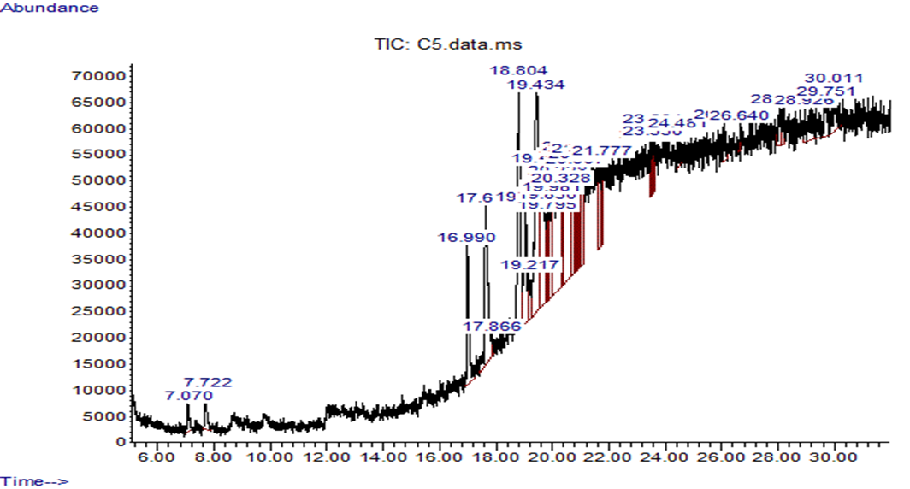
GC-MS Analysis of Cassava Peels Starch
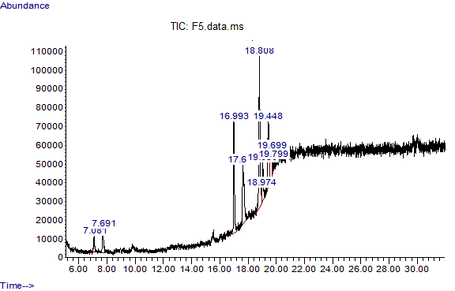
GC-MS Analysis of False Yam Starch (Fs)
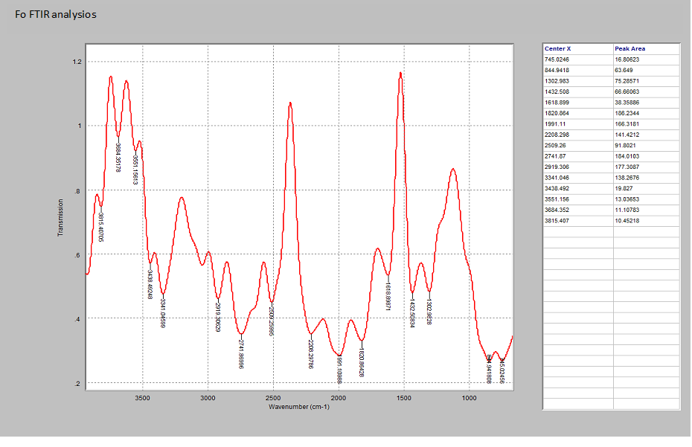
FT-IR Analysis of False Yam Starch (Fs)

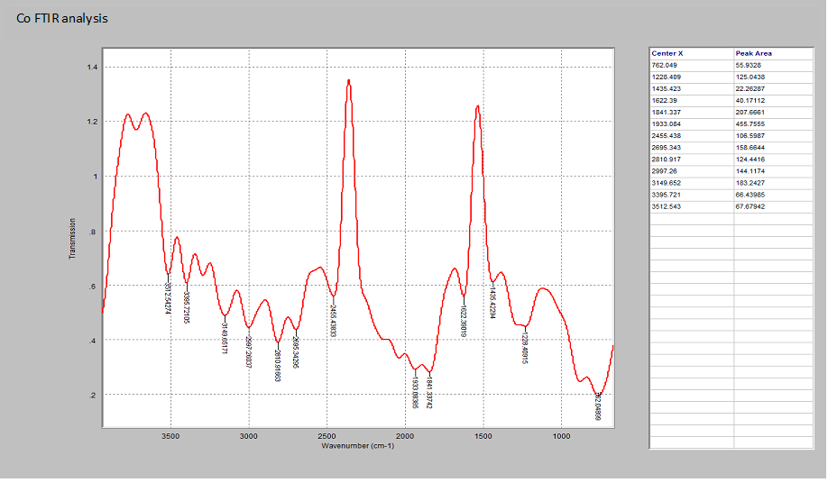
FT-IR Analysis of Cassava Peels Starch.

