Climate Smart Agroforestry for Sustainable Livelihoods: Evidence from Northwestern Tigray, Ethiopia

Abstract
Agroforestry is increasingly acknowledged as a crucial tool for smallholder farmers facing the impacts of climate variability. Yet, empirical evidence on how indigenous agroforestry systems enhance climate resilience and livelihood security in Ethiopia remains limited. This study assessed the role of local agroforestry practices in fostering adaptive capacity and improving livelihoods across distinct agroecological zones in northwestern Tigray. A total of 197 households were surveyed using structured questionnaires, complemented by key informant interviews and field observations. Data were analyzed through descriptive statistics, Chi-square tests, ANOVA, Pearson’s correlation, and multinomial regression. Findings revealed that farmers have adopted various adaptation strategies, including the diversification of crops, livestock, and tree species. Agroforestry emerged as the third most preferred adaptation option after livestock rearing and off-farm employment. On-farm trees were also ranked as the third most important livelihood asset, contributing approximately 34% of total household income. Trees supplied construction materials, livestock fodder, and energy sources while stabilizing crop yields during drought periods. Statistical analyses indicated a significant positive relationship between tree abundance and both crop productivity and household income. These results underscore the essential contribution of indigenous agroforestry to climate adaptation and livelihood resilience. Strengthening such systems through targeted research, extension support, and policy integration can substantially enhance climate resilience in Ethiopia’s dryland farming systems.
Keywords: Agroforestry, climate adaptation, livelihood resilience, indigenous knowledge, Tigray, smallholder farmers

1. Introduction
Climate change continues to pose serious threats to agricultural productivity, food security, and rural livelihoods, particularly in dryland regions of sub-Saharan Africa. Increasing temperatures, erratic rainfall, and frequent droughts have severely disrupted traditional farming systems, leading to declining crop yields and growing vulnerability among smallholders. Addressing these challenges requires locally adapted strategies that integrate both mitigation and adaptation measures (IPCC, 2014; FAO, 2013).
Agroforestry the deliberate integration of trees with crops and livestock—offers a practical solution to enhance resilience and productivity under changing climatic conditions (Mbow et al., 2014; Verchot et al., 2007). Through diversified production systems, agroforestry provides food, fodder, fuelwood, and income while improving soil fertility, regulating microclimates, and reducing erosion (Montagnini & Nair, 2004; Lasco et al., 2013).
In Ethiopia, agroforestry is deeply rooted in traditional land management practices (Teketay & Tegineh, 1991). Studies in regions such as Gedeo, Tigray, and Oromia confirm its potential to stabilize agricultural production and enhance household resilience (Linger, 2014; Alemu, 2016; Bekele, 2019). However, the specific contribution of indigenous agroforestry systems to climate change adaptation and livelihood diversification remains underexplored, especially in Tigray, one of Ethiopia’s most climate-vulnerable regions.
This study aimed to evaluate how traditional agroforestry practices support climate change adaptation and livelihood resilience in different agroecological zones of northwestern Tigray. The results provide valuable insights for policymakers and practitioners promoting sustainable land-use systems in Ethiopia’s drylands.

2. Materials and Methods
2.1. Study Area
The research was conducted in three districts of northwestern Tigray—Medebay Zana (highland), Tahtay Koraro (midland), and Tahtay Adiyabo (lowland)—representing distinct agro ecological settings. The region lies between 12°–15° N latitude and 36°30′–40°30′ E longitude, with altitudes ranging from 500 to 4,000 m a.s.l. Rainfall varies between 400 and 950 mm annually, and average temperatures range from 10°C to 30°C. The dominant soils include Leptosols and Cambisols (FAO, 2006).
Tree species such as Eucalyptus globulus, Acacia abyssinica, Olea africana, Faidherbia albida, Boswellia papyrifera, and Ziziphus spina-christi are common across the zones, integrated into diverse farming systems that combine crops, livestock, and tree cultivation.
Fig 1 : Study Area Map
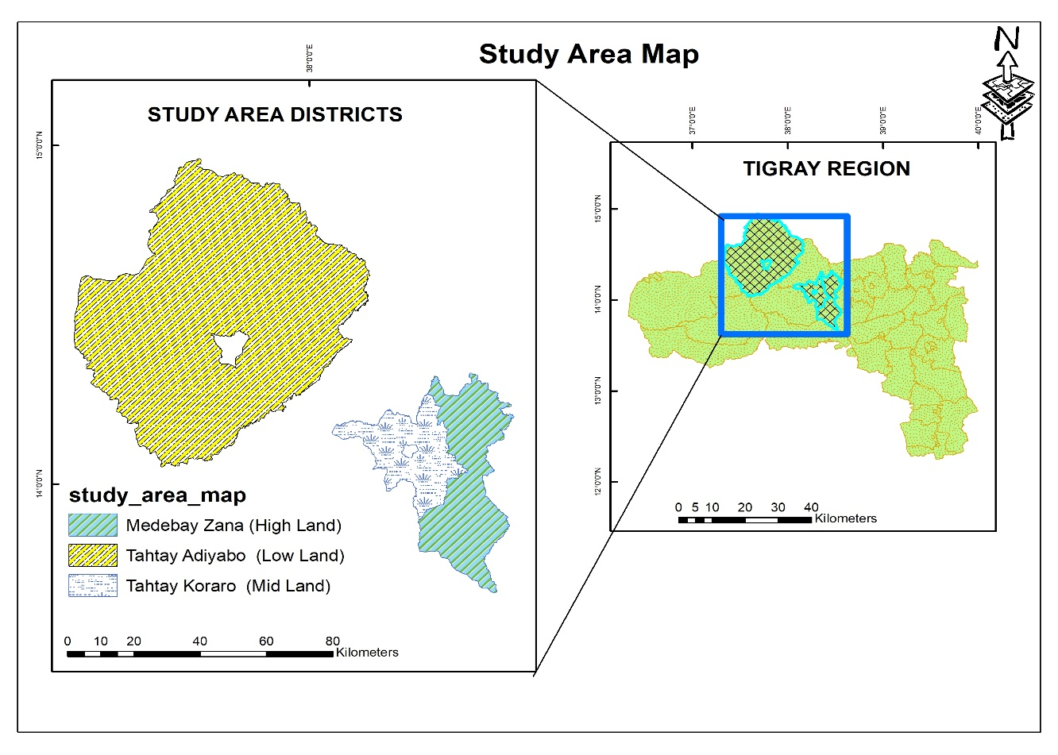

2.2. Sampling and Data Collection
A multi-stage sampling technique was used. Three agro ecological zones were purposively selected, and one district was randomly chosen from each zone. The sample size (n = 197) was determined following Yamane’s (1967) formula, ensuring 95% confidence and 7% precision levels. Data were collected using structured questionnaires, field observations, and key informant interviews.
$$n=\frac{Z^{2}.p.q}{e^{2}}$$
Where:
- n = Sample size
- z = Standard variate at a given confidence level
- p = Sample proportion
- q = 1 - p
- e = Precision level
The questionnaire captured information on household characteristics, benefits derived from agroforestry, adaptation strategies, and sources of income. Key informants including local elders, agricultural experts, and community leaders provided qualitative insights to complement quantitative data.
2.3. Data Analysis
Quantitative data were analyzed using IBM SPSS Version 26. Descriptive statistics summarized household characteristics and adaptation strategies. Chi-square tests, ANOVA, and Pearson’s correlations assessed relationships among variables, while multinomial regression identified factors influencing the choice of adaptation strategies. Qualitative information was thematically analyzed to enrich interpretation.

3. Results and Discussion
Most respondents were male and engaged primarily in mixed crop-livestock farming. Education levels were generally low, and the average household size was six members. Rainfed agriculture dominated livelihoods across all sites, supplemented by various agroforestry practices such as home gardens, woodlots, and boundary planting.
Nearly all respondents (94%) reported noticeable climate changes over the past three decades, primarily decreased rainfall, shortened rainy seasons, and rising temperatures. Drought was identified as the most prevalent hazard, especially in lowland areas. Farmers have developed diverse strategies to cope with climatic variability, including crop diversification, livestock adjustment, and agroforestry. Agroforestry ranked third among adaptation options.
Fig 2: Respondents from Lowland, Midland, and Highland Farm
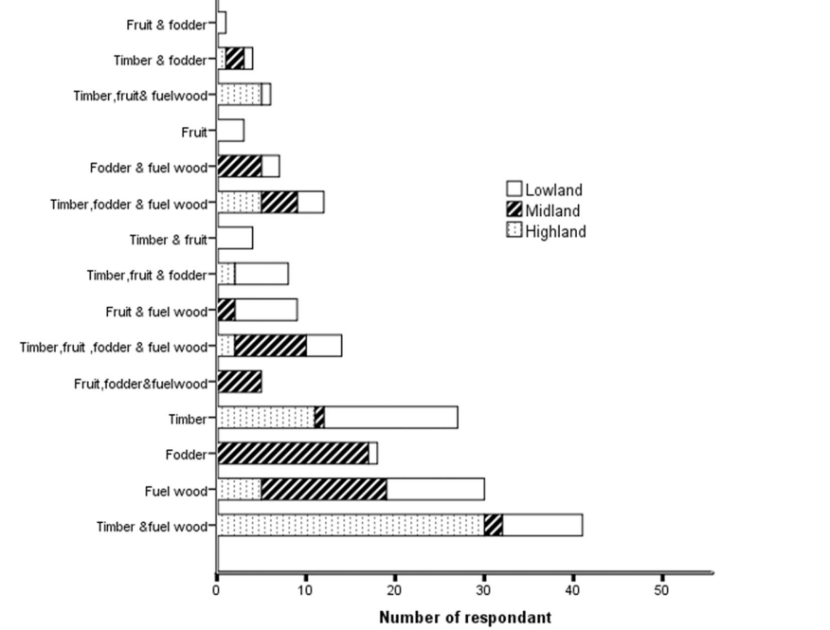
Agroforestry trees served multiple purposes: construction materials (30%), livestock feed (25%), and fuelwood (15%). Trees also provided essential resources for building and farming, reducing pressure on natural forests. About 73% of respondents agreed that on-farm trees enhance crop productivity, confirmed by significant positive correlations between tree abundance and both crop and total income (r = 0.37, p < 0.01; r = 0.55, p < 0.01). On average, trees contributed 34.35% of household income, underscoring their livelihood value.
Table 1. Type and source of material for house building and farm utilities
 |  |  | % of respondents
Type of material | Source |  | Highland |  | Midland | Lowland | Overall
farm utilities |  | open Forest |  | 21.5 | 21.9 | 17.6 | 20.3
 |  | own farm |  | 78.5 | 78.1 | 82.4 | 79.7
Most Material of wall a house |  | Wooden(with mud) |  | 79.7 | 21.9 | 13.2 | 37.8
 |  | Bricks/stones |  | 20.3 | 78.1 | 86.8 | 62.2
Most Material of wall a house |  | Wooden(with mud) |  | 9.5 | 59.4 | 61.8 | 43.9
 |  | Iron Sheet(with woo/timber/ |  | 90.6 | 40.6 | 38.2 | 56.1
The research also found that most residents use tree products from their farmland for constructing their houses. Respondents confirmed that more than two-thirds of their house walls are made from tree products sourced from their farmland. In the highland areas, most farmers use tree products for constructing house walls. However, in the lowland and midland areas, only 13.2% and 21.9% of respondents, respectively, use tree products for this purpose, as most house walls in these regions are made of stone or bricks. The use of tree products for house walls is significantly higher in the highland areas.
Additionally, 43.9% of total respondents stated that most of their house roofs are made of wood products. Farmers in the highland (9.4%), midland (59.4%), and lowland (61.8%) use tree products for roofing, with usage being higher in the midland and lowland areas. A majority of respondents also confirmed that they obtain farm tools from their farmland. Farmers across the highland, midland, and lowland areas primarily source farm tools from their land, while some respondents mentioned acquiring farm equipment from open forests (Table 1).
Most importantly, farmers acknowledged that the benefits of farm trees help them save money that would otherwise be spent on construction materials and farm tools, thereby enhancing their adaptive capacity. Responses from open-ended questions and interviews with elders revealed that trees on farmland tolerate drought one of the most frequent climate-related challenges allowing farmers to build shelters and obtain farm tools even during difficult periods. Farmers testified that by not purchasing construction or farm materials, they save money and time that would have otherwise been spent searching for resources in distant open forests. These savings provide financial security during challenging times. Despite a decline in tree product availability, farmers reported that they have never faced significant difficulties harvesting tree products (such as farm tools, timber, and forage), even during drought conditions.
Furthermore, 73.1% of respondents affirmed that the presence of trees on farmland improves crop production. The Pearson Correlation test confirmed that an increase in the number of trees on farmland leads to higher crop yields and increased household income. However, the chi-square test analysis results indicated a significant relationship between these factors.

Table 2. The relationship between trees in farmland and income (income from crop and total household income).
Variables | Income | Total Income
Abundance | .374** | .552**
Richness | .231** | .169*

**Correlation is significant at p < 0.01 and*p < 0.05
Table 3. Mean difference of on-farm trees and total household income in the three agro-ecologies.
Agro ecology | Total Household income(Us Dollar) | one Farm tree income
Highland | 622.19±434.99^{c} | 622.19±434.99c
Midland | 222.11±236.82ª | 222.11±236.82a
Lowland | 304.54±209.09^{b} | 304.54±209.09b
P-Value | 0.000 | 0.000
Similar letters indicate no significant difference and different letters indicate significant difference at p < 0.05. 1 US dollar ¼ 55.40 Ethiopian Birr (ETB) (Exchange rate as of November 29, 2023).

the study revealed significant differences in tree stand assets on farmland across different agro ecological zones. An increased number of tree species (higher diversity) on farmland was positively correlated with income from crop production and total household income (Table 2). With a moderate strength of correlation, an increase in tree abundance led to higher crop income and overall household income (p < 0.01). Similarly, increased tree species richness showed a weak but positive relationship with both crop income (p < 0.01) and total household income (p < 0.05). However, this positive relationship was only observed up to an optimal level of tree species richness.
The mean number of trees and the diversity of tree species on farmland varied significantly across different wealth categories. Notably, these two variables showed a significant difference between households in the poor and medium wealth categories.
The study also found that household income varied across agro ecological zones. The mean household income was highest in the highland ($622.19 ± 434.99), followed by the midland and lowland regions. The overall mean total household income was $382.57. Income from farm trees averaged $131.41, with the highest income reported in the highland ($202.63 ± 261.51), and followed by the midland and lowland agro ecologies. The contribution of on-farm trees to total household income was 32.57% in the highland, 39.05% in the midland, and 33.65% in the lowland. Overall, agroforestry practices in the studied agro ecological zones contributed 34.35% to total household income (Table 3).
Furthermore, interviewees from our study indicated that during climate shocks, trees on farmland played a crucial role in supporting farmers. During difficult times, particularly droughts, farmers harvested tree products such as timber, fuel wood, and forage, which served as a source of income and compensation for failed crop production. In times of extreme climate stress, farmers sold timber and fuel wood to meet their household's food and other essential needs. Additionally, trees provided a critical source of forage for cattle and sheep during droughts, helping farmers mitigate feed shortages.

Table 4. Percentage of respondents who ranked the main livelihood products based on their importance to their livelihood.
 |  | % of respondents
Agro ecology | Rank | Crop | Livestock | Non-Farm | Agroforestry
Highland | First | 93.8 | 1.6 | 1.6 | 3.1
 | Second | 6.8 | 54.2 | 6.8 | 32.2
 | Third | 31.4 | 0 | 9.8 | 58.8
Midland | First | 89.1 | 6.3 | 1.6 | 3.1
 | Second | 6.3 | 71.9 | 6.3 | 15.6
 | Third | 3.3 | 16.7 | 8.3 | 71.7
Lowland | First | 92.6 | 5.9 | 1.5 | 0
 | Second | 5.9 | 89.7 | 0 | 4.4
 | Third | 1.5 | 1.5 | 8.8 | 88.2
Overall | First | 91.8 | 4.6 | 1.5 | 2
 | Second | 6.3 | 72.8 | 4.2 | 16.8
 | Third | 1.7 | 15.1 | 8.9 | 74.3
This, in turn, helped mitigate food shortages for households. Additionally, respondents stated that income generated from trees during periods without climate challenges contributed to financial stability and improved resilience when climate shocks occurred. This finding highlights that trees on farmland, which are less affected by climate hazards, play a significant role in enhancing household income and livelihood resilience.
The study results indicated that income from on-farm trees varied across agro ecological zones (p < 0.05). A significant difference was observed in the mean income from trees between the highland and midland, as well as between the highland and lowland (p < 0.05). However, the mean income difference between the midland and lowland agro ecologies was not statistically significant (Table 3).
Furthermore, the study confirmed that on-farm trees are among the primary livelihood assets for households. Most respondents ranked crops, livestock, and trees as their first, second, and third most important livelihood assets, respectively. This pattern applied across all three agro ecological zones, except in the highland, where fewer respondents ranked trees as their third most important livelihood asset compared to the other zones. This finding underscores that trees on farmland are among the top three essential livelihood assets (Table 4).
Additionally, the total mean household asset value was estimated at $690.85 ± 524.72. The mean asset value of trees on farmland was $132.73, contributing 19.21% to the total household livelihood asset, ranking third after livestock ($369.86 ± 271.34) and crop production ($189.09 ± 211.69). The mean total livelihood asset value was highest in the highland ($795.86 ± 691.47), followed by the other agro ecological zones. Similarly, the mean tree stands asset value in the highland ($283.15 ± 409.66) was higher than in the midland and lowland. There was a significant difference (p < 0.05) in the mean values of all three main livelihood assets and total assets across the three agro ecological zones. However, the mean difference in total livelihood assets between the highland and lowland was not statistically significant at p < 0.05 (Table 5).
Interviews conducted during the study revealed that the increased income and productivity resulting from trees on farmland helped farmers enhance their adaptive capacity, making them more resilient to climate-related challenges.

Table 5. Mean difference of main household livelihood assets in different agro-ecologies (estimated in USD)
Agro ecology | Livestock asset |  | Crop production asset |  | Trees stand asset |  | Total main livelihood asset
Highland | 284.80 | ± 218.42ª | 238.39 | ± 279.41^{b} | 283.15 | ± 409.66^{c} | 795.86 | ± 691.47^{b}
Midland | 375.77 | ± 269.03^{b} | 120.28 | ± 156.78ª | 55.51 | ± 87.39ª | 555.59 | ± 380.09ª
Lowland | 444.21 | ± 298.07^{b} | 207.19 | ± 160.43^{b} | 73.99 | ± 72.16^{b} | 717.77 | ± 428.92^{b}
p-Value | 0.003 |  | 0.000 |  | 0.000 |  | 0.033
Similar letters indicate no significant difference and different letters indicate significant difference at p < 0.05.
The low vulnerability of trees to climate shocks has led farmers to consider them a primary livelihood asset and a crucial source of income. Interviewees highlighted that trees on farmland serve as a key livelihood asset and an essential source of livestock feed during droughts. This support helped farmers minimize livestock losses due to climate shocks and enabled them to meet their household food demands.
Additionally, respondents noted that accumulating agroforestry tree assets during periods without climate challenges provided them with a more resilient asset base during climate shocks. This, in turn, enhanced their adaptive capacity, allowing them to better withstand and recover from adverse climatic conditions.
Agroforestry was also identified as one of the top three livelihood assets—after livestock and crops—contributing nearly 20% to total household asset value. Trees provided a stable income source less sensitive to climate shocks, confirming agroforestry as a ‘natural insurance mechanism’ stabilizing rural livelihoods.

4. Conclusion and Recommendations
This study demonstrates that indigenous agroforestry systems play a critical role in enhancing smallholder adaptation to climate change in northwestern Tigray. Trees integrated into farmlands support multiple livelihood functions—improving crop yields, providing feed and fuelwood, and generating significant income even during droughts. By contributing to both economic and ecological stability, agroforestry serves as a cornerstone for resilient rural livelihoods.
However, adoption and benefits vary by gender and agroecology, indicating the need for site-specific interventions. Policymakers should promote the expansion of agroforestry through strengthened extension services, equitable access to resources, and integration into climate adaptation and land restoration programs.

6. References
Alemu, B. (2016). The role of agroforestry practices in improving rural livelihoods in Ethiopia. Addis Ababa University Press.
Bekele, M. (2019). Agroforestry practices and their contribution to household income in rural Ethiopia. Journal of Environmental Management, 244, 272–281.
Food and Agriculture Organization (FAO). (2006). World reference base for soil resources: A framework for international classification, correlation and communication. Rome: FAO.
Food and Agriculture Organization (FAO). (2013). Climate-smart agriculture sourcebook. Rome: FAO.
Intergovernmental Panel on Climate Change (IPCC). (2014). Climate change 2014: Impacts, adaptation, and vulnerability. Cambridge University Press.
Lasco, R. D., Delfino, R. J. P., & Catacutan, D. C. (2013). Agroforestry systems: Helping smallholders adapt to climate risks while mitigating climate change. Wiley Interdisciplinary Reviews: Climate Change, 5(6), 825–833.
Linger, E. (2014). Agroforestry practices and socio-economic roles of Cordia africana in Ethiopia. Journal of Agriculture and Rural Development in the Tropics and Subtropics, 115(1), 11–17.
Mbow, C., Smith, P., Skole, D., Duguma, L., & Bustamante, M. (2014). Achieving mitigation and adaptation to climate change through sustainable agroforestry practices in Africa. Current Opinion in Environmental Sustainability, 6, 8–14.
Montagnini, F., & Nair, P. K. R. (2004). Carbon sequestration: An underexploited environmental benefit of agroforestry systems. Agroforestry Systems, 61, 281–295.
Teketay, D., & Tegineh, T. (1991). Traditional tree crop production practices in Ethiopia. Agroforestry Systems, 14, 71–83.
Verchot, L. V., Noordwijk, M., Kandji, S., Tomich, T., Ong, C., Albrecht, A., … Palm, C. (2007). Climate change: Linking adaptation and mitigation through agroforestry. Mitigation and Adaptation Strategies for Global Change, 12, 901–918.
Yamane, T. (1967). Statistics: An introductory analysis (2nd ed.). New York: Harper and Row.

