Short Research Article

Screening and production of four varieties of pigeon pea [Cajanus cajan (L.)] in the Komadougou basin, Diffa, Niger

ABSTRACT
The Diffa region is an area of livestock farming par excellence. Unfortunately, it is confronted by a chronic fodder deficit in recent decades. It is important to find the mechanism to mitigate the consequences of this fodder deficit. It is in this framework that it was useful to conduct a study on the fodder cultivation of a legume. The objective of this study is to assess the production parameters of four varieties of Cajanus cajan in order to identify the most efficient. The four varieties are white (Va1), dark red (Va2), light red (Va3) and cream variety (Va4). To do this, the Latin square experimental design was installed, with four blocks and 16 elementary plots. Data were collected on 5 plants in each of the plots. The data analysis revealed the rate of germination is 95%, 96%, 98% and 100% for varieties Va3, Va1, Va2 and Va4. The flowering stage is 92.60±5.83, 91.90±3.29, 90.50±6.22 and 90.50±3.59 DAS respectively for Va4, Va1, Va2 and Va3. As for the maturity stage, it is 123.90±12.35, 125.23±8.96, 126.94±0.47 and 128.53±0.47 DAS respectively for Va1, Va2, Va3 and Va4. The number of pods is 188.75±69.16, 146.30±130.02, 111.15±58.73 and 102.95±55.91 respectively for Va4, Va1, Va3 and Va2. As for the lengths of the pods, they are 46.65±2.82, 44.40±2.96, 43.11±3.59 and 38.91±2.80 respectively for Va1, Va4, Va3 and Va2. The dry matter productivities are 4519.30±2227.02, 4011.49±2479.09, 3687.80±2100.81 and 3348.47±1618.93 kg.DM.ha respectively for Va4, Va2, Va1 and Va3. The Va4 variety has the best performance in green phytomass production, dry phytomass. It has the largest number of pods, which are relatively long.

Keywords : Variety, flowering, productivity, maturity, Cajanus cajan, Diffa.

1. INTRODUCTION
Niger, a Sahelian country with a hot and dry climate with an area of 1,267,000 km², of which 12% are used for agriculture and 19% represent the pastoral zone. It is a livestock country par excellence, with a large livestock estimated at more than 14 million TLU in all categories combined. After agriculture, livestock farming is the second activity practiced by nearly 87% of the population (Laminou, 2015). Livestock farming has been practiced for centuries with a system traditional information that allows them to manage the herd. It is an important asset for the socio-economic development of the country, in particular because the demand for export of livestock products, mainly to Nigeria, is constantly increasing (Dez et al. 1986).
Nevertheless, despite the large area available, livestock farming is like agriculture faced with a number of difficulties that hinder its full development. Indeed, in pastoral areas successive droughts, localized grazing, inadequate meshing of points water, have caused a quantitative and qualitative decrease in available fodder resources (Gagara and Djambouto 2020). In agro-pastoral areas, the extension of cultivated land to detriment of pastoral areas, the advanced degradation of pastures, the invasion of routes by unpalatable species and the land problem constitute constraints serious to the sustainable development of livestock farming. The latter is of an extensive type based on common grazing in natural grazing areas which are dependent on low rainfall and irregular (Dez et al. 1986).
To deal with these constraints, pigeon pea (Cajanus cajan), a crop nicknamed "treasure" by Niyonkuru (2002) could be a first attempt to provide solutions to the problem of recurrent fodder deficit. The species is adapted to semi-arid zones due to of its drought tolerance (Odeny, 2007). Being a legume, it fixes nitrogen atmospheric, and is cited as one of the few plant species that can use effectively iron bound to phosphorus (Subbarao et al. 1991). Pigeon pea is the fifth legume by its importance worldwide although weakly marketed (CIRAD-GRET, 2002). It is a source of dietary protein more accessible to local populations who cannot afford to buy animal protein at high costs (Massawe et al., 2005). Thus pigeon pea will allow better management of resources fodder in the context of improving the feeding conditions of ruminants domestic, especially in the dry season, and also used to restore soil fertility (Bodji, 1997). The genus Cajanus includes 34 species. It should be noted two wild species of Cajanus in Africa: Cajanus kerstingii Harms native to West Africa and C. scarabaeoides (L.) Thouars occurs along the African and Malagasy coasts. The first species does not cross with C. cajan, but the second can produce hybrids with it. He There are spontaneous hybrids, but they are rare. Although the use of Cajanus kerstingii in human and animal food is not documented, it may have a similar interest to pigeon pea. In Senegal, the twigs of C. kerstingii are used in the construction of walls of temporary huts. Other related species of C. cajan are found in Asia and Australia. In India, 10 maturity groups have been distinguished in C. cajan, which are combined usually in four categories: extra early, early, medium and late varieties (120, 145, 185, and more than 200 days after sowing, respectively) (FAO, 2007).
Thus, very little information is currently available on genetic diversity, and production parameters of C. cajan varieties, when grown on loamy soils of the Komadougou basin. The development of a prospecting, collection and evaluation of the seed quality of pigeon peas is therefore essential (Quenum et al. 2016). The identification of varieties, as well as the cultivation of pigeon peas is one of the solutions that can be considered in order to allow better fodder production in Niger Oriental. It is important to identify the variety of C. cajan that can externalize the best production performances in the agro-ecological zones of the Komadougou basin. He specifically involves distinguishing the different varieties and carrying out their test of germination; (ii) to compare the production parameters of C. cajan varieties and (iii) in order to identify the most efficient variety in terms of production in the municipality of Diffa.

2. MATERIALS AND METHODS

2.1 Geographical Location of study area
The trial was carried out at the INRAN experimental station in Diffa located in the municipality urban area of Diffa in eastern Niger. This site is located between 13 °18'58 '' North latitude, and 12°34'38.8'' East longitude with an altitude of 310m (Fig. 1 & 2).
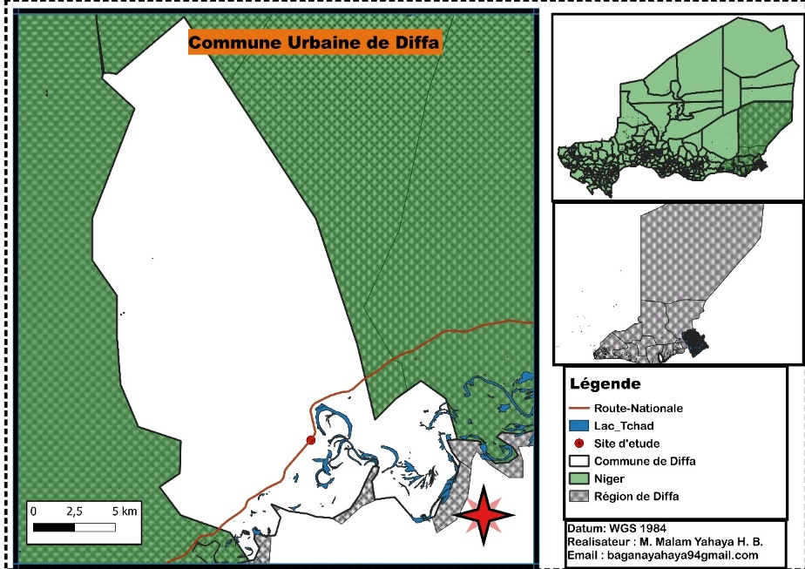
Figure 1 : Geographical location of the study site

The rainfall for the trial year started in June and ended in October 2024 (Fig. 2). The average annual rainfall is 477.1 ± 210 mm. In 2024, the number of rainy days is 38 with an annual rainfall of 668 mm. The climate of the year is hot and dry with an average annual temperature of 26.76°C, but varying from 9°C in December-January to 43.7°C in May (Fig 2).
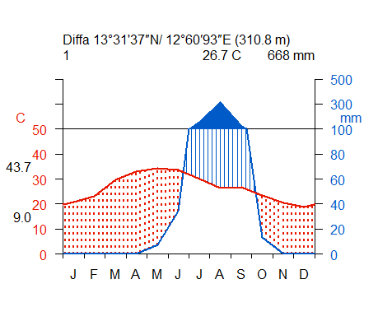
Figure 2 : Evolution of climatic parameters in the municipality of Diffa (2024)

2.2 Biological Material
The plant material used in the study consists of four (4) varieties of C. cajan. These are local varieties grown in Niger. Pigeon pea is characterized by seeds with very diverse colorations. These four varieties were chosen and tested. The seeds of these varieties used have different characteristics.

2.3 Methods

2.3.1 Experimental setup
The experimental design is a Latin square design, consisting of four blocks (or replicates). A single factor was studied, which is the variety, and two gradients of heterogeneity of the terrain, namely shading and uneven terrain. Each repetition contains 4 treatments. The distance between the repetitions is 0.5 m, the distance between the plots is 0.50 m. The total area is 379.25 m² (18.5m×20.5m). Indeed, each of the repetitions covers (20.5m×4m) 82m² (Fig. 3). and each treatment has an area of 18m² (4.5m×4m) (Fig. 4).
Thus each elementary plot is represented in 8 rows of 7 planting holes. The distance between
rows and also between planting holes is 0.5m (Fig. 4). And each treatment carries 56 planting holes (of 2 plants) therefore 224 planting holes per repetition. This gives a total of 896 planting holes, i.e. 1792 individuals (Fig. 4).
Figure 3 : Diagram of the Latin square experimental design

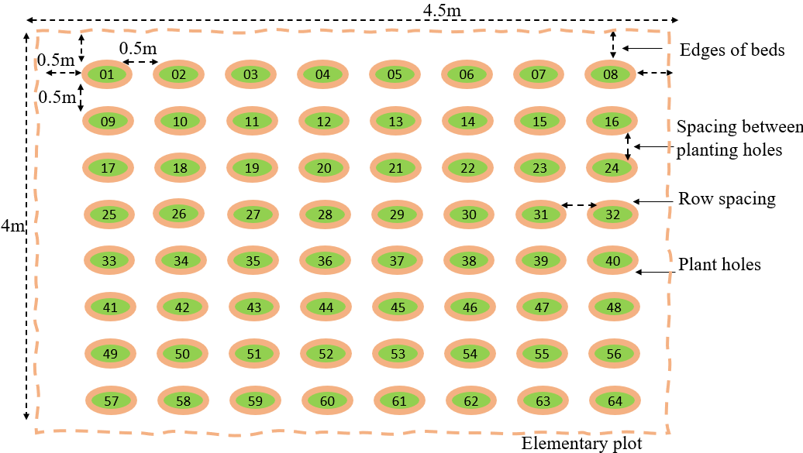
Figure 4: Identify the most productive varieties in forage production.

2.3.2 Land preparation, sowing and thinning
The preparation of the experimental plots was done at the beginning of the rainy season. The clearing was done to clear tree and shrub stumps to allow for good crop development. The leveling of the ground is carried out to make the plots homogeneous. And the delimitation of plots was carried out.
Sowing: All varieties were sown on the same day, July 9. Indeed, the sowing was done in line with 3 seeds per planting hole. The seeds were introduced at a depth of 3 cm. The seeds were sown in pure culture. Plant maintenance.
Thinning and weeding: The plowing was done three weeks after sowing, in a superficial way with a hoe, turning the soil to a depth of 10 to 20 cm to bury the crop residues from the previous year and weeds. And two weeks after the plowing, manual weeding was done. Weeding was carried out using a hiler at the fourth and eighth week after sowing. And thinning was done, fifth week after sowing, in order to leave two strong plants per hill.

2.3.3 Sampling and data collection method
- Sample size: The number of plants that were measured is obtained by applying the formula of the law of large numbers on the 896 hills, which are on the 16 plots elementary. The Sloven formula was used to calculate the sample size (Anderson, 2023). $n=\frac{N}{1+N*e^{2}}$
N: Population size, which is 1024 hills for this study; e: the risk of error (5 to
15%). In this study, a risk of 10.73% error was taken. This allowed
to obtain 96 samples of which $n=\frac{1024}{1+1024*{0.1073}^{2}}=\frac{1024}{12,79}=80,01$. On the total of 80 hills and 16 experimental plots, measurements were taken on 5 plants per plot.
- Sampling method: The ALEA-ENTRE-BORNES function of the Excel spreadsheet was used to choose the 5 plants, on which the measurements on the parameters of productions will be carried out.
- Monitoring of germination and productions: Monitoring of germination was done every day. Indeed, the germinated plants were noted from the beginning to the end of germination. It is about to assess the productivity in fodder, resulting from the cultivation of pigeon pea.
The forages were then mowed and introduced into the oven for 3h:30 mns at a temperature of 160°C for drying. This allowed to obtain the weight of the dry matter per variety. The forages were weighed in fresh and dry state using an electronic balance.
- Data collection method: 7 characters were selected from the list of Descriptors for pigeonpea (IBPGR/ICRISAT, ) for seed screening, germination and production of varieties of C. cajan. The monitoring parameters are summarized in Table 1.
Table 1: Quantitative characters N°
N° | Characters studied | Abreviation | Descriptions | Unit of measure
1 | Time of the  first flowering | Flo | Number of days, from sowing to  moment when 50% of the plants per plot  bear flowers. | (day))
2 | Time of  maturation | Mat | Number of days, from sowing to the  moment when 50% of the plants per plot  bear ripe grains. | (day))
3 | Length of  pod | LongGs | Average pod length measured from  five pods from three healthy plants. | (cm)
4 | Number of  pods | NGs | Number of pods from five plants per  plot counted after harvest. | (nbre)
5 | Number of  flowers | Nflower | Number of flowers from five plants during the strike. | (nbre)
6 | Fresh weight of  phytomassphyt  omass | FFresh | Le poids frais des cinq plantes pesé en kg, après la récolte. | (kg)
7 | Dry weight of  phytomass | Pdry | The weight of the five dried plants measured in kg, after harvest. | (kg)

2.3.4 Data processing and analysis
- Germination rate $T_{ger}=\frac{n_{ger}}{N_{GS}} X 100$, with T ger the germination rate (%), n ger N GS number of seeds sown.
- As for the productivity of dry matter, it was determined after passing the green leaves in the oven. They were then weighed. This made it possible to have the dry weight. The
dry weight expressed in kg.m
, is extrapolated in kg.MS.ha
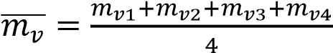 , after drying, dry matter was obtained in kg.MS.m²
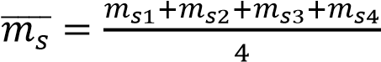. This result will be extrapolated in kg.MS.ha to obtain productivity
in fodder. 𝑃_{𝑝} = 10⁴𝑋̅𝑚̅̅̅_{𝑠}.
- Data analysis: RStudio 4.4.1 software (R Core Team, 2024) was used for the multivariate analyzes and comparison tests. The tidyverse, ggpubr and rstatix packages were used for the comparison tests. It was compared the production parameters (Flowering, maturity, number of pods, length of pods, etc.) of the different varieties of C. cajan.
The ggpubr and ggpmisc packages were used to observe the different correlations that exist between production parameters and the different treatments. As for the packages FactoMineR and factoextra for Principal Component Analysis (PCA) (Kassambara, 2017; R Core Team, 2024). The quantitative production data were subjected to an Analysis in Principal Components (PCA). This analysis was done in order to assess the relationships that exist between the production parameters of C. cajan and classify them into different groups.
The PCA was also carried out to assess the relationships between the production parameters and the treatments according to the axes. When the contribution of two axes (axis 1 and axis 2) is less than 80%, the representation was retained according to the first two axes (1 & 2).

3. RESULTS AND DISCUSSION

3.1 Seed screening and germination of four varieties of C. cajan
- Screening of C. cajan seeds: C. cajan seeds were collected from Madaoua (a chief town of the department of Niger). These seeds present a diversity morphological, mainly due to the color (Fig. 5). This allowed us to distinguish four varieties.
Table 2: Characteristics of seeds of different varieties of pigeon pea used
Varieties | Local name | Color of s integument | Color and shape of  the eye | Shape of  seed |  | Provenance
Va1 | Dan gori | White | Gray eye shaped like butterfly | Oval |  | Madaoua
Va2 | Pea of wood | Dark red | Gray eye shaped like butterfly | Oval |  | Madaoua
Va3 | Pea | Light Red | Gray eye shaped like butterfly | Oval |  | Madaoua
Va4 | Galo-nassara | Cream | Gray eye shaped like butterfly | Oval |  | Madaoua

Figure 5 : Photo of the different varieties of C. cajan studied

- Germination of four varieties of C. cajan
The test was carried out in Petri dishes at the INRAN laboratory in Diffa. Indeed 15 seeds of each variety were put into culture. On the 3rd days after sowing, the seeds began to germinate (Fig. 6). So the latency time of C. cajan is 2 days. Five days after the operation all the seeds have germinated (Fig. 7).
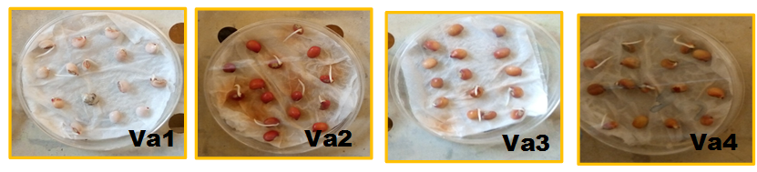
Figure 6 : Photo three days after sowing seeds

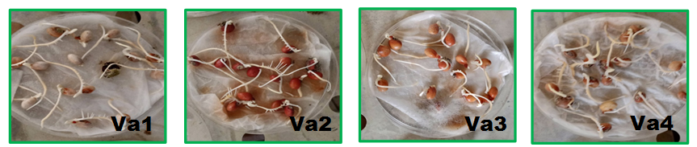
Figure 7 : Photo five days after sowing seeds

Germination-emergence: The seeds of C. cajan gave a good germination rate. After five days after sowing, the plants began to appear, showing two leaves (Fig. 8). One week after sowing, the germination rate is respectively 95%, 96%, 98% and 100% for the light red (Va3), white (Va1), dark red (Va2) and cream variety (Va4).
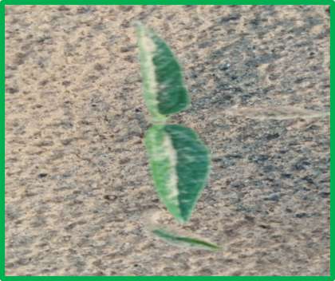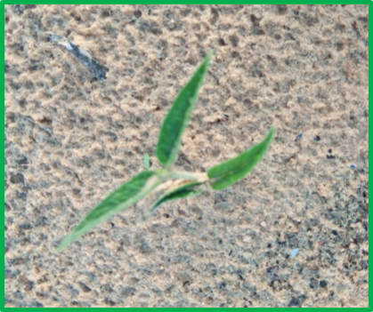
Figure 8 : Photo of C. cajan plants at emergence

3.2 Comparative analysis of some production parameters of four varieties of C. cajan
The Shapiro test with p-value of 0.000000548, 0.0000000172, 0.00000000413, 4.95.10⁻⁶, 0.00878, 0.00213, 0.00528 respectively on flowering, maturity, the number of plants having
flowered, the number of pods, the length of the pods, the fresh and dry weight of the phytomass, from the plants of C. cajan shows that these data do not follow a normal law. It is necessary to do a non-parametric test.
The Kruskal-Wallis test with p-value of 0.287, an effect of 0.0102 and a low magnitude shows that there is no significant difference on the flowering stages of the four varieties of C. cajan. This result is confirmed by the Wilcoxon pairwise test (Fig. 9).
The Kruskal-Wallis test with p-value of 0.000748, an effect of 0.183 and a large magnitude shows that there is a significant difference in the maturity stages of the four varieties of C. cajan. This result is confirmed by the Wilcoxon pairwise test where a highly significant difference between Va3 and Va4 was found. (Fig. 9).
The Kruskal-Wallis test with p-value of 0.328, an effect of 0.00590 and a low magnitude shows that there is no significant difference in the number of C. cajan plants having flowered. This result is confirmed by the Wilcoxon pairwise test where no significant difference was found (Fig. 9).
The Kruskal-Wallis test with p-value of 0.00034, an effect of 0.205 and a state of large magnitude shows that there is a significant difference in the number of pods of C. cajan. This result is confirmed by the Wilcoxon pairwise test where a difference was found between
Va4 and Va3 (0.00049) also between Va4 and Va2 (p = 0.00012) (Fig. 9).
The Kruskal-Wallis test with p-value of 0.0000000354, an effect of 0.454 and a state of a large magnitude shows that there is a significant difference in the pod lengths of C. cajan. This result is confirmed by the Wilcoxon pairwise test where a difference was found very highly significant between Va1 and Va2, Va2 and Va4 (0.0000), a highly significant significant difference between Va2 and Va3 (0.00021), also a very significant difference between Va1 and Va3 (0.0014) and significant between Va1 and Va4 (0.019) (Fig. 9). It should be noted that the C. cajan plants that have the long pods have the lowest number of pods.
The Kruskal-Wallis test with p-value of 0.284, an effect of 0.0105 and a state of low magnitude shows that there is no significant difference between the fresh weights of C. cajan. This result is confirmed by the Wilcoxon pairwise test (Fig. 9).
The Kruskal-Wallis test with p-value of 0.435, an effect of -0.00358 and a state of low magnitude shows that there is no significant difference between the dry weights of C. cajan.
This result is confirmed by the Wilcoxon pairwise test (Fig. 9).

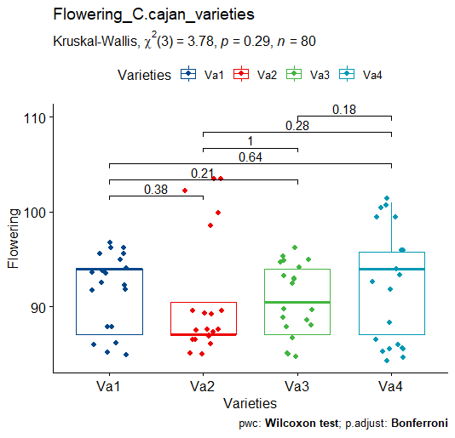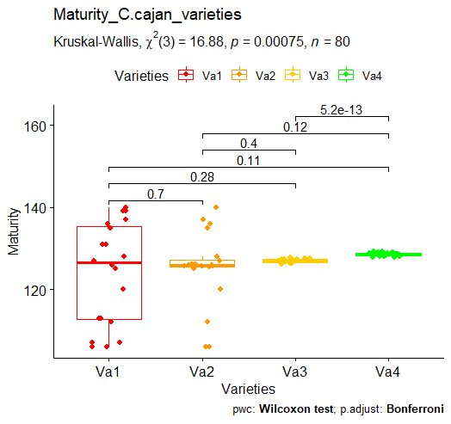
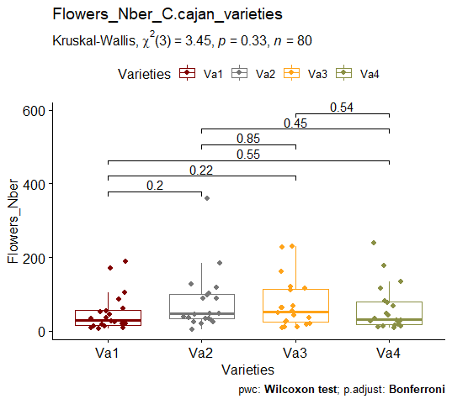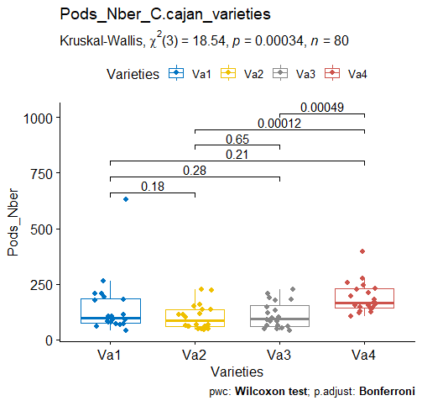
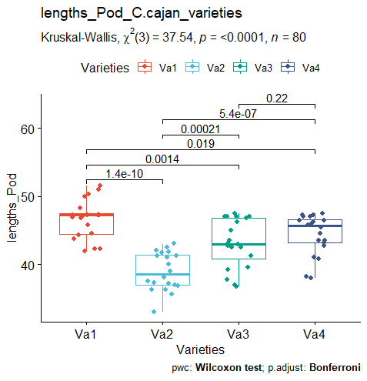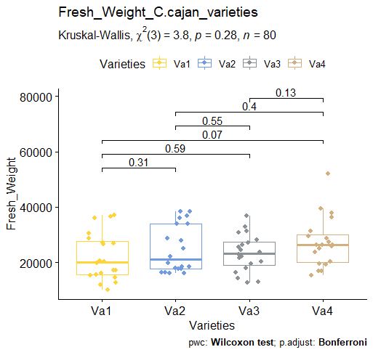
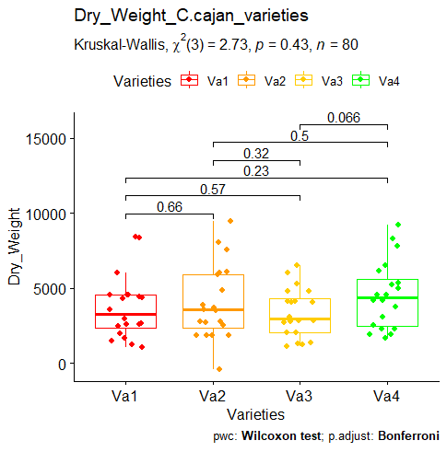
Figure 9 : Comparison of production parameters of four varieties of C. cajan

3.3 Performance of varieties of C. cajan

3.3.1 Relationships between different production parameters of C. cajan
The correlation coefficient values range from -0.087 to 0.322. No strong correlation was found between the production parameters of C. cajan (Fig. 10). However, it was found very strong positive correlations between the fresh weight and the dry weight of the vegetative matter of the four varieties of C. cajan (r.Va1=0.857***, r.Va2=0.849***, r.Va3=0.834***, r.Va4=0.791***). A positive correlation was also found between the maturity stages and those of flowering of Va4 (r.Va4=0.875***) (Fig. 11).
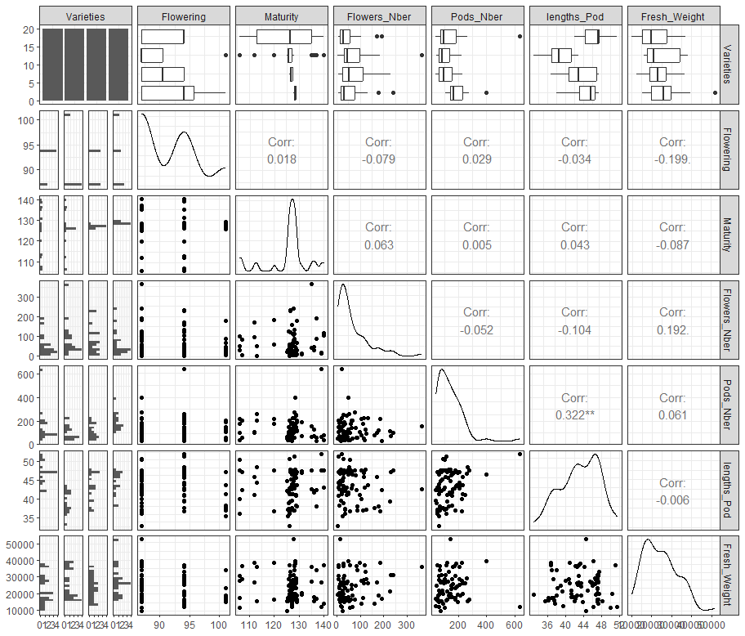
Figure 10 : Relationship between different production parameters of C. cajan

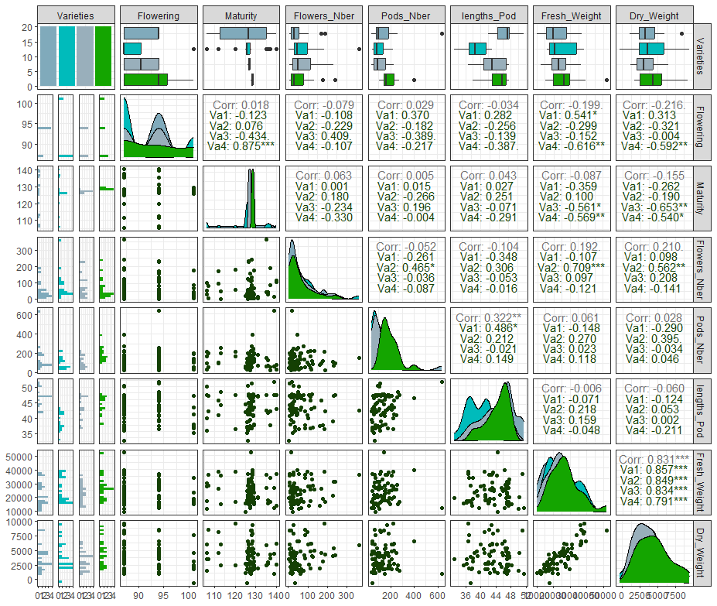
Figure 11 : Relationship between the different production parameters of C. cajan varieties

3.3.2 Summary of production parameters of C. cajan varieties
The first three axes concentrate more than 63% of the information. The fresh weight and the weight of dry matter are positively correlated to axis 1 of the PCA (29.1%). Varieties Va3 and Va4 show better performance in fresh and dry phytomass production (Fig. 12). The pod length and the number of pods are positively correlated to axis 2 of the PCA (19.3%). Varieties Va4, Va1 and Va3 have the longest pods with a high number elevated. Finally, the flowering and maturity stage are negatively correlated to axis 1.

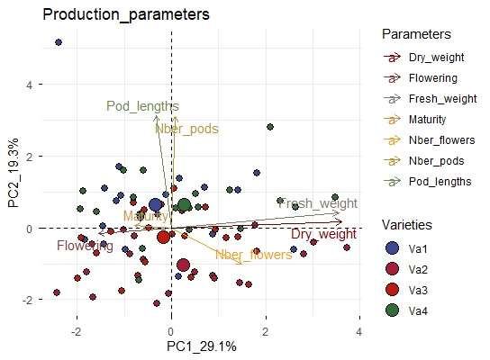
Figure 12 : Relationship between production parameters and the 4 varieties of C. cajan

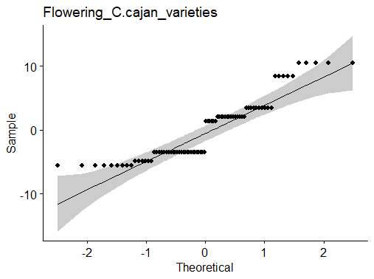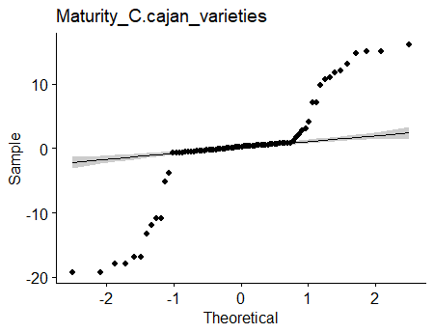
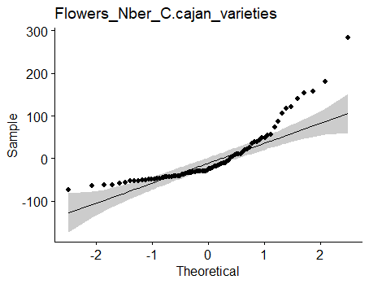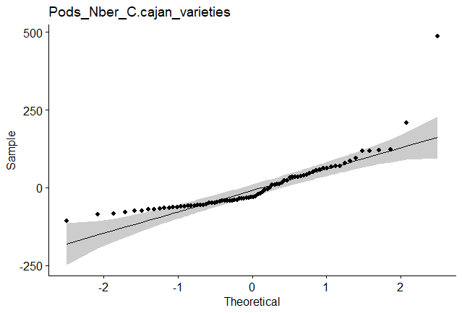
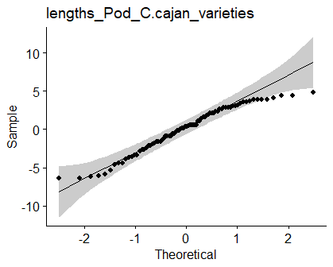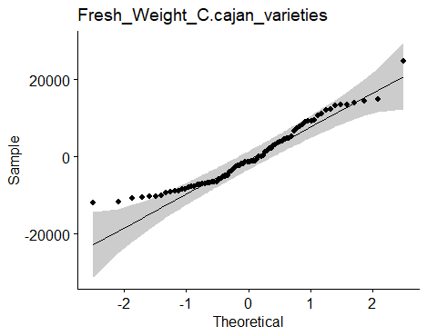
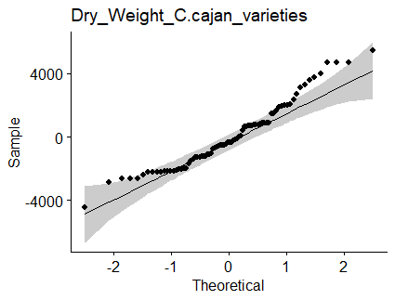
Fig 13: Normality test verification.

2.3.2 Comparison of Average Variety Performance
The analysis of variance based on comparing the means of the different traits for each variety shows highly significant differences. These differences are for pod length among all varieties Va1, Va2, Va3, and Va4 (p < 0.0001) and for the number of pods among all varieties Va1, Va2, Va3, and Va4 (p < 0.007) (Table 3).

Table 3: Variety Characteristics: Mean Values and Standard Deviation of Varieties
 | Va1 |  | Va2 |  | Va3 |  | Va4 |  | Statistiquedutest
Variable | M | Ơ | M | Ơ | M | Ơ | M | Ơ | F | P | CV(%)
Flo(jour) | 91,90b | 3,29 | 90,50b | 6,22 | 90,50b | 3,59 | 92,60b | 5,83 | 0,91 | 0,438 | 5,77
Mat(jour) | 123,9b | 12,35 | 125,23b | 8,96 | 126,94b | 0,468 | 64,3175c | 0,468 | 1,2 | 0,317 | 4,46
LongGs(mm) | 46,65a | 2,82 | 38,91b | 2,8 | 43,11c | 3,59 | 44,40c | 2,96 | 22,53*** | <0,0001 | 13,94
Nfleur | 49,40a | 51,9 | 77,50a | 80,3 | 73,00a | 67,8 | 60,30a | 62,3 | 0,74 | 0,534 | 48,08
NGs | 146,30d | 130 | 103,00c | 55,9 | 111,20b | 58,7 | 188,80a | 69,2 | 4,33** | 0,007 | 40,53
PFrais(kg) | 0,58c | 0,28 | 0,66c | 0,3 | 0,60c | 0,2 | 0,69c | 0,24 | 0,76 | 0,522 | 33,79
PSecs(kg) | 0,31d | 0,12 | 0,22d | 0,18 | 0,24d | 0,09 | 0,33d | 0,18 | 2,67 | 0,053 | 41,77
On each line, values accompanied by different letters are significantly different at the probability level (α=0.05). **: the difference is significant; ***: the difference is highly significant; and ns: the difference is not significant. Ơ: standard deviation; M: mean; Flo: flowering period; LongGs: pod length; Nflr: number of flowers at harvest; NGs: number of pods per plant; PFrais: fresh weight; PSec: dry weight of the forage.

Table 4: Cumulative Percentage of Eigenvalues
Dim | eigenvalue | variance.percent | cumulative.variance.percent
Dim.1 | 2.3007586 | 25.563984 | 25.56398
Dim.2 | 2.1936226 | 24.373585 | 49.93757
Dim.3 | 1.1936272 | 13.262525 | 63.20009
Dim.4 | 0.9000659 | 10.000732 | 73.20083
Dim.5 | 0.8459822 | 9.399802 | 82.60063
Dim.6 | 0.5374008 | 5.971120 | 88.57175
Dim.7 | 0.4279365 | 4.754849 | 93.32660
Dim.8 | 0.3383267 | 3.759185 | 97.08578
Dim.9 | 0.2622796 | 2.914218 | 100.00000

3.4 Discussion
Flowering: flowering reaches 50% at 90±4 -92±6 DAS depending on the variety. This duration of flowering is close to that recorded by Alisaheb, 2013, which varies from 82 to 112 DAS. But earlier than the varieties studied by Quenum, et al., (2016) where the period varies from 107 to 137 DAS. These varieties are still much earlier than the varieties studied by Angandza et al or flowering started 180 days after sowing. The flowering of C. cajan is influenced by temperature, environment, sowing date and also depends on varieties.
The maturity of the diaspores of the studied varieties varies from 123±12 to 128±1th DAS, there was a significant difference between the varieties. These varieties are a little earlier than those grown by Alisaheb, (2013), whose maturity is noted in the interval of 125 to 156th DAS. The latest varieties are studied by Hyppolite, (2017), with 150 to 240th DAS, for observe the maturity of fruits. We must also add Caburet and Hekimian (2002), who reported that the plants of C. cajan reach their maturity between 180 to 280th DAS. According to Saxena (2008) the maturity required for pigeon pea is 90 to 300 days. There has been a great diversity of fruit maturity of C. cajan, depending on the areas and period.
The number of pods varying from 102±56 to 189±69 slightly higher than that of Bautista, in 2009, where he obtained 70 to 215 pods per plant. These results from 22 varieties are also higher than those obtained by Alisaheb, (2013) with 106 to 144 pods. However Hyppolite, in 2017 produced C. cajan plants giving 309.8 to 818.25 pods.
The coefficient of variation on the number of flowers of 48.08% is higher than that obtained
by Hyppolite, with 43.27% in Côte d’Ivoire in a similar study. In Côte d’Ivoire the rainfall is higher than eastern Niger and the pedoclimatic conditions are different. Bautista, in 2009 also obtained CV of 46%, which is still low. As for what concerns the smallest CV obtained is that of maturity stage (CV: 4.46%), lower than that obtained by Bautista, (2009), (CV: 14%). and Hyppolite, (2017) (CV: 7.62%). These results show that there is a strong heterogeneity within different varieties of pigeon pea.
The dry matter productivity of the fodder varying from 3348.47 ±1618.93 to 4519.30 ± 4519.30 kg. DM.ha⁻¹ it is lower than that obtained in Côte d’Ivoire by Bodji et al. (2017). He recorded 5500 kg.DM.ha⁻¹ in the rainy season with the CIAT 18 700 variety. But he has obtained dry matter productivities of 400 kg. DM.ha⁻¹, in the dry season lower than those of this study. As for Iro, in 2019 he produced 3062.5 kg.ha⁻¹. This result is close to that of the Va3 variety with 3348.47±1618.93 kg.ha⁻¹ and Va2 with 3687.80 ±2100.81 kg.ha⁻¹. However, productivities lower than this study are obtained by Alisaheb, in 2013, with 1525 kg.ha⁻¹ on average, result from 5 varieties. The dry matter productivity of forage from C. cajan depends on the sowing density and plant maintenance during establishment cultivation of the species. It may also depend on the agroecological zone and also on the season.

4. CONCLUSION
The study carried out on the screening and productivity of four varieties of Cajanus cajan (L.) allowed to note that there are no morphological differences between the four varieties. The same trend also emerges when the four varieties germinated in Petri dishes at the laboratory. But when they are sown on the experimental field, differences were observed. Thus, the germination rate is higher respectively for the for light red (Va3), white (Va1), dark red (Va2) and cream (Va4) varieties. There was no no significant difference was observed between the duration of the flowering stage, the number of flowers, the quantity of green matter and the quantity of dry matter from the four varieties of C. cajan. However, a significant difference was observed between the maturity stages of the seeds of C. cajan from Va3 and Va4. Significant differences were also observed between the lengths of the pods of C. cajan. Thus the Va1 have longer pods than Va2, Va4, Va3. Va4. Also Va4 has longer pods than Va2. The varieties with the longest pods have a small number of pods. The variety Va4 called cream has the best performance in green phytomass production, dry phytomass. It has the largest number of pods, which are relatively long. Then comes the variety Va2, called dark red which have high fresh weights and dry weights, with a number of high pods, which quickly reach their flowering stages, with a high number.

CONFLICT OF INTEREST
We would like to notify that there is no conflict of interest for the publication of these results,
resulting from our research.

REFERENCES
Alisaheb A. N., (2013). Performance of peageonpea varieties under broad bed and furrow culivetion in vertisols of model watershed of dharwad. Departement of agronomy college of agriculture, Dharwad unversity of agricultural sciences. Master of science in agronomy. p107.
Anderson, D. B. (2023). What is Slovin's formula? (Definition and example). Statorials. https://statorials.org/formule-de-slovins/
Angandza G. S., Missoko M. R., Mboukou K. I., Marie C., Akouango P., and Diamouangana J., (2022). Monitoring the growth of Cajanus cajan (L.) Millsp for its use for
feeding livestock in the Republic of the Congo. Journal of Animal & Plant Sciences. ISSN 2071-7024 Vol.51 (3) : 9298-9312. 16p.
Bautista S. A. M., (2009). Agro-morphological and molecular characterization of a collection
of Peruvian landraces of pigeonpea (Cajanus cajan L. Millsp.) for the analysis of its diversity. Doctoral thesis. At the Faculty of Science, Department of Biology. Unit of research in plant cellular and molecular biology in Belgium. 245p.
Bodji C. N., Faustin P. K., Eboua N. W., Djéhi B. Ta Bi, (2017). Effect of fertilization phospho-potassium on grain yield and seed quality of Cajanus cajan L. Millsp. On a ferrasol in Yamoussoukro, Côte d’Ivoire. European Scientific Journal July 2017 edition Vol.13, No.21 ISSN : 1857 – 7881 (Print) p7
Bodji N.C., (1997). Influence of height and cutting rate on survival and production forage of Cajanus cajan CIAT 18 700. Côte d’Ivoire... Revue Élev. Méd. vét.
Caburet A. and Hekimian L. C., (2002). Seed legumes. Agronomist's Handbook, Ministry of Foreign Affairs, CIRAD, GRET, 1691p.
CIRAD-GRET, (2002). Agronomist's Handbook.
DEZ, F. N., Pelle P., Renvoise L., (1986). Livestock and Sahelian pastoral potential Cartographic syntheses Niger. CIRAD-IEMVI-FRA.1986. CTA-CIRAD-IEMNT. ISBN2- 85985-120-8, 30p.
FAO., (2007). System of declared quality seeds. FAO Plant Production Study and Plant Protection 185, 264 p.
Gagara K. A. L. And Djambouto I. M., (2020). Screening and growth characteristics of
seeds of Dolichos lablab at the INRAN experimental station (Diffa).
Hyppolite M., (2017). Use of perennial pigeon pea (cajanus cajan) in the system agroforestry, for better soil conservation of lalouère (4th communal section of st marc, haiti) under peanut cultivation (Arachis hypogaea). Master's in Agroforestry at Université LAVAL de Québec, Canada, 95 p.
IBPGR and ICRISAT, (1993). Descriptors for pigeonpea (Cajanus cajan (L.) Millsp.). International board for plant genetic ressources. Rome, Italy ; International Crops Research
Institue for the Semi-Arid Tropics, Patancheru.India. ISBN 92-9043-138-5. p37 17
Iro D. G., Ousseina S., Ousseini M. M. M., Ridouane I. B., (2019). Cultivation and ingestibility of angole peas ( Cajanus cajan ) in sahel goat in Niger. Département des Animal Production Department, Faculty of Agronomy, Abdou Moumouni University, Niamey Niger. ISSN-2350-0530(O), ISSN-2394-3629(P) v7.i9.2019.554, p9.
Kassambara, A. (2017). Practical Guide to Principal Component Methods in R. PCA, (M)CA, FAMD, MFA, HCPC, factoextra. Multivariate Analysis II. (1st ed.). http://www.sthda.com.
Laminou, (2015). Dynamics of gully erosion in a dune environment in the Nigerian part of the Lake Chad basin Good Eco-Frap, 2018, 42,2 : 337-342.
Massawe, F.J., Mwale S.S., Azam-Ali S.N., Roberts J.A., (2005). Breeding in Bambara groundnut [ Vigna subterranean (L.) Verdc.]: strategic considerations. African Journal of Biotechnology, 6(4), pp.463-71.
Niyonkuru D. N., (2002). Pigeon pea cultivation. Editions saild collection experiences des federations no 10, 23p.
Odeny D., (2007). The potential of pigeon pea (Cajanus cajan (L.) Millsp.) in Africa. Natural
Resources Forum. 31:297-305.
Quenum F. J-B., Djaboutou M. C., Houedjissin S. S., Sinha M. G., Doko R., Cacaï G. H.
and Ahanhanzo C., (2016). Production diagnosis in support of quality assessment of farm seeds of pigeon pea ( Cajanus cajan (L) Millsp.) in the Bulletin de la Recherche Agronomique du Bénin (BRAB) Number 80. 1025-2355 and ISSN online (on line) : 1840-7099 pp. 14p.
R Core Team. (2024). _R: A Language and Environment for Statistical Computing_. R Foundation for Statistical Computing, Vienna, Austria., 4.4.1. https://www.R-project.org/
Saxena K.B., (2008). Genetic improvement of pigeon pea- a review. Tropical Biology.Volume1, Issue 2, 159-178.
Subbarao G.V., Johansen C., Jana M.K. and Kumar Rao J.V.D.K., (1991). Comparative salinity responses among pigeonpea accessions and their relatives. Crop Sci 31: 415-418.

