Forest dependency among the indigenous communities of Karlapat wildlife sanctuary in Odisha state of India: An analysis of socio-economic parameters

ABSTRACT
Aim: This study aims at understanding the purpose and frequency of forest dependence among indigenous communities of Karlapat wildlife sanctuary with relation to their socio-economic parameters.
Place and Duration of Study: The study was carried inside Karlapat wildlife sanctuary covering six village sites and the primary work conducted from September 2024 to April 2025.
Methodology: Microsoft office (Version.2010) is used to organize the data. Statistical Package for Social Sciences (SPSS version 20.) is used for ordinal logistic regression to understand the connection between socio-economic parameters and level of forest dependency.
Results: Fuel-wood was primary reason of forest dependency while in summer months, slash cultivation was practiced in small patches as permission restricted to small patches. Gathering of fruits, tubers, resins, sago palm tree saps and medicinal plants are main items of forest product collection. Analysis revealed the occupation of respondents showed strong significant effect on forest dependency. Considering the service with agriculture as base, the level of dependency increased significantly with occupational shift from service with agriculture to small business with agriculture (OR = 2.97), daily wage with agriculture (OR = 6.62) and agriculture only (OR = 94.60). The results showed a transition from primary level of education (OR = 3.54) to no formal education (OR = 5.02) resulted in increasing forest dependency. Though respondents with higher education and high income level were more likely to less dependent on forests, almost all the respondents are forest dependent for firewood purpose.
Conclusion: This study shows an intrinsic relationship of accessing forest resources with the occupation of population. The low income group populations are more dependent on forest for non-timber forest products like mushroom, berries, plate making leaves and tubers of numerous categories. Their forest reliance also represents a wide knowledge on traditional medicine species. The regulated way on forest conservation also signifies awareness on forest resource maintenance by the communities. The purpose of forest reliance does not compromise the environmental condition; though slash cultivation practiced in few patches by very less section of people.

Keywords: Forest dependency, Sustainable Livelihood, Indigenous communities, Karlapat wildlife sanctuary
1. INTRODUCTION
Forest dependence is a practice which interprets the concept of forest use and forest reliance as a distinct concept. Forest use indicates harvesting forest products, accessing water as a service, forest land for agriculture and use for other cultural observations Campbell, 2005). Forest reliance has been described as an economic assurance and a means of poverty reduction (Nerfa et al., 2020). The forest dependence among communities indicates the human-environment inter-relationship which demonstrates the degree of such reliance in various regions and in different time periods. As the path of forest dependency led to food security (Prateek and Punia, 2025),such process paves the way for sustainable livelihood among various communities in terms of availability of essential products (Garekae et al., 2017; Miah et al., 2011; Mukul et al., 2016). The diversity of forest represents diversified field of forest reliance in various parts of India (Agarwal and Chandra, 2021). The forest and livelihood connection among communities represents sustenance, well-being (Jannat et al., 2018) and more particularly, livelihood improvement as it provides basic requirements for local communities, especially in developing nations (Bahuguna, 2000; Garekae et al., 2017). Attachment to forest grows through living period due to availability of essential items like household material, firewood, fruits, flowers, tubers, medicinal plants and other non-timber forest products like resin, gum, honey, mushroom etc. (Miah et al., 2011; Soe & Yeo-chang, 2019). Bearing animistic philosophy and traditions, the native communities worship the nature as well as maintain their forest ecosystem and do not pose threat to its existence (Miah et al., 2011). However, the availability of wild products for consumption purposes seems to have decreased now-a-days in various regions due to long period of slash-and-burn cultivation as well as due to influx of population towards the fringe areas of forests (Poudyal et al., 2018). Very often the activities around fringe areas are responsible for the exploitation of forest in terms of illegal logging for timber trade and encroachment (Gauriat, 2020; Vasile & Iordăchescu, 2022). More particularly, these activities have led to implementation of several strict forest policies (Tacconi et al., 2019) which affect the livelihood practices of native population (Banarjee et al., 2022). Maintaining some strict policies also gave ample chance to recreate the forest environment (Soman & Anitha, 2020). Policies concerning forest recreation are majorly supported by ethnic communities of India, who in turn have the responsibility to maintain the forest (Vasan et al., 2019)Given the significance of forests and their role in the livelihood maintenance structure of native communities (Grundel, 2022) , certain works have assessed the forest produces and other related goods; this is a piece of work focusing on the socio-economic parameters determining the forest dependency of native indigenous communities inside of Karlapat wildlife sanctuary of Odisha state in India.
Karlapat wildlife sanctuary is a protected zone situated in the Kalahandi district of Odisha state in India. The geographical boundary of wildlife sanctuary consists of Nehela reserve forest, Shagada reserve forest, Jugasaipatna reserve forest, Jerka reserve forest and Karlapat reserve forest. The ethnic communities residing within sanctuary includes Kutia Kondh, Dongria Kondh and Sauras. Kui is the primary language for communication. Having dry deciduous forest cover, this sanctuary represents variety of non-timber forest products. The non-timber forest products include plate making leaves, seasonal berries, fruits, gum, resins, honey, wild tubers and mushrooms. Categorized as KBK (Kalahandi-Bolangir-Koraput) planning region of India, this study aims at understanding the purpose and frequency of forest dependence among communities with relation to their socio-economic parameters.

2. material and methods
2.1 Study area
The study was conducted in Karlapat wildlife sanctuary of Odisha state in India. Spanning over 175 square kilometers (Pattanayak, 2008), this sanctuary covers parts of four Community Development blocks including Bhawanipatna, Junagarh, Thuamul Rampur and Lanjigarh. A river named as Sagada along with few rivulets supports as a source of water for flora and fauna of sanctuary. Officially established as protected area on October 15, 1992, this sanctuary designated as a wildlife sanctuary to protect and conserve the rich biodiversity. Widely known for conserving elephant, leopard, deer, and giant squirrel, Karlapat wildlife sanctuary is a protected zone situated in the Kalahandi district of Odisha state in India. There are eighteen villages located within sanctuary from which six villages including Kiapadar, Sapamundi, Jakham, Urharanga, Belagarh, and Panchakula were purposively selected on the basis of their location and dominance of ethnic population. The map concerning study area and selected study sites are prepared with ArcGIS 10.8

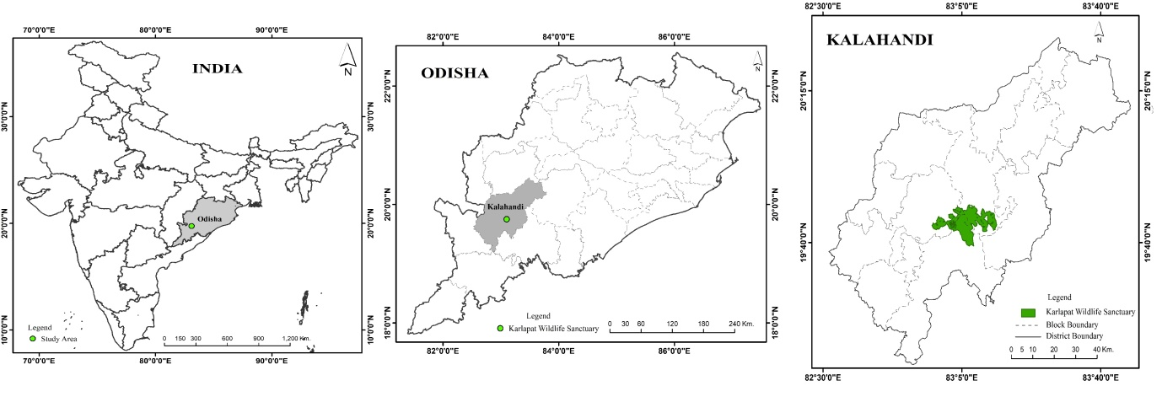Figure No 1: The study area
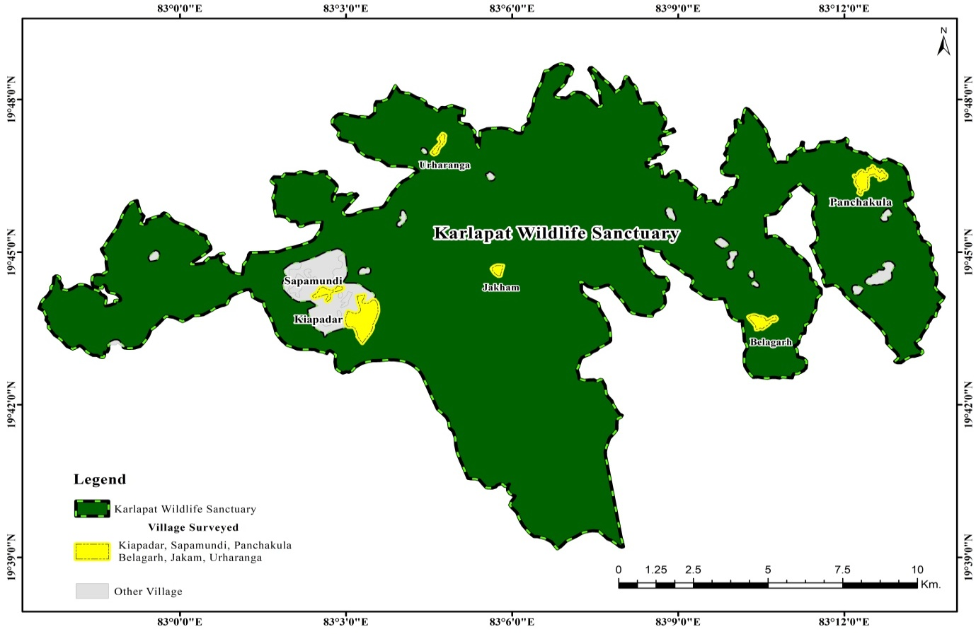
Figure no 2: The surveyed villages
2.2 Sample Size:
Out of eighteen villages located within sanctuary, six villages including Kiapadar, Sapamundi, Jakham, Urharanga, Belagarh, and Panchakula were purposively selected on the basis of their location and concentration of ethnic population. Random sampling method at household level applied to gather information on forest dependency and socio-economic parameters. The data collected from 180 households from the concerned villages. 30 respondents at household level were selected from each village.
2.3 Quantitative Analysis
Microsoft office (Version.2010) is used to organize the data. Statistical Package for Social Sciences (SPSS version 20.) is used for ordinal logistic regression to understand the connection between socio-economic parameters and level of forest dependency.
Here, the dependent variable is level of forest dependence, which categorised into three groups such as low, medium and high level of forest dependence. Socio-economic variables are depicted in percentage.

3. results and discussion

Various reasons determine the forest dependency of local communities on forest (Table .1). As several factors contribute for reliance on forest, income and occupation remain a prominent factor for long time (Chakraborty et al., 2018). Fuel-wood was primary reason of forest dependency while in summer months, slash cultivation was practiced in small patches as permission restricted to small patches. Gathering of fruits like Chahr (Buchanania lanzan), Aam or mango (Mangifera indica), Taynaa or cluster fig (Ficus racemosa) and Gunju or cashew apple (Anacardium occidentale) increased during summer season. The early monsoon month of June and July increase the accessibility to fruits like pineapple, jackfruit, guava and black berries. Wild tubers including Pit kanda (Dioscorea oppositifolia) and Kardi (Bambusa tulda) were collected and seasonally sold in the local market. The seasonal mushroom collection mostly during monsoon rainfall is of utmost important to these ethnic groups as the prices of such products increase at that time due to periodical availability. Most often the dried bamboo shoots (locally called as Hendua) are used for domestic use. The Resin, gum and mahua flowers were occasionally collected due to seasonal availability. Sap of sago palm tree (Caryota Urens L.) locally called as Salap is mostly collected and consumed for entertainment purposes (Figure 4).
Table no1: Frequency of household dependency on forest (N= 180)
Variables | Total | Percentage
Slash cultivation | 24 | 13.33%
Fuel wood | 169 | 93.88%
Fodder | 100 | 55.55%
Household materials | 82 | 45.55%
Medicinal plants | 67 | 37.22%
Wild tubers and mushroom | 118 | 65.55%
Plate making leaves (Sargi and Siali) | 139 | 77.22%
Fruits and berries | 154 | 85.55%
Others (resin, gum, seeds and mahua flower) | 29 | 16.11%
Source: Primary survey conducted (September 2024 - April 2025)

Figure 3: Purpose of forest reliance

Table no 2: Socio-economic variables of the respondents (N=180)
Variables | Category | %
Age (in years) | 20-29 | 20.7%
 | 30-39 | 26.7%
 | 40-49 | 32.2%
 | >50 | 20.4%
Sex | Male | 55.7%
 | Female | 44.3%
Livestock Size | No livestock | 6%
 | 1-4 | 32.2%
 | 5-7 | 35.1%
 | 8 or more | 26.7%
Household Size | 1-3 | 12.3%
 | 4-5 | 50.4%
 | 6 and above | 37.2%
Educational Level | No Formal Education | 54.9%
 | Primary | 21.2%
 | Secondary | 15.9%
 | Intermediate and Above | 8%
Occupation | Agriculture | 33.8%
 | Daily Wage + Agriculture | 35.1%
 | Small business + Agriculture | 17.8%
 | Service + Agriculture | 13.3%
Approx. Annual Income (INR) | Low (15000- 60000) | 42.8%
 | Medium (60000-100000) | 43.2%
 | High (>100000) | 14%
Source: Primary survey conducted (September 2024 - April 2025)

Of the total respondents, around 55.7% were male and 44.3% were females. The average age of respondents was 40.07, while average household and livestock size was 4.86 and 5.50, respectively. As livestock like cow, buffalo, goat, sheep and domestic fowl are of high value in nearby urban areas, domestication of these livestock play a major role in their household income. Most of the respondents fell into category of 40-49 (32.2%) followed by 30-39 (26.7%) and >50 (24.4%). Around 54.9% of respondents did not receive any formal education followed by primary (21.2%), secondary (15.9%) and intermediate groups (8%). 33.8% of respondents were engaged in agriculture, while greater parts were engaged on daily wages along with agriculture (35.1%). Around 13.30% of respondents were engaged in service with agriculture category. These socio-economic variables were considered as determinants for level of dependency on forests. The forest dependency was measured on weekly (high), fortnightly (medium) and monthly (low) basis. Around 44.7% of households agreed to be highly dependent on forest, while 34.2% and 21.1% households agreed to medium and low-level of forest dependency respectively.

Table no 3: Logistic regression analysis for socio-economic parameters influencing forest dependence
Parameter |  | B | SE | Hypothesis Test |  |  | Exp(B)
 |  | B | SE | Wald | df | Sig. | Exp(B)
Threshold | Low Forest dependency | 1.29 | 0.84 | 2.34 | 1 | 0.12 | 3.66
Threshold | Medium Forest dependency | 4.09 | 0.88 | 21.63 | 1 | 0 | 59.9
Sex | (Male) | 0.47 | 0.24 | 3.86 | 1 | 0.04 | 1.60
Sex | (Female) | 0ª | . | . | . | . | 1
Age | (20-29) | 0.52 | 0.59 | 0.75 | 1 | 0.38 | 1.68
Age | (30-39) | 0.03 | 0.52 | 0.005 | 1 | 0.94 | 1.03
Age | (40-49) | -0.25 | 0.42 | 0.35 | 1 | 0.55 | 0.77
Age | (50 and above) | 0ª | . | . | . | . | 1
Education | (No Formal Education) | 1.61 | 0.71 | 5.17 | 1 | 0.02 | 5.02
Education | (Primary) | 1.26 | 0.64 | 3.85 | 1 | 0.05 | 3.54
Education | (Secondary) | 0.30 | 0.54 | 0.31 | 1 | 0.57 | 1.35
Education | (Intermediate and above) | 0ª | . | . | . | . | 1
Occupation | (Agriculture only) | 4.55 | 0.70 | 41.34 | 1 | 0 | 94.6
Occupation | (Dailywage +Agriculture) | 1.89 | 0.53 | 12.51 | 1 | 0 | 6.62
Occupation | (Smallbusiness +Agriculture) | 1.09 | 0.49 | 4.92 | 1 | 0.02 | 2.97
Occupation | (Service + Agriculture) | 0ª | . | . | . | . | 1
Livestock size | (No Livestock) | -0.63 | 0.47 | 1.73 | 1 | 0.18 | 0.53
Livestock size | (1-4) | 0.005 | 0.31 | 0 | 1 | 0.98 | 1.00
Livestock size | (5-7) | 0.006 | 0.29 | 0 | 1 | 0.98 | 1.00
Livestock size | (8 and above) | 0ª | . | . | . | . | 1
Aproximate annual inome (INR) | Low (15000-60000) | 1.02 | 0.46 | 4.81 | 1 | 0.02 | 2.78
Aproximate annual inome (INR) | Medium (60000-100000) | 0.61 | 0.31 | 3.71 | 1 | 0.05 | 1.84
Aproximate annual inome (INR) | High (>100000) | 0ª | . | . | . | . | 1
Household size | (>6) | 0.74 | 0.39 | 3.52 | 1 | 0.06 | 2.10
Household size | (4-5) | -0.12 | 0.34 | 0.13 | 1 | 0.71 | 0.88
Household size | (1-3) | 0ª | . | . | . | . | 1
B=Beta Coefficients, SE= Standard Error, Sig. =Significance (p= .05), Exp (B) =Odd ratio (OR), a=set to zero because this parameter is redundant, df= Degrees of freedom

Analysis revealed the occupation of respondents showed strong significant effect on forest dependency. Considering the service with agriculture as base, the level of dependency increased significantly with occupational shift from service with agriculture to small business with agriculture (OR = 2.97), daily wage with agriculture (OR = 6.62) and agriculture only (OR = 94.60). Apart from occupation, educational level and income showed weak effect on level of forest dependency. The results showed a transition from primary level of education (OR = 3.54) to no formal education (OR = 5.02) resulted in increasing forest dependency. Looking after the income level, shift from medium (OR = 1.84) to high (OR = 2.78) income resulted in decrease in forest dependency. Though respondents with higher education and high income level were more likely to less dependent on forests, almost all the respondents are forest dependent for firewood purpose.

4. Conclusion
As forest is regarded as a source of maintenance and livelihood for ethnic communities, this study shows an intrinsic relationship of accessing forest resources with the occupation of population. The low income group populations are more dependent on forest for non-timber forest products like mushroom, berries, plate making leaves and tubers of numerous categories. Their forest reliance also represents a wide knowledge on traditional medicine species. This reflects a better sense of traditional ecological knowledge. The dependence on forest was measured on weekly (high), fortnightly (medium) and monthly (low) basis. An increase in educational level and income level depicts low forest dependency, thus regulate a path of natural forest conservation. The regulated way on forest conservation also signifies awareness on forest resource maintenance by the communities. The purpose of forest reliance does not compromise the environmental condition; though slash cultivation practiced in few patches by very less section of people. Accessing forest by ethnic communities also depicts the awareness on natural resource management as almost major aspects of dependency do not hamper the ecological balance. Strict regulations by forest authority also stopped illegal logging which enables the forest dependency

Competing interests
The authors confirm that they have no conflict of interest to declare.

COMPETING INTERESTS DISCLAIMER:
Authors have declared that they have no known competing financial interests OR non-financial interests OR personal relationships that could have appeared to influence the work reported in this paper.

References

Agarwal, R & Chandra, V. (2021). Forest dependent livelihood in relation to socio-economic status of the people in Chopta-Mandal forests of Garhwal Himalayas, Uttarakhand. Asian Journal of Conservation Biology, 10 (2), 317-325. https://doi.org/10.53562/ajcb.66499
Bahuguna, V. K. (2000). Forests in the economy of the rural poor: An estimation of the dependency level. Ambio: A Journal of the Human Environment, 29(3), 126–129. https://doi.org/10.1579/0044-7447-29.3.126
Banerjee, S., Niyogi, R., Sarkar, M. S., John, R. (2022). Assessing the vulnerability of protected areas in the eastern Himalayas based on their biological, anthropogenic, and environmental aspects,Trees, Forests and People,8,https://doi.org/10.1016/j.tfp.2022.100228.
Campbell, M. O. N. (2005). Sacred groves for forest conservation in Ghana’s coastal
savannas: Assessing ecological and social dimensions. Singapore Journal of Tropical Geography, 26(2), 151–169.
Chakraborty, A., Joshi, P.K. & Sachdeva, K. (2018). Capturing forest dependency in the central Himalayan region:Variations between Oak (Quercusspp.) and Pine (Pinusspp.) dominated forest landscapes Ambio 2018, 47:504–522 https://doi.org/10.1007/s13280-017-0947-1
Garekae, H., Thakadu, O.T. & Lepetu, J. (2017). Socio-economic factors influencing household forest dependency in Chobe enclave , Botswana. Ecological Processes, 6(40). https://doi.org/ 10.1186/s13717-017-0107-3
Gauriat, V. (2020). Romania’s virgin forests ravaged by “wood mafia”. From Euronews.. https://www.euronews.com/my-europe/2020/03/13/romania-s-virgin-forests-ravaged-by-wood-mafia.
Grundel, I., Christenson, N., & Dahlstr, M. (2022) Identifying interests and values in forest areas through collaborative processes and landscape resource analysis. Forest Policy and Economics, 142, https://doi.org/10.1016/j.forpol.2022.102801
Jannat, M., Hossain, M. K., Uddin, M. M., Hossain, A., & Kamruzzaman, M. (2018). People’s dependency on forest resources and contributions of forests to the livelihoods : A case study in Chittagong hill tracts ( CHT ) of Bangladesh. International Journal of Sustainable Development & World Ecology. https://doi.org/ 10.1080/13504509.2018.1434571
Miah, M. D., Chakma, S., Koike, M., & Muhammed, N. (2011). Contribution of forests to the livelihood of the Chakma community in the Chittagong hill tracts of Bangladesh. Journal of Forest Research. https://doi.org/ 10.1007/s10310-011-0317-y
Mukul, S. A., Rashid, A. Z. M. M., Uddin, M. B., & Khan, N. A. (2016). Role of non-timber forest products in sustaining forest-based livelihoods and rural household's resilience capacity in and around protected area: A Bangladesh study. Journal of Environmental Planning and Management, 59(4), 628–642. https://doi.org/ 10.1080/09640568.2015.1035774
Nerfa, L., Rhemtulla, J. M., & Zerriffi, H. (2020). Forest dependence is more than forest income: Development of a new index of forest product collection and livelihood resources. World Development.125. https://doi.org/10.1016/j.worlddev.2019.104689

Pattanayak, M. (2008). The Forest resources of Kalahandi- Past, present and future. Orissa Review, 12, 18-21
Prateek, G & Punia, S. (2025). Forest dependency and food security: Diverse livelihoods in India's tribal heartland, Forest Policy and Economics,177, https://doi.org/10.1016/j.forpol.2025.103527.
Poudyal, M., Rakotonarivo, O. S., Raza, J. H., Hockley, N., & Jones, J. (2018). Household economy, forest dependency & opportunity costs of conservation in eastern rainforests of Madagascar. Scientific Data, 5. https://doi.org/ 10.1038/sdata.2018.225
Soe, K. T., & Yeo-chang, Y. (2019). Livelihood dependency on non-timber forest products : Implications for REDD +. Forests, 10(427), 1–25.
Soman, D and Anitha, V. (2020) Community dependence on the natural resources of Parambikulam Tiger reserve, Kerala, India. Trees, Forests and People, 2, https://doi.org/ 10.1016/j.tfp.2020.100014
Tacconi, L., Rodrigues, R. J., & Maryudi, A. (2019). Law enforcement and deforestation: Lessons for Indonesia from Brazil. Forest Policy and Economics, 108. https://doi.org/ 10.1016/j.forpol.2019.05.029
Vasan, S., Mehta V., & Tribhuvan, P. (2019). Characterising the relationship between forest dependent peoples and state forest management institutions in the Global South. Environmental Research Letters. 14 https://doi.org/10.1088/1748-9326/ab2925
Vasile, M., & Iordăchescu, G. (2022). Forest crisis narratives: Illegal logging, datafication and the conservation frontier in the Romanian Carpathian mountains. Political Geography, 96. https://doi.org/ 10.1016/j.polgeo.2022.102600

