Case report
REIMPLANTATION OF EX-ARTICULATED CENTRAL INCISOR WITH EXTENDED EXTRA-ORAL DRY TIME -A CASE REPORT

ABSTRACT –
Ex-articulation refers to the complete displacement of a tooth from its alveolar socket, leading to disruption of the periodontium and its associated structures. Although relatively rare, this type of dental injury can affect both primary and permanent teeth. Tooth avulsion in children and adolescents requires immediate treatment to improve the chances of successful re-implantation. Oral trauma is frequently encountered and can happen at any stage of life. Tooth avulsion constitutes a significant traumatic dental injury, comprising 1–16% of cases, with a predilection for the maxillary anterior region.
This case report outlines the treatment of a 14-year-old male patient presenting with ex-articulation of the maxillary left central incisor, followed by delayed reimplantation after the tooth had been stored dry for 12 hours. Despite the unfavorable storage conditions, re-implantation was carried out due to the patient's age, as it was important to prevent psychological distress along with aesthetic and functional complications.
Keywords: Tooth avulsion, Traumatic management, Splinting, Dry storage, Traumatic dental injury (TDI), Periodontal ligament damage

INTRODUCTION –
Permanent tooth avulsion represents 0.5% to 16% of all cases of dental injury.¹ A sudden impact to the teeth and surrounding tissues can cause dentoalveolar trauma, which may result in various injuries, including the complete displacement of a tooth from its socket. Traumatic dental injuries are most commonly observed in individuals aged 7-11 years. The leading cause of these injuries is accidental falls, with other contributing factors including sports activities, road traffic accidents, and interpersonal violence.² Several studies have demonstrated that this injury is most severe, and the prognosis is heavily influenced by the immediate actions taken at the scene and shortly after the tooth is avulsed.¹
Tooth avulsion (exarticulation) is defined as the total removal of a tooth from its alveolar socket due to trauma. Martins et al. reported that physical altercations and sports injuries are the primary causes of tooth avulsion in permanent dentition, whereas falls against hard surfaces are more prevalent in the primary dentition. The distribution of etiological factors revealed that unknown causes and altercations were the most common, each accounting for 17% of cases. Contact sports contributed to 15.9%, followed by motor vehicle collisions (10.8%) and motorcycle accidents (10.4%). Ice hockey was a less frequent cause, representing 2.3% of cases.³
Avulsion constitutes the most severe injury to the periodontal ligament (PDL), with the timing of replantation being a crucial factor affecting prognosis. To optimize periodontal ligament cell survival before replantation, several storage protocols have been developed, including the use of storage media such as Hanks’ balanced salt solution (HBSS) and propolis.⁴ This injury most commonly happens in individuals aged 7–14 years, with the highest incidence observed in the maxillary central incisors.⁵
Twenty-five percent of children attending school sustain dental trauma, while thirty-three percent of the adult population report injuries to their permanent teeth. Globally, it is estimated that nearly one billion individuals have sustained traumatic dental injuries (TDIs)⁶ Effective splinting of teeth after trauma is a crucial predictor for the healing of both pulpal and periodontal tissues. The splints function to stabilize and protect the teeth, providing ideal conditions for the healing and regeneration of the surrounding supporting tissues.⁷
Effective immediate care for dental traumatic injuries relies on clear, evidence-based guidelines. Andreasen investigated the effects of extra-alveolar duration and storage conditions on periodontal and pulpal healing outcomes following the replantation of mature permanent incisors in a monkey model.³
This case report details the step-by-step management of a maxillary left central incisor that was successfully replanted despite an extended extra-oral dry time exceeding 13 hours.

CASE REPORT –
A 14-year-old male presented to the Department of Pedodontics and Preventive Dentistry with a chief complaint of dental trauma and avulsion of the upper front teeth, due to fall from bicycle the previous night. Extra-oral examination showed bruises on the chin, swollen upper lip and intra-oral examination revealed avulsion of 21, Subluxated with 11, Extruded with 22 and Grade 1 mobility with 11,12(Fig.1C) and patient also had deep traumatic bite. The patient did not present past medical history. However booster anti-tetanus dose was administer. The attendant (Mother) of the patient collected the avulsed tooth and covered in tissue paper (Fig.1A) and presented it in the department of pedodontics 13 hours of trauma. As soon as the tooth was received it was immediately placed in milk (Fig.1D).
Since the patient was young and was concerned about the tooth loss, the decision was made to replant the avulsed tooth in order to alleviate psychological, cosmetic, and functional trauma. The patient was advised of the possible complications related to replanting an avulsed tooth that had remained out of the mouth for over 13 hours, such as inflammatory resorption, replacement resorption (ankylosis), and discoloration of the tooth.
After obtaining informed consent, replantation of avulsed tooth was planned. The avulsed tooth exhibited an intact crown and a fully developed root with a closed apex. Since the extra-oral time was almost 13 hours, with the dried root surface was cleaned and scrapped with dental hand instrument (scaler) to remove any adhered debris and dead cells (Fig 2 A,) and tooth was then placed in APF gel for 20 min.
Since the extraoral dry time is more, extraoral RCT was done with through BMP and irrigation using CHX and normal saline. Obturation was completed with guttapurcha (Fig 2 A,B,C,D) and avulsed tooth was treated with Doxycycline solution until placed back into socket (Fig.2E)

FIGURE 1-
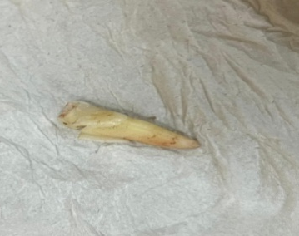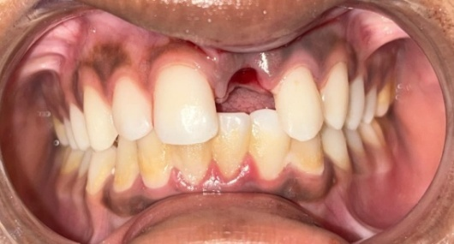
C
A
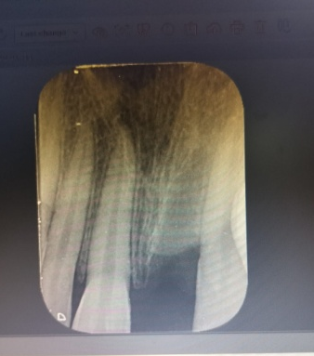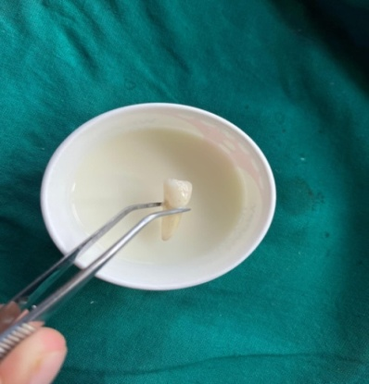
D
B

FIGURE 1: (A) Avulsed tooth in tissue paper. (B) Pre-operative radiograph showing empty alveolar socket in 21 region. (C) Pre-operative clinical image. (D) Tooth preserved in milk following avulsion injury.

FIGURE 2-

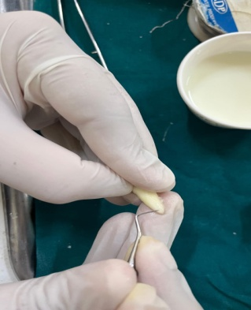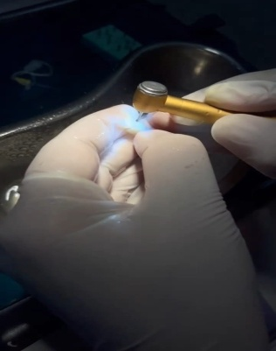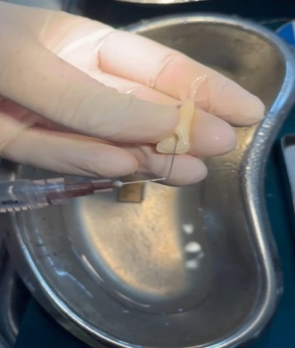
A
B
C
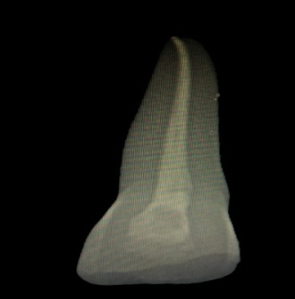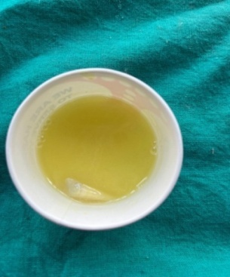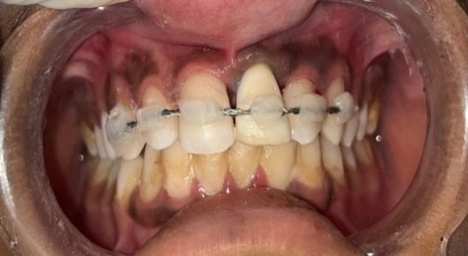
F
E
D

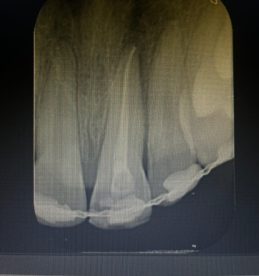
G

FIGURE 2- (A) Extra-oral root surface preparation. (B) Extra-oral Access opening done with 21. (C) Extra-oral Normal saline irrigation done. (D) Radiographic picture after Extra-Oral RCT. (E) After RCT Tooth preserved in Doxyclycline solution for 20 min.(F) Replanted tooth stabilised in place with composite wire splinting. (G) Post- operative radiograph of 21 immediately after replantation.

PREPARATION OF SOCKET AND REPLANTATION-
Local anesthesia was achieved using 2% lignocaine without a vasoconstrictor, administered via labial and palatal infiltration at the affected site to ensure adequate anesthesia before the procedure. The alveolar socket was carefully irrigated with normal saline. The avulsed tooth was then gently repositioned into the socket using light digital pressure (Fig. 2F), and its proper placement was verified through an RVG (Fig. 2G).Following radiographic confirmation, the replanted tooth was stabilized in its socket using a splint composed of 0.4 mm stainless steel orthodontic wire, which was secured with light-cure composite resin (Fig. 2F).
Post operative patient was advised antibiotic and analgesic. Additionally, he was instructed to follow a soft food for two weeks and to use a soft-bristled toothbrush along with a 0.12% chlorhexidine mouth rinse for maintaining oral hygiene. Patient recalled after 3 week and splint removal done followed by vitality test along with through clinical and radiographic evaluation done.
The replanted tooth revealed normal root configuration, intact periodontal ligament and without any periapical pathology. As the patient was having deep traumatic bite, anterior bite plane and passive labial bow appliance was fabricated and delivered (Fig.4). Regular follow up were done every 3 month.

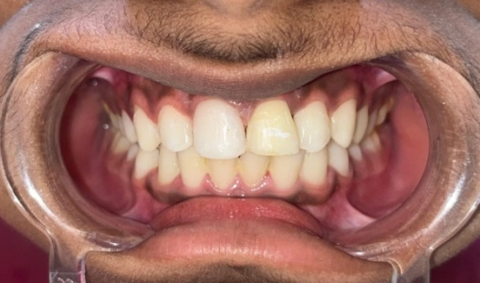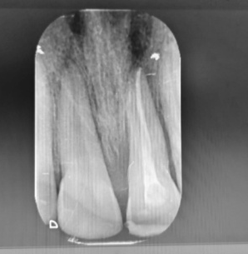
FIGURE 3- Intra-oral clinical image after 3 week removal of semi rigid composite splint.

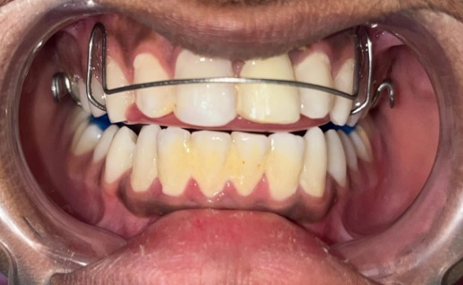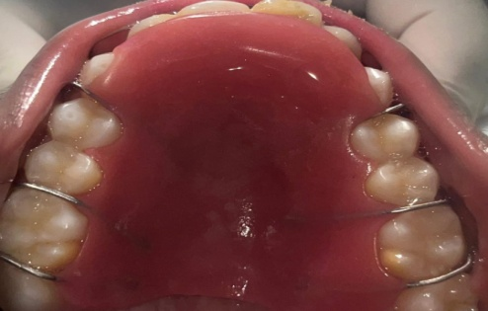
FIGURE 4- clinical image after insertion of anterior bite plane.

FOLLOW-UP-3 MONTH TO 18 MONTH
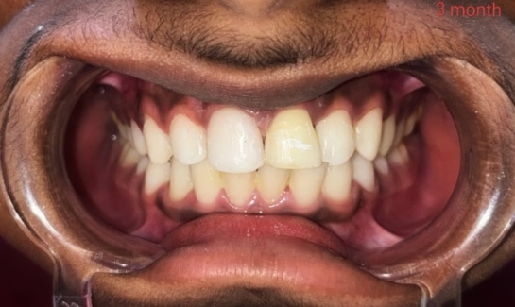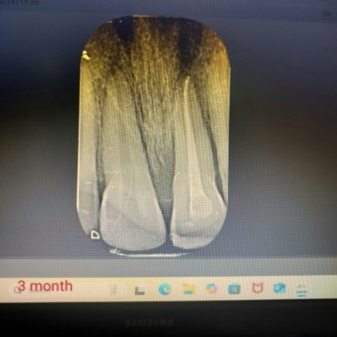
FIGURE 5- Clinical and Radiographic image after 3 month follow-up.
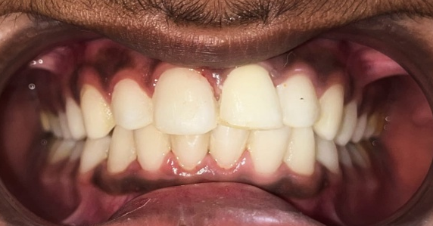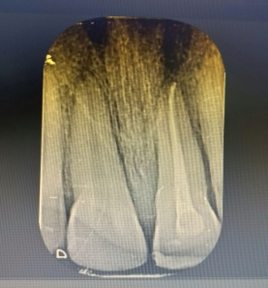
FIGURE 6 –Clinical and Radiographic image after 6 month follow-up

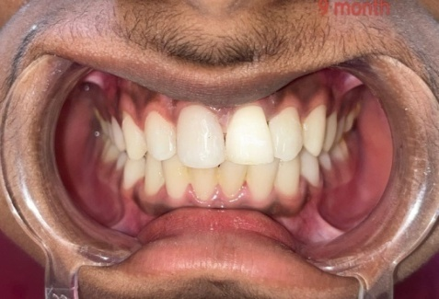
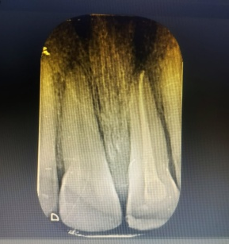
FIGURE 7-Intra-Oral Clinical and radiographic image after 9 month follow-up.

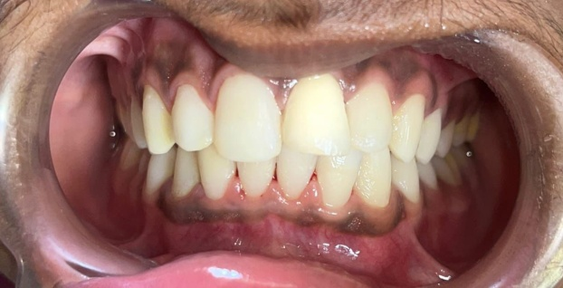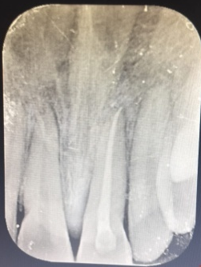
FIGURE 8-Intra-Oral Clinical and radiographic image after 12 month follow up.

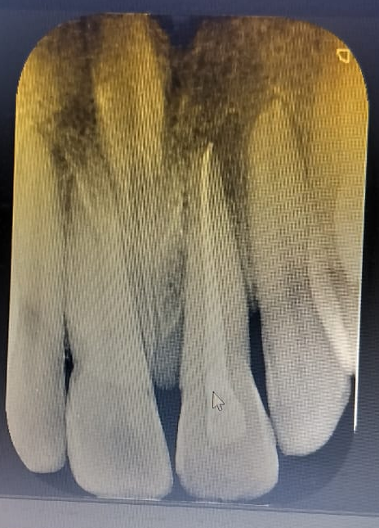
FIGURE 9-Intra-Oral Clinical and radiographic image after 18 month follow up

DISCUSSION-
Avulsion is regarded as the most serious type of dental injury. The maxillary central incisors are the teeth most frequently affected, especially as a result of sports-related trauma and automobile accidents. Timely and proper emergency care is crucial for achieving the best possible outcome following this injury.¹ The best treatment for an avulsion injury is to replant the exarticulated tooth as soon as possible. However, this may not always be possible. This case report describes the replantation of an avulsed maxillary central incisor, following an extra-oral period exceeding 3 hours. Effective emergency management, well-planned treatment, and timely intervention are crucial for achieving a positive prognosis in avulsion injury cases.
The success of tooth replantation depends on multiple factors, including the patient’s overall health, root development, storage medium, and the duration the tooth remains outside the mouth—with the latter two being the most critical. The primary cause of failure is damage to the delicate periodontal ligament (PDL). Over the past two decades, regenerative medicine, particularly cell- and stem cell-based therapies, has emerged as a promising approach to enhance treatment outcomes. Choosing an appropriate storage medium is vital for maintaining PDL cell viability after trauma. Although various media have been proposed, Hank’s Balanced Salt Solution (HBSS) is widely considered the gold standard. Nonetheless, alternatives like tooth rescue boxes, ViaSpan, and Eagle’s Medium are often impractical due to high cost and limited accessibility. More readily available options such as pasteurized milk, egg white, propolis, and coconut water have demonstrated encouraging results.⁵
When an avulsed tooth is left in the air, the periodontal membrane dries out, leading to cell necrosis. Teeth that are replanted within 6 to 48 hours of avulsion and undergo endodontic treatment have been found to remain clinically functional for many years. The optimal extra-oral time is 20 minutes, while the maximum reported time in the literature is 48 hours.⁸ Prior to replantation, the avulsed tooth was immersed in a sodium fluoride solution. According to Andreasen and Andreasen, after planing the root to remove necrotic periodontal tissue, the tooth should be soaked in a 1.23% acidulated phosphate fluoride (APF) solution for 20 minutes prior to extra-oral root filling and replantation.⁹
Replanted teeth should be carefully monitored, with clinical and radiographic findings documented. Aminizadeh M et al. (2016) described a case involving delayed replantation of an avulsed maxillary central incisor after a prolonged dry extra-alveolar time. Their clinical and radiographic assessments over a 12-month follow-up revealed that the tooth remained stable and functional, although early signs of replacement resorption and ankylosis were detected.¹⁰ Splinting is the recommended treatment to restore normal occlusal function and provide necessary stimulation. In cases without alveolar fracture, a semi-rigid splint is considered the most appropriate choice.¹¹
In the presented case, the avulsed incisor exhibited a closed apex and had been subjected to prolonged air-drying, significantly reducing the likelihood of pulpal and periodontal healing. As a result, the management strategy deviated from the standard replantation protocol. The primary treatment goals were to retain the avulsed tooth for functional and aesthetic purposes, prevent inflammatory root resorption, and promote periodontal stabilization while accommodating the process of replacement root resorption.⁸
J.V. Setty et al. conducted a study to assess the knowledge and attitudes of primary school teachers toward the emergency management of avulsed permanent incisors. The study concluded that primary school teachers in Bangalore city generally possess only basic knowledge of how to manage dental avulsion emergencies. The authors emphasized that teachers and other school personnel responsible for supervising children should be mandatorily trained in basic dental first aid, as children spend a significant portion of their day at school.¹² Rizwan Qureshi et al. (2024) conducted observational study to assess the awareness of emergency management of avulsed teeth among dental interns. The study found that, while dental interns generally possess a fair level of knowledge, their awareness does not fully meet the expected standards for proper management protocols. The authors concluded that there is a need for improvement in the training and education related to the effective handling of avulsion cases.¹³
S.S. Pamnani et al. (2018) conducted a study to assess knowledge and awareness of facial trauma and protective device use among sports participants and instructors aged 8 to 18 years. The study concluded that while most participants were aware of oro-facial injuries and the role of mouthguards in preventing them, their actual usage of such protective devices was insufficient. Additionally, both groups showed a lack of awareness about the availability of these devices. The authors emphasized that making the use of protective gear mandatory, especially in contact sports, could significantly reduce the occurrence of oro-facial injuries.¹⁴
Even after a prolonged extra-alveolar dry storage period, delayed replantation of teeth can still result in them remaining stable and functional within the dental arch. For patients who have not yet completed craniofacial growth, maintaining the replanted tooth can serve as a temporary measure to preserve alveolar bone structure until implant placement becomes feasible.¹⁰ In this case we successfully achieved goals such as satisfactory aesthetic appearance, occlusal function, and positive healing. The patient remained asymptomatic and expressed full satisfaction with the treatment after a one-year follow-up.

CONCLUSION-
In cases where avulsed teeth have experienced a prolonged extra-oral period, replantation may still be a viable option despite the increased susceptibility to replacement resorption over time, culminating in eventual tooth loss. Replanting the tooth can help preserve aesthetics and occlusal function. However, continued observation with scheduled reviews clinical and radiographic evaluations is essential to monitor the outcome and assess the success of the treatment. The one-year follow-up in this case has shown favorable healing and a positive treatment outcome.
REFERENCE-
- Fouad AF, Abbott PV, Tsilingaridis G, Cohenca N, Lauridsen E, Bourguignon C, O'Connell A, Flores MT, Day PF, Hicks L, Andreasen JO, Cehreli ZC, Harlamb S, Kahler B, Oginni A, Semper M, Levin L. International Association of Dental Traumatology guidelines for the management of traumatic dental injuries: 2. Avulsion of permanent teeth. Dent Traumatol. 2020 Aug;36(4):331-342.
- Kadulkar N, Kataki R, Deka A, Thonai S. Replantation of an Avulsed Tooth: A Case Report. Cureus. 2023 May 18;15(5):e39198.
- Tadikonda DC, Pagadala S. Tooth avulsion-a review. Sch J Dent Sci. 2016;3(1):20-3.
- Aksel H, Zhu X, Gauthier P, Zhang W, Azim AA, Huang GT. A new direction in managing avulsed teeth: stem cell-based de novo PDL regeneration. Stem Cell Res Ther. 2022 Jan 28;13(1):34
- Mitthra S, Lukram N, Prakash V, Mary NB, Shuruthi J, Subbiya A. Avulsion–Histological Perspectives and Storage Media-A Review. Indian J Public Health Res Dev. 2019 Sep;10(9).
- Huang R, Zhou C, Zhan L, Liu Y, Liu X, Du Q, Wang J, Zhao W, Song G, Wu LA, Jiang B, Li Y, Zhang H, Zou J. Experts consensus on management of tooth luxation and avulsion. Int J Oral Sci. 2024 Sep 26;16(1):57.
- Sobczak-Zagalska H, Emerich K. Best Splinting Methods in Case of Dental Injury-A Literature Review. J Clin Pediatr Dent. 2020;44(2):71-78.
- Bhavana V, Durga Rao PV, Aruna Kumari G, Leneena G. Delayed replantation of an avulsed tooth: A case report. IP Ann Prosthodont Restor Dent. 2017 Oct-Dec;3(4):127–129.
- Desai PY, Patel S. Delayed replantation of avulsed tooth: A case report. Int J Adv Res. 2022;10(1):730–737.
- Aminizadeh M, Shojaiepoor R, Aminizadeh R. Delayed replantation of avulsed tooth: a case report. Anat Sci. 2016;13(2):131–135.
- Ali AA, Al Qooz F, Mustafa OS. Tooth avulsion: etiology and management. Bahrain Med Bull. 2020 Sep;42(3):206–208.
- Jyothsna VS. Knocked-out tooth: knowledge and attitudes. J Dent Sci Res. 2012;3(3):9–16.
- Qureshi R, Iqbal A, Siddanna S, Siddeeq U, Mushtaq F, Arjumand B, Khattak O, Sarfarz S, Aljunaydi NAN, Mohammed Alkhaldi AM, Altassan M, Attar EA, Issrani R, Prabhu N. Awareness about emergency management of avulsed tooth among intern dentists-a cross-sectional observational study. J Clin Pediatr Dent. 2024 Mar;48(2):64-71.
- Sunaina SP, Jyothsna VS, Srinivasan I, Dandamudi L. Oro-facial trauma – awareness amongst sports instructors and players aged 8 to 18 years. Int Educ Res J. 2018 Feb;4(2).

