Case report

MANAGEMENT OF TRAUMATIC INJURIES IN VISUALLY IMPAIRED SPECIAL CHILD WITH MODIFIED BEHAVIOUR MANAGEMENT TECHNIQUES- A CASE REPORT

ABSTRACT-
The prevalence of childhood blindness varies globally, affecting approximately 0.3 per 1,000 children in industrialized nations, 1.2 per 1,000 in developing countries, and reaching 1.7 per 1,000 in India. Visual impairment significantly impacts a child's ability to navigate their environment and perform routine activities, presenting unique challenges in the context of paediatric dental care. Managing these patients requires the use of specialized behaviour management techniques to ensure effective communication and cooperation during treatment. One such approach is the Audio-Tactile Performance (ATP) technique, a multisensory health education method specifically designed for children with visual impairments. In place of the traditional 'Tell-Show-Do' technique, modified methods such as 'Tell-Feel-Do' and 'Tell-Hear-Do' can be employed to familiarize the child with dental procedures in a manner tailored to their sensory needs. This case report presents successful management of Ellis class IV fracture of anterior teeth in visually impaired children using these adapted behavioural techniques, demonstrating their value in achieving positive treatment outcomes.
INTRODUCTION-
Visual impairment refers to a functional limitation of the eye caused by a disorder or disease, leading to a visual handicap. A visual disability is a physical limitation experienced by the individual, while a visual handicap refers to the resulting personal and social challenges. Although visual impairment does not directly affect the dentition, individuals with such impairments often face difficulties in maintaining oral hygiene. As a result, dental health is frequently neglected, which can lead to significant oral health problems over time.¹
Visually impaired children face significant challenges in interacting with their environment, as they are unable to see facial expressions or perceive social cues from parents, teachers, and peers. These limitations affect their social development and daily learning of essential life skills, including the maintenance of oral hygiene.²
According to the World Health Organization (WHO), an estimated 285 million people worldwide were visually impaired as of 2012, including 39 million who were blind and 246 million with low vision. In India alone, approximately 280,000 to 320,000 children are visually impaired. Importantly, the term visual impairment does not necessarily indicate a complete loss of sight; many affected individuals can still perceive images, light, colors, or read large print. To navigate their environment, visually impaired individuals often rely more heavily on their remaining senses—such as hearing, speech, and touch—for communication and orientation.³ One of the most important considerations when treating children with special health care needs, including those with visual impairments, is ensuring their access to preventive dental care. Modifications in behavior management strategies can further support the effective delivery of dental treatment. Additionally, treatment techniques should be carefully customized to meet the individual needs and abilities of each patient.⁴
Braille is a tactile writing system developed by Louis Braille, traditionally produced on embossed paper. It consists of small rectangular cells containing raised dots that represent letters of the alphabet. In 2011, Hebbal et al. introduced the Audio-Tactile Performance (ATP) technique—an oral health education method designed specifically for visually impaired individuals. This technique teaches toothbrushing skills using a combination of audio instructions and tactile aids.³
Visual impairment affects a significant number of individuals worldwide and is not an all-or-none condition. According to clinical definitions, a person is considered legally blind if their visual acuity does not exceed 20/200 in the better eye with the best possible correction, or if their visual field is restricted to 20 degrees or less, even if visual acuity is better than 20/200.⁵ Effective management of visually impaired children requires clear communication with both the child and their parents to ensure the maintenance of overall general and oral health.¹
The following case reports highlight the traumatic tooth management of children with visual impairments, emphasizing the use of appropriate and effective behavior management techniques.
CASE REPORT-
A 14-year-old male child patient reported to the Department of Pediatric and Preventive Dentistry, with a complaint of pain and swelling in the upper front teeth region of the jaw for the past 1 week. The pain had a sudden onset and was short-lived. It was localized, dull aching, and occurred intermittently. The discomfort was triggered by mastication, lasting for a few minutes, and subsided upon removal of the stimulus. On chair side examination was done, which was Ellis Class IV fracture was observed in tooth #21, and an Ellis Class II fracture in tooth #11(Fig.1 C). All permanent teeth were present. Intraoral swelling was noted in relation to tooth #21. Additionally, extraoral swelling was evident on the left side of the upper lip, extending to the lateral border of the nose and the infraorbital region (Fig.1 A). The patient had reported a history of trauma to the upper front tooth region two years ago, which resulted in an Ellis Class IV fracture of tooth #21and radiographically evaluated that periapical abscess present with respect to 21.(Fig 1 B).
The patient was well-oriented and cooperative, corresponding to a rating of “++” on Frankel’s behavior rating scale. Behavioural management was initiated using the “Tell-Feel-Do” technique along with the use of euphemistic language to reduce anxiety. The child was introduced to the dental chair and surrounding equipment with a detailed explanation of the chair positioning and clear, simple instructions. All sharp instruments were deliberately kept out of reach to ensure safety.
The initial oral inspection was performed without the use of any instruments. Subsequently, a mouth mirror was introduced only after the child was allowed to touch and feel it. Verbal communication was maintained continuously to provide reassurance and guidance throughout the procedure. During the first visit, a general examination was conducted, and necessary clinical records were obtained. The child was diagnosed with ellis class IV fracture with respect to 21 and ellis class II with respect to 11. Treatment plan was formulated, composite restoration with 11 and Root canal treatment (RCT) with 21 followed by anterior esthetic restoration.
Since the patient was visually impaired and unable to perceive facial expressions such as a smile, voice modulation using a friendly and positive tone was employed to help keep him calm and relaxed throughout the appointment. To build rapport, the child was engaged in conversation about his interests—he shared that his favorite hobbies included singing, creating jingles, and mimicry. He was encouraged to perform these activities during the visit, and was enthusiastically applauded by the dental team, which helped transform his dental appointments into a fun and enjoyable experience.
Additionally, storytelling and riddles were incorporated to maintain a cheerful and interactive atmosphere. The parents were instructed to maintain a weekly diet chart, and appropriate dietary modifications were recommended based on the findings. The brushing technique was demonstrated using the Audio-Tactile Performance (ATP) technique, ensuring the instructions were conveyed through sensory feedback.
The patient remained cooperative and responded positively throughout the appointment, indicating the success of the modified behaviour management strategies. To help the patient understand and anticipate the procedure, the teeth were initially wiped with a cotton pellet to provide a familiar tactile experience. Before introducing the ultrasonic scaler intraorally, the tip was gently applied to the child’s fingernails, allowing him to become accustomed to its vibration and sensation. This desensitization step was essential in building trust and reducing anxiety.
Care was taken to avoid any sudden movements, unexpected sounds, or other startling stimuli during the procedure to maintain a calm and controlled environment. Morning appointments were scheduled to take advantage of the child's optimal alertness and cooperation.
The patient was introduced to the Airotor using the “Tell-Feel-Do” technique (Fig.2 A,B,E) by allowing him to touch and familiarize himself with the instrument. To ease anxiety, the sound of the Airotor was explained using the euphemism of a “whistling train” Tell-Hear-Do( Fig.2 A,D,E) . Dental materials such as cements were introduced through their scent, encouraging the child to smell them as part of the Tell-Smell-Do (Fig.2A,C,E) approach. Throughout the procedure, reassuring physical contact was maintained, ensuring that no sudden grabbing or movements occurred without prior warning. Positive reinforcement was given consistently in the form of gentle pats on the back and encouraging words, promoting cooperation and good behavior.
Access opening was performed using an Airotor, followed by drainage of purulent discharge. Working length determination was carried out (Fig.3 A), and biomechanical preparation of the root canal system was completed up to hand file size #80. After thorough cleaning and shaping, Triple Antibiotic Paste (TAP) was placed inside the canal as an intracanal medicament, and a temporary restoration was placed. The patient was recalled after 10 days for further treatment. At the follow-up visit, gutta-percha obturation was completed (Fig.3B), and postoperative instructions were provided. The patient was then scheduled for a follow-up visit after 1 month for permanent restoration and radiograph was taken to confirm that periapical radioluency was reduced or not (Fig.3 C). An anterior esthetic Composite restoration done and ultrasonic scaling was done both upper and lower arch (Fig.4), and postoperative instructions were provided to the patient. The patient was rewarded with gifts and toys as positive reinforcement.

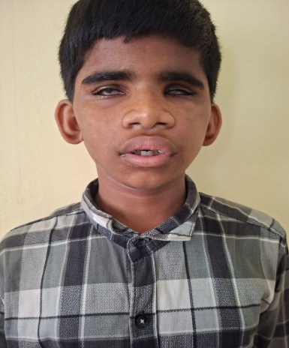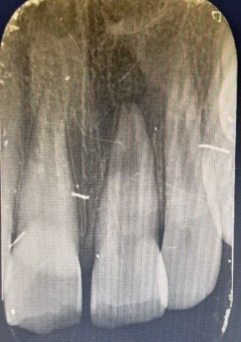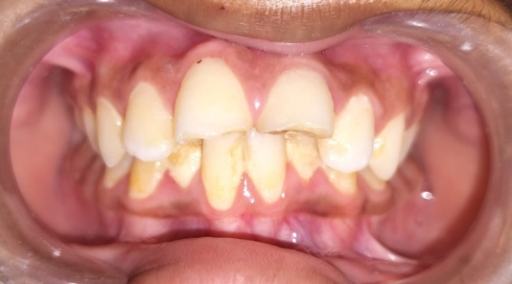
[Type a quote from the document or the summary of an interesting point. You can position the text box anywhere in the document. Use the Text Box Tools tab to change the formatting of the pull quote text box.]
[Type a quote from the document or the summary of an interesting point. You can position the text box anywhere in the document. Use the Text Box Tools tab to change the formatting of the pull quote text box.]
(A ) (B) (C)
Figure 1- A) Extraoral swelling upper front teeth region. B) Preoperative radiograph. C ) Intraoral picture

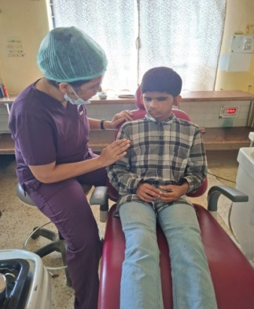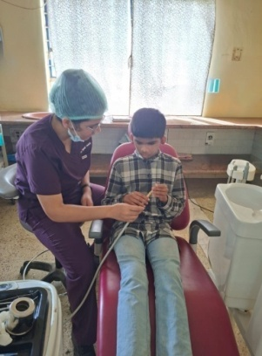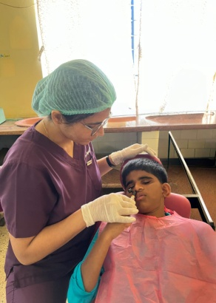
(A) (B) (C)
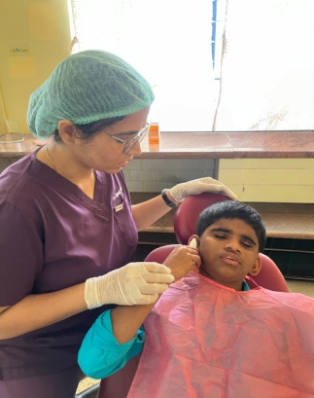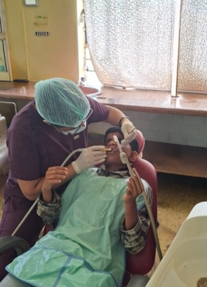
(D) (E)
Figure 2- A) Tell B) Feel C) Smell D) Hear E) Do
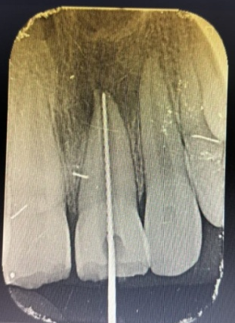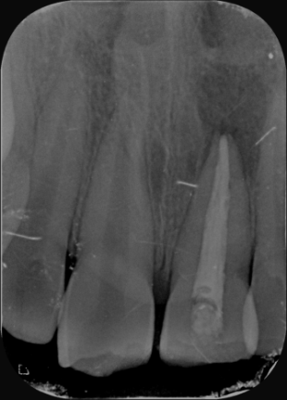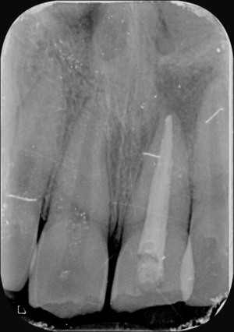
(A ) (B) (C)
Figure 3- A) WLD B) Post-obturation C)Radiographic image-1month follow up.

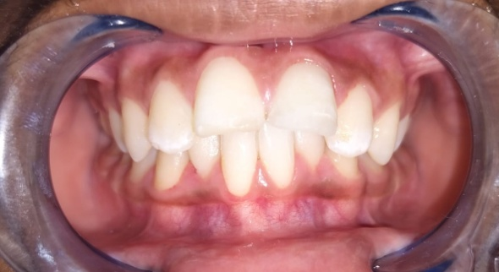
Figure 4-Postoperative image

DISCUSSION-
The Audio-Tactile Performance (ATP) technique, a specially designed health education method, was employed to teach children about oral hygiene maintenance¹.This approach involves initially providing verbal information about the importance of teeth and proper brushing techniques. Following this, the children are encouraged to explore the teeth on a large-sized dental model using their fingers to better understand the size and shape of teeth. They are then guided to practice brushing on the model using the Fones’ method with assistance. This process is repeated until the children are able to perform the brushing technique independently and confidently.¹
Visual impairment relates to a person’s eyesight, which cannot be corrected to normal vision. Instructions should be clear and simple, tailored to each child’s individual needs, educational level, and cognitive ability , with continuous reinforcement to ensure understanding and adherence.² Conventional oral health education methods primarily rely on visual cues to identify early signs of dental disease, which presents a significant challenge for visually impaired individuals. Therefore, customized educational and motivational approaches are essential to effectively promote and maintain proper oral hygiene in this population.³
Numerous behaviour management techniques have been documented in the literature for paediatric patients. However, children with visual impairments may not respond effectively to all conventional methods. Therefore, it is essential to customize and combine various techniques based on the individual needs and acceptance of each patient. Some of the techniques that can be successfully implemented in clinical practice are outlined below.⁴
- Tell- Feel- Do
- Ask- Tell- Ask
- Contingency Management
- Distraction
- Voice control
- Aversive conditioning
- Pharmacological techniques
The key to successful oral hygiene programs for individuals with visual impairments lies in creating adaptations and structured routines that promote independence and foster a sense of pride in personal care. This involves selecting appropriate oral hygiene aids, ensuring materials are clearly labeled or stored systematically to prevent misplacement, guiding effective brushing techniques for all areas of the mouth, and establishing methods to self-assess the adequacy of oral hygiene practices.⁵
The primary goal of the dentist or dental hygienist should be to train and empower visually impaired individuals to perform oral hygiene tasks independently. Promoting self-reliance is especially important, as it is often a deeply valued and sensitive aspiration in the lives of those with visual impairments. Every achievement—whether small or significant—can have a profound positive impact on the individual's self-esteem and confidence, reinforcing their motivation to maintain good oral health.¹

CONCLUSION-
Vision is a vital sense that enables children to recognize and navigate their surroundings. In its absence, especially in children with visual impairments, greater emphasis must be placed on the maintenance of oral health and prevention of oral diseases from an early age. Parents and caregivers serve as key partners in this effort and should be appropriately guided and supported in fostering good oral hygiene habits.
The implementation of modified behaviour management techniques and adapted oral hygiene practices is crucial to achieving successful dental outcomes and enhancing the overall well-being of these children. Paediatric dentists play a pivotal role in the care and management of visually impaired patients. Those who are committed to treating children with special health care needs often find the experience both enriching and deeply rewarding, as it allows them to make a meaningful difference in the lives of their patients.

REFERENCES-
- Dambare A, Mhatre S, Jayanna R, Razdan P. Full Mouth Rehabilitation in visually impaired children with modified behaviour management techniques: A Case Series. UNIVERSITY JOURNAL OF DENTAL SCIENCES. 2024 Apr 16;10(1).
- Chowdary BP, Uloopi KS, Vinay C, Rao VV, Rayala C. Impact of verbal, braille text, and tactile oral hygiene awareness instructions on oral health status of visually impaired children. Journal of Indian Society of Pedodontics and Preventive Dentistry. 2016 Jan 1;34(1):43-7.
- Nair DJ, Shetty AA, Hegde AM. Efficacy of a modified audio-tactile performance technique with braille (ATPb) on the oral hygiene status of visually-impaired children. Journal of Clinical Pediatric Dentistry. 2021 Jan 1;45(1):15-21.
- Nair DJ, Shetty AA, Hegde AM. Comprehensive dental management of visually impaired children: A brief review. IJMSIR. 2018;3:235-43.
- Nirmala SV, Saikrishna D. Oral health and dental care of children with visual impairment--An over view. EC Dental Science. 2019;18(5):848-53.

