Assessment and Quantification of Maternal Morbidity and Postpartum Complications, Childbirth in Ghana

ABSTRACT
This study develops an integrated statistical and machine-learning framework to identify predictors of childbirth-related complications and post-surgical sequelae. Using demographic, obstetric, clinical, laboratory, economic, dietary, and functional-status variables, we constructed a synthetic Ghana-specific cohort of 10,000 women of reproductive age. Logistic regression and Cox proportional hazards models were applied alongside decision trees, random forests, k-nearest neighbours, naïve Bayes, and neural networks to assess the consistency and relative importance of predictors. Across models, salient factors included maternal age, antenatal care attendance, prior obstetric complications, postpartum hemorrhage, pre-eclampsia, gestational diabetes, infections, hemoglobin levels, National Health Insurance Scheme (NHIS) status, delivery and transport costs, food expenditure, and limitations in activities of daily living. Women with a history of complications or postpartum hemorrhage exhibited markedly higher odds of experiencing adverse outcomes during childbirth. Overall, logistic regression performed robustly and offers interpretable, policy-relevant insights to support maternal health planning and resource allocation in Ghana.

Keywords: [Childbirth, postpartum hemorrhage, side-effects, pre-eclampsia, logistic regression}

1. INTRODUCTION

The complications and risks of childbirth are enormous and irreversible in some instances. According to Wang et al. 2025, estimated that about 45% of new mothers report experiencing psychological birth trauma, making it a serious global public health concern. The causes of psychological birth trauma have received little attention from researchers, who primarily concentrate on the effects of postpartum mental health conditions like postpartum PTSD (Mohammed et al,2025, Budiarti et al, 2025). These complications directly or indirectly may trigger heart related issues if not manage with care (Frederick, 2025)
Maternal mortality was rated high in 2023 by WHO where it is estimated that about 260,00 women directly died during pregnancy and childbirth with 92% of these maternal deaths occurred in underdeveloped and developing countries where with current advancement in physician’ knowledge, skills and improved information, science and technology could avert this decade canker. Again, Sub-Saharan Africa and Southern Asia contributed nearly 87% of the global maternal deaths in 2023 and these factors are severe bleeding after childbirth, complications from delivery, unsafe abortion, infections, and high blood pressure during pregnancy (WHO, 2025, Gayatri et al. 2021, and Geremew et al, 2025).
According to Gerald et al 2024, majority of maternal deaths (77.2%) are caused by sepsis (23.7%) and hemorrhage (27.8%). This result is consistent with worldwide trends and emphasizes how vital it is to enhance emergency obstetric care, especially in the management of postpartum hemorrhage and the prevention and treatment of infections. This result is consistent with findings from the 2017 Ghana Maternal Health Survey (GMHS), which found that direct obstetric causes accounted for nearly 75% of maternal deaths in Ghana, as well as findings from Ngonzi et al. 2016. Significant local differences in healthcare quality or access are indicated by the significantly higher mortality risk in the Oforikrom sub-metro than in Tafo (OR: 4.1495, p = 0.0219). According to this finding, Oforikrom needs focused resources and interventions to deal with its unique problems (Osborne et al. 2025 and Bearak et al. 2022).
Women who had primary education [aOR = 1.41; 95% CI: 1.05, 1.90] and those with secondary education [aOR = 1.46; 95% CI: 1.09, 1.97] had higher odds of experiencing unintended pregnancy than women with no education. Women with 3–4 children [aOR = 2.02; 95% CI: 1.48, 2.77] and 5 or more children [aOR = 4.34; 95% CI: 2.79, 6.74] were more likely to have unintended pregnancy than women with 1–2 children. Women with a household size of six or more [aOR = 1.53; 95% CI: 1.20, 1.94] were more likely to have unintended pregnancy than those with five or fewer. Women with female household heads [aOR = 1.47; 95% CI: 1.15; 1.87] were more likely to have unintended pregnancy compared to those with male household heads (Augustus et al, 2025, Oladebo et al, 2025, and Wahyuni et al, 2025).
In Majella et al 2019 it was revealed that 569 antenatal case records analyzed, 315 (55.3%) were aged between 20-25 years and most (463, 81.4%) were classified as below the poverty line. From the study sample, 410 (74.3%) registered their current pregnancy within the first trimester. The proportion of high-risk pregnancy among participants was 18.3% (95% confidence interval: 15.3%-21.7%). Most (81.9%) had term delivery. Concerning obstetric and neonatal outcomes, most delivered spontaneously (73.9%); around 10.4% had low-birth weight babies, and only 1.7% experienced stillbirth (Al-Hindi et al. 2020). With high-risk pregnancy, parity, socio-economic status and unfavorable outcomes such as, low-birth weight, preterm and post term delivery was associated (Jusmawati et al, 2025 and Contreras et al, 2025.

2.0 methodology
A retrospective cohort study with synthetic data (n=10,000) having outcomes that included a binary indicator of side effects and time-to-postpartum complication (Armero et al. 2022). Predicting variables included demography, obstetric history, clinical/labs, access, costs, diet, and disability. The artificial Intelligent models included: logistics, random forest, decision tree, k-Nearest Neighbor, neural network. Evaluation included: AUC, C-index, calibration, KM curves; internal split validation using their algorithms (Abuelezz et al. 202 and Kilicarslan et al. 2021).

2.1 Ethical considerations
The data solicited from the Integrated Health Management System; data obtained on cardiovascular diseases. Data obtained from the system were anonymity and confidentiality of their information and the information provided will solely be use for this research to help improve the treatment of cardiovascular diseases in Ghana, and Africa.
2.2 Model of binary logistic regression model
The labeled in logistic regression is usually binary that is the labelled can take the value 1 with a probability of success, or the value 0 with probability of failure $1-π$. This type of labeled is called a Bernoulli (binary) labeled. The relationship between the features/instances and labeled is not a linear function in logistic regression instead log it transformation of $π$ is used. Consider a collection of P features that the instance is present to denote by:
Probability of success/event occurrence is.
$P\left(π\right)=\frac{1}{\exp^{( β_{0}+ β_{1}x_{1}+β_{2}x_{2}+…+ β_{p}x_{p})}}$ (1)
Probability of failure/event not occurring and simplified form, Sum of the probability success rate and failure rate equals to 1,
$P\left(1-π\right)=1-\frac{1}{\exp^{( β_{0}+ β_{1}x_{1}+β_{2}x_{2}+…+ β_{p}x_{p})}}$ (2)
$P\left(1-π\right)=\frac{\exp^{( β_{0}+ β_{1}x_{1}+β_{2}x_{2}+…+ β_{p}x_{p})}-1}{\exp^{( β_{0}+ β_{1}x_{1}+β_{2}x_{2}+…+ β_{p}x_{p})}}$ (3)
$P\left(\frac{π}{1-π}\right)=\frac{\exp^{( β_{0}+ β_{1}x_{1}+β_{2}x_{2}+…+ β_{p}x_{p})}}{1+\exp^{( β_{0}+ β_{1}x_{1}+β_{2}x_{2}+…+ β_{p}x_{p})}}$ (4)
For ratio $(φ$) of the probabilities, $P\left(π\right) and P\left(1-π\right)=P(q)$.
$φ\left\{\frac{P\left(π\right)}{P\left(1-π\right)}\right\}=\frac{\frac{1}{\exp^{( β_{0}+ β_{1}x_{1}+β_{2}x_{2}+…+ β_{p}x_{p})}}}{\frac{\exp^{( β_{0}+ β_{1}x_{1}+β_{2}x_{2}+…+ β_{p}x_{p})}-1}{\exp^{( β_{0}+ β_{1}x_{1}+β_{2}x_{2}+…+ β_{p}x_{p})}}}$ (5)
Simplifying this equation leads to.
$φ\left\{\frac{P\left(π\right)}{P\left(1-π\right)}\right\}=\exp^{-( β_{0}+ β_{1}x_{1}+β_{2}x_{2}+…+ β_{p}x_{p})}$ (6)
The log-odds of experiencing heart failure $y=1$ is modeled as a linear function of the features such as:
$ln\left(\frac{π}{1-π}\right)=β_{0}+ β_{1}x_{1}+β_{2}x_{2}+…+ β_{p}x_{p} :0≤π≤1)$ (7)
Where $β_{0}$ is the intercept and $β_{1}, β_{2 }, β_{3}, …, β_{p}$ is the regression coefficients of the features in the model. In situations where the dependent variable assumed dichotomous, then binomial logistic regression technique is the best to used, using the binomial logistic link. Other similar types of modeling include probability modeling. (Dobson, 2001), (McCullagh and Nelder, 1989). Addressing the response variable as categories in the basic model, it is to permit binary categories of response data of binomial logistic analysis in the design or if the labeled is ordinal data set which also warrant the modeling to be performed in its raw state. (Agresti, 2007)). An introduction to categorical data analysis, 2017. The only alternative readily available is to recode the labeled into just two categories and do a binary logistic regression analysis (or to several logistic regression models to different pairs of categories in the labeled, although this is not as statistically efficient as doing a true binomial logistic analysis.

3. results and discussion

Table 1 Descriptive results
Features | Mean | Sd | Trimmed | Mad | Min | Max | Range | Skew | Kurtosis | Se
Age | 27.5203 | 5.7351 | 27.4865 | 5.7821 | 15 | 49 | 34.00 | 0.0965 | -0.1976 | 0.0574
Anc_visits | 5.2211 | 2.2862 | 5.2164 | 2.9652 | 0 | 12 | 12.00 | 0.0578 | -0.2758 | 0.0229
Previous_c_section | 0.1767 | 0.3814 | 0.0959 | 0.0000 | 0 | 1 | 1.00 | 1.6950 | 0.8732 | 0.0038
Previous_complication | 0.2195 | 0.4139 | 0.1494 | 0.0000 | 0 | 1 | 1.00 | 1.3552 | -0.1635 | 0.0041
Postpartum_hemorrhage | 0.1039 | 0.3051 | 0.0049 | 0.0000 | 0 | 1 | 1.00 | 2.5959 | 4.7390 | 0.0031
Preeclampsia | 0.0767 | 0.2661 | 0.0000 | 0.0000 | 0 | 1 | 1.00 | 3.1809 | 8.1187 | 0.0027
Infection | 0.0846 | 0.2783 | 0.0000 | 0.0000 | 0 | 1 | 1.00 | 2.9850 | 6.9108 | 0.0028
Distance_to_facility_km | 11.9737 | 8.4952 | 10.9120 | 7.4130 | 0.1 | 73.30 | 73.20 | 1.4420 | 3.3581 | 0.0850
Insurance_nhis | 0.7493 | 0.4334 | 0.8116 | 0.0000 | 0 | 1.00 | 1.00 | 1.1502 | -0.6771 | 0.0043
Delivery_cost_ghs | 51.4931 | 7.5110 | 50.0000 | 0.0000 | 50 | 203.01 | 153.01 | 8.1296 | 92.2678 | 0.0751
Transport_cost_ghs | 12.7470 | 9.8940 | 10.9312 | 6.4048 | 5 | 249.56 | 244.56 | 4.1228 | 47.8955 | 0.0989
Adl_limitations | 0.0889 | 0.2846 | 0.0000 | 0.0000 | 0 | 1.00 | 1.00 | 2.8885 | 6.3443 | 0.0028
Postpartum_complication | 0.2782 | 0.4481 | 0.2228 | 0.0000 | 0 | 1.00 | 1.00 | 0.9898 | -1.0204 | 0.0045
From table 1 above, the average age of childbirth is 28 years with minimum age of 15 years given that all other resilient factors like education and life prospects and building career goals. Ideal, it is required that pregnant women visit the antenatal care unit 5 times on average or more. On average, pregnant women travel about 12km to health facility for antenatal care and delivery and traveling cost of 13 Ghana Cedis and a minimum of cost 5 Ghana Cedis per visit.

3.1 Reduced logistic regression for childbirth dataset
From table 2 below shows the significant features for modeling the logistic regression model. The intercept coefficient is of 1.5707 units and its p-value of 0.147 is greater than 0.05 alpha value, hence the intercept is insignificant, so we fail to include it in the model formulation. Features that contribute to side-effects in childbirth are age, number of antenatal care visits, previous complication, postpartum hemorrhage, preeclampsia, gestational diabetes, infection, hemoglobin, insurance (NHIS), delivery cost, transportation cost, cost of food, and activities of daily living (ADL) limitations. For one additional unit of age, there is 0.035-unit increase of side-effects holding other features constant, also with one absenteeism of antenatal care will lead to 0.0267 unit of side-effects of childbirth holding other attributes constant. With a previous complication of childbirth, there is 0.429 units of side-effects with other attributes constant, one additional postpartum hemorrhage, there will be 0.3538 units of side-effects holding other factors constant. With pre-eclampsia, gestational diabetes, infection, hemoglobin, delivery cost, transportation cost, and activities of daily living limitations will increase side-effect in childbirth if there is an additional unit of these respective features with various magnitudes. With insurance and cost of food, if there is no additional cost of food there will be a decrease of 0.088 units of side-effects holding other features constant. When there is one additional improvement in health insurance, there will be 2.9931 units decrease in side-effects of childbirth in Ghana.
Table 2 the reduced logistic regression coefficients
Features | Coefficient | Std. Error | Z-Value | Pr(>|Z|) | Odds ratio
(Intercept) | -1.570682 | 1.081738 | -1.452 | 0.146502 | 0.207903
Age ($x_{1}$) | 0.035198 | 0.006062 | 5.806 | 6.39E-09 | 1.035825
Anc_visits ($x_{2}$) | 0.026741 | 0.015337 | 1.744 | 0.081224 | 1.027102
Previous_complication ($x_{3}$) | 0.429063 | 0.077954 | 5.504 | 3.71E-08 | 1.535818
Postpartum_hemorrhage ($x_{4}$) | 0.353765 | 0.10481 | 3.375 | 0.000737 | 1.42442
Preeclampsia ($x_{5}$) | 0.214901 | 0.122365 | 1.756 | 0.07905 | 1.239739
Gestational_diabetes ($x_{6}$) | 0.320746 | 0.130382 | 2.460 | 0.013892 | 1.378156
Infection ($x_{7}$) | 0.307420 | 0.113305 | 2.713 | 0.006664 | 1.359912
Hemoglobin ($x_{8}$) | 0.041031 | 0.022073 | 1.859 | 0.063045 | 1.041884
Insurance_nhis ($x_{9}$) | -2.993132 | 1.063361 | -2.815 | 0.004881 | 0.05013
Delivery_cost ($x_{10}$) | 0.042183 | 0.01557 | 2.709 | 0.006743 | 1.043086
Transport_cost ($x_{11}$) | 0.085949 | 0.035153 | 2.445 | 0.014485 | 1.08975
Food_cost ($x_{12}$) | -0.087567 | 0.034946 | -2.506 | 0.012219 | 0.916157
ADL_limitations ($x_{13}$) | 0.229167 | 0.113851 | 2.013 | 0.044128 | 1.257553
From table 2 above, the odds ratio for mothers with advance in age experienced 3.6% side-effects than those less and 2.7% more of antenatal care. For women with previous complications and postpartum hemorrhage experienced odds ratio of 53.58% and 42.44% side-effects during childbirth than women without previous complications and postpartum hemorrhage. Again, with women who exhibited pre-eclampsia, gestational diabetes, infections, and hemoglobin loss are likely to experience side-effect of 23.97%, 37.82%, 35.99% and 4.19% correspondingly odds ratio than those without these features. Also, the odds ratio of delivery cost, transportation cost and activities daily living limitations are 4.31%, 8.98%, and 25.76% of side-effects congruently than their fellow women who without these features. The logistic regression model is.
Therefore, the reduced model is
$logit\left({\tilde{y}}_{childbirth}\right)=β_{0}+ β_{1}x_{1}+ β_{2}x_{2}+ β_{3}x_{3}+β_{4}x_{4}+β_{5}x_{5}+β_{6}x_{6}+β_{7}x_{7}+β_{8}x_{8}+…+β_{13}x_{13}$ (8)
The reduced logistic regression model for childbirth side-effect is,
$logit\left({\tilde{y}}_{cb}\right)=0.035x_{1}+0.027x_{2}+0.429x_{3}+0.354x_{4}+0.215x_{5}+ 0.321x_{6}+0.307x_{7}+0.041x_{8}-2.993x_{9}+0.042x_{10}+0.086x_{11}-0.088x_{12}+0.229x_{13}$ (9)

3.2 Logistic model prediction of childbirth
From figure 1, the prediction of childbirth with side effects against age is shown with its predicted probability. The predicted probability of side-effects at early stages of women is low (less than 10%) and it steadily progress as they grow. Ladies between the ages of 15 to 30 years have 6% to 10% chance of experiencing side-effects and between 31 to 45 years have 10.01% to 15% chance of experiencing side-effects and it has been supported by the odds ratio.
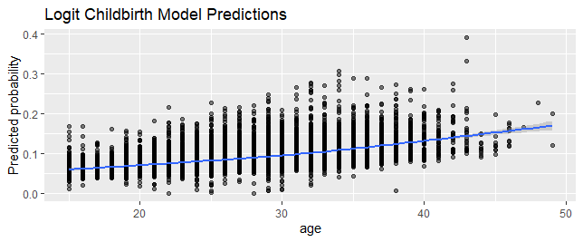
Figure 1 logistic model prediction

3.3 Neural network
From figure 2 below, the model performance 90.89% in predicting side-effects during childbirth. The bias term of the model is $\hat{y}=g\left(wx+b\right),$where the activition $\left(g\right)$ is 0.3118, the bias term $\left(b\right)$ is -0.22077 and weighted average $(w)$ is -1.02523.
The neural network model is,
$\hat{y}=0.3118\left(-1.02523x-0.22077\right)$ (10)
$\hat{y}=-0.3196668x-0.068836$ (11)
Without all these features that contribute to side-effects during childbirth of a women, there is 6.88% (absolute value) degree of effect in childbirth and with one additional unit of weigted average, there will be additional 31.97% degree of side-effects in childbirth.
The accuracy rate of the neural network is 90.89% with a confidence interval between 90.31% to 91.45%.
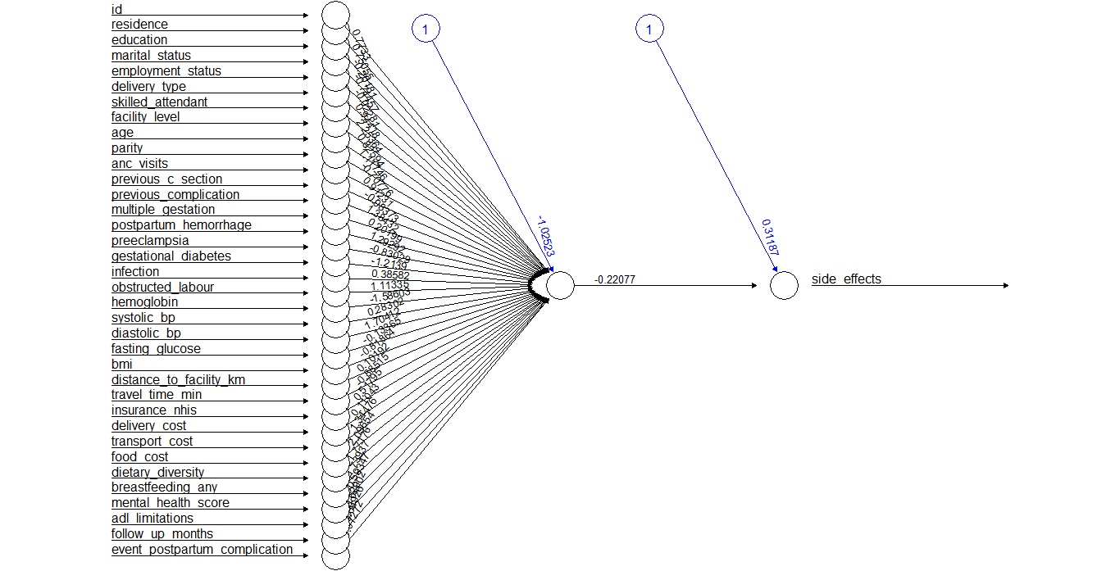
Figure 2 Neural network of childbirth dataset

3.4 Confusion Matrix

Figure 3 Confusion Matrix
From figure 3 above, it appears the random forest model is the best using their accuracy scores. With accuracy score of 1 inform us that random forest model overfit the childbirth dataset. Comparing these models’ logistic regression and neural network have shown higher accuracy score of 90.89%, which implies that both models performed better on the dataset. The researcher chose the logistic model for this research. The least performing the model is support vector machine.

3.5 Receiver operating curve on the reduced logistic regression model
From the figure 4 a below, the receiver operating curve is above the decision rule which implies that the model performed well on the dataset.
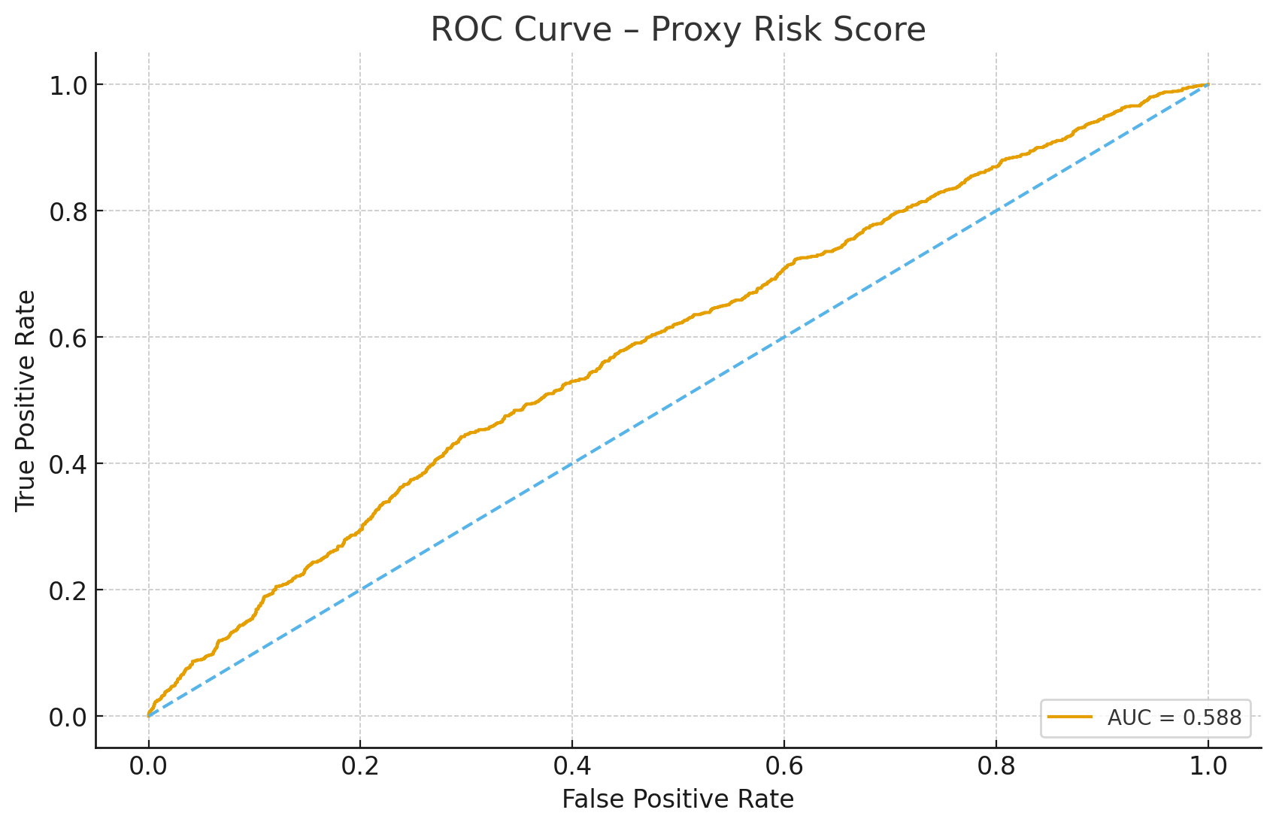
Figure 4. ROC curve for proxy risk score (side effects)

3.6 Calibration of the reduced logistic regression model on childbirth dataset
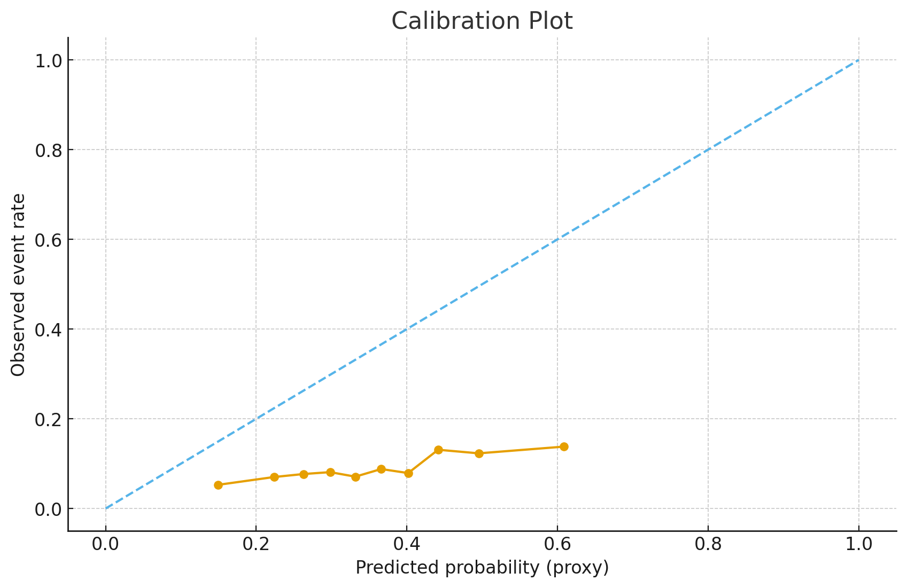
Figure 5 Calibration plot (deciles)
From figure 5 above, observed outcome rate = 61% for a bin of predictions and it lies above the diagonal, the model is underconfident.

3.7 Kaplan-Meier curves by risk tertile for postpartum complications
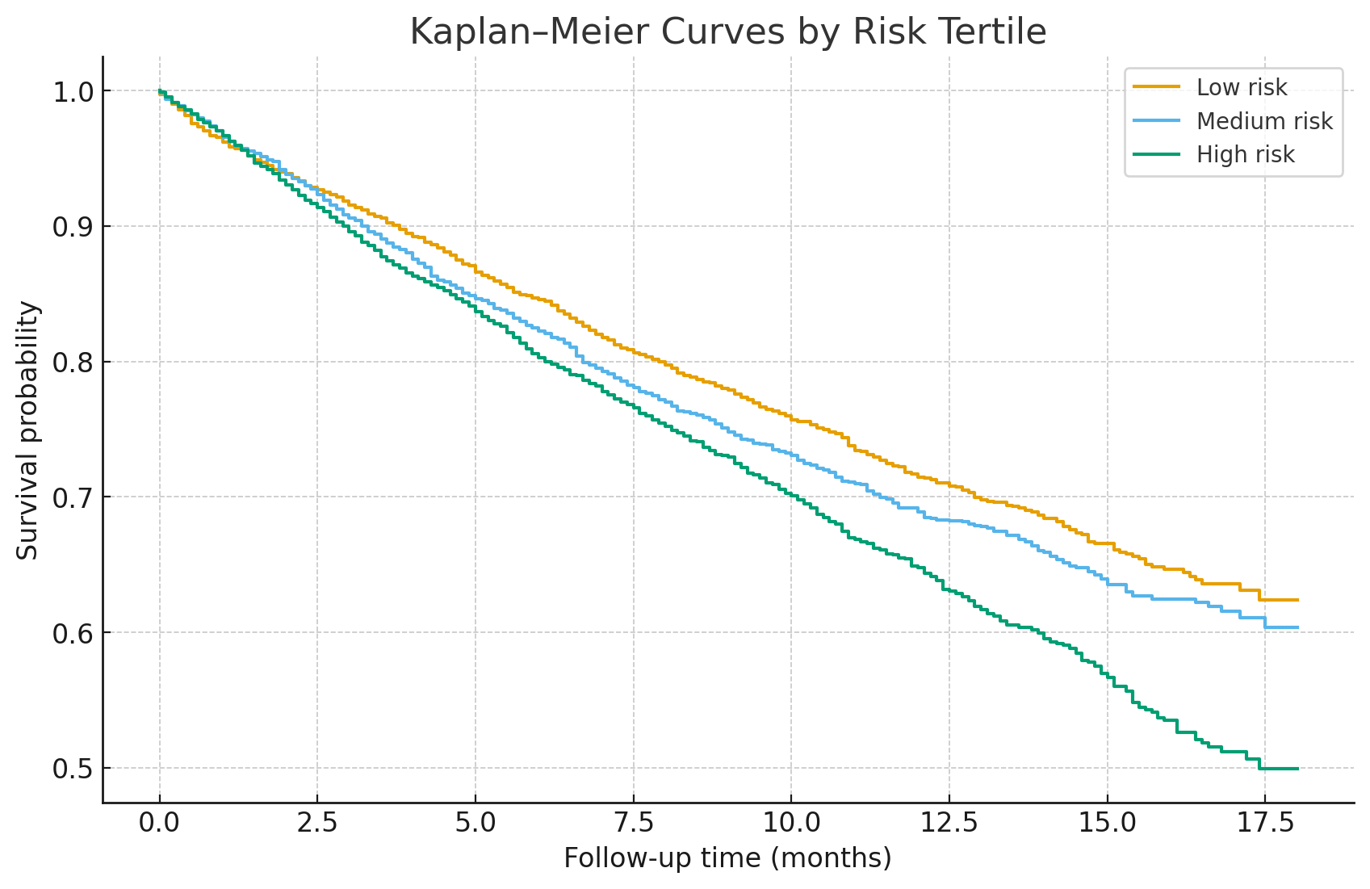
Figure 6 Kaplan-Meier curves by risk tertile for postpartum complications
In figure 6 above, the Kaplan–Meier analysis demonstrated clear risk stratification across tertiles. Participants in the highest risk tertile experienced postpartum complications earlier and more frequently than those in the intermediate and low tertiles (log-rank p < 0.001).

4.0 Findings
The results identify that age, number of antenatal care visits, previous complication, postpartum hemorrhage, preeclampsia, gestational diabetes, infection, hemoglobin, insurance (NHIS), delivery cost, transportation cost, cost of food, and activities of daily living (ADL) limitations are the primary factors contributing to maternal risk. While insurance coverage appears to provide a protective effect, out-of-pocket expenses seem to increase the risk, For women with previous complications and postpartum hemorrhage experienced odds ratio of 53.58% and 42.44% side-effects during childbirth than women without previous complications and postpartum hemorrhage. Again, with women who exhibited pre-eclampsia, gestational diabetes, infections, and hemoglobin loss are likely to experience side-effect of 23.97%, 37.82%, 35.99% and 4.19% correspondingly odds ratio than those without these features and is similar to Gerald et al, 2024.

4. Conclusion

Risk stratification tools based on hybrid models may be utilized to prioritize follow-up and allocate resources effectively. We suggest enhancing antenatal care (ANC), complication, emergency transportation, and financial safeguards to reduce postpartum hemorrhage risks.
Unintended pregnancy is prevalent among women in Ghana, with various factors such as maternal age, education, employment, parity, religion, ethnicity, household size, household head’s sex, wealth index, and region playing a significant role. To address this issue, it is crucial to implement comprehensive reproductive health education programs targeting women of reproductive age across diverse socio-economic groups. The government, through the Ministry of Health, should ensure equitable access to contraceptive services by strengthening family planning clinics and outreach programs. Empowering women through educational and economic initiatives is essential, along with community engagement, to address cultural norms and beliefs related to family planning and unintended pregnancy. Strengthening healthcare systems to provide high-quality reproductive health services and implementing targeted interventions for vulnerable groups are necessary steps. Additionally, advocating for policies supporting reproductive rights, including access to safe abortion services, comprehensive sexuality education, and protection against gender-based violence, is crucial.

Definitions, Acronyms, Abbreviations

CI | Confidence Interval
OR | Odds Ratio
SD | Standard Deviation
WHO | World Health Organization
PPH | Postpartum Hemorrhage
PE | Preeclampsia

References

Wang, Y., Liu, C., Sun, Y., Yuan, Y., & Chen, L. (2025). The mediating role of coping style in the relationship between fear of childbirth and psychological birth trauma among natural childbirth women in China: a structural equation model analysis. BMC Pregnancy and Childbirth, 25(1). https://doi.org/10.1186/s12884-025-07146-6

World Health Organization. (2025, April 7). Maternal mortality. World Health Organization. https://www.who.int/news-room/fact-sheets/detail/maternal-mortality

Edyedu, I., Ugwu, O. P. C., Ugwu, C. N., Alum, E. U., Eze, V. H. U., Basajja, M., ... & Aja, P. M. (2025). The role of pharmacological interventions in managing urological complications during pregnancy and childbirth: A review. Medicine, 104(7), e41381.

Mohammed, S., Lokubal, P., & Ackah Baafi, J. A. (2025). Intimate partner violence during pregnancy and its association with pregnancy and childbirth complications: A prospective cohort study. PLOS Global Public Health, 5(4), e0004311.

Contreras-García, M., Torres-Lacomba, M., Durán-Sierra, S., & Sarabia-Cobo, C. Reducing Worry and Enhancing Knowledge in Relation to Pregnancy and Childbirth Complications: Impact of an Online Antenatal Education Session. Available at SSRN 5281023.

Geremew, A. B., Roberts, C. T., Kassa, B. G., Ullah, S., & Stephens, J. H. (2025). Exploring evidence of healthcare-seeking pathways for maternal complications in Sub-Saharan Africa: a scoping review. BMC Pregnancy and Childbirth, 25(1), 634.

Geremew, A. B., Roberts, C. T., Ullah, S., & Stephens, J. H. (2025). Healthcare-Seeking Behaviour for Obstetric Complications in Ethiopia: A Multilevel Mixed-Effect Analysis. Health Services Insights, 18, 11786329251347353.

Budiarti, K. D., Sulliyawati, E., Sulastin, S., & Badriyah, S. (2025). Effect of the Antenatal Care Group Model on Childbirth Preparedness among Pregnant Women: A Quasi-Experimental Study. Journal of Applied Nursing and Health, 7(3), 582-594.

Oladebo, T. M., Bobholz, F., Zahra, T. A., Payjapo, C., & Anderson, A. A. (2025). Complications in Pregnancy and Childbirth: Analysis of Comments From the 2020–2021 Wisconsin Pregnancy Risk Assessment Monitoring System (PRAMS)[ID 1583]. Obstetrics & Gynecology, 145(6S), 19S.

Jusmawati, J., & Hasrida, H. (2025). Counseling on compliance with antenatal care visits for preventing delivery complications at bira health center 2024. Journal of Evidence-Based Community Health, 2(1), 15-18.

Wahyuni, S., Razak, D. S., Saputri, A. R., & Muzfah, A. W. (2025). Education and Assistance for Pregnant Women in Preparing for Safe Delivery to Reduce the Risk of Pregnancy Complications in Health Prone Areas Trimulya Village. Sustainable Applied Modification Evidence Community, 2(1), 36-34.

Gayatri N., Peby Maulina Lestari, Abarham Martadiansyah, Yusuf, M., & Muwarni Emasrissa Latifah. (2021). Cardiac Disease in Pregnancy: Maternal and Perinatal Outcomes in RSUP Dr. Mohammad Hoesin Palembang. Bioscientia Medicina, 6(2), 1380–1392. https://doi.org/10.37275/bsm.v6i2.448

Gerald Ohene Agyekum, Michael Fosu Ofori, Samuel Akwasi Adarkwa, Michael Arthur Ofori (October, 2024). A Cross-Sectional Study on the Occurrence of Maternal Mortality in Some Selected Hospitals in Kumasi Metropolis Using Zero-Inflated Negative Binomial. Journal of Probability and Statistics. Vol 2024, Issue 1/3306268.
https://onlinelibrary.wiley.com/doi/full/10.1155/2024/3306268

Ngonzi J., Tornes Y. F., Mukasa P. K. et al., Puerperal Sepsis, the Leading Cause of Maternal Deaths at a Tertiary University Teaching Hospital in Uganda, BMC Pregnancy and Childbirth. (2016) 16, 207–7, https://doi.org/10.1186/s12884-016-0986-9, 2-s2.0-84982812254

Osborne, A., Wongnaah, F. G., Adeleye, K., Bangura, C., Aboagye, R. G., & Ahinkorah, B. O. (2025). Prevalence and factors associated with unintended pregnancy among women in Ghana. BMC Pregnancy and Childbirth, 25(1). https://doi.org/10.1186/s12884-025-07749-z

United Nations Population Fund. (2022, March 30). Nearly half of all pregnancies are unintended—a global crisis, says new UNFPA report. United Nations Population Fund. https://www.unfpa.org/press/nearly-half-all-pregnancies-are-unintended-global-crisis-says-new-unfpa-report

Bearak JM, Popinchalk A, Beavin C, Ganatra B, Moller AB, Tunçalp Ö, Alkema L. (2022). Country-specific estimates of unintended pregnancy and abortion incidence: a global comparative analysis of levels in 2015–2019. BMJ Global Health.7(3):e007151

Bearak, J., Popinchalk, A., Ganatra, B., Moller, A.-B., Tunçalp, Ö., Beavin, C., Kwok, L., & Alkema, L. (2020). Unintended pregnancy and abortion by income, region, and the legal status of abortion: Estimates from a comprehensive model for 1990–2019. The Lancet Global Health, 8(9), e1152–e1161. https://doi.org/10.1016/S2214-109X(20)30315-6

Abuelezz, I., Hassan, A., Jaber, B. A., Sharique, M., Abd-Alrazaq, A., Househ, M., et al. (2022). Contribution of artificial intelligence in pregnancy: a scoping review. J. Public Health Inform. 289, 333. doi: 10.3233/SHTI210927

Ahmed, M., and Kashem, M. A. (2020). “IoT Based Risk Level Prediction Model for Maternal Health Care In The Context Of Bangladesh,” in 2020 2nd. International Conference on Sustainable Technologies for Industry 40 (STI19). doi: 10.1109/STI50764.2020.9350320

Ahmed, M., Kashem, M. A., Rahman, M., and Khatun, S. (2020). Review and Analysis of Risk Factor of Maternal Health in Remote Area Using the Internet of Things (IoT). Singapore: Springer Singapore. doi: 10.1007/978-981-15-2317-5_30

Al-Hindi, M. Y., Al Sayari, T. A., Al Solami, R., Al Baiti, A. K., Alnemri, J. A., Mirza, I. M., et al. (2020). Association of antenatal risk score with maternal and neonatal mortality and morbidity. Cureus. 12, e12230. doi: 10.7759/cureus.12230

Frederick, et al (2025). Development and Validation of a Robust Predictive Model for Early Detection of Heart Failure in Anfoega-Ghanaian Patients.” in International Journal of Recent Advances in Multidisciplinary Topics, vol. 7, no. 5, pp. 28-37, October 2025.

Armero, W., Gray, K. J., Fields, K. G., Cole, N. M., Bates, D. W., Kovacheva, V. P., et al. (2022). A survey of pregnant patients' perspectives on the implementation of artificial intelligence in clinical care. J. Am. Med. Inform. Assoc. 30, 46–53. doi: 10.1093/jamia/ocac200

Quarshie Frederick, “A Peer Review of a Predictive Model for Early Detection of Heart Failure Using Machine Learning,” in International Journal of Recent Advances in Multidisciplinary Topics, vol. 5, no. 10, pp. 28-37, October 2024.

Kilicarslan, S., Celik, M., and Sahin, S. (2021). Hybrid models based on genetic algorithm and deep learning algorithms for nutritional Anemia disease classification. Biomed. Signal Proces. Control. 63, 102231. doi: 10.1016/j.bspc.2020.102231

Majella, M. G., Sarveswaran, G., Krishnamoorthy, Y., Sivaranjini, K., Arikrishnan, K., Kumar, S. G. A., et al. (2019). longitudinal study on high risk pregnancy and its outcome among antenatal women attending rural primary health centre in Puducherry, South India. J. Educ. Health Promot. 8, 12. doi: 10.4103/jehp.jehp_144_18

