Original Research Article
Physicochemical Characterization and Spatial Variability of Leachate and Its Environmental Implications at Aluu Municipal Dumpsite, Port Harcourt, Nigeria

.
ABSTRACT

Aim: This study aimed to characterize the physicochemical composition of leachate, evaluate its environmental implications, and assess its spatial variability at the Aluu municipal dumpsite, Port Harcourt, Nigeria.

Study design: This study employed a field-based sampling and laboratory analytical design combined with geospatial and statistical analysis.

Place and Duration of Study: The study was conducted at the Aluu municipal dumpsite, Port Harcourt, Nigeria. Sampling and laboratory analyses were carried out over a period of 3 months.

Methodology: Leachate samples were collected from four locations within the dumpsite (North, South, East, and West). Samples were analyzed for key physicochemical parameters, including pH, total suspended solids (TSS), total dissolved solids (TDS), biochemical oxygen demand (BOD), and chemical oxygen demand (COD), using standard laboratory procedures. Spatial distribution patterns were evaluated using Golden Surfer software, while statistical analysis was applied to assess variability.

Results: Results revealed significant contamination across the study area. TDS ranged from 747 to 1,579 mg/L, with some values exceeding the desirable limit of 1,000 mg/L. BOD values (7.45–18.6 mg/L) were substantially elevated, indicating high organic pollution. COD ranged from 90 to 2,156 mg/L, reflecting strong chemical contamination, with the highest values recorded in the eastern section. TSS values (0.001–2.1 mg/L) remained low, while pH values (7.5–8.15) were within acceptable limits. Spatial analysis indicated heterogeneous contamination, with hotspots concentrated in the northern and eastern sections. COD exhibited the highest spatial variability (coefficient of variation = 105.4%).

Conclusion: The study demonstrates that leachate from the Aluu dumpsite poses significant environmental and public health risks due to elevated organic and chemical loads. The observed spatial heterogeneity highlights localized zones of intense contamination. There is a critical need for engineered landfill systems with effective leachate collection and treatment to mitigate environmental impacts.

Keywords: Physicochemical characterization, spatial variability Leachate geochemistry, spatial distribution, municipal solid waste, landfill contamination, groundwater risk

1. INTRODUCTION

The Niger Delta region of Nigeria experiences high annual rainfall and limited engineered waste-management infrastructure, conditions that significantly enhance leachate generation and contaminant migration from open dumpsites (Abam and Unachukwu, 2009; Nwankwoala et al., 2022). In many urban and peri-urban communities, MSW is still disposed of in open, unengineered dumpsites that lack leachate liners or collection systems, facilitating leachate generation and enhancing the potential for contaminant migration into surrounding soils, groundwater, and nearby surface water bodies (Adepegba, 2012; Esonanjor and Ohanuna, 2021).

Leachate is the liquid formed when water percolates through waste materials, extracting and mobilizing dissolved and suspended constituents (Christensen et al., 1992). Its chemical composition varies widely depending on waste type, landfill age, decomposition stage, climatic conditions, and operational practices (Kjeldsen et al., 2002; Bikash et al., 2014). Tropical regions such as the Niger Delta, characterized by intense rainfall and high humidity, are particularly susceptible to elevated leachate generation, especially where landfills remain uncovered and unmanaged (Ngah and Otei-Nda, 2017).

Leachate typically contains organic pollutants, reflected in elevated biochemical oxygen demand (BOD) and chemical oxygen demand (COD), as well as dissolved inorganic ions and potentially toxic metals (Abel et al., 2023; Christensen et al., 1992). These contaminants pose substantial ecological and public health concerns, particularly when leachate infiltrates shallow aquifers or enters drainage systems used by local communities (Akudo et al., 2010; Uma et al., 1989). The Aluu municipal dumpsite in Port Harcourt exemplifies such high-risk conditions: it is unlined, unmanaged, and located near residential buildings, schools, and other sensitive land uses (Udom et al., 2004).

Although several studies in the Niger Delta have assessed groundwater contamination around dumpsites (Nwankwoala et al., 2022; Akudo et al., 2010), While previous studies in the Niger Delta have primarily focused on groundwater contamination around dumpsites (Akudo et al., 2010; Nwankwoala et al., 2022), fewer studies have quantitatively characterized leachate chemistry within dumpsites and integrated these results with spatial interpolation techniques to delineate intra-site variability and potential contamination hotspots.

Accordingly, this study investigates the physicochemical characteristics and spatial variability of leachate. The specific objectives are to:
- Characterize the physicochemical composition of leachate.
- evaluate environmental and public health implications by comparing results with WHO drinking water standards;
- Determine spatial variability patterns; and
- assess potential risks to surrounding groundwater and surface-water systems.

1.2 Study Location

The study was conducted at the government-approved municipal dumpsite located along Aluu Road in Obio/Akpor Local Government Area, within the Port Harcourt metropolis, Rivers State, Nigeria. The site lies at approximately latitude 4.92078° N and longitude 6.91881° E, with an elevation of about 15.2 m above sea level. The dumpsite occupies an estimated surface area of 160 × 35 m and represents one of the major waste disposal points serving the surrounding communities (Udom et al., 2004).

The area around the dumpsite is predominantly residential, with a church located roughly 150 m from the site. Important institutions including the University Demonstration Secondary School (UDSS), approximately 800 m away, and the University of Port Harcourt, about 3 km from the site fall within the zone potentially affected by leachate migration (Udom et al., 2004; Adeyemi et al., 2021). The proximity of these sensitive receptors underscores the importance of assessing contamination risks within the area.

Aluu experiences a humid tropical climate characterized by an average annual rainfall of about 240 cm, relative humidity exceeding 90%, and mean annual temperatures of approximately 27°C (NIMET, 2019). These climatic factors, combined with the unlined and un-engineered nature of the dumpsite and the relatively flat topography, create favourable conditions for surface runoff and subsurface leachate migration (Nwankwoala et al., 2022).

To support spatial analysis, four sampling points were established within the dumpsite in the cardinal directions (East, West, South, and North). Their coordinates (in the local grid system used for Surfer mapping) are as follows: projection system are presented in Table 1.

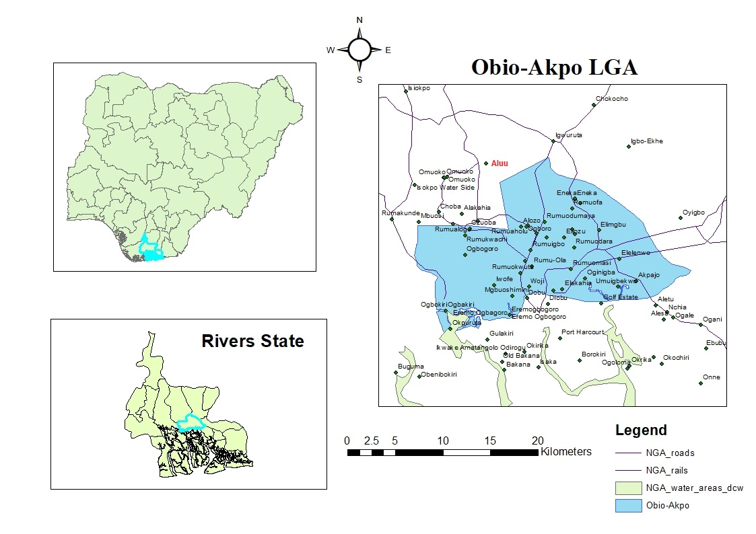
Figure 1. Study area
2. material and methods

2.1 Materials

The study was conducted at the government-approved dumpsite along Aluu Road in Obio/Akpor Local Government Area, Rivers State, Nigeria. The research involved a combination of field, laboratory, spatial, and statistical procedures, requiring the following materials:

Field equipment included:
Global Positioning System (GPS) unit for recording sampling coordinates and elevation, Polyethylene sampling bottles (1 L) for leachate collection, Sterile syringes for sub-sampling, Portable pH meter for in-situ pH measurement, Digital Total Dissolved Solids (TDS) meter for in-situ TDS measurement and Personal Protective Equipment (PPE), including gloves, safety boots, and nose masks.

Laboratory equipment included:
Conical flasks, beakers, amber bottles, filter papers, funnels, burettes, retort stands, pipettes, measuring cylinders, and drying ovens.

Chemical reagents used were:
Sulfuric acid (H₂SO₄), potassium dichromate (K₂Cr₂O₇), potassium iodate (KIO₃), sodium hydroxide (NaOH), Winkler reagents I and II, sodium thiosulfate (Na₂S₂O₃), starch indicator, mercuric sulfate (HgSO₄), ferrous ammonium sulfate, and ferroin indicator. All reagents were of analytical grade.

Software tools included:
Surfer (Golden Software) version 20 for spatial distribution mapping, Microsoft Excel for data processing, and SPSS (version 26) for statistical analysis.

2.2 Field Methods

2.2.1 Sampling Strategy

The study area was divided into four cardinal directions (North, South, East, and West) to ensure comprehensive spatial coverage. Four sampling locations (L1–L4) were established, and GPS coordinates and elevations were recorded for each point:

- L1 (Eastern section): 269241 E, 544219 N, elevation 20 m
- L2 (Western section): 269161 E, 544170 N, elevation 11 m
- L3 (Southern section): 269157 E, 544179 N, elevation 17 m
- L4 (Northern section): 269271 E, 544237 N, elevation 15 m
In-situ measurements included:
- pH, measured with a calibrated portable pH meter;
- TDS, measured using a digital TDS meter.
Leachate samples were collected using sterile syringes and transferred into 50-mL sample bottles. All samples were properly labeled, sealed, preserved on ice, and transported to the laboratory within the same day to prevent degradation.

2.3 Analytical Methods

All laboratory analyses were conducted following the Standard Methods for the Examination of Water and Wastewater. Samples were transported in clean, cooled containers and analyzed within 24 hours to maintain sample integrity.

pH Determination

pH was measured using a calibrated digital pH meter (e.g., Hanna Instruments HI98129). The instrument was calibrated with buffer solutions of pH 4.0, 7.0, and 10.0. For each analysis, 50 mL of sample was placed in a glass beaker, and the electrode was immersed until readings stabilized. Measurements were performed in triplicate.

Total Suspended Solids (TSS)

TSS was determined using the gravimetric method. Pre-weighed Whatman GF/C glass-fiber filters were used. Each 50 mL sample was filtered under vacuum, and the filters were dried in an oven at 103–105°C until a constant weight was achieved. The difference in weight before and after drying represented the TSS concentration. Analyses were performed in triplicate.

Total Dissolved Solids (TDS)

TDS was measured using a calibrated digital TDS meter (e.g., HM Digital COM-100). Each 50 mL sample was placed in a clean beaker, and the probe was immersed until a stable reading was obtained. Calibration was conducted with standard solutions. Triplicate measurements were averaged.

Biochemical Oxygen Demand (BOD)

BOD was determined using the 5-day BOD test. Initial dissolved oxygen (DO₁) was measured using the Winkler method. Samples were incubated in airtight BOD bottles at 20°C in the dark for five days, after which final dissolved oxygen (DO₅) was measured. Winkler reagents (manganese sulfate and alkaline iodide-azide) were used, and samples were titrated with sodium thiosulfate until the endpoint (colorless solution). BOD was calculated as DO₁ – DO₅ (mg/L). Triplicate analyses were performed.

Chemical Oxygen Demand (COD)

COD was determined using the closed reflux colorimetric method. Samples were digested with excess potassium dichromate in concentrated sulfuric acid, with silver sulfate as a catalyst, for two hours in sealed COD digestion tubes. After cooling, samples were titrated with standardized ferrous ammonium sulfate using ferroin indicator until the color changed from blue-green to reddish-brown. Analyses were performed in triplicate.

All laboratory equipment was calibrated before use, and analytical blanks and standard reference materials were included in each batch to ensure accuracy and reliability. All reagents were of analytical grade, and triplicate analyses enhanced methodological precision.

2.4 Spatial Analysis

Golden Surfer software was employed to generate spatial idistribution imaps ishowing icontamination ipatterns iacross ithe istudy iarea. iGPS icoordinates iand ianalytical iresults iwere iintegrated ito icreate iinterpolated isurfaces irepresenting iparameter idistribution. i i

2.5 iStatistical iAnalysis

Statistical ianalysis iincluded icalculation iof idescriptive istatistics, icorrelation imatrices, iand identification iof icontamination ihotspots.

3. results and discussion

Table 1: Geochemical Analysis Results
Location | Easting | Northing | Elevation (m) | pH | TSS (mg/L) | TDS  (mg/L) | BOD  (mg/L) | COD (mg/L)
L1 | 269241 | 544219 | 20 | 7.75 | 0.4 | 1502 | 8.12 | 2156
L2 | 269161 | 544170 | 11 | 8.00 | 0.001 | 747 | 7.45 | 90
L3 | 269157 | 544179 | 17 | 8.15 | 2.1 | 1236 | 9.74 | 690
L4 | 269271 | 544237 | 15 | 7.50 | 1.6 | 1579 | 18.6 | 548

Table 2: Comparison of Leachate Geochemical Parameters with WHO Drinking Water Standards (WHO, 2011,2017; NSDWQ, 2015)
Parameter | Study Range | WHO Guideline | NSDWQ Limit | Exceeds WHO? | Exceeds NSDWQ?
pH | 7.50 -8.15 | 6.5–8.5 | 6.5–8.5 | No | No
TSS (mg/L) | 0.001–2.1 | No strict limit (<10 suggested) | Not specified | No | -
TDS (mg/L) | 747–1,579 | ≤1,000 (desirable), ≤1,500 (max) | 500 | Some exceed | All exceed
BOD (mg/L) | 7.45–18.6 | No specific limit; <3 typical | 6 | All exceed | All exceed
COD (mg/L) | 90–2,156 | <10–40 typical | 10 | All exceed | All exceed

The analytical data in Table 1 reveal notable variability in leachate composition across the Aluu dumpsite. Each parameter is discussed below and compared with the WHO water quality standards and NSQWQ Limit (Table 2)

3.2 pH Analysis

The pH values (7.50–8.15) fall within the WHO recommended range (6.5–8.5), suggesting the leachate is neutral to slightly alkaline. This indicates moderate buffering capacity, common in mature landfill leachates due to ongoing decomposition processes. While the pH itself does not pose a direct hazard, it can influence the mobility and solubility of toxic metals and other contaminants in the surrounding environment.

3.3 Total Suspended Solids (TSS)

TSS concentrations are very low across all sites (0.001–2.1 mg/L), far below suggested thresholds for potable water (<10 mg/L). This implies most particles in the leachate are likely dissolved rather than suspended, reducing concerns over sediment-associated transport of pollutants.

3.4 Total Dissolved Solids (TDS)

TDS levels ranged from 747 to 1,579 mg/L. While some locations (L1 and L4) exceed the WHO desirable threshold (1,000 mg/L), all remain at or just above the short-term upper limit (1,500 mg/L). Elevated TDS reflects the presence of dissolved minerals and salts and can negatively affect water taste, utility for drinking, and suitability for irrigation if migration to groundwater or surface water occurs.

3.5 Biochemical Oxygen Demand (BOD)

All BOD values (7.45–18.6 mg/L) are significantly higher than what is typical or allowed in treated potable water (<3 mg/L). Elevated BOD signals a high organic load and strong microbial activity; if such leachate contacts surface water, it can deplete oxygen and harm aquatic ecosystems.
3.6 Chemical Oxygen Demand (COD)

Leachate COD values (90–2,156 mg/L) are extraordinarily high orders of magnitude above the maximum observed in uncontaminated water. While WHO does not set a specific limit for COD, these results indicate substantial concentrations of oxidizable organic and inorganic constituents, affirming a pronounced pollution threat.

3.7 Environmental and Health Implications:

While pH and TSS meet WHO guidelines, the high TDS, BOD, and COD values underscore serious risks if leachate enters groundwater or surface water. Chronic exposure to these elevated constituents can impair aquatic habitats, reduce water utility, and cause public health problems, particularly for communities relying on shallow wells.

3.8 Spatial Distribution Analysis
Golden Surfer software analysis revealed distinct spatial patterns in contamination distribution:

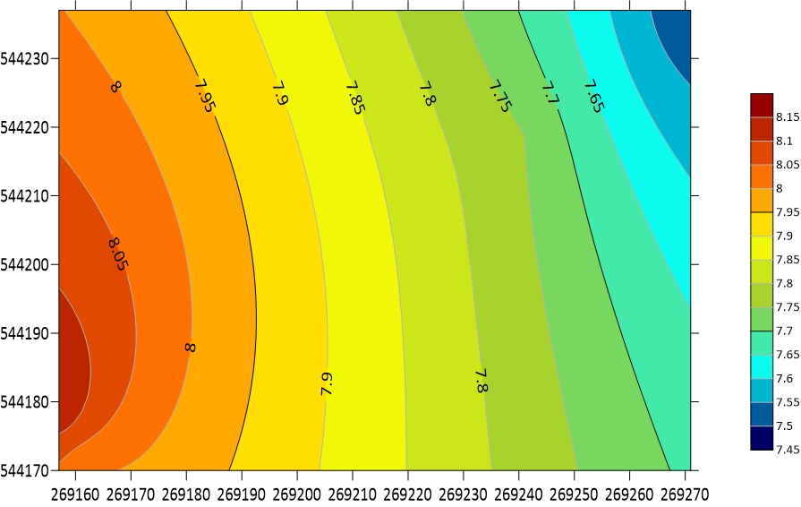
Figure 2: pH

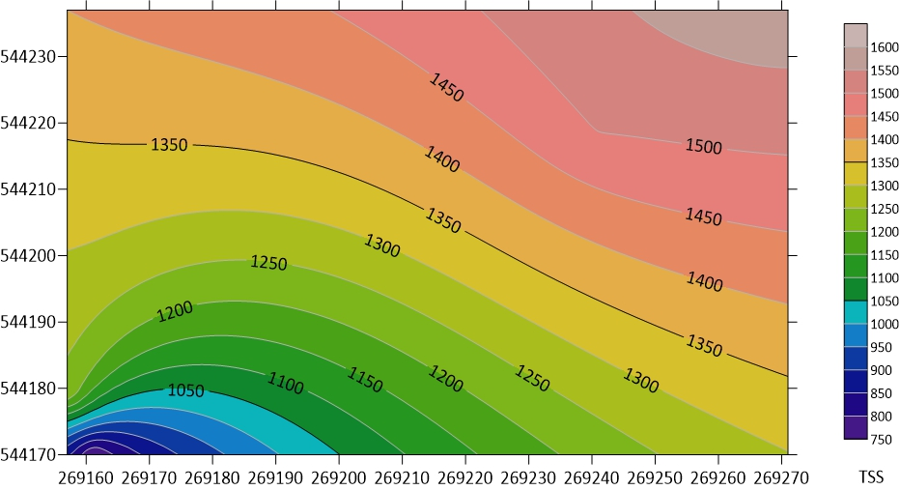
Figure 3: Total Suspended Solids (TSS)

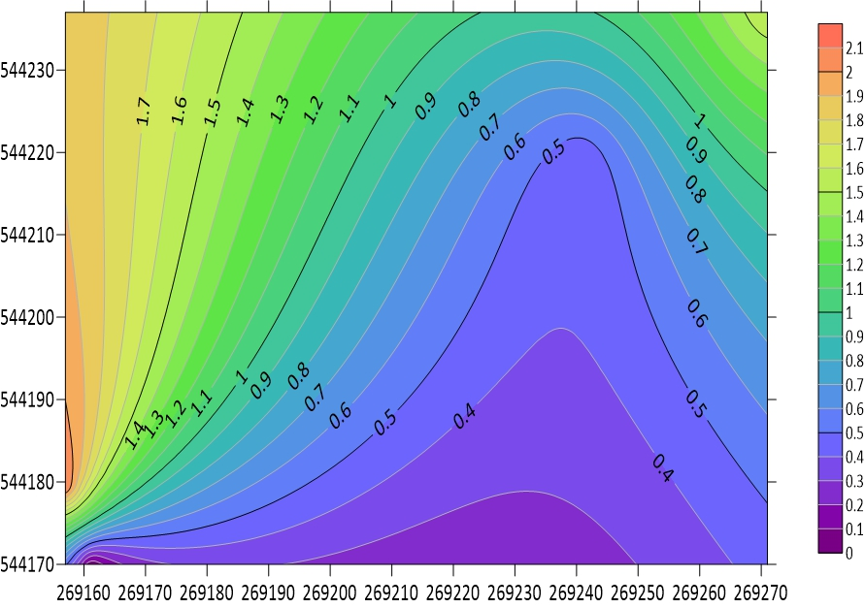
Figure 4: Total Dissolved Solids (TDS)

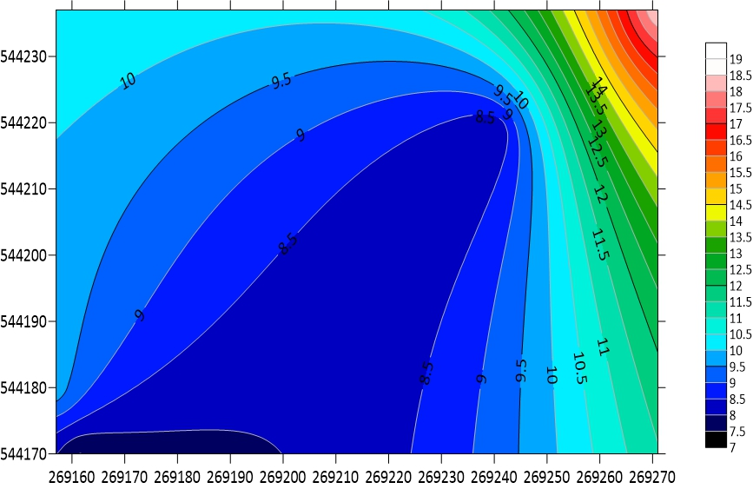
Figure 5: Biochemical Oxygen Demand (BOD)

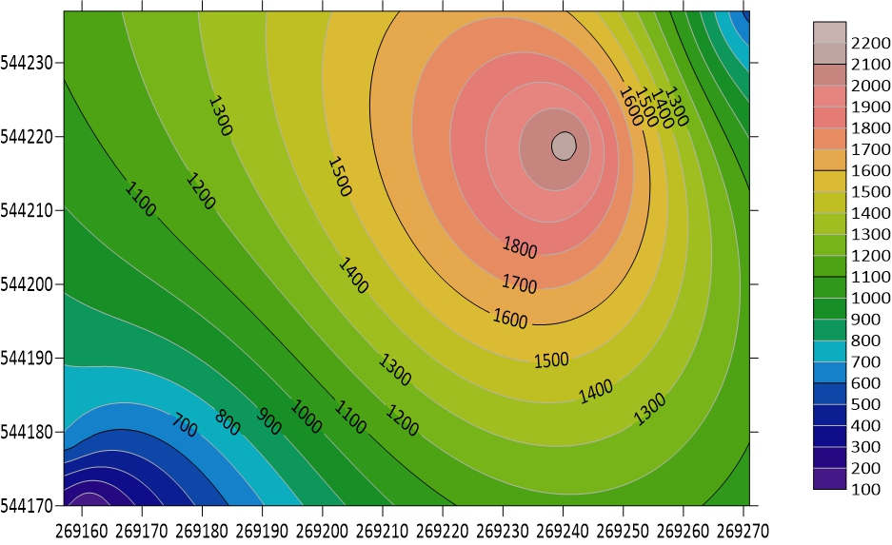
Figure 6: Chemical Oxygen Demand (COD)

Spatial imapping iof igeochemical iparameters iusing iSurfer isoftware ireveals idistinct ipatterns iof icontamination iacross ithe iAluu idumpsite. iHigh-resolution iinterpolation ihighlights iclear izones iof ielevated ipollutant iconcentrations, iunderscoring ivariability iin iwaste icomposition iand ileachate igeneration.

3.8.1 iHigh iContamination iZones
- Eastern iSection i(L1): iThis iarea iexhibits ithe ihighest iCOD ivalue i(2,156mg/L) ialongside isubstantially ielevated iTDS i(1,502mg/L). iThe iexceptionally ihigh iCOD isuggests iintensive iinflux iof ichemically ireactive iorganic iand iinorganic ipollutants, itypical iof iindustrial iwaste icontributions ior iconcentrated ichemical ispills. iTDS ilevels ifurther isupport isubstantial idissolved iload iin ileachate, iindicative iof iactive idegradation iprocesses ior iongoing iwaste iinput.
- Northern iSection i(L4): iL4 iregisters ithe ipeak iTDS i(1,579mg/L) iand ithe ihighest iBOD i(18.6mg/L). iThese ireadings ipoint ito ifresh iorganic iwaste ideposition, imost ilikely ilinked ito irecent ihousehold, imarket, ior ifood iwaste idisposal. iThe ielevated iBOD iconfirms iactive imicrobial idecomposition iand ia ihigh ipotential ifor ioxygen idepletion iif ithis ileachate ireaches isurface iwater isources.
3.8.2 Moderate iContamination iZone
- Southern iSection i(L3): iThis izone iis icharacterized iby iintermediate ivalues ifor imost iparameters, iwith iTSS ipeaking iat i2.1mg/L; ithe ihighest iamong iall isampled ilocations. iThe icombination iof imoderate iBOD, iCOD, iand ielevated iTSS isuggests imixed iwaste icomposition, ireflecting iboth iorganic iand iinert imaterials. iThe idata ipossibly iindicate ia imaturing ilandfill isegment ior itransitional iwaste ilayering.
3.8.3 Low iContamination iZone
- Western iSection i(L2): iLeachate ihere ishows ithe ilowest iTDS i(747mg/L), iBOD i(7.45mg/L), iand iCOD i(90mg/L). iSuch ilow ivalues itypically imanifest iin iolder, istabilized ilandfill isections iwhere iwaste ihas iundergone iextensive idecomposition iand ileachate iproduction ihas idiminished. iThe ireduced icontaminant iload isignifies ipast iwaste iinput ior ieffective inatural iattenuation iprocesses.
3.8.4 iContamination iSource iAssessment

Analysis iof ispatial idistribution imaps isupports ithe iinference iof imultiple, ilocalized icontamination isources:
- Eastern iZone i(L1): iThe imarkedly ielevated iCOD iand iTDS istrongly isuggest iinfluence iby iindustrial ior icommercial iwaste, ipotentially ifrom inearby iworkshops ior idumping iof ichemical-laden irefuse. iThe ispatial ihotspot iindicates iconcentrated ileachate igeneration iand ilimited idilution, iwarranting itargeted icontainment ior iremediation iefforts.
- Northern iZone i(L4): iHigh iBOD iand iTDS ilevels iare ialigned iwith iongoing ideposition iof ifresh iorganic iwaste, isuch ias ifood iscraps, ivegetation, iand imarket iresidue. iThe imicrobiological iactivity iimplied iby ithese ireadings ihighlights ithe ineed ifor ienhanced imonitoring iand iperiodic iwaste isorting ito iinterrupt ifurther icontamination icycles.
- Southern iZone i(L3): iThe imixture iof imoderate icontamination, iincluding ithe ihighest iTSS ivalues, ipoints ito ia isegment iwhere iwaste icharacteristics iare ivariable; ipotentially ireflecting ialternating ilayers iof inewly ideposited iand iolder iwastes, ias iwell ias icontributions ifrom iinert imaterials i(plastics, iglass, iconstruction idebris).
- Western iZone i(L2): iThe ispatial ilow iin iall imeasured iparameters iis iindicative iof ian iaged ilandfill izone, iwhere ileachate-generating iprocesses ihave imostly isubsided. iThe ipredominance iof istabilized iwaste iand iattenuated icontaminant iflux isupport iongoing inatural iremediation.

3.9 Descriptive Statistics
Table 3: Descriptive Statistics for Leachate Parameters
Parameter | Mean | Median | Std Dev | Min | Max | CV(%)
pH | 7.85 | 7.88 | 0.27 | 7.50 | 8.15 | 3.4
TSS (mg/L) | 1.03 | 1.00 | 0.97 | 0.001 | 2.1 | 94.2
TDS (mg/L) | 1266 | 1369 | 372 | 747 | 1579 | 29.4
BOD (mg/L) | 10.98 | 8.93 | 5.26 | 7.45 | 18.6 | 47.9
COD (mg/L) | 871 | 619 | 918 | 90 | 2156 | 105.4

3.9.1 Environmental Implications

The descriptive summary underscores several critical environmental and public health concerns:
Groundwater Contamination Risk: Elevated TDS, BOD, and especially COD point to leachates with both high mineral and organic pollutant loads. In such permeable, unlined dumpsites, these contaminants can easily infiltrate to shallow aquifers, threatening local water supply quality.
Surface Water Impact: Excessively high BOD and COD values suggest that, upon migration to surface waters, these leachates will exert significant oxygen demand: accelerating oxygen depletion, promoting eutrophication, and harming aquatic biota.

Soil Contamination: Leachate-borne dissolved and suspended contaminants are likely to accumulate in surrounding soils, reducing agricultural productivity, impacting soil structure and fertility, and possibly introducing toxic substances into the food chain.

Public Health Concerns: Given the proximity of residential areas and vital community infrastructure, populations are at increased risk of direct exposure, especially where shallow wells are used or where leachate runoff is accessible.

4. Conclusion

This study investigated the geochemical characteristics and spatial distribution of leachate contamination at the Aluu municipal dumpsite, Port Harcourt, Rivers State, using integrated field sampling, laboratory analysis, and geospatial mapping. The results reveal significant variation in leachate quality across the dumpsite, with notably high levels of COD, BOD, and TDS in the eastern and northern sections (L1 and L4), indicating zones of intense contamination. Although pH and TSS values were within acceptable limits, TDS at several locations exceeded the WHO desirable standard, and both BOD and COD were substantially above concentrations typical for safe water, underscoring a marked organic pollution load.

Spatial analysis highlighted that these contamination hotspots are linked to differences in waste composition, age, and likely inputs from industrial and fresh organic waste streams. The presence of such highly polluted leachate poses immediate environmental risks, including potential infiltration to groundwater, transfer to surface water bodies, and accumulation in soils, all of which threaten local ecosystem health and public safety especially given the proximity of residential and institutional areas.

The findings demonstrate the urgent need for improved landfill engineering, regular monitoring, and proactive waste management to mitigate the environmental and health impacts of uncontrolled leachate migration in the region.

4.1 Recommendations

- Implement Engineered Landfill Systems: Upgrade the dumpsite with engineered liner systems and leachate collection networks to contain and appropriately manage leachate flow, thereby minimizing subsurface and surface water contamination.
- Establish On-Site Leachate Treatment Facilities: Introduce appropriate physical, chemical, or biological treatment systems to reduce organic and inorganic pollutant loads before any potential discharge or infiltration.
- Strengthen Routine Environmental Monitoring: Conduct regular sampling and geospatial assessment of leachate and neighboring water resources (groundwater and surface water), focusing on identified contamination hotspots for early detection and proactive intervention.
- Enforce Waste Segregation and Control Industrial Disposal: Institute strict waste segregation policies at the source and closely monitor/prevent the dumping of hazardous or industrial waste to limit high-load organic and chemical contamination.
- Public Health and Community Engagement: Organize awareness campaigns for nearby residents on the dangers of contaminated water sources and promote safe water access, especially in communities utilizing shallow wells or water sources adjacent to the landfill.
- Policy Review and Enforcement: Urge local and state authorities to strengthen the enforcement of waste management regulations and align landfill operations with national and WHO environmental guidelines.
Further Research: Recommend future studies to include heavy metals, emerging contaminants, and seasonal effects, and to assess the effectiveness of remediation measures over time.

Consent (where ever applicable)

Not applicable. This study did not involve human participants, patients, or clinical data requiring informed consent.

Ethical approval (where ever applicable)

This study did not involve human subjects or animal experiments; therefore, ethical approval was not required.

COMPETING INTERESTS DISCLAIMER:
Authors have declared that they have no known competing financial interests OR non-financial interests OR personal relationships that could have appeared to influence the work reported in this paper.

References

Abam, T. K. S., and Unachukwu, G. O. (2009). Hydrogeologic and geotechnical properties of the Niger Delta sediments at Port Harcourt and environs. Environmental Geology, 58(6), 1251-1263.

Abel, C., Rellergert, D., Grol, E., and Mazzon, V. (2023). Assessment of combustion residual leachate volume, composition and treatment cost. Journal of Hazardous Materials, 12, 459.
Adepegba, O. (2012). Leachate Recirculation Practice and views. Retrieved from https://leachate.co.uk/main/leachate-management/

Adeyemi, A. Y., Agbede, O. A., and Udeze, A. O. (2021). GIS-based assessment of solid waste management in Port Harcourt metropolis, Rivers State, Nigeria. Environmental Management and Sustainable Development, 10(2), 45-62.

Akudo, E. O., Ozulu, G. U., and Osadebe, C. C. (2010). Assessment of groundwater contamination by leachates around Onitsha north landfill, south-eastern Nigeria. International Journal of Environmental Science and Technology, 7(4), 777-787.

Bikash, A., Khet, R. D., and Sanjay, N. K. (2014). Factors affecting the composition of municipal solid waste landfill leachate. International Journal of Emerging Science and Information Technology, 3(5), 123-135.

Christensen, T. H., Cossu, R., and Stegmann, R. (1992). Landfill leachate; an introduction to landfilling of waste leachate. Journal of Applied Sciences, 2, 3-14.

Esonanjor, E. E., and Ohanuna, C. (2021). Effect of waste dumpsite on groundwater quality of shallow aquifer in Port Harcourt, SE Nigeria. Environmental Contaminants Reviews, 4(1), 29-32.

Kjeldsen, P., Barlaz, M. A., Rooker, A. P., Baun, A., Ledin, A., and Christensen, T. H. (2002). Present and long-term composition of MSW landfill leachate: A review. Critical Reviews in Environmental Science and Technology, 32(4), 297-336.

Ngah, S. A., & Otei-Nda, P. (2017). Characterization of municipal solid waste leachate from Eneka dumpsite in Port Harcourt. International Journal of Environmental Science, 2(3), 145-158.

Nigerian Meteorological Agency (NIMET). (2019). Annual Weather Summary Report for Rivers State. Federal Ministry of Aviation, Abuja, Nigeria.

Nwankwoala, H. O., Onyughel, O., and Udom, G. J. (2022). Assessment of the effect of leachate on groundwater quality in Igwuruta, Ikwerre Local Government Area of Rivers State, Nigeria. Environmental Science and Engineering, 15(3), 142-156.

Standards Organisation of Nigeria (SON). (2015). Nigerian Standard for Drinking Water Quality (NIS 554:2015). Abuja, Nigeria: Standards Organisation of Nigeria.

Udom, G. J., Etu-Efeotor, J. O., and Esu, E. O. (2004). Hydrogeochemical evaluation of groundwater in parts of Port Harcourt and Tai-Eleme Local Government Areas, Rivers State, Nigeria. Global Journal of Geological Sciences, 2(1), 1-8.

Uma, K. O., Onuoha, K. M., and Egboka, B. C. E. (1989). New statistical grain-size method for evaluating the hydraulic conductivity of sandy aquifers. Journal of Hydrology, 108, 343-366.

World Health Organization (WHO). (2011). Guidelines for Drinking-water Quality (4th ed.). WHO Press, Geneva, Switzerland.

World Health Organization (WHO). (2017). Guidelines for Drinking-water Quality: Fourth Edition Incorporating the First Addendum. WHO Press, Geneva, Switzerland.

