Thermal Efficiency Enhancement and Entropy Generation Reduction in Solar-Powered Water Pumping Systems Using Oldroyd-B Hybrid Nanofluids in Nigeria

ABSTRACT
With the growing demand for sustainable and efficient energy solutions, optimizing solar water pumping (SWP) systems has become a priority. This study evaluates the thermal performance of a hybrid nanofluid (HNF) composed of AA7075–Ti–6Al–4V/ethylene glycol and compares it with a mono-nanofluid (AA7075/EG) for cooling applications. Considering the environmental impacts of conventional pumping systems, including high energy consumption and greenhouse gas emissions, the research investigates the heat transfer and flow characteristics of these advanced fluids. The mathematical model incorporates thermal radiation, heat generation, viscous dissipation, porous media effects, and viscoelastic properties, formulated as coupled non-linear partial differential equations. Numerical solutions are obtained using the fourth-order Runge-Kutta (RK4) method, yielding precise profiles of dimensionless velocity, temperature, and entropy generation. Results show that the hybrid nanofluid outperforms the mono-nanofluid in thermal conductivity and heat transport. Sensitivity analysis highlights the trade-offs between cooling efficiency and system irreversibility. By optimizing key parameters, including nanoparticle volume fraction, suction/injection rates, and Deborah numbers, this study provides a framework for designing more efficient, durable SWP systems, enhancing water and energy security in remote regions.
Keywords: Thermal efficiency; Solar-watered pump; Entropy generation; Oldroyd-B Hybrid Nanofluids

1. Introduction
Nanofluids have evolved as advanced heat transfer fluids, owing to their improved thermal conductivity and better heat transfer properties compared to conventional base fluids like water, oil, and ethylene glycol (Choi & Eastman, 1995; Das et al., 2008). Nanofluids, being a mixture of nanoparticles and a base fluid, have attracted considerable attention in thermal engineering applications, including solar energy systems, heat exchangers, and electronic cooling systems, where efficient heat transfer is a prerequisite (Mahian et al., 2013; Said et al., 2019). Previous studies have also shown the potential of highly developed nanofluids in improving heat transfer and reducing irreversibility in thermal systems. Fatunmbi and Salawu (2022) studied the analysis of hydromagnetic micropolar nanofluid flow with entropy generation under Navier slip conditions. Salawu et al. Okoya (2021) also studied the MHD heat and mass transport characteristics for Maxwell Arrhenius kinetic nanofluids with variable properties. Obalalu et al. (2023) examined the impact of solar thermal energy and variable properties on non-Newtonian nanofluid flow. However, conventional nanofluids, also known as mono-nanofluids, are found to suffer from certain limitations, including agglomeration, stability, and improvement in thermophysical properties. Therefore, to overcome the limitations of conventional nanofluids, hybrid nanofluids, designed by dispersing two or more nanoparticles in a single base fluid, have been proposed as next-generation heat transfer fluids, promising better thermal, optical, and rheological properties (Huminic & Huminic, 2018; Sundar et al., 2017). Due to such superior properties, hybrid nanofluids have gained significant attention in various applications, such as solar thermal systems, photovoltaic-thermal systems, solar water pumping, automotive cooling, electronic heat sinks, and energy storage devices (Ghadimi et al., 2011; Said et al., 2019).
Recent studies have also focused on the performance of hybrid nanofluids in renewable energy systems. Fatunmbi et al. (2024) proposed a model to study the heat transfer characteristics of hybrid nanofluids with nonlinear thermal radiation, and Obalalu et al. (2024) used numerical studies to assess the performance of hybrid nanofluid transportation in solar-powered systems using a parabolic trough collector system. Nevertheless, their application is limited by an increase in pressure drop and pumping power, especially in systems where flow enhancement techniques are utilized. Hence, a detailed assessment of their thermal hydraulic performance is required to ascertain their potential for actual and industrial applications.
Solar water pumping (SWP) systems are gaining popularity in irrigation, drinking water supply, and rural electrification, providing a renewable and environmentally friendly solution to conventional pumps, which utilize grid power or fossil fuels. However, their efficiency may be restricted by the lack of adequate heat transfer and thermal efficiency in the heat transfer system. The idea of utilizing hybrid nanofluids, which are suspensions of two dissimilar nanoparticles in a carrier fluid, has been recognized as an efficient approach to improve the heat transfer efficiency in SWP and solar systems in general, owing to the superior thermophysical and rheological properties of hybrid nanofluids compared to mono-nanofluids and conventional fluids (Saeed et al., 2021; Rasheed et al., 2021). The efficiency and effectiveness of hybrid nanofluids in solar systems, such as solar collectors and photovoltaic/thermal systems, have been extensively studied and demonstrated to achieve significant enhancement in heat transfer efficiency and reduction in entropy generation under optimized conditions (Jamshed et al., 2021; Esfe et al., 2024). The combined properties of hybrid nanofluids are expected to improve the thermal conductivity, solar energy absorption, and convective heat transfer efficiency, making hybrid nanofluids promising candidates for the working fluids in the next-generation SWP systems.
Thermal radiation plays a major role in the heat transfer process of solar powered systems, and it affects the rate of solar energy absorption and transportation in solar collectors and the working fluid. The working fluid in the solar water pumping (SWP) system is subjected to a radiative heat flux from the sun, and the proper utilization of the radiative energy by the working fluid affects the thermal efficiency and the behavior of entropy generation (Jamshed et al., 2021). Hybrid nanofluids have the ability to properly utilize the thermal radiation by the working fluid and transfer it effectively compared to the base fluid and mono-nanofluids, and it increases the rate of heat transfer in solar collectors and PV/T systems (Rasheed et al., 2021; numerous reviews have shown the enhanced thermal and optical performance of solar powered systems by the utilization of hybrid nanofluids). The inclusion of radiative effects in mathematical and numerical models of solar thermal systems allows for more accurate prediction of temperature distribution, heat flux dynamics, and overall system irreversibilities, which are essential for optimizing design parameters such as nanoparticle volume fraction, flow rates, and collector geometry. Thermal radiation's effect on heat transfer has been extensively researched in the context of engineering and renewable energy technologies. For instance, Chai and Fan (2023) examined the radiation modulating materials for building applications, whereas Li et al. (2016) investigated the combined effects of magnetic fields and thermal radiation on mixed convection in a cylindrical configuration. Fatunmbi and Adeniyan (2020) evaluated the effects of non-linear thermal radiation and entropy generation in the flow of a magneto micropolar fluid past a stretchable sheet. As a result, accounting for thermal radiation not only improves the fidelity of performance assessments but also supports the development of high-efficiency SWP systems with reduced energy losses and greater reliability in applications ranging from agricultural irrigation to off-grid water supply in remote regions.
Entropy generation analysis is a fundamental tool for evaluating thermodynamic irreversibilities in solar-powered water pumping (SWP) systems, particularly when advanced working fluids such as hybrid nanofluids are employed. In such systems, entropy is generated due to heat transfer, fluid friction, viscous dissipation, and radiative effects, all of which contribute to energy losses and reduced system efficiency (Bejan, 1996; Mahian et al., 2013). Minimizing entropy generation is therefore essential for improving the overall thermal efficiency and sustainability of solar-driven technologies. Hybrid nanofluids, while enhancing heat transfer due to their superior thermal conductivity, may also increase fluid friction and viscosity, leading to higher entropy production if not properly optimized (Rasheed et al., 2021). Consequently, a balance must be achieved between enhanced heat transfer and irreversibility minimization. Entropy generation analysis has found wide applications in solar collectors, photovoltaic–thermal systems, heat exchangers, and cooling technologies, where it is used to optimize system design, operating conditions, and material selection (Said et al., 2019; Mahian et al., 2013). Entropy generation analysis has been widely employed to improve thermal systems in many devices. Obalalu et al. (2022) carried out an entropy generation analysis for the flow of electromagnetohydrodynamic radiative Casson nanofluid over a melting Riga plate, whereas Fatunmbi and Salawu (2020) studied entropy generation analysis for the flow of magneto-micropolar fluid past nonlinear porous media with a non-uniform heat source. In another recent work, Salawu et al. (2025) assessed such a phenomenon on the flow of Casson $MoS₂-SiO₂/H₂O$ hybrid nanofluids in porous Riga plate systems and emphasized the significance of entropy minimization. In the context of SWP systems, incorporating entropy analysis enables the identification of optimal nanoparticle volume fractions, flow parameters, and thermal conditions that maximize useful energy output while minimizing losses, thereby supporting the development of efficient and durable water pumping solutions for remote and energy-constrained regions.
The integration of non-Newtonian fluids, particularly the Oldroyd-B model, can be used as a more realistic tool in studying fluids in complex thermal systems such as solar-powered water pumping schemes. Unlike Newtonian fluids, which only take into account the effect of viscosity, the Oldroyd-B model considers the effect of both viscous and elastic fluids, particularly viscoelastic fluids such as those containing polymers and nanoparticles (Obalalu et al., 2025; Varchanis et al., 2022). This model can be integrated with hybrid nanofluids to obtain a more comprehensive study of fluids in complex thermal systems. In spite of numerous studies on nanofluids and hybrid nanofluids, little attention has been given to the effect of viscoelastic fluids, thermal radiation, entropy generation, and porous media on solar-powered water pumping schemes. Moreover, little work has been done on utilizing the Oldroyd-B hybrid nanofluid in enhancing thermal efficiency and minimizing irreversibility. It is therefore the intent of this study to develop a robust mathematical model to investigate the effect of viscoelastic fluids, thermal radiation, entropy generation, and porous media on solar-powered water pumping schemes. This aims to obtain a more comprehensive understanding of the conditions necessary to enhance the efficiency of solar-powered water pumping schemes and to reduce entropy generation in such systems..

2. Mathematical Model and Problem Formulation
A schematic representation of the Parabolic Trough Solar Collector (PTSC) system considered in this study is shown in Figure 1. The system consists of a parabolic reflective trough that concentrates incoming solar radiation onto a cylindrical receiver tube positioned along the collector’s focal line. The absorbed thermal energy is transferred to a working fluid flowing inside the receiver. In this investigation, an electrically conducting Oldroyd-B hybrid nanofluid is employed as the heat transfer medium to enhance thermal performance. The hybrid nanofluid contains two types of nanoparticles dispersed in a base fluid, providing improved thermophysical and rheological properties. The fluid flows over a porous stretching sheet representing the heat-absorbing surface of the receiver, allowing simulation of convective, radiative, and viscous effects within the collector.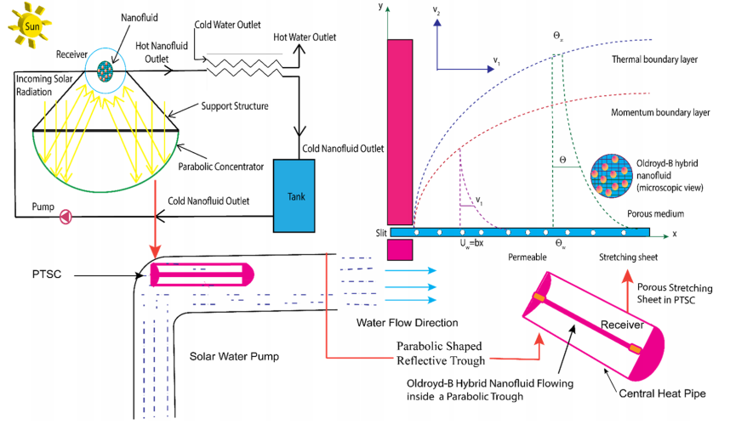

Figure 1: Physical model of Oldroyd-B hybrid nanofluid flow in a parabolic trough solar collector over a porous stretching sheet.

2.1 Governing Equations
Under the boundary layer approximations, the governing equations describing the conservation of mass, momentum, and energy for the Oldroyd-B hybrid nanofluid are expressed as follows.

 | $$\frac{∂D_{1}}{∂x}+\frac{∂D_{2}}{∂y}=0$$ | (1)
$D_{1}\frac{∂D_{1}}{∂x}+D_{2}\frac{∂D_{2}}{∂y}+γ_{1}\left({D_{1}}^{2}\frac{∂^{2}D_{1}}{∂x^{2}} +{D_{2}}^{2}\frac{∂^{2}D_{1}}{∂y^{2}}+ 2D_{1}D_{2}\frac{∂^{2}D_{1}}{∂x∂y}\right)$ = $\frac{μ_{hnf}}{ρ_{hnf}}\left(\frac{∂^{2}D_{1}}{∂y^{2}}\right)-$ $\frac{σ_{hnf}B_{0}^{2}}{ρ_{hnf}}D_{1}-\frac{μ_{hnf}}{ρ_{hnf}}\left(\frac{A_{2}}{k}\right)+\frac{μ_{hnf}}{ρ_{hnf}}\left(γ_{2}\left(D_{1}\left(\frac{∂^{3}D_{1}}{∂x∂y^{2}}\right)-\frac{∂D_{1}}{∂x}\left(\frac{∂^{2}D_{1}}{∂y^{2}}\right)+\frac{∂D_{2}}{∂y}\left(\frac{∂^{2}D_{1}}{∂y^{2}}\right)+D_{2}\left(\frac{∂^{3}D_{1}}{∂y^{3}}\right)\right)\right)$, |  | (2)
$$D_{1}\frac{∂T}{∂x}+D_{2}\frac{∂T}{∂y}=\frac{k_{hnf}}{{\left(ρC_{p}\right)}_{hnf}}\left(\frac{∂^{2}T}{∂y^{2}}\right)+\frac{1}{{\left(ρC_{p}\right)}_{hnf}}Q\left(T-T_{w}\right)+\frac{μ_{hnf}}{{\left(ρC_{p}\right)}_{hnf}}{\left(\frac{∂D_{1}}{∂x}\right)}^{2}-\frac{1}{{\left(ρC_{p}\right)}_{hnf}}\left(\frac{∂q_{r}}{∂y}\right)+\frac{σ_{hnf}B_{0}^{2}}{{\left(ρC_{p}\right)}_{hnf}}D_{1}^{2},$$ |  | (3)

with boundary conditions

$$\begin{matrix}D_{1}(x,0)=U_{w}+M_{w}\left(\frac{∂D_{1}}{∂y}\right), \\ D_{2}(x,0)=P_{w}, \\ -k_{O}\left(\frac{∂T}{∂y}\right)=h_{g}\left(T_{w}-T\right), \\ D_{1}→0,\frac{∂D_{1}}{∂y}→0,T→T_{∞}, as y→∞.\end{matrix}$$ | (4)
where
Parameters | values
Slip length | $$P_{w}$$
Velocity component | $D_{1}$, $D_{2}$
Dynamic viscosity | $$μ_{hnf}$$
thermal conductivity of solid | $$k_{O}$$
heat transfer coefficient | $$h_{g}$$
Surface permeability | $$M_{w}$$
Electrical conductivity | $$σ_{hnf}$$
Particles | s
Deborah number I, II | $$γ_{1},γ_{2}$$
Specific heat | $$ρC_{p}$$
Thermal conductance | $$k_{hnf}$$

Table 1 presents the thermophysical properties of the nanofluid and hybrid nanofluid utilized in the present analysis. The effective viscosity, density, heat capacity, and thermal conductivity of the working fluids are formulated based on widely accepted mixture models reported in the literature. For the conventional nanofluid, the effective viscosity is evaluated using the Brinkman model, which accounts for the influence of nanoparticle volume fraction on the fluid’s resistance to flow. The density and heat capacity are determined using classical mixture relations that consider the contributions of both the base fluid and the dispersed nanoparticles. Table 2 display the thermophysical factors of the of Ti-6Al-4V, and AA7075 nanoparticles, and EG base fluid
Table 1: Thermophysical properties of Nanofluid and Hybrid nanofluid
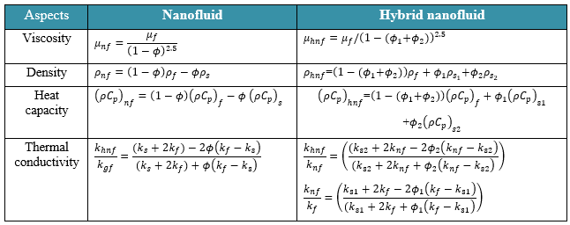

Table 2: The thermophysical factors of the of Ti-6Al-4V, and AA7075 nanoparticles, and EG base fluid
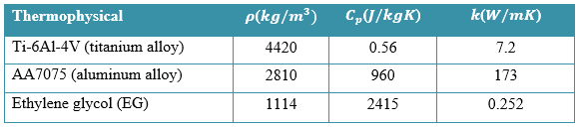
Similarity Transformation
To reduce the governing partial differential equations into ordinary differential equations, the following similarity variables are introduced
$D_{1}$ $=\frac{∂ψ}{∂y}$, and $D_{2}=-\frac{∂ψ}{∂x}$,  And  $$Γ\left(x,y\right)=\sqrt{\frac{b}{υ_{f}(1-Γt)}}y,$$  $θ(Γ)=\frac{T-T_{∞}}{T-T_{∞}}$,  and $ψ(x,y)$= $\sqrt{\frac{υ_{f}b}{(1-Γt),}}xf(Γ)$ | (5)
We derived the following equation.
$f^{'''}$+${ ω}_{1}ω_{2}({{ff}^{''}-f}^{'2}$) $-\frac{1}{ω_{1}}$ $Kf^{'}$ + ${ ω}_{1}ω_{2}\left({2ϱ_{1}ff}^{'}\right)$ +${ϱ_{2}f}^{''2}$ + ${ ω}_{1}ω_{2}\left({ϱ_{1}f^{2}f}^{'''}\right)$ $-$  ${ϱ_{2}ff}^{''v}$=0, | (6)
$θ^{''}\left(1+\frac{1}{ω_{4}}N_{r}P_{r}\right)+ \frac{ω_{3}}{ω_{2}}{ P}_{r}{fθ}^{'} - \frac{ω_{3}}{ω_{2}}{ P}_{r}{fθ}^{'}+ \frac{1}{ω_{4}}$ $P_{r}Q$ $θ$ + $\frac{1}{ω_{1}ω_{3}}P_{r}Ec{f^{''}}^{2}$=0, |  | (7)
Subjected to
$$f\left(0\right)=S,f^{'}\left(0\right)=1+δf^{''}\left(0\right),$$  $$θ^{'}\left(0\right)=-B_{i}\left(1-θ\left(0\right)\right),$$  $$as$$  $$f^{'}\left(Γ\right)⟶0, f^{'}\left(Γ\right)⟶0, θ\left(Γ\right)⟶0, Γ⟶∞.$$ | (8)
where
${ ω}_{1}$=${\left(1-{(ϕ}_{1}{+ϕ}_{2})\right)}^{2.5},ω_{2}$=$\left(1-{(ϕ}_{1}{+ϕ}_{2})\right)+ϕ_{1}ρ_{s_{1}}/{ρ_{f}+ϕ}_{2}ρ_{s_{2}}/ρ_{f}$,$ω_{3}=\left(1-{(ϕ}_{1}{+ϕ}_{2})\right)+ϕ_{1}{\left(ρC_{p}\right)}_{s1}/{\left(ρC_{p}\right)}_{f}$+$ϕ_{2}{\left(ρC_{p}\right)}_{s2}/{\left(ρC_{p}\right)}_{f},ω_{4}$=$\left(\frac{(k_{s2}+2k_{nf}-{2ϕ}_{2}\left(k_{nf}-k_{s2}\right)}{(k_{s2}+2k_{nf}+ϕ_{2}\left(k_{nf}-k_{s2}\right)}\right)×\left(\frac{k_{s1}+2k_{f}-2ϕ_{1}\left(k_{f}-k_{s1}\right)}{(k_{s1}+2k_{f}+ϕ_{1}\left(k_{f}-k_{s1}\right)}\right).$
Where

Parameters | Formula
Thermal radiation parameter | $$N_{r}=\frac{16}{3}\frac{σ^{*}T_{∞}^{3}}{k^{*}υ_{f}{\left(ρC_{p}\right)}_{f}}$$
Deborah number I | $ϱ_{1}$= b$γ_{1}$
Biot number | $B_{i}$= $\frac{h_{f}}{k_{o}}\sqrt{\frac{υ_{f}}{b}}$
Deborah number II | $ϱ_{2}$ = b$γ_{2}$
Suction/Injection Parameter | $$S={-P}_{w}\sqrt{\frac{1}{υ_{f}b}}$$
Prandtl number | ${ P}_{r}$ =$\frac{υ_{f}}{α_{f}}$
Porous medium | $$K=\frac{υ_{f}}{bk}$$
local Nusselt Number | $$Nu_{x}=\frac{xq_{w}}{k_{f}\left(T_{w}-T_{∞}\right)},$$
Eckert number | $Ec$=$\frac{U_{w}^{2}}{{\left(C_{p}\right)}_{f}\left(T_{w}-T_{∞}\right)}$
velocity slip | $δ$=$\sqrt{\frac{b}{μ_{f}}}M_{w}$
heat generation parameters | $$Q=\frac{Q_{0}}{{\left({ρC}_{p}\right)}_{f}b}$$

2.4 Engineering Quantities of Interest
The physical quantities of engineering importance in the present analysis are the skin friction coefficient and Nusselt number, defined respectively as
The $Nu_{x}$ can be written as:
$$Nu_{x}=\frac{xq_{w}}{k_{f}\left(T_{w}-T_{∞}\right)},$$ | (9)
by applying dimensionless conversions to the aforementioned formula, becomes:
$Nu_{x}Re_{x}^{1/2}$=$-\frac{k_{hnf}}{k_{f}}\left(\left(1+N_{r}\right)θ^{'}\left(0\right)\right)$ | (10)
here $q_{w}$=-$k_{hnf}\frac{16}{3} \frac{σ^{*}T_{∞}^{3}}{k^{*}υ_{f}{\left(ρC_{p}\right)}_{f}}\left(\frac{∂T}{∂y}\right)$, and ${ Re}_{x}$=$\frac{U_{w}x}{v_{f}}$. local Reynolds number is denoted as ${ Re}_{x}$=$\frac{U_{w}x}{v_{f}}$.
3 Numerical solution
Runge–Kutta 4th Order (RK4) Method
The Runge–Kutta 4th order (RK4) method is a widely used numerical technique for solving ordinary differential equations (ODEs) due to its accuracy and stability. It belongs to the class of single-step methods and is particularly suitable for solving nonlinear systems of ODEs, such as those arising in boundary-layer and heat transfer problems.
$$f^{'}=u, f^{''}=v, f^{'''}=w$$ | (11)
Then the third-order ODE:
$$f^{'''}+ω_{1}ω_{2}\left(ff^{''}-{\left(f^{'}\right)}^{2}\right)-\frac{1}{ω_{1}}Kf^{'}+ω_{1}ω_{2}\left(2ϱ_{1}ff^{'}\right)+ϱ_{2}{\left(f^{''}\right)}^{2}+ω_{1}ω_{2}\left(ϱ_{1}f^{2}f^{'''}\right)-ϱ_{2}ff^{''}v=0$$ | (12)
$w=$ expression in $f,u,v$ after isolating $f^{'''}$
For $(η)$ :
$$θ^{'}=ϕ$$ | (13)
Then the second-order ODE becomes:
$$ϕ^{'}=-\frac{ω_{3}}{ω_{2}}P_{r}fϕ+\frac{ω_{3}}{ω_{2}}P_{r}fθ^{'}-\frac{1}{ω_{4}}P_{r}Qθ-\frac{1}{ω_{1}ω_{3}}P_{r}Ec{\left(f^{''}\right)}^{2}/\left(1+\frac{1}{ω_{4}}N_{r}P_{r}\right)$$ | (14)
Step 2: Express the system as first-order ODEs
Define the state vector:
$Y=\left[\begin{matrix}f \\ u \\ v \\ θ \\ ϕ\end{matrix}\right]=\left[\begin{matrix}f \\ f^{'} \\ f^{''} \\ θ \\ θ^{'}\end{matrix}\right]$Then the system:
- $f^{'}=u$
- $u^{'}=v$
- $v^{'}=w=f^{'''}$ (from your given ODE)
- $θ^{'}=ϕ$
- $ϕ^{'}=$ expression from $θ$ equation

The comparison of heat transfer rate ($Nu_{x}$) for varying value of the Prandtl number (Pr) is display in Table 3.
Table 3: Comparison of heat transfer rate ($Nu_{x}$) for varying value of the Prandtl number (Pr).
$$Pr$$ | Present outcome | The outcomes of  Ishak et al (2007) | The outcomes of Das et al (2007) | The outcomes of Ishak et al (2009) | The outcomes of Jamshed et al (2021),
0.72 | 0.8086 | 0.80863135 | 0.80876122 | 0.8086 | 0.80876181
1.0 | 1.0000 | 1.00000000 | 1.00000000 | 1.0000 | 1.00000000
3.0 | 1.9237 | 1.92368259 | 1.92357431 | 1.9236 | 1.92357420
7.0 | 3.0723 | 3.07225021 | 3.07314679 | 3.0723 | 3.07314651
10 | 3.7207 | 3.72067390 | 3.72055436 | 3.7006 | 3.72055429

4. Result & Discussion
Figure 2(a) and Figure 2(b) demonstrates that increasing the thermal radiation parameter Nr ​ significantly enhances the dimensionless temperature profile θ(Γ) and the entropy generation number Ns for both the AA7075-Ti-6Al-4V/EG hybrid nanofluid and the AA7075/EG nanofluid. In Figure 2(a), the rise in N r ​ from 1 to 3 leads to a thickened thermal boundary layer due to the augmented radiative heat flux, with the hybrid nanofluid consistently exhibiting a higher thermal response than the mono-nanofluid as shown by the solid red lines. Similarly, Figure 2(b) reveals that the entropy generation number increases near the boundary as the radiation parameter grows, reflecting higher system irreversibility driven by intensified heat transfer and energy dissipation. The hybrid nanofluid demonstrates a more pronounced thermal conductivity and a corresponding increase in entropy compared to the traditional nanofluid, although both systems eventually converge toward a state of zero entropy generation far from the solid boundary as the effects of radiation and fluid friction diminish.
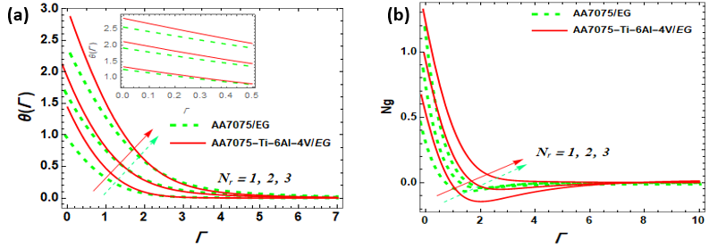
Figure 2a and 2b: Influence of thermal radiation parameter on $θ(Γ)$, and Ng.

The influence of the Eckert number Ec and the heat generation parameter Q on the dimensionless temperature θ(Γ) and entropy generation number Ng is characterized by an overall enhancement in the thermal state of the system for both the AA7075-Ti-6Al-4V/ethylene glycol hybrid nanofluid and the AA7075/ethylene glycol nanofluid (Figure 3a and b). As the Eckert number increases, the conversion of kinetic energy into internal energy through viscous dissipation leads to a significant rise in the fluid temperature, while the presence of a heat source via the parameter Q further intensifies the thermal energy within the boundary layer. These physical mechanisms result in a thickened thermal boundary layer where the hybrid nanofluid consistently demonstrates superior heat transport characteristics compared to the conventional nanofluid due to its enhanced effective thermal conductivity. Furthermore, the elevation of Ec and Q contributes to a higher entropy generation number Ns near the surface, as the increased temperature gradients and internal heat production heighten the system's irreversibility. The hybrid nanofluid profiles typically reside above those of the mono-nanofluid, indicating that while the ternary or hybrid suspensions are more efficient at maintaining high thermal energy, they also experience greater energy dissipation and entropy production before eventually decaying to the ambient conditions far from the wall.
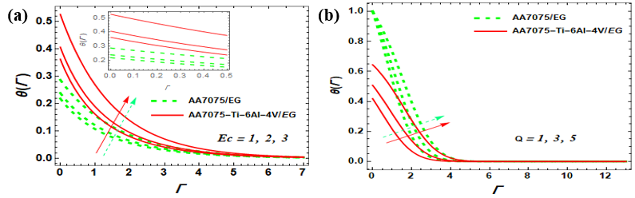
Figure 3a and 3b: Influence of Ec and Q parameter on $θ(Γ)$, and Ng.

The impact of suction and injection on the dimensionless and temperature for both the AA7075-Ti-6Al-4V/EG hybrid nanofluid and the AA7075/EG nanofluid is illustrated across the four panels of Figure 3. In Figures 4(a) and 4(b), the application of increasing suction serves to significantly deplete both the velocity and temperature profiles by pulling the heated fluid toward the boundary, which effectively shrinks the momentum and thermal boundary layer thicknesses. Conversely, Figures 4(c) and 4(d) demonstrate that increasing the injection parameter acts as a mechanism to blow the fluid away from the surface, thereby enhancing the velocity and temperature distributions and expanding the respective boundary layers. Across all cases, the hybrid nanofluid represented by the solid red lines shows a higher thermal state compared to the conventional nanofluid, likely due to the superior thermal conductivity provided by the dual nanoparticle suspension. Furthermore, the entropy generation number is expected to decrease under suction due to the stabilization of the flow and the reduction of temperature gradients, whereas injection typically promotes higher irreversibility by intensifying the disturbance and thermal dispersion within the system.
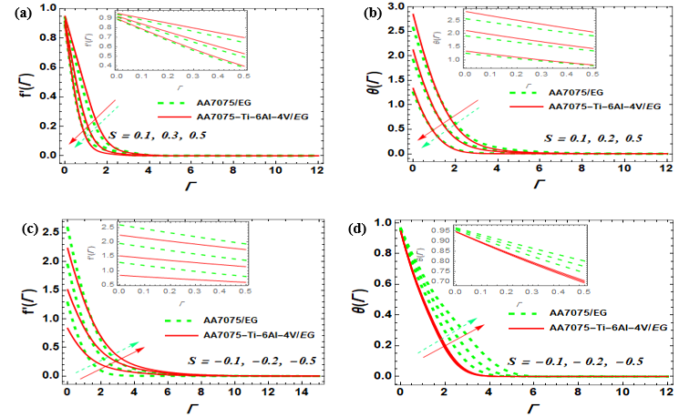
Figure 4(a, b c and d): Influence of $(S>0) and (S<0)$ on $'(Γ) , and$ $θ(Γ)$.

The impact of the Deborah number and Deborah number II on the velocity and temperature for the AA7075-Ti-6Al-4V/ethylene glycol hybrid nanofluid (HNF) and AA7075/ethylene glycol nanofluid (NF) is presented in Figure 5. As observed in Figures 5(a) and 5(b), an increment in the Deborah number I, which represents the relaxation time parameter, leads to a reduction in the fluid velocity while simultaneously enhancing the temperature profile. Physically, a higher relaxation time increases the fluid's resistance to flow, thereby thinning the momentum boundary layer and causing a rise in the thermal state due to increased internal friction within the viscoelastic medium. Conversely, Figures 5(c) and 5(d) illustrate that an increase in the Deborah number II, corresponding to the retardation time parameter, produces the opposite effect by accelerating the flow and cooling the system. This enhancement in velocity occurs because the retardation time allows the fluid to respond more effectively to shear stress, which reduces the effective viscosity and facilitates better heat dissipation, resulting in a narrower thermal boundary layer for both the hybrid and mono-nanofluids. Throughout these observations, the AA7075-Ti-6Al-4V/EG hybrid nanofluid consistently exhibits a superior thermal profile compared to the AA7075/EG nanofluid, confirming that the combination of multiple nanoparticles significantly improves the overall heat transport properties of the base ethylene glycol.
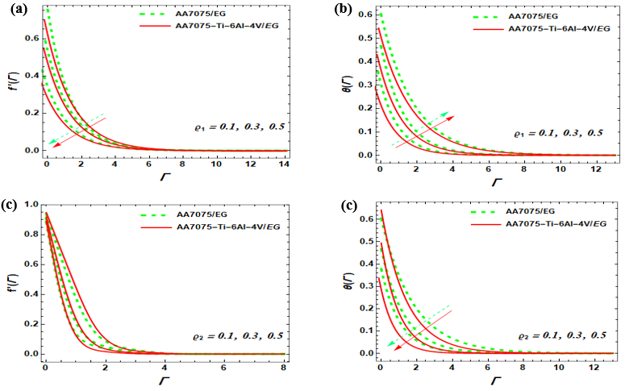
Figure 5(a, b c and d): Impact of $ϱ_{1}$ $, and ϱ_{2}$on f $'(Γ)$, and $θ(Γ)$.
In Figure 6(a), it is evident that increasing the volume fraction of the nanoparticles leads to a decline in the velocity profile. This phenomenon occurs because adding nanoparticles increases the effective dynamic viscosity of the base fluid, which enhances fluid friction and flow resistance, ultimately slowing down the motion within the momentum boundary layer. Conversely, Figure 6(b) demonstrates that the temperature profile is enhanced as the nanoparticle volume fraction increases. This is attributed to the fact that nanoparticles possess higher thermal conductivity than the base fluid (ethylene glycol), and their presence facilitates more efficient heat transfer and energy storage within the fluid, which results in a thickened thermal boundary layer. Across both figures, the AA7075-Ti-6Al-4V/EG hybrid nanofluid (represented by solid red lines) shows a more pronounced response compared to the AA7075/EG mono-nanofluid, confirming that the synergetic effect of combining multiple types of nanoparticles yields superior thermal performance.
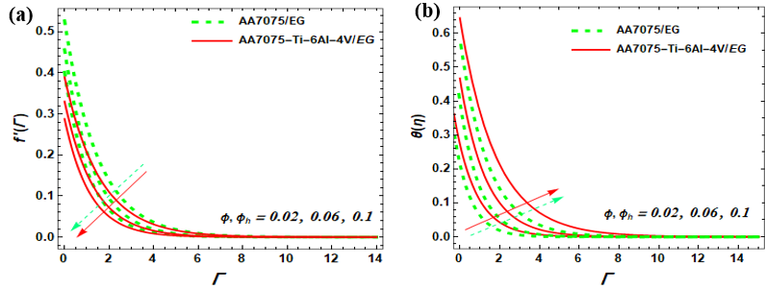
Figure 6(a, and b): Effect of ${ϕ,ϕ}_{h}$ on f $'(Γ)$, and $θ(Γ)$.
In Figure 7(a), increasing the Reynolds number leads to an increase in the entropy generation number near the boundary. Physically, a higher Reynolds number corresponds to increased inertial forces relative to viscous forces, which intensifies the velocity gradients and fluid friction near the solid surface, thereby heightening local irreversibility. Figure 7(b) depicts the effect of the Brinkman number, which relates the viscous heat generation to the external heat transport by conduction. As Br increases, the entropy generation number Ng also increases significantly. This is because a higher Brinkman number signifies greater internal heat generation due to viscous dissipation within the fluid, which adds a substantial source of irreversibility to the thermal system. In both instances, the hybrid nanofluid (solid red lines) consistently exhibits a higher magnitude of entropy generation compared to the mono-nanofluid (dashed green lines). This confirms that while the addition of dual nanoparticles improves thermal conductivity and heat transfer performance, it also leads to higher energy dissipation and entropy production within the boundary layer. As the distance from the boundary increases, the values for Ng for all cases converge toward zero, indicating that the influence of these parameters is localized to the near-wall region.
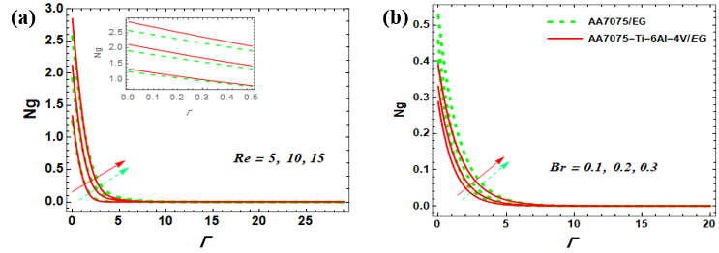
Figure 7(a, and b): Effect of $Br and, Re$on Ng.
Conclusion
This research successfully addressed the critical need for sustainable and efficient cooling solutions in solar water pumping (SWP) systems by evaluating the thermal performance of AA7075/EG nanofluids and AA7075-Ti-6Al-4V/EG hybrid nanofluids. Through a comprehensive investigation of heat kinetics and flow properties under varying conditions including thermal radiation, heat generation, and viscoelastic effects this study confirms that hybrid nanofluids provide superior thermal conductivity and heat transport capacity compared to traditional mono-nanofluids.
- Increasing the thermal radiation parameter enhances both the dimensionless temperature and the entropy generation number by increasing radiative heat flux, with the hybrid nanofluid demonstrating superior thermal performance.
- Elevating these parameters increases internal thermal energy through viscous dissipation and direct heat sources, leading to a higher and increased irreversibility near the boundary.
- Suction reduces velocity and temperature by drawing fluid toward the wall, thereby decreasing the boundary layer thickness, while injection produces the opposite effect by blowing fluid away from the surface and expanding the boundary layer.
- Relaxation time increases flow resistance and temperature, while retardation time accelerates flow and facilitates cooling through better shear response.
- Increasing nanoparticle concentration raises the effective dynamic viscosity, which reduces velocity, while simultaneously enhancing thermal conductivity, which boosts the temperature profile.
- Both parameters contribute to higher entropy generation; intensifies velocity gradients near the wall, and increases entropy by augmenting viscous heat dissipation.
- Across all examined parameters, the AA7075-Ti-6Al-4V/EG hybrid nanofluid consistently exhibits higher thermal conductivity and a more robust heat transport capacity than the mono-nanofluid, although this enhanced performance is accompanied by higher entropy generation due to increased energy dissipation and internal flow irreversibility.

COMPETING INTERESTS DISCLAIMER:
Authors have declared that they have no known competing financial interests OR non-financial interests OR personal relationships that could have appeared to influence the work reported in this paper.

References
Afrand, M., Toghraie, D., & Sina, N. (2016). Experimental study on thermal conductivity of water-based Fe₃O₄ nanofluid: Development of a new correlation. Applied Thermal Engineering, 100, 1085–1091.
- Ishak, R. Nazar, I. Pop, Mixed convection on the stagnation point flow toward a vertical, continuously stretching sheet, J. Heat Transfer, 129 (2007)
A. Ishak, R. Nazar, I. Pop, Boundary layer flow and heat transfer over an unsteady stretching vertical surface, Meccanica, 44 (2009) 369-375.
Bejan, A. (1996). Entropy generation minimization: The method of thermodynamic optimization of finite-size systems and finite-time processes. CRC Press.
Bird, R. B., Armstrong, R. C., & Hassager, O. (1987). Dynamics of Polymeric Liquids, Volume 1: Fluid Mechanics. Wiley.
Chai, J., & Fan, J. (2023). Solar and thermal radiation‐modulation materials for building applications. Advanced Energy Materials, 13(1), 2202932.
Choi, S. U. S., & Eastman, J. A. (1995). Enhancing thermal conductivity of fluids with nanoparticles. ASME International Mechanical Engineering Congress and Exposition.
Das, S. K., Choi, S. U. S., Yu, W., & Pradeep, T. (2008). Nanofluids: Science and Technology. Wiley.
S. Das, S. Chakraborty, R. Jana, O. Makinde, Entropy analysis of unsteady magneto-nanofluid flow past accelerating stretching sheet with convective boundary condition, 36 (2015) 1593-1610.
Esfe, M. H., et al. (2024). Hybrid nano-fluid for solar collector based thermal energy storage and heat transmission systems: A review. Journal of Energy Storage, 86, 111243.
Fatunmbi, E. O., & Adeniyan, A. (2020). Nonlinear thermal radiation and entropy generation on steady flow of magneto-micropolar fluid passing a stretchable sheet with variable properties. Results in Engineering, 6, 100142.
Fatunmbi, E. O., & Salawu, S. O. (2020). Thermodynamic second law analysis of magneto-micropolar fluid flow past nonlinear porous media with non-uniform heat source. Propulsion and Power Research, 9(3), 281-288.
Fatunmbi, E. O., Obalalu, A. M., Khan, U., Hussain, S. M., & Muhammad, T. (2024). Model development and heat transfer characteristics in renewable energy systems conveying hybrid nanofluids subject to nonlinear thermal radiation. Multidiscipline Modeling in Materials and Structures, 20(6), 1328-1342.
Ghadimi, A., Saidur, R., & Metselaar, H. S. C. (2011). A review of nanofluid stability properties and characterization. International Journal of Heat and Mass Transfer, 54(17–18), 4051–4068.
Hayat, T., Qayyum, S., Imtiaz, M., & Alsaedi, A. (2015). Magnetohydrodynamic flow of Oldroyd-B fluid with variable thermal conductivity. International Journal of Heat and Mass Transfer, 90, 896–902.
Huminic, G., & Huminic, A. (2018). Hybrid nanofluids for heat transfer applications – A state-of-the-art review. International Journal of Heat and Mass Transfer, 125, 82–103.
Ishak, A., Nazar, R., & Pop, I. (2007). Boundary-layer flow of a micropolar fluid on a continuously moving or fixed permeable surface. International Journal of Heat and Mass Transfer, 50(23-24), 4743-4748.
Ishak, A., Jafar, K., Nazar, R., & Pop, I. (2009). MHD stagnation point flow towards a stretching sheet. Physica A: Statistical mechanics and its applications, 388(17), 3377-3383.
Jamshed, W., Nisar, K. S., Gowda, R. P., Kumar, R. N., & Prasannakumara, B. C. (2021). Radiative heat transfer of second grade nanofluid flow past a porous flat surface: a single-phase mathematical model. Physica Scripta, 96(6), 064006.
Jamshed, W., et al. (2021). Thermal growth in solar water pump using Prandtl–Eyring hybrid nanofluid. Scientific Reports, 11, 18704.
Li, B. W., Wang, W., & Zhang, J. K. (2016). Combined effects of magnetic field and thermal radiation on fluid flow and heat transfer of mixed convection in a vertical cylindrical annulus. Journal of Heat Transfer, 138(6), 062501.
Mahamude, A. S. F., Kamarulzaman, M. K., Harun, W. S. W., Kadirgama, K., Ramasamy, D., Farhana, K., ... & Yousif, B. (2022). A comprehensive review on efficiency enhancement of solar collectors using hybrid nanofluids. Energies, 15(4), 1391.
Mahian, O., Kianifar, A., Kalogirou, S. A., Pop, I., & Wongwises, S. (2013). A review of the applications of nanofluids in solar energy. International Journal of Heat and Mass Transfer, 57(2), 582–594.
Obalalu, A. M., Adebayo, L. L., Colak, I., Ajala, A. O., & Wahaab, F. A. (2022). Entropy generation minimization on electromagnetohydrodynamic radiative Casson nanofluid flow over a melting Riga plate. Heat Transfer, 51(5), 3951-3978.
Obalalu, A. M., Fatunmbi, E. O., Bhakuni, A. S., Bajaj, M., Abdul-Yekeen, A. M., & Ojewola, O. B. (2024). Investigation of non-Newtonian flow behavior in Oldroyd-B ternary nanofluid: analyzing the thermal efficiency of solar radiation on water pumping systems. In E3S Web of Conferences (Vol. 564, p. 05002). EDP Sciences.
Obalalu, A. M., Fatunmbi, E. O., Madhukesh, J. K., Shah, S. H. A. M., Khan, U., Ishak, A., & Muhammad, T. (2024). Numerical study of hybrid nanofluid and thermal transport in sun-powered energy ship within the application of parabolic trough solar collectors. Multidiscipline Modeling in Materials and Structures, 20(6), 1148-1179.
Rasheed, T., et al. (2021). Hybrid nanofluids as renewable and sustainable colloidal suspensions for solar energy applications. Frontiers in Chemistry, 9, 737033.
Said, Z., Sharma, P., & Rahman, S. M. A. (2019). Performance enhancement of solar collectors using nanofluids. Renewable and Sustainable Energy Reviews, 101, 466–479.
Salawu, S. O., Yusuf, T. A., & Fatunmbi, E. O. (2025). Thermal quadratic radiation and entropy optimization of Casson MoS2-SiO2/H2O composite nanofluid in porous Riga plate media and heat loss. Surfaces and Interfaces, 107279.
Sundar, L. S., Singh, M. K., & Sousa, A. C. M. (2017). Enhanced heat transfer and friction factor of hybrid nanofluids. International Communications in Heat and Mass Transfer, 52, 73–83.
Varchanis, S., Tsamopoulos, J., Shen, A. Q., & Haward, S. J. (2022). Reduced and increased flow resistance in shear-dominated flows of Oldroyd-B fluids. Journal of Non-Newtonian Fluid Mechanics, 300, 104698.
W. Jamshed, S. Uma Devi S, R. Safdar, F. Redouane, K.S. Nisar, M.R. Eid, Comprehensive analysis on copper-iron (II, III)/oxide-engine oil Casson nanofluid flowing and thermal features in parabolic trough solar collector, Journal of Taibah University for Science, 15 (2021) 619-636.
Xiong, Q., Altnji, S., Tayebi, T., Izadi M., Hajjar, A., Sundén, B., & Li, L. K. (2021). A comprehensive review on the application of hybrid nanofluids in solar energy collectors. Sustainable Energy Technologies and Assessments, 47, 101341.

