Combining geophysical and remote sensing techniques to unravel the mineralization potential of the basement rocks of Ikole-Itapaji, Southwestern Nigeria.

Abstract
Despite the growing application of geophysical and remote sensing techniques in mineral exploration, many studies in Precambrian basement terrains of southwestern Nigeria lack an integrated approach that combines aeromagnetic, radiometric, and satellite datasets for robust structural and mineralization targeting. This study addresses this gap by integrating high-resolution aeromagnetic, radiometric, and Landsat 8 OLI imagery to delineate lithological variations, structural trends, and mineralization zones within the Ikole–Itapaji area. Landsat 8 OLI/TIRS imagery (scene LC09_L1TP_190054_20250211) obtained from the USGS Earth Explorer platform was used for lithological and structural mapping.High-resolution airborne aeromagnetic and gamma-ray spectrometric data covering the Ado-Ekiti Sheet 244 and Ikole sheet 245 with the following parameter terrain clearance of 80 m, flight line spacing of 150 m, and tie line spacing of 1500 m. were acquired by the Nigerian Geological Survey Agency in 2023 and processed using Geosoft Oasis Montaj 8.4 (HJ). The methodology involved IGRF correction of Total Magnetic Intensity (TMI) data, polynomial filtering for regional–residual separation, and Reduction to the Equator (RTE) to enhance anomaly positioning. Analytical Signal and Euler deconvolution were applied to delineate structural boundaries and estimate source depths, while radiometric processing and potassium deviation mapping highlighted alteration zones. Remote sensing analysis included principal component analysis (PCA) and automated lineament extraction. Results reveal dominant NE–SW and NW–SE structural trends, with high lineament density concentrated along the Itapaji–Bolorunduro axis. Euler solutions indicate shallow, structurally controlled sources at depths of approximately 0.5–2.5 km. Radiometric analysis shows significant potassium enrichment, indicating hydrothermal alteration. Mineralization is interpreted as structurally controlled hydrothermal mineralization associated with quartz veins and pegmatitic intrusions. The Itapaji–Bolorunduro corridor is identified as the most prospective zone due to the convergence of favorable structures, shallow mineralization depth, and strong alteration signatures.
Keywords: Itapaji, Mineralization, Landsat, Hydrothermal alteration, Aeromagnetic, Structural lineament

1. Introduction
The growing global demand for critical and metallic minerals has intensified exploration within Precambrian basement terrains, particularly in southwestern Nigeria. The Nigerian Basement Complex is known to host structurally controlled mineralization, including gold and rare metal deposits associated with pegmatites. In recent years, the integration of geophysical and remote sensing techniques has become increasingly effective for mineral exploration, as aeromagnetic data reveals subsurface lithological variations and structural features, while remote sensing enables the identification of hydrothermal alteration zones and lineaments linked to mineralizing processes (Abubakar, 2023; Salako et al., 2024; Ogah & Abubakar, 2024). The Ikole–Itapaji area lies within this basement terrain and is predominantly underlain by migmatite–gneiss complexes, granites, and minor schist belts, which are favourable for mineralization. Previous studies in and around the region have mainly focused on regional geological mapping and isolated applications of geophysical or remote sensing techniques. For instance, aeromagnetic and radiometric data have been used to delineate structural trends and infer mineralization potential in parts of Ekiti and adjacent areas, while remote sensing studies have mapped alteration zones and structural controls (Salako et al., 2024; Ogah & Abubakar, 2024).
However, despite the well-established geological framework and recognized mineralization potential of the Ikole–Itapaji area within the Pan-African Mobile Belt, previous investigations have not produced a coherent, high-resolution model of its fundamental structural architecture or clearly defined the spatial relationship between subsurface structures and mineralization zones. The reliance on traditional field mapping, often constrained by dense vegetation cover and thick regolith, has further limited the accurate characterization of subsurface structural geometry. Consequently, a critical knowledge gap persists in understanding the depth, extent, continuity, and connectivity of ore-controlling structures, thereby hindering the transition from reconnaissance-based exploration to predictive mineral targeting (Ogah & Abubakar, 2024). This study, therefore, addresses these limitations by integrating high-resolution aeromagnetic, radiometric, and remote sensing datasets to provide a comprehensive evaluation of the structural framework and mineralization potential of the Ikole–Itapaji area. The integrated approach adopted in this study aims to improve the delineation of structurally controlled mineralized zones, establish the relationship between subsurface geophysical signatures and surface alteration patterns, and enhance exploration targeting within the Nigerian Basement Complex (Salako et al., 2024).

2. The study area
The study area is located within the Ikole–Itapaji axis of Ekiti State in southwestern Nigeria, forming part of the Precambrian Basement Complex of the West African Craton. It lies approximately between latitudes 7°45′N–8°05′N and longitudes 5°20′E–5°40′E, encompassing Ikole-Ekiti, Itapaji, and adjoining settlements. The terrain is characterized by undulating topography with elevations ranging from about 300 to over 600 m above sea level, typical of basement terrains marked by ridges and inselbergs (Ojo et al., 2024). Geologically, the area is dominated by migmatite–gneiss complexes, granitic intrusions, and minor schist belts, which are characteristic of the Nigerian Basement Complex and are widely associated with mineralization processes (Adetunla et al., 2025). These lithologies have undergone multiple episodes of deformation, metamorphism, and magmatism, resulting in well-developed structural features such as faults, fractures, and joints that serve as conduits for hydrothermal fluids (Ogah & Abubakar, 2024). The occurrence of pegmatitic intrusions within the granitic units further enhances the mineralization potential of the area, particularly for rare metals.
Climatically, the region falls within the tropical humid zone, with distinct wet and dry seasons and annual rainfall exceeding 1200 mm. Vegetation is mainly derived savannah with patches of secondary forest, which moderately affects surface exposure during geological and remote sensing investigations. The area is relatively accessible through a network of roads linking Ikole-Ekiti to other parts of Ekiti State. Overall, the favourable lithological composition, combined with a complex structural framework, makes the Ikole–Itapaji area a promising target for integrated geophysical and remote sensing studies to delineate zones of mineralization (Salako et al., 2024).

2.1 Geological Setting
The study area is located within southwestern Nigeria, forming part of the Precambrian Basement Complex of the West African Craton. This crystalline basement terrain is distinct from the surrounding sedimentary basins, including the Sokoto Basin, Chad Basin, Bida Basin, and the Benue Trough, which are largely composed of Cretaceous to Tertiary sediments (Ojo et al., 2024). The southwestern region, including the Ikole–Itapaji axis, is dominated by crystalline rocks that have undergone extensive tectono-metamorphic evolution. The Nigerian Basement Complex evolved through multiple orogenic events, notably the Liberian, Eburnean, and Pan-African cycles, which resulted in widespread deformation, metamorphism, and granitoid emplacement (Adetunla et al., 2025). These processes led to the development of major lithological units, including the migmatite–gneiss complex, schist belts, and Pan-African granitoids. In the study area, migmatite–gneiss and granitic rocks are predominant, with minor metasedimentary occurrences. Structurally, the area is characterized by well-developed faults, fractures, and foliations, predominantly trending NE–SW and NW–SE, reflecting the imprint of Pan-African deformation (Ogah & Abubakar, 2024). These structures are critical in controlling hydrothermal fluid flow and mineral deposition. Mineralization within the Basement Complex is commonly associated with quartz veins, pegmatites, and shear zones. The presence of granitic and pegmatitic intrusions within the Ikole–Itapaji area further suggests favourable conditions for mineralization. Recent studies have demonstrated the effectiveness of integrated geophysical methods in delineating such structurally controlled mineralized zones (Salako et al., 2024). The geological framework of the study area reflects a complex interplay of lithology and structure, providing a suitable environment for mineralization and justifying integrated geophysical and remote sensing investigations (Fig. 1)
The geological map delineates the principal lithological units within the Precambrian Basement Complex of Southwestern Nigeria, particularly within the Ekiti basement terrain. The lithological framework reflects a long and complex evolution involving high-grade metamorphism, magmatism, and tectonic reworking associated mainly with the Pan-African orogeny (~600 ± 150 Ma). Regional geological syntheses have long established that the Nigerian Basement Complex is dominated by migmatite–gneiss complexes, granitoids, and related intrusive rocks formed during successive tectonothermal events (Rahaman, 1988; Oyinloye, 2011). The migmatite (Mg) unit dominates the southern and lower-central portions of the study area, especially around Ikole and Odo Oro. Migmatites represent the oldest lithological components of the terrain and are characterized by mixed metamorphic and igneous textures formed through partial melting (anatexis) under high-grade metamorphic conditions. According to Rahaman (1988), these rocks form part of the extensive Migmatite–Gneiss Complex that constitutes the basement basement’s foundational framework. The granite gneiss (GG) unit is the most widespread, covering the northern, central, and western portions of the map, including Itapaji and Bolorunduro. These rocks are foliated granitic bodies that have undergone dynamic metamorphism and represent competent, rigid lithologies within the basement. As emphasized by Oyinloye (2011), such units commonly preserve structural fabrics and act as mechanical hosts that localize deformation, faulting, and fracturing during tectonic events. A localized charnockite (Ch) body occurs along the western margin of the map. Charnockites are high-temperature, hypersthene-bearing rocks formed under granulite-facies conditions, typically associated with deep crustal environments. Their occurrence in the Nigerian Basement Complex is indicative of high-grade metamorphic conditions and provides evidence of deep-seated crustal processes during the evolution of the terrain (Rahaman, 1988). The granodiorite (OGd) unit forms a prominent, rounded intrusive body in the north-central part of the study area. This lithology belongs to the syn- to late-tectonic granitoid suite commonly referred to as the “Older Granites.” These intrusive bodies were emplaced during the waning stages of the Pan-African orogeny, often exploiting zones of structural weakness within the pre-existing basement (Oyinloye, 2011) (Fig. 2).
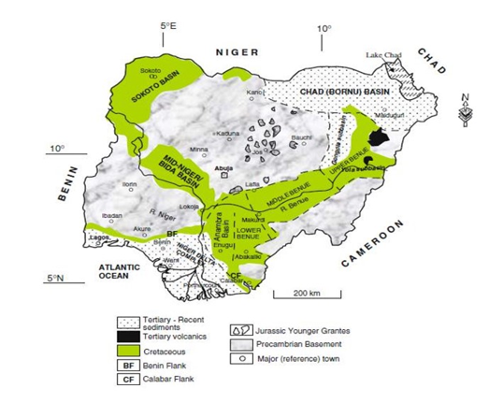
Figure 1: Geological map of Nigeria showing the distribution of major lithological units, including the Precambrian Basement Complex and surrounding sedimentary basins (Sokoto, Chad, Bida, and Benue Trough). The study area (Ikole–Itapaji, southwestern Nigeria) is located within the Basement Complex.

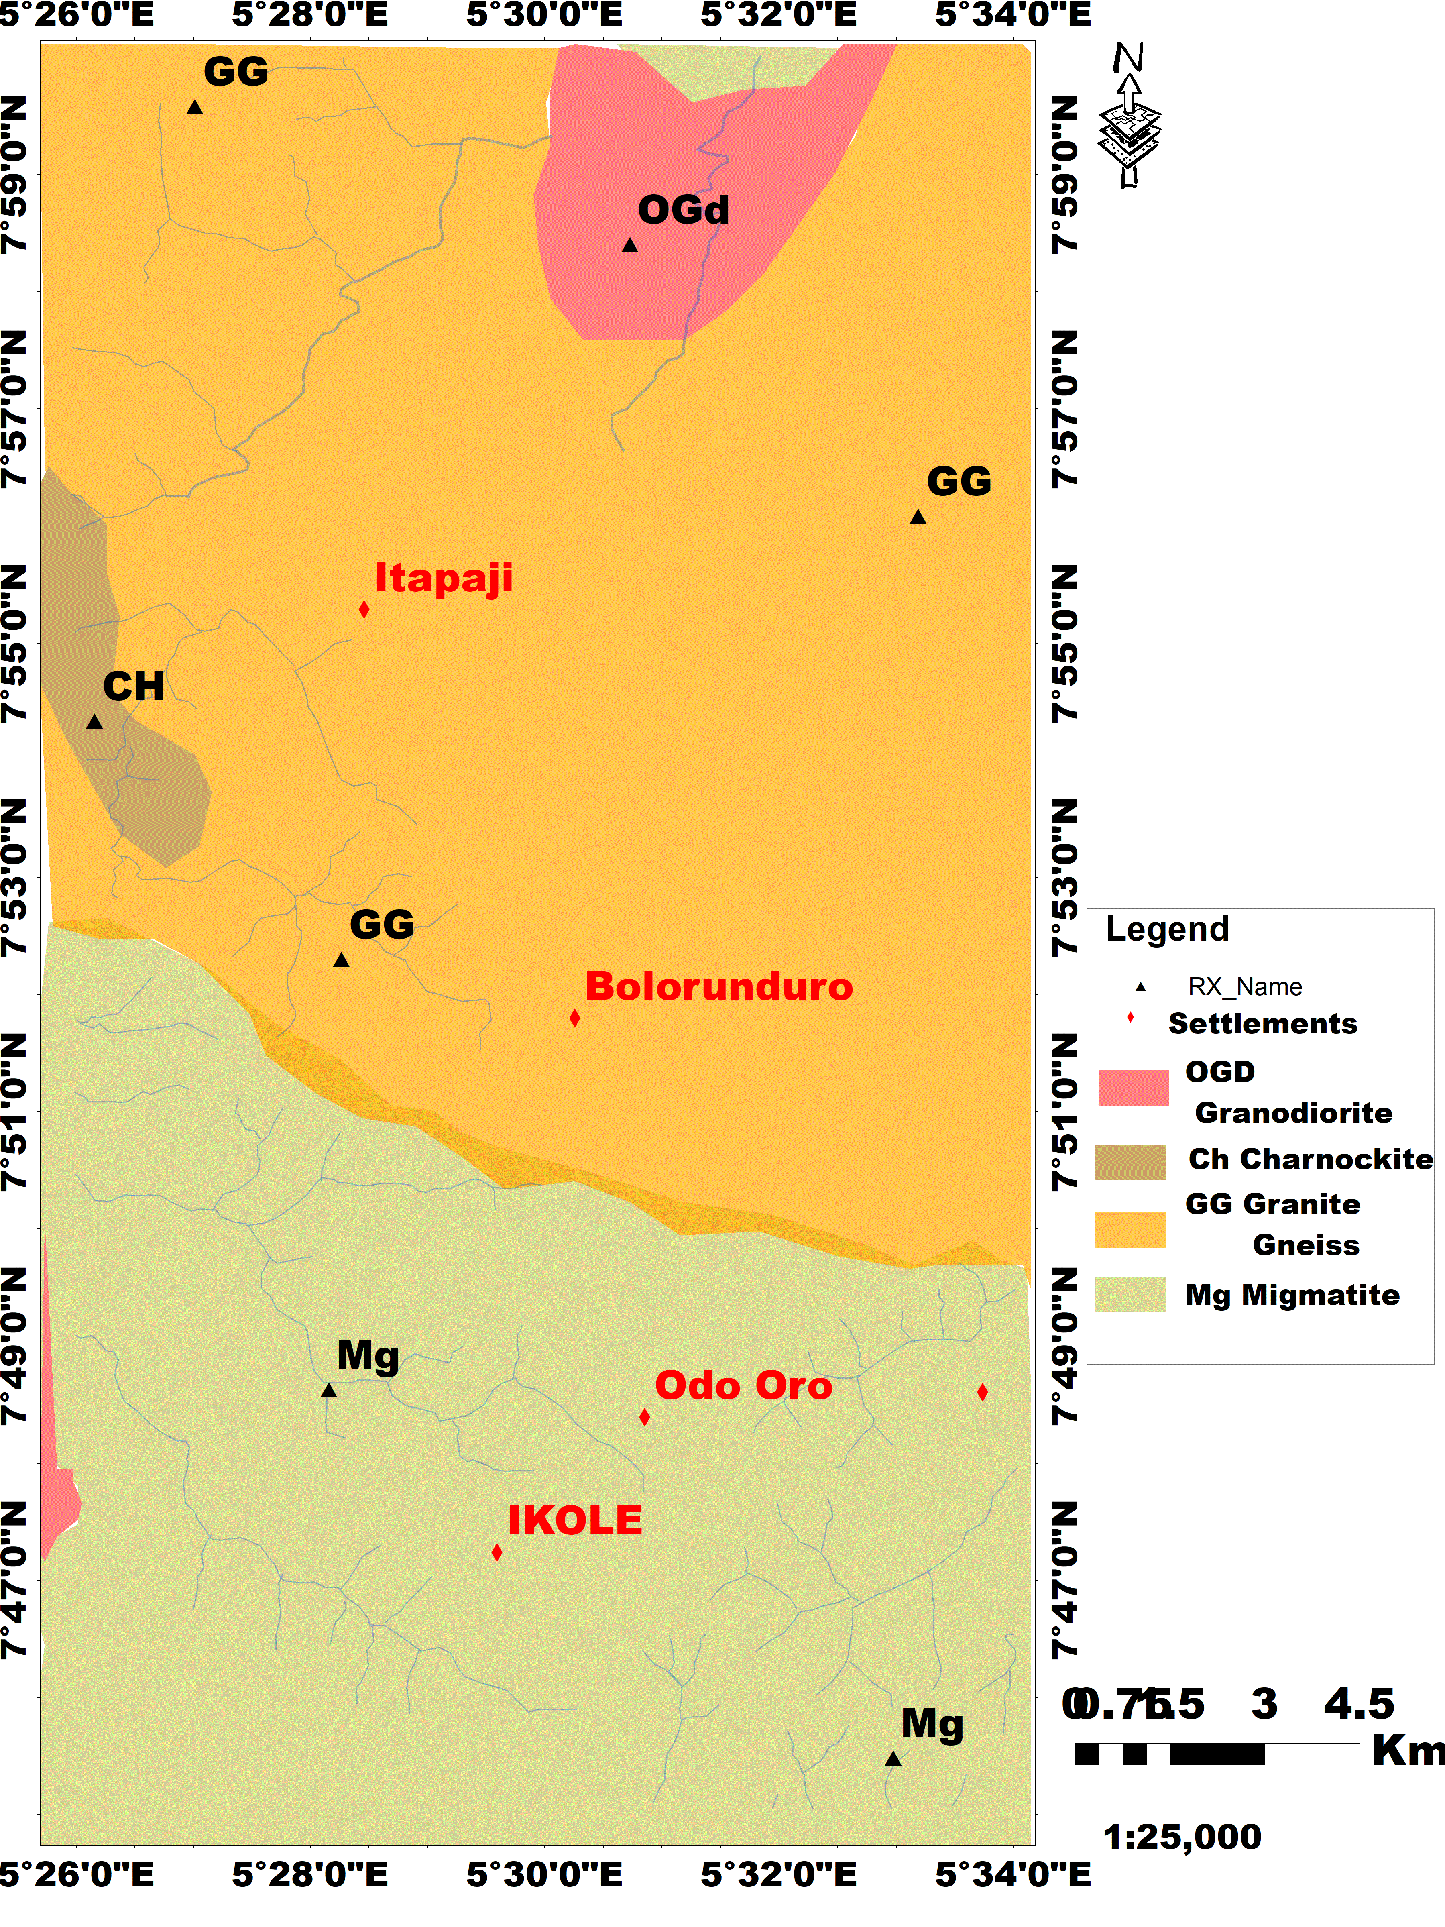
Figure 2: Geological map of the study area compiled after NGSA (2026). The map delineates the distribution of major lithological units and their spatial relationships. It provides a foundational framework for structural interpretation and mineral exploration within the study area.

3. Materials and Methods for Geophysical and Remote Sensing Data Workflow

3.1 Data Sources (Materials)
The datasets used in this study were clipped from high-resolution aeromagnetic, radiometric, and satellite-based remote sensing data. Landsat 8 OLI/TIRS imagery (scene LC09_L1TP_190054_20250211_20250215_02_TI_SR) was obtained from the USGS Earth Explorer platform and utilized for lithological discrimination and structural mapping. The imagery was acquired using the Operational Land Imager (OLI) and Thermal Infrared Sensor (TIRS).
Aeromagnetic and radiometric datasets (K, Th, and U channels) of Ado-Ekiti 244 and Ikole-245 sheets were acquired from the Nigerian Geological Survey Agency (NGSA), Abuja. The high-resolution data (1:100,000 scale) were collected between December 2023 and May 2024 by Fugro Airborne Survey, with a terrain clearance of 80 m, flight line spacing of 150 m, and tie line spacing of 1500 m. The aeromagnetic data were flown along NE–SW and gridded at 250 m resolution, while the radiometric data provide information on surface geochemistry.
All data processing and interpretation were carried out using Geosoft Oasis Montaj™8.4HJ and GIS 10.7-based platforms (Abubakar, 2023).

3.2 Methodological Workflow

Step 1: Pre-processing and IGRF Correction
The Total Magnetic Intensity (TMI) data were corrected for the Earth’s main magnetic field using the International Geomagnetic Reference Field (IGRF) to isolate local anomalies:
$ΔB \left(x, y\right)= TMI_observed \left(x, y\right)- IGRF$………………………………….. (1)
Radiometric data were corrected for background radiation and normalized. Potassium deviation (KD) was computed as:
$KD = (K - Kmean) / Ksd$……………………………………………………. (2)

Step 2: Generation of TMI and Radiometric Maps
The corrected TMI grid was used to generate the base magnetic map, reflecting subsurface lithological and structural variations. Radiometric maps (K, Th, U, and ternary composites) were produced to highlight geochemical variations associated with alteration and mineralization.

Step 3: Regional–Residual Separation (Polynomial Filtering)
A low-order polynomial surface was fitted to separate regional and residual magnetic components:
$ΔT_ residual (x, y) = ΔT_ observed(x, y) - ΔT_ regional(x, y)$…………… (3)
This enhances shallow structures such as faults and fractures.
Step 4: Reduction to the Equator (RTE)
Due to the low magnetic latitude (~5–10°N), RTE was applied to reposition anomalies directly over their causative sources, improving interpretability (Ogah & Abubakar, 2024).

Step 5: Analytical Signal (AS)
The Analytical Signal was computed to enhance the edges of magnetic bodies independent of magnetization direction:
$AS = √ [(∂M/∂x)² + (∂M/∂y)² + (∂M/∂z)²]$………………………………. (4)
This enables accurate delineation of lithological boundaries and structural lineaments.

Step 6: Remote Sensing Analysis
Landsat8 OLI Imagery clipped from the Landsat 8 scene LC09_L1TP_190054_20250211_20250215_02_TI_SR (available at: earthexplorer.usgs.gov), collected by sensors OLI (Operational Land Imager) and TIRS (Thermal Infrared Sensor) downloaded. These methods enhance spectral contrasts associated with lithological variations, iron oxides, clay minerals, and hydrothermal alteration zones. Extracted lineaments were used to define structural trends controlling mineralization.

Step 7: Euler Deconvolution
Euler Deconvolution was applied to estimate the depth and geometry of magnetic sources:
$(x - x₀)(∂M/∂x) + (y - y₀)(∂M/∂y) + (z - z₀)(∂M/∂z) = N(B - M)$... (5)
Where (x₀, y₀, z₀) represent the source location and N is the structural index. This provides depth solutions and structural control of mineralization.
Step 8: Integration and Interpretation
All processed aeromagnetic, radiometric, and remote sensing datasets were integrated to delineate structurally controlled mineralized zones. Correlation between subsurface structures and surface alteration signatures enhances the reliability and accuracy of mineral exploration targeting.

4.0 Results and discussion
4.1 Aeromagnetic maps
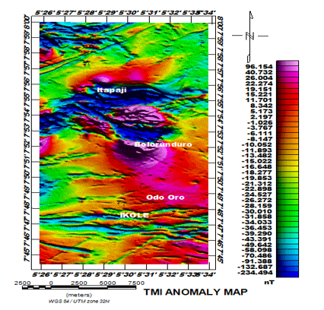
Figure 3: Total Magnetic Intensity (TMI) anomaly map of the study area showing variations in magnetic signatures associated with subsurface lithological and structural features. High and low magnetic anomalies reflect contrasts in rock types and magnetic susceptibility. The map serves as the baseline for subsequent filtering and structural interpretation.
Total magnetic intensity map reveals variations in magnetic field intensity across the study area, reflecting lithological and structural controls. High anomalies (~19 nT to ~96 nT), concentrated around Bolorunduro and parts of Itapaji, likely correspond to magnetically susceptible rocks such as mafic intrusions or banded gneisses (Ogah & Abubakar, 2024; Vallée et al., 2025). Moderate anomalies (~1 nT to 19 nT) dominate surrounding areas, indicative of intermediate lithologies, possibly granitic gneisses (Hamman et al., 2025). Low anomalies (−234 nT to −23 nT) around Odo Oro and Ikole suggest quartz-rich or migmatitic formations with low magnetic susceptibility (Ogah & Abubakar, 2024). The spatial distribution exhibits NW–SE and NE–SW alignments, reflecting structural trends likely controlled by basement lineaments and faults, consistent with regional tectonic fabrics that influence the emplacement of magnetic lithologies (Vallée & Mazur, 2025; Suleiman et al., 2025). These structural trends may guide fluid pathways and target zones for metallic mineralization, highlighting areas of exploration potential (Fig. 3).

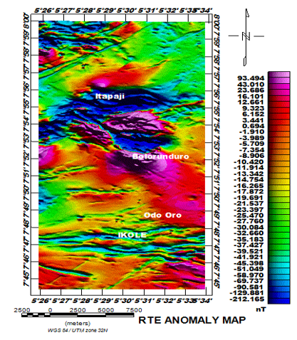
Figure 4: Reduced to equator (RTE) magnetic anomaly map of the study area showing transformation repositions magnetic anomalies over their causative sources, minimizing dipolar distortion at low latitudes. Enhanced anomaly patterns clearly delineate subsurface structures and lithological variations relevant to mineral exploration.
Reduced to Equator (RTE) magnetic anomaly map corrects for the asymmetry of magnetic anomalies at low magnetic latitudes by repositioning anomalies directly above their causative bodies, thereby enhancing geological interpretation (Blakely, 1995; Nabighian et al., 2005). The map reveals distinct spatial variations in magnetic intensity, reflecting differences in lithology and subsurface structural configuration. High-amplitude anomalies (approximately 23 to 93 nT), particularly around Bolorunduro and parts of Itapaji, indicate shallow, highly magnetic sources such as mafic intrusions, amphibolites, or magnetite-rich banded gneisses. These high magnetic signatures are often associated with zones of enhanced mineral potential due to strong magnetic susceptibility contrasts (Nabighian et al., 2005). Moderate magnetic anomalies dominate the central portions of the study area and are interpreted as granitic and granodioritic rocks with intermediate magnetic properties. In contrast, low magnetic anomalies (−212 to −40 nT), especially around Odo Oro and Ikole, suggest felsic lithologies such as migmatites and quartz-rich gneisses or zones affected by intense weathering and alteration, which reduce magnetic susceptibility (Kearey et al., 2002). Structurally, the RTE map delineates prominent linear and curvilinear features trending predominantly NE–SW and NW–SE predominantly, consistent with the structural grain of the Nigerian Basement Complex. These features likely represent faults, fractures, and lithological contacts that have influenced magmatic emplacement and fluid migration. The alignment of high magnetic anomalies along these structures suggests tectonic control on mineralization, making such zones important targets for further exploration (Nabighian et al., 2005) (Fig. 4).
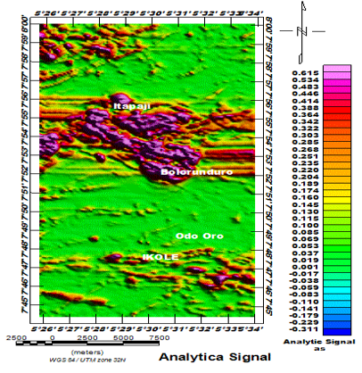
Figure 5: Analytical Signal (AS) Map. The map highlights the edges and geometry of magnetic sources, with amplitude maxima delineating lithological contacts and structural boundaries. High AS values indicate shallow, highly magnetic bodies, while low values correspond to deeper or weakly magnetic sources. Linear AS trends delineate faults and shear zones that control subsurface structures and mineralization pathways.
An analytical signal map is a powerful tool for delineating subsurface magnetic source boundaries because its amplitude is independent of magnetization direction and geomagnetic latitude, making it particularly effective in structurally complex terrains. This property enhances its ability to accurately highlight edges of magnetic bodies and lithological contacts, which is critical in mineral exploration and basement studies (Abraham et al., 2024; Vallée et al., 2026). High analytical signal amplitudes are interpreted as zones underlain by shallow magnetic sources such as igneous intrusions, migmatites, and highly deformed basement rocks, often indicating sharp magnetic contrasts and prospective zones for mineralization due to elevated magnetic susceptibility and hydrothermal alteration (Ogah & Abubakar, 2024; Vallée et al., 2026). In contrast, low analytical signal amplitudes are associated with deeper magnetic sources or weakly magnetic lithologies such as sedimentary cover, weathered rocks, or quartz-rich formations, reflecting minimal magnetic contrast and reduced tectonic disturbance (Abraham et al., 2024). Structurally, linear high-amplitude AS trends delineate faults, fractures, and shear zones that act as pathways for hydrothermal fluids and control mineral deposition. These features commonly define tectonic corridors that enhance mineral prospectivity when integrated with other geophysical derivatives (Ogah & Abubakar, 2024; Vallée et al., 2026) (Fig. 5).
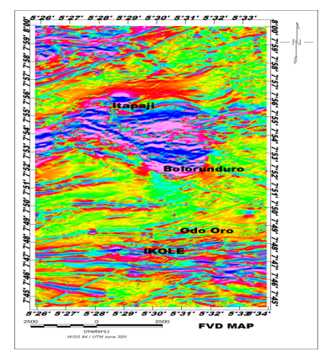
Figure 6: First Vertical Derivative (FVD) map showing enhanced shallow magnetic anomalies within the study area. The map highlights near-surface geological features including faults, contacts, and lineaments. These structures are important for interpreting subsurface geology and potential mineralization zones.
First vertical derivative map enhances shallow subsurface features by amplifying high-frequency magnetic anomalies and attenuating deeper regional signals, thereby improving the delineation of near-surface structures (Blakely, 1995; Nabighian et al., 2005). The map reveals dense, short-wavelength anomalies across the study area, indicating pronounced lithological variability and structural complexity. High-frequency anomalies observed around Itapaji and Bolorunduro suggest shallow magnetic sources, likely associated with fractured basement rocks, mafic intrusions, or magnetite-rich lithologies. These zones are marked by sharp gradients that correspond to lithological contacts and structural discontinuities such as faults and fractures. In contrast, relatively subdued anomalies around Odo Oro and IKOLE indicate deeper or weakly magnetic materials, possibly felsic or weathered basement units (Minshull, (2003).). The FVD map further delineates dominant NE–SW and NW–SE structural trends, consistent with the regional tectonic framework. These lineaments represent zones of weakness that may have controlled fluid migration and mineralization, making them important targets for further exploration (Nabighian et al., 2005) (Fig. 6).

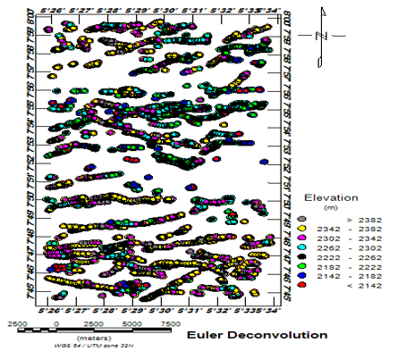
Figure 7: Euler Deconvolution map showing estimated depths and locations of magnetic source bodies within the study area. The solutions indicate structural features such as faults, contacts, and intrusive bodies. These depth estimates provide insight into subsurface geometry and potential mineralization
The Euler Deconvolution map provides estimates of the locations and depths of magnetic source bodies by solving Euler’s homogeneity equation, thereby enhancing subsurface structural interpretation (Reid et al., 1990; Nabighian et al., 2005). The solutions are widely distributed across the study area and form clustered patterns that reflect variations in source depth and geometry. High-density clusters of Euler solutions observed around Itapaji and Bolorunduro indicate zones of shallow magnetic sources, which may correspond to intrusive bodies, fractured basement rocks, or lithological contacts. These clusters are spatially aligned along linear trends, suggesting structural control by faults and fractures. In contrast, more dispersed and deeper solutions around Odo Oro and IKOLE indicate relatively deeper or less magnetic sources, possibly associated with felsic basement rocks or weathered zones. The dominant alignment of Euler solutions along NE–SW and NW–SE directions is consistent with the regional tectonic fabric and previously identified lineaments from the FVD and RTE maps. This structural coherence suggests that these trends represent major zones of weakness that may have facilitated magmatic emplacement and hydrothermal fluid migration. The concentration of shallow solutions along these ხაზaments highlights their potential significance as targets for mineral exploration. Overall, the Euler Deconvolution technique effectively constrains source geometry and depth, complementing other magnetic enhancement methods for robust geological interpretation (Fig. 7).
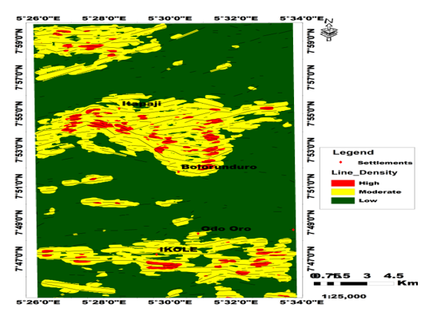
Figure 8: Lineament Density Map. The map illustrates the spatial distribution and concentration of structural lineaments across the study area, highlighting zones of intense deformation. Areas of high lineament density indicate structurally weak zones with enhanced fracturing and potential fluid flow pathways.

Lineament density map is an important structural tool for assessing the intensity of rock fracturing and deformation, which reflects subsurface structural control and mineralization potential. High lineament density zones (in red) indicate areas of intense faulting and shearing, typically associated with enhanced secondary porosity and permeability that facilitate hydrothermal fluid flow and mineral deposition (Abraham et al., 2024; Ogah & Abubakar, 2024). In this study, prominent high-density zones occur around Itapaji and Bolorunduro in the central–northern sector, with another cluster around Ikole in the south, suggesting zones of intense brittle–ductile deformation. Moderate to low-density areas (yellow to green) represent less deformed or more competent basement rocks, or regions where thick overburden masks underlying structures. These zones generally exhibit limited fracturing and reduced fluid circulation (Ogah & Abubakar, 2024). Structurally, the observed high-density lineaments display dominant E–W to ENE–WSW trends, consistent with the regional tectonic fabric of the Nigerian Basement Complex, indicating that these structures are products of long-lived stress regimes controlling deformation and fluid migration pathways (Abraham et al., 2024; Vallée et al., 2026) (Fig. 8).

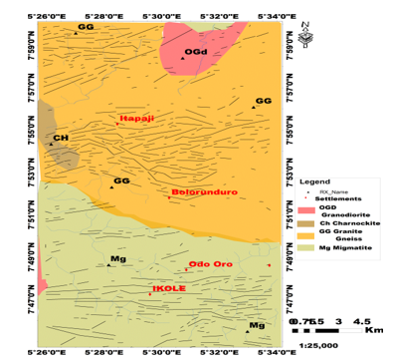
Figure 9: The integration of lineaments with the geological map reveals the relationship between structural features and underlying lithological units. The superimposed lineaments highlight fault systems, fractures, and shear zones controlling rock boundaries and deformation patterns. This combined view enhances the understanding of structural control on geology and mineralization within the study area.

The integration of lineament with the geological map reveals a strong spatial relationship between structural features and the underlying lithological units, highlighting the influence of rock competence on deformation patterns. Lineaments are predominantly concentrated within competent crystalline rocks such as granite gneiss and migmatite, which are more susceptible to brittle deformation under tectonic stress. This behavior is consistent with established structural geology principles, where mechanically competent rocks tend to localize fractures and faults (Telford et al., 1990; Kearey et al., 2002). The dominant structural trends observed are E–W to ENE–WSW, particularly along the Itapaji–Bolorunduro axis, reflecting the regional tectonic fabric of the Nigerian Basement Complex. Such orientations are characteristic of basement terrains influenced by long-lived tectonic stress regimes and reactivation of pre-existing structures (Kearey et al., 2002). In the southern sector near Ikole, E–W trending fractures within migmatitic units further emphasize the control of lithology on structural development. From an exploration perspective, the clustering and intersection of lineaments within crystalline basement rocks indicate zones of enhanced permeability. These structural corridors act as pathways for fluid migration and are therefore significant for hydrothermal mineralization and groundwater accumulation in basement terrains (Fitts, 2013) (Fig. 9).

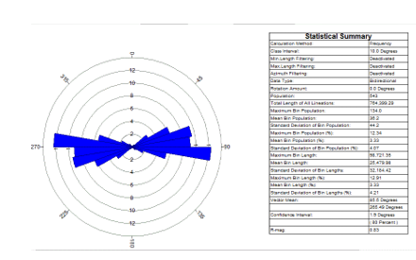
Figure 10: Aeromagnetic Rose Diagram. The diagram illustrates the dominant orientation and frequency of magnetic lineaments within the study area. It highlights the principal structural trends controlling subsurface deformation and mineralization pathways.

Aeromagnetic rose diagram shows that lineaments in the study area are predominantly oriented along the ENE–WSW to E–W direction, indicating a strong preferred structural grain. This dominant orientation reflects the influence of tectonic stresses that controlled fracture development and crustal deformation, as commonly observed in aeromagnetic structural interpretations (Kearey et al., 2009). A secondary trend is observed in the ESE–WNW direction, though less frequent. This suggests multiple phases of deformation and possible reactivation of earlier structures, a typical feature of crystalline basement terrains with complex tectonic histories. These lineaments represent zones of structural weakness, which may act as pathways for fluid migration, thereby influencing groundwater flow and potential mineralization. Aeromagnetic lineament analysis is therefore a key tool for understanding subsurface structures and their geological implications (Blakely, 1995) (Fig. 10).

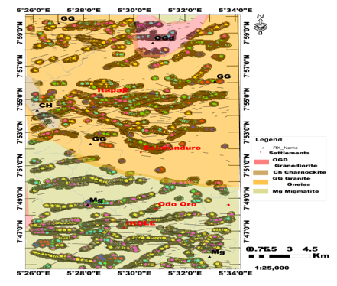
Figure 11: Integrated lineament and Euler Deconvolution map superimposed on the geological framework of the study area. The map highlights structural trends, fracture zones, and subsurface lineaments derived from geophysical analysis. Euler solutions delineate depth estimates and structural contacts, enhancing interpretation of basement features. This integration provides insight into tectonic controls and mineralization potential within the mapped geology.

Integrated lineament and Euler Deconvolution map superimposed on the geological framework of the study area provide insights into both surface and subsurface structural configurations. This integrated approach enhances the delineation of structural lineaments and allows for the estimation of source depths, which is essential in understanding the three-dimensional architecture of basement terrains. Modern studies have shown that Euler deconvolution, when combined with structural mapping, effectively constrains the edges, depths, and geometries of magnetic sources, thereby improving geological interpretation (Cooper, 2024; Pham et al., 2024). The Euler deconvolution solutions, represented as clustered circular points, define the spatial distribution and depth of causative magnetic bodies. The close alignment of these solutions along mapped lineaments—particularly in areas such as Itapaji and Bolorunduro—indicates that many of these features correspond to deep-seated faults or shear zones that extend from the subsurface to near-surface levels. In contrast, dispersed Euler solutions suggest more complex or moderately dipping structures. According to Pham et al. (2024), such clustering patterns are indicative of structurally controlled magnetic sources and can be used to distinguish between shallow and deeper structural features when appropriately constrained. Lithological variations exert a strong influence on the distribution of structural features observed in Fig. 2. The granite gneiss (GG) and migmatite (Mg) units exhibit a high density of both lineaments and Euler solutions, reflecting their brittle response to tectonic stress and their tendency to fracture rather than fold. Conversely, the charnockite (CH) and granodiorite (OGd) units display fewer surface lineaments; however, the presence of Euler solutions along their boundaries suggests the existence of concealed structural discontinuities at depth. This relationship between lithological contrast and structural localization is consistent with findings by Cooper (2024), who emphasized that structural boundaries often control the distribution of geophysical anomalies in mineral exploration settings. From an exploration perspective, the coincidence of dense lineaments and clustered Euler solutions marks zones of enhanced crustal permeability, which are critical for hydrothermal fluid migration and mineralization. The areas around Itapaji, Bolorunduro, and the southern sector near Ikole represent such zones, where structural complexity is highest. These regions likely served as conduits for mineralizing fluids, allowing the concentration of economically significant mineral deposits. Furthermore, the intersection of major structural trends with rheological boundaries—such as contacts between granite gneiss and migmatite—creates favorable conditions for ore deposition due to localized strain and dilation (Pham et al., 2024) (Fig. 11).
4.2 Radiometric maps
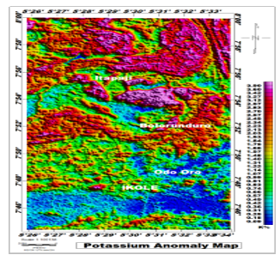
Figure 12: Potassium anomaly map of the study area highlighting the spatial distribution of K-rich radiometric signatures. The map reveals variations in potassium concentration associated with different lithologies and alteration zones. It provides key insights into potential zones of hydrothermal alteration and mineralization.

The Potassium (K) anomaly map reveals significant spatial variation in potassium concentration across the study area, with values ranging from low (<0.5%) to relatively high (>2.0%). Potassium distribution in crystalline basement terrains is primarily controlled by lithology, mineral composition, and secondary processes such as hydrothermal alteration and weathering. Recent airborne gamma-ray spectrometry studies have demonstrated that potassium anomalies are particularly effective in distinguishing lithological units and identifying zones of potassic alteration associated with mineralization processes (Adeyemi et al., 2025). Higher potassium values observed in the central and northern portions of the study area are associated with felsic lithologies such as granite gneiss and related units. These rocks are typically enriched in potassium due to the presence of K-bearing minerals like feldspar and mica. According to recent radiometric investigations, such elevated potassium signatures often indicate either primary felsic compositions or secondary enrichment through hydrothermal processes that introduce or redistribute potassium within the rock mass (Ohaegbuchu et al., 2025). Conversely, the southern and western parts of the study area exhibit relatively low potassium concentrations, which may be attributed to mafic or intermediate lithologies, or to intense weathering and leaching processes that reduce surface radioelement concentrations. Recent studies have also shown that weathering and regolith development can significantly attenuate gamma-ray signals, thereby lowering the apparent potassium values in radiometric datasets (Adeyemi et al., 2025) (Fig. 12)

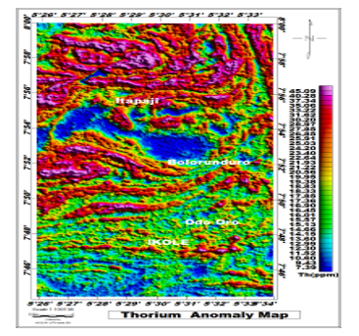
Figure 13: Thorium anomaly map of the study area showing the spatial distribution of thorium radiometric signatures. The map highlights variations in thorium concentration associated with different lithological units and structural controls. It provides useful indicators for delineating felsic rocks and potential zones of crustal enrichment.

The Thorium (Th) anomaly map shows concentrations ranging from <10 ppm to >40 ppm across the study area. Thorium, being an immobile and incompatible element, is typically enriched in felsic rocks and serves as a reliable indicator for lithological discrimination in radiometric studies (Adeyemi et al., 2025). High thorium values (>30 ppm) occur mainly in the northern and central parts, particularly around the Itapaji axis, corresponding to the Granite Gneiss (GG) and Granodiorite (OGd) units. This reflects enrichment in accessory minerals such as zircon and monazite, which host thorium in felsic rocks (Ohaegbuchu et al., 2025). In contrast, the southern region (Odo Oro–Ikole) shows lower values (<20 ppm), associated with the Migmatite (Mg) unit, likely reflecting more mafic or metasedimentary components with fewer thorium-bearing minerals (Adeyemi et al., 2025). The strong contrast between high and low thorium zones provides clear lithological boundaries. Due to its immobility, thorium is particularly useful for distinguishing primary rock variations, and when compared with potassium data, it helps identify true hydrothermal alteration zones (Ohaegbuchu et al., 2025) (Fig. 13).

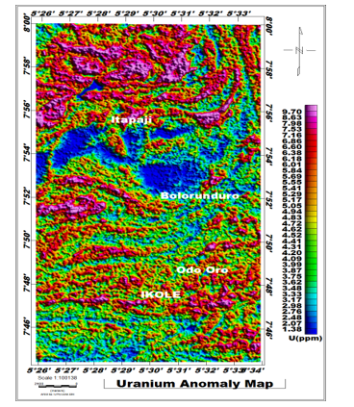
Fig. 14: Uranium anomaly map of the study area depicting the spatial distribution of uranium radiometric signatures.
The map highlights variations in uranium concentration linked to lithological differences and structural features.
It serves as an important tool for identifying zones of radiometric enrichment and potential mineralization.

The Uranium (U) anomaly map shows uranium concentrations ranging from <2 ppm to >9 ppm across the study area. Uranium is a highly mobile element in oxidizing conditions, making it particularly useful for identifying zones of fluid migration and structural control in radiometric surveys (Adeyemi et al., 2025). High uranium concentrations (>6 ppm) are concentrated in the northern and central parts of the study area, especially around Itapaji, where they correspond to the Granite Gneiss (GG) and Granodiorite (OGd) units. This enrichment reflects the tendency of uranium to concentrate in felsic rocks during late-stage magmatic processes and within accessory minerals such as zircon and apatite (Ohaegbuchu et al., 2025). In contrast, the southern area around Odo Oro and Ikole exhibits low uranium values (<3 ppm), associated with the Migmatite (Mg) unit. These lower values are consistent with mafic or metasedimentary compositions and possible uranium leaching under oxidizing surface conditions (Adeyemi et al., 2025). Structurally, elevated uranium values align with E–W and ENE–WSW trending lineaments, indicating that fault systems likely acted as conduits for uranium-bearing fluids. This behavior highlights uranium’s mobility and its sensitivity to structural pathways. When compared with thorium and potassium maps, uranium data provide valuable insight into distinguishing primary lithological signatures from secondary hydrothermal and structural controls (Ohaegbuchu et al., 2025) (Fig. 14).

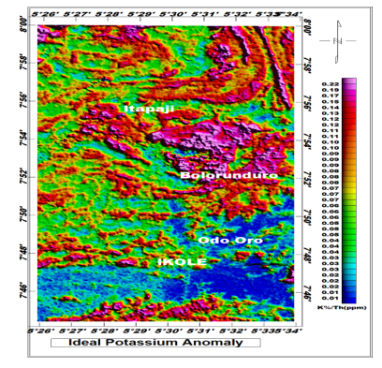
Fig. 15: Potassium deviation map of the study area showing departures from background potassium radiometric values. The map highlights areas of enrichment and depletion relative to regional potassium levels. It provides insight into alteration zones and structural controls affecting potassium distribution.
The Potassium Deviation map expressed as the K%/Th ratio, highlights zones of potassium enrichment by minimizing lithological background effects. Since thorium is largely immobile during alteration while potassium is mobile, elevated ratio values indicate areas of potassium addition due to hydrothermal processes (Adeyemi et al., 2025). The map shows ratio values ranging from <0.03 to >0.15, with high anomalies (red–magenta) concentrated in the central and northern parts, particularly around Itapaji extending toward Bolorunduro. These anomalies represent zones of true potassium metasomatism, where hydrothermal fluids have altered the host rocks through processes such as sericitization and secondary K-feldspar formation (Ohaegbuchu et al., 2025). In contrast, the southern region around Odo Oro and Ikole displays consistently low ratio values (<0.03), indicating minimal potassium enrichment. These values reflect background lithological characteristics of the Migmatite (Mg) unit and suggest limited influence of hydrothermal fluid activity (Adeyemi et al., 2025). The spatial alignment of high-ratio anomalies along E–W to ENE–WSW trends further indicates structural control, suggesting that fault systems acted as pathways for potassium-rich hydrothermal fluids. Such structurally controlled anomalies, especially where they coincide with other geophysical indicators, represent key targets for mineral exploration in basement terrains (Ohaegbuchu et al., 2025) (Fig. 15).
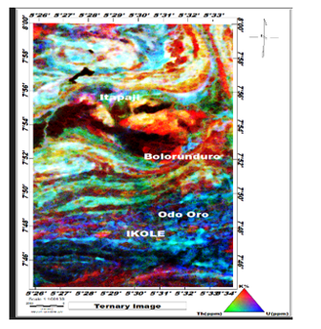
Figure 16: Ternary radiometric diagram illustrating the relative proportions of potassium, thorium, and uranium in the study area. The diagram aids in lithological discrimination and identification of radiometric anomalies associated with mineralization.

The Ternary Radiometric map integrates Potassium (K), Thorium (Th), and Uranium (U) into a composite RGB image, providing a comprehensive visualization of lithological variations and geochemical distribution. In this composite, potassium is represented by red, thorium by green, and uranium by blue, allowing for rapid discrimination of radioelement dominance and geological units (Adeyemi et al., 2025). Bright white to pinkish-yellow zones in the northern and central parts of the study area, particularly around Itapaji, indicate high concentrations of all three radioelements. These areas correspond to the Granite Gneiss (GG) and Granodiorite (OGd) units, reflecting highly evolved felsic compositions enriched in radioactive minerals. Such signatures are consistent with radiometric studies that associate mixed high RGB values with felsic lithologies and potassic alteration zones (Ohaegbuchu et al., 2025). In contrast, the southern region around Odo Oro and Ikole is characterized by darker tones with cyan to blue hues, indicating relatively low potassium and thorium but moderate uranium contributions. This pattern aligns with the Migmatite (Mg) unit and suggests lower overall radiometric intensity, typical of less evolved or more mafic lithologies (Adeyemi et al., 2025). Sharp color transitions and linear contrasts observed across the map, particularly along E–W trends, highlight structural boundaries and potential zones of hydrothermal alteration. These color boundaries often reflect lithological contacts or shear zones that have facilitated fluid movement and geochemical modification. The strong pink to red coloration along the Itapaji–Bolorunduro axis further indicates potassium enrichment associated with structurally controlled hydrothermal systems, making these zones significant targets for mineral exploration (Ohaegbuchu et al., 2025) (Fig. 16).
4.3 Remote sensing data

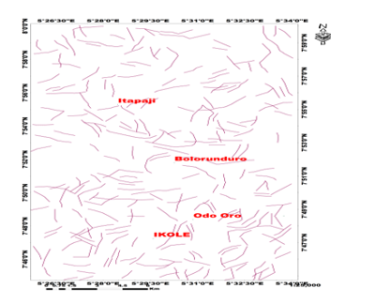
Figure 17: Landsat-derived lineament map of the study area. The map shows the spatial distribution and orientation of mapped lineaments from Landsat imagery. It highlights major structural features and tectonic trends controlling the geology of the area.

The Landsat lineament map shows a dominant structural grain trending East–West (E–W) to East-Northeast–West-Southwest (ENE–WSW), especially across the central portion of the study area. Secondary lineaments trending North–South (N–S) and Northwest–Southeast (NW–SE) intersect these dominant trends, forming cross-cutting structural networks. Such intersections are significant as they represent zones of maximum crustal dilation and permeability, which often act as conduits for hydrothermal fluids (Gabrielsen, 2024) (Fig. 17).

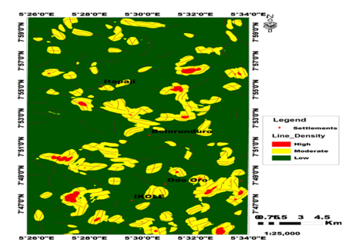
Figure 18: Landsat-derived lineament density map of the study area. The map illustrates the spatial distribution and concentration of lineaments extracted from Landsat imagery. Areas of high density highlight zones of intense fracturing and potential structural control.
The Landsat-derived lineament analysis provides insight into the structural framework controlling the study area. The lineament density map reveals a heterogeneous distribution, with pronounced high-density zones concentrated in the central and northern parts, particularly along the Itapaji–Bolorunduro axis, with a secondary cluster toward the Ikole area. These high-density zones indicate areas of intense brittle deformation and enhanced secondary porosity, which are essential for fluid migration and mineralization in basement terrains (Sabins, 1999) (Fig. 18).

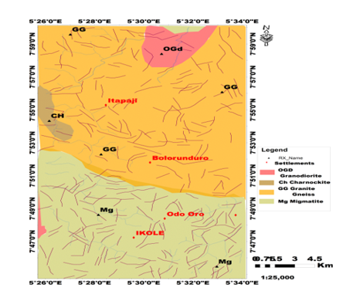
Figure 19: Landsat-derived lineaments superimposed on the geological map. The overlay illustrates the spatial relationship between structural lineaments and mapped lithological units. It highlights structural controls on rock distribution and zones of potential tectonic influence.

Landsat-derived lineaments superimposed on the geological map show clear lithological control. High lineament densities are concentrated within the Granite Gneiss (GG) and Migmatite (Mg) units, which respond to tectonic stress through fracturing due to their competent crystalline nature. In contrast, Granodiorite (OGd) and Charnockite (CH) units exhibit comparatively fewer internal lineaments, suggesting they behaved as rigid blocks that localized deformation along their boundaries. This observation aligns with established structural geology principles, where competent rocks accommodate stress through brittle failure (Salui, (2018) (Fig. 19).

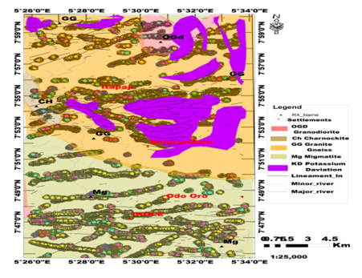
Figure 20: Integrated lineament, potassium deviation (KD), and Euler deconvolution superimposed on the geological map. The map highlights the spatial relationship between structural features, radiometric anomalies, and subsurface source depths. It delineates structurally controlled zones of alteration and potential mineralization within the study area
The integrated interpretation combining lineaments, potassium deviation (KD), and Euler deconvolution on geological map, provides a robust exploration model. The potassium deviation highlights zones of hydrothermal alteration, particularly along the Itapaji–Bolorunduro corridor, where potassium enrichment reflects fluid–rock interaction and metasomatism. Thorium remains relatively immobile, making it a stable reference for identifying potassium enrichment zones (IAEA, 2003). Euler deconvolution solutions further constrain the depth and geometry of subsurface structures. The clustering of Euler solutions along mapped lineaments confirms that many of the surface fractures are expressions of deep-seated faults. The spatial coincidence of lineaments, potassium deviation anomalies, and Euler solutions strongly suggests structurally controlled hydrothermal systems. From an exploration perspective, the Itapaji–Bolorunduro corridor is the most prospective zone due to the convergence of competent host rocks, intense fracturing, and evidence of hydrothermal alteration and deep structural control. Such integrated signatures are typical of mineralized systems in Precambrian basement terrains (Fig. 20).

Conclusion
The integrated analysis of geological, aeromagnetic, radiometric, and remote sensing datasets demonstrates that the Ikole–Itapaji area within the Precambrian Basement Complex of southwestern Nigeria is structurally complex and highly prospective for mineralization. The dominant lithologies—migmatite, granite gneiss, granodiorite, and minor charnockite—exhibit distinct geophysical and radiometric signatures that reflect variations in composition, structural competence, and tectono-metamorphic evolution. Remote sensing-derived lineament analysis reveals a well-developed fracture network, with high lineament density concentrated along the Itapaji–Bolorunduro axis and a secondary cluster near Ikole. The dominant structural trends (E–W to ENE–WSW, with subordinate N–S and NW–SE orientations) represent major zones of crustal weakness that have undergone multiple phases of reactivation. The strong spatial correspondence between lineaments and lithological units confirms that deformation is largely controlled by the mechanical properties of the host rocks, particularly the brittle response of granite gneiss and migmatite. The integration of lineament density, potassium deviation, and Euler deconvolution reveals that these structures are deeply rooted and extend into the subsurface. Euler depth solutions indicate that the causative magnetic sources—and by implication, the mineralized zones—occur predominantly at shallow to intermediate depths of approximately 0.5 to 2.5 km. The clustering of shallow Euler solutions along major lineaments confirms that these faults and fractures act as conduits for hydrothermal fluids. Radiometric anomalies, particularly potassium enrichment, indicate zones of potassic hydrothermal alteration. These signatures, when integrated with structural and magnetic data, reveal that the study area is dominated by structurally controlled hydrothermal mineralization, spatially associated with quartz veins and pegmatitic intrusions. At the identified depth range, such mineralization is typically associated with gold mineralization within quartz veins, as well as rare-metal pegmatite minerals such as columbite–tantalite, cassiterite, and spodumene, alongside accessory minerals like feldspar and mica. The convergence of high lineament density, shallow magnetic sources, and strong radiometric anomalies along the Itapaji–Bolorunduro corridor identifies this zone as the most prospective target for mineral exploration. Overall, this study demonstrates that the integration of aeromagnetic, radiometric, and remote sensing techniques provides a robust and reliable approach for delineating structurally controlled mineralization in Precambrian basement terrains and significantly enhances predictive exploration targeting.

Recommendations
- Targeted Ground Geophysical Surveys
The Itapaji–Bolorunduro corridor and other high lineament density zones should be further investigated using ground-based geophysical methods such as electrical resistivity, induced polarization (IP), and high-resolution magnetic surveys to refine subsurface structures and confirm mineralization targets.
- Detailed Structural and Field Mapping
Field validation of the mapped lineaments should be carried out to confirm fault orientations, fracture systems, and structural intersections, particularly in zones of high Euler solution clustering.
- Geochemical Exploration
Systematic rock, soil, and stream sediment sampling should be conducted in areas of potassium enrichment and radiometric anomalies to detect geochemical signatures of hydrothermal alteration and possible ore mineralization.
- Exploratory Drilling
Priority drill targets should be established along the Itapaji–Bolorunduro structural corridor where geophysical, radiometric, and structural indicators converge, to determine subsurface mineral potential and ore continuity.
- Integrated Exploration Strategy
Future mineral exploration programs in basement terrains should adopt an integrated approach combining remote sensing, aeromagnetic, and radiometric techniques, as this study has demonstrated their effectiveness in delineating structurally controlled mineralization zones.
- 3D Subsurface Modeling
Advanced 2D and 3D inversion and modeling of geophysical data should be undertaken to better constrain the geometry, depth, and extent of subsurface structures and potential mineralized bodies.

Declaration of competing interests
Ethical Approval
This study did not involve human participants, animals, or any form of clinical or ethical experimentation. Therefore, formal ethical approval was not required.
Declaration of generative AI and AI-assisted technologies in the manuscript preparation process
During the preparation of this work, the authors used ChatGPT (GPT-5-mini) to assist with language editing and content organization. After using this tool, the authors reviewed, revised, and verified all content to ensure accuracy, originality, and authenticity, and take full responsibility for the content of the published article.
Consent to Participate
As no human participants were involved in this research, obtaining consent for participation was not applicable. All research activities adhered to standard field and laboratory protocols without the involvement of people.
Consent to Publish
This study does not include any personal, sensitive, or identifiable information. Consequently, consent to publish was not applicable. All data presented are scientific observations and analyses, fully anonymized, and pose no ethical concerns.
Availability of Data and Materials:
The datasets used and analyzed during this study are available from the corresponding author upon reasonable request.

References
- Abubakar, F. (2023). Investigation of iron ore potential in north-central Nigeria using a high-resolution aeromagnetic dataset and a remote sensing approach. Heliyon, 10(1), e23618.
https://doi.org/10.1016/j.heliyon.2023.e23618
- Salako, K. A., Adetona, A. A., Rafiu, A. A., Augie, A. I., Jimoh, M. O., Alkali, A., Muriana, R. A., & Lawrence, J. O. (2024). Integrated geophysical investigation for gold mineralization potential over the southern parts of Kebbi State, northwestern Nigeria. Heliyon, 10(14), e34093.
https://doi.org/10.1016/j.heliyon.2024.e34093
- Ogah, A. J., & Abubakar, F. (2024). Solid mineral potential evaluation using integrated aeromagnetic and aeroradiometric datasets. Scientific Reports, 14, 1637.
https://doi.org/10.1038/s41598-024-52270-6
- Ayuba, B. J., Mallam, A., & Osagie, A. (2024). Structural characterization of high-resolution aeromagnetic data for potentially mineralized zones identification within the North-Central Basement Complex of Nigeria. International Journal of Latest Technology in Engineering Management & Applied Science, 13(7), 13–23.
https://doi.org/10.51583/IJLTEMAS.2024.130703
- Adetunla, F. R., Ayodele, O. S., Asowata, I. T., & Olususi, J. (2025). Integrated geological, aeromagnetic, and remote sensing datasets in litho-structural mapping of basement rocks in southwestern Nigeria. Asian Journal of Geological Research, 8(3), 523–553. https://doi.org/10.9734/ajoger/2025/v8i3213
- Ogah, A. J., & Abubakar, F. (2024). Solid mineral potential evaluation using integrated aeromagnetic and aeroradiometric datasets. Scientific Reports, 14, 1637. https://doi.org/10.1038/s41598-024-52270-6
- Ojo, O. F., Osazuwa, B. I., Chiemeke, C. C., Osumeje, O. J., Oyedele, A. A., Adagunodo, T. A., Oyeyemi, K. D., & Ejiga, E. G. (2024). Classification of the basement complex using aeromagnetic and remote sensing data analyses: Case study of Ekiti State, southwestern Nigeria. Earth Sciences Malaysia, 8(2), 158–162.
https://doi.org/10.26480/esmy.02.2024.158.162
- Vallée, M. A., Moussaoui, M., & Khan, K. (2026). Advances in magnetic and electromagnetic technique interpretation. Minerals, 16(2), 159. DOI: 10.3390/min16020159
- Vallée, M. A., & Mazur, S. (2025). Advances in magnetic and electromagnetic techniques for mineral exploration: Enhancing resource discovery. Minerals, 15(6), 595. DOI: 10.3390/min15060595
- Suleiman, U., Mustapha, B. A., Audu, O. S., Godday, B.-E. S., Eneojoh, A. S., Buba, M. B., & Muknaan, G. J. (2025). Structural interpretation of aeromagnetic data for regional controls on gold mineralization in northwestern Nigeria. International Journal for Research in Applied Science & Engineering Technology, 13(9). DOI: 10.22214/ijraset.2025.74298
- Hamman, I. K., Joseph, C. A., & Zakari, M. (2025). Integrated geological and aeromagnetic investigation of barite mineralization in Didango Area, Muri-Lau Sub-Basin, Upper Benue Trough, NE Nigeria. FUDMA Journal of Sciences, 9(12), 162–170. DOI: 10.33003/fjs-2025-0912-4253
- Kearey, P., Brooks, M., & Hill, I. (2002). An Introduction to Geophysical Exploration (3rd ed.). Oxford: Blackwell Science. https://doi.org/10.1017/S0016756803378021
- Blakely, R. J. (1995). Potential Theory in Gravity and Magnetic Applications. Cambridge University Press.
https://doi.org/10.1017/CBO9780511549816
- Nabighian, M. N., Grauch, V. J. S., Hansen, R. O., et al. (2005). The historical development of the magnetic method in exploration. Geophysics, 70(6), 33ND–61ND. https://doi.org/10.1190/1.2133784
- Minshull, T. A. (2003). Review of An Introduction to Geophysical Exploration (3rd ed.) by Kearey, Brooks & Hill. Geological Magazine, 140(3), 366. https://doi.org/10.1017/S0016756803378021
- Abraham, E. M., Uwaezuoke, A. E., & Usman, A. O. (2024). Geophysical investigation of subsurface mineral potentials in North-Central Nigeria. Geomechanics and Geophysics for Geo-Energy and Geo-Resources, 10, 192. https://doi.org/10.1007/s40948-024-00913-3
- Telford, W. M., Geldart, L. P., & Sheriff, R. E. (1990). Applied Geophysics (2nd ed.). Cambridge University Press. https://doi.org/10.1017/CBO9781139167932
- Fitts, C. R. (2022). Groundwater Science (3rd ed.). Academic Press. https://doi.org/10.1016/C2016-0-00985-3
- Pham, L. T., et al. (2024). Selection of Euler deconvolution solutions using enhanced horizontal gradient and β-VDR method. https://www.degruyter.com/document/doi/10.1515/geo-2022-0637/html?srsltid=AfmBOopBhgczL-GlQAVx9CHSq2DT3oJfYNo1z7URXx3M3-HuaTqdZrI2
- Cooper, G. R. J. (2024). Using Euler Deconvolution as Part of a Mineral Exploration Project. Minerals, 14(4), 393. DOI: https://doi.org/10.3390/min14040393
- Rahaman, M. A. (1988). Recent Advances in the Study of the Basement Complex of Nigeria. In Precambrian Geology of Nigeria, Geological Survey of Nigeria, Kaduna, pp. 11–41.
https://www.scirp.org/reference/referencespapers?referenceid=1712445
- Oyinloye, A. O. (2011). Geology and geotectonic setting of the basement complex rocks in Southwestern Nigeria: Implications on provenance and evolution. DOI: https://doi.org/10.5772/26990
- Nigerian Geological Survey Agency (NGSA), 2006. Geophysical mapping of Nigeria: Airborne radiometric and magnetic survey data, 2006. Available at: https://ngsa.gov.ng
- Adeyemi, A. A., Orosun, M. M., & Salawu, N. B. (2025). Geospatial distributions of natural radioactivity in Kwara State, Nigeria using airborne gamma ray spectrometry data. Discover Environment, 3, 289. https://link.springer.com/article/10.1007/s44274-025-00346-z
- Ohaegbuchu, H. E., Ndubueze, D. N., Obiajulu, O. O., & Ahamefule, Y. C. (2025). Geological interpretation of airborne radiometric data for mineral exploration potential. Nigerian Journal of Physics. https://njp.nipngr.org/index.php/njp/article/view/473
- Sabins, F. F. (1999). Remote sensing for mineral exploration. Ore Geology Reviews, 14(3–4), 157–183. https://doi.org/10.1016/S0169-1368(99)00007-4
- IAEA (2003). Guidelines for Radioelement Mapping Using Gamma Ray Spectrometry Data.
https://www-pub.iaea.org/MTCD/Publications/PDF/te_1363_web.pdf
- Gabrielsen, R. H. (2024). The Concept of Lineaments in Geological Structural Analysis. Geosciences, 4(2), 11. Available at: https://www.mdpi.com/2673-7418/4/2/11
- Salui, C. L. (2018). Automatic extraction and evaluation of geological linear features from digital remote sensing data using Hough Transformation. Journal of Indian Society of Remote Sensing. Available at: https://link.springer.com/article/10.1007/s12594-018-1015-6

