Original Research Article

Geomorphological Characterization and Spatial Distribution Analysis of Chikkaballapur District, Karnataka ,Implications for Groundwater Management in granite mining area

ABSTRACT

The Chikkaballapur District, situated within the hard-rock terrain of the Dharwar Craton,
exhibits a complex geomorphic landscape formed due to tectonic activity and prolonged
denudational processes (Kale & Gupta, 2001; Singh, 2013). In the present study, the spatial
distribution of geomorphological units was quantified over an area of 4,226.46 sq km² using
integrated Remote Sensing (RS) and Geographic Information System (GIS) techniques
(Lillesand et al., 2015). The results reveal that Pediplain Weathered/Buried units constitute the dominant geomorphic feature, covering 62.59% of the total study area. This is followed by Pediment–Inselberg complexes, which account for 14.46% of the area. In hard-rock terrains, groundwater occurrence is mainly controlled by the thickness of the weathered mantle, fracture
Systems and structural discontinuities (Karanth ,1987)
Therefore, the geomorphological analysis provides an important scientific basis for identifying groundwater potential zones and supports sustainable groundwater resource management, particularly in mining-affected regions where geomorphic characteristics strongly influence
Recharge conditions.

Keywords: Groundwater Quality, Drinking Water Quality Index (DWQI), Granite Mining, Irrigation Suitability, Fluoride Contamination, Chikkaballapur.

INTRODUCTION
Groundwater is a vital resource in semi-arid regions like Chikkaballapur District, where surface water availability is limited (Karanth, 1987). In hard-rock terrains, groundwater is typically confined to weathered and fractured zones, making it highly susceptible to depletion and contamination (Karanth, 1987; Rajmohan and Elango, 2005).
Geomorphology plays a fundamental role in controlling groundwater occurrence, storage, and movement, as landforms reflect subsurface geological conditions (Kale and Gupta, 2001; Singh, 2013). Pediplains, pediments, and denudational hills are particularly important in determining recharge and runoff characteristics.
In recent years, granite mining has intensified in the region, leading to significant alterations in landforms and hydrogeological conditions. Open-cast mining generates large volumes of waste material, which can leach contaminants into groundwater systems during rainfall events (Choubey, 1991; Galero et al., 1998).
Advances in Remote Sensing and GIS have enabled efficient mapping and analysis of geomorphological features over large areas (Lillesand et al., 2015). These tools are widely used for groundwater potential zone and environmental impact studies (Elubid et al., 2019).
This study aims to analyze the spatial distribution of geomorphological units and assess their implications for groundwater management in mining-affected regions.

STUDY AREA
The study area is located in the southeastern part of Karnataka, covering an area of 4,226.46 sq km². It lies between 13°20′–13°30′ N latitude and 77°40′–77°45′ E longitude.
Geologically, the region forms part of the Dharwar Craton and is dominated by Archaean granites and gneisses, which are extensively quarried for construction purposes (CGWB, 2020). These lithological formations significantly influence groundwater occurrence and movement (Karanth, 1987).
The region experiences a semi-arid climate with an average annual rainfall of 600–800 mm. Surface drainage is controlled by seasonal rivers such as Arkavathi, Chitravathi, and Papagni. Groundwater occurs mainly in weathered and fractured zones and serves as the primary source for domestic and agricultural use (Karanth, 1987).
Mining activities have significantly modified the natural terrain through excavation, formation of pits, and accumulation of waste materials, thereby affecting hydrological processes (Galero1998).

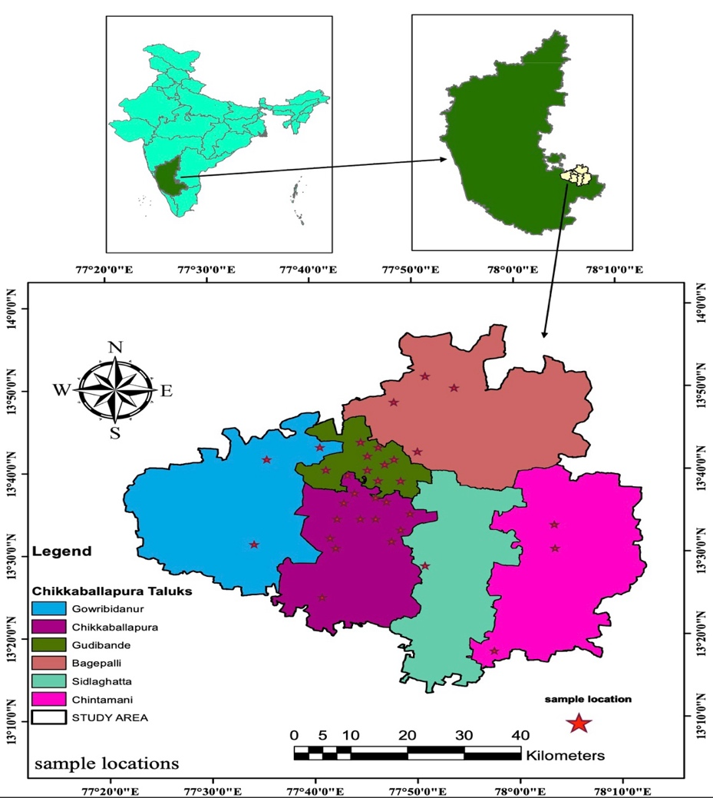
Fig -1 , Location map of Chikkaballapur District.

METHODOLOGY
The characterization of geomorphic units was conducted using an integrated approach involving Remote Sensing (RS) and Geographical Information Systems (GIS). This study followed the standard hierarchical classification system established by the National Remote Sensing Centre (NRSC) and the Geological Survey of India (GSI).
Satellite Data and Image Enhancement
To delineate landforms within the semi-arid, hard-rock setting of the district, multi-temporal satellite data from Landsat 8 OLI and Sentinel-2 MSI were utilized (Clark, 1991). During pre-processing, the datasets underwent radiometric and atmospheric corrections and were standardized to the UTM projection (WGS 84 datum).
For digital enhancement, False Colour Composite (FCC) images were generated to maximize the contrast between lithological variations, vegetation patterns, and geomorphic boundaries (Prenzel et al., 2012). This process facilitated the identification of structural controls and weathered mantles typical of the Eastern Dharwar Craton.
Terrain and Relief Analysis
A 30 m resolution Digital Elevation Model (DEM) from the Shuttle Radar Topography Mission (SRTM) was utilized to evaluate the physical attributes of the landscape (Tarboton et al., 1991). From this, topographic derivatives—including slope, aspect, and hillshade maps—were generated to identify break-of-slope points and differentiate upland units from lowland plains.
Geomorphological mapping was achieved through the integrated visual interpretation of enhanced satellite imagery and DEM derivatives, applying standard criteria such as tone, texture, pattern, and association (Jones, 1996; Lillesand et al., 2015).

RESULTS AND DISCUSSION

Spatial Distribution of Geomorphological Units
The geomorphological mapping of Chikkaballapur District using integrated Remote Sensing (RS) and GIS techniques reveals a landscape dominated by erosional and weathered landforms typical of the hard-rock terrain of the Dharwar Craton. The spatial analysis shows that the Pediplain Weathered/Buried unit is the most extensive geomorphic feature, covering 2,645.16 km² (62.59%) of the total study area (4,226.46 km²) . These landforms represent advanced stages of denudation where prolonged weathering processes have resulted in the formation of thick regolith layers over crystalline bedrock.

The Pediment–Inselberg Complex occupies 611.30 km² (14.46%), representing transitional geomorphic surfaces between uplands and plains. Inselbergs are residual rocky hills formed due to differential weathering and erosion of resistant granitic rocks. Their presence indicates prolonged geomorphic stability and structural control on landscape evolution. These units play a significant role in directing surface runoff and groundwater movement toward adjacent pediplain zones.

Denudational Hills, covering 384.17 km² (9.09%), represent elevated terrains formed by prolonged erosion of granite and gneissic rocks. These hills act as runoff zones and contribute to the recharge of adjoining plains through fracture-controlled percolation. Similarly, Residual Hills (2.20%) and Structural Hills (0.88%) indicate tectonic influence and lithological resistance within the study area.

The Lateritic Plain Shallow unit accounts for 225.49 km² (5.34%), representing zones of intense chemical weathering and iron enrichment. Lateritic formations generally exhibit moderate to low permeability depending on compaction, thereby influencing localized groundwater recharge characteristics.
Surface water features categorized under Water Body Mask (4.96%) primarily represent irrigation tanks and reservoirs, which play a significant role in artificial recharge of groundwater systems in semi-arid regions. Minor geomorphic units such as mesa, butte, pediplain eroded, and flood plains collectively constitute less than 1% of the total geographical area, indicating limited fluvial depositional environments within the district.
The dominance of pediplain and pediment systems indicates that the Chikkaballapur District has undergone prolonged geomorphic evolution under semi-arid climatic conditions, resulting in a mature topography characterized by low relief and extensive weathering mantles.

Geomorphological Control on Groundwater Occurrence
Groundwater occurrence in hard-rock terrains is largely controlled by secondary porosity developed through weathering and fracturing processes. The predominance of Pediplain Weathered/Buried units (62.59%) suggests favorable hydrogeological conditions for groundwater storage due to the presence of thick weathered zones and regolith material. These formations enhance infiltration capacity and act as primary aquifers supporting domestic and agricultural water supply.
Pediment–Inselberg complexes also contribute significantly to groundwater recharge by facilitating lateral subsurface flow from elevated rocky terrains toward lower pediplains. The contact zones between pediments and weathered plains are particularly important for groundwater accumulation due to the presence of fractures and structural discontinuities.
Denudational and structural hills, although occupying smaller spatial extents, influence drainage orientation and slope characteristics. These upland regions typically exhibit higher runoff rates and lower infiltration capacity; however, fracture networks within granitic formations may allow localized groundwater recharge.
Lateritic plains may restrict infiltration due to ferruginous crust formation, thereby reducing groundwater recharge potential in localized zones. However, weathered lateritic horizons may act as perched aquifers in certain conditions.
The spatial distribution of geomorphic units indicates that groundwater potential is not uniform across the district but is strongly dependent on geomorphic setting, weathering thickness, and structural controls.

Influence of Granite Mining on Geomorphological Processes
Granite quarrying activities in Chikkaballapur District are primarily concentrated within denudational hills, pediments, and residual hill complexes where high-quality crystalline rocks are exposed. These geomorphic units serve as natural recharge pathways due to the presence of fractures, joints, and weathered zones.
Mining operations involve blasting, excavation, and removal of overburden material, which significantly alters natural geomorphic processes. The removal of weathered mantle and fractured rock layers reduces infiltration capacity and disrupts natural groundwater recharge mechanisms. Excavation pits created during quarrying may temporarily store rainwater; however, they can also act as zones for contaminant accumulation.
Mining-generated waste materials, including granite slurry and fine rock particles, can be transported during rainfall events and deposited over pediplain surfaces. Due to the high permeability of weathered pediplains, these pollutants can easily percolate into shallow aquifers, potentially degrading groundwater quality.
The alteration of slope geometry due to quarrying may also modify local drainage patterns, increasing surface runoff and reducing infiltration opportunities. Furthermore, siltation of nearby tanks and reservoirs due to mining debris may decrease their storage capacity and reduce artificial recharge potential.

Implications for Groundwater Resource Management
The geomorphological framework derived from RS and GIS analysis provides valuable insights for groundwater management planning in hard-rock terrains affected by mining activities. Pediplain weathered zones and pediment interfaces represent high groundwater potential zones and should be prioritized for conservation and artificial recharge interventions.
Recharge enhancement structures such as check dams, percolation tanks, and recharge shafts can be effectively implemented within pediplain regions to improve groundwater availability. Protection of fracture-controlled recharge zones within pediment and denudational hill regions is essential for maintaining sustainable groundwater levels.
Mining activities should be regulated in geomorphologically sensitive zones to minimize adverse impacts on groundwater recharge processes. Environmental management strategies should include scientific reclamation of abandoned quarries, stabilization of overburden dumps, and periodic monitoring of groundwater quality.
Integration of geomorphological analysis with hydrogeological data provides a scientific basis for identifying groundwater potential zones and supports sustainable water resource management in semi-arid hard-rock terrains.

Mapping Units and GIS Framework
The primary geomorphic units identified included:
- Pediplain Weathered/Buried
- Pediment - Inselberg Complex
- Denudational Hills
- Lateritic Plain Shallow
- Water Body Mask
- Residual Hill
- Structural Hills (Small/Large)
- Pediplain Eroded
- Others (Mesa, Butte, Flood Plain)

List 1-Primary Geomorphic units
These units were digitized and assigned specific geomorphic and topographic attributes within a GIS environment to analyze their spatial distribution across the Chikkaballapur District (Kale and Gupta, 2001; Singh, 2013).

Validation and Cartographic Output
The preliminary geomorphological map was validated through GPS-based field surveys to document surface lithology, weathering profiles, and structural controls (Kadalli and Devappa, 2022). Field observations were cross-referenced with regional reports from the Central Ground Water Board (CGWB) and foundational hydrogeological literature (Karanth, 1987). The study culminated in the preparation of a final Geomorphological Map at a 1:50,000 scale, ensuring a scientifically rigorous characterization of the landforms within the study area.

Fig 2.Geomorphology map of Chikkallabapur District

The quantitative analysis of the district's landforms reveals a mature landscape dominated by erosional and weathered surfaces.
Table 1: Spatial Distribution of Geomorphological Units
Geomorphological Unit | Area (km²) | Percentage (%)
Pediplain Weathered/Buried | 2,645.16 | 62.59
Pediment - InselbergComplex | 611.30 | 14.46
Denudational Hills | 384.17 | 9.09
Lateritic Plain Shallow | 225.49 | 5.34
Water Body Mask | 209.80 | 4.96
Residual Hill | 92.85 | 2.20
Structural Hills (Small/Large) | 33.72 | 0.88
Pediplain Eroded | 19.19 | 0.45
Others (Mesa, Butte, Flood Plain) | 4.78 | 0.03
Grand Total | 4,226.46 | 100.00

Dominant Landforms
Pediplain Weathered/Buried (62.59%): Covering 2,645.16 km2, this is the most extensive unit. It represents a mature stage of landscape evolution where the bedrock is covered by a significant layer of weathered material (regolith). This unit is the primary repository for groundwater in the district.
Pediment-Inselberg Complex (14.46%): These units represent the transition from the hills to the plains. The presence of inselbergs (isolated hills) suggests a landscape undergoing advanced denudation.
Upland and Structural Features
Denudational Hills (9.09%): These are residual hills formed by the differential weathering of granitic and gneissic rocks. They act as primary runoff zones, feeding the surrounding pediplains.
Structural Hills (0.88% combined): Though spatially limited, these hills follow specific geological lineaments and often influence the drainage network orientation.
Specialized Landforms
Lateritic Plain Shallow (5.34%): These plains indicate specific chemical weathering crusts, often found in the higher elevation zones of the district, affecting the infiltration rates.
Water Body Mask (4.96%): This represents the spatial extent of surface water resources, primarily irrigation tanks (Keres), which are essential for artificial groundwater recharge in this water-stressed region.

Geomorphological Controls on Mining Impact;
The geomorphological setup of Chikkaballapur District creates a specific environment where anthropogenic activities, particularly granite mining, can have localized yet profound impacts on the hydrogeological regime.
Mining within the Denudational and Residual Landscape;
The Denudational Hills (9.09%) and Residual Hills (2.20%) are often the primary targets for granite quarrying due to the exposure of high-quality crystalline rock. These landforms naturally function as "recharge catalysts," where vertical fractures allow precipitation to infiltrate and move toward the lower-lying plains.
Impact: Extensive quarrying of these hills removes the natural protective cover and can alter the primary recharge pathways. The removal of hill mass can lead to a decrease in the hydraulic head that naturally drives groundwater flow into the surrounding pediplains.

Pollutant Transport in the Pediplain Weathered/Buried (62.59%);
The dominance of weathered pediplains indicates a pervasive regolith layer. While this is beneficial for groundwater storage, it also acts as a primary medium for the transport of mining-induced contaminants.Fine granite dust (slurry) and chemical residues from mining activities can settle on these flat surfaces. During monsoon events, these pollutants are easily leached through the weathered zone (62.59% of the area), potentially leading to increased turbidity and trace metal concentrations in the shallow aquifers tapped by local borewells.

Risk to Water Bodies (4.96%);
The Water Body Mask represents the critical surface-water-to-groundwater interface. In regions like Chikkaballapur, where pediplains are extensively weathered, these tanks are vital for maintaining the water table.If mining operations are located in the catchment areas of these water bodies, the resultant siltation can reduce the storage capacity of the tanks and block the natural pores required for effective infiltration, leading to a long-term decline in regional water levels.

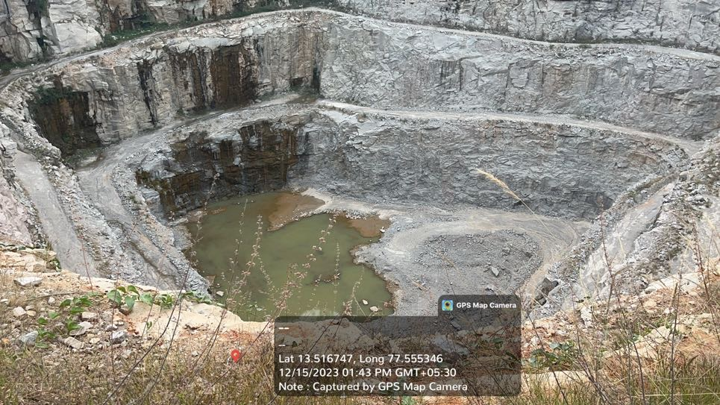
Quarry near Arasalubande

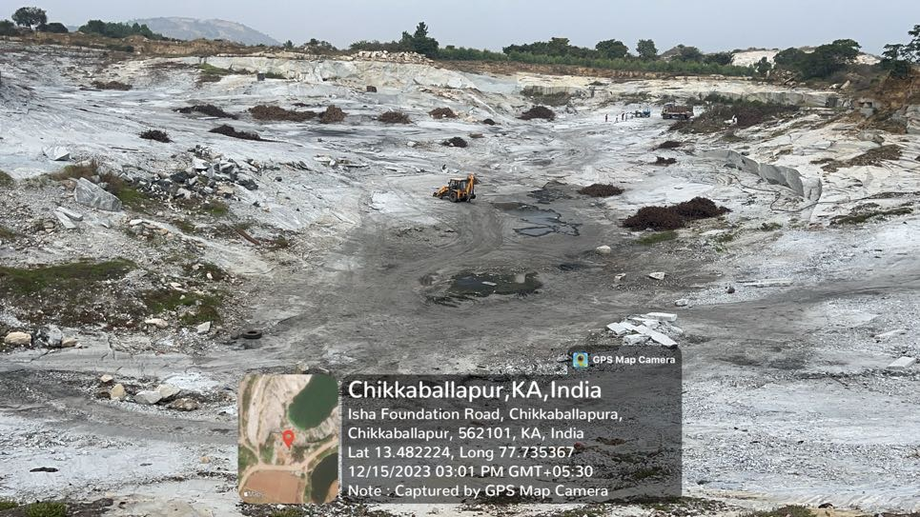
Quarry near Lingashettipura (Pediment inselberg complex)

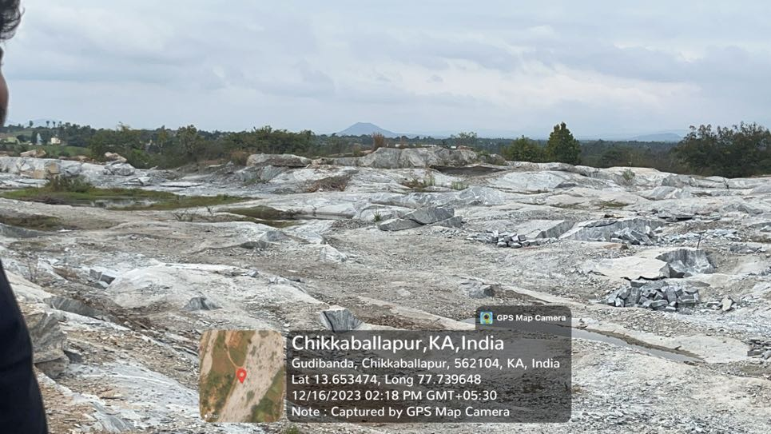

Quarry near Uppakuntanahalli (Pediment)
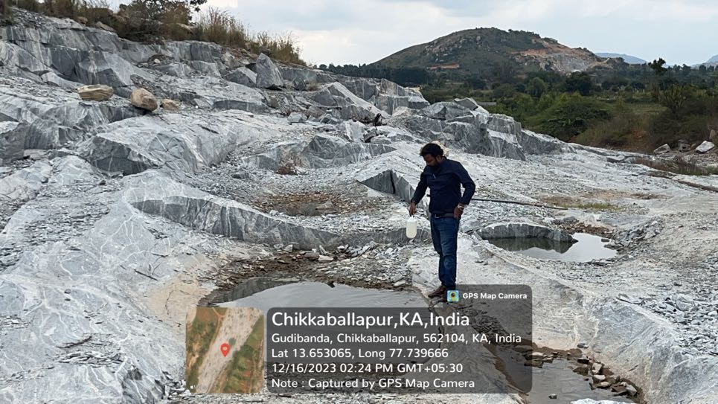

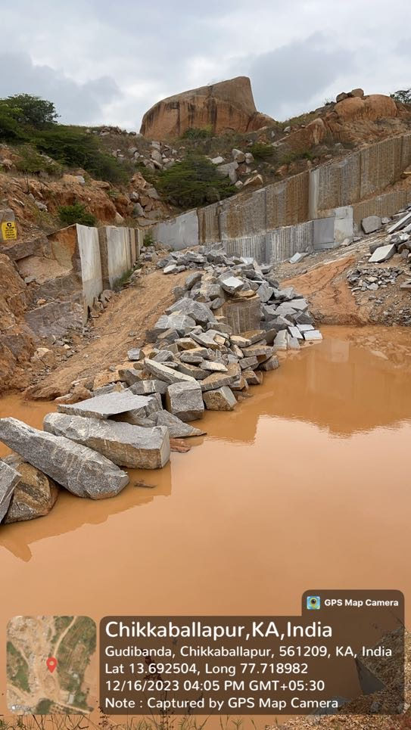

Quarry near Anupanahalli (Pediment)

Fig 3.Field Photograps of Chikkallabapur

Conclusion
The geomorphological investigation of the Chikkaballapur District reveals a landscape heavily influenced by the hard-rock characteristics of the Dharwar Craton. The study successfully quantified the spatial distribution of landforms, establishing that Pediplain Weathered/Buried units are the dominant geomorphic feature, covering approximately 62.59% of the study area. These units, along with Pediment–Inselberg complexes, serve as the primary indicators for subsurface water storage.
The research highlights several critical points for groundwater management:
Geomorphic Control: In this hard-rock terrain, groundwater occurrence is not uniform but is strictly governed by the thickness of the weathered mantle, fracture systems, and structural discontinuities.
Recharge Potential: By mapping these geomorphological units using RS and GIS techniques, the study identifies specific zones that are more conducive to groundwater recharge. This is particularly vital in the Chikkaballapur District, where semi-arid conditions limit surface water availability.
- Impact of Mining: The study underscores that in mining-affected regions, the alteration of geomorphic characteristics can significantly disrupt natural recharge conditions and lead to contamination, specifically fluoride issues as noted in the keywords.
- Management Strategy: The findings provide a scientific framework for local authorities to implement sustainable groundwater management. Future efforts should focus on protecting high-recharge geomorphic units from intensive mining activities to prevent further depletion and quality degradation of this vital resource.
In summary, integrating geomorphological analysis into regional planning is essential for ensuring water security and mitigating the environmental impacts of granite mining in the Chikkaballapur region.

Recommendations
The geomorphological distribution of Chikkaballapur District highlights a area that is highly dependent on its weathered mantle for water security. The study suggests that:
- Buffer Zones: Mining activities should be strictly regulated in areas identified as Pediment-Inselberg Complexes, as these are critical transition zones for water movement.
- Reclamation: Quarrying in Denudational Hills must be followed by scientific reclamation to prevent the permanent loss of recharge potential.
- Monitoring: Systematic groundwater quality monitoring is essential in the Pediplain Weathered zones surrounding active mining clusters to track the migration of potential contaminants.

References

- Adiga, S., and Shastry, G., 2015. Impact of granite quarrying on landform and drainage: A case study from eastern Karnataka. International Journal of Geosciences, V.6(4), pp.423–432.
- Central Ground Water Board (CGWB) (2020). Ground Water Year Book - Karnataka Cluster. Ministry of Jal Shakti, Government of India. (Essential for citing the 2014–2024 regional trends).
- CGWB, 2023. Ground Water Year Book – Karnataka State. Central Ground Water Board, Ministry of Jal Shakti, Government of India.
- Choubey, V.D., (1991). Hydrological and environmental impact of mining in hard rock terrains. Environmental Geology, V.18(3), pp.153–160.
- Clark, R.N., (1999). Spectroscopy of rocks and minerals and principles of spectroscopy. Manual of Remote Sensing. John Wiley and Sons.
- Egbueri, J. C. (2022) Incorporation of information entropy theory, artificial neural network, and soft computing models in the development of integrated industrial water quality index. Environmental Monitoring and Assessment V.194 (10). https://doi.org/10.1007/s10661-022- 10389-x.
- Egbueri, J.C., (2022). Integrated industrial water quality index using entropy theory and neural network model. Environmental Monitoring and Assessment, V.194(10), pp.1–18.
- Elubid, B.A., Rahman, M.M., and Karmaker, T., (2019). Integration of GIS and remote sensing for groundwater potential mapping. Sustainable Water Resources Management, V.5, pp.1453–1467.
- Galero, D.M., Pesci, H.E. and Depetris, P.J. (1998). Effects of quarry mining and of other environmental impacts in the mountainous Chicam-Toctina drainage basin (Cordoba, Argentina), Environ. Geol. V.XXXIV, pp.159–166.
- Galero, D.M., Pesci, H.E., and Depetris, P.J., (1998). Effects of quarry mining in mountainous drainage basins. Environmental Geology, V.34, pp.159–166.
- Gayatri Singh., Khoiyangbam R S. and Amit Pal. Assessment of Groundwater Quality in Granite Mining Areas of Bijauli in Bundelkhand Region of India Institute of Environment and Development Studies, Bundelkhand University. V.3, pp.1563–1567.
- Geological Survey of India (GSI) (2020). Manual on Geomorphological Mapping. Special Publication Series. (Standardizes the nomenclature for "Pediplain Weathered" and "Denudational Hills").
- GSI, (2020). Manual on Geomorphological Mapping. Geological Survey of India.
- Hosamani, S. (2021). Spatial Analysis of Groundwater Quality and Landform Interaction in Mining Districts of Karnataka. Environmental Earth Sciences.
- Hosamani, S.,(2021). Spatial analysis of groundwater quality in mining districts of Karnataka. Environmental Earth Sciences, V.80, pp.1–15.
- Jafar Ahamed, A., Ananthakrishnan, S., Loganathan, K. and Manikandan, K. (2013) Assessment of groundwater quality for irrigation use in Alathur Block, Perambalur District, Tamilnadu, South India. Applied Water Science V.3 (4), pp.763–771.
- Jafar Ahamed, A., Ananthakrishnan, S., Loganathan, K., and Manikandan, K., (2013). Assessment of groundwater quality for irrigation use. Applied Water Science, V.3(4), pp.763–771.
- Kadalli, N.M., and Devappa, M., (2022). Field validation methods in geomorphological mapping. Journal of the Geological Society of India, V.98(2), pp.215–224.
- Kale, V.S.and Gupta, A., (2001). Introduction to Geomorphology. Orient Longman.
- Karanth, K. R. (1987). Groundwater Assessment, Development, and Management. Tata McGraw-Hill. (A foundational text for Indian hydrogeology, particularly for crystalline basement aquifers).
- Lillesand, T., and Kiefer, R.W., Chipman, J., (2015). Remote Sensing and Image Interpretation, 7th ed. Wiley.
- NRSC (2011). National Geomorphological and Lineament Mapping on 1:50,000 Scale. Indian Space Research Organization (ISRO). (The authority for the classification of Pediment-Inselberg Complexes in hard-rock terrains).
- NRSC, (2011). National Geomorphological and Lineament Mapping on 1:50,000 scale. ISRO.
- Rajmohan, N., and Elango, L., (2005). Nutrient chemistry of groundwater in hard rock aquifers. Environmental Geology, V. 47, pp.885–893.
- Reddy, P. R., (2018). Geomorphology and Groundwater Resources in the Hard Rock Terrains of Southern India. Journal of the Geological Society of India. (Directly relevant to the Dharwar Craton and Chikkaballapura landscape).
- Reddy, P.R.,., (2018). Geomorphology and groundwater resources in hard rock terrains of southern India. Journal of the Geological Society of India, V.91(2), pp.197–206.
- Subramanya, K. (2013). Engineering Hydrology. McGraw-Hill Education. (Standard reference for calculating runoff and infiltration changes in modified landscapes).
- Tarboton, D.G., (1997). Determination of flow direction and upslope area in DEM. Water Resources Research, V.33(2), pp.309–319.

