Original research Article

Epidote-and Plumose Quartz-bearing Granodiorites of the Hayuliang Granitoids, Arunachal Pradesh, India: Mineral Chemistry and Petrogenetic implications

Abstract
Hayuliang granitoids are the products of felsic/acidic magmatism in and around Hayuliang locality. It is a part of the Lohit Plutonic Complex (also known as Mishmi massif) which is located at the Trans-Himalayan belt of Arunachal Himalayas. Granodiorites containing magmatic epidotes and plumose quartz provide critical constraints on magma oxidation state, volatile content, and depth of emplacement. The Hayuliang granitoids of Arunachal Pradesh, NE India represent a distinctive suite of calc-alkaline granodiorites characterized by the stable coexistence of epidote and plumose quartz. EPMA data indicates moderate pistacite contents (Ps $≈$ 20 -30), low Ti and Mn, and systematic Fe³⁺-Al substitution in epidote, consistent with a primary to late magmatic origin. Discrimination diagrams based on epidote mineral chemistry and whole-rock tectonic plots collectively suggest crystallization from oxidize, water-rich I-type magmas emplaced at mid-crustal depths in a convergent margin tectonic settings. Petrographic study of granodiorites reveals characteristic plumose extensional fracture patterns and radiating feather-like growths developed on healed microfractures. EPMA spot analyses of multiple plumose domains in granodiorites show high silica contents (SiO₂ $≈$93-100 wt%), consistent with nearly pure quartz overgrowth formed during low pressure and Si-rich fluid infiltration. Plumose overgrowths indicate multiple pulses of metasomatism and episodic fluid flow contemporaneous with late-stage cooling and emplacement related stress release. These findings highlight the role of brittle-hydrothermal processes in modifying granitoid textures and provide a micro-structural framework for interpreting episodic fluids activity in shallow magmatic system. Major oxides, trace elements, rare earth elements (REEs), CIPW norms and elemental ratios are used to constrain magma type, petrogenesis and tectonic setting. The data indicate calc-alkaline, sodic metaluminous granodiorite formed in a subduction related syn- to post-collisional environment with significant plagioclase controlled and late-stage silica-rich fluids.
Key words: Epidote-bearing granodiorite; Plumose-quartz; EPMA; Calc-alkaline magmatism; Hayuliang granitoids

- Introduction
Hayuliang granitoids of Lohit Plutonic Complex (LPC) occurs at the eastern corner of Arunachal Himalayas. Magmatic epidote is a relatively uncommon mineral phase in granitoids due to its restricted stability field, requiring high oxygen fugacity, high water activity, and moderate to high pressures. Granodiorites containing epidotes, particularly those associated with distinctive plumose quartz, therefore provide important insights into magma evolution and emplacement conditions. In the Hayuliang region of Arunachal Pradesh, epidote-and plumose quartz bearing granodiorites form an integral part of the Hayuliang granitoids and offer an excellent opportunity to evaluate the physico-chemical conditions of calc-alkaline magmatism along the eastern Himalayan margin, Cornelius (1915) recognized epidote as a magmatic mineral in the alpine Bergell tonalite. Later, Zen and Hammarstrom (1984) identified epidote as an important magmatic phase of intermediate calc-alkaline intrusives in plutons and followed by workers like Schmidt and Poli (2004). Whole-rock geochemistry is a fundamental tool in igneous petrology for understanding magma composition, source characteristics, differentiation processes and tectonic environments. Granodiorites containing plumose quartz represent a distinctive lithological variant within the Hayuliang Granitoid complex. The development of quartz textures indicates late-stage brittle fracturing and silica precipitation, making these rocks particularly valuable for integrating magmatic and post-magmatic processes. This paper aims to interpret the mineralogical and geochemical characteristics of these granodiorites and relate them to regional tectono-magmatic evolution.

- Geology of the study area
The Hayuliang granitoids form part of the Eastern-Himalayan-foreland magmatic assemblage intruding older meta-sedimentary and meta-volcanic country rocks during the Mesozoic-Cenozoic (Fig. 1). These granitoids are predominantly medium to coarse-grained, ranging in composition from granodiorites to diorites, and are spatially associated with mafic enclaves and discrete gabbroic bodies. Field relationships, structural fabrics, and petrographic observations suggest syn-to post-tectonic emplacement of these granitoids, closely linked with regional Himalayan deformation. The presence of microfractures, shear-related fabrics and secondary mineral growth indicates significant post emplacement deformation and fluid activity, conditions conducive to the development of plumose quartz. Regional deformation, crustal thickening and fluid activity have strongly influenced magma evolution and emplacement. Field exposures show textural heterogeneity and locally display sub-solidous hydrothermal alterations including sericitization, saussuritization, chloritization and carbonate veins.
Fig. 1 Geological map of the study area (modified after Rino et al., 2023). Red dots represent sampling sites

- Petrography
The granodiorite are medium-to coarse-grained and composed mainly of plagioclase, quartz, hornblende, K-feldspar (orthoclase) and biotite with epidote as an important accessory phase. Other accessory minerals include magnetite $±$ apatite $±$ zircon $±$ sphene. Texturally, the rock ranges from hypidiomorphic granular to locally porphyritic. Epidote occurs as euhedral to subhedral grains, commonly included within plagioclase and quartz, indicating crystallization during early to late-stages of magma solidification. Plumose quartz appears as feathery, radiating aggregates along microfractures suggesting rapid silica precipitation from volatile rich residual melts and magmatic fluids (Fig. 2). This feather like texture is called feathery texture by Adams (1920) and plumose texture by Sander and Black (1988). This texture indicates recrystallization of silica (Dong et al., 1995). Plagioclase often shows sericitization and saussuritization but retains its relict lamellar twinning. Orthoclase also often shows sericitization. Plumose quartz occurs as discrete populations: intragranular plumose domains, commonly bounding sub-rounded inclusions and showing suture margins. Inter-granular fracture-fill plumose quartz: plumose fibers lining microcracks at grain boundaries with plagioclase. Under cross polarized light, plumose quartz domains show undulatory extinction and locally low-order interference colours consistent with rapid crystallization under stress. Inclusion trails of fine mica and iron-oxide along the feather axes suggest syn- to post-deformational precipitation. Such textural features point towards secondary quartz growth rather than primary magmatic crystallization. Presence of magmatic epidote, calcic plagioclase and amphibole suggests crystallization under moderately high pressures and oxidizing conditions. Such conditions are typical of lower to middle continental crustal levels and are consistent with syn-to post-tectonic emplacement within an active orogenic belt.
Modal mineralogy
Modal estimates indicate plagioclase (40-55 vol%), quartz (20-30 vol%), K-feldspar (10-18 vol%), biotite (5-10 vol%) and hornblende (2-8 vol%) with accessories forming less than 5 vol%. The mineral assemblage is typical of calc –alkaline granodiorites.
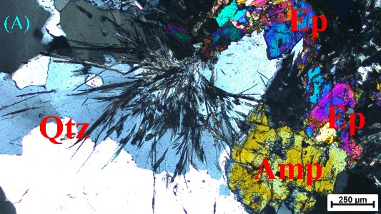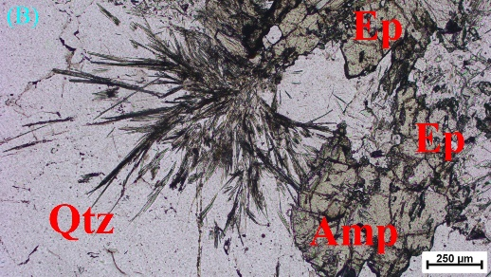
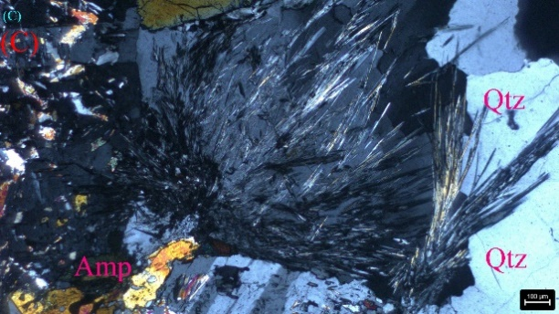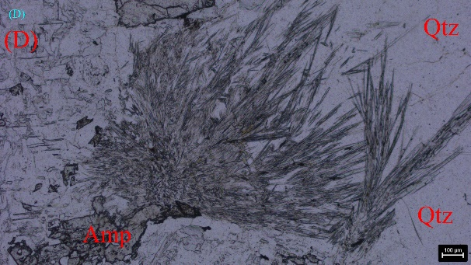
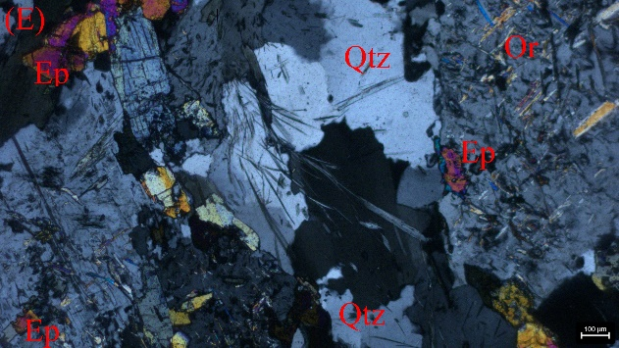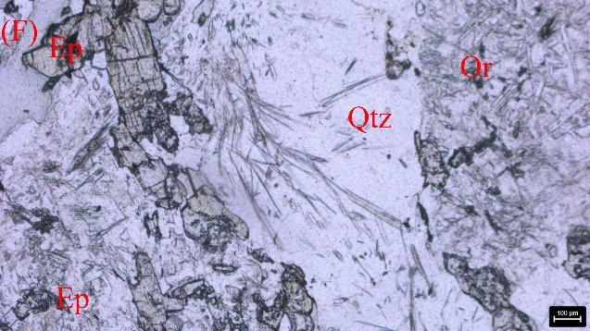
Fig. 2 Granodiorites showing plumose texture (XPL view - A,C & E : PPL view – B, D & F). A & B show plumose-quartz with magmatic epidote: C & D show plumose quartz associated with plagioclase and amphiboles : E & F show Plumose quartz and highly altered plagioclase.

- Analytical Methods
Representative fresh samples (HG22 and HG32) were analysed for major oxides and trace elements including REEs by using XRF and ICPMS. Major oxides and trace elements including REEs are studied at Wadia Institute of Himalayan Geology, Dehradun using XRF-Bruker, Tiger, SB and Agilent 8900 ICPMS/MS. CIPW norms were calculated to assess mineralogical proportions and magma affinity. Petrographical analysis is done at Department of Geology, Imphal College, Imphal using Polarizing microscope RXLr-5 NxPOL. Mineral chemistry of the plumose quartz and epidote of sample no. HG21 is determined by CAMECA-SX-EPMA at the Department of Geology, Banaras Hindu University. Pressure, temperature, oxygen fugacity and depth of emplacement of the granodiorites are calculated using the tools like Thermo-Calc. Other tools like MintPlotX is used for EPMA data analyses, and GCD kit for major, traces and REE analyses.

- Results and discussion
  - Major element geochemistry
The granodiorites contain ~64wt% SiO₂, indicating intermediate to felsic composition, high Al₂O₃ (16.8-17.9wt%) suggest aluminous character while Na₂O (5.6-5.9wt%) exceeds K₂O (1.5-1.9wt%), reflecting sodic calc-alkaline affinity. Low MgO and Fe₂O₃ indicate evolved melts. Loss on ignition values are low, indicating minimal alteration. CIPW norms show dominance of albite and quartz with minor orthoclase and anorthite, confirming granodioritic composition (Table 1).
Table 1: Major oxides (in wt%), trace elements (in ppm), REEs (in ppm) and some ratios of epidote- and plumose quartz-bearing granodiorites
Major elements |  |  | Trace elements and some ratios |  |  | REE and some ratios
Sample No. | HG22 | HG32 | Elements | HG22 | HG32 | REE | HG22 | HG32
SiO₂ | 64.26 | 64.04 | Ba | 608.18 | 229.37 | ¹³⁹La | 1.332 | 3.480
TiO₂ | 0.28 | 0.46 | Co | 65.00 | 109.00 | ¹⁴⁰Ce | 3.036 | 8.118
Al₂O₃ | 17.92 | 16.81 | Cr | 15.00 | 24.00 | ¹⁴¹Pr | 0.444 | 1.242
Fe₂O₃ | 2.44 | 3.37 | Cu | 13.63 | 12.61 | ¹⁴⁶Nd | 1.962 | 5.550
MnO | 0.04 | 0.04 | Ga | 17.00 | 21.00 | ¹⁴⁷Sm | 0.438 | 1.452
MgO | 1.46 | 1.67 | Nb | 0.43 | 2.27 | ¹⁵³Eu | 0.786 | 1.734
CaO | 3.28 | 3.74 | Ni | 3.00 | 2.00 | ¹⁵⁷Gd | 0.060 | 0.240
K₂O | 1.86 | 1.54 | Pb | 13.54 | 5.47 | ¹⁵⁹Tb | 0.102 | 0.576
Na₂O | 5.60 | 5.88 | Rb | 37.02 | 12.65 | ¹⁶³Dy | 0.036 | 0.294
P₂O₅ | 0.11 | 0.17 | Sc | 3.00 | 4.00 | ¹⁶⁵Ho | 0.174 | 1.716
LOI | 1.59 | 1.88 | Sr | 1147.69 | 495.43 | ¹⁶⁶Er | 0.078 | 0.864
Total | 97.25 | 97.72 | Th | 1.30 | 1.06 | ¹⁶⁹Tm | 0.012 | 0.126
CIPW NORMS |  |  | V | 50.00 | 74.00 | ¹⁷²Yb | 0.060 | 0.756
Quartz | 14.44 | 13.12 | Y | 14.00 | 14.00 | ¹⁷⁵Lu | 0.012 | 0.120
Orthoclase | 11.43 | 9.46 | Zn | 103.76 | 55.91
Albite | 47.39 | 49.75 | Zr | 39.53 | 31.00 | (La/Lu)_{N} | 11.45 | 3.00
Anorthite | 15.77 | 14.74 | Hf | 1.28 | 0.95 | (Ce/Yb)_{N} | 13.75 | 2.94
Corundum | 0.84 | 0.00 | Ta | 0.00 | 0.01 | (Eu_{N}/Eu*) | 14.56 | 8.82
Diopside | 0.00 | 2.37 | U | 0.23 | 0.33
Hypersthene | 5.47 | 5.38 | K/Rb | 417.12 | 1010.68
Olivine | 0.00 | 0.00 | Rb/Sr | 0.03 | 0.03
Ilmenite | 0.53 | 0.87 | Ga/Al | 1.79 | 2.36
Magnetite | 1.06 | 1.46
Apatite | 0.25 | 0.39
Zircon | 0.03 | 0.03

5.2 Trace Element Geochemistry
Trace elements show strong enrichment of Large Ion Llithophile Elements (Ba, Sr) and depletion of High Field Strength Elements (Nb, Ta), characteristic of subduction-related magmas (Table 1). Low Rb/Sr ratios indicate limited crustal residence, whereas K/Rb variability reflects feldspar fractionation and fluid interaction. The overall trace element signature support a subduction-modified mantle or lower crustal source.

5.3 Rare Earth Elements Geochemistry
REE pattern show LREEs enrichment relative to HREEs. Sample HG22 displays strong fractionation, whereas HG32 shows flatter patterns. Positive Eu anomaly in both sample indicates plagioclase retention in the source. These features suggest partial melting of a plagioclase bearing amphibolitic source.

5.4 Mineral Chemistry
Electron Probe Micro Analyzer (EPMA) data reveals that epidotes from the granodiorites are characterized by Si $≈$3 .00 apfu, Al^{vi} values of ~ 2.15-2.35 apfu, and Fe³⁺ contents of ~0.65-0.90 apfu (Table 3). Pistacite components range mainly between 22 and 30%. The limited variations in Ti and Mn, coupled with systematic Fe³⁺-Al substitution, supports crystallization of epidote under high-temperature, oxidized conditions rather than low temperature hydrothermal alterations.
EPMA studies of plumose quartz bearing granodiorites from the Hayuliang granitoids of Arunachal Pradesh reveal a chemically simple yet petrologically significant mineral phase. EPMA analysis indicate plagioclase compositions in the oligoclase-andesine range, biotite with moderate Mg# and amphibole compositions typical of magmatic hornblende. The analyses show that plumose quartz is overwhelmingly dominated by SiO₂, with concentrations ranging from ~93 to100 wt% (Table 2), confirming its high chemical purity. Minor analytical values exceeding 100wt% are attributed to instrumental limitations and the extremely low abundance of other oxides near detection limits. Among the trace components, MgO is the most consistently detected oxide, typically present in very low amount. Other oxides such as Al₂O₃, CaO, FeO, Na₂O, K₂O, MnO and NiO are either present at negligible levels or absent.
EPMA traverses across plumose quartz aggregates show chemical homogeneity in SiO₂ reflecting episodic quartz precipitations during microfracturing and fluid infiltrations. The overall mineral chemistry supports a secondary, deformation-related origin of plumose quartz, formed from silica-rich hydrothermal fluids during post-emplacement tectonic activity in the Hayuliang granitoids. Tectonic loading, late-stage cooling contraction or emplacement related stresses create a dense network of micro-fractures ($μ$m to mm) scale in the host quartz. These fractures are commonly sub-planar to dendritic and provides the physical space for fluid entry. Late -magmatic to hydrothermal fluids are enriched in silicon-dioxide. Changes in P-T or fluid chemistry cause silica supersaturation locally along fracture walls and at crack tips. Nucleation and crystal growth kinetics (supersaturation, temperature, presence of impurities or trace elements) control crystal size, branching and preservation of plumose morphology. Trace elements or micro inclusions retained in the quartz, and compositional zoning detectable by EPMA, can record fluid chemistry changes during successive growth pulses.
Table 2: Electron micro probe analysis data (wt%) of plumose quartz (sample no. HG21)
Spot no. | SiO₂ | MgO | CaO | FeO | Al₂O₃ | MnO | K₂O | Na₂O | NiO | F | Cl | Total
21/NC1 | 95.21 | 2.30 | 2.03 | 0.58 | 0.11 | 0.00 | 0.01 | 0.00 | 0.00 | 0.18 | 0.08 | 100.50
21/N1 | 93.06 | 3.69 | 0.00 | 1.49 | 2.54 | 0.03 | 0.13 | 0.06 | 0.17 | 0.07 | 0.08 | 101.33
21/N2 | 93.29 | 2.24 | 0.09 | 1.03 | 1.72 | 0.00 | 0.13 | 0.04 | 0.29 | 0.28 | 0.00 | 99.11
21/N3 | 100.44 | 0.07 | 0.00 | 0.06 | 0.00 | 0.00 | 0.01 | 0.00 | 0.03 | 0.07 | 0.09 | 100.68
21/NC2 | 100.14 | 0.00 | 0.00 | 0.08 | 0.00 | 0.00 | 0.00 | 0.00 | 0.00 | 0.05 | 0.13 | 100.40

Table 3. Electron micro probe analysis data (wt%) of epidote (sample no. HG21)
Sample No. | 21_ Epd5 | 21_ Epd7 | 21_Epd C2 | 21_Epd8 | 21_EpdR3 | 21_EpdC3 | 21_Epd C5 | 21EpdC6
SiO₂ | 38.23 | 36.39 | 38.03 | 36.41 | 36.26 | 36.86 | 36.29 | 37.13
TiO₂ | 0.02 | 0.34 | 0.03 | 0.01 | 0.11 | 0.08 | 0.10 | 0.07
Al₂O₃ | 22.95 | 21.50 | 23.52 | 22.42 | 21.75 | 23.45 | 21.95 | 21.47
FeO | 11.85 | 11.99 | 9.69 | 11.50 | 12.59 | 9.76 | 12.06 | 13.10
MnO | 0.37 | 0.10 | 0.18 | 0.26 | 0.14 | 0.12 | 0.16 | 0.23
MgO | 0.02 | 1.75 | 0.00 | 0.01 | 0.00 | 0.00 | 0.00 | 0.00
CaO | 23.60 | 20.53 | 23.50 | 23.49 | 23.66 | 23.96 | 23.40 | 22.89
Na₂O | 0.00 | 0.00 | 0.02 | 0.02 | 0.00 | 0.01 | 0.00 | 0.01
K₂O | 0.00 | 0.99 | 0.00 | 0.00 | 0.00 | 0.00 | 0.00 | 0.00
Total | 97.04 | 93.59 | 94.98 | 94.12 | 94.52 | 94.26 | 93.96 | 94.91
Structural formula based on 12.5 oxygen atom
Si | 3.00 | 3.00 | 3.00 | 3.00 | 3.00 | 3.00 | 3.00 | 3.00
∑T | 3.00 | 3.00 | 3.00 | 3.00 | 3.00 | 3.00 | 3.00 | 3.00
^{vi}Al | 2.21 | 2.16 | 2.19 | 2.34 | 2.18 | 2.31 | 2.20 | 2.14
Ti | 0.00 | 0.02 | 0.00 | 0.00 | 0.01 | 0.01 | 0.01 | 0.00
Fe³ | 0.79 | 0.83 | 0.64 | 0.79 | 0.89 | 0.65 | 0.85 | 0.91
Mn³ | 0.03 | 0.01 | 0.01 | 0.02 | 0.01 | 0.01 | 0.01 | 0.02
∑M | 3.03 | 3.02 | 2.84 | 3.15 | 3.09 | 2.98 | 3.07 | 3.07
Ca | 2.07 | 1.87 | 2.08 | 2.13 | 2.15 | 2.15 | 2.13 | 2.07
∑A | 2.07 | 1.87 | 2.08 | 2.13 | 2.15 | 2.15 | 2.13 | 2.07
Ps (Pistacite) | 26.33 | 27.76 | 22.61 | 25.24 | 28.99 | 21.96 | 27.87 | 29.84

5.5 P-T-fO₂ Constraints on Epidote and plumose quartz-bearing granodiorites
The pressure–temperature-oxygen fugacity (P-T-fO₂) conditions of crystallization were evaluated using epidote mineral chemistry. The stability of magmatic epidote requires high oxygen fugacity conditions and moderate to high pressures. In the Hayuliang granodiorites, epidote compositions characterized by moderate pistacite contents and systematic Fe³⁺-Al substitution indicates crystallization under oxidized conditions. Temperatures of epidotes stability are constrained to ~500-700⁰C, corresponding to late stage crystallization of hydrous granodioritic melts near the solidus. EPMA data demonstrated that the granodiorite of Hayulinag granitoids were emplaced as hydrous, oxidized, calc-alkline plutons, consistent with magmatism in an active continental arc to collisional setting.
The multi-panel Figure 3(A-C) illustrate the integrated P-T–fO₂-Depth evolution of the Hayuliang granodiorites, Arunachal Pradesh, derived from EPMA constrained epidote compositions. Figure 3A depicts a systematic decrease in pressure with falling temperature, defining a coherent cooling-decompression trajectory. The early magmatic stage is represented by high-T (~750-800ºC) and pressures of ~6-7Kbar, corresponding to mid-crustal conditions (~18-22Km). The downward trend towards lower pressures (~2-3Kbar) and temperatures (~500-650⁰C) reflects slow magma ascent and progressive cooling. Such a P-T path is characteristic of granodioritic magmas emplaced incrementally within the continental crust allowing preservation of primary magmatic epidote. Figure 3B illustrates the redox evolution of the magma during cooling. Oxygen fugacity values fall within the FMQ-NNO buffer range. Throughout most of the temperature interval, indicating persistently oxidizing conditions. These conditions are consistent with EPMA-derived pistacite contents (Ps = 21-30mol%) of epidote from granodiorites and associated rocks. The slight decrease in fO₂ with falling temperature suggest buffered redox conditions during crystallization, typical of water rich arc-related granitoid magmas. Figure 3C shows a near-linear relationship between pressure and depth, approximating lithostatic conditions. Emplacement depths inferred from this relationship range from ~15-22Km during early crystallization to ~6-10Km during late magmatic to sub-solidous stages.
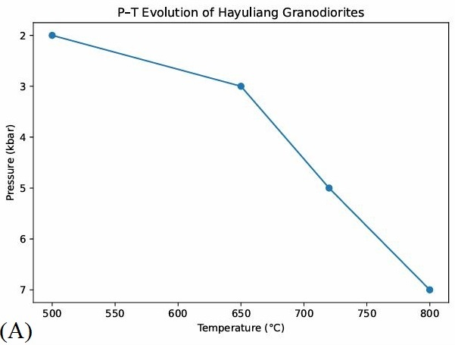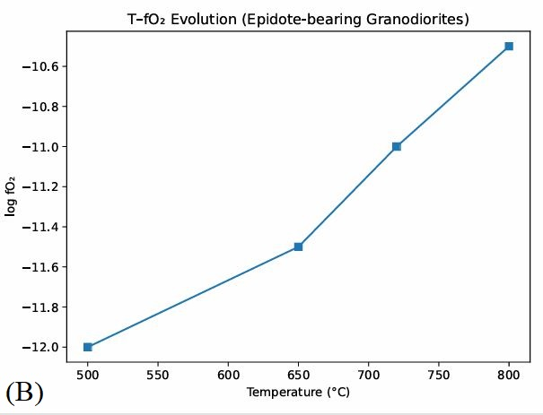
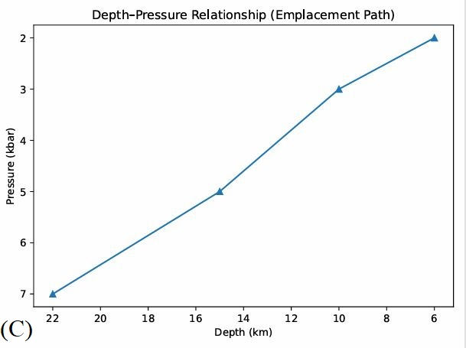
Fig. 3 (A) P-T path of granodiorites; (B) T-fO₂ evolution of granodiorites (C) Pressure-Depth relationship of granodiorites

5.6 Petrogenesis
The Hayuliang granodiorites of Arunachal Pradesh exhibit pronounced crustal affinity, as evidenced by their whole rock geochemistry, rare earth element (REE) characteristics and mineral chemical signatures. Major element compositions marked by high SiO₂ and Al₂O₃, moderate K₂O and low MgO contents indicate evolved felsic magmas generated through extensive differentiation and crustal involvement. The geochemical data suggest magma generation through partial melting of a hydrous mantle wedge or lower crust influenced by slab-derived fluids, fractional crystallization of plagioclase, amphibole and accessory minerals controlled magma evolution. Limited crustal assimilation is indicated by low Rb/Sr ratios.
The primitive mantle normalized multi-elements spider diagram show enrichment in LILEs (Rb, Ba, Sr) and distinct depletion in HFSEs (Nb, Ta) (Fig. 4). Such patterns are characteristics of subduction related calc-alkaline magmatism. The overall coherence of trace element patterns supports a common genetic source for the Hayuliang Granitoids (granodiorites) with variations reflecting different degrees of fractional crystallization and magma differentiation.
The chondrite normalized rare earth elements (REEs) patterns of Hayuliang granodiorite samples (HG22 and HG32) exhibit systematic enrichment of LREEs relative to HREEs, a characteristic feature of calc-alkaline granitoids formed in convergent margin settings (Fig. 5 and Fig. 6). Sample HG22 shows a steeper negative slope from La to Lu indicating stronger LREE/HREE fractionation and a more evolved melt composition. Such REE behaviour is characteristic of crust-derived or crust contaminated magmas, where plagioclase accumulation and fractionation play a dominant role during magma evolution. The elevated (La/Lu) ratios further signifies strong fractionation and a significant from continental sources. The pronounced positive anomaly in HG22 suggests either plagioclase accumulation during magma evolution or crystallization under relatively oxidizing conditions that stabilized Eu²⁺ within plagioclase. In contrast, sample HG32 displays higher absolute REE abundances with a comparatively flatter LREE-HREE pattern, implying derivation from a less fractionated magma or a source with higher REE content. The moderate positive Eu anomaly in HG32 indicates limited plagioclase fractionation and supports emplacement at mid-crustal levels. Overall, the REE characteristics of the Hayuliang granodiorites reflects magma generation from a metasomatised continental crust or mantle wedge source, followed by variable degrees of fractional crystallization and magma differentiation during ascent and emplacement The similarities in REE patterns between the two samples indicate a common genetic lineage, while differences in slope and Eu anomaly record subtle variations in magmatic differentiation and redox conditions during emplacement.
Tectonic discrimination diagrams (Rb vs, Y+Nb) after Pearce at al., 1984 (Fig. 7) place the samples within the volcanic arc granite (VAG) and the same samples fall on post collision uplift environment (after Batchelor and Bowden, 1983: Fig.8),
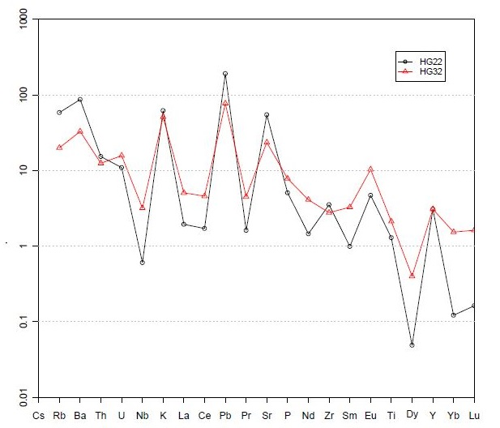
Fig. 4 Primitive mantle normalized spider diagram (Sun and MacDonough, 1989) showing enrichment of LILEs-Pb, K, Ba, Sr and depletion of HFSEs-Nb, Dy, Yb.
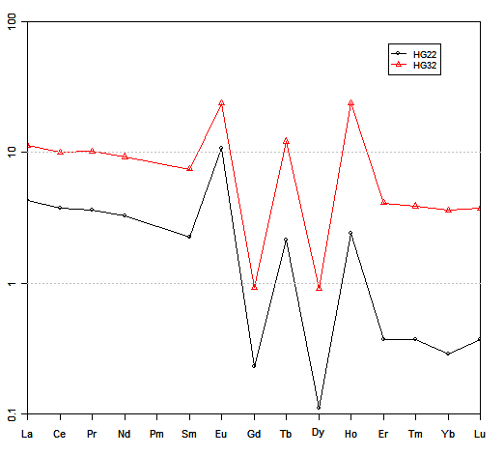
Fig.5 Chondrite normalized spider diagram (after Boynton, 1984) showing Gd, Dy depletion and enrichment of Eu, Tb, Ho.
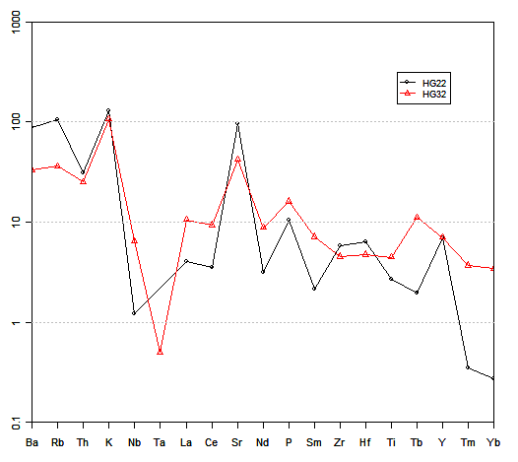
Fig. 6 Chondrite normalized spider diagram (after Thompson, 1982) showing depletion of HFSEs- Nb & Ta and enrichment of LILES-K & Sr.

5.7 Tectonic setting
The tectonic discrimination diagram based on immobile trace elements (Rb and Nb+Y; Pearce at al., 1984) are used to infer the tectonic setting of the Hayuliang granodiorites. In this diagram (Fig. 7), both samples (HG22, HG32) plot within the volcanic arc granite (VAG) field and close to the syn-collisional granite domain, reflecting enrichment of Rb and depletion of Nb relative to Y. Such geochemical characteristics are typical of granitoids generated in subduction related convergent margin settings. The low Nb content and corresponding Nb-Y relationships support a strong subduction imprint, resulting from retention of Nb in residual phases within the mantle wedge or its removal by slab-derived fluids.
Together with the REE and multi-elements spider patterns and tectonic diagrams confirm that the Hayuliang Granodiorites were emplaced in an active continental margin to syn-collisional tectonic environment. The calc-alkaline nature, LILE enrichment and HFSE depletion point to a continental arc to syn-collisional tectonic setting. The granodiorites likely formed during active convergent associated with eastern Himalayan orogeny.
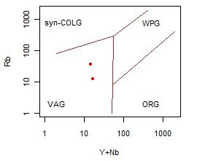
Fig. 7 Tectonomagmatic diagram (Rb vs Y+Nb) of granodiorites (after Pearce at al., 1984). The granodiorite samples fall on volcanic arc granitoid environment (VAG).
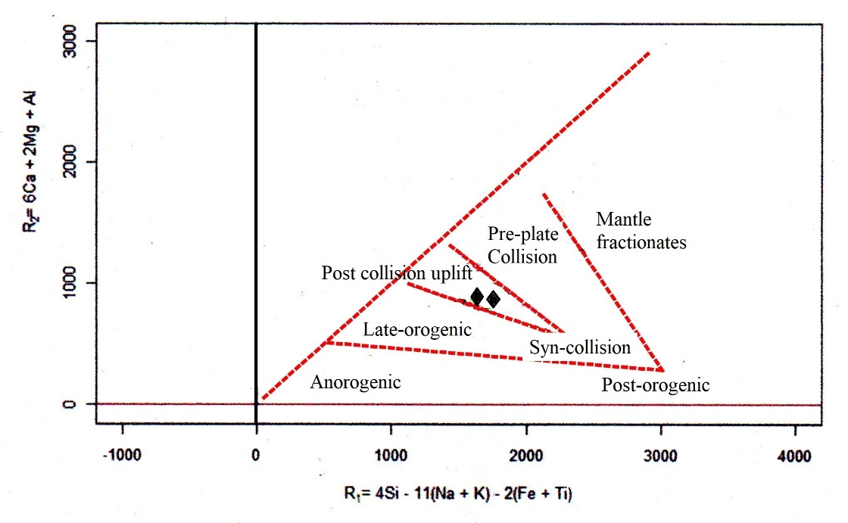
Fig. 8 Tectonomagmatic diagram of granodiorites (after Batchelor and Bowden, 1983). The granodiorites fall on post –collision uplift environment.

- Conclusions
Plumose bearing granodiorites of the Hayuliang granitoids represent arc related to calc-alkaline magmatism. Petrographic observations indicate that these textures in granodiorites formed during late-magmatic to early sub-solidus stages, controlled by localized strain, microfracturing and enhance silica mobility under volatile-rich conditions.
Whole –rock geochemical data show that the granodiorites are metaluminous to weakly peraluminous, enriched in LILE and depleted in HFSE with LREE enriched chondrite normalized REE patterns and positive Eu anomaly. These features reflects evolution dominated by fractional crystallization, particularly plagioclase accumulation and interaction with crustal components.
EPMA data demonstrate that the granodiorites of the Hayuling granitoids were emplaced as hydrous, oxidized calc-alkaline pluton at mid crustal depth (~6 to 22Km) consistent with emplacement in active continental arc or collisional tectonic setting. The high purity quartz chemistry coupled with textural evidence of recrystallization, supports episodic silica saturation and fluid assisted growth linked to the deformation during emplacement.
The geochemical and mineralogical features of the Hayuliang granitoids indicate that they were generated predominantly by partial melting of pre-existing continental crust, possibly with minor mantle input. Subsequent magma evolution involved fractional crystallization, plagioclase control, and limited crust-magma interaction during ascent and emplacement. These characteristics firmly establish the crustal affinity of the Hayuliang granitoids within the tectono-magmatic framework of the Eastern Himalayan orogeny.
Tectonic discrimination diagrams and integrated geochemical signatures suggest emplacement in a convergent margin setting, most consistent with continental arc to post collisional tectonics. The combined petrographical, geochemical and mineral chemical evidence syn-to post-tectonic magmatism where deformation, fluid activity and magma evolution collectively governed the development of plumose quartz. These granodiorites thus record dynamic tectonomagmatic process associated with the tectonic evolution of the Eastern Himalayan orogenic belts.

References
Adams, S.F.,(1920), A microscopic study of vein quartz: Economic Geology, v.15, p.623-664.
Batchelor, R.A., and Bowden, P. (1985). Petrogenetic interpretation of granitoid rock series using multicationic parameters. Chemical Geology, v.48, p.43 – 55.
Boynton, W.V. (1984). Cosmochemistry of the rare earth elements: meteorite studies, in Developments in geochemistry, Elsevier, v.2 p. 63-114

Cornelius H.P. (1915). Geologische Beobachtungen im Gebiet des Forno-Gletschers (Engadin). Centralblatt für Mineral Geol Paläontol, v.8:246-252.

Dong, G., Morrison, G. and Jaireth, S. (1995). Quartz textures in epithermal veins, Queensland--classification, origin, and implication, Economic Geology, v.90, p.841-1856.

Hammarstrom J.M., and Zen, E. (1984). Magmatic epidote and its petrologic significance, Geology, v.12(9), p.515-519.
Janousek, V., Farrow C.M. and Etahn, V. (2006). Interpretation of whole rock geochemical data in igneous geochemistry: Introducing Geochemical Data Toolkit (GCDkit), Jounal of Petrology, v.47(6) p1255-1259.
Pearce J,A., Harris, N.B. and Tindle, A.G. (1984). Trace element discrimination diagrams for the tectonic interpretation of granitic rocks, Journal of Petrology, v.25, p.956-83.
Rino, V. Meyase, D., Kumar, S., & Nagi, R. (2023). Magnetic susceptibility, mineral chemistry, and geothermobarometry of granitoids from Lohit Plutonic Complex, Arunachal Trans-Himalaya, Northeast India: Implications on emplacement and crystallization conditions of oxidized calc alkaline magmatic arc system. Island Arc, v.32(1), p.1-18.
Sander, M.V. and Black, J.E., (1988). Crystallization and recrystallization of growth zoned vein quartz crystals from epithermal system--Implications for fluid inclusion studies: Economic Geology, v.83, p.1052-1060.

Schmidt M.W. and Poli S. (2004). Magmatic Epidote, Reviews in Mineralogy & Geochemistry, v.56, p.399-430.
Sun, S.S. and McDonough, W.F. (1989). Chemical and Isotopic Systematics of Oceanic Basalts. Implications for mantle composition and processes. In A.D. Saunders, and M.J. Norry (Eds.), Magmatism in the Ocean Basins, Geological Society (London) Special Publication, v.42, p313–345.
Sundaman, B. Andersson, J.O. and Saunders, N. (2009). Thermo-Calc and DICTRA, computational tools for material science, Calphad, v.33 p.712-721.

Thompson R.N. (1982). Magmatism of the British Tertiary Province, Scottish J. Geol., v.18 p.49-107.
Walters, J.B. & Gies, N.B. (2022). MinPlotX: A powerful tool for formula recalculation, visualization, and comparison of large mineral compositional datasets, Mineralogia,v.53, p.51-60.

